Internship Report
Topic: “Impact of COVID – 19 on Bank performance (a case study from Pubali Bank Limited).”

Submitted to:
Mofijul Hoq Masum
Assistant Professor
School of Business & Economics
United International University

Submitted By:
Umaimah
114 172 009
BBA in AIS

Date of submission: 6th November, 2021


Letter of Acknowledgement

First of all, I would like to Thank Almighty Allah (S.W.T) to give me the hope, strength in order to finish this report keeping aside the obstacles that I have faced. It has been really tough for the past year as COVID hit worldwide creating pandemic situation and taking thousands of lives. I pray that may this situation end soon.
Internship report is an essential part in order to finish BBA. My firm is Pubali Bank limited, Motijheel, Dhaka.
Second of all, I would like show my gratitude towards Masum Sir, who is an Assistant Professor in UIU plus my honorable supervisor who had helped me to prepare this report by giving me proper guidance and insights in order to finish it timely.
I want to thank Harun – Ar – Rashid for providing me information related to my topic who works in PBL as Senior officer in General Banking department.
Finally, this would not have been possible for me to come at this stage, if it wasn’t for my parent’s support, as well as the honorable faculties of UIU who have helped me and guided me in order to come this far in my life.

Letter of Transmittal

6th November,2021
Mofijul Hoq Masum
Assistant professor
School of Business and Economics
United International University
Cell no: 01864007604
Email: masum1984du@gmail.com

Subject: Submission of internship report on “Impact of COVID – 19 on Bank performance. (a case from Pubali Bank Limited).”

Dear Sir,

I have prepared my report with all the available related information that I thought was suitable for this topic. I have managed to follow the guidelines that was provided to me thoroughly. I have provided graphs, calculations and interpretation as needed. I hope I have organized the report well to make it reliable as per requirement and that it fulfills your expectations.

However, if you have any difficulty to understand any part of my report you are more than welcome to contact me via Mail or Contact number that will be available below.

Lastly, once more I express my gratefulness to you for your support and generosity you have showed me.

Sincerely yours,

Umaimah
114 172 009
(BBA in AIS)
Email: u172017@bba.uiu.ac.bd
Contact: 01616669395

Abstract

Banking sector is an essential part of Bangladesh which is essential to run the economy smoothly in order to sustain as well. Pubali Bank Limited is one of the largest private commercial banks in Bangladesh. Aim of this report as to find out the impact of COVID – 19 had on Pubali bank Limited in the year of 2020. This has been done by comparing the results of the ratios with the previous year data (2019) before the COVID situation. The three kinds of ratios were taken. From profitability ratios (ROE, ROA, ROI, OPM) were taken and from liquidity ratios (Current ratio and cash ratio) and lastly from Solvency ratios (Debt to equity, debt to asset and interest coverage ratios) were taken for the comparison. The analysis will show was there any huge impact on any side like profit wise. Many of the information was availed from the PBL annual reports and financial statements along with some other information’s from news and articles. This report will benefit those who will research on the profit of PBL in future. They will get the information from this report which I must state that the values are reliable and authentic. This will make their research precise. Lastly, my recommendation would be to improve the structure more internally.

Key words

COVID – 19, Ratios, Pubali Bank Ltd, Bank performance, Financial Impact.

Table of Contents
Letter of Acknowledgement ii
Letter of Transmittal iii
Abstract iv
Key words iv
Chapter – 1 1
1.1 Introduction to the topic 2
1.2 Rational of the study 2
1.3 Background of the study 3
1.4 Limitations of the study 10
Chapter 2 12
2.1 Broad objectives 13
2.2 Specific objectives 13
Chapter 3 14
3.1 Data design 15
Primary data collection 15
Secondary data collection 15
3.2 Data collection process 15
3.3 Sample size 16
3.4 Sampling techniques 16
3.5 Analytical tools 16
Chapter 4 17
4 Literature review 18
4.1 Highlights of Bangladesh impact due to COVID: 18
4.2 Ratio analysis: 18
4.2.1 Liquidity ratio 19
Current ratio 19
Cash ratio 19
4.2.2 Profitability ratio 20
Return on Assets (ROA) 20
Return on Equity (ROE 20
Return on Investment (ROI) 20
Operating profit margin (OPM) 21
4.2.3 Solvency ratio 21
Debt – to – equity ratio 21
Debt – to – total asset ratio 21
Interest coverage ratio 22
4.3 Benefits of financial ratios: 22
4.4 Limitations of the financial ratios: 22
4.5 Some other information’s 22
4.6 Ratio’s formula 24
Chapter 5 25
5 Findings and Analysis 26
5.1 PBL situation 26
5.2 Key financial figure of balance sheet 27
5.3 Foreign exchange business 27
27
5.3.1 Import business 28
5.3.2 Export business 29
5.3.3. Inward Foreign Remittance (IFR) 29
5.4 Ratio Analysis (2019 & 2020) 29
5.4.1 Liquidity Ratio comparison 29
5.4.2 Profitability Ratio comparison 30
5.4.3 Solvency Ratio comparison 32
5.5 Key Findings 33
34
Chapter 6 34
6.1 Recommendation 35
6.2 Conclusion 35
37
Chapter 7 37
7.1 Internship experience at ‘Pubali Bank Limited’ 38
Chapter 8 39
8.1 Appendix 40
8.2 Some tables from annual report 42
8.3 References 44



Chapter – 1
Introduction

Introduction to the topic

“Bank” – what do you think when this word is said. A place where it receives deposits as a means of savings and making loans. The word had been derived from the Old high German “bench, counter.”

Financial system is the backbone of any nation. If it does not function well then it faces severe consequences as progress of economic activities highly depends on how properly the system works.

Without these institutions the country will not be able to function at all as it is responsible for the financial stability of a country. Bangladesh is still a developing country and along with it in many areas Bangladesh has done quite well one of them is banks. If I must mention that the era, we are passing now is most crucial ones. As we are passing the COVID – 19, which has created a vast pandemic worldwide taking millions of lives. Through this pandemic the institutions like banks have improved their way of reaching out to the customers and made sure that they can get help in any way.

However, many employees were affected by the virus and had passed away. Many industries have halted their operations and lead decrease in the profit level.

This report will give a clear idea about the bank that has been impacted due to COVID-19 situation along with the customers. While preparing this report, I have tried well to gather as much information as possible. I have compared the performance of the bank with the information from the year 2019 and 2020 to see how things have been changed before and after COVID situation.

Rational of the study

The ultimate reason for preparing this report is because it is mandatory to submit an internship report at the end of BBA undergrad program. My supervisor has assigned me this topic among the list I have provided to him.

This report will give an insight to the readers, that how the economy, mainly banks has been affected due to COVID-19 pandemic situation, which is a deadly virus originated from Wuhan, China; and has spread in Bangladesh at March of 2020. This resulted a worldwide pandemic which also has taken millions of lives.
This report will give the overview of how “Pubali Bank Limited” was impacted with COVID situations, in addition with how customers were handled.

Background of the study

Pubali bank was named as “Eastern Mercantile Bank limited” in the year 1959 under Bank company act 1913. In the year 1983 Pubali bank was denationalized and was renamed as “Pubali bank limited.”

PBL one of the largest private commercial banks in Bangladesh and has the big real time centralized online banking network. It has total of 482 branches so far. The bank’s head office is in Dhaka at Dikhusa, Motijheel. PBL has been listed on April 1996 in (DSE) Dhaka Stock Exchange. Today PBL is engaged to develop trade area, innovative observation, and efficient management.

In addition, PBL has been engaged in several CSR activities such as, PBL has donated Tk. 10 crore to Dhaka Ahsania Mission, towards setting up a brand-new Cancer hospital to reduce the sufferings of people who have currently no access to professional medical treatment of Cancer.
Other field of CSR activities:

- Financial support for the educational purposes
- PBL has been providing supports for extracurricular activities to major universities.
- Internship facilities to the students of the universities to gain higher studies
- For the natural causes and national tragedy PBL always extends its hand to help and provide financial support
- PBL always extends its support to distress people through government contribution to Government Fund etc.

Business growth
The following table shows the summary of the performance of PBL showing the key financial indicators that has achieved 20% growth for the last 10 years.
(Taka in crore)
Year | Deposit | Advance | Import | Export | Profit
2009 | 8,846.64 | 7,420.33 | 6,049.38 | 2,473.96 | 383.94
2010 | 9,885.05 | 8,910.62 | 8,568.35 | 3,390.97 | 548.5
2011 | 12,380.59 | 10,632.96 | 9,857.90 | 4,751.59 | 548.02
2012 | 15,041.88 | 12,206.85 | 10,812.03 | 5,900.48 | 613.58
2013 | 17,787.82 | 13,694.05 | 9,738.04 | 6,948.44 | 755.98
2014 | 19,309.02 | 14,997.45 | 9,751.69 | 7,707.13 | 708.14
2015 | 22,480.86 | 17,312.54 | 11,256.43 | 8,574.04 | 733.41
2016 | 24,727.85 | 20,301.12 | 12,185.20 | 8,676.41 | 655.65
2017 | 27,160.58 | 23,953.96 | 14,167.02 | 9,612.75 | 818.49
2018 | 30,889.98 | 27,090.95 | 15,571.37 | 10,486.16 | 885.77
2019 | 35,941.89 | 28,703.46 | 15,698.01 | 10,038.19 | 945.78

Year | Classified Advances | Remittance | NPL
2009 | 219 | 3,525.00 | 2.96%
2010 | 181.85 | 3,193.00 | 2.04%
2011 | 214.6 | 3,400.00 | 2.02%
2012 | 615.96 | 4,123.99 | 5.05%
2013 | 813.61 | 3,894.76 | 5.94%
2014 | 937.76 | 4,354.17 | 6.25%
2015 | 921.84 | 4,380.70 | 5.32%
2016 | 1,092.15 | 3,775.70 | 5.38%
2017 | 2,078.69 | 3,659.30 | 8.68%
2018 | 1,477.83 | 4,056.50 | 5.46%
2019 | 1,256.06 | 5,265.69 | 4.38%

Fig. 1

It can be concluded that gradually both the deposits and advances has increased. Which means that PBL has borrowed funds and as well as money was held in the bank in the year of 2019. As for NPL the highest peak was in 2017 which was 8.86%, and then in 2019 it has decreased to 4.38%. Later, in 2020 it has decreased more to a point of 2.73%. Which means that the outstanding loans presents a lower risk to PBL.

Position at a Glance:
Key financial as on 31st Dec 2020
(In million taka)
Particulars | 2014 | 2015 | 2016 | 2017 | 2018 | 2019 | 2020
Authorized Capital | 20,000.00 | 20,000.00 | 20,000.00 | 20,000.00 | 20,000.00 | 20,000.00 | 20,000.00
Paid-up Capital | 8,803.74 | 8,803.74 | 8,803.74 | 9,508.04 | 9,983.44 | 10,282.94 | 10,282.94
Reserve fund & other Reserves | 14,055.64 | 16,071.38 | 16,340.67 | 14,912.27 | 17,393.66 | 21,988.76 | 28,525.09
Total Deposits | 1,93,090.24 | 224,808.59 | 247,278.50 | 271,605.83 | 308,899.77 | 359,153.31 | 429,343.02
Total Advances | 1,49,974.53 | 173,125.42 | 203,011.23 | 239,539.60 | 270,909.51 | 287,034.67 | 315,578.90
Total Investment | 48,970.73 | 57,881.68 | 48,865.75 | 53,527.20 | 57,660.24 | 100,603.86 | 147,906.01
Import Business | 97,516.90 | 112,564.30 | 121,852.00 | 141,670.20 | 155,713.70 | 156,980.10 | 164,240.37
Export Business | 77,071.30 | 85,740.40 | 86,764.10 | 96,127.50 | 104,861.60 | 100,381.90 | 87,340.06
Bridge Finance | 6.22 | 5.55 | 4.81 | 4.81 | 4.81 | 4.81 | 4.81
Total Income | 25,629.36 | 25,637.59 | 24,407.68 | 27,310.89 | 32,225.71 | 36,101.65 | 38,175.87
Total Expenditure | 18,547.97 | 18,303.48 | 17,851.20 | 19,126.00 | 23,368.03 | 26,643.84 | 29,796.31
Pre-tax Profit | 7,081.39 | 7,334.11 | 6,556.47 | 8,184.89 | 8,857.68 | 9,457.81 | 8,379.56
Net Profit | 3,070.13 | 2,895.29 | 1,334.95 | (281.20) | 3,424.06 | 2,143.27 | 3,669.51
Total Assets | 2,48,386.50 | 285,462.25 | 320,361.89 | 368,314.62 | 409,744.09 | 478,074.84 | 565,032.07
Fixed Assets | 4,024.58 | 3,917.77 | 3,788.44 | 3,686.86 | 3,782.35 | 5,180.80 | 5,087.99

Other Information
Number of Employees | 7,645 | 7,086 | 7,204 | 7,652 | 7,587 | 8,153 | 8,118
Number of Shareholders | 92,836 | 75,058 | 62,687 | 52,515 | 48,130 | 43,352 | 40,223
Number of Branches | 434 | 444 | 453 | 465 | 473 | 482 | 482
Earnings per ordinary Share (taka) (Absolute EPS for Taka 10 Face Value) | 3.49 | 3.29 | 1.52 | (0.28) | 3.33 | 2.08 | 3.57

Fig 2.

Management structure of PBL

PBL is ran by an excellent management team. The current Chairman is Mr. Monzurur Rahman. There is 11 directors and two independent directors, along with the managing director and CEO of PBL, named, Mr. Saiful Alam Khan Chowdhury.
In addition, there is also additional managing director and Chief Operating officer (COO), named: Mr. Mohammad Ali.

Here is the structure of corporate organogram:

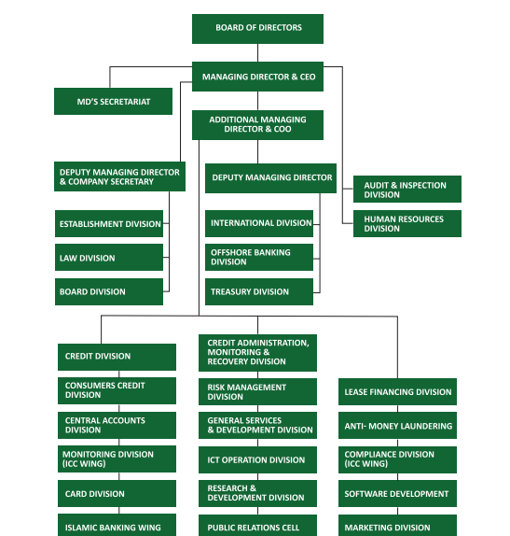

SWOT Analysis
SWOT analysis is a framework to identify the situation a company is currently at. By knowing these it will help organizations to make a better decision. An organization should analyze its processes often to make sure that it runs properly and as efficiently as possible only then they can apply appropriate strategies.

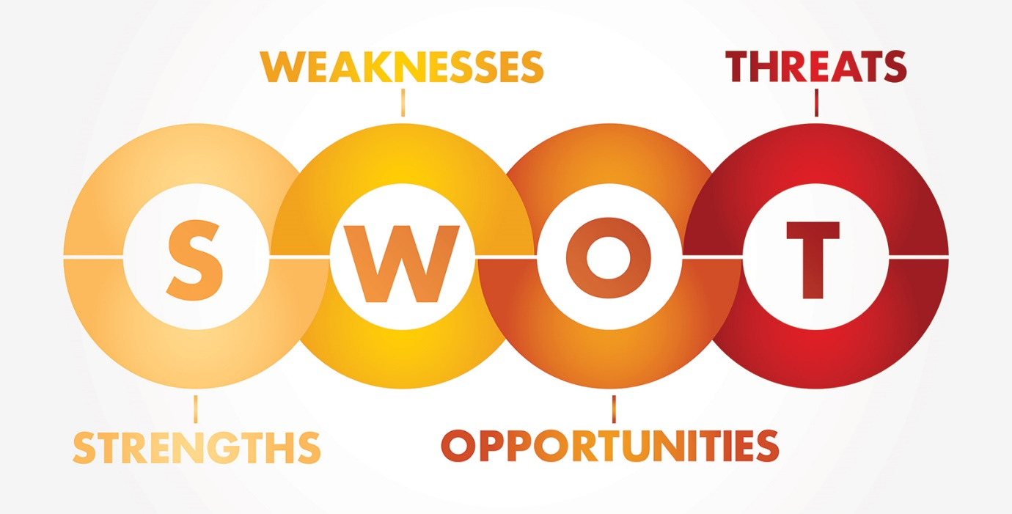
Fig. 3

Internal Factors
Strengths | Weakness
- Became a brand in the customers eyes  - Helped people in many ways during this pandemic  - Improved online banking services  - Technology has been improvised  - Safety measures was implemented like spraying sanitizer to every person who enters.  - Bank declares satisfactory dividend to its investors.  - Has experienced board of directors  - Work from home | - Lack of motivation for the employees  - Sanitization was maintained but then gradually it has decreased and the place started to get crowed.  - Each and every large loan need to approved by the (BOD) that is why it takes so much time to disburse a loan.  - Long ques made customer impatient  - Junior level staff was not trained well  - ATM services is not available like city bank.

External factors
Opportunities | Threats
- Efficient recruiting  - Improve training style  - Outsource modern technology  - Maximum security  - Electronic signature  - Electronic payments  - Can move to SME loan as the risk is comparatively low here. | - Due to COVID – 19 NPL may increase.  - High competitions like (Prime, Dutch, Southeast banks)  - Fear of failure due to economic situation  - Cyber risk  - Fall down in management teams  - High risk in Dhaka stock exchange (DSE)  - Unable to understand consumer needs and fulfilling them.

Fig.4

Limitations of the study

I have faced some difficulties while I was preparing the report, as the topic was new and very huge. Relating to the topic not all information were not available.
Despite of all the hardships I tried my utmost to provide all the reliable and relatable data so you can get an overview of the topic. Some of the issues that I have faced is mentioned in the following points.

- COVID situation
Not to mention, this current situation has affected us “the students” in many ways. Due to this scenario, I was not able to attend office regularly due to the restrictions.So, many insights of the bank are still unknown to me and have not gained any sort of experience which I really needed to in order to grow my persuasion in the working field.

- Lack of data
Due to bank confidentiality many information was not shared, such as exactly how they have managed their interests, or how the employees are being treated etc.

- Quality
Quality of this report may vary, as I am not a professional report writer. I still managed it to portray a standard view, hopefully it is clear and my topic is focused.

- Data
Actual conclusion cannot be drawn only with comparing with 2 years data.

Despite all the limitations, I have tried to collect as much information needed from various websites, Annual reports, colleague. I hope that this report is understandable and acceptable.



Chapter 2
Objectives of the study

2.1 Broad objectives
The broad objective describes the main purpose of the task. So, my ultimate objective is to find the impact on PBL overall performance due to COVID and compared with past data to see where changes has been made.
In addition, to fulfill the requirement of BBA internship program by submitting this report.

2.2 Specific objectives

Specific objectives are those elements of the task which provides the core idea of the study. Thus, for this report the specific goals are:
- To measure the performance before COVID – 19.
- To measure the performance during COVID – 19.
- To Portray different situation which was affected due to COVID – 19.
- To identify the key financial indicators of the firm.
- To illustrate the position in foreign exchange business.



Chapter 3
Methodology

3.1 Data design

Data collection is a procedure of collecting data by gathering related information in a systemic way. There are 2 types of data that are:

Primary data collection

This is the first-hand data or the original data that are collected directly from co-workers, focus group discussions, etc. this are accurate form.
For this report the first-hand data that has been collected was from a conversation with an employee. I have asked him questions related to my topic and he supported me by giving information which was helpful.

Secondary data collection

These are the data which are already there and you have to search for it. Those might be in the form of newspaper, internet. This is also known as second hand data which might also give you biased information and needs time to search the right information,
As I have mentioned earlier that for this topic, I could not get the first-hand data due to difficulties, thus I have tried to get all the information that are related from:
- PBL website
- Different websites
- Annual reports
- Articles

3.2 Data collection process

For collecting data, I have gathered it from websites, articles, the official sites of PBL and annual reports. I have calculated the ratios manually by seeing the amount from the financial reports and then made charts to compare them.

3.3 Sample size

For the financial analysis, 2 years data (2019 and 2020) of PBL has been taken.

3.4 Sampling techniques

Online method was used to collect information. And judgmental aspect was used to collect relevant sample from given data.

3.5 Analytical tools

I have used MS – Word for writing my report and have made use of MS – Excel for graphical representations.
I have used Browser (Google) platform for my intensive search and for collecting data.



Chapter 4
Literature Review

4 Literature review

4.1 Highlights of Bangladesh impact due to COVID:

Before going further, I want to highlight some issues related with Bangladesh economy and global impacts. The year 2020 was very crucial for Bangladesh where the economy was unstable due to the COVID – 19 Pandemic.

As we all know that the garment sector contributes around 84% to the country’s total annual exports due to COVID outbreak the foreign buyers had cancelled the purchase orders, which lead severe loss. According to (BGMEA), up to March, a total of $2.87 billion order was cancelled and $7.38 million work orders were suspended. (Coronavirus: BGMEA reports $3.15 billion order cancellation, 2020)

Poverty has also increased in 2020 by 120 million people globally. As to the baseline, the 2020 figure is 144 million people higher. The predictions states that by 2030, the poverty number could still be higher and that the baseline by 60 million people. (Pubali bank limited, 2020)

Global remittance has declined by 20% in 2020 due to the crisis. The top countries of remittance recipient were India, China, Mexico, the Philippines, and Egypt. (Pubali bank limited, 2020)

Here I will discuss and explain the key terms that are taken for this report and also have included the explanation of the ratios that I have used. This section is mainly to define the terms or process that I have taken into account for the topics that is covered in the findings section along with some other relevant information about PBL.

4.2 Ratio analysis:

It is a method to analyze the company’s liquidity, profitability, efficiency, solvency by evaluating the financial statements of the selected years data.
It also shows the status of the organization of where it is in the present time. Such analysis is used by the external parties to know the organization performance so that they are attracted to make an investment. The financial ratios are often divided into 5 categories. Those are:
- Liquidity
- Profitability
- Solvency
- Efficiency
- Market value (Thakur)

4.2.1 Liquidity ratio

It is a measurement of a company’s ability to be able to pay its debt both long term and short term by calculations of the variables, in other words, it tells us that how fast the organization can convert its current assets into cash to pay off its liabilities. (Thakur)
I have chosen 2 ratios:
- Current ratio
- Cash ratio

Current ratio

It evaluates the financial strength. It is a measure of a company’s ability to pay off short term liabilities with current assets. The ideal ratio is 2:1 (which may vary). (Thakur)

Cash ratio

This ratio computes the total liquidity that is available in the company. It only contemplates marketable securities and cash available to the company which gives us a deeper insight. It is preferred that the ratio doesn’t go below 0.5 to 1. Cash equivalents are those short-term assets which easily convertible to cash and are highly liquid. Examples: stocks, government securities, bank deposits, etc. (Cash ratio, n.d.)

4.2.2 Profitability ratio

This ratio it measures the profitability of the company. As the ratio measure the efficiency of operations with the help of profits, they are known as “Profitability Ratios.” (Thakur)
Every company has initial motive and that is to make profit. It is crucial to show that the company is generating profits and is working efficiently and thus this tool is very useful for evaluation as investors wants their returns on their investments too.
There are many related ratios that calculates the profitability of the company.
I have selected 4 ratios to make comparison.
- ROA (Return on Assets)
- ROE (Return on Equity)
- ROI (Return on Investment)
- Operating Profit Margin

Return on Assets (ROA)

It determines that how good the company utilizes its assets to make maximum profits. The higher the outcome means the asset has been utilized well. (Borad, ROA, 2021)

Return on Equity (ROE)

This is used mainly for the equity holders. The investors usually look onto this particular ratio to see where the company’s profitability suited at presently. It portrays the percentage (%) return to the shareholders earns on its invested capital. Profit after tax means that all the costs, depreciation, dividends given to preference shareholders and tax has been deducted. If ROE is greater than cost of capital then it is said to be value to the shareholders. (Borad, ROE, 2013)

Return on Investment (ROI)

It evaluates how well an investment has performed.

Operating profit margin (OPM)

It underlines the operating income as a percentage of the revenue. It tells us the contribution of the operations towards profitability.
Operating profit is that profit which remains after the deductions of expenses but before deducting interest and taxes. Higher the margin the better.

4.2.3 Solvency ratio

This ratio is a sign of a company that states that do they have the capability to meet its long-term obligations. It means that will it be able to pay of their long-term debts on time or not and compare the level of their current debt level.
Solvency ratio also specifies that whether a company’s cash flow is abundant to meet its total liabilities or not.
The ratios that are chosen are:
- Debt to equity ratio
- Debt to total asset ratio
- Interest coverage ratio

Debt – to – equity ratio

It is calculated to have an idea about the long-term financial solvency of an organization. Higher DE ratio means owners can retain control over their business with limited capital. (Borad, Debt to Equity Ratio, 2011)

Debt – to – total asset ratio

It is a broad parameter that is used to compute what part of assets are served by liabilities signifying the financial risk. It helps in calculating that how far a company is capable of meeting its long-term financial deeds. Lower debt to total asset ratios indicates a better sign of financial stability of the company. If it gets higher than 0.5 it is considered as highly leveraged. (Borad, Debt to Total Asset Ratio, 2013)

Interest coverage ratio

This ratio states that how many times a company can pay its obligations using its earnings before taxes and interest can cover its interest expenses. Higher ICR shows a strong sign of solvency. (MAVERICK, What Is a Good Interest Coverage Ratio?, 2021)

4.3 Benefits of financial ratios:

- These ratios can be compared with industries to see the overall position.
- It aids in future forecasting of the firm and so the management can plan accordingly.
- Indicates overall profitability of the firm and can foresee that are they are able to pay off their debts.
- Easy to understand at a glance. (Assignment Consultancy, 2018)

4.4 Limitations of the financial ratios:

- Some results or ratios varies industry to industry which may lead to irrelevant comparisons.
- As past data will be taken for comparisons it will not give the big picture for the resent situation.
- Data and their situation may differ in many ways.

Some other information’s

The DSEX (Dhaka Stock Exchange Index) has become 5402.07 from 4452.93 which has rose 21.31% in the midst of pandemic situation. Average daily turnover in DSE is increased 34.93% in 2020 = 647.92 crore BDT which was 480.20 crore BDT in 2019. (Pubali bank limited, 2020)
PBL prepares their financial statements with sufficient disclosures according with the (BAS) Bangladesh Accounting standards, (IFRS)/(BFRS) International Financial Reporting Standards / Bangladesh Financial Reporting Standards, the Companies Act 1994, the securities exchange Rules 1987, and other applicable laws and regulations. (Pubali bank limited, 2020)
There have been no significant changes is legislation or policy, which may affect the banking activities. Adequate disclosures have been made in the financial statements and different areas of these statements to understand the appropriateness of going concern basis in preparing these.
Human capital and business are intertwined where they depend on each other. So, PBL focuses on strengthening its manpower by acquiring the right person for the right job regarding with their right skills set. In order to do this the HR team, ensure to select the most fitted one through a competitive, transparent and fair process.
The total number of employees of PBL on 2020 stands 8,118 compare to 2019 which was 8,153 employees. The reason behind this reduction may be due to the pandemic situation, which might have affected the employees. In memory of Md. Rafiqul Islam, who was the chief deputy general manager of the lease financing division had passed away after being affected by Coronavirus as well as Sayed Saiful Islam the general manager and head of principal branch. Like these cases many employees might have got affected or due to any other reason the number of employees may have reduced. (Pubali Bank limited, n.d.)
Some benefits to employees that are provided by PBL are as follows:
- Fringe benefits Schemes
- House rent allowance
- Conveyance allowance
- Medical allowance
- Lunch Subsidy
- Leave fare assistance (LFA)
- Other benefit Schemes
- Life term insurance
- Staff welfare fund
- Leave salary
- House Building Loan (HBL) (Pubali bank limited, 2020)

4.6 Ratio’s formula

Formulas
- Current ratio | Current asset / Current liabilities.
- Cash ratio | Cash and cash equivalent / Current liabilities
- ROA | Profit after tax / Total assets
- ROE | Profit after tax / Shareholders equity *100  *Shareholders equity = Assets – Debt
- ROI | Net income / Cost of investment
- OPM | EBIT / Total revenue  *EBIT (earnings before interest and tax)
- Debt – to – equity ratio | Total debts or liabilities / Total shareholders’ equity
- Debt – to – total asset ratio | Total debt / Total assets
- Interest coverage ratio | EBIT / Interest expenses

Fig.5

**Note: Profit after tax means that all the costs, depreciation, and tax has been deducted.
Total Debt = Long-Term Liabilities + Current Liabilities (Long-Term Debt and Short-Term Debt).
Total Assets = All Assets (Intangible assets, Tangible, Current, Fixed.)



Chapter 5

Findings and Analysis

5 Findings and Analysis

5.1 PBL situation
This full section I am going to elaborate the issues that I have found so far along with data representations, calculations, etc. I have tried to state all the reliable date as much as possible. To begin with I will briefly discuss the PBL situation was in 2020.

Out of total BDT 28,525.09 million of the bank, statutory reserve was BDT 10283 million, and other reserves was BDT 6,870.11 million at the close of 2020 whereas at the end of 2019 Total reserve were BDT 21,988.76 million. For the last few years, the stock market has been remaining uncertain. Authorized capital, paid up capital, Earnings per share (EPS), and Net Asset value per share (NAVPS) has been portrayed below.
(BDT in millions)
Year | 2019 | 2020
Authorized Capital | 20,000 | 20,000
Paid up Capital | 10282.94 | 10282.94
EPS | 2.08 | 3.57
NAVPS | 31.38 | 37.74
Fig.5
EPS shows the profitability of PBL and the higher the EPS ratio means a greater value as investors will pay more for a company’s shares if they assume that the company has higher profits relative to its share price. Here in fig.5, it is showing that 2020 has 3.57 greater than 2019 showing a positive path.
However, PBL has borrowed BDT 17,486.80 million in 2020 compare to 2019 which was BDT 16,970.35 million. This means that in COVID – 19 situation the bank had to borrow funds to maintain the internal affairs of the bank and support customers.
Total investment in 2019 was BDT 100,603.86 million whereas in 2020 it was BDT 147,906.01 million which shows that it has increased 47.02% which is a positive thing for PBL.

5.2 Key financial figure of balance sheet

(BDT in million)
Particulars | 2019 | 2020
Assets | 478,074.84 | 565,032.07
Deposits | 359,153.31 | 429,343,02
Loans and Advances | 287,034.67 | 315,578.90
Shareholder’s Equity | 32,271.71 | 38,808.04
Fig.6

By visualizing this table, I may state that each year we can see all are increasing showing a positive view. Asset increasing means that the value of the firm has been improvised to provide better services to customers. In addition, customers got more aware of the situation in COVID – 19 pandemic and started to deposit funds into their accounts so that it will aid them when emergency rises. As for bank it is also a plus point as more deposits means they are getting known for their services. We also can see that that the shareholders’ investment has been increased too as that means the share price was reasonable in 2020 (22.60 tk).

5.3 Foreign exchange business

(BDT in millions)

Fig. 7

Fig.8

5.3.1 Import business
By comparing this data, it can be seen that the value was increased by BDT 7260.04 in the year 2020 which was 4.62% higher than 2019. That means services or goods were imported from foreign countries and aid in COVID situations.

5.3.2 Export business
The percentage has been decreased in 2020 by 12.99%. As we know that RMG is one of the major sources of income in Bangladesh, due to the outbreak many orders were cancelled as well as workers were out of work due to lockdown. This has affected many businesses that were involved in exporting and thus has been put to halt.

5.3.3. Inward Foreign Remittance (IFR)
The percentage has been decreased by 1.03%. IFR means that the money which is received from a foreign country into your account. Due to the outbreak people who are Bangladeshi but lives abroad faced financial crisis. Many were out of work, or did not get paid, etc. which then made it difficult to send money back in their home country which is Bangladesh. These may be some reasons why IFR has been decreased in the 2020.

Ratio Analysis (2019 & 2020)

5.4.1 Liquidity Ratio comparison

Ratio name | 2019 | 2020
Current Ratio | 1.11 | 1.13
Cash Ratio | 0.17 | 0.18

Fig. 9
Interpretation:
A ratio under 1for current ratio, it signals that the company’s debts due in a year or less than a year are greater than assets. The higher the ratio the better. However, higher than 3 it could mean that it is not using its current assets efficiently and is not maintaining finance very well. The ideal ratio of bank is between 1.2 is to 2. In this comparison we can see that 2020 did a little better than 2019. That means it has improved its situation in order to fulfill the short-term obligations.
As for the cash ratio, there are 3 conditions that tells us what the results means.
Firstly, if Cash and cash equivalents is greater than Current liabilities the it tells us that the organization has more cash in terms of ratio it will be more than 1, than they need to pay off the current liabilities. However, it is not always great to have more cash as it might send negative signal showing that the firm might not have utilized its assets to its fullest.
Secondly, if Cash and cash equivalents is equal to Current liabilities then it means that the firm has sufficient amount to pay off its debts.
Lastly, if Cash and cash equivalents is less than Current liabilities then it means it is in the fitted situation in terms of firms view. This means that the firm has utilized its assets well enough to earn profits.
So, we can see here that in 2020 they have managed to pay of their debts slightly higher than 2019. It is just a difference of 0.01 ratio. but if we bring the current ratio in perspective here, we can see that 2020 did better in paying of their debts than in 2019.

5.4.2 Profitability Ratio comparison

Ratio name | 2019 | 2020
ROA | 0.45 | 0.65
ROE | 7.5 | 9.46
ROI | 7.51 | 9.46
OPM | 14.39 | 15.07

Fig. 10

Interpretation:
The higher the return (ROA) the better it is for the firm. Higher ROA means that the firm was able to utilize its resources well in generating profit. So, for this case it seems 2020 did a little better than of 2019.
This ratio indicates that whether the firm is earning profits without pouring new capital into the firm. A steadily increasing ROE shows that the management is giving the shareholders more amount, which is represented by the shareholders equity. It basically indicates that how well the team is using investors capital. So, the higher the ratio the better. It seems that in 2020 the return has increased by 1.96 which shows that it has been successfully utilized the resources provided by the equity investors and its accumulated profits in earning profits.
This margin shows how much profit a company make from its core business in relation to its total revenues. The higher the ratio it shows that there will more revenues available to fund firms’ nonoperational costs. We can see that in 2020, the ratio went slight up, indicating that it has been improved through better management controls, efficient use of resources, etc.

5.4.3 Solvency Ratio comparison

Ratio name | 2019 | 2020
Debt to equity Ratio | 0.1381 | 0.1356
Debt to asset Ratio | 0.93 | 0.93
Interest coverage Ratio | 0.29 | 0.028

Fig. 11
Interpretation:
Here it seems both years have done quite well in order to maintain the leverage in debt-to-equity ratio. Below 1 is usually safe meaning that the firm is financially stable. But, PBL should try not to go in negative side as that is risky which will show that the firm has many liabilities than assets. Then it might go into the risk of bankruptcy. Usually, in banking sectors high D/E ratio seems to be common as they carry higher amounts of debt as they own substantial fixed assets.

As for debt to asset ratio, for both years it is 0.93. A ratio greater than 1 shows that some parts of the assets is funded by debt. Below 1, indicates that a greater portion of a company’s assets is funded by equity and can pay off liabilities. For the both years it is in the margin side, and it is common for bank as relatively their liabilities are comparatively higher.

As for the interest coverage ratio, If the ratio is below 1 it shows that the firm current earnings are insufficient to service its outstanding debts. Generally, the optimum ratio should be at the level of 2. By seeing the outcome 2020 has done really bad, and may put PBL at the risk of going bankrupt and also not good in financial health. Which also means the PBL has been engaged in high loans and high interest expenses.

5.5 Key Findings

PBL has a positive financial ratio as shown in the report calculation also in PBL annual report financial highlights. This indicates that the banks sound financial strength and good prospects is positive. In 2020 the operating profit was higher which makes PBL the top performer among other banks in the banking industry.

PBL maintains their capital beyond the required level which is really good for them especially in this COVID period. In the year 2020 the total equity was at BDT 38,808.04 million which has increased from 2019 which was BDT 32,271.71 million.

Overall, PBL health was in a good point compare to other banks. However, import was made more in the year in 2020 and export was made way less in 2020 which was BDT 87340 million against BDT 100382 million in 2019. This was due to the restriction like country wise lockdown.

Number of employees was slightly reduced due to the pandemic which made them leave the town for financial crisis and other who had been affected.



Chapter 6

Recommendation & Conclusion

6.1 Recommendation

PBL could take some more effective steps into the future by grabbing more opportunities. Some suggestion that I would like to make is stated below:

First of all, they should try to improve the interest coverage ratio so that they can pay off their interest payments. As in 2019 it was 0.29 and in 2020 it has been decreased more to 0.028. This means that if it continues like this PBL will not be able to pay off their debt if their earnings are low before deducting the interest and tax. So, they should look for those options where the interest rate is low.

Second of all, as nowadays, everything has been done via online, PBL must ensure the online security as though Bangladesh Bank had security but yet had faced many cyber-attacks.

Allow cloud computing that will allow PBL to store data and applications and use scalable computing resources on demand via internet. In addition, PBL should be introduced with the advancement of technology which will aid them to forecast their profitability etc. by just inputting amounts and see various outcomes and according to that they might make better decision. Such as, where to invest, what will be the effect of particular investment if it is made to XYZ company and so on,

Furthermore, as we already have seen in the findings section that employees have be reduced due to the COVID situation, PBL should hire new ones who will be more skilled in order to improve their stability.

6.2 Conclusion

This report was made in order to find out the impact on PBL due to COVID on different aspects. Many institutions had faced huge losses as initially we had to be in lockdown which have made all business go down, many left the Dhaka city as they could not meet the financial obligations. Thus, saving accounts were being emptied as a result of a sudden revenue fall in the bank causing a liquidity constraint.
For more better evaluation more information was needed. As with only 2 years data we cannot conclude how COVID was impactful on PBL financial structure. Moreover, comparison with other banks could have shown a clear picture.

Last but not the least, when the Bangladesh GDP was 8.51% in 2019 PBL’s ROE and ROI were 7.5 which is lower against the GDP’s growth.
On the other hand, in 2020 the Bangladesh GDP had fallen to 2.38% but despite this drastic fall PBL’s ROE and ROI was 9.46 showing its positive stability in the economy. (world bank, n.d.)



Chapter 7
Internship Experience

7.1 Internship experience at ‘Pubali Bank Limited’

I have joined at PBL as an intern on 7th August,2021. My time period was for 3 months which I have completed successfully. Relating to this I have completed my report with a given topic that was provided to me by my supervisor.

These three months were beneficial to me as well as there were some limitations too. By working there, it taught me things like, how the paperwork of financial statements was made and presentations were prepared. Also, how to interact with the superiors and saw them to make contracts with other companies. In addition, it also taught me how to handle different kinds of customers with different needs and providing them the service.

On the other hand, these three months was not enough to learn how usually a bank plays an important role in our society. Moreover, for COVID restriction regular attendance was not possible and thus many insights are still unknown.

Overall, I hope I have gathered sufficient knowledge and realize that all organization has its own system to run which needs full dedication and hard work to achieve the goal.



Chapter 8

Appendix

8.1 Appendix

Current ratio:
2019
= 257607.55 / 231867.79
= 1.11
2020
= 272830.19 / 241543.18
= 1.13

Cash ratio:
2019
= 39143.57 / 231867.79
= 0.17
2020
= 43955.60 / 241543.18
= 0.18

Return on asset (ROA):
2019
= 2143.27 / 478074.84 * 100
= 0.45 %
2020
= 3669.51 / 565032.07 *100
= 0.65 %

Return on equity (ROE):
2019
= 2143.27 / 32271.71*100
= 7.5 %
2020
= 3669.51 / 38808.04*100
= 9.46 %

Return on investment (ROI)
2019
= 7.51 % (given)
2020
= 9.46%

Operating profit margin (OPM):
2019
= 5196.15 / 36101.65 *100
= 14.39 %
2020
= 5753.25 / 31875.87 *100
= 15.07%

Debt to equity ratio:
2019
= (231867.79 + 213669.75) / 32271.71
= 13.81 times (0.1381)
2020
= (241543.18 + 284680.85) / 38808.04
= 13.56 times (0.1356)

Debt to Asset ratio:
2019
= (231867.79 + 213669.75) / 478074.84
= 0.93 times
2020
= (241543.18 + 284680.85) / 565032.07
= 0.93 times

Interest Coverage ratio
2019
= 5196.15 / 17691.77
= 0.29
= 29%
2020
= 5753.25 / 198512.84
= 0.028
= 2.89%

8.2 Some tables from annual report

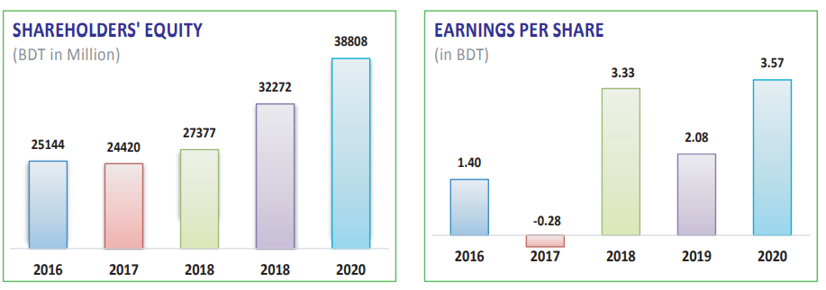
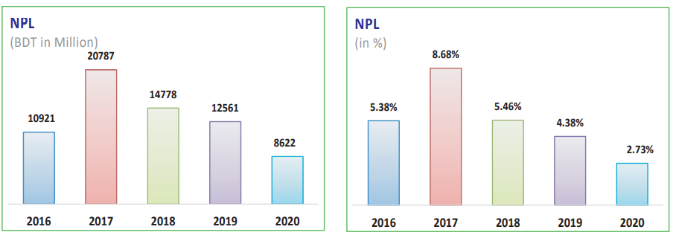
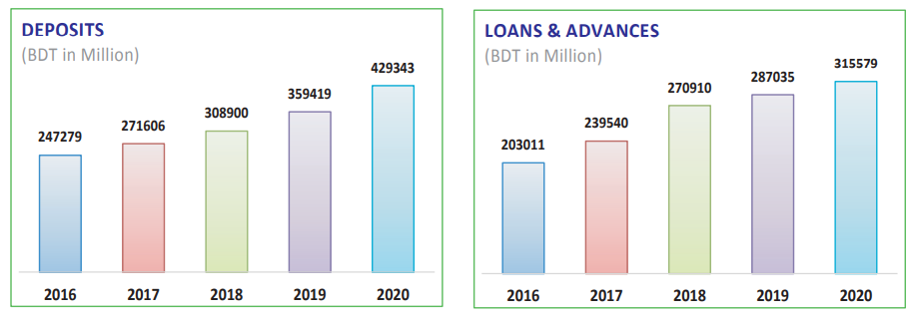
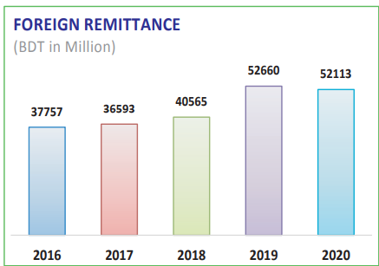

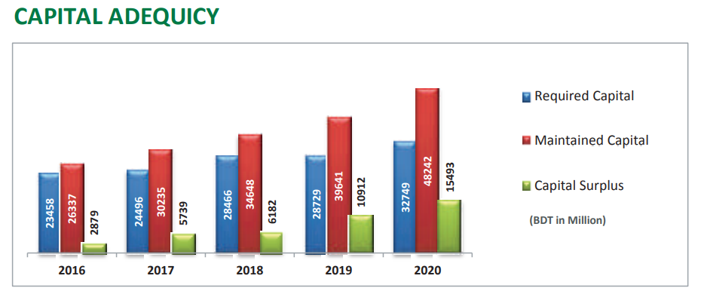

8.3 References
Assignment Consultancy. (2018, July 24). Advantages of Financial Ratio Analysis. Retrieved from medium.com: https://medium.com/@craigstewart110/advantages-of-financial-ratio-analysis-45a22ce5bf32
Aziz, K. (2020, June 18). What Covid-19 has taught the banking industry in Bangladesh. Retrieved from The daily Star: https://www.thedailystar.net/opinion/news/what-covid-19-has-taught-the-banking-industry-bangladesh-1916097
Barua, B. B. (2020, july 9). COVID-19 implications for banks:The case of an emerging economy with a weak finance system. Retrieved from SSRN: https://papers.ssrn.com/sol3/papers.cfm?abstract_id=3646961
Borad, S. B. (2011, January 02). Debt to Equity Ratio. Retrieved from e finacne management: https://efinancemanagement.com/financial-analysis/debt-to-equity-ratio
Borad, S. B. (2013, January 14). Debt to Total Asset Ratio. Retrieved from e finance mangement : https://efinancemanagement.com/financial-analysis/debt-to-total-asset-ratio
Borad, S. B. (2013, April 13). ROE. Retrieved from e finance management: https://efinancemanagement.com/financial-analysis/return-on-equity-roe
Borad, S. B. (2013, April 21). ROE. Retrieved from e finance management: https://efinancemanagement.com/financial-analysis/return-on-equity-roe
Borad, S. B. (2021, October 04). ROA. Retrieved from e financ management: https://efinancemanagement.com/financial-analysis/return-on-assets-roa
Cash ratio. (n.d.). Retrieved from Corporate finance institue: https://corporatefinanceinstitute.com/resources/knowledge/finance/cash-ratio-formula/
Coronavirus: BGMEA reports $3.15 billion order cancellation. (2020, April 12). Retrieved from The bsuiness Standard: https://www.tbsnews.net/coronavirus-chronicle/covid-19-bangladesh/coronavirus-bgmea-reports-315-billion-order-cancellation
Hasan, M. (2020, March 19). BB raises MFS transaction limits. Retrieved from Dhaka Tribune: https://www.dhakatribune.com/business/2020/03/19/bb-raises-mfs-transaction-limits
Javed, R. (n.d.). accounting for management. Retrieved from accounting for management: https://www.accountingformanagement.org/debt-to-equity-ratio/
MAVERICK, J. (2021, May 31). Key Financial Ratios to Analyze Retail Banks. Retrieved from Investopedia: https://www.investopedia.com/articles/active-trading/082615/key-financial-ratios-analyze-retail-banks.asp
MAVERICK, J. (2021, April 18). What Is a Good Interest Coverage Ratio? Retrieved from investopedia: https://www.investopedia.com/ask/answers/121814/what-good-interest-coverage-ratio.asp
Paul, T. C. (2020, June 19). COVID-19 and its impact on Bangladesh economy. Retrieved from The financial Express: https://thefinancialexpress.com.bd/views/opinions/covid-19-and-its-impact-on-bangladesh-economy-1592580397
Pubali Bank . (2020). Pubali Bank accounts. Dhaka.
Pubali bank limited. (2020). Director report. Retrieved from Directors report 2020: DirectorsReport2020.pdf
Pubali Bank limited. (n.d.). Pubali. Retrieved from Pubali bank limited: https://www.pubalibangla.com/about.asp
Pubali bank. (n.d.). Pubali bank. Retrieved from Pubali bank limited: https://www.pubalibangla.com/about.asp
Thakur, M. (n.d.). Ratio analysis formula. Retrieved from EDUCBA: https://www.educba.com/ratio-analysis-formula/
world bank. (n.d.). Bangladesh GDP 1962-2021. Retrieved from Macrotrends: https://www.macrotrends.net/countries/BGD/bangladesh/gdp-gross-domestic-product

The End

