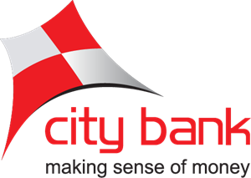

I N T E R N S H I P R E P O R T O N

Training and Development Practices: A Study on City Bank Limited


I N T E R N S H I P R E P O R T O N
Training and Development Practices: A Study on City Bank Limited

Course Title: INTERNSHIP
Course Code: INT 4399

S U B M I T T E D T O
Piana Monsur Mindia
Assistant Professor
United International University

S U B M I T T E D B Y
Jarin Tasnim
ID: 111 161 252
Major: Human Resource Management
School of Business & Economics

DATE OF SUBMISSION: 06-12-2020

LETTER OF TRANSMITTAL
Date: 06-12-2020.
Piana Monsur Mindia
Assistant Professor
School of Business and Economics
United Internal University.

Subject: Submission of Internship report.
Dear Ma'am,
I am very pleased to submit my Internship Report on The City Bank Limited Training and Development" as a partial requirement of the United International University BBA program.
I have done my best to prepare an accurate & reliable report at my point. I hope you'll see the importance of all the effort I've put into it in this report. The internship program provided me with an opportunity to be introduced to the working atmosphere and job experience at The City Bank Limited Ltd., a renowned private commercial bank. I considered the analysis to be very interesting, supportive & informative.
Finally, in spite of my limitation, I will be curious if you go through my paper and give my job your evaluation.
Yours sincerely,
………………………
Name: Jarin Tasnim
ID No: 111 161 252
BBA Program (HRM)

ACKNOWLEDGEMENT
First of all, I would like to express my sincere gratitude to the Almighty for giving me the ability and strength to complete my studies.
The internship system is very helpful as part of the Bachelor of Business Administration (BBA) program for bridging the difference between academic knowledge and real-life experience. This internship study was structured to provide realistic job experience by theoretical interpretation. I would like to express my gratitude for supporting and leading me in making this paper to Piana Monsur Mindia Internship Supervisor, Assistant Professor, School of Business, United International University.
It is my honor to have the chance to do an internship at their Pragati Sharani Branch at The City Bank Limited. I am deeply grateful to Muhammad Shakil, (BM), Choudhury Noor A Alam (CSM) Md Noor A Alam (BOM) Department of Customer Service at City Bank Ltd. Pragati sharani Branch, for the finalization of the study with guidance and advice. I am very grateful to all CBL individuals, too. The planning of this study would have been very difficult without their kind oversight. In order to complete this internship paper, I am also grateful to them for providing me with all the necessary and accessible information to have a clear understanding about the issue.

EXECUTIVE SUMMARY
The main purpose of this report is to focus on organizational development at City Bank Limited by training and development in city Bank Limited. Any kind of training gives the prime opportunity to expand the knowledge base on every employee. The focus of this study is on many forms of training City Bank arranges for the numerous levels of workers defined. The main aim of the study was to create a realistic interpretation of City Bank LTD's preparation and growth for the development of workers and their organization. Chapter one is focused on the origin of the report, scope ,objectives, methodology, limitations of the report and chapter two is based on history, mission, vision, value statements products/ service organization structure. Chapter three gives a brief discussion of hr function of training and development. Chapter four is based on analysis and findings. Chapter five is all about City Bank’s recommendations and conclusions.

Table of Contents
Letter of Transmittal iv
Acknowledgement v
Executive Summary vi
CHAPTER 1: INTRODUCTION OF THE REPORT 1
1.1 Introduction of the report 1
1.2 Origin of the report 1
1.3 Scope of the report 2
1.4 Objective of the Study 2
1.4.1 Main Objective 3
1.4.2 Specific objective 3
1.5 Methodology 4
1.5.1 Data collection technique 5
1.5.2 Sampling 5
1.6 Limitation of the report 6
CHAPTER 2: INTRODUCTION OF THE ORGANIZATION 7
2.1 History of the bank 7
2.1.1 Overview of the bank 8
2.2 Vision, Mission and Value statement 8
2.3 Strategy of the bank 9
2.4 Product/Service offering of the bank 12
CHAPTER 3: HR FUNCTION OF THE CITY BANK 13
3.1 HRM Department 13
3.2 HR Objective 13
3.3 Recruitment & Selection 14
3.3.1 Recruitment Process 14
3.3.2 Recruitment Policy 15
3.3.3 Factors to be considered in recruitment procedure 15
3.4 Training Process of City Bank 16
3.4.1 Assessment to Training 16
3.4.2 Center of Training 16
3.4.3 Training program includes 17
3.4.4 On the job training 18
3.4.5 Of the job training 18
3.5 Development Process of City Bank 19
3.5.1 Assessment to Training 19
3.5.2 Development process of City Bank 20
CHAPTER 4: FINDING & ANALYSIS 21
4.1 Frequency analysis 22
4.2 Frequency table 24
4.3 Description analysis 29
4.4 Questionnaire analysis 32
4.5 Discussion about survey questionnaire 40
CHAPTER 5: RECOMMENDATION 43
CONCLUSION 44
BIBLIOGRAPHY 45
APPENDIX 46

CHAPTER 1: INTRODUCTION
1.1 INTRODUCTION OF THE REPORT
Preparation prescribes a company's intended attempt to simplify the training of employees for job-related success. Awareness, talents, abilities or habits that are essential to workers who do a good job in a company require competencies. The goal of training for workers, which is emphasized in training programs and to extend to employees for their everyday work practices, is to perform information, expertise, skills and behavior. Training generally focused with developing and improving individual skill. Training and development is one of the most critical aspects where any bank focuses on improving its workforce to better support its clients and to thrive on the market. City Bank Ltd.’s HR maintains a formal and coordinated training schedule to train its workers with better trainers to meet their goal.
The overarching goal of their preparation is to ensure the overall advancement of workers and to gain core competencies by trained employees. They have invested a great deal of work into their educational program to prepare their staff best. Their training involves all the conventional, contemporary training required to carry out the banking tasks of employees. The City Bank provided possibly the best training programmers to workers, rather than most banks, to ensure the maximum growth of all who already invest in the highest development of their organization. This practice also involves and modifies the changing needs of the banking industry every day to deal with the new world Launch
1.2 ORIGIN OF THE REPORT
This research is created as per my United International University Bachelors in Business Administration (BBA) program's internship requirement. I operated at the City Bank Limited of Pragati Sharani Branch. During this time I wanted to do a number of human resource management tasks. This report is a detail overview of those daily activities I have done during the internship period. The number one purpose of the internship was to provide ‘on the job’ publicity to the pupil and an opportunity for translation of theoretical conceptions in real existence state of affairs. The students are placed in organizations, groups, research institutions as well as development initiatives. In this connection, after the completions of the BBA program, I was assigned to Training and Development on The City Bank Limited for practical orientation. I chose the topic
“Training and Development on The City Bank Limited” for my internship report under the supervision of Mr. Nitai Chandra (BM of City Bank), Mr. Riad Hossain Bhuiyan (CSO), Mr. Mirza Shamim (CSM) department of Customer service of The City Bank Limited.

1.3. SCOPE OF THE REPORT
My scope was limited and restricted for some purpose. I had maintained some official formality for the collection of data of my report. This study will give a clear idea about the practice of training and development in the organization. There are some other scopes that help me to learn more about the organization. The report covers retail banking offerings, processes and activities of The City Bank Limited. This record mainly emphasizes on the gathering technique and jobs.

1.4. OBJECTIVE OF THE REPORT
It is a popular belief in the industry that I researched that, practice is blind and without practice theory is meaningless. Objectives can be divided into two categories; namely general objective and specific objectives. The general objective of this study is to provide an overview of learning of the course during the BBA programme and meet the course requirement. This report can be divided into two further categories: main objectives and specific objectives. Below, these targets are clarified. A comparative analysis on The City Bank Ltd. (The City), Eastern Bank Ltd. (EBL) and Prime Bank ltd. (PBL) will be addressed in this article.

1.4.1 Main Objective
The key purpose of this research is to prepare a project report on the review of training and growth processes in Bangladesh's banking sector. This will also reflect on the actions taken to strengthen the workers. It should be pointed out that 'training' is a general term. Under this word, expertise, attitude and awareness drops. Both these considerations will also be discussed in this article as 'training'.
Training's definitive aim is to cultivate and grow the internal workforce. Training, however has increased the efficiency of not only the staff, but the influence of good training is seen in the business.
1.4.2 The specific objectives are:
The basic objectives of this study are to examine preparation and growth and to assess their impact on the banking industry's workforce. This goal has been accomplished by looking at the training of The City Bank, Eastern Bank and Prime Bank, as stated earlier in the article.
Specific objectives
1. To recognize the difficulties faced by banks in keeping their workforce in an increasingly competitive environment.
2. To recognize any workforce performance and growth challenges
3. And find out how pleased the workers are with the preparation,
4. To assess the productivity of the training
5. Identifying the employee's performance during the training cycle
6. Identifying whether the course provides some real skills and experience that can be implemented in practice
7. Training could be made more successful to explore whether there is some route.

1.5. METHODOLOGY
All has to follow certain rules & regulations for smooth and detailed analysis. This is the
Study insights have been obtained from two sources:
- Primary sources
    - Practical jobs on tables
    - Conversation with the officer face to face
    - Direct Findings specifically
- Secondary sources
. I) The City Bank Limited Ltd's annual audit.
(ii) Memos & Circulars of Archives & Directories
(iii) Regular report (containing my practical orientation activities) kept by the researcher,
1.5.1. Data collection technique
Sources of Data Collection:
The data are collected from two sources --
Primary sources:
- Practical banking work.
- Discussion with the employees of the City Bank limited.
- Personal Observation.

Secondary sources:
- Annual report, publications, training materials
- Periodical statements of the bank, brochures, booklets etc.
- Official Website of the City Bank Ltd.
- Documentary file of the City Bank Ltd.

Data Process and Analysis:
- Collected information based on my own experience.
- Detailed analysis, working variable future projection and working definitions are incorporated in the report.

1.5.2 Sampling
Population
A community of people is called the population, who are identical features from which data can be collected and evaluated. The workers working at the City Bank became the target population.
- Sample
To collect the details, the non-probability convenience sampling technique was used for
- Sample size
10 participants were chosen from the target population in particular.
- Questionnaire Design
A questionnaire of close-ended questions was prepared.
Data Analysis
The details obtained from both primary and secondary sources has been structured to offer a good view of the City Bank's training and growth program. Both qualitative and quantitative analysis was part of the research. With the well-known Likert process, quantitative questions were scaled up. I used some computer applications in this analysis, such as Microsoft Office, Microsoft Excels, and Microsoft PowerPoint.

1.6. LIMITATION OF THE REPORT
When the study was being carried out, there were several challenges that are summarized here:
- The big impediment is getting this study ready on time. Although the internship program was for a short amount of time, it is also not possible to reflect extensively on the whole.
- Any other issues that prohibit this article from being more distinctive or analytical have been altered by job strain within the workplace.
- Another problem that impeded the analysis was the secrecy of information. Each employer has its own personal confidentiality that is not disclosed to an employee outside the agency. Although the processing of city bank details was limited, employees did not reveal adequate information for the sake of the organization's secrecy policy.
- I get 6 responses for my survey. This is a small brunch but there remain rush in this brunch so all employees cannot respond.

CHAPTER 2: INTRODUCTION OF THE ORGANIZATION
2.1. HISTORY OF THE BANK
With "For A Better Tomorrow" as their goal, City Bank began their journey. They identify it as the day-to-day operation of the bank is managed by a technical term for bankers. Among other banks, City Bank Limited is one of the oldest private commercial banks in Bangladesh. The Bank, under entrepreneurship, has been working with Tk's capital since 1983. 1.75 Billion of the nation's 12 outstanding & key businessmen. The purpose behind starting City Bank is to "bring about qualitative changes in the banking and financial management world." (Alo, 1999) Today, City Bank Limited's 89 branches scattered throughout the country servicing all customers have a fully-fledged Islamic Banking division and over three hundred management correspondences covering all of the world's major cities and business centers. There is personalized support for customers in diverse fields of trade, business & business, according to the unique needs of consumers, and they are known for an outstanding degree of timely and personal attention. Over the years, the bank has extended its offerings. The comprehensive and ever-growing domestic network offers and transports numerous goods and services. Besides these conventional distribution points, the City Bank is still very operational in the alternate delivery field. Currently, 100 ATMs have been incorporated on their own; and ATM sharing agreements with a partner bank with 225 ATMs in place; SMS banking; interest banking, etc. Some new banking products, such as dual currency credit cards, ATMs and online services, have created attraction among customers, and these products are already launched through city bank limited. With all the new distribution platforms, they will incorporate real-time Internet, SMS and phone banking services that are very convenient to use for bank customers.

2.1.1 Overview of City Bank Limited
Bangladesh's economy has been evolving steadily since the 1990s. It changes the way of life and urbanization is developed. At the same time, Bangladesh's banking industry is expanding. It makes life more relaxed and simpler. People have always found a safe place where they can comfortably hold their earnings. And the bank is one of the places you can believe.
The CBL network is entrusted to provide customers in the retail commercial, corporate and Islamic banking divisions with the highest standard banking service. CBL is represented by the top firms, global and local businesses and financial institutions in the world. Among other banks, with a total asset of BDT 15,035.89, CBL is the highest-performing local bank in Bangladesh. City Bank Limited is the first bank to have issued an outstanding dual currency credit card in Bangladesh. CBL is a main VISA international member and issues all Local Currency (Taka) in a single plastic with Foreign Currency (US Dollar) card caps. Another common commodity provided in any ATM is the VISA Debit Card launched by CBL. In order to ease the queues at the branch built by its surprising base of some 400,000 retail customers, CBL is pressing hard. Currently, the VISA Prepaid Card is being launched in CBL for the travel industry. The City Bank provides a very customized and welcoming client experience that they commend themselves in with their service. It has a tailored service excellence model named GAP (Graceful-Appropriate-Pleasing) in place that focuses on ensuring satisfied customers by setting expectations for the mindset, actions, preparation level, consistency and service quality timelines of the bank's employees. . (https://www.thecitybank.com/who-we-are)
2.2. Vision, Mission and Value statement
CITY BANK LTD.
Vision | - Financial marketplace for an enjoyable cultural experience  - Vision of the city bank is that in the new millennium, Bangladesh will be badly free and represent the dreams of a country.  - Their mission is to create a world with the highest respect for individual dignity and human rights along with poverty reduction.
Mission | - Provide a wide variety of goods and services that make all consumer groups more distinct and thrilling.  - Be your boss by building an atmosphere in which employees are outstanding and champions.  - Systems and platforms are continuously questioned to increase performance and efficacy.  - Promote creativity and automation to ensure and improve quality excellence.  - Maintain compliance, good government, and respect for the environment in all of our acts.
Values | - Priority consumer value and delivery and personalized product and service banking.  - Bring value to customers by taking part in banking excellence.  - Uphold high levels of ethics and openness of commerce.  - Responsible and open driven outcomes  - Be consistent with the regulatory obligation by adhering to it.  - Lead substantially to society's improvement.  - Courageous and compassionate.  - Consumer Delight Motivated & Empowered Cantered.

2.3. STRATEGIES OF THE CITY BANK LIMITED
CBL has confidence in the act of strategic organization, development and management in accordance with the aims, skills and properties of the organization. The purpose of this strategy is to handle banks and organizations with the intention of achieving gains and change. CBL trusts in the following two organizational strategies:
1. Strategy on location
2. Strategy for company level
2.4. PRODUCT/ SERVICE OFFERING OF CBL
The services serve a wide variety of market, trade and sector sectors, which are suited to the customers' unique needs and are characterized by outstanding pace and personal attention. The City Bank Limited has increased its product and service portfolio over the year. The widespread and ever-growing domestic network offers and supplies millions of goods and services. The City Bank Ltd. undertakes a wide range of operations from small to large-scale industrial ventures. CBL is active with export and import finance. At a glance, the repertoire of behaviors is:
Departmental segments of CBL
- Account opening segment
- Remittance
- Cash segment
- Cash receipt
- Cash payment

Deposit | Loans and advances | Foreign Exchange | Other services
- Current account  - Savings account  - Short-term deposits  - Fixed deposit  - Different Scheme  - Non-resident foreign deposit account and  - Resident foreign currency account | - Term loan  - Working capital loan  - Cash credit  - Overdraft  - Packing credit & trust receipt  - House building finance Import finance  - Consumer Credit  - Transport Loan  - Lease financing | - Export L/C, Import L/C  - Foreign Remittance | - Safe custody(locker)  - Travellers’ Cheque Demand draft  - Pay order  - Telegraphic transfer  - Selling and buying foreign currency

In the past, City Bank Limited (CBL) launched in all new distribution networks Internet, SMS and phone banking services in real time. The Bank is known nationally and globally for its excellent and important results. As part of the wealth, deposit and benefit measured by "ASIA WEEK" in the year 2000, City Bank Limited, CBL is one of 12 Bangladesh banks of the 500 Banks in Asia. Besides this the Prime Minister of the People's Republic of Bangladesh awarded the City Bank of Limited (CBL) in the years 1992-1993 with the 'Top Ten Company.' (Armstrong, 1995)

2.5. ORGANOGRAM
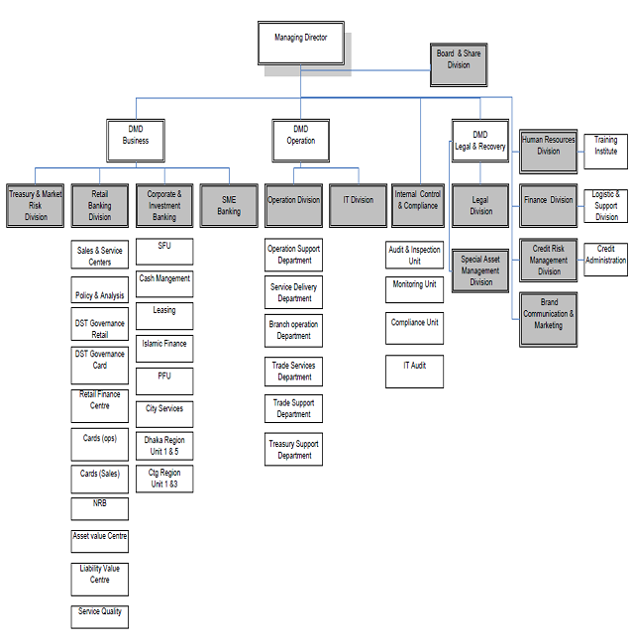

CHAPTER 3: HR FUNCTION OF CITY BANK
3.1. HUMAN RESOURCE DEPARTMENT OF CITY BANK
The Department of Human Resources in City Bank Ltd. serves to help individuals and organizations achieve their destination their priorities. They face several challenges along the way, emerging from the demands of the workers, the business, the culture. The domestic and foreign conditions are the climate of the due to the increasing challenges especially tumultuous, often result from ever-changing rules, in specific regulations that resolve the need for equitable conditions for jobs. Among these ones the human resource department of The City Bank ltd. must contribute to the limitations.
In areas that are legal and socially conscious, the organization's bottom line

3.2. HR OBJECTIVE OF CITY BANK
The City bank Ltd is funded by a completely operating HRD The City Bank Ltd.
Workforce. The HRD is the role of the City Bank Limited:
- Selection and recruiting: recruitment to determine and prepare for the choice and hiring of positions that are open. Evaluation is understood as the search and recruitment method for work candidates from which the correct person will be chosen. The hiring process continues after recruitment. Not all applications must be chosen, does not suit for employment. The selection process is named. (Mamoria, 1995)
- Training and employee growth: Training and employee development includes increasing employee loyalty and morality, morale, productivity and ability, and employee methodology. It also decreases staff turnover.
- Wages and benefits preparation: Human capital administration salary & benefits planning is typically designed by officers who repair employee compensation & benefit
- Organizing promotion: All forms of executive advancement are set by personnel management who offer employee incentives for better performance.
- Making Compensation and Appreciation Policies: With improved results, business human resource administration makes unique incentives & recognition arrangements that will inspire staff to do their best.
- Regulation Design for Staff Loans (Car/Housing): Employee loans are all established by the administration of human resources to enable workers to do their best.
- Employee Provident Fund Program Formulation: Employee funds are developed by staff managers to assist workers in saving money
- Policy Creation of the Employee Benefit Fund: Helping workers devise welfare funds and policies.
3.3. RECRUITMENT & SELECTION
Management of human capital is a holistic approach to the care and recruitment, training, rehabilitation and development of an organization’s human resources. If a company's productivity is dependent upon its workers, the company's function to recruit, educate, review and reward employees who play an important role in the company's success. Human resources administration as part of an enterprise must be trained to handle the implications of the developing working environment. This means that you consider the consequences Globalization, technological transition, diversity in the population, changing expertise demands, current efforts to develop, contingent workforce, decentralized workplaces, and employee engagement. (Ashish D, 2017)
3.3.1 Recruitment Process of the City Bank Ltd
The City Bank is working to discover industry-friendly and creative professionals. City Bank performs various operations in the hunt for talent, for example:
- Online Database: A large number of trained people will apply for various jobs by online activity log recruitment. You choose the best person for good employment very quickly. Thus, it is very important to pick the correct user for online databases.
- Daily newspaper ads: daily applicants can quickly know about the roundtable recruitment by publishing vacancy advertisements. Thus, you can conveniently know about bank vacancy notice by uploading advertisements.
- Approving the hard copy presentation of CV in the Section of Human Resource: online cv must be sent online for registration. For last viva human resource management copies of the cv from applicants should be obtained.
- Career Fair occasionally: different Govt & Non-Govt Organizations can hold work fairs to let applicants know the job vacancy and new recruitment ads.
- Direct recruitment: certain companies specifically hire potential hires. Recruiters & candidates are related. In this situation, only direct recruiting is performed, no evaluation is required, etc.
- Internal work posting: Certain job posting is performed internally via cv mailing & pay for such post. In this situation, internally applications for such posts are chosen.

3.3.2. Recruitment Policy of the City Bank Ltd
- The Executive Director appoints all daily staff.
- The Director of Human Resource Division appoints all HR contract and outsource contract workers
- The recruiting plan will be defined in compliance with the SLA.
- The Interview Board shall deal with the Head of the post, the Department Head and the HRD Head.

3.3.3. Factors to be considered in Recruitment procedure
Prior to the hiring method, City Bank adopts those factors which are taken into account in the recruiting process. The following are:
• Retirement and end of business.
• Employee quality and quality benefits.
• The employee's improvements in infrastructure and management.
• Candidates' financial accessibility.

3.4. TRAINING PROCESS OF THE CITY BANK LTD
The production of human capital is a crucial pre-condition for meeting business goals. The City Bank Limited has a resourceful training institute. Accomplished bankers operate as faculty members closely directed by the Director of Training is learning by finding a comparatively consistent improvement in the person which would further enhance the professional development of workers and managers during the year. Training will normally require a shift in skills, expertise, behaviors or social behavior. It's information implementation. (Kumar, 2017)

3.4.1. Assessment to Training
• Product launch: staff from brand planning, product launch, product advertising etc specialists can carry on the launch of the latest product on bank preparation. Training for workers is also necessary as new goods are created on the bank.
• Orientation: When it needs to orient itself towards its employee as the latest product is introduced on bank, preparation must be focused. Just an employee learns about new product plan, production appraisal process through preparation.
• Inability to perform: If employees lack the expertise on new product creation preparation, employees must obtain new products details.
• Transition to other departments: When an employee is moved to new departmental school, information of new department processes, culture must be created and gathered, job process and so on.

3.4.2. Center of Training
• Center: Training for bank training and growth workers. All branches operate with clients, so that some branches are just new workers for potential training & growth.
• Self/Hire: Some training is provided by brunch leaders or senior leaders; others are given by staff of highly educated and well-known organizations.
• Inceptives: All preparation took place at the bank; minimum initials are given to workers. Tea breaks are also served to workers for lunch.
• Development assessment: The general review of the skills acquired from the training/training is carried out on all staff. Over all it is a method for measuring how often workers acquire expertise from training.

3.4.3. The Training Program Includes
• Direction preparation: Guidance training curriculum for new hires is critical. Which requires the sustainability of new workers in new locations? New employees are introduced alongside other staff in this programmed. Their new work roles, rotation and enjoyment are added. For new hires, the instruction program is also very relevant. (Fashola, 2002)
• Job-specific education: Job-specific preparation for workers is also essential. It defines all training, including applicant jobs obligations. Training for candidates is also important.
• Need local/international education: if foreign training is needed, foreigners are haired for fresher, otherwise they are sent to foreign countries for a higher degree.
• Coaching of the supervisor: coaching curriculum for new recruits should be introduced. The coaching strategy should be adopted where necessary by new applicant trains.
• E-learning: for new trainee administrators, the right teaching approach should be introduced to e-learning. E learning for better preparation of new entrants in business should be adopted.

3.4.4. On the job Training
On-the-job preparation techniques are the most commonly used. This can be due to the simplicity and cost-effectiveness of such approaches. On job preparation the workers are placed in a real working condition and they tend to be effective automatically. It's learning about it. Low efficiency is one of the limitations of work preparation when workers improve their skills.

3.4.5. Off the job Training
Off-the-job instruction includes a range of instructional methods, film shows, case studies, simulation and programmed preparation. For both of these methods, the facilities specifications range from smaller pre-structured classrooms to large production centers and meeting rooms with specialized audiovisual devices, too many mirrors and all the fences.

3.5 DEVELOPMENT PROCESS OF THE CITY BANK LTD
There is a distinct organizational development unit in some organizations and management development in others, which are coordinated by a broad organizational planning department as one of its tasks, and yet there are no other scenarios of strategic development activity. (Burak, 1977)
In comparison, executive growth plays a specific function for the enterprise, as the basic concept is to establish managerial ability for the workers. In reality, some management development works at developing managerial capabilities, but the management development is also used to assess the ability of the future, the future leaders, and the process used by the CEO and the Executive Committee to cascade the other management team and ultimately the business with their plans, priorities and even cultural elements. In the best of situations, executive growth not only benefits the organization, it also leads to the advancement of plans.
3.5.1. Purpose of Development
Creation of management aims to boost management efficiency with the following points:
• Knowledge
• Increasing skill
• Changing attitude

3.5.2. Development Process of City Bank Limited
Management productivity through a designed and deliberate learning process is the key goal of growth. This ensures the expected development of management to fulfill potential company needs.
To boost employee efficiency, CBL uses multiple implementation approaches. Take the following:
- Revolving employment: an employee is moved to a new division for three years and normally every three months, before a promotion is received, he is then assigned to a different agency. The workers gain the confidence to face multiple obstacles in this manner.
- Monitoring: A high-ranking and accomplished company head ensures the tasks delegated to less experienced workers are adequately completed.
- Performance evaluations: the acknowledgment of a well-documented work helps workers to retain good performance through the City Bank. For eg, workers with positive grades are appreciated at the conclusion of training sessions. In addition, the ranking of workers from various sectors is based on an accelerated advancement of employees.

CHAPTER 4: FINDING & ANALYSIS

I have used SPSS software to analyze the data, where the statistical process has been done as Likert Scale. The value of the “Likert Scale” given below:
Strongly Agree = 5.00
Agree = 4.00
Neutral = 3.00
Disagree= 2.00
Strongly Disagree = 1.00
so, after analyzing the whole survey data, I have come up with frequency analysis, frequency table, descriptive statistics. Frequency Analysis shows, if there is any occurrence response or not and the accuracy of the data. Descriptive Analysis shows minimum value, maximum value, sum, mean, median, variance so that there is a strong possibility to get authentic result from the survey.
4.1 FREQUENCY ANALYSIS

Statistics
 |  | Organization’s HR team fully aware of the business needs and strategies | Organization highly consider about training that this is the part of organizational strategy | Induction training given adequate importance to every employees | Norms and values of the organization are clearly explained to new employees during induction training. | Training programs periodically reviewed and improved
N | Valid | 6 | 6 | 6 | 6 | 6
N | Missing | 0 | 0 | 0 | 0 | 0
Minimum |  | 3.00 | 3.00 | 4.00 | 3.00 | 3.00
Maximum |  | 5.00 | 5.00 | 5.00 | 5.00 | 5.00

Statistics
 |  | Training enhance the quality of service being performed by employees. | Training and development (T&D) minimized the fault of operations. | Training have a great impact to improve employee’s productivity. | Training and development is helpful to stabilize the organization. | T&D helps employees in promotions and other monetary benefit if employees perform well.
N | Valid | 6 | 6 | 6 | 6 | 6
N | Missing | 0 | 0 | 0 | 0 | 0
Minimum |  | 4.00 | 2.00 | 3.00 | 3.00 | 2.00
Maximum |  | 5.00 | 5.00 | 5.00 | 4.00 | 5.00

Statistics
 |  | The Organization give the training in a favorable environment for the employees | The training method and process Which is given to employees need to be changed. | Organization evaluates the performance effectively for training selection. | Management gives priority to all level of employees for training | Assessing employee’s performance for training needs at least one in a year.
N | Valid | 6 | 6 | 6 | 6 | 6
N | Missing | 0 | 0 | 0 | 0 | 0
Minimum |  | 3.00 | 2.00 | 3.00 | 3.00 | 3.00
Maximum |  | 5.00 | 4.00 | 5.00 | 5.00 | 4.00

4.2 FREQUENCY TABLE:
Organization’s HR team fully aware of the business needs and strategies
 |  | Frequency | Percent | Valid Percent | Cumulative Percent
Valid | 3.00 | 1 | 16.7 | 16.7 | 16.7
Valid | 4.00 | 4 | 66.7 | 66.7 | 83.3
Valid | 5.00 | 1 | 16.7 | 16.7 | 100.0
Valid | Total | 6 | 100.0 | 100.0

Organization highly consider about training that this is the part of organizational strategy
 |  | Frequency | Percent | Valid Percent | Cumulative Percent
Valid | .00 | 1 | 16.7 | 16.7 | 16.7
Valid | 3.00 | 1 | 16.7 | 16.7 | 33.3
Valid | 4.00 | 2 | 33.3 | 33.3 | 66.7
Valid | 5.00 | 2 | 33.3 | 33.3 | 100.0
Valid | Total | 6 | 100.0 | 100.0

Induction training given adequate importance to every employees
 |  | Frequency | Percent | Valid Percent | Cumulative Percent
Valid | 4.00 | 2 | 33.3 | 33.3 | 33.3
Valid | 5.00 | 4 | 66.7 | 66.7 | 100.0
Valid | Total | 6 | 100.0 | 100.0

Norms and values of the organization are clearly explained to new employees during induction training.
 |  | Frequency | Percent | Valid Percent | Cumulative Percent
Valid | 3.00 | 1 | 16.7 | 16.7 | 16.7
Valid | 4.00 | 3 | 50.0 | 50.0 | 66.7
Valid | 5.00 | 2 | 33.3 | 33.3 | 100.0
Valid | Total | 6 | 100.0 | 100.0

Training programs periodically reviewed and improved
 |  | Frequency | Percent | Valid Percent | Cumulative Percent
Valid | 3.00 | 2 | 33.3 | 33.3 | 33.3
Valid | 4.00 | 1 | 16.7 | 16.7 | 50.0
Valid | 5.00 | 3 | 50.0 | 50.0 | 100.0
Valid | Total | 6 | 100.0 | 100.0

Training enhance the quality of service being performed by employees.
 |  | Frequency | Percent | Valid Percent | Cumulative Percent
Valid | 4.00 | 2 | 33.3 | 33.3 | 33.3
Valid | 5.00 | 4 | 66.7 | 66.7 | 100.0
Valid | Total | 6 | 100.0 | 100.0

Training and development (T&D) minimized the fault of operations.
 |  | Frequency | Percent | Valid Percent | Cumulative Percent
Valid | 2.00 | 2 | 33.3 | 33.3 | 33.3
Valid | 4.00 | 2 | 33.3 | 33.3 | 66.7
Valid | 5.00 | 2 | 33.3 | 33.3 | 100.0
Valid | Total | 6 | 100.0 | 100.0
Training have a great impact to improve employee’s productivity.
 |  | Frequency | Percent | Valid Percent | Cumulative Percent
Valid | 3.00 | 1 | 16.7 | 16.7 | 16.7
Valid | 4.00 | 3 | 50.0 | 50.0 | 66.7
Valid | 5.00 | 2 | 33.3 | 33.3 | 100.0
Valid | Total | 6 | 100.0 | 100.0

Training and development is helpful to stabilize the organization.
 |  | Frequency | Percent | Valid Percent | Cumulative Percent
Valid | 3.00 | 3 | 50.0 | 50.0 | 50.0
Valid | 4.00 | 3 | 50.0 | 50.0 | 100.0
Valid | Total | 6 | 100.0 | 100.0

T&D helps employees in promotions and other monetary benefit if employees perform well.
 |  | Frequency | Percent | Valid Percent | Cumulative Percent
Valid | 2.00 | 1 | 16.7 | 16.7 | 16.7
Valid | 3.00 | 1 | 16.7 | 16.7 | 33.3
Valid | 4.00 | 3 | 50.0 | 50.0 | 83.3
Valid | 5.00 | 1 | 16.7 | 16.7 | 100.0
Valid | Total | 6 | 100.0 | 100.0

The Organization give the training in a favorable environment for the employees
 |  | Frequency | Percent | Valid Percent | Cumulative Percent
Valid | 3.00 | 1 | 16.7 | 16.7 | 16.7
Valid | 4.00 | 3 | 50.0 | 50.0 | 66.7
Valid | 5.00 | 2 | 33.3 | 33.3 | 100.0
Valid | Total | 6 | 100.0 | 100.0

The training method and process Which is given to employees need to be changed.
 |  | Frequency | Percent | Valid Percent | Cumulative Percent
Valid | 2.00 | 1 | 16.7 | 16.7 | 16.7
Valid | 3.00 | 1 | 16.7 | 16.7 | 33.3
Valid | 4.00 | 4 | 66.7 | 66.7 | 100.0
Valid | Total | 6 | 100.0 | 100.0

Organization evaluates the performance effectively for training selection.
 |  | Frequency | Percent | Valid Percent | Cumulative Percent
Valid | 3.00 | 1 | 16.7 | 16.7 | 16.7
Valid | 4.00 | 3 | 50.0 | 50.0 | 66.7
Valid | 5.00 | 2 | 33.3 | 33.3 | 100.0
Valid | Total | 6 | 100.0 | 100.0

Management gives priority to all level of employees for training
 |  | Frequency | Percent | Valid Percent | Cumulative Percent
Valid | 3.00 | 2 | 33.3 | 33.3 | 33.3
Valid | 4.00 | 3 | 50.0 | 50.0 | 83.3
Valid | 5.00 | 1 | 16.7 | 16.7 | 100.0
Valid | Total | 6 | 100.0 | 100.0

Assessing employee’s performance for training needs at least one in a year.
 |  | Frequency | Percent | Valid Percent | Cumulative Percent
Valid | 3.00 | 3 | 50.0 | 50.0 | 50.0
Valid | 4.00 | 3 | 50.0 | 50.0 | 100.0
Valid | Total | 6 | 100.0 | 100.0

4.3 DESCRIPTIVE ANALYSIS
Descriptive Statistics
 | N | Range | Minimum | Maximum | Sum | Mean |  | Std. Deviation | Variance
 | Statistic | Statistic | Statistic | Statistic | Statistic | Statistic | Std. Error | Statistic | Statistic
Organization’s HR team fully aware of the business needs and strategies | 6 | 2.00 | 3.00 | 5.00 | 24.00 | 4.0000 | .25820 | .63246 | .400
Organization highly consider about training that this is the part of organizational strategy | 6 | 5.00 | .00 | 5.00 | 21.00 | 3.5000 | .76376 | 1.87083 | 3.500
Induction training given adequate importance to every employees | 6 | 1.00 | 4.00 | 5.00 | 28.00 | 4.6667 | .21082 | .51640 | .267
Norms and values of the organization are clearly explained to new employees during induction training. | 6 | 2.00 | 3.00 | 5.00 | 25.00 | 4.1667 | .30732 | .75277 | .567
Training programs periodically reviewed and improved | 6 | 2.00 | 3.00 | 5.00 | 25.00 | 4.1667 | .40139 | .98319 | .967
Training enhance the quality of service being performed by employees. | 6 | 1.00 | 4.00 | 5.00 | 28.00 | 4.6667 | .21082 | .51640 | .267
Training and development (T&D) minimized the fault of operations. | 6 | 3.00 | 2.00 | 5.00 | 22.00 | 3.6667 | .55777 | 1.36626 | 1.867
Training have a great impact to improve employee’s productivity. | 6 | 2.00 | 3.00 | 5.00 | 25.00 | 4.1667 | .30732 | .75277 | .567
Training and development is helpful to stabilize the organization. | 6 | 1.00 | 3.00 | 4.00 | 21.00 | 3.5000 | .22361 | .54772 | .300
T&D helps employees in promotions and other monetary benefit if employees perform well. | 6 | 3.00 | 2.00 | 5.00 | 22.00 | 3.6667 | .42164 | 1.03280 | 1.067
The Organization give the training in a favorable environment for the employees | 6 | 2.00 | 3.00 | 5.00 | 25.00 | 4.1667 | .30732 | .75277 | .567
The training method and process Which is given to employees need to be changed. | 6 | 2.00 | 2.00 | 4.00 | 21.00 | 3.5000 | .34157 | .83666 | .700
Organization evaluates the performance effectively for training selection. | 6 | 2.00 | 3.00 | 5.00 | 25.00 | 4.1667 | .30732 | .75277 | .567
Management gives priority to all level of employees for training | 6 | 2.00 | 3.00 | 5.00 | 23.00 | 3.8333 | .30732 | .75277 | .567
Assessing employee’s performance for training needs at least one in a year. | 6 | 1.00 | 3.00 | 4.00 | 21.00 | 3.5000 | .22361 | .54772 | .300
Valid N (list wise) | 6

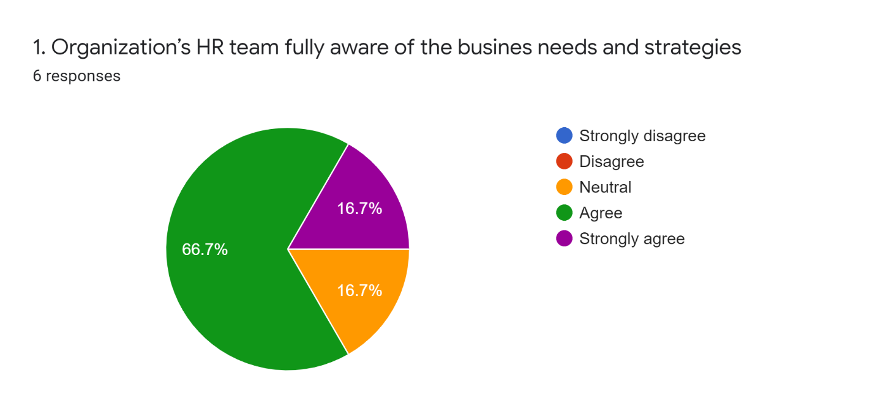
4.4 QUESTIONNAIRE ANALYSIS:
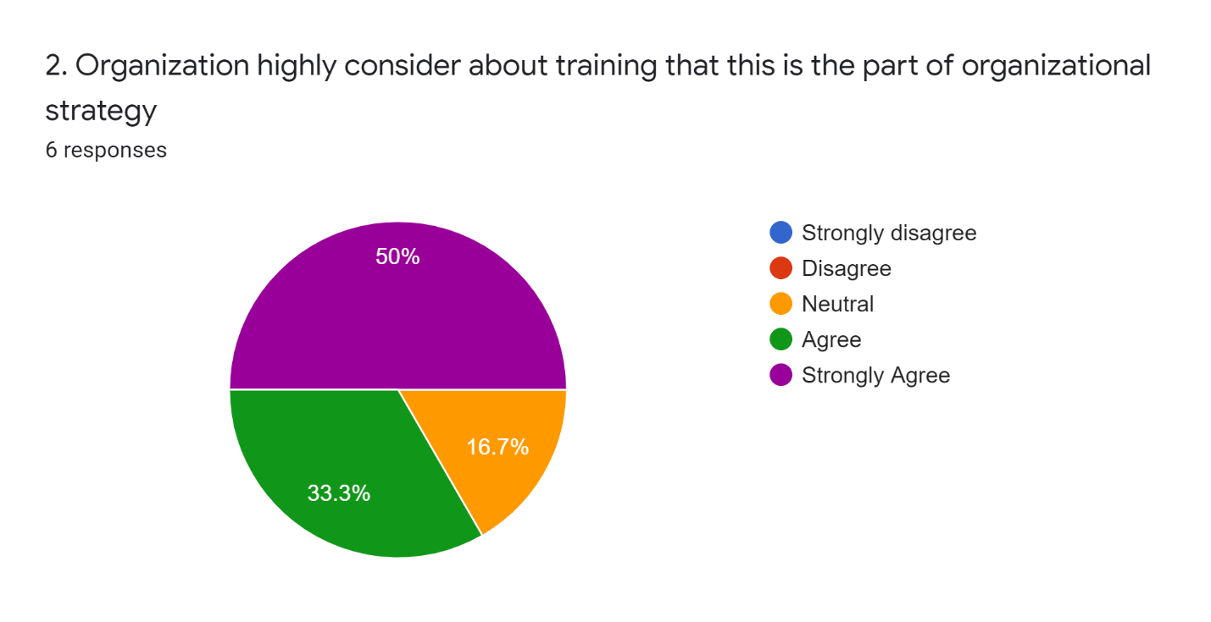
The first question has been asked to identify the awareness of their HR team about their business needs and strategies. 66.7% of them agreed that their HR team is fully aware and concern about their business needs and strategies and 16.7% is strongly agreed with the statement.
Training is the most important for any kind of business organization and also for employees. A good strategy depends on the good training. 50% employee strongly agreed that City Bank highly consider about training that is the part of organizational training. 16.7% is neutral here.
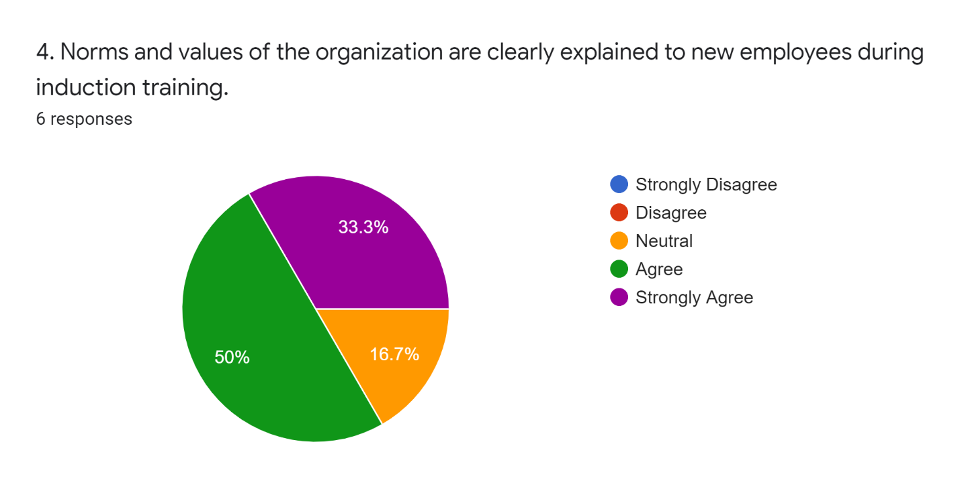
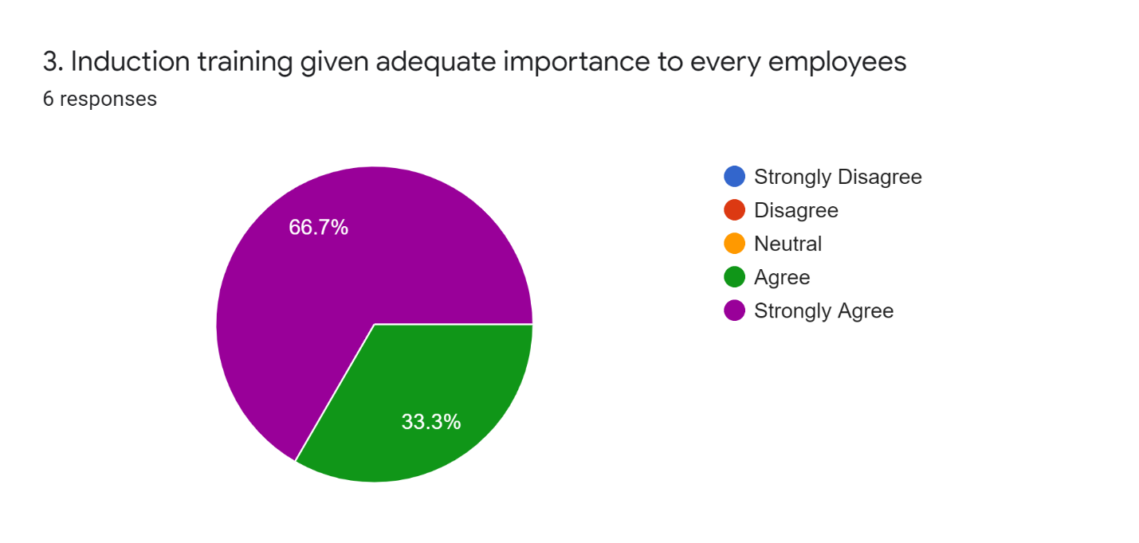
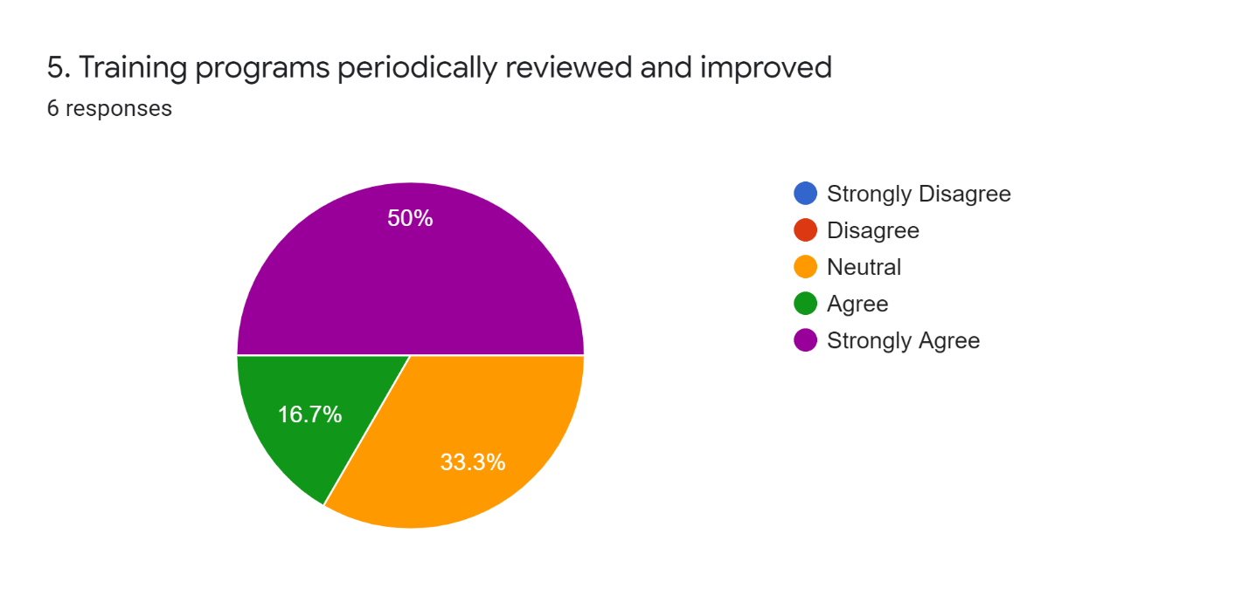
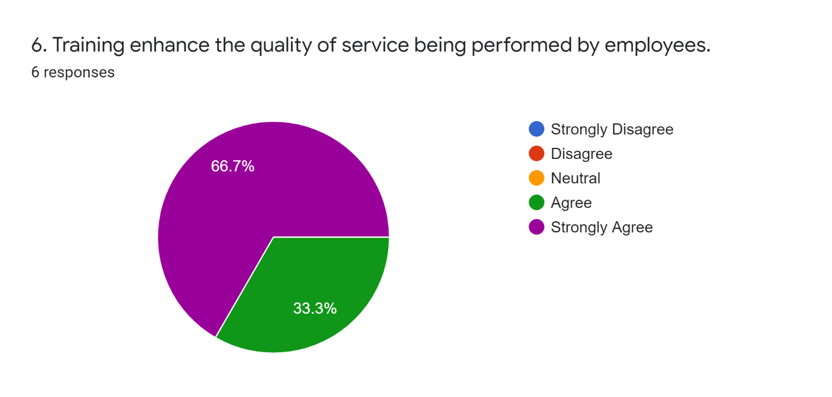
This question has been asked to know about the importance of induction training for each employees. So, 66.7% employees do strongly agree with this statement that they are getting the adequate importance of the induction training. Most of the employees are positive about this statement.
As a new employee, understanding organization’s norms and values are highly important. The employees more clear about the norms are more active to the organizational activities. So most of the employees of City Bank is positive to this statement that they was clear about the norms and values about City Bank while they were new comer. 16.7% is neutral about the statement.
Training programs are the focus point of the organizational strategy. So this question is about their revision and improvement of their training program. 50% employees do strongly agree with the statement and 33.3% was neutral with the statement.
The performance of an employee depends on the training he/she have taken. If the training quality is better, so the performance will be better. 66.7% employee of the City Bank strongly agreed that training enhance the quality of their performance, and 33.3% employee do only agree with the statement.
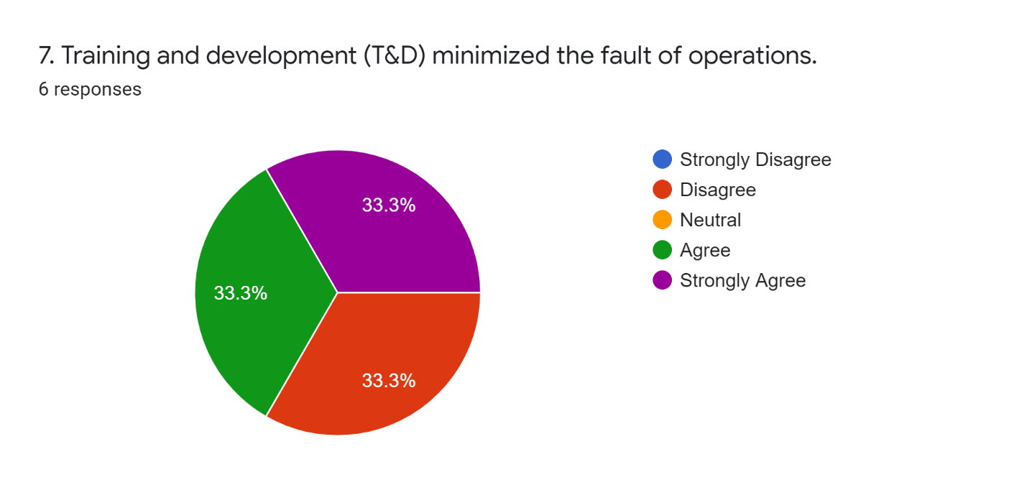
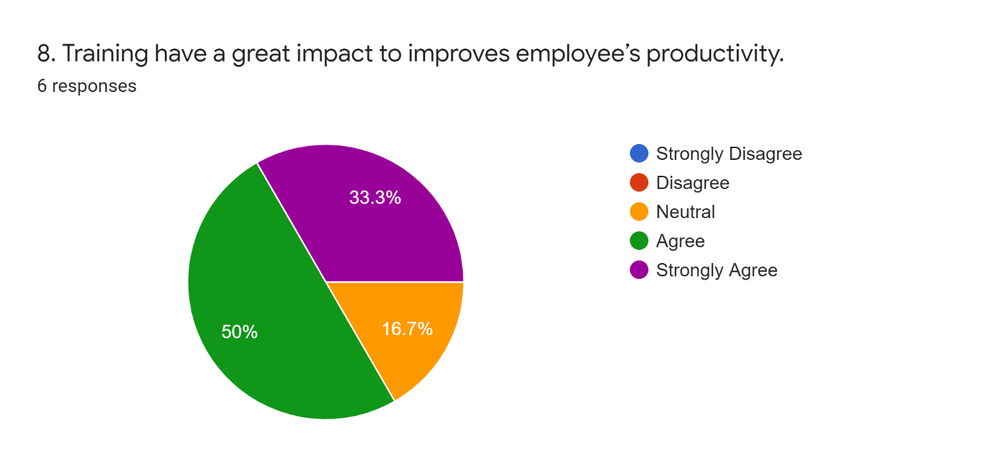
Training and Development (T&D) help to reduce the faults of operational activities. 66.6% employee of City Bank positive with the statement and 33.3% were unfortunately disagreed with the statement and maybe they were not concerned about the fault minimizations.
Training produces potential within the employee and it also develop human’s productivity. So this statement was about is their training good enough to improve their productivity. Most of the employees positively respond and few are neutral with the statement.
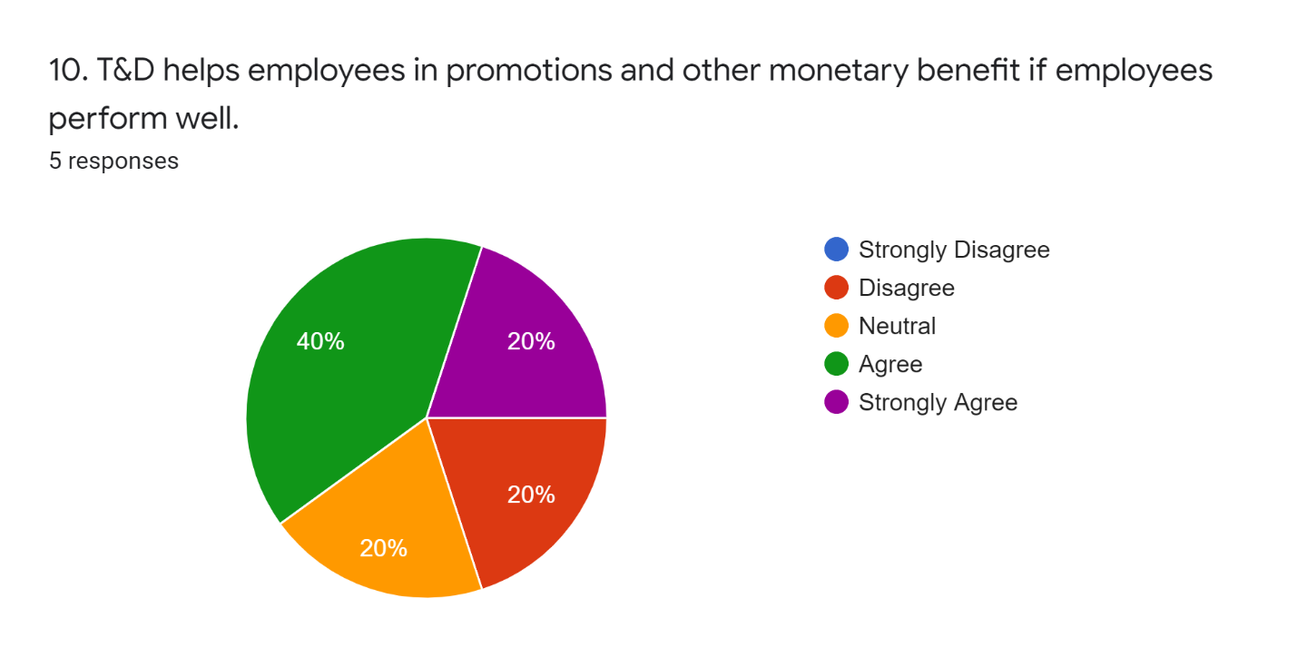
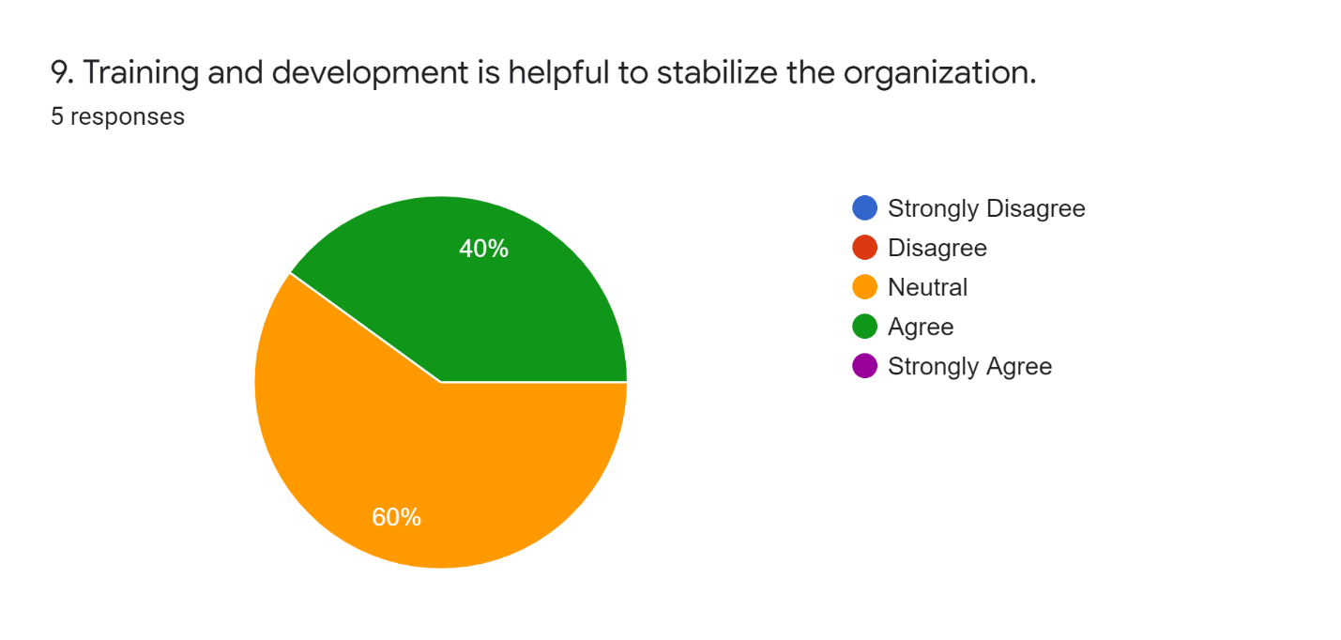
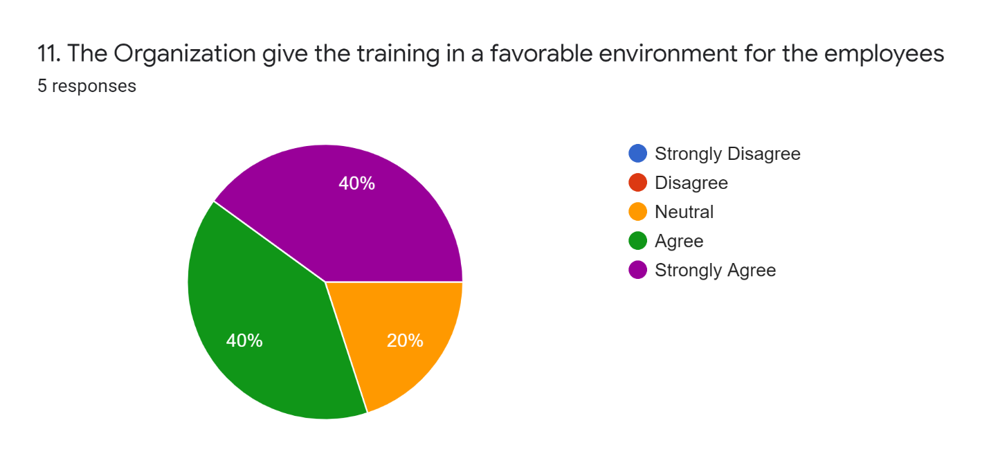
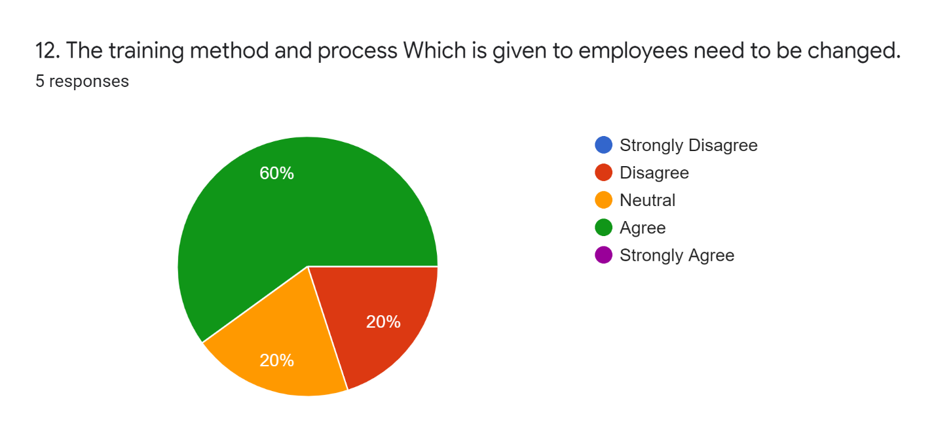
This statement was about the stabilization of the organization by the training and development. 40% of the employee thoughts that training and development is helpful enough to stabilize the organization and rest of them are neutral.
The statement is about their T&D that helpful for employee’s promotions and other monetary benefit if employees perform well. 40% employee do agree with the statement, 20% strongly agree with the statement and 20% are disagree with the statement. But the large number of employees are agreed so that the organization T&D is helpful enough to the employee promotional and other benefits.
Environment is the most sensitive and important part of the organization. An environment can give a good entitlement. So the statement was about their favorable environment while they give their training. 40% employee agree, 40% employee strongly agree and nobody disagreed with the statement.
The statement was about their training method and process, is that need to improve or need to change. Large number of employee was agreed about this statement. 20% employee disagreed with the statement and 20% was neutral.
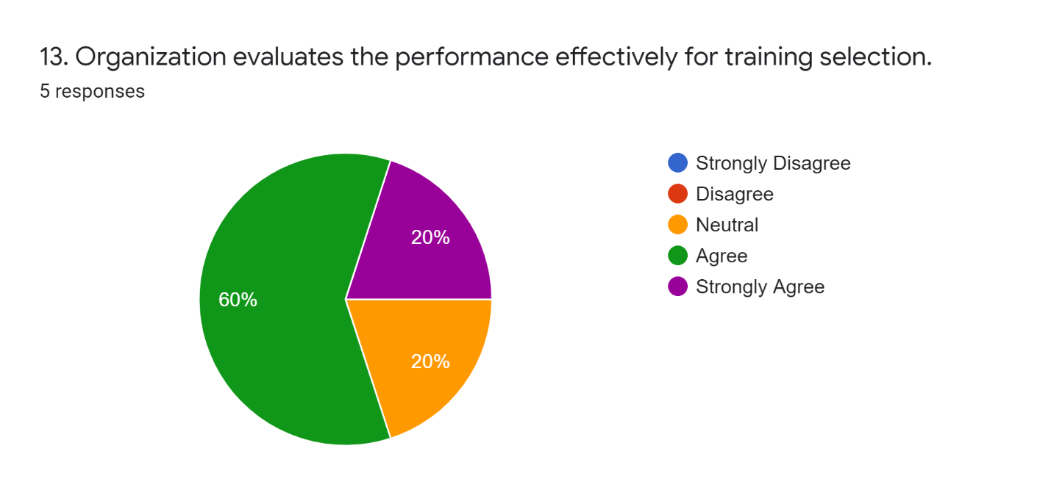
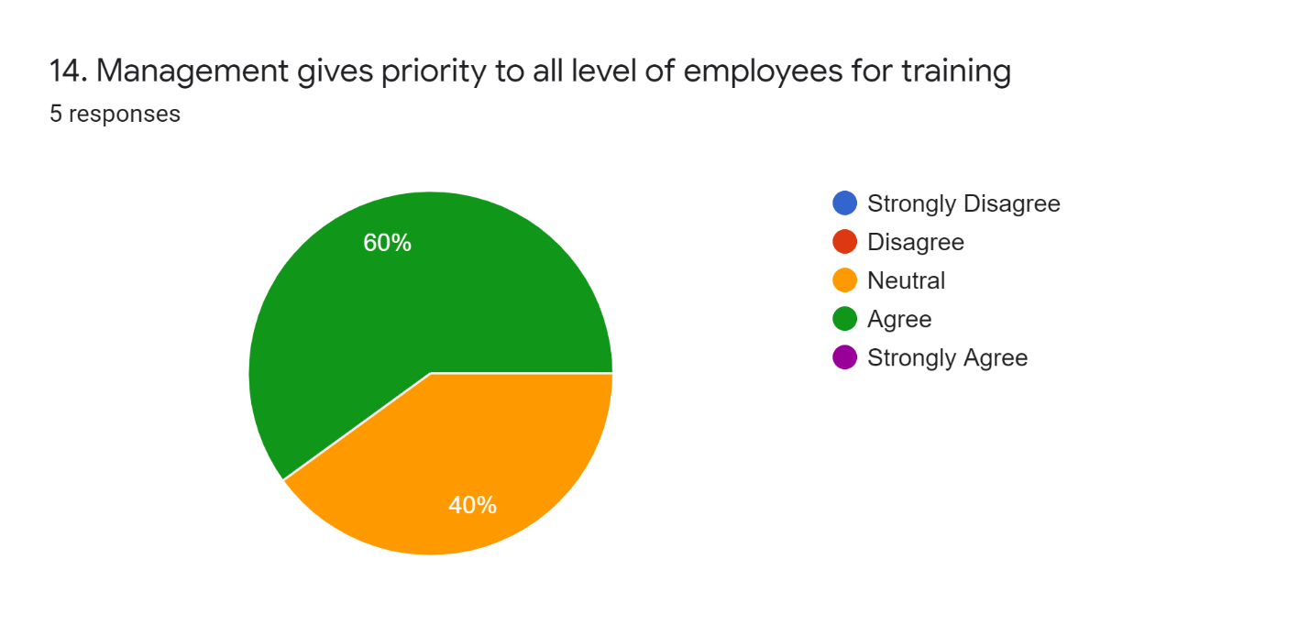
If an organization evaluate the performance effectively then it can be a extra value to the training session for the further step. So we asked that if the organization evaluate the performance effectively for training selection. 80% employees are positive with the statement that City Bank evaluate the performance carefully.
Equality is the first concern in the organizational environment, as well as in the training because it is the part of the organization. So the statement was about the priority to all level of employees for training. 60% employee do agree with the statement and 40% are neutral.

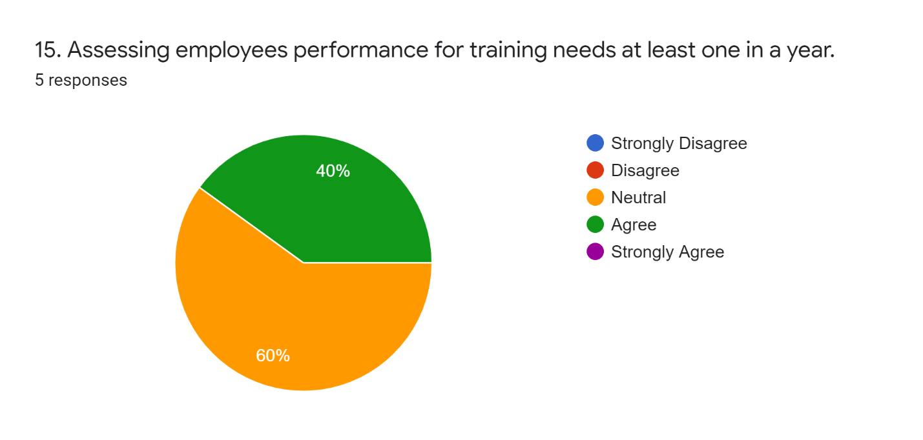
Evaluating employee’s performance is important to develop individual performance. So every organization have to assess their employee’s performance for training needs after a specific period of time. So, 40% employees do agree with the statement and 60% are neutral.

4.5 BRIEF DISCUSSION ABOUT SURVEY QUESTIONNAIRE:
- The first question has been asked to identify the awareness of their HR team about their business needs and strategies. 66.7% of them agreed that their HR team is fully aware and concern about their business needs and strategies and 16.7% is strongly agreed with the statement.
- Training is the most important for any kind of business organization and also for employees. A good strategy depends on the good training. 50% employee strongly agreed that City Bank highly consider about training that is the part of organizational training. 16.7% is neutral here.

- This question has been asked to know about the importance of induction training for each employees. So, 66.7% employees do strongly agree with this statement that they are getting the adequate importance of the induction training. Most of the employees are positive about this statement.

- As a new employee, understanding organization’s norms and values are highly important. The employees more clear about the norms are more active to the organizational activities. So most of the employees of City Bank is positive to this statement that they was clear about the norms and values about City Bank while they were new comer. 16.7% is neutral about the statement.

- Training programs are the focus point of the organizational strategy. So this question is about their revision and improvement of their training program. 50% employees do strongly agree with the statement and 33.3% was neutral with the statement.
- The performance of an employee depends on the training he/she have taken. If the training quality is better, so the performance will be better. 66.7% employee of the City Bank strongly agreed that training enhance the quality of their performance, and 33.3% employee do only agree with the statement.

- Training and Development (T&D) help to reduce the faults of operational activities. 66.6% employee of City Bank positive with the statement and 33.3% were unfortunately disagreed with the statement and maybe they were not concerned about the fault minimizations.

- Training produces potential within the employee and it also develop human’s productivity. So this statement was about is their training good enough to improve their productivity. Most of the employees positively respond and few are neutral with the statement.

- This statement was about the stabilization of the organization by the training and development. 40% of the employee thoughts that training and development is helpful enough to stabilize the organization and rest of them are neutral.

- The statement is about their T&D that helpful for employee’s promotions and other monetary benefit if employees perform well. 40% employee do agree with the statement, 20% strongly agree with the statement and 20% are disagree with the statement. But the large number of employees are agreed so that the organization T&D is helpful enough to the employee promotional and other benefits.

- Environment is the most sensitive and important part of the organization. An environment can give a good entitlement. So the statement was about their favorable environment while they give their training. 40% employee agree, 40% employee strongly agree and nobody disagreed with the statement.

- The statement was about their training method and process, is that need to improve or need to change. Large number of employee was agreed about this statement. 20% employee disagreed with the statement and 20% was neutral.

- If an organization evaluate the performance effectively then it can be a extra value to the training session for the further step. So we asked that if the organization evaluate the performance effectively for training selection. 80% employees are positive with the statement that City Bank evaluate the performance carefully.

- Equality is the first concern in the organizational environment, as well as in the training because it is the part of the organization. So the statement was about the priority to all level of employees for training. 60% employee do agree with the statement and 40% are neutral.

- Evaluating employee’s performance is important to develop individual performance. So every organization have to assess their employee’s performance for training needs after a specific period of time. So, 40% employees do agree with the statement and 60% are neutral.

CHAPTER 5 RECOMMENDATION
It is difficult to make recommendations from the results and review of the City Bank Human Resources Department. However, in order to enhance the organization, I would like to give some recommendations for the training and development area of the bank.
Company needs to improve its reimbursement policy In order to attract well skilled, knowledgeable and promising personnel, the program of preparation and advancement should be transparent to everyone and understandable to all.
The training programs on their working days should be arranged. Since planning a holiday training event makes workers unmotivated to participate. They also launched their online training curriculum in order to concentrate further on the advancement of training methods.
They should be more worried about the results of their employee training and giving sufficient concentration to the pre & post training of the employee. There are few workers who give a neutral response to the survey, which means that they are not sure about the functions so that they can think about the matter. Every employee should keep the performance appraisal form. And the marks were reviewed every month and the production outcome of each was shown.
There should be a more revised and comprehensive online recruiting scheme. All City Bank recruitments should be made on the basis of merit. If this is necessary, the bank would be provided with a professional staff. Reduce the job burden to hire the productive workers offered by HRD. The HR department of CBL can mention their pay structure in a thorough way in the work advertisement.
In order for highly qualified fresheners to get a chance at this esteemed institution, they should go for campus section

CONCLUTION
All and all, working at The City Bank Ltd was a wonderful learning opportunity and a total liberation for me. This training made me mindful of my strengths and shortcomings and what I need to commit to getting myself fit for the job market and most importantly, it gave me the first lesson in a business atmosphere how to approach myself together with that gave me my first corporate experience and gave me hands-on experiences on what's going on in the actual working environment. Today, banks in Bangladesh are highly competitive and the success of one bank depends on the excellent service provided to customers by bankers. Via good training and growth, highly qualified bankers in banks can be created who can represent the customer very well and can also generate customer loyalty for the company. Via the proper preparation and learning process, workers become more productive and competent and will contribute to any role in the company in a positive way. Learning is not a privilege, but it is important if organizations are to participate in the competition with high-quality operation, and the organization's workers can ensure a competitive advantage through well-structured and constructive training. The City Bank Limited is a bank which in addition to the members of the Human Asset Division, affirms the best service of clients. Therefore, with proper planning, improved marketing policies and adequate customer care, the management of The City Bank Limited can effectively deliver more concentration in this field. The teaching activity that has helped the organization expand the enterprise and develop the expertise and abilities they need to excel in customer service. If a wide distance exists in the expertise and skills imparted, the workers cannot work and that failure hampers the overall performance of the organization. Ultimately, the company and those that compose it are about assembling tangible meaning.
The training method is gradually viewed to be a key function in supporting the organization through its primary component persons to accomplish its objectives. It is the trendy market world that is one and all that is rising broader and wider in the highest flow of competition. The corporate unit of calculation formulating new strategies and industry found the most productive levels in all industries to have assets in this dynamic environment.

BIBLIOGRAPHY

References
Alo, O. (1999). Human Resource Management. Nigeria: Business science books.
Armstrong, M. (1995). A handbook of personal management practice. London: Kogan Page Limited.
Ashish D, T. K. (2017). Employee Retention, Training and Development in Banking Sector: A Review Paper. Researchgate.net.
Burak, E. (1977). Personnel management a human resource system approach. New York.
Fashola. (2002). Management Trainer Development. Lagos: Generation Press Ltd.
Kumar, D. (2017). BENEFITS OF TRAINING AND DEVELOPMENT PROGRAM ON EMPLOYEES’ PERFORMANCE. ResearchGate.
Mamoria, C. (1995). Personal Management. Delhi: Freman Publication.

Website References
https://www.thecitybank.com/who-we-are
https://en.wikipedia.org/wiki/The_City_Bank
https://www.thecitybank.com/career
APPENDIX
Organization- City Bank Ltd.
Department- Human Resource (HR)
 | Rating
Statements | Strongly Disagree  (1) | Disagree  (2) | Neutral  (3) | Agree  (4) | Strongly Agree  (5)
- Organization’s HR team fully aware of the business needs and strategies
- Organization highly consider about training that this is the part of organizational strategy
- Induction training given adequate importance to every employees
- Norms and values of the organization are clearly explained to new employees during induction training.
- Training programs periodically reviewed and improved
- Training enhance the quality of service being performed by employees.
- Training and development (T&D) minimized the fault of operations.
- Training have a great impact to improve employee’s productivity.
- Training and development is helpful to stabilize the organization.
- T&D helps employees in promotions and other monetary benefit if employees perform well.
- The Organization give the training in a favorable environment for the employees
- The training method and process which is given to employees need to be changed.
- Organization evaluates the performance effectively for training selection.
- Management gives priority to all level of employees for training
- Assessing employee’s performance for training needs at least one in a year.

