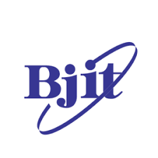
Internship Report on
“Recruitment and selection process of BJIT Limited: A study on Bangladesh Japan Information Technology Limited. (BJIT Ltd.)”


Internship Report
on
“Recruitment and selection process of BJIT Limited: A study on Bangladesh Japan Information Technology Limited. (BJIT Ltd.)”

Submitted To:
Shayla Khanam
Assistant Professor
School of Business & Economics
United International University
Submitted By:
Mithela Islam
ID:111192033
Department: Human Resource Management

Date of Submission:22nd December,2024

Letter of Transmittal:
22nd December,2024
Shayla Khanam
(Asst. Professor)
School of Business and Economics, (SOBE)
United International University, Madani Avenue, Dhaka-1212

Subject: Submission of Internship report titled “Recruitment and selection process of BJIT Limited: A study on Bangladesh Japan Information Technology Limited. (BJIT Ltd.)”

Dear Ma’am,
This is my utmost pleasure to accomplish the internship work and submit internship report on “Recruitment and selection process of BJIT Limited: A study on Bangladesh Japan Information Technology Limited. (BJIT Ltd.)”, with the grace of Allah, this report has been organized as a requirement for the BBA program at United International University (UIU). To fulfill the requirements of my internship at BJIT Ltd. the study delivers a comprehensive analysis of the role of HR in the recruitment and selection process
I would like to express my gratitude to my supervisor for helping the BJIT Ltd.- office team members, as well as to Anannya Aktar Nupur (Assistant Manager HR) and Faria Faiema (Team Leader, HR), MD Hasan Abdullah (Team Leader, HR) for their guidance and support in helping me learn about the HR procedures at BJIT Ltd.
I have made a sincere effort to present this report in a clear and concise way also ensuring it is both informative and well-structured. I am thankful for the opportunity to contribute to this effort.
Kind Regards,
Mithela Islam
ID: 111192033

Acknowledgment

Before all, I would want to thank the Almighty Allah, the Most Graceful and Merciful, for giving me the scope to successfully complete the internship and turn in the internship report on time.
First of all, I would like to express my deep gratefulness to Ms. Shayla Khanam, an assistant professor at United International University’s School of Business and Economics, for her guidance and support in writing this internship report. Moreover, I could not possibly complete such a broad document by the deadline without the guidance and the structure of the report.
Moreover, I would like to express my genuine gratitude to Assistant Manager of HR Anannya Aktar Nupur my internship supervisor at BJIT Ltd. For providing me with this valuable opportunity and for her constant support and guidance throughout my internship. Her insightful feedback and willingness to answer my questions were influential in my knowledge and growth. I am also thankful to the whole BJIT Ltd. HR team for their warm welcome and willingness to share their information and knowledge.
I would like to express my genuine gratefulness to Mr. Masud Mehedi (COO & Director, BJIT Ltd.), Mr. Ariful Islam (Business Development, Sales), Mr. Md. Kamrul Hasan (Head of Operations), and Mr. Alamgir Mostafa (Head of Administration) for their precious supervision and support. Their patience, encouragement, and willingness to address my queries have significantly contributed to my professional growth and skill development.
Finally, I would like to extend my genuine gratitude to United International University for preparing me with the foundational knowledge and skills required for success in my internship. The insights and knowledge gained through my coursework proved precious during my tenure at BJIT Ltd

Table of Contents
Letter of Transmittal: iii
Acknowledgment iv
Executive Summary 1
Chapter 01: Introduction 2
1.1: Introduction of the topic: 3
Chapter 02: Objective of the study 5
2.1: Primary Objective: 6
2.2: Secondary Objective: 6
Chapter 03: Methodology of the Study 7
3.1: Primary Data: 8
3.2: Secondary Data: 8
3.3: Sample Size: 9
3.4: Data collection process: 9
3.5: Data Analysis Techniques: 9
3.6: Limitations: 10
Chapter 04: Organization Background and Industry Perspective 11
4.1: About BJIT Limited: 12
4.2: Mission of BJIT Ltd.: 14
4.3: Vision of BJIT Ltd.: 14
4.4: Validation of BJIT Ltd.: 14
4.5: Product Categories of BJIT Ltd.: 15
4.6: SWOT Analysis of BJIT Ltd.: 17
❒ Strengths: 17
❒ Weaknesses: 17
❒ Opportunities: 17
❒ Threats: 18
4.7: Current Industry Scenario: 18
Chapter 05: Findings of the study 20
5.1: HR strategies and operations at BJIT Limited.: 21
❒ Recruitment and Onboarding: 22
❒ Employee Training and Development: 22
❒ Performance Management: 22
❒ Compensation and Benefits: 22
❒ Work Culture and Employee Engagement: 23
❒ Technology-Driven HR Management: 23
❒ Global Opportunities: 23
❒ Employee Feedback and Support: 23
❒ Corporate Social Responsibility (CSR): 23
❒ Work-Life Balance 24
5.2: Recruitment process of BJIT Ltd.: 24
❒ Job Announcement: 25
❒ Application Process: 25
❒ Initial Assessment: 25
❒ Interview Process: 25
❒ Cross-Cultural Evaluation: 25
❒ Offer and Negotiation: 26
❒ Onboarding: 26
❒ Additional Features 26
5.3: Selection Process of BJIT Ltd.: 27
5.4: My Job responsibilities at BJIT Ltd: 29
5.5: Findings: 29
Chapter 06: Conclusion and Recommendations 31
6.1: Conclusion: 32
6.2: Recommendation: 33
Chapter 07: Appendix 34
7.1: Reference: 35
7.2: Questionnaire: 35

Executive Summary
This internship report observes the recruitment and selection processes of BJIT Ltd., an internationally known IT services and software solutions provider. Over the internship period, a wide-ranging analysis was directed to assess the effectiveness, efficiency, and alignment of the company's hiring practices with its strategic goals.
The report summaries the critical stages of BJIT Ltd.'s recruitment and selection process, including job posting, candidate sourcing, screening, interviewing, and final selection. It highlights the use of modern recruitment tools such as applicant tracking systems (ATS) and online job platforms, as well as traditional procedures like employee referrals and campus hiring.
Crucial findings reveal that BJIT Ltd. places significant emphasis on technical capability, cultural fit, and adaptability to meet its operational demands and global project standards. However, challenges such as lengthy recruitment cycles and high competition in the talent market were identified, potentially affecting the company’s ability to attract top talent rapidly.
The report also provides actionable recommendations, including accepting advanced AI-driven recruitment tools, streamlining the interview process, and attractive employer branding to position BJIT Ltd. as a chosen workplace in the IT industry.
To sum up, this analysis highlights the importance of filtering the recruitment and selection process to sustain BJIT Ltd.'s competitive edge in the active IT sector. By addressing current challenges and leveraging innovative strategies, the company can confirm a strong talent bank to support its future growth and global ambitions.

Chapter-01: Introduction

1.1: Introduction of the topic:
The recruitment and selection process play an underlying role in HRM and it affects the overall organizational achievement, culture, and long-term success.
The process of searching for candidates for the vacant position in an organization is called recruitment. On the other side, choosing the best one from the candidates is known as the selection process.
Recruitment and selection are not the same thing. However, recruitment and selection are correlated. Such as if we want to select the best employee for the organization
Recruitment and selection both have some specific processes.
The recruitment process needs to go through several processes such as:
- Human Resource Planning.
- Description
- Job Specification.
- Sourcing.
- Screening & Shortlisting.
- Test
- Decision Job making & Onboarding.
The first step of the recruitment process is planning, which is known as human resource planning (HRP). In Human resource planning, at first, we need to identify the hiring needs. In hiring needs, the HR Department needs to find out the needs of the new employees and also needs to understand the roles, skills, and experience required for the specific vacant positions.
After that, we need to develop a job description and job specification where the job description needs to define the required job responsibilities, tasks, and qualifications.
Then the next step is sourcing candidates. Sourcing candidates is a term where we need to identify where to source potential candidates. It can be internal or, external. Internally, it can be promotions or internal referrals. On the other hand, external means get candidates from job portals, social media, recruitment agencies, campus recruiting, etc.
The next step is screening and shortlisting. In this part, the HR department needs to review the resumes and applications, find out and shortlist the candidates who meet the required skills and experiences, and filter out those who do not meet basic qualifications.
After screening and shortlisting candidates, the next step is conducting an interview. This interview can be structured, semi-structured, or unstructured.
After conducting the interview, the next part is to test the specific skills, personality, psychology, and cognitive abilities.
After that, the next step is decision-making and job offers. Here, the HR Department chooses the most suitable candidate, and the job offer includes salary, bonuses, and other benefits. However, before offering the job, we need to check the candidate's qualifications, work history, and background.
The last and final step is onboarding through welcoming new hire into the organization through training, onboarding support and orientation.

Chapter-02: Objective of the study

2.1: Primary Objective:

- The main purpose of finishing this internship report is it is compulsory to submit for completing the BBA Degree.
- Through this internship, I required to bridge the gap between academic concepts and professional practice by actively observing and evaluating how HR knowledge is applied to real-world actions and decisions within an organization.
- As the topic of this internship, I’m analyzing and evaluating the recruitment and selection process and try to transfer my all knowledge which learned from my academic books and courses.

2.2: Secondary Objective:
- Explain the recruitment process of BJIT Ltd.
- Identify the gap in the recruitment and selection process of BJIT Ltd.
- Suggest some recommendations that would improve the recruitment and selection process of BJIT Ltd.
- Knowledge about the official work beliefs and skill management at the head office of BJIT Ltd.
- Gaining knowledge about how the organizations HR Department assesses the organization's upcoming requirements, handles unexpected situations that may develop in day-to-day business actions, and accomplishes the hiring process.

Chapter-03: Methodology of the Study

The potential to carry out a research study effectively is reliant on picking a appropriate and efficient methodology. For the purpose of effectively generate my report, the whole internship report assists as an overview for the knowledge I grown during my internship at BJIT Ltd. This report was written after cautiously examining the data and proofs from study and on-the-job practice. The procedure for data assembly, sampling, and analysis is below:
I accessed both primary and secondary sources of information. In order to create this report, I evaluated and merged the data I had.

3.1: Primary Data:
My internship report was supported by a strong primary data collection approach, which included active participation during the internship, conducting interviews with managers, senior colleagues, and staff from several departments as well as close observation of daily operations. The guidance and valuable understandings provided by my supervisor were instrumental in the successful completion of this report.
- Monitor the real-world recruitment and selection process.
- Physical deliberations with the Assistant Manager, Senior Executive and other executives.
- I repeatedly surveyed employees during break time using my set of questionnaires so that I understand further about their work, culture, and departmental strategies, boundaries and ideas for improvement. Interactions were used to gain qualitative data.
- Own findings and work understandings helped in identifying various components of the study.

3.2: Secondary Data:
I also get information from several kinds of secondary sources. As in-
- BJIT Ltd. website and annual reports: Company mission, values, HR policies, performance metrics, and financial data.
- Gathered information from interviews with company executives, google, web portal,
- Also gain more knowledge from the in-house software called Enterprise resource planning (ERP), Human Resource Information System (HRIS).

3.3: Sample Size:
During my internship at the Head Office of BJIT Ltd. I had the opportunity to cooperate with the Assistant Manager of HR & Admin, the Manager of Operations & HR, and teams from the Administration, Marketing & Sales, and Finance departments. The other HR functions of BJIT Ltd. run from the Baridhara office in Dhaka. Consequently, my primary engagement involved conducting an in-depth interview with my supervisor Ms. Anannya Akter Nupur, the Assistant Manager of HR.

3.4: Data collection process:
This report is primarily based on my practical experiences during the internship. To achieve the objectives, I analyzed both primary and secondary data using qualitative methods. The primary data was collected through direct interactions with my supervisor, other employees, and staff members at BJIT Ltd. as well as personal interviews with my supervisor. To ensure a comprehensive data collection process I designed a questionnaire comprising both closed-ended and open-ended questions. The qualitative data obtained through the interview process was subsequently analyzed and applied in this study.

3.5: Data Analysis Techniques:
By employing appropriate analytical techniques for qualitative data, this research developed a comprehensive understanding of the relationship between HR practices and industrial operations. A variety of resources, including specialized knowledge, historical trends, and literature reviews was used to examine the responses. This thorough analysis identified key themes and patterns, highlighting the critical role of HR in enhancing operational efficiency. Additionally, a questionnaire comprising both closed-ended and open-ended questions was used to collect perceptions from employees regarding their experiences, work culture, and departmental strategies.

3.6: Limitations:
Though I tried to write a quality internship report, there were limitations on the data that could be gathered because I was an intern at the company. I was unable to completely understanding all of the activities. I was unable to discover more for details. I was unable to fully hold all of the activities. In addition, I had some trouble during writing the report. Such as:
- The learning is built on data that may have had access and availability limitations during the internship program. Certain insights and information not be immediately available and require additional verification.
- It is tough to find out extra information.
- Doing this report in 3 months is quite difficult.
- The privacy of data was a major issue.
- There are strict rules.
- There wasn't enough current information available.

Chapter-04: Organization Background and Industry Perspective
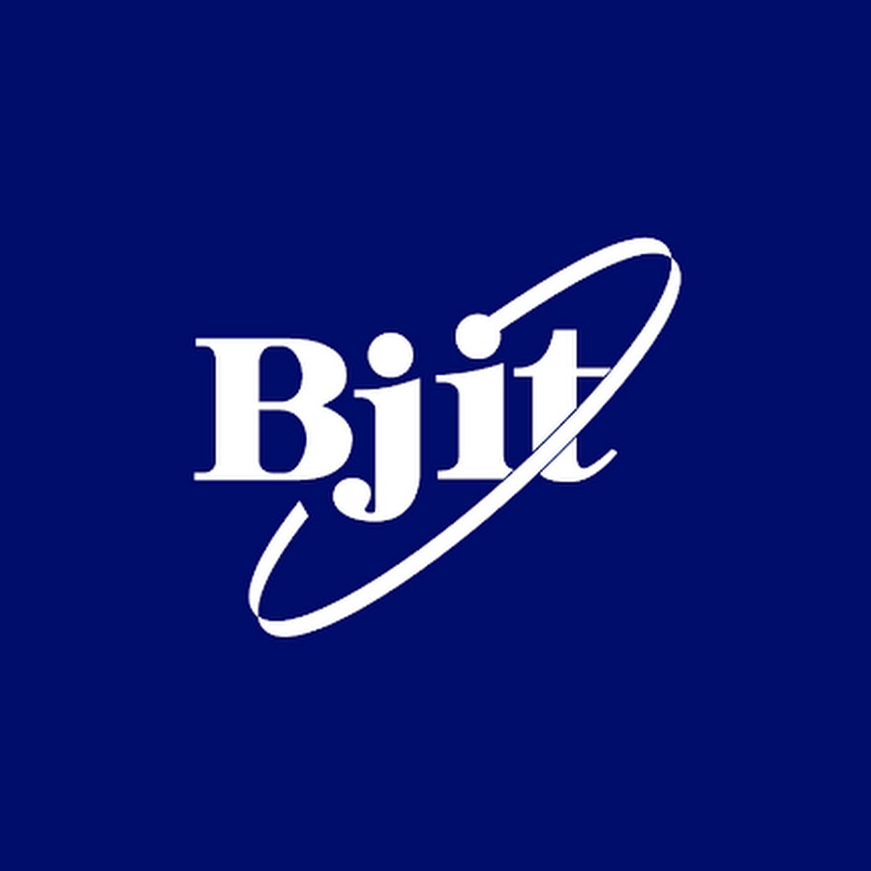
"Your Trusted Global IT Partner."

4.1: About BJIT Limited:
BJIT was co-founded by Japanese and Bangladeshi magnates, including Masataka Otake, a Japanese IT industry veteran, and a group of Bangladeshi software engineers. The leadership of BJIT contains individuals from both Japan and Bangladesh, bringing together a combination of technical expertise, operational insight, and cross-cultural understanding that has driven the company's growth.
BJIT Limited, initially started in 2001, is a Bangladesh-Japan IT (BJIT) collaboration that grew out of a partnership between Japanese and Bangladeshi entrepreneurs. Its establishment vision was to link the IT service gap between Japan and Bangladesh by bringing high-quality software development and IT services from Bangladesh to the Japanese market. Over the years, BJIT extended its proficiency in areas like software development, embedded systems, and digital transformation.
The company primarily focused on providing offshore development services to Japanese companies but increasingly increased its scope, serving clients in North America, Europe, and other regions. BJIT became known for its enthusiastic engineering teams, skilled software developers, and commitment to rigorous quality standards, with the aim of becoming a trusted global IT partner.
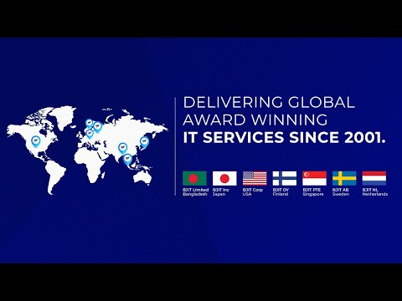 Nowadays, BJIT works with a significant workforce across several offices worldwide, including in Bangladesh, Japan, Finland, the United States, and the Philippines. The company has established a strong client base across various industries, including finance, telecommunications, automotive, and consumer electronics. BJIT’s achievement is driven by its commitment to linking cultural and operational gaps, leveraging technology, and adhering to strict quality assurance practices.JM Akbar is one of the co-founders and a main figure in BJIT Limited. As a Bangladeshi entrepreneur and IT leader, JM Akbar played a pivotal role in establishing BJIT and expanding its operations beyond Japan to become a global IT services provider. He has been involved in developing BJIT's reputation for delivering high-quality, customized software solutions and creating strong partnerships with clients worldwide.

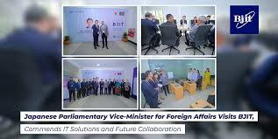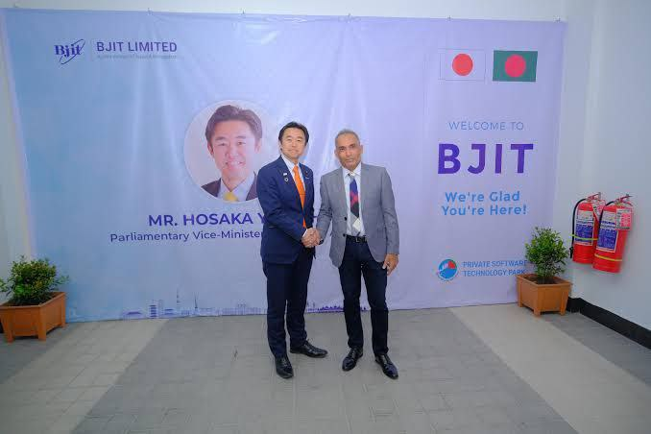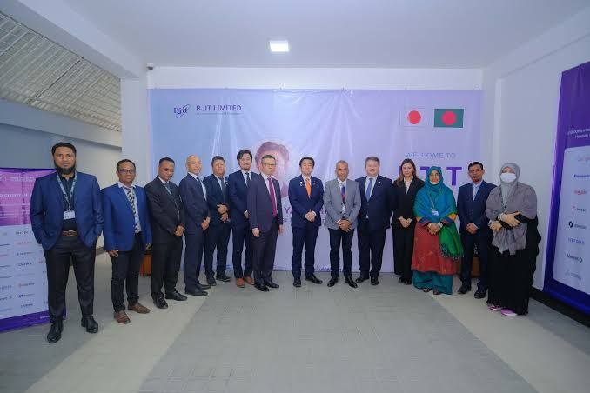

4.2: Mission of BJIT Ltd.:
The mission of BJIT Limited is to be a right-hand global IT partner by distributing high-quality, advanced, and cost-effective IT solutions that meet the growing needs of clients worldwide. BJIT is dedicated to fostering long-term partnerships through reliability, technical excellence, and a assurance to customer success. By leveraging a skilled, multicultural workforce and observing to international quality standards, BJIT intentions to help businesses drive digital transformation, achieve operational efficiency, and adapt to technological advancements.
BJIT's mission also includes connecting cultural and technical divisions, particularly between Bangladesh and Japan, by providing customized services custom-made to each client's exceptional needs.

4.3: Vision of BJIT Ltd.:
The vision of BJIT Limited is to be a leading global IT services provider known for its technical excellence, innovation, and cross-cultural collaboration. BJIT aims to create a world where technology bridges gap and increases efficiency across industries, enabling businesses to succeed in the digital age. By increasing its global footprint, building a diverse, skilled workforce, and frequently evolving with technological developments, BJIT imagines itself as a key player in shaping the future of IT outsourcing and digital transformation on a global scale. Through its obligation to value and customer-centric solutions, BJIT try to find to become a first-choice partner for companies looking to connect the power of technology to drive growth and achieve their goals.

4.4: Validation of BJIT Ltd.:
BJIT Limited holds numerous worldwide standard certifications that reflect its commitment to superiority, safety, and best performs in IT service area and software development. Some of BJIT's key certifications include:
- ISO 9001: This authorization guarantees that BJIT follows to rigorous quality management standards, ensuring high levels of customer satisfaction and continuous development in processes.
- ISO/IEC 27001: This authorization determines BJIT's commitment to information safety management, highlighting that it meets strict standards for protective client data and maintaining strong security practices.
- CMMI Level 3: The Capability Maturity Model Integration (CMMI) Level 3 authorization reflects BJIT's assurance to process development, project management, and value assurance in software development. CMMI Level 3 is a significant achievement, indicating that BJIT follows well-defined and standardized processes in its operations.
These authorizations support BJIT create belief with customers, ensuring them that the company follows worldwide recognized values in quality, information security, and process management.

4.5: Product Categories of BJIT Ltd.:
BJIT Limited offers a wide-ranging of IT solutions and services that deliver to numerous industry needs. Its product categories primarily attention on software development, surrounded systems, digital transformation, and consulting services. Here are the core product and service classes of BJIT Limited:
- Custom Software Development:
  - Tailored software solutions for web, mobile, and desktop applications.
  - Enterprise application development for business process automation and workflow management.
  - Development of scalable and secure software to meet specific business requirements.
- Embedded Systems and IoT Solutions:
  - Embedded software development for devices in industries like automotive, telecommunications, and consumer electronics.
  - IoT-based solutions for smart devices and connected systems.
  - Firmware and hardware integration for custom embedded systems.
- Digital Transformation Solutions:
  - Cloud migration services to enable scalable, cloud-based infrastructures.
  - Big data analytics and AI-driven insights for improved decision-making.
  - Digital workflow automation, including RPA (Robotic Process Automation).
- Product Engineering and R&D:
  - End-to-end product development from concept to prototype and production.
  - Product lifecycle management (PLM) support and innovation consulting.
  - Research and development (R&D) services for new technology solutions.
- Enterprise Resource Planning (ERP) and Customer Relationship Management (CRM):
  - ERP system implementation and customization to optimize operations.
  - CRM solutions to enhance customer engagement and service.
- Consulting and Managed IT Services:
  - IT consulting for strategy, process optimization, and technology selection
  - Managed IT services, including infrastructure management and support
  - Cybersecurity consulting and solutions to protect business assets
- AI, Machine Learning, and Data Science Solutions:
  - Development of AI and ML algorithms for business applications
  - Data science solutions for predictive analytics and data-driven decision-making
  - NLP (Natural Language Processing) and computer vision solutions tailored to specific industry needs
These product categories allow BJIT to serve clients across a range of industries, including automotive, telecommunications, healthcare, finance, manufacturing, and more. Each category emphasizes BJIT’s dedication to providing innovative, scalable, and secure IT solutions tailored to global market.

4.6: SWOT Analysis of BJIT Ltd.:
- Strengths:
- BJIT runs in several countries, providing a wide geographical footprint that spreads market risks.
- Offers services such as software development, enterprise solutions, and IT consulting, catering to various industry needs.
- Strong talent pool with knowhow in cutting-edge technologies like AI, IoT, and cloud computing.
- Cooperates with leading global tech firms, enhancing credibility and access to innovative technologies.
- Competitive pricing models due to its offshore and hybrid development centers.

Weaknesses:
- An important percentage of revenue might come from outsourcing contracts, making the company susceptible to fluctuations in client demand.
- Compared to global IT giants, BJIT’s brand might not be as widely recognized.
- High competition for skilled professionals in the IT sector can lead to challenges in retaining top talent.
- Rapid expansion could strain internal systems and processes if not managed effectively.

Opportunities:
- Rising need for businesses to assume digital tools provides BJIT with opportunities to expand services.
- Untapped markets in Asia, Africa, and South America offer potential for growth.
- Increasing demand for AI, machine learning, and blockchain solutions can be leveraged to expand service offerings.
- Growing client interest in sustainable IT practices opens avenues for eco-friendly tech solutions.
- Expansion of remote work culture globally can boost demand for IT infrastructure and cybersecurity services.

Threats:
- Fierce competition from both established global IT firms and emerging startups.
- Global economic downturns or geopolitical tensions can impact client budgets and projects.
- Need to continuously adapt to fast-paced technological advancements to stay relevant.
- Increasing cyber threats pose challenges in maintaining data security for clients.
- Complex and evolving data privacy laws across regions could add operational burdens.

4.7: Current Industry Scenario:
BJIT Ltd., a top IT services company, is actively increasing its global footprint and agreement current industry trends to increase its market position. Here is an summary of its industry scenario in 2024:
- Strategic Partnerships:
- BJIT recently aligned with Etteplan which is a global technology service company, to improve delivery capabilities and expand expertise. This move is expected to support its industrial client base globally.
- Alliance with Amazon Web Services (AWS) highlights BJIT's focus on cloud solutions, enabling faster service deployment and operational optimization​.

- Product Innovations:
- BJIT introduced new products such as FaceAI, Xamify, and miniERP, reflecting its obligation to advanced technological solutions in AI, HR automation, and enterprise resource planning​.
- Certifications and Recognitions:
- The company completed the ISO 27001:2022 certification for information security management, demonstrating its dedication to maintaining high standards in data security​.

Chapter-05: Findings of the study

5.1: HR strategies and operations at BJIT Limited.:
BJIT Ltd. is a worldwide known IT services and solutions provider. The Human Resource (HR) department of BJIT plays a critical role in managing the organization's workforce and ensuring a productive work environment. Some of the crucial responsibilities and purposes handled by the HR department of BJIT Ltd.:
- Sourcing, interviewing, and hiring skilled professionals in software development, IT services, and management.
- Team up with technical and managerial teams to describe hiring requirements.
- Onboarding new employees and integrating them into the organizational culture.
- Guaranteeing a positive work environment and addressing employee concerns or conflicts.
- Organizing team-building activities, workshops, and events to boost morale.
- Encouragement to open communication between employees and management.
- Directing technical and soft skills training to improve employee capabilities.
- Providing opportunities for professional certifications and career growth.
- Guaranteeing continuous learning aligned with industry trends.
- Executing performance appraisal systems.
- Setting key performance indicators (KPIs) and reviewing achievements.
- Offering feedback and creating performance upgrading plans as needed.
- Designing and enforcing company strategies, including workplace ethics and code of conduct.
- Ensuring compliance with local labor laws and international standards.
- Handling employee benefits, compensation, and leave management.
- Using data-driven insights to advance workforce efficiency.
- Tracking employee satisfaction, retention, and turnover rates.
- Managing payroll, bonuses, and other financial incentives.
- Supervision health insurance, retirement plans, and additional perks for employees.
BJIT Ltd., a multinational IT services company with operations in Bangladesh, Japan, and other global markets, emphasizes strategic HR practices to generate a creative and supportive work environment.
- Recruitment and Onboarding:
- BJIT cooperates with top universities to recruit fresh graduates, focusing on IT and engineering talent.
- Recruitment is based on skills, technical expertise, and problem-solving abilities, often evaluated through coding challenges, technical interviews, and project evaluations.
- New employees are introduced to company culture, processes, and expectations through structured orientation programs.
- Employee Training and Development:
- BJIT capitalizes in continuous learning through technical training, certifications, and knowledge-sharing sessions.
- Employees working with Japanese and global clients receive language and cultural sensitivity training to bridge communication gaps.
- High-potential employees are encouraged for leadership roles through workshops, mentorship, and global exposure.
- Performance Management:
- Performance evaluations are tied to clear, measurable objectives aligned with company goals.
- Emphasis on trimestral or bi-annual performance reviews to ensure appropriate feedback and improvement.
- Appreciation through promotions, bonuses, and performance-based encouragements to inspire employees.

- Compensation and Benefits:
- Confirms alignment with industry standards, offering attractive packages to retain talent.
- Delivers medical insurance, annual health check-ups, and support for mental health.
- Options like supported transportation, meals, and allowances for work-related expenses.
- Work Culture and Employee Engagement:
- A team-oriented culture with opportunities to work on diverse, cutting-edge projects.
- Promotes a workplace that values employees from varied cultural and professional backgrounds.
- Regular team-building events, cultural celebrations, and recreational activities to enhance employee bonding.
- Technology-Driven HR Management:
- Automated systems for managing employee data, attendance, and payroll.
- Use of technology to streamline candidate screening and hiring processes.
- Digital tools for skill development and training.
- Global Opportunities:
- Employees are often offered international project opportunities, especially in Japan and Europe.
- Facilitates collaboration between global teams to share expertise and best practices.
- Employee Feedback and Support:
- Encourages transparent communication and accessibility to senior management.
- Regular pulse surveys to gauge satisfaction and gather suggestions.
- Structured mechanisms to address employee concerns fairly and swiftly.

- Corporate Social Responsibility (CSR):
- Participates in initiatives like IT education for underprivileged communities and environmental sustainability projects.
- Encourages employees to engage in CSR activities as part of the company’s values.
- Work-Life Balance
- Options for remote work or adjustable schedules to support employee well-being.
- Generous leave entitlements, including vacation, sick leave, and maternity/paternity benefits.
- Access to fitness programs, gaming zones, or relaxation spaces in offices.
BJIT Ltd. focuses on aligning its HR practices with its global business strategy, ensuring employees are equipped to meet dynamic market demands while fostering a positive, innovative work culture.

5.2: Recruitment process of BJIT Ltd.:

The recruitment process of BJIT Ltd. is designed to recognize and attract skilled specialists who align with the company’s needs and culture. The general steps in BJIT Ltd.'s recruitment process typically include the following:
- Job Announcement:
- Job vacancies are advertised on BJIT’s official website, LinkedIn, job portals (like Bdjobs in Bangladesh), and through campus recruitment drives.
- In-depth descriptions of roles, responsibilities, required qualifications, and skills are provided.

Application Process:
- Candidates submit their resumes and cover letters through BJIT’s website or other job platforms.
- The HR team analyses applications to shortlist candidates who meet the job criteria, focusing on educational background, technical skills, and relevant experience.
- Initial Assessment:
- Shortlisted candidates take an online or in-person aptitude test evaluating logical reasoning, problem-solving, and quantitative skills.
- A coding test or practical task designed to evaluate the candidate’s technical expertise in areas like software development, programming languages, or domain-specific skills.
- Interview Process:
- Technical Interview: Directed by a panel of senior developers or team leads to assess the candidate’s technical depth, problem-solving approach, and familiarity with tools and technologies. Topics are including algorithms, data structures, system design, and relevant technologies.
- HR Interview: Concentrations on understanding the candidate’s soft skills, cultural fit, career aspirations, and alignment with the company’s values. Questions cover communication skills, teamwork, adaptability, and willingness to learn.
- Cross-Cultural Evaluation:
- For roles that involve working with international clients, especially in Japan, BJIT evaluate candidates’ cultural adaptability and communication skills in a global work environment.
- Language skills (like Japanese proficiency) evaluated if required.
- Offer and Negotiation:
- Successful candidates receive an offer letter detailing salary, benefits, and other terms of employment.
- Candidates negotiate terms before confirming the offer.
- Onboarding:
- Selected candidates complete required formalities, such as submitting academic and professional credentials.
- New hires are familiarized to the company’s culture, policies, and team structure.
- Depending on the role, employees experience technical and soft-skills training during their initial days.
- Additional Features
- BJIT conducts recruitment drives at universities, offering positions to top-performing students and organizing workshops.
- Inspires current employees to refer potential candidates, leveraging internal networks to source talent.
- BJIT Ltd. highlights hiring fresh graduates and training them to meet industry demands.

5.3: Selection Process of BJIT Ltd.:

The selection process of BJIT Ltd. is designed to identify the best candidates who match the company's technical, cultural, and project-specific requirements. An overview of the selection process at BJIT Ltd.:
- HR evaluations resumes and cover letters to shortlist candidates based on:
  - Educational qualifications.
  - Relevant technical skills and experience.
  - Alignment with job requirements.
  - ATS (Applicant Tracking Systems) used to filter candidates for keywords and qualifications.
- Candidates required to take a written or online test that evaluates:
  - Logical reasoning.
  - Problem-solving skills.
  - Basic quantitative aptitude.
  - A practical coding test or task to assess proficiency in programming languages, algorithms, or specific tools and technologies.
  - This is often conducted online or in a controlled test environment.
A critical step in the selection process, often divided into multiple rounds. Initial Technical Interview conducted by team leads or senior engineers which focuses on:
- Programming skills.
- Domain-specific knowledge.
- Problem-solving approach and coding efficiency.
- Hands-on problem-solving required.
- Advanced Technical Interview:
- Assessment of in-depth technical expertise, system design, or architecture knowledge.
- For skilled candidates, it includes discussions on past projects or specific challenges solved.
- For roles linking international clients, especially in Japan, candidates’ proficiency in English and/or Japanese may tested.
- Assessed to confirm the candidate can work effectively in diverse, global teams.
- HR Interview focuses on assessing:
- Alignment with BJIT’s values and work environment.
- Communication, teamwork, adaptability, and leadership potential.
- Understanding the candidate's ambitions and long-term fit with the organization.
- HR also discusses salary expectations, benefits, and other employment terms.
- Final Review and Decision focuses on:
- All assessment scores, interview feedback, and recommendations are reviewed by the hiring panel.
- BJIT contact provided references to verify past performance and behavior.
- Successful candidates receive a formal offer such as:
- Job title and description.
- Compensation package and benefits.
- Terms and conditions of employment.
- Candidates may negotiate aspects of the offer before acceptance.
- Submission of essential documents like academic certificates, identification proofs, and previous job credentials.
- New hires are introduced to company policies, team members, and project expectations.
- Key Features of BJIT’s Selection Process:
- Heavy focus on hands-on assessments to ensure candidates possess the required expertise.
- Clear stages and criteria to maintain fairness in selection.
- Ensures candidates can thrive in a multicultural, international work environment.

5.4: My Job responsibilities at BJIT Ltd:
- Assist in the recruitment and coordinate onboarding process.
- Facilitate recruitment efforts by posting job openings and managing applicant screenings.
- Coordinate interview schedules and communicate with candidates.
- Communicating with the general manager and other representatives of the recruitment team.
- Help with employee inquiries, resolving issues, maintaining open communication and promoting a positive workplace culture.
- Maintain relations with different departments for day to day smooth HR operations.
- Social media management and employer branding.

5.5: Findings:
- Insufficient focus on building a strong employer brand may reduce BJIT’s ability to attract top-tier talent, especially in competitive IT markets. Talented candidates may overlook BJIT for more prominent companies.
- While technical skills are essential, overemphasis on coding or technical tests might neglect soft skills, problem-solving creativity, and leadership potential. May result in hiring technically competent employees who lack interpersonal or global collaboration skills.
- Screening resumes manually or relying solely on ATS (Applicant Tracking Systems) may result in qualified candidates being overlooked due to keyword mismatches or biases. Reduces the pool of quality candidates and delays hiring.
- Lengthy recruitment cycles due to multiple assessments or inefficient coordination between HR and technical teams. Delays can lead to losing top candidates who accept offers from competitors.
- Recruitment processes may inadvertently favor certain demographics, academic institutions, or technical specializations. Leads to less diversity in teams, which can stifle innovation and limit perspectives.
- Campus recruitment may focus only on a few institutions, neglecting other colleges with talented candidates. Missed opportunities to tap into emerging talent pools.
- Lack of timely communication, unclear feedback, or impersonal interactions during the recruitment process. Creates a negative impression of BJIT, deterring talented candidates from applying again or referring others.
- Not all recruitment processes may adequately assess a candidate's readiness for working in cross-cultural environments or with international clients. Candidates may face challenges adapting to BJIT’s global projects, especially in Japan or Europe.
- Lack of reliance on data-driven insights to refine recruitment strategies and track hiring effectiveness. Missed opportunities to identify bottlenecks and optimize hiring practices.
- Recruitment processes may not thoroughly assess a candidate’s long-term commitment or cultural fit. High turnover rates if candidates leave due to mismatched expectations.

Chapter-06: Conclusion and Recommendations

6.1: Conclusion:
The internship at BJIT Ltd. provided a complete understanding of their recruitment and selection process, highlighting its implication in building a skilled and motivated workforce. Through practical experience, I observed how the company tactically aligns its recruitment practices with organizational goals, confirming that only the most suitable candidates are selected to drive business success. The recruitment process at BJIT Ltd. is a mixture of up-to-date tools, traditional methods, and a focus on generating a comprehensive work environment. From finding candidates through diverse channels to conducting rigorous interviews and assessments, the company highlights transparency, efficiency, and alignment with its core values.
Whereas the existing procedure is strong, a few areas for improvement, such as enhancing employer branding and adopting advanced applicant tracking systems, were distinguished during this internship. Implementing these changes could further update operations and attract top-tier talent.
Overall, the experience provided valuable understandings into human resource management, permitting me to develop a real-world understanding of the theoretical concepts studied. BJIT Ltd.'s assurance to brilliance in its recruitment and selection process positions it well for future growth and success.

6.2: Recommendation:
- Capitalize in branding creativities such as showcasing employee achievement stories, work culture, and global projects on social media and specialized platforms like LinkedIn.
- Include valuations for critical thinking, teamwork, and cultural flexibility through the selection process.
- Implement mix screening methods joining automated tools with manual reviews for complete evaluation.
- Throughout interviews, discuss career growth opportunities, and clearly communicate company culture and expectations.
- Reorganize the recruitment process, minimize redundant steps, and adopt alert practices to make quicker decisions.
- Confirm comprehensive hiring practices by sourcing candidates from varied backgrounds, regions, and institutions.
- Increase campus recruitment programs, familiarize coding boot camps, and establish long-term partnerships with a diverse range of universities.
- Frequently update candidates on their application status, provide constructive feedback, and ensure a professional and engaging interview experience.
- Include cultural flexibility and communication skills valuations in the hiring process for roles involving international collaboration.
- Implement advanced HR analytics tools to track recruitment metrics.
- Through interviews, deliberate career growth opportunities, and clearly communicate company culture and expectations.

Chapter-07: Appendix

7.1: Reference:
BJIT Ltd. (2023). BJIT Official Website: https://www.bjitgroup.com/about
BJIT Career: https://bjitgroup.com/career
BJIT Facebook: https://www.facebook.com/bjitltd/
BJIT LinkedIn: https://www.linkedin.com/company/bjit/posts/?feedView=all
Article: https://www.researchgate.net/publication/353648009_Critical_Review_of_Recruitment_and_Selection_Methods_Understanding_the_Current_Practices

7.2: Questionnaire:

- Do BJIT follow recruitment and selection process?
- What kind of procedures BJIT use in the recruitment process?
- Is BJIT have any framework?
- Can you briefly explain the whole process?
- How do BJIT find out potential candidates?
- How BJIT update the recruitment and selection process?
- What kind of problem BJIT face to complete the entire process?
- How does BJIT Ltd. plan its recruitment process, starting from identifying hiring needs to onboarding new employees?
- What methods does BJIT Ltd. use to source potential candidates?
- What criteria are considered during the screening and shortlisting stages?
- What types of interviews does BJIT conduct and how do they assess technical and cultural fit?
- What techniques are used for evaluating a candidate’s technical expertise?
- How does BJIT ensure that candidates are prepared for cross-cultural collaboration and international roles?
- What challenges does BJIT face in recruiting and retaining top-tier talent in the competitive IT market?
- What steps has BJIT taken to improve its employer brand and attract skilled professionals?
- Does BJIT utilize HR analytics or other tools to optimize its recruitment strategies?
- How does BJIT communicate with candidates during and after the recruitment process?
- How does BJIT ensure diversity in its recruitment process?

