Internship Report

On

Managing Market Insights for Better Market Management:
A Study on Sonali Paper & Board Mills Limited

Internship Report

On

Managing Market Insights for Better Market Management:
A Study on Sonali Paper & Board Mills Limited

Submitted to:

Muhammad Hasan Al-Mamun
Assistant Professor
School of Business & Economics United International University (UIU)

Submitted By:
Afroza Yesmeen ID No: 111 143236
School of Business & Economics United International University

January 25, 2020

Acknowledgement

I begin by thanking the Almighty Allah for my successful completion of the internship report, which is a significant part of the BBA Program. I would like to take the opportunity to thank those people who have given me constant supports while doing my course.

At first It’s a pleasure to convey my heartiest gratitude and greeting to my honorable supervisor, Muhammad Hasan Al-Mamun, Assistant Professor of School of Business and Economics United International University. I deeply appreciate his cooperation, advice and guidance in preparing this report.

I would like to extend my heartiest thanks to the Marketing Department of Sonali Paper & Board Mills Ltd. for allowing me to complete my Report.

I am very grateful to all of the people mentioned above for their cooperation in every step to prepare my report successfully.

Letter of Transmittal
25 January, 2020

Muhammad Hasan Al-Mamun
Assistant Professor
School of Business and Economics
United International University

Subject: Submission of the Internship Report

Dear Sir,
I would like to submit my internship report titled “Managing Market Insights For Better Market Management: A Study on Sonali Paper & Board Mills Limited”, which has been prepared as a partial requirement for the completion of the BBA Program of United International University.
My internship started at Sonali Paper & Board Mills Limited in Market Operations Division started from 10th of June, 2019 and ended on 9th of September, 2019 under the supervision of you. I achieved appreciation for my performance from my line Manager Md. Golam Zilani Bhuiyan, Director (Marketing & Operations).
While working on the report, I have tried to follow each and every guideline that you have advised. It has been a very enlightening experience to work in this giant Paper Manufacturing Company and I have thoroughly enjoyed my internship period in Sonali Paper & Board Mills Limited. The authority of Sonali Paper & Board Mills Limited has also extended their cooperation whenever required.
Sincerely,
Afroza Yesmeen
ID No: 111 143 236
BBA Program
School of Business and Economics
United International University (UIU)

Executive Summary
The report deals with managing market insights for better market management of Sonali Paper & Board Mills Limited. The report includes the brief discussion of market management activities and exemplifies the use of the market insights of Sonali Paper & Board Mills Limited.
Younus Group has established itself as one of the fastest thriving conglomerate in the industrial arena of Bangladesh. It started from humble beginnings as a cold storage businesses in 1981. Since then the business operating for 38 years now has transformed and expanded itself into a group through a plethora of various businesses in diverse sectors. Currently the group consists of paper mills, cold storages, plastic goods manufacturing companies, trading concerns, spinning mills and a potato flakes production plant.
Sonali Paper and Board Mills Ltd. was started in 1983 by Mr. Khan Md. Iqbal. It was the first paper mill factory in the private sector. Back at that time, Khulna Newsprint was the only paper mill factory existing in the government sector. Thus, Sonali Paper and Board Mills Ltd. being the only paper mill factory in the private sector, was enjoying a monopoly power. As a result, Mr. Khan Md. Iqbal was making huge profits, but this man never paid any of its taxes due. Hence, in 1998, the mill was closed down. Fortunately, in 2005, Younus Group took over the mill, invested a lot behind it, renovated it and finally, started it with complete enthusiasm in the year, 2006.
As we all are aware of the matter that the world is going a recession period. Even in this time of crisis, Sonali Paper and Board Mills Ltd. has been successful in keeping its mark in the hearts of millions of people of Bangladesh. Today, Sonali Paper and Board Mills Ltd. stands as one of the leading paper mill companies of our country, Bangladesh. The efforts and contributions are really worth appreciating by anyone and everyone.
This organization has been managing the market insights quite successfully and using these market insights to organically transform itself into a more effective organization. The success stories are covered in detail in the report. At the bottom of the report covers the effectiveness of their market management and contribution of these initiatives in Bangladeshi Socio-economic system.
Key Words: Market Insights, Market Management

DECLARATION

I am Afroza Yesmeen, student of School of Business and Economics (Marketing & HRM) of United International University, Bangladesh, do hereby declare that the internship Repot on “Managing Market Insights For Better Market Management: A Study On Sonali Paper & Board Mills Limited ” is an original work and has not been previously submitted for any degree, diploma, title, or recognition.



Afroza Yesmen
ID No: 111 143 236
School of Business and Economics
United International University

Table of Contents
Contents
Introduction 8
Organizational Background 9
Industry Review 13
Objectives of the Report 17
Methodology 18
Primary sources 18
Secondary sources 18
Findings of the Study 36
Recommendations 43
Conclusion 45
References 46

Introduction

Businesses that succeed do so by creating and keeping customers. They do this by providing better value for the customer than the competition. Marketing constantly have to assess which customers they are trying to reach and how they can design products and services that provide better value. Today’s competitive and free business world Marketing is the essence for any organization. In these days successful companies all levels have one thing in common that is they are strongly customer focused and heavily committed to marketing. For many business firms, a common important goal is the long-term increase in the value of their common stock. Every manager must have an effective marketing strategy. Marketing is more than any other business function that deals with customers. Understanding, creating, communicating, and delivering customer value and satisfaction are the very heart of modern marketing thinking and practice. In this report we have tried to understand marketing management in practice by studying the marketing process and strategies followed by marketing department of Sonali

Sonali Paper & Board Mills Ltd. believes in achieving intact rate of growth & being one of the best paper manufacturer organizations. Their aim is to keep their own position compact as well as to create national economic growth & value for their shareholders. Their primary objective of trade & commerce is to satisfy customers, investors, shareholders & employees; and to develop the society. Overall, their program is directed for these purposes. Manufacture & distribution of different types of quality grade papers at reasonable prices is their main focus. Business is directed through maintaining strong moral quality which enables them to create assets for the organization.

Organizational Background

Younus Group has established itself as one of the fastest thriving conglomerate in the industrial arena of Bangladesh. It all started from humble beginnings as a cold storage business in 1981. Since then, the business operating for 38 years now has transformed and expended itself into a group through a plethora of various business in diverse throughout the country.
Currently the group consists of paper mills, cold storages, plastic goods manufacturing companies, trading concerns, spinning mills and a potato flakes production plant. The group has also involved itself in the environmental sector, mass media, education and social welfare which enable it to contribute to the Bangladeshi socio-economic development.
“Commitment” & “Punctuality” are the two main qualities that Younus Group has built its principals on. The group believes that this was the driving force behind their successful journey of 38 years.

Group at a Glance:
- Companies: 36
- Business Partners: 6
- Suppliers: 50+
- Employees: 2,409
- People involved indirectly: 2,000+
- Operating Sectors: Paper Manufacturing, Textile, Cold Storage, Food Industry, River Dredging, Light Engineering, Education, Aviation Sector, Agro, Information Technology, Media, E-Commerce, Tour Operation

Mission:
The Group is bound to provide modern echo-friendly effective technologies in all its factories with a promise of ensuring safe & environment friendly facilities to the employees for a satisfactory output.
Vision:
We prefer to be one of the most committed business groups in Bangladesh as well as be a partner in the progress of this country’s rising economic avenue, and we firmly believe it is possible with our 38 years of extensive experience.
Corporate Social Responsibility:
Since its inception, Younus Group has always advocated the idea of doing well for the environment and it has tried to maintain its reputation as an environment friendly entity. The group has witnessed dire socio economic conditions in Bangladesh, but was able to successfully overcome those hurdles and came up with a solution every time. However, the group believes that there is still room for improvement and whatever problems they face, they can tackle it as they have been doing for the last 38 years. It hopes to become one of the headlining business groups in Bangladesh within the next few years.

The Green Company:


Younus Group prefer to call them a Green Company because it always tries to maintain a harmonious balance between environment and progress. It has maintains this environmental friendly process for 38 years, amidst several socio-economic crises in the country and yet it has turned itself around, keeping in mind the group’s core principles of “Commitment” and “Punctuality” time and again.

Enterprise’s:
- Paper Manufacturing:
- Sonali Paper and Board Mills Ltd.
- Ananta Paper Mills Ltd.
- Younus Fine Paper Mills Ltd.
- Younus Offset Paper Mills Ltd.
- Younus Newsprint Mills Ltd.
- Textile:
- Younus Spinning MILLS Ltd.
- Cold Storage:
- Sobhan Ice and Cold Storage Ltd.
- Akco Cold Storage Ltd.
- Garib A.Newaz Cold Storage Ltd.
- Nowapara Cold Storage Ltd.
- Younus Cold Storage Ltd.
- Combined Cold Storage Ltd.
- Europa Cold Storage Ltd.
- Food Industry:
- Bikrampur Potato Flakes Industries Ltd.
- River Dredging:
- Sonali Dredger Ltd.
- Real Estate:
- Sonali Abason Ltd.

- Information Technology
- Sonali IT

- E-Commerce
- Sonalibazar.com
- Manufacturing
- Sonali Tissue Industries Ltd.
- Younus Plastic Industries Ltd.
- Younus Filament Industries Ltd.
- Meghna Pipe Factory

Industry Review

Sonali Paper & Board Mills Limited, a private Limited Company started its production in 2006. This unit produces different G.S.M. White writing and printing papers with two units. There are currently two machines with a production capacity of 45,000 kg per day and 505 people are currently working in this unit.

Paper & Tissue Products market growing:

There are many local brand in Tissue and Paper industry in Bangladesh. Local brands play a dominant role to produce tissue paper and paper products in Bangladesh. Now Bangladesh has 13 Paper and Tissue manufacturing plant and more than 15 Paper and tissue converting plant.

Pulp and Paper Industries in Bangladesh:

The major pulp and paper industries in private sector in Bangladesh have grown in Dhaka and Chittagong regions. An overview of pulp and paper industries in Bangladesh is presented below:

A. Dhaka Region

Sl No. | Name of The Paper Mills | Paper Grades | Production, TPD
01 | Sonali Paper Mills | Board | 25
02 | Sonali Paper Mills | Writing | 30
03 | Islamia Paper Mills | Media | 20
04 | Islamia Paper Mills | Media | 20
05 | Lina Paper Mills | Writing | 25
06 | Dhaka Paper Mills | Media | 10
07 | Konik Paper Mills | Writing | 30
08 | Konik Paper Mills | Writing | 20
09 | Bengal Packages Ltd. | Media | 50
10 | Capital Paper Mills | Media/Newsprint | 20
11 | Capital Paper Mills | Media/Newsprint | 20
12 | Sadek Paper Mills | Media | 20
13 | BPN | Media | 35
14 | Afil Paper Mills | Media | 20
15 | Afil Paper Mills | Media | 15
16 | R.S. Paper Mills | Media | 35
17 | Pioneer Board Mills | Media/Board | 22
18 | Magura Paper Mills | Media | 45
19 | Magura Paper Mills | Writing | 70
20 | Shahjalal Newsprint | Newsprint | 70
21 | Bashundhara Tissue | Writing | 25
22 | Bashundhara Tissue | Tissue | 20
23 | Bashundhara Tissue | Media | 10
24 | Ananta Paper Mill | Media | 25
25 | Ananta Paper Mill | Writing | 10
26 | Ananta Board Mill | Board | 20
27 | Eastern Paper Mill | Board | 20
28 | Eastern Paper Mill | Newsprint | 10
29 | Maq Mill | Paper | Media
30 | Maq Mill | Paper | Writing
31 | Maq Mill | Paper | Simplex
32 | Azad Board Mill | Media | 20
33 | Asia Mill | Paper | Media
34 | Hossain Pulp and Paper Mill | Cigarette | 10
35 | Hossain Pulp and Paper Mill | Duplex | 40
36 | Bangla tissue Mill | Tissue | 5
37 | Amber Paper Mill | Writing | 20
38 | Amber Paper Mill | Writing | 20
39 | Lina Mills | Paper | Writing
40 | Baizid Newsprint | Newsprint//Liner | 40
41 | Adunik Paper Mill | Writing/Liner | 30
42 | Padma Paper MIll | Liner/ Newsprint | 40
43 | Universal Paper Mills | Media/Liner | 15
44 | Union paper Mills |  | 15
45 | Bangladesh Paper Mills |  | 40
46 | Mokka Paper Mills |  | 20
47 | Gazi Mills | Paper
48 | City Mills | Paper
49 | Arefin paper Mills |  | 25
50 | Nice Mills | Paper
51 | Uzzal Paper Mills |  | 10
52 | Creative Paper Mill | Writing-printing | 100
53 | Capital Paper Mills | Writing | 100
Total |  |  | 1,537

B. Chittagong Region

Sl No. | Name of The Paper Mills | Paper Grades | Production, TPD
01 | Hakkani Pulp and Paper Mill | Writing printing/Newsprint | 20
02 | Hakkani Board Mills | Media/Liner | 18
03 | Hakkani Board Mills | Media/Liner | 15
04 | Mostafa Paper Mills | Media/Liner | 18
05 | Anawara Paper Mills | Newsprint | 5
06 | Anawara Paper Mills | Media/Liner | 10
07 | MEB Paper Mills | Media/kraft Liner | 20
08 | T.K. Paper Mill | Writing printing/offset | 75
09 | T.K. board mill | Duplex board | 40
10 | G.C. Box | Media/Liner | 10
11 | Mack paper Mill | Media/kraft Liner | 20
12 | Chittagong Asia Paper Mill | Media/Kraft Liner/Newsprint | 50
13 | Motaleb Paper Mill | Media/Liner | 10
14 | S.A. Pulp and Paper Mill | Media/Newsprint/ Writing-printing | 40
15 | Export Pack Ltd. | Media/Kraft Liner/Newsprint | 20
16 | Ma-zainab paper Mill | Media | 20
17 | Baizid Paper Mill | Media/Kraft liner | 35
18 | T.K. Paper Mill | Writing-printing | 60
19 | Karnaphuli Paper Mill | Writing-printing | 25
20 | Karnaphuli Paper Mill | Writing-printing | 25
21 | Karnaphuli | Brown | 22
Total |  |  | 558

The capacities of single paper machine mentioned above vary from 10 tpd to 250 tpd. They produce different grades of paper e.g., writing, printing, packaging, liner, media, simplex, duplex, board, newsprint, tissue, cigarette, etc. Single paper mill is able to produce more than one grade. Total capacity is around 2500 MT/day, i.e., 2500 x 300 = 7, 00,000 MT/YR (around). Now producing around 2000 x 300 =500000 - 600000 MT/yr.

Tissue Market history in Bangladesh:
Introduction: At First in 1987 Kollol Industries Limited has developed a converting unit to start commercial operation. In 2000 Basundhara stated first manufacturing plant in Bangladesh. Now 2017 Bangladesh has 10 tissue manufacturing company.
The privileged people were used the tissue product in that time and that’s why the market was limited. But with the development of our country the market has spread widely as even to the mass people. To meet the market demand Bashundhara, fresh, Hakkani super star (SSG), Sonali and other companies established their own factory. And also some companies engaged with converting unit by collecting tissue jumbo roll from (local & import) based on doing business own pvt Brand is growing market to reach the position on established Brand on Bangladesh Market.
Tissue sales sector:
General trade, Super shop, Digital market and corporate house, Diplomatic zone, Hotel and Restaurant.
Increase tissue users:
The tissue paper industry, mostly led by local factories, has kept booming in the country due to a change in the people’s lifestyle with rising incomes.80 per cent of the people using tissue papers. The local tissue paper industry meets the demand for toilet paper, facial tissue, kitchen towels, table napkin, and wrapping tissue, incentivized by diversified consumers of the country. Rapid urbanization is leading the industry, he said, adding that the size of the market will increase tenfold in next five years due to growing use of the product even in rural areas.
Though average annual growth rate 1.70 and density of population Bangladesh is the key growth tissue market in south Asia.

Objectives of the Report

General Objective of the report:
- This report is prepared primarily to fulfill the partial requirement of complete my Internship course.

- To evaluate the process of managing marketing analysis and generating and using the market insights of Sonali Paper & Board Mills Limited.

Specific Objective:

More specifically, this study entails the following aspects:

- Everything is performed for achieving some selected goals. So, our present report named “Managing Marketing Insights for Better Market Management: A Study on Sonali Paper & Board Mills Limited”. The main objectives of our report are:
  - To review the process of the market management of Sonali Paper & Board Mills Limited.
  - To analyze the different types of ratio: both financial and non-financial.
  - To gain Knowledge about the marketing insights management process in this organization.
  - To identify the major problems in their product market and how they may overcome it.
  - To evaluate the performance of this organization in the various markets they operate.

Methodology

For smooth and accurate study everyone has to follow some rules and regulations. The study inputs ware collected from two sources:

Primary sources
    - Practical observation
    - Marketing Activities of the organization observed
    - Face to face conversation with the Project Supervisor
    - Direct observations
    - Face-to-face conversations with employees

Secondary sources
    - Reports of Sonali Paper & Board Mills Limited
    - Memos and Circulars of Sonali Paper & Board Mills Limited
    - Websites of Sonali Paper & Board Mills Limited

Data Collection Instruments:
For data collection, I used Books, Website of Sonali Paper & Board Mills Limited and some others information’s and reports which are related with market management analysis of Sonali Paper & Board Mills Limited.

Data Analysis Technique:

I used both qualitative and quantitative data analysis techniques in my study. Basic descriptive statistics were mainly used for quantitative data collected for this report.

Marketing Sales Plan/ Strategy (Retail & Corporate):

- Name of the Company: Sonali Papers & Board Mills Ltd.
- Name of the Brand: Sonali

Products:

- Sonali Perfumed Wallet Tissue


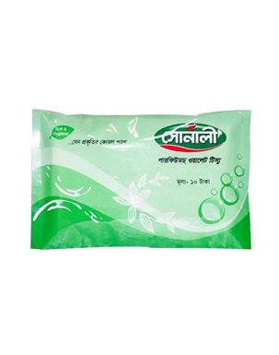

- Sonali Facial Tissue Box




- Sonali Pink & White Toilet Tissue (Regular)
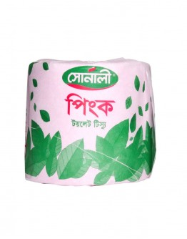


- Sonali Hand Towel (White)



- Sonali Kitchen Towel

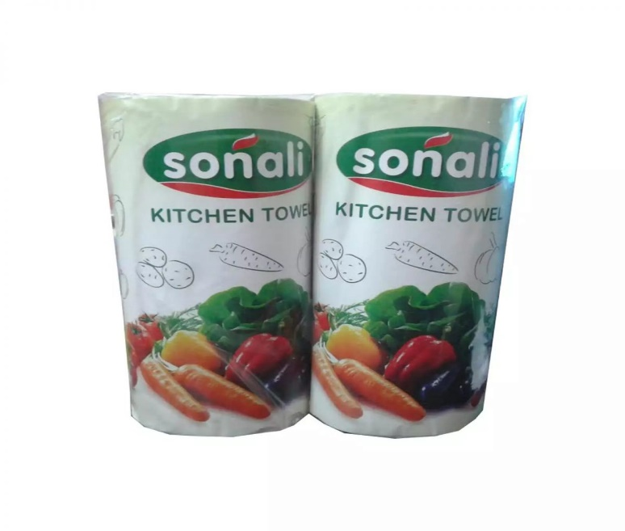

- Sonali A4 Paper


 | Marketing, Retail, Corporate & MIS Units (Summery)
Grand Total | Manager | 7 | 60,000 | 25,000 | 3,000 | 88,000 | 616,000
Grand Total | Regional Sales Manager | 16 | 40,000 | 15,000 | 2,000 | 57,000 | 912,000
Grand Total | Area Manager | 58 | 25,000 | 10,000 | 1,000 | 36,000 | 2,088,000
Grand Total | Executive (Marketing) | 2 | 23,000 |  | 2,000 | 25,000 | 50,000
Grand Total | Market operation officer (MIS-Team) | 15 | 23,000 |  | 2,000 | 25,000 | 375,000
Grand Total | Sales Officer | 450 | 10,000 | 5,000 | 300 | 15,300 | 6,885,000
Grand Total | Marketing, Retail, Corporate & MIS Unit (Remuneration) | 548 |  |  |  |  | 9,396,000
Grand Total | Marketing, Retail, Corporate & MIS Unit (Sales) |  |  |  |  |  | 100,000,000
Grand Total | Marketing, Retail, Corporate & MIS Unit (Expenditure & Contribute %) |  |  |  |  |  | 9.4

Proposed Sales in Values (Summery):

Sl No. | Particular | Retail Sales & Value In BDT (Expected Sales) |  | Corporate sales Value in BDT (Expected Sales) |  | Sub Total |  | Remarks
1 | Tissue | Qty | Values | Qty | Values | Qty | Values
1 | Tissue | 318 MT | 70,000,000 | 136 MT | 30,000,000 | 454 MT | 100,000,000

Marketing, Retail, Corporate & MIS Grand-Total Expenditure (Summery):

Sl  No. | Description | Unit Wise sales | Depot Commission (6%) | Distributor Commission (8%) | Sales Force Remuneration | Distribution (3%) | Damage (1%) | Promotion (1%) | Total | % | Remarks
1 | Marketing unit | 100,000,000 |  |  | 138,000 |  |  |  | 138,000 | 0.14 | Fixed & Variable
2 | Retail Unit | 70,000,000 | 2,700,000 | 5,600,000 | 8,593,000 | 2,100,000 | 700,000 | 700,000 | 20,393,000 | 29.13 | Fixed & Variable
3 | Corporate & Toll Manufacturing Unit | 30,000,000 |  |  | 202,000 | 900,000 | 300,000 | 300,000 | 1,702,000 | 5.67 | Fixed & Variable
4 | MIS Unit | 100,000,000 |  |  | 463,000 |  |  |  | 463,000 | 0.46 | Fixed & Variable
Grand Total |  | 100,000,000 | 2,700,000 | 5,600,000 | 9,396,000 | 3,000,000 | 1,000,000 | 1,000,000 | 22,696,000 | 22.70 | Fixed & Variable

Targeted Points of sales:

- Retailer/Pharmacy
- Wholesaler
- Chain Shop (Agora, Shapnaw, Mina Bazar etc.)
- Institution (Govt. Office, Private Office, Garments, Community Center, NGO etc.)
- Export
- Traders
- All Type Hawkers
- Online Service (Daraz, Chaldal)
- Bus Stands
- Mini Chain Shops
- Show Room
- All Type Of Canteen
- Mobile Store
- Toll Manufacturing
- Launch Stations
- All Types of Fair
- Campaign
- Greeting Program
- Workshops

Marketing Tools:

- Trade Scheme Offer
- Consumer Scheme Offer
- Poster, Dangler, Sticker, Wall Sign. Shop Signboard, Billboard etc.
- Product catalogue
- Print media
- Electronic media
- Quality products
- Available products
- Proper time delivery ensure (within 72 hour)
- Minimum floor stock maintain (for smooth delivery)
- All logistics support available
- Credit facility only for depots (after confirmation bank guarantee)
- Ensure market reasonable price, trade offer, incentive offer
- Take necessary (legal) action for all unexpected situation
- Adjust all previous claim (if available in market)

Companies Direct Distribution Central Depot

Sl No. | Area
1 | Dhaka
2 | Narayanganj
3 | Munsiganj
4 | Norshingdi
5 | Gazipur
6 | Manikgonj
7 | Chittagong
8 | Sylet

National wide strategic marketing and sales plan:

Sl No. | Name of the Region | Allocation Distributor No. | Sl No. | Name of the Region | Allocation Distributor No.
1 | Dhaka North | 25 | 9 | Barishal | 30
2 | Dhaka South | 25 | 10 | Jessore | 25
3 | Savar | 25 | 11 | Bogra | 20
4 | Gazipur | 20 | 12 | Rongpur | 20
5 | Mymensingh | 25 | 13 | Faridpur | 25
6 | Sylhet | 25 | 14 | Narayanganj | 30
7 | Comilla | 25 | Total |  | 350
8 | Chittagong | 30 |  |  | 350

SWOT Analysis

SWOT analysis is the detailed study of an organization’s exposure & potential in perspective of its strength, weakness opportunity & threat. This facilitates the organization to make their existing line of performance and also foresee the future to improve their performance, in comparison to their competitors. As through this tool, an organization can also study its current position, it can also be considered as an important tool for making changes in the strategic management of the organization.

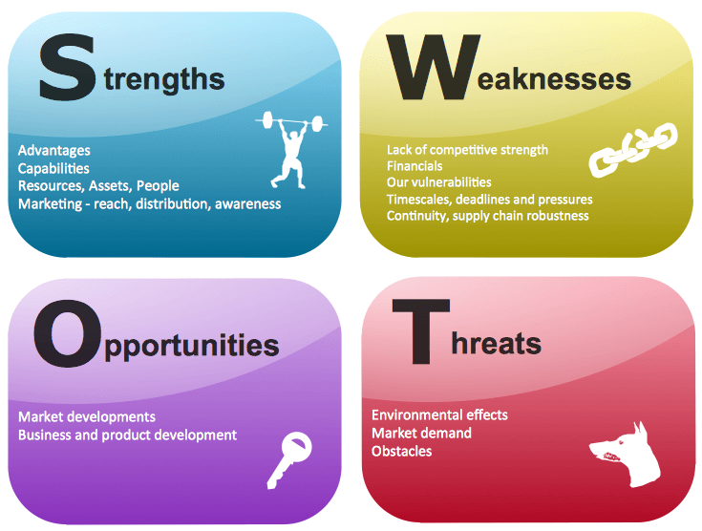

Strengths | Weaknesses
- Superior quality  - Deinking  - Brand image  - Efficient Machineries  - Economies of Scale  - Low input cost | - Training cost  - Chances of losing trained workers  - Forecasting
Opportunities | Threats
- Expansion capabilities  - Financing opportunities  - Diversification | - Competitors  - Government rules & regulations  - Competitors hiring trained workers  - Economic Fluctuations

- Strengths:

Strengths are those internal factors that give an organization a competitive edge.

- Supervisor Quality:

Sonali Paper and Board Mills Ltd. provides better quality papers in the form that the manufactured papers are smooth & uniform all over. This is turn delivers greater customer satisfaction.

- Deinking:

Generally the used papers are thrashed away. But Sonali Paper and Board Mills Ltd. buy those used papers & recycle them. They do this by implementing a German theory called “Deinking.” It is a process by which the ink can be removed from the papers. After recycling, the papers are resold. Hence, they can make an extra profit through the use of this technique.

- Brand Image:

Sonali Paper and Board Mills Ltd. has already established a favorable reputation in the paper industry of the country. It is one of the leading public limited company of Bangladesh known today. Through delivering better quality, it is struggling to be the best.

- Efficient Machineries:

Sonali Paper and Board Mills Ltd. imports its machineries which costs them 10 times more just because of its superior functioning & greater efficiency. This ensures superior quality.

- Economies of Scale:

Economies of scale are gained when average cost decreases as output increases. Due to its effective machineries & huge production capabilities, Sonali Paper and Board Mills Ltd. enjoys economies of scale. This results in low cost of production which can be passed on to consumers as lower prices, increasing market share or it can be kept as profit.

- Low input costs:

Sonali Paper and Board Mills Ltd. employ low paid workers which helps them to ensure low input costs. This can again be used to charge lower prices.

- Weaknesses:

Weaknesses are those internal factors which can cause an organization to lose its market share.

- Training Cost:

Since Sonali Paper and Board Mills Ltd. employs low skilled workers to ensure lower wages, they have to train them in order to make them produce the desired quality. As a result, the paper mill has to bear huge training costs. Sometimes, this training cost can become unimaginably greater than the benefits which may result in losses.

- Chances of Losing Trained Workers:

After training the workers to the desired level, it might happen that the workers leave their jobs. As a result, the training cost instrumented behind each worker goes in vain.

- Forecasting:

Sonali Paper and Board Mills Ltd. takes decisions on a weekly and sometimes on a monthly basis. They generally plan according to whatever situations they are facing currently. As a result, they are not very efficient in forecasting. On the other hand, the competitors are game makers, so they are really good at forecasting. They not only plan to make profits but they also plan how to take away profits from its opponents. Thus competitors remain one step ahead of Sonali Paper and Board Mills Ltd.

- Opportunities:

Opportunities are those external factors which helps an organization to grow in the near future.

- Expansion Capabilities:

Due to efficient machineries, Sonali Paper and Board Mills Ltd. always has room for expansion. When the economy is booming, the paper mill can easily increase its production level & utilize its spare capacity & earn huge profits.

- Financing Opportunities:

Since Sonali Paper and Board Mills Ltd. is the only public limited company in the paper industry, they have scope to raise finance easily whenever required. This is because the amount of authorized share is very large whereas the amount of issued share in the market is a small proportion of the authorized share. So, if Sonali Paper and Board Mills Ltd. require fund, they can issue another portion of their authorized share in the market.

- Diversification:

Diversification means having a greater variety of product lines. Since using paper many things can be made, Sonali Paper and Board Mills Ltd. can diversify itself by investing in paper-oriented goods.

- Threats:

Threats are those external factors which act as a risk for the existence of an organization.

- Competitors:

Since the existing competitors are game makers, they can implement predatory pricing policy to drive away opponents including Sonali Paper and Board Mills Ltd. This is a threat for the existence of the paper mill company.

- Government Rules & Regulations:

Currently government charges VAT in twofold. If there are any changes in these VAT systems, there could be a negative impact on the paper mill industry. Inclusion of any new taxation or paper work system can act as a threat for the company.
- Competitors hiring trained workers:

Once the workers are trained by Sonali Paper and Board Mills Ltd. completely, some strategies of manufacturing paper are open to them. Now if competitors hire these workers at a higher salary, these workers may leave the jobs & may join the competitors. As a result, there is a risk of unveiling strategies in front of competitors.

- Economic Fluctuations:

Economic fluctuations refer to booms & downturns of an economy. It is not really easy to predict when the economy would be booming or vice versa. This acts as a threat if the predictions are wrong to a very great extent.

Company Goal

Sonali Paper and Board Mills Ltd. wants to be recognized around the whole country as the “No. 1 for customers, investors, shareholders and employees, through minimizing costs and maximizing profits at reasonable price” – referred by company insiders.

Objectives:

Objectives are the specified future conditions that an organization hopes to achieve. It is a refined statement which must answer 3 questions:

- What the firm wants to do?
- When it wants to do?
- How it wants to do?

- Profitability Objectives:

Profitability objectives usually measure the efficiency of an organization. For the time being, Sonali Paper and Board Mills Ltd. has an objective to earn profit which not only helps to meet its operational expenses but also satisfy its shareholders with good amount of dividends.

- Strategy:

It focuses on increasing production to an optimum level where production cost is minimized through a strategy of lower input which gains higher output.

- Marketing objectives:

Marketing objectives usually measure performance related to products, markets, distribution & customer service objectives. Sonali Paper and Board Mills Ltd. wants to grow its market share in the near future.

- Strategy:

In order to do so, it plans to implement the strategy of GSM which means maintaining an uniform thickness of paper from every area.

- Productivity objectives:

Productivity objectives measure how well an organization is using its resources. During the production process, Sonali Paper and Board Mills Ltd. plans to attain maximum output with minimum input.

- Strategy:

They perform these activities using different strategies. They use the deinking policy to recycle used papers. In addition, they do not allow the water used in manufacturing to flow directly into the rivers. Rather, they retrieve the short fibers from the water & then let it flow.

- Financial Objectives:
Financial objectives reflect the firm’s capacity to acquire resources sufficient to acquire its objectives.

In the long term, Sonali Paper and Board Mills Ltd. wants to raise capital for new investment or any other expansion policies.

- Strategy:

It can easily issue its authorized shares in the stock exchange.

In the short term, Sonali Paper and Board Mills Ltd. wants to acquire resources for production purposes.

- Strategy:

It plans to earn at least a normal profit.

- Other objectives:

Sonali Paper and Board Mills Limited have objectives to work towards maintaining good relationship with its employees & to be environmental friendly.

- Strategy:

It tends to be effective in building good relationship with its employees by listening to their thoughts, by appreciating their work & by rewarding them with incentives whenever necessary. It tends to be environmental friendly by implementing ETP i.e. Environment Treatment Plant.

Limitations

In preparing this report certain limitations I faced:
- Lack of sufficient sources prevented verification of information
- The analysis presented here may vary with opinions of expert in this field.
- Some aspects of the report may be considered confidential by the organization
- Adequate efforts have been made to prepare this report. But since Sonali Paper and Board Mills Limited is a vast company, knowing its full operation is a difficult task. Therefore I had to make my report limited to Sonali Paper and Board Mills Limited of only the Marketing division.
- The time period of complete this report is not so much enough.
- I have not enough knowledge to prepare this report accurately.

Findings of the Study

Every study which is conducted has some findings which are very interesting implications of the study. So, my present report conducted on Sonali Paper & Board Mills Limited has also some interesting implications which are as follows:

Situational Analysis

There are some internal & external factors within on organization. Sonali Paper & Board Mills Limited also has some internal & external factors.

Internal Factors:

Internal factors identifies the settings where managers work, the day-to-day activities that utilizes much of their time, & some generalized skills necessary to cope up. In other words, the internal factors include the day-to-day forces within the organization in which managers perform their functions. There are many internal factors within Sonali Paper & Board Mills Limited It includes:

- Level of Management:

Most organizations function on three district but overlapping levels, each requiring a different managerial focus & emphasize. They include the strategic level, the technical level & the operations level. Managers at each of these three levels must plan, organize, lead & control.

- Strategic Level:

The strategic level determines the long range objectives & direction for the organization. Managing Director, CFO & Directors who constitute the top management level are responsible to perform the job in this level of the organization. They do the planning functions which include setting up the mission of Sonali Paper & Board Mills Limited Further the strategic level must make sure that the technical level operates within the bounds of the society. Executive Director, Director Technical & Director Admin of Sonali Paper & Board Mills Limited empower the managers at the technical level so that they can make decisions on their own regarding all the technical activities.

- Technical Level:

As an organization increases in size, someone must coordinate the activities at the operation level as well as decide which products or services to produce. These problems are the focuses of the technical level. Here, managers of Sonali Paper and Board Mills Limited perform the organizing function of the company. It usually includes the allocation of resources & acts as a liaison between lower & top level management. Technical managers provide assigned tasks to lower level managers. In this level, senior executive officers are responsible to do the job. Sometimes electrical, mechanical & foreign specialists are also involved.

- Operations Level:

The operations level focuses on effectively performing whatever the organization produces or does. The managers in this level are engaged in performing day-to-day activities, e.g. ensuring the best allocation of resources producing paper according to the desired output, etc. Hence, operations functions are at the core of Sonali Paper and Board Mills Ltd.

- Technology & The Impact:

Technology is another very important factor. In order to ensure reduced cost Sonali Paper and Board Mills Ltd. could have used machines imported from China which costs only 20-30 crore but to bring qualitative papers in the market, the paper mill imported expensive machineries which cost them 10 times more. Using such high technology based machines was a thriving act, implemented by the managers of the company.

- Human Resource:

Human Resource is perhaps the most important factor within an organization. The people who work within an organization play a vital role in operating the company. Although Sonali Paper and Board Mills Ltd. does not employ the best employees like Bashundhura Group but they know how to get the best from their employees. They do not look for high education skills on papers rather they look for hardworking efficient people. That is why they even employ retired army people who are not educated in this field but Sonali Paper and Board Mills Ltd.trains them & makes them capable of handling the paper mill operations. Thus, they may not have the most brilliant employees, but they do have hardworking & trustworthy employees. In addition, they maintain an excellent interpersonal relationship within the management level.

External Factors:

External factors are the forces that act on the organization from outside. Sonali Paper and Board Mills Ltd.also has some external factors. These factors may be direct, exerting an immediate & direct influence on the organization, or they may be indirect, influencing the climate in which the organization operates.

- Direct Factors:

The major direct forces of an organization are the customers the organization must satisfy, the competitors with whom the organization must effectively compete for customers & the suppliers that provide the organization with essential resources.

- Customers:

Customers purchase an organization’s products or services. Sonali Paper and Board Mills Ltd. does not maintain direct contact with its final users. Rather they contract the manufactured papers among different agents & dealers who in turn sell the papers to the consumers. But whatever is the case, the main focus is in maintaining quality at low costs to ensure reasonable price at all time.

- Competitors:

Competitors are an organization’s opponents, the companies against which the organization compete for customers & needed resources. The biggest competitor of Sonali Paper and Board Mills Ltd. is Bashundhara Group. Next are Meghna Group, Creative Paper Mill., TK paper mill & Capital paper mill. In order to maintain market share Sonali Paper and Board Mills Ltd. not only have to maintain quality but they have to ensure better quality in comparison to its opponents, that also at lower price.

- Suppliers:

All organizations require resources- pulp, funds & equipment to produce paper that succeeds in the market place. Suppliers are organizations that provide these resources. Since the suppliers’ output of pulp is in turn, the input of Sonali Paper and Board Mills Ltd. they acquire the pulp from suppliers of China & Canada. This helps them to ensure better quality, reduced costs & timeliness of delivery.

- Indirect Factors:

The major indirect factors of the organization are government regulations, economic forces and technology.

- Government Regulations:

Government has set up rules & regulations that every organization must abide by. Sonali Paper & Board Mills Ltd. respects the rules & regulations set by the government & promise to maintain them. They are quite good at keeping their promises to the government. However, when the government changes any of its rules & regulations, they are in trouble. In case of paper, government has imposed VAT in twofold: one is when the raw materials are imported & second is when the finished goods are sold. As a result, it becomes hard for Sonali Paper & Board Mills Ltd. to maintain reduced costs & lower prices. However, the paper mill is committed to follow the government regulations.

- Economic Forces:

Economic forces are changes in state’s economic condition such as GDP, unemployment rates, inflation rates, tax rates, tariffs, etc. Sonali Paper & Board Mills Ltd. successfully tries to keep with the changes in the economic conditions of Bangladesh. There are times when the company has to bear losses due to an economic downturn, while there are times when the economy is booming & they get the opportunity to maximize profits. Whatever the situation might be, Sonali Paper & Board Mills Ltd. goes on with their ongoing process.

- Technology:

Technological forces are developments in technology. Sonali Paper & Board Mills Ltd. always has to ensure that they are not using backward technology in compared to their competitors. Otherwise, the competitors can take away their market share at any time.

If we analysis pulp and paper market for 2019 we can find out below details about pulp and paper market in Bangladesh:

Products wise Market size in MT
Sl. No. | Product Variants | Total Market Size in MT/ Monthly
1 | Facial Tissue | 800
2 | Paper Napkin | 1,300
3 | Toilet Tissue | 1,360
4 | Kitchen Towel, Hand Towel, Clinical Bed sheet | 160
5 | Pocket Tissue and Wallet Tissueoters | 320
Total Market Size |  | 3,940

Tissue Market Growth Ratio:

In every year nature of FMGG (Tissue) market as well as sales volume growth average 20-25% from past year.

Tissue Products Market size in Bangladesh:
Sl No. | Product Variants | Market Size in MT/Month
01 | Bashundhara Tissue | 1900
02 | Bangla Tissue | 250
03 | Super touch (Super Star) | 100
04 | Fresh Tissue | 850
05 | Kasper Tissue | 180
06 | Hakkani | 300
07 | Sonali | 125
08 | Jononi | 150
09 | Fay | 40
10 | Safe | 15
11 | Nice | 30
Total |  | 3940

Export Tissue products:
Monthly 300-400 MT of tissue products export to various countries in Asia, Africa and Middle East.
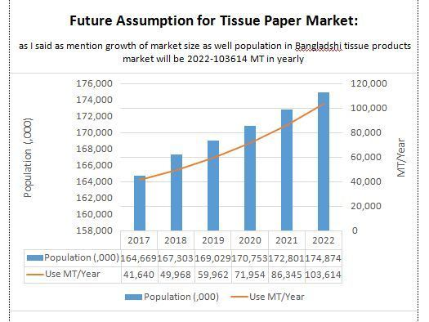

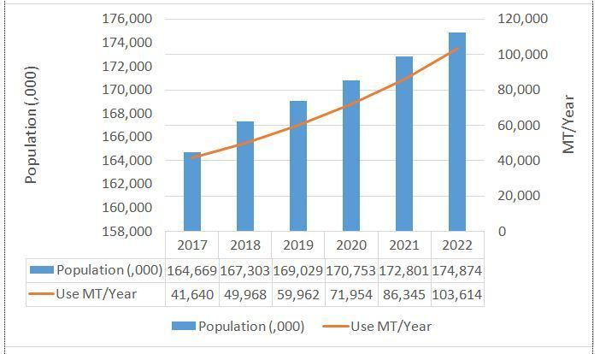

Recommendations

After completing the report on “Managing Marketing Insights For Better Market Management: A Study On Sonali Paper & Board Mills Limited” we are in position to recommend the following implications-

During my tenure as “Intern” in Sonali Paper & Board Mills Limited my placement was in “Marketing & Operation” department. I worked there for three months where I encountered some issues that I thought should catch the Sonali Paper & Board Mills Limited management. Sonali Paper & Board Mills Limited is one the biggest pulp and paper manufacturing in the country & it has been operating quite successfully. Although it has a healthy and steady growth in sales development in pulp and paper related product, the organization needs to address some of the bottlenecks found out at the time at internship program conducted for the concerned study. In the attempt to solve various problem so far identified in the study. The following recommendation can be out forward which are given below, are from observational point of view:

- Sonali Paper & Board Mills Limited should implement the best service providing strategy that will ensure more values for the existing and target customer.
- Sonali Paper & Board Mills Limited should implement internet marketing then the existing client and potential. Client will be benefited with the system.
- Sonali Paper & Board Mills Limited give the best services to the customers solve their problems and queries.
- Marketing and Operation department should run their activities in the most efficient and effective way. For ensuring better service they should recruit more people in this department.
- Marketing team is not satisfied with their sales commission. So they should provide them fix sales commission and some rewards. Like “the best performer” maybe awarded annually.
- Sonali Paper & Board Mills Limited should give more attention to solve their customer problems.
- Sonali Paper & Board Mills Limited can convey greetings to their present and potential clients in different occasions. It will create extra values for clients and make them more pleased and positive towards the company.

Conclusion

Sonali Paper and Board Mills Ltd. is one of the leading paper manufacturing organizations. It is committed to provide high quality grade papers to contribute to the growth of GDP of the country through stimulating trade & commerce accelerating the pace of industrialization, creating employment opportunity for the deserving candidates, alleviating poverty, raising standard of living & overall sustaining socio economic development of Bangladesh. The presence of such a giant company like Sonali Paper and Board Mills Ltd. is always appreciated by any country in the world.

It gave Bangladesh the opportunity to use quality grade papers. Also it is a quality employer ensuring good working conditions for its employees. It wants to provide the best possible quality papers at affordable prices to its customers & maintain a leading position in this sector. It also understands the responsibility that is vested upon it for being one of the most prestigious business entities’ in Bangladesh & therefore takes social, ethical & environmental issues into account in every step of its operations. Finally, Sonali Paper and Board Mills Ltd. will always try & work to be the number one choice for customers providing them with superior value.

References

- Philip Kotler (n.d.) Strategic Marketing Management, 7th edn.
- Philip Kotler (n.d.) Marketing Management, 14th edn.
- https://www.younusgroup.com (Accessed: 15th November 2019).
- En.wikipedia.org. (2019). Marketing strategy. [online] Available at: https://en.wikipedia.org/wiki/Marketing_strategy [Accessed 17 Nov. 2019].
- En.wikipedia.org. (2019). Marketing management. [online] Available at: https://en.wikipedia.org/wiki/Marketing_management [Accessed 13 Nov. 2019].
- Younus Group. (2019). Younus Group. [online] Available at: https://www.younusgroup.com/ [Accessed 10 Nov. 2019].

