Project Report

Promise Vs Reality
Of
Real Estate Sector



Submitted To
S M Asif-Ur- Rahman
Assistant Professor
School of Business and Economics

Submitted By
Sanjana Ferdous
111 133 093
Program: BBA
Major: Marketing

Date of Submission:
30th May, 2018

Letter of Transmittal

May 30, 2018
S M Asif-Ur- Rahman
Assistant Professor
School of Business and Economics
United International University
Badda, Dhaka.

Sir,
With due respect, I am here to submit the following report on Promise and Reality of various real estate companies of Bangladesh according to the instructions given by you.
I have completed the report through putting the theories and techniques I learnt throughout the BBA life. This report contains the actual scenario and services provided by the real estate sector. The following report is the result of my findings and efforts.
I appreciate this opportunity to work under you. I am eagerly waiting for your feedback on the overall report.

Sincerely,

Sanjana Ferdous
111 133 093

School of Business and Economics,
United International University.

Executive Summary
This report is basically focused on customer satisfaction by various builders company. By conducting a door to door survey my goal was to find out the gap between the promised and the reality in the real estate sector. After conducting the survey, all the information was analyzed. The analysis shows that the builder company may promise a lot of thing but actually they don’t tend to work as promised. As a result the customers are not being satisfied. Each question is analyzed individually in the report along with a graph so that it helps to understand the percentage of people which are satisfied and which are not satisfied.

Table of Contents
2 Introduction 8
2.1 Origin of the report 8
2.2 Background 8
2.3 Literature Review 9
2.4 Purpose of Statement 10
2.5 Scope and limitations 10
2.6 Methodology 11
2.6.1 Research Type 11
2.6.2 Data Type 11
2.6.3 Sample Size 12
2.6.4 Sampling technique 12
2.6.5 Data collection method 12
2.6.6 Data Analysis Method 12
2.6.7 Data presentation Method 12
3 Finding and Analysis 13
3.1 Elevator Placement in the Building 13
3.1.1 Verbal Analysis 13
3.1.2 Tabular Analysis 13
3.1.3 Graph 13
3.2 Fire Safety Planning of the Building 14
3.2.1 Verbal Analysis 14
3.2.2 Tabular Analysis 14
3.2.3 Graph 14
3.3 Drainage Design and Planning 15
3.3.1 Verbal Analysis 15
3.3.2 Tabular Analysis 15
3.3.3 Graph 15
3.4 Brightness or light in the house during day time 16
3.4.1 Verbal Analysis 16
3.4.2 Tabular Analysis 16
3.4.3 Graph 16
3.5 Ventilation System 17
3.5.1 Verbal Analysis 17
3.5.2 Tabular Analysis 17
Graph 17
3.6 Dampness in the House 18
3.6.1 Verbal Analysis 18
3.6.2 Tabular Analysis 18
3.6.3 Graph 18
3.7 Doors and windows operation 19
3.7.1 Verbal Analysis 19
3.7.2 Tabular Analysis 19
3.7.3 Graph 19
3.8 Architectural finishing work in Building 20
3.8.1 Verbal Analysis 20
3.8.2 Tabular Analysis 20
3.8.3 Graph 20
3.9 Energy Efficiency 21
3.9.1 Verbal analysis 21
3.9.2 Tabular Analysis 21
3.9.3 Graph 21
3.10 Rain protection during monsoon 22
3.10.1 Verbal Analysis 22
3.10.2 Tabular Analysis 22
3.10.3 Graph 22
3.11 Easy communication with customer service Department 23
3.11.1 Verbal Analysis 23
3.11.2 Tabular Analysis 23
3.11.3 Graph 23
3.12 Quick feedback/ management of problem from Customer Service 24
3.12.1 Verbal Analysis 24
3.12.2 Tabular Analysis 24
3.12.3 Graph 24
3.13 Easy step by step help in preparing documentation of the property 25
3.13.1 Verbal Analysis 25
3.13.2 25
3.13.3 Tabular Analysis 25
3.13.4 Graph 25
3.14 Easy access/ Availability of builder's personnel in maintenance time 26
3.14.1 Verbal Analysis 26
3.14.2 Tabular Analysis 26
3.14.3 Graph 26
3.15 I can rely on the builder's promises to solve problems or perform any specific service 27
3.15.1 Verbal Analysis 27
3.15.2 Tabular Analysis 27
3.15.3 Graph 27
4 Recommendations 28
5 Conclusion 29
6 References 30
7 Bibliography 30
8 Questionnaire 31

Introduction

Origin of the report

The report was assigned to us by my Internship Supervisor, Assistant Professor of Business and Economics department of United International University as a mandatory task of BBA Program. The topic had to be approved before I could pursue the project. A detailed list of instructions, which acted as a guideline to write the report, was also provided.

Background

It is essential at the start that we characterize the term real estate, and in addition some firmly related terms that are utilized all through this book. At the point when individuals consider land, they frequently think about the homes in their locale or the matter of purchasing and offering houses. This is most likely in light of the fact that the individual venture that most family units make in their home speaks to their essential contribution in the land showcase. Obviously, land incorporates our homes, as well as our work environment, trade, venerate, government, training, amusement, and stimulation our physical condition, regular and construct. Furthermore, it incorporates an extensive variety of business and institutional exercises related with the improvement, buy, utilize and offer of land and building.

Currently world is changing quickly to confront the test of aggressive free market economy. To keep pace with the pattern the each association require official with current information, to give new graduate present day hypothetical and expert learning about showcasing and all other distinctive administration, it is necessary to work on the relevant factors.

Bangladesh is a Southeast Asian nation. Its measurement just 1, 47,570 square kilometer yet it has an extensive populace and that is more than 160 million individuals. Now a large portion of the general population is brought together also, live in the city territory like there roughly 20 million individuals lived in Dhaka city. A substantial number of individuals are enduring by settlement/lodging issue. To comprehend this issue there are number of Real Estate Company are experienced childhood in Bangladesh. Presently there are in excess of 1500 land organizations precede with their task in Bangladesh and the aggregate number of organization.
But still there are lots of conflicts of opinion regarding consumers’ expectation and their experienced services. This report shows the promise and the real scenario of the services provided by the real estate companies.

Literature Review

Beyond providing physical shelter, housing may have significant impact on the lives of the dwellers in terms of skills enhancement, income generation, increased security, health, self-confidence and human dignity. Nordberg has clearly demonstrated that in most regions, housing has the potential of becoming an engine of economic growth because of its high yield on invested resources, a high multiplier effect, and a host of beneficial forward and backward linkages in the economy. Both the Constitution of the People‘s Republic of Bangladesh and the UN Declaration on Fundamental Rights recognizes shelter as one of the fundamental human rights. Making shelter available to all is increasingly becoming a significant challenge in Bangladesh. The economic development is far from satisfaction and the GDP per capita in 2010-11 is Tk. 26019 (Amin, 2011).

Moreover, a large portion of the population lives below the poverty line and are deprived of habitable shelter along with other basic services. Bangladesh, like many other developing countries faces an acute shortage of affordable housing both in the urban and rural areas (Aim Research Report, 2012). Moreover, housing affordability is being eroded by poor land administration policies, which have resulted in very high land prices that make urban housing prohibitive for lower-income groups; and in infrastructure that is inadequate for expansion into periurban and rural areas. There is no active secondary market for real estate, mainly because of the high transfer taxes and an uninterrupted long-term increase in land prices (hossain, 2012). Bangladesh is one of the most densely populated countries in the world.

Land prices are high and permanent housing is rare—barely 2% in rural areas and 23% in urban centers. Estimates suggest a shortage of about 5 million houses in Bangladesh, with as many as 500,000 houses added annually in urban areas and 3.5 million added in rural regions (Bhattacharya, 2013). Statistics show that Bangladesh will need to construct approximately 4 million new houses annually to meet the future demand of housing in the next twenty years. Dhaka, with a total population of over 10 million, is the 9th largest city in the world and also 28th among the most densely populated cities in the world (BanDh). While comparing the growth of the real estate and housing, and the construction sector with that of GDP, it was found that growths in the two sectors are the period 1992-2002 were 4.8 and 7.5% is much higher than the trend growth in GDP of 4.6% for that period. The shares of the real estate and housing sector and the construction sector in the GDP were quite high in the year 2002 and accounted for 8.3 and 8.0% respectively. However, the incremental contributions of these two sectors in the same year were also considerably high at 6.0 and 12.8% respectively ( (Smith, 2014). Experts opine that, Bangladesh will encounter high levels of urbanization by 2015 and by that time Dhaka will need to house about two crores people to become the fifth largest city in the world. So mitigation of this huge demand requires a long-term plan to be formulated so that a collective effort from both the private sector developers and individual developers may adequately provide for the huge demand (Rahman, 2015).

Purpose of Statement

The goal of the report is to analyze the customer’s feedback on real estate companies as per their expectation of services. Analyze the reality or the actual scenario regarding the services provided through the companies.

Scope and limitations
I faced the following hindrances while writing this report. The geographic extent of this exploration is bound to Dhaka city. To find out the promised and provided services by the developer companies sample tests were drawn from the current and potential flat owners inside Dhaka city.

- Unavailability of documents or proof: Literally I had to believe to the things said by the furious consumers but I couldn’t gather any documents in which the promised services were mentioned.

- Time Constraints: As there is limited for conducting survey it was hard to collect huge number of data.

- Financially Expensive: Conducting door to door survey takes financial sponsor. Because I had to personally visit the flat owners so the transportation cost is working as constraints on this survey.

- New Researcher: Being a new researcher its hard to combine everything smoothly.

Methodology

Selection of the sample: To qualify for selection, a respondent had to understand question properly and have lived in the home for more than 1 month. The customers determined the eligibility of each respondent based on location of site and geographic area. All resident satisfying the criteria were invited to participate in the survey. Questionnaire distributed to male and female of demographic area. If respondents understand question properly then respondents complete the question themselves.

Research Type

Quantitative Research

This examination depends on numeric figures or numbers. Quantitative research expects to quantify the amount or sum and compare it with past records and tries to extend for future period. In sociologies, "quantitative research alludes to the methodical observational examination of quantitative properties and marvels and their connections". The goal of quantitative research is to create and utilize numerical models, speculations or theory relating to marvels. The procedure of estimation is key to quantitative research since it gives central association between experimental perception and scientific articulation of quantitative connections. A measurement is the most generally utilized branch of arithmetic in quantitative research.

Data Type

The team has conducted both primary and secondary research for collecting the data and information used in this report. The primary purpose of developing the attributes to use it in a research work aimed to exploring the influences of various factors (Design and planning, quality, and service) on residential customer satisfaction. Hence this work wished to include a variety of residential customer responses from various geographic areas. This report will show various problems faced by home buyers.

Primary data source:
        - Personal Interview
        - Questionnaire was also provided to them during the interview.
        - Telephone Enquiry
        - Survey

Secondary data source:
A number of websites were used to gather information.

Sample Size

Selection of the sample: To qualify for selection, a respondent had to understand question properly and have lived in the home for more than 1 month. The customers determined the eligibility of each respondent based on location of site and geographic area. All resident satisfying the criteria were invited to participate in the survey.

Sampling technique

Questionnaire distributed to male and female of demographic area. If respondents understand question properly then respondents complete the question themselves. The questionnaire was sent to the different zones defined above at different dates to collect data. Within a zone, the RAs randomly approached potential sampling elements and collected responses from those sampling units who have willingly participated in the survey.

Data collection method
Respondents were presented with a questionnaire, set of questions regarding their own real estate company.

Data Analysis Method
Quantitative analysis was done using statistical and mathematical tools such as Ms Excel.

Data presentation Method
Result of the analysis was presented based on three categories
- Verbal analysis
- Tabular analysis
- Graph

Finding and Analysis

Elevator Placement in the Building

Verbal Analysis
People are quite happy with the elevator placement. As we can see 37% people have marked excellent and very few people has marked the worst so it indicates that there is no major problem from the element.

Tabular Analysis

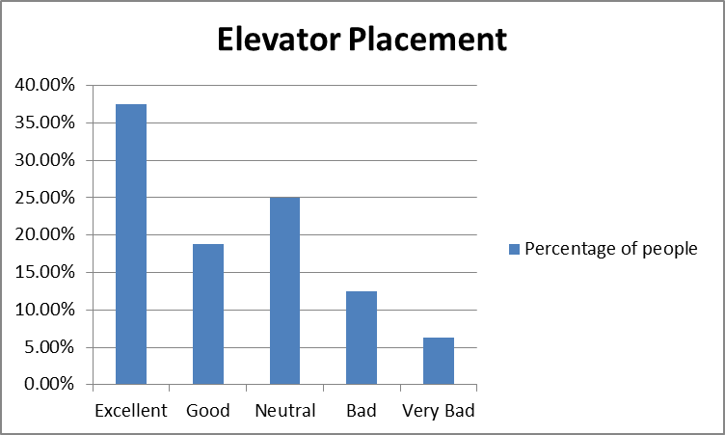

Graph

Fire Safety Planning of the Building

Verbal Analysis
From the chart we can see 34% people are in neutral position which indicates they are not happy neither furious but only 11% people marked excellent which is a negative side because the aim is to make the larger portion excellent.

Tabular Analysis
Variable | Number of People | Percentage of people | Total
Excellent | 9 | 11% | 80
Good | 15 | 19% | 80
Neutral | 27 | 34% | 80
Bad | 18 | 23% | 80
Very Bad | 11 | 14% | 80

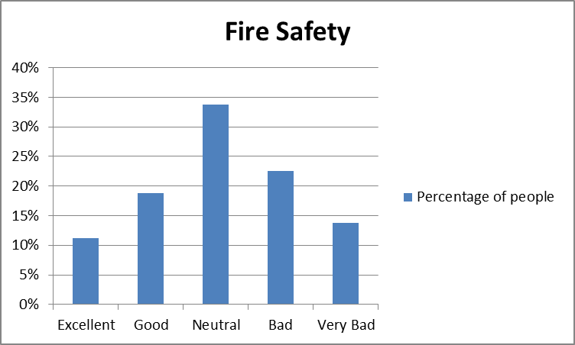

Graph

Drainage Design and Planning

Verbal Analysis
In this chart we can see 48% people are in neutral position which indicates a comparatively positive situation and 0% people marked very bad which also shows positivity. Though the services need to be improved in order to increase the portion of excellence.

Tabular Analysis
Variable | Number of People | Frequency | Total
Excellent | 12 | 15% | 80
Good | 23 | 29% | 80
Neutral | 38 | 48% | 80
Bad | 7 | 9% | 80
Very Bad | 0 | 0% | 80

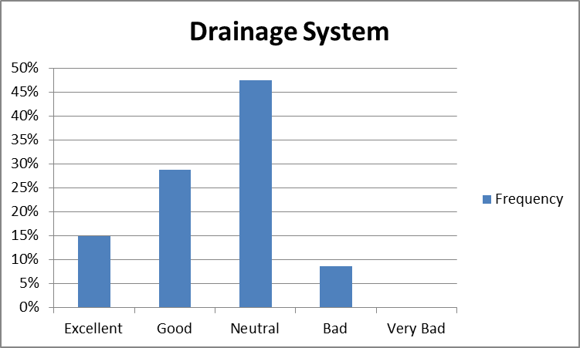

Graph

Brightness or light in the house during day time

Verbal Analysis
In this chart, it shows that the customers are quiet happy with their services. 40% of the consumers marked well, while only 4% marked very bad. But the moto is to get high portion from excellence.

Tabular Analysis
Variable | Number of People | Frequency | Total
Excellent | 18 | 23% | 80
Good | 32 | 40% | 80
Neutral | 19 | 24% | 80
Bad | 8 | 10% | 80
Very Bad | 3 | 4% | 80

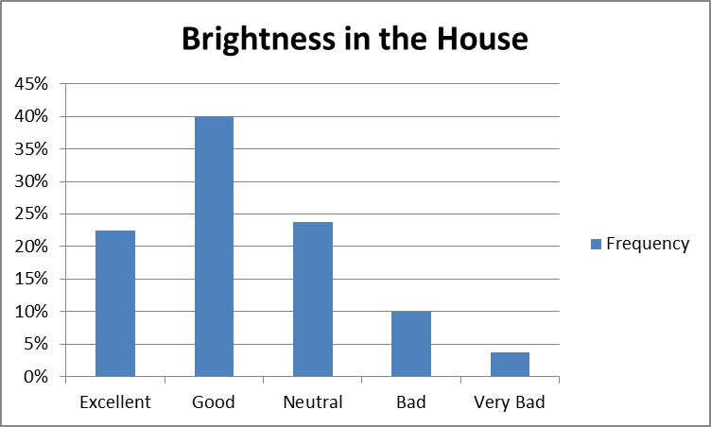

Graph

Ventilation System

Verbal Analysis
It seems that the customers are highly satisfied in this section which means that the ventilation system of their houses is good enough. Positive side is that 0% people marked bad and few very bad. But large portion marked well.

Tabular Analysis
Variable | Number of People | Frequency | Total
Excellent | 27 | 33.75% | 80
Good | 31 | 38.75% | 80
Neutral | 15 | 18.75% | 80
Bad | 0 | 0.00% | 80
Very Bad | 7 | 8.75% | 80

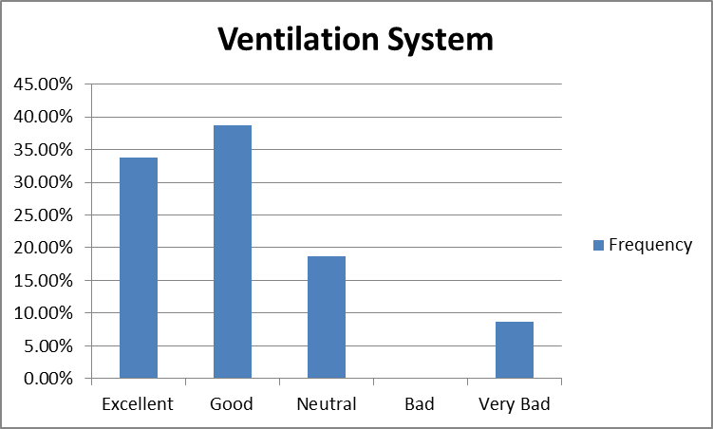

Graph

Dampness in the House

Verbal Analysis
The chart shows that 36% people are in neutral situation and only 21% people are suffering from dampness. The rest 39% people are happy with their house condition.

Tabular Analysis
Variable | Number of People | Frequency | Total
Excellent | 22 | 27.50% | 80
Good | 10 | 12.50% | 80
Neutral | 29 | 36.25% | 80
Bad | 15 | 18.75% | 80
Very Bad | 4 | 5.00% | 80

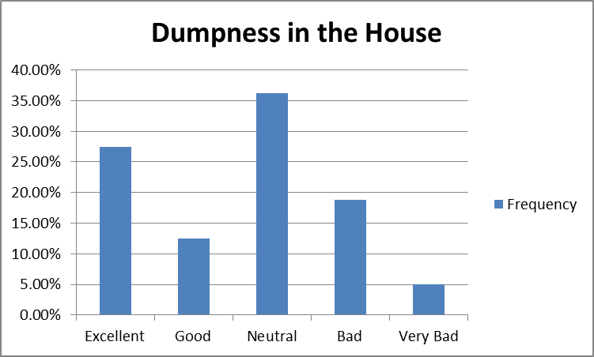

Graph

Doors and windows operation

Verbal Analysis
It is a very positive side that the large proportionate are happy which is 56% people marked good. The negative side is that the people who suffer from problems regarding doors and windows, they suffer really badly. As a result they put very bad. Though the percentage of those is really low.

Tabular Analysis
Variable | Number of People | Frequency | Total
Excellent | 3 | 3.75% | 80
Good | 45 | 56.25% | 80
Neutral | 27 | 33.75% | 80
Bad | 0 | 0.00% | 80
Very Bad | 5 | 6.25% | 80

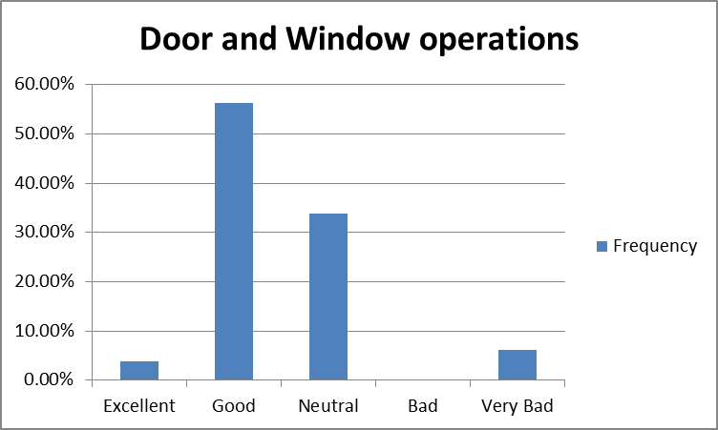

Graph

Architectural finishing work in Building

Verbal Analysis
The positive side of this section is that 40% people are in neutral situation. There is no negative option marked. But still it needs improvement

Tabular Analysis
Variable | Number of People | Frequency | Total
Excellent | 15 | 18.75% | 80
Good | 19 | 23.75% | 80
Neutral | 46 | 57.50% | 80
Bad | 0 | 0.00% | 80
Very Bad | 0 | 0.00% | 80

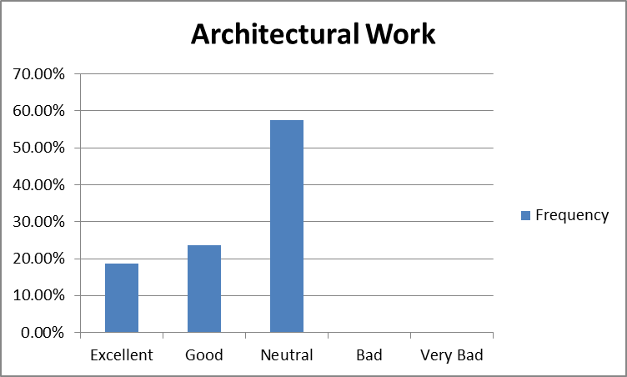

Graph

Energy Efficiency

Verbal analysis
In perspective of Bangladesh, there is always load shedding in most of the areas. So very few people are satisfied. Most of the people seem to have marked negatively.

Tabular Analysis
Variable | Number of People | Frequency | Total
Excellent | 1 | 1.25% | 80
Good | 15 | 18.75% | 80
Neutral | 11 | 13.75% | 80
Bad | 14 | 17.50% | 80
Very Bad | 39 | 48.75% | 80

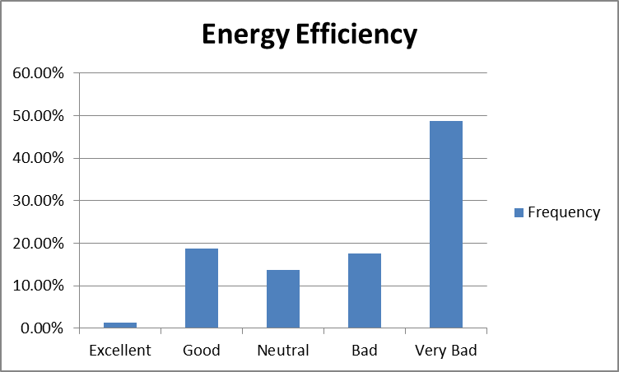

Graph

Rain protection during monsoon

Verbal Analysis
The chart shows a very harsh condition. About 43% people are heavily dissatisfied about rain protection. This section needs improvement.

Tabular Analysis
Variable | Number of People | Frequency | Total
Excellent | 10 | 12.50% | 80
Good | 28 | 35.00% | 80
Neutral | 0 | 0.00% | 80
Bad | 7 | 8.75% | 80
Very Bad | 35 | 43.75% | 80

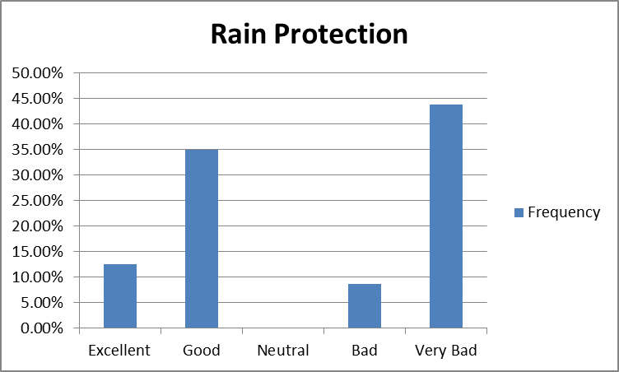

Graph

Easy communication with customer service Department

Verbal Analysis
It’s a positive indication that large proportion of people is in neutral situation which means they are okay with the service of customer department.

Tabular Analysis
Variable | Number of People | Frequency | Total
Excellent | 0 | 0.00% | 80
Good | 15 | 18.75% | 80
Neutral | 48 | 60.00% | 80
Bad | 11 | 13.75% | 80
Very Bad | 6 | 7.50% | 80

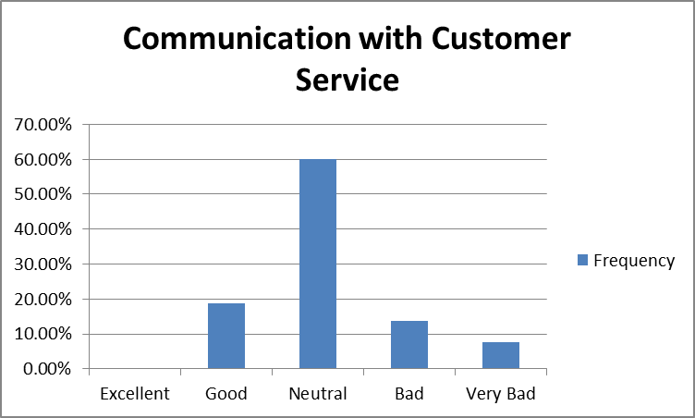

Graph

Quick feedback/ management of problem from Customer Service

Verbal Analysis
48% of the people are highly dissatisfied which is a severe situation. They don’t get help immediately from customer service.

Tabular Analysis
Variable | Number of People | Frequency | Total
Excellent | 0 | 0.00% | 80
Good | 0 | 0.00% | 80
Neutral | 16 | 20.00% | 80
Bad | 25 | 31.25% | 80
Very Bad | 39 | 48.75% | 80

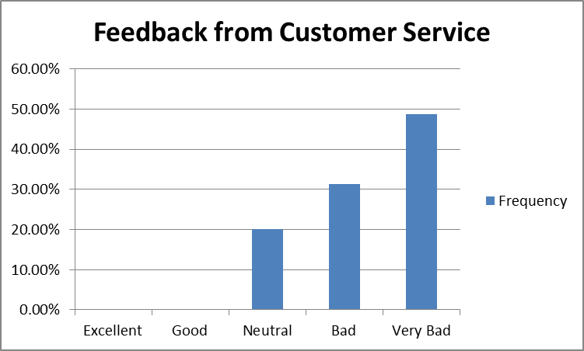

Graph

Easy step by step help in preparing documentation of the property

Verbal Analysis
76% of people are in neutral situation but there should have been more number of people to mark positively. Only3-4% people agree with the ter. Satisfaction level is really very low.

Tabular Analysis
Variable | Number of People | Frequency | Total
Strongly Agree | 0 | 0.00% | 80
Agree | 3 | 3.75% | 80
Neutral | 61 | 76.25% | 80
Disagree | 13 | 16.25% | 80
Strongly Disagree | 3 | 3.75% | 80

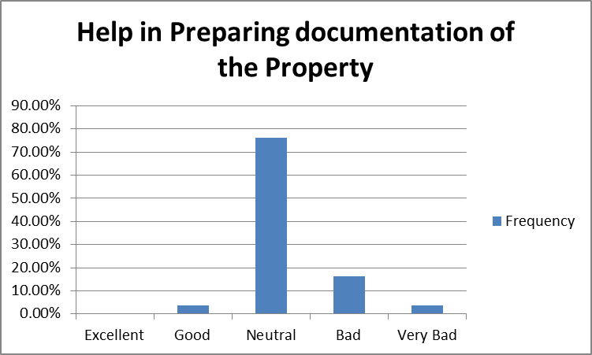

Graph

Easy access/ Availability of builder's personnel in maintenance time

Verbal Analysis
Personnel were available mostly as indicated that 72% people are quiet okay with the term. Satisfaction level is medium.

Tabular Analysis
Variable | Number of People | Frequency | Total
Strongly Agree | 0 | 0.00% | 80
Agree | 15 | 18.75% | 80
Neutral | 58 | 72.50% | 80
Disagree | 7 | 8.75% | 80
Strongly Disagree | 0 | 0.00% | 80

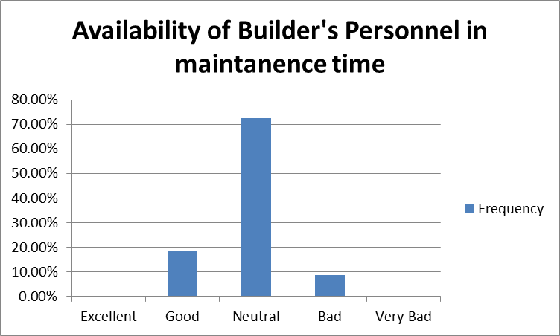

Graph

I can rely on the builder's promises to solve problems or perform any specific service

Verbal Analysis
Satisfaction on reliance level is medium. 71% people are in neutral situation.

Tabular Analysis
Variable | Number of People | Frequency | Total
Strongly Agree | 0 | 0.00% | 80
Agree | 8 | 10.00% | 80
Neutral | 57 | 71.25% | 80
Disagree | 15 | 18.75% | 80
Strongly Disagree | 0 | 0.00% | 80

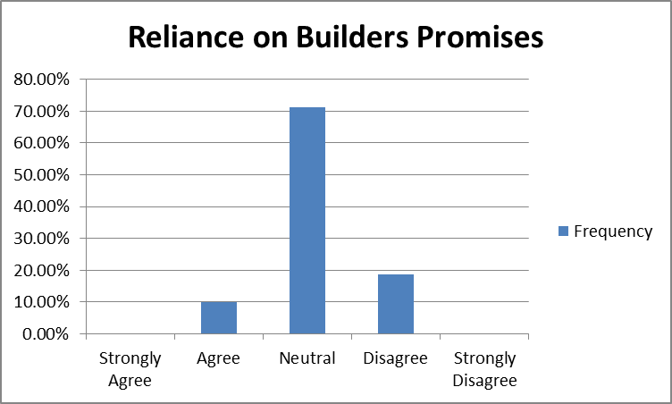

Graph

Recommendations

The objective of this research was to gather a comprehensive idea about the Real Estate sector of Bangladesh. During this study, the research team observed many things and identified some important issues that are to be noted and taken under consideration for ensuring a sustainable growth in this sector. Based on the observations of the researchers and outcomes of this research the following recommendations can be made:

- Necessary steps should be taken to improve the lacking parts and to satisfy the consumers.

- From the overview, it was discovered that in up and coming 10 years there is an interest for around 100,000 pads in or around the Dhaka city. So there is a colossal interest for ready made pads among the potential purchasers. From the overview, it was additionally discovered that, the 40-50 age groups are quicker to buy pads inside a long time from now. Additionally, among various word related gatherings, Businessmen, Bankers and Doctors (both Govt. benefit holders and private experts) are all the more ready to assemble their own particular houses or buy pads. So the Real Estate designers should develop suitable showcasing devices to focus on these gatherings of individuals.

- With this huge demand for flats in future, private Real Estate Sector has plenty of opportunities to play an important role in satisfying the housing needs of the people. The total volume of Real Estate sector has increased every year satisfying the housing needs of the urban people in the last few decades. And also contributions to the Government exchequer through Registration Fees, VAT, Advance Income Tax (AIT), Stamp Duty, Property Handover Tax etc. has increased every year. In future, this sector has enormous potential to expand its volume and thus contribute more in the national economy. For this, sufficient the Government assistance is required. While negotiating with the Government, this can be argued that, rather than tightening the grip to regulate this sector, if the Government takes initiatives to support this sector to grow and expand its volume, then this sector will be able to contribute more not only by generating more revenue to the Government but also by generating more employment opportunities to the people and by satisfying the essential housing needs of the people.

Conclusion

With a rising population and increasing housing demand, apartment culture has grown up in Dhaka sharply. Apartments were first introduced by the formal private developers in early 80s to the housing history of Dhaka. It first appeared in Dhaka near Central Road and subsequently the city experienced a boom in apartment development in all residential areas including Paribagh, Maghbazar, Siddeshwari, Shantinagar, Dhanmondi, Mirpur, Banani, old DOHS, new DOHS, Gulshan and Baridhara, to name just a few. During the last decade, the total volume of Real Estate, Renting and Business service sector increased every year which implies a positive growth in the sector every year.

But the inconsistency between the promised services and provided services may result In making people avoid taking help from builder company which may affect our economy.

References

Bangladesh China Friendship Conference Centre. Dhaka: Sceduled Bank Statistics.
Aims of Bangladesh. (2012). Real estate sector .
Amin, S. (2011). Weber's Perspective on city and Culture. University of Dhaka, Department of Sociology. Dhaka: Contemporary urbanisation of Bangladesh,.
Bhattacharya, C. K. (2013). Strengthing the Role of Private Sector Housing.
hossain, A. (2012). Rehab in the Development of the society. Paper present at the Rehab Week Seminar.
Rahman, M. M. (2015). Real Estate Financing in Bangladesh: Problems,Programs and Prospects. The AIUB Journal of Business and Economics , Vol 7, No-2.
Smith, M. C. (2014). Housing Finance in Bangladesh: Improving Access to Housing Finance by Middle and Lower Income Groups. 98-103.

Bibliography

1. Marketing Research/ 6th edition/ Naresh K. Malhotra, Satyabhushan Dash
2. Marketing Management/ 13th edition/ Philip Kotler, Abraham Koshy
3. A comprehensive study on real estate sector of Bangladesh/ Thesis paper on Mr.
Iftekharul Amin/ Lecturer IBA, University of Dhaka
4. Real estate market in Bangladesh/ Thesis paper on Mr. Tarikul Islam/ Masters Student of
the Royal institute of technology Stockholm, Sweden
5. The dynamics of residential real estate sector in Bangladesh/ Journal on management
study department, University of Dhaka

Questionnaire

Customers Satisfaction Questionnaire

Your feedback is very valuable to calculate the consistency between the promised services and service provided by your house building builder companies.

1. Elevator Placement in the Building
Perfect | Good | Neutral | Bad | Very Bad

2. Fire safety planning of the building
Perfect | Good | Neutral | Bad | Very Bad

3. Drainage design and planning
Perfect | Good | Neutral | Bad | Very Bad

4. Brightness or light in the house during day time
Perfect | Good | Neutral | Bad | Very Bad

5. Ventilation System
Perfect | Good | Neutral | Bad | Very Bad

6. Dampness in the house
Not Visible | Slightly Visible | Clearly Visible

7. Doors and windows operation
Perfect | Good | Neutral | Bad | Very Bad

8. Architectural finishing work in building (like plastering, painting, cladding)
Perfect | Good | Neutral | Bad | Very Bad

9. Energy Efficiency
Perfect | Good | Neutral | Bad | Very Bad

10. Rain protection during monsoon (like leakage and cracking in roof)
Perfect | Good | Neutral | Bad | Very Bad

11. Easy communication with customer service department -
Perfect | Good | Neutral | Bad | Very Bad

12. Quick feedback/ management of problem from Customer Service
Perfect | Good | Neutral | Bad | Very Bad

13. Easy step by step help in preparing documentation of the property
Strongly Agree | Agree | Neutral | Disagree | Strongly Disagree

14. Easy access/ Availability of builder's personnel in maintenance time
Strongly Agree | Agree | Neutral | Disagree | Strongly Disagree

15. I can rely on the builder's promises to solve problems or perform any specific service
Strongly Agree | Agree | Neutral | Disagree | Strongly Disagree

