
PROJECT REPORT



HR Role in Managing Workforce Diversity in organization- “A Case Study on United Commercial Bank Limited”.

This report is submitted to the school of Business and Economics, United International University as a partial requirement for the degree fulfillment of Bachelor of Business Administration Program.

Project Report
On
HR Role in Managing Workforce Diversity in organization- “A Case Study on United Commercial Bank Limited”.

Course code: INT 4399
Submitted To
Shayla Khanam
Assistant Professor
School of Business & Economics
United International University
Submitted By
Sunzida Akther Chowdhury
ID: 111 181 010
Enroll: SPRING 2022
Bachelor of Business Administration
Major in Human Resource Management
School of Business and Economics
United International University
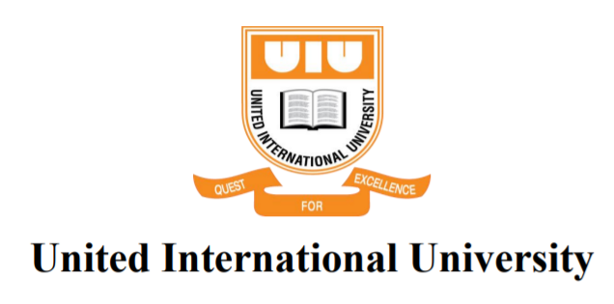
Date of Submission
February 04, 2023

Letter of Transmittal
February 04, 2023
Shayla Khanam
Assistant Professor
School of Business & Economics
United International University
Subject: Submission of Project Report on “HR Role in Managing Workforce Diversity in organization- A case study on United Commercial Bank Limited.”
Dear Mam,
I am writing to submit my project report as required by the BBA department at United International University. The internship provided me with valuable hands-on experience in creating and implementing HR programs and workforce diversity management practices of United Commercial Bank Limited.
As a result of this, I am presenting the report that I created during my project time for your review and consideration. In the event that there are any further queries about the content of my report, I will do my best to answer them.
Thank you for your time and consideration.

Sunzida Akther Chowdhury
ID: 111 181 010
Bachelor of Business Administration; Major in Human Resource Management
School of Business and Economics
United International University

Declaration of the Student
I, Sunzida Akhter Chowdhury, declare that the project report entitled “HR Role in Managing Workforce Diversity of United Commercial Bank Limited” is a result of my own work and efforts during my project time to study on one of the renowned private commercial bank in Bangladesh which is United Commercial Bank Limited. This report has not been submitted to any other university or institution in order to get credit toward the completion of any other degree or diploma program. All sources used have been properly acknowledged and referenced in accordance with the guidelines provided by United International University.

Sunzida Akther Chowdhury
ID: 111 181 010
Bachelor of Business Administration; Major in Human Resource Management
School of Business and Economics
United International University

Letter of Acknowledgment
I would like to express my deep gratitude to all those who have supported and guided me throughout my project journey. This report would not have been possible without the valuable contributions and support of many individuals.
First and foremost, I would like to extend my sincere appreciation to my project supervisor, Shayla Khanam, Assistant Professor, School of Business and Economics at United International University for her invaluable guidance and support throughout the duration of my internship. Her expertise and support were instrumental in shaping my understanding of the field of school education and marketing strategies.
I would like to express my gratitude to Tanjum Nisha, Officer at UCBL for supporting me to prepare this report. Finally, I would also like to extend my sincere appreciation to the all employees of UCBL (Gulshan Branch) for participating in the interview sessions and survey.

Table of Contents
Project Report 2
Executive Summary vi
1.1 Introduction of the Report 2
1.2 Objectives of the Report 2
1.2.1 Broad Objective 2
1.2.2 Specific Objectives 2
1.3 Scope of the Report 3
1.4 Methodology of the Report 3
a) Primary Sources 3
b) Secondary Sources 3
1.5 Data Analysis Plan 4
1.5.1 Research Design 4
1.5.2 Sample Selection 4
1.5.3 Questionnaire Development 4
1.5.4 Data Collection and Analysis Plan 4
1.5.5 Data Analysis Plan 5
1.5.6 Interpretation and Reporting 5
1.6 Limitations of the Report 5
2.1 Work Force Diversity 7
2.2 Work Force Diversity Management 7
2.3 Benefits and Limitations of Diversity Management in Organizations 8
2.4 The Role of HRM in Diversity Management 9
2.4.1 Diversity Related Recruitment Programs 10
2.4.2 Diversity Related Selection Programs 11
2.4.3 Diversity Related Training Programs 11
2.4.4 Diversity Related Performance Management Programs 12
2.4.5 Diversity Related Reward Programs 12
2.4.6 Diversity Related Career Development Programs 13
3.1 Overview of the United Commercial Bank Limited 15
3.2 Vision, Mission, Objectives and Core Values 16
3.3 Organogram 18
3.4 Products and Services 19
3.5 Business Policies and Ethics 20
3.6 Human Resource Management and Development 21
4.1 Analysis of Demographic Characteristics 23
4.1.1 Ratio of Gender 23
4.1.2 Ratio of Participates’ Age 24
4.1.3 Ratio of Participates’ Educational Background 24
4.1.4 Ratio of Participates’ Designation 25
4.1.5 Ratio of Participates’ Working Experiences 26
4.2 Descriptive Analysis 27
Statement 01: The organization follows Equal Employment Opportunity (EEO) standards on its recruitment and selection process which are treated as fairly regardless of the gender, race, or ethnicity of the candidates. 27
Statement 03: For the purpose of diversity management, organization has built comprehensive in-house diversity training programs. 28
Statement 04: The organization’s in-house diversity training programs ensure that all workers have an equal chance for training and development. 29
Statement 05: The organization’s in-house diversity training programs place a primary focus on satisfying the requirements of employees who come from a variety of backgrounds. 30
Statement 06: Provision of access to the organization's training programs encourages workers to take more action toward achieving their goals. 31
4.3 Findings 39
5.1 Recommendation 42
5.2 Conclusion 43
Survey Questionnaire 44

Executive Summary
In the competitive business world, Human Resources (HR) practices are essential for the success of an organization. The workforce is one of the most valuable assets of a business, and it is the department of human resources' job to oversee its management and development. Managing workforce diversity is important for a bank because it can lead to improved performance, increased innovation, better customer service, greater employee engagement and compliance with laws and regulations. The role of HR in managing workforce diversity in a bank includes creating and implementing policies and programs that promote a diverse and inclusive work environment. This includes recruiting and hiring a diverse workforce, providing training and development opportunities, and promoting a culture of respect and inclusion. United Commercial Bank Limited is a well renowned private commercial bank in Bangladesh and around 4thousnd employees are working in this organization and they are likely to have a comprehensive set of policies and procedures in place to govern its HR practices and ensure ethical behavior. The main purpose of this report is to study and analyze the current state of workforce diversity management practices in the United Commercial Bank Limited by the HR department and identifies the challenges of HR to play a role in managing the workforce within the organization.
In order to examine the issue, a standard questionnaire has been prepared. Data have been collected through survey from the employees of the United Commercial Bank Limited. The role of HR in managing workforce diversity in United Commercial Bank Limited includes creating and implementing policies and programs that promote a diverse and inclusive work environment. This includes recruiting and hiring a diverse workforce, providing training and development opportunities, and promoting a culture of respect and inclusion. The collected data have been analyzed by descriptive way, and draw the conclusion and recommendation according to the analysis and findings part.
Keywords: Human Resource Management, Workforce Diversity Management; HR Role in workforce diversity management, Banking Industry of Bangladesh.

CHAPTER 01
INTRODUCTION

Introduction of the Report
Management of diversity is essential in a financial institution for a variety of reasons. In the first place, it contributes to the formation of a more welcoming and considerate working atmosphere for all workers, irrespective of their origins or the qualities they possess. This can lead to improved morale and productivity among employees, and can also help to attract and retain top talent. Second, a group comprised of individuals from a variety of backgrounds is more likely to generate original ideas that have the potential to enhance the products and services that the firm provides to its clientele. Lastly, banks that are seen as being committed to diversity and inclusion can help to improve its reputation and build trust with customers from diverse backgrounds.
Additionally, HR plays a crucial role in diversity management in a bank by developing and implementing policies and programs that promote a diverse and inclusive workplace. This involves actively seeking out applicants from a wide range of backgrounds, giving education and training on issues pertaining to diversity and inclusion, and cultivating a culture that recognizes and respects all staff members. HR also plays a key role in addressing and preventing discrimination and harassment and in promoting and supporting diversity and inclusion at all levels of the organization. Moreover, HR is responsible for monitoring and reporting on the bank's progress in meeting its diversity and inclusion goals and for ensuring that the bank is in compliance with all relevant laws and regulations. The primary objective of this research is to conduct an investigation of the part that human resources play in the management of workforce diversity at the United Commercial Bank Limited. The completion of this project report fulfills a requirement for the Bachelor of Business Administration degree for the successful completion of the Internship program at United International University under the supervision of Shayla khanam, Assistant Professor, Business and Economics, United International University.

Objectives of the Report

Broad Objective
The primary objective of this study is to do study on the function of human resources in the United Commercial Bank Limited's management of the bank's diverse workforce.

Specific Objectives
- Identifying the current state of workforce diversity in the banking industry in Bangladesh and its impact on organizational performance.
- Analyzing the strategies and policies implemented by the HR of United Commercial Bank Limited to promote diversity and inclusion in the workplace.
- Examining the challenges faced by the HR of United Commercial Bank Limited in managing workforce diversity and potential solutions to overcome these challenges.
- Proposing recommendations for the HR of United Commercial Bank Limited to effectively manage workforce diversity and improve organizational performance.

Scope of the Report
The scope of the report on the HR role in managing workforce diversity in the private commercial banking industry of Bangladesh would likely include an examination of the current state of diversity within the industry, including demographic data on the makeup of the workforce. It would also likely include an analysis of the policies and practices currently in place to promote and manage diversity within the industry, as well as an examination of the potential challenges and opportunities for improving diversity management in the banking sector of Bangladesh. Additionally, the report might also include recommendations for actions that could be taken by HR professionals and organizations to effectively manage and leverage workforce diversity in the industry.

Methodology of the Report
In order to compile the report, both primary and secondary sources of data and information have been utilized.

Primary Sources
Interviewing employees and HR staffs of United Commercial Bank Limited, and observing different organizational HR processes and structures, are used in the collection of primary data. The original data were mostly gathered through conversations with staff members as well as responses to questionnaires sent to employees of United Commercial Bank Limited (Gulshan Branch) for conducting a survey and the total number of sample size is 15.

Secondary Sources
Additionally, the report incorporates a variety of various kinds of secondary data. The following is a list of examples that may be considered secondary information sources:

  - Journals, articles and newspaper;
  - Web-based studies and articles on a variety of topics connected to the workforce diversity management and the role of HR.
  - Web site of United Commercial Bank Limited

Data Analysis Plan
The methods and strategies used throughout this study's entirety have been analyzed and studied in great detail for the convenience in this chapter. Research, variables, questionnaire design, sample size considerations, data collection, and analysis were all part of the discussion.

Research Design
The main purpose of this report is to analyze the current state of workforce diversity management practices in the United Commercial Bank Limited by the HR department that outlines the objectives of the study, the research questions to be answered, and the methods of data collection and analysis.

Sample Selection
A sample of participants would then be selected from the population of interest, such as employees from different sex, age, educational background, working experiences and designation in the United Commercial Bank Limited.

Questionnaire Development
In order to examine the issue, a standard questionnaire has been prepared. The questionnaire was constructed with five likert scores (typically 1 or 5-point scale; such as "Strongly Agree, Agree, Neutral, Disagree, Strongly Disagree) and 20 statements in order to collect information. A total of 30 staff members from United Commercial Bank Limited (Gulshan Branch) took part in the survey.

Data Collection and Analysis Plan
Data would then be collected from the sample using a variety of methods, such as surveys and interviews. The survey would likely include questions about the participants' demographic information, their perceptions of diversity and inclusion in their workplace, and their experiences with the HR department.

Data Analysis Plan
The collected data would then be analyzed using a statistical method such as descriptive statistics, and draw the conclusion and recommendation.

Interpretation and Reporting
The findings of the study would then be interpreted and reported in a clear and concise manner, highlighting the key findings and their implications for the United Commercial Bank Limited in Bangladesh.

Limitations of the Report
There are several limitations that can arise when preparing this project report, including:
- The significant obstacle that was encountered over the period of the study was maintaining the confidentiality of the data collected from the HR and the employees; of the bank.
- It is quite challenging to acquire accurate information and to collect it;
- Time and resource constraints also acted as limiting factors;
- Because each and every employee is engaged in their work, they do not always have time to provide a response to the question being asked because they are too busy;
- Due to the very limited timeframe, I was unable to conduct research on a large scale.
- Employees are not willing to make the time and expense required to fill out the questionnaire. There are some individuals who are quite unfriendly when they say no.

CHAPTER 02
LITERATURE REVIEW

Work Force Diversity
The field of human resource management is concerned with all elements of employing and managing people within firms (Armstrong, 2017).
The term "diversity" refers to the condition of having a variety of characteristics (Mousa, 2019). Workforce diversity refers to the wide range of qualities that workers bring with them to the workplace. These characteristics might include, but are not limited to, race and ethnicity, country of origin, religion, age, sexual orientation, physical ability, and disability (Saxena, 2014). On the other hand, the last twenty years have seen an increase in the use of diversity as a corporate strategy all around the world. There are a variety of reasons why diversity has become such an urgent issue in modern times, including but not limited to: globalization; shifting labor markets; different approaches to working together as a team; the transition from manufacturing-based economies to service-based economies; mergers and alliances; and other factors (Cascio, 1998). Creativity, innovation, adaptability, and productivity in the business, as well as a better grasp of the world as a whole, are all boosted by diversity efforts, which in turn promote a competitive (Kundu, 2003).

Work Force Diversity Management
The idea of diversity management is always developing in today's modern society, and this expansion and development is ongoing. The management of diversity is a strategy for risk reduction (Babalola, 2013) that is meant to supervise a multiethnic team (Cascio, 1998) in such a way that its benefits are maximized while its drawbacks are kept under control. The management of diversity is a notion that was made popular by (Cox, 1991). Equal opportunity in the workplace allows for a more diversified group of people to provide their best efforts (Kundu, 2003). When employees' individuality is valued and their insights are put to good use, everyone benefits and the company thrives. This is done to build a more efficient and successful business (Bateman, 2009). As a result, (Kundu, 2003)argues that effective diversity management requires not just an acceptance and accommodation of individual differences but also the promotion, development, and exploitation of these differences for the benefit of organizations according to research done in 2009 (Bateman, 2009). It is necessary for top management and HR managers to have a common knowledge of what motivates each employee in order for them to learn from and accept these differences (Kreitz, 2008). The two most essential components of any diversity management strategy are firstly, an organization-wide effort to foster diversity, and secondly, placing the highest possible value on that organization-wide effort (Shen, 2009).

Benefits and Limitations of Diversity Management in Organizations
Some have argued that a company's diverse workforce may have both beneficial and bad results, depending on the circumstances. As such, it has the potential to be a "double-edged sword" in this context. Recent studies (Milliken FJ, 1996) show that having a diverse workforce in terms of race and gender increases a company's chances of success by 35% and 15%, respectively. According to studies, businesses that employ people from different backgrounds have an easier time "problem-solving, broader thinking, and better solutions" (Hunt V, 2015). All of these studies conclude that organizations with racially and ethnically diverse staffs have access to a pool of personnel that are not only unique to the company owing to their varied life experiences, but also provide a fresh viewpoint on the problems that must be solved. When people with different perspectives work together to address an organization's problems, they are more likely to come up with novel solutions than when the same kind of minds are tasked with finding a resolution. As a direct result of this, businesses get a persistent edge over their competitors as well as increased returns. Once again, the presence of a multicultural varied staff contributes to the enhancement of the corporate image of a firm. This contributes further to the growth of the company in previously unexplored market spaces (Daus, 1997).
However, as was previously mentioned, diversity can also lead to a number of unfavorable outcomes in organizations, such as a decrease in communication, a lack of team unity, and dissatisfied employees as a result of discrimination, unfair treatment, and bias, all of which contribute to high employee turnover (Milliken FJ, 1996). This often occur when businesses attempt to deal with diversity using simply EEO (Equal Employment Opportunity) and AA (Affirmative Action) as their primary tools. In order to satisfy the standards imposed by the law, an organization can decide to actively seek out new members from a variety of racial and cultural backgrounds. Employees face a variety of obstacles on the path to parity in compensation, advancement, and training opportunities if the organization does not create a friendly setting that develops a culture of inclusion. In the absence of an inviting workplace that fosters a welcoming culture, employees are less likely to feel comfortable expressing their. They feel suffocated by such a specific cultural system, and they choose to use the departure option when they understand that they cannot advance further because of the "glass ceilings." Moreover, according to the authors of social categorization theory (Tajfel, 1981) and social identification theory (Turner, 1887), variety often instigates distinctions between groups, which ultimately results in conflicts inside organizations. When taken into consideration as a whole, each of these elements carries with it the potential to have a negative effect on the company's overall performance (Sacco & Schmitt, 2003).

The Role of HRM in Diversity Management

The idea that "diversity breeds diversity" relates to the assumption that in order to attract, hire, and keep a diverse workforce, a company must first ensure that its clientele is as diverse as possible (Cascio, 1998). It is becoming more common for businesses to operate on the concept that their staff should be representative of their customers (Cascio, 1998). This requires paying attention to the diversity of their own employees in order to meet the needs of their increasingly diverse customer. In addition, modern, forward-thinking businesses actively seek out employees who are different from the norm (Kundu, 2003) so that everyone may contribute to the company's overall success (Meena, 2013). Thus, HR strategies must include diversity management (Cascio, 1998). One may argue that HRM and diversity management go hand in hand since they both focus on the people side of a business (Babalola, 2013). Second, human resource managers are in a strategic position within the company and are particularly suited to address the problems of diversity management because of their position (Kreitz, 2008).
There are many different Human Resources (HR) practices and policies that all revolve on diversity management (Shen, 2009) such as hiring, placement, promotion, succession, evaluation, and compensation (Cascio, 1998). As a result of this, diversity planning needs to make efficient use of management of human resources (HRM) (Babalola, 2013). According to (Alcázar, 2013); five HR strategies are used for managing diversity. These strategies include inter-cultural training, flexible compensation, participatory performance evaluation, flexible working hours, and work-family balance. Equal access to opportunities was another topic explored by the authors (Shen, 2009) HR practices at the strategic (diversity-valuing HR strategies, formalized HR policies, measuring and auditing diversity, etc.), the tactical (staffing, training and development, appraisal, and compensation), and the operational (etc.) levels are demonstrated in a research-based framework of HR diversity management (educating employees, networking communication, flexible employment, and support for generating work-life balance). To attract, retain, reward, and develop a diverse group of employees, companies must actively manage diversity, as defined by Bassett-Jones (2005). Effective diversity management often incorporates a number of HR best practices, but there are select handfuls that are ubiquitous. Among them include senior mentoring, communication standards, diversity audits, employee support groups, flexible work schedules, accommodations for families, and a variety of additional activities (Cascio, 1998).
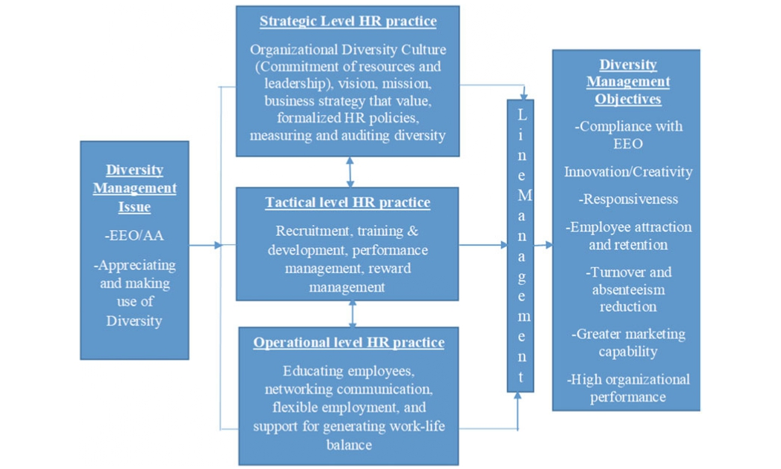
Figure2.1: Diversity Management through Human Resource Management

Diversity Related Recruitment Programs
According to (Meena, 2013), managing diversity may be helped an organization obtain a competitive edge by hiring employees from diverse backgrounds. To reflect the growing diversity of the world's workforce, several top-tier companies have successfully increased their representation of women, people with disabilities, members of marginalized communities, and other demographics (Shen, 2009). Genpact is a good example of a company that has come a long way toward understanding the relevance of gender diversity in the workplace. At the current moment, women make up forty percent of the total population around the globe and thirty-five percent of the total population in India. Other major corporations have also taken steps to ensure diversity in their workforces, including Wipro, IBM, Infosys, Xerox, Pepsi Co, Burger King, etc., by reaching out to marginalized groups like the disabled, the LGBT community, newcomers to the country, and the economically and socially disadvantaged (Bateman, 2009); (Shen, 2009); (Meena, 2013). Developing recruitment methods that are intended to improve diversity inside the firm, advertising in local newspapers, and other similar activities are examples of several practices that are included in HR diversity management (D’Netto, 1999). (Meena, 2013) Found that the chance of a diverse workforce was increased when the medium used to advertise open positions was chosen to have a wide reach.

Diversity Related Selection Programs
If human resource managers at a company wish to successfully manage diversity in their workplaces, they are necessary to make recruiting decisions based on criteria that are sensitive to diversity (Babalola, 2013). The presence of diverse managers on selection committees; selection procedures that are based on job-relevant duties, qualifications, competencies, and experience; selection criteria that comply with anti-discrimination laws; etc. are all examples of the various types of diversity-related selection programs (D’Netto, 1999).

Diversity Related Training Programs
Diversity training refers to the practice of educating a workforce about the cultural, socioeconomic, ethnic, and religious differences that exist in the workplace (Babalola, 2013). It may be broken down into two groups: those that focus on raising people's level of awareness (such as training employees to become more knowledgeable about diversity and its issues) and those that focus on developing people's abilities (such as encouraging them to alter their behavior) (Day, 2000). Leaders in several fields, like Hewlett-Packard, Microsoft, IBM, and TCS, have developed in-depth diversity training programs for their employees. For the objective of diversity management, these programs provide participants with a wide range of educational options such workshops, seminars, and hands-on activities (Bateman, 2009).
According to (D’Netto, 1999), there are three key components to successful diversity training. First, it ensures that all workers have an equal chance for training and development; second, it places an emphasis on diversity training to increase diversity-related awareness; and third, it focuses a major priority on addressing the expectations of workers who come from a range of backgrounds, and it does so as a key means of attracting and retaining talent. Training that places an emphasis on the advantages that result from having a diverse workforce may be of tremendous value and may turn out to be one of the most profitable expenditures that can be made.

Diversity Related Performance Management Programs
Diversity related performance management programs are initiatives implemented by organizations to promote diversity and inclusion within the workplace. These programs typically include measures such as setting diversity goals and targets, providing training and education on diversity and inclusion, and implementing policies and procedures that promote equal opportunity and fair treatment for all employees. The goal of these programs is to create a more inclusive and equitable work environment, which can lead to improved employee engagement, increased productivity, and better overall performance (Babalola, 2013).
In order to effectively address issues relating to diversity, a performance management system need to be conceived of in such a way that its performance assessment procedures are objective (rather than subjective), fair, and equal to one another (Schuler RS, 1993). According to (Fulkerson & Schuler, 1992) the evaluation mechanism should focus on assessing performance rather than a person's personality or demographics in order to be accurate. This opinion is consistent with what they said. In other words, they recommended for companies to make an effort to ensure that their evaluation methods are as culturally neutral as feasible. According to (D’Netto, 1999), unbiased performance reviews could be achieved with the support of multicultural managers who were included into the review processes. Organizations, as indicated by and (Schuler RS, 1993) should provide employees regular opportunities for feedback and mentoring. The varied workforce will benefit from this opportunity to grow and strengthen their skills. The term "diversity management" has emerged as a potential metric by which managers' contributions to an organization might be judged. Particularly, the HR manager's contribution to diversity management will be assessed when it comes to recruiting and promoting individuals from marginalized groups inside the firm (Sessa, 1992).

Diversity Related Reward Programs
Providing financial incentives to HR managers based on how well they do in diversity management is becoming an increasingly popular practice among firms. This is done as part of an initiative to broaden the employee pool's cultural and ethnic backgrounds (Meena, 2013). A reward management system that is founded on the ideas of equal pay and performance-based remuneration may be one of the factors that may promote successful diversity management as well as the recruitment and retention of a varied team (Shen, 2009). As a consequence of these and other studies, it is clear that businesses cannot afford to pay their employees less because of their gender, race, religion, nationality, or any other factor. Instead, they need to ensure that all aspects of remuneration (from salary to benefits) are structured in a way that fairly recognizes and rewards the efforts of a wide range of workers. This necessitates that they factor in the diversity of people's backgrounds, experiences, and skill sets (D’Netto, 1999). In conclusion, (Shen, 2009) argue that businesses need to make extra efforts at the operational level to manage diversity effectively. Individual employees achieve a work-life balance, giving chances for learning outside formal training, supporting employee usage of social media, and so on are all examples. Additionally, HR diversity management at the strategic, tactical, and operational levels should fully include line managers.

Diversity Related Career Development Programs
The key reasons for job dissatisfaction and a lack of motivation among varied workforces are salary inequality and discrimination in performance assessment, which makes diversity in human resources a crucially important problem (Shen, 2009). The HR of the companies needs to take into consideration AA and EEO guidelines when developing their compensation policies and performance evaluation systems if they want their diversity management efforts to be effective (Shen, 2009). A culturally neutral assessment method, the incorporation of diversity as prominent criteria on performance scorecards, and a variety of other HR strategies are also available to be used. It is important to encourage employees from a wide range of experiences to submit applications for seats on performance review panels (D’Netto, 1999).

CHAPTER 03
OVERVIEW OF THE ORGANIZATION

Overview of the United Commercial Bank Limited
Bangladesh is home to United Commercial Bank Limited (UCBL), a commercial bank. It has been around since 1983, and its services include deposits, loans, and trade financing for both consumers and companies. All around the nation, customers may visit one of the bank's locations, or they can take use of the bank's convenient online and mobile banking options. Listed on both the Dhaka Stock Exchange and the Chittagong Stock Exchange, United Commercial Bank (UCB) is widely recognized as one of Bangladesh's premier private commercial banks.
Over the course of three fantastic decades, they have worked tirelessly to establish one of the largest private commercial banks in Bangladesh. For as long as it has been in business, UCB has maintained a firm commitment to provide nothing but the best in customer service and support. To achieve their goal of offering the best possible financial services, they are always innovating new services to meet the demands of their diverse clientele.
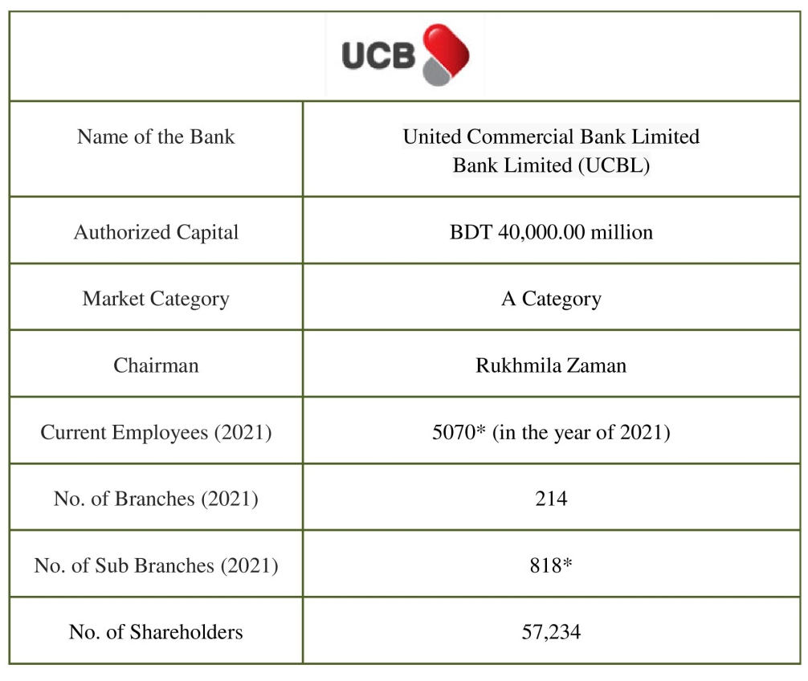
UCB offers a wide variety of banking products and financial services to large corporations, small and medium-sized enterprises (SMEs), and individual customers via its fully owned subsidiaries and various channels of distribution. The bank's 215 branches, Off-shore Banking Unit, Unet, Uclick, E-Commerce, Agent Banking, Islamic Banking, Sub Branches, Priority Banking (UCB Imperial), remittance services, credit card business, and 5,060 committed human capital members have helped it become a leader in the private sector banking industry.

Vision, Mission, Objectives and Core Values
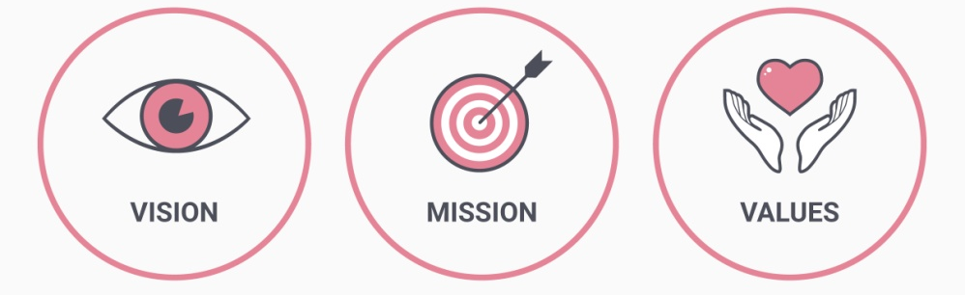
Vision: The long-term goal of UCBL is to become the most trusted supplier of financial services by using innovative strategies for development that are mutually beneficial over the long term and by offering premier services that are beneficial for all parties involved.
Mission: The mission is to provide financial solutions that build, manage, and expand the wealth of its clients and customers while simultaneously enhancing the quality of life in the communities that they serve. Specifically, the aim is to.
Strategic Priorities and Objectives:
- Enjoyable Experience: To ensure that all stakeholders are satisfied and that the whole banking transaction is a pleasurable one for each and every customer.
- Compliant: In order to be in accordance with all of the laws and regulations those are valid in Bangladesh.
- Innovation and Diversity: In order to promote originality, creativity, and variety with the goal of achieving sustainable corporate growth.
- Needs of the Future Generation: Continued growth that takes into account the requirements of succeeding generations without sacrificing their standards.
- World Class IT Infrastructure: To ensure that each and every one of UCB's clients is happy with the services they get by providing them with an information technology infrastructure of the highest possible standard.
- Good Governance: To develop effective governance.
- Risk Management: Ensuring that an efficient risk management strategy is implemented across all stages of the activity.
- Corporate Social Responsibility: Putting up best endeavors in the field of corporate Social Responsibility.
- Image: To construct and improve one's brand image.
Core Values:
- Integrity: Maintaining integrity and moral righteousness in whatever we do, at all times and in all places.
- Transparency and fairness: working hard to provide the finest service possible to all of our clients in an equitable manner.
- Innovation: Inspiration is fostered and developed via the process of innovation.
- Commitment: Dedicated to providing outstanding customer service and working together to increase the value created for all stakeholders.

Figure3. 1: Core Values of United Commercial Bank Limited

Organogram
United Commercial Bank Limited is run by a Board of Directors, consisting of a Chairman and several other members. The Board is responsible for the overall management and direction of the bank, including making strategic decisions, setting policies, and appointing senior management. The day-to-day operations of the bank are managed by the Management Director (MD) and other senior managers, who report to the Board.
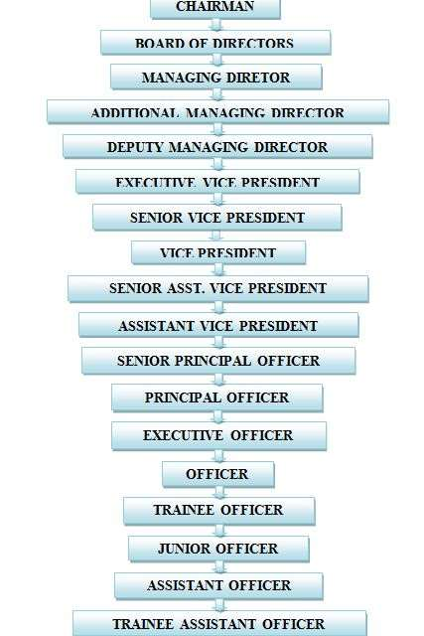

Products and Services
UCB Stock Brokerage Limited, UCB Investment Limited, UCB Asset Management Limited, and UCB Fintech Company Limited are the four subsidiaries that make up the bank. UCB Stock Brokerage Limited was formerly known as UCB Capital Management Limited.
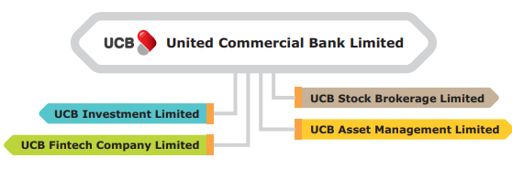
- UCB Investment Limited: The principal activities of UCBL typically include accepting deposits, making loans and advances, and providing other financial services such as foreign exchange transactions, trade finance, and various types of banking services to its customers. The Bank is also responsible for maintaining the stability of the financial system by managing credit risk and liquidity risk. They may also engage in other activities such as investment banking, wealth management, and insurance. Overall, the main goal of UCBL is to provide financial services that support economic growth and development while ensuring the safety and soundness of the banking system.
UCBL also earns interest from a variety of activities, including lending money to individuals and businesses, investing in government bonds, and offering fixed deposit accounts to customers. They also earn fees from services such as foreign currency exchange, electronic fund transfers, and issuing credit and debit cards. Additionally, UCBL may engage in other forms of investment, such as trading in the stock market, to earn additional income.
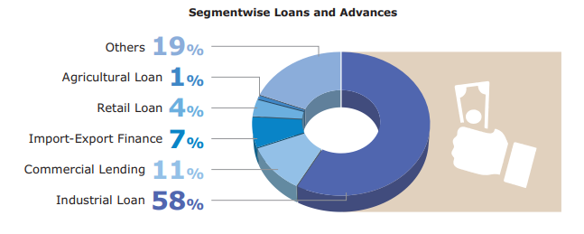
- UCB Stock Brokerage Limited: UCBL is able to offer stock brokerage services to their clients as part of their overall financial services offerings. These services typically include buying and selling shares on behalf of clients on the Bangladesh Stock Exchange (BSE), as well as providing research and analysis of different stocks and the overall market. UCBL may also offer margin trading and other advanced investment options for more experienced investors. Overall, the stock brokerage activities of UCBL are regulated by the Bangladesh Securities and Exchange Commission (BSEC).
- Agent Banking: Agent banking is a branchless banking service provided by UCBL where a designated agent acts as a representative of the bank and provides banking services to customers in a designated location. This allows customers in remote or underserved areas to access banking services without having to travel to a physical branch. Agent banking services typically include account opening, deposit and withdrawal transactions, and money transfer services.
- Islamic Banking: UCBL offers Islamic banking services as one of its products. Islamic banking is based on the principles of Islamic law (Sharia) and prohibits the charging or paying of interest (Riba), which is considered haram (forbidden) in Islam. Instead, Islamic banking practices profit and loss sharing, where the bank shares the profits and losses with the customers on certain pre-agreed terms and conditions. UCB Bank's Islamic banking services include various types of deposit accounts, financing, and investment options that comply with the principles of Islamic law.

Business Policies and Ethics
United Commercial Bank Limited is likely to have a comprehensive set of policies and procedures in place to govern its business practices and ensure ethical behavior. These policies may include:
- Compliance with laws and regulations: The bank is complied with a wide range of laws and regulations, including those related to banking, consumer protection, anti-money laundering, and data privacy. It is likely to have policies in place to ensure compliance with these laws and regulations.
- Financial reporting and accounting: The bank is maintained accurate financial records and report its financial performance to regulators and shareholders. It may have policies in place to ensure that financial reporting is accurate and transparent.
- Anti-money laundering: UCB bank is complied with anti-money laundering laws and regulations to prevent the illicit use of its banking services. It may have policies in place to detect and report suspicious activity.
- Customer service: The bank is likely to have policies in place to ensure that it provides high-quality customer service, such as responding promptly to customer complaints and resolving disputes fairly.
- Code of conduct: UCBL may have a code of conduct that outlines expected ethical behavior for its employees. This code of conduct may include provisions on maintaining confidentiality, avoiding conflicts of interest, and acting in the best interests of the bank and its customers.

Human Resource Management and Development
The Board is responsible for formulating and approving the policies and service regulations that pertain to matters such as recruiting, promotion, transfer, disciplinary and punitive measures, human resource development, etc. In accordance with the established service regulations, neither the Chairman nor the Directors may participate in or exert any influence over any Administrative Affairs, such as hiring, promotion, transfer, or discipline. No Board of Directors member may serve on any committee responsible for hiring new employees or promoting current employees to higher positions. However, the Board will be responsible for the hiring, promotion, transfer, and termination of the two levels of officers immediately below the CEO. Such hiring and promotion must be carried out in accordance with the service regulations, i.e., the hiring and promotion policies.
The Board's primary emphasis ensures that the bank's employees are well-trained in all aspects of their work, from prudently appraising loan/investment proposals to using cutting-edge electronic and information technology to create an efficient Management Information System (MIS). The Board must ensure these initiatives are included in its yearly agenda.
The Board will be responsible for drafting a Code of Ethics for each tier, and they will adhere to it in the appropriate manner. A culture of compliance will be fostered by the board via the promotion of a healthy code of conducts.

CHAPTER 04
ANALYSIS AND FINDINGS

Analysis of Demographic Characteristics
There were a total of 30 employees from United Commercial Bank Limited who took part in the survey, and they came from a wide range of departments.
The Sample Size (N) = 30

Ratio of Gender

Figure 4.1
According to the data shown in figure 4.1, there were a total of 60% female participate and 35% men participate who took part in the survey. This indicates that there were a greater number of female participants than male ones. As a result, we can reach the conclusion that;
- Female of respondents > Male of respondents on this survey.

Ratio of Participates’ Age

Figure 4.2
According to the data shown in figure 4.2, there were a total of 33% of respondents’ age is 25 to 28 years; 40% of respondents’ age is 29 to 35 years; 17% of respondents’ age is 36 to 40 years; and 10% of respondents’ age is 41 years or above. As a result, we can reach the conclusion that the ratio respondents’ age is:
- 29 to 35 years > 25 to 28 years > 36 to 40 years > 41 years or above

Ratio of Participates’ Educational Background

Figure 4.3
According to the data shown in figure 4.3, there were a total of 63% of respondents completed their graduation and 37% of respondents completed post-graduation and these employees of UCBL took part in the survey. As a result, we can reach the conclusion that;
- Graduated Employees > Post Graduated on this survey.

Ratio of Participates’ Designation

Figure 4.4
According to the data shown in figure 4.4, there were a total of 27% of respondents’ designation is probationary officer; 53% of respondents’ designation is officer; 17% of respondents’ designation is HR officer; and 4% of respondents’ designation is HR Manager. As a result, we can reach the conclusion that the ratio respondents’ designation is:
- Officer > Probationary Officer > HR Officer > HR Manager

Ratio of Participates’ Working Experiences

Figure 4.4
According to the data shown in figure 4.4, there were a total of 40% of respondents’ work experience is 0 to 1 years; 54% of respondents’ work experience is officer; 3% of respondents’ work experience is HR officer; and 3% of respondents’ work experience is HR Manager. As a result, we can reach the conclusion that the ratio respondents’ work experience is:
- Officer > Probationary Officer > HR Officer > HR Manager

Descriptive Analysis

Statement 01: The organization follows Equal Employment Opportunity (EEO) standards on its recruitment and selection process which are treated as fairly regardless of the gender, race, or ethnicity of the candidates.

Figure 4.5
According to the data shown in Figure 4.5, 67% of respondents agreed with this statement. 6% of respondents responded an answer that was neutral, and 27% of respondents disagreed with the statement. Those who disagreed with the statement claimed that sometimes in the case of the recruitment and selection process, employers make decisions based on candidate’s living location, age, race, and ethnicity.

Statement 02: When deciding who should be hired for open positions in the organization, each candidate's experience and qualifications are evaluated together with their application.

Figure 4.6
According to the data shown in Figure 4.6, 93% of respondents agreed with this statement and they said candidate's experience and qualifications can be evaluated based on resume, education and personnel skill through the behavioral and panel interview. 7% of respondents were neutral, with the statement.

Statement 03: For the purpose of diversity management, organization has built comprehensive in-house diversity training programs.

Figure 4.7
According to the findings shown in Figure 4.7, 58% respondents agreed with this statement. 9% of respondents were neutral, and 33% of respondents disagreed with the statement and said that some in-house training programs such as unconscious bias, cultural competency, and micro aggressions may not be effective at producing meaningful changes in employee attitudes and behaviors in the workplace to create a more inclusive and equitable workplace for all employees, regardless of their race, gender, sexual orientation, or other characteristics.

Statement 04: The organization’s in-house diversity training programs ensure that all workers have an equal chance for training and development.

Figure 4.8
According to the findings shown in Figure 4.8, 93% respondents agreed with this statement and according to them in-house diversity training programs can help ensure that all workers have equal access to training and development opportunities by providing education and resources that promote diversity, equity, and inclusion in the workplace. This can include topics such as unconscious bias, cultural competency, and anti-discrimination policies. These training programs can also provide a space for employees to discuss and address issues related to diversity and inclusion in the workplace, which can help create a more inclusive and equitable work environment for all employees. And 9% of respondents were neutral with the statement.

Statement 05: The organization’s in-house diversity training programs place a primary focus on satisfying the requirements of employees who come from a variety of backgrounds.

Figure 4.9
According to the findings shown in Figure 4.9, 93% respondents agreed with this statement and according to them in-house diversity training programs of the organization focus on educating and raising awareness among employees about diversity, inclusion, and cultural sensitivity to create a more inclusive and equitable work environment for individuals from a variety of backgrounds, including those from different races, ethnicities, genders, sexual orientations, abilities, and ages. These programs may include workshops, seminars, and discussions, and may be mandatory for all employees or targeted to specific groups. 9% of respondents were neutral with the statement.

Statement 06: Provision of access to the organization's training programs encourages workers to take more action toward achieving their goals.

Figure 4.10
According to the findings shown in Figure 4.10, 50% respondents agreed with this statement and according to them providing access to training programs can be an effective way to support employee development and help them achieve their goals. It can also improve job satisfaction, engagement, and retention. It is important to ensure that the training programs offered are relevant and meet the needs of the employees. Additionally, providing opportunities for employees to apply their new skills and knowledge on the job can help to reinforce learning and increase the overall impact of the training. But 43% respondents disagreed with this statement and according to them some employees may not have access to the necessary technology or resources to participate in online training programs.
Statement 07: The organization's present performance appraisal systems have the potential to improve an employee's overall performance, which in turn will benefit the organization.

Figure 4.11
According to the findings shown in Figure 4.11, 97% respondents agreed with this statement and they said performance appraisal systems of the organization have the potential to improve an employee's overall performance by providing clear and specific feedback on their strengths and areas for improvement, setting performance goals, and providing opportunities for professional development and training.
Statement 08: A fair rating is given by the supervisor for the all employee's performance within the organization.

Figure 4.12
According to the findings shown in Figure 4.12, 67% respondents agreed with this statement. But the 30% respondents disagreed with this statement and they said, sometimes evaluators of the organization may have unconscious biases that can affect their ratings of employees, which can negatively impact employees from underrepresented groups.
Statement 10: The Organization makes an effort on their performance evaluation system to be as racially neutral as possible in their evaluations.

Figure 4.13
According to the findings shown in Figure 4.13, 77% respondents agreed with this statement. But the 20% respondents disagreed with this statement and they said, the system may not take into account the unique experiences and challenges that individuals from different racial backgrounds may face in the workplace.
Statement 11: The organization's objectives are used as a starting point for conducting performance reviews of staff members.

Figure 4.14
According to the findings shown in Figure 4.14, 95% respondents agreed with this statement and they said that by providing regular feedback and coaching to staff members to help them improve their performance.
Statement 12: The organization’s reward management system is based on equitable pay and performance-based compensation that helps with diversity management, recruiting, and retention of the employees.

Figure 4.15
According to the findings shown in Figure 4.15, 95% respondents agreed with this statement and they said that the organization’s reward management system ensures that the program is fair and equitable for all employees, regardless of their background or identity.

Statement 13: Individual awards are given to employees who fulfill productivity, performance, or other objectives (or commissions).

Figure 4.116
According to the findings shown in Figure 4.16, 95% respondents agreed with this statement and they said that the individual awards are given to employees as a form of recognition and incentive for achieving specific goals or objectives. These may include productivity goals, performance targets, or sales commissions. They may be in the form of bonuses, gift cards, or other forms of recognition.
Statement 14: The promotion of EEO (equal employment opportunity) as well as its acknowledgment is one of the organization's primary concerns.

Figure 4.17

According to the findings shown in Figure 4.17, 95% respondents agreed with this statement and they said Equal Employment Opportunity (EEO) is a legal framework in the organization that prohibits discrimination in the workplace based on certain protected characteristics, such as race, gender, age, and disability. Organizations have a responsibility to promote and acknowledge EEO, as it ensures that all employees are treated fairly and given equal opportunities to succeed.
Statement 15: The organization takes into consideration AA and EEO guidelines of Bangladesh Bank when developing their compensation policies and performance evaluation systems.

Figure 4.18
According to the findings shown in Figure 4.18, 95% respondents agreed with this statement.
Statement 16: Within the organization, there are opportunities for women to develop their careers and progress through the top positions.

Figure 4.19
According to the findings shown in Figure 4.19, 53% respondents agreed with this statement. But 44% respondents disagreed with this statement and according to them women may face discrimination and bias in the workplace, which can make it more difficult for them to advance in their careers.
Statement 17: Within the organization, the development of women in their professional lives is encouraged and supported.

Figure 4.20
According to the findings shown in Figure 4.20, 53% respondents agreed with this statement. But 44% respondents disagreed with this statement and according to them women may have fewer opportunities to connect with mentors or network with other professionals in their field, which can make it more difficult for them to advance in their careers.

Statement 18: Equal representation of men and women is ensured in the organization's decision-making processes.

Figure 4.21
According to the findings shown in Figure 4.21, 47% respondents agreed with this statement. But 50% respondents disagreed with this statement and according to them the organization have a lack of diversity in their leadership teams, which can make it difficult for women to have equal representation in decision-making processes.
Statement 19: The organization maintains a healthy work life balances for its all employees.

Figure 4.22
According to the findings shown in Figure 4.22, 43% respondents agreed with this statement. But 54% respondents disagreed with this statement and the majority of female employees claimed that they often bear the majority of responsibilities for childcare and household tasks, which can make it difficult for them to focus on their careers.
Statement 20: When compared to other banks, this organization's turnover rate is significantly lower.

Figure 4.23
According to the findings shown in Figure 4.23, 95% respondents agreed with this statement.

Findings
In United Commercial Bank Limited, the role of HR in diversity management is critical in ensuring that the organization has a diverse and inclusive workforce. HR professionals of the organization are responsible for creating and implementing policies and programs that promote diversity and inclusion, as well as fostering a culture that values and respects all employees. However, there are several challenges that HR professionals may face in this role. According to the analysis part, some of these challenges include:
- In the case of diversity management of recruitment and selection programs,
- The few respondents said the sometimes employers make decisions based on candidate’s living location, age, race, and ethnicity during the recruitment and selection process within the organization.

- In the case of diversity management of training programs,
- Few respondents claimed that some in-house training programs such as unconscious bias, cultural competency, and micro aggressions may not be effective at producing meaningful changes in employee attitudes and behaviors in the workplace of the organization that could not help create a more inclusive and equitable work environment for all employees.
- The majority of respondents claimed that they may not have access to the necessary technology or resources to participate in online training which is related diversity management training programs.
- In the case of diversity related performance evaluation programs,
- Few respondents claimed that sometimes evaluators of the organization may have unconscious biases that can affect their ratings of employees because all humans have unconscious biases, which are formed by past experiences and societal influences. These biases can influence an evaluator's perceptions, decisions, and actions without them realizing it, leading to potential unfairness and inaccuracies in employee evaluations.
- In the case of Diversity Related Reward Programs,
- Majority of female respondents claimed that they have fewer opportunities to connect with mentors or network with other professionals in their field, which can make it more difficult for them to advance in their careers.
- The majority of female employees claimed that they often bear the majority of responsibilities for childcare and household tasks, which can make it difficult for them to focus on their careers.

CHAPTER 05
RECOMMENDATIONS AND CONCLUSION

Recommendation
Diversity management is an important aspect of organizational management because it can lead to a number of benefits for the organization, including increased innovation, improved decision-making, and better performance. However, according to the finding of the report, there are also challenges that the organization must overcome in order to effectively manage diversity. HR professionals of United Commercial Bank Limited can overcome these challenges by following of some suggestions:
- Employers making decisions based on a candidate's living location, age, race, and ethnicity can lead to discrimination and bias in the hiring process. This can result in qualified candidates being overlooked or not considered for positions due to factors that have nothing to do with their qualifications or abilities. It can also perpetuate existing inequalities and limit opportunities for certain groups of people. Such practices are illegal and a violation of anti-discrimination laws in many jurisdictions. The employers of the organization should instead base their hiring decisions on a candidate's qualifications, skills, and experience.
- To overcome the challenges of diversity management in in-house training programs, organizations can take a number of steps such as:
  - Assessing the diversity needs of the organization: This will help identify any specific training needs based on the diverse backgrounds and experiences of employees.
  - Developing a diverse training team: Having a diverse team of trainers will help ensure that the training content is inclusive and relevant to all employees.
  - Tailoring training content to diverse groups: By providing customized training content, organizations can ensure that all employees can relate to and benefit from the training.
  - Encouraging active participation: Creating an inclusive environment where all employees feel comfortable participating in training can help ensure that everyone benefits from the training.
- Diversity management related online training programs have many advantages over traditional in-person training, including accessibility, flexibility, and cost-effectiveness. However, technology and resources can present challenges within the organization for both instructors and learners. Some possible solutions to these challenges include:
  - Providing technical support to participants who are experiencing issues with their technology.
  - Creating and providing clear instructions and tutorials for using the online platform and tools.
  - Designing online training programs to be interactive and engaging, using a variety of multimedia and interactive elements to keep participants engaged.
  - Utilizing resources such as online libraries and databases to supplement the training material.
  - Creating a community or support system for participants to connect with each other and share resources.
- To mitigate the impact of unconscious biases on employee evaluations, the HR of the organization can use various strategies such as training evaluators to recognize and address their biases, using multiple evaluators to provide a more well-rounded view, and using objective criteria when evaluating employees.
- The HR of the organization should play a critical role in connecting women with mentors and networking opportunities by implementing a formal mentorship program, encouraging employee participation in professional development and networking opportunities, and promoting a culture of inclusivity and support for career development. HR can also encourage senior leaders to sponsor and mentor talented women in the organization, which can help them advance in their careers.
- "Caregiver bias" or "motherhood penalty" this is a common issue which can negatively impact the career advancement and earnings of women who have children or other care giving responsibilities. Some ways for the HR of the organization to address this issue include offering flexible working arrangements, such as telecommuting, flexible schedules, and job sharing, providing childcare benefits and support, and implementing policies that promote gender equality and work-life balance which can help to reduce the negative impact of care giving responsibilities on women's careers.

Conclusion
The role of HR in managing workforce diversity in United Commercial Bank Limited includes creating and implementing policies and programs that promote a diverse and inclusive work environment. This includes recruiting and hiring a diverse workforce, providing training and development opportunities, and promoting a culture of respect and inclusion. Challenges in managing diversity in UCBL may include a lack of understanding and acceptance of diversity, resistance to change, and biases and prejudices that may exist within the workforce. Therefore, some solutions for addressing these challenges for the HR manager of UCBL may include, developing and implementing diversity and inclusion training programs for all employees; establishing mentorship and networking programs for underrepresented groups; conducting regular diversity and inclusion audits to identify areas for improvement; holding leaders and managers accountable for creating a diverse and inclusive work environment; establishing a diversity and inclusion council to provide guidance and recommendations to senior management. It is important for HR to take a proactive approach in managing diversity, by creating a culture of inclusion, fostering an environment of mutual respect and providing equal opportunities to all employees regardless of their background, religion, gender, age, ethnicity and other personal characteristics.

References

Alcázar, F. F. (2013). Workforce diversity in strategic human resource management models: A critical review of the literature and implications for future research. Cross Cultural Management: An International Journal, 20(1), 39-49.
Armstrong. (2017). Armstrong’s handbook of human resource management practice. New York: Kogan Page.
ATM Tahmiduzzaman, F. (2021). Annual Report of UCB. Bangladesh: United Commercial Bank Limited.
Babalola, S. &. (2013). Integrated approach to workplace diversity through human resource management. Journal of Social and Development Sciences, 4(9), 435-445.
Bateman, T. &. (2009). Management: Leading & collaborating in a competitive (8th ed.). New Delhi: ND: McGraw-Hill.
Cascio, W. (1998). Managing human resources-Productivity, quality of work life, profits. Boston: McGraw Hill.
Cox, T. &. (1991). Managing cultural diversity: Implications for organizational competitiveness. Academy of Management, 5(3), 45-56.
D’Netto, B. &. (1999). Human resource practices and workforce diversity: An empirical assessment. International Journal of Manpower, 20(8), 530 – 547.
Daus, J. R. (1997). Challenges of leading a diverse workforce. Acad Manag Exec 11(3):32–48. Academy of Management Perspectives; Vol. 11, No. 3, 11(3):32–48.
Day, N. &. (2000). Teaching diversity: A study of organizational needs and diversity curriculum in higher education. Journal of Management Education, 24, 338-352.
Fulkerson, J., & Schuler, R. (1992). Managing worldwide diversity at Pepsi-Cola International. In: Jackson SE (ed) Diversity in the workplace: human resources initiatives. Guilford Press, New York, 248–276.
Hunt V, L. D. (2015). Diversity matters; McKinsey . Q 1(1):15–29.
Kreitz, P. A. (2008). Best practices for managing organizational diversity. The Journal of Academic Librarianship, 34(2), 101-120.
Kundu, S. C. (2003). Workforce diversity status: A study of employees’ reactions. Industrial Management & Data Systems, 103(4), 215-226.
Meena, K. &. (2013). Diversity management and human resource development-A study of Indian organizations. Pacific Business Review International, 5(7), 45-51.
Milliken FJ, M. L. (1996). Searching for common threads: understanding the multiple effects of diversity in organizational groups. Acad Manag Rev , 21: 402–433.
Mousa, . M. (2019). Organizational inclusion, responsible leadership and physicians’ psychological contract: a study from Egypt. Equal Divers Incl , 39(2):126–144.‬‬‬
Sacco, J., & Schmitt, N. (2003). The relationship between demographic diversity and profitability: a longitudinal study. Paper presented at 18th annual conference of the Society for Industrial and Organizational Psychology, Orlando.
Saxena, A. (2014). Workforce Diversity: A Key to Improve Productivity. Proc Econ Financ , 11:76–85.
Schuler RS, D. P. (1993). An integrative framework of strategic international human resource management. International Journal of Human Resource Management , 5:717–764.
Sessa, V. (1992). Managing diversity at the Xerox Corporation: balanced work force goals and caucus groups. In: Jackson SE (ed) Diversity in the workplace, 37–64.
Shen, J. C. (2009). Managing diversity through human resource management: An international perspective and conceptual framework. . The International Journal of Human Resource Management, 20(2), 235–251.
Tajfel, H. (1981). Human groups and social categories. Cambridge, UK: Cambridge University Press.
Turner, J. (1887). Rediscovering the social group: a selfcategorization theory. UK: Basil Blackwell, Oxford.

Appendix

Survey Questionnaire
Topic: HR Role in Managing Workforce Diversity in the Organization-A Case Study of United Commercial Bank Limited.
Dear Respondent,
Using the following questionnaire, the employees of UCBL will be asked about the organizations on the HR role in diversity management at their workplace. The information given would only be used for academic purposes.
Gender | Male |  |  | Female
Age | 25 – 28 years | 29 – 35 years | 36 – 40 years |  | 41 years and above
Educational Background | Gradated |  | Post Graduated
Designation | Probationary Officer | Officer | HR Officers |  | HR Managers
Working Experience | 0-1 years | 2-4years | 5-7 years |  | 8years and above

Statement |  | S. D  (1) | D  (2) | N  (3) | A  (4) | S.A  (5)
HR Role in Diversity Management at the workplace
Diversity Related Recruitment and Selection Programs
01. | The organization follows Equal Employment Opportunity (EEO) standards on its recruitment and selection process which are treated as fairly regardless of the gender, race, or ethnicity of the candidates.
02. | When deciding who should be hired for open positions in the organization, each employee's experience and qualifications are evaluated together with their application.
Diversity Related Training Programs
03. | For the purpose of diversity management, organization has built comprehensive in-house diversity training programs.
04. | The organization’s in-house diversity training programs ensure that all workers have an equal chance for training and development
05. | The organization’s in-house diversity training programs place a primary focus on satisfying the requirements of employees who come from a variety of backgrounds.
06. | Provision of access to the organization's training programs encourages workers to take more action toward achieving their goals.
Diversity Related Performance Evaluation Programs
08. | The organization's present performance appraisal systems have the potential to improve an employee's overall performance, which in turn will benefit the organization.
09. | A fair rating is given by the supervisor for the all employee's performance within the organization.
10. | The Organization makes an effort on their performance evaluation system to be as racially neutral as possible in their evaluations.
11. | The organization's objectives are used as a starting point for conducting performance reviews of staff members.
Diversity Related Reward Programs
12. | The organization’s reward management system is based on equitable pay and performance-based compensation that helps with diversity management, recruiting, and retention of the employees.
13. | Individual awards are given to employees who fulfill productivity, performance, or other objectives (or commissions).
14. | The promotion of EEO (equal employment opportunity) as well as its acknowledgment is one of the organization's primary concerns.
15. | The organization takes into consideration AA and EEO guidelines of Bangladesh Bank when developing their compensation policies and performance evaluation systems
Diversity Related Career Development and Employment Security Programs
16. | Within the organization, there are opportunities for women to develop their careers and progress through the top positions.
17. | Within the organization, the development of women in their professional lives is encouraged and supported.
18. | Equal representation of men and women is ensured in the organization's decision-making processes.
19. | The organization maintains a healthy work life balances for its all employees.
20. | When compared to other banks, this organization's turnover rate is significantly lower.

Shen, J. C. (2009). Managing diversity through human resource management: An international perspective and conceptual framework. . The International Journal of Human Resource Management, 20(2), 235–251.
ATM Tahmiduzzaman, F. (2021). Annual Report of UCB. Bangladesh: United Commercial Bank Limited.

