

“Internship Report Based on Performance Analysis of Bata Shoe Company Bangladesh Ltd.”



An Internship Report
On

“Performance Analysis of

Bata Shoe Company Bangladesh Ltd.”

Submitted To:
Mohammad Amzad Hossain
Assistant Professor
School of Business & Economics
United International University

Submitted by:
S.M. Rabiul Alam
ID: 114 132 021

Date of Submission: 8 January, 2019

Letter of Transmittal

Date: 8th January, 2019

Mohammad Amzad Hossain
Assistant Professor-AIS
School of Business & Economics
United International University

Subject: Submission of Internship report.

Dear Sir,
I am pleased to submit my internship report based on my experience of working with Bata non retail sales (NRSD) department. Throughout this journey my supervisor “Fayj Ullah” as well as Omar Faisal Chowdhury of that department helped me a lot. Because of their excellent guidelines and supervision I learned a lot about the corporate culture and Wholesale related various works. I had put in a lot of effort and hard work to the preparation of this report with the help of all the members of Bata Bangladesh Company LTD co.
It was a pleasant experience for me to work on this project. I would like to thank you for giving me such a wonderful opportunity.

Sincerely Yours,

  - _________________
S.M. Rabiul Alam
ID: 114 132 021

Acknowledgement

First of all, I would to convey my special thanks to Mohammad Amzad Hossain, my honorable faculty advisor for his support and valuable guidelines. Without your positive critics this report would not be possible to complete. Your office hours and positive suggestions really helped me to successfully complete the report.
Next, I would like to acknowledge my supervisor Fayj Ullah and the whole NRSD team. Without the help of them I would not been able to learn so many things. They also introduce me with the real corporate world and taught how to deal with important people in an organization.
After that, my loving parents who always supports me throughout my life. Besides them one of my all-time well-wisher my elder brother, who is like a mentor for me. All I am now is for them and with the help of Almighty all that will be done in future will be for them.
Finally and most importantly I am thankful for everything to Almighty ALLAH the most merciful and graceful.

Declaration

Myself, S.M. Rabiul Alam, the student of Accounting and Information System, ID: 114 132 021 would like to solemnly declare here that the presented report of internship titled “Internship Report Based on Working at Bata Bangladesh Company LTD as an Intern” is uniquely prepared by me under the supervision of, Mohammad Amzad Hossain, Asst, professor, School of Business &Economics, United International University, after completion of internship period in Bata Bangladesh LTD.
I confirm that, the report is only prepared for my academic requirement not for any other purposes and the internship report is submitted in the part of requirement not for any other purposes and the internship report is submitted in the part of requirement for the completion of the Bachelor of Business Administration (BBA in AIS).
I enjoyed preparing this report, which enriched my pragmatic knowledge of the theoretical concept. I am very much glad for giving me the opportunity to prepare this report.

---------------------------------------------------
S.M. Rabiul Alam
Id: 114 132 021
BBA Program
Department of Accounting and Information Systems
United International University

Acceptance Letter

This is to certify that the Internship report entitled “Internship Report Based on Working at Bata Bangladesh Company LTD as an Intern” has been prepared by S.M. Rabiul Alam, ID: 114 132 021, Department of Accounting and Information Systems, United International University.

In preparing this report he spared much time and effort. I wish him every success in life.

-----------------------------------------------
Mohammad Amzad Hossain
Assistant Professor-AIS
School of Business & Economics
United International University

Table of Content
Table of Contents
“Performance Analysis on 1
Bata Shoe Company Bangladesh Ltd” 1
“Internship Report Based on Performance Analysis on Bata Bangladesh Company LTD as an Intern” 2
Letter of Transmittal 3
Acknowledgement 4
Declaration 5
Acceptance Letter 6
Table of Content 7
Acronyms 9
Executive Summary 10
1.0 Introduction 11
1.1 Origin of the study 12
1.2 Significances of the study 12
1.3 Objective of the study 12
1.4 Methodology of the study 13
1.5 Limitations of the study 14
2.0 Organization overview of Bata shoe company Bangladesh 15
2.1 Management of Bata Shoe Company Bangladesh Ltd 16
2.2 Organ gram of Bata Shoe Company (Bangladesh) Ltd. 16
2.4 Worldwide Business Unit of Bata Bangladesh 17
2.5Bata Shoe Company of Worldwide Coverage 17
2.6Mission & Vision 18
2.7 Pricing 19
2.8 Literature Review 19
3.0Experience at Bata Shoe Company Bangladesh 20
3.1My Contribution to Bata 20
3.1.1Week 1 Experience and Contribution: 20
3.1.2 Week 2Experience and Contribution: 21
3.1.3 Week 3 Experience and Contribution: 21
3.1.4Week 4 Experiences and Contribution: 22
3.1.5Week 5 Experiences and Contribution: 23
3.1.6Week 6 Experiences and Contribution: 23
3.1.7Week 7 Experiences and Contribution: 24
3.1.8 Week 8 Experience and Contribution: 25
3.1.9Week 9 Experiences and Contribution: 25
3.1.10Last week Experience and Contribution: 27
3.2Lesson Learned 28
3.3Interaction with supervisors and co-workers 31
3.4Difference between Expectation and Experience 32
3.5How this experience will help me in future 34
4.0 Analysis and Interpretation of Data 36
4.1 Gender of the Respondent 36
4.2 Market Positioning of Bata Shoe Company Bangladesh 37
4.3 Frequency of Store Refurbishment 38
4.4 Top of Mind Awareness (TOMA) 39
4.5 How did you hear About Bata Bangladesh? 40
4.6 How Many Times Customers Visited the Store in Last Six Months 41
4.7 How Many Pairs of Shoes Brought By a Customer in the Past Six Months 42
4.8 Factors to Decide Which Footwear Brand to Buy 43
4.9 Brands Customer Purchase Frequently 44
4.10 Performance of Bata Store 45
4.11 Performance of Apex store 46
5.0 Findings of the Analysis, Conclusion and Recommendations 47
5.1 Findings 47
5.2 Conclusion 49
5.3 Recommendation 50
BIBLIOGRAPHY 51

List of Tables and Figures
List of Table & Figure
Table 1 | Management Table of Bata shoe company Bangladesh
Table 2 | Bata shoe company Pricing
Table 3 | Example of Furniture Statement
Figure 1 | Bata shoe company Business Units
Figure 2 | Bata Worldwide Coverage
Figure 3 | Bata shoe company Bangladesh Factories
Figure 4 | Gender of Respondent
Figure 5 | Market Positioning of Bata Shoe company BD
Figure 6 | Frequency of Store Refurbishment
Figure 7 | Top of Mind Awareness (TOMA)
Figure 8 | How did you hear About Bata Bangladesh
Figure 9 | How Many Times Customer Visited the Store in Last Six Months
Figure 10 | How Many Pairs of shoe Brought By a Customer in the Past Six Months
Figure 11 | Factors to Decide Which Footwear Brand to Buy
Figure 12 | Brand Customer Purchase Frequently
Figure 13 | Performance of Bata store
Figure 14 | Performance of Apex Store

Executive Summary

The internship report on Bata shoe company Bangladesh ltd footwear industry. A study on Bata shoe Bangladesh ltd as required by the supervisor Mohammad Amzad Hossain, Assistant professor, Department of business & Economics, United International University. This report consist the spread of the Bata shoe company Bangladesh.

This report divided by five chapters. In the first chapter, contains the background of the study that is it origin, objective, methodology and the limitation of the study. In the chapter two, overview of Bata Shoe Company Bangladesh ltd is given where firm’s structure, strategies, pricing, mission & vision, literature review are also given. In chapter three, I have organized and discussed all my knowledge about experience of NRSD department. In chapter four, here follow up the analysis and interpretation of data. Finally chapter five is about findings, conclusion and recommendation which are down by analysis of overall process.

The result of analysis will help to understand the correlation between independent and dependent variables. This research will help to assess the hypothesis which the researcher has assumed this research will also help the organization to maintain a continuous development process to ensure customer satisfaction.

1.0 Introduction
“Our Success is built on our legacy of values and belief
"Thomas G. Bata,
Chairman and Grandson of Founder”

Bata is one of the well reputed footwear companies not only in Bangladesh but also throughout many countries in the world. It’s a multinational manufacturing and retail based Canadian owned company. Bata is a family owned business founded by “Thomas Bata” on 24th august 1894 in today’s Czech Republic. This leading company has the retail presence over 70 countries and has production facility about 18 different countries and has enormous amount of retail shops all over the worlds and growing continuously. It’s headquartering situated at Lausanne, Switzerland. The company has market presence in all major continents and the major product line is footwear, clothing and accessories.

Bata was the first multinational footwear manufacturer started its operation at Tongi. The company suffers a lot during the war in terms of manufacturing and making business but, rehabilitee after newly born country. Since then Bata is the largest retailer and footwear manufacturer in the country despite the presence of new strong competitors entered into the market. Its major production activity take place at Dhamrai Tannery Effluent Treatment Plant (ETP) which was established at 1988.Major production works is still operated at Dhamrai but there is some small production facility at Tongi corporate head office. Its retail presence is enormously spreads throughout every part of the country. They have 239 premium outlets which have been directly monitored by Bata due to its high volume of sales and profitability. Bata outlet at Basundhara city shopping mall is one the exclusive of the country which generates the highest selling volume and this is the largest Bata outlet in the worlds. They also have 13 wholesale depot agents’ located important cities throughout the country and responsible for satisfying local retail demand

1.1 Origin of the study
In Bangladesh Bata Shoe Company are the largest footwear manufacturer and marketer. Basic reason of this report is to justify the satisfaction level of the consumers of the company. For this reason new competitor, program assessment has become an essential thing. Let us the market condition, consumer behavior towards competitor’s goods, consumer marketing attitude and skill at Bata store. Try to analyze this research researcher the customer happiness level and give essential recommendation.

1.2 Significances of the study
BBA in AIS program this internship report is an essential partial recommendation. Knowledge and learning process become perfect, when it has been theoretical and practical process. By the fellowship program students can set up the more networking to contract good people to help get the job in real life. The real job market situation students can prove themselves into the competitive market. A developing country like Bangladesh has a number of unemployed educated graduates because of they have no internship experience and also no normal professional experience to establish the networking system. As the crucial requirement of BBA in AIS program it is the most significance of internship.

1.3 Objective of the study
The objectives of the study are as follows:

- To know how to performs Bata shoe company at Bangladesh.
- To acquire the knowledge about the NRSD by the company.
- To research the impact of quality of shoes in consumer mind.
- The impact of advertisement in customer perception.
- The impact of knowledge of the stuff in consumer mind.
- To analyze the layout and design of store.
- Adapting as a professional organizational environment.
- Acquiring practical experience and knowledge.
- The cash facilities were really misused before the introduction of independent cash incentive.
- How the NRSD is being planned and what proper manner it is being implemented.
- To compare the Bata shoe company to other brands the satisfaction level analyzing.

1.4 Methodology of the study
I am prepared this term on the basis of my experience and from the assistance of our seniors as well as respected sis. By using different charts and tables, I have disclosed my skill and finding in the analysis paragraph. The methodology of the report mainly processes the statistical methodology in gathering data and essential impact on different application laws and act. Briefly discuss the details of the study in below:

Sources of Data: The data & information of this report have been gathering from both the primary and secondary sources. In order to prepare this report I have been collected necessary information from two types of sources as follow:

Primary data:
- I have gathered primary information by the department of NRSD.
- Discussing with the Bata supervisor, engagement partner, Bata employee, NRSD manager and articled students.
- Consideration during physical CDC and factory visit.

Secondary data:
- Each year annual report basis.
- Some excel working report.
- Studied various marketing books.
- Studied Bata previous transactions.

1.5 Limitations of the study
According to the objectives that efforts have been taken to accomplish the research. The research is both time and cost consuming, apart from its not possible to cover massive additional areas, which might give better result.

- Here need to more study to get detailed of customer at marketplace. They are showing that they are too much busy to getting the access. It was the tremendous difficulty for me to collecting data & information.

- Many times they left the interview when I respondent were found after answering, which resulted in discontinuity in interview.

- Lake of understanding of the purpose of the report that’s a major limitation.

- I explain the nature of the study for the purpose of some questions several times a number of customers.

- Besides I have failed to observe application of related law procedures.

2.0 Organization overview of Bata shoe company Bangladesh

In 1894 the founder of Bata shoes Bangladesh Mr. Tomas Bata who under the wind of change in the foot house industry. This company started from Czechoslovakia as known as the Czech Republic. Bata Shoe Company is the biggest manufacturer and market leader of the footwear industry in Bangladesh.
All over the world Bata has develop a strong distribution channel that showing in the below:

Bata Today
- Par day Bata serves 1.5 million customers.
- Their stuff more than 55000 people.
- They operate 5200 retail stores.
- They manage over 70 countries in retail presence.
- Across the 22 countries they have 27 production runs.

2.1 Management of Bata Shoe Company Bangladesh Ltd

Table 1: Management Table of Bata Shoe Company Bangladesh
Name of Management | Designation
Chitpan Kanhasiri | Managing Director
Mr. Muhammad Sohail Aslam | Finance Director
Mr. Syed Zahidul Islam | Head of Human Resource
Mr. Omar Faisal Chowdhury | Non Retail Sales Manager
Mr. Patricio Andres Alegris Oteiza | Product Development Manager
Mr. Lee Sin Kee | Retail Manager
Mr. A. A. Md. Arfanul Hoque | Merchandising Manager
Mr. Jalil Ahamed Chowdhury | Supply Chain Manager

2.2 Organ gram of Bata Shoe Company (Bangladesh) Ltd.
Store
Store
Store
East/West
Central
City
Distribution
CDC
DPS/RWD
MIS
AUB
LAB
Depot
Audit
VAT
A/C
H.R
Product Dev
Merchandising
Production
Purchase
Wholesale
Retail
Marketing
Company Manager

CFooO

2.4 Worldwide Business Unit of Bata Bangladesh
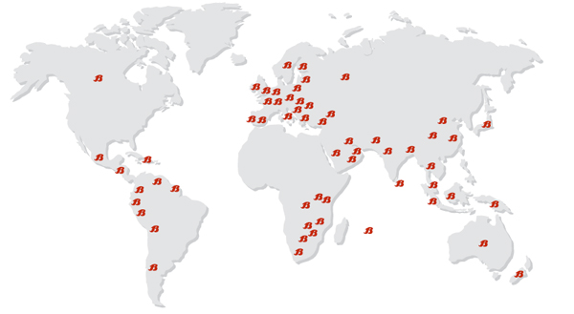
In the whole world Bata has operate business in five units such as Asia, Europe, Latin America, North America and Africa. It’s worldwide presence of Bata through this business.

Figure 1: Bata Shoe Company Business units

2.5Bata Shoe Company of Worldwide Coverage
Selected red area has already been entered by the Bata shoe Company.
Figure 2: Bata Worldwide Coverage
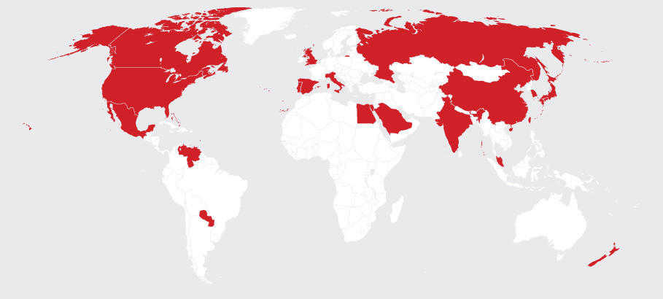

2.6Mission & Vision
Bata shoe company operation has been successfully running for years with a vision and mission at the heart part.

2.6.1 Mission:
“Introduction of a strong shoe line targeted to various market segments to maintain leadership through increased market share.”

2.6.2 Vision:
“To provide good quality shoes at an affordable price by keeping in mind the comfort that needs to be there and providing new designs with it.”

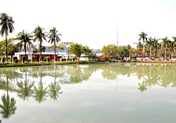
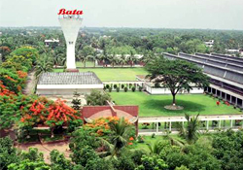
Figure 3: Bata shoe company Bangladeshi Factories.

Dhamrai Factory Tongi Factory

2.7 Pricing
For pricing Bata use Price-Quality leadership approach. They set up their price based on value and price can be varying country to country.
Also Bata follow the Geocentric pricing techniques. According to the demographic features Bata shoe company change their dress model and features etc.
Bata shoe company price list is given below:

Table 2: Bata Shoe Company pricing

Variations | High  Price | Low  Price
Children Footwear | 1400 | 290
Women Dress | 6000 | 1200
Women Summer | 3500 | 1490
Men Dress | 7990 | 999
Men Summer | 4000 | 650
Athletic Footwear | 13900 | 5900
Sandals | 180 | 65

2.8 Literature Review
Customer Satisfaction
The word satisfaction first appeared in English during the thirteenth century. The word satisfaction itself is divided from the Latin states and Latin ending- function. Early usage centered on satisfaction being some sort of release from wrong doing. It’s not good enough to your customer after you have sold them the product and ask them how satisfied they were. What you need to do your customer before you develop the product or service and find out what is important to them”
Measuring Customer Satisfaction
The actual manifestation of the state of satisfaction will vary from person to person and product/service to product and customer satisfaction is an ambiguous and abstract concept. Customer satisfaction depends on psychological and physical variables with good behaviours such as return and recommendation.

3.0Experience at Bata Shoe Company Bangladesh

3.1My Contribution to Bata
Bata is on one of the biggest shoe retail and manufacturing company in the world having operation over 25 countries. It’s been such an excellent opportunity for me is a part of this organization even though for a very short period of time. To be honest if I have to discuss about my contribution I would have very little things to say. Rather than contribution the exact word should be use here is help, how I help my team to perform their task smoothly and through this how I learn about the corporate culture. The main reason for this department to hire an internship student is to organize the work which has been blundered due to the sudden leave of the whole previous NRSD team. Throughout this three month I tried my level best to help my team, worked according to my supervisor’s instruction and most importantly develop myself as an individual to deal with corporate set up in future.
Throughout this section I will discuss about the work that I have performed weekly basis and possible sample of my work which have been performed as a documentary on pc.

3.1.1Week 1 Experience and Contribution:
My first week experience about learning about making important documents that will be needed to upcoming three important projects. To make those documents meaningful four signature must be collected in those papers from high rank managers. With the help of my supervisor I also learned the approach I need to take in front of those Bosses. The first signature that I have collected is from retail department manager Mr. Sin Ki Lee. Very well behaved and punctual person and surprisingly I found that he know my name. Second, person who signed the papers is Mr. Indrajit, senior accounts officer responsible to verify all the retail expenditure. He is the most critical person to collect any sign who scrutinized a lot before making any sign. He wants proper justification and packages of documents and he sign the documents based on priority basis. Next person to sign the papers is the Finance Director, a very well behaved Pakistani senior person who is about to retire within couple of weeks. At last, Managing Director Mr. Chitpan, from Japan have signed the papers and now this documents are fully complete and it can be provided to suppliers so that they can prepare the bill against the work they have done.

3.1.2 Week 2Experience and Contribution:
New week starts with some new challenge alongside other existing works. First time I have received the supplier bills. Bata have around 20 suppliers who basically provide seven different categories of products which requires in store improvement service. My departments used diversification approach where they equally distributed the works with all the vendors. All the suppliers submits their bills according to the work order, if somehow the supplier have done anything extra and the store manager have signed that he received the goods then he need to issue an additional bill for that extra work. Proper bills combined with three documents-a billing top sheet at vendor’s official logo page, most importantly the actual work done copy with store manager and district manager signature and the work order supplier copy which we provide. If bills come with the proper way my job is to collects further signature and forward it to Bata accounts. As per rules I collect sign from store operation manager (SOM) and then put a NRSD department sill at the top of the billing top sheet and collect my supervisor and retail manager signature. Additionally I prepare a top sheet to record all the bills that I have submitted into accounts for our records and also for tackle the situation when suppliers asked about the status about their bills.

3.1.3 Week 3 Experience and Contribution:
Week 3 starts with a huge task which my supervisor have preplanned to assign over me. This task should have been done way before but I have no clue what so ever how they not doing this before. The task is to create a standard rate chart from all the suppliers’ price list. Then I realize why this become necessary right now so that before making the reduction of the amount of suppliers they want to see which suppliers can provide the lowest rate. Part of my work I made contact with all the 20 vendees and asked their price rate as quickly as possible. As expected in the next morning I have collects all the rate charts and started my work.
Bata had the tendency to go for the cheapest option available but through this they overlook the quality issue majority of times. My job is to create a standard format through comparing all the vendors price and come up with the cheapest option as the standard one. Some suppliers may not have all the offerings we are looking for, so made more calls over phone to ask what will be the rate if they started to provide this. I prepare 11 different categories of standard price list and collect sign from all the necessary sources to make this as an official rate chart.

3.1.4Week 4 Experiences and Contribution:
The entire employee involved with retail has a tough time over the weekend as it is the week when Bata have started all the insurance activity for all their 238 outlets. With that vast amount of work load we welcome a new employee Mr. Rahat, who previously worked for Samsung. During the week he helped me a lot and together we make it possible to complete the work. In order to select the appropriate amount of insurance premium we have specify all kind of fixed assets in all the outlets. This is going to be a very hectic work with knowing that all the previous work order have not been organize store wise. Previous team has organized it according to vendor wise. In terms of top vendors separate file have been organized and small ones collected chronological order and all those combined into 13 huge files. Our work is to separate those store wise accordingly into 11 different asset categories.
I with the help of Rahat, started to separate those files. As a new employee, who have not seen much of this organization is become very frustrated with that much paperwork’s. We prepare a top sheet with the entire assets name that we are looking for and started to figure out this store wise. We are able to complete almost 100 stores and immediately submit the figure to the statistics team so that they can proceed. Throughout the week we have been able to complete the task and successfully submit the figure as they required. Confidential information that I have noticed is that Bata’s insurance policy is based on considering the highest selling date of the year which is within the month of Ramadan.

3.1.5Week 5 Experiences and Contribution:
Prior to this week we have completed the supplier rate chart for upcoming 2019, to make the chart more competitive we welcomed new suppliers to offer their price list according to the product category what we are looking for. As a part we have collaboration with some of the very big vendor’s like-step media one of the well-known interior vendors, Rahimafrooz popular for supplying batteries, Hydrokleen for AC servicing support and so on. We have arranged a formal meeting with them in our department meeting room with specific time and date. As previously planned the vendors representative have come with their some sort of sample and complete rate chart that we have asked for. During the meeting we discussed about the kind of offerings Bata is looking for, Suppliers scope, payment terms and most importantly issues related to warranty etc. We are excited able to make the chart more competitive and perhaps able to reduce some price and suppliers also seems very excited to have opportunity to work with a multinational company like Bata. The main motto of supplier sourcing is that we don’t want to be too reliable on suppliers like what we have suffers to be too much reliable on Transcom who use to be the sole supplier for AC and its servicing.
After accessing all aspects we started our procedure to enlist those suppliers. We collect the form from accounts department and provide the suppliers to fill with all the necessary information and documents copy. Within couple of days they hand over the form and we have successfully enlisted them.

3.1.6Week 6 Experiences and Contribution:
New month starts with receiving four new projects from retail manager Sin ki lee. He set a time frame of almost couple of weeks to complete all four projects as those are relatively small compared to what we have done in previous month. Among them two Shops were very near to my home at Narayangonj so I requested my supervisor so that I can have side visit to those places which will help me to understand the work more in depth. When old shops are decorated with the new Bata concept this called “Renovation” and new shops opening called as the brand new ones. Old shops get priority to renovate if they can perform very well and generate huge amount of sales.
As previous we assigned the supplier that we have selected to work in those projects and collect quotation from them. We assign some new suppliers to work whose have been enlisted previous month. Based on the supplier quotation we verbally ordered them to execute the work and in the mean time we prepare the entire necessary purchasing order related document. We have collaboration with all the stores managers and district managers to look after the work properly.
One most important thing is that we have implemented the new price rate that we have established in the month of October and will be valid until 2019. All the suppliers are bound to follow this rate and bills should be prepared according to the standard price rate policy.

3.1.7Week 7 Experiences and Contribution:
We have the entire week to complete the new projects that we have started last week. Other than two from Narayangonj, there is another two at Shyamoli and Sylhet which are comparatively big projects and also have big budget. Our main challenge is to complete those two on time and start the business as quickly as possible. Moreover we just can’t be relief to complete the work we also have to collect the bills from suppliers with in very short period of time because at the end of this month Bata will close their year account. If we cannot collect the bills with in time we will not be able to make them entry into Bata accounts and as consequences the supplier will not get paid. Bata have a clear policy not to pay any bills which was not belonging to that financial year.
Because of our effective team performance we are able to complete the project on time but we are suffering about the billing issue. For any valid bill supplier must have to collect the signature from respective store manager and assigned district manager who usually sign after the work have been completed. Unfortunately DM doesn’t have any specific office where he stays foe specific time rather he needs to continuously move within his district. Which create difficulties for suppliers to collect his signature which eventually delay bill processing? To make the process smoother we propose DM, s to be in the side when the suppliers have finished the work and about to hand over the shop.

3.1.8 Week 8 Experience and Contribution:
I have given a huge task over this week to prepare the furniture statement for 20 outlets. This is not going to be an easy task as I know that all the documents are not in an organized way. Actually this kind of work has never been done before but Bata recently have a new Financial Director from India, who asked for those documents. This work requires specifying each and every kind of work related to fixed assets or capital expense and came up with the final amount. This will also be needed for store manager and district manager because they have to present in front of higher authority.
I started my work with separate those documents according to outlet wise. I feel frustrated with that much paperwork but I have to complete it within a couple of days. Fortunately some of them have already been organized by me previously especially the project works that have been done within my internship period. I with the help of Mr. Rahat have come up with a format which can help us to sort that issue quickly. We put each and every category of works that usually take place during any work in a format and started putting the entire figure over there. At last we come up with the final amount after excluding expense related to lights and plastic materials because those are not belong.

3.1.9Week 9 Experiences and Contribution:
I am almost the end of my three month internship period and next week I will wrap up all things from here. Before that I need to organize everything what I have done throughout this period and have to submit everything to my team. Started with arrange all the soft copy of work orders according to project wise and also according to vendor wise. To make the work easier for my team in my absence I prepare a master file where all the work orders with their number have been put together, in case of need they will find everything in a single file.
All the suppliers bills received in my team have been sort out but few have been not been submitted because there are some technical verification issue and some stuck due to rate issue which need to sort before I leave. I really don’t want to hear they supplier face trouble that’s why I contact with each and every one to have a visit at the head office and bring any issue which have not been sorted yet. As expected we found several issues where suppliers suffers because this has not been settled yet. We arrange meeting so that suppliers can raise those issues to authorities and things can be settled quickly as possible.
One of the most important tasks performed this week is a requirement from accounts to arrange the final amount of capital expense from the last three months projects. We already store the files according to project wise which makes this work very easy for me. I just collect the capital expense work orders and come up with the final amount and submitted into Bata accounts.
Sl. No | Item | Unit | Qty | Unit Price | Total
1 | Track light - TL03064 - White - 30 (4000K)(2yr Warranty) | Pcs | 3 | 2,750 | 8,250
2 | Track light Frame - 3 Fit-(White Body) [Track Channal] | Pcs | 1 | 390 | 390
3 | LED - 644/18w Round 4000K (2 Years Warranty) | Pcs | 65 | 490 | 31,850
4 | LED Tube Light for stock room(3 Years Warranty)  ENERGY + 22W T8/AC/WM/WH-DL Regular | Pcs |  |  | -
Electric work |  |  |  |  | -
5 | 10A SP MCCB Circuit Breaker, Havels | Pcs | 4 | 275 | 1,100
6 | 32A DP MCCB Circuit Breaker, Havels | Pcs |  |  | -
7 | 32A TP MCCB Circuit Breaker, Havels for AC | Pcs | 2 | 1,100 | 2,200
8 | 63 A 16K TP MCCB Circuit Breaker, Havels | Pcs
9 | 100 A TP MCCB Circuit Breaker, Havels | Pcs
10 | SDB board with bus bar Protection, 26"x18"x5" | Pcs |  |  | -
11 | Switch Board with PVC Channel, 36"x18"x5" | Pcs |  |  | -
12 | 4 Gang Switch , ABB/Legrans | Pcs |  |  | -
13 | 6 Pin Combined Socket , 13 A | Pcs |  |  | -
14 | 1.5 RM BRB Cable FR Type | Coils | 2 | 2,396 | 4,792
15 | 2.5 RM BRB Cable FR Type | Coils | 1 | 3,825 | 3,825
16 | 1.5 RE BRB Cable FR Type for Earthling | Coils |  |  | -
17 | 4.5 RM BRB Cable FR Type for AC | Coils | 2 | 6,720 | 13,440
18 | 4.0 RM BRB Cable FR Type for Signboard | Coils
19 | 14.0 RM BRB Cable FR Type for Mainline | Coils |  |  | -
20 | Multiplug for Computer | Pcs | 1 |  | -
21 | MK Double Board | Pcs | 4
22 | PVC Flexible Pipe | rft | 200 | 8 | 1,600
23 | PVC Pipe 1" | rft | 300 | 6 | 1,800
24 | PVC Channel for wiring | rft
25 | Tape, Screw, Royal Plug, Black Tape etc | LS | LS | LS | 2,000

Table 3: Example of furniture statement

3.1.10 Last week Experience and Contribution:
Starting last official working week at this place things get a little bit emotional for me as this is my first corporate experience. I try to organize all things I have done but my mind is feeling sad remembering that the time is almost over. This experience will always be fresh in my mind especially the kind of people that I have worked with throughout this period.
The furniture statement that I have started last week has to be finished before 12th the last official day for me at Bata. As planned I started the week with those documents and continuing repeated process to finish all the outlets that requires. I know that this particular work will give me a lot of pain because all the new projects done by new tram are properly organized and a have prepare these documents last week. But whatever lefts are very old projects and there papers are not organized. So I started to find out all the papers from giant files and organize them according to projects wise, which kills considerable amount of time throughout the day. Unfortunately the most important one which is the exclusive outlet situated in the main gate of the office is missing. I found just couple of documents and majority are still missing which I inform my team and they decided to collect those from the Bata archive.
Other than that all the documents have been properly collected. With all the papers in my hand it’s become easy for me to complete the task. One by one I put the entire figure over the format and complete the task. Then I send all there information to the respective district manager who has to cross check whether I have missed anything or have I put anything extra there. Rest of the responsibility will be performed by other members of NRSD team as I am on the verge of leaving.

3.2 Lesson Learned
Internship is periods through which students like us that hardly have any corporate experiences get to know the inside about the real job world. Each and every day that I have passed there is like e lesson for me and I am glad to have this lesson at well reputed company like Bata. For me my biggest lesson learned was the way that I should approach with important persons. I found myself very fortunate to deal with people outside from our country that holds very important position at this organization. Extensive discussion about my lesson learned is describe below-
- With the help of HR induction process I get to know about all the departments and their core jobs. Get to know a lot about my department and who have what responsibility and the overall culture of the organization, and finally the most important part of my first week learning is the process of preparing the documents.

- With knowing how the documents have been done now I have extensive responsibility to collects signature for those papers to make them valid. I made a silly mistake to ask for signature with my first visit to accounts department without proper backup documents. Whenever we made any work order from the supplier quotation we need to cross check the rates at which suppliers doing work with Bata. But unfortunately there is not any standard rate chart established format which can make our life easy. Due to this I need to bring previous work order copy with mw as a justification to sign. Usually three copies of work order are made original one is for Bata accounts, one is for SIS team and last one is for the suppliers through which they prepare the bill. Overall my mistake will surely make my upcoming accounts visit much easier.

- Majority part of my learning this week is related to billing documents. I understand based on what I should receive a bill and which condition I can reject any bill to accept and most importantly how to proceed with those bills until it’s finally submits into accounts. I also get to know about the SOM (Store operation manager) and have the chance to interact with them. They are responsible for maintain all the 17 districts categorized into urban and suburban concepts. Basically urban represents within Dhaka and rest are as suburban’s. I put the bills to SOM to verify through their district managers (DM) who actively manage and oversees all the work with store manager(SM). My responsibility is not just forward the bill I need to be careful about actual work done copy. Also need to care about whether the supplier did any extra work or not if so then he needs to issue an additional bill in order to get the extra work.

- Completing this rate chart is not an easy task and I need to finish it as perfectly as possible. To make it perfect I need some in depth knowledge about MS excel, though I have good basic knowledge but I get lot of help from Mr. Rahat, which increase my knowledge. I don’t have any scope to make any mistakes so the pressure is on me. Moreover the suppliers continuously make modification on their rate because next one year they have to work on that price makes my life more difficult to complete the task. But finally I am able to fulfill the task within time and have a sense of proud that this document will be used by upcoming days no matter I will be there or not.

- But in this week due to excessive amount pressure over me to complete the rate chart along with some other normal works I need to stay at office for longer period of time, sometimes even at 7 pm. I observed that if anyone doing work at extra hours all the foods from is completely free. You just don’t even need to ask for food, the foods will be send by office authority. That’s a little reward for extra work. Most importantly whenever I stay longer my supervisor always provide me transport facility.

- Most important lessons for me are the way insurance works in an organization like Bata. As a part of the company policy they must have to make insurance of all their enlisted outlets. Now they have total of 238 enlisted outlets and it will increase very shortly as some new shops are about to be open.

- Most important lesson for me in this week is being able to know how to source external suppliers and how to approach them. This is one of the most important lesson is university major course and I am very happy to experience some part of it. Our sourcing is based on some criteria like we are looking for only those who will be able to provide us the service throughout the country. We collect information about those vendors from our existing suppliers who work for our other product category as well as from the market experts.
- For two suburban projects I have the opportunity to visit during the work at my home city Narayangonj. The projects were take place at the most busiest place at the city and we have the challenge to re start the shop very quickly. I have the company of Mr. Rahat, who have ample amount of knowledge about this field which help me to learn a lot to acquire the technical terms related to this field. During our visit we also try our best to educate store managers about the things they need to look after during works and take over all the things before they sign in the supplier bill.

- For Supply Chain Management as a major I did a course about “Project management”. Throughout these four new projects I have experienced some sort of project management. From our retail manager we receive specific time frame and budget to implement those before hand over and make the store re open for business. Courtesy of Mr. Rahat I have learned various technical terms related to this industry and experienced real time project visit. In order to track future needs we differentiate specific project on capital expense and maintenance expense. In near future when they will make insurance will found it very easy to figure out the capital expense, expense that can serve up to 5 years and mention as a fixed assets.

- The similar kind of work was done by me in my first month due to insurance purpose. Though this task is little different to that previous ones, both were very much hectic and belongs too much paperwork which really disturbing.

- I did not experience any significant learning in this week rather than the works is very much repetitive. But arranging the meeting with suppliers and managers to sort out unsolved issue and actively present in the meeting is a very good experience. Both the parties negotiate the issue and settled in a middle ground where both are satisfied.

- I am not learning anything significant in this week as the task is repetitive from last week remaining. I also request senior executive not to engage me further new works because it will create difficulties for me to hand over the work that I have performed which I have already organized. This somehow limits new learning, moreover my supervisor share ma that she is also leaving one day after me. She request me not to engage any further work and spend rest of the days with her to organize everything’s that this team has done under her supervision.

3.3 Interaction with supervisors and co-workers
I have been selected under Bata retail store improvement service (NRSD) department. This is a very small team consist of four people including me. Fayj Ullah is the supervisor to be honest I found myself very fortunate to be a part of this team with such lovely and helpful people. Throughout this journey they treated me like a younger brother even though I made vast amount of mistakes in the initial stages. They never get angry over me; they always correct my fault and make sure that I am able to learn it properly.
We all used to have breakfast together as a team and the kind of family feeling that I have experienced will be missed after I leave. Most interestingly if my supervisor wants to have a cup of tea she will make sure that whole team join her and have quick refreshment. Just like breakfast we always have lunch together and discussing things from personal to political to work related. Whenever we have to stay excess of office hours, I never have worry about my transport. My supervisor always hires an uber for all of us so that we all can go together and has little snacks before go to home.
To make our collaboration more efficient my supervisor create a whats app chat group (NRSD Only) where we share everything from personal to work related. Few days that I have missed due to university works or because of sickness, I used to post on that chat group and the whole team gets aware about the issue.

3.4 Difference between Expectation and Experience
I am almost on the verge of becoming a university graduate and have no prior experience in corporate world before joining Bata. My expectation about what to expect is very much undefined and have a sense of learning no matter how. I consider myself very lucky to be a part of this multinational organization. As a student of marketing I always hold very positive feelings towards companies who conduct their business outside their national border. My common perception towards those companies is always positive in terms of their policies, CSR and management style. With my pre positive favorable perception I started my internship program with high enthusiasm. But things really have not according to what I expected. I came here to learn and I really can’t deny that I learned a lot but my perception about how an MNS will operate and the Bata’s reality is quite different. In this next section I will try to address those issues-
- The first thing came into my mind is the canteen, to be honest I expect much more batter quality food and canteen environment from an MNC like Bata. My words may seems to critics but I did not found any different any different with that canteen compare to a road side canteen. Organization who have been there for more than 50 years and hires top quality people across the country and have been serve from that kind of a canteen really shocks me.

- To be honest I am little disappointed with the way Bata accounts work. Despite being a multinational it seems me like e old fashion office with too much paperwork and formality. Funny part is that sometimes they wants the documents that’s original copy have already been submitted to them way before but still they want the photocopy version from NRSD. Also get to know that all the team members from previous NRSD team left together couple of month’s age and not even bother to take over the work before they leave, which create a complete mess right now to this relatively new team. Another important issue I want to address is that there NRSD team lacks proper job description guidelines. Works just come from here and there and suppliers frequent visit of makes it more difficult to concentrate our core job.

- Within this short period of time I understand that the suppliers are not happy with the way Bata us dealing with them. Some even share with me that they incur losses but because of Bata is a very big company they stuck with it. Few moths back a new billing process have been implemented but unfortunately there is not any afford to notify this to suppliers as a consequences they suffers. Previously suppliers die not to collect the SM and DM signature in the actual work done copy but it is a must. They get even more frustrate because DM does not have any specific place where he will be always found, they move throughout the district to oversees the work. So it’s become difficult to collect signature from them. On the other hand after all those hassles from the time the bill submitted into accounts it takes 60 days to mature or sometimes even more. It is become very difficult for suppliers to sustain especially small vendors.

- Sometimes I feels that I have been too criticized with Bata, but I really wonder how they have done this work before and how this work have not been organized yet. Insurance work has been running throughout the ages and still nothing has been in a proper shape. Most disappointing is that, when a particular project have been done all the documents related to that project should be together but the reality is all the papers have been files according to vendor basis which create a disaster for us to re arrange those papers. From now we have planned to arrange those according to project basis and have already manage to do some with the previous work and will complete is as soon as possible.

- Though I don’t have much knowledge about but I can understand that the materials that suppliers used during renovation work is very cheap and looks not going to last for too long. I can sense about the quality of goods specially looking at the products especially electric goods. Though I really can’t blame suppliers for this because Bata is always looking for cheapest option no matter what the quality is and supplier provide the lowest quality in order to sustain into the business. As a consequence Bata really suffers and spend huge amount of cost throughout the year due to maintenance purpose. For me this kind of approach really needs to change and they should go for the good quality products.

- At Bata I belong to a team which is very new and having its provision period. I am more than sure that the work that have been performed throughout this week is not even a part of this department but because this is new tram everyone loves to forward their work here as a consequences we suffers. The rule says that all the store managers should prepare this statement while renovation work and should maintain account throughout the year but store managers are unaware about those technical issues that they can’t even get the job done by suppliers. More surprisingly Bata never have any plan to educate those store managers who holds an important position during any projects.

- Throughout this small time I have heard so many good things about the previous team. Under the supervision of Mr. Rehan with two executives they used to solve everything including that should not perform by them. Which create bad consequences for that present team who had to perform multi-tasking despite not having those in their job responsibility? Alongside the kind of extra work that accounts forwarded to us in completely disturbing. I can clearly see why my supervisor decided to quit the job. But there are some other issues between supervisor and senior executive which I should not discuss here.

3.5How this experience will help me in future
This experience will ever be remaining as an important lesson throughout my life. Prior to start I am more nervous than excited and have hardly any idea what to expect or what I am going to experience. Everything is new for me and has zero knowledge about corporate world. But with the grace of Almighty I am successfully able to complete this journey. Team work and interaction with people especially from outside the country border is a vita lesson for me which surely going to help me in my near future.
I have high ambition to establish myself in the corporate set up. Non retail sales team maker huge contribution to make me edge closer to reach my destiny. Every week there is like a new lesson for me with knowing new things under supervision of a friendly boss. I also learn some sort of perfection as a need to fulfill my task. All the documents that prepared by me and later sighed by controller sir are the reason for that. In order to deal with that person I have to be prepare a full package of work neither I may get a bad impression.
With the help of Mr. Sohan I get to know more in depth about Excel which I really want to know properly for a long time. With this knowledge I am planning to acquire more in depth understanding of this and really prepare myself in the job field.
As a student of supply chain management my learning with SCM issues and direct interaction with suppliers and most importantly some sort of sourcing activity really going to help in coming days.
Finally, my experience to mix with corporate culture is the next step to climbing into ladder.

4.0 Analysis and Interpretation of Data

Location of surveyed stores:
This analysis about Bata Shoe Company was conduct at several stores. They have 4 city store and 7 family stores. The following is the list of stories.
- Ghulshan 2 city store
- Bata factory gate family store
- Farmgate city store
- Mirpur family store
- Rapa plaza city store
- Shawrapara family store
- Uttra south city store

4.1 Gender of the Respondent

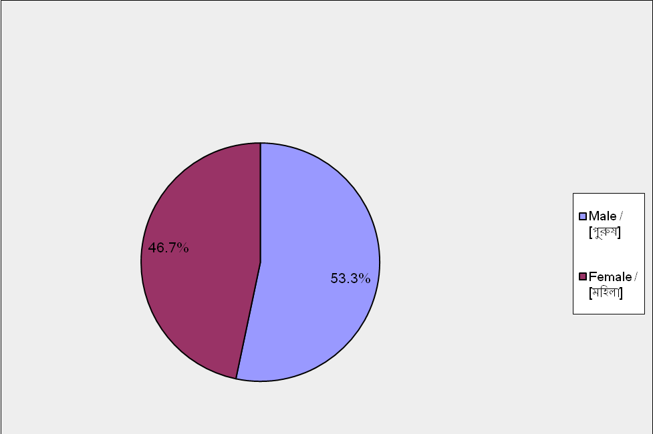
Figure 4: Gender of Respondent
Here total sample size was 270 out of all sample size man are 145 and women are 125. This graph shows that total sample size women cover 47% and men cover rest of the part 53%.

4.2 Market Positioning of Bata Shoe Company Bangladesh

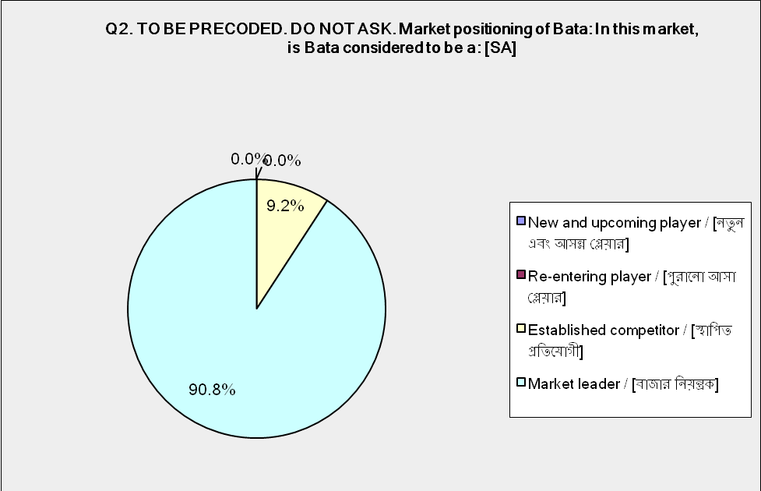
Figure 5: Marketing Positioning of Bata shoe company Bangladesh

Here showing the market positioning of Bata Shoe Company. According to the graphical findings that is too much high the sample size was 270 with the 25 sample size customer choose the Bata as all competitor and rest of the sample size 245 consumer choose Bata as a market leader. So we can say customers consider Bata Shoe Company as a market leader.

4.3 Frequency of Store Refurbishment

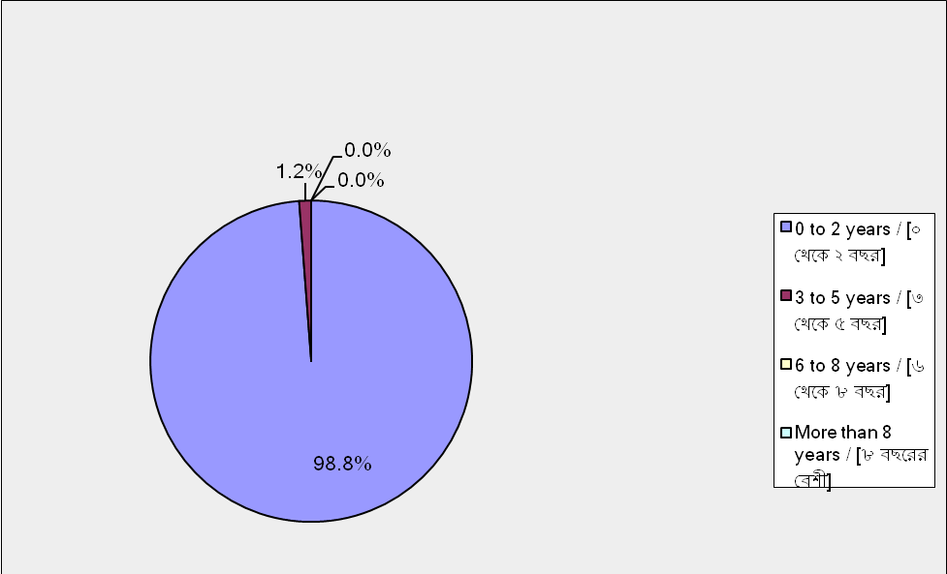
Figure 6: Frequency of Store Refurbishment

Here showing the Bata shoe company has frequency of store that ensures the level of activity of renovation department because of renovation capable to ensure the customer happiness level. If the outlet is frequently renovated and improves it continuously that customers are attracted to buy and visit the outlet. This graph shows that 98% outlet are renovated within 2 years, 2% is renovated after 3 years almost. That means 100% is outlet is renovated in every year. For this reasons customer satisfaction level is increasing day by day.

4.4 Top of Mind Awareness (TOMA)

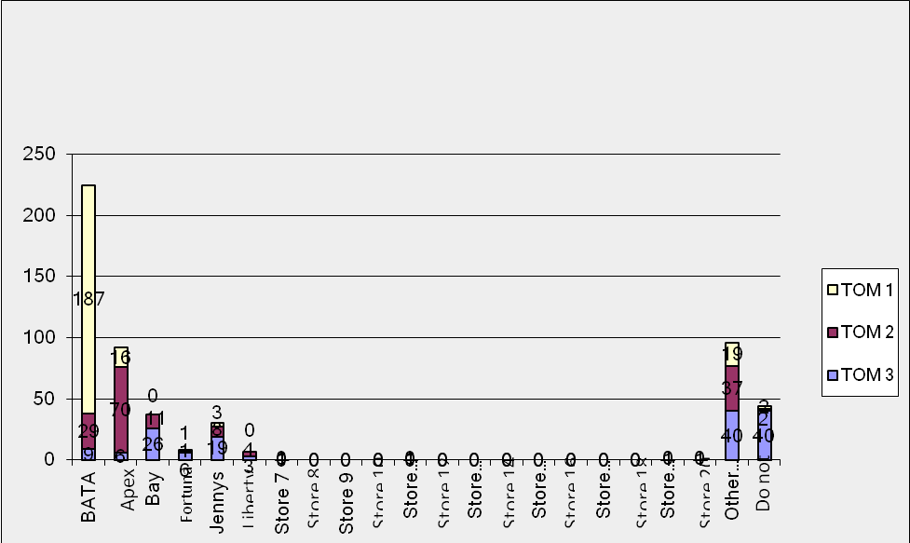
Figure 7: Top of Mind Awareness (TOMA)

This bar show the awareness minded customer when a customer think of a footwear outlet.
Bata is considered the 1st preferable by the consumer because of 80% consumer out of 100% respondent choose Bata TOM 1 and 15% customer out of 100% choose Bata TOM 2, finally rest of the 5% customer choose Bata TOM 3 that means TOM 1 is the market leader of Bata shoe company. Apex is considered as the 2nd preference by the consumer respondent. Bay emporium is considered as the 3rd position by the customer chooses.

4.5 How did you hear About Bata Bangladesh?

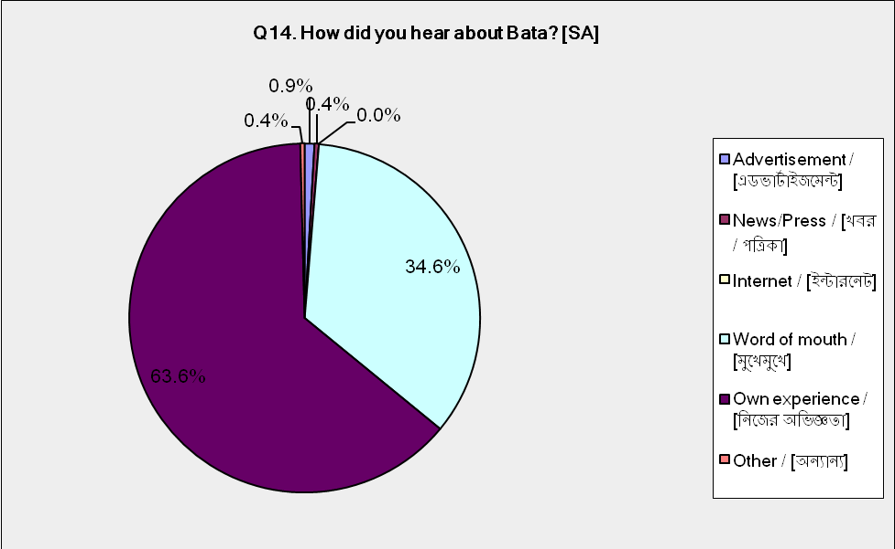
Figure 8: How did you hear About Bata Bangladesh

Bata is a multinational brand that’s why customer has come to know about Bata Shoe Company. Bata show his strategy to attention the customer. This bar draw the 1% customers that they hear about Bata advertising and 34% people know about Bata from word of mouth like peer influence and the huge percentage such as 64% customer know about Bata from their own experience. So we can mention the highest percentage of customer know about Bata from his knowledge.

4.6 How Many Times Customers Visited the Store in Last Six Months

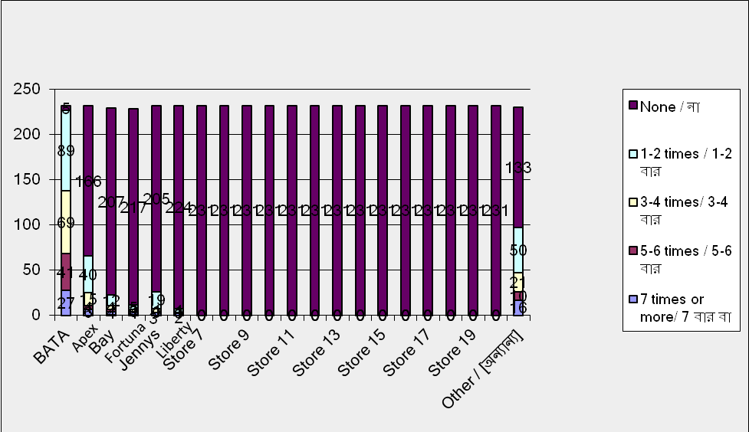
Figure 9: How Many Times Customers Visited the Store in Last Six Months

Here this graph showing the how many times customer come to the retail store on the basis of willingness to buy and customers perception and liking towards the store of selected brand. This graph draw the high percentage of customer come to Bata retail store rather than other competitor customer visit Bata store more frequently. For that reason we conclude that customers are happy with the store of Bata Shoe Company.

4.7 How Many Pairs of Shoes Brought By a Customer in the Past Six Months

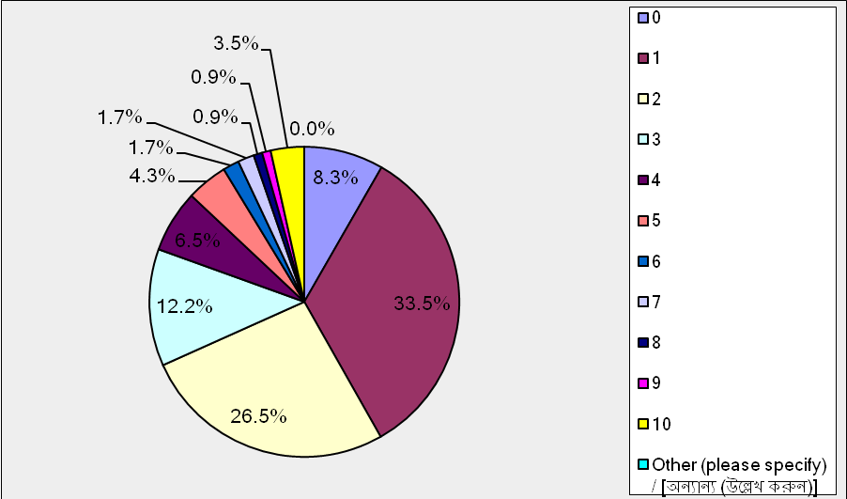
Figure 10: How Many Pairs of shoe Brought by a Customer in the Past Six Months

This pie chart draws that how many shoes are bought by customer in last 6 months that customer buying pattern and purchasing behavior in the last 6 months to perception frequency. According this pie chart 8.5% customer did not purchase any shoes 33% customer bought 1 pair 27% customer purchase 2 pair of shoe in the last 6 months. 12.2% customer bought 3 pair 6.6% buy 4 pair of shoe in last 6 month 3.5% purchase 10 pair of shoe so we can say that highest percentage of customer buying pattern position and better then the competitors.

4.8 Factors to Decide Which Footwear Brand to Buy

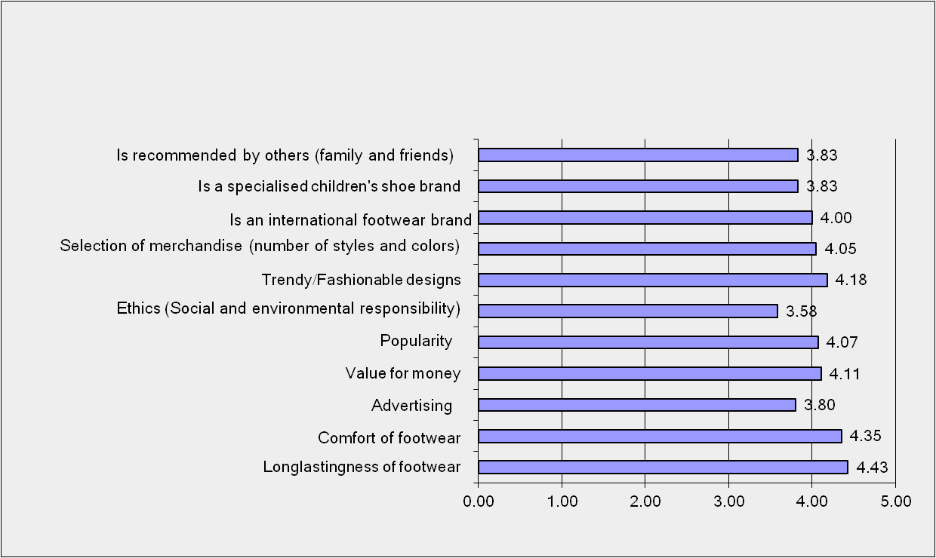
Figure 11: Factors to Decide Which Footwear Brand to Buy

This graph draw that some customers are determined to judge before buying footwear from and local retail store. This graph measure five point such as 1 is not good 2 is fair 3 is average 4 is good 5 is excellent so long lastingness of footwear comfort of footwear, trendy and fashionable design. It is an multinational footwear brand.

4.9 Brands Customer Purchase Frequently

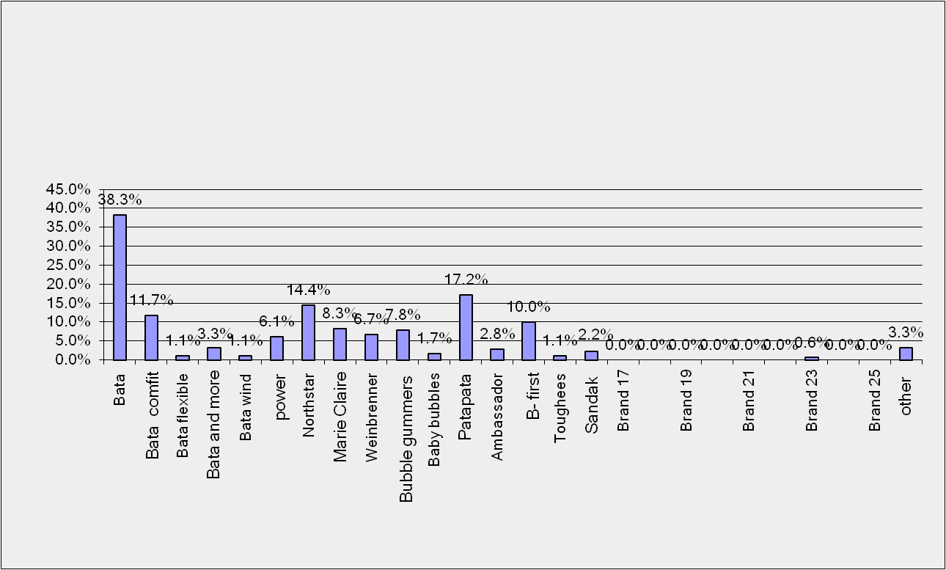
Figure 12: Brands Customer Purchase Frequently

This graph show which Bata shoe company brand is high level which Bata brand is more choosefull by the customer. The higher bar means the high range of sales. These are the desired selling brand such as north star, marie claire, Bata comfit, power, patapata, B.first, ambassador Bata and more sandak etc.

4.10 Performance of Bata Store

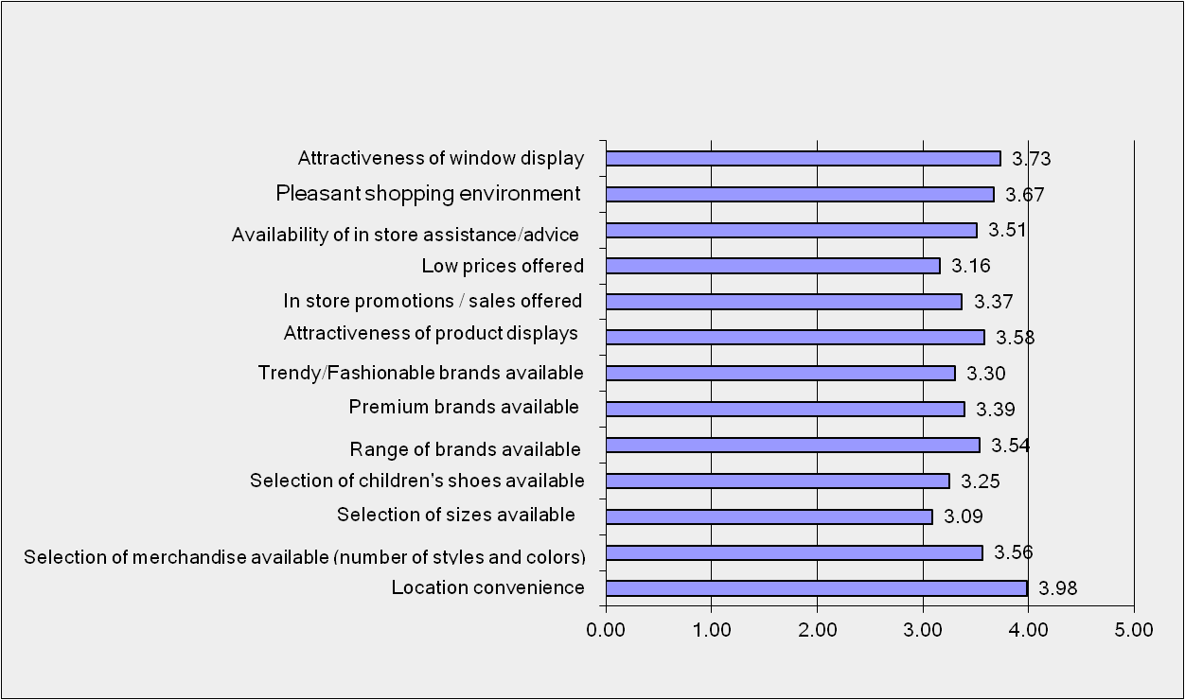
Figure 13: Performance of Bata Store

Performance of Bata store means the layout, design, outlook, in store display, store decoration, salesmen helpfulness, behavior of the store manager, location of the store availability of merchandise availability of premium brand etc. this all the variable and measured by firm point scale that is 1 to 5 is excellent. Above this graph 3-4 shoe the average to good. So we can say that to improve the store performance to stay at top in the footwear industry.

4.11 Performance of Apex store

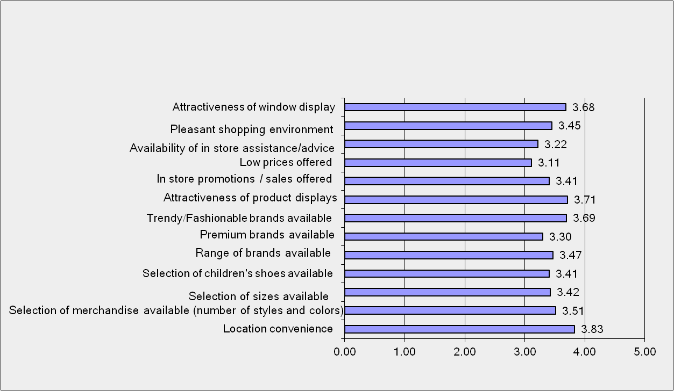
Figure 14: Performance of Apex Store

Apex performance symbolizes the measured by the various variables like attractiveness of window display. In store promotion low price offered, range of brand in store assistance, location convince etc. for the customer satisfaction Apex store play a vital role by the competitor of Bata shoe company Bangladesh. Most of the variables are within the average to good. So we can say that Apex is improving the performance in the footwear industry.

5.0 Findings of the Analysis, Conclusion and Recommendations

5.1 Findings
- The survey it is found that when people are asked about Bata they refer to the quality of shoes those they are using from childhood.

- Price is the important factor to bring the customer. Value for money offered by the store has impact on customer satisfaction.

- The findings suggest that, comfort of shoes is an important factor to the respondents those were surveyed. Respondents were strongly agreed with the fact that Comfort of Shoes has impact on customer satisfaction. Bata has a strong team who always work for the development of the products.

- Fashionable Style is an important factors to the respondents those were surveyed. Now a day’s people are more fashion concern that is why they agreed with the fact that Fashionable Style has impact on customer satisfaction. From the comparison it is found that Bata is lacking in this very criteria than the competitors.

- Selection of colors, styles and sizes is an important factors to the respondents those were surveyed. Respondent were more or less agreed with the fact that Selection of colors, styles and sizes has impact on customer satisfaction. From the analysis it has found that Selection of colors, style and sizes and Customer satisfaction are positively related.

- An important factors to the respondents by the brand of shoe offered these were surveyed. Respondent were more or less agreed with the fact that availability of Brand shoes is important to them and has a positive impact on customer satisfaction. Bata serves to the customers with rich collection of brand shoes.

- Best communication tool is advertisement to reach the customers. It has a positive impact on customer satisfaction. Bata advertises its products through different media like electronic & print media, television commercials, new arrivals, fashion shows, social networking face book, twitter etc. Bata Bangladesh is maintaining modern strategies to ensure mass marketing as well as huge brand awareness. Bata shoe company (BD) Ltd is increasing its number of seasonal TVC.

- Finally about this analysis it has found that Bata provides superior value of the customer also quality shoe stores location, comfort of shoes, quality service from salesmen friendliness of behavior from salesman, product knowledge of salesman. These bring Bata close to the customer with desired satisfaction.

5.2 Conclusion
This journey will ever be fresh in my mind with lots of emotion. I was very nervous about how I will spend three long months but as days goes I feel disappointed of getting near to end. The experience was beyond imagination and will miss everything. I will be thankful to my team they help me and they way they have make me understand about the corporate culture. I will be ever graceful toward this organization and the things that I have learned throughout this period will be use in near future. I also like to thank my honorable faculty who supports me throughout the report making with his proper guidance. Most importantly thanks to Almighty that I have successfully able to complete my internship program.

5.3 Recommendations
From this analysis it’s a evidence of Bata. Bata has a large loyal customer base on throughout Dhaka city most of the people are satisfied to use the Bata product and services. In word of mouth and brand reorganization are in a good position.
However Bata take some steps to improve his quality and services such as:
- Customer think that the other Bata competitors are more fashionable and Bata fails to reflect up to date fashion.

- Bata allowed the after sales service program me where customer can provide feedback on their purchasing and consuming experience also Bata has claim control department.

- Bata might focus on customer service. It has good brand awareness but their lack of promotional activity because of some new offering unnoticed. To overcome this Bata should introduce brochures, newspaper ad and price discount scheme.

- Bata provide loyalty card for their loyal customer.

BIBLIOGRAPHY
Journals:
- Cardozo, R.N, (1965), “An experimental study of consumer effort, expectation and satisfaction”,Journal of Marketing Research, 2, 244-9.

- Churchill, G.A, Surprenant, C (1982), “An investigation into the determinants of customer satisfaction”, Journal of Marketing Research, XIX, 491-504.

- Dabholkar, P. A., & Thorpe, D. 1. (1994), Does customer satisfaction predict shopper intentions, Journal of Consumer Satisfaction, Dissatisfaction and Complaining Behavior, 7(291), 161-71.

- Olive, Terence A., Richard L. Oliver and Ian C. MacMillan, (July 1992) “A Catastrophe Model

- For Developing Service Satisfaction Strategies,” Journal of Marketing, 56, p. 83-95.

- Oliver, R.L. (1980). A cognitive model of the antecedence and consequences of satisfaction decisions, Journal of Marketing Research, 17, 46-9.

- Oliver, R.L, (1977), “Effects of expectation and disconfirmation on post-exposure product evaluations: an alternative interpretation”, Journal of Applied Psychology, 62, 4, 480-86.

- Zeithaml, V.A., Berry, L.L, Parasuraman, A, (1993), “The nature and determinants of customer expectations of service”, Journal of the Academy of Marketing Science, 21, 1-12.
Websites:
- www.bata.com
- www.batabd.com
- http://bangladesheconomy.wordpress.com/category/emerging- industries!
- There are no sources in the current document.Books:
- Kotler. Philip, Armstrong. Gary, (2008), “Principles of Marketing”, Twelfth edition
- Zikmund, William G. (2003) “Business Research Methods”, 7th Edition

