Loan Defaulters in the Banking Sector of Bangladesh: Evidence from Social Islami Bank Limited

Md Atik Shahariar
Loan Defaulters in the Banking Sector of Bangladesh:
Evidence from Social Islami Bank Limited

Submitted to:
Name: Dr. Mofijul Hoq Masum
Designation: Associate Professor (AIS) , FCMA, ITP
School of Business & Economics (SoBE) & Director, IQAC
Major: Accounting & Information System
Submitted by:
Name: Md Atik Shahariar
Id: 111 211 046
Major: Accounting
Registration Trimester: Fall 2025

School of Business and Economics
United International University
Date of submission: July 22, 2026

Letter of Transmittal
22nd July, 2026
Dr. Mofijul Hoq Masum
Associate Professor (AIS) , FCMA, ITP
School of Business & Economics (SoBE) & Director, IQAC
Subject: Submission of Internship Report on “Loan Defaulters in the Banking Sector of Bangladesh: Evidence from Social Islami Bank Limited”
Dear Sir,
I am pleased to submit my internship report titled “Loan Defaulters in the Banking Sector of Bangladesh: Evidence from Social Islami Bank Limited” as a partial requirement for my BBA program. I did my internship in the General Banking Department of Social Islami Bank PLC, Mohammadpur Branch. This report focuses on the prevalent loan defaulting issue in the banking sector of Bangladesh with special reference to SIBL and presents my learning outcome from the internship program. I extend my sincere gratitude for your kind support and guidance throughout the internship and report preparation. My special thanks also go to the bank authorities for their cooperation. I hope to meet your expectations with this report; I remain at your disposal for any clarifications
Md Atik Shahariar
ID: 111 211 046
Major: Accounting
School of Business and Economics
United International University

Certification of Similarity Index

Declaration of the Student
I, Md Atik Shahariar, with ID: 111 211 046, student of School of Business and Economics, United International University do solemnly declare that the internship report entitled “Loan Defaulters in the Banking Sector of Bangladesh: Evidence from Social Islami Bank Limited” is my own work. I have prepared this report for the completion of my Bachelor of Business Administration degree.
The study has been conducted on the basis of my three months’ training from Social Islami Bank PLC, Mohammadpur Branch, Dhaka. In this report, I have analyzed the issues related to loan defaulters in the banking sector of Bangladesh. For this purpose, I have collected both primary and secondary data. The primary data was gathered from my working place, Social Islami Bank PLC, Mohammadpur Branch, Dhaka whereas, the secondary data were acquired from different reliable sources like, reports of Social Islami Bank PLC and Bangladesh Bank, journals etc. In case of all the sources, due acknowledgment has been made.
Further to this, I certify that this thesis either in whole or in parts has not been presented to any other university for the award of any academic qualification. Finally, I am solely responsible for any mistakes that might have occurred in this report.
I believe that this research work will help to have a clear concept about the problem of loan defaulters in our banking system.
Md Atik Shahariar
ID: 111 211 046
Major: Accounting
School of Business and Economics
United International University

Corporate Evidence
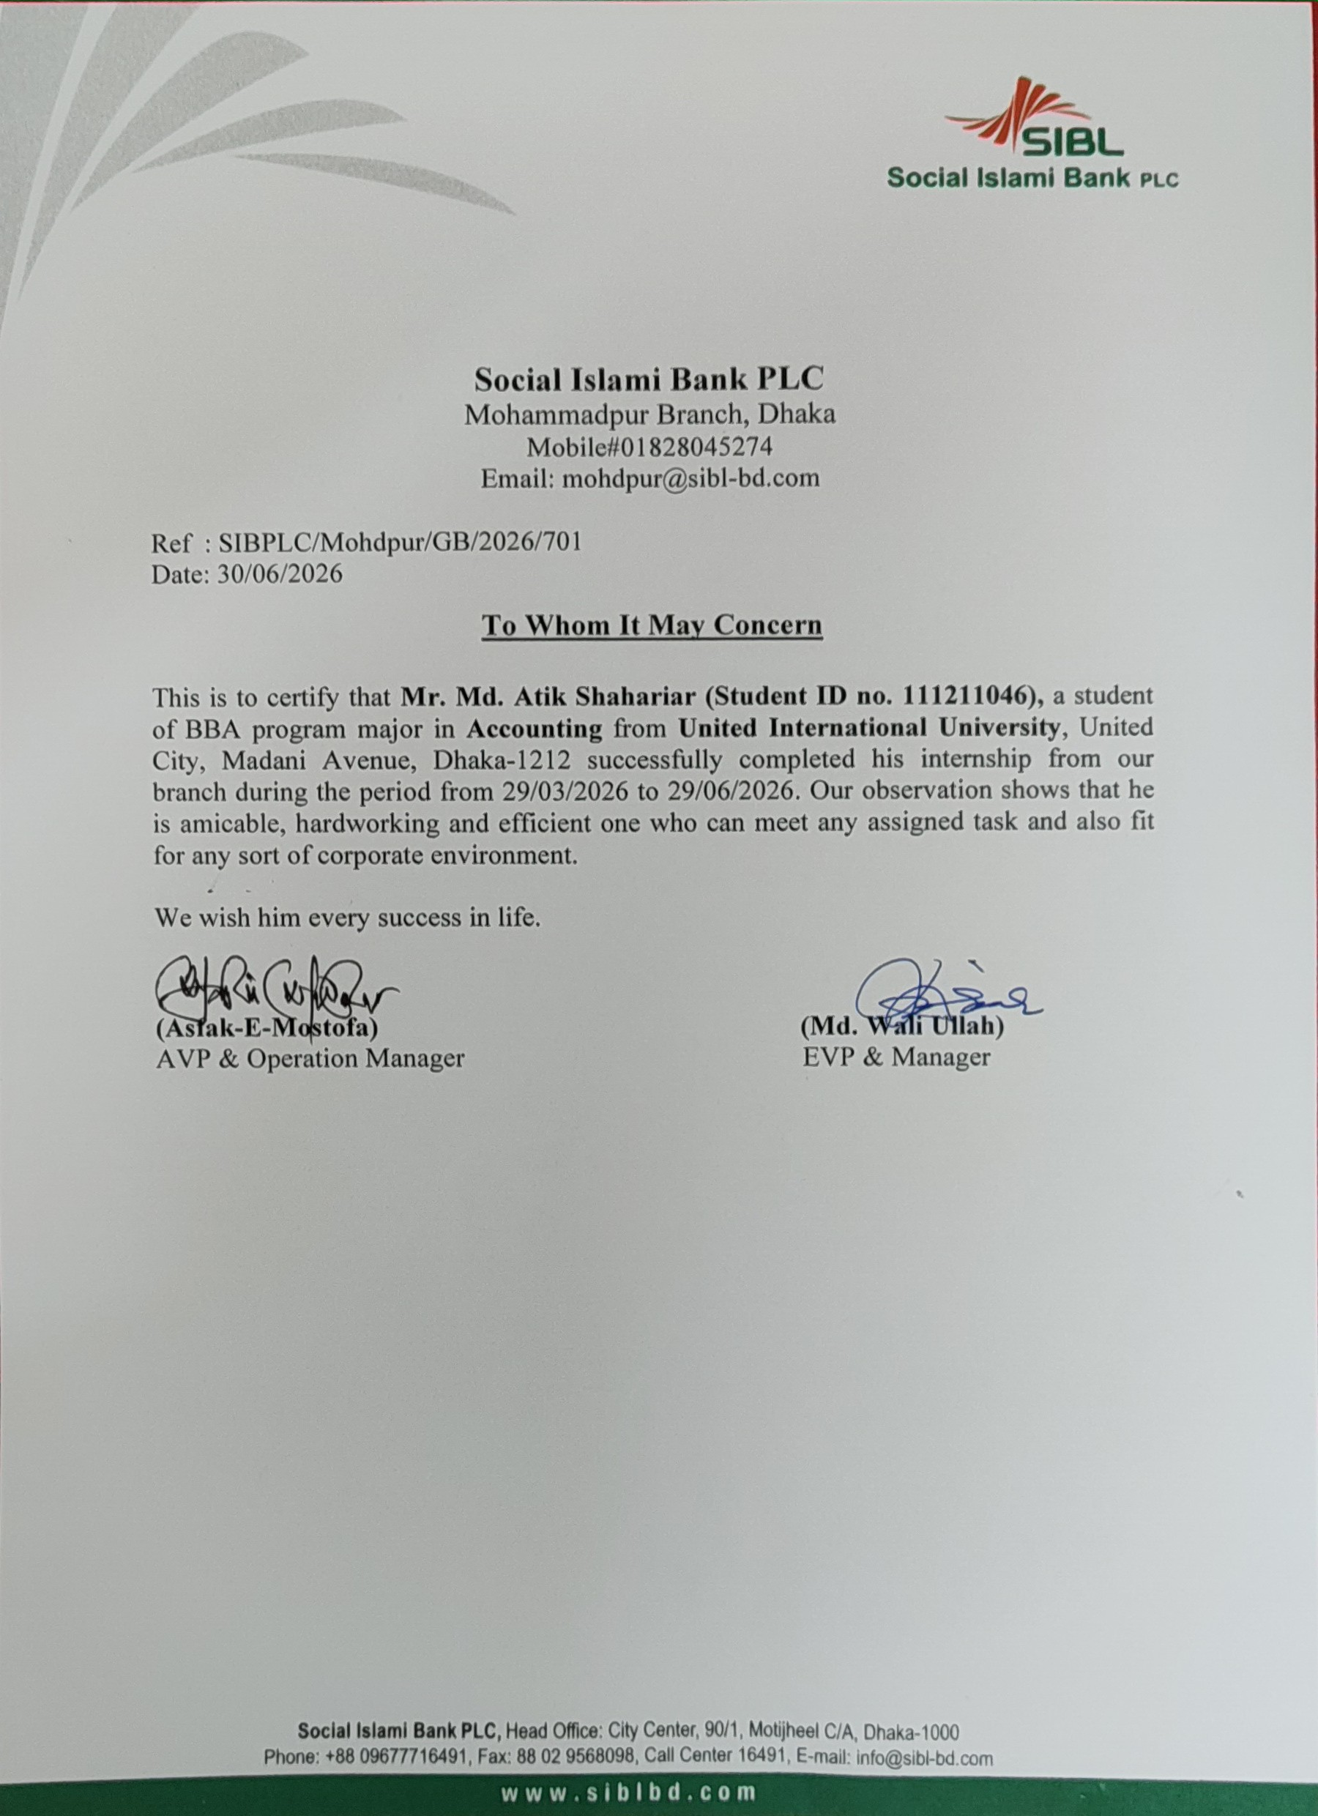

Acknowledgement
First and foremost, I would like to thank Almighty Allah for granting me the opportunity to make progress in my career by completing the internship program.
In addition, I would like to extend my sincere gratitude and appreciation to my supervisor, Dr. Mofijul Hoq Masum, Associate Professor (AIS) , FCMA, ITP, IQAC, School of Business and Economics, United International University, for his valuable guidelines, suggestions, feedback, and support that facilitated the completion of this report. I am confident that without his insightful recommendations and motivation, it would not have been possible for me to finalize this report.
Moreover, I am profoundly grateful to the Social Islami Bank PLC, Mohammadpur Branch, specifically the General Banking department, and the management/executives for providing me with a pleasant and cooperative environment throughout my internship. Their valuable guidance played a significant role in shaping my understanding of the banking sector, particularly regarding loan defaulting issues. I am truly thankful for their hospitality and support during this period.
Lastly, I would like to express my heartfelt thanks to all the faculty members of the School of Business and Economics, United International University, for their exceptional teaching skills and support throughout my BBA program. I am also indebted to my family for their continuous love, support, encouragement, and faith in me.

Executive Summary
The banking sector is the backbone of Bangladesh because it mobilizes domestic savings and provides credit for development activities. However, the problem of loan defaults or non-performing loans has significantly increased, threatening the existence and profit of many banks. This study focuses on the challenges, implications, and management strategies of loan defaults (NPL) in Bangladesh: the case of Social Islami Bank PLC.According to the industry data, the rate of NPL reached its peak in September 2025, hitting 36% or Tk. 6.44 trillion. It dropped slightly to 32.26% or Tk. 5.89 trillion in March 2026. SIBL also faced severe challenges, with a 61.74% classified investment ratio as of 2024. The high level of NPL can be attributed to several factors, including inappropriate credit appraisal and post-disbursement review, wilful default, political issues, and economic factors. I did my three-month internship in the General Banking (GB) Department of Mohammadpur Branch of SIBL. Thus, I have gained adequate insight into the functioning of the bank and understand the role of General Banking in detail. Additionally, I have knowledge about the account-opening procedure, Mobilizing Monthly Term Deposit Receipt (MTDR) and Deposit Pension Scheme (DPS), KYC norms, AML compliance, and document submission in SIBL. My experience in SIBL helped me realize the importance of General Banking in preventing future loan defaults. The present report includes a complete evaluation of SIBL, including an overview of operations, products/services/customers mix, SWOT analysis, and a brief assessment of the banking sector in Bangladesh, including its size, trends, and maturity levels. It also covers the steps taken by Bangladesh Bank in this regard, and recommendations focus on credit risk management and recovery, including improvements in post-disbursement and monitoring procedures for effective NPL management. The study concludes with critical observations on the banking sector and NPL situation in Bangladesh. This internship created a platform for me to develop a comprehensive understanding of the relationship between General Banking and credit risk management in theory and practice.
Keywords: Loan Defaulters, Banking sector, Bangladesh.

Table of Contents
Contents
Letter of Transmittal i
Certification of Similarity Index ii
Declaration of the Student iii
Corporate Evidence iv
Acknowledgement v
Executive Summary vi
List of Figures ix
List of Tables x
List of Equations xi
List of Acronyms and Abbreviations xii
CHAPTER 1: INTRODUCTION 1
1.1 Background of the Report 1
1.2 Objectives of the Report 4
Primary Objective 4
Specific Objectives 4
1.3 Rationale of the Report 5
1.4 Scope and Limitations of the Report 7
Scope: 7
Limitations: 7
1.5 Definition of Key Terms 8
Table 1: Definition of Key Terms 8
CHAPTER 2 COMPANY AND INDUSTRY PROFILE 10
2.1 Company Analysis: Social Islami Bank PLC 10
2.1.1 Overview and History 10
2.1.2 Trend and Growth 13
2.1.3 Product / Service / Customer Mix 25
2.1.4 Company Operations / Activity 28
2.1.5 SWOT Analysis of Social Islami Bank PLC 29
2.2 Industry Analysis: Banking Sector of Bangladesh 31
2.2.1 Specification of the Industry 31
2.2.2 Size, Trend, and Maturity 34
2.2.3 Industry SWOT Analysis 47
CHAPTER 3: INTERNSHIP EXPERIENCE 49
3.1 Position, Duties, and Responsibilities 49
3.2 Training & Development 50
3.3 Contribution to Organization 52
3.4 Evaluation 55
3.5 Skills Applied 56
CHAPTER 4: CONCLUSIONS AND KEY FACTS 59
Key Findings 59
4.2 Recommendations 61
4.3 Conclusions 63
Reference 64

List of Figures
Figure 1 Power Hierarchy Chart for Social Islami Bank PLC 12
Figure 2: Investment Portfolio Trend (2016-2024) 16
Figure 3: Classified Ratio Trend (2016-2024) 17
Figure 4: Trend in Investments and Classified Investments in SIBL (2016-2024) 19
Figure 5: Growth in Investments 22
Figure 6: Change in Classified Ratio (Percentage Points) 23
Figure 7: Invetsment Growth (%) and Change in Classified Ratio (2017-2024) 24
Figure 8: Product/ Service/ Customer Mix 25
Figure 9: Company Operations/ Activity 28
Figure 10: SWOT Analysis of Social Islami Bank PLC 30
Figure 11: Growth Trend of Total Loans/Investments ( Tk. Trillion) in Bangladesh Banking Sector (2016-2026) 37
Figure 12: Trend of Non-Performing Loan (NPL) (Tk. Trillion) in Bangladesh Banking Sector (2016-2026) 38
Figure 13: Size and Growth Trends of Banking Sector Loans 40
Figure 14: Rising Trend of Non-Performing Loan (NPL) (Tk. Trillion) in Bangladesh Banking Sector (2016-2026) 43
Figure 15: Trend of Non-Performing Loans (NPL) Ratio (%) in Bangladesh Banking Sector (2016-2026) 45
Figure 16: NPL Trend in Banking Sector in Bangladesh (2016-2026) 46
Figure 17: SWOT Analysis for Banking Industry in Bangladesh 47

List of Tables
Table 1: Definition of Key Terms 8
Table 2: Trend in Investments and Classified Investments Ratio (2016-2024) 14
Table 3: Investment Portfolio Trend (2016-2024) 15
Table 4 : Classified Ratio (%) 17
Table 5: Trend In Investments and Classified Investment in SIBL (2016-2024) 18
Table 6: Year Over Year Growth in Investments vs Classified Ratio Changes 20
Table 7: Growth in Investments 21
Table 8: Change in Classified Ratio ( Percentage Points) 23
Table 9: Investment Growth (%) and Change in Classified Ratios ( 2017-2024) 24
Table 10: Size and Growth Trend of Banking Sector Loans/ Investments 35
Table 11: Growth Trend of Total Loans/Investments In Bangladesh Banking Sector (2016-2026) 36
Table 12: Trend of Non-Performing Loan (NPL) IN Bangladesh Banking Sector (2016-2026) 38
Table 13: Total Investments/Loans vs Total NPL 39
Table 14: NPL Trend in Bangladesh Banking Sector (2016-2026) 41
Table 15: Rising Trend of Non-Performing Loans (NPL) in Bangladesh Banking Sector (2016-2026) 43
Table 16: Trend Of Non-Performing Loans (NPL) Ratio (%) in Bangladesh Banking Sector (2016-2026) 44
Table 17: NPL Trend in Bangladesh Banking Sector (2016-2026) 46

List of Equations

No equations were used in this report.

List of Acronyms and Abbreviations

- Money Laundering (ML): Laws and regulations enacted by the government to ensure that banks do not deal with money illegally gained and assist in legitimizing it.
- BB (Bangladesh Bank): The central bank that oversees the operations of all the banks in Bangladesh.
- BL (Bad/Loss): The lowest grade of loans classified as non-performing where the bank assumes that no amount will be recovered (provision of 100%).
- CIB (Credit Information Bureau): The database maintained by the Bangladesh Bank that provides information on credit worthiness of borrowers and ensures that lenders have access to the information.
- CSR (Corporate Social Responsibility): Activities carried out by the bank to support social causes such as education, health, and poverty reduction.
- DF (Doubtful): The second lowest classification of loans categorized as non-performing with a provision of 50%.
- DPS (Deposit Pension Scheme): One of the special deposit schemes offered by the banks where the depositor agrees to save a certain amount of money every month and profits from the scheme.
- FCBs (Foreign Commercial Banks): The banks that operate from Bangladesh but have their headquarter overseas.
- GB (General Banking): The regular operations of the bank carried out by the general banking department such as account opening, deposits and withdrawals of cash, KYC, and providing customer service.
- HPSM (Hire Purchase under Shirkatul Melk): One of the modes of transactions allowed under Shariah that enable people to acquire goods on installment.
- KYC (Know Your Customer): The procedure used in ascertaining the true identity and other vital information of the customer before they are allowed to access the services of the bank.
- MTDR (Monthly Term Deposit Receipt): One of the special deposit schemes offered by the banks where the depositor profits from the scheme on a monthly basis.
- NPL (Non-Performing Loan): A loan provided to a borrower that fails to repay the due amount for a certain period of time also referred to as classified loans and defaulted loans.
- PCBs (Private Commercial Banks): The commercial banks operating within Bangladesh that are privately owned.
- RFCD (Resident Foreign Currency Deposit): One of the special deposit schemes available to residents of Bangladesh to save foreign currencies with the bank.SCBs (State-Owned Commercial Banks): The commercial banks owned and operated by the government.

CHAPTER 1: INTRODUCTION

1.1 Background of the Report
The banking industry is critical for any country’s economic development since it involves saving and lending money for productive purposes. As one of the principal financial intermediaries, banks collect money from individuals and institutions and lend that money to consumers, businesses, industries, and entrepreneurs as loans and advances. The banking sector plays an instrumental part in job creation, industrialization, infrastructural development, poverty reduction, and overall economic development by doing this. Apart from ensuring investments, trade, and commerce and enhancing financial accessibility, an efficient banking sector ensures that the flow of money in the economy is smooth. It is crucial for the financial stability and sustainability of the country that the loan portfolio be healthy.
The backbone of the banking industry in Bangladesh is the banking sector of the country. The Bangladesh Central Bank controls and regulates the banking sector in the country that includes state owned commercial banks, private commercial banks, foreign commercial banks and specialized banks. The economic growth of the country has witnessed a remarkable rise in the last few decades and similarly the banking sector of the country has also seen a rapid growth. Due to the rising demand for credit from various sectors such as manufacturing, agriculture, SMEs, export oriented industries, infrastructure projects and consumers, there has been an increase in the lending operations of the banks.
Despite these promising developments, the country’s banking sector continues to encounter several challenges that pose a threat to its future sustainability and stability. One of the main challenges that has arisen out of these challenges is the increase in loan defaults. A loan is considered to be in default when the borrower fails to repay the principle amount and the interests according to the schedule previously agreed upon. These types of loans are known as Non-Performing Loans (NPL). This results in deterioration of the quality of the bank’s assets due to an increased risk of losses.

Over the past decade, the problem of loan defaults has been growing increasingly serious in Bangladesh. A lack of risk assessment, poor monitoring and control systems, poor credit management, uncertainties in the economy, and insufficient efforts in enforcing loan recovery methods have led to an increase in the quantity of categorized loans, according to several reports issued by Bangladesh Bank. Some borrowers might fail to make their payments due to a lack of success in the business, unfriendly business environment, inflation, fluctuations in exchange rates, political disturbances, calamities of nature, or world economic crises. However, there are other borrowers who intentionally delay making their payments despite having sufficient funds.
A deficiency in the credit evaluation and monitoring system is one of the key reasons for the increasing rate of default loans in Bangladesh. The banks are expected to undertake proper evaluations of the credit history, business feasibility, repayment ability, and financial situation of the borrowers before issuing any loans. However, bad loan issuance is often as a result of improper monitoring after the loan is issued, too much emphasis on collateral instead of cash flow evaluation, and improper risk evaluation. Sometimes, the efficiency of the loan issuance process is undermined by political pressure, corruption, favoritism, and poor corporate governance, allowing risky borrowers to obtain large amounts of money as loans.
Inappropriate use of borrowed money is a major contributing reason to loan default. Many borrowers divert money to speculative investments, real estate acquisitions, personal expenses, or other unproductive activities instead of using loan profits for the planned business goals. Because of this, anticipated company returns are not produced, which makes it harder for debtors to pay back their debts. Additionally, insufficient operational strategy, inadequate financial planning, ineffective market research, and inefficient business management all raise the likelihood of business failure, which ultimately results in loan defaults.
Furthermore, the capacity of the borrowers to repay the banks' loan is affected greatly by the macroeconomic situation in the economy. There are a lot of businesses from various industries that have been suffering because of inflation, increased interest rates, devaluation of Bangladeshi Taka, disruption of the supply chain, reduction in export demand, and change in the commodity prices worldwide. The small and medium-sized firms, which account for a significant proportion of the borrowers from the banks in Bangladesh, being financially constrained and having low risk-taking ability, are particularly vulnerable to these economic fluctuations.
The issue of loan default has implications that are not limited to particular banks and individuals only. The entire financial system as well as the country’s economy is greatly affected when there are many loan defaults. High levels of non-performing loans lead banks to hold more loan loss reserves, thereby reducing their profitability and capital adequacy ratios. With reduced profits, banks find it more difficult to make investments in profitable sectors, hence slowing down investment and economic growth. Loan defaults could discourage foreign investments, affect the country’s financial reputation, lead to high borrowing costs, as well as reduce confidence in the banking sector. Bank depositors may lack confidence in the safety of their deposits if banks find themselves in financial distress due to many loan defaults.
Loans that are defaulted upon also create problems for Bangladesh Bank and other regulatory agencies. In order to improve loan recovery effectiveness and manage credit risks, the central bank should continuously apply new policies, guidelines, prudential regulations, and monitoring mechanisms. There have been some measures applied in order to decrease the level of default loans, which include risk-based supervision, tougher standards for classifying loans, better standards for corporate governance, better reporting mechanisms of Credit Information Bureau (CIB), and loan rescheduling regulations. Yet, the willingness of commercial banks to follow responsible lending practices and ensure proper monitoring is important for making such measures successful.
It is worth noting that there is great concern about loan default among researchers, policy makers, economists, financial institutions, and organizations involved in international development. A number of researches have attempted to determine the key factors behind loan defaults, measure the effectiveness of recovery measures, assess the regulatory framework, and propose legislation that can improve the overall health of the banking sector. From these researches, one of the recommendations to reduce loan defaults and maintain financial stability includes strengthening the credit risk management, improving the process of screening borrowers, being transparent, reducing government interference, adopting the latest risk assessment technologies, and taking legal action against intentional defaulters.
A comprehensive research on loan defaulter in Bangladesh would be extremely relevant in light of the increasing relevance of the issue. Commercial banks could improve their lending system, contribute towards developing effective supervisory systems for the regulator, and even help lawmakers in enacting financial sector reforms through gaining knowledge about the causes and consequences of loans and how these loans are recovered. By bringing together the theoretical perspective on managing credit risk with the practical issues faced by Bangladeshi banks, this study will benefit academia.

1.2 Objectives of the Report

Primary Objective
The main purpose of this report is to examine, analyze and assess the reasons, trends, impacts and management policies of default on loans (Non – Performing Loans) in the Banking sector with specific focus to Social Islami Bank PLC (SIBL), Mohammadpur Branch. The report will help the reader to get an insight about how theoretical knowledge can be applied in practice by considering the experience gained during the three month internship program in the General Banking Department of SIBL.

Specific Objectives
The objectives of the study are specifically focused on the following;
- To investigate the overall loan default trend and its implication on the financial status of the commercial banks in Bangladesh.
- To assess the significant factors which contribute to loan defaults, covering the borrower, institutional, and economic elements that affect the repayment capacity of the borrower.
- To examine the credit appraisal policy, monitoring mechanism, loan classification policy, and recovery mechanism that Social Islami Bank PLC practices to mitigate investment risk and lower classified loans.
- To assess the impact of loan defaults on the profitability, liquidity position, quality of assets, and overall performance of the commercial banks in Bangladesh with a focus on Social Islami Bank PLC.
- Finally, to come up with recommendations on the best intervention strategies that could help improve credit risk management practices, enhance recovery performance, and ultimately reduce loan defaults in Bangladesh’s commercial banking industry.

1.3 Rationale of the Report
The banking industry represents one of the major components of the financial system in Bangladesh, as it performs an important function in mobilization of saving, investments, and business activities for the purpose of achieving economic growth and development. Banking institutions offer financial support to individuals, businessmen, industries, and others via lending activities. However, the success of these lending activities is mainly determined by the ability and willingness of the borrowers to return their loan amounts during the specified period of time. In recent times, the issue of loan defaulters has become one of the most serious problems that confronts the banking industry of Bangladesh. There has been a constant increase in loan defaults which have had a negative impact on the performance of banks as well as their profitability and financial stability. Therefore, it has become very important to conduct a study about loan defaulters.
The choice of the research topic 'Loan Defaulter in Bangladesh' has been made for a number of reasons. The main reason for opting for the topic is related to the problem associated with the increase in the amount of non-performing loans in Bangladesh. The presence of loan defaulters in Bangladesh has an adverse impact on the quality of the bank's assets and its capacity to lend money to productive areas of economy. The higher the provision against defaulting loans, the lower is the profitability and capital of the bank. Thus, by studying the problems associated with loan defaults, the researcher will be able to solve one of the major problems of the banking system.
There is also another vital reason behind the execution of this report, and it is the need for determining those factors that are responsible for creating the problem of loan default in Bangladesh. Loan defaulting can take place because of improper credit assessment, ineffective monitoring of the borrowers, poor corporate governance, inappropriate use of the loan amount, poor economic conditions, political pressure, or poor legal enforcement. It is necessary to determine these factors in order to evaluate the efficacy of current credit management techniques and improve them.
The report is equally important in terms of commercial banks. Good management of loan defaults is necessary to maintain financial stability, safeguard depositors' money, and sustain business growth. This report can help bank management in the improvement of credit appraisal process, loan monitoring, better recovery procedures, and efficient credit risk management techniques. The reduction in loan defaults will allow banks to be profitable, engage in more lending activities, and develop people's confidence in the banking system.
Moreover, the study carries substantial significance for the regulatory agencies like Bangladesh Bank. Being the central bank of the country, Bangladesh Bank is in charge of overseeing commercial banks, maintaining financial stability, and formulating policies concerning credit risk management and loan classification. Results of the report can prove to be very informative on the issue of whether the current regulations are effective or not and which areas require any changes in the existing policies. Strict regulation and good lending practices are necessary to keep down the number of non-performing loans.
This report also has relevance to those people who are involved in formulating policy for financial reforms. A healthy banking sector is essential for investment, development of industries, and sustainable economic growth. An increase in the number of defaulted loans will result in lower investments, less availability of loans, and will also bring about financial instability. Through an understanding of the causes and effects of loan defaults, this report could help develop better policies that would ensure higher effectiveness in loan recovery and corporate governance.
In addition, through this study, there is increasing knowledge about the importance of good borrowing practices on the part of borrowers and other stakeholders. This will ensure that there are sound lending practices and loan repayment for financial institutions and borrowers as well, making the entire process a lot more reliable.

1.4 Scope and Limitations of the Report

Scope:
The scope of this report will involve the study of the problem of loan defaulters in Bangladesh with specific reference to the experiences of Social Islami Bank PLC (SIBL), Mohammadpur Branch. The areas covered in this report are:
- Analysis of Loan Default Patterns: This section will deal with the study of loan defaults pattern in the banks of Bangladesh, including SIBL and other commercial banks.
- Causes of Loan Defaults: Major causes that have resulted in the increasing number of loan defaults in Bangladesh will be identified in this section.
- Impact of Loan Defaults on Banks: Study of the effect of loan defaults on profitability, liquidity, asset quality, and financial stability of the banks in Bangladesh will be performed in this part.
- Loan Recovery and Credit Risk Management: In this section, the strategies and approaches employed by SIBL and banks in general to recover from the defaulted loans will be studied.

Limitations:
Even with all the efforts made to make this report as accurate and comprehensive as possible, the report still faces the following limitations:
- Use of Secondary Sources: In this case, the study is done using secondary sources such as annual reports, Bangladesh Bank documents, journal articles, and other published sources due to lack of accessibility to primary sources.
- Confidentiality Issues: Customer loan files, confidential loan files, and credit analysis report were inaccessible because of the confidentiality issues in the banks.
- Time Limitation: The limited time for internship and academics did not allow for field study.
- Organizational Limitations: Observation was only done in one bank namely SIBL Mohammadpur branch, but the report covers the entire banking industry of Bangladesh.
- Environmental Change: Trends in loan defaults are also influenced by environmental changes.

1.5 Definition of Key Terms

Table 1: Definition of Key Terms

Term | Definition
Loan Defaulter | A borrower who doesn't pay back the loan's principal and/or profit as agreed. Also referred to as "Rin Khelapi" in Bengali
General Banking (GB) | Department that handles all GB-related tasks, including opening and closing accounts and writing cheques.
Investment Department | Department handling loan, investment, credit card, EGP.
Monthly Term Deposit Receipt (MTDR) | A deposit product that allows customers to make a single deposit and earn a profit each month.
Deposit Pension Scheme (DPS) | A savings plan with monthly installments that matures after a predetermined amount of time.
Continuous Loan | Loan that has limit and expiry date .Example includes Cash Credit and Overdraft .
Demand Loan | Loan repayable on demand. Example includes PAD, LIM.
Fixed Term Loan | Loan repayable in installments Example includes housing loan.
Past Due / Overdue | The day after expiry date when repayment is not made
Special Mention Account (SMA) | Loan overdue 2-3 months (early warning)
Sub-Standard (SS) | Loan overdue 3-6 months. Provision: 20%
Doubtful (DF) | Loan overdue 6-12 months. Provision: 50%
Bad/Loss (BL) | Loan overdue 12+ months. Provision: 100%
Provision | Funds set aside from profits to cover expected losses.
Interest Suspense Account | Where interest on classified loans is parked (not income)
Rescheduling | Extending repayment period with down payment
Eligible Collateral | Assets like FDR, government bonds, gold that reduce provision base

CHAPTER 2 COMPANY AND INDUSTRY PROFILE

2.1 Company Analysis: Social Islami Bank PLC

2.1.1 Overview and History
Social Islami Bank PLC (SIBL) is one of the premier Shariah-based private commercial banks in Bangladesh. This bank was set up with the aim of delivering modern banking products and services according to the Shariah principles of Islam. SIBL has been playing a major role in encouraging ethics, financial inclusion, and sustainable economic development in the form of banking activities. Since its inception, SIBL has been consistently expanding its activities by offering innovative banking products, technology-driven financial services, and customer-friendly options.
Social Islami Bank commenced its banking operations on 22 November 1995 as a second-generation private commercial bank in Bangladesh. It was established under the Companies Act with the vision of creating a unique banking model based on Islamic principles while contributing to social welfare and poverty alleviation. Unlike conventional banks that operate primarily for profit maximization, SIBL introduced the Three-Sector Banking Model, consisting of the Formal Sector, Non-formal Sector, and Voluntary Sector. This innovative concept was designed to integrate commercial banking with social responsibility by promoting financial services that support economic development and community welfare.
From its foundation, SIBL has consistently grown in its branches, number of clients, deposits, investments, and technology use. The bank has successfully metamorphosed into a highly modern bank by using sophisticated banking technology, offering better quality services, and improving its risk management system. Presently, the bank is operating through 180 branches, 236 sub-branches, and 375 agent banking branches in Bangladesh, which allows customers from all regions to easily access banking services.
SIBL provides an extensive range of Shariah-based banking products and services. These services include the following: Mudaraba Savings Accounts, Current Account, Fixed Deposit, SME Investment, Corporate Investment, Consumer Investment, Home Financing, Vehicle Financing, Agriculture Investment, Foreign Trade Services, Remittance Services, Debit/ Credit Card, Online/Internet Banking, Mobile Banking, Agent Banking, and Treasury Services. The bank engages in investments via Shariah-based financing methods such as Murabaha, Bai-Muajjal, Musharakah, Hire Purchase under Shirkatul Melk (HPSM), Ijarah, and Quard.
Besides being involved in its commercial dealings, CSR is a very important part of the SIBL. The bank is actively involved in promoting education, health care, disaster assistance, environmental conservation, financial literacy, and poverty alleviation programs. The bank’s vision statement of “Working Together for a Caring Society” is a clear indication of how important CSR is to the bank.
The Mohammadpur Branch, where the internship was taken place, is an important branch of SIBL in Dhaka. Situated in 20/15 Tajmahal Road, Block C, Mohammadpur, Dhaka-1207, the branch offers various kinds of banking services such as deposits, investments (loans), remittances, foreign currency, cash dealing and customer relations. The internship experience gave the chance to gain knowledge about the working process of a modern Islamic commercial bank by getting hands on experience of the banking functions through practical work.
In its almost three decades of existence, Social Islami Bank PLC has made itself known as one of the most notable Islamic banks in Bangladesh due to its steady growth in terms of business operations, innovations, sound financial practices, and following Shariah requirements. With its emphasis on ethical banking and customer-oriented services and strategies, it continues to help the country in its economic development in terms of financial inclusion and responsible banking.

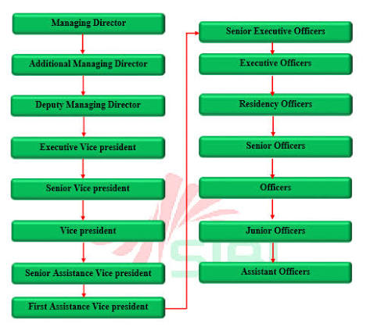

Figure 1 Power Hierarchy Chart for Social Islami Bank PLC

Vision
In order to become the number one Islamic bank in Bangladesh offering Shariah-compliant financial services while achieving sustainable growth and adding value to our stakeholders, which include customers, shareholders, employees, and the society as a whole.

Mission Statement
- "Provide banking services of high quality that are Shariah-compliant."
- "Sustainable growth through customer satisfaction and innovation."
- "Contribute to the socio-economic development of the nation through ethical banking."

Strategic Goals (Corporate Objectives)
- Expand banking services that comply with Shariah in Bangladesh.
- Achieve profitability and financial stability.
- Enhance customers' satisfaction by way of digital banking and superior service.
- Enhance the quality of investments by reducing classified investments (defaulted loans).

2.1.2 Trend and Growth
The dynamics of investment (loan) portfolios of the Social Islami Bank PLC (SIBL) have been on a growth path for several years, thus illustrating the bank’s expansion in terms of Islamic banking activities in Bangladesh. At the same time, an analysis of the phenomenon of delinquency (loan defaults) in SIBL using such indicators as classified investments (or non-performing loans (NPLs) in conventional banks) and the ratio of classified investments to total investment demonstrates that they are growing at a significant pace after 2023 due to economic, governance, and other factors.
SIBL’s investment (general) increased steadily from approximately BDT 174,196 million in 2016 to more than BDT 383,165 million in 2024, suggesting that the company grew its portfolio. However, the quality of assets deteriorated significantly year-on-year, particularly for classified loans, which surged drastically in 2024. The current study aims to assess the changes in the trends of selected items using the company’s Annual Reports for 2016-2024 and additional sources.

Key Trends in Investments and Classified Loans
- Investment Portfolio Growth: SIBL’s general investments grew steadily until 2023, primarily driven by an increase in retail, corporate, and SME financing under Shariah principles. However, the growth rate decreased or stalled in 2024 for most deposit categories, with the exception of corporate deposits, which were impacted by economic challenges.
- Classified Investments (NPLs): Despite the overall growth in the investment portfolio, the ratio of classified investments has remained stable and relatively low (4-8%) since 2016. Nevertheless, there was a significant surge in 2024 (61.74%), primarily due to the under-provisioning of NPLs, hidden defaults (associated with the S. Alam Group), and the inability to recover defaulted amounts.
- External Context: In Bangladesh, the banking sector’s NPL ratio has also experienced a notable increase (reaching 20.2%). Additionally, SIBL faced challenges related to the concealment of defaults and insufficient provisioning.

Table 2: Trend in Investments and Classified Investments Ratio (2016-2024)

Year | Total/General Investments | Approx. Classified Amount (Calculated) | Notes
2016 | 174,196 | 7,734 | Stable asset quality
2017 | 210,046 | 17,224 | Increase noted
2018 | 238,654 | 18,355 | Slight improvement
2020 | 300,618 | 18,187 | Post-COVID stability
2021 | 312,774 | 16,202 | Improving trend
2022 | 342,944 | 16,461 | Low point
2023 | 360,817 | 17,283 | Reported low; actual higher per BB
2024 | 383,165 | 236,500 | Sharp spike; major crisis

Interpretation of Trend in Investments and Classified Investments Ratio (2016-2024)
Based on the information provided in Table 2, it can be concluded that SIBL has recorded significant growth in investment funds while maintaining a stable asset quality level. Specifically, general investments for the bank grew steadily from 2016 to 2023, reaching BDT 360,817 million in 2023 from BDT 174,196 million in 2016. The growth was mainly driven by the bank’s strategy of expanding its branch network across the country, encouraging customer deposits, and investing in shariah-compliant products, including retail financing, SME, and foreign exchange, among others. The overall growth rate was remarkable and at a CAGR of 9-10% per annum. Concurrently, the ratio of classified investments for the bank remained stable at 4.44% to 8.20%. For example, from 2020 to 2023, the percentage of classified investments slightly declined from 6.05% to 4.79%, which further implies that the bank was able to sustain the low-risk investment strategy during the covid-19 period.
However, the jump of 61.74% in 2024, reaching the ratio of 61.74%, with the volume of funds classifying surpassing the mark of BDT 236,500 million, represents a significant concern. In this situation, the growth reflects the recognition of the previously unclassified defaults, provision shortfalls, and difficulties in collecting funds from major borrowers. In this case, the volume of classified funds has increased by over two times (or even three times in terms of value) within a year, which was driven not by significant investment growth (only +6.2% in 2024). This dynamic demonstrates the risk of economic, political, and managerial factors deteriorating within a short period and impairing the bank’s capacity to perform its obligations. As for visualizing this data, a line/bar graph with two different Y-axes (investment volume and ratio) would be a great choice to highlight the growth of investment and the sudden increase of the fund classification ratio in 2024. This trend suggests the vulnerability of Islamic banks to macroeconomic forces, which requires continuous monitoring of such banks’ risk exposure.

Table 3: Investment Portfolio Trend (2016-2024)
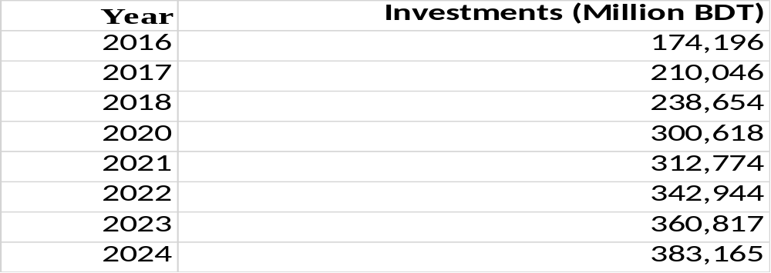
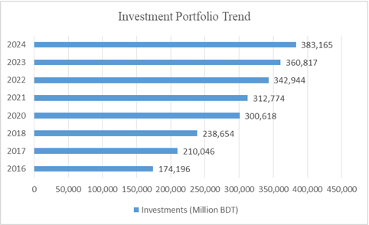

Figure 2: Investment Portfolio Trend (2016-2024)

Interpretation of Investment Portfolio Trend (2016-2024)
It contains a data set that can be used to display the absolute growth of the investment portfolio of SIBL. The tendency of growth is positive, which indicates the bank’s ability to maintain its competitive position on the market. Specifically, the total value increased from 174 to 383 billion Bangladeshi Taka (BDT) in 2016 and 2024, respectively. The highest growth rates were observed in 2018-2022, probably due to digitalization, network development (more than 180 branches and sub-branches), and increasing foreign exchange and remittances. Thus,the bar chart can be built using the data set. It will visualize the amount of growth, which was the highest in 2023-2024 and was about 25-30 billion BDT per year on average.
Despite the fact that the graphical display demonstrates a positive association between the two variables, the chart in tandem with the classified loan information suggests otherwise. Indeed, the year 2024 appears to be the most impressive one regarding the loan portfolio size, which reached its peak at 383,165 million. However, it also implies that the biggest share of the industry investments have defaulted, which is reflected in the highest number of delinquencies registered in the latest period. This observation can support the suggested recommendations; hence, in the report, one should mention the chart to emphasize that despite the successful growth of SIBL’s operations, the company should be more careful about its future ventures to avoid significant delinquencies.

Table 4 : Classified Ratio (%)
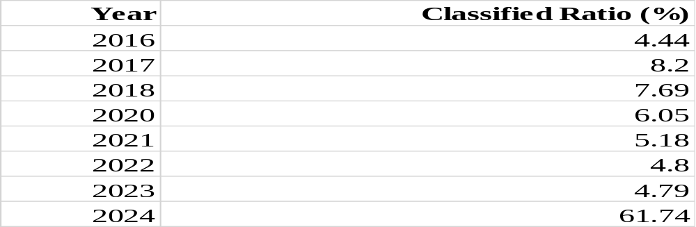
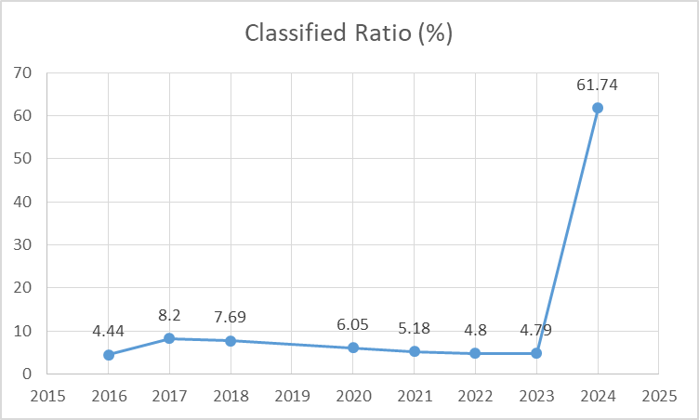

Figure 3: Classified Ratio Trend (2016-2024)

Interpretation of Classified Ratio Trend (2016-2024)
This set of data is best presented using the line chart type to evaluate the tendency, which changed drastically in 2024. Prior to the year, there was a slow, steady rise in the ratio, which remained in the range of 4.5 – 8.2 percent for nearly ten years. In other words, the bank performed stable risk management and following the guidelines of the Bangladesh Bank regarding classification and provisioning of loans. The 2017 reform, implementation of improved client management strategy, and more focused recovery efforts accounted for the tendency. Therefore, it is possible to say that before 2024, the bank was performing reasonably well in terms of credit risks.
However, a sudden increase to 61.74 percent in 2024 suggests that the bank faced serious challenges with repayment capabilities in the last year. There is a number of reasons to assume that such a tendency may emerge under the influence of economic, political, and internal factors. For example, there is evidence of deliberate cover-ups in regard to non-performing loans in Bangladesh (Bangladesh Bank, 2023). Thus, the line chart would present the information in the most compelling way to visualize both the overall stability and a sudden surge in delinquencies. Such a display would also raise concerns about the profitability of the bank and its ability to manage risks, thus affecting stakeholders’ trust. In the context of an internship, this finding can be considered more closely within the framework of credit risk management best practices.

Table 5: Trend In Investments and Classified Investment in SIBL (2016-2024)
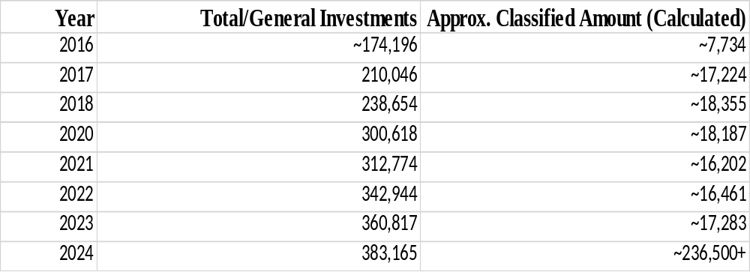
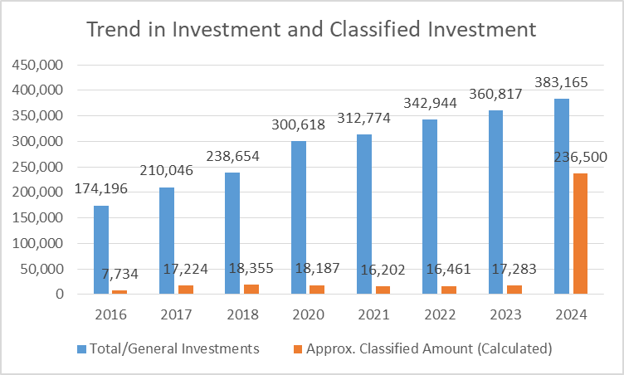

Figure 4: Trend in Investments and Classified Investments in SIBL (2016-2024)

Interpretation Trend in Investments and Classified Investments in SIBL
It shows the trend of the Social Islami Bank PLC’s total investment portfolio and the approximate amount of classified (default) investments for the period under review. Firstly, an upward trend in the Bank’s total investment portfolio from 2016 to 2024 suggests that SIBL continuously expands its Shariah-compliant financing activities in various sectors of the economy. It implies that the Bank prioritizes growth and invests in more opportunities. However, the second line of the graph indicates that the volume of classified investments was relatively stable during 2016-2023 and increased significantly in 2024. It suggests that the Bank faces challenges in maintaining an acceptable level of investment quality since a considerable amount of its portfolio has become classified as defaulted in 2024. Such a situation might be caused by economic instability, inflation, governance concerns, insufficient credit control, and the borrowers’ inability to repay loans. Thus, the graph suggests that SIBL has been successful in growing its investment portfolio; however, the rapid increase in classified investments implies that the Bank has some issues with credit risk management.Such a significant increase in classified investments despite a small increase in total investments (6.2%) implies financial distress and exposes the risk that comes with relying on the bank. Some of the reasons that may have triggered this wave of default include economic downturn, political instability, governance issues, and last but not least, some default cases may have been overlooked, especially those that occur in a short-term.
From this table, I can conclude that despite the impressive performance of SIBL in terms of the total amount of investments, the sudden rise of loan defaulters (classified investments) in 2024 can cause adverse impacts on the bank’s performance, profitability, and eventually, its sustainability. There is a need for the bank to ensure that credit appraisal, risk management, and recovery policies are enhanced to check this rising level of defaults.
Growth Rates (Year-over-Year)

Table 6: Year Over Year Growth in Investments vs Classified Ratio Changes
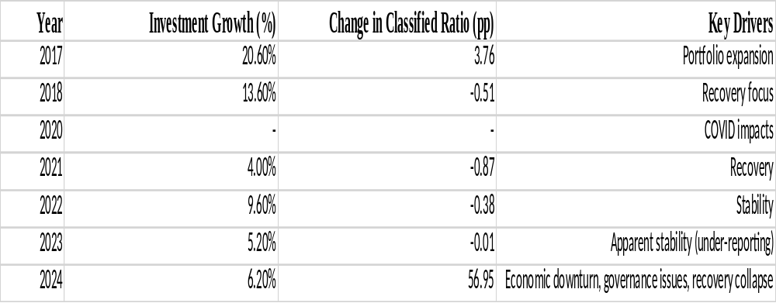

Interpretation of Table 6: YoY Growth in Investments vs. Classified Ratio Changes
Table 6 suggests the trends in the course of two consecutive years. Thus, the data illustrates that increases in investment did not necessarily lead to an improvement in the quality of assets. For example, the substantial growth of investment by 20.6% (in 2017) was associated with a 3.76% increase in the classified ratio. Apparently, in 2017, the bank had adopted a strategy of aggressive investment growth with little attention to the quality of loans. However, in 2018 – 2023, the growth of investment remained considerable (between 4 and 13.6%), while the classified ratio decreased or remained stable, suggesting that the bank had improved its ability to handle delinquencies with a specific emphasis on recovery efforts.
The only questionable piece of data is the one referring to the year 2024. It appears that a modest growth of 6.2% was paired with an unreasonable raise of the classified ratio by 56,95 p.p. Thus, it might be concluded that the banking sector experienced some difficulties in terms of resolving delinquencies in the latest period under consideration. In general, the given table suggests that the Islamic banking sector should be careful about a rapid growth of its’ assets as it may lead to insufficient credit appraisal according to Shariah principles and result in an increased number of NPLs. Notably, the banking sector faced significant challenges in 2024 that could be observed on both levels – the lack of recovery in some periods and an extreme increment in delinquencies in the latest period. Therefore, it can be stated that the sector’s performance in terms of NPLs management is at risk and requires additional attention.

Table 7: Growth in Investments
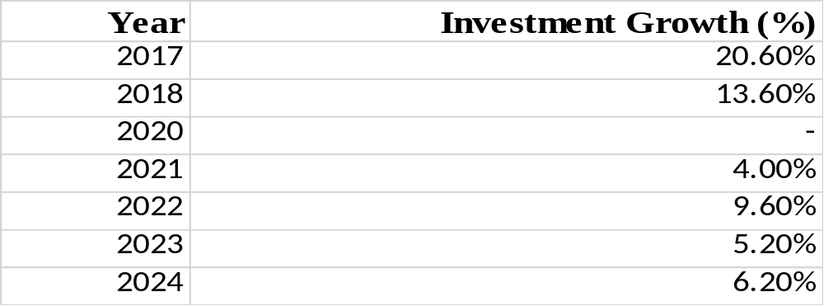
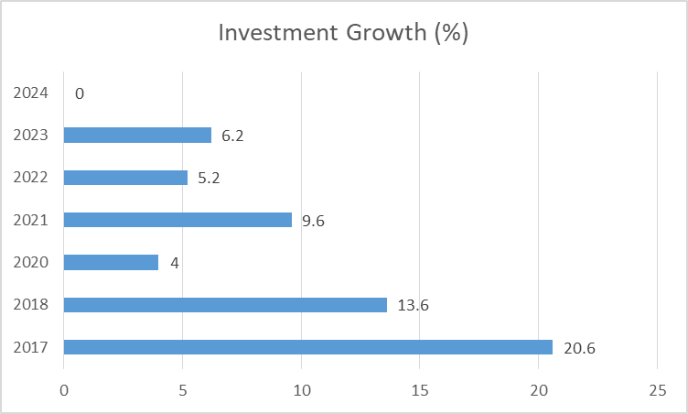

Figure 5: Growth in Investments

Interpretation of Growth of Total Investment Portfolio)
The given bar chart illustrates the year-on-year growth of the total investment (loan) portfolio of Social Islami Bank PLC for the given period. The chart shows that the Bank has been actively investing in developing various sectors of the national economy, such as corporate business, small and medium-sized enterprises (SMEs), agriculture, consumer financing, and trade, by providing Shariah-compliant financing products and services. In particular, the gradual growth of the bar chart’s bars reflects the Bank’s efforts to increase its investment portfolio and support the national economy. Despite the COVID-19 pandemic-related restrictions, investment opportunities, and regulatory changes, the Bank has been growing steadily year by year to improve its market share, generate additional profits through investments, and offer Shariah-compliant financial products to its customers.

Table 8: Change in Classified Ratio ( Percentage Points)
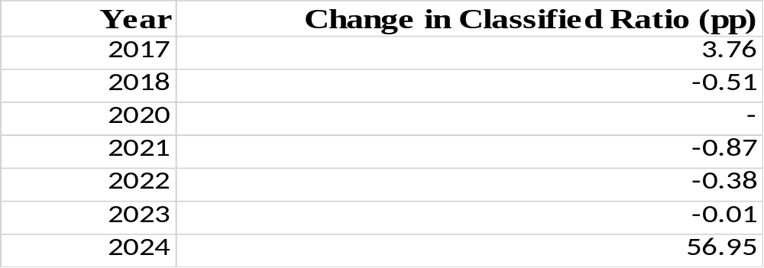
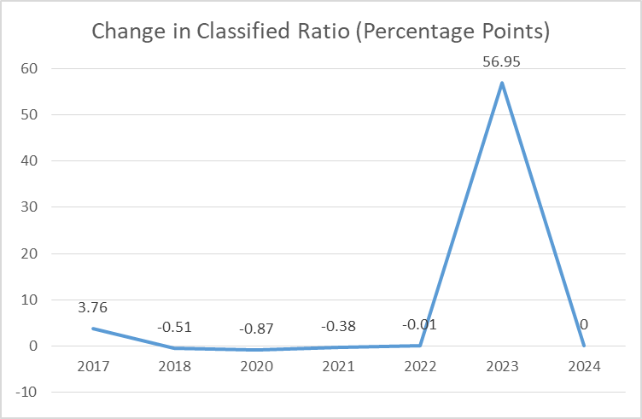

Figure 6: Change in Classified Ratio (Percentage Points)

Interpretation of the Line Graph (Trend of Classified Investments/Loan Defaults)
The line graph indicates the trend of classified investments (loan defaults) of Social Islami Bank PLC during the study period. The line graph depicts the changes in classified investments (defaulted loans) of the bank against the years. From the graph, it can be interpreted that there occurs a rising trend of classified investments (loan defaults) and signifies the poor performance of the bank in terms of investments. The rising trend might be due to economic instability, failure of the business, inability of the borrower to pay back the loan due to various reasons, and change in the policy of Bangladesh Bank about loan classification. However, it can also be interpreted that with the slow rise and down in some intervals, the banks have improved their performance in terms of collection of loan from the borrowers to minimize defaults. Thus, it can be concluded that though the SIBL continues to grow its investment, it should take a specific focus to minimize loan defaults. As such, they should monitor the borrower and ensure a proper credit appraisal in order to minimize defaults and ensure the growth of the bank.

Table 9: Investment Growth (%) and Change in Classified Ratios ( 2017-2024)
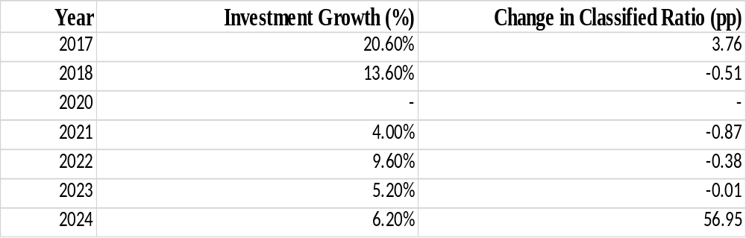
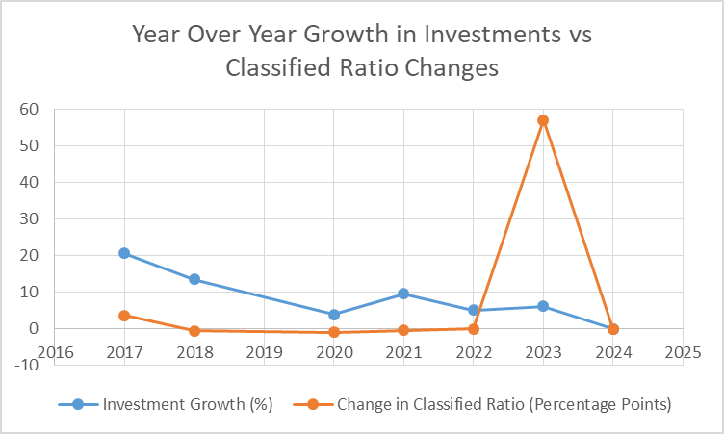

Figure 7: Invetsment Growth (%) and Change in Classified Ratio (2017-2024)

Interpretation of Investment Growth (%) and Change in Classified Ratio
It illustrates the annual investment growth rate in the Bank with changes in the classified investment ratio over the same period. As the graph shows, the Bank registered positive investment growth in most years apart from 2020. However, there is a clear decline in the investment growth rate from 2017 to 2022. This implies that the Bank was cautious about its investment decisions from 2017 onwards, possibly due to adverse economic conditions. On the contrary, the classified investment ratio remained stable and improved slightly between 2018 and 2022, which implies effective credit risk management. However, there is a significant rise in the classified investment ratio in 2023–2024, thus indicating negative trends in the Bank’s investment quality. Therefore, it can be argued that external economic conditions, default risk, and challenges in credit risk recovery significantly impacted the Bank’s investment growth in recent years. Overall, the graph shows that investments should not be increased irresponsibly without credit risk management and recovery mechanisms to minimize the risk of non-performing investments.

2.1.3 Product / Service / Customer Mix
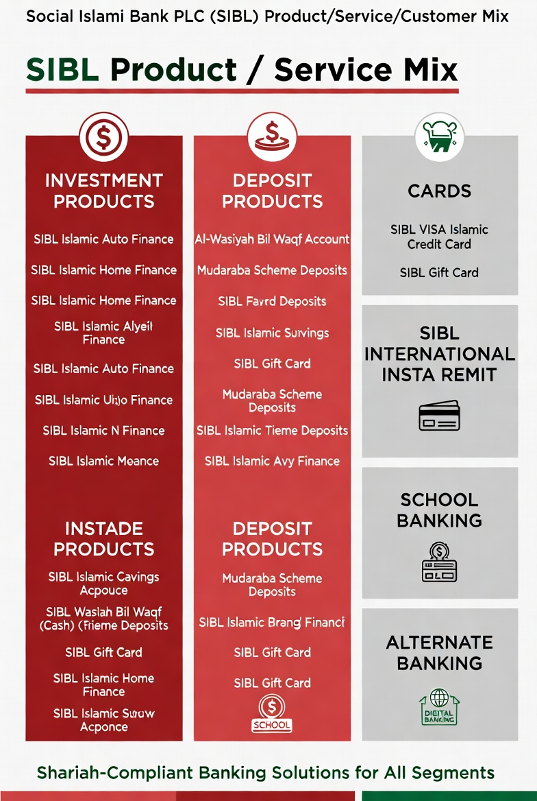

Figure 8: Product/ Service/ Customer Mix
Social Islami Bank PLC (SIBL) deals in all types of Shariah-based products and services to serve the customers’ needs. The products have been categorized into different sections as seen on the company’s website. These are Investment Products, Deposit Products, Cards, SIBL International Insta Remit, School Banking, Alternate Banking, and Other Services.
Investment Products constitute one of the key financing functions offered by SIBL. The products include SIBL Islamic Auto Finance, SIBL Islamic Home Financing, Islamic Consumer Finance, SIBL Retail Investment for Students, Bai-Muajjal, HPSM, HPSM-IJARA, Murabaha, Musharaka, Bill Purchase, Bai-Salam (PC) and Quard. The products allow individuals, communities and firms to acquire goods, expand their businesses, meet working capital needs and achieve other related objectives.
Deposit Products are meant for mobilizing customer money on a profit and loss sharing basis. The business offers various deposit products including Al-Wasiyah Bil Waqf (Cash) Account, Mudaraba Scheme Deposits, Al Wadiyah Current Account, Mudaraba Savings Deposit, Mudaraba Term Deposit, Mudaraba Notice Deposit, Cash Waqf Deposit, SIBL Super Savings Account, and Resident Foreign Currency Deposit (RFCD) Account. The products are available in different terms that help in attracting both short and long-term deposits that offer attractive profits to the savers.
Cards offer convenient payment methods. SIBL offers SIBL VISA Islamic Credit Card, SIBL Gift Card, SIBL Dual Prepaid Card, Visa Islamic Credit Card (Local), SIBL Zameel Debit Card, SIBL Prepaid Card, SIBL Hajj Card, special offers, and other card-related guidelines.
SIBL International Insta Remit is engaged in offering quality remittance services to the expatriates and their family members. The company’s popular services include SIBL International Insta Edu Remit, SIBL International Insta Medi Remit, SIBL International Insta Family Remit and other special instant remittance options.
School Banking focuses on targeting students and young customers by providing products like SIBL Student Account, Mudaraba Education, and SIBL Youngster Account, which encourages savings from an early age and educates them on saving their earnings for the long-term.
Alternate Banking offers contemporary digital and agent-based services viz. Internet Banking and Agent Banking to offer convenience to customers in day to day transactions.
Other Services include Locker services, Insurance Services, Pre-registration and Registration fee of Hajj along with a number of other value added services to supplement the core services of the bank.
Customer Mix at SIBL is very diverse. The bank serves a wide range of clients by offering various financial products and services. It attracts more retail and individual customers through deposit, pension schemes, and consumer finance products. SME players acquire investment products for their business development, while corporate customers purchase loans in large volumes through schemes such as Murabaha and Musharaka. The customer base comprises expatriates and their families transacting remittances. Students and young people also patronize the bank due to special education and youth accounts. Finally, SIBL offers social welfare products such as cash Waqf for vulnerable groups.
Overall, SIBL’s product and service offering is appropriate from the perspective of Shariah, financial inclusion, and customer satisfaction. In my opinion, the bank’s current range of products and services allows it to serve the needs of diverse customer groups in an adequate manner while promoting its Islamic values.

2.1.4 Company Operations / Activity
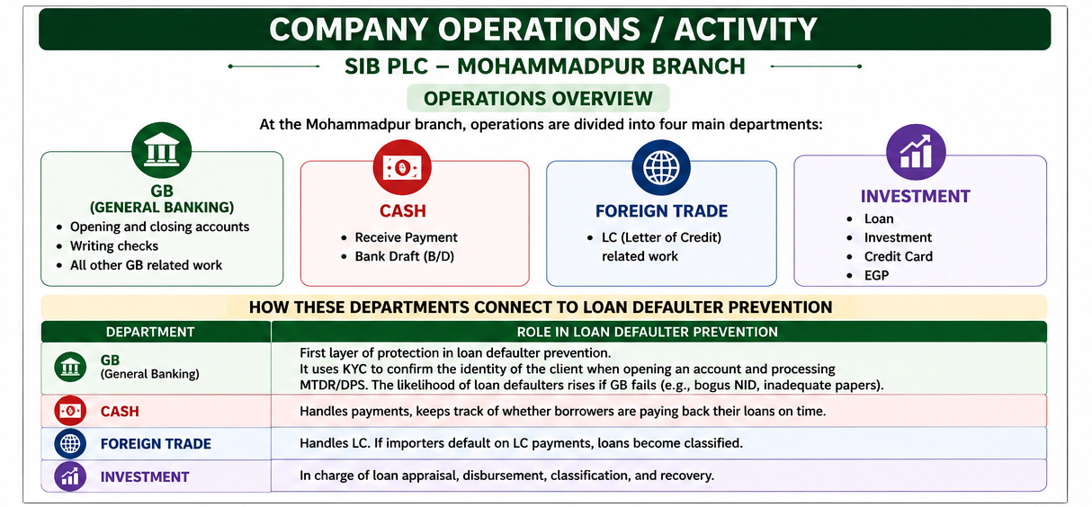

Figure 9: Company Operations/ Activity
The operations and activities of the Social Islami Bank PLC are appropriately structured into the main department so that they could serve the Shariah-compliant banking needs of their customers with utmost precision and provide the best risk management and control mechanism. The bank has a total of 180 branches and 236 sub-branches and 375 agent banking centers with modern technology to serve its clients. The bank’s entire operation is categorized under various segments that are crucial and contribute significantly to the smooth operations of the bank.
The General Banking (GB) Department serves as the foundation of customer interaction and fund mobilization. It handles account opening (Savings, MTDR, DPS), KYC/AML compliance, cheque processing, cash transactions, and file management. GB acts as the first line of defense against potential defaults by ensuring proper customer verification and documentation. The Cash Department manages cash receipts, payments, vault operations, and daily cash balancing, ensuring liquidity and security of funds. The Investment Department is responsible for appraising, sanctioning, disbursing, monitoring, and recovering investments under various Shariah modes such as Murabaha, HPSM, Musharakah, and Ijarah. This department works closely with GB to maintain asset quality and minimize classified investments. The Foreign Trade Department handles import/export LCs, remittances, and foreign exchange operations, supporting the country’s trade and remittance inflows.
SIBL lays great emphasis on Digital banking and Alternative delivery channels. The bank has developed internet banking, mobile banking (SIBL Go), agent banking, and ATMs to add convenience and efficiency to its customers’ transactions. Furthermore, the Treasury Department carries out liquidity management, government securities, and foreign exchange operations. Other relevant departments are Human Resources and Training which handles training activities, and Risk Management, Compliance, and Internal Audit which looks after risks, compliance, and internal control.
In general, the operation policy of SIBL can be defined as customer-oriented, technology-based, and risk-managed, while following the Shariah and the guidelines of Bangladesh Bank. The way General Banking, Investment, and Recovery, as its key departments, are being integrated is also important in this regard. Particular attention is paid to the strategy of improving the cooperation between the three departments, as well as utilizing technology, to address the problem of defaulters in the sphere of loan distribution.

2.1.5 SWOT Analysis of Social Islami Bank PLC
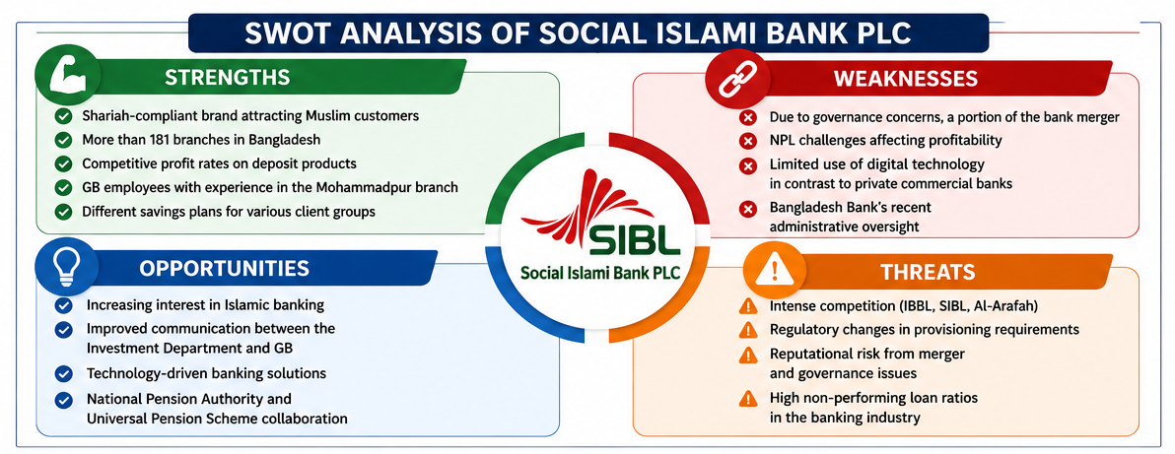

Figure 10: SWOT Analysis of Social Islami Bank PLC
- Strengths: Social Islami Bank PLC (SIBL) is a well-known brand in Bangladesh that provides top-quality Shariah-based banking services. The bank’s main strength is its innovative Three-Sector Banking Model (Formal, Non-formal, and Voluntary), which covers commercial and social spheres, thus distinguishing it from other banks. Moreover, SIBL has a vast branch network that ensures the delivery of high-quality services to its clients. Altogether, the bank has 180 branches, 236 sub-branches, and 375 agent banking outlets. The bank offers a wide range of Shariah-based products such as Mudaraba deposits, Murabaha, HPSM, Musharakah, Islamic cards, remittance system, and other banking services. SIBL’s commitment to corporate social responsibility in terms of education, health, and poverty reduction has increased the bank’s appeal to customers. Additionally, the bank’s growth in terms of the investment portfolio and technology development is another strength that should be noted.
- Weaknesses: The main weakness of SIBL is a significant deterioration in the quality of assets. Indeed, the level of classified investment reached 61.74 percent in 2024, which is a much higher percentage compared to other banks. This issue is associated with weaknesses in post-disbursement credit risk management and recovery policy. In 2024, the concentration of risk also became a significant concern as the bank was highly dependent on a small number of borrowers (e.g., S. Alam group). Other weaknesses include weaknesses in credit documentation, moderate digitalization compared to industry leading companies, and a lack of sophisticated risk management instruments.
- Opportunities: There is significant potential for growth for SIBL in the Islamic banking sector. Firstly, the demand for Shariah-compliant products among young and middle-class customers increases constantly. Moreover, there is a significant opportunity for growth in terms of digital products as more and more customers prefer to make transactions using mobile phones and the Internet. In addition, an increase in small business loans, investments, and agricultural loans is also a lucrative opportunity for growth. The merger of social Islamic banks also creates opportunities for growth for SIBL. On the one hand, the merger allowed the banks to raise their combined capital, and on the other hand, it facilitated better governance structure and organizational capabilities. Finally, an increase in remittances also creates opportunities for growth for the bank.
- Threats: One of the major threats facing SIBL is the level of non-performing loans in the banking sector, which is at a critical level. Apart from that, economic problems such as inflation, exchange rates, political instability, and global economic issues reduce the ability of borrowers to repay loans. In addition, the bank faces increased competition from commercial and Islamic banks. Moreover, the regulatory environment in Bangladesh, particularly Artha Rin Adalat, is a threat to the bank as it is difficult to recover bad loans through these courts. Finally, a threat to the bank’s reputation and creditworthiness may arise if any unfavorable news about the bank emerges.

2.2 Industry Analysis: Banking Sector of Bangladesh

2.2.1 Specification of the Industry
The banking sector in Bangladesh represents an essential segment of the economy as it intermediates the flow of funds from savers to investors through various financial instruments. This sector has been categorized into State-Owned Commercial Banks (SCBs), Private Commercial Banks (PCBs, also known as Islamic banks, e.g., Social Islami Bank PLC), Foreign Commercial Banks (FCBs), and Specialized Banks (SBs) based on the authority of Bangladesh Bank. As of the most recent data (up to 2025–2026), the banking sector has facilitated over Tk. 18 trillion in loans, supporting agriculture, small and medium enterprises (SMEs), industries, infrastructure, trade, and consumer credit.
Islamic banking has become extremely popular in this sector. SIBL is based on the Shariah principles (Mudaraba, Murabaha, Ijarah, etc.). The banks are rid of the element of interest (riba) and include such mechanisms as profit and loss sharing, risk, investment, and others. There are about 5-10 banks that deal exclusively with Islamic banking, several of which have adopted the concept of Islamic windows. Five Islamic banks, including SIBL, owned by the S. Alam Group, have been merged to form one of the largest alliances in the fight against high bad debt.

The Problem of Loan Defaulters (NPLs/Classified Loans)
Loan default, or Non-Performing Loans (NPLs), is one of the most pressing concerns of the Bangladesh banking sector. A loan is classified as ‘non-performing’ if the borrower fails to make payments of principal and/or profit/mark-up due on the loan, as stipulated in the contract. According to the Bangladesh Bank (BB), the loans are classified into the following categories in BRPD Circulars:
- Standard (STD): Standard asset.
- Special Mention Account (SMA): Special Mention Account is a warning signal of financial trouble and is overdue by 2-3 months.
- Sub-Standard (SS): Sub-Standard assets are those which are overdue by 3-6 months with a 20% provision.
- Doubtful (DF): Dubious assets are those which are overdue by 6-12 months with a 50% provision.
- Bad/Loss (BL): Bad and Loss assets are those which are overdue by 12 months and more with a 100% provision.
As of March 2026, the total Non-Performing Loans (NPLs) in the banking sector amounted to Tk. 5.89 trillion, or 32.26 percent of total loans, which is among the highest levels globally. The NPL ratio peaked at around 36 percent (Tk. 6.44 trillion) in September 2025. Moreover, it is noteworthy that the share of Bad/Loss loans accounts for more than 93 percent of classified loans.
Distribution by Bank Category (as of 2026, approximately):
- State-Owned Commercial Banks (SCBs): The biggest share (45.85%) of total non-performing loans (NPLs).
- Private Commercial Banks (PCBs) (including Islamic): The second biggest share (30.11%).
- Foreign Commercial Banks (FCBs): The lowest share (4.82%).
- Specialized banks: The biggest share in absolute terms.
As a PCB/Islamic bank, SIBL has been encountering extreme challenges. Its classified investment ratio significantly grew to 61.74% in 2024, increasing by more than 50% compared to the industry’s average. The major reasons for the deterioration are the default of investments, insufficient provisions, and investment-backed recoveries. SIBL is under the merger process of Islamic banks to address these concerns.

Major Causes of Loan Defaults in the Industry
- Weak Credit Appraisal and Monitoring: Weak credit assessment, over-emphasis on collateral over cash flow, and inadequate follow-up after loan disbursement,
- Wilful defaulters: Those who have the capacity to repay but intentionally default by misusing legal and political systems,
- Economic and external factors: Inflation, depreciation of local currency, trade deficits, political and economic crises, and geopolitical tensions,
- Governance-related factors: Political interference in bank affairs, corrupt practices, and related-party transactions,
- Misutilization of funds: Using funds for purposes other than those for which the loan was sought,
- Regulatory forbearance: Regulatory policies that have allowed workouts and windows for restructuring have masked the true level of non-performing loans (NPLs)

Impacts on the Banking Sector and Economy
High NPLs have negative implications on the profitability of the banks, capital adequacy, provisioning, and lending capacity of the banks. As a result, the following adverse effects can be foreseen:
- Decline in investment and economic growth,
- Loss of confidence of the depositors,
- Higher interest rates for the genuine borrowers,
- Supervisory challenges for the Bangladesh Bank and overall instability in the financial system.
The provisioning shortfalls in the sector amounted to Tk. 2.06 trillion as of now, constraining the lending capacity of the banks. In addition, the default in the payments by the Islamic banks such as SIBL can cause concern about Shariah compliance in terms of funds utilization and risk diversification.

Regulatory Framework
The Bangladesh Bank has been issuing regulatory guidelines through BRPD circulars (for example, the Master Circular on Loan Classification and Provisioning). Amongst others, the recent initiatives include the development of a Credit Information Bureau, introduction of more stringent classification norms, and the move towards the adoption of the IFRS 9 (Expected Credit Loss model) by 2027. Recently, the bank has also been involved in mergers, asset recovery task forces, and resolution frameworks. However, the problem is compounded by the protracted legal procedures in the Artha Rin Adalat courts.
In summary, although the banking sector has grown significantly in terms of both size and outreach, the industry’s ability to manage the increasing number of defaulters poses a significant risk to its growth. The situation demands that the banks exercise more caution in loan approval and implement stringent measures in recovery, in addition to enhanced transparency and accountability in the system, including better coordination between the banks, the regulator, and the government. In particular, the case of SIBL highlights the need for addressing the NPL problem through the merger and better management practices.

2.2.2 Size, Trend, and Maturity
The banking industry in Bangladesh is among the most significant sectors in terms of both volume and dynamism. As of 2025-2026, it comprises nearly 61 scheduled banks, including 6 State-Owned Commercial Banks (SOCBs), over 40+ Private Commercial Banks (PCBs), 9 Foreign Commercial Banks (FCBs), and 6 Specialized Banks. The total value of assets of the banking sector in Bangladesh exceeds Tk. 25-30 trillion, while the total amount of loans, advances, and investments of the banks surpass Tk. 18.25 trillion as of early 2026. In addition, the deposits of the banking sector in Bangladesh account for over Tk. 20+ trillion. Additionally, the banking sector in Bangladesh involves hundreds of thousands of employees and thousands of branches and agent banking outlets nationwide.
Islamic banking has become a prominent force that covers a considerable amount of the market. Social Islami Bank PLC (SIBL) is an integral part of the Islamic banking industry and plays an essential role in promoting financial inclusion.

Trend Analysis

Table 10: Size and Growth Trend of Banking Sector Loans/ Investments
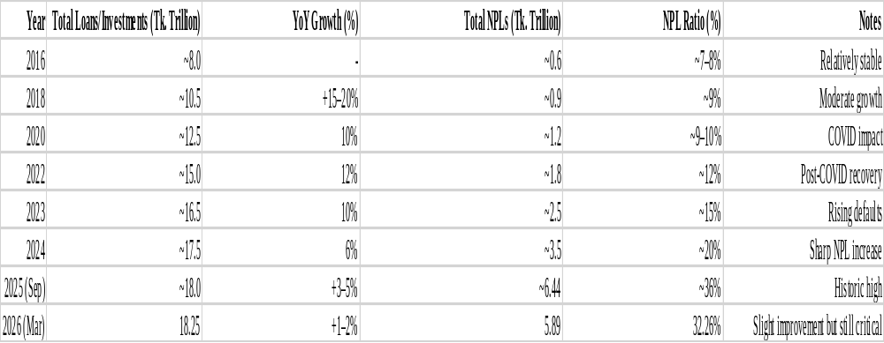

Interpretation of Size and Growth Trend of Banking Sector Loans/Investments (Approximate, in Tk. Trillion)
Table 10 above provides an insight into the dynamics of the total amount of loans and investments in the banking sector of Bangladesh, as well as the level of non-performing loans (NPLs). It can be seen that the overall volume of loans and investments has grown steadily from Tk. 8 trillion in 2016 to Tk. 18.25 trillion in March 2026. In other words, over the past decade, the total amount has more than doubled. As of March 2026, NPLs account for 3.6% of the total amount, which is the lowest level since 2016. The growth rate was consistent throughout the period at 10-15% year-over-year, peaking in 2022.
However, a different situation emerges when examining the trend of NPLs. Despite being under control until 2022 (Tk1.8 trillion or 12%), NPLs skyrocketed after 2023 and hit a staggering Tk6.44 trillion or 36% in September 2025. With downward pressure, the figure reduced to Tk5.89 trillion or 32.26% in March 2026. Evidently, the amount of NPLs increased nearly ten times since 2022, which raises serious questions about the banking system’s sustainability. The abrupt rise in NPLs has primarily been triggered by economic and political instabilities, governance issues, wilful default, and lacklustre credit management
For Social Islami Bank PLC (SIBL) specifically, this industry-wide trend has been even more severe, with its classified investment ratio reaching 61.74% in 2024 — significantly higher than the sector average. The table therefore highlights a critical imbalance: while the banking sector has achieved impressive quantitative growth in lending, the qualitative health of assets has deteriorated sharply. This poses serious risks to profitability, capital adequacy, depositor confidence, and overall financial stability.

Table 11: Growth Trend of Total Loans/Investments In Bangladesh Banking Sector (2016-2026)
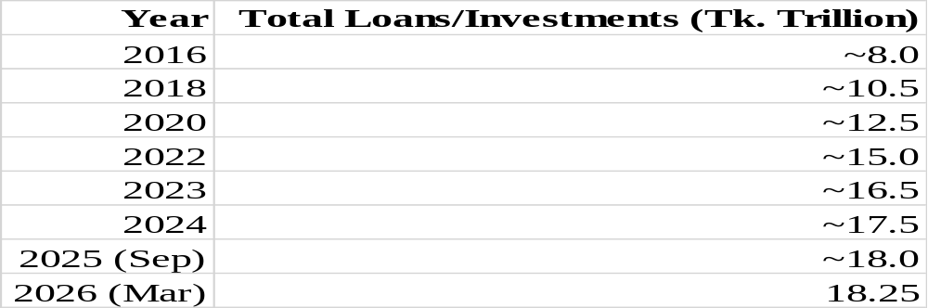
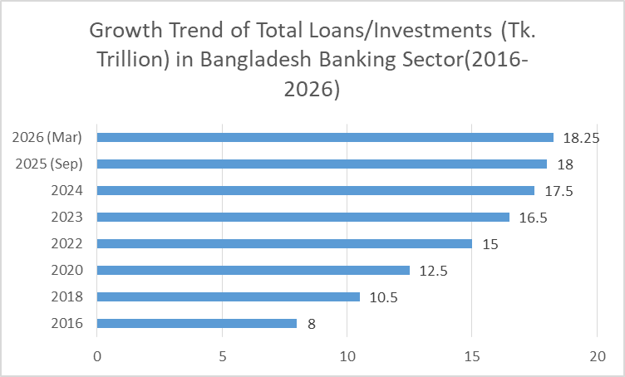

Figure 11: Growth Trend of Total Loans/Investments ( Tk. Trillion) in Bangladesh Banking Sector (2016-2026)

Interpretation of Growth Trend of Total Loans/Investments (Tk. Trillion) in Bangladesh Banking Sector (2016-2026)
This bar chart displays the year-wise growth of Total Loans/Investments in the Bangladesh banking sector. The X-axis represents the Years (2016 to 2026), while the Y-axis shows the Total Loans/Investments in Tk. Trillion.
The chart reveals a steady and consistent upward trend in the banking sector’s loan and investment portfolio. Starting from approximately Tk. 8 trillion in 2016, the total loans/investments grew gradually to Tk. 10.5 trillion in 2018, Tk. 12.5 trillion in 2020, and reached Tk. 15 trillion by 2022. Growth continued at a moderate pace, rising to Tk. 16.5 trillion in 2023, Tk. 17.5 trillion in 2024, and finally Tk. 18.25 trillion by March 2026.
This consistent increase in the height of the bars demonstrates the expanding role of the banking sector in supporting the national economy through higher credit disbursement to various productive sectors such as SMEs, agriculture, industry, infrastructure, and consumer finance. The growth reflects rising demand for funds and the sector’s efforts toward greater financial inclusion.
However, when viewed alongside the NPL data (from the same table), this growth in total loans appears concerning. Although the portfolio size has more than doubled over the decade, the quality of these assets has deteriorated significantly, as evidenced by the sharp rise in Non-Performing Loans during the same period. For Social Islami Bank PLC (SIBL), this industry-level growth was accompanied by an even more severe asset quality crisis, with its classified investment ratio reaching 61.74% in 2024.
In summary, the bar chart highlights the quantitative success of the banking sector in expanding its loan book, but it also serves as a reminder that sustainable growth requires equal emphasis on maintaining healthy asset quality and effective credit risk management.
Table 12: Trend of Non-Performing Loan (NPL) IN Bangladesh Banking Sector (2016-2026)
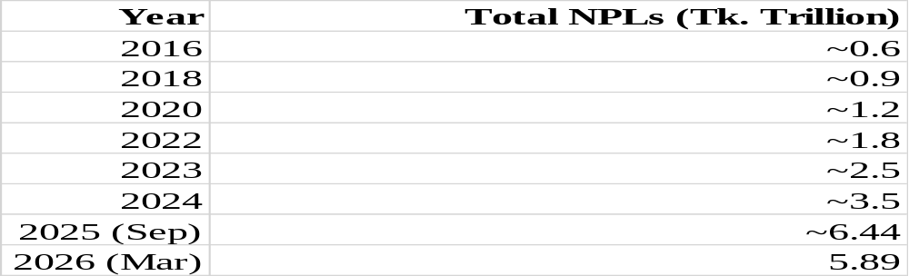
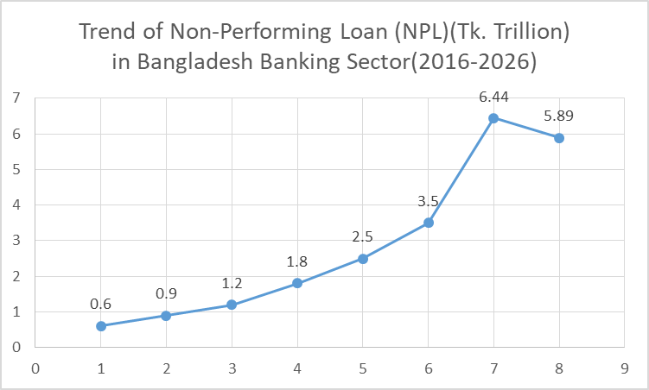

Figure 12: Trend of Non-Performing Loan (NPL) (Tk. Trillion) in Bangladesh Banking Sector (2016-2026)

Interpretation of Trend of Non-Performing Loan (NPL) Ratio in Bangladesh Banking Sector (2016–2026)
The line graph below shows the changes in the NPL ratio over time. Between 2016 and 2022, the ratio ranged between 7% and 12%. Therefore, the NPL ratio was stable, and the banks’ asset quality was relatively good, supported by economic recovery policies.
However, as the graph shows, there is an alarming increase in the NPL ratio in 2023. Specifically, the ratio reached 15% in 2023, 20% in 2024, and 36% in September 2025, dropping slightly to 32.26% in March 2026. This jump in NPL indicates a significant rise in the number of defaulted loans. The NPL ratio increased because of economic challenges and poor governance and lack of effective recovery mechanisms for bad loans.
Therefore, based on the graphs, while the banks’ loan portfolio and investments grew significantly, the asset quality declined, raising concerns about the banks’ performance. As such, some corrective measures need to be undertaken to promote loan recovery and improve governance policies in the banking sector, particularly in SIBL.

Table 13: Total Investments/Loans vs Total NPL
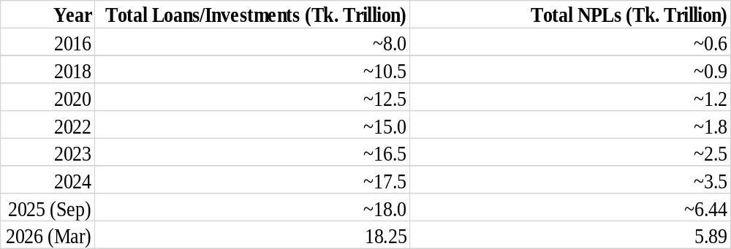
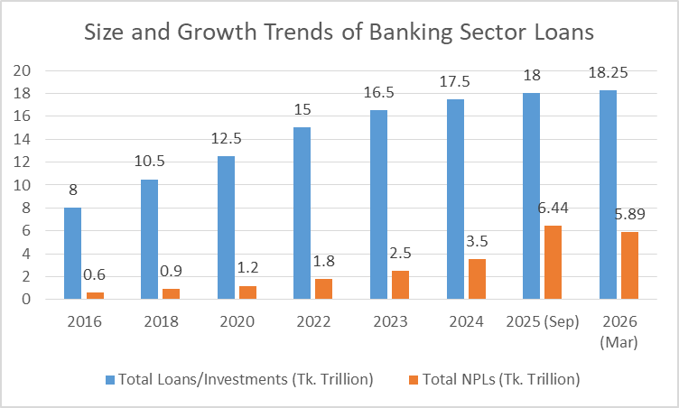

Figure 13: Size and Growth Trends of Banking Sector Loans

Interpretation of Size and Growth Trend of Banking Sector Loans/Investments vs. NPLs (2016–2026)
Table 13 below indicates Bangladesh Banking Sector Development as well as tremendous deterioration in terms of asset quality. In particular, the total amount of loans and advances (in Tk) has been on a steady rise, peaking at Tk 18.25 trillion as of March 2026. It is projected to increase further due to the sector’s critical role in supporting the national economy through its extensive outreach and contribution to the growth of agriculture, small and medium enterprises, industry, infrastructure, and foreign trade, with an average growth rate of 14.5% during the 2018-2022 period and an expected annual growth rate of 12.05% from 2023 to 2026.
However, the picture is not so good for non-performing loans. NPLs were contained until 2022 (peaking at around Tk. 1.8 trillion or 12 percent of the total loan portfolio). But since 2023 the situation has deteriorated. By September 2025, NPLs climbed to Tk. 6.44 trillion (36 percent of total loans), and as of March 2026, they stood at Tk. 5.89 trillion (32.26 percent). Thus, the amount of non-performing loans increased by almost 10 times since 2016 and surpassed the growth of the total loan portfolio.

Key insights visible in the charts/graphs:
The two columns (Total Loans – blue and Total NPLs – red) on the clustered column chart will allow visualizing the significant increase of the latter in 2023 as compared to the former, which will be evident from the chart’s visual appeal. A line chart presenting the NPL ration (%) will also display a considerable increase after 2022.
The trends suggest that despite the banking industry’s maturation process (growth in the total loans and the number of customers), its credit risk management practices still need improvement.
For Social Islami Bank PLC (SIBL), the case is more severe. Its classified investment ratio has increased to 61.74% in 2024, surpassing the industry’s level and placing it in the merger list of major Islamic banks. The information shows several risks, including a lack of recovery, governance problems, wilful default, and economic challenges, which are associated with these banks.
Although Bangladesh’s banking industry has been performing exceptionally well in terms of the quantity of loans issued, its quality (i.e., the health of the asset base) has nose-dived. As such, unless provisioning, loan recovery, corporate governance, and lending policy are given due attention, profit, capitalization, depositor confidence, and the overall financial stability of the domestic banking system may be severely compromised.

Table 14: NPL Trend in Bangladesh Banking Sector (2016-2026)
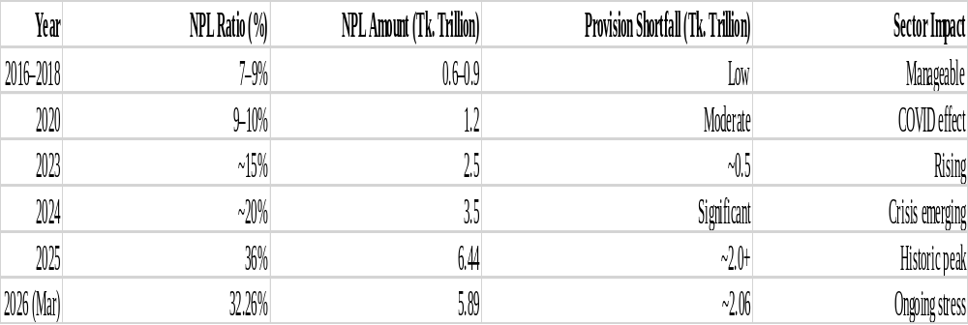

Interpretation of NPL Trend in Bangladesh Banking Sector (2016–2026)
Table 14 below shows a distressing picture of the Bangladesh banking system’s asset quality over the past decade. It indicates the trend of Non-Performing Loan (NPL) in terms of absolute amount and ratio, provision shortfall, and overall impact to the sector:
From 2016 through 2018, the NPL ratio remained within tolerance levels between 7-9%, and total NPL stood at less than 1 trillion Taka as of 2018. The overall impact to the banking system remained contained during this period. However, the COVID-19 pandemic triggered a fresh rise in the delinquency ratio, which crossed 9-10% in 2020 and 1.2 trillion Taka worth of loans in default. The most alarming rise came in 2023 when NPL crossed 15%, followed by a spike to 20% in 2024. In September 2025, the ratio reached a staggering 36%, and the total value of NPL stood at an all-time high of Tk. 6,440,000 million. It reduced slightly to Tk. 5,890,000 million or 32.26% of total loans in March 2026. Nevertheless, the provision shortfall crossed Tk. 2,000,000 million, which exerts extreme pressure on the profitability and capital of the banks.
Overall, Table 14 suggests that even though the industry continued to grow steadily over the past decade, its balance sheet strength remained under serious stress due to a high proportion of NPLs. The most prominent reason for the deterioration of asset quality is weak credit appraisal and willful default. Several other factors impacting the economy, such as political instability, governance issues, and economic crises, also contributed to the credit crisis. SIBL faced exceptionally high pressure on its balance sheet as its classified investment stood at an eye-popping 61.74% in 2024.
Summing up, Table 14 reveals that the problem of NPL has turned into one of the significant challenges threatening the sustainability and growth of the Bangladesh banking sector. Thus, the situation requires a swift and forceful response, including proactive provisioning, enhanced recovery efforts, and better corporate governance.

Table 15: Rising Trend of Non-Performing Loans (NPL) in Bangladesh Banking Sector (2016-2026)
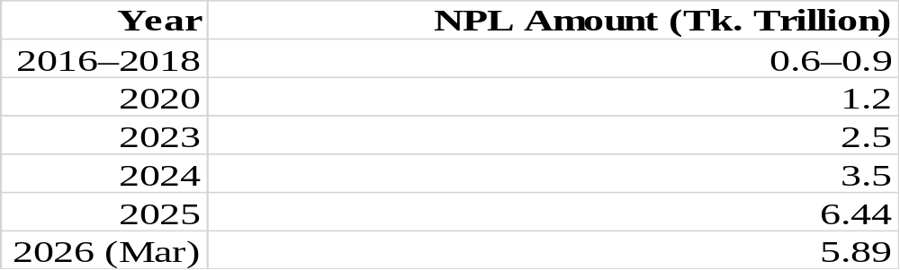
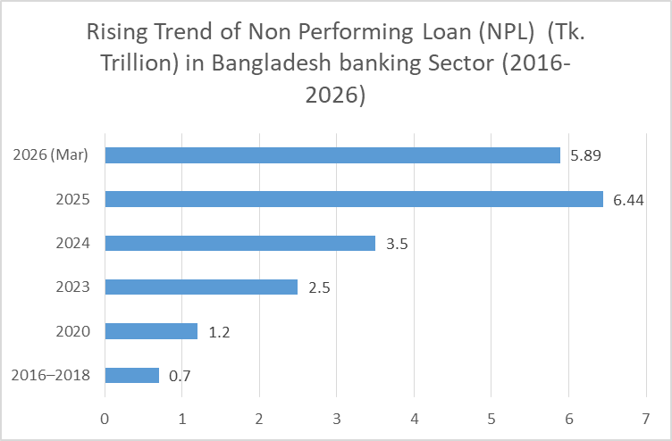

Figure 14: Rising Trend of Non-Performing Loan (NPL) (Tk. Trillion) in Bangladesh Banking Sector (2016-2026)

Interpretation of rising trend of Non-Performing Loan (NPL) in Banking Sector (2016-2026)
This bar chart reflects the number of Non-Performing Loans (NPLs) in the Bangladesh banking sector of the years 2016-2026. The horizontal axis of the graph refers to Years and the vertical axis refers to NPL Amount in Tk. Trillion.
The height of the bar chart remains the same or only slightly increases for the period 2016-2018 at Tk. 0.7 trillion and then dropped slightly in 2020 at Tk. 1.2 trillion. From 2023, an opposite scenario emerged as the value jumped at Tk. 2.5 trillion and Tk. 3.5 trillion in 2024, reaching a peak of Tk. 6.44 trillion in 2025. It declined slightly to Tk. 5.89 trillion in 2026.
The significant rise of the bar chart height after 2023 shows the seriousness of the NPL problem. A high jump of the bar indicates that either the bank’s credit policy was not strong enough to ensure quality loan recovery or deliberate default took place, or some external factors affected the country’s financial market. SIBL’s NPL issue is not an isolated event that took place because of a short-term incident. Instead, it is a frequent occurrence that deteriorated the overall banking system’s health, significantly increasing the classified investment ratio.
In conclusion, the bar chart shows that the amount of NPLs increased almost 9 times during 2016-2026, which is extremely dangerous for the profit, liquidity, and overall stability of the Bangladesh banking sector.

Table 16: Trend Of Non-Performing Loans (NPL) Ratio (%) in Bangladesh Banking Sector (2016-2026)
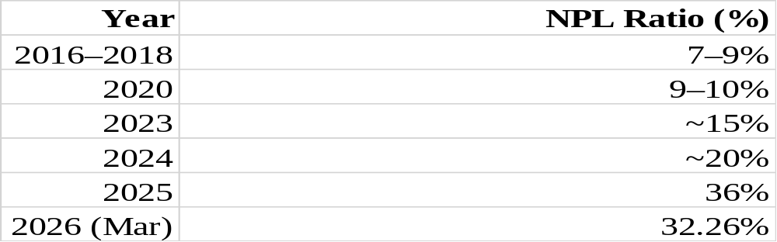
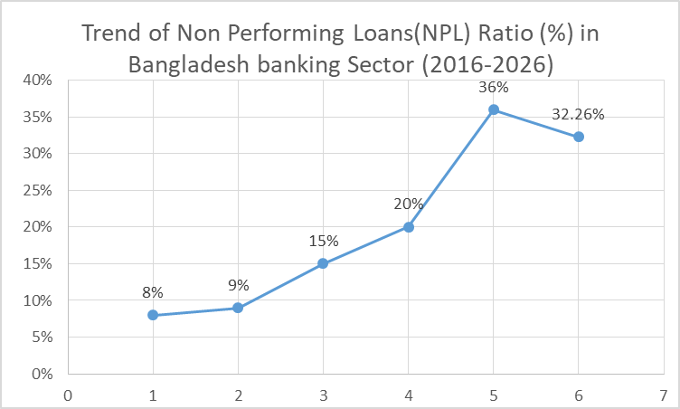

Figure 15: Trend of Non-Performing Loans (NPL) Ratio (%) in Bangladesh Banking Sector (2016-2026)

Interpretation of Trend of Non-Performing Loan (NPL) Ratio in Bangladesh Banking Sector (2016–2026)
The line chart below shows the behavior pattern of the NPL Ratio (%). The x-axis indicates the years while the y-axis depicts the percentage (%) of the NPL Ratio.
The line graph remained stable at approximately 8% from 2016-2018 (for 2016-2018) before rising gradually to 9% in 2020. It shot upwards steeply to 15% in 2023 and further increased to 20% in 2024. Interestingly, the NPL ratio peaked in 2025 at 36%, signifying the worst-ever performance in the history of the NPL. Although the ratio dipped slightly to 32.26% in March 2026, it remains at an unsatisfactory level.
The line chart above shows how fast things have deteriorated, especially in the last three years. The sudden rise of the curve suggests that the asset quality in the banking system is at stake. It indicates the presence of a severe default problem that erupted due to adverse economic conditions, political instability, poor governance, and ineffective recovery strategies among the various banks. Notably, the chart shows that the default issue has escalated and become one of the critical challenges in the banking industry today.
SIBL’s turn is not an exception to the general trend of the NPL as evidenced by their 61.74% classified investment ration in 2024. Therefore, the line chart above indicates the need to develop proper initiatives to promote quality lending practices and expedited recovery of defaulted loans in the banking industry.

Table 17: NPL Trend in Bangladesh Banking Sector (2016-2026)
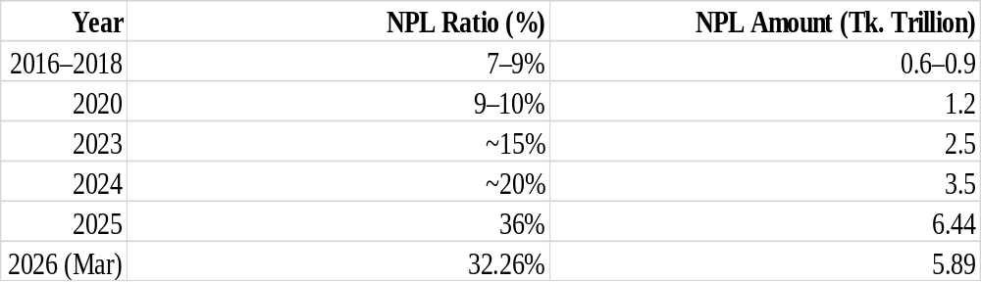
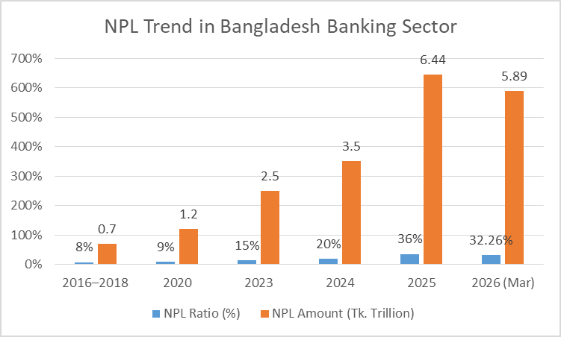

Figure 16: NPL Trend in Banking Sector in Bangladesh (2016-2026)

Interpretation of Non-Performing Loan Trends in the Banking Sector
The given graph below represents the changes in the level of non-performing loans (NPL) in the banking sector of Bangladesh during the selected period. From the graph, it could be seen that there was a consistent growth in NPL rates during the analyzed period. It means that the banks faced significant challenges in terms of loan repayment. During the identified period, the loan defaulters became a major problem in Bangladesh. The main reasons for the problem of bad loans include poor credit appraisal and supervision, political and economic instability, business failures, and COVID-19. The high level of NPL affects the profitability, liquidity, and capitalization of the banks since financial institutions are forced to make significant provisions for loan defaults. Therefore, the graph demonstrates that one of the major concerns of Bangladesh’s banking system is a high level of non-performing loans interpretation of the NPL Trend in the Banking Sector

2.2.3 Industry SWOT Analysis
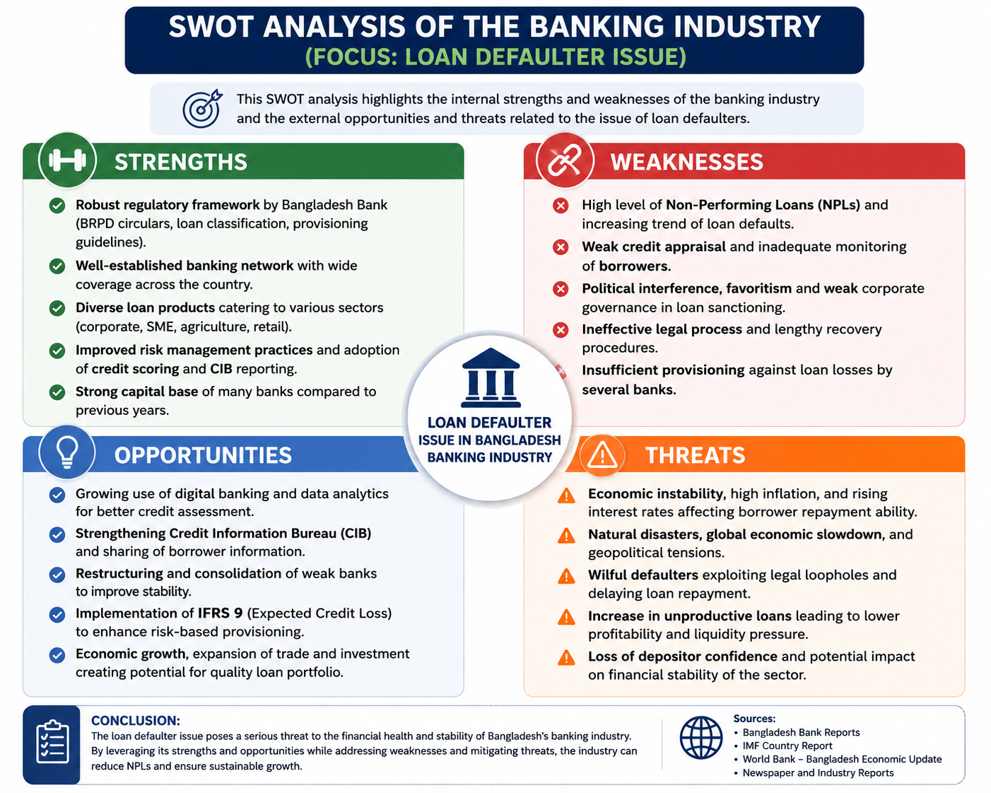

Figure 17: SWOT Analysis for Banking Industry in Bangladesh
- Strengths: The banking sector in Bangladesh has been growing exponentially over the past decade. There are 61 scheduled banks in Bangladesh, which operate an extensive branch and agency network. The sector’s total assets amount to over Tk. 25-30 trillion, with significant emphasis on supporting agriculture, small businesses, and the overall economy. Islamic banking plays a vital role in Bangladesh, as it can meet the demand for Shariah-compliant financial instruments. The banking sector benefits from the strong oversight of Bangladesh Bank, access to the Credit Information Bureau, and thorough risk assessments conducted by the central bank. Additionally, the high level of digitization and mobile banking penetration supports the industry’s stability and efficiency. Finally, the banking sector’s high barriers to entry prevent potential competitors from entering the market, as startup costs are prohibitively expensive, and banks need to navigate through a complex licensing process and build profitable relationships with the sector’s stakeholders.
- Weaknesses: In this segment, the most serious weakness is a high level of non-performing loans (NPLs). .According to the data, the percentage of NPLs reached its peak of 6.44 trillion Taka or 36% in September 2025, while, as of March 2026, it constitutes 5.89 trillion Taka or 32.26%. The main reasons for weak credit quality of the bank include inadequate appraisal of credit proposals, lack of proper follow-up measures, political interventions, corruption, and deliberate default. Moreover, slow recovery processes in Artha Rin Adalat, under-provisioning, and continued use of manual processing in a number of banks are also weakness factors.
- Opportunities: Attracting credit from small and medium-sized enterprises (SMEs), agriculture, green, and infrastructural development is on the rise. Moreover, the level of financial literacy is growing, as is the government’s support for the Digital Bangladesh agenda. The adoption of new technologies, including artificial intelligence and machine learning in credit scoring, block chain, and accounting standards such as IFRS 9, creates opportunities for transformation and innovation in risk management and operations. Furthermore, mergers among Islamic banks, the development of remittance and cross-border services, and the need for Islamic banking products are also worth considering.
- Threats: The banks’ industry is intensely competitive, facing competition from conventional players, Islamic banks, and new entrants such as fin-tech companies. Additionally, there is a high threat posed by substitute products like digital lending platforms and mobile financial services (MFS). The macro-environment is also characterized by inflationary economic pressures, exchange rate volatility, supply chain disruptions, and global economic slowdowns that could affect the repayment capacity of borrowers. Political instability, regulatory challenges, capitalization problems caused by non-performing loans (NPLs), deposit-taking trust issues, downfalls posed by scandals, environmental factors, and cyber-security threats also constitute some of the threats.

CHAPTER 3: INTERNSHIP EXPERIENCE

3.1 Position, Duties, and Responsibilities
I did my internship program in Social Islami Bank PLC (SIBL), Mohammadpur Branch, 20/15 Tajmahal Road, Block-C, Mohammadpur, Dhaka-1207. I have completed my internship program in the General Banking (GB) Department of SIBL, Mohammadpur. As an intern, I was employed in the General Banking Department as an Intern. The GB Department is the department where all kinds of routine works like dealing with customers, opening accounts, clearing etc. are done to help with the main functions of the bank. So my internship program helped me to gain practical knowledge on the working procedures of an Islamic commercial bank in Bangladesh. It also helped me understand how the general banking activities facilitate the main functions of a bank like lending and investments.
My main duties were to assist customers with any account opening and maintenance-related queries. One of the tasks I handled was helping customers open Savings Accounts. Prospective account opening requires filling out application forms, providing NID cards, two recent passport-size photos, specimen signatures, and nominee details. Another task was ensuring that KYC (Know Your Customer) details were correctly filled out to ensure compliance with the Bangladesh Bank guidelines. This is essential in account-opening processes since it serves as the first line of defense against borrowers who could default on loans.
Another crucial duty was to process MTDR (Monthly Term Deposit Receipt) accounts. For each customer, I had to ask about the desired amount they wanted to deposit. I had to inform them about the tenure of the deposit (which was usually between 1 to 5 years), profit rates, and maturity proceeds. After taking their NID copies, photographs, and nominee details, I had to fill out the MTDR application form. As MTDR deposits are one of the primary sources of funds for the investment department to provide loans and investments, any flaws in the documentations at the GB level could create default risks for the bank in the future. I had to perform similar tasks for DPS (Deposit Pension Scheme) accounts, but instead, I had to take customers’ preferences regarding monthly deposits (Tk. 500, Tk. 1,000, Tk. 2,000, Tk. 5,000, or more). After taking their documents, I had to fill out the application form.
Apart from the above-mentioned account opening functions, I was also involved in cheque-related duties. I was tasked with the duty of recording and ensuring the serial numbers of the cheques received from various customers are cleared and tallied with their respective accounts. During this process, I discovered that dishonored cheques are sometimes an indicator of impending default credit facilities since most defaults originate from such irregularities. In addition to handling cheques, I was also involved in organizing and maintaining files including; AML, BCD, solvency certificates, and dormant account activation files. It is always important to organize these files appropriately and store them in chronological order. This will help the bank detect any form of a default risk, especially in credit facilities, early enough.
Under the supervision of the GB officers, I performed a variety of tasks throughout my internship. Every activity that I did was strictly done according to the rules and regulations imposed by Bangladesh Bank, especially on KYC, AML, and other customer due diligence matters. By doing these mundane tasks, I learned how closely General Banking is directly involved with the credit risk management of the bank. Even though I was working in the GB department, I understood that proper documentation and verification are essential for the smooth performance of the Investment Department as well, especially when it comes to loan default issues.
Overall, my work as a GB intern exposed me to the practical aspects of the banking sector. In addition, I gained quality knowledge about ensuring proper customer onboarding and documentation to prevent defaulters in the future. Working in the Mohammadpur Branch of SIBL was an incredible opportunity for me to apply theoretical concepts and acquire practical knowledge of the industry.

3.2 Training & Development
During my internship at Social Islami Bank PLC, Mohammadpur Branch, I received comprehensive practical training in the General Banking (GB) Department. The training aimed to provide me with knowledge of various banking operations and simultaneously understand the connection between general banking and reducing default rates in loans. The training took place under the supervision of competent officers who provided an in-depth understanding of related theories and their practical application in Islamic Banking.
One of my key learning areas was Savings Account Opening. I was trained on the whole procedure starting from filling up the application form, presenting NID, passport size photos, specimen signature, nominee’s information, etc. The officers emphasized on collecting proper KYC (Know Your Customer) information at the time of account opening as it will be the first level of protection against any defaulters. I was taught how to verify the authenticity of the customers’ documents and other information provided to detect any inconsistencies that may indicate a potentially riskier loan applicant.
Another crucial aspect of the training was MTDR (Monthly Term Deposit Receipt) Processing. I was trained on the procedure for enquiring about the amount a customer wishes to deposit, describing tenure options (1-5 years), profit rates, and maturity proceeds. After collecting necessary documents, including NID copies, pictures, and nominee information, I had to fill out the MTDR form correctly. The training emphasized that MTDR deposits constitute a significant portion of the bank’s Investment Department funds. Therefore, any errors in document submission could indirectly impact loan default rates by impairing the department’s profitability.
I also got training regarding DPS (Deposit Pension Scheme) Processing. During this session, I learned how to respond to a customer’s query about Tk. 500 to Tk. 5,000 or higher monthly installment. I learned how to inform the customer about the benefits of the scheme, collect required documents, and fill application forms correctly. The officers highlighted the significance of DPS accounting and mobilization of long-term funds to be invested in the bank’s investment program. Additionally, they emphasized the need to provide complete documentation to ensure that legitimate customers are not denied services, thus, minimizing the banks’ exposure to defaulters.
In addition, I was trained in File Organization and Record Keeping. This included arranging files in chronological order relating to Anti-Money Laundering (AML), BCD, solvency certificates, and dormant account activation. Through this, I learned the significance of organizing files systematically to enable easy retrieval of information during a regulatory audit or inspection by the Bangladesh Bank. Such records also help the bank detect dormant accounts that may be risky when a customer applies for a loan.
During my training period, I have also acquired the art of cheque processing, record maintenance as well as the understanding of the relationship between GB and the investment department. I also learned how to clear cheques, record, and check their serial numbers. Besides, I have also learned that if a customer’s cheque is dishonored many times, it could be an indicator of their financial status, which would eventually lead to defaulting on a loan. The officers also helped me understand the link between GB and investment, including appraisal, disbursement, and classification of SMA, SS, DF, BL, and recovery.
The training was very practical. I was handling real-life customer transactions under the supervision of my manager, thus learning the art of accuracy and speed of handling transactions plus the skill of managing customers. At the end of the internship, I was able to handle Savings Account opening, MTDR and DPS forms filling and file organization on my own at a speed of 5-7 minutes per customer. The training added value to my knowledge on technical aspects of banking and enhanced my understanding of how General Banking supports the achievement of low defaulters and risk management in the banking sector.
The practical knowledge attained during the training period played a significant role in filling the gap between academic skills and practical banking procedures. During the training period, I was able to understand the importance of being alert about details and upholding Bangladesh Bank rules and regulations, as well as treating customers ethically in case of Islamic banking. In general, the training and development received at SIBL Mohammadpur Branch contributed to my overall professional transformation and improved my comprehension of the banking sector.

3.3 Contribution to Organization
During my internship in Social Islami Bank PLC, Mohammadpur Branch, I could contribute to the daily work of the General Banking (GB) Department significantly. Even though I was an intern with limited authority, I managed to participate in a number of regular operations to help the permanent workers and improve the quality of services rendered to customers. Most of my tasks related to account opening and documentation, which are essential for any banking operations and serve to prevent defaults in loans provided by the bank.
One of my primary responsibilities included processing applications for Savings accounts. I managed more than 25 savings account transactions and ensured that all the required documents such as NID, passport size pictures, specimen signature, and nominee details were presented and cross-verified appropriately. My experience helped me identify areas that usually result in discrepancies and take precautions to avoid weaknesses that could trigger compliance risks or poor credit management. Following the KYC policy when dealing with new accounts is fundamental in reducing the credit risks associated with default accounts. In this case, incomplete information during the opening of an account by a customer could allow dishonest people to access credit facilities and default afterward.
I also achieved good results while working on the MTDR (Monthly Term Deposit Receipt). In particular, during my internship, I processed more than 15 MTDR applications. In this work, I performed several functions, including consulting customers, asking for deposits, providing information on profit rates and terms, collecting the necessary documents, and completing the forms. Given that the deposits processed are one of the main sources of stable funds for the bank, which the Investment Department then uses to provide loans, my work on them allowed me to indirectly contribute to the work of these departments. In particular, by quickly and qualitatively executing these transactions, I had a positive impact on the constant inflow of deposits, which are transferred to the Investment Department.
In the field of DPS (Deposit Pension Scheme), more than 30 applications were handled with immense precision. During this period, I took initiatives to inform the customers about the different monthly installment schemes and collected the NID, photograph, and nominee’s information and prepared the forms accordingly. These long-term deposit schemes play a vital role for the banks as a source of funds. By helping in providing complete documentation, I helped the bank reduce future discrepancies, hindering the process of loan recovery and regulatory compliance in Bangladesh Bank.
Moreover, I provided my operational support to the branch by maintaining cheque records and arranging various files in order. For instance, I recorded more than 100 cheques and cross-verified their serial numbers with those of the clients. In another duty, I also arranged more than 50 files in chronological order. Some of the files arranged included AML, BCD, solvency, and dormant account files. By arranging and maintaining these files, I ensured that the GB team can locate the required documentation within a short time. In addition, the compliance of the branch was improved due to the proper arrangement and management of the files.
My contributions were not limited to the quantity of work performed. I ensured a high quality of completed tasks, as well as polite communication with customers and superb support from the officers. Indeed, the latter evaluated my performance positively, noting my ability to explain the details regarding MTDR profit calculations and DPS installment benefits clearly. Moreover, although I worked as an intern, my productivity was adequate to handle the increased flow of customers during the busiest hours.
In general, despite being of a minor nature, my contributions to supporting the general banking activities at SIBL Mohammadpur Branch enhanced the operations of the General Banking Department. My efforts towards facilitating the account opening process, mobilizing deposits, maintaining records, and supporting other related activities indirectly catered to the bank’s initiative of strengthening its first line of defense against loan defaulters, thus benefiting the organization. As such, I can confidently state that my experience at SIBL Mohammadpur Branch provided me with insight into the basic banking activities that play a critical role in sustaining credit risk management and overall banking operations.
The practical knowledge I was able to gain during my internship contributed to my increased confidence and skills. I am grateful to the branch management and GB officers for giving me this opportunity and allowing me to apply my theoretical skills to practical tasks and make a small but meaningful contribution to the company’s daily operations.

3.4 Evaluation
While working as an intern in Social Islami Bank PLC, Mohammadpur Branch, the head of the bank assessed my performance on a regular basis. He evaluated my performance according to the accuracy, speed, handling documents, file system, customer service, and compliance with the bank rules and Bangladesh Bank rules. The head of the bank appreciated me for my performances. As a result, I gained confidence, and my performance improved.
In terms of accuracy, I maintained a very high standard. There were no major mistakes in customer names, NID numbers, nominee details, deposit amounts, or installment figures across all the forms I processed. The officers appreciated that I double-checked every entry before finalizing Savings Account, MTDR, and DPS applications. This attention to detail is particularly important in banking because even small errors can lead to compliance issues or create problems during loan processing later.
Concerning the topic of speed and efficiency, by the end of the first week, I was able to do MTDR and DPS form filling for each customer within 5-7 minutes after obtaining the required information. Even with a large influx of customers during busy hours, I was able to keep up with the demand without any shortcomings. The GB officers were quick to note my improvement, which allowed them to serve more customers in a shorter period of time.
My collection and verification skills were also challenged during the work. I had to gather all the required KYC documents for the Savings, MTDR, and DPS accounts properly organized. In addition, I made sure that all photocopies were accurate, signatures were identical, and nominee details were filled out correctly. This way, I could minimize the number of incomplete files sent to the Investment Department, thus reducing the risk of future loan defaults.
In the course of action, I was able to reorganize over 50 files in chronological order, which included AML, BCD, solvency certificates, and dormant accounts. The officers appreciated my initiative and effort, as it made the task of finding specific files less time-consuming, especially during audits or when clients requested particular documents. File management is a vital component of compliance, and my contribution was acknowledged.
Another strength in my assessment was customer service. Throughout the process, I ensured that my attitude towards customers was friendly, professional and patient. This allowed me to effectively explain the figures associated with the MTDR Profit and clarify DPS instalment options to them. As a result, several customers expressed their appreciation verbally to the officers regarding the assistance provided to them.
Finally, my compliance with rules and regulations was acknowledged to be satisfactory. I was able to adhere to Bangladesh Bank’s KYC, AML, and documentation guidelines. The officers determined that all work I did was consistent with the bank’s procedures and Shariah rules.
Overall, my internship was positively evaluated. The GB officers appreciated my work, quick learning, and attitude. They also noted my ability to be productive despite being an intern. As a result, I am now confident that I can pursue a career in banking because my internship helped me identify work ethics and other skills needed for the profession.
The internship assessment at SIBL was a comprehensive evaluation of my professional capabilities as a banker. I feel that my professionalism, technical skills, and commitment to the company were effectively demonstrated during the appraisal. The feedback provided by the branch management will also contribute to my future performance improvement as a professional banker.

3.5 Skills Applied
During my internship period at Social Islami Bank PLC, Mohammadpur Branch, I could apply different skills and learned a lot from my academic studies and practical works. My internship experience helped me relate my theoretical knowledge in the BBA programme to practical situations in the bank. I could apply a variety of technical, interpersonal, organizational, and analytical skills in executing the duties at the General Banking (GB) Department.
One of the key skills I was able to apply during the internship is attention to detail. In the banking sector, this skill is essential to avoid errors in customer information, National Identity Numbers (NID) in deposits, nominees, and other areas that could cause compliance issues and problems claiming deposits and loans in the future. When filling out the saving account, MTDR, and DPS forms, I used this skill to double-check the information and ensure that all documents provided by the clients are original and their signatures are valid. As a result, I was able to maintain a high level of precision in my work and reduce the possibility of mistakes and defaults on loans.
I also used my computational and mathematical skills for the job. For instance, in case of MTDR accounts, I would calculate the profit percentage that a customer would earn on a monthly basis (e.g., Tk. 1, 00,000 deposits with 8% profit would give Tk. 667 per month). In DPS accounts, I would assist the customers with the different options of installments and benefits they might avail on maturity. I had to do these calculations mentally, which was not really challenging for me since I was quite confident with numbers, a skill I picked up while studying accounts and finance.
I have used many organizational and time management skills while performing my duties. For instance, I arranged more than 50 files in order including AML, BCD, solvency certificates, and dormant account files. While handling many customers at peak times, I was able to complete the processing of their MTDR and DPS forms faster than my colleagues without compromising on the quality of work. This way, I was able to offer more assistance to my colleagues by managing time to attend to more customers while ensuring that every customer was served well.
Customer communication and interpersonal skills were an integral element of my experience. I would ask the customer whether they wanted to make a certain deposit for the MTDR. I would also remind them of the options of paying monthly installments for the DPS. I explained the concept of profit, time limits, and maturity in detail; I was able to answer various questions regarding the topic. The majority of the customers expressed satisfaction with my explanation and attitude. Moreover, such skills as public speaking, team-building, and presentation are vital to achieve success in any branch of economics. I have acquired these skills during the process of academic learning. Furthermore, knowledge about presentation technology became helpful to maintain relationships with customers.
In addition, I demonstrate compliance and regulatory know-how. When opening accounts and processing deposits, I adhered to the Bangladesh Bank regulations on Know Your Customer (KYC), Anti-Money Laundering (AML), and documentation. The knowledge helped me understand the importance of KYC, AML, and documentation in minimizing risks, including loan defaults – an insight I gained during my banking studies.
Overall, I had a great opportunity during the internship to apply and develop my academic skills in the working environment. In particular, my technical knowledge about the sphere of banking has increased manifold; moreover, my soft skills have also improved to meet the industry standards. In addition, I was able to understand the interrelation of different departments within the banks and the contribution of each of them to achieving the organization’s goals. Above all, I realized the significance of the skills gained at General Banking for the work with risk management and reduction of defaulters of the bank.
I appreciate that this practical application of the knowledge gained has helped me improve my confidence and prepare better for future challenges in my professional career in the banking sector. I express deep gratitude to SIBL Mohammadpur Branch for giving me this immense learning opportunity.

CHAPTER 4: CONCLUSIONS AND KEY FACTS

Key Findings
Figure 2: Investment Portfolio Trend (2016-2024
- Significant Growth in Investment Portfolio but Sharp Deterioration in Asset Quality: The banking sector in general and SIBL in particular witnessed a significant increase in total investment in the period under review. As shown in Figure 2: Investment Portfolio Trend (2016-2024), the total investment increased from Tk. 174 billion in 2016 to Tk. 383 billion in 2024. But the investment quality was deteriorating significantly.
Figure 12: Trend of Non-Performing Loan (NPL) (Tk. Trillion) in Bangladesh Banking Sector (2016-2026)
- The overall banking sector has witnessed a significant increase in NPLs. Figure 12: Trend of Non-Performing Loan (NPL) (Tk. Trillion) in Bangladesh Banking Sector (2016-2026) illustrates that the value of NPL has increased significantly from Tk. 1.8 trillion in 2022 to Tk. 6.44 trillion in September 2025.
Figure 4: Trend in Investments and Classified Investments in SIBL (2016-2024)
- Weak Credit Appraisal and Monitoring as Primary Causes of Defaults: Poor credit appraisal and inadequate post-disbursement monitoring were identified as major reasons for the surge in defaults. This is strongly supported by Figure 4: Trend in Investments and Classified Investments in SIBL (2016-2024), which shows the sudden and massive spike in classified investments in 2024.
Figure 3: Classified Ratio Trend (2016-2024)
- SIBL Faces More Severe Challenges Than the Industry Average : SIBL’s situation is much worse than the industry’s. Figure 3, namely, Classified Ratio Trend (2016-2024), demonstrates that the bank’s investment ratio in the most challenging category was as high as 61.74% compared to the industry’s 32.26%.

4.2 Recommendations
Based on the research and my internship experience at Social Islami Bank, I would like to suggest the following recommendations to overcome the problems of defaulting loans in the banking sector of Bangladesh:
Improving the credit appraisal and assessment mechanism: The management of SIBL and other commercial banks should work on their credit appraisal and assessment system to ensure that the borrower has enough income to repay the principal amount along with the interest. The banks should take into account the cash flow position, business feasibility, and credit history of the borrower from the Credit Information Bureau (CIB). Moreover, the banks in Bangladesh should pay specific attention to the repayment capacity of the prospective borrowers instead of relying on collateral security.
Monitoring and supervising loan utilization: The banks should have a proper monitoring and supervising mechanism for tracking the utilization of loans. They should conduct field inspections and regular surveillance to confirm that the borrower utilizes the sanctioned amount for the intended purpose only. In case of default detection, the bank officials should initiate SMA classification and take immediate steps to recover the overdue amount.
Upgrading loan recovery machinery: The management of SIBL should install a vigorous recovery mechanism for defaulting loans. In this regard, the bank should contact Bangladesh Bank frequently to get instant decisions in default cases, recover the overdue amount on time through legal action, and restructure the default accounts. Moreover, the bank can get benefits from Artha Rin Adalat to resolve default disputes quickly.
Using modern technologies in credit risk management: SIBL should utilize different modern technologies in credit risk management to avoid paper processing and manual interventions in the credit approval process. For instance, artificial intelligence can help in credit scoring, while software systems can help monitor and manage the defaulting accounts efficiently. Using such technologies can reduce human errors in Know Your Customer (KYC), Anti-Money Laundering (AML), and other procedures.
Following the Bangladesh Bank guidelines strictly: SIBL should follow the regulatory requirements of Bangladesh Bank while maintaining a healthy level of classified loan investments. To achieve the objective, the top management needs to conduct regular internal audits, enhance employees’ knowledge, and improve corporate governance practices.
Spreading awareness about ethical banking: SIBL should create awareness among its clients about ethical banking products and services offered by the bank. The initiative will increase the number of depositors and discourage them from defaulting on loans due to a better understanding of Shariah-compliant banking practices.

Conclusions
Loan default, commonly referred to as Non-Performing Loans (NPLs), remains one of the most critical challenges facing the banking sector of Bangladesh. This report has examined the Evidence from Social Islami Bank Limited of loan defaults with special reference to Social Islami Bank PLC (SIBL), Mohammadpur Branch. The analysis reveals that despite significant growth in the investment portfolio, asset quality has deteriorated sharply due to weak credit appraisal, inadequate monitoring, wilful defaults, political interference, and adverse macroeconomic conditions.
The study found that the industry NPL ratio reached a peak of 36% (Tk. 6.44 trillion) in September 2025, while SIBL’s classified investment ratio stood at a concerning 61.74% in 2024 — substantially higher than the industry average. The three-month internship experience in the General Banking Department of SIBL provided valuable practical insights into how proper customer onboarding, KYC/AML compliance, and documentation play a crucial role in preventing future defaults.
Overall, the findings highlight that sustainable growth of the banking sector depends not only on expanding the loan/investment portfolio but also on maintaining strong credit risk management, effective recovery mechanisms, and strict regulatory compliance. Without immediate and coordinated efforts from banks, regulators, and policymakers, the high level of NPLs will continue to threaten financial stability, reduce profitability, and hinder economic development.
This internship report successfully bridged the gap between academic knowledge and real-world banking practices. It is hoped that the recommendations provided will contribute to improving credit risk management and reducing loan defaults in the Bangladesh banking industry, thereby supporting a more resilient and stable financial system.

Reference
Bangladesh Bank. (2023). Financial stability report 2023. https://www.bb.org.bd
Bangladesh Bank. (2024). Annual report 2023–2024. https://www.bb.org.bd
Bangladesh Bank. (2024). Monthly economic trends. https://www.bb.org.bd
Brigham, E. F., & Ehrhardt, M. C. (2022). Financial management: Theory and practice (16th ed.). Cengage Learning.
Mishkin, F. S., & Eakins, S. G. (2021). Financial markets and institutions (10th ed.). Pearson.
Rose, P. S., & Hudgins, S. C. (2021). Bank management and financial services (10th ed.). McGraw-Hill Education.
Saunders, A., & Allen, L. (2020). Credit risk management in and out of the financial crisis (4th ed.). Wiley.
Social Islami Bank PLC. (2016). Annual report 2016. https://www.siblbd.com
Social Islami Bank PLC. (2017). Annual report 2017. https://www.siblbd.com
Social Islami Bank PLC. (2018). Annual report 2018. https://www.siblbd.com
Social Islami Bank PLC. (2019). Annual report 2019. https://www.siblbd.com
Social Islami Bank PLC. (2020). Annual report 2020. https://www.siblbd.com
Social Islami Bank PLC. (2021). Annual report 2021. https://www.siblbd.com
Social Islami Bank PLC. (2022). Annual report 2022. https://www.siblbd.com
Social Islami Bank PLC. (2023). Annual report 2023. https://www.siblbd.com
Social Islami Bank PLC. (2024). Annual report 2024. https://www.siblbd.com
World Bank. (2024). Bangladesh development update. https://www.worldbank.org

