Internship Report
On
Developing and Managing the Marketing Program of RISE: A Study on a Fashion Brand



Internship Report
On
Developing and Managing the Marketing Program of RISE: A Study on a Fashion Brand

Submitted to
Muhammad Hasan Al-Mamun
Assistant Professor
School of Business and Economics
United International University

Submitted by
Md. Sabbir Ahmed
ID: 111 142 028
BBA Program
United International University

Date of Submission: 09.01.2019

Letter of Acknowledgement
I would like to thank the internship Supervisor, Muhammad Hasan Al-Mamun who has helped me in every step of my internship. I am very much grateful to Engr. Mosharraf Hussain (Managing Director of STANDARD GROUP) and Faheem Mosharraf (Chief Executive Officer of RISE BRAND) for giving me the opportunity to complete my internship at RISE BRAND. I am sure that their dynamic managerial activities will give inspiration to anybody to build one’s career properly.
I also want to thank Mr. Najiur Rahman (Senior Marketing Officer) and Mr. Arefin Sourov (Senior Supply Chain Officer) and all individual of the RISE BRAND, for their support that I have been provided for preparing my report. I practically work with them, try to share their perception, feelings and on the basis of my realization, I prepared report from my own point of view. Then at last I shall be grateful to those people who read this report and who shall get benefit from this report at present and in future.

Letter of Transmittal
09 January, 2019
Muhammad Hasan Al-Mamun
Assistant Professor
School of Business and Economics
United International University

Subject: Submission of the Internship Report

Dear Sir:

I would like to submit my internship report titled “Developing and Managing the Marketing Program of Rise: A Study on a Fashion Brand”, which has been prepared as a requirement for the completion of the BBA Program of United International University.
RISE is a sister concern of STANDARD GROUP. RISE is focused on local retail marketing in Bangladesh. They produce world class clothing product for local market. It started the business in 2014 and opened the first store in 2017 Bashundhara City Shopping Complex.
While working on the report, I have tried to follow each and every guideline that you have advised. It has been a very enlightening experience to work in this new venture and I have thoroughly enjoyed my internship period at RISE. The authority of STANDARD GROUP has also extended their cooperation whenever required.

Sincerely,
Md. Sabbir Ahmed
ID No: 111 142 028
BBA Program
School of Business and Economics
United International University (UIU)
Executive Summary

The clothing industry in our country in involved in various kinds of marketing aspects that significantly enhanced my interest towards doing my internships report on the topic of “Developing and Managing Marketing Program of RISE: A Study on a Fashion Brand”
The objective of this research is to evaluate the process of the developing and managing marketing program strategy of RISE.
This research is descriptive in nature. To conduct this study the primary and secondary data are used. My research report initially provides a nominal idea of the clothing industry in our country. STANDARD GROUP is a top leading readymade garments produce company in Bangladesh. STANDARD GROUP started their apparel business in 1984 under the corporate operations of The Civil Engineers Limited. STANDARD GROUP is the biggest garment manufacturing company in Bangladesh. They produce product for Europe, America, Spain and also many others country. They are renowned for producing denim product and kid’s products. RISE, which is a sister concern of STANDARD GROUP. They started their business in 2014 and after 3 years they launched their first outlet in Bashundhara Shopping Complex. Now a days they was successfully launched their four outlets in Dhaka city corporation area. They have strong management team and also they have enough financial support. In near future they have the opportunity to become number one fashion brand in Bangladesh. Their uses of latest technology have more cost effective and also get some competitive advantage. But there have some corporate political problem that on impact to takes decision.
Overall they have the opportunity to lead the fashion industry. In my point of view they need to some changes in their management team and also needs some strategic plan to satisfy their customer.
Key Words: Marketing Program, Fashion Industry

Contents
Chapter 1: Introduction 5
1.1: Marketing Mix 5
1.1.1: Product 6
1.1.2: Price 7
1.1.3: Place 9
1.1.4: Promotion 10
1.2: RISE BRAND 11
Chapter 2: Organizational background and Industry Perspectives 12
2.1: Organizational Background 12
2.2: Industry Perspective 15
2.2.1: The Main players in Clothing Industry 15
2.2.2: The main suppliers in this Industry 15
2.2.3: SOWT Analysis 18
Chapter 3: Objectives and Methodology 20
Chapter 4: Findings of the Study 21
4.1: Market Identification 21
4.1.1: Market Segmentation 21
4.1.2: Target Marketing 22
4.1.3: Positioning 23
4.2: Marketing Program 25
Chapter 5: Limitations of the study 32
Chapter 6: Recommendations and Conclusion 33
References 34

Chapter 1: Introduction

1.1: Marketing Mix
Marketing mix is about putting the right products or services in the marketplace, at the right time, and at the right price. The difficult part is doing this well, as you need to know every aspect of your business plan. We know that marketing mix is predominately associated with the 4P’s of marketing. A marketing expert named E. Jerome McCarthy created the Marketing 4Ps in the 1960s. This classification has been used throughout the world.
- Product
- Price
- Place
- Promotion
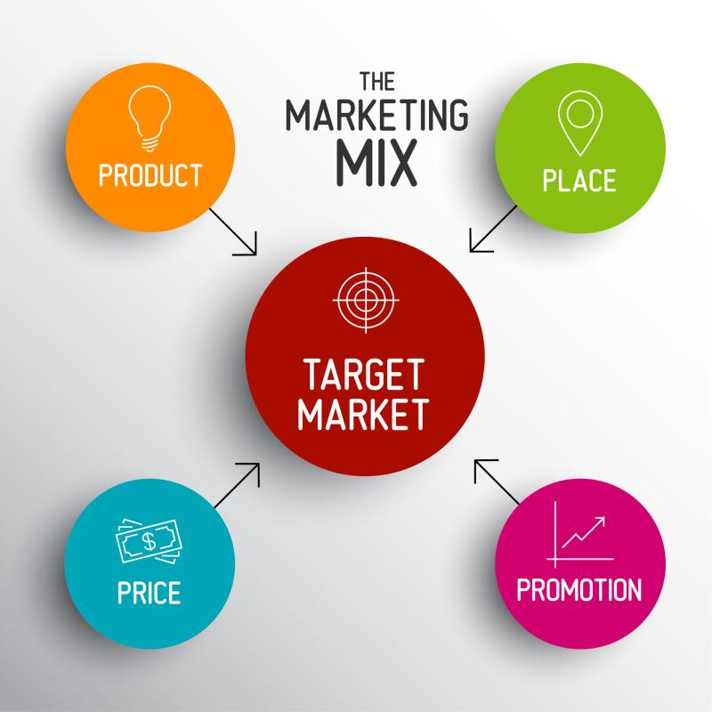

1.1.1: Product
A product is the item that marketers make for satisfy the needs of a certain group of people. Product can be tangible or intangible. It can be goods or services. Marketers must be ensure that the product they made that is right type and able to fulfill the customer demands. So that when marketers want to produce certain type of product they research which type of product customers’ demands.
Every product has certain life cycle that include introduction phase, growth phase, maturity phase and decline phase. It is important to the marketers because marketers are not want that their product life cycle is too short. So when they make product mix they briefly research on this product that they want to produce.
In developing the right product, marketers must find that questions answer:
- What does the customers want from us?
- The product we made is it perfect solution for them?
- Where will the customer us it?
- What type of features customer want from the products or services?
- Are we actually made the correct features or not?
- What’s the name of our products?
- Is it have catchy name or not?
- Is our products different from our competitor?
- Is our product have available color or different sizes?



1.1.2: Price
Price means, “The sum of the values that consumers exchanges for the benefits of having or using the product or service”. If shortly describe then price is the basically amount that customer given for enjoy a products or services. Price is the most important component of marketing mix because it determine firm’s profits and survival. Adjusting the price of the product is very critical for that reason there are many pricing strategy, Mostly marketers are follow some pricing strategy that are given below:
- Penetration pricing
- Skimming pricing
- Competition pricing
- Product line pricing
- Bundle pricing
- Psychological pricing
- Premium pricing
- Optional pricing
- Cost plus pricing
- Cost based pricing

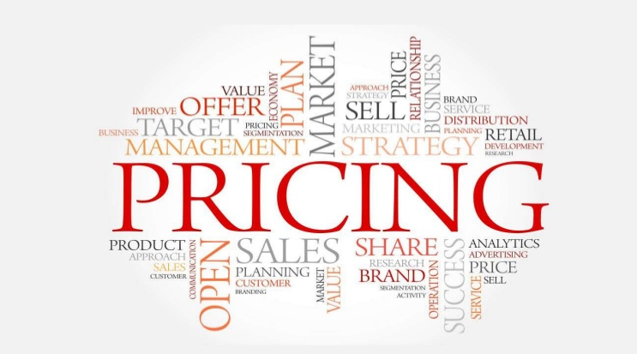

Penetration pricing
Penetration pricing is a pricing strategy to attract the customers to give low price of the product and services. Basically this pricing strategy use when they want to reach customers firstly and customer lower engagement with competitor.
Skimming pricing
This is a temporal pricing strategy that marketer use when they introduce new product. First they charge high price from customer and then lower the price over the time.
Competition pricing
Actually this pricing strategy is follow the competitor pricing strategy. Marketers sets their price as the same level of competitor. They produce the same product or similar product that competitor produce and set the price that are set by their competitor.
Product line pricing
This pricing strategy used by the retailers of separating goods into cost categories in order to create various quality levels in the minds of customers.
Bundle pricing
Marketer’s offer some package for customer at a selected price that are lower than they would charge if the all product bought separately.
Psychological pricing
Psychological pricing is a pricing strategy that based on customer psychological thinking. Some price have a highest psychological impact on customer than others.
Premium pricing
Premium pricing strategy follow when marketers want to create good impression on customer mind. They charge more than their competitor. They create perception on customer mind that higher price means high quality product.
Optional pricing
Optional pricing strategy follow when marketers guarantee some quality or some extra features if they pay extra price.
Cost plus pricing
Cost plus pricing strategy is basic pricing strategy that marketers used. They calculate the all direct and indirect cost that used to produce the final product and add some markup percentage.
Cost based pricing
Cost based pricing is which a fixed sum or percentage of the total cost is added to the cost of the product to arrive at its selling price.

1.1.3: Place
Placement and distribution is a major part of marketing mix. Proper product placement or distribution have some competitive advantage. Marketers should positioning their product where potential and actual customer have easily accessible. Marketers should need deep understanding about their target customers. Understand them inside out and find the efficient distributor channel and positioning that directly connect with their target customers. There are some distribution channel that r given below:
- Indirect distribution
- Direct distribution
- Intensive distribution
- Exclusive distribution
- Selective distribution


Indirect distribution
When marketers use more distribution channel that is called indirect distribution channel. They have more supply chain channel that include distributor, retailer and finally reach the end customers.
Direct distribution
When marketers use less distribution channel on supply chain phase that is called direct distribution. Marketers try to distribute their product directly to their end customers.
Intensive distribution
When marketers use mass marketing strategy then they use intensive distribution. Because they want to cover as much of the market as it can.
Exclusive distribution
Exclusive distribution is an agreement between a manufacturer and a retailer granting the retailer exclusive rights within a specific geographical area to carry the supplier’s product.
Selective distribution
Selective distribution are on the middle of intensive distribution and exclusive distribution. When marketers use more than one distribution and lesser than intermediaries and distributor that carry the product on the basis of organization set of rules.

1.1.4: Promotion
When we think about to sell our product to the end customer we should need to promotion our product. Promotion is the key marketing mix element. We convince our customer through promotion our product to tell them why they are buy this product and how they use it. This is the most important part of marketing mix. There are many types of promotion channel that use to promoting their product that are given below:
- Mass media or advertising
- Sales promotion
- Public relations
- Personal selling
- Direct marketing
- Digital marketing


Mass media or advertising
Most of the organization use mass media or advertising to promoting their product. This is most effective when target customer is not specific or segmenting based on male or female. There are some advertising channel that are mostly used: Radio, television, magazine, business directories and outdoor ads etc.
Sales promotion
Marketers sometime provides some coupons, discounts, loyalty incentives or organized some referral program to promoting their product.
Public relations
Usually public relations focused on to building a favorable image or connect to their customer strongly. They try to communicate with their customer through press conference, through their local media as a part of their promotional strategy. They are also sometime organized public relations events.
Personal selling
Personal selling is also most effective promotional tolls. This is so costly but that have some extra benefits that are not provide others promotional tools. When marketers targeting some group of people as their potential customers they try to do personal selling promotional tools.
Direct marketing
Direct marketing is also more effective promotional tolls. Marketer’s use email marketing, mail order catalogue, telemarketing, point of sales displays and mail mailers to promoting their product.
Digital marketing
Now a day’s digital marketing is most effective and more used promotional tools. This is also less costly than other promotional channel. Company website, social media- Facebook, Instagram and twitter, blogging, mobile phone promotions and YouTube is under digital marketing.

1.2: RISE BRAND
RISE BRAND is a modern lifestyle clothing brand that puts emphasis on style and fashion, infusion street culture with national and tradition styling. RISE BBRAND represent one thing: Pride in yourself, no matter where you from what have been through, your past defines you and that is something to be proud of. Confidence is the key to self-expression. Self-expression is yours to define. Their clothing is crafted with the finest quality and meticulous details.

Chapter 2: Organizational background and Industry Perspectives

2.1: Organizational Background
Standard Group started its garment and apparel manufacturing operations in 1984 part of the corporate operations of The Civil Engineers Limited. It was the manifested era for the for the neo-industrial revolution in Bangladesh after the Jute Industry.
Standard Group is one of the biggest running garment manufacturing companies in Bangladesh. Over the years, the company has grown substantially in both size and customer base. It has one of the biggest woven garment manufacturing facilities in Bangladesh including sweater production facility. In addition, the company has its own in house garment washing, printing, embroidery, apparel design, garment testing and various accessories production facilities. Standard Group has one of the most comprehensive and technical manufacturing system in the country. From the beginning of the order process to the end, STANDARD GROUP provide a complete and efficient solution each step of the way. Their production lines utilize the newest technologies available in the market, which alongside our highly skilled employee are able to produce garments with the highest quality.

MANAGEMENT
Engr. Mosharraf Hussain
Managing Director
Born in 1944, he spent his early ages in Sirajganj area. He instituted his BSc Engineering degree from BUET. He is one of the most successful entrepreneurs in the country.

Engr. Atiqur Rahman
Chairman
Born in 1946. He spent his childhood in Comilla. He earned his BSc Engineering Degree from BUET. He is one of the most successful entrepreneurs in the country.

M. Tofazzal Ali
Executive Director
Born in 1957 in Chittagong. He completed his graduation degree in Finance from Chittagong University.
Hasnat Mosharraf
Director
Born in 1975 in Dhaka. He spent most of this time abroad and has an MBA from Australia.

H.T.M. Quader Newaz
Director
Born on 1956, Newaz grew up in Rajshahi. He also got his graduation degree from Rajshahi University and also completed MBA.

Mission

To provide the clothing retail market quality, price competitive and timely ready-made garments (RMG) produced under both socially and environmentally responsible conditions.

Corporate Values

- Adhere to high ethical standards that exceed compliance standards set by our customers
- Provide equal employment opportunity to all employees
- Encourage innovation and adopt necessary changes
- Ensure a safe & healthy working environment for all our employees
- Abide by all laws and regulations set by both our customers and the government
- Assist all employees and their families in need
- Keep our production environmentally friendly

Compliances

Standard Group is always welcoming in new international standards and compliances measures set by International Agencies as well as our customers. Standard Group maintains a professional culture that abides by an ethics, employee standards, industry standards, and legal compliances. Our business growth is directly transformed into reality within these compliances.

Safety Compliance: Standard Group follows rigorous safety compliance for the safety of all our employees as well as for the safeguard of company resources. Standard Group prioritizes safety as a major concern. These safety regulations include fire safety, movement, worker health and safety and various others
Legal Compliances: Standard Group strictly maintains the legal compliances set by the Government of Bangladesh as well as the demanding compliances set by our customers throughout the world.

RISE BRAND

RISE BRAND is a sister concern of STANDARD GROUP. RISE started their journey in 2014. In 2017 they launched their first outlet at Bashundhara city shopping complex. Now they have 4 outlet in different place in Dhaka city corporation area. The brand produces a wide range of premium clothing and accessories for both men and women. Their clothing is crafted with the finest quality with meticulous details. Fit is essential to RISE and is perfected at every corner of the garment with constant improvements being made over time. RISE uses only the best fabrics and finishes for its entire product range.

Management Team:

Faheem Mosharraf
Chief Executive Officer

Tanjila Tanvin
Senior Designer

Enamul Haque
Senior Merchandiser

Najiur Rahman
Senior Marketing Officer

Md Arefin Haque
Senior Supply chain Officer

2.2: Industry Perspective

The history of Clothing Industry of Bangladesh is not very long. Developing countries like Bangladesh has future for this business but initial investment is huge. The idea of retail marketing came in the period of industrial revolution, about 1940.
In Bangladesh clothing industry have successfully made a breakthrough in the urban lifestyle. Aarong as the first clothing retail store which was founded in 1978. Aarong is Bangladesh’s most popular lifestyle retail chain. Now there are so many superstores in the affluent areas like Uttara, Gulshan, Dhanmondi, and Banani.
Today all the peoples are fashion conscious. Everyone wants to get latest or fashionable dress for their daily life. That’s why there are opportunities to increase our fashion industry. Now a days in Bangladesh many other fashion brand successfully operate their business.

2.2.1: The Main players in Clothing Industry
- Aarong
- Freeland
- Ecstasy
- Noir
- Yellow
- Sailor
- Infinity
- Easy
- Taaga Man
- Urban Truth
- O’code
- Twelve
- Dorjibari
- Red Origin
- Raw Nation
- KlubHouse
- Sciccoso
- Le Reve
- Cats Eye
- Myth

2.2.2: The main suppliers in this Industry
- Local suppliers
- Importers
- Companies own garments
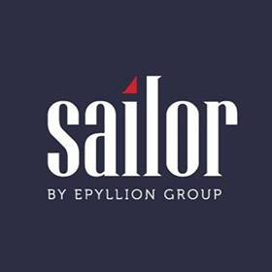

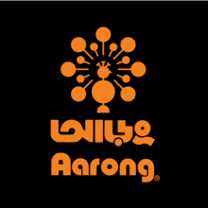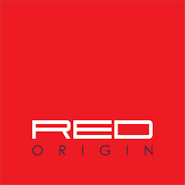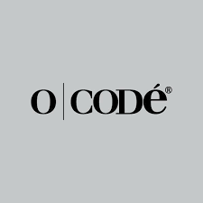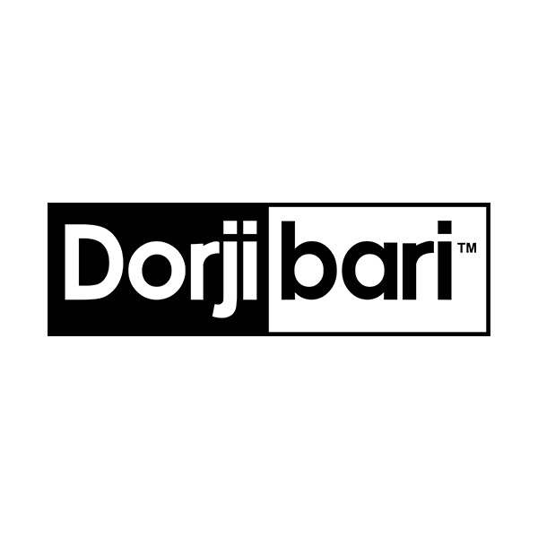






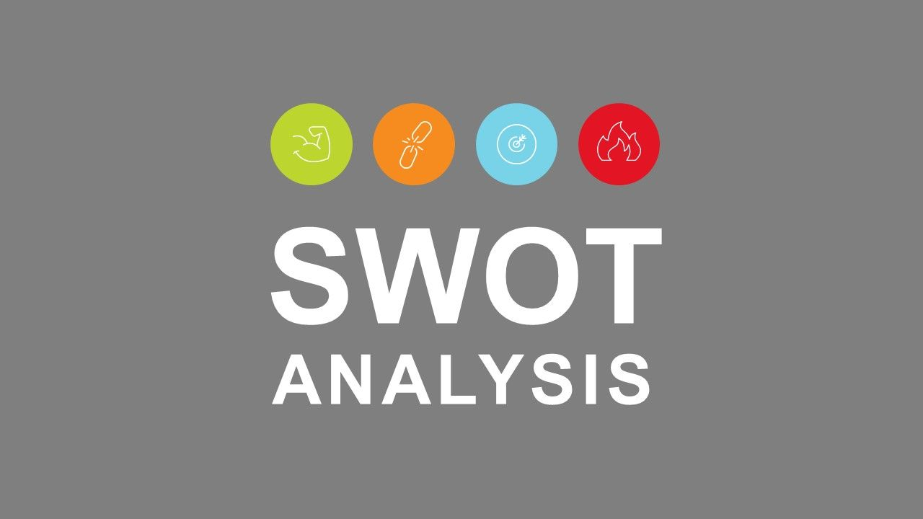

2.2.3: SOWT Analysis
SWOT analysis is a framework which allows determining company’s strength, weakness, opportunity and threat. With a little thought, it can help to uncover opportunities and understanding the weakness it can help to eliminate threats.
Strengths
- Strong management: Rise has skilled human resource which allows running the business properly. We know that skilled human resource has impact on eliminating weakness.
- Strong Financial support: We know that RISE is the sisters concern of STANDAR GROUP. So they have strong financial support. We know that clothing industry day by day changing so that reason they need more investment to cope up with this situation.
- Technology: latest technology helps the organization to make the products smoothly and helps to reduce production time. Rise have implement the latest technology to produce their product. It can also help to defeat their competitor.
- Supply chain: we know that supply chain phase have more impact on making profit. RISE supply chin process is more accurate than other company. They collect the raw materials timely and deliver the product to the end customers timely. This is helps to communicate with their strongly and helps to increased profit.
- Unique product: RISE have unique products that’s helps to defeat competitor.

Weakness
- Lack of Management team: RISE have skilled management team but they need some more employee to run their business smoothly.
- Less experience in the retail business in terms of understand timely proper customer needs.
- Being new in the retail market they have improper supply chain management.
Opportunities
- Growing economy: It is easy to expand their business. When countries economy is suitable they can expand their business. We know that clothing business is more suitable for any kind of financial situation because of clothing is the basic needs.
- Growing demand: Today all the peoples are fashion conscious. Everyone wants to get latest or fashionable dress for their daily life. So that reason the demand of clothing industry is increasing. RISE targets the mid income and high income customers.
- Huge profitability scope in retail market.
Threat
- Political risk: We know that Bangladesh political situation is not suitable, which can act like a threat. Any time government can changes and they can puts some rules regulation, if government put some new regulation against RISE, it can affect in long-term.
- Unethical practice of competitor.
- Any new company introduce new products that have impact on product line.

Chapter 3: Objectives and Methodology

Objectives of the Study: The specific objectives of the study can be clarified here subsequently:
- To evaluate the historical origin of the Rise as a sister concern of the Standard Group.
- To review the competitive scenario of the Rise, specially focusing on the key competitors of the brand.
- To conduct a SWOT Analysis of the Rise focusing on the previously identified key competitors of the brand.
- To understand and review the market targeting strategy of Rise including segmentation, targeting, and positioning.
- To evaluate the marketing mix components of the Rise as a fashion brand. Specific marketing mix component strategy will be clarified in terms of—
  - Product Strategy
  - Pricing Strategy
  - Place (distribution) Strategy
  - Promotion Strategy
- To come up with some specific suggestions for the purpose of improving the performance of the Rise. All these suggestions will be duly presented in the Recommendations section of the Report.

Methodology of the Study: I was placed as an internee in the aforesaid organization for a period of three months. I was observing the organizational culture and the operational procedures particularly related to the marketing department of the organization. For the purpose of the completing the report on the assigned topic, following types of data were used:
- Primary Data
- Face to face interview with my supervisor and employees of the Rise office.
- After three months job observation of the officer.
- Past organization data
- Secondary Data
- Company Official website
- Different magazine, newspaper, Article
- Different websites

Chapter 4: Findings of the Study

4.1: Market Identification

4.1.1: Market Segmentation
Every organization can’t not be all things to all people. They have some product line those want to serve to their customer. So marketers need to segment customers into groups of people with common characteristics and needs. This is helps to organizations produce products for each groups needs cost effectively and helps to earn more profit than competitor those use “one product for fit every customer” approach.
Demographic segmentation: This is done by personal attributes such as age, gender, marital status, education or occupation.
Geographic segmentation: This segmentation done by neighborhood, city, state, region or country.
Psychographic segmentation: By lifestyle, personality or values.
Behavioral segmentation: By usage rate, loyalty, purchasing behavior, user status, occasion/Timing or benefits sought.
Market segmentation (RISE BRAND)
RISE BRAND produce world class clothing products. But they also can’t produce all the product that all group of people want. So that reason they segment their potential customer base that they want to serve their product. They segmentation process are:
Demographic:
- Age: (0 years – 15 years) and (16 years – Above)
Geographic:
- City: Dhaka, Sylhet, Khulna, Chittagong, Rajshahi, Barishal, Rangpur
Psychographic:
- Lifestyle: Modern lifestyle and Traditional lifestyle
Behavioral:
- Loyalty
- User status: lower class, upper lower class, middle class, upper middle class, higher class and upper higher class.
- Occasion: seasonal buyer (winter, summer, spring) and day to day buyer (buy products every day).

4.1.2: Target Marketing
Market targeting consists of dividing the total market into segments, evaluating these segments, and selecting the appropriate segments as the target market that means target the potential customers group that are segment based on common characteristics and needs. It can be the key to attracting new business, increasing sales, and making business a success. An organization can’t concentrate all the segments of the business, so that reason they should needs find the profitable target markets.
Market targeting procedure consists of two steps:
Evaluating market segments:
In his process marketers first evaluating market segments on the based on attractiveness of segments and objectives & Resources of Company.
Selecting Market Segments:
After evaluating market segments, marketers has to selecting in which market segments to enter. That is, marketers decide which and how many segments to enter.

Target Marketing (RISE BRAND)
RISE BRAND targeting strategy is to help them to increase and earn more profit than their competitor. Selecting the appropriate segments is much complicated because of customers’ needs and demands changing every day. So when they target the segments they wisely evaluate those segments.
Demographic
- Age group 16 years-Above: This group of peoples are more concern about their clothing items and more fashionable. Some people are brands oriented, they want to buy luxuries product.
Geographic
- Dhaka city: Dhaka is the capital and largest city of Bangladesh. With a population of 2 crore people. Dhaka is the economic, political and cultural center of Bangladesh. Here are lots of opportunities to grow fast and increasing business easily.
Psychographic
- Modern And traditional lifestyle: RISE BRAND mainly focused on modern lifestyle but in customers demand they also focused on traditional lifestyle. When people are follow the western culture that are under modern lifestyle and when people are more concern about own countries culture, ritual, norms, values that are under traditional lifestyle.
Behavioral
- Loyalty: Some customers are not want to apparently switch in many brands. They want to buy products in few brands and they become loyal customers of that brand.
- User status: RISE BRAND mainly focused on Upper middle class, middle class, upper higher class and higher class of people.
This is the common targeting strategy but also they consider the target markets is distinguishable, measurable, sizable, Accessible, Growing, Profitable and Compatible with the firm’s resources. Also some factors considered when target market selection.
- Attractiveness of market segment
- Size of the market segment
- Growth rate of the market segment
- Competition in the market segment
- Brand loyalty of existing customers in the market segment
- Expected profit margins in the market segment

- Suitability of Market Segments to the Firm
- Whether the firm can offer superior value to the customers in the market segment
- The impact of serving the market segment on the firm’s image
- Access to distribution channels required to serve the market segment
- The firm’s resources vs. capital investment required to serve the market segment

4.1.3: Positioning
Positioning refers to the development of a distinct image for the product or service in the mind of the customer.
Approaches of positioning
The main positioning strategy is to either developing or reinforcing a particular image for the brand in the mind of the customer. The main approaches to positioning strategy are:-
- Customer benefits approach.
- The price-quality approach.
- The use or application approach.
- The product user approach.
- The product class approach.
- The cultural symbol approach.
- The competitor approach
- Customer benefits approach
Actually this approach focus on product characteristics or customer benefits. When the product positioning focusing on the basis of customers benefits or solution basis. Example Customer want to something that helps them to connect each other without going any place. Marketers provide internet service that helps them to connect the whole world on hand. Within a minute customer can contact with other people by sitting at home.
- The price-quality approach
This approach actually used when marketers try to differentiate product quality and try to tell customer that their product quality is higher than others company product. Example some company try to convince customer that their product is number one.
- The use and application approach
This positioning approach is actually use to expand the market. When company introduce some new product that are not introduce any other brands.
- The product user approach
This approach uses when marketers want to produce some product that carry signature image. Sometime some marketers used some spoke person to promote their product. Example we know that Sakib al hasan is one of the best role model in Bangladesh. If Sakib al hasan told that their first choice is Rolex watch then we are believe that and try to buy this watch.
- The product class approach
Sometime the competition for a products is comes from anther products class. When marketers want to positioning on the basis of product class they also consider the direct and indirect competitor. Example Partex group produce mum water and Pran produce Pran mango juice. We know that this two product is not same class but the both product is compete with each other.
- The cultural symbol approach
Sometime marketers positioned their product on the basis of cultural symbol. They try to positioned customer mind that their product carry the culture and give them fell proud.
- The competitor approach
This approach is consider the direct competitor. They follow the competitor positioning strategy and try to implement them with some changes. Example in clothing bran sometime we see that they are produce same category product and also try to convince same group of people. When one brand offer some gift pack another brands follow the same.

Positioning Strategy (RISE BRAND)
In this seven positioning strategy RISE BRAND mainly follows the cultural symbol approach, Competitor approach and the price quality approach. They believe that their product is produce using best quality fabrics and their Denim product is one of the best quality in Bangladesh. And they also follows the competitor approach. And finally they believe that the produce their product to following the traditional lifestyle and also follow our culture.

4.2: Marketing Program

RISE BRAND has lots of products line. They produce wide range of product for both men’s and women’s. RISE BRAND is focused on modern and traditional clothing product. RISE BRAND first start produce street clothing product. After that in consider of customers demand they also produce traditional and casual clothing product. In additional RISE BRAND has exclusive accessories collection. In Bangladesh clothing industry RISE first start to produce clothing item for GYM ad Yoga matt. RISE BRAND also has sunglass, bag, shoes, watch, belt, wallet, cap and many clothing product.
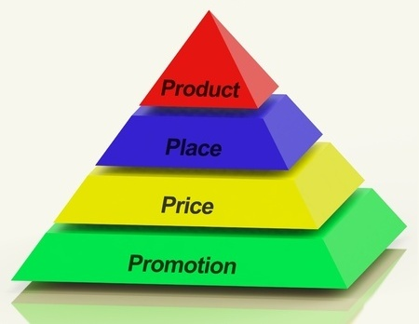
- Product
RISE BRAND believes in providing best quality clothing products to value its customers. All the high tech technological support and factory site established to increase the capability to satisfy customers’ needs and wants.
RISE BRAND categories its product in three different product line and its line incorporates various products to captivate the market.
Men’s Wear
Casual Shirt: - Price range BDT 1495-1995 Taka.
Chino/Gabardine: - Price range BDT 1695-2995 Taka.
Denim Jacket: - Price range BDT 1995-3195 Taka.
Denim Pant: - Price range BDT 1995-4995 Taka.
Denim Shirt: - Price range BDT 1595-2395 Taka.
Jacket: - Price range BDT 1995-4995 Taka.
Jogger: - Price range BDT 1095-1795 Taka.
Knit Polo: - Price range BDT 395-1295 Taka.
Men’s Blazer: - Price range BDT 3995-6995 Taka.
Men’s Hoodie: - Price range BDT 1495-1995 Taka.
Panjabi: - Price range BDT 1495-3995 Taka.
Sweater: - Price range BDT 1195-1995 Taka.
Sweater T-Shirt:- Price range BDT 595-1195 Taka.
T-shirt:- Price range BDT 395-995 Taka.
Women’s Wear
Active Wear: -
For the first time in Bangladesh, introducing RISE ACTIVE wear for women. Price range BDT 795-2495 Taka.
Bolero: - Price range BDT 1395-1995 Taka.
Casual Tops: - Price range BDT 595-2495 Taka.
Denim: - Price range BDT 1495-2495 Taka.
Ethnic Tops: - Price range BDT 1495-4995 Taka.
Gown: - Price range BDT 1995-3995 Taka.
Jeggings: - Price range BDT 1195-1995 Taka.
Knitted Tops: - Price range BDT 495-2195 Taka.
Leggings: - Price range BDT 495-1495 Taka.
Non Denim Bottoms: - Price range BDT 1595 Taka.
Palazzo: - Price range BDT 1495-1995 Taka.
Skirt: - Price range BDT 1695-2295 Taka.
Tops: - Price range BDT 1295-1595 Taka.
Women&#39; s Jacket: - Price range BDT 1595-2295 Taka.
Women’s Blazer: - Price range BDT 2295 Taka.
Accessories
Men’s Shoes: - Price range BDT 2295-6995 Taka.
Women’s Shoes: - Price range BDT 1995-3495 Taka.
Men’s Sunglass: - Price range BDT 695-3495 Taka.
Women’s Sunglass: - Price range BDT 695-1995 Taka.
Women’s Bag: - Price range BDT 1095-2795 Taka.
Women’s Earrings: - Price range BDT 195-1295 Taka.
Men’s Bracelet: - Price range BDT 195-1295 Taka.
Backpacks: - Price range BDT 2195-2995 Taka.
Men’s Watch: - Price range BDT 3495-4995 Taka.
Snapback Hats: - Price range BDT 650 Taka.
Men’s Dog tag: - Price range BDT 895 Taka.
Men’s Wallet: - Price range BDT 1095-1895 Taka.
- Price
We know that pricing is the major part of marketing mix. This is the most challenging work to do. There are several pricing strategy but RISE BRAND follows some of that.
First they follow competition pricing. We know that now a day’s market have so much competitive, so they should needs follows their pricing strategy. If they not match with them they can get some advantage of that.
Second RISE BRAAND follow the Psychological pricing strategy. We know that customer have thinking before they purchase the product. We have some limitation of thinking. We cannot think widely but we think. Suppose if any product price is 1999 then we think this is fair enough to buy this product but that product price is 2050 then we think that this is too much price.
Third they follow premium pricing. RISE BRAND has so many premium clothing item. When they pricing those product they follow the premium pricing strategy.
And finally they follow cost based pricing. We know that every organization follow hat pricing strategy when they have some basic product. RISE BRAND also follow this strategy.
- Place
Place means the patters of distribution the product to the end customer. It’s consider the whole process from raw materials to finished goods on customer’s hand. RISE BRAND is consider the best distribution channel around the Dhaka city. RISE BRAND follows the direct distribution channel. They have open own outlets to provide product to their end customers.
Products from RISE BRAND factory stored in their in house warehouse. The warehouse is at situated in tejgaon industrial area. Then the supply chain department allocated the products to distributor their outlet that around the Dhaka city. After the delivered the product from the warehouse to their outlets. After receiving the products the outlets distributing the product accordingly distribute them among the final customers.
- Promotion
It is one of the most important fact of a company. RISE BRAND follows the some promotional strategy to set their brand on their targets customer.
Mass media or advertising
- TV Commercial
- Magazine choose for advertising
- ICE TODAY
- CANVAS
- RODHOSI
Sales promotion
RISE BRAND provide some coupons for sales promotion and also they have loyalty membership card.
Sales Coupon: Buy 3000 taka products and get 300 taka discount
Loyalty membership card: Buy 7000 taka products and get loyalty membership card and enjoy one year 10% discount.
Direct marketing
Email Marketing: Send some promotional offer to their customer through email and customers get some excited offer.
Mobile Marketing: provide product update and send different occasional promotional offers.
Digital marketing
Facebook: RISE BRAND 70% of their promotional campaign done by using Facebook age. Customers can easily engagement with RISE BRAND 24 hours. In Facebook page customer feedback option are given so that customers are easily connect with the brand. By using Facebook page they promote their business on the basis of demographic segmentation. Some time they offer some quiz competition page and give some gift when they correctly answer this. Actually this is the process of connect the people with the brand. Actually every occasion RISE BRAND arranged campaign photoshoot and video shoot. They also promote their product on Facebook page. They posted product related post every day So that customers get information to see that. In Facebook page customers can easily contact with the brand by sending message and the response time is so fast so that customers are not late for getting information. Facebook page: www.facebook.com/risebrandclothing



Instagram: They also use Instagram for promote their brand and product. They made 10-15 seconds videos and upload this on Instagram.

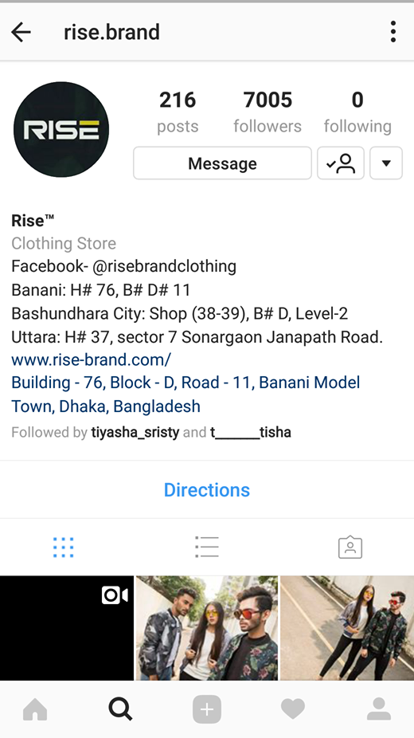

You tube: They have also upload video on YouTube. Sometime they organized fashion show, some special event for promoting their brand. They upload those event video on YouTube.
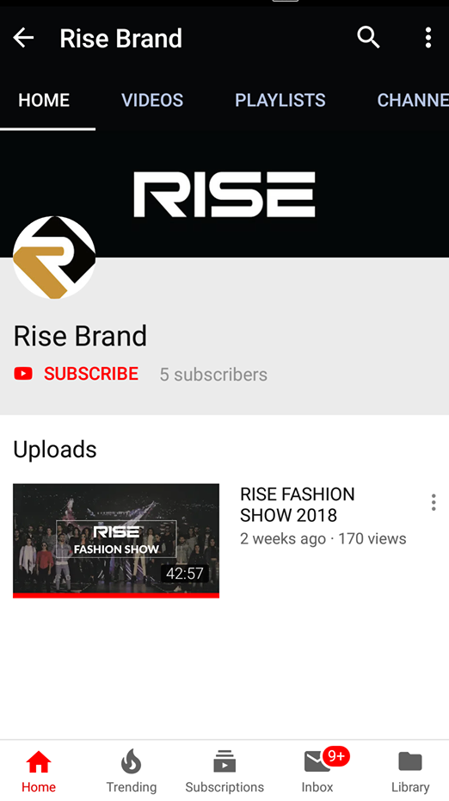
Website: They have also website for promoting their product. Customers can easily buy their product from various kinds of products.
Website link www.rise-brand.com
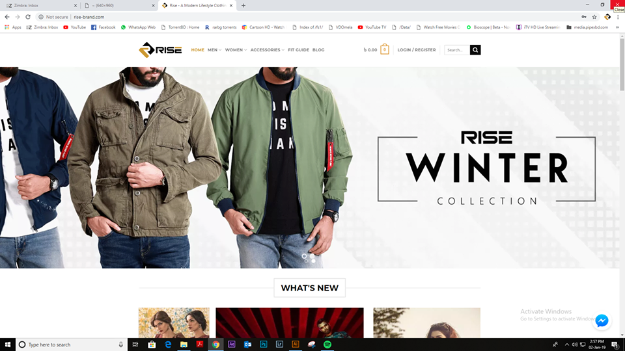

Chapter 5: Limitations of the study
When I was started to do this research, I was faced different difficulty. First of all, I am new on this environment and meet new people. I am working here for three months so that I can’t find the all data that I need to complete my research. This is so difficult to do the research very deeply within the short time of period. There were number of obstacles in my way of research which glory all through the internship: -
Shortage time
I have already mentioned that the internship period is too short and this is the main limitation to do my research.
Access to information
There are some limitations to access the data store. They have some confidential information. If the data is leaked then they can suffer and they are can be faced some big issue. For this reason, I couldn’t use the all data to my research paper.
Lack of communication and cooperation with customer
Face to face communication is very important to get information from the customer. Some customers were agreed to cooperate with me but not all the customers were cooperative. In this short time of period I could not communicated with the customers and they were also not communicated with me. So there are some lacking of collecting the data.

Chapter 6: Recommendations and Conclusion
Recommendations
RISE BRAND produces best quality product, but they are not properly survey the product demands on market. And, they are not overview the problem. I think they should survey the customer demand and their choice.
Their marketing strategy is so much impressive, but they are not able to do anything because of higher management authority. I think top level manager should provide the freedom to do the best things that they want to do.
Make the salary structure attractive to the employee.
They should increase the manpower of HRD in recruitment wing.
Managerial control should be implemented perfectly.
Arrange proper training for the employee & training should be motivational.
Sales people must be needs proper training and must be done proactive work.
Conclusion
Throughout my internship period I gained a lot of valuable knowledge regarding the operations of the entire the local clothing industry. RISE BRAND lately came to this industry but it has already achieved the heart of Bangladeshi people. I am very glad to part of this Brand and understand their business policies, operational structure and business implementations. Now a day’s Local clothing industry is one of the fastest growing sectors in the Bangladesh. Peoples are now prefer to wear Bangladeshi branded product then foreign product. I am believe that RISE BRAND will be lead the local clothing industry in future.
In my internship time period I have seen the most delegated, hardworking and experienced team members and at the same time friendly. The entire organization works together is like family members. I have enjoyed my whole internship time period with the support of RISE BRAND team and my supervisor. I would like to conclude that being part of such an organizations lead me to huge amount of knowledge and practical experience which in return will support my future and gain opportunities.

References

- Edward Kasabov (21 January 2015), Marketing Mix, Wiley Online Liabray
Retrieved From http://doi.org/10.1002/9781118785317.weom090307
- Michael G. Harvey, Robert F. Lusch & Branko Cavarkapa(18 December 2015), A Marketing mix for the 21st century, Retrieved from http://doi.org/10.1080/10696679.1996.11501734
- B.R. Londhe Dr. (14 July 2014), Marketing mix for next generation Marketing, Retrieved from http://doi.org/10.1016/S2212-5671(14)00201-9
- Martin ( 6 August 2014), Marketing Mix Production In four P’s, Retrieved From http://www.cleverism.com/product-four-psmarketing-mix/
- Doris C. Van Doren, Deborah L. Fechner & Kathy Green-Adelsberger ( 9 December 2010),
Promotional Strategies on the World Wide Web, Retrieved From http://doi.org/10.1080/135272600345534
- Contemporary Marketing 2011( Text Book), Louis Boone, David Kurtz, Cengage Learning ( 1 January 2010), Elements of the Promotional mix, Retrieved 26 August 2014
- Essential of Marketing, Charles Lamb, Joe Hair, Carl McDanie, Cengage Learning, ( 1 January 2011), Discuss the Element of the Promotional mix, Retrieved From 26 August 2014

