Customer and Employee Perception of the Banking Service: A Case of Dhaka Bank Limited

Eynoon Zaria Adiba

This internship report is submitted to the School of Businesses & Economics, United International University as a partial requirement for the fulfillment of Bachelor of Business Administration Degree

Customer and Employee Perception of the Banking Service: A Case of Dhaka Bank Limited

Submitted By
Eynoon Zaria Adiba
ID: 111201199
Major: Marketing
School of Business & Economics
United International University

Supervised by
Dr. Kawsar Ahmmed
Professor
School of Business & Economics
United International University

Date of Submission: 12/07/2025

Letter of Transmittal
12th July 2025

Dr. Kawsar Ahmmed
Professor
School of Business and Economics
United International University

Subject: Submission of internship report on “Customer and Employee Perception of the Banking Service: A Case of Dhaka Bank Limited”

With due respect, I am delighted to have the opportunity to submit my internship report. Under your strict supervision, I completed my internship at Dhaka Bank Limited. Mother-Branch (Progoti Sarani, Dhaka-1212). I believe that this report will help me better understand how to serve the banking sector and handling customer. I did my best to prepare this paper meticulously. Any weaknesses or flaws may develop because I have no experience in this area. I would appreciate any clarification or suggestions you may have regarding any views or concepts presented in my paper.

Sincerely,
Eynoon Zaria Adiba
111201199
Major in Marketing & Supply Chain Management
United International University

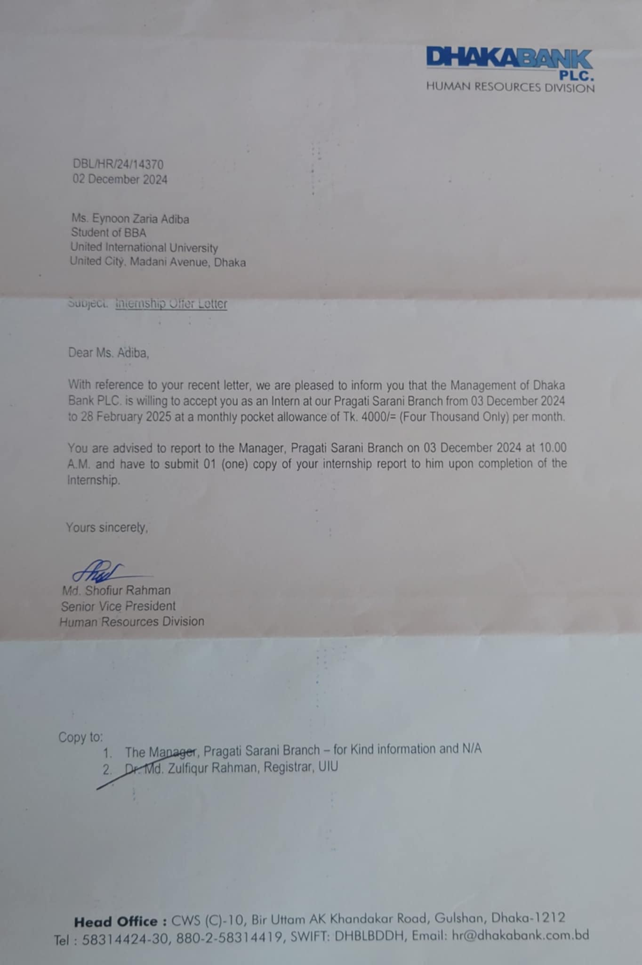

Acknowledgment

I am deeply thankful to my parents for their unwavering support and encouragement, which enabled me to pursue my passion for working with organizations. Without their guidance, my aspirations would not have come to fruition.
I express my gratitude to Md. Ashiqur Rahman, Branch Manager of progoti-sarani, Dhaka Bank Limited. I am glad to work with Salma Sultana who is the head of General Banking and also supervising my intern behalf on her.
Special thanks to my supervisor, Professor Kawsar Ahmmed, for his mentorship and support throughout my internship, and for guiding me to complete my degree.
I am thankful to all the employees of Dhaka Bank who assisted me during my internship and made me feel at home. Their guidance and encouragement were instrumental in completing my internship report.
Finally, I am grateful to my friends for their emotional and academic support. I am fortunate to have them by my side whenever I need assistance.

Executive Summary
Customer perception refers to how clients view and interpret a bank’s services, trustworthiness, and overall brand experience. In the banking sector, positive customer perception is crucial for attracting and retaining clients, especially in a highly competitive environment. It influences service satisfaction, loyalty, and even word-of-mouth referrals, ultimately shaping the bank's reputation and profitability. The purpose of this report is to present the scenario of the perception of bank service at the Dhaka Bank Limited by both customers and employees.
Based on the experience of my internship at Dhaka Bank Limited, this report is written in connection with the customer perception of services at the General Banking Department of Dhaka Bank Limited. The internship was successfully completed within a three-month period, and I gathered knowledge about operations of the banking sector, like account opening, customer services, fund transfer, deposit, and internet banking facilities.

The document provides the Bangladeshi banking industry from the perspective of government, private, foreign, and Islamic banks. It discusses banking industry growth trends, technological upgrades in the form of digital and agent banking, and general issues like non-performing loans and regulatory concerns. At the same time, it also highlights opportunities in digital upgrades, Islamic banking, remittance from overseas, and the emerging middle class.
Dhaka Bank, the first private commercial bank of Bangladesh, formed in 1995, has a customer-friendly service operation in the areas of retail, corporate, Islamic, and investment banking. During my internship visit there, I was engaged in the general banking sector, where different activities varied from customer assistance during account opening procedures to handling deposit products such as DPS and FDR, assisting fund transfer and RTGS operations, and rendering ATM services and regular credit-related responsibilities.
Based on the study findings, several recommendations are forwarded so that Dhaka Bank Limited can actively monitor and adapt to customer perceptions to be better positioned to deliver personalized, inclusive, and innovative services.

Keywords: Perception, Banking Service, Customer satisfaction, Dhaka Bank Limited, Bangladesh

Contents
Letter of Transmittal i
Acknowledgment iii
Executive Summary iv
Chapter One 1
Introduction 1
1.1 Premier 2
1.2 Objectives of the Report 2
1.3 Motivation of the Study 2
1.4 Limitation of the Study 3
1.5 Key Terms 3
Chapter 2 5
Analysis of the Banking Industry in Bangladesh 5
2.1 Introduction 6
2.2 Specification of the Industry 6
2.3 Size, Trend, and Maturity of the Banking Industry in Bangladesh 7
2.4 Technological Factors 7
2.5 Political, Legal, and Regulatory Factors 8
2.6 Industry Rivalry 8
2.7 Summary of Challenges and Opportunities 9
Challenges 9
Opportunities 9
Chapter 3 11
Overview of Dhaka Bank Limited 11
3.1 Overview and History: 12
3.2 Mission Statement: 12
3.3 Location and Facilities: 12
3.4 Customer Mix: 12
3.5 Product/Service Mix: 13
3.6 Service Quality – 13
3.7 SWOT Analysis: 13
Strengths: 13
Weaknesses: 14
Opportunities: 14
Threats: 14
3.8 Strategies to meet the Challenges and Opportunities (Based on SWOT Analysis) 14
Challenges 14
Opportunity 15
Chapter 4 16
Perception of Dhaka Bank Limited Services 16
4.1 Introduction 17
4.2 Importance of Perception in the Banking Sector 17
4.3 Perception of Banking service: Customer perspective 18
4.4 Perception of the Banking service: employee's point of view 19
4.5 Managing Perception in Service Marketing 20
4.6 Customers’ Perception: An analysis 22
4.7 Employees’ perception: An analysis 27
Chapter 5 33
Internship Experience, Recommendations and Conclusion 33
5.1 Work Experience 34
5.2 Recommendation 36
5.3 Conclusion 37

Chapter One

Introduction

1.1 Premier

Internships are part of coursework especially for business students. Internship shows students the gap between theory and practice. This report is prepared based on my three-month internship experience at Dhaka Bank Limited. My department was general banking department where I spend my internship period.
General banking is one of the main functions of banking operations and includes with several services such as account opening, fund transfer, cheque-book issuance, handling deposits (DPS and FDR), and overall customer service. Throughout this internship, I had the opportunity to observe and take part in some of the activities of general banking and see firsthand how a commercial bank operates in a competitive Bangladesh financial market.

1.2 Objectives of the Report

The main objective of this internship report is to give an overall image of the general banking operations of Dhaka Bank and examine the practical knowledge gained through the internship period-
- To identify the main activities of the General Banking Department
- To observe and study account opening, fund transfer, cheque clearing, and other day-to-day banking operations
- To identify the customer service practices followed by Dhaka Bank
- To examine the customer perception of the banking service
- To examine employee perception of the banking service
- To examine how customers are adopting digital banking services like DBL Go Plus
- To relate academic theory to real-life banking practice.

1.3 Motivation of the Study
The motivation behind taking this research is my field of study and getting knowlegde towards the banking industry. As a Marketing and Supply Chain Management student, it is relevant to learn about customer service operations, front-desk communication, and the flow of financial services. Dhaka Bank is a prestigious private commercial bank in Bangladesh that has a belief in customer orientation, and interning in its mother branch provided an ideal opportunity to witness banking operations in the real world.
Additionally, the increasing importance of e-banking and financial inclusion in Bangladesh also provides this study with additional relevance, as it offers an insight into how traditional banking processes are being transformed through the adoption of new tools and methods.

1.4 Limitation of the Study

Despite the immense learning experience, there were several limitations encountered while conducting the internship and also in preparing this report:
- The duration of the internship was three months, which is too limited a timeframe to exhaustively examine all aspects of banking operations.
- For the confidentiality and company policies I was not allowed to access some sensitive data such as customer financial information and internal audit reports.
- When i was going to collect data some of the customers and employees were not willing to give detailed feedback, which made it difficult.

1.5 Key Terms

General Banking- The core business of a bank such as customer relations, account services, deposits, cheque handling, and transfers.
DPS (Deposit Pension Scheme)- this is a process of saving money where customers save a specified amount of money each month for a specified tenure and earn interest on maturity.
FDR (Fixed Deposit Receipt)- this is also a money saving method but here customer same huge amount money at different high interest rate as the period of time.
RTGS (Real-Time Gross Settlement)- A funds transfer system that allows real-time transfer of money from one bank to another for high-value transactions, mostly it use for emergency purpuras.
DBL Go Plus App- Dhaka Bank's mobile banking application that enables customers to access banking services online.
TIN Certificate- which stands for Taxpayer Identification Number, required for account opening and tax.
Aroni Account- A savings account package offered by Dhaka Bank for female clients with features like a free chequebook.

Chapter 2

Analysis of the Banking Industry in Bangladesh

2.1 Introduction
The banking sector of Bangladesh has a lot to contribute to our economic sector. The banking sector has developed long with many banks being in operation in the country, state-owned commercial banks, private commercial banks, foreign commercial banks, Islamic banks. Despite having gone through massive reforms and development, the sector is still struggling.

2.2 Specification of the Industry
Bangladesh banking sector offers a myriad of services, which are contributors to economic development and financial inclusion. They are-
Government Banking - The role of the banks is very contributory for making the economy develop, especially in public sector projects, infrastructure and agriculture. They are very important in terms of financial deepening and are usually tasked with the responsibility of carrying out the government directives. Such as- Sonali Bank Limited, Janata Bank Limited, Agrani Bank Limited, Rupali Bank Limited.
Private Banking - Private-owned banks have a significant contributing role in business development, offering banking services to different individuals and businesses. Private banks have an important role in the operation of business, economic development, and financial innovation in the private sector. Such as- Dutch-Bangla Bank Limited, BRAC Bank Limited, Dhaka Bank, Eastern Bank Limited etc. The banks are committed to personal banking, corporate banking, also offer home loan, business loan, deposit and investment.
Foreign Banking- They are foreign financial institutions with their branches in Bangladesh who deal with multinational businesses, high-net-worth clients, and foreign investors. Example Standard chartered bank, Woori bank Bangladesh, Bank Alfalah Limited. They provide company to have international trade, foreign exchange, specialist corporate banking service.
Islamic Banks: Islamic banks of Bangladesh offer finance service under Islamic law which mentioned Shariah, which prohibits payment of interest that also mentioned riba. These banks are used extensively, primarily by Muslims, who do not wish to make use of conventional interest-based banking. The banks that fall in this category are – Al-Arafah Bank, Islamic Bank Bangladesh Limited, Social Islamic Bank. Islamic banking provides Profit-sharing investment accounts, Islamic mortgages, and interest-free loans to their customers.

2.3 Size, Trend, and Maturity of the Banking Industry in Bangladesh
Size: Bangladesh banking is a huge portion of the total financial sector of the nation, and it boasts over 60 commercial banks operating all over the country. And, the banking sector will probably grow mostly in the upcoming years. For the banking sector, the Net Interest Income (NII) will boost to a whooping US$44.17 billion in 2025. The large and heterogeneous industry plays a prominent role in Bangladesh's GDP, leading to economic growth. With the country experiencing relentless economic growth, the banking sector is expanding with the increasing demand for financial services.
Trend: In the past two years, the banking sector in Bangladesh has seen a rapid transformation with technology upgradation. Internet-based platforms and mobile banking have been at the forefront, with increasing numbers of people gaining access to banking services. The expansion has also been fueled by the innovation of agent banking, where local agents act as middlemen to take banking services to rural areas, to reach rural pockets of the nation. As mobile phones are becoming more widespread, the sector is reaching new bases, increasing penetration, and driving financial inclusion.
Maturity: While the industry has made unbelievable growth, the industry is in a developmental phase as far as international banking practices are concerned. Disturbances like non-performing loans (NPLs) and issues of governance act as a deterrent factor discouraging overall sector maturity. There are efforts from the government as well as private enterprise to address the issues and move the industry toward a stronger and internationally competitive footing. In spite of this adversity, the future direction of the industry is full of huge scope for growth and development.

2.4 Technological Factors
Technology has revolutionized Bangladesh's banking sector, encouraging innovation and easy and trouble-free access to banking products and services for the nation's people. The most significant means through which technology is shaping the future of the industry are:
• Digital Banking: With the deepening penetration of internet services and mobile phones, digital banking too has gone phenomenally viral. Customers now have the option to manage their finances through mobile banking applications, online payment platforms, and electronic commerce transactions, making banking faster and simpler than ever before. This has facilitated the convenience of carrying out day-to-day banking transactions, ranging from checking balances to money transfer, at their fingertips.
• Agent Banking: Agent banking has been revolutionary, especially for rural areas where there is no infrastructure of physical banks. Local-level agents now act as an intermediary and offer basic banking services like deposits, withdrawals, and remittances. Agent banking has been crucial in expanding financial inclusion by reaching individuals who otherwise would have had little or no access to financial services.
• Fintech: Bangladesh's entry by fintech companies is also turning banking services easier and more efficient. Online loans, mobile payments, and e-wallets are coming into mainstream life and offering more choices and flexibility to manage money. This fintech wave is not only making things easier but is also opening new channels for people to join the financial system.

2.5 Political, Legal, and Regulatory Factors
Political, legal, and regulatory circumstances have a huge impact on the Bangladesh banking sector:
•Political Factors: Bangladesh has never enjoyed political stability, breaking investor confidence and destabilizing the economy at large. The same volatility is capable of having a direct impact on the banking sector with a cascading effect on all, ranging from market level to overall institution stability.
• Legal Considerations: Banking business in Bangladesh is governed by law under the provisions of Bangladesh's central bank, Bangladesh Bank. Significant advances have been made in recent times in the areas of financial disclosure, anti-money laundering legislation, and customer protection. However, it remains difficult to enforce such legislation effectively.
•Regulatory Factors: Bangladesh Bank plays a key role in the regulation of the banking sector, ensuring liquidity, stability, and financial inclusion. While there are reforms to consolidate the regulatory environment, there remain issues in the sector, notably in keeping up with rapidly changing global financial standards and practices.

2.6 Industry Rivalry
The Bangladeshi banking sector is highly competitive with over 60 banks all trying to get their share of the market. Among all these banks available in the market, there is fierce competition. Each bank is intensely competing to get new customers, provide card, win loans, and receive deposits to dominate the game. Banks are coming up with innovative concepts and ideas to stay competitive. Suppose, each bank has its own mobile banking app and try to provide 24/7 service through the ATM booth. Whether they're investing in their websites, customer service, or broader investment and insurance product sets, banks are constantly looking to differentiate. In addition, they become competitive when interest paid on deposits and interest returned on loans is a significant source of competitiveness. Banks compete to surpass each other by offering the best terms to customers. Banks also focus on catering to a particular segment of customers, e.g., high-net-worth customers, corporate, or rural. In this manner, they attempt to position themselves differently and carve out a niche in the market.

2.7 Summary of Challenges and Opportunities

Challenges
Non-Performing Loans: The majority of the banks, especially government banks, are facing large amounts of non-performing loans. They are loans that are not being serviced as they were designed to, restricting the banks from making additional lending and affecting their well-being in general. Weak Governance: Political interference, managerial inefficiencies, and corruption still prevail in the majority of the public sector banks. This is discouraging such bank development and deterring their transparency and efficiency levels.
Cybersecurity Threats: Increasingly, customers are becoming digital, and there is a greater likelihood of cyber-attacks and fraud. Banks have prioritized customer data confidentiality and security.
Regulatory and Legal Compliance: The rapidly evolving regulations are a challenge for banks. Banks must keep up with new regulations and be absolutely compliant every time, which can be a challenge for certain banks.

Opportunities
Digital Transformation: The move to digital banking, mobile banking, and fintech solutions is enormous opportunities. Banks can attend to more customers, make their processes easier, and become more efficient on the whole by adopting these technologies.
Islamic Banking Growth: Islamic banking is growing, and more customers are looking for ethical, interest-free financial products. This provides a potential opportunity for banks to diversify their offerings and bring in a wider customer base.
Economic Growth: As the economy of Bangladesh expands, a new middle class is putting increased pressure on diversified financial services. The expansion provides banks with room to develop their customer base and offer more tailored products.
International Remittance Market: As a lot of diaspora remit funds back to their home countries, there is scope for banks to leverage the remittance market. Through providing simple and low-cost mechanisms to manage these funds, banks can establish solid connections with remittance senders and receivers.

Chapter 3

Overview of Dhaka Bank Limited

3.1 Overview and History:
Dhaka Bank Limited, which was formed in 1995, grew rapidly to be one of the top private commercial banks in Bangladesh. It was founded with the vision of delivering innovative banking products to serve individuals and business needs. With the passage of time, the bank diversified its products and currently has services such as retail, corporate, and investment banking. Based on customer satisfaction, Dhaka Bank is now a reliable and trusted brand.

3.2 Mission Statement:
The mission of Dhaka Bank is to be a customer-centric financial organization dedicated to offering innovative products and services that adapt according to evolving customer needs. The bank aims to develop value for customers, employees, and shareholders for long-term relationships and delivering superior-quality financial solutions.

3.3 Location and Facilities:
The head office of Dhaka Bank is based in Dhaka and has an enormous number of branches and ATMs throughout Bangladesh. the bank can serve urban and rural customers. In addition, the bank has embraced digital banking, and it offers mobile banking services that provide easy and convenient access to financial services everywhere, anytime.

3.4 Customer Mix:
The customer base of Dhaka Bank is vast and includes individuals and organizations. Individual customers vary from high-net-worth individuals needing more sophisticated financial products to middle-class house owners needing minimum banking facilities. Dhaka Bank provides such facilities such as business loans, trade finance, and customized corporate banking facilities to different sizes of corporations ranging from start-ups to large-sized corporations. As part of its initiatives to extend its contribution towards financial inclusion objectives, the bank is attempting to expand its reach to rural remote locations.

3.5 Product/Service Mix:
To cater to diversified customers, Dhaka Bank has diversified services and products.
- Retail banking, the services and products are credit card, personal loan, savings, fixed deposit, and mobile banking.
- Corporate banking: corporate credit facilities, trade financing facilities, cash management facilities, and business finance.
- Islamic Banking: Interest-free banking products for customers who need banking products as per Sharia law.
- Investment banking: Mergers and acquisitions, underwritings, and advisory services to corporations.
- Digital banking: Use the internet, mobile phone applications, and ATMs for convenient 24/7 access to the bank.

3.6 Service Quality –
Dhaka Bank stands out for providing customers with the best-in-class service. The bank places high value on personalized care and ensuring that the needs of the customers are addressed efficiently and effectively. The bank is also committed to delivering high standards of service through regular staff training and the implementation of technology solutions that simplify the banking experience for customers. Be it at the branch level or through online systems, Dhaka Bank is committed to providing customers with a hassle-free experience.

3.7 SWOT Analysis:

Strengths:
- A very well-known brand, respected and trusted.
- Deep portfolio of services of interest to different retail as well as corporate customers.
- A very high level of push towards digital banking with high ease and flexibility provided to customers.
- A management team of an extremely high level of experience with a growth and customer satisfaction orientation.

Weaknesses:
- Exposure to external economic downturns and market forces that affect business.
- Relying on conventional banking procedures that may restrict growth in digital banking activities.
- Less extensive global network than that of giant global banks.

Opportunities:
- Enhanced application of digital banking and ATM services offers immense potential for growth.
- Growing customer demands for Islamic banking products that represent a potential for diversification and serving new customers.
- Bangladesh's growing middle class, which will create increased demand for a range of banking products.
- The large Bangladeshi diaspora presents opportunities in the international remittance market.

Threats:
- Intense competition from other private and government banks, which may impact market share.
- Enhance cybersecurity threats since more and more customers have been relying on online and mobile banking.
- Economic uncertainty or inflation can reduce consumer borrowing and expenditure.

3.8 Strategies to meet the Challenges and Opportunities (Based on SWOT Analysis)

Challenges
1.Embrace Digital Transformation:
Dhaka Bank must invest in its mobile app-based and online banking platforms to provide technology-based customers with an integrated experience. This will keep the bank ahead of the competition and allow the bank to manage the rising demand for online financial services.

2. Expand Islamic Banking Services:
As there is a growing demand for Sharia-compliant products, Dhaka Bank will have a good chance to diversify its Islamic banking products. It will attract new customers interested in interest-free banking and minimize risk to the bank as the product mix becomes diversified.
3.Upgrade Cybersecurity Measures:
To remain ahead of growing threats of cyber-attacks, Dhaka Bank should continue to invest in advanced cybersecurity products protecting online transactions and data of customers. This will lead to trust with the bank's services, especially with more and more clients doing business online.

Opportunity
1.Strengthen Governance and Compliance
Dhaka Bank can focus on building stronger systems of governance and strict compliance with international as well as national legislations. This will help it boost public perception and attract more investors towards the bank, making it even more solidify its grip on the market.
2. Leverage the Emerging Middle Class
Bangladeshi middle class is growing and with it comes the need for a variety of financial products. Dhaka Bank can serve to meet this purpose by launching specially designed products targeting the changing demands of this group, such as home finance, savings schemes, and pension products.
3. Improve International Remittance Services
Dhaka Bank can build a solid proposal on the international remittance market using huge Bangladeshi expatriate population. By providing quicker, cheaper, and simpler remittance service, the bank can reinforce its domestic and foreign market customer relationship.
With an attempt to utilize its potential and overcome its vulnerabilities, Dhaka Bank is able to continue growing and remain competitive in the ever-evolving banking sector. The bank's focus on innovation, customer satisfaction, and financial inclusion will aid it in enduring the test of times and harvesting new opportunities.

Chapter 4

Perception of Dhaka Bank Limited Services

4.1 Introduction
The perception of bank service is shaped by multiple touchpoints, including customer interactions, service efficiency, technological accessibility, and trustworthiness. Clients often evaluate a bank's quality through the responsiveness of staff, clarity of communication, ease of transactions, and security of financial data. A positive perception typically grows when banks offer personalized attention, minimize bureaucracy, and adopt user-friendly digital platforms. Conversely, delays, hidden fees, or lack of empathy can erode confidence and create dissatisfaction. In today’s competitive landscape, a bank’s reputation is increasingly tied to how well it adapts to customer expectations, blending professionalism with emotional intelligence across all service channels.

4.2 Importance of Perception in the Banking Sector
1. Fosters Confidence in the Financial System
Trust is the foundation of financial inclusion in the economy of a developing nation like Bangladesh. Favorable perception about banks (transparency, integrity, fairness) motivates people to hold deposits with banks instead of in non-institutional channels (e.g., cooperatives, hundi, cash holding). Of especial importance to the poor and rural groups, where lack of trust or negative experience can lead to financial exclusion.
2. Determines Customer Behavior and Loyalty
Customer attitude determines whether people Open accounts, take loans, refer a bank to others. A technology or customer-oriented bank is cooler for urban youth customers. Conversely, poorly perceived banks fall behind in customer retention and reputation.
3. Determines Employees' Morality and Performance
Employees with a positive view of the organization (fair, professional, growth-oriented) are bound to: perform better, be more loyal, be brand ambassadors. Negative perception by toxic culture, nepotism, poor HR results in high turnover and poor delivery of services, eventually to customers.
4. Influences Public Perception and Market Positioning
With word-of-mouth and social media, perception dictates how the public views banks. A mere negative event such as customer harassment, fraud case can cause so much damage to public trust. Positive advertising or civic activism fosters the image of a bank. Banks spend more on corporate social responsibility (CSR) and electronic branding to influence perception.
5. Affects Competitiveness and Customer Attraction
Perception can distinguish between one bank and another if products are otherwise equal. One customer may prefer Bank A over Bank B simply because Bank A "looks more professional or modern."
6. Construct Financial Inclusion
The majority of the unbanked or underbanked Bangladeshis avoid banks due to negative perceptions: Too complicated., for the rich only, they’ll cheat me. Changing such a mindset through training, outreach, and streamlining of services allows banks to reach the rural markets and meet the government's financial inclusion objectives.
7. Enables Digital Adoption
Perceived security, convenience, and efficiency are critical to mobile and internet platforms' banking. Unless people trust digital systems, they will not use services like internet banking, bKash link, or mobile wallets-even if they are available.
8. Facilitates Regulatory Trust
Moral, regulated banking environment gives confidence to investors, consumers, and external stakeholders. Facilitates FDI attractiveness, remittance increase, and overall economic stability. Customer perception of Dhaka Bank financial services refers to the image and feeling which customers have in regard to bank service quality, trust, and value. Customer perception is dependent on customer service, product attributes, internet banking experience, trust, and satisfaction.

4.3 Perception of Banking service: Customer perspective
1.Trust and Reliability
Current customers will be inclined to trust the large, name banks (Sonali, Agrani, BRAC, Islami Bank) since they are large and reliable. Some mistrust of smaller lesser known private banks or newer NBFIs due to fear on issues of stability or transparency. Enhanced customer confidence over the last few years with enhanced supervision by Bangladesh Bank and web monitoring.
2. Customer Experience at the Branch
Slow branch operations, long queues. Too lengthy complaint resolution. Inadequate personalized attention in the majority of government-owned public sector banks. Private sector banks like City Bank, Dutch-Bangla Bank, and Eastern Bank are highly valued for faster service and more polite staff. 24x7 call centers and online support are leading overall satisfaction.
3. Tech Adoption & Digital Banking
Customers are increasingly demanding when it comes to mobile apps, internet banking, and fast digital transactions. Nagad, bKash, and Rocket have redirected customer behavior towards faster, mobile-based banking. Digital banks lag behind technology, ill-omened for young or literacy-in banking consumers. Fintech collaborations are viewed generally positively.
4. Accessibility and Inclusion
Rural vs Urban Divide: Urban consumers are readily accessing banking facilities—branches, ATMs, and online. All rural consumers rely on agent banking and mobile financial services primarily. Government programs, agent banking, and mobile banking have provided access but need to be accompanied with more confidence and awareness.

5. Transparency and Fees
Hidden charges, fees charged for withdrawal of money from ATM, and obscure terms of the loan are the most complained issues. The majority of the customers lack adequate knowledge regarding how the interest rates, late charges, or account fees work. Simple clear communication and improved financial literacy are essential.
6. Product Offerings and Satisfaction
Demand for Variety: Customers looking for increased tailored financial products: SME loans, education loans, benefit-linked saving plans. Islamic banking increasing among religion-based customers with Shariah-compliant products.
Loan & Credit Services: Divided sentiments regarding simplicity of availing loans—while some complain about bureaucracy and delays, others cite quick processing in private banks.
Importance of perception

4.4 Perception of the Banking service: employee's point of view
1.Job Security and Stability
The majority of bank employees in Bangladesh have the positive perception that their job is comparatively secure, especially in experienced public banks or large private banks such as Sonali Bank, BRAC Bank or Dhaka Bank. On the other hand, workers from newer or non-bank finance institutions will most likely be insecure against less stable managements or doubtful financial performance.
2. Compensation and Benefits
Government Banks: Would most likely grant higher stability but lower compensation in relation to private banks.
Private Banks: Will most likely give higher compensation as well as bonus but at risk of added work pressure and load.
3. Work-Life Balance
Private Banks: Too much overtime work is complained about by staff, especially for sales and marketing personnel.
Public Sector: Less strict on working hours, but maybe slower career progression.
4. Career Progression and Promotion
Public Banks: Employees' grievance that advancement is slow on the seniority, not merit.
Private Banks: Merit-oriented with quicker advancement, though highly competitive.
5. Organizational Culture and Management
Top-Down Structure: Feeling of one-way communication experienced by most of the staff management to staff.
Training & Development: Some banks have excellent training, while others lack this.

6. Ethical Standards and Pressure Sales Pressure:
Employees, particularly from private banks, complain about aggressive sales targets and being requested to achieve unachievable KPIs. Some employees have ethical issues regarding loan sanctioning, treatment of customers, and office politics.

4.5 Managing Perception in Service Marketing
When people think of a bank, their perception – or view – is based on the way the bank has treated them, how convenient it is to use the services, and if they feel safe and respected. So, for Dhaka Bank, managing perception means making sure that people see and experience the bank in a positive way.
1.Know What Customers Want
Customers want fast service, simple messages, courteous staff, and easy online banking. Dhaka Bank needs to hear from their customers, maybe by survey or feedback, and then improve accordingly.
2. Provide Great Service
If a customer visits a branch or utilizes the app, their experience needs to be convenient and pleasant. That includes:
- Friendly and respectful staff
- Fast service with less error
- Helping customers with care
When people feel respected and looked after, they'll trust the bank more.
3. Keep Promises
If Dhaka Bank assures to deliver a loan in 5 days, they have to do that in 5 days. Also, after opening new account they promised customers to give checkbook within 5 working days and they do it. If the app is said to run 24/7, it should. As well as they give ATM service to their customer 24/7. Keeping promises creates trust, and trust creates a positive impression.
4. Improve the Digital Experience
Most individuals currently bank online and using mobile apps. If Dhaka Bank's app is easy to use and effective, individuals will judge the bank to be modern and convenient but not user friendly for all customer. But if it crashes or is complicated, customers will become annoyed.

5. Show That They Care
Individuals like banks to treat them as individuals, not as account numbers. Dhaka Bank can:
- Offer personal advice about DPS or FDR.
- Help in times of need such as flexible home loans or business loan
- Celebrate customers' milestones like birthdays or business growth
It is the human touch that makes the sentiments for the bank better.
6. Share the Good Stuff
The bank should post its success stories, customer reviews, and community service. They need to develop their facebook page, boosting their advertise, discount offers of cards etc. This indicates that they care about people.

4.6 Customers’ Perception: An analysis
The pie chart is customer perception which is shows the gender distribution of 14 survey takers:
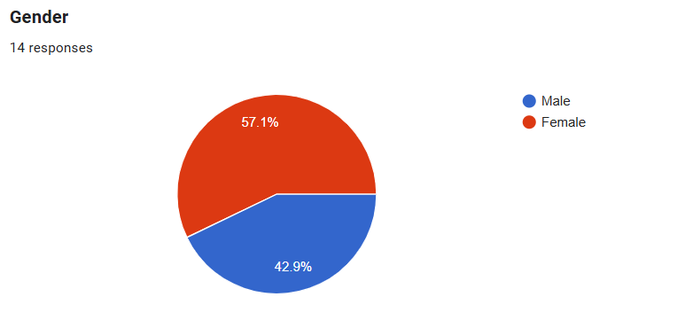
Male: 42.9%
Female: 57.1%
This indicates a comparatively higher response level from the females compared to the males in this survey.

The pie chart indicates the age distribution of 14 people who took the survey:
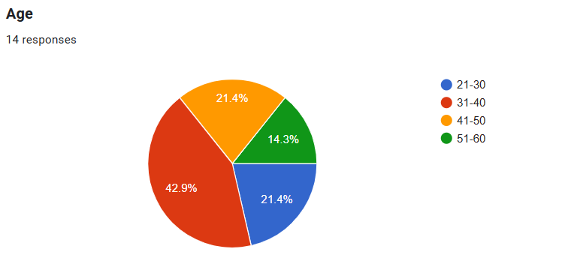
21–30 years: 21.4%
31–40 years: 42.9%
41–50 years: 21.4%
51–60 years: 14.3%
The largest age group represented is 31–40 years and is nearly half of all participants.

The pie chart shows survey responses of 14 individuals on "Trust and Reliability" of their bank:
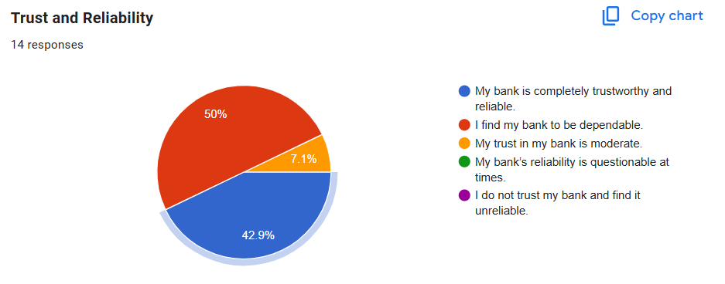
42.9% My bank is extremely trustworthy and reliable.
50% I consider my bank reliable.
7.1% My bank's trust is medium.
0% My bank's reliability can sometimes be questionable.
0% I don't trust my bank and consider it unreliable.
The majority of participants (over 90%) consider their bank to be trustworthy and dependable. No participants received low trust scores, and that implies generally high trust towards banks.
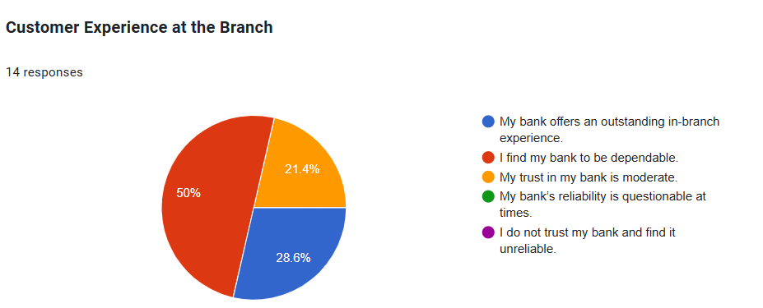
The pie chart "Customer Experience at the Branch" presents responses from 14 individuals regarding the extent to which they trust and are satisfied with the branch service of their bank. Scores are as follows:
50% of I find my bank to be reliable.
28.6% of My bank offers an excellent in-branch experience.
21.4% My trust in my bank is average.
0% My bank's reliability is sometimes questionable.
0%I do not trust my bank and find it to be unreliable.
Positive Sentiment (78.6%) The majority of respondents have a positive attitude towards their bank, with half finding it reliable and nearly 29% terming their experience as excellent. Neutral Sentiment (21.4%) Fewer find their bank's service in moderation. No Negative Sentiment, no customers expressed skepticism or distrust for their bank.

The pie chart "Tech Adoption & Digital Banking" is a summary of responses of 14 individuals regarding their experience with the digital services of their bank. Here is the breakdown of the findings
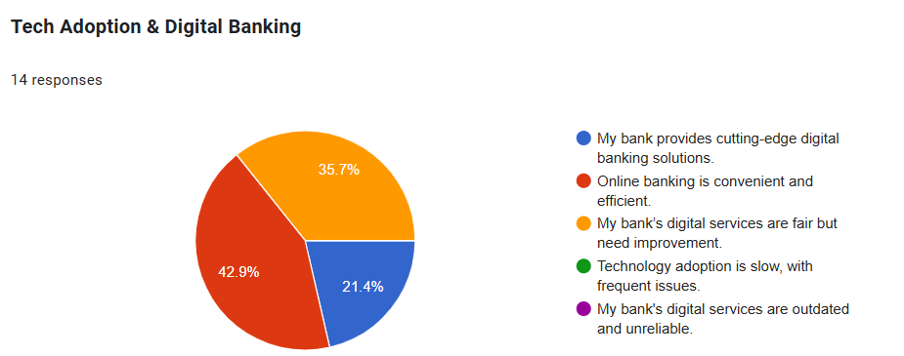
Online banking is convenient and efficient 42.9% Indicates that there is a clear majority that is content with the digital banking experience.
My bank's digital services are fair but need improvement 35.7% Means that while customers find the services to be functional, they need improvement clearly.
My bank has cutting-edge digital banking facilities -21.4% a smaller number of people find the bank highly technologically advanced in adopting technology.
Technology adoption is slow, with frequent problems- Nobody opted for this, hence slow tech adoption is not an issue of importance. My bank's digital services are outdated and inefficient no respondent was vitally discontent to this degree. 78.6% value digital banking, yet some find that there's room for improvement.
Just a minority (21.4%) believe that their bank is at the forefront of digital innovation, indicating scope to improve or promote their tech credentials better.
The "Accessibility and Inclusion" chart aggregates feedback of 14 respondents on how inclusive and accessible the bank's services are to a diverse customer base. Analysis is provided below-
Services are inclusive and accessible- 64.3% Most respondents feel that the bank is inclusive with its services, which are accessible to all and do very well in terms of inclusivity.
My bank is completely transparent with decent fees - 21.4% One smaller segment sees the bank as equitable and transparent in its practices this captures faith in fiscal transparency.
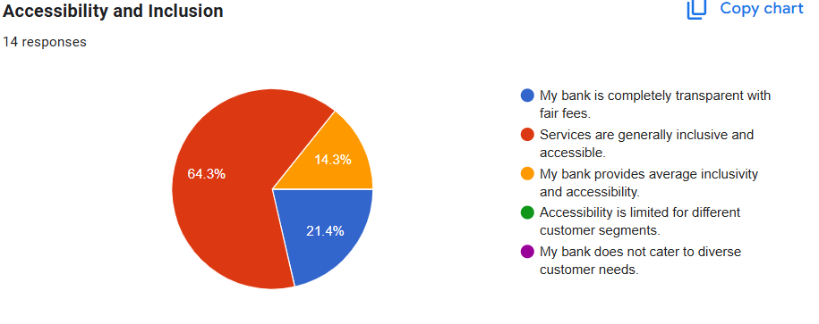
My bank provides median inclusivity and accessibility- Implies that while some are included, there is a little bit of leeway to be more inclusive of diverse or underserved segments.
Nobody ticked these options, so serious issues around inclusivity are not the standard.
Most (64.3%) feel that the services of the bank are inclusive and readily accessible, which is a positive indication of the social responsibility of the bank.
No strong negative remarks suggest the bank doesn't exclude any material customer segments.
Are areas for improvement Transparency and average accessibility need to be improved upon, since approximately 35.7% didn't give the most positive answer.

Following is the breakdown of the "Transparency and Fees" pie chart on the basis of responses of-
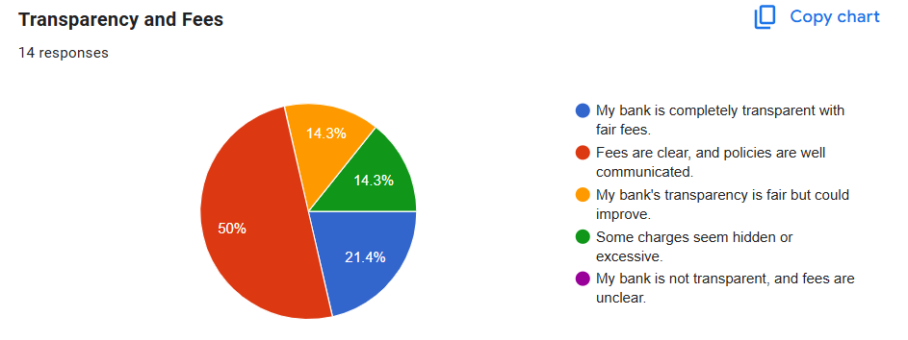
Policies are well explained and fees are transparent - 50% Fifty percent of people are satisfied with the bank's fee and policy explanations.
Reasonable fees and my bank are very transparent - 21.4% a smaller category believes the bank is very transparent and reasonable.
My bank is clear enough but could be better- 14.3% Customers feel the bank is fine but could do better in terms of being clear or transparent.
A few of the fees are too obscure or too high-14.3% Indicates a concern that could harm trust if it's not addressed.
Nobody felt a lack of transparency at all, which is reassuring. an astonishing 71.4% of customers feel that the bank is good at fee explanation or being totally transparent. 28.6% recognize areas of poor performance, i.e., in terms of concealed or unnecessary fees. No respondent felt completely lost or confused about fees, indicating the bank maintains a low degree of transparency.

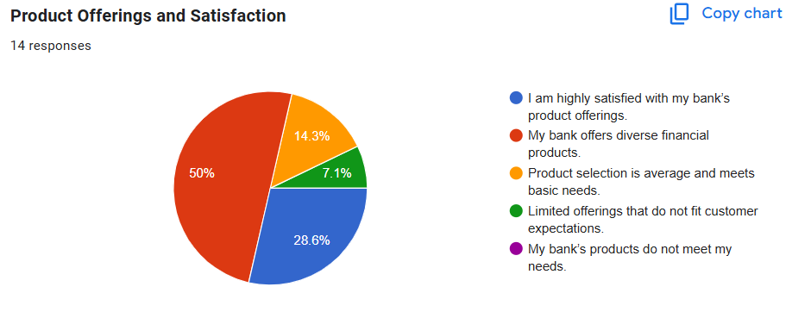
Below is an analysis based on the pie chart captioned as "Product Offerings and Satisfaction" The pie chart illustrates customer reaction towards the type and quality of financial products offered by their bank. Their reaction is as stated below-
50% of respondents believe their bank offers diverse financial products, indicating a generally positive perception of the variety available.
28.6% are extremely satisfied with their bank's product offerings which is a strong alignment between customer needs and the bank's offerings.
14.3% feel that the range of products is average which is an area for development in offering more customized or innovative financial products.
7.1% of customers think that the products are narrow in scope and are below expectation, which could indicate a potential gap in product development or an understanding of the customers. 0% of respondents felt their needs were not at all unmet, which is a positive sign in the sense that nobody was totally dissatisfied.

4.7 Employees’ perception: An analysis
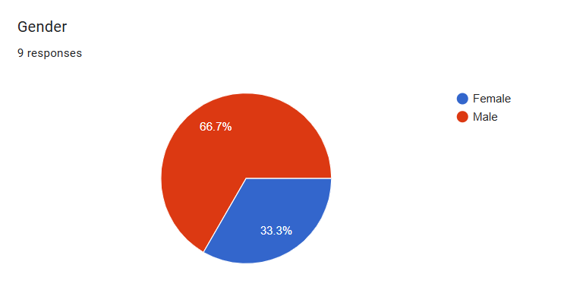
Pie chart illustrating the gender divide of 9 respondents. This is how it is divided:
Male: 66.7%
Female: 33.3%
This shows that there are twice as many male respondents as female respondents in this group. Let me know if you’d like help creating a report or analyzing more data.

The pie chart displays 9 respondents' age range. The distribution of age ranges is as follows:
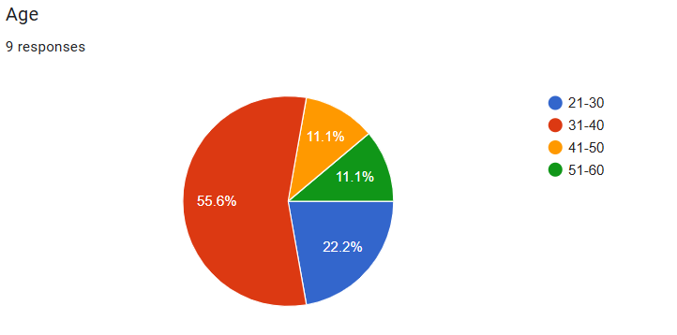
31–40 years: 55.6%
21–30 years: 22.2%
41–50 years: 11.1%
51–60 years: 11.1%
This indicates the majority of respondents fall in the 31–40 age range. If you prefer, I can produce this in a report or compare it to other groups.

The pie chart shows the educational levels of 9 respondents. The following is the distribution:
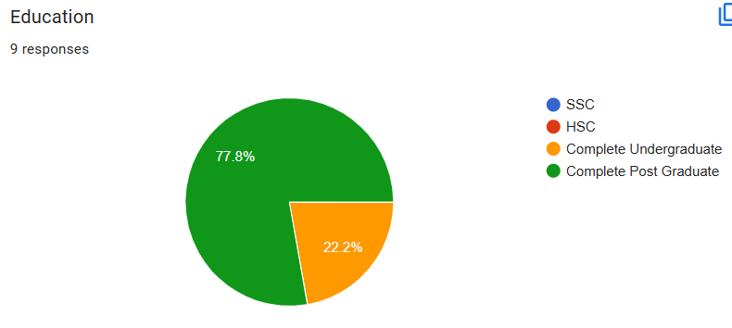
Complete Post Graduate: 77.8%
Complete Undergraduate: 22.2%
SSC and HSC: 0%
This shows a very well-educated demographic; most having done postgraduate studies. If you would like an overall demographic overview that merges gender, age, and education, let me know.

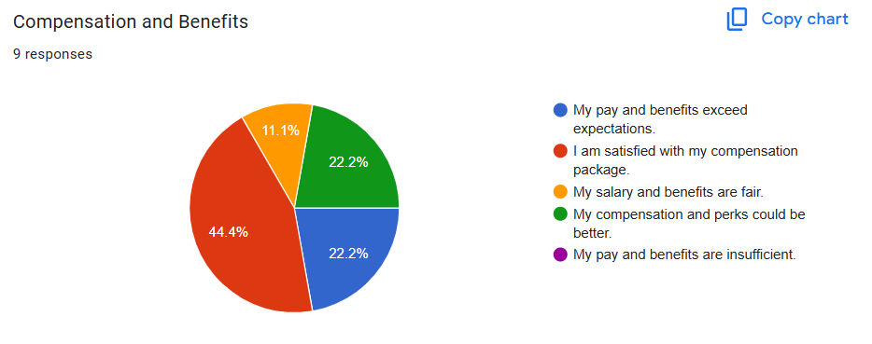
The pie chart illustrates 9 participants' opinions regarding their “Compensation and Benefits” Here is the summary:
I am satisfied with my compensation package 44.4%
My pay and benefits are better than expected – 22.2%
My compensation and perks could be better– 22.2%
My salary and benefits are average– 11.1%
My pay and benefits are inadequate– 0%
66.6% of the respondents are very satisfied or satisfied with their compensation.
Less than a quarter (22.2%) believe there's some room for improvement. No one groused that their compensation is just not sufficient.

The pie chart shows the “Work-Life Balance” for 9 respondents. The distribution is as follows:
I have an excellent work-life balance – 33.3% (3 respondents)
My work-life balance is moderate – 33.3%
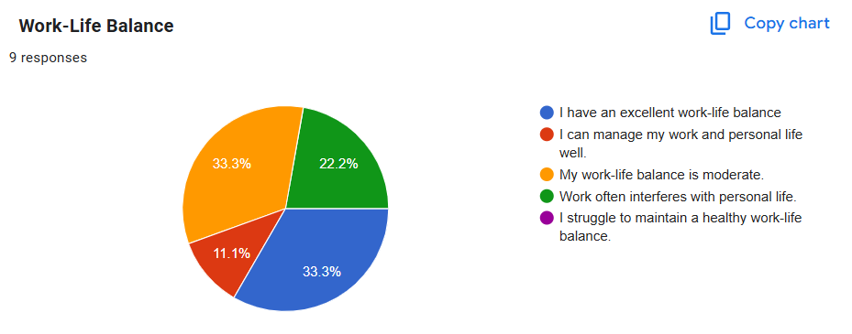
Work tends to interfere with personal life – 22.2%
I am able to manage work and personal life effectively – 11.1%
I find it difficult to achieve a healthy work-life balance– 0%
Summary:
44.4% reported good work-life balance (excellent or manageable). 33.3% said moderate balance. 22.2% report work tends to interfere with personal life often. No one reported they have extreme difficulty balancing work and life.

The pie chart titled as "Career Progression and Promotion" is the consolidation of responses from 9 interviewees on work-life balance. Given below is the meaning of the responses:
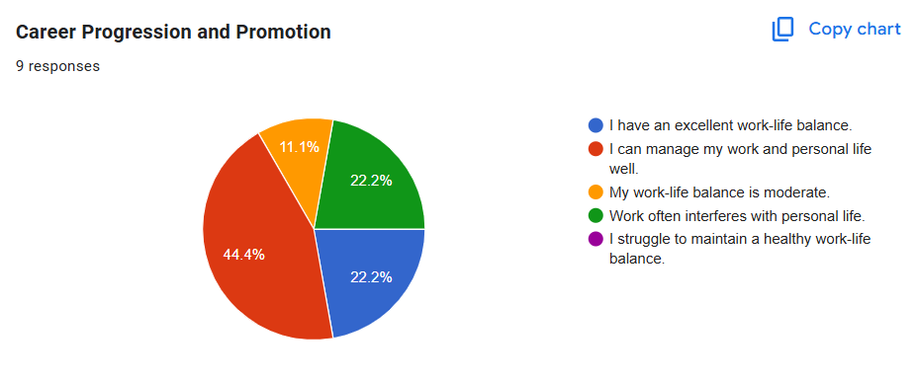
44.4% I am capable of balancing my work and my life. This is the largest category, suggesting that nearly half are self-assured in balancing their work and personal life.
22.2% of people enjoy a good work-life balance. There is a smaller percentage who feels that they've achieved an optimal balance.
22.2% Work often conflicts with personal life. An equal split sees work-life conflict.
11.1% My work-life balance is moderate.
0% I have a hard time having a healthy work-life balance.
No participants selected this most negative option, which can suggest overall moderate-to-positive experiences for participants.

The second pie chart, "Career Progression and Promotion" is the representation of the way 9 respondents view their potential for future growth at their workplace. This is the distribution:

44.4% I have good prospects of rising through the ranks. It is the most highly favored choice, which shows that most of the employees are optimistic about their future career growth.
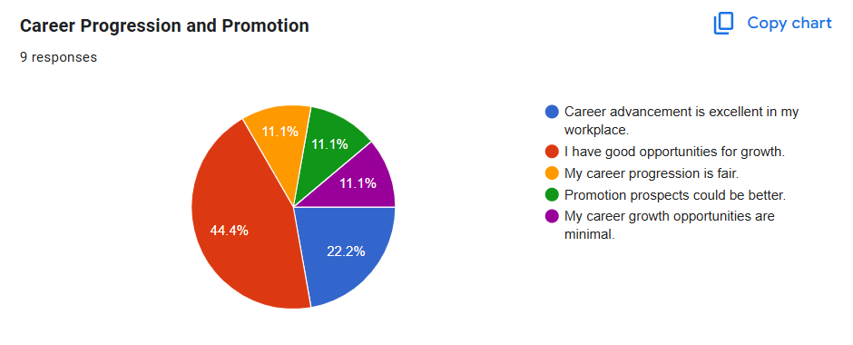
22.2% My company's career development is great. A small but positive group is highly satisfied with career development.
11.1% (1 respondent) My own career development is average. This is a middle-of-the-road description.
11.1% (1 respondent) Career opportunities for growth are something that can be improved. This reflects potential for future growth from the perspective of one respondent.
11.1% (1 respondent) Career development potential is limited. There are some who see themselves as being limited in potential for development.
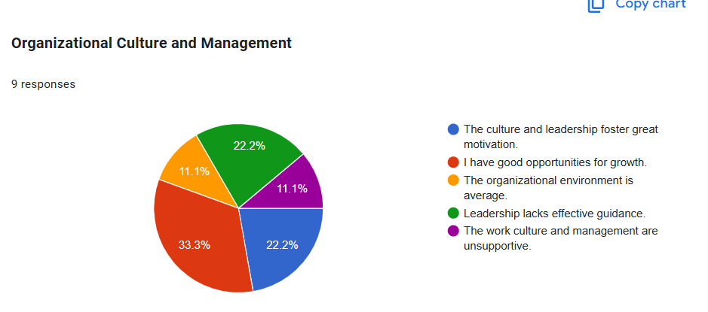
The third pie chart, "Organizational Culture and Management" shows that 9 respondents have the following perception of the culture and leadership in the workplace. The following is an unequivocal summary:
33.3% (3 respondents): I have good opportunities for growth.
This is the most chosen answer, showing a positive general sentiment for development in the organization.
22.2% (2 respondents): Excellent motivation is encouraged by culture and leadership. A majority of employees are positively inclined towards leadership and culture. 22.2% (2 respondents): Effective guidance from leadership is lacking. The same amount as positively inclined, some observe strengths in leadership weakness. 11.1% Organizational environment is average. Implies a neutral sentiment regarding the organizational environment. 11.1% Management and work culture are unsupportive. Minority believe that culture and leadership are negative.

The fourth pie chart, entitled "Ethnic Standards and Pressure Sales Pressure" is the 9 respondents' perception of ethics and pressure sales pressure in the workplace. The distribution is as follows:
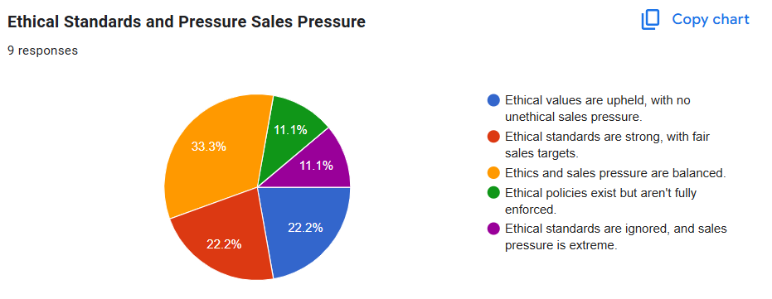
33.3: Both ethics and sales pressure are in balance. Most common opinion that most employees feel that there is a balance mix between ethics and pressure to sell.
22.2% There are ethics with no unethical sales pressure. Indicates a good impression where ethics are the overriding element in the sales culture.
22.2% Ethical standards are good, with reasonable targets of sales. In line with the image of the workplace of having overall good ethical practices.
11.1% There are ethical policies but not fully implemented. Some are apprehensive about inconsistency in ethical enforcement.
11.1% Ethical codes are disregarded, and too much pressure to sell. Few of the staff are negative, with too much pressure and weak ethical enforcement.

Chapter 5

Internship Experience, Recommendations and Conclusion

5.1 Work Experience
I spent three months at Dhaka Bank as an intern. This branch is the mother branch, it has a sub-branch on Madani Avenue. This bank is focused on the company more than individual customers. Mainly, I worked in the general banking department also I was connected with the credit department, IT department and cash department. As an intern, most of the time I manage the customers such as giving information about account opening, registering their Dhaka bank Go Plus app (DBL Go Plus), and also informing customers through the phone to collect their checkbook and card, sometimes receiving checks from customers. Basically, customers come to the bank with two types of checks one is a paycheck which is also known as a payee check and another one is a fund transfer check.

Account Opening Requirements- in the banking sector have several types of accounts, one is a savings account which is for the person and another account type is a current account which is for proprietors and partnership businesses.
For opening a savings account people need to give their NID card copy, the account holder’s 2 copy passport size photo and for his or her account they give a nominee who must be their family member and a photo of the nominee. For opening a savings account customer need to show their utility bill copy to the bank.
On the other hand, in current accounts, customers open their accounts in their company name and bankers create a CIF (customer Information From) for each proprietor. They also give nominee against their company. For this account, the account holder needs to give their NID, passport size photo, TIN Certificate, and updated trade license and also give the nominee’s NID and photo.
Joint Account- a joint account means operating an account jointly or with any of the partners. It is open for business or family purposes. It is also known as a savings account but here the difference is anyone can operate this account.
DPS & FDR - if any accountholder wants to save their money, they can open DPS and FDR. So, DPS means Deposit Pension Scheme, here actually want to save a certain amount of money (such as 500tk or 1000tk or 3000tk 5000tk like this) and it saves for two years, five years or ten years as per customer choice. The main thing about this DPS is that every month bank will cut the money from the customer's account. For example, one customer does 500tk DPS for 5 years that means every month bank will cut the money from that customer's account. If this customer continues his/her DPS and after five years his/her DPS will mature then the bank will give him/her a certain percentage of interest, which can be 8% or 9.50% or 10% it’s depending on the Bank's situation. If anyone doesn’t complete this DPS, in the middle of the DPS they want to close it then they can but the Bank does not give any extra money.

FDR which is known as Fixed Deposit Receipt, is mainly what customers do to save huge amounts of money and they can save that for three months or six months or one year or thirteen months (it is known as SDS). Customer can take their interest in their account or roll-over that interest with the main amount. If any customer does an FDR for three months or 91days then he/she can get 10.50% or if he/she can do an FDR for six months or 184days then Bank will give him/her 10.75% or if the customer wants to do an FDR for one year or 364 days then Bank will give 11.40% interest. Customers can close this FDR at any time and also withdraw their money but in SDS customers cannot do it, without completing the thirteen-month customers cannot close it, and after matured the FDR customer can get 11.50% interest also it is not rollover after thirteen months. So, after completing the period customers must be informed bank what they want. Every year bank cuts the tax against FDR and DPS, if the customer has a TIN return certificate, the bank will deduct 10% and if the customer does not have any return copy then the Bank will deduct 15% tax.
For account opening purposes, Dhaka Bank has an opportunity for woman customers that is when a woman opens an account for the first time their checkbook will be free and that is 10-page checkbook. This account is also known as the “Aroni” account.

Also, this bank opens salary accounts for different companies like an oriental oil company, Intelligent Image Management Limited, porchestta company, Nagad etc. For this type of account customers don’t need to deposit money. Also, if they reissue their card then it will be taking half payment of the total payment.

Money transfer through the bank
Payee check- if the customer is a Dhaka bank account holder but his/her client or anyone give him/her another bank check then they come to Dhaka bank and write a deposit clip and submit the check and that deposit clip. If they give that check within 12 pm then that transfer his/her account at 6 pm, this is the rules of Bangladesh Bank. Also here transfer two types of checks one is high value and another one is regular value. If the amount is within 500000 lakhs then it is regular value and more than 5lakh and also 5 lakhs is high value and its charge will be 60 tk.
Fund transfer –the customer has an account in Dhaka Bank and any person gives him/her a Dhaka bank check then they will come in the general banking section, write a deposit clip and submit it and within 20-25 minutes the money will be transferred into the customer account and then they will cash out the money if they want.
RTGS which is real-time gross settlement, customers do it for transferring money to another bank as fast as they can. It has a requirement that is customer has to transfer 1lakh or more than that and also do it before 3.30 pm.
Cash department- without cash deposit and cash withdrawal, they also maintain the ATM booth. Three to four times a week cash in charge refiles the booth machine and collects the capture cards. Also, they collect passport payments, and utility payments here.
Credit Department- in the credit department they give loans to the customer and sell credit cards also. They give home loans to the basic customer and do L/C for businessman, endorsing passports, creating all kinds of official bills etc.
I work in the general banking sector but they give all kinds of knowledge in different sectors. I feel so glad that my seniors are very helpful and teach me banking. During this internship period, I enjoy a lot and learn the corporate culture as much as I can.

5.2 Recommendation
During the internship period i observed of Dhaka Bank's general banking procedures, the following recommendations are improved their process more-
1. Encourage Customer's Digital Literacy: A majority of customers mainly rural and aged customers find it difficult to use digital app like the DBL Go Plus app. Basic-level training sessions or easy tutorials (branches or online) could be provided by the bank to help increase usage of digital channels.
2. Improve ATM Services: ATM breakdowns and limits on the cash withdrawn at times are inconvenient. Routine maintenance and more frequent cash replenishment, especially during weekends and holidays, is recommended.
3.Customer Feedback System: It will make it possible for customers to give feedback on their issues and make recommendations so that the bank can continuously improve the service.

5.3 Conclusion
This internship was a tremendous learning process regarding the basic operations of Dhaka Bank's General Banking Department. This internship bridged the theoretical aspects and practical applications, and it enhanced the knowledge of banking activities such as account opening, fund transfer, DPS/FDR processing, and customer service. Dhaka Bank has good customer focus and operational performance but still lags behind in digital literacy, service speed, and transparency. Adopting more customer-focused approaches, increasing technology support, and investing in staff training can significantly advance the bank's competitive position in Bangladesh's evolving financial sector. The internship experience overall was enriching, and it contributed significantly to building professional expertise, confidence, and real-world knowledge in the banking field.

References
Bank Limited Dhaka . (2025 ). Dhaka Bang PLC . Retrieved from Vision Mission & Value : https://dhakabankltd.com/mission-vision-and-values/
BD.Bank. (2025). Foreign Commercial Bank in Bangladesh . Retrieved from banksbd.org: https://www.banksbd.org/banks/foreign.html
Dhaka Bank Limited . (2025). Products and Services . Retrieved from Dhaka Bank PLC : https://dhakabankltd.com/product-and-service/
Royal, C. (2022, November 26th ). Royal Capital bd. Retrieved from Banking Industry in Bangladesh : https://adda.royalcapitalbd.com/banking-industry-of-bangladesh/
Studocu. (n.d.). Dhaka Bank Limited SWOT Overview . Retrieved from Studocu : https://www.studocu.com/row/document/central-university-of-science-technology/buy-usa-facebook-accounts/summary-tes/112423610
Tapash, P. C. (2023). Challenges and Prospects of Bangladeshi Banking Industry. Mercantile Bank PLC. Retrieved from https://mblbd.com/assets/corporate/senior/Challenges_and_Prospects.pdf

