
Internship Report
On

Asset Management Industry & Shanta Asset Management

Submitted to:
Md. Mohan Uddin, Ph.D.
Professor
School of business and Economics
United International University

Submitted by:
Tanvir Islam
ID- 111 133 008
BBA Program
School of Business and Economics

Date of Submission: April 1, 2019
Letter of Transmittal
April 1, 2019
Md. Mohan Uddin, Ph.D.
Professor- Finance
School of business and Economics
United International University

Subject: Submission of Internship Report

Dear Sir,
I have prepared my internship report on the topic of “Asset Management Industry & Shanta Asset Management” under your kind supervision as a requirement of completing the degree of BBA program. I have tried my best to prepare the report in consistence with the optimal standard under your valuable direction.

I made every effort to reveal greater insight in this report. I hope that this will meet the standard of your judgment.

Thanking you for your kind supervision.

Sincerely yours,

Tanvir Islam
ID No: 111 133 008
Major in Finance
School of business and Economics
United International University

ACKNOWLEDGEMENT

My acknowledgement begins by thanking my Supervisor honorable Supervisor, Md. Mohan Uddin, Ph.D., Professor- Finance, School of business and Economics United International University, who has provided me with suggestions for making this Final Internship Report and also provided me with the format for preparing this report. I would also like to express my sincere appreciation to him for his whole hearted support and guidance. It was a great pleasure to prepare Internship report on “Asset Management Industry & Shanta Asset Managemen”. I am also grateful to the management of the Shanta Management Ltd. for selecting me for the three months Internship program. I would like to show my warm-hearted gratitude to the Research department of Shanta Management Ltd.; which has provided me with great deal of information, adequate data and co-operated me for the accomplishment of this report successfully. My sincere gratitude goes to my internship mentor at SAML Mr. Jahidul Islam (Deputy Fund Manager) for his very kind assistance regarding the report. Without the help my mentor it would have not been possible to complete this internship report as I got all necessary guidelines, cooperation, and advises from him to complete this complicated task.

I would also like to thank each and every Staffs of Shanta Management Ltd. Specially Mr. Salman Rahman, Deputy Fund Manager at SAML for his kind assistance and attention towards me while I was completing different tasks at SAML.

The experience I have gathered will be privilege for my future career planning. I believe that this situation has prepared me for taking up new challenging opportunities in future. I have tried my best to complete such a big project in an efficient manner. Last but not the least my heartiest thanks to my family, friends at class mates at united international university for being so co-operative and for believing in me.

Table of Contents

1. Introduction 3
1.1 Background 3
1.2 Objectives: 6
1.3 Significance of the Report 6
2. Analysis of the Industry 8
2.1 Specification of the Industry: 8
2.2 Size, Trend, and Maturity of the Industry 8
2.2.1 Size of the Industry 8
2.2.2 Trend of the Industry 8
2.2.3 Maturity of Asset Management Industry 10
2.3 Seasonality 10
2.4 External Economic Factors 11
2.5 Technological Factors 13
2.6 Political, Legal & Regulatory Factors 14
2.6.1 Political Factor 14
2.6.2 Legal Factor 15
2.6.3 Regulatory Factors 16
2.7 Barriers to entry 16
2.8 Supplier Power 18
2.9 Buyer Power 18
2.10 Threat of Substitute 18
2.11 Industry Rivalry 19
2.12 Summary of challenges and opportunities 20
3. Analysis of the organization 22
3.1 Overview and History 22
3.2 Trend and Growth 22
3.3. Customer Mix of Shanta Asset Management Ltd. 23
3.4 Product/Service Mix 24
3.5 Operations of SAML 25
3.6 SWOT Analysis 26
3.7 Steps/strategies to meet the challenges and opportunities 27

4. Internship experience 29
4.1 Position, duties, and responsibilities 29
4.2 Training 29
4.3 Contribution to the departmental functions 29
4.4 Evaluations 29
4.5 Skills Applied 30
4.6 New Skills Learned 30
4.6.1 Preparing Daily Market Data 30
4.6.2 Preparing Event & Record Calendar 31
4.6.3 Preparing Weekly Mutual Fund Data 32
4.6.4 Preparing Weekly Macro-Economic Data 32
4.7 Application of Academic Knowledge 33
5. Recommendations 34
5.1 Recommendations for improving departmental operations 34
5.2 Recommendations for improving self- performance 34
6. Conclusion 35
References 36
Appendix 37

Executive Summary
Once defined as a third world country, Bangladesh has been recently promoted to developing countries. Bangladesh now has the potential to become the world's 23rd largest economy by 2050, overtaking countries such as Netherlands, Australia, Spain, Thailand, and Malaysia according to a recent report published by PricewaterhouseCoopers (PwC). Bangladesh has been included in the “Next Eleven” (N-11) economies of the world by Goldman Sachs while SCB has included Bangladesh in ‘7% Club’. Growth at 7% means the economy doubles in a decade. Moreover, in FY 14-15 Bangladesh graduated from the category of lower income country to lower middle-income country.
The Bangladesh asset management industry is still in an early stage of development. In recent years the number of asset managers has substantially increased. Currently there are 37 registered Asset Management Companies who are managing 77 mutual funds. Among them there are 40 open-end mutual funds and 37 close-end funds available with Asset Under Management (AUM) totaling to approximately BDT 120bn. In Bangladesh Mutual funds have not yet been able to gain a significant share of investors’ wallet mainly due to lack of financial awareness among a major portion of the population while some investors continue to view mutual funds as trading tools as opposed to long-term savings tools. So as our economy matures and investors gain financial awareness we expect sharp rise in demand for mutual funds. Moreover, favorable demographics, rising income levels and a burgeoning affluent middle class will provide a strong customer base for the asset management industry.
Shanta Asset Management Limited (SAML) received its Asset Management License from the Bangladesh Securities and Exchange Commission on November 26th, 2015. Their vision is to be the leading asset management company in the country in terms of the fund’s performance, assets under management and compliance. Investment team of SAML applies distinct and rigorous investment processes to the management of mutual funds and institutional portfolios to generate the lucrative risk adjusted return.
I worked at Shanta Asset Management Ltd. as intern. My responsibilities was preparing and maintaining databases, analyzing the economic activities of the country, preparing write up featuring changes in macro-economic variables on the capital market and the companies and any other relevant job assigned by the management. I have learned lots of new things during my internship period at SAML.
In conclusion it can be said that Shanta Asset Management Ltd. (SAML) recently started its journey in asset management industry but its performance is very good up to date. In this report overall condition of asset management in Bangladesh, Shanta Asset Management performance in asset management industry, my internship experience have been discussed. From the above discussion we can understand that asset management industry in Bangladesh performing well now. Still it is in at the stage of growth. It has enough opportunity to grow in the future.

Chapter 1

Introduction

Background
Bangladesh is a country of limitless opportunity, a country of South Asia whose both GDP and GNP are increasing day by day. GDP growth rate of Bangladesh is 7.86% in 2018. In was it was 7.28%. It is predicted by PricewaterhouseCoopers that Bangladesh will become 23rd largest economy of the world within 2050. The GDP of Bangladesh from 2008 to 2018 is shown in the following figure no. 1.1:

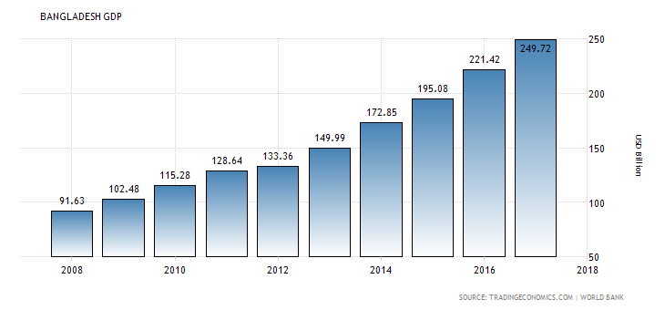Figure 1.1: Bangladesh GDP (Source: World Bank)
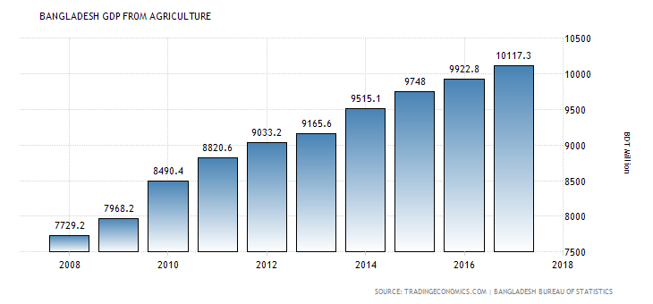Figure 1.2: Bangladesh GDP from Agriculture (Source: Bangladesh Bureau of Statistics)
There is huge workforce in Bangladesh since 57.3% population of Bangladesh is under 25 years old. In Bangladesh, at present English is widely spoken. So, there is no communication gap between western countries & Bangladesh.
Bangladesh is an attractive place for investment. Business laws of Bangladesh are very favorable for operating business enterprises. For example, there is no VAT on imported capital machineries.
Inflation rate of Bangladesh is at a tolerable level. Over last 5 years, inflation rate is decreasing. 7.54%, 7.01%, 6.16%, 5.68%, 5.61% were inflation rate of Bangladesh for 2013, 2014, 2015, 2016 & 2017 respectively. It is assumed that in 2022, inflation rate will be decreased to 5.58%.
Amount of import in terms of money of Bangladesh is also increasing. Fresh opening of import Letter of Credits in July 2018 enhanced by 7.55% and stood at US $5.07 billion. In July 2017 it was US $4.71 billion.
It can be clearly understood from the above data that Bangladesh’s economy is in a favorable condition now. There is 6% continuous economic growth rate for a decade. So, it is high time the foreign & local investors invest in different sectors in Bangladesh. Even our honorable Prime Minister Sheikh Hasina has invited US investors to invest in our country for getting mutual advantages.
Capital Market
Capital market in Bangladesh has experienced several cycles in the last decade, showing both the bullish phase and bearish phase. Fueled by various positive macro-economic drivers, in FY17, DSEX, the broad index, entered into a long cherished bullish phase. Figure no. 1.3 shows that the broad index gained 25.8% in FY17, the highest return in a single year since the inauguration of DSEX. In line with the market rally, average daily turnover (ADV) (figure no. 1.4) of the broad index soared 11.9%. But, in the very next year, the coin has been flipped owing to several conservative stances by regulatory bodies, particularly Bangladesh Bank (BB). As a result, the broad market shed 4.4% YoY in FY18. However, market participation has been continued to surge – ADV grew further by 15.7% in FY18, reflecting increased investors’ confidence on the market.
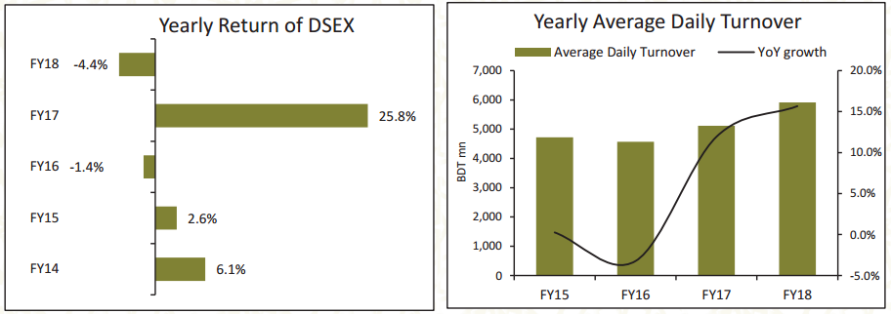
Figure 1.3: Yearly Return of DSEX Figure 1.4: Yearly Average Daily Turnover (Source: Prospectus of Shanta First Income Unit Fund)
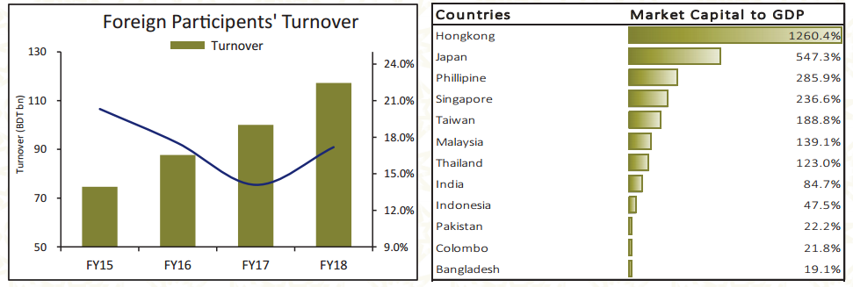
Figure 1.5: Foreign Participants’ Turnover Figure 1.6: Market Capital to GDP (Source: Prospectus of Shanta First Income Unit Fund)

Foreign Market Participant (FMP) have been increased their activities seamlessly over the last four years. Figure no. 1.4 shows that turnover from FMPs grew at a 4-year Cumulative Average Growth Rate (CAGR) of 17.3%. Foreign turnover in DSEX stood at BDT 117bn, which was only BDT 62bn in FY14. This hefty growth represents FMPs’ growing interest in Bangladesh market.
In Bangladesh, market capitalization to GDP ratio has been very tiny in comparison to peer countries and developed countries. Figure no. 1.5 shows that market capitalization to GDP ratio has been hovered in between 15.0% - 20.0% whereas the market capitalization to GDP ratio in Hong Kong, Singapore, India, Sri Lanka, and Pakistan are 1159.0%, 245.9%, 86.7%, 23.8%, and 36.0% respectively. We believe that the broad market growth will align with the strong economic growth and other peer countries, resulting in a steady market in the long horizon.
An asset management company invests its client’ pooled fund into securities that match its declared financial objectives. Asset management companies provide investors with more diversification and investing options than they do would have by themselves. Asset management industry consists by asset management companies.
In Bangladesh, asset management industry’ size is not very big till now. But its size is increasing day by day. Currently 37 asset management companies exist in Bangladesh. Asset management companies are increasing as time passes. Still huge opportunity exists in asset management industry. So that big group of companies is coming in this industry.

Objectives:
- To present the real scenario of asset management industry of Bangladesh
- To inform the activities of Shanta asset management Ltd.
- To inform about my internship experience at Shanta Asset Management Ltd.

Significance of the Report
This part is a major component of any internship report. A report that has no significance is valueless. My internship report is huge importance to many people.
Significance to the General Investors
In Bangladesh, many general investors face huge loss. Some of them lose all their capital. This happens as maximum general investors do not have sufficient knowledge about extensive fundamental analysis & technical analysis. They buy shares & sell shares on the basis of rumor. That is, they cannot manage their portfolio professionally. Mutual fund is a very good option for these less knowledgeable investors. As, mutual fund is professionally managed, there is less that mutual fund holder will face loss. In this report, details operation of mutual funds of Bangladesh is discussed. So, this is report will be very beneficial to general investors since this report will increase their knowledge about mutual funds.
Significance to the Asset Management Company
Many companies buy mutual funds. Sometimes, corporations provide sponsorship in the mutual fund. Most importantly, one asset management company buys unit of mutual fund of another asset management company. This report will help all institutional investors to make decisions relating with investment in the mutual fund. So, this report will be significant to asset management companies’ CEOs and/or fund managers. In fact, CEO and fund managers of Shanta Asset Management Company will also be benefited by reading this paper as from the recommendation section he can come to know how he can improve the financial health of the company.
Significance to the academicians
In Bangladesh, at both private & public universities researches on capital market are conducted. Asset management companies are integral part of any capital market. This paper will help academic researchers to do further research on mutual fund industry of this country, because they will clearly see the real scenario of different sectors of economy in which Shanta Asset Management has invested.

Chapter 2

Analysis of the Industry

2.1 Specification of the Industry:
There are many industries in Bangladesh. Asset management is one of them. The organization in which I do my internship belongs to asset management industry. Currently, there are 37 asset management companies in Bangladesh (AMC) that are approved by Bangladesh Securities and Exchange Commission (BSEC). Most of the asset management company is doing operation now. Shanta Asset Management is one of them (SAML).

2.2 Size, Trend, and Maturity of the Industry

2.2.1 Size of the Industry
Asset management companies mainly operate mutual funds (both open and closed end). Closed end mutual fund industry holds only 1.06% of the total market capitalization. This industry holds only 0.46% of the total turnover. (This data is up to September 2018).
The size of asset management industry of Bangladesh is very small relevant to other industries. One reason is that the mutual fund which is the main item of asset management industry is at a nascent stage in our country. The first mutual fund of Bangladesh was issued in 1984. The first mutual fund of Bangladesh was “2nd ICB Mutual Fund issued by ICB asset Management Company.” However, the mutual fund rules were issued in 2001 after 17 years of issuance of first mutual fund of Bangladesh.
AIMS Bangladesh Limited, RACE Management Pvt. Co. Limited and ICB Asset Management Company limited are the market leader in asset management industry in Bangladesh in terms of total asset under management.

2.2.2 Trend of the Industry
The Bangladesh asset management industry is still in an early stage of development. In recent years the number of asset managers has substantially increased. Currently there are 37 registered Asset Management Companies who are managing 77 mutual funds. Among them there are 40 open-end mutual funds and 37 close-end funds available with Asset Under Management (AUM) totaling to approximately BDT 120bn. Figure no. 2.1 shows number of asset management companies in Bangladesh from 2008 to 2018. In Bangladesh, now most of the retail and institution investors prefer mutual funds to invest in Capital Market due to the advantage of portfolio diversification, professional management at low cost, tax incentives, operational transparency and robust and effective regulatory framework.

Figure 2.1: Number of Asset Management Companies in Bangladesh from 2006-2018 (Source: Author)

In 2018, Open End Mutual Funds have provided the best return among all saving instruments in Bangladesh. The relative attractiveness of the Open End Mutual Funds compared to other products can make Open End fund the best saving investment vehicles for the people of Bangladesh. Figure 2.2 shows that investment yield on different savings instruments in Bangladesh for the year of 2018.
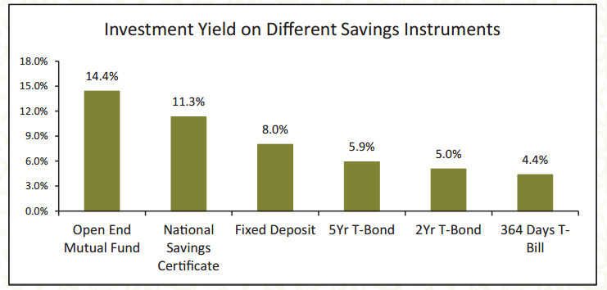Figure 2.2: Investment Yield on Different Savings Instruments
(Source: Prospectus of Shanta First Income Unit Fund)
Now trend of asset management industry in Bangladesh is upward or positive.

2.2.3 Maturity of Asset Management Industry
In Bangladesh Asset management industry have not yet been able to gain a significant share of investors’ wallet mainly due to lack of financial awareness among a major portion of the population while some investors continue to view mutual funds as trading tools as opposed to long-term savings tools. However, historically mutual funds have revolutionized the global investing industry by bringing capital markets to the masses in a relatively cheap and easy manner. So as our economy matures and investors gain financial awareness we expect sharp rise in demand for mutual funds. Moreover, favorable demographics, rising income levels and a burgeoning affluent middle class will provide a strong customer base for the mutual fund sector.

2.3 Seasonality
Some products’ demand is fluctuated with the change in phase of business cycle, and some products’ demand is not. Business cycle indicates Gross Domestic Product’s upward or downward movement. There are five phases of business cycle (economic cycle/trade cycle). They are:
- Expansion
- Peak
- Recession
- Trough
- Recovery
If a product has seasonality, then its demand will be very low at the time of recession & trough, and its demand will be high at the time of expansion & peak. That is, such product’s demand is not stable. Examples of such products are expensive cars, luxurious hotels, beauty products etc.
If the is not seasonal, then its demand will be the same both at recession and at expansion. Products of pharmaceuticals industry & food industry are examples of such products.
Asset management industry is an industry whose demand increases or decreases with the phase of economic cycle. If the economy is in a recession, the stock market will generally fall. That is, people can buy fewer units of mutual funds or stock then. When the economy booms, peoples’ income increases & thus people can save more. As a result, people can invest more money in share market. So, asset management industry has seasonality. It is invigorated when the economy is in expansion or in peak.
Like other industries, seasonality exists in asset management industry, as asset management industry’ performance depends on economic condition.

2.4 External Economic Factors
External economic factors have huge impact on stock market & on asset management industry. Net National Product, Gross National Product, Net National Income, Currency Value, Banking System, & Venture Capitalists etc. are external economic factors.
In fact, economic system has also significant impact on stock market. For example, there is no stock market in a socialist country. In the following page, impact of external economic factors is discussed in details:
- Interest Rate: In many researches it is found that when interest rate in the economy rises, performance of stock market downs. If bank provides high interest on deposits, people will withdraw their money from capital market & will deposit that money into commercial banks, because risk of investment in banks is lower than risk of investment in share market or in mutual funds. Then people will buy more & more deposits schemes of banks rather than mutual funds or unit funds of asset management companies since return on mutual fund is not guaranteed.

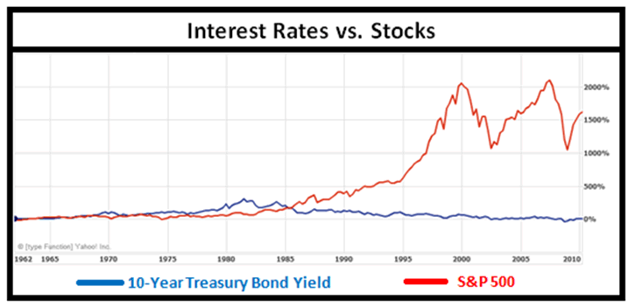
Figure 2.3: Relationship between interest rate & stock market (Source: Google)

In Bangladesh in January 2018, commercial banks suddenly started to charge higher interest rate due to increase in loan demand. Many banks had charged 10-12% interest rates, whereas they were charging below 10% few months ago. According to a Bangladesh Bank report, as of December 2017, over 40 banks have hiked the interest rate on bank loans, and 30 of them are charging 10% or more. Due to increase in interest rates stock market suffered a lot. Figure 2.4 shows that DSEX the broad index of Dhaka Stock Exchange (DSE) fall rapidly due to the interest rates increases in market. As a result asset management industry also suffered a lot during that time.

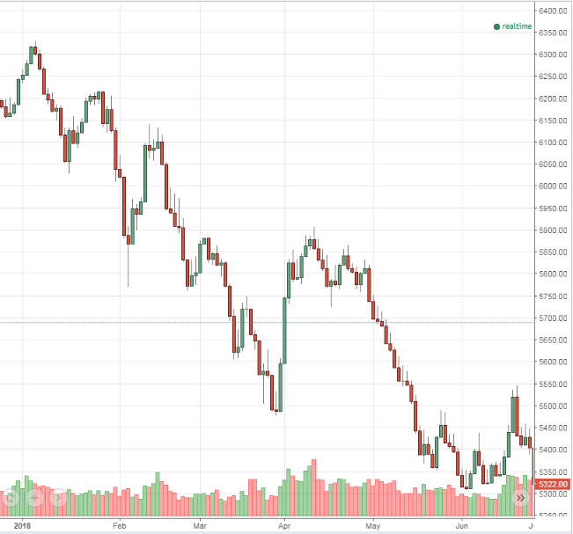
Figure 2.4: Rapid fall of DSEX during January to June 2018 (Source: Author)

So, there is a negative relationship between interest rates & stock market.

- Economic Growth Rate: A positive relationship can be found between economic growth and stock market development.

- Currency Value: Like the interest rate & economic growth rate, it cannot be said that there is a positive or negative relationship between currency value of a particular country and stock market. For example, there is no consistency in historic relation of the U.S. dollar with the S&P 500. As shown in the figure below, over the last 20 years U.S. $ & S&P 500 have moved together, moved in opposite directions, and have been unrelated.

- Inflation Rate: Fama and Schwert (1977), Schwert (1981) and Fama (1981) found a significant negative relationship of stock market with inflation. However, Pearce and Roley (1985) and Hardouvelis (1988) showed that there is no significant relationship between inflation & stock market.
So, we can say confidently anything about relationship between inflation rate & stock market.
- Tax Rate: If there is low tax rate on the dividend declared by mutual fund managers, then individual & institutional will be encouraged to buy more & more mutual funds. Again, if corporate tax increases, then stock prices will be decreased and vice versa.
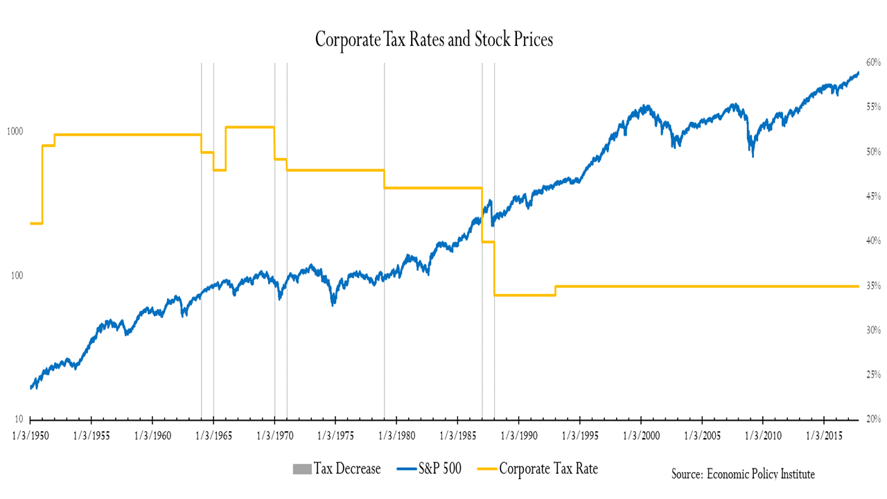
Figure 2.5: Relationship between Tax Rate & Stock Price (Source: Economic Policy Institute)

2.5 Technological Factors
There is no business organization in the world in which there is no impact of technology. Like the other enterprises, asset management companies have also to face impact of technology. Relationship between technology & asset management companies is show in the following:
- To acquire clients, technology is used. For example, to know investors’ investment style, their risk tolerance, and their desired outcome (that is, expected return) asset management companies can conduct online surveys. Again, potential investors can see useful information in the website of fund manager. So, asset managers should build a useful website.
- To execute client’s order, technology is needed. For example, a client, wishing to redeem his or her shares from the open-end mutual fund, can communicate quickly with the portfolio manager via using the technology.
- All necessary documents like “Fund Fact Sheet” as well as weekly, monthly, quarterly, & yearly portfolio statements, financial statements of the fund etc. are computerized now-a-days. Therefore, an asset management company must be first mover in case of using the latest technology before its competitors starts to use it.
- Asset management companies use technology to communicate with the traders.
- “Research team” of an asset management company use software like SPSS, Stata, SYSTAT etc. to do various types of researches such as equity research, hypothesis testing. So, asset management companies should arrange training programs for their employees to let them familiar with the technology.
- At present, technology has been reached at such a stage that even issues related with compliance can be checked with the help of technology. So, compliance officer of Asset Management Company should work this matter.
- Collect organization-specific data like internal ratings
- Mutual funds or unit fund’s risk & return should be matched with the client’s demand. Technology can ensure this matching.
Due to severe usage of technology, now-a-days there is huge amount of data available to portfolio managers. So, if one wealth manager of a mutual fund fails to avail the benefits of technology, he/she cannot make desired income & growth of the fund.

Political, Legal & Regulatory Factors

2.6.1 Political Factor
If the political environment is not stable, it can affect the asset management company into two ways. One is that net asset value of the unit or mutual fund can be adversely affected by political unrest. Another is that asset management company’ day to day operation can be hampered.
One may question that how net asset value can be reduced because of political environment’s instability. The answer is that the portfolio of a mutual fund consists of blue-chip companies’ shares. If there is shutdown, blockade in the country, then the day to day operation of the blue-chip companies of Dhaka Stock Exchange will be obstructed. Consequently, their net income & EPS will be declined. Usually, if EPS decreases, stock price also decreases. If stock’s market price of the blue-chip companies reduces, then net asset value of the fund will also be reduced. Therefore, investors of mutual fund will face loss, and will lose confidence on mutual fund managers.
Human resource of the asset management company can be negatively affected by political collision. For example, On January 03, 2014 an employee of an organization was killed at petrol bomb attack. So, key employees of asset management company can be killed. Thus irrecoverable human resource loss might be faced by the company. Moreover, employees may not come to office on time due to political clashes. So, day to day business activities of the asset management company will be hampered. Besides, volume of transaction in Dhaka Stock Exchange & in Chittagong Stock Exchange can be reduced.


Figure 2.6: Political violence (Source: The Daily Star)

2.6.2 Legal Factor
On every business, there is impact of legal environment. Business’s profit margin, product transportation, & durability of certain markets can be badly influenced by the legal environment. Asset management companies of Bangladesh are impacted by legal issues in the following ways:
- Securities Law: Bangladesh’s asset management companies have to follow the law relating to securities & exchange such as Bangladesh Securities and Exchange Commission act 1993, The Securities & Exchange Ordinance, 1969, Securities and Exchange Rules 1987 etc. So, they have to operate their business with the boundary defined by these laws or rules. If they don’t follow these laws, then they have to face fines & penalties.
- Organizational Law: There are different types of laws on the basis of the ownership of the business enterprise; for example, partnership act 1932, company act 1994, co-operative society act 2001 etc. In Bangladesh, almost all Asset Management Companies are private limited company. Therefore, they have to abide by the company act 1994. If they don’t do so, they will be punished. Even their license can be void.
- Employees Protection law: All asset managers must provide financial & non-financial benefits according to the Bangladesh Labor Law 2006. Not maintaining labor can be very dangerous for an organization & even for an industry. For example, after “Rana Plaza” tragedy garments industry of Bangladesh has faced huge loss. Generalized Scheme of Preferences facility was voided. At present, owners of garments are compelled to follow Labor Law; otherwise foreign buyers are cancelling the orders.

2.6.3 Regulatory Factors
Asset management companies of Bangladesh have to follow the rules of the Dhaka Stock Exchange & Chittagong Stock Exchange if those rules are applicable to them. Besides, they have to submit weekly net asset value in a daily newspaper like the Financial Express; they have to submit hard copy of weekly portfolio statement at Securities Commission Bhaban at Agargaon at every Thursday. They are doing these things as it is ordered to do so in the Mutual Fund Rule 2001. They have to send hard copy of weekly portfolio statement to custodian & trustee. Usually Investment Corporation of Bangladesh is the custodian of Mutual funds of Bangladesh.

2.7 Barriers to entry
To create a new asset management company is not so much easy. Even, to issue a new mutual fund is not also easy. There are some barriers to enter into the investment management industry of Bangladesh. Unlike hedge funds, mutual fund is not poorly regulated. Hedge fund’s limited partners are wealthy enough to bear huge losses. However, all unit holders of mutual fund are not that much wealthy enough. That’s why; activities of mutual fund managers are highly regulated, because there is hard-earned money of small general investors in the mutual fund. In the following, some barriers that are faced by asset managers are discussed:
1. Capital Requirement: According to the Mutual Fund Rules 2001, a company can be an asset manager of a mutual fund if it has not at least BDT 5 corer paid-up capital. So, a sole entrepreneur it is very hard to collect BDT 5 corer as capital. In Bangladesh, there are only a few venture capitalists. There are only two venture capital firms in Bangladesh till now. As result, it is hard to find angel investors in Bangladesh. Therefore, a person with a passion to set up fund management company, cannot establish such type of company due to money constraint.
2. Regulatory Compliance: To set an asset management company, its owners need to fulfill some requirements. Therefore, not everyone can establish asset management company. For example, if any director of the company is loan defaulter, then that company will be treated as disqualified to get registration as an asset management company. Moreover, company’s chief executive officer has to fulfill some requirements.
3. Organizational Capacity Requirement: Suppose, an entrepreneur manages BDT 5 corer as paid up capital to set up an asset management company. Unfortunately, he/she will not get registration just because if he or she doesn’t have a business place, office & necessary equipment to provide service. So, he/she has to set up necessary organizational structure, which will increase his or her cost. Such constraint will discourage him or her to set up fund management company.
4. Licensure cost: There is an annual fee, which has to be paid through pay order or bank order to the Bangladesh Securities & Exchange Commission before starting the fiscal year. If the asset manager fails to pay the annual fee, then there will be penalty for him or her such as the asset manager has to pay half of the annual fee as fines with the actual annual fee due to delay.

2.8 Supplier Power
Asset Management Company does not produce any goods. So, it does not have any supplier. At first, it brings permission from the Bangladesh Securities & Exchange Commission to issue an open or close end mutual fund. Then it offers the public for subscription. Usually full subscription is achieved within two or three hours if the asset management company is a good one. For example, subscription of Shanta First Income Unit Fund was finished in the very first day.
However, any business entity can supply fund to the asset management company. So, if it is thought in that way that the sponsor company who provides fund to the asset management company is a supplier of the company, then there is supplier of asset management company. However, it is usually considered that there is no supplier of assert management firm.

2.9 Buyer Power
There are two types of buyer of asset management firms. One is institutional buyer & another is individual buyer. Institutional buyers include insurance company, commercial banks, brokerage house, & other asset management companies etc. It is known to all that usually institutional buyers do not have narrow buying power. So, asset managers do not need to worry about the purchasing power of this type of buyer.
Asset managers don’t have to think about their individual buyers’ power, because an investor can buy a lot from the mutual fund if he or she has only BDT 5,000. That is, a lot consists of 500 units, and each unit’s cost price is only BDT 10. Therefore, an investor needs to buy 500 units of mutual fund if he or she wishes to buy a lot.

2.10 Threat of Substitute
There is only one substitute of mutual fund in the capital market of Bangladesh, which is common equity since there is no bond market, no exchange traded fund, & no hedge fund in Bangladesh. There is only one corporate bond right now listed in the Dhaka Stock Exchange. However, in the money market there are some substitutes of mutual funds. Fixed Deposit Receipt, Commercial Paper, Post Office Savings Account etc. are substitutes of mutual fund in the money market of Bangladesh. A person may ask that how the money market instruments can become substitutes of mutual fund. Fixed Deposit Receipt, Commercial Paper, Post Office Savings Account etc. are mutual fund’s substitutes, because these also generate 8% or 10 % income for the holder.
Now, what is the exposure of the threat of substitutes for asset management firms? From, many studies & events it is found that Bangladesh’s share market is not semi-strong or strong form of efficient. For example, the crushes & bubbles of 1996 & 2010 tell that Dhaka Stock Exchange & Chittagong Stock Exchange is not efficient stock exchange. As a result, investors are losing confident on the stock market. New investors’ number & transaction volume of the Dhaka Stock Exchange are reducing. So, number of bank accounts is increasing more comparing with the number of Beneficiary Owner’s Account (B/ O Account). Therefore, it can be said that threat of substitute is high for the asset management firms.


Figure 2.7: Substitutes of mutual fund (Source: Internet)

2.11 Industry Rivalry
The intensity of rivalry among competitors in an industry refers to the extent to which firms within an industry put pressure on one another and limit each other's profit potential. If rivalry is fierce, then competitors are trying to steal profit and market share from one another.
In Bangladesh competition level is high in asset management industry. Companies that exist in asset management industry always compete against each other’s. For example, every asset management company claims that they are the number one asset management company in this country. They frequently launch new product or service to get maximum market share. One AMC try to get other AMC talented employee by offering better remuneration and others benefits. Among top companies, intensity of rivalry is very high.

2.12 Summary of challenges and opportunities
Asset management industry in Bangladesh is still in the stage of growth. It has huge opportunity to expand in the future and it also faces some challenges.

Challenges:

- Asset Management industry’ success or failure depends on economic condition of country’. If the economic trend is downward then asset management industry experience bad time, because on that time investors withdraw their investment.
- In Bangladesh the deposit interest rate is still high. Banks and Non-banking financial institutes offer high interest rate to their investors. As a result investors don’t want to buy mutual fund unit, instead they deposit their savings in banks and NBFI.
- Asset Management companies' performance depends on stock market condition. If the market is bad then asset management performance is also bad.
- Asset management industry must invest 80% of their total investment in capital market instruments according to BSEC rule. For this strict rule asset management companies always need to invest in capital market. No matter market condition is good or bad.

Opportunities:

- In Bangladesh, still retail investor participation is low in mutual funds. So asset management companies have huge opportunity to attract retails investors by creating awareness among retail investors.
- In Bangladesh, peoples have high level of saving habit for the future. Asset Management company can attract new investors by offering standard return on investment.
- Investors always expect to get higher return from their investment. So if the AMC perform well and able to generate higher return for investors then they have huge opportunity to catch more investors.
- Recently few scandals occurred in banking sector of Bangladesh. Due to these scandals in banking sector asset management industry can attract investors who are dissatisfy with banking industry and want to switch their investment sector.

Chapter 3

3. Analysis of the organization

3.1 Overview and History
Shanta Asset Management Limited (SAML) received its Asset Management License from the Bangladesh Securities and Exchange Commission on November 26th, 2015. Their vision is to be the leading asset management company in the country in terms of the fund’s performance, assets under management and compliance.
Their Mutual Funds offer superior risk adjusted returns for individual and institutional investors. They also provide Institutional Fund Management Services for institutions, provident funds, foundations, pension funds and others according to their investment objectives. They believe in the benefits of active fund management over the long term and hence our fund managers always remain truly active. They focus only on those areas of investment in which we have particular expertise.
Investment team of SAML applies distinct and rigorous investment processes to the management of mutual funds and institutional portfolios to generate the lucrative risk adjusted return. Their operation and compliance team ensures proper compliance as per Mutual Fund Act, 2001 of BSEC and smooth operation of the funds.

3.2 Trend and Growth
Shanta Asset Management Ltd. recently started their journey in asset management industry. They are new in asset management industry of Bangladesh. They launched their first Mutual Fund on 4th may, 2018. The name of the fund is “Shanta First Income Unit Fund” whose initial offer price was 10.00 TK. per unit when they launched this fund in May, 2018. Few months ago they distributed 5% cash dividend on fund’s face value (face value 10 TK. per unit) which is 0.50 TK. per unit and currently (updated as on 27 December, 2018) fund’s Net Asset Value (NAV) is 11.17 BDT per unit. So from the beginning till today their fund’ return is {(11.17+.5)-10}/10=1.67/10=16.7%. Very soon they are going to launch a new shariah based open end mutual fund which name is “Shanta Amanah Shariah Fund”. So we can say that currently SAML’ business trend and growth are positive based on these statistics. Figure 3.1 show that the month-wise dividend adjusted Net Asset Value (NAV) of Shanta First Income Unit Fund.
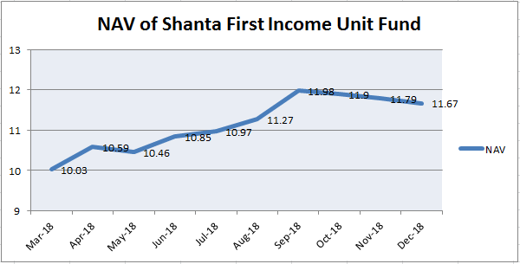
Figure 3.1: Dividend Adjusted NAV of Shanta First Income Unit Fund (Source: Author)

3.3. Customer Mix of Shanta Asset Management Ltd.
Customer mix is the sales driven by a particular type of customer segment expressed as a percentage of business’s total sale.
As Shanta Asset Management Ltd. operates in asset management industry, their main product is mutual fund. They sell mutual fund units to institutions and general public. Institutions are their large buyer compare to the public. Currently they have only one open end mutual fund which name is “Shanta First Income Unit Fund”, Institutions holding 70% units of this fund and public holding 30% unit out of 100%. So we can see that generally SAML has two types of customers (i) Institutional Customer (ii) General Customer.

Figure 3.2: Customer mix of SAML (Source: Author)

3.4 Product/Service Mix
Currently Shanta Asset Management Ltd. has two types of product/service they offer to their customers. Products/Services are:
- Mutual Fund
- Institutional Fund Management
Mutual Fund: Shanta Asset Management Ltd. offers investment solutions for individual and institutions through different types of Mutual Funds. SAML’s highly professional team has a dynamic approach to ensuring long-term growth for our investors. Their dynamic investment strategy is developed by a team of highly experienced fund management professionals, supported by a strong research team to ensure the best risk adjusted return for our investors.
Institutional Fund Management: SAML offers customized Institutional Fund Management services to generate superior returns based on clients’ investment objectives and risk appetites. Their first investment is in carefully understanding customers’ objectives. They take the time to get to know their clients’ circumstances, risk profiles and ambitions. They take into account factors such as your investment horizon; customers risk tolerance and your income objectives. Along with their equity research team, they then actively develop a portfolio based on these factors. Moreover, they work to proactively rebalance the portfolio from time to time in order to consistently generate the best possible risk adjusted returns for customers’ institution.
Currently Shanta Asset Management Ltd. has one open end mutual fund and they are going to launch a shariah based open end mutual fund very soon. The name of open end mutual fund that they are currently operating is “Shanta First Income Fund”.
Shanta First Income Fund: Shanta First Income Fund is an open end mutual fund. It is launched on 4th may, 2018 at face value of 10 TK. per unit. At the time of launching its fund size was 20 crore TK. and SAML total issued 2 crore units at the price of 10 TK. each. Now the fund’ unit is buy sell on latest Net Asset Value (NAV). Current NAV of this fund is 11.17 BDT.

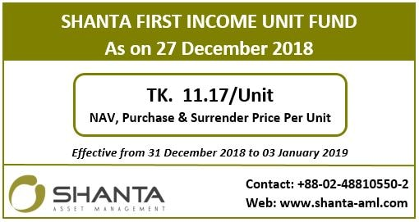
Figure 3.3: NAV of Shanta First Income Unit Fund (Source: SAML Facebook Page)
Investors can purchase or surrender their existing units through SAML or its authorized agent. Investors can purchase or sell during workdays based on latest NAV.

3.5 Operations of SAML
Figure 3.4 show organization chart of Shanta Asset Management Ltd:

Figure 3.4: Organization chart of SAML

The highest officer rank in the board director level of SAML corporate hierarchy is chairman. The chairman leads and influences the board of the directors and chief officers to manage the financial, human, technical and environmental working of a corporation. The directors of SAML are responsible to develop, design and implement strategies and plans for the company in a time efficient and cost effective environment. They are affiliated to company by any mean and handling the day to day operation of the company, managing staff and committees, developing and enhancing business process with other board members for the future growth of the company. They are the shareholders of the company.
The Chief Executive Officer (CEO) of SAML is responsible for the overall management, operation and development of the company. The head of accounts and admin of SAML is responsible the activities of accounts and HR department of the company. Head of operation is responsible overall day to day activities of SAML. Head of research is responsible overall activities of research department of SAML.

3.6 SWOT Analysis
SWOT analysis is a strategic planning technique used to help a person or organization identify strengths, weaknesses, opportunities, and threats related to business competition or project planning.
Strengths of SAML
Lucrative Return: SAML provides lucrative returns over the long horizon to maximize their clients’ wealth. For the first year Shanta First Income Unit Fund generated 18% return for their investors.
Sustainable Investing Approach: SAML uses sustainable and ethical approach in case of investing their investors’ money.
Experienced Professionals: Mutual funds are managed by professional and proactive fund managers. They have vast experience in investment world.
Strong Research Team: Investment decision backed by a dynamic and strong research team.
Diversification: SAML carefully diversify investors’ assets.
Easy Divest Option: Investors can easily withdraw their investment at any time.

Weaknesses of SAML
High Charge: SAML charges high management fee on asset under management.
Lack of Retail Investors Participation: Participation of retail investors’ in shanta first income unit fund is Poor.
Lack of Investment Option: SAML manages only one mutual fund. Investors haven’t enough option to buy another fund’ unit.
Weak Sales Team: Sales service of SAML is not good compare to competitors. Sales team of SAML consists of by only one executive.
Opportunities of SAML
Untapped Market in Rural Area: Huge untapped market in rural areas.
Savings Habit: High level of savings habit among the people
Scandals in Banking Sector: SAML has the opportunity to catch new customers from banking sector as now banks and NBFI can’t perform well as a result investors of money market can be attracted towards capital market.

Threats of SAML
Competitive Market: SAML can lose market share due to increase competition among the players in asset management industry.
Volatile Market: High level of volatility in Dhaka Stock Exchange (DSE) can creates problem for asset SAML as it operates in stock market.
Harder Rules and Regulation: Possibility of more stringent regulations by BSEC in future.

3.7 Steps/strategies to meet the challenges and opportunities
As Shanta Asset Management Ltd. (SAML) operates in asset management industry so that its performance depends on overall economic condition of the country as well as stock market performance. SAML carefully invest its clients’ money in different types of stock in order to reduce risk. It also makes FDR in commercial banks for fixed income in order to diversify. Its main strength is smart diversification of investors’ money. Stock market’ index always fluctuate as a result generate lucrative return for investors is always challenging. SAML has a strong research team to evaluate new investment opportunities as well as threats. In Bangladesh people have high savings habit as a result SAML has huge opportunity to capture these investors by giving lucrative return on their investment. SAML CEO Mohammad Emran Hasan is an experienced investment professional. Under his guidance SAML is doing well now and has the capability to keep this consistency for the future.

Chapter 4

4. Internship experience

4.1 Position, duties, and responsibilities

Position: Intern in Shanta Asset Management Limited
Duties and responsibilities:
- Preparing and maintaining databases.
- Analyzing the economic activities of the country in the light of major policy/regulatory guidelines of the government as well as important regional and global activities/events which are likely to have significant impact on our economic activities.
- Preparing write up featuring changes in macro-economic variables on the capital market and the companies.
- Any other relevant job assigned by the management.

4.2 Training
During my internship there is no formal training provided by the company. But few informal training has provided. For example, office time/hour, dress code etc.

4.3 Contribution to the departmental functions
The research department of Shanta Asset Management Ltd. Consist of three people, two are Deputy Fund manager and one is intern. As an intern I did basic work like preparing databases, input weekly data of mutual funds, create note on financial news from the daily newspapers etc.

4.4 Evaluations
My supervisor of Shanta Asset Management Ltd. evaluated me by my tasks. He gave me few tasks and told me complete those within this deadline. If I able to complete those task within deadline he congratulate me for my work.

4.5 Skills Applied
I completed a course on Excel which name is “Financial Modeling Master class” from Professional Finance Studies (PFS) which helps me a lot to do my work in Shanta Asset Management Ltd. As I worked in research department I need to work with databases which is done by using Microsoft excel. So I apply my excel knowledge here to do complete my tasks.

4.6 New Skills Learned
While I worked in Shanta Asset Management I learned few new things during my internship. Before joining this company I haven’t any knowledge on these tasks. I did few regular tasks as well as few weekly tasks. The new skills learned are:
- Preparing daily market data
- Preparing event & record calendar
- Preparing weekly mutual fund data
- Preparing weekly macro data

4.6.1 Preparing Daily Market Data
As an intern I prepared daily market data from Dhaka Stock Exchange website (DSE) (www.dsebd.org/) using our formatted excel file. It was my daily task during workdays. I learned to prepare market date during my internship period from my supervisor. Updating market data means update day to day share price, volume, total trade, total market volume etc. from DSE website.
Here is an example of daily market data
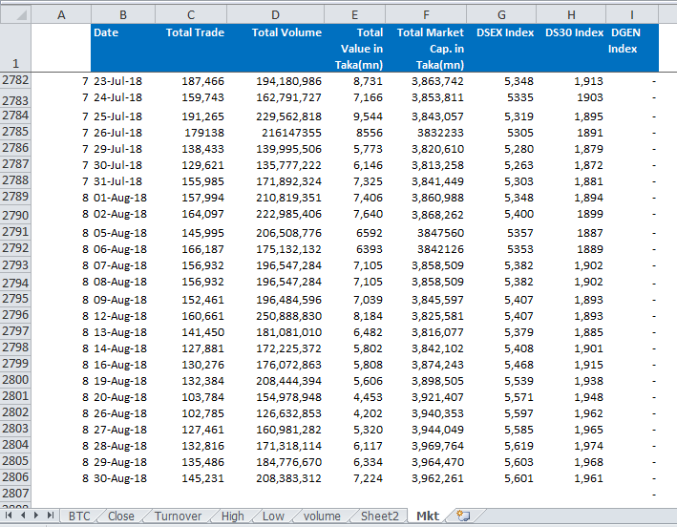
Figure 4.1: Daily Market Data (Source: Author)

4.6.2 Preparing Event & Record Calendar
I prepared event calendar from DSE website by (https://dsebd.org/display_news.php) using our formatted excel file. It was my daily task during workdays. Updating market data means update company’s upcoming announcement date regarding dividend, earnings etc.
Here is an example of Event Calendar
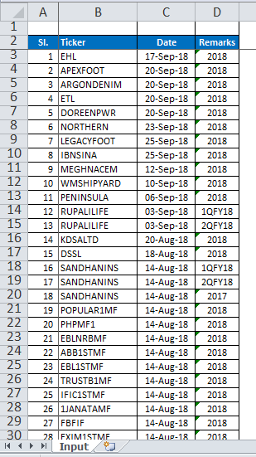
Figure 4.2: Event Calendar (Source: Author)
Like event calendar I also prepared “Record Calendar” which is all about listed companies’ upcoming record date for dividend. Which help us to inform about all listed companies’ upcoming record date for dividend or other special issue such as right share record date. It is prepared by the same way like event calendar by the help of DSE website.
Here is an example of Event Calendar
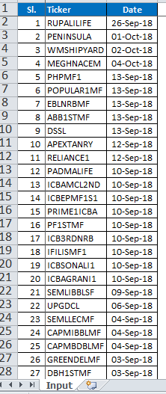
Figure 4.3: Record Calendar (Source: Author)

4.6.3 Preparing Weekly Mutual Fund Data
The first workday of every week I have prepared weekly mutual fund data in where the main objective was report latest Net Asset Value (NAV) of both open end and closed end mutual fund that are currently exist in mutual fund industry. I learned this during my internship from my supervisor. Before doing internship I had not this skill. I prepared mutual fund NAV data from newspaper and asset management companies’ websites. After collecting latest data about funds’ NAV I input those data on our formatted excel file.

Here is an example of weekly mutual fund NAV file:

4.6.4 Preparing Weekly Macro-Economic Data
Every week I have also prepared macro-economic data from Bangladesh Bank website regarding changes in total foreign exchange reserve amount, changes US dollar rate against taka, and changes call money rate. I updated these data on weekly basis.
Here is an example of weekly macro data:
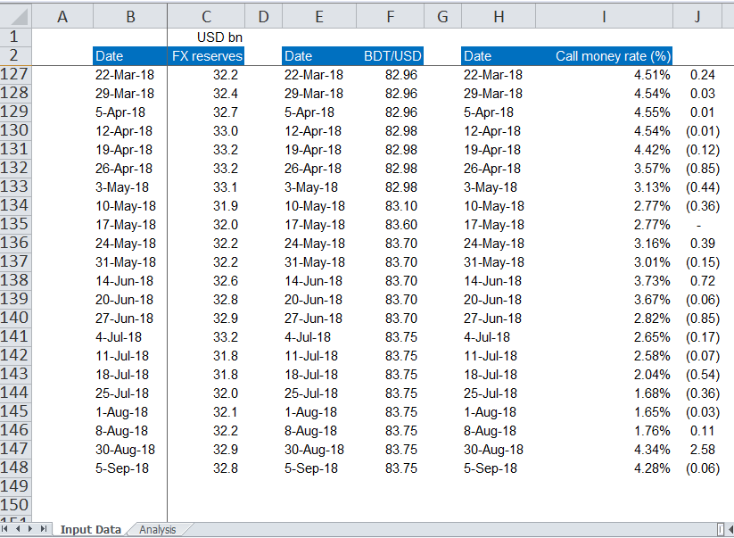Figure 4.4: Weekly Macro Data (Source: Author)

4.7 Application of Academic Knowledge
As Shanta Asset Management Ltd. is an Asset Management Company (AMC). It operates in financial industry. As my major is finance in BBA so that I were able to applied my academic knowledge in my internship. I worked in research industry where I worked with financial databases and prepared many financial files also. I used few financial ratios while I analysed companies’ financial statements.

5. Recommendations

5.1 Recommendations for improving departmental operations
Shanta Asset Management Ltd. (SAML) recently started its journey in asset management industry in Bangladesh. In SAML i worked as an internee in research department. Although research department of SAML is consist by experienced personnel but i feel few more improvement needed. In research department of SAML there is a lack of executive. There are only two executives and one internee in research department. I feel one more junior analyst is needed in research department in order to complete tasks smoothly. SAML management should appoint a junior analyst for the research department.

5.2 Recommendations for improving self- performance
Although I completed my internship successfully at SAML but I didn’t feel 100% comfortable during my internship because I had not prior work experience. Now I feel I have to improve in certain area for doing better performance in near future. Microsoft excel is very important for doing analytical work. I must learn advance things of excel in order to do my work effectively. Also I need to improve my English language skill. As I want to be a fund manager in investment industry for that I need acquire a professional degree like CFA.

6. Conclusion
In conclusion it can be said that Shanta Asset Management Ltd. (SAML) recently started its journey in asset management industry but its performance is very good up to date. In this report overall condition of asset management in Bangladesh, Shanta Asset Management performance in asset management industry, my internship experience have been discussed. From the above discussion we can understand that asset management industry in Bangladesh performing well now. Still it is in at the stage of growth. It has enough opportunity to grow in the future. Shanta Asset Management also performing well as a new comer company in this industry. Its return is above average than industry average. I learned many important things during my internship period from SAML. I am hopeful that Asset Management industry and SAML will go ahead by giving superior performance by overcoming challenges. Government should take necessary steps to helps asset management industry to do better in future.

References
- https://en.wikipedia.org/wiki/Economy_of_Bangladesh
- https://www.dhakatribune.com/uncategorized/2015/03/15/study-bangladesh-to-be-23rd-largest-economy-by-2050
- https://tradingeconomics.com/bangladesh/gdp
- https://tradingeconomics.com/bangladesh/gross-national-product
- https://www.statista.com/statistics/438363/inflation-rate-in-bangladesh/
- https://www.bb.org.bd/pub/monthly/selectedecooind/magecoindsep2018.pdf
- https://www.dhakatribune.com/bangladesh/foreign-affairs/2018/09/25/pm-to-us-investors-invest-in-bangladesh-to-share-in-prosperity
- https://www.dsebd.org/by_industrylisting1.php
- http://www.shanta-aml.com/mutual-fund
- https://www.dsebd.org/pdf/Mreview_Sep_2018.pdf
- https://globaljournals.org/GJMBR_Volume16/1-Evaluation-of-Mutual-Funds.pdf
- https://mpra.ub.uni-muenchen.de/83018/1/MPRA_paper_83018.pdf
- http://www.sec.gov.bd/home/assetmancom
- https://www.economicshelp.org/blog/541/economics/relationship-between-stock-market-and-economy/
- http://business.uonbi.ac.ke/node/1017
- https://www.babypips.com/learn/forex/relationship-stocks-forex
- https://www.omicsonline.org/open-access/the-relationship-between-inflation-and-stock-market-evidence-from-malaysia-united-states-and-china-2162-6359-1-011.pdf
- http://www.theindependentbd.com/arcprint/details/18538/2015-10-09
- https://www.thedailystar.net/news/wb-expects-muted-global-growth
- http://www.arthosuchak.com/archives/414745/
- http://article.sciencepublishinggroup.com/pdf/10.11648.j.ajtab.20170303.12.pdf
- http://www.shanta-aml.com/shanta-first-income-unit-fund#funds-documents
- http://www.shanta-aml.com/shanta-first-income-unit-fund#nav

Appendix

