Customer Centricity in the Marketing Communication Industry: A Case of PASSWORD COMMUNICATION

Sheikh Mehedi Hasan

Customer Centricity in the Marketing Communication Industry: A Case of PASSWORD COMMUNICATION

Submitted by:
Sheikh Mehedi Hasan
ID: 111 123 205
School of Business & Economics
United International University

Submitted to:
Prof. Dr. Kawsar Ahmmed
Professor
School of Business & Economics
United International University

Date of Submission: August 04, 2025

Letter Of Transmittal
August 04, 2025
Dr. kawsar Ahmed
Professor
Department of Business Administration
United International University
Subject: Acceptance of internship report on “Customer Centricity in the Marketing Communication Industry: A Case of PASSWORD COMMUNICATION”
Respected sir,
With great respect and enthusiasm, I am pleased to submit my internship report titled “Customer Centricity in the Marketing Communication Industry: A Case of PASSWORD COMMUNICATION”, prepared as part of the requirements for the completion of my academic degree.
In preparing this report, I have followed your instructions and guidelines with utmost diligence and sincerity. The content is based primarily on insights gathered through online research, industry analysis, and practical observations from my work at Password Communication. I have made every effort to ensure that the report is accurate, relevant, and reflective of current industry practices.
I would like to express my sincere gratitude for your valuable guidance, continuous support, and encouragement throughout the process. Your direction played a crucial role in helping me complete the report meaningfully.
I welcome any feedback or queries you may have regarding the content and would be more than happy to provide further clarification if needed. I hope you find the report informative and well-structured, and I look forward to your kind acceptance.
Thank you once again for your support and cooperation.

Sincerely Yours,
Sheikh Mehedi Hasan
ID: 111 123 205

Acknowledgement
I would like to express my sincere gratitude to all those who have supported, guided, and inspired me throughout the preparation and completion of this internship report titled “Customer Centricity in the Marketing Communication Industry: A Case of PASSWORD COMMUNICATION.”

First and foremost, I extend my heartfelt appreciation to my academic supervisor, Prof. Dr. Kawsar Ahmmed, whose valuable feedback, encouragement, and constructive guidance played a significant role in shaping the direction and quality of this report. Their support has been instrumental in completing this academic endeavor with diligence and professionalism.
I would also like to express my profound appreciation to the entire team at Password Communication, whose dedication, collaboration, and innovative spirit served as the foundation of this report. As the Founder & CEO of the organization, I am grateful for the opportunity to reflect on our journey, operations, and contributions to the evolving marketing landscape of Bangladesh.
Special thanks are due to our clients and partners across various industries, whose insights, feedback, and real-world challenges continue to drive our growth and innovation. Their trust in our services has been vital to the success of both our projects and this academic reflection.
Finally, I acknowledge the role of my academic institution for providing the opportunity and platform to document and analyze real industry experiences, enabling a stronger connection between theory and practice.
With deep respect and gratitude, I thank everyone who contributed directly or indirectly to the successful completion of this report.
Sheikh Mehedi Hasan
111 123 205

Student Declaration

I, Sheikh Mehedi Hasan, hereby declare that this internship report titled “Customer Centricity in the Marketing Communication Industry: A Case of PASSWORD COMMUNICATION” is my original work, completed under the supervision of Prof. Dr. Kawsar Ahmed of United International University.
This report does not contain any material previously published or submitted elsewhere, except where properly cited. It has been prepared solely for academic purposes in partial fulfillment of my degree requirements at UIU.

……………………………….
Sheikh Mehedi Hasan
111 123 205

Supervisor’s Declaration

This is to certify that Sheikh Mehedi Hasan, a student of the BBA program with ID: 111123205 at United International University, has successfully completed his internship report titled “Customer Centricity in the Marketing Communication Industry: A Case of PASSWORD COMMUNICATION.”
The report has been prepared under my supervision and in accordance with the academic guidelines. He has shown dedication and professionalism throughout the internship and the report-writing process.
I hereby authorize him to submit this report for academic evaluation on the scheduled date.

…………………………………..
Prof. Dr. Kawsar Ahmed
Professor
United International University

Executive Summary

This internship report provides an in-depth analysis of the operations, challenges, and opportunities within Password Communication, a full-service marketing agency in Bangladesh, where I serve as the Founder & CEO. The agency specializes in ATL and BTL marketing, digital marketing, web and mobile application development, SMS and email marketing, TVC/OVC production, and logistics support.
The report begins with an overview of the marketing industry in Bangladesh, highlighting its rapid evolution driven by digital transformation, shifting consumer behavior, and increasing competition. It also explores external factors such as political, legal, and technological influences, and provides a detailed assessment of industry rivalry.
The second part focuses on the organizational structure and business model of Password Communication. It includes a review of the agency's mission, service portfolio, customer base, and operational facilities. A SWOT analysis is conducted to identify strengths, weaknesses, opportunities, and threats, followed by strategic recommendations to address these elements effectively.
The report also emphasizes the agency’s strong commitment to customer centricity, demonstrated through tailored service delivery, transparent communication, and continuous feedback integration. Key internal and external factors influencing this customer-first culture are explored, including leadership, technology, client diversity, and market competition.
Lastly, the report presents insights from the internship experience itself, reflecting on practical learning, organizational dynamics, and areas for future development. It concludes with a set of recommendations aimed at reinforcing Password Communication’s position in the dynamic marketing landscape of Bangladesh.
Keywords: Customer Centricity, Marketing Communication, PASSWORD COMMUNICATION, Bangladesh

Contents
Letter Of Transmittal 3
Acknowledgement 4
Student Declaration 5
Supervisor’s Declaration 6
Executive Summary 7
Chapter I 10
Introduction 10
Primer 11
Objective 11
Motivation of the Study 12
Limitation 12
Chapter II 14
Analysis of the Marketing Industry in Bangladesh 14
2.1 Specification of the Industry 15
2.2 Size, Trend, and Maturity of the Industry 21
2.3 Technological Factors 21
2.4 Political, Legal, and Regulatory Factors 22
2.5 Industry Rivalry 22
2.6 Summary of Challenges and Opportunities 30
Chapter III 33
Analysis of Password Communication 33
3.1 Overview and History 34
3.2 Mission Statement 34
3.3 Location and Facilities 35
3.4 Customer Mix 35
3.5 Product/Service Mix 35
3.6 Service Quality 36
3.7 SWOT Analysis 37
3.8 Strategies to Meet the Challenges and Opportunities 38
Chapter IV 45
Customer Centricity at Password Communication 45
4.1 Customer Centricity 46
4.2 Importance of Customer Centricity at Password Communication 46
4.3 Steps We Take to Be Customer-Centric 50
4.4 Factors That Influence Our Customer-Centric Approach 52
4.5 How Customer Centricity Varies Across Our Services and Clients 54
Chapter V 56
Internship Experience, Recommendations and Conclusion 56
5.1 Internship Experience 57
5.2 Recommendation 57
5.3 Conclusion 58
Reference 60

Chapter I

Introduction

Primer
This internship report presents an inclusive study of the structure, strategy, and service offerings of Password Communication, a full-service marketing agency based in Bangladesh. The report is prepared as part of the academic requirement of my undergraduate program and aims to reflect the practical experience I have gained by working within my own company.
As the Founder and CEO of Password Communication, this internship experience offered a unique opportunity to critically assess the internal operations, evaluate strategic initiatives, and identify both challenges and growth opportunities from an analytical and academic perspective. The report covers industry dynamics, organizational analysis, service quality, and customer-centric strategies, along with personal reflections and learning outcomes.

Objective
The key objectives of this report are:
- To analyze the current state and trends of the marketing and communication industry in Bangladesh.
- To examine the internal structure, service offerings, and customer-centric strategies of Password Communication.
- To identify the strengths, weaknesses, opportunities, and threats (SWOT) of the agency.
- To evaluate how the company maintains service quality and adapts to changing client expectations.
- To bridge theoretical marketing concepts with real-life agency operations.

Motivation of the Study
The motivation behind this study stems from my dual role—as a student of business and as the founder of a marketing and tech company. While I have had hands-on experience managing the business, I saw this internship as a chance to view my organization through a more structured and academic lens.
This study allowed me to:
- Reassess our service models and operational practices
- Gain strategic insights by applying academic theories to real-world scenarios
- Identify areas of improvement and innovation within the agency
- Create a documented roadmap that can be useful for future training, planning, and academic collaboration
The process also served as a self-evaluation exercise, helping me recognize leadership strengths and managerial blind spots that are not always visible in day-to-day operations.

Limitation
Despite being both the researcher and the organizational leader, this report does face some limitations:
- Limited External Perspective: The internal focus of the report may lack the objectivity that an external evaluator could provide.
- Time Constraints: Balancing daily responsibilities as CEO while preparing the report restricted the depth of analysis in certain areas.
- Confidentiality Concerns: For privacy and competitive reasons, some strategic data and financial details have been generalized or omitted.
- Scope of Study: The study primarily focuses on core services and customer-centric practices and does not delve into financial performance or legal compliance matters.

Chapter II

Analysis of the Marketing Industry in Bangladesh

The marketing industry in our country has seen a quick revolution over the last decade, driven by digital penetration, globalization, and changing customer behavior. From data-driven digital campaigns to traditional methods like billboards and print ads, the industry now plays a vital role in the strategic operations of businesses across all sectors.

2.1 Specification of the Industry
The marketing and advertising industry in Bangladesh is undergoing rapid evolution, influenced by technological advancements, shifts in consumer behavior, and the increasing digitalization of everyday life. Traditionally, the industry has been divided into two broad categories ATL (Above the Line) and BTL (Below the Line) marketing. However, in recent years, TTL (Through the Line) or integrated digital marketing has emerged as a dominant third force, blurring the boundaries between ATL and BTL. Understanding these classifications is critical to assessing the current structure of the marketing ecosystem in Bangladesh.
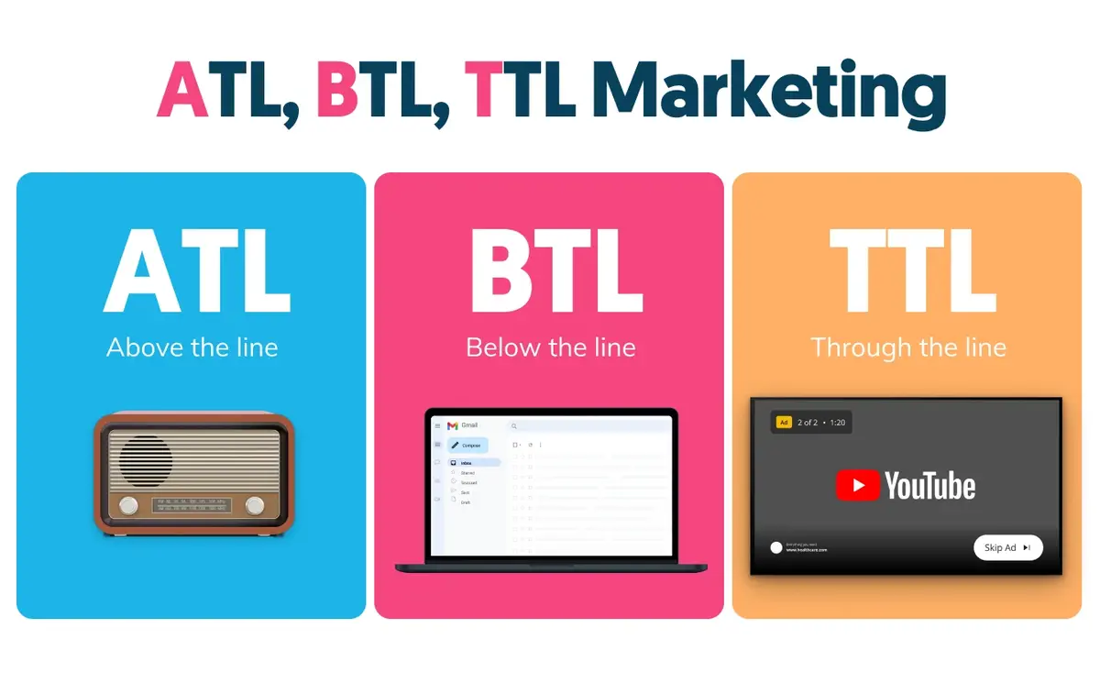

ATL (Above the Line) Marketing
Above the Line (ATL) marketing refers to mass media-based promotional strategies aimed at reaching a wide, generalized audience. These campaigns are typically non-targeted, aiming to build brand awareness and recall across broad population segments.
Key Characteristics:
- High reach but low precision
- Ideal for brand-building and national campaigns
- Commonly used by large corporations with significant advertising budgets
Primary ATL Channels in Bangladesh:
- Television:
Television remains one of the most influential media platforms in Bangladesh. Major channels like NTV, Channel i, and RTV provide national coverage, making TV ads highly effective for mass consumer products, especially in the FMCG sector.
- Radio:
Though more limited in reach compared to television, FM radio channels like Radio Foorti and ABC Radio serve as effective channels for brand messaging, particularly for urban, youth-focused campaigns.
- Print Media (Newspapers and Magazines):
Daily newspapers such as Prothom Alo, The Daily Star, and Kaler Kantho are still widely read, particularly among middle-aged and older demographics. Print advertisements are especially popular among real estate, education, and financial service sectors.
- Outdoor Advertising (Billboards and Hoardings):
While sometimes considered a grey area between ATL and BTL, outdoor campaigns with mass visibility (e.g., major city intersections or highways) are generally classified as ATL due to their broad exposure.

Use Cases in Bangladesh:
ATL strategies are most common among:
- Large FMCG brands (e.g., Unilever, Pran-RFL)
- Telecom operators (e.g., Grameenphone, Banglalink)
- Financial institutions
- Consumer electronics brands
ATL campaigns in Bangladesh often focus on product launches, festival promotions (like Eid and Pohela Boishakh), and public service awareness (e.g., voter registration, health campaigns).

BTL (Below the Line) Marketing
Below the Line (BTL) marketing refers to highly targeted, direct, and interactive promotional efforts. These strategies are designed to create a personal connection with the consumer and often encourage immediate action or engagement.
Key Characteristics:
- Targeted and measurable
- Focus on consumer engagement and conversion
- Typically, more cost-effective than ATL

Common BTL Activities in Bangladesh:
- Event Marketing & Activations:
Roadshows, mall activations, campus campaigns, and pop-up events are common in both urban and semi-urban areas. These are used to generate direct consumer interactions.
- Point-of-Sale (POS) Promotions:
In-store branding, shelf displays, and product sampling at retail outlets help influence purchasing decisions at the moment of sale.
- Trade Shows and Expos:
Sectors like real estate, education, and IT frequently organize trade fairs where companies can interact with target customers face-to-face.
- SMS and Email Campaigns:
Bulk SMS services are widely used in Bangladesh due to the high penetration of mobile phones. SMS marketing is especially effective for banks, retailers, and telecom operators.
- Direct Marketing and Leaflet Distribution:
Localized campaigns involving door-to-door flyer distribution or targeted advertising in specific communities remain relevant, particularly for regional businesses.

Use Cases in Bangladesh:
BTL strategies are common among:
- SMEs and startups with limited budgets
- Regional businesses
- NGOs and development agencies
- Campaigns requiring localized engagement (e.g., rural health awareness, voter drives)
BTL marketing has gained momentum because it offers greater ROI transparency, especially in resource-constrained environments.

TTL (Through the Line) Marketing / Digital Marketing
As the line between ATL and BTL has blurred, Through the Line (TTL) marketing—especially through digital platforms—has become an essential part of any brand’s strategy. TTL combines the broad reach of ATL with the precision and interactivity of BTL, made possible through data-driven targeting, automation, and real-time engagement.
Key Characteristics:
- Blended approach using both mass and targeted reach
- Highly measurable with real-time analytics
- Scalable across regions and platforms

Major TTL Platforms in Bangladesh:
- Facebook and Instagram:
Bangladesh has over 45 million Facebook users. These platforms are central to social media campaigns, often used for product promotions, customer engagement, and direct sales.
- YouTube and OTT Platforms:
Video content, including ads and branded storytelling, is extensively used by marketers to engage visually-driven audiences.
- Google Ads and Display Networks:
SEM (Search Engine Marketing) is used to capture intent-driven audiences searching for specific products or services.
- E-commerce and Digital Marketplaces:
Platforms like Daraz, Evaly, and Chaldal allow brands to promote products directly within digital shopping ecosystems.
- Influencer Marketing:
Collaborating with YouTubers, TikTok creators, and Facebook personalities is an emerging trend that blends storytelling with product placement—highly effective among Gen Z and millennial consumers.

Why TTL Matters in Bangladesh:
- The country has over 125 million mobile users and over 45 million internet users.
- Brands want to measure every penny of their campaign budget.
- Digital literacy and mobile-first behavior are expanding beyond urban areas.
TTL marketing allows Password Communication and similar agencies to offer cross-channel campaigns—where a single campaign can appear on TV, engage via social media, follow up via SMS, and offer a conversion point through a web/app form.

Evolving Toward Integration
The Bangladeshi marketing industry is no longer siloed into ATL or BTL; instead, it is moving rapidly toward integrated communication strategies that combine creativity, data, and platform diversity. While ATL offers mass reach and brand equity, and BTL provides personal interaction and measurable impact, TTL marketing has emerged as the most dynamic and future-ready model.
Agencies like Password Communication that can navigate all three domains—creative, strategic, and technical—are in the best position to serve modern clients. As the lines continue to blur, successful agencies must think holistically, act quickly, and deliver consistently across all platforms.

2.2 Size, Trend, and Maturity of the Industry
The industry is growing progressively, with digital marketing growing at over 20% per annum due to increasing internet access and mobile penetration. The marketing sector in our country is currently valued at about BDT 3,000 crore (as of 2024) and is still considered in the growth stage, especially in rural and semi-urban areas.
Trends include:
- Increased usage of AI and data-analytics in campaign strategy
- Growing acceptance of influencers and content marketing
- Addition of omni-channel experiences

2.3 Technological Factors
As we all know, technology is an enabler and a disruptor at the same time. The use of automation tools, CRM systems, web development platforms, mobile apps, and cloud computing is revolutionizing how campaigns are planned and executed. Augmented Reality (AR), chatbots, and programmatic advertising are entering the scene in urban markets as well.

2.4 Political, Legal, and Regulatory Factors
The industry operates under the regulatory oversight of the Bangladesh Telecommunication Regulatory Commission (BTRC), the Ministry of Information, and related entities. Key legal considerations include:
- Concerns regarding data privacy with SMS/email marketing
- TV and radio advertisements licensing
- Limitations on promotion of tobacco, alcohol, and sensitive content
Government initiatives supporting Digital Bangladesh Vision 2041 also benefit marketing firms, particularly those involved in tech or digital services.

2.5 Industry Rivalry
The marketing and communications industry in Bangladesh has evolved significantly in the last decade, particularly with the rise of digital platforms and the expansion of mobile and internet usage. Cities like Dhaka and Chattogram (Chittagong) have become bustling hubs for advertising, branding, and digital service providers. As urbanization accelerates and consumer expectations shift, businesses are increasingly allocating their budgets to professional marketing agencies to ensure strong market presence and brand engagement.
In this dynamic context, the industry has become intensely competitive, with numerous local agencies fighting for relevance, visibility, and client loyalty. While large global players such as WPP, Ogilvy, and Dentsu have limited direct operations in Bangladesh, their influence is felt through indirect partnerships or multinational campaigns. However, the local and regional players are the real drivers of competition—constantly innovating, customizing, and pivoting to retain market share in a fragmented and price-sensitive environment.

Nature of Rivalry: High and Intensifying
The nature of rivalry in the marketing industry in Bangladesh is characterized by five key factors:
- High number of similar-sized competitors
- Low differentiation in certain service areas
- Rapidly evolving technology and media trends
- Price sensitivity among clients, especially SMEs
- Talent-driven value creation

Let us analyze this further using Porter’s Five Forces framework, which provides a comprehensive lens to understand competitive intensity.
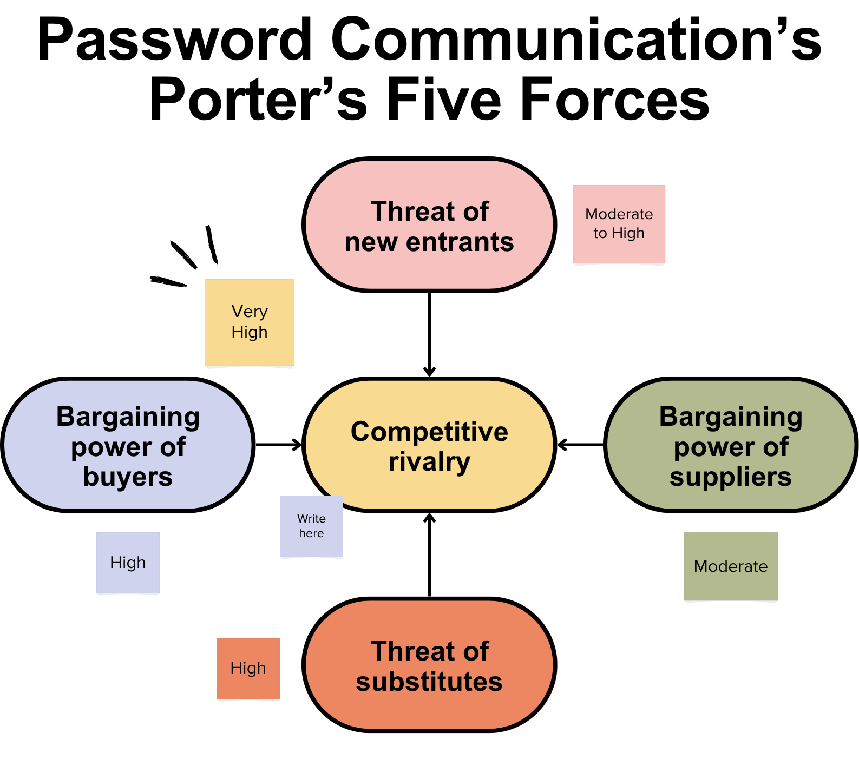

1. Threat of New Entrants – Moderate to High
The barrier to entry in the marketing and digital communication industry is relatively low. Setting up a marketing agency does not require significant capital investment, especially for digital services. Many freelancers and small teams often start by offering basic services like social media management, content creation, or SMS marketing and scale as they gain clients.
- Factors encouraging new entrants:
- Low startup costs for basic digital services
- Abundance of free or low-cost tools (e.g., Canva, Hootsuite, Meta Ads)
- Access to gig workers and outsourced talent
- Online learning platforms (e.g., Meta Blueprint, Google Skillshop)
- However, sustaining and growing an agency into a reputable, full-service firm like Password Communication requires:
- Strategic planning
- Skilled talent
- Strong client servicing
- Project management discipline
- Scalable infrastructure
Thus, while entry is easy, survival and growth remain challenging, increasing the number of small players who continuously disrupt pricing and service standards, contributing to a competitive industry environment.

2. Bargaining Power of Buyers – High
Clients in Bangladesh, large corporates, NGOs, and development partners have significant bargaining power. With a wide range of agencies available, clients can demand:
- Lower prices
- More value-added services
- Faster delivery timelines
- Flexible contract terms
This high bargaining power leads agencies to often undercut each other on pricing or throw in additional services (like basic analytics or event support) at no extra cost. In such a scenario, differentiation becomes critical. Agencies that cannot offer a unique value proposition often resort to price-based competition, which erodes margins and hampers long-term sustainability.
At Password Communication, we combat this through:
- Exceptional service customization
- Post-project support
- Transparent communication
- Technical integration that others lack (e.g., mobile app + campaign bundle offerings)

3. Bargaining Power of Suppliers – Moderate
In the marketing industry, "suppliers" can include:
- Freelance creatives (graphic designers, videographers, editors)
- Media buying agencies
- Production houses
- Influencers and content creators
- SMS gateway providers and tech vendors
While suppliers are abundant, specialized service providers (such as TVC directors, animation experts, or drone videographers) can exert pricing pressure due to their niche skills. Additionally, dependency on tech platforms like Meta, Google, or YouTube adds vulnerability—algorithm changes or pricing shifts directly impact campaign performance.
Agencies like Password Communication must develop strong vendor relationships and diversify their supplier base to avoid over-reliance on any one party.

4. Threat of Substitutes – Moderate
Clients may opt for alternative marketing solutions instead of hiring a full-service agency. Substitutes include:
- In-house marketing teams
- Freelancers for project-based tasks
- Automated marketing platforms (e.g., Mailchimp, Canva, ChatGPT for content)
- Influencer partnerships handled directly by the client
As automation and AI tools become more accessible, substitution risks increase, especially for tasks like content writing, ad scheduling, or basic design. However, for strategic brand building, integrated campaigns, or technical development (web/app), full-service agencies still provide unmatched value.
To stay ahead, Password Communication focuses on offering integrated services where creativity meets technology—something not easily replicable by freelancers or AI tools alone.

5. Industry Rivalry – Very High
The core of this analysis is the intense rivalry among existing players. Some reasons why competition is so fierce include:
a) Service Overlap
Many agencies offer overlapping services BTL, ATL, digital marketing, SMS promotions, and event management. With similar portfolios, the only way to stand out is through execution quality, creative depth, and strategic insights.

b) Local Saturation
In cities like Dhaka and Chattogram, hundreds of agencies compete for the same client pool. For example, the same FMCG company might receive dozens of proposals for a product launch campaign. This saturation pushes agencies to constantly innovate or risk becoming irrelevant.

c) Creativity as a Commodity
Creative ideas are now expected instantly. Clients often expect mockups or draft strategies before signing contracts, which puts agencies under pressure to deliver “free value” upfront. Many smaller agencies comply just to stay in the game, which dilutes overall industry standards.

d) Talent Migration
Top creative or tech talent frequently switch agencies or move abroad, causing instability in team structure and knowledge continuity. Agencies must therefore invest constantly in team development and culture building to retain human capital.

e) Technology Leapfrogging
Agencies that fail to adopt the latest tools (e.g., programmatic advertising, marketing automation, AI-driven targeting) quickly fall behind. As a result, rivalry is no longer just about price or creativity—it’s also about technological agility.

Differentiation as a Competitive Weapon
In such a high-stakes environment, differentiation is the only sustainable strategy. Password Communication leverages multiple differentiators to thrive in the competitive landscape:
Integrated Services: From ATL/BTL to mobile app development, very few agencies offer such a wide service portfolio under one roof.
Tech-Driven Solutions: Our strength in developing custom applications, desktop tools, and back-end automation adds value to clients looking beyond traditional marketing.

- Results-Oriented Approach: We focus on KPIs leads, conversions, user engagement not just visuals or slogans.
- Rural Reach: Our ability to execute campaigns beyond major cities gives us an edge in national-level activations.
- Client Retention Strategy: We don’t just complete projects, we build relationships through continuous support and value-added consultation.

Trends Shaping Industry Competition
Several macro trends are intensifying competition:
- Digital-first campaigns are now the norm, shifting agency focus from physical materials to digital storytelling.
- Influencer marketing is becoming more central, with agencies scrambling to build influencer networks.
- Data privacy laws are emerging slowly, which will favor agencies that already prioritize ethical data handling.
- Hybrid event experiences post-pandemic have transformed BTL strategies, requiring new tech skills and logistics planning.
- OTT and video content demand has surged, pushing agencies to invest in production infrastructure or partner with content creators.

How Password Communication Navigates Competition
- Password Communication understands that in a market as competitive as Bangladesh, adaptability and client focus are everything. Here's how we stay ahead:
- We offer end-to-end brand solutions, combining creative marketing with technical development, allowing clients to centralize their project needs.
- We actively invest in training, ensuring our team stays updated on SEO, ad trends, AI tools, and design innovations.
- Our pricing is transparent and scalable, accommodating both high-budget brands and SMEs with flexible packages.
- We foster internal innovation, encouraging team members to test new formats (e.g., AR filters, gamified content, WhatsApp marketing).
- We maintain a culture of accountability—from project briefing to final delivery, we focus on ownership, timelines, and outcomes.

Surviving and Thriving in a Competitive Arena
Industry rivalry in Bangladesh’s marketing sector is not just intense—it’s relentless and evolving. Agencies are no longer competing only on design or messaging; they are competing on insights, platforms, speed, and even ethics. While this makes survival harder, it also drives excellence, forcing agencies to constantly improve and innovate.
For Password Communication, this competitive environment has been a catalyst for growth. It has pushed us to embrace new technologies, expand service offerings, and become more client-centric than ever. We believe that competition, when harnessed correctly, fuels creativity, drives innovation, and ultimately benefits both agencies and the brands they serve.

2.6 Summary of Challenges and Opportunities
Challenges
• Talent scarcity in particular digital marketing skills
Although digital marketing is rapidly growing in Bangladesh, there’s a significant gap in skilled professionals—especially in areas like SEO, paid media, analytics, and marketing automation. Many agencies struggle to find and retain talent with up-to-date knowledge, which affects campaign efficiency and innovation. This talent gap slows the industry’s progress and forces companies to either train staff internally or outsource expertise, which isn't always sustainable for smaller firms.

• Budget limitations for small and medium-sized enterprises (SMEs)
SMEs often operate with limited marketing budgets, making it difficult for agencies to offer comprehensive services without compromising quality or profit. These businesses may prioritize low-cost solutions over strategic investment, which can hinder long-term brand growth. Agencies must strike a balance between affordability and value, which is challenging when working with high expectations but restricted financial flexibility.

• Regulatory uncertainty
Changing government policies, inconsistent digital advertising guidelines, and unclear data protection laws create uncertainty for agencies and advertisers. Marketers must constantly adapt to new restrictions on content, messaging, and media channels. This lack of regulatory stability can delay campaigns, restrict creativity, and make it harder for agencies to plan long-term strategies, especially in politically sensitive sectors.
• Increasing cost of digital promotion
With more businesses investing in online advertising, the cost of digital media—especially on platforms like Facebook, YouTube, and Google—continues to rise. Competition for ad space drives up bid rates, making it harder for small advertisers to achieve visibility. This rising cost also pressures agencies to deliver higher ROI, often without proportional budget increases from clients.

Opportunities
• Untapped rural markets
Rural areas in Bangladesh present a huge opportunity for marketers due to increasing internet and smartphone penetration. Brands that can localize content and connect with rural audiences through community-based strategies or mobile platforms stand to gain significant reach. For agencies, this opens doors to design inclusive campaigns that bridge urban-rural divides and drive brand loyalty in underrepresented regions.

• Automation, data and AI-driven marketing
The rise of AI tools, data analytics, and marketing automation platforms presents new ways to deliver personalized, efficient, and measurable campaigns. Agencies can now optimize budgets, target the right audience segments, and track performance in real time. Embracing these tools allows companies to enhance creativity with intelligence, leading to smarter marketing and improved client satisfaction.

• Expansion of OTTs and social platforms
With the growing popularity of streaming platforms and emerging social networks, there are more channels than ever to reach audiences—especially younger demographics. Agencies can experiment with storytelling, branded content, influencer partnerships, and short-form videos to engage users. The diversification of platforms means more creative freedom and better audience targeting possibilities.

• Government and NGO partnerships
Government initiatives like "Digital Bangladesh" and development projects led by NGOs often require marketing and communication support. Agencies that align with national goals—such as education, health, or digital literacy—can benefit from impactful, large-scale partnerships. These projects not only offer steady business opportunities but also allow agencies to contribute to social development through strategic communication.

Chapter III

Analysis of Password Communication


Password Communication is a 360-degree marketing and tech solution agency in Bangladesh, founded by Sheikh Mehedi Hasan. With knowledge and experience in ATL, BTL, digital marketing, and technology services, the agency has placed itself as an up-to-date, advanced, and results-driven performer in the competitive arena of digital agencies operating in the county.

3.1 Overview and History
Founded a few years ago, Password Communication started as a small marketing agency serving both creative and event activations and has since evolved into a full-service provider offering marketing, branding, and technological solutions to a wide array of clients, including both local and multinational firms like United group, The Westin, ACI Logistics and so on.

3.2 Mission Statement
“To empower brands with innovative marketing and technological solutions that drive measurable results and foster meaningful customer engagement.”

3.3 Location and Facilities
With a headquarters in Dhaka, the company functions from a modern office equipped with cooperative workstations, a creative studio, tech development labs, and client meeting facilities. The set-up supports everything from TVC production to mobile app development.

3.4 Customer Mix
Password Communication serves a diverse client base, including:
- FMCG brands
- Financial institutions
- Telecom operators
- NGOs and development organizations
- Startups and SMEs

3.5 Product/Service Mix
- BTL & ATL Marketing Campaigns
- Digital Marketing (SEO, SEM, Social Media, Content)
- Web Design and Development
- Mobile and Desktop Applications
- SMS and Email Marketing
- TVC & OVC Production
- Logistics and Event Management Support

3.6 Service Quality
• A Results-Oriented Approach
Password Communication focuses on delivering measurable outcomes for clients—for example increased brand awareness, lead generation, or sales conversions— making sure that every strategic move aligns with clear business aims.
• Continuous Training and Talent Development
The agency participates in regular workshops, certifications, and on-the-job training to keep the team up-to-date with the newest tendencies in marketing, design, and technology, maintaining a high standard of professional expertise.
• Use of Advanced Project Management Tools
Software that is utilized to streamline workflows, ensure timely delivery, track progress, and improve internal teamwork, leading to more efficient project implementation.
• Rigorous QA Processes in Digital and Technical Deliverables
Before deployment, all digital products and campaigns undergo severe quality assurance checks to ensure functionality, security, and user experience meet both client and industry standards.
• Client-Centric Customization
Each project is tailored to the specific goals, audience, and budget of the client, ensuring relevance and success rather than applying one-size-fits-all solutions.
• Prompt Communication and Feedback Loops
Continuing communication with clients throughout a campaign confirms alignment, allows real-time modifications, and builds long-term trust through transparency.

3.7 SWOT Analysis
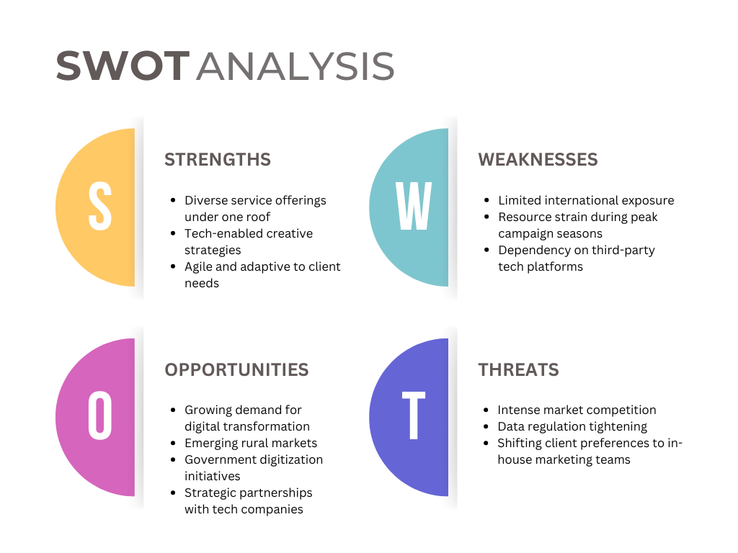
Strengths:
- Diverse service offerings under one roof
- Tech-enabled creative strategies
- Agile and adaptive to client needs
Weaknesses:
- Limited international exposure
- Resource strain during peak campaign seasons
- Dependency on third-party tech platforms
Opportunities:
- Growing demand for digital transformation
- Emerging rural markets
- Government digitization initiatives
- Strategic partnerships with tech companies
Threats:
- Intense market competition
- Data regulation tightening
- Shifting client preferences to in-house marketing teams

3.8 Strategies to Meet the Challenges and Opportunities
In an increasingly complex and competitive marketing environment, Password Communication must adopt both defensive and proactive strategies to ensure continued growth, client satisfaction, and long-term sustainability. These strategies are aimed at addressing current internal weaknesses and external threats while leveraging our organizational strengths to seize emerging opportunities. This strategic direction is aligned with the dynamic nature of the Bangladeshi marketing industry and is designed to help Password Communication remain adaptive, competitive, and innovative.

Tackling Weaknesses and Threats
1. Invest in Internal Training and Cross-Functional Capacity Building
A key internal weakness identified in the SWOT analysis is the scarcity of specialized digital marketing skills within the workforce a challenge shared by many agencies in Bangladesh. Rapid technological advancements and evolving client demands require a more agile and skilled team.
Strategy Implementation:
- Regular Skill Audits: Periodic assessment of team competencies to identify skill gaps.
- In-House Training Programs: Develop a structured training calendar focusing on areas like SEO, Google Ads, campaign analytics, UI/UX, content strategy, and mobile app development.
- Cross-Training: Encourage employees from non-digital teams (e.g., event or logistics teams) to gain basic digital skills, enabling cross-functional collaboration.
- Certifications: Facilitate access to Google, Meta (Facebook), HubSpot, and other industry-relevant certifications.
Expected Outcome:
This strategy will build a robust, flexible talent pool capable of handling multidimensional projects, reducing dependence on external freelancers and agencies while improving service delivery and innovation capacity.

2. Establish Contingency Planning for High-Demand Periods
In a project-based service business like Password Communication, demand is often seasonal and unpredictable, especially around national holidays, product launches, or government campaigns. Failure to manage resource allocation during peak times can lead to missed deadlines or suboptimal service delivery.
Strategy Implementation:
- Forecasting and Resource Pooling: Use past campaign data to forecast high-demand periods and create a reserve workforce pool.
- Project Management Tools: Leverage advanced tools like Asana, Monday.com, or ClickUp to plan tasks, assign responsibilities, and monitor progress.
- Freelancer Network: Build a vetted database of on-call freelancers and partner agencies for surge support.
- Internal Escalation Protocols: Develop clear escalation workflows to address project delays or delivery challenges quickly.
Expected Outcome:
Effective contingency planning will lead to better client retention, enhanced reputation for reliability, and less employee burnout during peak periods.

3. Explore Partnerships to Reduce Reliance on Third-Party Technology
Password Communication currently depends on multiple third-party tools and platforms for campaign management, analytics, and client deliverables. While these are essential, over-reliance can pose risks such as rising costs, lack of control, or platform instability.

Strategy Implementation:
- Build Strategic Tech Partnerships: Collaborate with local or regional tech firms to create co-branded solutions that cater to Bangladesh’s marketing ecosystem.
- Open-Source Alternatives: Identify and adopt open-source tools where applicable to reduce licensing costs.
- In-House Tool Development: Over time, invest in the development of proprietary tools for campaign tracking, SMS marketing, and performance dashboards tailored to SME clients.
- Regular Vendor Evaluation: Monitor performance, pricing, and service level agreements of third-party providers and renegotiate or switch when necessary.
Expected Outcome:
This strategy enhances technological independence, strengthens long-term cost-efficiency, and ensures continuity in case of third-party disruptions.

Capitalizing on Strengths and Opportunities

1. Expand into Regional Markets with a Targeted Strategy
Urban centers like Dhaka and Chittagong are saturated with marketing agencies, but regional and rural markets remain largely untapped. With growing digital literacy and infrastructure development in smaller towns, Password Communication can strategically expand its services to these markets.
Strategy Implementation:
- Market Research: Conduct feasibility studies to identify regions with growing business activities (e.g., Rajshahi, Sylhet, Barisal).
- Local Partnerships: Collaborate with regional businesses and local influencers to build trust and gain traction.
- Language Localization: Offer services in Bengali and regional dialects to ensure cultural relevance.
- On-Ground Events: Organize local seminars, workshops, and BTL activations to build brand visibility and client networks.
Expected Outcome:
Expanding into underserved regions allows Password Communication to diversify its revenue base, tap into new customer segments, and position itself as a pioneer in rural digital communication.

2. Launch Exclusive Digital Tools and Marketing Platforms
One of the agency’s core strengths lies in its technical proficiency, particularly in web development, app creation, and digital platform integration. This strength can be transformed into new business lines through the launch of proprietary tools that address common SME pain points.
Strategy Implementation:
- Marketing Automation Platform: Build a tool that enables clients to manage their campaigns, schedule social media posts, and track analytics from one dashboard.
- SMS & Email Suite: Develop a simplified communication tool for mass SMS, email newsletters, and engagement tracking.
- E-commerce Integration Toolkit: Offer plug-and-play solutions for local e-commerce brands that need seamless payment gateways, inventory management, and customer feedback loops.
- Subscription-Based Model: Introduce SaaS (Software-as-a-Service) pricing for these tools, making them accessible and affordable for SMEs.
Expected Outcome:
Launching digital tools adds a passive income stream, enhances client dependency on Password Communication’s ecosystem, and boosts brand perception as a digital-first agency.

3. Cooperate with Educational Institutions to Recruit and Train Fresh Talent
One long-term solution to the talent scarcity problem is to build a strong academic-industry partnership that channels fresh graduates into the agency with hands-on, industry-relevant training.
Strategy Implementation:
- Internship and Apprenticeship Programs: Establish formal internship pipelines with universities like North South University, BRAC University, and Dhaka University.
- Campus Branding: Host competitions, workshops, and guest lectures to raise awareness about the agency and its work culture.
- Joint Certification Programs: Co-design short courses or bootcamps in digital marketing, UI/UX design, or video production in partnership with academic institutions.
- Mentorship Opportunities: Allow senior agency members to mentor students and contribute to curriculum development.
Expected Outcome:
This strategy ensures a continuous inflow of fresh, motivated talent while also contributing to the broader marketing education ecosystem in Bangladesh.

4. Grow Thought Leadership Content to Boost Brand Visibility
Thought leadership not only elevates the brand’s authority in the market but also helps attract clients and talent organically. Content marketing and knowledge sharing can serve as an effective promotional tool, especially in the digital space.
Strategy Implementation:
- Blogs and Articles: Regularly publish content on marketing trends, campaign case studies, and industry insights on the company website.
- Webinars and Podcasts: Launch a branded webinar or podcast series with expert discussions and client success stories.
- Industry Reports: Develop quarterly or annual reports on the state of marketing in Bangladesh to position the agency as a data-driven thought leader.
- LinkedIn & YouTube Presence: Grow presence on professional platforms where potential clients, partners, and future employees can discover the agency.
Expected Outcome:
This strategy strengthens Password Communication’s online presence, builds credibility, and helps generate inbound leads while also aiding talent recruitment.

In today’s rapidly evolving marketing landscape, agencies must do more than deliver great campaigns—they must be strategic, scalable, and resilient. The strategies outlined above offer Password Communication a roadmap not just to survive but thrive amid growing competition, technological disruption, and client expectations.
By simultaneously addressing internal weaknesses and leveraging external opportunities, the agency can build a well-rounded, future-proof organization. Internal training, contingency planning, and technological independence will form the backbone of operational resilience. Meanwhile, regional expansion, proprietary tools, academic partnerships, and thought leadership initiatives will serve as engines for growth, innovation, and differentiation.
Together, these strategies will ensure that Password Communication not only adapts to the present but also confidently leads the future of marketing in Bangladesh.

Chapter IV

Customer Centricity at Password Communication

4.1 Customer Centricity
At Password Communication, customer centricity is more than just a business strategy, it is a core value embedded into everything we do. It means putting our clients’ goals, challenges, and audience at the center of every marketing campaign, design concept, and technological solution. Whether we’re launching a nationwide BTL campaign or developing a customized mobile application, we prioritize what matters most to our customers and their clients.
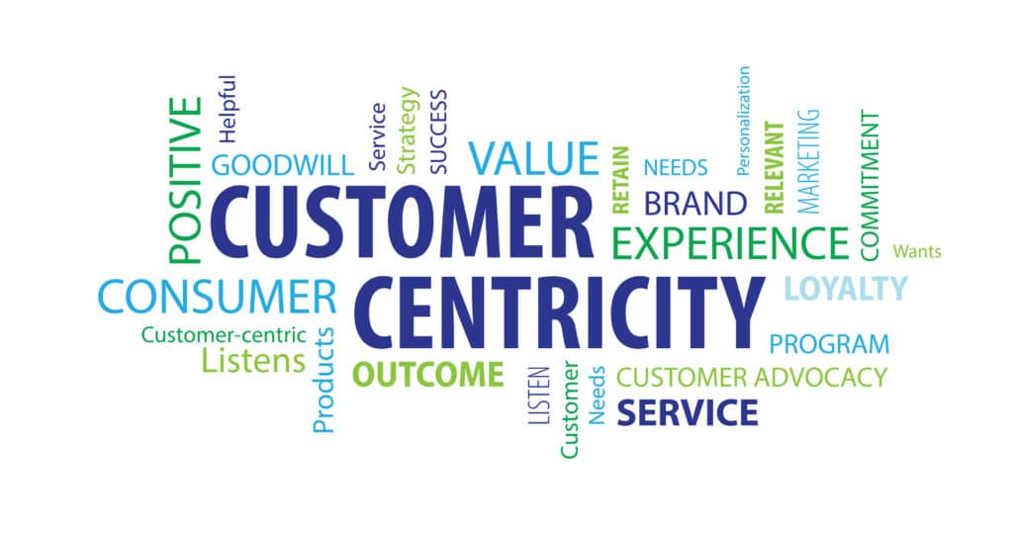

4.2 Importance of Customer Centricity at Password Communication
Customer centricity has been vital in building long-term partnerships and a strong market reputation. Here’s why it’s important to us:
1. Client Retention and Loyalty
At Password Communication, client retention is not just a metric, it’s a reflection of trust, value, and consistent performance. Our customer-centric approach ensures that we design and deliver marketing solutions that are tailored to the unique needs, industry contexts, and business objectives of each client. Rather than offering generic, one-size-fits-all packages, we listen closely to client challenges and goals, adapting our strategies accordingly. This level of personalization not only creates a better client experience but also fosters long-term loyalty.
Transparency is another key driver of client trust. We maintain open communication during every stage of the campaign, from strategy planning to execution and reporting. Clients are kept informed about timelines, deliverables, budget allocations, and performance analytics, which helps establish credibility and reduce uncertainty.
This commitment to client satisfaction has led to a high percentage of repeat business and long-standing partnerships. Several clients have continued to work with us for years, not only for specific projects but also as their long-term strategic marketing partner. Moreover, returning clients often expand their scope of work with us—from ATL and BTL services to digital campaigns and technology integration—demonstrating their confidence in our capabilities.
Ultimately, prioritizing client retention reduces our customer acquisition costs and improves our profitability. It also allows us to deepen our understanding of each client’s evolving business, enabling more strategic collaboration over time. Our loyalty-driven model has proven to be a competitive advantage in an industry where client switching is common and loyalty is hard-earned.

2. Effective Campaign Outcomes
Customer centricity directly impacts the quality and effectiveness of the campaigns we deliver. By prioritizing our clients’ business goals and deeply understanding their target audiences, we are able to design and execute marketing strategies that are not only creative but also results-driven. At Password Communication, success is measured not just in clicks or impressions, but in tangible outcomes like increased sales, brand engagement, and ROI.
We begin each project by conducting a comprehensive needs assessment. This involves discussions with the client’s internal teams, studying their market position, and understanding their short- and long-term objectives. From there, we build tailored strategies that reflect those goals, whether it’s launching a new product, entering a new market, or improving customer retention.
Furthermore, we rely heavily on performance data and audience insights to inform our campaigns. This approach ensures that messages are targeted correctly, media budgets are optimized, and every piece of creative work serves a specific purpose. For instance, when working with a retail client, we don’t just push promotional content—we build campaigns around customer behaviors, seasonal trends, and sales funnel performance.
The results speak for themselves. Our client-focused planning has helped us consistently exceed KPIs, whether in terms of reach, engagement, or conversion. Additionally, we conduct post-campaign reviews with clients to evaluate outcomes, collect feedback, and identify areas for improvement. This continuous feedback loop allows us to fine-tune our processes and deliver even better results in future campaigns.
Ultimately, our ability to align with client priorities not only boosts their business success but also strengthens our own reputation as a dependable and strategic marketing partner.

3. Brand Advocacy
Brand advocacy is one of the most powerful benefits of a customer-centric approach, and it has played a pivotal role in the organic growth of Password Communication. When clients are satisfied not just with the outcomes but also with the service experience, they become advocates, spreading positive word-of-mouth, writing testimonials, and recommending us to others within their professional networks.
This form of marketing—where your existing clients promote your brand voluntarily, is both credible and cost-effective. In Bangladesh’s tight-knit business community, referrals carry substantial weight. Clients who trust and respect our work often refer us to peers, suppliers, and partners, leading to new project opportunities without significant advertising spend.
What enables this advocacy is our commitment to building relationships rather than just executing deliverables. We stay involved beyond the project timeline, providing post-launch support, checking in on results, and being available for strategic consultations. This builds emotional loyalty, where clients feel a genuine connection to our team and see us as collaborators rather than vendors.
In fact, many of our long-term accounts, particularly in the SME and development sectors, originated from a single referral or shared case study. When a client sees that we’ve gone the extra mile, whether it’s staying late before a product launch, managing a crisis smoothly, or proposing a better solution proactively, they’re more likely to share that story with others.
Brand advocacy is especially crucial in today’s digital era, where client testimonials, case studies, and online reviews influence purchasing decisions. At Password Communication, we actively encourage and nurture this advocacy, not through incentives, but through excellence and relationship-building—ensuring every client becomes a promoter of our brand.

4. Agility and Innovation
Customer-centricity also drives organizational agility and innovation—two essential traits for any modern marketing agency. At Password Communication, we recognize that our clients’ needs are constantly evolving due to shifting market dynamics, technological advancements, and consumer behavior trends. By actively listening to client feedback and remaining open to change, we are able to adapt our services and solutions in real-time.
This adaptability begins with our feedback culture. After each campaign or major project milestone, we conduct debrief sessions where clients can share candid feedback on what worked and what didn’t. Instead of treating feedback as criticism, we treat it as valuable data that fuels our innovation engine. For example, when clients started requesting faster campaign turnaround times, we invested in project management tools and agile workflows to enhance delivery speed.
Our client conversations also frequently spark new service ideas. In response to multiple requests for localized e-commerce integration, we developed new modules for our web development service line. Similarly, feedback about gaps in analytics led to our partnership with a third-party data visualization platform to offer advanced reporting dashboards.
Moreover, our clients often alert us to emerging industry needs, allowing us to stay ahead of the curve. This includes trends like short-form video, AI-generated content, or SMS-based engagement in rural markets. Because we are tuned into our clients’ challenges, we can be proactive in exploring new tools, training our team, and piloting new service models.
Ultimately, our agility stems from our client-centric DNA. Rather than being driven by internal assumptions, we let client needs and market demands guide our innovation roadmap. This ensures that we remain relevant, responsive, and resilient in a highly competitive industry.

4.3 Steps We Take to Be Customer-Centric
At Password Communication, we actively practice customer centricity through the following steps:
1. In-Depth Client Discovery
Before any project begins, Password Communication engages in thorough consultations with each client to fully grasp their vision, target market, goals, and challenges. This discovery phase is critical to ensure that every strategy and execution aligns with the client’s brand identity and business objectives. It includes competitor analysis, audience profiling, and understanding past campaign performance. This groundwork helps build a strong foundation for trust, clarity, and shared expectations, enabling our team to deliver more relevant, targeted, and impactful campaigns across ATL, BTL, and digital platforms.

2. Data-Driven Strategy
Our approach to marketing is rooted in research and analytics. We leverage tools and platforms to gather customer insights, behavioral trends, and market data that inform every stage of our strategy—from ideation to execution. Whether it’s selecting the right media mix, timing a campaign, or crafting a brand message, data helps us make smarter decisions. This ensures our campaigns are not only creative but also highly relevant, goal-oriented, and ROI-focused. It minimizes guesswork and maximizes effectiveness, especially in competitive markets where precision and audience understanding are key.

3. Personalized Solutions
At Password Communication, we reject the idea of generic marketing. Every brand is unique, and we believe their campaigns should be too. That’s why we customize every aspect of our services—be it a BTL activation, social media strategy, or a full-scale digital transformation—based on the client’s industry, audience behavior, and brand voice. Personalization allows us to connect more deeply with the target market, deliver more authentic brand experiences, and enhance engagement. It also increases campaign success by focusing on what truly matters to both the client and their customers.

4. Transparent Communication
We prioritize open, consistent communication with our clients at every stage of a project. From initial strategy discussions to final delivery, we provide regular updates, check-in meetings, and detailed progress reports. This transparency helps avoid misunderstandings, allows for timely feedback, and keeps clients actively involved in the decision-making process. Clients are never left in the dark—they are partners in the creative and strategic journey. This clear communication builds trust, reduces project friction, and ensures smoother execution and stronger client-agency relationships.

5. Post-Delivery Support
Our commitment doesn’t end at delivery. After a campaign or project goes live, we continue to monitor performance, provide support, and make necessary adjustments based on real-time data. Whether it’s updating website content, tweaking a social media campaign, or resolving technical issues in an app, our team remains available for post-launch optimization. This ensures long-term success and client satisfaction. We view our projects as ongoing partnerships, not one-time transactions, and this mindset leads to better client retention and sustained performance improvement.

6. Client Feedback Integration
We believe that client feedback is one of the most valuable tools for growth and improvement. That’s why we have systems in place to collect structured feedback after key project milestones and campaign closures. This feedback is reviewed seriously and used to refine our processes, tools, and service offerings. It enables us to identify gaps, enhance efficiency, and deliver better results in future collaborations. By actively listening to our clients and making improvements based on their input, we create a culture of continuous improvement and client-centered innovation.

4.4 Factors That Influence Our Customer-Centric Approach
Several internal and external factors help shape our customer-centric culture:

1. Company Leadership
Under the leadership of Founder & CEO Sheikh Mehedi Hasan, Password Communication has embedded client success into its core values. His vision emphasizes delivering real business value rather than just outputs, ensuring that all team members stay focused on understanding client needs and exceeding expectations. This leadership style cultivates a culture where strategic thinking, accountability, and empathy guide everyday decision-making. By modeling client-first behavior, the leadership sets a strong example, encouraging every department—from creative to technical—to put the customer at the center of their work and uphold a standard of service excellence.

2. Trained, Passionate Team
A key pillar of our customer-centric culture is the passion and professionalism of our team. Employees are regularly trained in communication, empathy, problem-solving, and technical skills to ensure they can anticipate client needs and respond proactively. Our team members work cross-functionally, which promotes collaboration and a 360-degree understanding of the client’s journey. We hire for attitude and train for skill, seeking people who care deeply about delivering positive experiences. This culture of accountability and passion helps us maintain long-term client relationships, respond faster to concerns, and innovate based on real feedback and client interaction.

3. Technology Infrastructure
Our investment in digital tools and systems plays a crucial role in maintaining a customer-focused approach. We utilize CRM platforms to track client preferences, history, and engagement metrics, while project management software ensures transparency in task assignments, progress updates, and deadlines. Feedback tools and analytics dashboards further help us gauge satisfaction levels and performance. This digital infrastructure enables smoother workflows, faster communication, and real-time visibility—allowing us to respond quickly, reduce errors, and deliver measurable value. By leveraging technology, we ensure every client interaction is informed, consistent, and aligned with their goals.

4. Client Diversity
Serving a wide variety of clients, from NGOs and development organizations to FMCG companies and startups, has significantly expanded our understanding of diverse customer expectations. Each industry brings its own challenges, audience behaviors, and marketing nuances. This variety pushes our team to remain flexible, continuously learn, and adapt strategies that cater to different sectors and demographics. It also broadens our creative and technical skillsets, enabling us to offer more innovative, inclusive, and effective campaigns. Client diversity doesn’t just enrich our portfolio—it sharpens our customer-centric lens, making us more versatile and insightful marketers.

5. Competitive Landscape
Bangladesh’s marketing industry is fast-paced and highly competitive, particularly in major cities like Dhaka and Chattogram. In such an environment, being client-centric isn’t optional—it’s a strategic imperative. Our focus on long-term client satisfaction allows us to stand out amid agencies that prioritize short-term profits or generic service models. Exceptional client service acts as a differentiator, building loyalty and generating referrals in an industry where switching agencies is common. By prioritizing the customer experience, we not only retain valuable accounts but also create a reputation that draws in new business organically.

4.5 How Customer Centricity Varies Across Our Services and Clients
We adapt our customer-centric approach depending on the industry or project we are working on:
Client Type/Service | Our Customer-Centric Focus
Retail/FMCG Campaigns | Understand consumer triggers, optimize shelf presence, and run data-backed promotions
Digital Marketing Clients | Personalize content, target the right audience segments, and measure real-time engagement
NGO/Development Sector | Focus on message clarity, rural engagement, and impact-based communication
App & Web Development Clients | Prioritize usability, accessibility, and continuous user testing during development
TVC/OVC Projects | Deeply involve the client in storytelling and editing to reflect brand identity
Event & Logistics Support | Provide seamless on-ground execution and real-time client coordination

At Password Communication, customer centricity is not just a practice, it’s our promise. We believe that the more we understand and align with our clients’ needs, the more impactful and lasting our solutions will be.

Chapter V

Internship Experience, Recommendations and Conclusion

5.1 Internship Experience
As the Founder and CEO of Password Communication, this internship experience provided a rare and valuable opportunity to step back from the executive role and engage with the organization from a more academic and reflective standpoint. While I am deeply involved in the day-to-day operations and strategic decisions of the company, approaching this experience as an intern allowed me to examine internal systems, team dynamics, and service workflows with a critical eye.
I gained deeper insights into our internal culture, employee motivation, service delivery mechanisms, and client management processes. It was particularly rewarding to analyze how our customer-centric values translate into operational excellence across departments, from creative strategy to software development and logistics.
Moreover, working on this report helped me align academic theories with practical experiences, such as applying SWOT and customer-centricity models to real projects we have executed. It also gave me the chance to evaluate how well we are adapting to evolving market trends, especially in digital transformation and client engagement.
This internship was not only a formal academic requirement, it served as a meaningful thoughtful journey and helped me become a better planner, leader, and learner.

5.2 Recommendation
Based on my internship experience and the findings from this report, I would like to make the following recommendations for Password Communication’s continued growth and sustainability:
- Invest in Knowledge Sharing and Internal Training:
Regular training and cross-functional workshops can help employees stay updated with industry trends and adopt emerging technologies more effectively.
- Strengthen Data Analytics Capabilities:
Enhanced use of analytics tools in campaign tracking, user behavior analysis, and reporting can improve ROI for clients and boost performance transparency.
- Expand Service Automation:
Automating repetitive workflows (like campaign scheduling or customer feedback collection) will increase efficiency and reduce human error.
- Foster a Culture of Innovation:
Encouraging creative experimentation and open idea-sharing across all departments can lead to more innovative service offerings and problem-solving strategies.
- Establish Stronger Client Onboarding Systems:
A more structured onboarding process, including detailed discovery sessions and expectation alignment, will improve project execution and client satisfaction.
- Explore Regional and International Markets:
With a solid foundation in the local market, exploring opportunities in regional and global markets could unlock new growth potential for the agency.

5.3 Conclusion
Completing this internship and report has been an enriching and transformative experience. It allowed me to take an analytical view of Password Communication, reflect on our accomplishments, and classify actionable areas for growth. As a marketing and technology agency, we are navigating a fast-changing industry where innovation, agility, and customer-centricity are key to long-term success.
This report does not just fulfill an academic purpose; it also acts as a tactical guide for core reflection and structural development. I believe that the insights gathered through this internship will continue to shape our future actions, improve our operations, and strengthen our position in Bangladesh’s competitive marketing landscape.
Ultimately, this experience has reaffirmed my commitment to building a company that delivers value, inspires creativity, and evolves with the changing needs of our clients and the industry.

Reference
The Business Standard. (2023, July 14). The digital advertising market in Bangladesh is expected to hit $500 million by 2025. https://www.tbsnews.net/
The Daily Star. (n.d.). News and reports on business and media in Bangladesh. https://www.thedailystar.net/
a2i Programme. (2021). Vision 2041: Digital Bangladesh. Government of Bangladesh. https://a2i.gov.bd/
Password Communication. (2025). Internal documents and strategic planning materials [Unpublished company materials].

