STUDENT PROFILE MANAGEMENT APP

Sadaf Fatin
Student Id: 011 131 031
Kabir Hasan
Student Id: 011 131 112
Muhammad Moyeenul Haque
Student Id: 011 113 015


A project in the Department of Computer Science and Engineering presented
in partial fulfillment of the requirements for the Degree of
Bachelor of Science in Computer Science and Engineering

United International University
Dhaka, Bangladesh
July 2018

Declaration

We, Sadaf Fatin, Kabir Hasan and Muhammad Moyeenul Haque, declare that this project on Student profile management and the work presented in it are our own. We confirm that:
- This work was done wholly or mainly while in candidature for a BSc degree at United International University.
- Where any part of this thesis has previously been submitted for a degree or any other qualification at United International University or any other institution, this has been clearly stated.
- Where I have consulted the published work of others, this is always clearly attributed.
- Where I have quoted from the work of others, the source is always given. With the exception of such quotations, this thesis is entirely my own work.
- I have acknowledged all main sources of help.
- Where the thesis is based on work done by myself jointly with others, I have made clear exactly what was done by others and what I have contributed myself.

________________________________________
Sadaf Fatin, 011131031, BSCSE

________________________________________
Kabir Hassan, 011131112, BSCSE

________________________________________
Muhammad Moyeenul Haque, 011113015, BSCSE

Certificate

I do hereby declare that the research works embodied in this project named “Student profile management” is the outcome of an original work carried out by Sadaf Fatin, Kabir Hasan and Muhammad Moyeenul Haque, under my supervision.

I further certify that the dissertation meets the requirements and the standard for the degree of BSc in Computer Science and Engineering.

________________________________________
Mr. Suman Ahmmed
Assistance Professor
Department of Computer Science and Engineering
United International University

Abstract

The student management system is very important for any organizations so this projects is developed to implement those institutions who are willing to less their paperwork. Besides to reduce time wasting it plays a vital role. This system will play a good role to establish a better communication between teachers, students and organizations. So we think this project will help in so many ways whenever they need to manage their academicals stuffs.

Table of contents
1. Introduction: 8

1.1 Motivations...………………………………………………………………………....8

2. Requirement Analysis: 9
2.1 System studies…………………………………………………………9
2.3 Benchmarking……….………………………………………….……13

3. System Analysis & Design 14
3.1 Context flow………………………………………………………….14
3.2 Data flow……………………………………………………………..15
3.3 Use case………………………………………………………………16
3.4 ER diagram…………………………………………………………...17
3.5 Sequence diagram………………………………………………….....18
3.6 Activity diagram……………………………………………………...19
4. Project Demonstration: 20
4.1 Technologies.…………………………………………………………....20
4.2 Project Screenshot…………………………………………………….…21
5. Conclusion: 32
5.1 Summary……………………………………………………….………..32
5.2 Future scope………………………………………………………….….32
References…………………………………………………………….……………...33

List of Figures
Figure 3.1: Context flow 14
Figure 3.2: Data flow 15
Figure 3.3: Use case 206
Figure 3.4: ER diagram 17
Figure 3.5: Sequence diagram 18
Figure 3.6: Activity diagram 19
Figure 4.1: Login page 21
Figure 4.2: Faculty dashboard 21
Figure 4.3: Faculty profile page 21
Figure 4.4: My class 22
Figure 4.5: Central Notice 22
Figure 4.6: Academic Calander 22
Figure 4.7: Student Dashboard 23
Figure 4.8: Student Dashboard 2 23
Figure 4.9: Student profile…………………………………………………………………...…..23
Figure 4.10: My class 24
Figure 4.11: Class routine 24
Figure 4.12: Notice 24
Figure 4.13: Result 25
Figure 4.14: Academic calendar 25
Figure 4.15: Add notice 25
Figure 4.16: Messaging 26
Figure 4.17: Add result 26
Figure 4.18: Attendance 26
Figure 4.19: Attendance2 27
Figure 4.20: Schedule 27
Figure 4.21: Seven day routine 27
Figure 4.22: Message 28
Figure 4.23: Notice 28
Figure 4.24: Admin login 29
Figure 4.25: Admin dashboard 29
Figure 4.26: Admin profile 30
Figure 4.27: Add student 30
Figure 4.28: Add schedule 31
Figure 4.29: Add central notice 31

Chapter 1

Introduction:

Now a days every educational organizations need quick services regarding their routines, notices, results and many more informations. With support of technical expertise, this system has been developed for using in any educational institution according to their requirements. So therefore to reduce paper work and extra employee this type of system is very important.

1.1 Motivations

- This system is developed to help smartphone users who can use the key features of a school management system using the app.

- Since most of the people are now using smart devices, it enables the students & teachers to get more connected with their institutions throughout their devices.

Chapter 2

Requirement Analysis:

To do this project we needed to study about some existing systems we needed to collect various types of information. In this section we’re going to compare our system with some other existing systems. Some limitations of our system according to us is showed in this section.

2.1 System Studies

After doing numerous study we have found some existing systems which help us to design our system. These are mentions below,



Major Features:
These systems has many useful features and information. Some of the key features are as follows -
• Online Exam
• Student can submit assignment
• Checking central notice.
• View class routine.

Limitations:
We find some flows and limitations those are as follows,
• Payment isn’t possible.
• Billing info isn’t implemented.
• There is no feature for parents.

Major Features:
These systems has many useful features and information. Some of the key features are as follows -
• Online Exam
• Billing info is present
• Checking central notice.
• View class routine.

Limitations:
We find some flows and limitations those are as follows,
• Adding assignment isn’t possible.
• Messaging isn’t possible.
• There is no feature for parents.


Major Features:
These systems has many useful features and information. Some of the key features are as follows -
• Messaging
• Attendance.
• Checking central notice.
• Notification

Limitations:
We find some flows and limitations those are as follows,
• Adding assignment isn’t possible.
• Online Exam is not present.
• There is no feature for parents.

After doing some study we extract some important features from those existing systems which we have tried to implements in our project. According to us these are some major features in our system.
- Messaging
- Class routine
- Checking results
- Notice for separate classes & sections
- Notification

Initially there are three major stake holders: - Admin, Student & Teacher.
Their roles are describing below:-

Admin
- Admin can login and check profile.
- Admin can add student and teacher.
- Can assign course to faculty
- Can Publish academic calendar and central notices

Student
- Student can view profile
- Student can view class routines.
- Student can check results.
- Student can view the academic calendar and central notices of the school.
- Student can communicate with the teacher by messaging

Teacher
- Teacher can view profile
- Teacher can view schedules.
- Teacher provide individual notices for any particular class
- Teacher can make attendance and submit results.
- Teacher can view the academic calendar and central notices of the school.
- Teacher can communicate with the student by messaging

Benchmarking:
In this table we are comparing our proposed system’s main features with benchmark products

Table 1: Comparison features
CATEGORY | EDUMAAT | FEDENA | SCHOOLTONIC | OUR  SYSTEM
Live  Message | ✓ | ✗ | ✗ | ✓
Class Routines | ✓ | ✓ | ✓ | ✓
Attendance | ✓ | ✗ | ✓ | ✓
Notice | ✓ | ✓ | ✓ | ✓
Notification | ✗ | ✗ | ✓ | ✓

Chapter 3

System Analysis & Design

3.1 Context flow diagram:
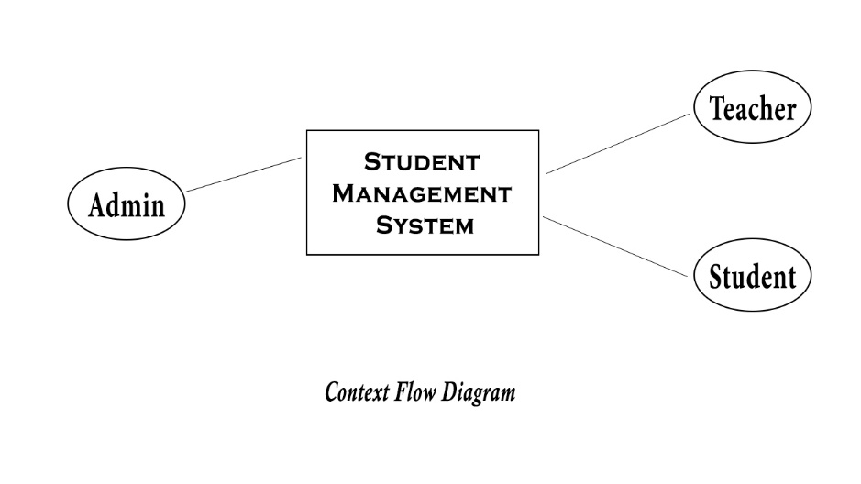
Figure 3.1: context flow diagram

3.2 Data flow diagram:
A Data Flow Diagram (DFD) is a diagram that describes the flow of data and the processes that
Change or transform data throughout a system. We are presenting our DFD below

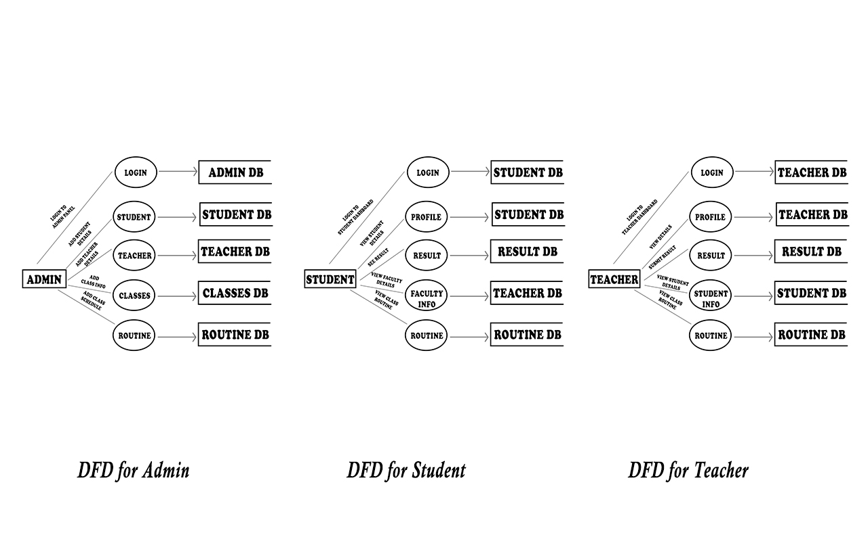 Figure 3.2: Data flow diagram

3.3 Use Case diagram:
UML Use Case diagram for Student profile management is shown below. The various participants of the same are detailed below:-
Actors: Admin, Teacher, Students
Roles for those actors are mentions below:-
Admin: Add teachers and students, Add Class, Add notices and publish calendar.
Teacher: Mark Attendance, Message to students
Student: See routines, View Results
The Use Case UML diagram for School Management System is shown below:-

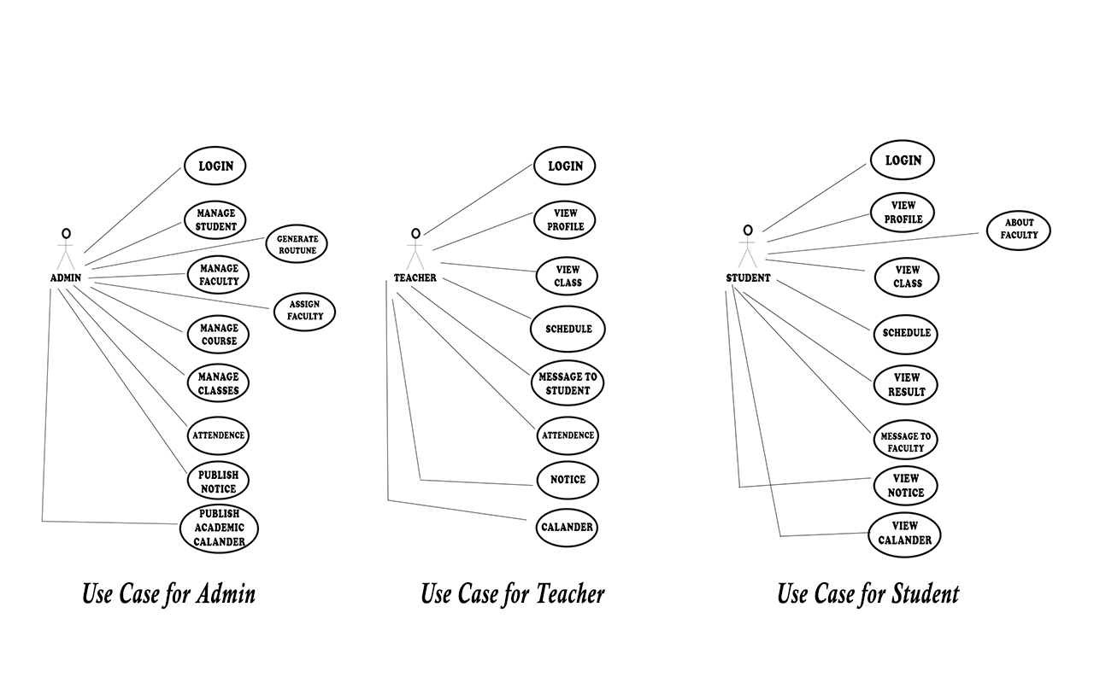Figure 3.3: Use case diagram

3.4 ER diagram:

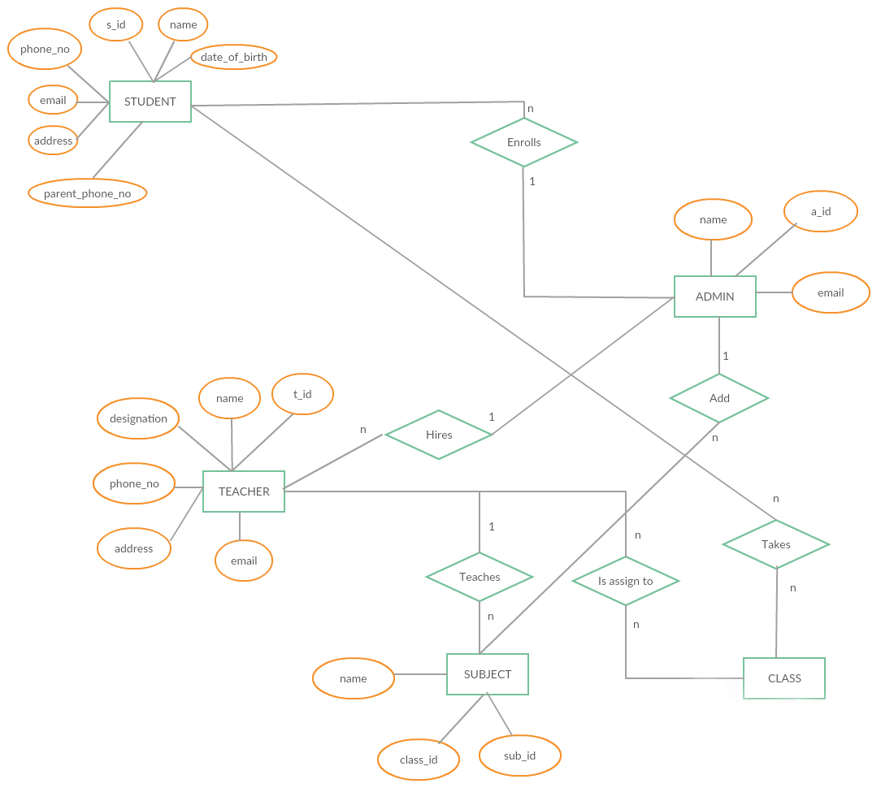

Figure 3.4: ER diagram

3.5 Sequence diagram:

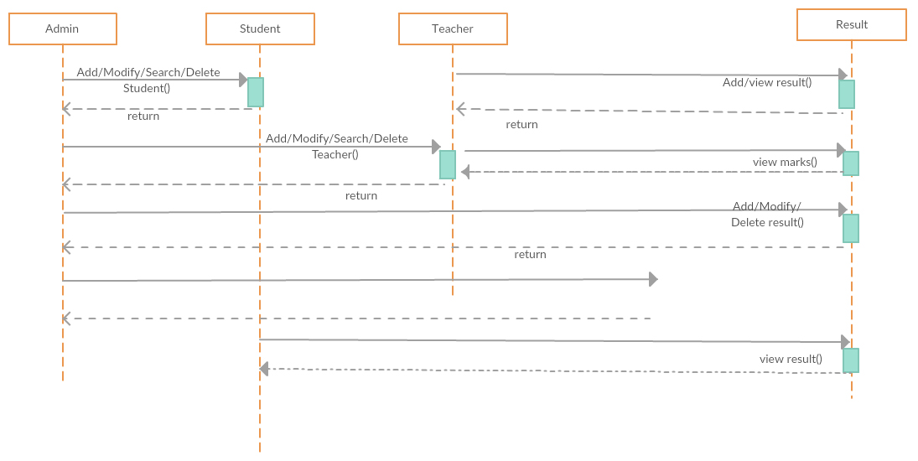
Figure 3.5: Sequence diagram

3.6 Activity diagram:

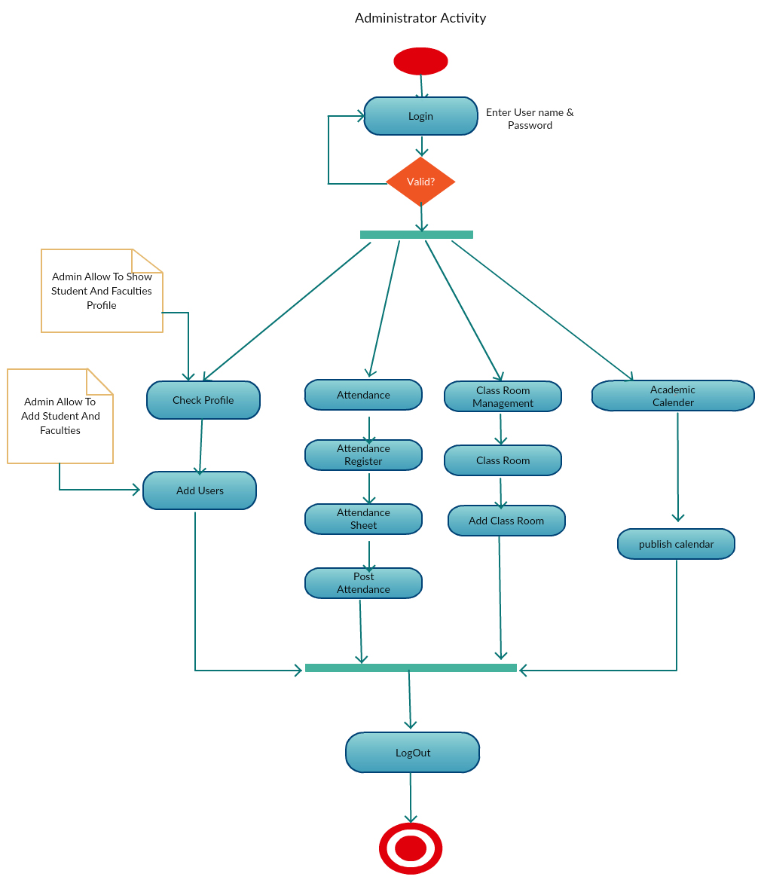
Figure 3.6: Activity diagram

Chapter 4

Project Demonstration:

In this chapter we are discussing about the technologies we have used and screenshots from our projects.

4.1 Technology Used

Operating Systems:

Android device for using the app.

Technologies:

- HTML,CSS and JavaScript
- MySQL

Software:

- PHP
- APACHE HTTP Server
- Eclipse
- Dreamweaver or any other text editor, FrontPage for Front End Programming
- Android SDK

4.2 Project screenshot

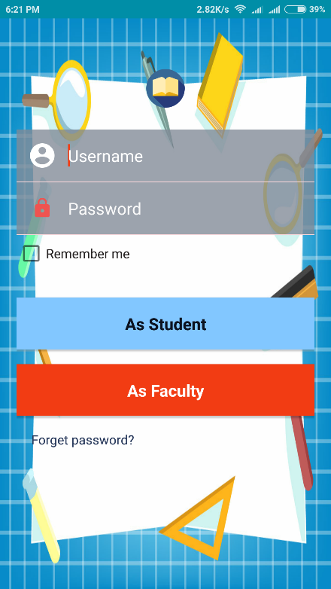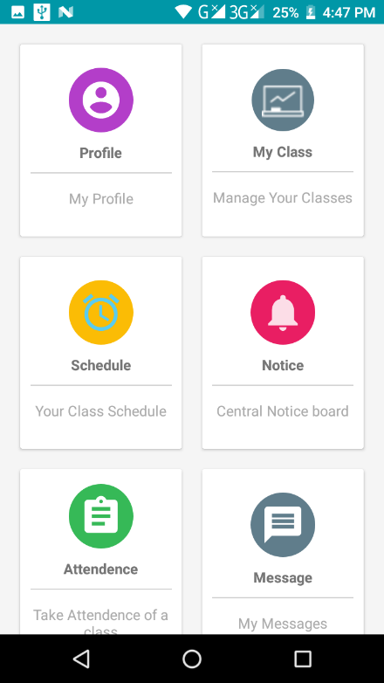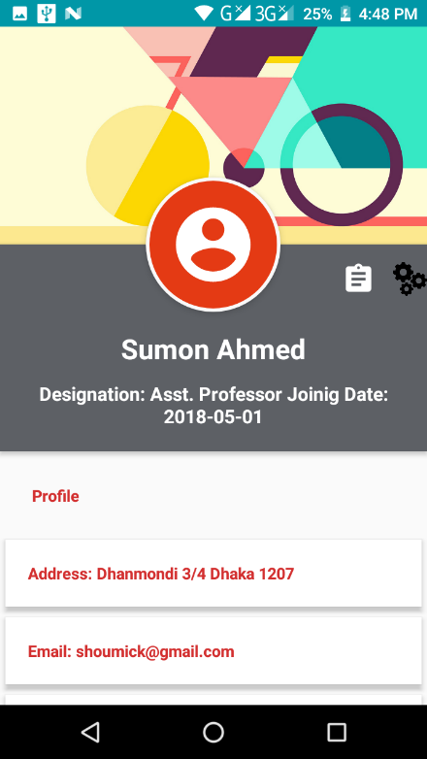
Figure 4.1 Login page Figure 4.2: Faculty Dashboard Figure 4.3: Faculty Profile

[Figure 4.1] this is our app login page. Student and Teacher both can login in their respective dashboard.
[Figure 4.2] this is faculty dashboard. Teacher can see this dashboard after login.
[Figure 4.3] this is profile page for faculty. Teacher can his/her information from this page.

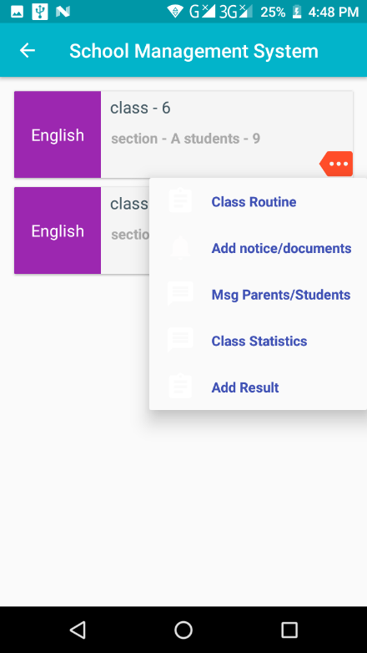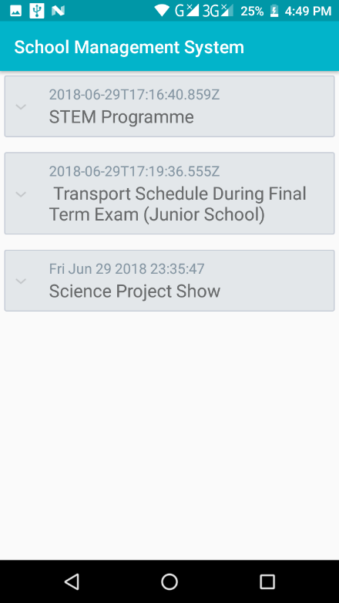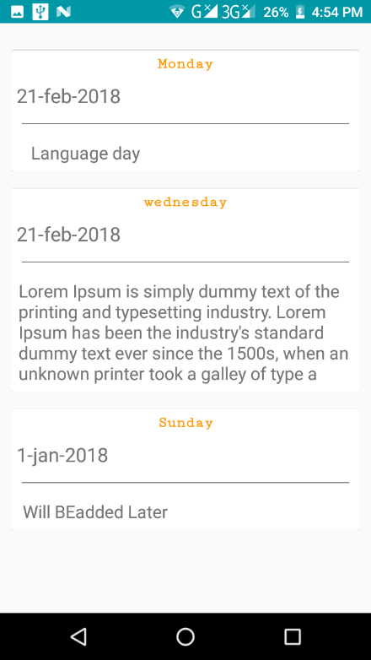
Figure 4.4 my class Figure 4.5 Notice Figure 4.6 Calendar

[Figure 4.4] this is class section for faculty. Classes he/she is taking in this semester
[Figure 4.5] this is central notice section for faculty. Notices published by authority is shown here.
[Figure 4.6] this is academic calendar section for faculty. Events, holidays others information is shown here

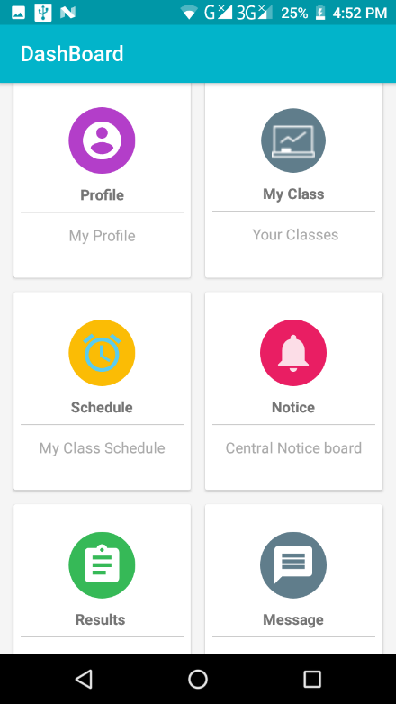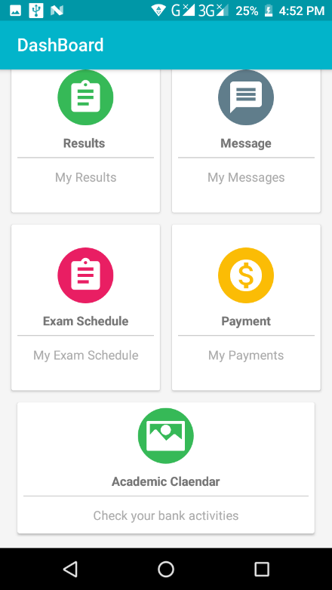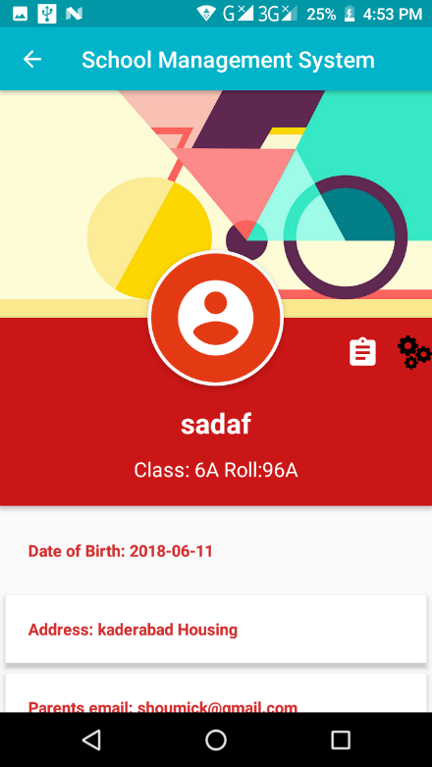
Figure 4.7 Student dashboard Figure 4.8 Student dashboard2 Figure 4.9: Student profile

[Figure 4.7, 4.8] this is student dashboard. Student can see this dashboard after login
[Figure 4.9] This is profile section. Student can check his/her information from this page

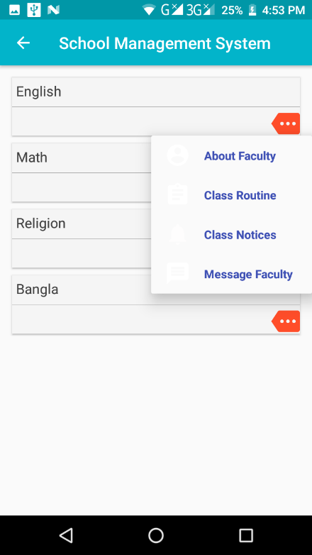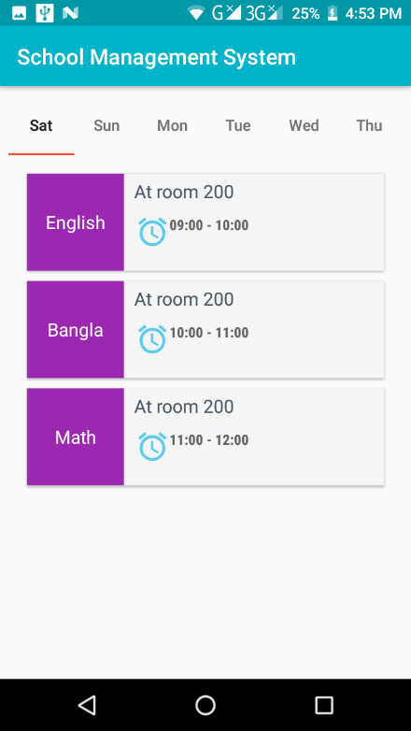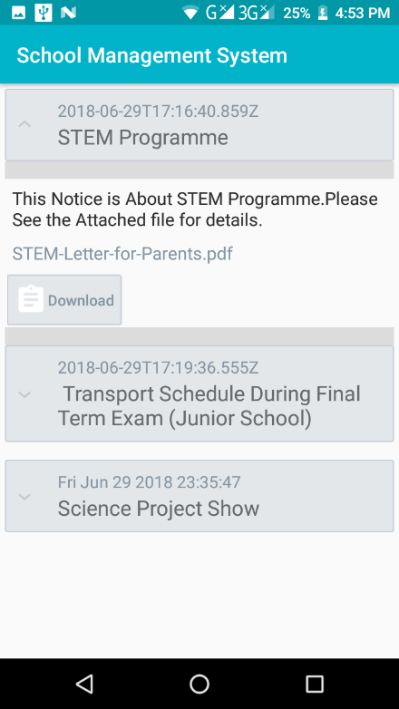
Figure 4.10 my class Figure 4.11 Class routine Figure 4.12: Notice

[Figure 4.10] this is my class section. Student can see classes he/she has in this semester.
[Figure 4.9] This is routine section. Student can check routine of a week with times, & classrooms.

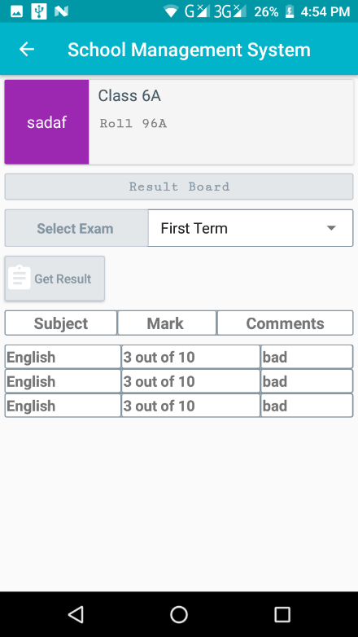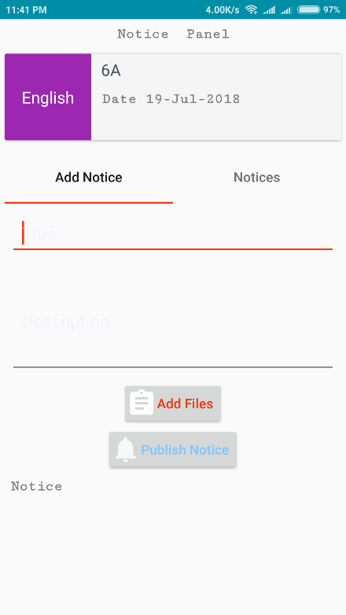
Figure 4.13: Show Result Figure 4.14: Academic calendar Figure 4.15 Add notice

[Figure 4.13] this is result section. Student can check their result from this page.
[Figure 4.14] this is academic calendar section for student. Events, holidays others information is shown here

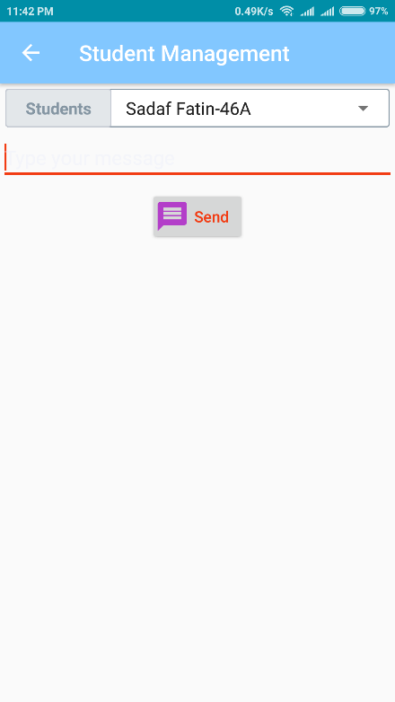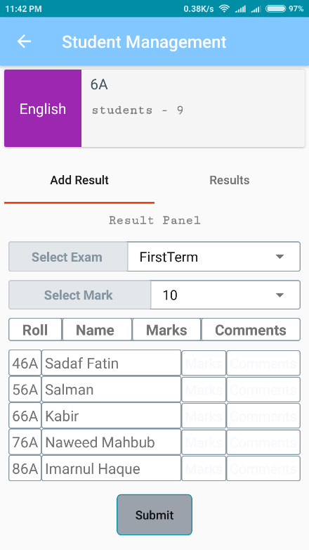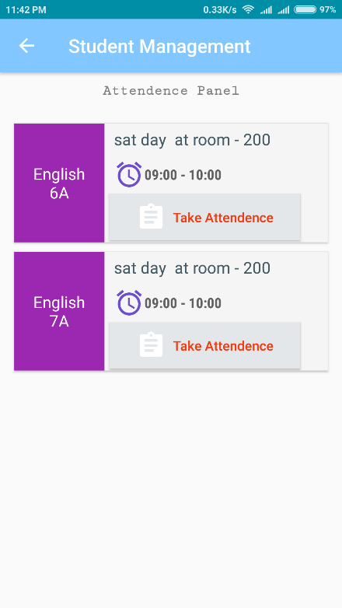
Figure 4.16 message to student Figure 4.17 Add result Figure 4.18 Attendance

[Figure 4.16] this is message section. Teacher can send message to student.
[Figure 4.17] this is add result section. Teacher give marks to the student
[Figure 4.18] this is add attendance section. Teacher give marks to the student

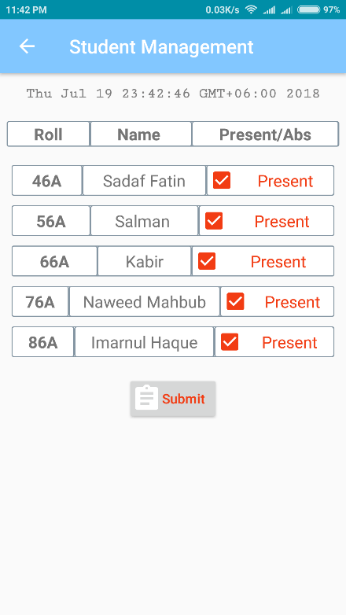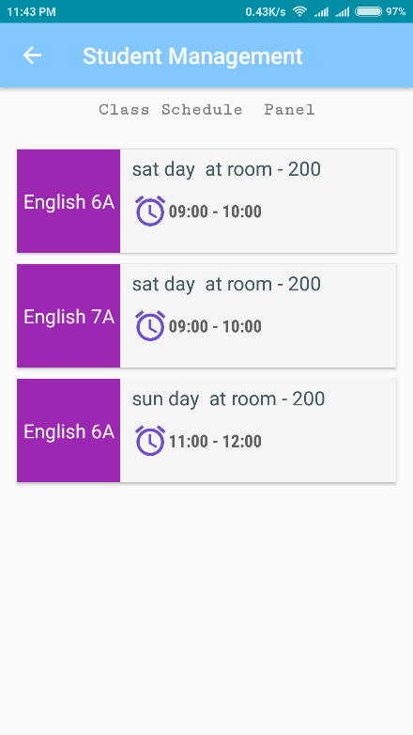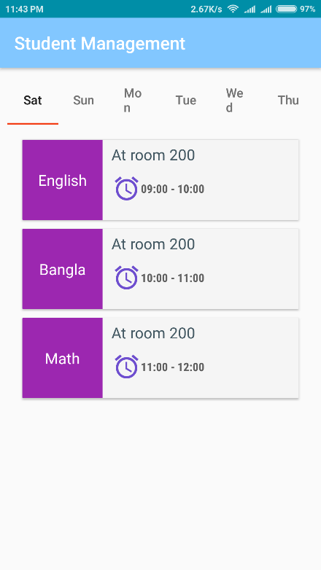
Figure 4.19 Attendance2 Figure 4.20 Schedule Figure 4.21 seven day routine

[Figure 4.19] this is add attendance section. Teacher give marks to the student
[Figure 4.20] this is Schedule for teacher
[Figure 4.21] this is seven day routine section for a student.

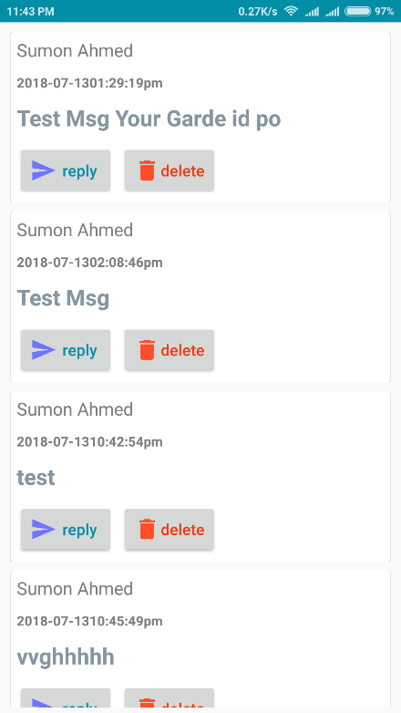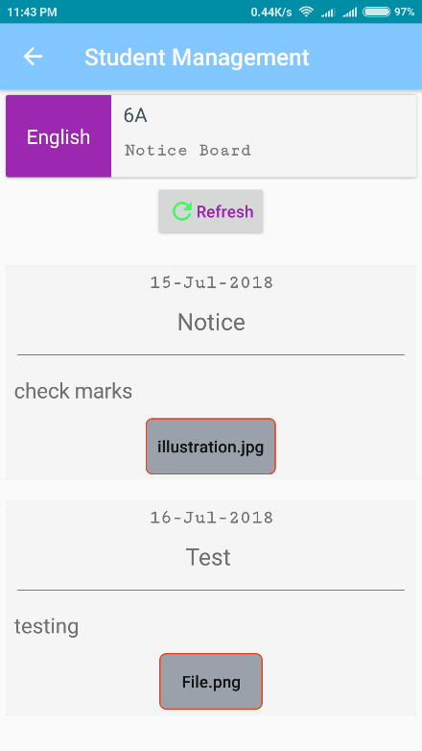
Figure 4.22 Message Figure 4.23 Notice

[Figure 4.22] this is Message section. Student can watch messages they receive from teacher in this section.
[Figure 4.23] This is individual notice section. Student can see notices from teacher.

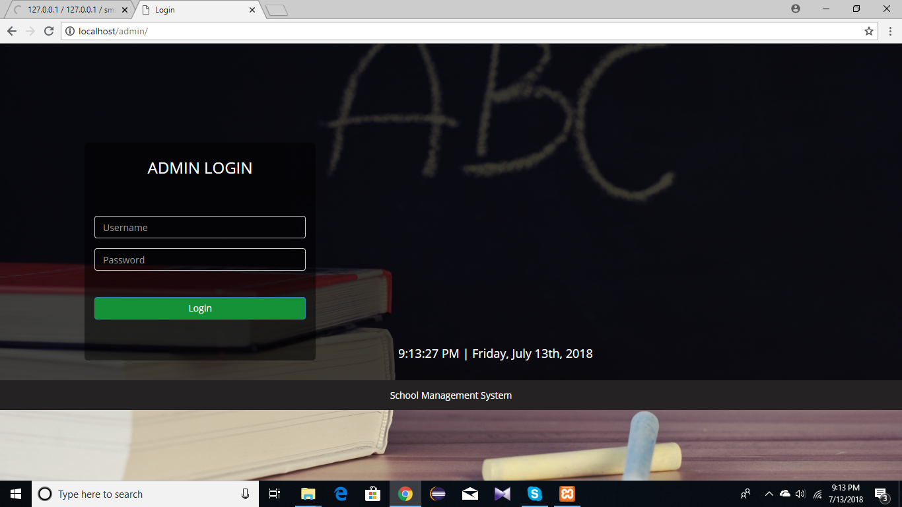

Figure 4.24: Admin login page

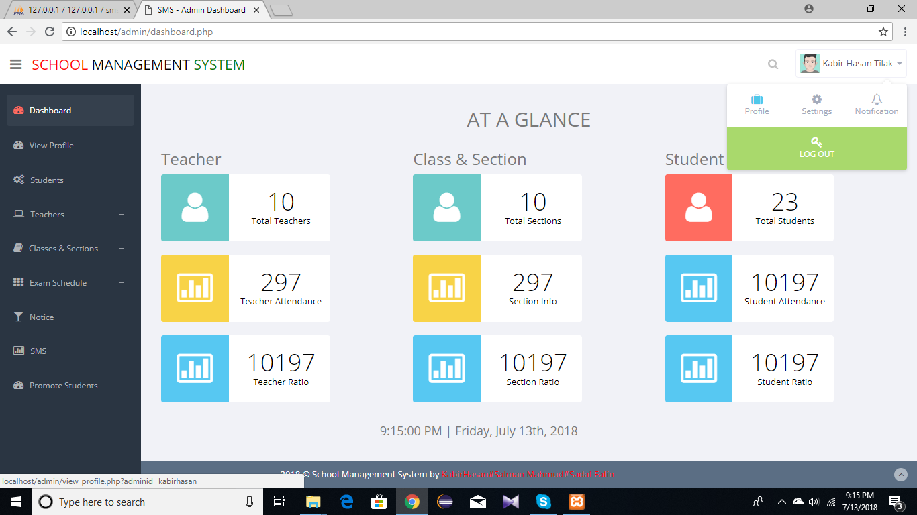

Figure 4.25: Admin dashboard

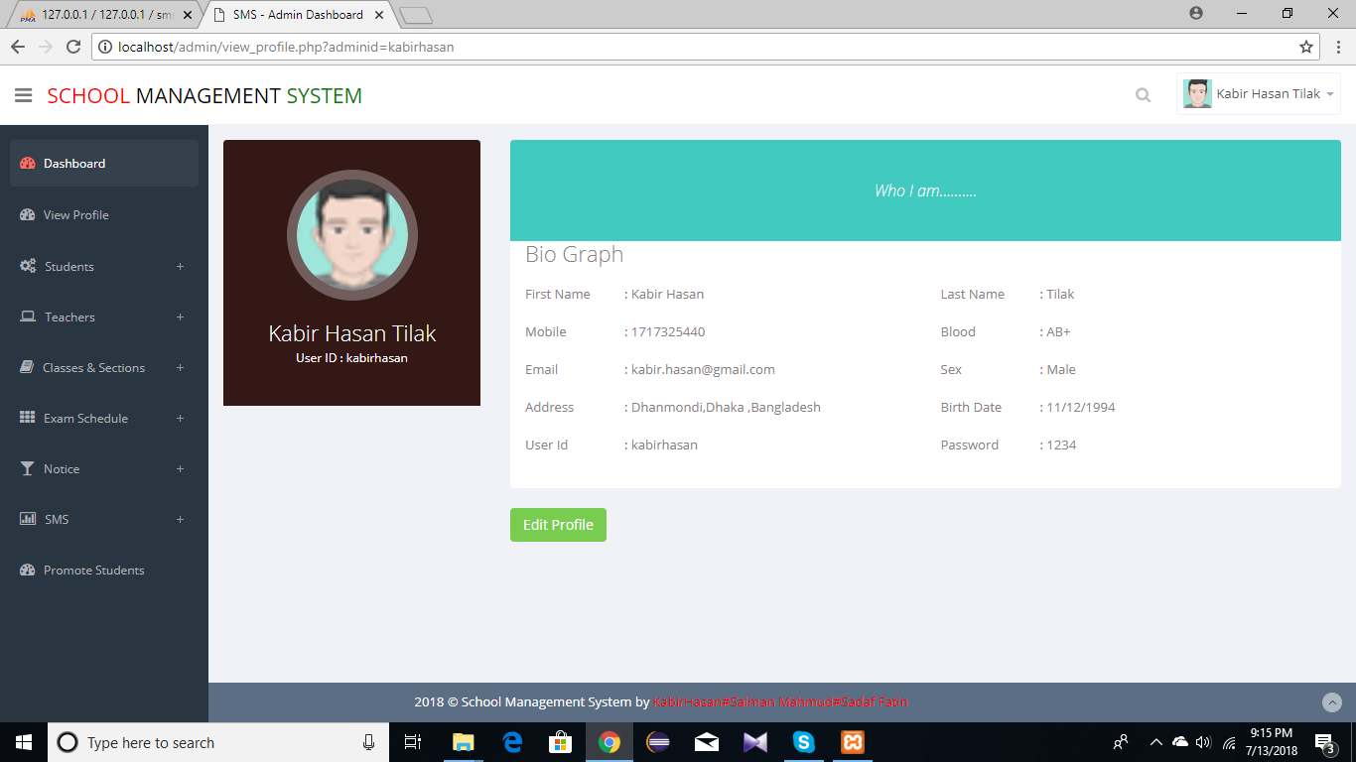

Figure 4.26: checking admin profile

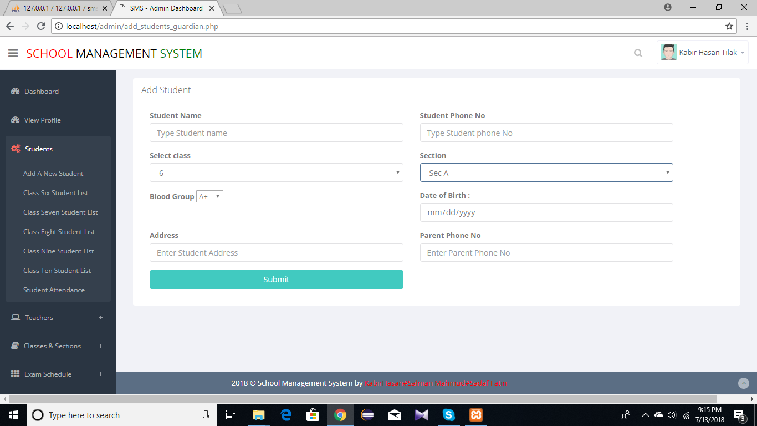

Figure 4.27: Adding student by admin

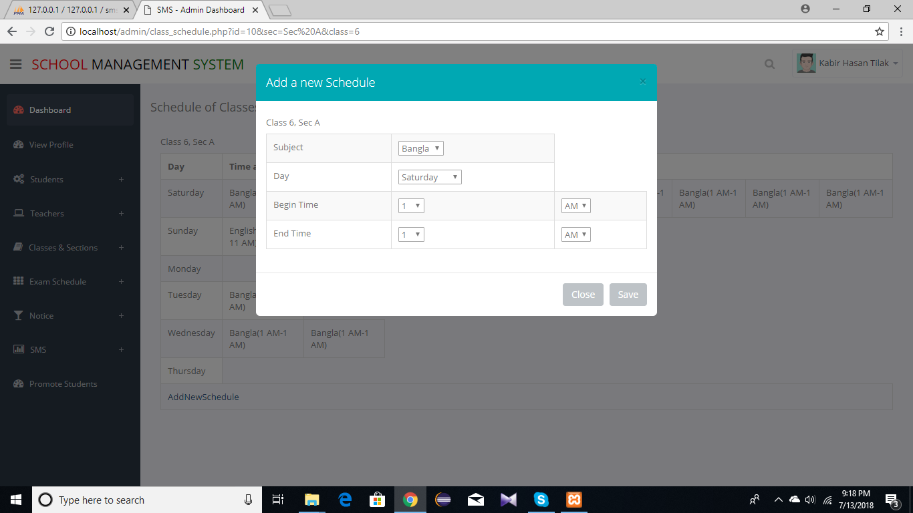

Figure 4.28: Adding new schedule

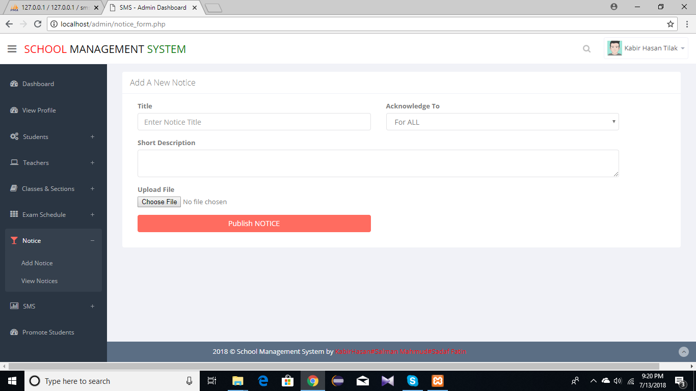

Figure 4.29: Adding central notice from admin

Chapter 5

Conclusion:

5.1 Summary

The system has been developed with simple user interaction, efficient and less time consuming. This Application is useful for any organization who are keen to utilize this kind of software it can be operated very easily. It provides user friendly function and we are willing to make the application more flexible and professional.

5.2 Future Scope & Enhancement of the Project

- Adding billing information.
- Will provide assignment and exam facility.
- A whole new sections for parents.
- Staff Management.

Reference:

- www.google.com
- www.slideshare.com
- www.scribd.com
- www.youtube.com
- www.softwaresuggest.com/us/school-management-software
- www.developer.android.com

