Success Factors in New Product Introduction: A study on MAXIM Label & Packaging (BD) Pvt.Ltd.

MD. Serajus Sakline

This report is submitted to the School of Business and Economics, United International University as a partial requirement for the fulfillment of Bachelor of Business Administration Degree.

Success Factors in New Product Introduction: A study on MAXIM Label & Packaging (BD) Pvt.Ltd.

Prepared by
MD. Serajus Sakline
ID: 111-123-148
Major: Marketing
School Of Business and Economics
United International University

Supervised by
Dr. Kawsar Ahmmed
Associate professor
School of Business and Economics

Date of submission: June 25, 2018
Letter of Transmittal

June 25, 2018

Dr. Kawsar Ahmmed
Associate Professor
School of Business & Economics
United International University

Subject: Submission of Internship Report.

Dear Sir:

It has been a pleasure as well as a challenge on my part to work on Success Factors in New Product Introduction: A study on MAXIM Label & Packaging (BD) Pvt.Ltd. that has enabled me to know about overall marketing practice of all the Accessories products in Maxim Label and Packaging.

I hope you would be to kind to recognize my Intern report and help me to complete my degree.

Sincerely,
MD. Serajus Sakline
ID: 111-123-148
Major: Marketing
School Of Business and Economics
United International University
Acknowledgement

At first I would like to express my gratefulness to almighty Allah as I have completed this internship report on the topic “Success Factors in New Product Introduction: A study on MAXIM Label & Packaging (BD) Pvt.Ltd. " successfully by His compassion. I would also like to thank my honorable supervisor Dr. Kawsar Ahmmed , Associate Professor of Business & Economics, United International University for whom I have prepared this report. I would like to acknowledge and extend my heartfelt thankfulness to him because of his vital encouragement and support and assistance. I would also like to thank Mr. Salman Hossain Khan, Sr. HR Executive of MAXIM LABEL & PACKAGING (BD) PVT.LTD, for his cooperation in the organization. I would also like to thank MD, Tanjim Ahmed, Compliant officer who was my supervisor in the MAXIM LABEL & PACKAGING (BD) PVT.LTD.

I am additionally appreciative to my people and the greater part of my companions for their nonstop help and to every one of the individuals who have somehow added to the arrangement of this report. Last however not the minimum; I am appreciative to every one of the respondents for persistently outfitting the necessary data, which was required for effective finish of this report.

Executive Summary
Maxim Group was established in Taiwan in 1973. This Maxim Label & Packaging Pvt. Ltd. company is a concerned of Maxim Group which has been working internationally. Saying is a designated organization to settle buyers in readymade garments segment. It is one of the main adornments providers in Bangladesh. The primary movement of Maxim is sending out exchanging of pieces of clothing adornments. This report is essentially in light of the Success Factors in New Product Introduction at Label & Packaging Pvt. (BD) Ltd.

As Maxim is a renowned organization, subsequent to getting a request from the purchaser the obligation goes to the floor of Sales and before going creation they do nearly everything to make the business smooth. At that point test making, item improvement, arranging, booking of each and every material for tests and getting endorsement are all the key obligations of Sales. Dealings should work intimately with a buyer to guarantee the item that is purchased will empower them to accomplish the business design. It's regularly clarified its product success, by acquiring market knowledge and meets the customer requirement. Maxim also tackles it competitors by maintaining a competitive business situation, as getting the correct buyers, in the perfect place, at the suitable time, in the correct amounts at the correct cost. The work procedure of offers starts at getting a request from buyers and end with the shipment of that request.

In this report, descriptive statistics were used to see the patter of various factors that have an impact on the new product introduction and success. In addition, we find some correlation among various success factors with the dependent variable namely product success or failure. It shows that correlation between product success or failure and the five variables is strong and their effect on product success or failure. By the analysis, we found that the marketing knowledge and proficiency affect the product success or failure more. But at this stage, the market dynamism affects product success or failure so much low. Based on the findings several recommendations were forwarded along with the conclusion.

Keywords: Business design, maintaining competitiveness, market knowledge, market growth and size, product superiority, new product development

Table of Contents
CHAPTER ONE  Introduction | 1.1 | Introduction | 9
CHAPTER ONE  Introduction | 1.2 | Motivation of the study | 9
CHAPTER ONE  Introduction | 1.3 | Objectives of the Study | 9
CHAPTER ONE  Introduction | 1.4 | Scope of the study | 9
CHAPTER ONE  Introduction | 1.5 | Limitations of the study | 10
CHAPTER ONE  Introduction | 1.6 | Significant of the study | 10-11
CHAPTER ONE  Introduction | 1.6.1 | Value to the customers | 10-11
CHAPTER ONE  Introduction | 1.6.2 | Better society | 10-11
CHAPTER ONE  Introduction | 1.6.3 | Constant existence of the company | 10-11
CHAPTER ONE  Introduction | 1.7 | Organization of the remaining chapters | 11
CHAPTER TWO  Organizational Overview and Literature Review | 2.1 | Profile | 13
CHAPTER TWO  Organizational Overview and Literature Review | 2.2 | Core value | 13
CHAPTER TWO  Organizational Overview and Literature Review | 2.3 | Missions & Vision | 13
CHAPTER TWO  Organizational Overview and Literature Review | 2.4 | Service to the client | 13
CHAPTER TWO  Organizational Overview and Literature Review | 2.5 | Product and service of the organization | 15
CHAPTER TWO  Organizational Overview and Literature Review | 2.6 | Management team | 17
CHAPTER TWO  Organizational Overview and Literature Review | 2.7 | Corporate social responsibility | 18
CHAPTER TWO  Organizational Overview and Literature Review | 2.8 | Buyers of Maxim | 19
CHAPTER TWO  Organizational Overview and Literature Review | 2.9 | Operational Countries | 19
CHAPTER TWO  Organizational Overview and Literature Review | 2.10 | What does Product success and failure (PSF) Means? | 20
CHAPTER TWO  Organizational Overview and Literature Review | 2.11 | Why Product success and failure (PSF) important? | 20
CHAPTER TWO  Organizational Overview and Literature Review | 2.12 | What Factors impact on Product success and failure (PSF)? | 22
CHAPTER TWO  Organizational Overview and Literature Review | 2.12.1 | Top Management Support | 22
CHAPTER TWO  Organizational Overview and Literature Review | 2.12.2 | Market Orientation | 22
CHAPTER TWO  Organizational Overview and Literature Review | 2.12.3 | Technology | 22
CHAPTER TWO  Organizational Overview and Literature Review | 2.12.4 | Knowledge Management | 22
CHAPTER TWO  Organizational Overview and Literature Review | 2.12.5 | New Product Development Strategies | 22
CHAPTER TWO  Organizational Overview and Literature Review | 2.12.6 | New Product Development Speed | 22
CHAPTER TWO  Organizational Overview and Literature Review | 2.12.7 | New Product Development Process | 22
CHAPTER TWO  Organizational Overview and Literature Review | 2.12.8 | New Product Development Teams | 22
CHAPTER TWO  Organizational Overview and Literature Review | 2.12.9 | The Take Away | 22
CHAPTER TWO  Organizational Overview and Literature Review | 2.13 | Study Variable | 26
CHAPTER TWO  Organizational Overview and Literature Review | 2.13.1 | Marketing Knowledge and Proficiency (MKP) | 26
CHAPTER TWO  Organizational Overview and Literature Review | 2.13.2 | Product Superiority (PUS) | 26
CHAPTER TWO  Organizational Overview and Literature Review | 2.13.3 | Market competitiveness and customer satisfaction (MCS) | 26
CHAPTER TWO  Organizational Overview and Literature Review | 2.13.4 | Market need, growth and size (MNG) | 26
CHAPTER TWO  Organizational Overview and Literature Review | 2.13.5 | Market Dynamism (MD) | 26
CHAPTER THREE  Study Methods, Data Analysis and Discussion | 3.1 | Introduction | 30
CHAPTER THREE  Study Methods, Data Analysis and Discussion | 3.2 | Sample For the present study | 30
CHAPTER THREE  Study Methods, Data Analysis and Discussion | 3.3 | Measurement | 30
CHAPTER THREE  Study Methods, Data Analysis and Discussion | 3.3 | Table 1 | 30
CHAPTER THREE  Study Methods, Data Analysis and Discussion | 3.3 | Table 2 | 30
CHAPTER THREE  Study Methods, Data Analysis and Discussion | 3.3 | Table 3 | 30
CHAPTER THREE  Study Methods, Data Analysis and Discussion | 3.3 | Table 4 | 30
CHAPTER THREE  Study Methods, Data Analysis and Discussion | 3.3 | Table 5 | 30
CHAPTER THREE  Study Methods, Data Analysis and Discussion | 3.3 | Table 6 | 30
CHAPTER THREE  Study Methods, Data Analysis and Discussion | 3.4 | Data collection procedures | 33
CHAPTER THREE  Study Methods, Data Analysis and Discussion | 3.5 | Data Analysis | 33
CHAPTER THREE  Study Methods, Data Analysis and Discussion | 3.6 | Findings | 33
CHAPTER THREE  Study Methods, Data Analysis and Discussion | 3.7 | Correlation | 34
CHAPTER THREE  Study Methods, Data Analysis and Discussion | 3.8 | Discussion | 35
CHAPTER THREE  Study Methods, Data Analysis and Discussion | 3.9 | Recommendations | 35
CHAPTER THREE  Study Methods, Data Analysis and Discussion | 3.10  3.11  3.12 | Conclusion | 35
CHAPTER THREE  Study Methods, Data Analysis and Discussion | 3.10  3.11  3.12 | Reference | 36
CHAPTER THREE  Study Methods, Data Analysis and Discussion | 3.10  3.11  3.12 | Appendix | 37

Chapter one
Introduction

1.1. Introduction
Basically this report is on Success Factors in New Product Introduction. So it is an important factor to any organization to manage and maintain the success method to survive in the market. Here we will find many ways to judge the market and customers need.
Now days many renown company use their own strategy to compete with others and do the best thing to capture the market. As an example we can talk about the two giant Apple and Samsung. They always take each other out by offering some exclusive to the market.
So our study is to know how the factors work with new product development process in the market.
1.2. Motivation of the study
By this study now I can clearly understand how MAXIM LABEL & PACKAGING (BD) PVT.LTD Work so smoothly and satisfied the client
1.3. Objectives of the Study
Main objective
The main objective of the study is to make an overall analysis on MAXIM LABEL & PACKAGING (BD) PVT.LTD
Specific Objective
- To know the marketing policy of Maxim’s products
- To know what compels to consume Maxim’s products.
- To know the preferred price for the entire products category.
- To find out the market share and growth of Maxims products.
- To find out the consumer perception towards newly developed products.

1.4. Scope of the study
Internship experience plays a significant role for every student to implement their theoretical information and get a practical knowledge from any organization. A student can implement this internship experience in his future employment area. Maxim Label and Packaging gives me opportunity for gathering practical experience and preparation of the report. I prepared this report under the super supervision of Md. Kawsar aahmed sir, Assistant Professor, Department of Marketing, United International University (UIU). In this report, the overall view of the Garments Accessories, its history and instrument, policies and appraisal of Maxim label and packaging and other areas of activity is widely analyzed and the finding is clarified along with the depth study. This study focuses mainly on “Success Factors in New Product Introduction”.

1.5. Limitations of the study
•Time limitation was a big fact as it was a 3 months program so I had to collect all the information’s around that time.
•Hard to collect information from websites and internets.
•There was no choice to compare the new product with other brands so comparison may not give exact hypothesis.

1.6. Significant of the study
Item advancement is the life-blood of organizations and social orders. The item could be a physical item, for example, a vehicle, cell phone, or espresso producer. It could likewise be administrations, for example, new IT arrangement, new assembling process, or another land showcasing idea.
All successful product development actions provide the following:
- Value to the customers
- Better society
- constant existence of the company

1.6.1. Value to the Customers
The first and most vital purpose behind any new advancement is to give new an incentive to the client. Without this, there is no purpose behind them to exchange their cash for the new gadget. In any case, if the item or administration offers overpowering worth, at that point clients will run to it.

This new and expanding esteem is the thing that keeps organizations developing. On the off chance that there is no new an incentive to offer clients, the firm shrinks and in the end kicks the bucket. In the event that the esteem offered isn't expanding, at that point the organization is losing ground in the market as its rival’s increment their incentive in the market.
1.6.2. Better Society
Numerous new items are just an incremental change over the past adaptation with just some new highlights or slight speedier execution. These items may support the organization by offering enough new an incentive to produce extra income; however they are not really a shelter to society.
There are sure occasions where new items will enhance society past simply the quick satisfaction of the customer. Case of these is inventive new medications to treat crippling infections and car wellbeing gadgets that spare several lives for every year. Neither of these may offer the buyer quick fulfillment, yet they spare lives and accordingly enhance society.
1.6.3. Constant Existence and Growth of the Company
New items and administrations are the soul of any organization. Without them, the firm dies from neglect and either bites the dust or is consumed by another firm. Society is all around served by the duration of these organizations from the work of the people who work there (who are likewise shoppers), and the help for society everywhere as tax assessment and altruistic giving.

Organizations (and human advancements) have minimal decision however develop and enhance on the off chance that they need to move from survival to flourishing. The new items and administrations made and gave by organizations of all sizes give the component to this development and change.

1.7. Organization of the remaining chapters
In the remaining chapter I‘ll discuss an overview of the organization. By this we will know about the profile, mission, vision, service, product, management team, corporate social responsibilities, buyer and many more things
In literature review I’ll discuss product success and failure part and also the study variables.
In chapter three the data collection and processing will be discussed.

Chapter Two
Organizational Overview and Literature Review

2.1. Profile of the MAXIM LABEL & PACKAGING (BD) PVT.LTD
Maxim Group was established in Taiwan in 1973. What started off as a small company in Taiwan has now become a company with more than 4000 employees worldwide? MAXIM LABEL & PACKAGING (BD) PVT.LTD. is a concern of Maxim Group. Maxim located at Mirpur-1, Dhaka, you can say It's our liaison office in Bangladesh. We are nominated company for fixed buyer in RMG sector. It is one of largest leading garments accessories supplier, managing the supply chain for retailers and brands worldwide. Its headquarter situated in China, Taiwan. Most of the order comes from UK, Russia & USA Office to MAXIM LABEL & PACKAGING (BD) PVT.LTD.

2.2. Core value
- Global
- Reliable
- Service oriented
- Passionate
2.3. Missions & Vision
Our mission is to provide reliable, global and seamless solutions for the label and packaging industry. We strive to be our clients’ premium partner for the sustainable development of their enterprises and brands.

2.4. Service to the client
Maxim does not see itself as just a manufacturer, but rather a solution provider for our customers. We offer creative solutions that help brands and retailers to develop a product from idea conception to final production. Our design team produces a trend book to support our customers with inspirations annually. Our customers can also choose from Maxim design showrooms and exhibition booths that showcase current trends and hot topics.
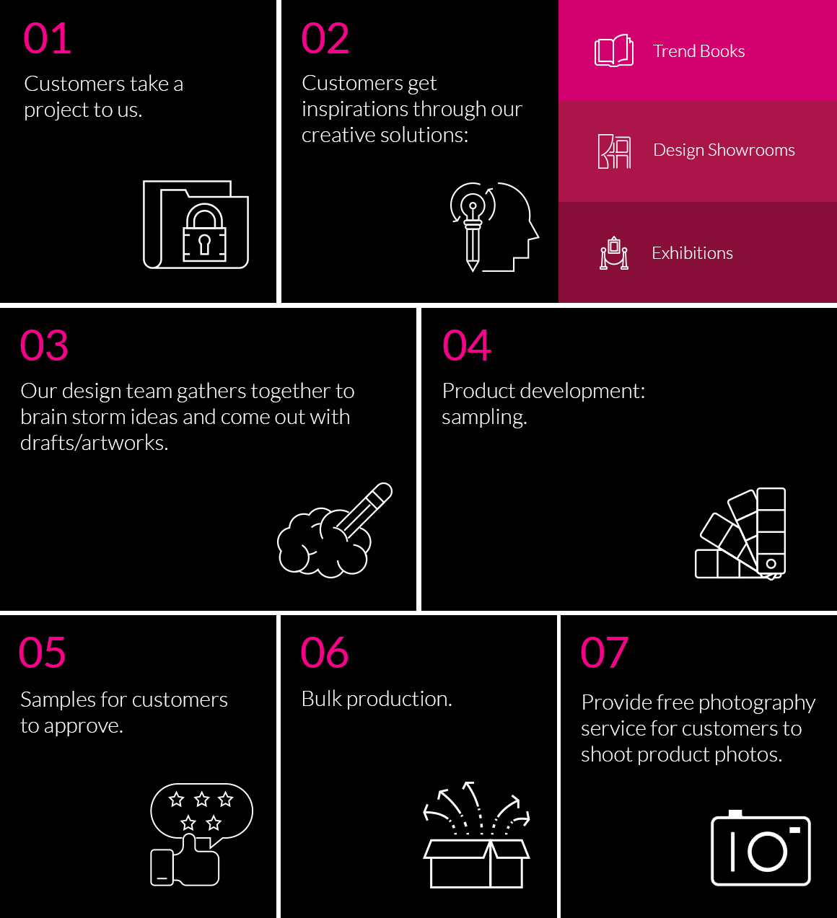

2.5. Product and service of the organization

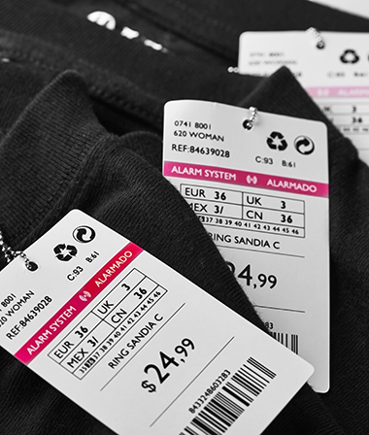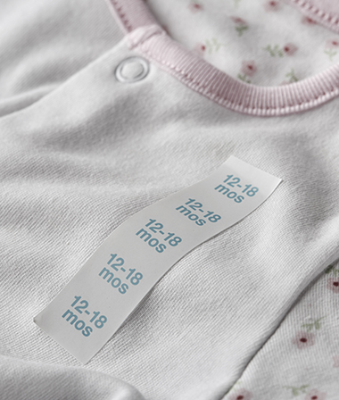
Price tickets Adhesives

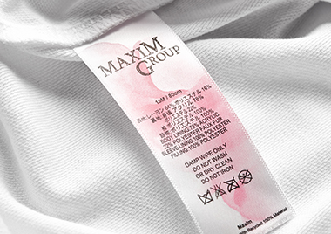
Care Labels Hang tags

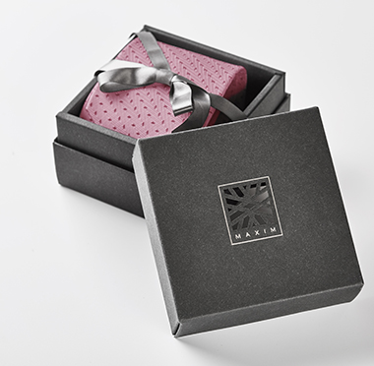

Packaging


RFID

2.6. Management team
CEO
Manager
Head of sales
Junior (QA)
Production Coordinator
Business Head
Executive customer service
Senior (QA)
Head (Quality Assurance)
Sales Supervisor
Junior Sales
Senior sales

2.7. Corporate social responsibility
Green Factory
Maxim is committed to minimalizing our impact on the environment. We integrate sustainable practices in all our offices and manufacturing facilities. We have a dedicated Corporate Social Responsibility (CSR) team that conducts audits in all our locations. Being sustainable is a core value in our company’s culture and we practice it in many different ways:
- Recycling 400 tons of paper annually
- Replaced 1300 light bulbs with LED energy-saving light bulbs
- Installed solar panels for clean energy
- Using vegetable-based inks
- Waste-gas and wastewater treatment that meets international standards
Sunshine Charity Program
Maxim believes that education is the key to achieving sustainability. The Sunshine Charity Program was created in 2004 to bring happiness to needy students in the form of scholarships and donations. Goods and monetary donations from employees and customers are collected all year round. Maxim also sets aside a portion of earnings as proceeds for the program annually.

Employees volunteer to go to impoverished remote locations to award scholarships and distribute proceeds and donations. Qinghai province and Ningxia autonomous region are annual destinations. In those locations, Maxim organizes events that promote the preservation of local culture. The Maxim Singing Contest is held annually in Qinghai to recognize children that are gifted in the art of singing.




2.8. Buyers of Maxim
H&M Disney Store GAP




Adidas Nike Levi’s

2.9. Operational Countries
Year Country
1973 Taipei, Taiwan
1994 Shanghai(HQ), China
2001 Ho Chi Minh, Vietnam
2001 Hong Kong
2007 ZheJiang, China
2007 Phnom Penh, Cambodia
2009 Bangalore, India
2010 Dhaka, Bangladesh
2011 Köln, Germany
2011 New Delhi, India
2012 Barcelona, Spain
2012 North Carolina, USA
2013 Karachi, Pakistan
2013 Istanbul, Turkey
2014 London, UK

Literature Review

2.10. Product success and failure (PSF) means to us
Product success and failure (PSF)
Everyone needs a fruitful item, however achievement isn't generally simple to benchmark. These estimations can differ in view of industry and utilitarian setting. Item achievement is at last accomplished when an item rapidly on sheets new clients and conveys steady an incentive to them. Organizations that make item progress develop clients, develop income, and beat their rivals.
And the other hand, the off chance that the item and brand disappointments happen on a continuous premise to differing degrees inside most item based associations. This is the negative part of the advancement and promoting process. Much of the time, this "disappointment rate" disorder winds up being a numbers amusement. There must be some proportion of effective items to everyone that winds up being a disappointment. At the point when this does not occur, the association is probably going to fall flat, or possibly encounter budgetary troubles that preclude it from meeting productivity goals. The essential objective is to gain from item and brand disappointments with the goal that future item advancement, plan, technique and execution will be more productive.
A product is a failure when its existence in the market leads to:
- It may be the extraction of the product from the market for any cause;
- The incapability of a product to realize the required market split to sustain its presence in the market;
- The incapability of a product to achieve the predictable life cycle as defined by the organization due to any reason; or,
- The ultimate failure of a product to achieve abundance.

2.11. The importance of product success and failure (PSF)
Albeit no single variable holds the way to new item execution, a large number of the generally perceived achievement factors share a repeating theme: the handling of market data. Understanding client needs and needs at last comes down to an organization's abilities for social event and utilizing market data. What's more, another very much recognized achievement factor the reconciliation of advertising, R&D, and assembling centers around the sharing of data. At the end of the day, an association's viability in advertise data preparing—the social affair, sharing, and utilization of market data—assumes a significant part in deciding the achievement or disappointment of its new items.

The aftereffects of an investigation that inspects the association between showcase data preparing and new item achievement. They likewise investigate the authoritative components that encourage effective handling of market data, and in this way offer thoughts for better dealing with the improvement of new items. The respondents—promoting, R&D, and assembling administrators from Utah-based PC and medicinal gadget makers—gave data around 58 new items, including level with quantities of victories and disappointments.
The studies reactions uncover solid connections between item achievement and market data handling, with progress most firmly connected to data utilize. As such, the social occasion and sharing of data are critical, yet just if the data is utilized adequately. In 80 percent of the item victories contemplated, the respondents at last had and utilized a more noteworthy than normal measure of market data. Furthermore, in 75 percent of the disappointments, the respondents knew not as much as normal about the market at venture initiation, and accumulated or utilized not as much as the normal measure of market data amid the undertaking. For the projects in this study, the integration of marketing, R&D, and manufacturing contributed not only to the sharing and use of information, but also to overall project success.

2.12. Factors that impact on Product success and failure (PSF)

2.12.1. Top Management Support
At first look, this has all the earmarks of being totally wild of the plan group. All things considered, top chiefs settle on the choice regarding what to help and what not to help right?

Lamentably, it isn't so much that basic. The help of best administration is basic to a venture's prosperity. Without that help, spending plan or assets are not prone to be allowed to the venture and it may not get the need it needs inside the business for some time. In any case, while the plan group can't drive administration to help their activities they can build up the political canny to convince administration to help the best ventures.

Figuring out how to impact supervisors is a basic ability for configuration groups. Setting out on ventures without administrative help is a formula for disappointment however prevailing upon help is an issue of initiative and correspondence.

2.12.2. Market Orientation
Investopedia characterizes advertise introduction as takes after: "Market introduction is an organization reasoning concentrated on finding and addressing the necessities and wants of its clients through its item blend."

It appears to be sensible to recommend that while an outline group does not have control over organization theory it ought to be in a decent position to impact this. Directing client investigate and where suitable statistical surveying – two basics of growing excellent client encounters; will empower the revelation of client/client needs and how to meet them

2.12.3. Technology
The innovation used to make and convey the item should be appropriate for the market. While it is impossible that the outline group will have the last say in innovation spending plans or assignment it is likely that they will have the capacity to impact the advancement groups in their decision of innovation.

Obviously, for instance, multi-million dollar equipment and programming prerequisites will make an item blocked off to the shopper advertise yet may not be an unfavorable obstacle for government or corporate markets.
Technology must be chosen with the end-users in mind

2.12.4. Knowledge Management
In many organizations today; knowledge is treated like gold dust and guarded by its owners as they would stole treasure. Unfortunately, the creation of knowledge silos like these makes it impossible for knowledge to be effective.

Market research data, for example, can be incredibly useful to a design team but only if they can access that data and it’s not kept securely in the marketing department under lock and key. Likewise user research data can be highly valuable to the marketing team but once again – only if they can access it.

Knowledge management structures will normally fall outside of the design team’s remit. However, there is nothing preventing the design team from advocating for open knowledge management structures or indeed persuading senior management to support such structures.

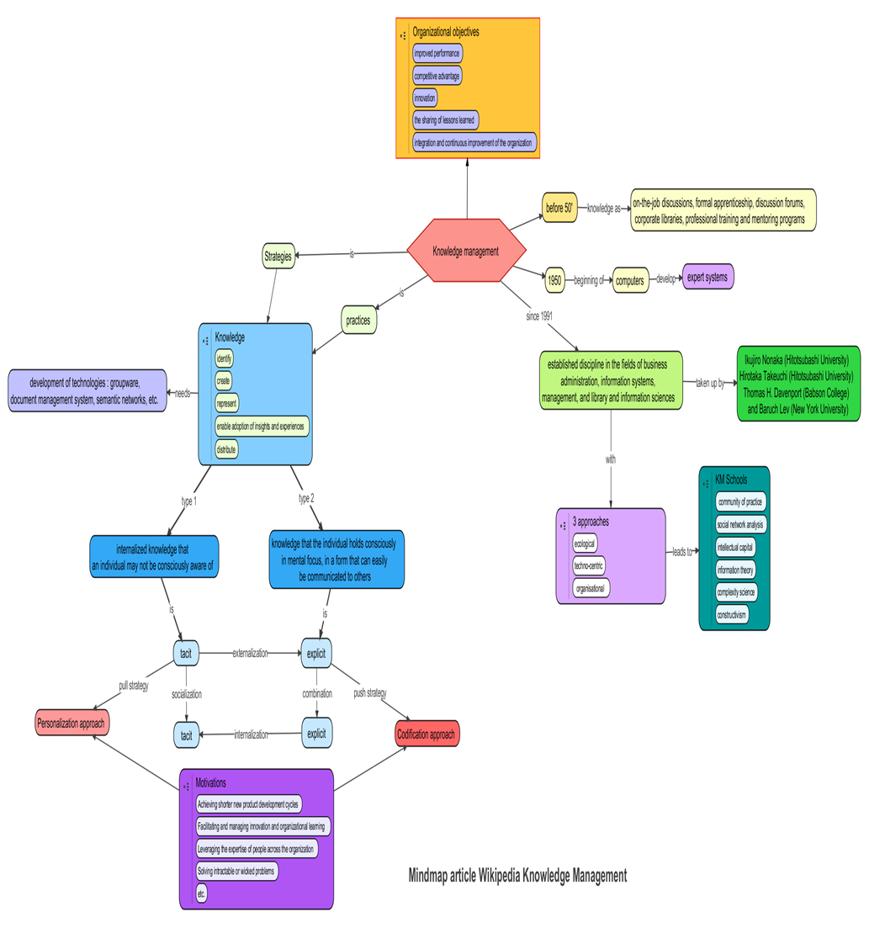

2.12.5. New Product Development Strategies
A technique, notwithstanding the way usually mishandled in administration talk is basically; "an arrangement of activity intended to accomplish a long haul or general point."

Obligation concerning new item advancement systems is most likely going to be shared between outline, item administration and improvement. This implies the outline collection will have some contribution to the systems picked and will have the capacity to impact these techniques with their client research to manage the tactic to fit the necessities of their clients. It is likely reasonable for say that item administration will typically have the last say on a key bearing yet fashioners have a lot of freedom to consult with item directors to guarantee better results

2.12.6. New Product Development Speed
Speed to platform is a basic factor in progress. On the off chance that your new item improvement process takes 5 years however your rival's takes 2 years – it is likely that in spite of of how great your outlines are; they will have been overshadowed when they get the chance to advertise.
Refining the outline procedure to amplify speed while securing the client encounter is a sensitive exercise in careful control and it is completely inside the architect's transmit. Be that as it may, the advancement process speed is significantly less prone to be inside the outline group's control and their ability to impact that speed might be negligible, best case scenario.

2.12.7. New Product Development Process
Having clear procedures for plan and advancement are primary. While these might be custom fitted to fit particular circumstances – a strategy for working that is plainly comprehended and consented to by all individuals from the item advancement group is exceedingly prone to item preferable outcomes over those made with no formal procedure.

The plan group will, regularly, have some contribution to these procedures and have the capacity to arrange changes to forms when they neglect to create ideal outcomes. There is little control for the outline group over the way different groups execute these procedures. Disappointment in execution, from different groups, is one of only a handful couple of zones where it is sensible to state that disappointment was totally outside of the outline group's control.

2.12.8. New Product Development Teams
New item improvement ordinarily unites groups of differing individuals from the whole way across an endeavor. It is firmly proposed that these different groups have a tendency to be exceedingly innovative and more fruitful than groups of a more institutionalized nature.

The way groups cooperate is a basic factor in their prosperity and architects working as a major aspect of such a group have their part to play in this. Polished skill and authority can be shown by any individual from a group (counting those without official administration and administration parts) and keep in mind that the outline group can't manage any obligation regarding the activities of others inside a group – they bear finish duty regarding their own behavior.

As Michael Jordan, the world acclaimed competitor and b-ball hotshot says; "Ability wins recreations, yet collaboration and knowledge wins titles."

2.12.9. The Take Away
Not every factor of success for a new product development project is directly within the design team’s remit. However, in the majority of cases the design team will have the ability to influence these factors and play a strong role in ensuring that the project is given the greatest possible chance of success.

The 8 key factors involved in new product development are Knowledge Management, Market Orientation, New Product Development Process, New Product Development Speed, New Product Development Strategies, New Product Development Teams, Technology and Top Management Support.

Study Variable
2.13.1. Marketing Knowledge and Proficiency (MKP)
At first we have to gain the absolute marketing knowledge, and then we have to study about the impact about the new product success in the market. After that we should understand about customers need and want properly. A well understanding of customer price sensitivity also impact on the new product success. Understand the next step of competitors against our new product launch. And after that we have to measure the potential size of our market.

2.13.2. Product Superiority (PUS)
We must offer special and unique feature to our customers. The new product should be better than our competitor’s product and also meets client’s need. It must maintain the top quality to serve its customer.
This ratio is resolute by dividing company s total expenditures for creating new products and processes by total annual sales. Higher percentages are indicative of the quantity of promise a firm devotes to product modernism.

2.13.3. Market competitiveness and customer satisfaction (MCS)
A competitive market is one in which a large numbers of producers compete with each other to please the wants and needs of a large number of customers. In a competitive market no single manufacturer, or group of producers, and no single consumer, or group of consumers, can dictate how the market operates.
It is a measure of how products and services supplied by a company meet or surpass customer expectation. Customer satisfaction is a measurement used to quantify the degree to which a customer is happy with a product, service, or experience
When it comes down to it, customer happiness is a reflection of how a customer feels about interacting with your brand. And businesses and brands enumerate this positive or negative feeling principally using surveys

2.13.4. Market need, growth and size (MNG)
Marketplace needs" is a marketing concept that relates to the functional or emotional needs or desires of a target market. Generally, a successful company identifies when a segment of customers is not effectively served by existing providers and develops and promotes products or services to match.
If the market is large then the new product will make great impact on the market. High potential market can influence the new product launch.

2.13.5. Market Dynamism (MD)
Market dynamics means the factors that affect a market. Frequently new product introduction to the market will help to engage the customer with the brand. Also quick changes of the customers need make a negative impact for a new product launch.

In PSF MKP needs to understand the market and customers need . How much customers are sensitive with the price of a new product.
PUS shows how much uniqueness we can offer a customer as a new product in the market
MCS helps to understand the competition by comparing the product side by side with our competitors.
MNG knowledge is important to understand what kind of thing customers actually needed. It also creates the customers future need.
MD is one of the powerful factor what changes the need and the uniqueness of a product to take the advantages from market.

Chapter Three
Study Methods, Data Analysis and Discussion

3.1. Introduction
In this sector we will discuss about the findings and the result of new product success and failure. What actually influence the success rate of new entry product and what is the reason behind the failure of the product.
By using some questionnaire we will try to understand the perception of customer.
3.2 Sample for the present study
We are using almost 20 people as a sample to answer those questions. Those samples are aware of market knowledge and also working with the customer compliance. For deliver the best product experience.
3.3. Measurement
To measure the success factors in new product introduction, this study adopted measures from the existing literatures. In addition, a self-developed scale is developed to collect the demographic information.
To measure the Product Success and Failure variable, six items were used and tested on five point likert scale anchored with 1= strongly disagree to 5= strongly agree. Following table contains the total items used to measure the Product Success and Failure variable.

Table 1:
Product Success and Failure measurement

PSF1 | Product success means the introduction of unique but superior product
PSF2 | Profound market knowledge and marketing proficiency indicate product success
PSF3 | Product success mainly depends on a large, high need, growth market
PSF4 | a good "product/company fit" with respect to managerial and marketing resources ensure product success
PSF5 | Capability to avoid a competitive market with satisfied customers enhance product success
PSF6 | a strong marketing communications and launch effort enhance product success

Table 2:
Marketing knowledge and proficiency (MKP)
MKP1 | Undertaking a good market study impacts on new product success
MKP2 | A well understanding about customers' needs, want impacts positively on new product success
MKP3 | A well understanding of customer price sensitivity impact on new product success
MKP4 | Understanding the competitors’ situation is important for a new product success
MKP5 | A well understanding about customers behavior impact on the new product success
MKP6 | Understanding the actual size of potential market has relationship with the new product success

Table 3:
Product Uniqueness/Superiority (PUS)
PUS1 | A new product should have special features to be succeed
PUS2 | A new product should be better than competing items in addressing client's needs
PUS3 | A new product should offer unique features for its customer
PUS4 | A new product should have top quality than competitor’s

Table 4:
Market Competitiveness and Customers Satisfaction (MCS)
MCS1 | Availability of huge competitors negatively impacts on product success
MCS2 | Side by side price competition impact on the new product entry and success in the market
MCS3 | Too much competitors in market create entry barrier for the new product
MCS4 | In time of our new product entry into the market place, customers will be happy by using competitors' products

Table 5:
Market need, growth and size (MNG)
MNG1 | Greater needs for various types of product open up the door for new product success
MNG2 | A large size market impact positively on the new product success
MNG3 | High potential market pushes the new product success

Table 6:
Market Dynamism (MD)
MD1 | Frequent new product introduction into the market place is a threat for the product success
MD2 | Quick change in the customers need negatively impact on product success

Demographic variables
Gender
Male
Female
Others

Age
15-20
21-25
26-30
31-35
36-40

Education
Bachelor
Masters
Others

3.4. Data collection procedures
Data collection is the process where we can gather and measure information on variables of interest, in a built up efficient design that empowers one to answer expressed research questions, test theories, and assess results. In this study I collected data from 20 sample people. At first I assure them these data will never affect their job life; it’s just a survey which will show a statistical data where they can put their opinions. Then I collect the data by one to one process. Some time they are confusing with some question, but I try to make the q easy for them. Some of the samples are so busy that they even can’t give me much time as I want. They are trying to communicate with me by phone calls. It takes almost three days to finish my all survey. By these I also understand how the marketing sector works in our organization. It’s been a great experience to work with these people and understand some of the new principals of marketing.

3.5. Data Analysis
Descriptive studies are observational studies which describe the patterns of disease occurrence in relation to variables such as person, place and time. They are often the first step or initial enquiry into a new topic, event, disease or condition.
In this survey we used all the data’s mean and stand a graph for show which observation is stronger than the other observation. Here we can easily rank which one features are most expectable to the customer for a product success and failure. We used each options mean in the excel and also the grand average of the average to stand the graph.

3. 6. Findings
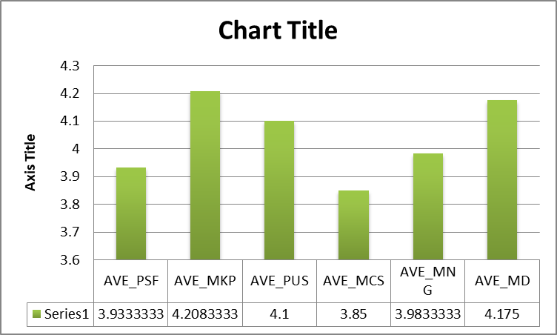
In this chart we can see the highest acceptance of customer is the average of Marketing knowledge and proficiency (MKP) and here the lowest acceptance by the customer is Market Competitiveness and Customers Satisfaction (MCS).
PSF | MKP | PUS | MCS | MN | MD
3.933333333 | 4.208333333 | 4.1 | 3.85 | 3.983333333 | 4.175

3.7. Correlation
This correlation affects the five variables of the product success and failure. Each of these affects the (PSF) to continue to survive in the market.
In this table we can see that the MKP affect the PSF in a highest position, so we can say that if the MKP is high the Product success will be higher but if the MKP is low it should indicate the failure of the product.

In the same way PUS shows not so much effect to PSF, that’s why if its changes go upward than it will make a positive impact on the market.
By the rank, here MCS will affect much to the PSF factor. Because it impacts so much to the PSF fact. If it grows up the products success will pretty much high. But if the numbers go down, the failure chances will be higher.
MNG affects the lowest portion in PSF factors. It may not so much important to follow the MNG to succeed the product in the market.
MD factors are in minus situation. It may not be much affect the success factor of a new product so far.

Table: 7
Correlation matrix
Correlations
 | PSF | MKP | PUS | MCS | MNG | MD
PSF | 1
MKP | 0.43686 | 1
PUS | 0.078758 | 0.316963 | 1
MCS | 0.425689 | 0.518711 | -0.13443 | 1
MNG | 0.007294 | 0.577781 | -0.17038 | 0.315026 | 1
MD | -0.02018 | 0.644913 | 0.029468 | 0.363991 | 0.645312 | 1
Sample size | 20
*Correlation is significant at the 0.05 level (2-tailed).
**Correlation is significant at the 0.01 level (2-tailed).
3.8. Discussion
In the previous discussion we can see the Marketing knowledge and proficiency (MKP) is in higher position and Market Competitiveness and Customers Satisfaction (MCS) is in lower position by rank. In MKP everything is discussed about the market knowledge and where we actually want to enter with a new product. Here the entire customer recommends to study about the market, to understand the customer need and the other variable.
On the other hand (MCS) shows the competitiveness and customer satisfaction, but here people are not so concern about this. They want something different what offer them something new.

3.9. Recommendations
In recommendation we can say Organization should take proper care about PSF. All the factors should work success fully either the whole plan can collapse very soon.
Nobody wants to see the competition. They just want the result. A perfect result what actually meet their needs properly. All the customers are playing a neutral role in case of competitiveness of the market.

3.10. Conclusion
In conclusion, I can state that this temporary job report is extremely fundamental for each understudy of business concentrates to get thought regarding the material industry. By finishing this report I have a general thought of RMG area and the achievement factor of new item improvement. These might be useful to think about the specialized and administration learning of pieces of clothing industry likewise these segment related associations. This is an enormous segment but to find the entirety.

By setting up this report, I have accumulated a great deal of learning about the articles of clothing industry and really this is a vital errand in attire and piece of clothing businesses. I try my best to make this report enriched with lots of apparel related info and I am quite satisfied. Maxim group is really a good experience for me because every one of there so much helpful and give me the proper guideline of practical learning. Finally I can say that by the knowledge from this report which will help me in my professional life to take challenge and solve it in a better way.

Reference
http://www.maxim-group.com.cn/
https://articles.bplans.com/product-and-brand-failures-a-marketing-perspective/
https://www.researchgate.net/publication/227762442_The_Role_of_Market_Information_in_New_Product_SuccessFailure
https://www.sciencedirect.com/science/article/pii/S0737678297000131
Investopedia definition - http://www.investopedia.com/terms/m/market-orientation.asp
GONZáLEZ, F. J. M. & PALACIOS, T. M. B. (2002) The effect of new product development techniques on new product success in Spanish firms. Industrial Marketing Management 31, 261-271
https://blog.hubspot.com/service/what-is-customer-satisfaction

Appendix
Questionnaire


Success Factors in New Product Introduction

Dear Respondent:
I am a student of BBA program at the United International University doing project on “Success Factors in New Product Introduction, as a partial requirement for the fulfillment of the BBA degree. For preparing my project report on this topic, I am collecting data from the respected executives.

This is not a test. There is no correct or wrong answer to any question. Don’t worry or puzzle on individual question. Response quickly and record your immediate thoughts. The information you provide will be treated as strictly confidential. All analyses will be conducted on an aggregate level with no reference to individual responses.

If you have any questions please contact my supervisor Dr. Kawsar Ahmmed (E-mail: kawsar@bus.uiu.ac.bd, Phone: +8801915078285).

Sincerely yours,

MD. Serajus Sakline
111 123 148
Marketing Major
School of Business and Economics
United International University

- Gender
- Male | - Female | - Other
- Age
- 15-20 | - 21-25 | - 26-30 | - 31-35 | - 36-40
- Education
- Bachelor | - Masters | - Others

Product Success and Failure (PSF) |  | Strongly Disagree (1) | Disagree (2) | Neutral (3) | Agree (4) | Strongly Agree (5)
PSF1 | Product success means the introduction of unique but superior product | 1 | 2 | 3 | 4 | 5
PSF2 | Profound market knowledge and marketing proficiency indicate product success | 1 | 2 | 3 | 4 | 5
PSF3 | Product success mainly depends on a large, high need, growth market | 1 | 2 | 3 | 4 | 5
PSF4 | a good "product/company fit" with respect to managerial and marketing resources ensure product success | 1 | 2 | 3 | 4 | 5
PSF5 | Capability to avoid a competitive market with satisfied customers enhance product success | 1 | 2 | 3 | 4 | 5
PSF6 | a strong marketing communications and launch effort enhance product success | 1 | 2 | 3 | 4 | 5
Marketing knowledge and proficiency (MKP)
MKP1 | Undertaking a good market study impacts on new product success | 1 | 2 | 3 | 4 | 5
MKP2 | A well understanding about customers' needs, want impacts positively on new product success | 1 | 2 | 3 | 4 | 5
MKP3 | A well understanding of customer price sensitivity impact on new product success | 1 | 2 | 3 | 4 | 5
MKP4 | Understanding the competitors’ situation is important for a new product success | 1 | 2 | 3 | 4 | 5
MKP5 | A well understanding about customers behavior impact on the new product success | 1 | 2 | 3 | 4 | 5
MKP6 | Understanding the actual size of potential market has relationship with the new product success | 1 | 2 | 3 | 4 | 5
Product Uniqueness/Superiority (PUS) |  | Strongly Disagree (1) | Disagree (2) | Neutral (3) | Agree (4) | Strongly Agree (5)
PUS1 | A new product should have special features to be succeed | 1 | 2 | 3 | 4 | 5
PUS2 | A new product should be better than competing items in addressing client's needs | 1 | 2 | 3 | 4 | 5
PUS3 | A new product should offer unique features for its customer | 1 | 2 | 3 | 4 | 5
PUS4 | A new product should have top quality than competitor’s | 1 | 2 | 3 | 4 | 5
Market Competitiveness and Customers Satisfaction (MCS)

MCS1 | Availability of huge competitors negatively impacts on product success | 1 | 2 | 3 | 4 | 5
MCS2 | Side by side price competition impact on the new product entry and success in the market | 1 | 2 | 3 | 4 | 5
MCS3 | Too much competitors in market create entry barrier for the new product | 1 | 2 | 3 | 4 | 5
MCS4 | In time of our new product entry into the market place, customers will be happy by using competitors' products | 1 | 2 | 3 | 4 | 5
Market need, growth and size (MNG)
MNG1 | Greater needs for various types of product open up the door for new product success | 1 | 2 | 3 | 4 | 5
MNG2 | A large size market impact positively on the new product success | 1 | 2 | 3 | 4 | 5
MNG3 | High potential market pushes the new product success | 1 | 2 | 3 | 4 | 5
Market Dynamism (MD)
MD1 | Frequent new product introduction into the market place is a threat for the product success | 1 | 2 | 3 | 4 | 5
MD2 | Quick change in the customers need negatively impact on product success | 1 | 2 | 3 | 4 | 5

Thank you for the kind cooperation!!

