A PROJECT REPORT ON

THE CORPORATE SOCIAL RESPONSIBILITIES (CSR) PERFORMED BY SMALL AND MEDIUM ENTERPRISES (SME) IN BANGLADESH


Prepared by GULE JANNAT

This report is submitted to the school of Business and Economics, United International University as a partial requirement for the degree fulfilment of Bachelor of Business Administration

A PROJECT REPORT ON
THE CORPORATE SOCIAL RESPONSIBILITIES (CSR) PERFORMED BY SMALL AND MEDIUM ENTERPRISES (SME) IN BANGLADESH

SUPERVISED BY
ELIZA HUQ
ASSISTANT PROFESSOR - Finance
SCHOOL OF BUSINESS AND ECONOMICS
UNITED INTERNATIONAL UNIVERSITY

PREPARED BY
GULE JANNAT
ID: 111 152 052
MAJOR: FINANCE
BBA PROGRAM

UNITED INTERNATIONAL UNIVERSITY

Date of Submission
25th August 2019
UNITED INTERNATIONAL UNIVERSITY
DHAKA, BANGLADESH

Letter of Transmittal
To
Eliza Huq
Assistant Professor - Finance
School Of Business and Economics
United International University
Subject: Submission of Project report on “The Corporate Social Responsibilities (CSR) Performed by Small and Medium Enterprises (SME) In Bangladesh”.
Dear Madam,
I am happy to inform you that I have finished my three months project program and successfully complete the observation on the Small and medium enterprises of Bangladesh and also have prepared my project report on the title “The Corporate Social Responsibilities (CSR) Performed by Small and Medium Enterprises (SME) In Bangladesh”.
When a company carries out its business in an ethical and sustainable manner and its environmental and social impacts are generally considered to be corporate social responsibility (CSR). For companies, the overall objective is to have a positive impact on society as a whole, while maximizing the value of the shares for owners, employees, shareholders and business partners. Not long ago, the European Commission (EU) defined CSR as "the responsibility of companies to influence their society", a brief and brief summary of CSR. Focusing on CSR in Bangladesh will be effective not only in improving environmental management, workers' well-being, occupational protection, labour rights, community development, and corporate governance but also in industrialization and access to global markets.
I want to add that the report outline and efforts you have provided me for my project was highly appreciated. All the steps are followed here according to your advice and no information are directly copied from anywhere to prepare this report.
I would be highly appreciated if you check the report and accept it.
Sincerely yours,
Gule Jannat
ID: 111 152 052
BBA Program
United International University

Certification of Similarity Index

Declaration of the student

I, Gule Jannat, would like to declare that the study is prepared with proper Corporate Social Responsibilities information that are being performed by small and medium enterprises. All the information used in the report are collected from valid sources and no information were copied directly from any published articles. Moreover, the report guidelines are also properly followed in the study.

____________________________________________
GULE JANNAT
ID: 111 152 052
MAJOR: FINANCE
BBA PROGRAM
UNITED INTERNATIONAL UNIVERSITY

Acknowledgment

I want to thank at the very beginning to my Almighty ALLAH and my Parents for supporting me and help me to be able to conquer till now and finish my under graduation from United International University.

At first, I would like to thank my project supervisor and course faculty Eliza Huq, Assistant Professor – Finance, School Of Business and Economics, United International University for all the time and effort provided to me to complete and make my project report a valuable one. The report guidelines that I had received from her outstandingly helped me to understand the report structure and how I need to attempt for it to prepare a good one.

Secondly, I want to thank and show my respect to Mr. Abdul Momen, Head of SME, Brac Bank & Md. Ashiqur Rahman, Marketing Manager, Dutch Bangla Bank Limited for sharing their valuable time and reply my queries that I had sent them into their LinkedIn accounts. Without their co-operation the report could not be such a good one.

Finally, I want to thank my friends & course mates who had given their time to make me capable to understand a lot of concepts that were new to me. All of your efforts are highly appreciated.

Executive Summary
Corporate social responsibility is based on the idea that social responsibility is above and beyond a company. It demands that management is responsible for all interested parties. Corporate Social Responsibility is an ethical commitment by business to contribute to the economic development of the country, as well as its ongoing commitment to improving the quality of life of workers, their families, their communities and local communities. Moreover, it is commercially successful in respecting ethical values ​​and people, communities and the natural environment. It is a combination of policies, education, and practices that extends to all business activities and the communities in which they operate. However, CSR is committed to contributing to sustainable economic development by working with all partners to improve their lives in ways that benefit the business and, in principle, the business.
Since the birth of Bangladesh, many Small and Medium Enterprises (SMEs) have contributed to our economy by providing employment, products, and services. The majority of small and medium-sized enterprises (SMEs) belong to the informal sector and have an insufficient management structure and weak resources to deal with social and environmental problems. These limitations lead local entrepreneurs to think only of maximizing profits instead of doing business with the triple end result: profits, planet, and people. Discussions on CSR practices in Bangladesh in their modern global context are relatively new, but not the concept itself. As part of the global market, it is difficult to ignore the CSR standard specified in the export sector. In general, it is true that in Bangladesh the state of practices regarding workers' rights, environmental management, and corporate governance transparency are unsatisfactory, mainly due to the lack of enforcement of existing laws and insufficient pressure from civil society and interest groups as consumer forums.
The purpose of the study is to identify the CSR activities contributed by the SME’s of Bangladesh. A survey questionnaire is prepared to analyse this contribution and gather 15 SME’s responses to analyse to what extent the sector is practicing the CSR activities in Bangladesh. A few suggestions are also shared to improve the practices as practicing CSR is highly important for human being, society and the earth.

Table of Contents

Chapter one: Introduction
1.1 Background of the report 2
1.2 Scope of the report 2
1.3 Methodology of the report 2
1.3.1 Data Collection Sources: 3
1.3.2 Report design 3
1.3.3 Data analysis: 3
1.4 Objectives of the report 4
1.5 Limitations of the report 4

Chapter Two: Literature Review
2.1 Small and Medium Enterprises (SME) 6
2.2 Corporate Social Responsibilities (CSR) 6
2.2 Dimensions of CSR 7
a. Economical Dimension 7
b. Volunteer Dimension 8
c. Societal Dimension 8
d. Interested parties 8
e. Environmental dimension 8
2.3 The importance of CSR in Bangladesh 8

Chapter Three: Industry Analysis
3.1 Small and Medium enterprises in Bangladesh 12
3.2 Current Scenario of SMEs in Bangladesh 12
3.3 Potential Sectors for SME in Bangladesh 14
3.4 SME products of Bangladesh 16

Chapter Four: CSR activities performed by SME in Bangladesh
4.1 History of Corporate Social Responsibilities 19
4.2 The application of CSR in Bangladesh 19
4.3 The CSR Activities performed by SME’s in Bangladesh 21

Chapter Five: Finding of the study
Findings of the Report 24
5.1 Findings of the report 25

Chapter Six: Recommendations and Conclusion
6.1 Recommendations of the Report 28
6.2 Conclusion 29
References 30
Appendix 31

List of Tables
Table Name | Page Number
Table 1: Features of MSE | 6
Table: 2 Definition of SMEs in Bangladesh | 12
Table 3: Potential Sectors of SME in Bangladesh | 15
Table 4: Example of Bangladesh SME sector’s Products | 16
Table 5: 15 SME and Their business type | 22
Table 6: CSR activities results | 23

List of Abbreviations
BBA – Bachelor of Business Administration | RMG - Ready Made Garments
UIU – United International University | BB – Bangladesh Bank
CSR – Corporate Social Responsibility | FMCG - Fast-moving consumer goods
SME - Small and Medium Enterprises

Chapter one
Introduction



1.1 Background of the report
The thesis/project is the core idea of ​​an academic paper that reveals the author's position on a topic. In United International University, students who choose to perform projects, have to choose a sector to observe for three months and also have to submit a project report on that selected sector/industry in the same time period.
The sector I have observed for last three months were Small & Medium Enterprises of Bangladesh and according to my project supervisor’s suggestion I had started to work on the title on “The Corporate Social Responsibilities (CSR) Performed by Small and Medium Enterprises (SME) In Bangladesh”.
The title of the report is highly related to my field of study and I think focusing on CSR activities performed by Small and Medium Enterprises in Bangladesh will be effective not only in improving community development, labour rights, environmental management, occupational protection, workers' well-being, and corporate governance but also in industrialization nationally and access to global markets.

1.2 Scope of the report
The research aims to determine the scope of social responsibility activities of small and medium-sized enterprises in Bangladesh. It also indicates how to respond to social responsibilities vis-à-vis small industries. The report is also going to introduce the concept of CSR and analyse the various perspective of conducting CSR activities. Any organization can easily grab any idea when it understands the necessity of performing CSR activities going through the report. The University students and teachers can also identify the ways the enterprises are actually performing their Corporate Social Responsibilities.

1.3 Methodology of the report
According to Baker (212), determining the appropriate research methodology is a very critical aspect of research. This section will detail the proposed global research methodology for our study, including the theoretical basis of data collection and analysis.

1.3.1 Data Collection Sources:
- Primary sources:
- Through formal and informal communication with the personnel.
- Visiting and interviewing few banks that are operating CSR.

- Secondary Sources
- From various published books based on CSR.
- Through the leaf-let and annual report published by few SME’s.
- Through online blogs and websites.
- From the reports published by Bangladesh Bank.

1.3.2 Report design
Researchers can choose between two options: the types of research called "quantitative" and "qualitative". In this study, both of them are chosen. It will allow to describe ourselves and our personalities, as well as define and analyse the different qualities of interactions, "human-related events", parameters and experiences (Ragin, 2014). Qualitative research methods are numerous and varied and provide a deeper understanding of the most incredible research problems that individual statistical analysis can provide. Given all the data, it is suggested that it is much more appropriate than a qualitative approach to the proposed research.

1.3.3 Data analysis:
As this study is a qualitative study, the researcher will use a qualitative data analysis method called "content analysis". It refers to a systematic description of behaviour based on the analysis of various factors of interest from the data. This method is particularly suitable for answering qualitative questions "why and how". Researchers use content analysis to identify and evaluate key research topics from relevant secondary data. Working with the primary data of our study, we will analyse the performance of SMEs in two different countries in terms of CSR.

1.4 Objectives of the report
- Primary objective: The core objective of the report is to analyse the ways of performing CSR activities by the Small and Medium Enterprises in Bangladesh.
.
- Specific Objectives:
- To analyse the Corporate Social Responsibility Concept in terms of Bangladeshi context.
- To analyse the ways the SME’s are conducting the CSR activities.
- To recommend few ways how the CSR activities can be improved and can be conducted.

1.5 Limitations of the report
The difficulties faced while preparing the report and collecting information are generally termed as limitation. The limitation of preparing this report is listed below:
- Short period of time: The report is made in only three months of time period. But, while preparing the report, it has been realized that the topic context is huge and it is difficult to collect all the information in this short time.
- Confidentiality: A lot of enterprises are requested not to share few internal data publicly. Therefore, few important information are not shared in the report.
- Reluctant to respond: Few SME’s authorities were very reluctant to respond on their CSR practices because of their insufficient knowledge and improper CSR practices.

Chapter two
Literature Review

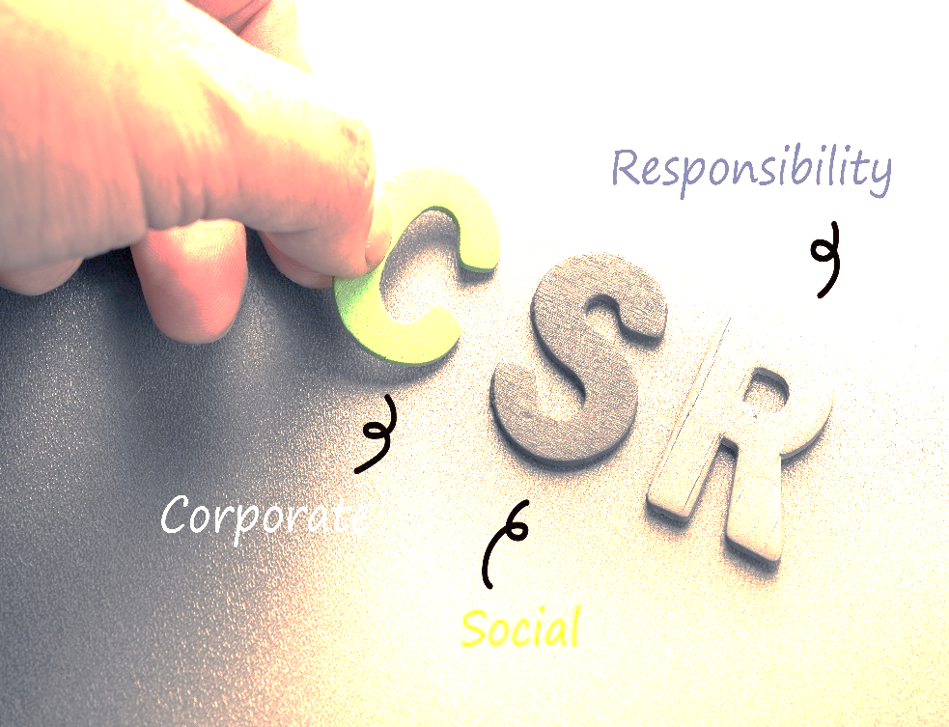

2.1 Small and Medium Enterprises (SME)
Small and medium enterprises (SMEs) are businesses that maintain an income, wealth or number of employees below a limited margin. Each country has its own definition of what a small and medium business (SME) wants. Some size criteria must be met, from time to time, the business area of ​​the organization is also taken into account. Small, medium and small businesses (SMEs) play a vital role in the economy. They go much further than larger companies, they have many people with job losses and they are generally of a business nature, which contributes to the size of innovation.
In Bangladesh, Bangladesh Bank defines small and medium-sized enterprises on the basis of employed labour, fixed assets, as well as annual turnover, and they are not must be Public Limited Company and require these features:

Serial No | Sector | Fixed Asset other than Land and Building (Tk) | Employed Manpower | Yearly Turn Over (Tk)
Serial No | Sector | SE (Small Enterprises) & ME (Medium Enterprises) | Employed Manpower | (N/A-Not Applicable)
1 | Services | For SE 1000,000 - 200,00,000 & For ME 200,00,000 - 30,00,00,000 | SE - 16-50 & ME - 51-120 | N/A
2 | Business | For SE 1000,000 - 200,00,000 | SE - 16-50 | SE 10,000,000-120,000,000
3 | Industrial | For SE 7,500,000 - 150,000,000 For Me 150,000,000 - 500,000,000 | SE - 31-120 & ME - 121-300 | N/A
Table 1: Features of MSE
Source: Wikipedia

2.2 Corporate Social Responsibilities (CSR)
According to Investopedia, CSR that abbreviates as Corporate Social Responsibility, is a self-regulating business model that helps an organization be socially responsible to itself, its partners and the public. Corporate social responsibility, also known as corporate citizenship, allows companies to become aware of the impact they have on all aspects of society, particularly in economic, social and environmental terms (Campbell, J.L. (2007)). Participation in CSR means that, in the general course of business, a company acts as a means of improving society and the environment rather than a negative contribution between them.
Corporate social responsibility is a broad concept that can take many forms depending on the companies and sectors. Through CSR programs, philanthropy and voluntary efforts, companies can benefit by promoting their brands. According to Campbell, J.L. (2007), CSR is as important to a community as it is valuable to an organization. CSR activities can help create more connections between employees and businesses. They can boost morale and help employees and employers feel more connected to the world around them.
According to Coleman, J.C. (1988), for a company to be socially responsible, it must first be accountable to itself and its shareholders. Companies that adopt CSR programs have often brought their businesses to a point where they can return to the business. CSR is therefore fundamentally a strategy for large companies. In addition, the more visible and successful a business is, the more responsible it is to set ethical standards of behaviour for its peers, competition and the sector.

2.2 Dimensions of CSR
Usually, the company is responsible for profitability, but the concept of corporate social responsibility means that companies must be more responsible than their owners. Corporate Social Responsibility says that there are more aspects that should influence the company's behaviour (Garriga, E. & Melè, D. (2004). Be aware of these aspects when planning CSR activities.

Economical Dimension
The economic dimension refers to the impact of corporate social responsibility on corporate finance. In an ideal world, corporate social responsibility has no cost and there is no reason to limit it. But in the real world, it's important to recognize the financial impact of these behaviours and balance them into good corporate citizenship and profits.

Volunteer Dimension
Actions under the voluntary dimension are what you don't have to do. These actions are based on the ideas of your company. They can be based on your company's specific ethical values. For example, you might think that using organic products is correct, even if it is not necessary.

Societal Dimension
The social dimension of corporate responsibility means the relationship between your company and society as a whole. When solving social problems, people should be committed to using one's business to benefit the whole society. For example, this may involve buying a fair trade product or accepting an employee's living wage. It can also mean a commitment to society, such as using resources to raise funds for charitable purposes.

Interested parties
Stakeholders are people who are interested in the behaviour of your company. These include employees, suppliers and the public. When considering the size of stakeholders in corporate social responsibility, consider the impact of business decisions on these groups. For example, you can force employees to work harder to increase production, but you should consider their impact on them, not just your income.

Environmental dimension
The environmental dimension of corporate social responsibility refers to the impact of your business on the environment. As a socially responsible company, the goal is to participate in environmentally friendly business practices. For example, you can choose to use recycled materials in your packaging or promote renewable energy sources such as solar energy in your facility.

2.3 The importance of CSR in Bangladesh
Bangladesh's CSR can contribute greatly to community development. The company can improve the community by contributing to infrastructure development such as home employment, creating primary education, roadways and highways, and addressing environmental concerns. This is more relevant for a country like Bangladesh, where government intervention in this sector, enhanced by corporate alliances, can greatly help in the development of the economy, society, and the environment.

There are many CSR practices in Bangladesh. The SMEs of Bangladesh is largely dependent on export. U.S. shoppers to the United States (US) and the European Union (EU) has created guidelines for the Ready Made Garments (RMG) industry to ensure standards. The Harkins Bill of 1992 and subsequently excluded consumers and the RMG products industry in the United States and here are examples of corrective measures that result from the local RMG sector. In addition, some EU buyers have recently visited clothing factory sites. The EU banned shrimp exports for health and hygienic reasons; also sufficient corrective action was followed in this case. However, some exporters had trouble understanding US buyers. Due to inadequate CSR practice, the EU will have a positive attitude towards Bangladesh. Entrepreneurs must recognize the effects of corporate social responsibility. Companies have to face the challenges of effectively adapting to the changing environment in the context of globalization and especially in the export sector.

Although a structured view of the consumer rights movement, the application of government regulations and the economic importance of CSR has not yet spread widely in the business world, firms have gradually given greater importance to CSR in the local market. They are increasingly aware that CSR may have direct economic value. Companies can contribute to social and environmental goals, integrating CSR into their core business strategies, management tools and strategic investments in management. Like value investing, it is not an expense, an investment. Thus, business firms can have an inclusive financial, commercial, and social approach, which comes with a long-term strategy that reduces the risks associated with uncertainty.

Weak trade unions, high levels of corruption within regulatory bodies, absence of consumer rights groups, and lack of enforcement of industry laws and regulations have led to the spread of CSR violations in Bangladesh. The two most important sources of foreign exchange earnings in the country are the RMG sector and the export of labor overseas. Incredibly common and prevalent in measuring inequality, low compensation, work hours, health /hygienic conditions, fire safety and various forms of abuse, which will affect every single person. Recently, the employees of the RMG sector have been agitating for their rights. Foreign workers are largely exploited by employment companies, though these rural and mostly illiterate people have to sell all their property in order to get out of the house and borrow at a very high-interest rate. Many of them were forced to return as beggars because of the trapping of employers and illegal treatment of employers abroad, some after prolonged imprisonment in foreign prisons. Almost no cure is available from the police. Many industrial units deal with half-century machinery that produces deadly pollutants for air, soil, and water. Most of them do not even bother to set up a large number of folate treatment plants, including modern factories. Unusual ripening of adulterants, fruits, and consumer items is sometimes associated with toxic ingredients, with deadly formalin application that keeps the fish fresh and all other bad habits prevalent. Only good governance and effective law enforcement can solve this deadly problem.

Chapter Three
Industry Analysis

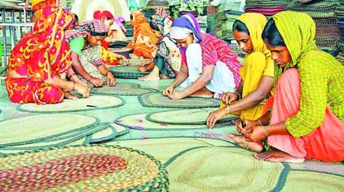

3.1 Small and Medium enterprises in Bangladesh
SMEs are the most important part of any economy on earth. Small and medium enterprises are highly valued by decision-makers because they have been shown to make multiple contributions to a country's socio-economic environment as these businesses require the least capital, are easy to begin, produce products that meet local demand, contribute to export earnings, recruit a relatively large number of people. The definition of SMEs depends mainly on the number of employment, replacement costs (investment), annual income, etc. The size of the index varies according to the socio-economic conditions of the country and even the region. The following Table 2 shows the way the Bangladesh government has defined SMEs in the latest industrial policy (the country's national policy 2016).
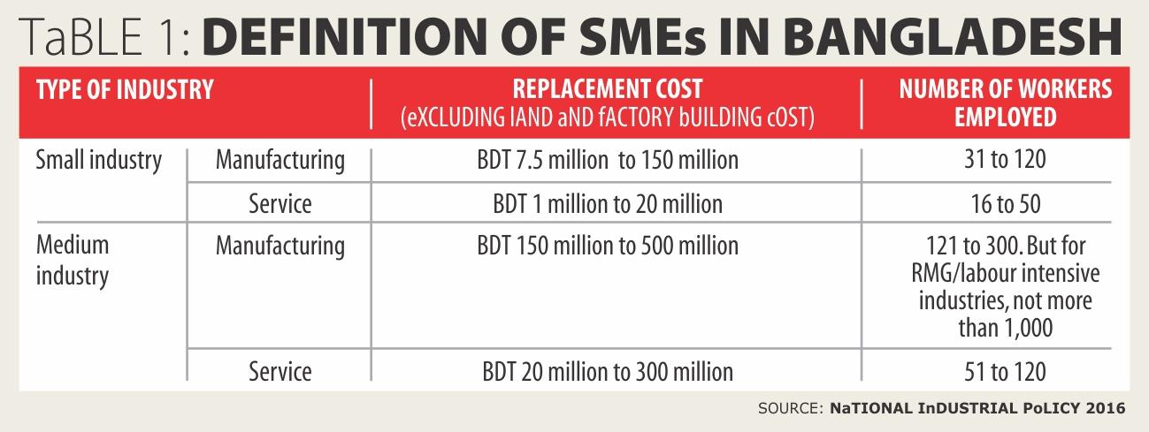
Table: 2 Definition of SMEs in Bangladesh
(Source: Dailystar.net)

3.2 Current Scenario of SMEs in Bangladesh
A small and medium business (SME) is an independent company that employs less than a certain number of employees or has a total investment below a certain limit. SME stands for unlimited business opportunities. Despite the global economic crisis and domestic economic challenges, Bangladesh's gross domestic product (GDP) steadily increased more than 6% prior to the 2014-2015 financial year and increased 7.11% during the 2015-2016 financial year. Financial year (Bangladesh Economic Review, 2016). Of the five fastest-growing emerging economies in 2014, Bangladesh ranked fourth (Asian Development Bank, 2014).

SMEs play a very important role in the economy of Bangladesh. SMEs are considered important tools to create new jobs, reduce poverty and rapid industrialization (Ahmed, 2009). These companies are considered the main engine of the economic growth of Bangladesh. The country is working to develop its entrepreneurs, promote SMEs, and facilitate their transition to large industries for rapid industrialization (Abdin, 2015). Development workers, economists, policymakers, and related innovators bring different tools, techniques, methods, and approaches to SMEs around the world based on the size, capabilities, and characteristics of the economy. Moreover, due to economic liberalization, markets are volatile and highly competitive. SMEs of Bangladesh are accelerating entrepreneurial skills by increasing diversification of economic activities, thus helping entrepreneurs to adapt to changing market conditions (Helal uz Zaman and Md. Jahirul Islam, 2011). At the same time, SMEs of Bangladesh faces many problems. Among other issues, financing is a major problem for most SMEs in Bangladesh. If financing problems are solved, SMEs can contribute more to the economy. Joint banking planning, venture capital, human resource development in financial institutions and public administration, training and development as potential tools to remove restrictions on financing for SMEs. SMEs' performance did not meet Bangladesh's expectations, which may be due to lack of access to institutional financing, lack of a basic consumer market for SME products, and lack of formal development initiatives. Therefore, appropriate government policies and measures must be adopted while ensuring that infrastructure is improved to meet the challenges of SMEs for the development of this sector. Medium and long-term credit, limited access to market opportunities, technology, and experience, limited business information, lack of appropriate incentives, ineffective and limited services provided by competent government agencies, and the capacity of entrepreneurs with low levels of service. These are other factors for the slow growth of SMEs. The reason The SME financing success rate is high and has contributed to Bangladesh's GDP, but loan payments to SMEs are lower than industrial loans. In fact, the implementation of appropriate policies and strategies is a prerequisite for the sustainable competitiveness of SMEs across the country. Therefore, priority should be given to the SME sector by providing certain financial facilities and services for the development and expansion of the sector.

3.3 Potential Sectors for SME in Bangladesh
Bangladesh has a lot of potential sectors where an individual can start his business. In fact, already a huge part of population are being employed in these sectors. The Table 3 below show a lot of SME sectors of Bangladesh.

- Agro tools making and Marketing | 22. Laboratory | 43. Warehouse and container business
- Agro-based and agro-processing industry | 23. Salon and beauty parlour | 44. Plastic industry
- Jewellery | 24. Call centre | 45. Printing and Packaging
- Nakshi Katha and Handloom | 25. Diagnostic centre | 46. Cosmetic Industry
- Bakery | 26. Tailoring | 47. Production from lime of oyster
- Food seed preservation | 27. Community centre | 48. Railway slipper manufacturing
- Hatchery | 28. Digital colour lab | 49. Cement pillar manufacturing
- IT-Based Operations | 29. Cable operators | 50. Oil and Pulse mill
- Cyber café | 30. Boutiques | 51. Ceramic business
- Computer software and ICT products | 31. Generator business | 52. Mini sugar mill
- Horticulture, Floriculture | 32. Old iron goods | 53. GPI pipe producing industry
- Forestry and furniture | 33. Mobile set and Accessories | 54. Hosiery
- Cold Storage | 34. Electronics Business | 55. Bronze and brass industry
- Hospital and Clinic | 35. Fertilizer tools | 56. Wood and steel goods
- Construction business | 36. Jute Trading | 57. Paddy rice business
- Handicrafts | 37. Rod and cement business | 58. Small amusement park
- Transport communication | 38. Clothing and shoe business | 59. Free-lancing
- Herbal medicine industry | 39. Crockery business | 60. Partex Industry
- Stationary goods industry | 40. Hardware business | 61. Bio-gas plant
- Jute products industry | 41. LP gas business | 62. Paddy rice and vegetable business
- Ginning and baling | 42. Grocery and chaff goods | 63. Delivery services
Table 3: Potential Sectors of SME in Bangladesh

3.4 SME products of Bangladesh
A lot of sectors are included in Bangladesh Small and Medium Enterprises and huge varieties of products are being made all these sector. For Instance, Mechanical engineering related products produced by Bangladesh are:

Brakes | Transmission Chain | Cylinders | Seat Covers | Tire Repair Tools | Auto Filter | Tire Inflators
Special Purpose Bearing | Gears | Piston | Steering Wheel Locks | Tire Inflators | Tank & parts | Tire Gauges
Spherical Plain Bearing | Gearboxes | Worms | Car Organizers | Tire Gauges | Muffler Assembly | Grease Guns
Auto Bearing | Bearings | Chains | Car Seats | Grease Guns | Engine Mounts | Diagnostic tool
Wire Assembly | Pillow Block | Couplings | Seat Cushions | Diagnostic tool | Car Fenders | Axles
Tube Assembly | Bearings | Moulds | Boilers | Axles | Pulleys | Clutches
Car Mats | Car Jacks | Valve | Car Perfumes | Clutches | Car Bumpers | Transmission Parts
Car Safety Belts | Transmission Jacks | Shafts | Steering Wheel Covers | Tire Repair Tools | Car Grill | Drive Shafts
Table 4: Example of Bangladesh SME sector’s Products

The images below may help to understand few more SME products that are being produced in Bangladesh.
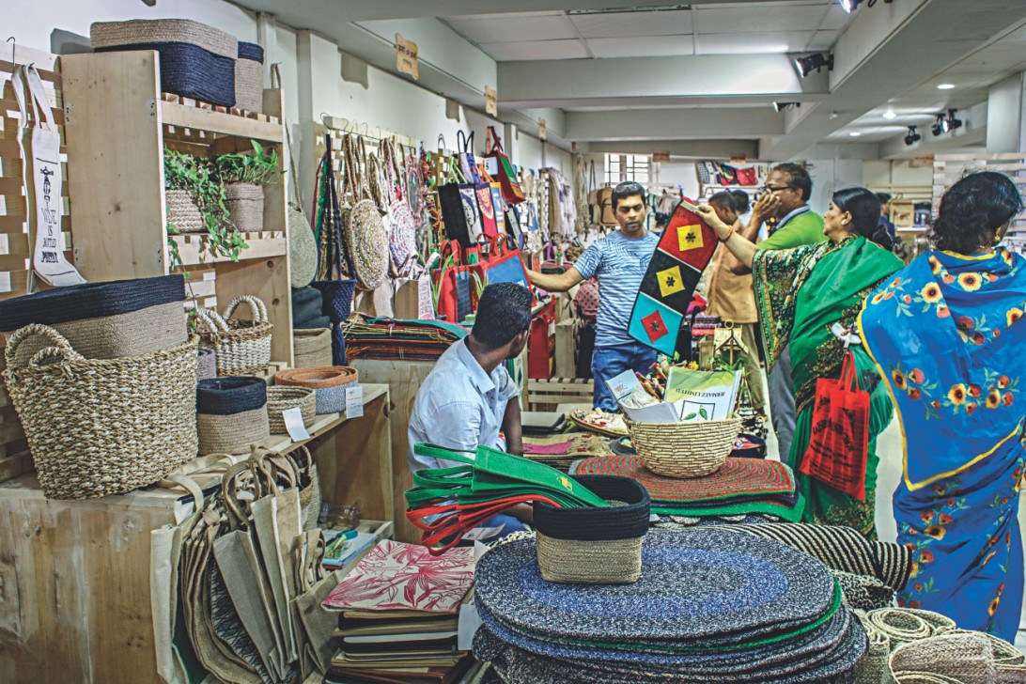
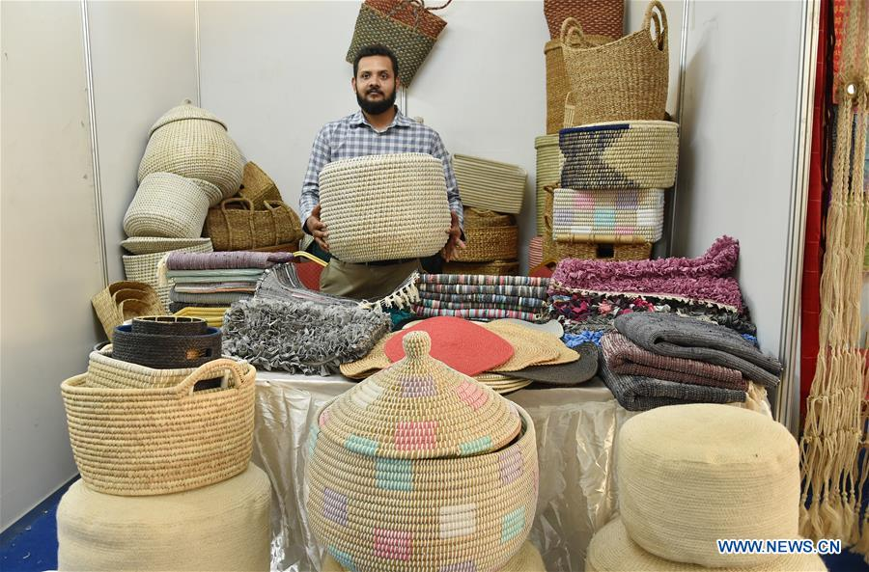
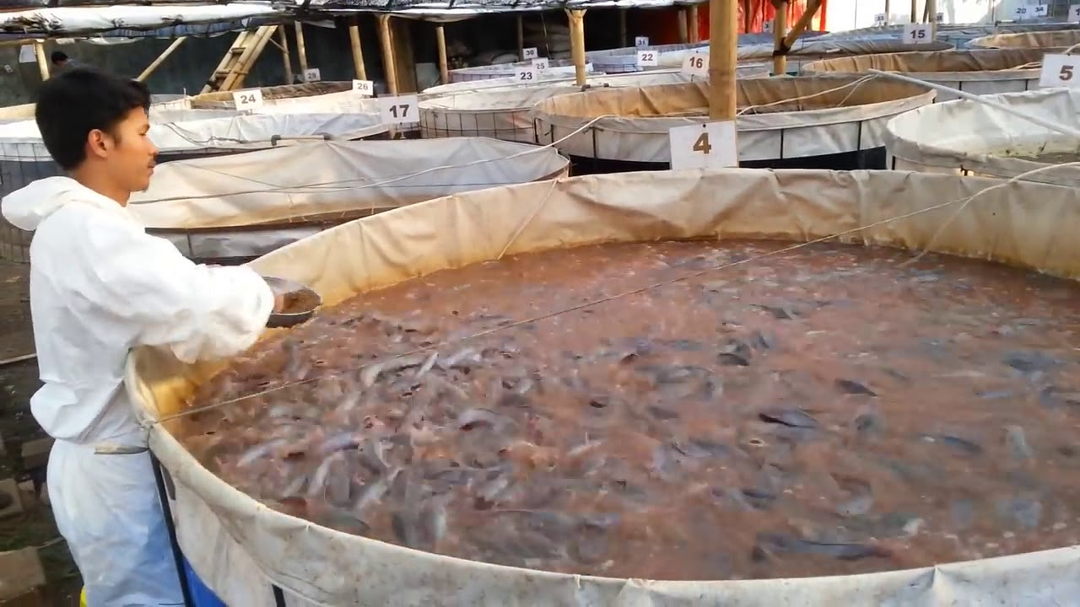

Chapter Four
CSR Activities performed by SME in Bangladesh
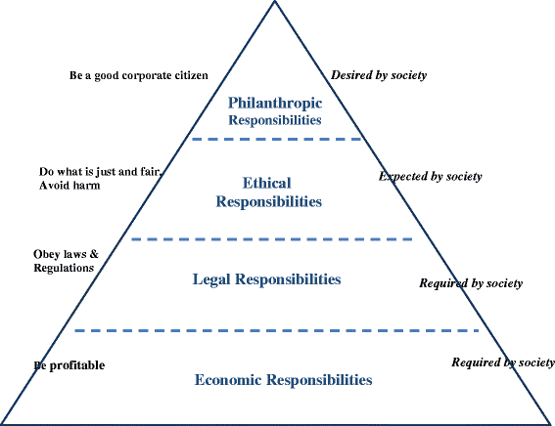

4.1 History of Corporate Social Responsibilities
According to Green Paper (2001), corporate Social Responsibility is a social responsibility in which companies integrate social and environmental concerns into their activities and interact with their partners on a voluntary basis. (Green Paper, 2001) Social responsibility means not only complying with legal expectations but also investing more in "non-compliance" and building relationships with human capital, the environment, and stakeholders. This concerns all types of organizations and activities in all types of organizations, from SMEs to multinational companies. .Green Paper, 2001 also shared that several companies with good social and environmental data indicate that these activities can lead to better performance and greater profitability and growth Research showed that almost half of the above-average performance of socially responsible companies can be attributed to their CSR image, while socially responsible companies should generate higher financial returns to the average intrinsic dimensions, such as human resources management, health and safety at work, environmental impact and adaptation to change and change in natural resources. External dimensions include local communities, companies, partners, suppliers and customers, human rights and global environmental concerns. Again, CSR can be as simple as sponsoring events in a nutshell, "CSR is a positive partnership with society." In Bangladesh, several multinational companies and local companies practice CSR. Although multinationals are influenced by their own provisions of the ESRB, most commercial concerns in Bangladesh are not of high quality in CSR practice unless foreign buyers exert pressure on export-oriented trade.

4.2 The application of CSR in Bangladesh
There is a long history of philanthropic activity in Bangladesh since the concept and practice of corporate social responsibility (CSR). These philanthropic activities included donations from various charities, poor and religious organizations. Until now, most of the businesses in Bangladesh are family owned and first-generation. They take part in the development of the community without forming a definite expense policy or a specific cause in the financial field, without specifying the financial field. Furthermore, most SMEs include informal sectors with management structures and limited resources to address social and environmental issues. These limitations lead local business leaders to think only of maximizing profits without engaging in commercial activity. Discussions of CSR practices in Bangladesh are relatively new in their modern global context, but they do not really concern the idea. Because it is difficult to ignore the CSR standard, especially in the export sector, as part of the global market. In general, it is true that the state is dissatisfied with the conduct of workers' rights, environmental management and transparency of corporate governance in Bangladesh, especially due to non-enforcement of existing laws and insufficient pressure from governments. Civil society and interest groups such as customer forums. Globally, CSR practices gradually become integrated into international business practice and become one of the determining factors of market access, they also become fundamental to local adoption. . CSR in Bangladesh will be effective not only for corporate management, workers' rights, workplace security, fair treatment of workers, community development and environmental management but also for industrialization and sustainable development. Guaranteed access to the global market. Since CSR is expected to cooperate with interesting parts, it is important to work from the inside and determine the interested parts; it is feared that CSR has truly integrated into firms. At present, many levels of CSR are practiced in Bangladesh. SMEs are dependent on export. US EU buyers. And sets guidelines to ensure compliance with EU RMG sector standards. The Harkin Bill of 1992 and subsequently the consumer exclusion and RMG products industry in the United States. UU. And an example of a subsequent corrective action taken by the local RMG sector. Also, some EU buyers have recently visited the seized garment factory.
However, some exporters have struggled to convince United States or European Union, buyers. They had tried to create a positive attitude towards Bangladesh but lag behind due to insufficient CSR practices, non-compliance with industry laws and regulations, high levels of corruption in the regulatory body, lack of consumer rights, and weak trade unions. The main two sources of exchange are the RMG sector and the export of labour overseas. Incredibly low wages, health/ hygiene, work hours, fire safety and various forms of abuse are such a trivial and inhumane thing that any conscience is surprised. RMG workers have recently taken steps to establish their rights. Foreign workers are largely exploited by employment agencies, while these rural and illiterate people have to turn all their resources into very high-interest private credit institutions. Many of them were forced to return as beggars after prolonged incarceration in prisons overseas because of the trapping of employers and the illegal conduct of employers abroad. There is almost no appeal to law enforcement. Many industrial units use old machines that pollutes soil, water, and air. Moreover, few modern plants do not bother to install technologically improved plants.

From fruits, vegetables, FMCG, and all other transportable products, abnormal ripening with adulterated and toxic ingredients, a refreshing fish with the application of lethal formalin and all other abuses are frustrating and inattentive. Good governance and competent law enforcement agencies can only solve these problems.

4.3 The CSR Activities performed by SME’s in Bangladesh
To analyse the Corporate Social Responsibilities (CSR) performed by Small and Medium Enterprises (SME), I have prepared a questionnaire which consist 20 CSR related question (added in the Appendix part of the report) and enquired 15 Bangladeshi SME owners, and in absence of owners, collected information from their employees. The company name are listed below:
SME’s Name | Types of business
- Meena Bazar | Reputed Super shop of Bangladesh
- Swapno | Reputed Super shop of Bangladesh
- Family Mart | Reputed Super shop of Bangladesh
- Agora | Reputed Super shop of Bangladesh
- Bikrompur Cafe | Food shop / Restaurants
- Dcafe | Food shop / Restaurants
- Jannat Restaurant | Food shop / Restaurants
- Khan's kitchen | Food shop / Restaurants
- Olimpya cafe, | Food shop / Restaurants
- RS plastic limited | Producer and reseller of plastic products
- Jannat plastic limited | Producer and reseller of plastic products
- Menz Salon | Salon shop
- Al-Muttakin school | Kinder-garden educational institution
- Porisongkhan Coaching Centre | Institutional Institution
- Kusumkoli kinder garden | Kinder-garden educational institution
Table 5: 15 SME and Their business type

After collecting information on 20 questions of the questionnaire of CSR activities of 15 Small and Medium Enterprises, I have added the positive responses into “yes”, the negative responses into “NO”, and the enterprises who remain silent taken as “Neutral”. Finally, the results I have found are given below:
Question | Yes | No | Neutral
Human rights
1. Do your company hire the right person in the right job? | 12  (80%) | 0 (0%) | 3  (20%)
2. Do your company provide adequate and relevant information about the organization and job to the candidates? | 11  (74%) | 3  (20%) | 1  (6%)
3. Do your company care about employees? | 12  (80%) | 3  (20%) | 0  (0%)
4. Are salaries for women and man the same for jobs of the same valid? | 9  (60%) | 2  (13%) | 4  (27%)
Human Resource
5. Do your company give you proper training? | 13  (87%) | 0  (0%)) | 2  (13%)
6. Are employees treated well by your company? | 14  (94%) | 1  (6%) | 0  (0%)
7. Are your company concerned about employee’s health, safety and working condition? | 12  (80%) | 0  (0%) | 3  (20%)
8. Employees opinion and ideas are listed and valued by your company. | 11  (74%) | 3  (20%) | 1  (6%)
9. Do your company pay you on time? | 8  (54%) | 7  (47%) | 0  (0%))
Environmental
10. Do your company perform activities that are not part of work but beneficial for society? | 5  (33%) | 4  (27%) | 6  (40%)
11. Does materials policy of reduction taken by your company to reuse and recycling? | 7  (47%) | 4  (27%) | 4  (27%)
12. Is your company monitoring and taking responsibility for releases to the environment? | 13  (87%) | 0  (0%)) | 2  (13%)
13. Do your company manage wastes perfectly? | 15  (100%) | 0  (0%)) | 0  (0%))
14. Do your company takes other action to keep the environment free from pollution? | 6  (40%) | 8  (54%) | 1  (6%)
15. Does environmental policy for supplies followed by your company. | 7  (47%) | 3  (20%) | 5  (33%)
16. Do your company take action for tree plantation? | 3  (20%) | 12  (80%) | 0  (0%)
Philanthropic
17. Do your company donate to poor people? | 14  (94%) | 0  (0%) | 1  (6%)
18. Do your company donate to the orphanage? | 13  (87%) | 0  (0%)) | 2  (13%)
19. Do your company effectively communicated its needs for donation? | 4  (27%) | 0  (0%)) | 11  (73%)
20. Do your company donate frequently? | 7  (47%) | 2  (13%) | 6  (40%)
Total Score | 196 | 52 | 57
Table 6: CSR activities results

Chapter Five
Findings of the Report

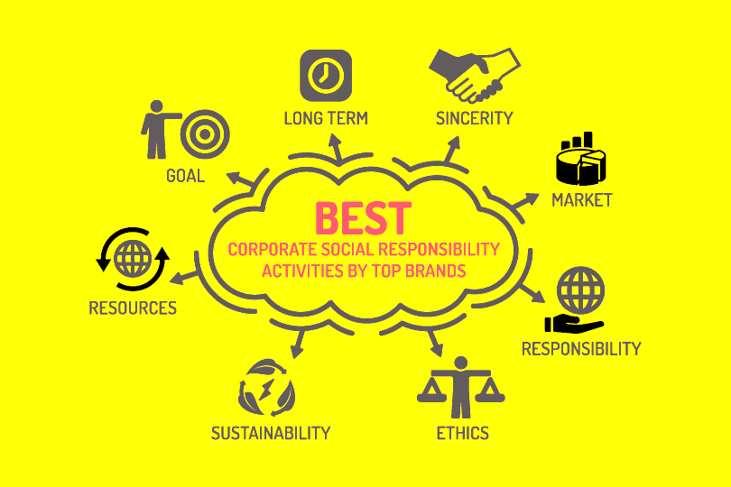

5.1 Findings of the report
The results of the survey of 15 Small and Medium Enterprises on Corporate Social Responsibilities is showing that the SME’s of Bangladesh gave significant impact on the CSR activities. Therefore, not only that foreign rich multi-national companies are offering or promoting CSR in Bangladesh. The findings of the reports of 20 questions are analysed below:

- In terms of Human Rights:
- 12 (80%) out of 15 SME’s are hiring right per person for their job. 20% of them were neutral, and have taken them as not hiring right person for their job.
- 11 (74%) out of 15 SME’s provide adequate and relevant information about the organization and job to the candidates.
- 12 (80%) out of 15 SME’s care about employees
- 9 (74%) out of 15 SME’s pays equal salary to women and man for the same jobs from the same valid.
- 11 (74%) out of 15 SME’s provide adequate and relevant information about the organization and job to the candidates.

- In terms Human Resource:
- 13 (87%) out of 15 SME’s are providing their employees proper training.
- 14 (94%) out of 15 SME’s treat their employees well.
- 12 (80%) out of 15 SME’s are concerned about employee’s health, safety and working condition.
- 11 (74%) out of 15 SME’s listed and valued their employee’s opinion and ideas.
- 8 (54%) out of 15 SME’s pay their employees on time.

- In terms of Environmental concern:
- 5 (33%) out of 15 SME’s perform activities that are not part of work but beneficial for society.
- 7 (47%) out of 15 SME’s have materials policy of reduction taken to reuse and recycling.
- 13 (87%) out of 15 SME’s monitoring and taking responsibility for releases to the environment.
- 15 (100%) out of 15 SME’s manage wastes perfectly.
- 6 (40%) out of the 15 SME’s restrict other action to keep the environment free from pollution.
- 7 (47%) out of 15 SME’s have their own policies for their supplies.
- 3 (20%) out of 15 SME’s take action for tree plantation.

- In terms of Philanthropic purposes:
- 14 (94%) out of 15 SME’s donate to poor people.
- 13 (87%) out of 15 SME’s donate to the orphanage.
- 4 (27%) out of 15 SME’s are effectively communicated its needs for donation.
- 7 (47%) out of 15 SME’s donate frequently.

Finally, the total score of CSR activities performed by the Small and Medium Enterprises of Bangladesh is not quite satisfactory as the positive results found from the survey was in total of 196 out of 300 (15 SME x 20Q). On the other hand, we can see there are significant effort are provided in the terms of human rights and human resource section, but lag behind in the environmental and philanthropic purposes.

Chapter Six
Recommendations and Conclusion

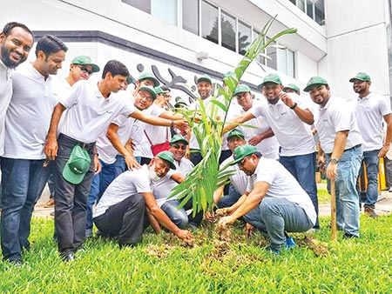

6.1 Recommendations of the Report
According to the analysis performed in the previous parts of the study, we can see that there are low results in the environmental concerns and philanthropic purposes. Therefore, a few suggestions are shared below to improve condition of the Corporate Social Responsibilities that are performed by the Bangladeshi SME’s:
- First of all, Bangladesh Bank and other government organization require to provide few mandatory yearly rules, laws, and guidelines so that all Bangladesh organization have to contribute in the CSR activities. The rules that are already been provided have to check for further improvement.
- Government should promote the necessities of the CSR Activities to the environment and human beings by sharing advertisement in the newspaper, phone messages, and television advertisement so that people as well organization are aware of its necessities.
- It was found that only 8 out of 15 SME’s are paying their employees on time. The rest of 7 companies are not paying on time. Therefore, awareness of pay on time is necessary as we know, when employees are not properly paid, they can leave the company, take legal action against the employer or even ban them and cause complications to the company. Under the law, if a worker has not received adequate monetary compensation for his or her working time within the company, the owner can be held responsible for the prosecution and severe penalties. So, paying employees on time is important.
- It is also found that only 5 out of 15 SME’s perform activities that are not part of their organizational work but beneficial for the society. I think it should be improved as society is most vital factor that is required to save first and working for the society any organization can build the trust with their customers.
- Only 7 SME’s have materials policy of reduction taken to reuse and recycling means there are 8 organizations who don’t have any materials policies for recycle their waste. Each organization should research and develop methods to reuse and recycle their products so that the waste products cannot be burden for the society and the companies may earn some extra profit as well.
- It is a matter of great sorrow that only 3 organizations SME’s take actions for tree plantation knowing the importance of trees. A strict law need to be established that each organization has to plant a tree in each year so that everyone don’t take tree plantation to their own desire and aware them how important the trees are for our earth.
- Another findings show that SME’s are less interested to donate frequently. They should know that if they perform corporate charitable contributions to non-profit firms can benefit their self from tax deductions. But still, donate to a charity because you feel connected to an organization and not because you want a tax deduction. Charity is not just about tax benefits. When it comes to paperwork and tax requirements for charitable contributions, it is often easier to speak with a tax advisor.

6.2 Conclusion
Social responsibility has become increasingly important to companies in recent years. Whether it is empowering women, helping the environment, or trying to end poverty, more and more companies are integrating social responsibility into their overall business strategy. Social issues can be local, national or global.
Being a socially responsible company can strengthen a company's image and build its brand. An organization's public perception is essential to the trust of customers and shareholders in the sector. By presenting a positive image, an organization can identify itself as not only financially viable but also socially conscious.
Furthermore, by being active in the community, employees of a company communicate with potential customers and, in doing so, indirectly commercialize the company in the process.
The project report describes the concept of corporate social responsibility and how SMEs take initiative to contribute to Bangladeshi society. As I see it, the results are quite satisfactory, but there are still some small and medium-sized enterprises are unwilling to take any action to perform CSR activities. I hope the suggestions I have given, based on my academic background in my business world, will help all to understand the need for CSR activities in small and medium enterprises in Bangladesh.

References
(1) List of SME’s and BB policy on agriculture based industry and SME, Available at: https://bb.org.bd/sme/index.php
(2) Green paper, 2001, Green Paper Promoting a European framework for Corporate Social Responsibility, Available at: https://www.eea.europa.eu/policy-documents/com-2001-366-final-green
(3) Bangladesh Bank Rules and Guidelines on performing CSR, Available at: https://www.bb.org.bd/aboutus/regulationguideline/guidelist.php
(4) Campbell, J.L. (2007) ‘Why should corporations behave in socially responsible ways? An institutional theory of corporate social responsibility’, Academy of Management Review, Vol. 32, No. 3, pp.946–967
(5) Barney, J.B. (1991) ‘Firm resources and sustained competitive advantage’, Journal of Management, Vol. 17, No. 1, pp.99–120.
(6) Coleman, J.C. (1988) ‘Social capital in the creation of human capital’, American Journal of Sociology, Vol. 94, (suppl.), pp.S95–S120.
(7) Brammer, S. and Millington, A. (2008) ‘Does it pay to be different? An analysis of the relationship between corporate social and financial performance’, Strategic management Journal, Vol. 29, No. 12, pp.1325–1343
(8) Garriga, E. and Melè, D. (2004) ‘Corporate social responsibility theories: mapping the territory’, Journal of Business Ethics, Vol. 53, No. 1, pp.51–71.


Appendix
Questionnaire on
The CSR activities performed by SME’s of Bangladesh
Question | Yes | No | Neutral
Human rights
1. Do your company hire the right person in the right job?
2. Do your company provide adequate and relevant information about the organization and job to the candidates?
3. Do your company care about employees?
4. Are salaries for women and man the same for jobs of the same valid?
Human Resource
5. Do your company give you proper training?
6. Are employees treated well by your company?
7. Are your company concerned about employee’s health, safety and working condition?
8. Employees opinion and ideas are listed and valued by your company.
9. Do your company pay you on time?
Environmental
10. Do your company perform activities that are not part of work but beneficial for society?

11. Does materials policy of reduction taken by your company to reuse and recycling?
12. Is your company monitoring and taking responsibility for releases to the environment?
13. Do your company manage wastes perfectly?
14. Do your company takes other action to keep the environment free from pollution?
15. Does environmental policy for supplies followed by your company.
16. Do your company take action for tree plantation?
Philanthropic
17. Do your company donate to poor people?
18. Do your company donate to the orphanage?
19. Do your company effectively communicated its needs for donation?
20. Do your company donate frequently?

