
NATIONAL BA NK LIMITED
REPORT ON TRAINING AND
DEVELOPMENT PROCESS OF NATIONAL BANK LIMITED


Submitted By
Nazmus Sakib

111 131 155
3.31.2019
02)202



INTERNSHIP REPORT
ON
TRAINING AND DEVELOPMENT PROCESS OF NATIONAL BANK LIMITED

Submitted by

Nazmus Sakib
ID: 111 131 155
School of Business & Economics United International University

Submitted to: Ishrat Sultana
Assistant Professor
School of Business & Economics United International University

Submission Date: 31st March, 2019



Letter of Transmittal

01/02/2019
Ishrat Sultana
Assistant Professor
School of Business and Economics
United International University
Subject: Submission of Internship Report.

Dear Madam,

I am exceptionally happy to yield my internship report on “Training and Development Process Of National Bank Limited” which could be a portion of the BBA Program course of think about. It may be a great accomplishment to piece of work beneath your dynamic supervision. I would like to require this opportunity to thank you for the directing and backup you've got given me amid the course of this report. With profound appreciation, I too recognize the assistance given by Sumana Yasmin(Assistant Vice president), Shimanto Square,, 5th floor, 210/A, Dhaka-1205, Bangladesh) for giving me most extreme bolster amid my internship within the framework. To get ready the report I have collected what I accept to be most relevant information to form my report as expository and solid as conceivable. I would truly be thankful on the off chance that you edify me along with your considerations and sees with respect to the report. Moreover, on the off chance that you want to investigate around a viewpoint of my report, I would gladly answer your quarries. Thank you again for your support and patience.
Yours Sincerely,

Nazmus Sakib Raihan,
ID: 111131155,
United International University

Supervisor’s Certificate

This is to certify that the internship report on “Training and Development Process Of National Bank Limited” in the bona fide record at the report is done by Nazmus Sakib as a partial fulfillment of the requirement of Bachelor of Business Administration (BBA) degree from School of Business & Economics, United International University.
The report has been prepared under my guidance and is a record of the bona fide work carried out successfully.

__________________________ Signature of the Supervisor

__________________________ Date

Declaration

I do hereby earnestly declare that the work presented in this Internship Report has been carried out by me and has not been submitted to any other University for any academic qualification.
The work I have presented does not breach any existing copyright and no portion of this report has been copied from any work done earlier for a degree or otherwise.
I further undertake to indemnity the Department against any loss or damage arising from breach of the foregoing obligation.

__________________________ Signature of the Student

_________________________Date
Acknowledgment
I would like to convey my significant appreciation to all those who have been instrumental within the training of this internship report. Much obliged to All-powerful Almighty for favoring to complete the report within the plan time. I am obligated to an entirety part of individuals for their kind suggestion, accommodation, course, co-operation and their collaboration would like to thank Sumana Yasmin(Assistant Vice president) for her warm welcome within the bank and kind exhortation. It is my delight to them and my thankful appreciation goes to National Bank Limited (NBL) specialist for rendering me their ability, information and giving me the opportunity of having a down to earth encounter through this internship program. I need to expand my profound sense of appreciation to my supervisor Sumana Yasmin(Assistant Vice president) Internship supervisor, for her persuading motivation, kind rules, important recommendations & exhortation amid my internship period to prepare this report.
I shall remain ever grateful to my organizational supervisor Sumana Yasmin (Assistant Vice president), EVP & Principal of NBL. Moreover, Sayed Nazmul Haque (Junior Assistant Vice President), Md. Abdul Hannan (Junior Officer) of National Bank Limited, Shimanto Square, 5th floor, 210/A, Dhaka-1205, Bangladesh, for their continuous guidance and valuable suggestion from time to time.
I would like to thank all the honorable teachers of the United International University Business School, for their valuable supports, inspirations and proper advice during this study. Finally, I would like to thank Ishrat Sultana (Assistant Professor), United International University for enormous help and feedbacks on the report procedure.

Executive Summary

This report provides a study and collected information on “Training and Development Process Of National Bank Limited”. Method of findings and analysis include both primary and secondary data. The method of analysis includes frequency distribution of the collected data. The primary data was collected by face to face conversation with officers and customers and the secondary data was collected from company’s annual reports, website and other yearly reports. This report also includes overview of National Bank Limited, services and products, working experience during the internship period and operation of foreign exchange department of NATIONAL BANK LIMITED. The report also includes the fact that the analysis conducted has limitations. Based on the data, this report finds that most of the customers are satisfied with quality of service provided by the foreign trade department of NATIONAL BANK LIMITED. However, in case of overall environment, service charges, and timeliness, some of the customers were dissatisfied with the service quality of the Foreign Exchange department and but due to some networking error some card holding customers are dissatisfied to NATIONAL BANK LIMITED. NBL should focus on these issues in order to improve their quality of service in Foreign Exchange department and card divisions. A bank’s performance and profit largely depends on its divisions.
I have completed my internship at NBL because I have preferred to work in this area and I think NBL is one of the best training institutions for all sectors because of its good accommodation, providing best speakers to the trainees, and it also has a sophisticated management system.

Table of Content

CHAPTER NAME | PAGE NO

CHAPTER-ONE  Overview Of The Study | 1
Introduction | 2-3
Methodology | 3-4
Limitations Of the Study | 4
CHAPTER-TWO  Banking Industry Of Bangladesh | 5
Banking Sector Scenario In Bangladesh | 6-9
Types Of Banks | 9-11
CHAPTER-THREE  Organization Overview | 12
Company Profile, Mission, Vision, Core Value | 13-15
Corporate Structure | 15-16
Organogram | 17
Types of Banking Business | 18-22
Human Resource Division | 22-24
CHAPTER-FOUR  Literature Review | 25
Literature Review | 26-30
Methods of Training at NBL | 30-35
CHAPTER-FIVE  Findings and Analysis | 36
Training & development at NBL | 37-43
Training Offers in NBL | 44-45
Findings and Analysis in Summary | 45-50
CHAPTER-SIX  Conclusion and Recommendations | 51
Conclusion | 51-53
Recommendations | 54-5
Bibliography | 56
Appendix-A | 57-69
Appendix-B | 70-71



CHAPTER –ONE
OVERVIEW OF THE STUDY

Introduction

Origin of the Report

It is vital that all BBA understudies mandatorily lock in any organization for at least three months as an internship to have practical information and experience, and after three months he/she has to yield an internship report. The report is the outcome of the gave out training position recommended by the direct teacher. The theme of my internship report is “Training and Development of National Bank Limited.” And I have completed my three months internship on National Bank Limited, Shimanto Square-Branch, 80, Pilkhana, Dhanmondi, Dhaka.

Scope of the Report

National Bank Limited is presently well known and has been carrying on business through its 180 branches at present spread all over the country. Besides, the Bank has drawn arrangement with 415 correspondents in 75 countries of the world as well as with 32 overseas Exchange Companies. NBL was the first domestic bank to establish agency arrangement with the world famous Western Union in order to facilitate quick and safe remittance of the valuable foreign exchanges earned by the expatriate Bangladeshi nationals. NBL was also the first among domestic banks to introduce international MasterCard in Bangladesh. The scope of the report will be restricted to the organizational setup, work and operation of the NBL in the Bangladesh. As I was sent to National Bank limited, Shimanto Square-Branch, the scope of ponders is as it were constrained of this department. The report covers the Training and Development of National Bank limited. The report more over covers the subtle elements around National Bank limited.

Objectives of the Study

The primary objective of the study is to show our gathered commonsense information on managing an account framework and operation amid introduction period. This viable introduction gives us a chance to co‐ordinate out hypothetical information with the viable encounter. The taking after are of objective for this down to earth introduction in bank. The common objective of this think about is to fulfill the prerequisite of internship report.

Broad Objectives

The broad objectives are:

- To achieve overall understanding of National Bank limited.

- To know the different types of product and services of National Bank limited.

- Identify the Training and Development of National Bank limited.

Specific Objectives

The specific objectives are:

- To enrich my knowledge in banking sector.

- To analyze general banking practice of the bank.

- To get practical knowledge about money transaction.

- To know about the employee satisfaction as well as customer satisfaction.

Methodology

Data collection

Methodology means the methods, problems and techniques to collect the data. Broadly speaking, methodology means the underlying principles and of the organization of a philosophical system or equity. The report mainly prepared based on primary data. Both structured and not- structured questionnaire and informal interviews are the main source of the collected data. The sources are:

Primary Data

          - Face to face confront discussion with the officers, Practical observation,
          - Face to face confront discussion with the customers.

Secondary Data

- Yearly Reports and other materials, Site of the Bank, Periodical articulation of the bank brochures, booklets etc.

Limitations of the Study

A few confinements at the time of planning this report was faced by me. The present ponder was not out of impediments. But as an understudy it was an awesome opportunity for me to know the managing of an account exercises of Bangladesh particularly NBL. A few limitations are as follows:
- One of the major confinements is the deficiency of internship period. Since three month isn't sufficient to know everything about the bank, so this report does not contain all the range of National Bank Limited.
- The head-office always remains busy as it has to deal with walk in customers from 10 am to 6pm, therefore the officers are in a rush and get occupied with their own work as an outcome a very few chances prevails to talk to them properly.
- At first, the authority did not want to disclose much about their training process as it does not fall under any bank’s policy.
- For the first time, since I was conducting the whole study alone so lack of experience is a matter of fact that constituted the limitation of the study.

CHAPTER –TWO
BANKING INDUSTRY OF BANGLADESH

Banking Sector Scenario in Bangladesh

In Bangladesh the banking segment has traveled through a journey where the division has experienced a few ups and downs. Subsequently, changes have been attempted with goals such as expanding the capital ampleness of banks, streamlining rules for rescheduling of different sorts of advances, fixing arrangements for non-performing credits, reinforcing revelation necessities and moving forward bookkeeping frameworks have without a doubt progressed the soundness of the segment over the a long time. Be that as it may, the managing an account division within the later past has not been palatable. At show, key performing use proportion, return on resources and return on value in spite of a few measures taken by the central bank.
Banking industry of Bangladesh has achieved remarkable momentum over the years. It has brought several positive changes in terms of expansion, modernization, quality of assets, application of international standards, technology adaptation, capacity development efforts, corporate governance, and improved regulatory and supervisory environment. The development is not, however, uniform in all banks. Fortunately, the industry did not have to face any severe fallout from the 2007-2008 Global Financial Crisis (GFC). However, like other global economies, the industry is becoming exposed to newer challenges, financial crimes, and competitions. Though there are several instances and successful efforts of bank leadership to address the changing needs, all banks are required to develop their customized paths to sustain on a continuous process. Effective leadership, sound governance framework, and emotional intelligence are tools for tomorrow's banks to survive.

Bangladesh Bank (BB) has undertaken remarkable regulatory and supervisory initiatives over the years in line with the internationally accepted standards and compliance requirements. Banking sector of the country now has risk management guidelines and compliance requirements for all the key areas of banking; and prudential and capital standards are duly in place. Adoption of technology has brought in remarkable efficiency in the supervisory arrangement of Bangladesh Bank. The central bank has created a platform for modernization of banking, payment system and financial service delivery by formulation of rules, guidelines and supportive arrangements. Notable initiatives have been taken for effective oversight of risk management, internal controls and customer interest protections. It is good to observe that the central bank has responded with due support to technology-driven initiatives of the scheduled banks. Currently, maximum banks are holding substantial idle money, as the private sector is still unable to absorb funds on offer for investment. The growth of deposits is also adding to this problem, Banks are in reality getting return from the said funds. Instead, interest is to be paid against them. In the best case scenario some of the banks are getting some nominal return by getting their funds invested in government bills and bonds. This avenue has also become limited, of late, as the Government has virtually stopped borrowing from the banking system due to huge sales of national savings certificates. The central bank has advised the banks to invest in the SMEs, with a view to improving the position.
Maintaining cyber security has become another challenge for the overall banking industry in the midst of some recent developments all over the globe. Due to integration of technology, it has become easier now days to transfer funds online. Hence, the sector is now more concerned for providing its customers greater cyber security protection.

Banks' Deposits

Total deposit of the scheduled banks has increased by BDT 9,56,421 million (14.78%) at the end of December 2017 from that of December 2018. Time deposits registered a growth of BDT 154,325 million or 11.92% and demand deposits also registered a strong growth of BDT 798,126 million or 20.51% in December 2017 over December 2018.
NBL’s deposits registered an increase of BDT 12,868 million or 10.87% from BDT 118,405 million in December 2018 BDT 131,272 million in December 2017.

Bank’s Advance
Banks' advances recorded an increase of BDT 956,395 million or 15.49% at the end of December compared to the same of December 2018 Whereas, NBL's advances registered an increase of BDT 16,767 million or 17.18% from BDT 97,589 million in December 2018 to BDT 114,356 million in December 2017.

Banks' Profitability

Despite a sharp cut in the lending rates and presence of excess liquidity in the banking system, profit of most of the private commercial banks rose considerably in 2017.
Most of the banks operating profit experienced higher growth during 2018 compared to the same of previous year. However, profit after tax for PCBs were reported to be below expectations due to higher provisioning required against default loans NBL's operating profit stood at BDT 3,209 million during 2018 experiencing an impressive growth of 20% compared to BDT 2,672 million in 2017. Whereas, the consolidated operating profit for NBL at the end of 2018 was reported to be BDT 3.408 million that is 21% more than what it achieved during 2017.

Money Market

Since the banks are having excess liquidity, the interbank call money rate in the banking sector experienced a downward adjustment. At the end of November 2017, deals were getting settled at percent, whereas during the initial months of the year the same deals were getting settled at percent. Interest rates on treasury bills and bonds fluctuated significantly throughout the entire 2017. 91 days cut off got hit to as low as 2.69 percent during February 2017 to rise as high as 4.72 percent during July 2017. The Repo and Reverse Repo rates have been re-fired at 6.50% (from 5.75%) respectively, with effect from January 2018.
Money market and its instruments are being adjusted downwards simply due to the lack of investment opportunities. Banks are slashing interest rates on deposits to adjust themselves with the prevailing market scenario. The declining trend of BGTB cut off has created more pressure on banks to cut their interest rate.

Interest Rate Spread

The spread between the weighted normal propels and the deposit rates of all banks diminished in the midst of 2017 with small variances. The spread between weighted average advances and deposit rates came down to 5.25% in December 2017 from 5.84% of December 2018. On a year on year premise, both interest expenses on deposit and interest income on progresses dropped altogether. Interest on deposit decreased by 1.02% point to 5.22% in December 2018 from 6.30% of December 2017, while, interest on advances diminished to 9.93% amid December 2018 from 11.18% of December 2017.

Primary Dealer Operation

Primary dealers operate in an attempt to ascertain a sound, proficient and vivacious secondary market for the government securities by active participation of market makers, operators and the market participants. A total of 12 leading commercial and three non-banking financing institutions (NBFIs) are working as primary dealers in treasury bills and government bonds while other banks and NBFIs did not require to involve their funds in related operations. However, during 2018, interest rates on the government treasury bills and bonds declined as a whole as most of the scheduled banks rushed to invest their excess liquidity in the government tools and a lethargic business situation in the country.

Types of Banks

Central Bank

- Bangladesh Bank.

State-owned Commercial Banks

- Sonali Bank Ltd,
- Janata Bank Ltd,
- Agrani Bank Ltd,
- Rupali Bank Ltd,
- Bangladesh Krishi Bank,
- Bangladesh Development Bank Limited,
- Basic Bank Limited

Private Commercial Banks

AB Bank Limited, Bangladesh Commerce Bank Limited, Bank Asia Limited, Bengal Bank Limited, BRAC Bank Limited, City Bank Limited, Dhaka Bank Limited, Dutch-Bangla Bank Limited, Eastern Bank Limited, IFIC Bank Limited, Jamuna Bank Limited, Meghna Bank Limited, Mercantile Bank Limited, Midland Bank, Modhumoti Bank Limited, National Bank Limited Limited, National Bank Limited, National Credit & Commerce Bank Limited, NRB Bank Limited, NRB Commercial Bank Limited, One Bank Limited, Premier Bank Limited, Prime Bank Limited, Pubali Bank Limited, South Bangla Agriculture & Commerce Bank Limited, Southeast Bank Limited, Standard Bank Limited, The Farmers Bank Limited, Trust Bank Limited, United Commercial Bank Limited, Uttara Bank Limited, Shimanto Bank Ltd.

Islamic Commercial Private Banks

- Islami Somaz Bank Limited,
- Al-Arafah Islami Bank Limited,
- EXIM Bank Limited,
- First Security Islami Bank Limited,
- ICB Islamic Bank Limited,
- Islami Bank Bangladesh Limited,
- Shahjalal Islami Bank Limited,
- Social Islami Bank Limited,
- Union Bank Limited.

Foreign Commercial Banks

      - Bank Al-Falah Limited,
      - Citibank N.A,
      - Commercial Bank of Ceylon PLC,
- Habib Bank Limited,
- National Bank of Pakistan,
- Standard Chartered Bank,
- State Bank of India,
- Punjab National Bank,
- Woori Bank, HSBC.

Non-Scheduled Banks/Specialized Banks.

      - Ansar VDP Unnayan Bank,
      - Karmashangosthan Bank,
      - Probashi Kollyan Bank,
      - Grameen Bank,
      - Jubilee Bank,
      - Palli Sanchay Bank.

CHAPTER –THREE
ORGANIZATION OVERVIEW

Company profile

National Bank Limited provides private banking and other financial services. Its deposit products include savings deposits, current deposits, term deposits, foreign currency deposits, monthly savings and income schemes, double benefit schemes, and millionaire income schemes. The company’s loan products portfolio comprises overdraft facilities for corporate customers for day-to-day business operations; lease financing for capital machinery, medical and information technology equipment, lifts or elevators, construction equipment, other various equipment, and consumer durables, as well as gas, diesel generator, and power plants; home loans for purchasing flats or constructing houses; small medium enterprise loans; consumer credit facilities for retail customers; banking services for various commercial concerns, such as in the industrial sector for export-import purpose as working capital, packing credit, trade finance, issuance of import L/Cs, advising and confirming export L/Cs, and bonds and guarantees; and agriculture and rural credit facilities. It also provides debit and credit cards; and trade, cash management, treasury, security, and custodian services. The company conducts its operations through approximately 200 branches, including 16 SME/Agri-branches in Bangladesh. National Bank Limited was founded in 1983 and is headquartered in Dhaka, Bangladesh.

NBL focused on all key areas covering capital adequacy, maintaining good asset quality, sound management, satisfactory earnings, and liquidity. As a consequence, it was possible to a record growth of 175.51 percent with Tk. 8,809.40 million pre-tax profit in the year under review over the preceding year. The net profit after tax and provision stood at Tk. 6,860.34 million which was Tk. 2,070.47 million in the previous year registering a 231.34 percent rise. The total deposits increased to Tk. 102,471.83 million being 33.37 percent increase over the preceding year. Loans and advances stood at Tk. 92,003.56 million in the year under report which was Tk. 65,129.289 million representing 41.26 percent rise over the preceding year. Foreign trade stood at Tk. 144,255.00 million in 2010 compared to Tk. 115,939.00 million, increased by 24.42 percent compared to that of the previous year. During 2010, the bank handled inward remittance of Tk. 49,145.30 million, 10.73 percent higher than that of the previous year. Return on Equity (ROE) registered a 77.84 percent rise over the preceding year.

Vision

Ensuring highest standard of clientele services through the best application of latest information technology, making due contribution to the national economy and establishing ourselves firmly at home and abroad as a front-ranking bank of the country are our cherished vision.

MISSION

Efforts for expansion of our activities at home and abroad by adding new dimensions to our banking services are being continued unabated. Alongside, we are also putting highest priority in ensuring transparency, accountability, and improved clientele service as well as to our commitment to serve the society through which we want to get closer and closer to the people of all strata. Winning an everlasting seat in the hearts of the people as a caring companion in uplifting the national economic standard through continuous upgradation and diversification of our clientele services in line with national and international requirements is the desired goal we want to reach.

Core Values

Obligation:

- Shareholders -Construct sustainable economic value for our shareholders by utilizing an honest and efficient business methodology.
- Community- Devoted to serve the society through employment creation, support community projects and events and be a responsible corporate citizen.
- Customers- Render state-of-the-art service to their customers by offering diversified products and by aspiring to fulfill their banking needs to the best of their abilities.
- Employees -They rely on the inherent merits of the employee and honor our relation as a part of this renowned financial institution. They work together to celebrate and reward unique backgrounds, viewpoints, skills and talents of everyone at the workplace, no matter what their job is.

Corporate Structure

Growth of NBL in terms of Capital, Assets and Liability:

BDT Million

SL | Items | 2018 | 2017 | 2016 | 2015
1 | Authorized Capital | 10,000 | 10,000 | 10,000 | 10,000
2 | Paid up Capital | 4,689 | 3,693 | 3,987 | 2,224
3 | Shareholder’s Equity | 9,457 | 8,876 | 6,760 | 5,987
4 | Total Capital | 13,568 | 12,798 | 8,086 | 8,543
5 | Total Asset | 176,381 | 146,059 | 116,301 | 101,173
6 | Total Liability | 155,872 | 136,130 | 109,530 | 95,723
7 | Total Deposits | 131,252 | 118,405 | 96,087 | 84,373

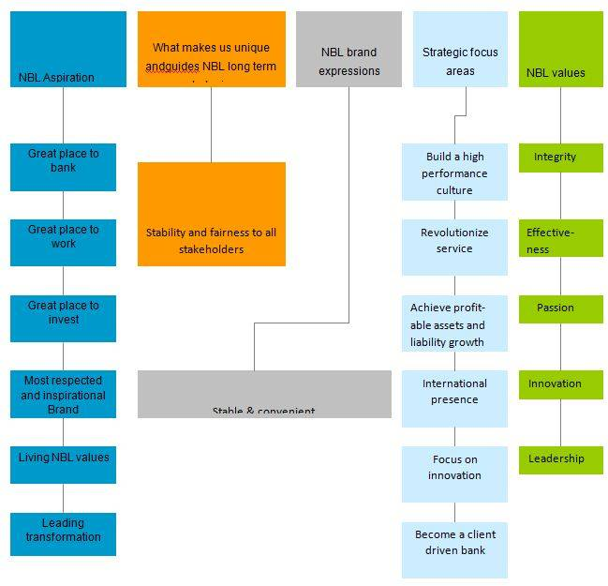
Flow chart: How NBL Is Delivering Growth

Slogan: “A Bank for Performance with Potential”

Organogram

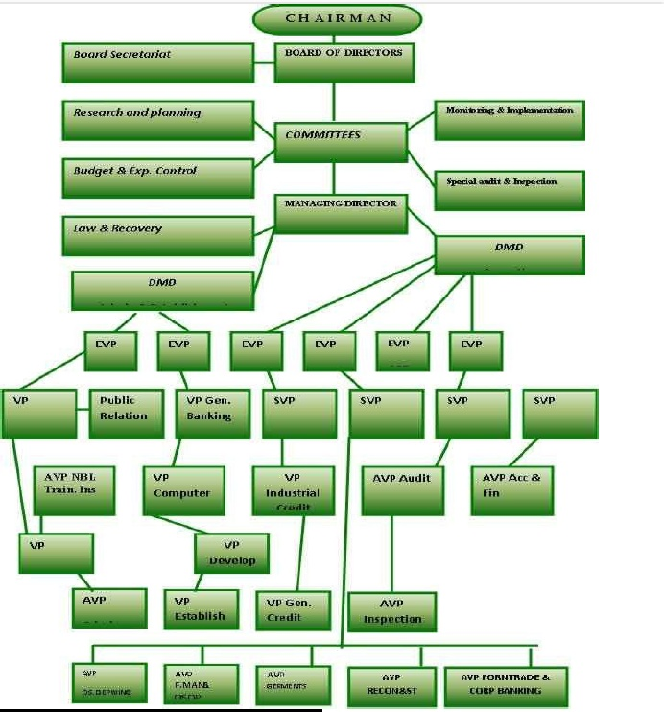

Types of Banking Business

As anticipated within the Reminder of Attachment and as authorized by Bangladesh Bank beneath the arrangements of the Banking Companies Act 1991, the Company begun its banking operation and entitled to carry out the taking after sorts of banking business.
  - Wholesale Banking

  - Retail Banking

  - Privilege Banking

  - Treasury Operation

  - Agent Banking

Wholesale Banking

The emergence of National Bank Limited in the private sector was an important event in the Banking arena of Bangladesh. When the nation was in the grip of severe recession, the government took the farsighted decision to allow the private sector to revive the economy of the country. Several dynamic entrepreneurs came forward for establishing a bank with a motto to revitalize the economy of the country. While the wholesale banking business team operates in a centralized system through the specialized corporate business unit, it operates in a decentralized system through the strategically located NBL branches across the country. The Corporate Business Unit calls corporate and emerging corporate clients and allocate them to branches that are convenient for business transactions of those clients. Branch Corporate Business is catered by the Branch Business Support Unit in WBD.
As on December 31, 2018, the total lending portfolio of the bank stood at BDT 114,356 million, out of which the Wholesale Banking Division contribute BDT 95,987 million, which constitute 80.40% of the entire lending portfolio of the bank.

Retail Banking

National Bank Limited was born as the first hundred percent Bangladeshi owned Bank in the private sector. From the very inception, it was the firm determination of National Bank Limited playing a vital role in the national economy. We are determined to bring back the long forgotten taste of banking services and flavors. We want to serve each one promptly and with a sense of dedication and dignity. Bangladesh is one of the highest growing financial markets worldwide. A recent research conducted by Boston Consulting Group (BCG) which involved 2.000 Bangladeshis, shows that Bangladeshi consumers now have a higher purchasing power for buying a broad variety of consumer goods. The middle and wealthy class (MOA) of Bangladesh now share 18.9% of the total population and it can be hopped that Bangladesh will soon reach even the percentage captured by Thailand and Indonesia.
By trenchant more deeply in retail banking industry, NBL is actually contributing towards the economic growth of the country. As a prudent leader, the bank has always focused on tenable lending. In 2018, NBL, slowly but progressively, started penetrating in Home Loan sector as well. Growth in construction sector is a derivative of the growth in real estate sector which will only blossom through the growth in Home loan industry. The building Construction Industry is considered as one of the fastest growing and largest sectors in Bangladesh. Real Estate Development in private sectors in this country started in pre-liberation days. Concurring to Bangladesh Bureau of Statistics, the development sector accounted for a record 9.4% of GDP. The taking after chart appears the comparison between overall GDP development and development of Real Estate, leasing and commerce administrations.

Privilege Banking

With a view to serving the ever increasing need of the Bank's high net worth clients, NBL Privilege Banking commenced its operation in October 2010 with a modern and state of art Privilege Banking Centre located inside the NBL Corporate Head Office. NBL Privilege Banking aims to cater to the needs of the high net worth section of the society provided that the 360 degree solutions. NBL Privilege Banking was to structure in 2014 to make it a time befitting unit to serve the need of the ever demanding clientele, and since then, it is aspiring to become the top premium banking service provider in the country.
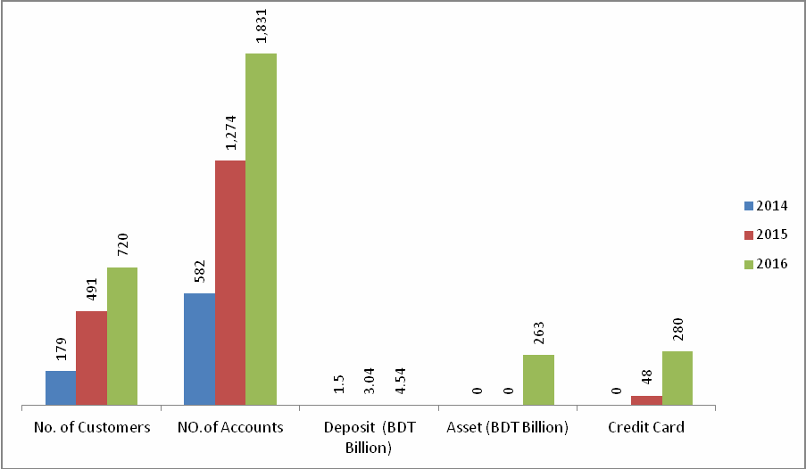
Post restructuring of the unit, NBL Privilege Banking added seven new centers, with six in Dhaka and one in Chittagong. Currently, there are eight Privilege banking center’s strategically located in Dhaka and Chittagong metro areas and these are located within the close propinquity of quality segment clients.
Figure: Privilege Banking Net Growth 2014-2016

Treasury Operation

At present, NBL has been carrying on business through its 200 branches & Agricultural Branches spread all over the country. Since the very beginning, the bank has exerted much emphasis on overseas operations and handled a sizable quantum of homebound foreign remittance. NBL Group Treasury is responsible for the overall management of treasury functions comprising regulatory observance, liquidity management, asset liability management, and most importantly, risk mitigation, both in treasury activities and balance sheet of the bank. It managed to stay ahead of the market through accurate forecasting and efficient strategy formulation amid additional liquidity in the local market and unstable international market due to BREXIT and declining crude oil price. NBL Group treasury has to perform an array of functions in different risk areas to manage and mitigate risks to achieve its organizational goals.
SL. | BANK NAME | COUNTRY | CITY | SWIFT
1. | Bank of Bhutan | Bhutan | Phuentsholing | BHUBBTBT
2. | Standard Chartered Bank (Germany) GMBH | Germany | Frankfurt | SCBLDEFX
3. | Commerzbank AG | Germany | Frankfurt | COBADEFF
4. | Alpha Bank AE | Greece | Athens | CRBAGRAA
5. | State Bank of India | India | Kolkata | SBININBB106
6. | Standard Chartered Bank | India | Mumbai | SCBLINBB
7. | AB Bank Ltd | India | Mumbai | ABBLINBB
8. | Mashreqbank | India | Mumbai | MSHQINBB
9. | HDFC Bank Limited | India | Mumbai | HDFCINBBCAL
10. | Sonali Bank Ltd | India | Kolkata | BSONINCC
11. | The Bank of Tokyo-Mitsubishi Ltd | Japan | Tokyo | BOTKJPJT
12. | Nepal Arab Bank Ltd | Nepal | Kathmandu | NARBNPKA
13. | United Bank Ltd | Pakistan | Karachi | UNILPKKA
14. | Meezan Bank Limited | Pakistan | Karachi | MEZNPKKA
15. | Standard Chartered Bank | Singapore | Singapore | SCBLSGSG
Overseas Operation

NBL has drawing arrangements with 415 correspondents in 75 countries of the world, as well as with 37 overseas Exchange Companies located in 13 countries. NBL was the first domestic bank to establish agency arrangements with the world famous Western Union in order to facilitate quick and safe remittance of the valuable foreign exchanges earned by the expatriate Bangladeshi nationals. This has meant that the expatriates can remit their hard-earned money to the country with much ease, confidence, safety and speed.

Agent Banking

With a view to providing banking and financial NBL aims to expand its agent banking network services to the un-banked population across the country, National Bank Limited started its agent banking operation on June 6, 2018 with the first NBL Agent Banking Centre in Jahapur Baza, Muradnagar, Comila Agent banking offers limited scale banking and financial services to the underserved population by engaging agents under agency agreements. An agent, who is the owner of a center, facilitates banking transactions on behalf of NBL. Agent banking is an additional delivery channel, which offers convenience and extends the outreach of quality and affordable financial services, particularly to the underserved in a cost efficient manner and in places where a financial institution does not have sufficient incentive to establish a full-fledged branch.
As of December 2018, NBL has launched 10 NBL Agent Banking Centers in Comilla Feni, Tangail, Pabna and Dhaka districts. Till December 31, 2018, NBL Agent Banking has opened 2,523 accounts with a total deposit of BOT 36.52 million and the cash disbursement figure against foreign remittance during the period was BDT 124 million. The year 2017 will be the Year of Agent Banking', as we plan to increase the number of centers from 10 to at least 50 by December 2017.

Human Resources Division

NBL Group Human Resources (GHR) plays a causative role in invigorating the future success of NBL. This contributing function is led by NBL's home grown philosophy. NBL3V ensuring a congenial functioning environment, where NBLians can surge and are capable of delivering sustainable governmental performance.
Strategic Priorities of NBL GHR (Group of HR)

- To contribute to sustainable organizational performance;

- To apply NBL's human capital proficiency more energetically to support the business divisions and operational functions;

- To be a flourishing contributor to the control function of NBL for managing human capital risks;
- To correspond and create a more open and translucent environment;

- To encourage recompense culture based on performance and merit.

Performance Management Process

Performance management is about getting the things done well and efficiently. It is the way one keeps track of SMART (Stretching, Measurable, Agreed-upon. Realistic, Time bound) objectives that are the heart of the Performance Management System PMS), GHR categorically focuses on ongoing job requirements, projects and assignments, people development, and self-development for performance management.

Total Human Resources (2011-2016)
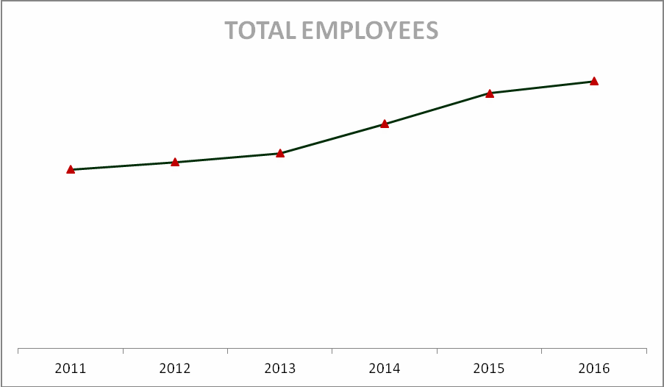

Gender position as on 31st December, 2018
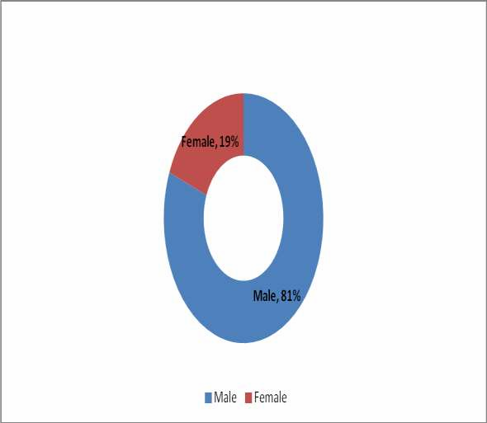

Internship Roles and Responsibilities:

I was welcomed by the all officers at the bank with a brief introduction of them day one. Then from day 2, I was assigned a train desk with no task. I was asked to observe the whole surroundings and was given enough time to settle in. The officers delivered very clear instruction about which Job is done by whom as a result in a short period of time I understood which whom to report for certain issues. My daily activities used to updating the register cheque books and making sure up all the desired client information correctly in right place. I also used to keep a verification on the number of choose region comes a day and then updating those again in the chronicle.

CHAPTER – FOUR
LITERATURE REVIEW

Thesaurus

Human Asset the board regards readiness and improvement as a work worried about authoritative activity pointed at bettering the work execution of individuals and bundles in hierarchical settings. Training and advancement can be depicted as "an enlightening get ready which incorporates the sharpening of aptitudes, ideas, changing of manner and grabbing more data to enhance the execution of representatives".

It gives the idea that it augments the entire authoritative execution and Training includes the basic part inside the achievement of a hierarchical target which identifies with the interface of the association and the workforce (Stone RJ. Human Asset Administration 2002).

Theoretical framework








To execute consider spilling subordinate and self-governing sans showed up inside the theoretical prominence excellent training and advancement is the free factor and authoritative execution inside the subordinate variable. These two elements have been seen the connection between these elements with the impact of Training and advancement on the association execution. The speculative layout work can too be seen from the taking after diagram.

Delivery Style

IV

DV
Training Design
On the Job
Training
Training and
Development
Organizational
Performance

Figure: Training and development speculative layout

Training and Development:









Training could be a learning experience in that searches for a by and large unchanging modify in an individual that will advance the ability to perform on the work. We normally state training can incorporate the changing of capacities, data, perspectives, or conduct. It might remorseless changing what agents know, how they work, their perspectives towards their work or their connection with their partners executive. For our motivations, we'll separate between representative training and advancement for one explicit reason. Regardless of the way that both are similar inside the systems used to impact Learning, their time diagrams differentiate. Training is more show day arranged; its inside is on individuals 'current occupations, redesigning those specific aptitudes and abilities to immediately play out their businesses. For delineation, expect you enter the work feature in the midst of your senior year of school. Input Process Output
New
Employee
Motivated and
Committed
Unskilled
Employee
Training and Development
Programs
Skilled
Employees
Competent
Managers

Potential Management
Figure: Training and development Process

Bring displaying operator. Disregarding the way that you have a degree in exhibiting, when you are enrolled, a couple of training is in organized. Especially, you'll get the opportunity to become familiar with the organization's game plans and practices, thing information, and other relevant offering sharpens. This, by definition, is work explicit training, or setting up that is intended to make you increasingly effective in your present work.

Training

Training as a general rule incorporates enlightening or persuasive activities illustrated to advance data, capacity, and execution of the individual dimension. Training basically suggests a masterminded effort by an organization support agents" learning of employment related skills. The skills join data aptitudes or practices that are essential for successful work execution.

Development

Development could be a prepare by which the workers create their aptitudes, behaviors, demeanors, activities, and other capacities with nonstop training or learning, that are required to perform in an organization viably and easily. A fruitful advancement prepare conveys fitting alter in person behavior, state of mind and movement specifically related to organizational objectives and quantifiable comes about.
According to Griffin, “Development refers to teaching managers and professionals the skill needed for both present and future jobs.” [Complete training Evaluation; The Comprehensive Guide to Measuring Return on Investment, page 53,3rd Edition, Published: 2014.

Importance of employee training and development

Most specialists have a couple of deficiencies in their workplace aptitudes. A training program grants to strengthen most aptitudes that every agent should make progress. An enhancement program conveys all laborers to the following dimension so they all have equivalent capacities and learning.
  - Keep up with industry changes.
  - Be in contact with all the latest advancement improvement.
  - Be ready to see inadequacies and capacities holes.
  - Maintain data and expertise.
  - Advance delegate abilities.
  - Provide a rousing power to learn.
  - Increase work satisfaction levels.
  - Provide internal progression openings.
  - Attract present day ability.

The Five-Steps of Training and Development:






Need
Analysis
Instructional
Design
Validatio
n
Implement
the Program
Evaluatio
n

Figure: Steps of Training and Development

Need Analysis-Needs examination is the essential advance of the planning handle. It perceives the specific work execution capacities required, gets to the arranged coach's aptitudes and makes specific quantifiable data and execution objectives dependent on any inadequacies.

2. Instructional Design-Inside the minute advance guidance configuration individuals pick on gather and make the getting ready program substance tallying exercise manuals works out.

3. Validation-approval is the third step in which the bugs are socked out of the getting ready program by acquaintance it with a little specialist gathering of people.

4. Implement the program-The Fourth means' to execute the program by truly setting up the concentrated on laborers gathering.

5. Evaluation-Fifth is an appraisal venture in which organization assesses the program's triumph or disappointments.

Methods of Training

There are diverse procedures of planning which can be divided into Cognitive and Behavioral systems. Coaches got the chance to get it the experts and cons of every procedure too its impact on students keeping their establishment and aptitudes in keenness some time as of late giving training.

Cognitive Strategies: This technique is a greater amount of giving theoretical planning to the students. The distinctive procedures underneath subjective methodology give the guidelines for how to accomplish something, or verbal information, show, associations among ideas, and so on., these techniques are connected with changes in data and attitude by strengthening learning.

Behavioral Strategies: This system is a greater amount of giving realistic getting ready to the students. The diverse procedures underneath conduct approach allow the student to conduct in a certifiable form. These methodologies are best used for mastery advancement.

The distinctive procedures that come underneath social methodology are followings:

1. Amusements and reproduction.

2. Conduct demonstrating

3. Business recreations

4. Contextual analyses

On the job training:
    - Job rotation
    - Coaching,
    - Action Learning

Off-the-job administration training development:

- The case thinking about method.
- Management games.
- Outside seminars.
- University- related programs.
- Role playing.

Training methods followed by National Bank:

Several methods that can be used by National bank to satisfy on organization training needs and accomplish its objectives. NBL classified their training into two categories:
- Supervisory training
- Non Supervisory training

Supervisory training:
The training for the managerial employees is called supervisory training. Different department’s officers and management trainee are included to these training.

Non Supervisory training:
Non Supervisory training is the training for workers and operators of the company. Permanent and casual workers are included for these.

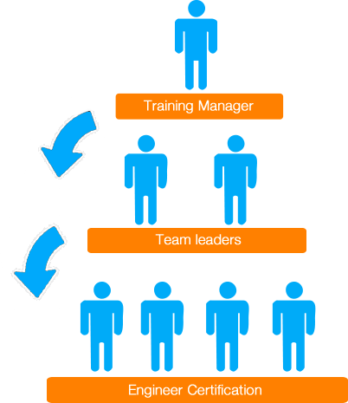
Figure: Training Hierarchy

While several different approaches can be used to identify the training needs of an organisation, McGhee and Thayer's Three-Level Analysis is the most commonly used. The model provides a systematic means of conducting a TNA at three levels:
- Organizational,
- Operational (or task), and
- Individual (or person).

The TNA Process:
A Training Needs Analysis (TNA) is a process by which an organization’s HRD needs are identified and articulated. The process can identify:
- An organization’s goals and its effectiveness in reaching these goals
- Discrepancies or gaps between an employee’s skills and the skills required for effective current job performance
- Discrepancies or gaps between an employee’s skills and the skills needed to perform the job successfully in the future
- The conditions under which the HRD activity will occur.
Ultimately, the TNA will identify needs which require addressing in some way. It not only provides clear direction for identifying training needs, but also helps to evaluate how effective previous training programmers have been. The two outcomes are a training need and a non-training need.
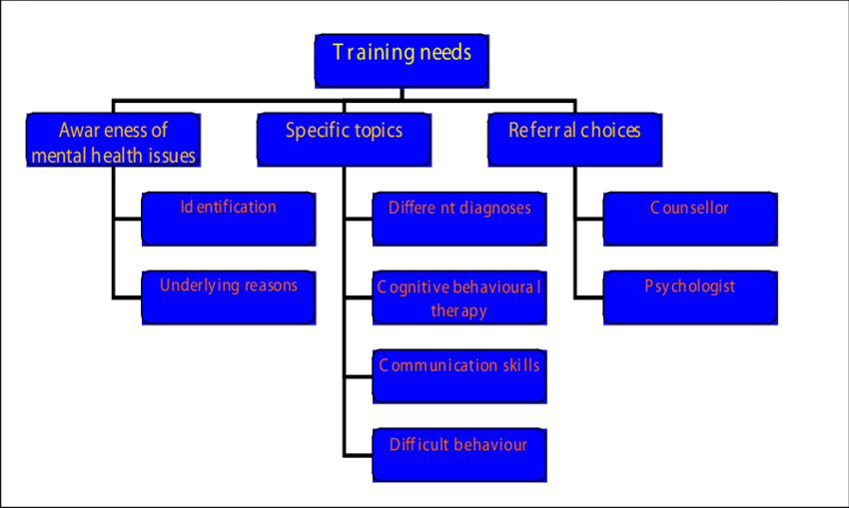
Figure: Levels of Training Needs
A Training Need reveals a performance gap, and the gap can be filled with training. It exists when the employee does not know how to do the job – it is a lack of knowledge, skills, and attitudes.
A Non-Training Need reveals a gap, however this gap cannot be filled (or fixed) with training. It might encompass workflow, recruitment, or job design. Employees know how to do the job, but something else affects their performance.

McGhee and Thayer’s Three-Level Analysis
While several different approaches can be used to identify the training needs of an organisation, McGhee and Thayer’s Three-Level Analysis is the most commonly used.

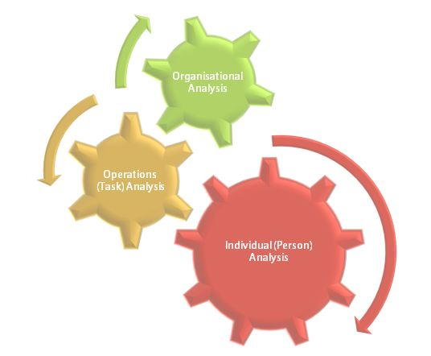
` Figure: McGhee and Thayer’s Three-Level Analysis

The model provides a systematic means of conducting a TNA at three levels:
- Organizational,
- Operational (or task), and
- Individual (or person).
The levels of analysis are a hierarchy which descends from the organizational level to the personal level. At the same time as you descend the hierarchy, you also move to a more micro focus in the organization.

National Bank Ltd hierarchy Training Curriculum
The curriculum of NBL structure training session involves lessons on how the structure works to accomplish the company's mission. The curriculum states the goals for the training classes and the strategies the program uses to help workers and employees to accomplish those goals. The program also includes a means of measuring how well the workers and employees understand the lessons. Three Levels of NBL that are trained differently are described below:
- Top level
- Mid level
- Entry Level
- Top level: Senior executives and CEOs benefit from training programs – and board member training is also essential for company success. Corporate governance courses, for example, can help board members to better manage risk, identify the right business opportunities and meet the challenges of the business environment of today and tomorrow.
  - Mid level: Bank management training can help experienced functional managers prepare for general bank management positions. Bank development training builds skills for developing and implementing strategies, while general management training courses provide essential skills for managing across functions. A leadership development program is also helpful for honing “soft” leadership skills, such as conflict resolution skills, negotiation skills, and skills for effectively motivating, inspiring and leading others. This career stage is also a good time to consider bank management degrees.
- Entry Level: Young, ambitious bank managers with 0-10 years of business experience can prepare for greater responsibility through project management training, corporate training in different business functions, and managerial training.

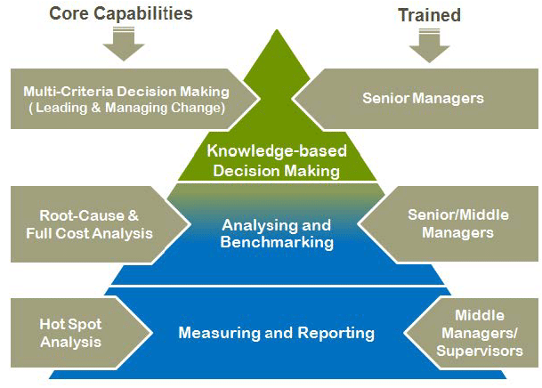

Figure: Training on NBL Hierarchy

CHAPTER – FIVE
FINDINS AND ANALYSIS

Training & development at NBL

Human Resource Development practices point at fulfilling the banks mission. One of NBL four noteworthy missions is to: "Supply advantage to their customers with the help of a skilled and submitted workforce whose creative blessings, imaginative action and focused edge make their position uncommon in giving quality advantage to all establishments and people that they care for".

They have given highlight on need-based training. In the midst of the headway meet, they endeavored to recognize the weakness and the individual require for training and advancement. Other than that, they have net quantities of delegates and met them training need. From the representatives, yearly execution evaluation of report they have taken the information and data on training need. Since the majority of the directors/chiefs are included with the arranging, accordingly, in such manner they have given due significance to their proposals, HR Division sent a draft Training and Development proposition to all worried of the bank and got their remarks/recommendations.

From the distinctive dimension meeting and the executives talk with, it has been discovered that their potential supervisors require advancement on various abilities (for example administrative expertise, authority aptitude, basic leadership ability, correspondence expertise and so forth.)

National Bank Limited
Shimanto Square-Branch,
80, Pilkhana, Dhanmondi, Dhaka-1205
Outlines of proposed Training Courses/Workshops for the year 2018

Introduction

Based on counseling a year ago affair and in perspective of practical training, following training procedures have been proposed for the year 2018:

• Foundation Training Program

• Orientation Training for new joiner

• Regular Program at NBLTI (Off the activity Training)

• Outreach Training Programs at divisional/locale level

• Network empowered E-Learning

• Branch level training (On the activity Training)

Foundation Training Program to be held at NBL for the year 2018

Banks select administrators and authorities from different controls. Be that as it may, bank occupations relates with indicated expert and control. Taking these into comprehension NBL has presented expansive

Arrangement of establishment training on keeping money courses, which may give the comprehension of how the managing an account framework runs, gives credit, funds exchange and venture, raises capital, exchanges chance, gives liquidity bring issues to light on digital security, and so forth. Destinations of this training program will grow information and the board aptitudes to create of new joiners to a standard with various modules of Learning Solutions' on money related instructional classes. Establishment

Orientation Training for 2018 for up-coming new joiners:

Adequately arranging new representatives with respect to elements of NBL and making them effective on beneficial working issues is testing. Through the training program NBLTI collaborates with the recently joined representative's and would make a positive impression to them on NBL 3V would incredibly build the open door for an effective begin .During introduction program. The plan of the program incorporates presenting members with the followings

a) NBL's association structure, vision, mission, openings and Challenges,
b) NBL Winning Strategy and NBL Code of Conduct,
c) Providing features on budgetary arrangement of Bangladesh,
d) Policy issues on Real segment, Monetary division, Fiscal segment and External areas,
e) NBL Products and administrations,
f), Techniques of assembling minimal effort and no cost reserve like CASA account,
g) Payment card enterprises and repayment frameworks like EFT, ACPS, RTGS, MFS,
h) Agent Banking, Privileged Banking, SME and Retail saving money,
i) Business correspondence and manners and so on. Based on a year ago ordeal NBLTI is anticipating 75 introduction courses as pursues:

Regular Program (Off the job Training) to be held for the year 2018 at NBL:

Banks would utilize different experts, including office and managerial care staff, bank employees, advance officers, reviewers, administrators and so on. Off the activity training is the demonstration of expanding the learning and expertise of a worker for completing a specific employment at off the activity site. The sorted out system is by which individuals learn information, ability and upgrade skill for playing out a particular occupation in a classroom procedure. Before defining these sorted out training programs, training need (TNA) of various offices, division and branches has been is properly surveyed. Late TNA done by NBL talks about: Regulatory Requirement, Compliance Requirement, Application and Process prerequisite, Leadership and individual expertise advancement and so on. Planning training programs additionally pursued consultative methodology.
Outreach Training Programs at suitable divisional/district town:

Effort training program has been intended to convey instructional classes close to bank offices individuals where they live or invest energy. It is like classroom training at a reasonable setting of Divisional/District/Up-Zilla put closer to the point of bank offices. These training programs incorporate substantial number of members just as financially savvy. Ongoing TNA demonstrates following Training Courses might be orchestrated at effort of Dhaka:

• Workshop on "Internal Control and Compliance (ICC) Practice & Regulatory Requirements".

• Workshop on Integrated Supervision System (ISS) and Reporting To Bangladesh Bank

• Cash Operation

• Workshop on Money Laundering and Terrorist Financing Risk Management

• Information and Cyber Security Awareness Program

• Payment and Settlement System of Bangladesh

• Foreign Exchange Transactions and on line answering to Bangladesh Bank Reporting

• Credit Risk Management, and so on.

- Branch level training (On the job Training) :

To create normal learning base and to address inadequacy in mindfulness on general managing an account education at branch level "Hands on training", is incredibly basic to be presented. "Off the activity training" or classroom based trainings are target arranged and chiefly would offer concentration to extend aptitude and productivity of the members on a specific region of the bank work. Establishment training for the in administration authorities may resolve the issue however it takes long term and it includes immense expense. To beat the circumstance in brisk path and at less cost branch level training /hands on training (OJT) could be supported and presented:

  - Branch Manager could orchestrate "Hands on training (OJT)" routinely on fundamental saving money writing.

  - GHR through issuing an office request could make the "Hands on training" compulsory and it might be incorporated into the periodical execution detailing of the branch.

  - NBLTI through routine visiting NBL branches may support for OJT at the branch.

  - Methods for "Hands on training" at least would be as per the following:

    - Apprenticeship
    - Mentoring
    - Presentation and sharing bits of knowledge accomplished from Off the Job training
    - Critical episode notes
    - Job growing
    - 'Stretch' assignments
    - Special ventures
    - Coaching
    - Networking and Maintaining Communication

2) NBL Class room interfacing with branch level gathering room: NBL classroom training and addresses could be imparted to branch level members through associating with branch level gathering room. For this situation each branch need sound video catch capable, show upheld and net associated gathering room. This learning technique would be trailed by branch level authorities according to their need.

3) Advantages of On-the-Job Training are -

• It is most affordable

• Trainees turn out to be profoundly energetic

• It is free from fake classroom circumstances

• It is specifically with regards to work

• It is regularly casual

• It is best since it is learning by understanding

System empowered E-Learning:

System empowered e-learning could exchange aptitudes and information to countless authorities at the equivalent or diverse occasions. With the fast advancement in innovation and the progression in learning frameworks is currently much famous. Rather than books electronic instructive materials those can likewise be shared through the Internet, which will be open day in and day out, anyplace, whenever. NBLTI require labor bolster for study and creating Content and Module with respect to this Network empowered E-Learning process.

Training Offers in NBL

NATIONAL BANK LIMITED consistently focuses marvelous highlight on training and advancement of its representatives. NBL acknowledges that in a manner of speaking specialists must give way better advantage if they are arranged well. The GHR (Gather of HR) needs to ensure a dedicated gathering of all around prepared delegates who can serve the customers just as the bank by their mastery. Differing sorts of trainings are publicized to the laborers agreeing to the bank aggravate. A large portion of the trainings are concerning keeping cash practices and the trainings are efficient.
Some item classes are given cry where trainings are given to the workers to their expertise improvement just as serve a superior support of their clients.

Functions of GHR Section

- Assessing Training needs

Every unit will survey it Manpower's training needs on a yearly premise based the destinations indicated in the Annual Operating Plan just as the investigation of individual training needs characterized in Individual Operating Plans rising out of the Annual Performance Appraisal process. Preceding these yearly arranging activities, GHR will give directions and direction about how this arranging ought to happen.
- Responsibilities

The obligation regarding evaluating training needs is shared:

- Employees together with their managers will talk about capabilities and territories that require advancement as a major aspect of the yearly examination process.

- Supervisors will consult with their workers about which zones can be plausibly created. The manager and coordination unit must give the needed help (monetary, time, Logistics) expected to influence the training to occur.

- Department need to evaluate their future headings and requirements. Out of this arranging procedure will develop training needs are set for the representatives. It is vital that senior chiefs are earnest and straightforward with data sharing about arranged training occasions and methodologies.

- GHR must assume a planning job. Other than ordering training plans, its job is to coordinate needs with arranged activities.

Findings and analysis in summary

I have done this part with the help of my cordial Sumana Yasmin (Assistant Vice president),and my beloved senior colleagues. They have helped me by answering a set of questionnaire which let me complete my analysis and findings.

In my questionnaire I made a set of questions which is related to the Training practices & procedure that is followed and applied by National Bank Limited:

There were two sets of question. One for the employers with is assisted by Sumana Yasmin (Assistant Vice president),and the other for the employees asking them about the training practices and development procedures of NBL.
Sumana Yasmin(Assistant Vice president), answered very cordially and descriptively as the requirements. Her answers are very practical which helped a lot to prepare a concrete analysis and findings statement. The answer part of both employers and employees are given below:

Employer
- Training helps the employees in developing their skills by creating an ability and capacity acquired through deliberate, systematic, and sustained effort to smoothly and adaptively carryout complex activities or job functions involving ideas (cognitive skills), things (technical skills), and/or people (interpersonal skills).
- Training can improve/enhance employees business performance, profit and staff morale through the followings:
- Stay ahead of competitors.
- Keep up with latest industry and technology changes.
- Retain staff and attract new talent.
- Incentive to learn.
- Opportunities for promotion.
- Better job satisfaction.
- Customer service training is the training and teaching that employees undergo to improve customer support and satisfaction. It's an iterative process that involves teaching skills, competencies, and tools needed to better serve customers so they derive more value from products and services.
- A work force filled with people eager to learn and develop is a sure sign a company hired well. Employees who are engaged in their jobs and careers want to know more about their company and industry and to learn skills that will improve their performance. Employers who want to harness the full value of their employees and foster loyalty and retention will find training is a winning prospect and motivates all involved.
- NBL follows 3 ways to measure training effectiveness that is being used in the training process:
- Visual Confirmation. Here we follow the traditional trainings, learners demonstrate their knowledge by performing a role-play
- Social Ownership. The ability to teach others is one of the highest forms of mastery of a subject.
- Skill Assessments.
- Training and development is indispensable strategic tool for enhancing and enriching employee performance and knowledge in the applied sector. We use Cross-trainings for enriching banking sector knowledge which is good for managers, because it provides more flexibility in managing the workforce to get the job done, and it is good for employees because it helps them learn new skills, increase their value to their firm and combat position fatigue.
- NBL training program has resulted benefits in almost sphere in our workings.
- A successful economy has a workforce capable of operating industries at a level where it holds a competitive advantage over the economies of other countries. To achieve this, nations may try incentivizing training through tax breaks and write-offs, providing facilities to train workers, or a variety of other means designed to create a more skilled workforce. While it is unlikely an economy will hold a competitive advantage in all industries, it can focus on a number of industries in which skilled professionals are more readily trained. But overall it actually carrying out huge benefits to the economy.
- A training company's main resource is its people. Automating/trained tasks allows the company to save a lot of time, which will increase profit while allowing its employees to perform value adding and profit driven tasks.
- A good economy sits on the top of the pyramid, but what holds it there is its trained and highly skilled workforce. Training companies have a responsibility to deliver exceptional training and really turn their learners from unskilled average-wage workers to high skilled, highly-paid individuals who are able to offer a competitive advantage in their local market that triumph on others around the world. By improving our training operation, we subsequently improve our training delivery and revenue, which consequently increases the number of a highly capable workforce and boosts the economy through earning profits.
- NBL uses different methods to assess the benefits of training in terms of numbers i.e. the profits, the cost. Some of the frequently used methods are ROI, Utility analysis; Cost assessment. There are many costs that are associated with the training apart from the direct and apparent costs. These costs can be described under two headings:
- There are costs incurred towards the training needs analysis, compensation of the training program designers, procurement of training material and various media like the computers, handouts, props, gifts and prizes, audio visuals etc.
- Then there is another category of costs which is incidental to the training session itself such as trainer’s fee/salary, facility costs/rental etc.
- Finally there are costs involved is losing a man day of work (for those who are sent for training), travelling, boarding and lodging and training material that cannot be reused in some other training program.
- Depending on the costs we incurred, we count the ROI, ROA; we do the Utility analysis and assess the effectiveness of the cost.
- From an employer’s perspective there are several drawbacks of training process estimated below:
Surely these drawbacks can be said as the Disadvantages of Staff Training:
- Waste of time and money. There is surely a waste of valuable resources, as the organization needs to spend money, time, and hire other people for training. Waste because the trained employees may leave the organization but the costs incurred for training them will only be counted as wastage.
- Increased stress
- Too much of theory
- Loss of interest
- Leave for the new job
- Time requirements.

Employee

- Skilled/untrained employees get larger scope of getting promotions than the unskilled or untrained employees.
- Training program boasts up the employees to work more passionately rather than the employee who’s not getting the trainings. Surely it does motivate employees.
- Training programs get the employers and employees close where they can know more about each other and improve their relationship. Training helps both in building good bonding.

- Training helps employees to improve their performance which deliberately give them promotions. Promotion certainly means increase in salary/bonus.
- Training programs on banking sector surely enriches the practicality but not all the programs are on banking sectors only. There are lots of issues on which training programs are designed.
- Depending on the providers, satisfaction levels vary. As different time different process/methods are used, it fluctuate our satisfactory requirements.
- Definitely training makes us more confident and compassionate about our workings which results in high level of performance.
- When we are trained well in serving the clients, it makes us a better provider of service which builds better relationship with them.
- NBL training program benefits all the related parties including employers, employees; customers and others.
- From employee’s perspective the drawbacks are followings:
- Increased stress
- Too much of theory
- Loss of interest
- Time requirements.
- Limitations/Responsibilities.

The answers are summarized below in two sections:
- Training helps the employees in developing their skills by creating an ability and capacity acquired through deliberate, systematic, and sustained effort to smoothly and adaptively carryout complex activities or job functions involving ideas, things and/or people. Training can improve/enhance employee business performance, profit and staff morale. Customer service training is the training and teaching that employees undergo to improve customer support and satisfaction. A work force filled with people eager to learn and develop is a sure sign a company hired well. Employees who are engaged in their jobs and careers want to know more about their company and industry and to learn skills that will improve their performance. Through Visual Confirmation, Social Ownership and Skill Assessments, training effectiveness is measured in the training process. Using Cross-trainings for enriching banking sector knowledge which is good for managers, because it provides more flexibility in managing the workforce to get the job done, and it is good for employees because it helps them learn new skills, increase their value to their firm and combat position fatigue. The training program has resulted benefits in almost sphere in our workings. Training and development is indispensable strategic tool for enhancing and enriching employee performance and knowledge in the applied sector. While it is unlikely an economy will hold a competitive advantage in all industries, it can focus on a number of industries in which skilled professionals are more readily trained. But overall it actually carrying out huge benefits to the economy. A successful economy has a workforce capable of operating industries at a level where it holds a competitive advantage over the economies of other countries. A training company's main resource is its people. Automating/trained tasks allows the company to save a lot of time, which will increase profit while allowing its employees to perform value adding and profit driven tasks. Training companies have a responsibility to deliver exceptional training and really turn their learners from unskilled average-wage workers to high skilled, highly-paid individuals who are able to offer a competitive advantage in their local market that triumph on others around the world. By improving training operation, subsequently improve training delivery and revenue, which consequently increases the number of a highly capable workforce and boosts the economy through earning profits. A good economy sits on the top of the pyramid, but what holds it there is its trained and highly skilled workforce. There are many costs that are associated with the training apart from the direct and apparent costs. Some of the frequently used methods are ROI, Utility analysis; Cost assessment. Depending on the costs incurred, ROI, ROA, utility analysis all are assessed to know the effectiveness of the cost. Still there are several drawbacks of training process like everything else has.

The other set of question that was assisted by my senior colleagues helped me a lot to analysis more about the training practices and procedures:

- Skilled/untrained employees get larger scope of getting promotions than the unskilled or untrained employees. Training program boasts up the employees to work more passionately rather than the employee who’s not getting the trainings. These programs get the employers and employees close where they can know more about each other and improve their relationship. Training helps both in building good bonding. It helps employees to improve their performance which deliberately give them promotions. Promotion certainly means increase in salary/bonus. Training programs on banking sector surely enriches the practicality but not all the programs are on banking sectors only. There are lots of issues on which training programs are designed. Different time different process/methods are used, satisfaction levels fluctuates. Training makes confident and compassionate workers about their workings which results in high level of performance. Well trained employees in serving their customer provide better and build greater relationship with them. It benefits all the related parties including employers, employees; customers and others. From employee’s perspective there are several drawbacks too.



CHAPTER – SIX
CONCLUSION AND RECOMMENDATION

Conclusion

While working I have gotten a progressively present sort of experience. In the wake of gathering and examination data, I have a couple of pondered the training and improvement routine with regards to National Bank Limited which is given underneath:

- The examination demonstrates that a large portion of the workers of National Bank Limited Ltd. imagine that training and development is an approach to accomplish the association's objectives.

- In National Bank Limited Ltd the greater part of the workers imagine that the training assumes a critical job to build up their bearer just as bank's improvement.

- Most of the workers of these banks believe that their bank comprehends the training requirements for representatives.

- Almost all workers firmly concurred that their expertise of being meticulous have been improved by the training.

- Most of the workers of these banks believe that their execution has turned out to be well subsequent to receiving training,

- These banks don't lead sufficient programming based training for their representatives. However, to adapt to the developed managing an account framework programming based training is extremely basic for the workers of the bank.

- The training spending plan of National Bank Limited is expanding bit by bit. That implies they are giving more significance on training to accomplish the association's objectives.

- These Banks utilize diverse training strategies to give training to their workers. More often than not they use Class address for the training reason for their representatives. They use mixed media and projector to offer training to the representatives. However, they don't more stress on orchestrating PC based training and motion picture or film based training to their workers.

- The training branch of these Banks fundamentally fixates on the requirements examination of workers for the assurance of representatives for training. They also use execution, evaluation break down the past record, proposal of beat organization to pick the possibility for training.

- The examination demonstrates that the motivation behind giving training of these Banks fluctuates starting with one then onto the next. Be that as it may, the primary reason for existing is to expand the business focus of the bank, persuade the workers and increment the representative's abilities. Be that as it may, all banks don't more concentrate on to build the mechanical information of the representatives.

- The primary motivation behind training of these banks is to expand their benefit. Be that as it may, they don't organize training to incite their representatives. In any case, without inspiration the representative's efficiency won't increment.

Recommendations

With the learning about banking, it is a simple occupation to discover the challenges of the bank: Rather than prescribing might want to give my supposition to enhance the worker improvement by giving legitimate training and the keeping money administration and make the client increasingly fulfilled.

▪ To enhance its everything current advertising systems to pull in increasingly long haul and steadfast customers for the bank.

▪ NBL ltd. necessities to concentrate more on need managing an account.

▪ Increasing the pay for the representatives.

▪ Allocating more bleeding edge officers in the branch workplaces.

▪ Upgrading the bank server.

▪ Redecorating the insides of the bank.

▪ Increase the fixation on publicizing and advancement.

▪ Upgrading the administrations for the ATM corner.

▪ Work more on the bank exercises deceivability.

▪ NBL l. should offer global charge card to its customers.

▪ Monthly training projects for the officers for enhancing their execution level.

Human is most powerful asset for association. Getting the best individual is a basic issue. The learning, abilities, Experience and Job explicit skills evaluation system as of now oppressive, straightforward, advance uniformity of chance and be objective.

Thus, on the off chance that the training for enlistment and choice process is legitimately done, other criteria of the training will be simpler for training organization's worker.

The bank has a coordinated HR plan. Their labor proportion is agreeable for smooth and quality administrations to the potential clients. Notwithstanding great HR plan, the bank ought to pursue incline examination for determining HR needs to hold standard client administrations.

Banks have essential influence inside the present day economy. Human Resource Management (HRM) issues have a basic impact in each association and inside the banks also. No association can achieve its target or can be extraordinary until or except if it satisfies laborers. Authoritative people can fill the role of group who convert the corporate destinations into the real world and triumph. Inside the keeping cash portion exceedingly educated and indispensable work constrain are required to make an aggressive position and to hold it for quite a while. Enrolling, Training. Rule of consistency, work satisfaction and profession enhancement are critical inside the bank. They are building up their system and are endeavoring to get its managing an account organizations increasingly modernized step by step. They regard their customers in each possible way and serve to every exercise of people inside the general public for their reason. The quantity of customers for the bank is extending than contrasted with other inside the business for its quality organizations. Furthermore, for giving its extraordinary administrations NBL has all around organized getting ready sessions each independently and cautiously laid out to set up the most astounding enrolled officer.

It was an unfathomable enjoyment for me to add up to my temporary position program at National Bank Limited, one of the driving banks of the country. My for the most part experience was extraordinary. What's more, I trust, regardless of the couple of controls the report is all around organized and serves the reason of the pursuer. I acknowledge the experience will offer help me a bundle inside the capable world. Finally, I wish unprecedented triumphs of National Bank Limited inside the coming quite a while.

Bibliography

- Bangladesh, C. B. (2018, August 9). Bank: Bangladesh Bank. Retrieved May 12, 2018, from Bangladesh Bank Web site: https://www.bb.org.bd/links/links.php
- Bangladesh, C. B. (2018, February 7). Banks & FIs: Bangladesh Bank. Retrieved May 12, 2018, from Bangladesh bank: https://www.bb.org.bd/fnansys/bankfi.php
- Griffin. Complete Training Evaluation; The Comprehensive Guide to Measuring Return on Investment. 2014.
- Limited, M. T. (n.d.). About Us: National Bank Limited Limited. Retrieved May 12, 2018, from National Bank Limited Limited
- The Daily Star. (2 February,2018). "Of colors, aesthetic contemplations and nature" .

- The Daily Star. (3rd February, 2018). "LIC of India enters insurance business in Bangladesh" . The Daily Star. (3rd February, 2018). "Laurels for Brilliance In Business" .
- NBL Training Institute (NBLTI) Course Calendar 2018
- https://www.bb.org.bd/links/links.php
- https://www.bb.org.bd/fnansys/bankfi.php
- https://www.nblbd.com/home/correspondent_banking
- http://www.worldbank.org/en/about/leadership/managers
- http://www.assignmentpoint.com/wp-content/uploads/2013/11/nbl.jpg
- https://www.imd.org/imd-reflections/general-management-reflections/management-training- programs/
- https://smallbusiness.chron.com/importance-involving-upper-level-management-training-35614.html
- https://smallbusiness.chron.com/organizational-structure-training-73539.html
- https://www.academia.edu/30250718/An_Internship_Report_On_Effectiveness_of_Training_and_Development_in_National_Bank_Limited_NBL_An_Internship_Report_Presented_in_Partial_Fulfillment_of_the_Requirements_for_the_Degree_Bachelor_of_Business_Administration_SUPERVISED_BY_SUBMITTED_BY
- http://www.assignmentpoint.com/business/banking/profile-analysis-of-national-bank-limited.html

Appendix-A

Training Program Schedule & Practices in NBL:

National Bank Limited
Shimanto Square-Branch,
80, Pilkhana, Dhanmondi, Dhaka-1205
Performance in 2018

Training Courses/Workshop/Seminar arranged by NBL

Training Courses/Workshop/Seminar |  | How many  Courses | Frequencies | At NBL | Outside Dhaka  (Out- reach) | No of participants of different target  groups
Need based Training (excluding AML&CFT,  Agent Banking, Foundation &  Orientation) | For in-service officials | 39 | 63 | 57 | 6 | 2535
Foundation Training | Foundation for MMTs 2017 | 1 | 1 | 1 | - | 14
Foundation Training | Foundation for in- service officials | 1 | 2 | 2 | - | 72
course | For new recruit | 1 | 73 | 73 | - | 161
Training | officials
AML & CFT  Risk Management | Workshop  /Conference | 4 | 26 | 14 | 12 | 1663
Agent Bankers & Agent  employees | Training/Workshop | 4 | 12 | 12 | - | 324
Total |  | 51 | 177 | 159 | 18 | 4385

Manpower of NBL (04 in number) Principal (EVP) -01
Faculty & Course Coordinator (SVP) -01 Administrative officer& Course Coordinator (JAVP)- 01 Librarian cum Office Assistant (JO) -01

Proposed for 2018

Training Courses/Workshop/Seminar to be arranged by NBLTI

Training Courses/Workshop/Seminar |  | How many  Courses | Frequencies | At NBLTI | Outside Dhaka  (Out- reach) | Expected no. of participants of different  target groups
Need based | For in-service | 32 | 76 | 53 | 23 | 3000
Training (excluding AML&CFT ,  Agent Banking, Foundation &  Orientation) | officials
Foundation Training for | MMTs 2017 &  MMTs 2018 | 1 | 2 | 2 | - | 40
Foundation Training for | In-service officials | 1 | 3 | 3 | - | 100
Orientation Training | For newly recruit officials | 1 | 60 | 60 | - | 150
AML & CFT  Risk Management | Workshop  /Conference | 4 | 22 | 13 | 9 | 1500
Agent Bankers & Agent employees | Training/workshop | 4 | 12 | 12 | - | 324
Total |  | 43 | 175 | 143 | 32 | 5114
Manpower of NBL Training Institution (04 in number) Principal (EVP) -01
Guest Faculty & Course Coordinator - 01 Administrative officer& Course Coordinator (JAVP)- 01 Librarian cum Office Assistant (JO)- 01

Training Program to be held at NBL for the year 2018 is as per the following:

 | Course No. |  | Name of Training Courses/Workshop/Seminar |  | Duration |  | Frequency |  | Date |  | Venue
 | 01 |  | Foundation Training for NBL Management Trainees (NBLMTs) |  | 90  working days  (Excluding internship) |  | (As to be requested by GHRD) |  | Jan 04  2018 –  Jun 28,  2018 |  | NBL
 | 02 |  | Foundation Training for  Cash Officers (In-service/ Newly Joined) |  | 15  working days |  | 01 |  | Jan 02-18,  2018 |  | NBL
 | 03 |  | Foundation Training for Agent Banker/ Agent Users |  | 05 |  | (As per request of Agent Banking  Department) |  | Jan 14-18,  2018 |  | NBL
 | 04 |  | Foundation Training Course for the Executives of Privilege Banking |  | 05 |  | 01 |  | May 13-  17, 2018 |  | NBL
 | 05 |  | Foundation Training for In- services officers & executives |  | 28  working days |  | 01 |  | April 01 –  26, 2018 |  | NBL
06 |  | Orientation Course |  | HR  request |  | 60  (approx.) |  | As per HR request |  | NBLTI

Proposed Regular Program (Off the job Training) for 2018 at NBL:

Course No. | Name of Training Courses/Workshop/Seminar | Duration | Frequency | Date | Venue
07 | Credit Risk Management | 03 | 3 | Feb 07-08,  2018  Jun04-05, 2018  Nov 11-12,  2018 | NBL
08 | Workshop on Risk Management | 02 | 1 | April 15-16,  2017 | NBL
09 | Workshop on “Internal Control and Compliance (ICC) Practice & Regulatory  Requirements”. | 01 | 1 | Sept 20, 2018 | NBL
10 | Workshop on Integrated Supervision System (ISS) & Reporting To Bangladesh  Bank | 01 | 2 | Mar 15,2018  Aug 28,2018 | NBL
12 | Credit Appraisal & Financing | 05 | 1 | Jul 15- 19,  2018 | NBL
13 | Cash Operation | 02 | 2 | Mar 21-22,  2018  Jul 04-05, 2018 | NBL
14 | Foreign Exchange Finance of Foreign Trade (FOFT) | 05 | 1 | Apr 22-26,  2018 | NBL

Course No. | Name of Training Courses/Workshop/Seminar | Duration | Frequency | Date | Venue
15 | Workshop on Money Laundering and Terrorist Financing Risk Management | 01 | 10 | Jan 14, 2018  Jan 16, 2018  Jan 25, 2018  Feb 19, 2019  May 07, 2018  Jun 24, 2018  Jul 26, 2018  Sept 5, 2018  Sept 24, 2018  Nov 8, 2018 | NBLTI
16 | General Banking, Law & Practice in Banking | 05 | 1 | May 20-24,  2018 | NBLTI
17 | Information & Cyber Security Awareness Program | 01 | 3 | Feb 17, 2018  Apr 21, 2018 | NBLTI

 |  |  |  | Jul 12, 2018
18 | Workshop on Student File Processing & Student Banking | 01 | 1 | Jun 11, 2018 | NBLTI
19 | Retail Lending Products Refreshment and RM Skill Development | 02 | 2 | Feb 14-15,  2018  Aug 05-06,  2018
20 | Retail Products ( Both Assets | 02 | 2 | Mar 11-12,
 | & Liabilities) & Process |  |  | 2018
 |  |  |  | Sept 26-27,
 |  |  |  | 2018
21 | Retail Credit Risk Management | 02 | 1 | May 08-09,  2018
22 | Workshop on Retail Liability products & Student file processing | 01 | 1 | Jul 08, 2018
23 | Business Etiquettes & | 03, 10 | 5 | Jan 02-04, | NBLTI
 | Communicative English |  |  | 2018
 |  |  |  | Feb 04-15,
 |  |  |  | 2018
 |  |  |  | May 29-31,
 |  |  |  | 2018
 |  |  |  | Aug07-09,
 |  |  |  | 2018

Nov 13-15,
2018
24 | Trade Based Money Laundering | 01 | 1 | Aug 06, 2018 | NBLTI
25 | Foreign Exchange Transactions & on line reporting to BB | 01 | 1 | Aug 01, 2018 | NBLTI
26 | Management , Supervisory- skill & Leadership Development | 03 | 1 | Aug 12-14,  2018 | NBLTI
27 | Firefighting, First aid, | 02 | 2 | April 17-18, | NBLTI
 | Earthquake and CCTV |  |  | 2018
 |  |  |  | Oct 10-11,
 |  |  |  | 2018
28 | Green Banking,  Environmental & Social Risk Management | 01 | 1 | Oct 18, 2018 | NBLTI
29 | Training on negotiation skill and cross selling | 01 | 1 | Oct 25, 2018 | NBLTI
30 | “Card Products & Features” | 01 | 1 | April 19, 2018 | NBLTI
31 | Workshop 0n “NPL Management” | 01 | 1 | March 29,  2018 | NBLTI

Course No. | Name of Training Courses/Workshop/Seminar | Duration | Frequency | Date | Venue
32 | Workshop on “Implementation of Electronic Loan  Documentation Check List (E-LDCL), E-Sanction Letter and Loan Classification (CL)  and Provisioning.” | 01 | 1 | July, 26, 2018 | NBLTI
33 | Export Credit Agency Covered Financing | 01 | 1 | January 17,  2018 | NBLTI
40 | SWIFT Infrastructure Security | 01 | 01 | Mar 03, 2018 | NBLTI
42 | Specialized Training on Account Opening and Operating Procedure | 01 | 3 | Mar 18,2018  Apr 3, 2018  Apr 12, 2018 | NBLTI
43 | UCPDC: Alternative Dispute Resolution | 01 | 01 | Mar 21, 2018 | NBLTI

Proposed Out-reach Training Programs for the year 2018

Course No. | Name of Training Courses/Workshop/Seminar | Duration | Frequency | Date | Out-reach Venue
07 | Credit Risk Management | 03 | 3 | Mar 17, | Khulna
 |  |  |  | 2018 | Chittagong
 |  |  |  | May 18,  2018 | Rajshahi
 |  |  |  | Nov 23,
 |  |  |  | 2018
08 | Workshop on Risk | 02 | 3 | February, | Chittagong
 | Management |  |  | 24, 2018 | Shylhet
 |  |  |  | Jun 23,  2018 | Rajshahi
 |  |  |  | June 02,
 |  |  |  | 2018

Cours e No. | Name of Training  Courses/Workshop/Semina r | Duratio n | Frequenc y | Date | Out-reach Venue
09 | Workshop on “Internal Control and Compliance (ICC) Practice &  Regulatory Requirements”. | 01 | 2 | March16,201 8  Oct12, 2018 | Sylhet Jessor
10 | Workshop on Integrated | 01 | 3 | March17,201 | Sylhet

 | Supervision System (ISS) & Reporting To Bangladesh Bank |  |  | 8  Oct13, 2018  Nov 17, 2018 | Jessor  Chittagon g
38 | Training of Trainers “ On the Job Training” | 01 | 2 | Apr 14, 2018  Nov 24, 2018 | Jessore  Rajshahi
15 | Workshop on Money Laundering and Terrorist Financing Risk Management | 01 | 6 | Mar 10, 2018  Apr 21, 2018  May12, 2018  Oct 13,2018  Oct 27, 2018  Nov 24, 2018 | Sylhet Jessore Rajshahi Comilla  Chittagon g  Chittagon g
17 | Information & Cyber Security Awareness Program | 01 | 6 | Jan20, 2018  Apr 20, 2018 | Rajshahi  Jessore
 |  |  |  | Mar 09, 2018 | Sylhet
 |  |  |  | Oct 12,2018 | Comilla
 |  |  |  | Oct 26, 2018  Nov 23, 2018 | Chittagon g
Chittagon
g

11 | Prevention of Frauds and Forgeries in Banks | 01 | 3 | Apr 14, 2018  May19, 2018 | Jessore  Chittagon g
25 | Foreign Exchange Transactions & Online  Reporting to BB | 01 | 2 | Nov 03, 2018 | Chittagon g
41 | BAMLCO Conference | 01 | 1 | Feb 10, 2018 | BRACK CDM  SAVAR
42 | Specialized Training on Account Opening and Operating Procedure | 01 | 1 | Mar 24, 2018 | Chittagon g

Appendix-B
Questionnaire

Employer

- Does the training help employees in developing their skills?

- Does the training enhance employee performance?

- Does the training play any significant role in serving the customers?

- Does the training motivate the related parties?

- Is it a really effective method that is being used in the training process?

- Does the training enrich knowledge about banking sector?

- Are the employers satisfied with this training process?

- Is there actually any benefit in the economy by providing the training?

- Does the training provide profits in the company?

- Is the training cost effective?

- What are the drawbacks of this training process from employer’s perspective?

Employee

- Does this training help employees in promotions?

- Does this training motivate employees in skill developments?

- Does this training play important role in employer-employee relationship?

- Does this training help in increasing salary/bonus?

- Does this training enrich practical knowledge about banking sector?

- Is the training process/methods being used actually satisfying?

- Does this training enhance performance level of the employees?

- Does this training provide better relationship with the customers?

- Is this training process actually beneficial to all the related parties/overall company?

- What are the drawbacks of this training process from employee’s perspective?

