Internship Report
on
HR Audit & Recruitment and Selection Process of
Anwar Group of Industry

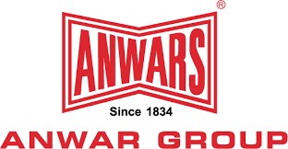

This Internship Report is required as part of my Bachelor of Business Administration,
United International University

United International University


Internship Report on
HR Audit & Recruitment and Selection Process of Anwar Group of Industry
Course Code: INT 4399

Submitted to
Ms. Nasrin Akter
Assistant Professor, School of Business and Economics

Submitted By
Ummay Umama Peya
Student Id- 1111 72070
BBA in Human Resource Management
Bachelor of Business Administration
United International University (UIU)

Date of Submission: 4 December 2022

DECLARATION OF THE STUDENT

I, Ummay Umama Peya, my topic of internship is “HR Audit & Recruitment and Selection process of Anwar group of Industry”. I have made proper analysis regarding the Human Resource department of AGI.
- I’m confirming that my internship report is unique, report material are not previously published/written by third party or no plagiarized material will be found.
- To complete this report I didn’t use any unethical practices.
- I have totally acknowledge all the sources of help.
Students Full Name & Signature

__________________________________________
Student Full Name : Ummay Umama Peya
Student Id: 1111 72070

Supervisor’s Full Name & Signature
__________________________________________
Supervisor’s Name : Ms. Nasrin Akter
Assistant Professor, School of Business Administration
United International University

Letter of Transmittal

Date: 4 December 2022

Ms. Nasrin Akter

Assistant Professor, School of Business Administration

United International University

Subject: Submission of Internship Report

Dear Madam,

I would like to very grateful for your instructions and helpful advice for me to ready my internship report with tremendous pleasure. I have completed my internship report on “Anwar Group of Industries “that had approved me required of my BBA program. I give my best to prepare this report with important information with the format that you have gave me.
I wish that my research will convenes your expectancy and I would really glad that if you need any interruption or query related to this report please let me know I will be happy to give you justification about this report.

Yours obediently,

Ummay Umama Peya
Id – 1111 72070
United International University

ACKNOWLEDGEMENT
This report would not have been possible without help and direction of some people:
First I want thank almighty Allah who granted me strength and long life to result of the required task within timely. There was many ups and downs but preparing this internship report learning is very good for my upcoming career. There are some people their contribution is really helpful and I will be always grateful to them. Especially them who have given at their busy time schedule with me and share experience and suggestions to improve the report.

I would like thank to my honorable internship supervisor Ms. Nasrin Akter ma’am, Assistant Professor of School of Business Administration at United International University, her proper guidance was an amazing that help us to successfully complete this report.

I also thank my reporting boss Mr. Iskander Mirza Sir, Human Resources Manager (Group HR).he gave me the chance to complete my internship program under his supervision in Anwar Group of Industries. I would special thanks to all my helpful colleagues of my HR team. They helped me and support me by sharing their valuable experiences in AGI.
I enjoyed my each and every moment and get as much as learning knowledge about Human Resources Department.
Most importantly my gratefulness goes to my family and friends for supporting me and giving me maximum moral support that I needed that time for preparation of this report.

EXECUTIVE SUMMARY

Anwar Group of Industry is one of the largest industrial renowned organization of Bangladesh. Over a century Anwar Group has been contributing to different sector of improvement of the country. There is a various field that serve the group of organization, as Building material division, automobile division, textile division, real estate division, finance division also various. Anwar group is committed to their consumers and clients, provides high value of service and generates higher revenue.
This report consists of the overview of Anwar Group of Industries, their scope, objectives, mission, vision, methodology along with the process and contribution of the Human resources department. It also consist of the findings and recommendations of the group of organization.
This internship report is created to complete a requirement for graduating from United University’s Bachelor of Business Administration degree. I have successfully completed my internship in the department of Human resources management and learn about the HR audit criteria and Recruitment and Selection process, also AGI employee development process by investigation and evaluation the employee performance. Employee development process of AGI is very effective that I experienced properly and I made this report about details the methods and technique ready to employee for future performance.
The Human resources Department works very effectively and follow the best process to get the best potential employee to enhance their organization and also the employee benefit. The criteria is very knowledgeable to hiring processes, HR audit process employee development process, evaluation of employee performance, compensation and benefits rewards etc. Everyone know that in Bangladesh, Anwar group of industries is among the top conglomerates. The HR hire the most experience employee also they polish their employee by organizing many employee development program for they are able to maintain their tasks and activities appropriately and reach to the organization goal.
In closing, AGI has a highest reputation in the Top industries because of its greater execution of work. My whole internship report is made all the process of recruitment and selection also development programs of employee.

Contents
DECLARATION OF THE STUDENT i
Letter of Transmittal ii
ACKNOWLEDGEMENT iii
EXECUTIVE SUMMARY iv
Chapter: 1 1
Introduction 1
1.1 Background of the Report 2
1.2 Scope 2
1.3 Objective 3
1.3.1 Broad Objective: 3
1.3.2 Specific Objective: 3
1.4 Methodology 3
1.4.1 Manpower of the survey sample size 3
1.4.2 The Primary data gathered: 4
1.4.3 Respondents: 4
1.4.4 Secondary Data gathered: 4
1.5 Limitation 4
1.6 Internship Information 5
Chapter: 2 6
Literature Review 6
2.1 LITERATURE REVIEW 7
2.2 HUMAN RESOURCE AUDIT 9
2.3 Purpose of HR Audit 10
2.4 How Recruitment Plays an Important Role 11
2.5 Recruitment & Selection Process 12
2.4.1 Sources of Recruitment 13
Chapter: 3 18
Organizational Overview 18
3.1 OVERVIEW OF THE COMPANY 19
3.2 Mission of Anwar Group of Industries 20
3.3 Vision of Anwar Group of Industries 20
3.4 Corporate Achievements 20
3.5 Values of Anwar Group of Industries 20
3.6 Department of AGI 21
3.7 Product of Anwar Group of Industries 22
3.8 AGI Management Practices 23
3.9 Porters 5 Forces Model 24
3.10 SWOT Analysis 25
3.11 HUMAN RESOURCE DEPARTMENT OF ANWAR GROUP OF INDUSTRIES 26
3.12 HR Audit Procedure of AGI 29
3.12.1 Manpower of conducting HR Audit 29
3.12.2 Area of categories to conduct HR Audit 30
3.12.3 Effectiveness of HR Audit 31
3.12.4 HR Audit Checklist 32
3.13 Recruitment & Selection Process of AGI 34
3.14 Contribution of AGI in Employee Development 35
Chapter: 4 37
Analysis 37
4.1 Procedure followed HR Audit of Anwar Group of Industries 38
4.2 Procedure followed recruitment and selection of Anwar Group of Industries 38
4.3 ANALYSIS QUESTIONAIRE 41
Chapter: 5 45
Findings, Recommendations & Conclusion 45
5.1 FINDINGS 46
5.2 RECOMMENDATIONS 47
5.3 CONCLUSION 48
5.4 REFERENCES 49
Chapter: 6 50
Survey Questionnaire 50
6.1 Survey Questionnaire 51
6.2 Appendix 1 52
6.3 Appendix 2 53
6.4 Appendix 3 54

Chapter: 1

Introduction

1.1 Background of the Report
This report I have completed based on my experience and knowledge. In order to graduate from United International University’s BBA program, a formal report is required. All UIU, School of Business & Economics students are required to complete either an internship or project before graduating. My Three-month internship at Anwar Group began on August 1, 2022 and ended on October 30, 2022.
My report topic is about “Anwar Group of Industries’ HR Audit & Recruitment and Selection Process in the wake of the Anwar Landmark,” and I have based my report on my investigation of these procedures. Human resources department work is very important of any business organization. The department actually work effectively for the management and employee related issues. Anwar group HR recruitment and selection process and employee development criteria discussed specifically in this report.

1.2 Scope
Anwar Group of Industries HR Audit & Recruitment and Selection Process is the subject of this research. HR practices at the organization and give a springboard for more investigation into the company’s approach to Audit process, recruitment and selection process in the future.
Learning Statement:
- Internships are a deciding component of my education since they prepare me the realistic of the working world. This internship allows me to get insight into Human resources department of one of Bangladesh’s most successful businesses.
- As an intern, I was able to learn about many types of HR functions. According to my learning knowledge and whole experience, here I share what is picked up throughout my internship at AGI.
- Internship helps me to grab Human Resources Management more than I could have with just textbook study.
- I have learned a lot about the Recruitment and selection process and how to organize the interview and hiring the employee.
- Now I understand the ins and outs of the Recruitment and Selection process also the improvement of the procedure.
- My understanding of hiring methods has expanded in many ways.
- Now I understand the procedures in place to protect the privacy of the information.
- I can do the recruitment summary report.
- I can get insight from people’s experiences with it.
- The experience helped me become better at managing my time.
- The whole internship experience instructed me on proper business etiquette.
- Now I know how to tackle the difficult situation and projects.
- I have learned the ropes of writing a summary report, Data update, maintaining many types of tracker in Excel.
- My ability to perform under stress has improved much more because I have experienced in many multitasking situation.

1.3 Objective
Bring out the Anwar Group of industries’ HR Audit & Recruitment and selection process was the main objective of this report as well as which criteria use to evaluate and hire their employee. This report mainly focuses on organization’s employee recruitment process and development plan by the following process of employee do Anwar group of industries.

1.3.1 Broad Objective:
The broad objectives are to learned about HR audit & Recruitment and Selection Process and also the operational works in real organization, how they actually implement those methods in Anwar group of industries.

1.3.2 Specific Objective:
The specific objectives are to learn the impact of HR audit & Employee Recruitment and selection and development of the process for employee.

1.4 Methodology
The Human Resources Division of Anwar Group of Industries, primary data will be collected via observation of the HR Audit & recruitment and selection process, through interviews with employees. Secondary Data collection from the company’s own website, other published articles, journals, works and online resources.

1.4.1 Manpower of the survey sample size
Taking survey from the HR Department people. There is a three person who are respondents all the survey analysis.
- Manager of HR department
- Sr. Executive of HR department
- Executive of HR department

1.4.2 The Primary data gathered:
- Conversations with supervisors and coworkers in person.
- Participant centered, face-to-face discussion
- Tasks that may be accomplished at a desk

1.4.3 Respondents:
- HRBP, from Group HR
- Members of various senior and managerial levels from the head office, including those Departments in Administration, Accounts & finance, Sales & Marketing and Human Resources.

1.4.4 Secondary Data gathered:
- Documents regarding HR Audit & Recruitment and Selection criteria of AGI
- Books and academic magazines devoted to study of artificial intelligence hiring process from official websites.
- AGI Research journals.

1.5 Limitation
There are some problems that I face during my internship time for preparing of this report are giving as follows.
I have tried giving enough explanation of all the components of HR Audit & Recruitment and Selection Process. HR manager didn’t share everything due to confidentiality.
- The management are not disclosing the confidential information with the employee.
- The workers and employees are not permission to submit confidential information such as their financial assistance, salary structure, and tax salary certificate information of their employees.
- The employees were already busy with their own tasks so that they complete that then they provide anything in the way of advice and assistance.
- The lack of access to information was the primary limitation of my learning, as it significantly disrupted the scope of analysis needed for the gathering experience.
- My attention that several previously published materials are now out of recent times because some published articles are not updated.

1.6 Internship Information

Company Name: Anwar Group of Industries
Period: August 1, 2022 to October 30, 2022 (3 months)
Department: Human Resources Management (Group HR)
Designation: HR Intern
Address: 27, Dilkusha, Motijheel, and Dhaka-1000

Information about Supervisor
Name: Iskander Mirza
Designation: Human Resources Manager of Anwar Group of Industries- Group HR
Job Responsibility
- Human resources task assignment
- Help the human resources department by calling potential candidates and checking up with them.
- In order to arrange an interview.
- Making and maintaining interview schedule and mailing for reminder interview board of directors.
- Making all assessment elements for interview
- Complete all employee joining procedure, Employee paperwork, initial verification of employee personal file, and other supporting tasks; administer pre and posts all tests; compile full employee summary file.
- Maintaining Recruitment tracker, Attendance tracker.
- To coordinate various activities, occasions and activities for enhancing employee engagement.
- Post vacancies in Bdjobs and CV sorting.
- Help out with writing job descriptions for various openings
- Helping at HR Audit.

Chapter: 2

Literature Review

2.1 LITERATURE REVIEW
This section provides a brief review of literature on HR Audit & Recruitment Process and also Employee Development. Here we will see some of the valuable quotation of HR audit, recruitment process also the employee development given by different authors and scholars and then we will analyze accordingly.
Anwar Group of Industries follow the best procedure to recruitment that happen in various steps as they identify the job vacancy according to the AGI needed employee, analyzing the job requirement, review application in Bdjobs, CV sorting, arranging interview, conducting interview and select the candidates. There is lots of training system to increase the hiring eligible employee efficiency. Human resource department of AGI always try to evaluate the lack of efficiency and how to increase the productivity so that HR audit conducted and practices. It is the process that help to evaluate the need the need about employee enhancement and development of the HR functions. The organization maintaining and changing rules regulation for employee is HR audit needed the most.
The organization has many division. All division growth is very productive, recruitment sources very updated, HR department follow the organogram and consider the department head requirement by collecting job description and proceed the process. Publishing in many site and also event some program that is newly way to recruitment such as Advertisement, University career office, Job fair, Internet etc. for collection process.

Now, we will see how different scholars define HR Audit
According to Sadhana Kumari, “The Human Resource Audit is a systematic formal process which is designed to examine the strategies, policies, procedure, documentation, structure, systems and practices with respect to the organization human resource management.”
It is a clear view of explanation, an organization follow the design and structure that is evaluate of the rules regulations, papers of maintaining, also the government applicable rules.

According to Eric Flamholtz, “Human Resource Audit is a systematic assessment of strengths, limitations and development needs of its existing human resources in the context of organizational performance.”
According to definition HR Audit is the evaluation of organization workforce capability to work, there level of productivity, and there outcome of the delivering things.
According to Denise M. Rousseau, “An HR Audit is like an annual health check-up, it plays a vital role in instilling a sense confidence in the management and the HR functions of an organization.”
A definition shows that HR audit is about that various organization do their own policy but it happens annually searching or auditing their information about finance, efficiency of workers, and organization entity dealing with its people.
Now, we will see how different scholars define Process of Recruitment & Selection
According to Korsten and Jones, “Human Resources Management theories emphasize on techniques of recruitment and selection and also outline the benefits of interviews, assessment and psychometric examinations as selection process.”
The view of hiring process is about the benefit of recruitment and selection procedure following the way as conducting interview ,selecting by taking examination in department wise questions and depend on assessment that evaluating the assessment. Simple words that levels of management hiring policies is start with manpower requisition, vacancy posting information, branding, interview process upholding, decision come from the respected board members.

According to Flippo, “Recruitment and selection process as a process of searching for prospective employees and submitting and encouraging them to apply for jobs in an organization.”
The terms of the definition is shown that recruit and select are procedures very sensitive, and it is different from each other vary to one organization to another organization. Organization always try to show in their recruitment to encouraging to apply the employees, grab the potential applicant by selection. This is the process that organization expect potential and capable applicants are get in actual job post.

According to William B. Werther, “Recruitment & selection process is discovering of potential applicants for actual or anticipated organization vacancies, it can be looked at the linking activity together those with jobs and those seeking jobs.”
This definition is about to clear that the process of recruitment and selection is totally the way to ready the employee for relevant field. And many employees has seeking jobs for the relevant field, so that recruitment process should they way to link with them.

2.2 HUMAN RESOURCE AUDIT
Human Resource Audit is about a comprehensive method that objective of organization HR system practices, documentation, policies and procedures. The goal is to look for trouble spots or identify ways you can improve. An effective HR audit helps in identifying the need for improvement and enlargement of the HR function.
HR audit is the systematic verification of job analysis, HR policy, Service rules, HR planning, Design recruitment, Performance and management, Training & Management Development, Job changes, Job evaluation, Executive remuneration, Motivation & Morale , Industrial Relations, Leave Administration, Discipline Employees, Health & Safety, Employee Services, Salary & Wages, Library, HR Research. And also some of the variant that also be audited by the HR Checkup the employee personal files maintenance, induction procedure, termination procedures. The intension is to be the result of reducing the risk of department.
There are some approaches for HR Audit as follows:
- Comparative Approach
It is about the model approach for organization auditor who identify the adopted report are compared analytically to get areas of some corrections.
- Outside Authority Approach
The auditors are use the standards to use by outside of the space as benchmark for compare of the result of company.
- Statistical Approach
It is about the measurement of statistical and their work performance how much considerations that can be developed.
- Compliance Approach
This approach is about the auditors checking the previous actions to calculate the activities applicable by the legal way and requirement and industry policy and systems.
- Management by Objective Approach
The approaches creates specific goals, and the auditors set them by measuring the performance and give them the auditing final decision about the organization actual objectives.

2.3 Purpose of HR Audit
Organization foremost function is conducting effectively or not is totally depend on Audit process. HR audit is about to conduct an in depth analysis to run all the organization function effectively. Through HR audit process organization identify areas of strength and weakness and by applying redefining process and making improvements where needed. Organization various area should be audited for improvements and ensure for all the policies, rules regulations, system practices are maintained as needed for organization.
There are organization some area that should be organization audit for reach to maintain all the curriculum:
- Employee relations
Employee relations is developing and maintaining for organization positive outcome and it is depends on company’s employees. It is the main HR function between employer and employee to build the collaboration to ensure a good workplace and good culture.
- HR policy
There are an important some roles that organization maintained by outline of responsibilities of both employer and employee that is HR policy. Organization ensure the HR policy by auditing and supporting all the things. HR audit look after that which type of HR policy are getting and giving the employers and employee so that it is very important. It helps to address all the issues, complaints, problems also the solvency appropriately.
- HR planning
The HR planning is core function to conducting by the management and also HR gaps should analysis by HR audit and it is based on the strategic direction and operational work. HR audit is very important to develop the organization plan and fill all the gaps that on the basis of needs.
- Legal compliance
Organization legal compliance is an important tool for all types of business for making organization best practices in alignment with employment laws, HR Audit is the only way to find out all the lacking and fill all the gap. Legally all the sectors as leave structure, business policies, medical facility, insurance policy, payroll, disability structure etc. are audited by HR systematically.
- Record keeping
All the things are depend on the information of proper records that are organization keeping by note sheet, Excel files etc. a lack of information can effect badly not only calculation or audit system but also the productivity of performance levels By HR audit management are more concern about keeping records.
- Industrial relations
HR audit conducting for this field to build the good relationship between the employer and the employee and organization. Organization should maintain always the warm relation to future strategic approach and supporting employees for better environment to work.
- Leave administration
The leave administrators is the line of all employees to maintain their day to day life in organization and HR audit is conducting the report that allows HR to leave records for employees. Leave report is display that the employee line of each pay period that employees avail what kind of leave, how many leaves etc.
These is the process which is called routine exercise in every area of organization. It is based on the Human Resource Management criteria that is dynamic always and must continually be redirected and building up to remain responsive to the changing organization needs.

2.4 How Recruitment Plays an Important Role
Recruitment plays a very important role in every organization. It is the process of catching and attracting the applicants whom are eligible for job vacancy. By recruitment criteria it provides all necessary human resources for various job positions for perform organization development. Another thing recruitment helps employers find suitable employees. The process is about match candidates to permanent or temporary jobs. Recruitment is the foundation for the selection process by providing the number of applicants from which the selection process proceed.
- Recruitment ensures that the organizations daily activity properly.
- It is the source of manpower to meet the requirement that are needed in the staffing process.
- Recruitment is the effective process that increase success rate of the organization criteria.
- Recruitment process improves the validity of job openings and maintain professionalism of the organization.
- By this process organization expanding pool of qualified applicants easily.
- Recruitment process is always known as cost-effective method by attracting a large number of people at a lower cost.

2.5 Recruitment & Selection Process
The organization important process that is hiring process function of HR department. For there is a many types of requirement the educational qualifications, skills for analytical & operational, experience, abilities these are thing are taken into consideration when recruitment takes place. It is the process that help to hire the best candidates based on their capability and attitudes. And also the evaluation is how much effort they give to accomplish of reach the goal.
HR department follow some steps to recruit the eligible employee and also experienced though that is vary to vary from the organization purpose of organization culture and organization target. The process called as functions as like vacancy created, sources of recruitment, CV sorting, taking written exam, taking interview, reference check, finally selected.

Figure 1: Recruitment process steps
Process 1 - Recruitment Planning
Recruitment planning is the most important steps whereas job vacancies in the organization are should be analyze and work with that. It is the phase that is preparation of job requirement discussion and specification about qualification and skills as to maintain and complete the vacancy work.

Process 2 - Strategy Development
Completing the planning of the process of job description, the second one is the strategy development and use that of recruits. Strategy development is very important to achieve organization growth. By development lists detailed data and objectives that explained how about the plans on accomplishing the goal. Strategy should be list out first and foremost the vision and mission of the company and ensure each employee.

2.4.1 Sources of Recruitment
There is a two types of recruitment sources process and process are exercise to every top of the companies, the sources of recruitment are as follows.
- Internal Recruitment
In this process people are already working in the organization and when the vacancies are created HR people circulate all the probationary employees who are capable to the vacancy jobs portal HR publish the circular on notice them and publish also in online portal to invite the deserving employees to participate in the interview via the process and for upgrading their position level and go further their career growth. Employees who are work in the organization already they refer their CV personally and sometimes with the communication internally for the portal.
- External Recruitment
The organization recruitment process is about when HR people recruit the candidates who are not a part of the organization. This is the process which is very intensive and the company have to post the job vacancy and the description on different job boards, create the vacancy and collect the talent pool candidates for the position of requisition and improve all the procedure and conducted that also complete the recruitment process. Simply, the outsiders are invited to fill the vacancy.
The strategic development is must needed including the sources of recruitment, methods of recruitment, geographical area, and also making employee by recruiting.
Process 3 - Searching
The HR department has vacancy activation confirmation and the HR manager took searching about the requirement, approving the confirmation of job description as well as specification. There are many sources by searching the source activation and selling or branding the job description. Selling the organization selects vacancy of communication to complete the organogram.
Process 4 - Screening
When the job applications are received by the HR employers they starts the process of screening. The recruiter are shortlisted the application of candidates. The next steps is about short listing applicants are based on the job specification begin with the selection process. By seeing all the thing about applicant’s qualifications and skills are justified by recruiter and by this to remove the applications which are not capable and also select those who are suitable for the vacancy.
Process 5 - Evaluation process and Control
HR recruiter is assessed in this process. Organization has to check the essential cost during the recruitment, selection process and also joining process. The financial all the expenses are bear by the management for completing the whole recruitment process. As the cost of branding, selection of all the things such as internet, pages, pen, pencils; consultant fees if the recruitment outsourcing and also the salaries of recruiter.
Simply say that, Recruitment and selection process is a very essential and core function for HR department that create the good direction for future growth.

2.6 Contribution of Recruitment in Employee Development
The contribution of recruitment process can effectively improves employee satisfaction levels. Employee development is very important for organization development. An employee development program is conducted to help people manage their future work, learn new things and also take steps to improve not only personally but also professionally. It is the decision taking of the employee also the employers to upgrade the existing skills and knowledge of an individual.

The recruiter always look after the organization department wise development for employee before recruiting and so that HR department try to assessment to the specific requirement. It is the major contribution for recruitment in employee development for organization.

Figure 2: Process of contribution in Employee Development
Employee Development activities given as follows.
- Orientation and Onboarding
Orientation is the program is about to employee get help to adjust to their jobs quickly, newly recruited employees get knowledge about their position of work, what is the employee’s responsibility, what the employees activity’s need to do. It is the way that they can easily get communication with their co-workers, their team and understand their job roles also witn the department. The program is organize to welcome the newly hired employee and give motivation with that procedure.
- Training
Training is the process that is most important event for employee development. It is about the program which is organize for increase the key learning of an employee for performing a particular work properly. And also it provides for the employee who are feeling that they have lack of knowledge to specific sectors and seeks to improve the job performance.
- Stretch Assignments
It is the criteria to involving employees to work and get ideas to improve themselves by completing some assignments that take by the management and it is very helpful to get idea about their gap. It is one kind of KPI work that employee use to get more similar work and responsibility to do.
- Coaching and Mentoring
It is the formal process of skills development for employee by involves with existing employees who are experienced. It is the process which is very speedy way to learning very specific leadership knowledge. It is very formal process that employee easily grab the learning as technical and analytical skills.
It should be contribute for helps to build a positive and built concrete change in individuals, also boost transfer of knowledge from the mentoring. It is beneficial for the newly hired employee for the career growth for giving good amount of output whenever the employees. They use their leadership skills in any hypothetical time or situation.
- Workshop
Arranging workshop is one of the best contribution to employee development. It is the opportunity to interact with peers and colleagues from organization. It is the program where access to similar and dissimilar employees together and discussing the things. Workshop program is increasing the employee improvement for some skills that’s is very important for one employee to workplace, if I say the soft skills about communication, presentation slides, teamwork etc. it is the way where some employee practice the terms by opening up and polish their research skills.
- Conferences
It is similar as workshop and committees. Conferences are useful way to buildup network and gather a vast knowledge based on both interdisciplinary and outside industries. It is the training session to increase awareness about the employee existing knowledge or relevant topics clearance for working execution. They used to bring together with common interest and discuss issues also ideas relating to a specific new ideas for organization development work.
- On-The-Job Training
On the job training is basic training program for employee to develop their technical skill. Providing everything to the employee for self-study while at workplace. They learn how to use something about applying the criteria as they should do about their assigned tasks. By this training employee can easily develop a variety of hard and soft skills. It is very popular way to develop employees as companies typically don’t have the time to train every single employee so that they provide every single tools that they need to develop their skills as technical skills, leadership skills, operational skills, time management , multi- tasking etc.
- 360- Degree Performance Review
An employee always need for development reason is about the feedback for their work report and operational communication. It is the method for contribution as organization that involves getting feedback about employee, from a cross section of peers, subordinates, supervisors. Organization relies the feedback and get them chance to develop their gaps and lacking in people facing roles, conflict resolutions tactfulness, and skills to serve.
- Career planning
It is shown by the HR department for employee development. Employers can identify the skills of employee that already exist and that need to be enhanced for the organizational work. Career planning can help to identify and develop a board sector of cross organizational skills. Discussing career planning is give good motivation for their management of work, analyze their own strengths and shortcomings and also take some of those roles. Organization must contribute the thing that is when employees facing and confused about the thing surely consult with HR and get help to reach their goal.

Chapter: 3

Organizational Overview

3.1 OVERVIEW OF THE COMPANY
When it comes to business, Anwar Group of Industries (AGI) has a rich history, remarkable present and promising future. Late Lakku Mia founded the company in 1834, and it has been in the family ever since. Management of the firm has been passed down through the generations in order to ensure the continuous of purpose and commitment to the highest standards of business conduct. To some extent it has been able to enhance knowledge and understanding gained at this time. The upcoming leaders successfully used their expertise to boost the company’s bottom line. The Business expanded until it was a national industrial powerhouse, with a national and worldwide reach thanks to its enormous subsidiaries and affiliates. There were more than 20,000 skilled and talented employees to makeup the group of industries as the company due to renowned.
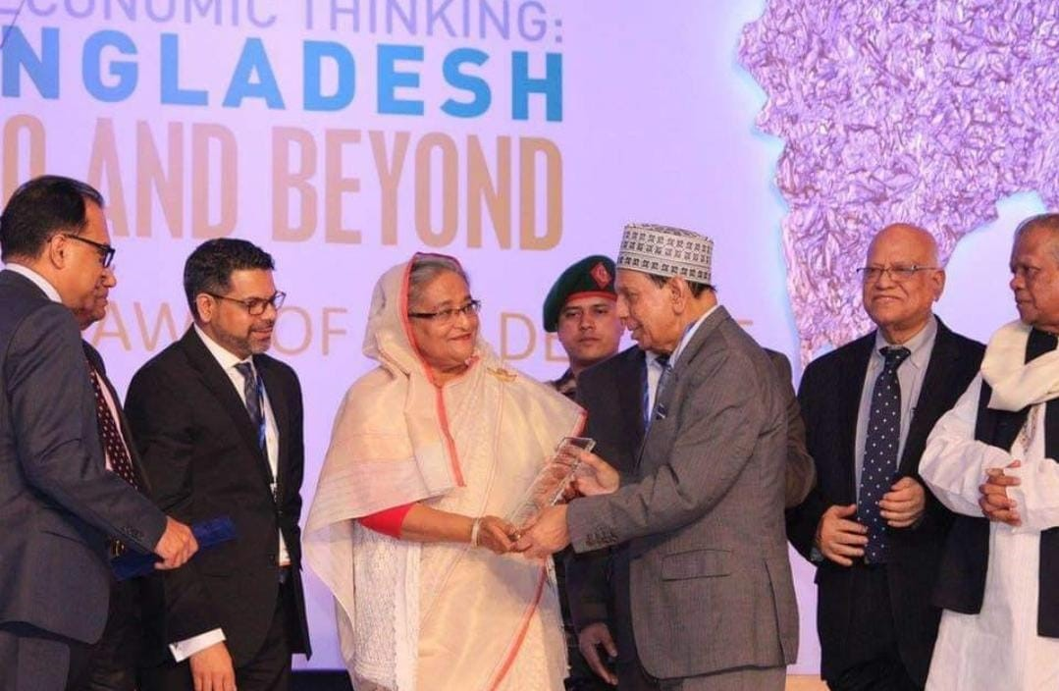

Honorable Prime minister of Bangladesh handling over illustrious son of Dhaka to Anwar Hossain

Company’s former chairman Late Anwar Hossain who had widespread respect in his community and represent Bangladesh in the parliament. The eldest son of company’s new chairman is Mr. Manwar Hossain. The Anwar Group’s upper stage have extensive connections to the political establishment, the military and the civil administration. The group has the achievements of its affiliated business, that include many dealing in compile textiles, jute, banking, insurance, construction supplies, residential and commercial real estate, furnishings, industrial and commercial trade and automobiles.

3.2 Mission of Anwar Group of Industries
- To hold down our position as Bangladesh’s most multifarious company, with flexibility & dedication to meet the needs of our clientele.
- Act sustainability and honor the social obligations.
- Providing regular opportunities for enhancing the county’s exports of goods and services.
- Creating a productive and Supportive workplace.
- Maintaining the position as quality leader in all markets in which it operates by making keep up investments in people, systems and procedures.
- Creating new life forms.

3.3 Vision of Anwar Group of Industries
- AGI carrying on the tradition of technological and industrial pioneer.

3.4 Corporate Achievements
- Multiple sales awards for excellence First Bangladeshi Real Estate firm to be ISO certified.
- First cable and wire manufacture and kitchen towel exporter.
- Bangladesh’s second cutlery factory.
- Bangladesh’s first electronics assembly plant.
- Fabric with the ISO certificate and the Oeko-Tex Standard for June.
- First Rayon Yarn Processing unit
- Awards & honors for their extraordinary performance in services
- Jute ISO certificate.

3.5 Values of Anwar Group of Industries
- Trust in Allah.
- Honor one’s parents, elders and the fellow citizens.
- Maintain and believe Ethics and Morality of the highest order.
- Employee confidence.
- Respect for each and every people and devotion to one’s family.
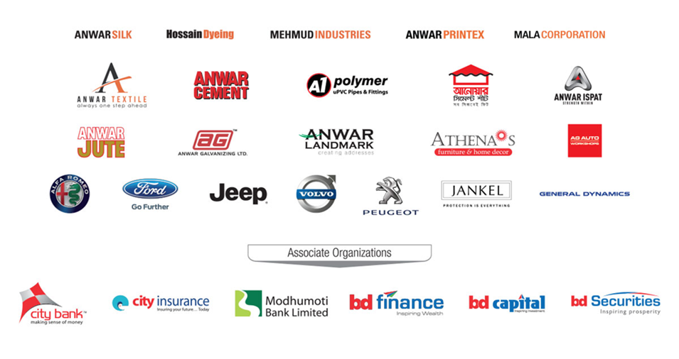
Figure 3: Business Division of Anwar Group of Industries

3.6 Department of AGI
- Division of Human Resources Management (Group HR)
- Engineering/Commercials
- Conceptualization Manufacturing & Quality Assurance
- Marketing and Sales (Public Relation)
- Land Acquisition
- Contract Management
- Credit Realization
- Maintenance and Repairs (Logistics)
- Supply Chain Management
- Inventory
- Internal Audit
- The Financial and Accounting Department
- Managing Stock and Production
- Billing
- Construction
- Information & Technology (Group IT)
- Customer Service in Business Operations

3.7 Product of Anwar Group of Industries
Building Material Division:
- Anwar Cement Ltd.
- Anwar Cement Sheet Ltd.
- Anwar Ispat Ltd.
- Anwar Galvanizing Ltd
- A-One Polymer Ltd.
Textile Division:
- Anwar Silk Mils Ltd.
- Anwar Yarn Dyeing Ltd.
- Mehmud Industries Private Ltd.
- Hossain Dyeing and Printing Ltd.
Finance Division:
- The City Bank Ltd.
- The City General Insurance Company Ltd.
- Bangladesh Finance & Investment Company Ltd
- Bangladesh Commerce Bank Ltd
Jute Division:
- Anwar Jute Spinning Mills Ltd.
- Anwar Specialized Jute Goods Ltd.
Real Estate Division:
- Anwar Landmark Ltd.
Automobiles Division:
- AG Automobiles Ltd.
Furniture & Home decor Division:
- Athena’s Furniture & Home Decor
Software Division:
- Anwar Enterprise System Ltd.

3.8 AGI Management Practices
Anwar Group of Industries has extraordinary & beneficial leadership style, with a strong emphasis on a democratic from of management in which the General Manager takes the time to hear employee perception before making decisions. The newly elected chairman, a former group managing director, called each HOD also listed their opinion before taking decision not only that he also provide feedbacks and make sure all problems are solved technically as well as in cost effective way and it makes employees feel valuable and motivated because it boosted morale, improved productivity and ultimately allows to achieve to the organization goal.
- Marketing strategy
AGI is mainly focused on their marketing strategy to reach the top position in the international market. They try to send gifts regularly to their dealers give discounts them on time market when their demand are increased so that they can be their loyal customers.
They also receive customer’s feedbacks very gently and actively, if any problem arise they actively try to solve those issues accordingly. They make sure that all their products delivery on time with maintaining the product quality.
- Target Customer
There is a various sectors has different target customers. And only one specific target customer for government handle projects also the others are for Infrastructural Company. Some of them as carpenters, dealers are primary sectors.
- Branding and Advertising
AGI most important team that is branding team always post regularly on social media with their attractive content to reach the target customers. Not only have that, for the urban areas or village areas they regularly give posters and billboards attracted potential customers. Moreover they provide monthly based seminar to every district to educate clients and provide them with information about their goods, and they discounts offers and freebies to their dealers and carpenters. They also provide TV commercial with creative concept with an original angle. In addition, customers may visit their website and to make an order and use that.

3.9 Porters 5 Forces Model
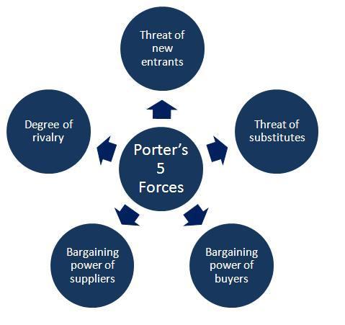

Figure 4: Porter’s five forces model
- Rivalry in the Industry
Anwar Group of Industry is one of the largest group of companies of Bangladesh. There are many competitors as AKIJ, Basundhara,PRAN, Abul Khayer Group, Meghna Group, Premium Cement also many others. Anwar Cement Sheet is leading in the cement industry and grab the market share, according to Bongo note, so while competitors may try to steal market share, and also they are always processing hiring sales force and arranging training sessions for cement sheet to maintain their dominant position in the market. Further one thing add that everyone else is scrambling to overtake you as the industry standard bearer. In the market competition is fierce.
- Power of suppliers
Anwar Group of industry have various types of suppliers is well regarded in the industry. AGI have their own create supplier to distribute their services and product in the as they export high and quality full raw materials from the suppliers in that case in recent time market power of suppliers is excessive amount.
- Power of customers
It’s clear that Anwar Group of industries has staff competition of many leading companies. So the price war is to be seen the industry therefore, we can say that power of customers is high reason, since buyers have the ability to switch brands if prices are not to their liking, it’s safe to state that price competition is common in this market.
- Threat of new entrants
Anwar Group of industry is the group of company for a new entrant it need quite big amount of capital to enter in the industry and managing supply chain and other organization unit will not be easy for a new arrivals unit and the difficulty of turning a profit.
- Threat of substitute goods
Finding comparative and alternative to the manufacturing products is challenging. For making infrastructure it is hard to use substitute products rather than cement and others goods for use in infrastructure construction. Textile division customers can substitute it with different product so that threat of alternative product is low moderate.

3.10 SWOT Analysis

Figure 5: SWOT Analysis
Strength
- One of the largest group of company
- Cement Sheet’s most dominant market share holder
- Good & strong percentage of the market
- Integrity of the Brand
- The employees are very dedicated and committed
- The best of intentions
- The use of high quality raw materials.
Weaknesses
- Product price is very high than the others
- Promotional Activities lacking
- Delay in delivery lead time
- Poor sales network in rural areas
- Less marketing for the goods than rivals
- Dependency on import scraps
Opportunity
- Company’s own ERP software which is newly customize and can do work more officially
- For boost up productivity organization establish advance machine for good amount of output and reducing the cost of production
- Large market and increasing the demand vastly
- Market reputation for financial support
Threats
- Rivalry among the competitors regarding price
- Differentiating themselves from the competition, many businesses offer sales prices to retailer’s distributors and customers.
- Ensuring quality standards
- Other company attract the customer by giving discount offers, call for better service.

3.11 HUMAN RESOURCE DEPARTMENT OF ANWAR GROUP OF INDUSTRIES
An Industry success are mainly seen as a team effort by all employees. The Anwar group of industries Human Resources Department follows best approaches & strict policies and procedures that are both legally and ethically maintained. The department of HR introduce many organizational policy that stick to the AGI. Human resources department applying the policy with the proper guideline to operate with the management mission and vision to reach the expectation of organizational goal. The HR department of AGI also work for the detail of the organization’s expectations for how its personnel should be evaluated, how they should be compensated and how they should rewarded over time, Employees get insight on where they stand in the organization, where they may improve and how they contribute to the company’s success.
The Human resource department is a central position to holding, empowerment, profitability and policies of the company. Each procedure is guideline to use with discretion, understanding and management in the policy is written by detailed descriptions of these activities follow.
- Recruitment
The term Recruitment encompasses all the steps of attracting, evaluating and hiring the potential employees for the company. The success of recruiters and employment specialist generally is measured by the number of positions they fill and the time it takes to fill those positions. HR division of AGI who work in house as opposed to companies that provide recruiting and staffing services, play as a key role of developing the employer’s workforce. There are many criteria that is practices by the company which is job postings, source various eligible candidates, screening procedure should follow for them, conduct preliminary interviews and after that coordinate hiring the employees and with manager and board of directors for making the final selection.
- Compensation & Benefits
This is the important functions of HR professional handling with competence in both employee and labor relations. HR specialist with dual expertise. On the compensation and benefits side, the HR functions include setting compensation structures and evaluating competitive pay practices. When it comes to salary, HR duties entitle both structure creation and market analysis. The specialist of Human resources department always try to make a healthy coordination with the employee and their activities and give the savage savings funds. Sometimes the major role or responsible the team for compensation and benefit is payroll.
- Training and Development
Human resource department of Anwar group of Industries ensures that all employees have access to resources they need to do the job properly so that often includes intensive orientation training for new joiner. This training to help them transition into the organizational culture. AGI, HR division take great care in training all newly hiring employees especially the sales executives are trained with very much care.

- Employee Relation
In a unionized work environment, the number of employee and labor relation functions of HR could have combined and handled by a line manager and also single in charge of both. The Human Resources known as Employee engagement & relationship that focus on mending ties between employers and employee by tracing factors like morale and productivity by giving job satisfaction, solving the conflict of workplace and rebuilt the employee engagement. Human resources department is the core department have to buildup good relationship with the every single employees to closely monitors by the internal interactions. If any employee of the company break the delegate rules regulations so that in this area get warning which is called show cause and after that punish or termination for regarding the reason of violate company rules.
- Safety
Safety and security must always come first. Organization management take responsibility to provide a safety in workplace for their employees, according to the Occupational Safety and Health Act of 1970. Human resources department support and play a systematically important role in facilitating workplace with precocious safety and keeping if any employee happen injury problem and death records. Another thing is the departmental safely and risk by professionals as HR benefits given by the company’s policy maintain by the management. It is about compensation which is also the Human resources functions. Human resources of company personally delivers all kinds of first aid kits and initial problem medication or medicine to the affected employee.
- Compliance
Human resources department should prioritize compliance with labor and employment laws because that is a critical HR function. There is a lot of things, Complaints about unfair employee practices, dangerous working conditions, unsafe workplace, and dissatisfaction from noncompliance which is affected productivity and profitability. Human resource department of companies is known of federal and state employment legislation such as civil rights. Act The Fair Labor Standards Acts, The National Labor Relations Act and many other rules and regulations. Organization adhere and strictly follow the rules of Bangladesh’s Labor Laws, if any needed circumstances.

- Performance Appraisal System
An organization keeps track of performance and ensures that the employees are evaluated and appraised in right way. The dedicated Human resource department gathers feedback from all department head (HOD) and Line managers with their standard. Employees have need to meet their key Performance Indicators (KPIs), and if they are unable to do so by the deadline set by management and evaluate properly KPI and those who not able to achieve their KPI on time necessary steps like job rotation, transfer or arraigning training for them to a different position so that they can be able to improve their performance.

3.12 HR Audit Procedure of AGI
Anwar group of industries follow the best practices of Human Resource Audit procedure, the process is making standard of HR Department, and for that they using checklist for all the curriculum.

3.12.1 Manpower of conducting HR Audit
Anwar Group of Industry mainly conduct the Audit is totally by the management, but AGI all the audit start from each of the department by as represent a cross section of employees including line managers, middle managers and the upper management that all are responsible for HR functions. AGI also the important department they have their regular basis all the information are keeping record and do their immediate solvency.
- Management of the department
Anwar group of Industry’s HR audit is conducted by the management of the organization they are directors, chairman, chief executive officer (CEO). They all are also report of the gap analysis to the Managing Director.
- Managers
Anwar group of Industry’s all managers are the line managers of the department and departmental each of the work are audit by the manager initially.
- Department of Internal Audit
AGI have their specific department they totally audit the all internal works, policies and the confidential works. There are two special audit managers and their under work two executives.

3.12.2 Area of categories to conduct HR Audit
Anwar Group follow three categories of area to conduct HR Audit that are explain as follows.
- Compliance Audit
Anwar group HR department include the most important area that would be for making the organization legal policies and legal rules and regulations. By HR audit management evaluate that the employees and employers are maintain the policies, giving tax or not. It is totally internally management doing for each and every employees and employers. Also the department of HR giving the Tax salary certificate to each of the employees that is the size of receipt. HR audited all the things and compare with the laws. AGI all compliance are maintain simultaneously and for that AGI are reputable at ministry of legal department.

Figure 6: HR Audit Process Area
- Operational Audit
Anwar group operational process is very smooth, and HR try to conducting all the things by auditing in daily and effectively. AGI Audit process for area of operation is very important and the organization audit that by the department of HR as the employee and employers compensation, benefits, salary problems, attendance problems, job security, safety practices, performance management etc. In audit process AGI whole operational works are audited, organization productivity is depend on the operational works.
- Strategic Audit
Anwar group audit the process of all strategic approaches that they have to do. Management of AGI follow many practices, key positions, many hiring process, employee developing training, planning of departmental way to manage the systems etc. By auditing HR ensure all the objective of above strategical process are conducted and practices and giving best employee and employer workplace for the organization, also all the gap analysis and fill the way to fixed and create best professional workplace.

3.12.3 Effectiveness of HR Audit
AGI HR department conducting a best audit criteria in very systematic way and HR Audit is the most strategic practices to redefine all the curriculum of their industry. Anwar group maintain audit also for reducing the size of gaps and ensure the professional quality productive workplace.
There is many effectiveness to do HR Audit that are explain as follows.
- AGI established the best legal rules regulation and policies for employee and employers.
- HR department used to streamline the work procedure to carry out the functional curriculum as hiring process, compensation, employee training and benefits etc.
- All the gaps are easy to fill for about the operational work process.
- AGI explore easily and know what the employees wants and they better serve to the needs and satisfy and the result would be productive work.
- Measuring the improvements of organizational curriculum and identify where need to initiative to do better things.
- The audit system are work as like the alarming system to identify problems before it will be happen.


3.12.4 HR Audit Checklist
Anwar Group of Industry’s Human Resources Department maintain for the Audit effectively they made the checklist of the all segments that is very easy to Audit.
HR Audit Checklist Segments
Issues | Details | Issues | Details
HR Policy | - All recorded Approved policy | Service Rules | - Detail Service Rule  - All Job Description with Specification
HR Planning | - HR Existing Strength  - Existing HR Requirement  - Future HR Requirement  - Turnover Rate  - Absenteeism Rate | Recruitment | - Details of Recruitment Including Test, Selection Board, Result Etc.  - Induction Program
Performance Management | - Key Performance Indicators (KPI)  - Performance Appraisal Format  - Performance Interview  - Performance Feedback  - Pay for Performance Policy | Training & Management Development | - Training Needs Analysis  - Arranging Training  - Program In-House/Outside the organization  - Officers Training  - Worker’s Training  - List of Relevant Training Institutions  - Nominated Personnel
Industrial Relations | - Number of Members, Activities Etc.  - Negotiation result if any  - Grievance Policy  - Records related to Employee Grievances  - Types of grievances with Date and other detail Information | Leave Administration | - Leave Policy  - Casual Leave, Annual Leave, Sick Leave Etc.
Disciplining  Employees | - Disciplinary  - Procedure  - Observance of Statutory Rules  - Disciplinary  - Action  - Statistics | Health & Safety | - Personal Protective Equipment Inventory list  - Supply of PPE  - Safety rules & regulation
Employee Services | - Canteen/Dinning related detail  - Employee counseling  - Welfare activities-ration shop, cooperatives  - Welfare committee  - Measure Taken | Salary & Wages | - Observance of statutory Regulations  - Maintenance of wage structure  - Wage schedule  - Salary bills  - Incentive Plans  - Benefit Plans  - Provident Fund
Library | - Books Or Documents Details | HR Research | - Report
Figure 7: HR Audit Checklist Segments of AGI

Anwar group of industries followed the above thing for HR Audit procedure, another things is there is the department that internal audit and Special Audit managers, they are always go and check all the curriculum that happen in the AGI and report to the CEO, Human resource audit is very much useful to achieve the organizational problem solvency.


3.13 Recruitment & Selection Process of AGI
Anwar group of Industry follow the large process of Recruitment and Selection. And following needed steps for choose the best Human resource for maintain and achieve the goal of organization.
The process is given as follows.

Figure 8: Recruitment and Selection Process of AGI

3.14 Contribution of AGI in Employee Development
Anwar group of industry contribute of recruiting the employee and immediate start their improvement their work efficiency. AGI (Group HR) conducted the training assessment program in every month and analysis employee needs and development area.

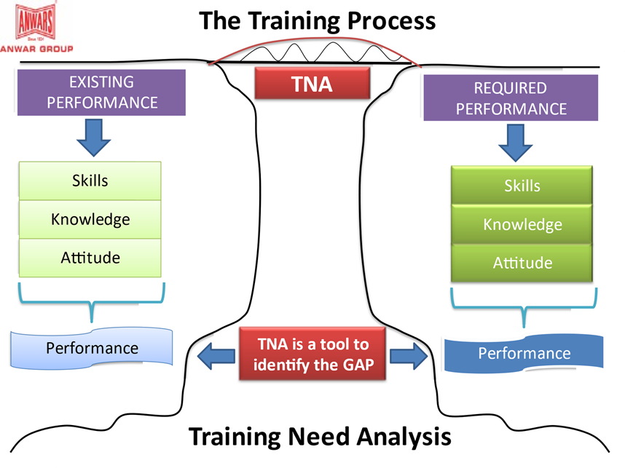

Figure 9: Anwar Group of Industries TNA Analysis

- Induction Program
HR department announce the newly hired employee via email is one that is written introduce with summery of the information about employee. And give employee the form which is signed by the department welcome. The purpose is to familiarize new employees with AGI, the policies, their roles and duties in the company and rules regarding the attendance. It is the motivational session for employee icebreaking development to completing the joining formalities.
- In house Training
The leader of the T&D team conducts in house training for employers and employees. AGI senior executives have also participate in the program. Managers and staff members at higher levels are held accountable by Key performance indicators (KPI) for the development of their performance. Each training consists of minimum 40 workers and solution of problems by the industry’s top trainers to help its personnel perform at a higher level.

Figure 10: Employee development Programs
- Online Training
It basically held on Zoom conference platform. AGI training sessions is the beneficial contribution for employee development program. The authority of Anwar group always give instruction by online meeting. And also maximum labor workers are not always present to head office so that the virtual training is necessary for them to develop their skills. AGI conducted 90 people participate in online session by inviting them also using arising questions by employees and solving that the top trainers.
- Monthly Presentation
Anwar group of industry conducted the monthly one presentation for their whole month work and improvement their efficiency of work. The departments are prepare the power point slides and present their efficiency and also the future goal of working. By this employees not only develop their leadership skills also their organization skills, analytical skills & operational skills. HR department conduct the program and assess them for development.

Chapter: 4

Analysis

4.1 Procedure followed HR Audit of Anwar Group of Industries
Anwar group of industry’s HR Audit firstly they overlook the processes and practices and then try to fill the gap in organizational objectives, legal requirements, and industrial policy. They try to maintain all the process and objective for executing the audit process. The systematic comparison of HR practices with against the legal rules regulations, by identifying the gaps between that what is requirements and what was done.
WORK ANALYSIS OF ‘HR AUDIT’
In this process I involve with the HR Department
- Firstly I get knowledge from my line manager and learn the functions of the HR Audit checklists. Because every segments of HR functions are audited and management work in the area of gap and develop for the betterment.
- I learn how to collect from the line mangers audit reports and submit to the management for final audit. Every department audit reports are audited by the HR department and I involve with these for my learning.
- I used to maintain the recruitment tracker for all employee information because of when HR Audit happen all the information are easy to access. My line manager are giving me the instruction to do for future access.
- I used to learn that how work on the result of HR Audit process to improvement of lacking the area of quality employees or employers.
- I learn that audited the employee lacking’s and list that what types of reward system are given to motivation. Also what kinds of training are giving for employee improvement and conduct that.

4.2 Procedure followed recruitment and selection of Anwar Group of Industries
- Recruitment Stage
AGI recruitment and selection process is raised by the department based on the requisition on position in organogram. And HR Manager identify the vacant and take approval of existing position.HR Executive posting the job at Bdjobs and also many other social platform. Then shortlisting CV and conduct interview panel. Fixing date and time with the interview board members, let know the candidates by calling and texting for the interview.
- Selection Stage
Taking written exam/viva at tentative dates and from them shortlisting candidates are asking for final interview phase with the Department Head and HR Manager. After that final negotiation with selected candidates. The organizations HR department proceed with the selected candidates a specific date of joining with offer letter.
WORK ANALYSIS OF ‘RECRUITMENT & SELECTION PROCESS’
In this process I involved of the whole system as an Intern.
- First of all I have done to practices the organogram that is the key to Recruitment. Because I need to know whose reporting line manager are whom. There are 23 departments and 152 working employees are in the Anwar Landmark.
- I had practices to making the format of the manpower requisition form, and also many types of letters that are; Offer letter, Appointment letter, Confirmation letter, show cause letter, Increment letter/Promotion letter, No objection letter, Resignation letter.
- I used to practice post the vacancy at Bdjobs and shortlisting the candidates CV from Bdjobs and shown my line manager when he approved the CV for interview then I proceed to the next phase.
- For taking interview I had to take time from the interview board members by calling and also making interview schedule & mailed them as a reminder date for interview.
- I used to maintain “Recruitment Tracker” in Excel sheet, so I had list down all the data for upcoming interviews dates, candidate summery, and interview board members name.
- I had called and giving massege for the candidates for interview.
- I used to prepare the “Interview Assessment Form” for the respective board members to asses and giving the numbers to the candidates.
- Also prepared “Interview Attendance Sheet” for the candidates.
- In interview day I used to coordinate the interview for serially.
- After the selection of first interview I used to prepare the “Candidates Summery” for the negotiation for HR manager.
- I used to call the selected candidates, and after Final negotiation I used to give the offer letter.
WORK ANALYSIS FOR ‘JOINING PROCESS’
As an intern I had practice the procedure of joining candidates. That is explain as follows.
- I used to give the documents to the candidates that were given by the organization for joining. The candidates needed to fill all the documents and submit to the HR Department. The papers are: Joining letter; Annexure A, B, C; Appointment letter; CV; Clearance from previous company; NID; Declaration form; Personal Information form; all educational certificates; Id & Visiting card Requisition form; Bank Account Opening form; Job description.
- Prepared joining kit and arrangement food for the new joiner.
- I captured the joiner picture and mail to brand team for create joining flyer, I prepare the flyer content and mail to HR manager who posted the new joiner Announcement.
- Also sending mail to IT for making the face reading and create the corporate ID.
- Another mail is sending to inventory for new joiner office stationary.
- Create ‘Induction form’ and maintaining induction for new joiner with all the departments.
WORK ANALYSIS FOR ‘FILE ARRENEGEMENTS’
- I used to check all the papers and maintain the employee personal file according to the organization policy including the above documents.
- Then I send the file to payroll for create employee Id.
WORK ANALYSIS FOR ‘RECRUITMENT TRACKER’
I used to maintain all the things in Recruitment tracker that is excel file consist of organizational HR department data list. Including as follows.
- Interview schedule,
- Candidate summery,
- Id & Visiting card Requisition,
- Live and closed employee file information.
WORK ANALYSIS OF ‘SALARY WORK’
- I used to counting the attendance of labor worker at the end of month for salary and send to the audit.
- Also I had solve the problem of attendance apps for employees who are absent or late count.
As an Intern, I was involve in many works to learn the things as much as possible for my learning and career improvement. I have prepared some questionnaire to analysis the Anwar group of Industry from colleagues, supervisor, people and friends.

4.3 ANALYSIS QUESTIONAIRE
- Does Anwar Group of Industries’ in recruitment are involving and handling by Third party?
Particular | Survey Respondents | Percentage
Fully Agree | 0 | 0%
Agree | 0 | 0%
Impartial | 1 | 10%
Disagree | 2 | 20%
Fully Disagree | 7 | 70%

Interpretation
In this analysis respondents give feedback, 70% strongly disagree, 20% disagree, 10% Neutral, 0% Agree and strongly agree. Anwar group of industries are handling all the hiring employee that is called recruitment process and policies of their own. So that there is no third party to involve at all.

- Does Anwar Group of Industries hiring employee internally from their own sources?
Particular | Survey Respondents | Percentage
Fully Agree | 2 | 20%
Agree | 5 | 40%
Impartial | 2 | 20%
Disagree | 1 | 20%
Fully Disagree | 0 | 0%

Interpretation
In this analysis respondents give marking as 50% agree, 20% strongly agree, neutral & disagree, and 0% strongly disagree. Anwar group of industry used to recruit employee internally some sources that is specific departments.
- Do you think Anwar Group of Industries Recruitment and Selection Process is standard and systematic?

Particular | Survey Respondents | Percentage
Fully Agree | 7.5 | 75%
Agree | 1 | 10%
Impartial | 1.5 | 15%
Disagree | 0 | 0%
Fully Disagree | 0 | 0%

Interpretation
In this analysis respondent’s response 75% strongly agree, 10% agree, 15% neutral and 0% disagree & strongly agree. It’s very clear picture that Anwar Group of Industry follow the standard and systematic hiring process of recruitment and selection process.
- Does Anwar Group of Industries conduct Training Session for employee Development monthly?
Particular | Survey Respondents | Percentage
Fully Agree | 6.6 | 66%
Agree | 1.4 | 14%
Impartial | 1 | 10%
Disagree | 1 | 10%
Fully Disagree | 0 | 0%

Interpretation
In this analysis respondent’s response 66% strongly agree, 14% agree, 10% neutral, 10% disagree and 0% strongly disagree. Anwar Group of Industry conduct employee training session for employee development, AGI always assess all the employee performance and organize session monthly to update always.
- Do you think HR Audit happen that is the reason Anwar Group HR department is very stick to their policy & their employee?
Particular | Survey Respondents | Percentage
Fully Agree | 7.1 | 71%
Agree | 1 | 10%
Impartial | 0.9 | 9%
Disagree | 1 | 10%
Fully Disagree | 0 | 0%

Interpretation
In this analysis respondents 71% strongly agree, 10% agree, 9% Neutral, 10% disagree and 0% strongly disagree. Anwar group HR Audit process is very stick to their employee policy because it results is maintain all the curriculum.

Chapter: 5

Findings, Recommendations & Conclusion

5.1 FINDINGS
As an Intern, Conducting the recruitment and selection process and work for employee development with Anwar Group of Industry I have observed such major findings and also analysis those as follows.
- The reputable organization AGI management person give reference maximum time for the upper position, but Anwar group HR give their hard work hundred percent but if management refer someone and for this reference it makes problem for the hiring process.
- Anwar Group HR Audit conducting by the Management of HR. There is lack of manpower to conduct the procedure.
- Anwar Group Recruitment process is very lengthy that really, one on one interview time period is very long that is problem for the lasts candidates.
- Human Resources Department follow the joining day one induction program which is for all the day long and that is very disturbing for new employee.
- Anwar group of industries hiring process they do not count on the fresher for chance to work. AGI always maintain and hire the experienced people. They think fresher are not able to work properly and organization will not depend for the important work. That is the reason I think the organization lost many talented people to work for AGI.
- AGI employee development program is conducted for 2 days or 3 days, it is not enough to know all the things properly for any kinds of employee.

5.2 RECOMMENDATIONS
Anwar group of industry have a strongest potential department, HR department is very efficient and as an intern I work with 4 month. The department is well try to progressive all the lacking that effect the output of the organization and make sure that all the process which is recruitment and selection, employee development steps they try to recover for making their best.
- AGI, HR department has to reducing the reference system and maintain the recruitment process by their own and it should try to add their policy system. Only for reference system HR department facing problem to select the best and capable candidates.
- For conducting HR Audit, AGI should increase the manpower to maintain all the information and divide the area of keeping information to get in currently.
- The HR department call the candidates for set by the timing schedule because interview time period is lengthy, if the candidates calling at the different time and maintain properly the timing so that no one suffer.
- The induction program is very problematic for the new employee, because it is whole day process, so that it should be maintain by calling the head of the departments and specific department person to familiarize with the new employee and maintain with the timing.
- Nowadays many fresher are very intelligent and capable to work for upper position and they work with the proper dedication, fresher are very updated and they brand the things very proper way so that AGI should have to provide the opportunity to join their organization.
- Employee development program days should increase to get more knowledge about work and organization in practically.

5.3 CONCLUSION
Every organizations success depends on their employee performance and their dedication of work and also the collaboration of all the things that helps to serve people. Anwar group of industry depends heavily on their ability to their employees so that their Department of Human resources maintain the major work that is recruitment and selection do properly to give best employee to work the one of the renowned organization. The management of the organization need to invest more money in the organization run the process flexibly. HR audit do regularly to find where improvement is needed and what is beneficial for the AGI employees. As an intern, I am learning many important lessons that will be beneficial my career. Anwar group of industry’s every unit Group HR work very efficiently to recruit very potential employee to work for the best output. They conduct employee development program that is inspire their employee to improve their productivity and quality of working. AGI needs to take various necessary path for the improvement of the organization which is given to the recommendation. I have gained a greater hands on understanding and practical knowledge by involving in the process of the HR Audit, Recruitment and selection process also how to develop the employee skills. As an intern I have tried my level best to identify and analysis the information about the Human resource department work and present the detailed properly. I have used my efficiency, knowledge, Best effort to prepare the report to successfully carry out my professional obligations in the future.

5.4 REFERENCES

Human Resource Investopedia. (2022). Human Resource Investopedia. Retrieved November 07, 2022, from Human Resource Investopedia Web site: https://www.investopedia.com/terms/h/humanresources.asp

Anwar Group Wikipedia (2021). Anwar Group Wikipedia. Retrieved April 11, 2021, from web site: https://en.wikipedia.org/wiki/Anwar_Group_of_Industries

Anwar Group of industries, Anwar group of industries LinkedIn,
From Web site: https://www.linkedin.com/company/anwar-group-of-industries.

Human Resource Audit, Concept of Human Resource Audit, From Web site: https://www.academia.edu/9906176/Concept_of_Human_Resource_Audit

Employee Development Program, Blog of Employee Development Program, Retrieved November 16, 2021, From Web Site employee development program: https://matterapp.com/blog/employee-development-program

Achievements of AGI, Anwar Group of Industries Achievements, From Web site: https://www.anwargroup.com/achievements/

Chapter: 6

Survey Questionnaire

Survey Questionnaire
Educational Institution: United International University
Internship Survey Topic: HR Audit & Recruitment and Selection Process of AGI

The respondents are fill the column by ticking their perspective, by various option as the respondents mark one/two column and giving percentage of possibilities.
SL | Questionnaire | Fully Agree | Agree | Impartial | Disagree | Fully Disagree
1 | Does Anwar Group of Industries’ in recruitment are involving and handling by Third party?
2 | Does Anwar Group of Industries hiring employee internally from their own sources?
3 | Do you think Anwar Group of Industries Recruitment and Selection Process is standard and systematic?
4 | Does Anwar Group of Industries conduct Training Session for employee Development monthly?
5 | Do you think HR Audit happen that is the reason Anwar Group HR department is very stick to their policy & their employee?

6.2 Appendix 1

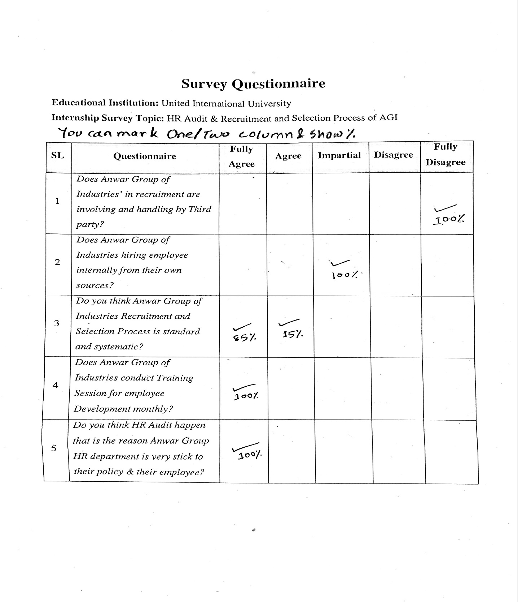

6.3 Appendix 2
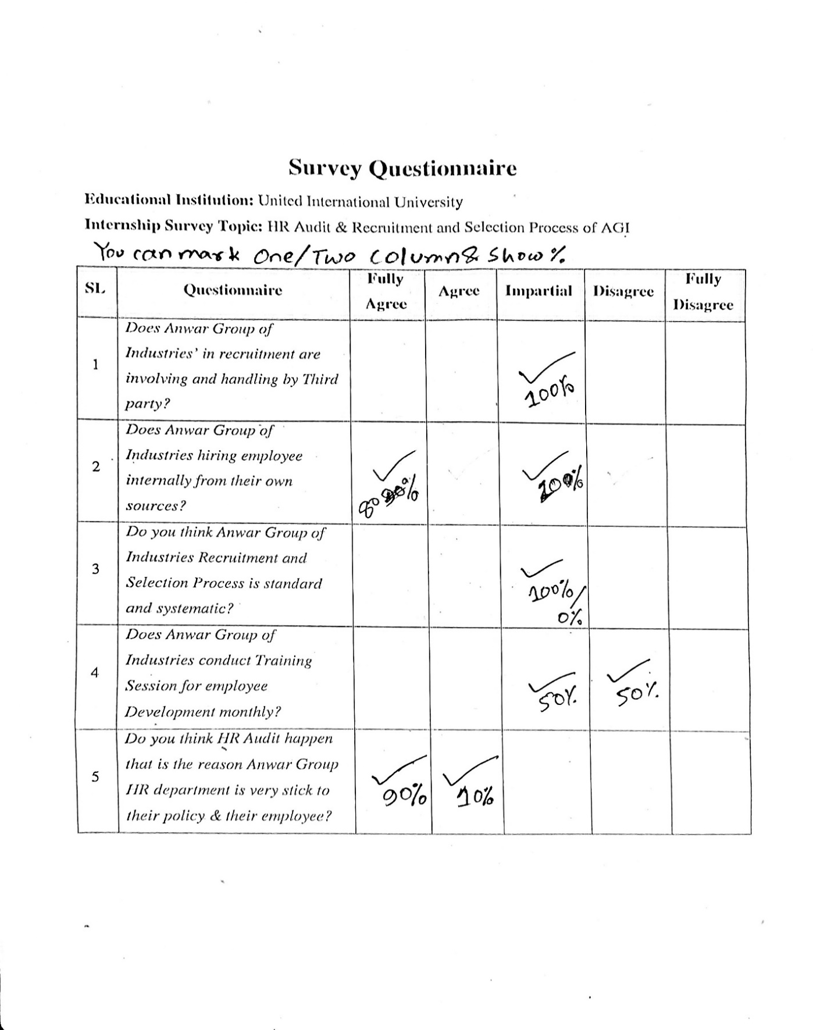

6.4 Appendix 3
