Marketing Strategy and Market Creation: A Study on Al Amin Electric Company

Md. Abu Rayhan

This internship report is submitted to the School of Businesses & Economics, United International University as a partial requirement for the fulfillment of Bachelor of Business Administration Degree

Marketing Strategy and Market Creation: A Study on Al Amin Electric Company

Submitted by
Md. Abu Rayhan
ID- 111171126
School of Business & Economics
United International University

Supervised by
Dr. Kawsar Ahmmed
Professor
School of Business & Economics
United International University

Date of Submission: 21-Nov-22

Letter of Transmittal

21-Nov-22
Prof. Dr. Kawsar Ahmmed
United International University

Subject: Submission of Bachelor’s Internship report on “Marketing Strategy and Market Creation: A Study on Al Amin Electric Company”

Dear Sir,
With due respect, I want to submit my report that has been assigned to me as a requirement of the internship program for completing my undergraduate degree from the School of Business and Economics, United International University. I have prepared my Internship report on “Marketing Strategy and Market Creation: A Study on Al Amin Electric Company” with my best efforts to make it specific, coherent and meaningful as per your guidelines which is being submitted along with this letter.
I would like to thank you for your valuable guidance and support while preparing this report. I hope with great anticipation that you would be kind enough to accord your approval to this report.

Sincerely Yours,

Md. Abu Rayhan
ID- 111 171 126
School of Business and Economics
United International University

Declaration

I, Md. Abu Rayhan, the student of Bachelor of Business Administration, bearing the ID: 111171126, hereby declare that this report, submitted in fulfillment of the requirements of the degree of Bachelor of Business Administration (BBA) in the School of Business and Economics, United International University, is wholly my work unless otherwise referenced or acknowledged. This paper has not been submitted to any other academic purpose or for further research.

Md. Abu Rayhan
ID- 111 171 126
School of Business and Economics
United International University

Executive Summary
Market creation refers to the strategic step taken by a company to develop the existing market as well as looking for a new market. The aim of this study is to identity the marketing strategies necessary for creating market. In identifying and creating new market, four paths are considered which include PATH 1- A new product to an unknown customer set, PATH 2- A new product to a known customer set, PATH 3- A known product to a known customer set, and PATH 4- A known product to an unknown customer set where Al-Amin Electric is taken as the case.
Several Bangladeshi companies manufacture a number of consumer electronics products. Electronic goods hold a large portion of the domestic market. Previous research estimates that the global electronics market will surpass $1 trillion in 2021. That market is anticipated to reach $1.29 trillion by 2025 and increase at a rate of 5% annually. According to Report linker, the market for household appliances is anticipated to reach $331.57 billion by 2021 and increase by 7% annually, reaching $436.04 billion by 2025. The market for consumer electronics and home appliances in Bangladesh, however, is only worth $2.32 billion. Therefore, we are missing the big chunks of this huge trending sector. The fourth industrial revolution is on the horizon, and that is the technological revolution. The more technologically advanced we are, the more the benefits will prosper our country. Technological marvels are all around us, and we cannot help but appreciate the wonders of modern science. Al-Amin Electric is one of the largest household electric, appliances, electronics, and dish networking service providers in Bangladesh. Our name is not as famous as other companies doing the same business because we are not the retailers, but rather the whole sellers. We have been in this business for 30 years and ongoing. We have a profound history and an ethical management team for the smooth running of our operations. In this paper, we start with the company portfolio, which includes the Board of Directors, company overview, visions, and missions. Then, in the second part, we talk about the overall electronics sector, market trends, and major players. This part also includes our products and prospects. The third part talks about dominating the new market while formulating a suitable marketing strategy for AL-Amin Electric. Analyzing the activity of the company while preparing this report gave us some valuable insights and we found some limitations which are hampering the company while providing recommendations to solve them.

Keywords: Market creation, Path, strategy, AL-Amin Electric, Bangladesh
Contents
Letter of Transmittal 3
Declaration 4
Executive Summary 5
Chapter One 9
Introduction 9
Origin of the report 10
Objective of the report 10
Methodology 10
Primary Data 10
Secondary Data 10
Limitations 11
Chapter Two 12
Electronics Industry: An Overview 12
Introduction 13
Electronic Sector and Market Size 15
Consumer Electronics Producer 17
Product Segment- FAN 17
Chapter Three 18
Company Overview 18
About Us 9
Mission 10
Vision 10
Overview of Our Operations 10
Board of Directors 11
Sister Concern 11
Supporting Companies- 11
Product 11
Brand 11
Core Values 12
Core Strength 12
Core Competencies 12
Analysis of Al Amin Electronics 13
SWOT Analysis 16
Strategies to Meet the Challenges 17
A Detailed Introduction to Our Products 18
Chapter Four 24
Marketing Strategy and Market Creation 24
NEW MARKET 33
Challenges of entering a new market- 33
Attractiveness of entering a new market- 33
Creating New Market- 34
# PATH 1- A new product to an unknown customer set 34
# PATH 2- A new product to a known customer set 35
# PATH 3- A known product to a known customer set 35
# PATH 4- A known product to an unknown customer set 36
Suitable and Attractive market for AL-Amin Electric 36
WORKS WITH ALEXA 38
Dominating New Market 39
Market-Customer Involvement 40
Customer Engagement Strategies 40
Building and Using Credibility 42
Use of Information Technology- 43
Limitations of the entity 43
Recommendations 44
Conclusion 45
References 46

Chapter One

Introduction

.

Origin of the report
The internship report is mandatory for completing the Bachelor of Administration degree program. When selecting a topic for the internship report, my internship supervisor allowed me to choose the topic “Marketing Strategy and Market Creation_ A Study on Al Amin Electric Company.” I was interested in it. Since I am doing my internship at Al Amin Electric.

Objective of the report
The overall objective of this report is to learn and analyze how marketing strategies rae used to create new market for electric goods. More specifically, this study aims at exploring the following four paths to identify the realistic path for market creation.
- PATH 1- A new product to an unknown customer set,
- PATH 2- A new product to a known customer set,
- PATH 3- A known product to a known customer set, and
- PATH 4- A known product to an unknown customer

Methodology
I used primary and secondary data to create this report. However, most of the data come from primary sources relating to Al Amin Electric.

Primary Data
The following sources were used to collect secondary data:
- Interacting & discussing with my colleagues, and supervisor.
- Direct observing at the Al Amin Electric.

Secondary Data
The following sources were used to collect secondary data:
- Magazines, newspapers, articles, and annual reports.
- Official website of Al Amin Electric and its social media.

Limitations
Some limitations to the conduct of the study are following:
- Most information and data are confidential.
- Current data are not available on the internet.
- Restricted access to department service information.

Chapter Two

Electronics Industry: An Overview

Introduction
The electronics industry in Bangladesh is one of the fastest-growing industries in the country with great potential. Popular Bangladeshi electronics brands include Walton Electronics, Singer Bangladesh, Jamuna Electronics, Vision Electronics (PRAN-RFL Group). Local companies such as Fair Group, Butterfly Group, Electra, Rangs Group, Electro Mart, and Transcom Group manufacture and assembles Electronics Home Appliances in collaboration with foreign brands such as Samsung, Whirlpool, LG, Sony, Gree, Konka, and Sharp. The electronics industry in Bangladesh mostly produces consumer items. Home appliances includes televisions, radios, DVDs and CD players, refrigerators, air conditioners, ovens, electronic fans, blenders etc. are being assembled to a large extent. To ensure the performance reliability, the key challenges in this sector are technical assistance and proper technology orientation of the industry. The use of electronic products in Bangladesh started in the 1930s through the field of communication with the enterprise of radio stations, telephone exchanges and wireless stations. During World War II, to satisfy needs of military, the technology of wireless communication was enhanced and the latest technology was introduced in this part of Asia.

In 1950, consumer electronics industry made an beginning in the private sector and a few assembly plants were established to produce a limited number of radio sets. In the 1960s more assembly plants were established. In 1964, with the establishment of the first television station in Dhaka Bangladesh, some of these plants started assembling television sets. In 1983, a digital telephone system was introduced and in 1992, mobile phones introduced. Before 1980, most of the domestic appliances and equipments were imported from other countries, except the one-band radio, but after 1980 many assembly plants for radio, television, audio, and video cassette recorders and players were locally established.

Since 1990, sophisticate products like cordless telephones, satellite TV signal receiving equipment, computers, etc. started to be assembled and some spare parts also began to be manufactured. Within this time, a number of multinational companies have set up their assembly and manufacturing plants in Bangladesh. Local companies in joint collaboration with foreign companies have established assembly and manufacturing plants. At present the total number of such companies is more than sixty. Since 1994, after Bangladesh's integration into the free market agreement, all kinds of commodities including electronic products began to be imported freely, which created a competitive environment. By the 2000s, Revolution started and few local companies began to export locally manufactured electronic home appliances abroad. Walton, Jamuna Electronics, Marcel, Vision, ViGO, Minister Etc. were the frontier leaders to start manufacture of electronic goods in Bangladesh. After Walton, many other local companies started manufacture electronic home appliances in the country. Walton introduced country's first compressor manufacturing plant in April, 2017. In 2017, Samsung inaugurated two home appliances manufacturing plant in Bangladesh, in collaboration with Fair Electronics and Transcom Electronics. In 2018, LG Electronics inaugurated TV manufacturing plant in Bangladesh, in a collaboration Butterfly Group. LG also plans to open a Refrigerator and Air Conditioner manufacturing plant in 2019. Japanese electronics brand Sharp and Fujitsu General home appliances also started their journey in Bangladesh with a local conglomerate, Esquire Electronics.

The electrical and electronics sector in Bangladesh is not developed because of higher technical knowledge and production capacity. However, with the growing population and improved principles of living, Bangladesh is importing enormous quantity of consumer electronics products to meet the higher consumer demand. China remains the largest exporter of electronics products for Bangladesh. In this context, Indian High Commission commissioned a market research in 2017 with the aim to get a complete picture of the Bangladeshi consumer electronics market to examine the potential of India companies entering the Bangladeshi electronics market. The study involved desk research and primary data collection through in-depth interviews with the representatives of the different government bodies and electronics companies to understand the market. The market volume of the electronics industry is around 4 billion USD in 2017 and by 2025, it is expected to reach about $ 12 billion. The volume of the consumer electronics market was estimated to be around 1.8 billion USD in 2016. Consumer electronics’ market size is estimated to reach about 6.3 billion USD by 2025. At present, television and refrigerator are two items with highest demand. Demand for air conditioners has also been increasing rapidly in the urban areas of Bangladesh for the last couple of years. The demand for television, refrigerator, and fan is also observing an expansion in the rural areas and demand for air conditioner, refrigerator and smart TV has been registering a rise in the urban areas.

Among the import items, air conditioner and refrigerator were the greatest items and Bangladesh imported electronic products worth around 2.2 billion USD in 2016 including consumer and industrial products. Chinese manufacturers hold the 69% share of the market of imported consumer electronics products in Bangladesh. Other main import destinations for Bangladeshi importers include India, Korea, and Japan among others. Beyond this, if we look at the exports of electronic and electrical products from Bangladesh, the figures are insignificant in comparison to the imports.

Electronic Sector and Market Size
Bangladesh produces different types of consumer electronics products but in most cases the producing companies import different parts and elements from other countries and assemble them in their production plants. According to Ferdous Ara Begum, CEO, Business Initiative Leading Development, electronic goods have a large increasing domestic market in Bangladesh, which has more than 3000 units in operation. Consultation with the representatives of government executives and different consumer electronics producers it was observed that the market volume of electronic industry is around 4 billion USD in 2017 and it is expected to have a yearly expansion rate of 15%. Based on the expansion rate, the market size is estimated to be around 12 billion USD. It is noted that this figure includes the consumer electronic products and industrial/business electronic products. It was also observed that the whole market of the consumer electronics was around 1.8 billion USD in 2016. It corresponds to the market size of consumer electronic products from the year 2013 to 2016 which shows a steady expansion over the time.

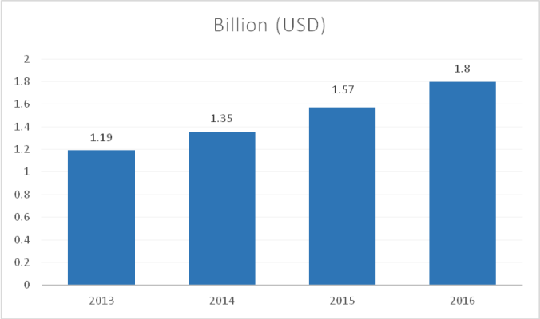

On the basis of the available market volume data from 2013 to 2016, it is estimated the market volume for consumer electronics and electric products up to 2025. The estimation shows that the market volume of consumer electronic and electric products will be about $ 6.31 billion in 2025.

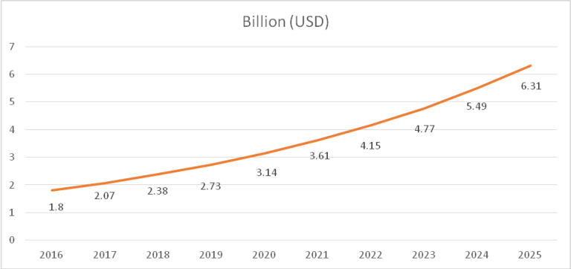

Fig- Growth Potential

Consumer Electronics Producer
The major competing Bangladeshi companies in the consumer electronic and electric markets are:
- Walton Group
- Transcom Electronics Ltd.
- Rangs Electronics Ltd.
- Best Electronics Ltd.
- MyOne Electronics Industries Ltd./Minister
- Jamuna Electronics
- PRAN RFL (Vision and Click)
- Esquire Electronics Ltd.
- Electra International
- Super Star Group (SSG); and
- Astute Electronics
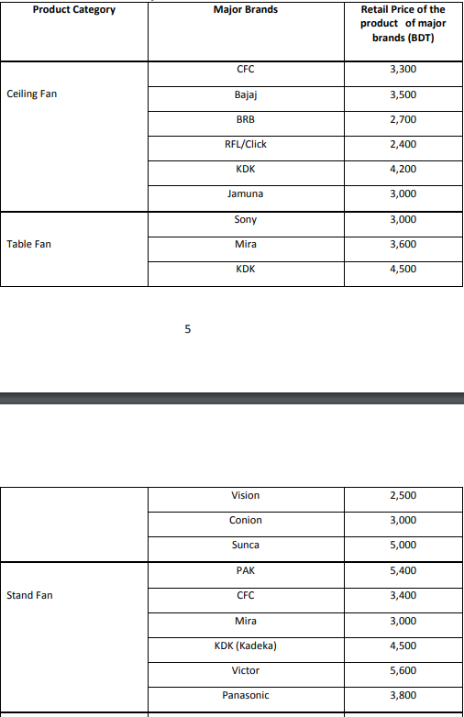

Product Segment- FAN

Chapter Three

Company Overview

About Us

The Company was established under esteemed leadership of late Mr. Md. Mostafizur Rahman Hasib at Nawabpur Road, Dhaka, Bangladesh with the aim of becoming market pioneer in complete range of electrical products.

Now ‘Al Amin Electric’ stands distinguished in the local market of Bangladesh and is helping customers, both domestic and commercial, to choose from a wide variety of products for different applications.

The company is the sole distributor of ‘MIRA’, a renowned Thailand brand of Electric Fans, in Bangladesh.

In 2015, the company received distribution of a well reputed Pakistani Brand of Electric fans ‘Pak Punjab Super’, manufactured by Nazir Industries, Gujranwala, Pakistan.

Thanks to the quality of products that we supply, our company has the highest customer satisfaction.

“We assure not only the best service but also the very best after- sales service because happy customers are our biggest promoter”

Mission

We aim to provide the best quality service to our customers. We offer high-quality products, long-lasting performance, competitive prices, and technical superiority over our competitors. We are in a league of our own which has been thriving in the market for the last 25 years or so. We are continuously developing our products and services to be the best in Bangladesh.

Vision
In MIRA, we idolize our founder late Mr. Md. Mostafizur Rahman Hasib Sir’s vision in order to become the market leader in our country. Our superior-tech and after- sales services are rare to be seen in our country. Again, Our offered product “Pak Punjab Super Fan” is in a league of its own. It’s very hard to find a person in Bangladesh who hasn’t heard about our brand and the lifelong service it provides. We provide value for money. Thus, by doing so we hope and plan to become the market leader in Bangladeshi Fan. Our dream is to be in every household of the nation while creating wealth for our equity holders.

Overview of Our Operations

Mother Company: Al Amin Electric
Established date- 1992
Starting capital- 100,000 Taka Only

Head Office-
Al AMIN ELECTRIC
154 Nawabpur Road
Dhaka
Bangladesh

Our Ex-Chairperson
Late Mr. Md. Mostafizur Rahman Hasib

Board of Directors

Motiur Rahman Hasan
Managing Director
Md Abu Rayhan
Chief Executive Officer

Sister Concern

- Rayhan Electric
- Rafid Electric

Supporting Companies-

- Hasib Electric
- M.R International
- M.H Corporation
- Spark Electric
- Dhaka Electric

Product

Brand
  - Mira
  - Pak Punjab Super
  - Victor
  - National Deluxe (for fan)
  - SolarOn
  - Gold Star
  - Victor
  - King Star (for Blanket)

Core Values

- Integrity. Acting with strong ethics is a priority for everyone representing the organization as well as the company’s behavior as a whole.
- Honesty. It’s not just the best policy. It’s a core business practice to act in a transparent, trustworthy manner that earns the respect of colleagues, customers, and the public.
- Fairness. Treating everyone with the common decency we all deserve and expect.
- Accountability. Accepting responsibility for your actions (and inactions) is the ultimate way to build trust internally and externally.
- Promise to Customers. Creating a great customer experience begins with staying true to the words we speak and the bonds we make.

Core Strength
- Consistently high quality
- Incomparable value
- Ceaseless innovation
- Clever, successful marketing
- Great customer service

Core Competencies

- Diversity and Inclusion. Organizations succeed by bringing different lived experiences and a range of backgrounds into a shared environment where everyone has equal opportunity.
- Learning. No one has all the answers. A culture of humility and continuous learning is a bedrock principle of successful companies.
- Teamwork. When people work together, they can create something greater than themselves as individuals.
- Passion. Having a joy not just for the work itself but also the people around us, so that everyone can be bold, innovative, and creative.
- High Quality – We do not compromise our product quality.
- Customer Service- We provide the best after sales support.
- Commitment- Our words are absolute. Our Clients are our top Priority.

Political, Legal and Regulatory Factors - Tax, Vat, Customs Duty, Excise Duty and all the regulatory factors are properly documented and maintained.

Analysis of Al Amin Electronics

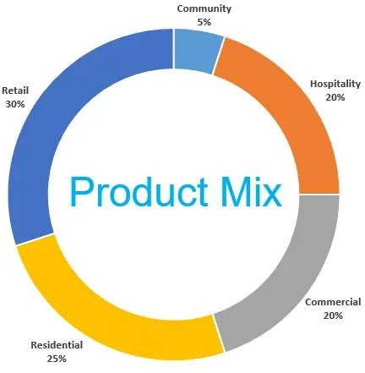
Mira 25%

Gold Star 20%
Brand MIX
Pak Punjab Fan 30%
National Deluxe Fan 20%
Others 5%

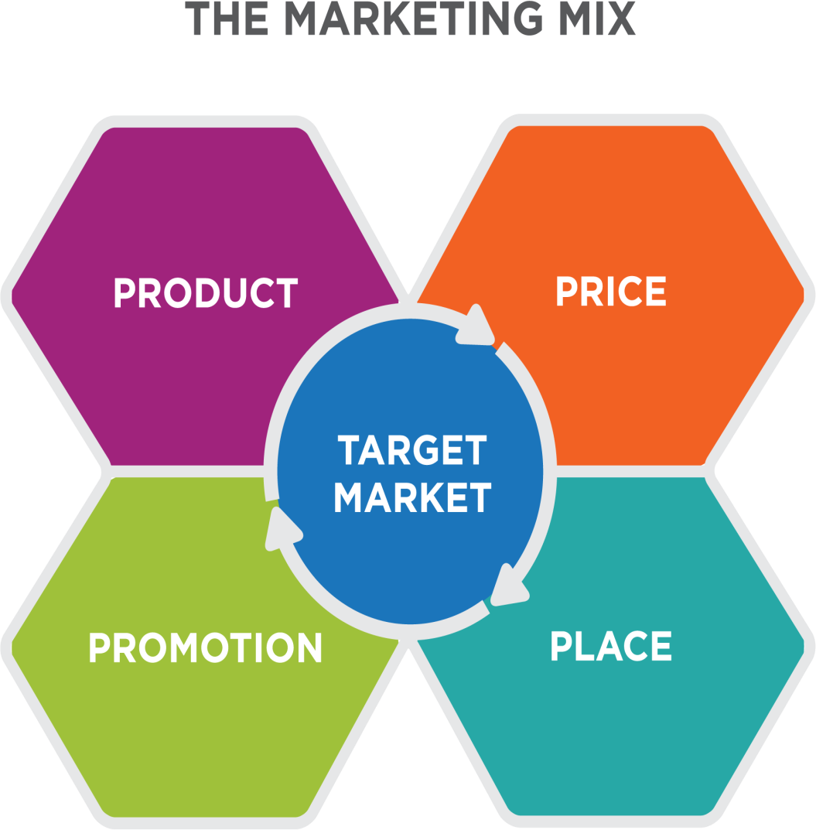

All Over the Bangladesh
TVC, Newspaper, Magazines, Poster, Banners and Goodwill.

Starting from 2999 tk only
Ceiling, Table, Pedestal. Exhaust, Wall Mounted Fan.

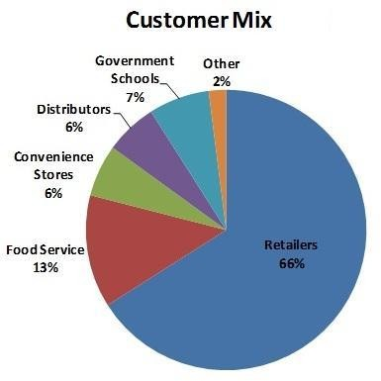
Corporate 13%

SWOT Analysis

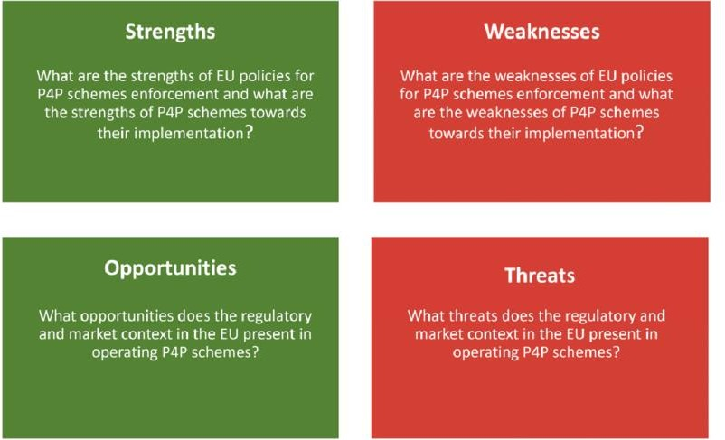

SWOT Analysis of AL AMIN ELECTRONICS

The overall evaluation of a company’s strengths, weakness, opportunities and threats is called SWOT analysis. SWOT Analysis is an important planning tool that helps a person or organization to identify and understand its internal strengths and weaknesses. It also match this strengths/weaknesses with the opportunities/threats in the environment.

Industry Rivalry
- Walton
- RFL Fan
- National Fan
- BRB Fan

Strategies to Meet the Challenges

- The demands of a growing workforce can be mitigated by hiring new employees.
- Introduction of a dedicated marketing team.
- Usage of Enterprise Resource Planning Software.
- Modernizing the supply chain activity, real time monitoring.
- Inventory management.
- Keeping the supply chain running is always a crucial task.
- New compliance responsibilities.
- Adopting technologies while keeping our culture intact.

A Detailed Introduction to Our Products

Best Seller- PAK PUNJAB SUPER

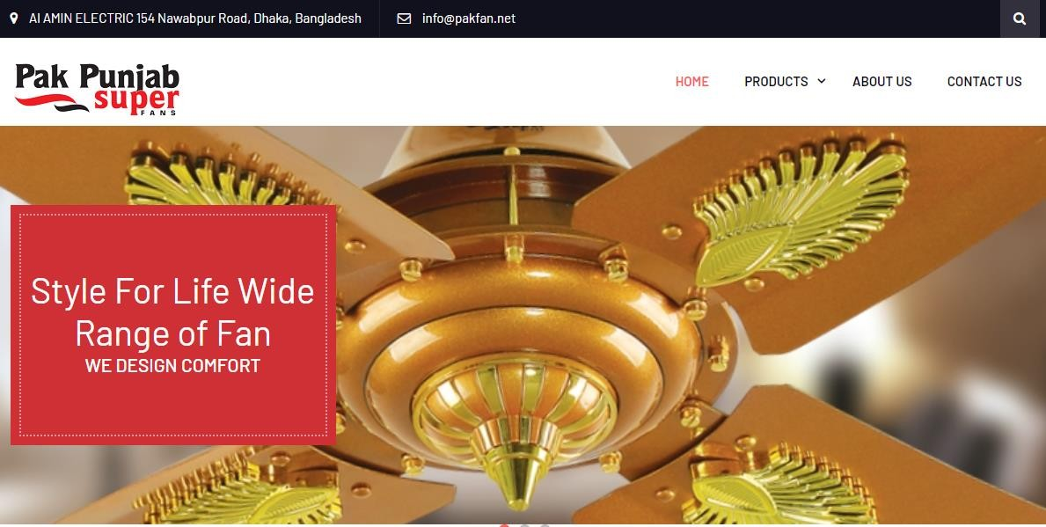

Website- https://pakfan.net/
Facebook- https://www.facebook.com/pakpunjubsuperfans/?ref=page_internal

Product Categories
- Ceiling Fan
- Wall Fan
- Exhaust Fan
- Pedestal Fan

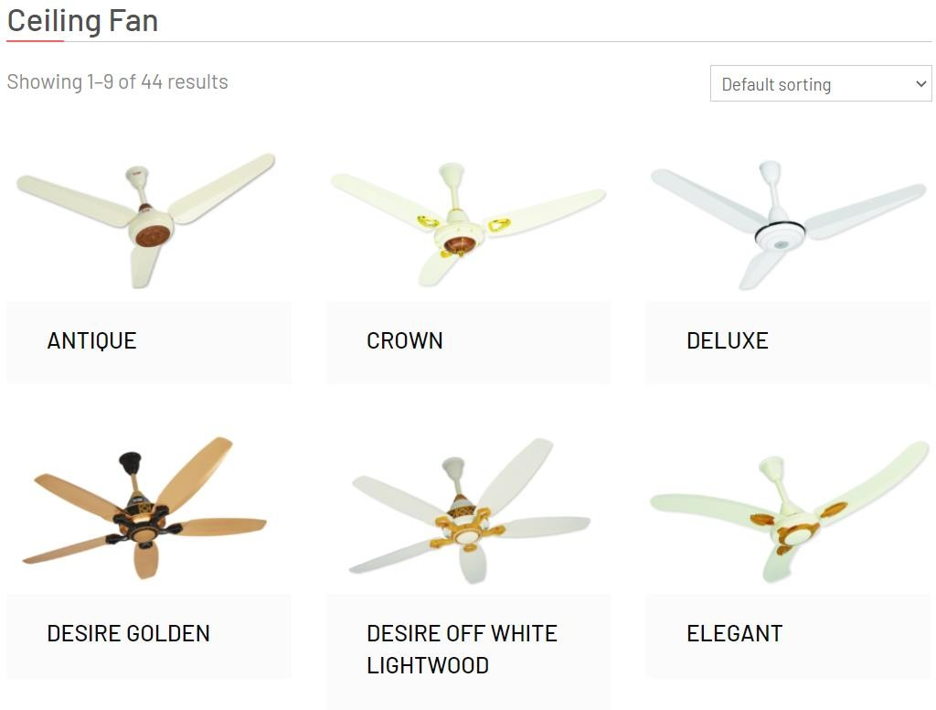

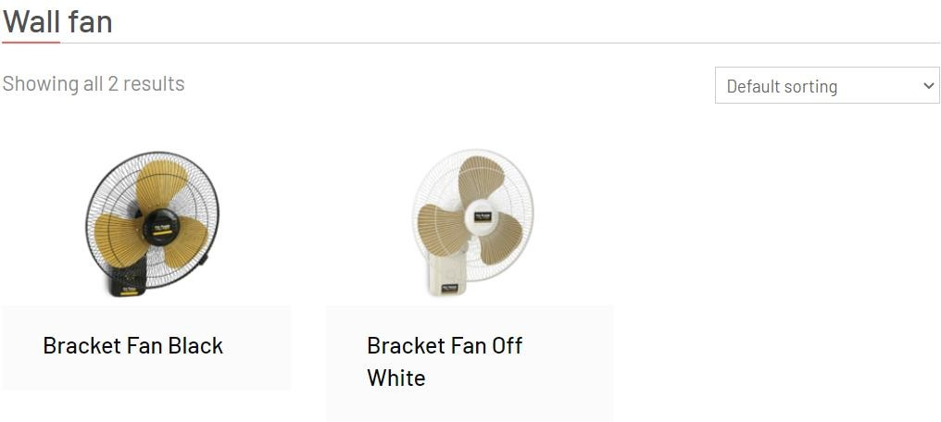

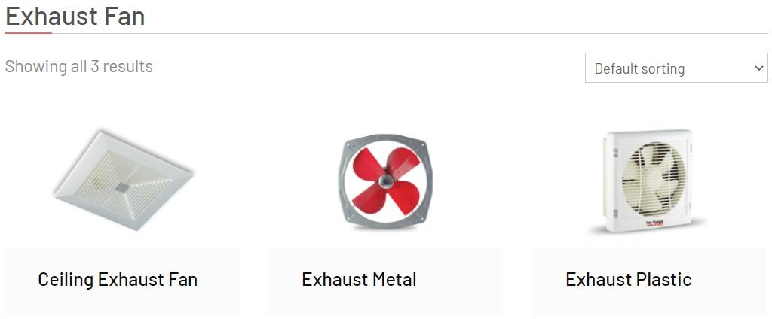

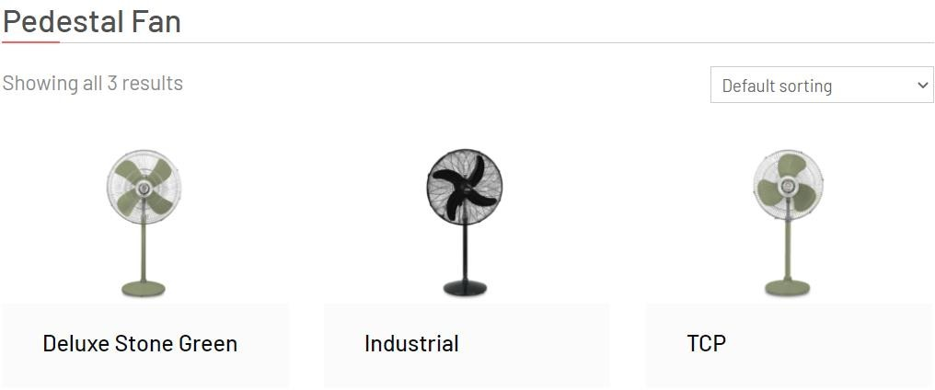

Star Products-

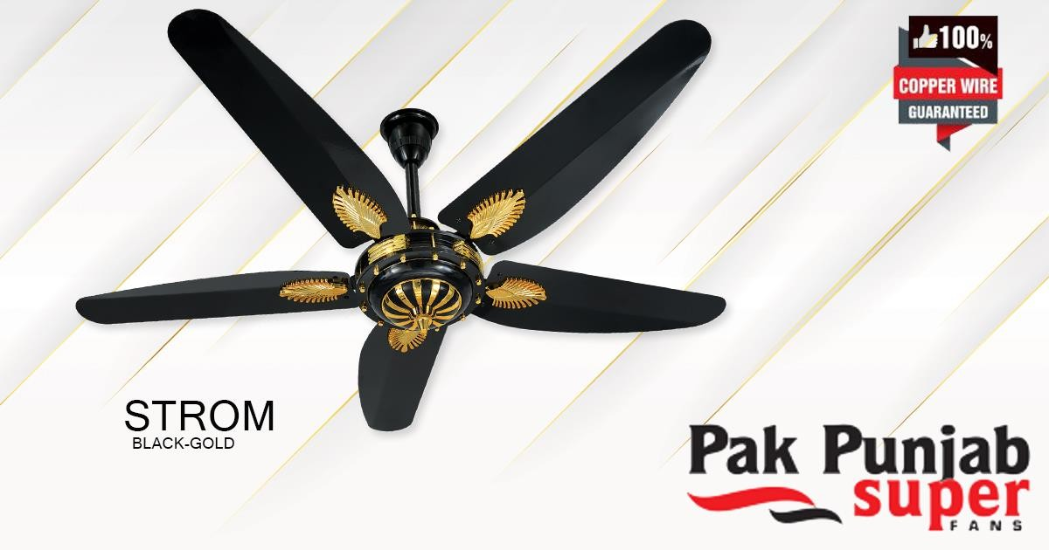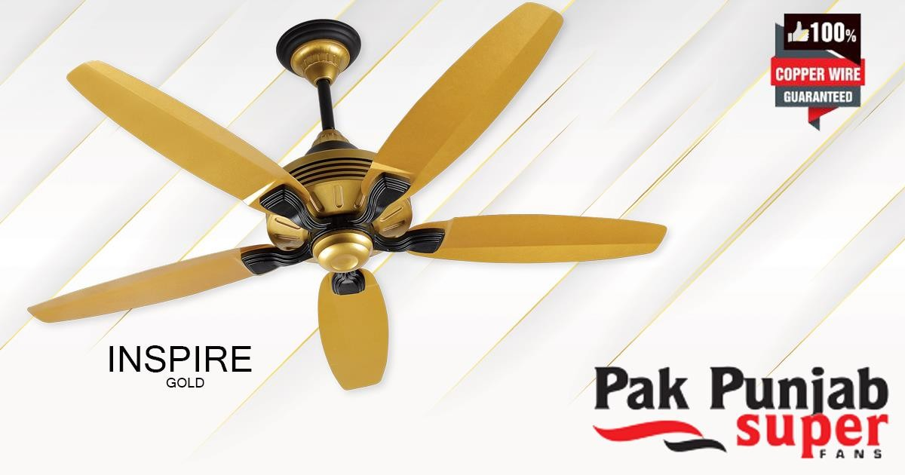

Top Brand- Mira Electric



We Provide-
- Wall Fan
- Exhaust
- Stand
- Wall Mount
- Moving Wall Mount
- Turbo
- Stand

Chapter Four

Marketing Strategy and Market Creation

NEW MARKET
An organization that is entering a new market or market segment is said to be "new to market." Gaining access to a new market or market segment aids in growing the clientele and business. Before entering a new market, it's crucial to take a few steps to ensure success.
A SWOT (strengths, weaknesses, opportunities, and threats) analysis is always beneficial when evaluating the market. A list of all businesses that provide similar products or services must be compiled. Following the identification of competitors, the company should scrutinize all marketing materials provided by the competitors. This will assist them in determining how to differentiate their products or services from the competition. This will also aid in comprehending the market's scope.

Challenges of entering a new market-

- Rivals
- Unknown customer base
- Currency
- Lack of Customer Engagement
- Brand is not promoted by the distributors

Attractiveness of entering a new market-

- New market equals to new probabilities
- Product customization opportunities
- Better business growth
- More revenue
- Brand Recognition

Creating New Market-

In the broadest sense, a company competes not only with the companies in its own industry but also with companies in those other industries that produce substitute products or services. In making every purchase decision, buyers implicitly weigh substitutes, often unconsciously.

# PATH 1- A new product to an unknown customer set

Let us use examples to get a better idea about this concept.

We Bangladeshi people love Fuchka. So a young entrepreneur in New York, USA opened a fuchka shop there. Now the American people love this new food item.

Here Fuchka is a new product.
And USA people are the Unknown customer set. Nobody knew how they would react to the new food item. But the business worked because of the uniqueness and traditional feeling with this food.
- Understanding of the market
- Featuring unique things about the new product
- Promotions and branding
- Foreign culinary tag is helpful as people likes to explore.
- Quality and Passion

# PATH 2- A new product to a known customer set

Pathao has brought revolution in our everyday life. They have been here for quite some time. Their users know what the app is for and what the company delivers. So here the customer is known.

When they launched Pathao parcel that’s a new product for them. So they heavily promoted this new feature which eases the peoples Hassel to deliver items. Now it is more popularized because its time efficient and effective to use.
- Check the feasibility of the new product
- Comparison with the competitors
- Great benefits at attractive price
- Hassel free experience
- In app promotions
- Flyers banners and tv ads

# PATH 3- A known product to a known customer set

Let us use the example of the Smartphone industry.
Here all the phones offers mostly the same things and theres less variations among them. Still people are looking for option here and there.

People knows the Smartphone so well that now companies are using heavy R&D to differentiate the product form the competitors
Such as, Samsung launched Galaxy Fold and Galaxy Z flip.

Which are smart phones but can be folded or be flipped as per the wish of the customers.
One makes the experience larger where the other one makes the process as compact size as possible.
Here the customers are known and the product is known too.

- Depth understanding of the business sector
- Heavy R&D exposure
- Comparisons with competitors in the TVC
- Branding and Promoting the exclusives of the product,
- Make something unique rather than being mainstream.

# PATH 4- A known product to an unknown customer set
For easier understanding we look back a few years.
Pathao launched in BD which is a motor vehicle sharing service. It was a new product to us. As we get used to Pathao we saw “Uber” launching in Bangladesh.

Here uber is offering the same service (known product) as Pathao and though they are new to the market but they know that the customers are eager for a better service and quality which uber could easily provide. As they hype of the Pathao was on peak back them, it was no brainer for uber to move into Bangladesh although it’s a new territory for them.

- Understanding the customer demand
- Better service
- Look out for lacking of the competitor
- Providing quality service
- Attractive prices
- Promo codes
- Referral bonus

Suitable and Attractive market for AL-Amin Electric

For AL-Amin Electric PATH 2- A new product to a known customer set is more appropriate. It’s better to follow the secondary approach because of various reason
  - Economic Recession
  - Unstable dollar price
  - Price Inflation
Middle class and Upper middle class of our country is the new target market of our company.
Because of the economic recession middle class people are looking out for options which will cut cost of their daily necessities. And the way electric bills are going up, it’s easy to assume that someday it will get worsen. As we can’t but use electronics in our usual life so it’s better to opt to options which are energy efficient. Thus, we will launch Energy Efficient Fan Such as
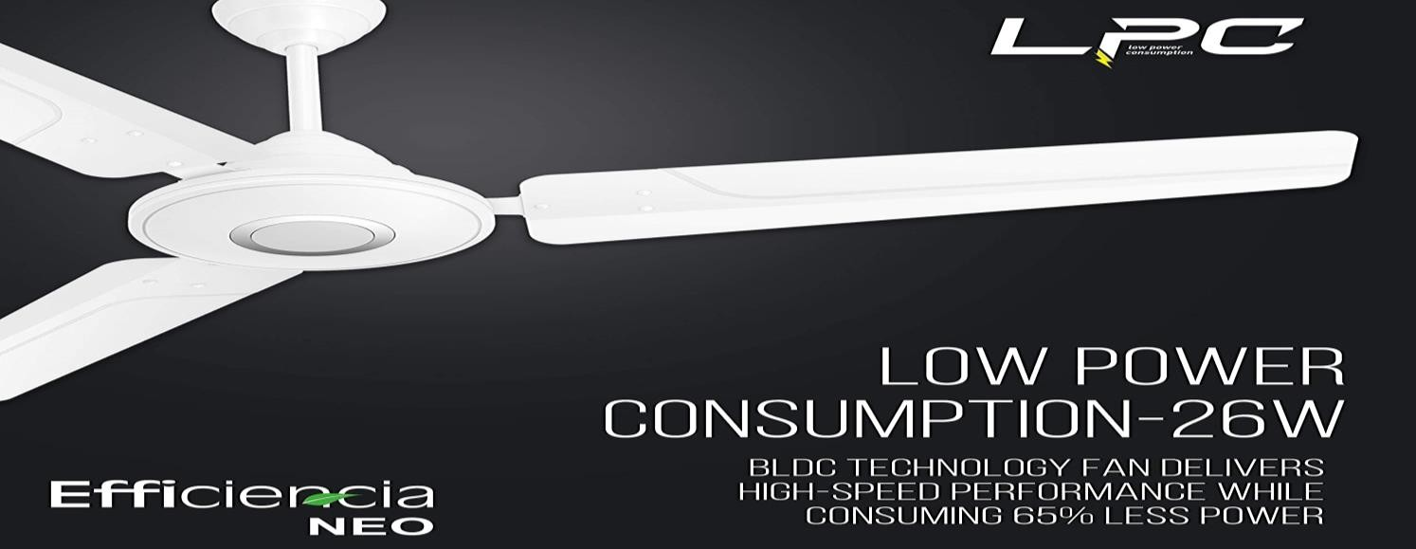
So, this is from a foreign manufacturer. Currently we are planning on importing this fan parts and assemble it on our factory. This is a new product using our country. Currently there are many fans, from basic to exotics and they vary in color, sizes and performance. This product differentiates normal fans from the new tech ones. Perks of its area-
- Ultra-Low Power Consumption
- 26w/hour only
- Run 3 times longer than regular fan while on inverter
- Remote Control
- Low noise
- Well Built

This product is a new one in our market because it has yet not been popularized. We have moved from Sodium Light to Halogen Light to light up our households. The way electricity bills are going up, someday soon this will be the most popular among all.

But we must not forget about the other user so we have thought about and planning on bringing the latest tech in the fan industry. They rich peoples use Air Conditioners and air coolers but the upper middle-class cant affords ac thus we bring the closest thing to AC, a fan can offer.

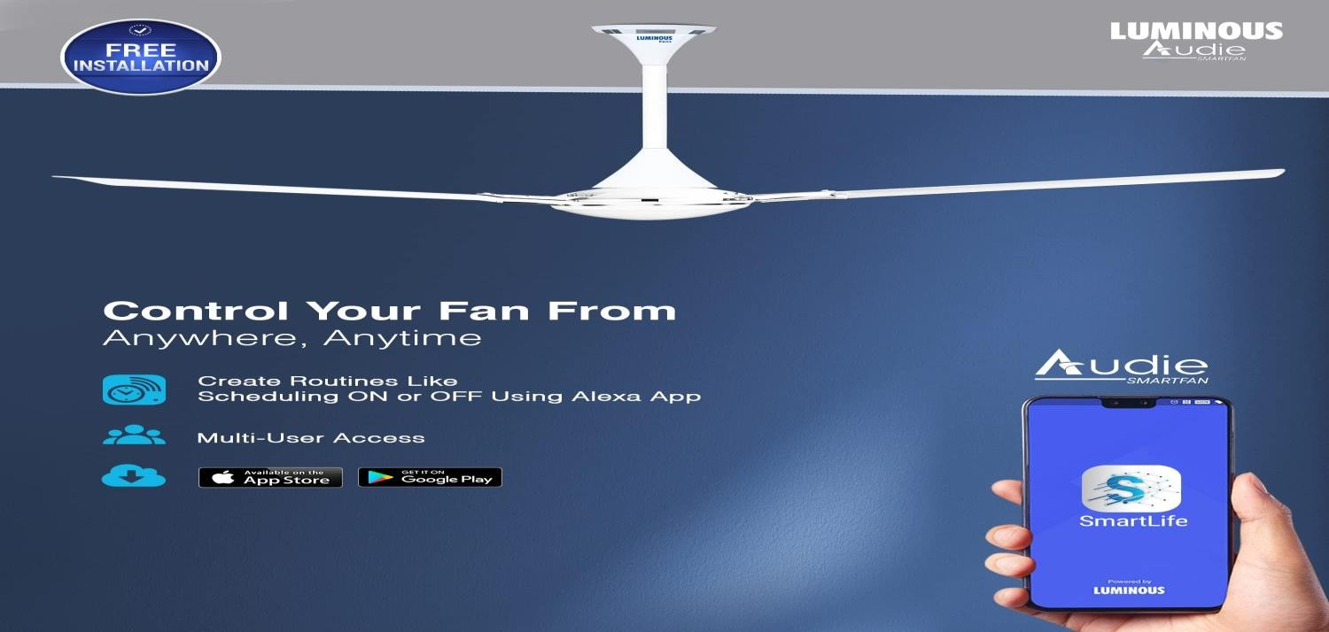
APP

This is the future of the Fan. This fan is for the tech savvy ones who cares about being efficient and want more control over their daily life. This fan features some cool perks such as-

  - High-speed motor produces a high speed of rotation and ensures better heat dissipation
  - Power Consumption: 70 Watts
  - Remote Control, Voice Control

WORKS WITH ALEXA

- APP Control
- High speed 380 RPM
- High air delivery
- Longer blades
- Various Level speed control
- Wi-Fi configuration settings

This fan provides experience which is of best value. It is voice controlled with a 5level speed control. This is the perfect gadget for smart home appliances. Those who use Assistants to digitalize their home, controlling all the household activities with their Smartphone, voice control will give them an upper hand in these activities. Life will be an easier and smoother for all.

This product is from another Indian Company. Al-Amin Electrics is planning on importing this luxury product, then rebrand it and sell it to the Bangladeshi People. All our households are with Wi-Fi facilities so using this can be done from an app. This days we use our mobile phones so extensively that modern amenities can easily be controlled with the help of it. Connectivity is the Key. Hyper Cars, Electric Vehicles, TV, Fridge, AC, Fan, Light etc. all are app controlled so why not the fan over our head. Life’s changing and so must we. And our product is a small step towards it.

Dominating New Market

Balancing Resources and Opportunities

Resources | Opportunities
5 Store House inside Dhaka city | We always have enough inventory
Presence in 64 Districts | Customer Engagement is easier
Authorized Seller Points | Our products are always visible
Company owned Pickup Trucks | Delivery is so easy for us anywhere
Large Distribution Network | Agile and Fast
Star Distributors | Strong Business Ground

Largest distributors of our products around Bangladesh-
- Dhaka- M.K Electronics
- Rajshahi - Melody Electric
- Bogura- Sun Electric
- Chittagong - Al- Amin Electric
- Sylhet - Shahajalal Electric
- Mymensingh - Radio Vision Electric
- Rangpur - Bismillah Electric
- Barisal - Mohammadia Lighting

Market-Customer Involvement

Customer involvement is the most crucial task for a business. There are so many options in the market so a company can anytime lose its position.
Ex- before JTI, the market share of BAT was 79%. But as JTI took over, the company took some time to start manufacturing again. And in this off day of JTI, BAT did so extensive customer and retailer’s engagement that in recent times JTI has only 7% of the entire tobacco industry and it’s on a decline.
So, you need to be relevant in the market and when you are relevant customers are bound to come back to your services over and over again.
Customer engagement marketing is a strategy which focuses on increasing the customer’s interaction with the business. The relationship between brand and customers can be increased by using this strategy which consists of providing personalized messages and interacting with customer via any favorable channels.

Customer Engagement Strategies
.

Establishing Brand’s Voice
One need to establish a clear brand voice. By breaking down the brand’s mission and values into simple words, the customers can easily connect with the brand.

Personalization of the Customer Experience
Customers don’t crave for content rather they want to feel valued. A completely personalized experience gives them that honor and by doing this properly one will surely see considerable return on investments.

Building a robust Relationship the Customers
E-commerce is growing, with total US sales expected to exceed $1,000 billion by 2024. And with that rise comes fierce competition. With similar brands vying for a foothold in your market, hoping your customers will return is no longer enough. Building strong customer relationships is the key to success.

Creative Campaigns
To create engaging content that shows the customers that the company is listening, the companies firstly need to understand the customers; who they are, what do they like etc.
Some key points like:
- Age
- Demography
- Common Pain Points and key motivations
- Potential sales objections

A customer engagement platform gathers, analyzes, unifies customer data, and drives customer engagement. This model provides a single view of the customer and the metrics, segments, variables, and analytics that are most relevant for the entity.
One must remember that information is power and using this certain platform and understanding and implementing the knowledge of the data will unlock company’s growth potential across channels to boom the business.
- Designing- Before launching something new we update a model photo on our homepage and ask the user about their preferred colors. There’s a poll most of the time in which everyone votes. Whichever gets the highest votes gets to be the prime color of the new product. It’s not much but its honest work.
- Delivery- For delivery we provide our own transport. For large orders we use bigger trucks. We do B2B and B2C both but B2C is our main target zone. Thus we offer them easier delivery process so that we get preference or recommendation of the seller to the customers about our products.
- Free Setup- We provides free setup to our newest customers. Plugging on a fan is easy but sometimes it can be tricky without the right tools. So if someone calls our hotline number then we send our nearest technician to the desired location for smooth user experience.
- Getting Distributors Feedback- We take 4 feedbacks yearly from the distributors and the resellers. Their feedbacks are as crucial as the customer’s one. We pile these up, analyze and find out the pain points as well as to find gold chances to increase our business.
- Customer Engagement- Our Company keep track of the customer’s cell number. We call them time to time to know about their products health and any issues or suggestions regarding it.

Building and Using Credibility
We build credibility with trust of our customers. They are our greatest assets, no denying of it.
Credibility means to be
- Believable
- Reliable
- Plausible
A credible organization holds such a strong relationship with the customers, employees and distributors that all the parties are confident that the vow the company made to them will be fulfilled.
Al-Amin Electric follows the under mentioned procedures to be credible to the stake holders-
- What we offer is what we deliver
- No hidden clause
- Easy Warranty Claim
- Strong Advertising
- Brand Value
- Word Of Mouth

Use of Information Technology-

Al Amin Electric Has an overall good presence on the Internet. We maintain-
- Official Website
- Facebook Page
- Instagram Page
- WhatsApp User Group
- Messenger Chabot

These apps and websites have been of tremendous use. User acceptance is important for a business of ours. Now days whenever someone hears of anything, they search it on Google. So, it’s a must to have a strong presence on the web.

Our pages are boosted and official so the customers get the best type of service. The pages include all our products. User Reviews. Their usage. Specifications, Warranty Information everything that you can think of. This information helps the customer to make comparisons with similar products in the market. We believe in the transparency about everything. We may offer high price and that's because that we deliver the best products. We keep our promise and we strive for greatness.

Limitations of the entity

While doing this paper, we discovered some weaknesses which are having negative effects on the overall performance of the company. They are
  - Communication gap with the customers.
  - Information Gap between employees.
  - Communication gap with third party vendors.
  - The quality assurance team is not present.
  - Lacking in the marketing strategy.
  - Inconsistency between pricing models.
  - Skilled labor force.
  - Less focus on digital/online platforms.
  - Online Promotions and Loyalty Programs
  - There is no formal accounting team to recognize earnings and expenses.
  - Asset management is not proper, thus there are no investments in new ventures and profitable portfolios.

Recommendations

In order to mitigate these limitations, Al-Amin Electric plans on doing the following:
- Effective Promotional Activities to Attract New Customers
- The electronic media presence needs to be more attractive.
- Blogs about the upcoming products might come in handy.
- User reviews are very important, so the webpage should contain more reviews from customers.
- The website should introduce an online purchase mode both for distributors and customers.
- Billboard advertisements in major cities
- Loyalty Program
- The introduction of the quality assurance team
- Formation of a skilled accounting team for sound financial reporting. 10.Employee Grooming
11. As Al-Amin Electric has its own trucks and pickups, they can be used as moving billboards. Painting them with our advertisements would be a nice idea.

Conclusion

The 21st century is blessed with modern amenities. Humankind is reaching new peaks every day. The whole world has become so much smaller with the help of these technological marvels. Now we can order food with just a tap, shop with our Smartphone, and pay with a digital wallet. Everyone wants more comfort in life these days. It has been understood that now is the moment to give more attention to the topic of human comfort and enjoyment as we make unrelenting progress in this direction. In the year 2023, AL- Amin Electric plans on expanding its business to the global market. Currently, we are making partnerships with foreign super shops and distributors. Our main focus will be on Africa. Though the corona virus pandemic harmed the market, there is still hope if we sustain the market in the long run. For the days ahead, sustainability is a must for us. While doing so, we plan on expanding our business while starting different services, like providing broadband internet in rural areas. Before 2020, our profit was almost 70 lac taka, though it declined during Corona. It’s been 8 months of 2022 and we have reached 50 lacs during this time. Hopefully, we will be able to keep up this upward trend. Implementation of strong internal controls will also help the management to thrive for success while motivating them to take risks when it’s needed. By following the above- mentioned recommendations, Al-Amin Electric will surely be able to do better in the upcoming days. If management solves the limitations of the company, then it will definitely be a bigger business than it was ever before. Not profitability but rather sustainability should be the main target of AL-Amin electric because he who endures wins the most.

References
- AL-Amin electric. Retrieved from https://pakfan.net/cart/
- Market Creation for Biodiversity. Retrieved from https://www.oecd.org/env/resources/marketcreationforbiodiversity.htm#:~:text=Creation%20of%20markets%20refers%20to,realise%20their%20full%20potential%20values

