A Study
On
Covid-19 & the Online Purchasing Behaviour of Customers in Bangladesh

Title
Covid-19 & the Online Purchasing Behaviour of Customers in Bangladesh

Submitted to:
Dr. Md. Shariful Alam
Associate Professor & Deputy Director
Of BBA Program

Submitted by:
Nafisa Tasnim Zaman
ID: 111153018
Major: Marketing

School of Business & Economics
United International University


Date of submission: 30.11.2021

Letter of Transmittal

November 30, 2021
Dr. Md. Shariful Alam
Associate Professor & Deputy Director [School of Business & Economics]
United International University
Dhaka: 1212
Subject: Letter of Transmittal
Dear Sir,
I am Nafisa Tasnim Zaman [Id: 111153018] and I am currently doing project under your supervision on ‘Covid-19 & the Online Purchasing behaviour of Customers of Bangladesh’. This project has enabled me to understand the current covid-19 situation and its impact on economy of Bangladesh and how covid-19 has impacted on increase in the online business and to understand customer’s perspective to purchase online.
Thank you sir for your support and help to find me project topic and other project related work. Without your kind help I won’t be able to properly finish my project.
Sincerely,
NafisaTasnim Zaman [ID: 111153018]
School of Business & Economics
United International University

Declaration of the Student
Nafisa Tasnim Zaman, hereby declare that the presented project paper titled “Covid-19 & The Online Purchasing Behaviour Of Customers In Bangladesh” is uniquely prepared by me.
I also confirm that, this project paper is only for my academic requirement not for any other purpose.

Nafisa Tasnim Zaman
Id: 111153018
School of Business & Economics
United International University

Acknowledgement
I would like to express my gratitude to my project supervisor Dr. Md. Shariful Alam, who gave me the golden opportunity to work on this wonderful project topic and helped me to write and complete this project paper properly. Also I am thankful to my parents to help out to taking care of my mental and physical needs to finish this paper in this short period of time.

Nafisa Tasnim Zaman
Id: 111153018
School of Business & Economics
United International University

Table of Contents
Chapter-1 1
Introduction 1
1.1 Origin 1
1.2 Background 2
1.3 Literature Review 4
1.4 Purpose Statement 6
1.5 Scope & Limitations 6
1.6 Methodology: 7
1.7 List of Abbreviations and Technical Terms 9
Chapter- 2 10
2.1 Findings & Analysis: 10
Chapter- 3 35
3.1 Suggestions &Recommendations: 35
Chapter-4 35
4.1 Conclusion 35
Appended Part B
Reference & Bibliography B
Questionnaire D
Glossary: C

Executive Summary:

Out of 70 samples 68.6 percent are female and other 31.4 percent are male population. As we can observe females are very active in the online selling and buying scene in Bangladesh. Through Facebook live many are selling cloths, various other products and doing marketing through facebook platform.
Most online buyers are mostly above 18 males and females but mostly females and also maybe early thirty females and males as well. Late thirties males and females are low in this number. Young people prefer online buying more than actually going to physical store but elders prefers physical store visit for buying. People don’t usually like buying luxury goods through online platforms mostly but there are very few buyers are there nut can work as niche. People prefer using mostly facebook page or instagram page to order good and also company’s website but few prefer apps. Customers like to mostly purchase cloths online, then groceries and then any other electrical products but regular customers like to purchase it all. Regular buyers think it’s safe to buy stuffs online [mostly above 18 males and females], elders not very sure. People mostly bought in the pandemic mostly young above eighteen males and females regular buyers but because of severity of lockdown people who do not usually buy online also tried it. Among them a few percentage said they are satisfied and they may or may not buy from online again but mostly positive but on the other hand traditional market place buyers mostly said they will not buy after the lockdown. Bangladesh’s online buying behaviour has definitely increased during the pandemic. Regular young buyers defiantly bought then and newer buyers tried out during corona. Majority of them liked the platform and will time to time buy but there will also be occasional users as well or people who are not fond of the platform much. But overall if we look at the economy, there are now lots of big companies generating profit by working online business. So from small to big businesses which are doing business online are all making good money and changing the country’s economy, revolutionizing the business sector and helping in developing it.

Chapter-1

Introduction

1.1 Origin
Covid-19 or Coronavirus is a respiratory disease which is caused by SARS-COV-2 virus. This respiratory disease is a very infectious disease which in a very short period of time infected the whole world and became a world pandemic acknowledged by WHO.
On December 2019 in China Wuhan corona virus disease was first discovered and in a very short time it spread all over the world. As this is a respiratory disease mostly by air virus gets into the nose or by mouth. That is why face mask is a mandatory item to wear when ever heading out or whenever we are going to have contact with any other human being. Also if a covid-19 patient touches any surface virus can get on the surface, so that is why washing of hand with alcohol base sanitizers or washing of hand for at least twenty second is mandatory. So that virus germs can completely die in the hand and cannot get inside the body through skin.
In the whole world approximately 4.55 million people died from this disease. As It is a respiratory disease severely ill patients cannot breath properly and required oxygen to properly breath. Mostly old citizens are vulnerable to this disease. But in some case young people can also fall extremely sick and death can also happen. Most coronavirus cases patients have cold and fever initially, followed by some other symptoms like coughing, body joints pain, cold, high fever, lose motion and some patients loses sense of smell and sense of taste temporarily. Most covid-19 cases are mild to moderate symptoms and does not need much medical help to get better but when at extreme cases patient must need to take to hospital.
All over the world the exact number of deaths by covid-19 is not revealed by the countries and being manipulated because of political reasons as it can create tensions between the active politicians and their citizens of their country. Because when covid-19 was detected in December, 2019, lots of countries didn’t take precautions against the virus’s spreading in their own country including USA, India, Bangladesh etc. Because to avoid any criticism made by their citizen and oppositions many country’s presidents did not reveal the accurate death number from corona virus disease. If proper measurements were taken lots of lives could have been saved.

1.2 Background
This Coronavirus pandemic have affected the lives of everybody of the world. The way we study, the way we work, the way we earn, the foods we eat sometimes, social life, family life, finance, countries’ economies etc. Some lost their jobs due to slow economy, some lost their family members, some lost their house due to unemployment during pandemic, we have to stay home and we have to do work from home and study from home.
[6] E-commerce is electronic transactions, which can be expressed as the buying and selling of products and services and also the transfer of funds, money, data, and information related to the commercial transactions through the internet by using information and communication (ICT) technology [6].Basically, e-commerce permits buying and selling the physical products and services through an online platform which makes the commercial transaction of all categories of businesses and consumers convenient [6].
This research is done to understand the online purchase behaviour of Bangladeshi customers in the time of pandemic. Lock down was declared in Bangladesh in 17th march, 2020. Citizens in Bangladesh never saw that coming. Because of laid back attitude towards the coronavirus at the beginning of the 2020 by the Government that time citizens thought maybe it will not affect us nor any lockdown will be declared. But sudden lockdown created tensions among the citizens. People could not head out to buy necessary day to day life items like groceries, cloths, medicine, important house supplies etc.
Here coming online markets in the rescue. As people could not head out but they can order them sitting home and get those necessary items delivered at door steps. Thus in the severe situation of initial lockdown in Bangladesh, citizens started buying through online platforms. Demand increased for online home essential supply and to meet the need many small mom and pop online business grew, as well as other known brand came up with better deals, offers and products and supplies as well and it’s working for them. For example,Chaldal.com, Meenaclick, Shopno, Aagora etc. According to E commerce Association of Bangladesh, online shopping generated $708.46 million revenue. During pandemic online business got revolutionized in Bangladesh.
Here in the study, we asked eleven questions in survey to better understand on this from the actual online customers and their behaviour and preference. We will try to understand from the responses by the sample what customers actually think and prefer and come to the conclusion that if customers actually increased buying from the online source or not.
Some university freshmen had to spend their two years worth of education by staying home and could not observe and enjoy the actual university life, school kids staying home to the point they feel sad as there is no the fun in learning by staying at home. For longer period of staying at home impacted negatively in the mental health of many people. In cities at least few schools being able to study through online platform and are connected with classmates and school but the students of sub cities and rural village are deprived of this opportunity because of lack of good internet situation.
This critically affected the economy of every country. Also, the rise of using online platforms while people could not head out to do regular day to day activities has provided new opportunities to many online businesses. Many small businesses have converted their physical shops into one virtual shop. So that businesses can still operate without paying rent for store space. Alsothis situation has motivated new online small business owners or we can say many are joining because of the opportunities.
This phenomenon can also be seen in Bangladesh. Their many youths who are higher educated but could not find jobs. Online platforms are providing great opportunities for these youths to turn their life around. Many are now financially independent, have proper websites, Facebook pages etc.
But what is most interesting is the customers of Bangladesh really enjoying this phenomena. As for coronavirus Bangladeshi citizens could not go outside to do many jobs including grocery shopping, shopping for daily needs like medicine, cloths, shoes etc, to provide these services many online platforms rose and giving great services and getting popular. New businesses have emerged, also generated more profits and activity to many already existing online market platforms and also many big brands also focusing their activity on full visibility on their virtual presence as well. This study will focus the online purchasing habits of Bangladeshi citizens during this pandemic.

1.3 Literature Review
Author of [2] said, The COVID-19 outbreak will check a major distinction for the reception of online-based business and mobile commerce platforms. According to author [2], a trifecta of cell phone infiltration, less expensive 4G networks, and expanding shopper wealth, the Bangladesh online-based business market is yet to develop.
According to author [3] with the shock of COVID-19, the e-commerce activity is noticing the witness of sparkling elaboration of e-shopping. According to author [3]: Social influence, responsiveness, e-payment mode, discount or coupon offer, electronic word of mouth (E-WOM) trust in online store, marketing activities, peer recommendation brand loyalty factors ominously stimulus the consumers purchase intention on social media during COVID-19 according to author [3].
Authors of [5] found out that by using digital platform for buying and selling, online customers have conjugated a way to buy international branded items, mostly makeup. A large number of Bangladesh’s population are interested to buy branded cosmetic items. Many stores are not available who sells authentic branded cosmetics, so buying online can solve the idea. Also, young generations who have smart phones, laptop and desktop, tablet can easily avail this benefit from online platform. Also found out that the mobile market has been growing and citizens are willing to buy more homemade handsets as these are affordable and have good quality. Digital economy gained global context during pandemic and also digital marketing role impacts the selling and buying in every stage of life. In this study, author of [5] focused on digital platform use, which has definitely increased and also digital marketing which can add as a fuel to buy and sell through these digital platforms. Consumers buying decision changes and marketers must have good digital communication and invest in digital communication.
Author of [4] said that fish consumption during this pandemic has reduced because of during pandemic 13 percent people are jobless in Dhaka city. So to adjust this situation people started buying online, buying only the necessities and less if they can. Cutting of fish consumption decreased from 80 percent to 45 percent, frequency of grocery shopping also decreased.
Author of [1] said, six reasons for increasing the online platform of business are: less job security during pandemic, increased popularity of online shopping among youths, lack of option during lockdown, increased demands for daily used supply and services, online customers can avoid transportation cost and demands for daily necessities getting higher.
Here in this study author of [1], focused mostly on entrepreneurship of the youth which can help develop youth development and leadership as Bangladesh’s one third population are youths. It will improve Bangladesh’s economy. Also how during pandemic many youths started their business online to combat financial situation as the online business popularity rising high in Bangladesh.
. According to author [6] the aim of the study was to investigate the factors affecting consumers’ internet shopping behavior during the coronavirus disease (COVID-19) pandemic in Bangladesh. [6] The E-commerce industry in Bangladesh is increasing speedily despite having some barriers and becoming more competitive day by day. Not only local companies but also foreign companies are engaged in the competition [6].
According to author [9] because most of the customer prefer cash on delivery instead of an electronic payment system in Bangladesh. [9]Security, delivery, product availability, and product variety are the important factors which significantly affect consumers’ internet shopping decision in Bangladesh (Hossain, Rahman, & Hasan, 2018)
According to author [6] the impact of seven factors: product factor, price factor, time saving factor, payment factor, security factor, administrative factor and psychological factor on consumers internet shopping behavior during the coronavirus disease (COVID-19) pandemic, according to author [6]. Business who are maintain good balance between these factors are doing well.
According to author [7] Bangladesh is an emotional nation as an uncontrollable emotion of danger and fear and could have aggressive activities such as the accumulation of all capital to buy food, medication, and products [7]. According to author [7] panic shopping would intensify concerns about the flu, increasing product prices beyond reach and grabbing products, stores or shops, particularly in big cities where fresh food like fruit and vegetables is difficult to be self-sufficient [7].
From all these we can conclude that, at the primary lockdown point, because people were scared they rushed to buy everything as they feared there will be scarcity of food and daily necessary items mostly from online and also from physical stores after the lockdown was declared. But after a while lockdown got strict and only online was an option so blooming of online purchase during pandemic started. This increase of buying behaviours also depends on few factors like safe delivery, safe e payment system, quality product, discount, loyalty to brands, good marketing communication, good service, demand and supply etc. As many people are now jobless because of pandemic, decrease in spending in unnecessary items decrease for many people. But overall online buying behaviour is increasing as its cost effective, good service, safe for health.

1.4 Purpose Statement
The purpose of this research study to see how customers uses online platform in this pandemic, to see with the rise of online market platforms during pandemic because of high demand and even after pandemic people will use these platforms or not.

1.5 Scope & Limitations
As this is a time of pandemic, there were few scopes and limitations to do this study. As I had to do survey I had to choose online survey option. I cannot deny that it saved a lot of my time. If I had to do traditional paper base survey it would have been difficult at this time and age, as I cannot head out. And more importantly because of the benefits of using online survey option it can be use even after pandemic.
But there were few limitations I had to consider while making questionnaires. As human attention span is decreasing day by day, I could not put too many questions to answer, Multiple choice questions were there and direct questions were asked. Otherwise proper survey would not been possible. Out of discomfort people may have chosen answers even without reading the question properly, so that minimum time is taken and also exact responses could have been collected. That is all.

1.6 Methodology:
- Research type: This research study is done by simply doing survey. As we know survey research is very simple, easy collection of data on various contexts and systematically done.
- Data Type: Majority data from survey data which are primary data collected entirely for this research and very few from secondary source.
- Sample Size: Seventy samples have been collected through Google form.
- Sampling Technique: While choosing samples I choose mostly middle-class population in Bangladesh who are used to internet in their day-to-day lifeand cover all possible ages. Because mostly middle-class people make the mass in the online market buying and selling situation as a customer in Bangladesh according to my observation. There are also higher-class citizen there but they do not make the masses and lower income people do not usually use internet for buying and selling purpose.
- Data Collection Method: Data was collected by making questionnaires in Google form survey and sending links of the survey to the chosen samples who are daily internet users and buy from internet on a regular or very little basis.
- Data Analysis Method: Data was very simply analyzed by calculating the percentage of each question’s variables. In my research case Google already calculates the percentage as a by product of each responsive answers of every questions. Percentage calculation is easily understandable by many to understand the overview of a situation.
- Data Presentation Method: Data will be presented by graphical image of pie graph. It will be easier for the reader to grasp the understanding for the research.

1.7 List of Abbreviations and Technical Terms

Abbreviations | Definations
SARS-COV-2 | Severe Acute Respiratory Syndrome Coronavirus 2
Covid-19 | Corona virus of 2019
HR | Human Resource
E-WOM | Electronic Word Of Mouth
ICT | Information and Communication Technology

Chapter- 2

2.1 Findings & Analysis:

There were eleven questions asked to seventy samples from different age groups who are very active in internet for various use. Analyzing the findings from each answered questions are presented below:
- Question: Gender?

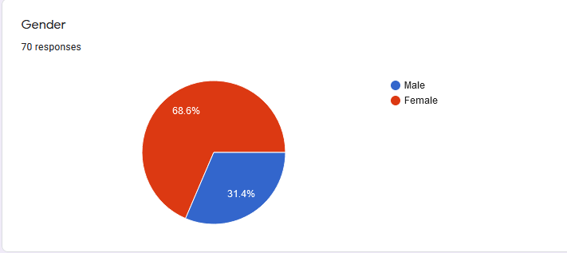

Out of 70 samples 68.6 percent are female and other 31.4 percent are male population. While taking samples I directly texted few via messenger, posted on Facebook community groups and random peoples has answered the questioners. This is how I got most samples.
These days we can observe that females are very active in the online selling and buying scene in Bangladesh. We can easily see that by using Facebook or Instagram. We will see there are certain popular internet personality mostly females who promote various brands and their products, some has launched their own brands and promoting it. Many females are using Facebook live to sell their products. But does gender specifically has any impact in the online market scene?
According to author [10], he tried to find out difference on online buying behaviours of genders through attitude which is a component of three things; these are cognitive, affective and behavioural. Cognitive is what we know about the object, mainly our experience. Affective is our likeliness towards the object and behavioural is our action towards the object. So if we have good experience, we will like it and our approachable behaviour will be positive and vice versa. Study found out that the main difference is in the cognitive section where males are at high score than females, means males have high cognitive attitude towards shopping online and it does not change. Women like conventional way of shopping than online shopping and thus also score low both in affective and behavioural components. Author suggested that online sellers should focus more on educating women about the efficiency and benefit of online shopping than trying to sell women products, Also websites should look good in women’s eye to attract women. But this study is twelve years old and now time has changed.
According to author [11], Male prefer to use online shopping than conventional shopping more as it does not need any social interaction, quick and easy and easy to get delivery. As most men does not like to go to shopping with their family as it takes more time and energy and they don’t seems to enjoy this experience in generally. Men like website designing, internet tools to search for more work related stuffs. But females tend to be more social, like to prefer shopping conventionally. But apparently females feel joyful shopping online then men.
Lots of brands focusing on attracting females by showcasing female products online and it’s increasing day by day. But males also have few options but not many. Mostly technology markets are men liked.

But during Covid -19 pandemic has anything changed? Well we can say yes. Not just females, males also had no option other than using online shopping to shop for necessary items. Under lockdown as no one could go outside to do regular tasks they have to use internet. People liked it or not they had to try it out for necessity.
Maybe in online shopping gender may pay a role but during covid pandemic gender who can use internet and could not head outside tried it out. But we have to also acknowledge the increasing use of social media among the females in Bangladesh and it’s definitely growing. Lots of online entrepreneurs are females. Various sectors are now covered by female online entrepreneurs.
F commerce industry is blooming in Bangladesh. According to IDLC Finance sector review 2019, F Commerce industry in Bangladesh is worth 312 crore and half of it run by female facebook entrepreneurs. Women from home or working women both can run a business online by facebook easily. No need to have a actual office space.
When women online entrepreneurship rose in Bangladesh, women are more reliable to use technology for online use. We can say definitely high chance much have changed from the past.

- Question: Age?
Out of 70 samples 71.4 percent are aged 18 and above section and other 28.6 percent are 30 and above section.

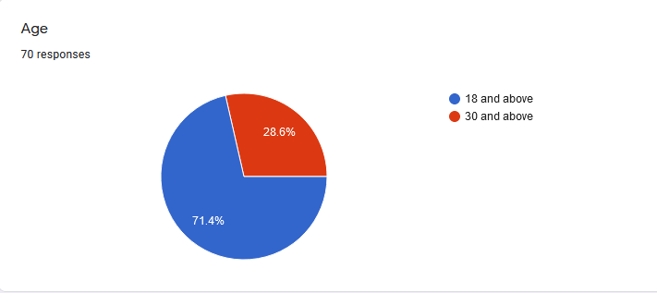

This also goes with the fact that mostly social media and internet platforms in Bangladesh are much more popular among young generation. Young people under 30 years old using social media not only for communication but also various purposes like conducting business, searching for jobs and companies HR teams also give job notices in facebook as it can attract more masses. Marketing for selling goods also are done by social media platform like Instagram, Facebook as brands can find their customers through these social Medias very easily, without much spending in television advertisements. Social media marketing and advertisements are lower in cost than television advertisements.

After lunching the 4th generation internet in Bangladesh, Bangladesh has experienced a growth in internet browsers and the internet infrastructure is developing day by day. According to a study [12], urban youth would like to spend 4000tk in online shopping and 5000tk for foreign branded item. Most online selling items are cloths, food and beverage, electronic items, phones, accessories. Most online issue according to youth age between eighteen to thirty five was the inability to touch the delivered product. Most appreciated factor of online shopping is the delivery system.
Online education was a big deal during lockdown period of covid-19 pandemic. Kids from elementary school to university had to take online classes. Young Bangladeshi citizens age from eighteen thirty, also some cases thirty five are the daily users of internet. These people use internet for their education, frequent buying products, foods, cloths, grocery, accessories and electronic items.
These days its even easier to buy from online as buyer can check more info online by reading reviews on products, quality and price difference from page to page. Few pages may sell the same things but one may be lesser in price and quality. In conventional shopping people have to head out to markets but online shopping is providing this opportunity with additional better options and by sitting on a sofa or bed or may be in workplace buyers can place order. Young Bangladeshis can understand this benefits and availing it.
As life has becoming very fast pacing and people have so many responsibilities to handle study life, family life, work life, personal life, social life etc. So the ease online market places are offering are getting much more attraction. Plus as youth population have to use internet so much in their daily life, they understand the proper use of internet in buying online, it’s loop holes as well. Many have issue on how products look different in picture from the actual product itself. Some raises issue on service and while ordering they make sure they go through all the sources before placing order, as most cannot cancel order after placing the order.

During pandemic internet would be used immensely more than usual. This created various health issues among youth like anxiety, depression, family issues, unhealthy life style like eating more than three meals and not exercising and gaining weight. Specifically phone internet is bit too extreme. As user can scroll until it stop. During most used phone internet like this and due to poor sleep lots of mental health cases started appearing from all over the country.
Internet has it’s beneficial side to it but as well pretty extreme negative side to it, if not kept well maintained problems appears. According to [13] study, Problematic Smart Phone Use (PSPU) and Problematic Social Media Use (PSMU) are directly and positively linked to depression, poor sleep, anxiety, social media use, younger in age like adolescence. University students are also affected but most affected are school and college kids.
There are 500 advertising agencies in Bangladesh and whenever any new product is lunched, it is created centring youth mostly. As more than half of the Bangladeshi population is youth. Mobile operator companies always offering new package to sell internet package in a lower amount to attract youth. One of the key factor for young citizens having internet always even while travelling.
Internet connection is very easily available in Bangladesh which also helped in internet reach. The more reach the more business can find buyers and covid lockdown situation was a golden time for online new entrepreneurs. There are more mobile banking accounts than actual bank card in Bangladesh.

- Question: Do you like online purchasing?

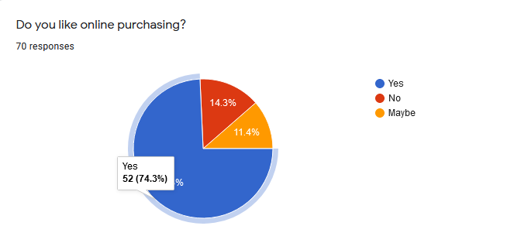

About 74.3 percent said yes they do, 14.3 percent says no and 11.4 percent says maybe from the respondents. And from the yes section most respondents are above eighteen age and most are females and also above eighteen males , few male are from early thirties and few are above thirty age female. In the no section most of them are above thirty males (age starts from forties) samples and very few eighteen above male and very few above thirty female.

Here in this study, people who are above forty also participated. To make the sampling quick and easy above thirty option was chosen. Most male above forty ages in Bangladesh does not like shopping online as they are not that comfortable using the online selling platform, as sometimes products can be defective and sometimes they do not take return, which create risk as money is involved here. People from that generation like to buy from whole sellers to get discounts and for authenticity. Online where product cannot be seen properly sometimes, cannot be touched, sometimes quality cannot be ensured is a big issue for them. Even after all positive alerts they hesitates to buy online.

Elder women (age from forties and on) are also traditional shoppers who like to visit shops and bargain for products and over online there no bargain policy, feel unsatisfied to buy online. As in Bangladesh not yet a strong online selling law in introduce it is quite easy to send buyers defective products. So that negativity also adds up here.

There are also few traditional young men likes to stay on low budget for day to day life shopping as online sometimes products price gets pricy. Mostly these men are lower in number but still their reason is quite relatable for other youth citizens. Most of them are age from twenty three to twenty five and are students.

Some may or may not have part time jobs, some does tuitions as a part time earnings. They like to stay on very tight budget and often we will see online products may have more price than actual roadside vendors. So which they can buy from roadside vendors in a cheaper rate, they buy from there. But if something branded and online offers them good price than the actual conventional shop they will also get this chance.

- Question: Do you feel safe purchasing online?

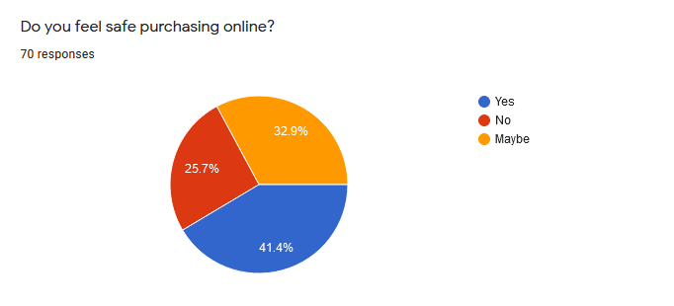

About 41.4 percent said yes, 25.7 percent said no and other 32.9 percent says maybe as they are not sure. Among the yes section most are females and male samples aged eighteen above, very few are above thirty female and male. From no section most are above thirty males and females. And from section maybe there are few above males and females and few above thirty females and very few above thirty males.

As because of usage most young people doesn’t feel discomfort spending money online but older generation usually not comfortable using digital platforms for shopping and digital payments as well not well received by old generation unless it’s for sending money from afar distance.

Digital payment is well received in most case but in some case people does not prefer it. While sending money citizens loves using mobile baking apps but which purchasing anything people like to usually use cash on delivery. It is marketed or advertised to use for sending money from one part to another part of the country. But using it for buying and selling purpose is still new. Few months age a transportation app calls Obhai digitalized it’s payment system fully. People does not like to use mobile banking or does not have account could not use it. They had to make effort to use this app.

People who are not inclined to use internet for purchasing purpose, it is normal to feel unsafe. As most people who like to buy online also feels same, sometimes the source is not that reliable. Even sometime reliable source sends defective package and in Bangladesh where law implementation is quite slow, getting refund from sellers becomes a hassle. Still as online market these days offers various kinds of imported items, many entrepreneurs are also selling their products online, many good reviews are also available and offers becomes lucrative, many buyers are also getting inclined to it. Shops which have their own showroom are also selling online for more selling purpose and more reach. So if something online came defective they can go to actual shop for query.

Still as some negative loop holes remains, sometimes before first purchase it is not easy to determine the source is reliable or not. So generally male and females whom at their forties and above, likes to stick to conventional shopping. Even though they have to go outside for shopping, they don’t like to have any uncertain feelings, doubt while ordering online.

- Question: Have you purchased during covid-19 pandemic?

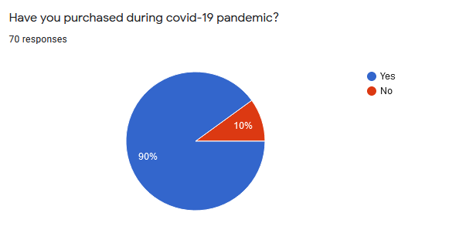

About 90 percent said yes and 10 percent said no. Among the 90 percent there are all age group available. The other 10 percent were mainly forty above females and very small number of forty above males.

During the first lockdown in Bangladesh, every little shop were closed down due to spreading of virus. There was not much way left for people to go to buy daily needs like grocery, necessary clothing items, necessary electrical and other equipment etc. So people had to look for necessary items online and there were available sources and gradually market grew during pandemic.

According to study [14], mainly three factors that influenced online shopping rise in the first lockdown or mostly during the whole year of 2020 in Bangladesh. These are the benefits of the online shopping, technological support and convenience. This study [14] also says, this behaviour of online purchasing which was mostly adapted due to restriction on in store purchase, going to stay post pandemic days. Mainly when people could not purchase their essential and non essential from store due to restriction, along the three factors online buying started. Most urban cities which have good technological support with good internet support found it convenience to purchase stuff online.

Mostly people preferred products which is available locally and cost effective. Because mostly city dwelled citizens faced financial crisis due to covid-19. Lots of people lost their job, were in a tight budget, some moved to their hometown for financial security. Financial crisis also hit outside urban system, but indirectly. For example, farmers faced trouble as their crops were getting ripe but in time they could not pluck the crops as for shortage of man labour. Even after been successful plucking the crops they could not sell produce in the urban market due to road restriction during covid.

First when lockdown implicated people did not understand the severity of the disease, but when lots of people started dying and getting affected and symptoms were quite visible, fear emerged in citizen’s mind. People started taking the disease seriously. Many lost their loved ones, created seriousness among family members. Families who never believed in purchasing online is a good thing, started to follow trend of online shopping. People thus started buying from online retailers.

Lots of shops closed their existing shops and started selling online through Facebook. Some created their own websites and showcased it through Facebook. Some people started online business by selling non essential grocery items which were trending during lockdown, then started adding more items when profits started coming.

According to study [14], Mostly fashion industry faced the most negative impact of covid lockdown in Bangladesh. Most middle class and lower middle class citizens in Bangladesh did not purchase during covid lockdown. Many restaurants lots their money during covid lockdown and lost business and had to close down. Mainly because of being non essential need of the citizens of Bangladesh, whom are already facing financing struggle only for providing for the essential need.

According to study [14], citizens of Bangladesh who had used online shopping option even before covid scene (more than five times), started using online shopping option more. This study suggested that 27 percent had increased. Lockdown was the main reason and also fear of getting affected by disease as well.

- Question: Did you purchase online even before pandemic?

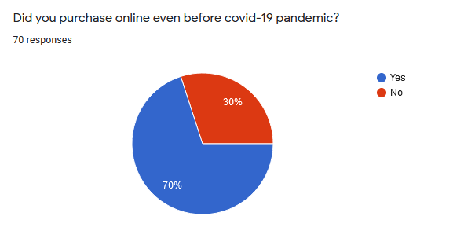

About 70 percent said yes and about 30 percent said no. From the section of yes, most of them are eighteen and above males and females. Most of these people are regular online shoppers, who like to purchase goods online for various reasons. Some are for convenience, easy and quick purchase and delivery system, online sometimes has more authentic items available, availability of goods, well reach and easy to connect to buyers and sellers, no need to manage time for going browse physically to shop and picking up products, trendy foreign stuffs are more available through many authentic importers.

Who said no are mostly late thirty above males and females and few eighteen above males. These people usually like to go browse physical stores to shop. Likes to bargain and likes to live in a tight budget life style. Some may like to spend more if they have to but mostly when they think it is worth to buy the product. Some like to touch before buying to check any defects. So these people feel usually do not consider online purchase as their option. Because purchasing through online is a very new thing in Bangladesh. In western country online purchasing has started pretty early by the introduction of internet. Yes it was not well spread by then also but started in a small portion. But here in Bangladesh it’s still a new concept.

According to NewAge youth, online sale has increased seventy to eighty percent the regular time. Bangladeshi online shopping market will hit USD 3 billion by 2023. According to German based research institute Statista, Bangladesh has already exceed one and a half billion dollar mark and growing. They are assuming by country will exceed 3 billion dollar mark. According to Bangladeshi officials five lack Bangladeshi will be employed in this sector.
It is great news for our country.

More of these shoppers are from upper middle class and upper middle class families. But people who belong from lower income, lower middle class families refrain themselves from online shopping. Sometimes lower middle class does buy online but during covid-19 situation mostly they avoided the option. Mostly because they could not afford the bazaar price of daily grocery. Some had to depend on government ration.

Bangladesh is new interest for big online giants like Amazon and Alibaba. Alibaba already has started working by purchasing Daraz. Daraz is known for being the largest e commerce company in Bangladesh right now. 700 corers is being transacted monthly through online purchase now and annually exceed more than 8000 corers. Also Ajker deal, Othoba, Priyo shop, Bagdoom also doing well. Even though Amazon is interested but they are not enter the market soon directly.
This all shows how fast ecommerce market in Bangladesh is growing and how much people are interested in the country. Most online buyers in Bangladesh are aged around eighteen to thirty five. These are mostly students and regular office goers.

- Question: What do you prefer purchasing online?

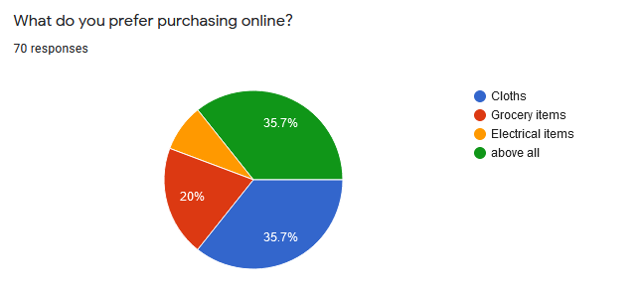

About 8.6 percent said electrical items, 35.7 percent said all three items they would like to purchase online, 20 percent said grocery items and lastly 35.7 percent said cloths. These 35.7 percent are mostly citizens around eighteen to thirty five male and females and these people are regular online buyers. These are mostly students and office goers and few are small business owners. We can see the same pattern here as well.

That regular online shoppers also likes to shop online for every items, essential or non essential. If proper availability for fresh produce is online in a affordable rate, which their local van sellers offer and good fresh quality produce, these people will also prefer buying from them. Because in most case people usually like fresh produce from local producers, retailers, super shops. Because these produces goes bad pretty fast.

Chaldal is the largest online grocery in Bangladesh. Big super shop brands like Shopno, Agora, Mina Bazaar also started their online sale through facebook marketing and company’s website even before pandemic but during pandemic sales increased as people could not go outside to buy during primary lockdown.
We can see that online purchase was trendy and easy option even before the pandemic but lockdown factor took it to new trendy height.

Also many new businesses started during the pandemic because of high demand. If we scroll down our Facebook feed we will see selling cloths live online by many female entrepreneurs. No wonder buying of good quality cloths are popular among online buyers now. By asking some samplers, they said they can get trendy Pakistani and Indian cloths from authentic importers and the whole process looks very lucrative.

Women who have good fashion sense mostly are involved with these business and they present trendy item in their Facebook live sessions. As we know fashion and trend change very fast. And in the day of social media this change happens extremely fast. So in a sense these entrepreneurs are also works as a trend setter along with the Bangladeshi celebrities. Most cloths which get shopped are salwar kameez and shari, then after that western style cloths like female tops, dresses, male shirts and t shirts etc. Also people love buying bags online as well.

In Bangladesh online electronic market mostly got noticed and popular by Evaly. This company introduced big discounts and offers, which a expensive electronic item can be bought half of its market price. Before lockdown this got popular and also lasted few months after lockdown. But the company faced bankruptcy and many who gave money before the delivery got scammed. But in general people do buy electronic products online but not in a bigger batch. But during holiday seasons in the country, many lucrative offers are introduced and buyers buys products online. For example in eid ul Adha the selling of fridge increases, during winter air conditions. Companies offer if they buy from online they will have discounts etc. According to Daraz, Bikroy, Ajker deal mobile phones were mostly sold online items and most popular ones as well.

Even when it was during covid-19 lockdown time, people bought these items online. Of course most of these people are from higher and middle income household and also because they would most probably getting these products in a discounted price. In Bangladesh big corporations are trying to digitalize themselves by stabilizing their online presence and they often do it by offering discounts if products are bought from their page or app.

- Question: Do you prefer purchasing luxury items online?

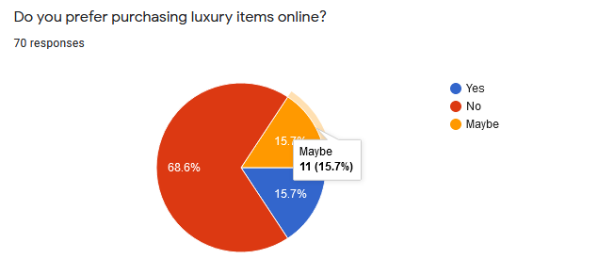

About 68.6 percent people said no, 15.7 percent said yes and 15.7 percent said maybe. Both numbers of yes and maybe are same. Most of these are intense online purchasers, comes from higher income and higher middle class family and are much low in numbers.

Being living in Bangladesh they will buy luxury items over online is very interesting. In many western countries there are online businesses which are does business online for the rich and ultra rich clients. These businesses are conducted by maintaining few personal online interviews and client by the manager and not by regular business conduct. As rich citizens tries to live ahead and expensive lifestyle there are niche for this in online.

As we already know people of Bangladesh naturally don’t like purchasing anything too expensive online because it can be risky, this kind of response is understandable. These are the general online population which comes from comfortable income households.
But there are few options in online where we can get authentic item which are expensive but few reliable pages are there who operate properly. But those loyal customers who are loyal to their expensive foreign brands, with every new lunch of expensive lipsticks, bags, perfume, skin care items they do spend. Those items can be expensive but authentic and mostly healthy. That is why we can understand there are online customers for that. Just the importer needs to do proper safe business and legally. But some extra luxury items are still cannot be afforded by masses like customized luxury items of various foreign luxury brands.

According to study [15], forty percent of luxury online shopping results from customer’s digital shopping experience. Most luxury shopper have mobile phone and tablets and they research before purchase. Brands must have informative and easy to navigate site for customers. Also this study says that people are interested to buy online without any discount and any large price item but product information should be provided properly. Also brands should not just be sitting by making their own websites but also try to boost their online presence and good product and service reviews. Various fashion bloggers are there to write blogs on their experience of using luxury items and their services.

Luxury brands often connect and work with online multi brand retailers. But must make sure their brands name and image outshines other luxury brands. Brands sometimes play role of affordable luxury brand so that their share of sell increases in every category from high priced to low priced product in that website.

This study [15] also suggests that, High end luxury brands should not have their own mobile apps as it does not yield good profit. According to study [15], most luxury brand customers use social network for review and thirty percent comments on these posts rather than using apps. Mostly Instagram and Tweeter is used for this. That is why we can see Instagram influencers a lot. Luxury cars are most buzzed and get 2000 tweets per day and followed by luxury accessories. According to study [15], luxury brand online customers uses each social media for different reasons. Facebook for discounts, marketing advertisements and coupon. Tweeters for reviews, comments, live events. Instagram for aesthetics and fashion ideas, blogs for customer service in house and also digital service.

In Bangladesh fashion blogs are also available and some bloggers write and make videos about frequent experience of using luxury items. This is how youth are much more knowledgeable about various luxury fashion brand and make frequent purchase. This are called promotional videos where brand pay good amount to showcase their luxury items to masses to these fashion bloggers and youtubers. High end items are not essential items and are purchased by who are generally high income citizens. Many have purchased even in covid-19 lockdown, when national and global financial and health crisis were there. So covid-19 lockdown did not much change in this sector of online business.
- Question: Which option you [prefer /comfortable with] using for purchasing?

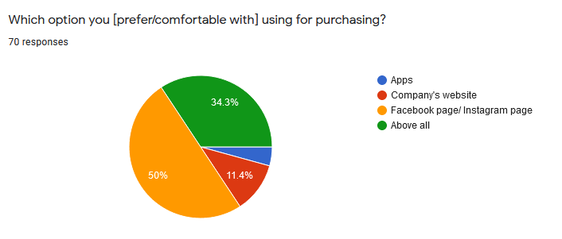

About 50 percent said they are comfortable using facebook or instagram page, 11.4 percent said company’s website, about 4.3 percentage said company’s apps and 34.3 percent chose all three options.

By this we can understand that as we use facebook on a regular basis, using it for buying something online reliable and easier. Whereas for app we first have to download it in our phone then it can take space from our phone storage. Some finds it time consuming. In Bangladesh majority citizens are Facebook users. From lower income citizens to higher income citizens, majority have a Facebook account. About two crore and twenty lakh Facebook users are from only Dhaka.
According to a study in April 2021, there were Four crore sixty six lakh and sixty thousand Facebook users in Bangladesh. The majority of them were men - 68.8%. People aged 18 to 24 were the largest user group.

In Bangladesh people really likes to use apps where it is more comfortable and easy to use it. Using of app is pretty popular but not for purchasing purpose. Yes but if it’s a multi brand retailer and using app is easier than buying from site people will consider it. But still people prefer websites for multi brand retailers and Facebook pages. Daraz app is quite popular as well. Instagram is mostly use for show case but some pages are much active there as well. It will also depend on few things. If brand or company mostly small to mid range company, if they are mostly active on Inatagram and their products are attractive to the targeted customers, customers will use that app to purchase.

But if any app is easier to use and also convenient, people will prefer the app. For example, Bkash have website and app but people prefer app to use it mostly. But Facebook have good reach and for certain product Facebook can find targeted customers easily for the online seller. In that case customers will use Facebook for that purpose.

Most people in Bangladesh have Pathao, Uber, Ovai, Food Panda, Hungrynaki apps as they use it all the time or most of the time. But I guess samplers did not considered this option for them for buying necessity items for daily use like grocery, cloths etc. For ordering food online which is very popular these days, people consider using app. It is easier, does not take much time and information generation is much clear and fast through in app. online food delivery companies are trying hard to developing app from time to time. Also online transportation service companies like Pathao, Uber, Obhai, Obon, Truck lagbe etc also keep developing their apps for customer’s easy use.

But for grocery buying option from online retailers for example from Shopno, Mina Bazar, Agora, Chaldal people usually consider using website as information generation is much more faster there and easier. But apps are developing, so if meet with people’s taste people may consider switching to app as well.

- Question: Even After pandemic will you buy from online source?

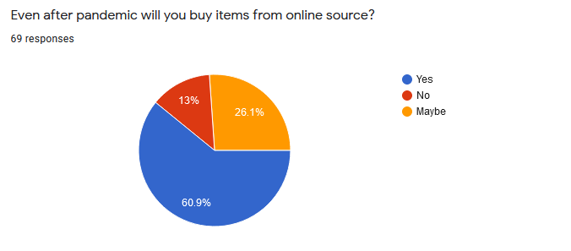

13 percent samplers choose no they will not. These are mostly forty above males and females. Consider local shopping from local stores where they can touch products and buy. This is more of a mental thing. People giving their hardly earn money to buy something they need, so they want to have a clear quire before purchase.

In online no matter how big the brand is, defective product comes often. This kind of action creates dissatisfaction among the customers and chose to dislike the whole online scene. Sometimes the company’s service is bad also. Customer calls to call centre and sometime calla are not picked up, proper information is not given or instruction delivery is not proper etc. Companies should always have worked hard to train their employees so that these kinds of situations, does not happen. So companies have to work hard to earn the trust of the customers.

60.9 percent said they will and most of them are above eighteen females and males. These are mostly age eighteen to thirty five. These are regular internet users. In covid-19 lockdown, these two years this population ordered and purchased more goods online than ever. And studies are assuming this will keep increasing in the later years. This age group are attracted to the fact that they can easily browse information online by sitting at home and many options are there for them to avail. Most products these group purchases are electronic, accessories, cloths, travel related purchase, office information tool which accompanies their daily education and work related aspect. Also home decor items and kitchen essential are also attracted by this group. These Group first see which option gives them product in a less price with good quality. If offline they can get it they also avail it.

And other 26.1 percent are those who are ambiguous. They will if they get a good deal they will buy but not regular buyers. These are mostly forty above males and females, who used online for purchasing for two years in the covid-19 lockdown. Liked the product quality, service and system of the company and felt great after purchasing online without heading out.

Not everything citizens need are online. There are many essentials from various aspects of life that citizens need and they have to head out to get them. But still there is hope that in the coming future online use and infrastructure develops to that level in Bangladesh.

- Question: Are you satisfied buying from online?

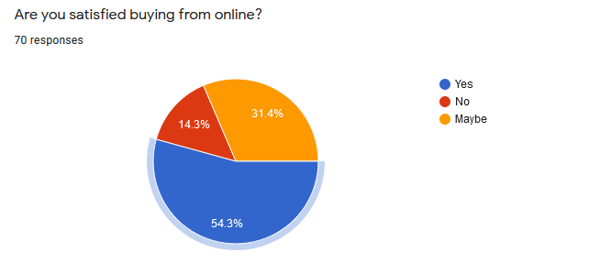

About 54.3 percent said they are satisfied. Most of these samplers are regular online buyers and few are new into online purchasing. Most of the samplers are from eighteen to thirty five, both males and females. A small number of men and women from their forties and up. 14.3 percent said no and these are mostly people who either are dissatisfied from the service where they have purchased or not into the whole idea of online buying. 31.4 percent said maybe. We can say these 31.4 percent can become a regular if they find good deals and also quality.

According to a [16] study, user ecommerce satisfaction depends on six factors and these are information quality, service quality, system quality, product quality, delivery quality and perceived price. Study also suggests that customers care more about the product and the delivery; these are two most important things to customers. If they are getting the product they ordered and how easily and comfortably they are getting it. So online companies or companies delivers online should make their product quality is good, correct order, timelines, packaged properly or safely and must hire good delivery sources. While making managing decision companies must develop high quality ecommerce system and also quality product, reliable delivery and fair price.
According to [17] study, some companies are financially constrained in practice in terms of what e service technology to focus on. Important of interface design such as aesthetics, graphic presentation, visual effects are huge. Website should be design in such a way it is easy to navigate from one page to another, every product should have high quality aesthetics, information are proper, how many stock for what product is properly informed. So that customers can be sure what they are ordering. Website is just kind of a pretty face or one small thing. But how the whole system technology is working along with good quality control of product, service and delivery and review are most important.
During covid-19 lockdown many sellers and buyers switched to online platform to make sure no one gets affected by the disease. This lockdown had worked out great for the online business platform. Companies who could maintain these criteria flourished in their online business game and they have possibility to stay online in future time with evolution of internet system and technology. When customers are satisfied they keep coming back to that store, it applies to the online store as well. Customers give reviews on other social interaction flat forms and if negative reviews spread it can be constrain in the future sells and getting new customers. Retaining customer as well as attracting new customers with great quality product, service, website, website system, package, delivery and reviews should be priority for online businesses.

Chapter- 3

3.1 Suggestions &Recommendations:
.Some suggestions and recommendations can be to sellers who are selling goods online to keep the price minimum or at least try not to put too much price more than actual bazaar price, good quality products, and good service all in all from taking order to delivery. And most importantly try to do business honestly and make sure to return money if defective product is mistakenly sent. Good quality goods with good price and good service. These are the keys.
Some suggestions to buyers can be always ask question about the products properly before confirming the order and always check properly when delivery man come to deliver the product. Do not pay for any defective product and call the page owner or company owner to in front of the delivery man. Ask for refund if not don not pay.

Chapter-4

4.1 Conclusion

By analysing the responses we can see that Bangladesh’s economic dynamic is actually changing. People who are naturally not inclined toward online purchasing also started using this option and some of them are ambiguous about repurchase. And there are also a good number of positive responses towards online purchasing behaviour. Covid-19 lockdown was kind of a blessing for this industry. While in this lockdown many lost their job, faced financial crisis, lost loved ones but for some this platform helped them to keep their business going even under this hard financial situation. Already at a good speed Bangladesh’s online business have grown and in future it will flourish more.

Appended Part

Reference & Bibliography
[1] AMIN, A. (2020). Youth Entrepreneurship and Online Business: A Study on Economic Effects of Coronavirus Outbreak (COVID-19) in Dhaka City. International Journal of Career Development, 3(2020), 31-46.
[2] Zayed, N. M., AbdelrhmanMeero, A. A. A. R., Islam, K. A., &Shahiduzzaman Khan Shahi, S. T. (2021). Demand and Supply-Side Analysis of Dhaka Based Online Business during the COVID-19 Pandemic: Evidence from Bangladesh. Journal of Southwest Jiaotong University, 56(3).
[3] Eti, I. A., Horaira, M. A., & Bari, M. M. (2021). Power and stimulus of social media marketing on consumer purchase intention in Bangladesh during the COVID-19. International Journal of Research in Business and Social Science (2147-4478), 10(1), 28-37.
[4] Mandal, S. C., Boidya, P., Haque, M. I. M., Hossain, A., Shams, Z., & Mamun, A. A. (2021). The impact of the COVID-19 pandemic on fish consumption and household food security in Dhaka city, Bangladesh. Global Food Security, 100526.
[5] Akter, M., & Sultana, N. (2020). Digital marketing communication and consumer buying decision process in pandemic standpoint (Covid-19): an empirical study of Bangladeshi customers’ in branded cosmetics perspective. Open Journal of Business and Management, 8(06), 2696.
[6] Neger, M., & Uddin, B. (2020). Factors affecting consumers’ internet shopping behavior during the COVID-19 pandemic: Evidence from Bangladesh. Chinese Business Review, 19(3), 91-104.
[7] Khan, M. N. A. (2020). Intention to reserve food during COVID-19 Pandemic among Bangladeshi internet users: Based on theory of planned behaviour. European Journal of Medical and Educational Technologies, 13(2), em2010.
[8] Nathiya, M. A. R., & Asha, K. (2020). AN IMPACT OF COVID-19 PANDEMIC ON THE DYNAMIC CONSUMER BUYING BEHAVIOUR TOWARDS ONLINE SHOPPING. MANAGEMENT STRATEGIES TO COMBAT COVID19 AFTERMATH, 14.
[9] Hossain, A., Rahman, M. L., & Hasan, M. M. (2018). Consumers’ internet shopping decision toward fashion apparels and its impact on satisfaction in Bangladesh. Business Ethics and Leadership, 2(4), 74-82. http://doi.org/10.21272/bel.2(4).74-82.2018
[10] Hasan, B. (2010). Exploring gender differences in online shopping attitude. Computers in Human Behavior, 26(4), 597-601.

[11] Yet Mee, L., Boon Liat, C., Cham, T. H., Ng, C., & Tan, J. X. (2019). Gender differences in perceptions and attitudes toward online shopping: a study of Malaysian consumers. Lim, YM, Cheng, BL, Cham, TH, Ng, CKY, & Tan, JX (2019). Gender Differences in Perceptions and Attitudes Toward Online Shopping: A Study of Malaysian Consumers. Journal of Marketing Advances and Practices, 1(2), 11-24.
[12] Ali, M., Ahmed, T., & Absar, S. (2020). Urban Youth Attitude toward Online Shopping: Evidence from Dhaka City. International Journal of Entrepreneurial Research, 2020, 33-40.
[13] Islam, M. S., Sujan, M. S. H., Tasnim, R., Mohona, R. A., Ferdous, M. Z., Kamruzzaman, S., ... & Pontes, H. M. (2021). Problematic smartphone and social media use among Bangladeshi college and university students amid COVID-19: the role of psychological well-being and pandemic related factors. Frontiers in psychiatry, 12.
[14] Showrav, D. G. Y., Hassan, M. A., Anam, S., & Chakrabarty, A. K. (2021). Factors influencing the rapid growth of online shopping during covid-19 pandemic time in Dhaka City, Bangladesh. Academy of Strategic Management Journal, 20, 1-13.
[15] Dauriz, L., Remy, N., & Sandri, N. (2014). Luxury shopping in the digital age. Perspectives on retail and Consumers Goods. McKinsey, 3-4.
[16] Lin, C. C., Wu, H. Y., & Chang, Y. F. (2011). The critical factors impact on online customer satisfaction. Procedia Computer Science, 3, 276-281.
[17] Ba, S., & Johansson, W. C. (2008). An exploratory study of the impact of e‐service process on online customer satisfaction. Production and Operations Management, 17(1), 107-119.

Questionnaire
Survey on Online Purchase during Pandemic:
- Gender
a. Male
b. Female
- Age
a. 18 and above
b. 30 and above
- Do you like online purchasing?
a. Yes
b. No
c. Maybe
- Do you feel safe purchasing online?
a. Yes
b. No
c. Maybe
- Have you purchased during covid-19 pandemic?
a. Yes
b. No
- Did you purchased even before covid-19 pandemic?
a. Yes
b. No
- What do you prefer purchasing online?
a. Cloths
b. Grocery Items
c. Electrical Items

d. Above all
- Do you purchase luxury items online?
a. Yes
b. No
c. Maybe
- Which option you [prefer/ comfortable with] purchasing for online purchase?
a. Apps
b. Company’s Website
c. Facebook page/ Instagram page
d. Above All
- Even after pandemic will you buy items from online source?
a. Yes
b. No
c. Maybe
- Are you satisfied buying items from online?
a. Yes
b. No
c. Maybe

Glossary:

Corona virus | Corona virus is a kind of virus which causes diseases like covid-19, SARS, MARS and few influenza diseases.
Covid-19 | Covid-19 is a respiratory disease which is caused by a virus named Corona.
Social Media | Social media is a virtual platform.
Facebook | Facebook is a social media platform.
App | A small computer programme we can use in a device.
E-Money | E- Money means electronic money.
Niche | A very specific segment of any market for any product or service.
Trifecta | A any situation when we achieve altogether three things.

