INTERNSHIP REPORT ON
THE OUTSOURCING OF FINANCIAL CONSULTATION SERVICES FOR RETIREMENT
PLAN AT DATA-PATH LTD.

Syed Mosiur Rob Nobel

This report is submitted to the school of Business and Economics, United International University as a partial requirement for the degree fulfillment of Bachelor of Business Administration
Title of the report
INTERNSHIP REPORT ON
THE OUTSOURCING OF FINANCIAL CONSULTATION SERVICES FOR RETIREMENT
PLAN AT DATA-PATH LTD

Submitted to:
Name: Md. Qamruzzaman
Designation: Associate professor

Submitted by:
Name: Syed Mosiur Rob Nobel
Id: 111162010
Major: Finance
Trimester: 212


School of Business and Economics
United international university

Date of submission 08.03.2022

Letter of transmittal
Date: 13.02.2022
Md. Qamruzzaman
Associate Professor
School of Business & Economics
United International University

Subject: Submission of Internship Report

Dear Sir,
I have prepared my internship report on “The Outsourcing Of Financial Consultation Services For Retirement Plan At Data-Path Ltd”.
I made every effort to disclose the actual insights in this report. I hope and pray that my all effort and work will fulfill your expectation.
Thanking you for your kind consideration.

Sincerely Yours,
Syed Mosiur Rob Nobel
ID: 111 162 010
United International University

Certification of similarity index

Declaration of the student

I, Syed Mosiur Rob Nobel, hereby declare that the Internship report titled “The Outsourcing of Financial Consultation Services For Retirement Plan” at Data-Path Ltd was solely prepared by me after 4 months internship at Datapath.
I also confirm that the report is only prepared for my academic requirement, not for any other purpose.

Syed Mosiur Rob Nobel
ID: 111 162 010
BBA
School of Business and Economics
United International University

.

Acknowledgement

I would like to acknowledge the fact that the completion of this report would not have been possible without guidance of my “trainers” and supervisor in the Business Process Outsourcing department at Datapath Ltd.
The intensive training there helped me acquire knowledge which I have used to prepare this report.

Abstract/ Executive summary

Financial consultation involves guiding clients in taking actions which would help clients to avoid financial losses and make financial gains where possible. The Outsourcing department at Datapath Ltd. Is involved with providing financial consultation services to administrators of a retirement plan.
In this report I have tried to focus on how a retirement plan is evaluated and financial implications are extracted and then decisions are formulated using analytical knowledge.
In the Last 4 months of my internship, I learned a lot about the practical and characteristics of the US retirement plan industry. Although it’s hard to relate the function of Datapath Ltd. With any other organization in Bangladesh, however, the skills and knowledge I gained from DataPath has helped me acquire advanced skills in excel and analytical ability specific to this industry.

Table of contents for Internship
Table of Contents
Letter of transmittal 2
Certification of similarity index 2
Declaration of the student 2
Acknowledgement 2
Abstract/ Executive summary 2
Table of contents 2
List of Figures 2
List of Tables 2
List of Equations 2
List of Abbreviation 2
CHAPTER I: INTRODUCTION 2
I.1 Background of the Report 2
I.2 Objectives of the Report 2
I.3 Motivation of the Report 2
I.4 Scope and limitations of the Report 2
I.5 Definition of Key terms 2
CHAPTER II: COMPANY PREVIEW 2
2.1 Company Analysis 2
2.2 Industry analysis 2
CHAPTER IV: INTERNSHIP EXPERIECNE 2
4.1 Position, duties, and responsibilities 2
4.2 Training 2
4.3 Contribution to departmental functions 2
4.4 Evaluation 2
4.5 Skills applied 2
4.6 New skills developed 2
4.7 Application of academic knowledge 2
CHAPTER V: CONCLUSIONS AND KEY FACTS 2
5.1 Recommendations for improving departmental operations 2
5.2 Key understanding 2
5.3 Conclusion 2
Reference 2
Appendix-A: 2

List of Figures

List of Tables

Table 4.7 Asset Reconciliation

List of Equations

List of Abbreviation

TPA: Third Party Administration
RK: Record Keeping
ACP: Average Contribution Percentage
ADP: Average Deferral Percentage
DOL : Department of Labor

CHAPTER I: INTRODUCTION

Background of the Report
This report covers the financial consultation services provided by the Outsourcing department of Datapath ltd. Datapath is a sister concern of July Business Services which provides financial consultation services to the plan sponsors in USA. The outsourcing department works independently from July Business Services and outsources financial services to other US based companies which provides financial services to plan sponsors in USA.

Objectives of the Report
The Goal of this report is to portray the work of the Outsourcing department of Datapath Ltd. This will be done by fulfilling the following objectives:
• To know about the Retirement plan industry in U.S.A.
• To know about the governance of DOL, ERISA and IRS and the transparency that has to be maintained by the Employer of a plan of their retirement plan.

Motivation of the Report
The motivation behind the completion of this report is my Internship evaluation which requires to me show the implementation of my academic understanding which I gained from four years of training at my University.

Scope and limitations of the Report
This report covers financial consultation service which is outsourced by Datapath Ltd to third party administrators in U.S.A. It shows the formulation of a plan according to the guideline of U.S concerned regulatory bodies.
A couple of limitation while preparing this report was time constraint and scattered training materials which were difficult to comprehend.

Definition of Key terms
Third party administrator- A service provider who does the accounting and management of retirement plan assets.
Record Keeping- Maintaining records of plan assets and plan participants’ account balances.
Average Contribution Percentage- Average Contribution received from employer.
Average Deferral Percentage- Average Tax exempted amount invested by participants in the retirement plan.
Department of Labor- Department which ensures benefits of a retirement are not solely reaped by highly paid employees.

CHAPTER II: COMPANY PREVIEW

Company Analysis

- Overview and history
Data Path Ltd. is a private limited Outsourcing company which was founded in 2008 under the leadership of Mr. Ashfaqur Rahman who is the CEO and Managing Director of the company. The company provides support and services to many national and international companies. Data Path focuses on the preservation of traditional values of professionalism and integrity while integrating creativity and innovation through the adoption of modern technological advancements. Combining unparalleled experience, comprehensive capabilities across all industries and business functions, and extensive research on the successful companies, Data Path collaborates with clients to help them become high-performance businesses.

- Trend and growth
The trend of Datapath is around the deadlines of filings required by ERISA from the plan sponsors which are March 15 and October 15. The growth has been rapid in this ongoing Covid situation as the activities involving a Retirement plan and retirement plans overall has increased in number in the U.S.

- Customer mix
The customers usually range from a plan sponsor to another financial consultation service provider as in the case of BPO department.

- Product/service mix
The service provided by Datapath are financial consultation services in order to fulfill the minimum compliance requirements of the DOL and ERISA and maintain the integrity of a retirement plan as per U.S laws.
- Operations
Datapath is a sister concern of the July Business Services which operates in the state of Nevada. All the other departments at Datapath works for July Business Services except the BPO department which works for other such financial consultation service providers like July Business Services

- SWOT analysis

Industry analysis

- Specification of the industry
This industry specifically serves the management and accounting of the retirement plan industry in the U.S .

- Size, trend, and maturity of the industry
The size of this industry is quite vast and mostly based in the U.S. This industry usually has it’s busy season during the deadlines of DOL. Some retirement plans start at odd months which have different deadlines. The industry is observing a phase of supernatural growth which could be attributed due to the increased transaction since the outbreak of the coronavirus.

- External economic factors
The retirement plan industry is affected by inflation and nominal interest rate. If inflation is persistent less people will save money in their plan since people will have to spend more on consumption. As a result fees for the plan administrators will reduce since they charge on the basis of the number of participants in the plan. Also if the nominal interest rate of banks are higher enough participants would be interested in saving their money in the banks which would also reduce the number of participants.
- Technological factors
There are many softwares designed to generate reports consistent with the regulations of DOL. These softwares are continuously going through phases of update in order to accommodate the generation of additional reports or filings as per the legal requirements. These softwares are costly to maintain and update. Also the industry participants have to ensure security measures in order to prevent hacking of crucial information related to the plan participants.

- Barriers to entry
The technological investment and security regulation compliance are two major barriers to entry in the retirement plan industry. Softwares have to be developed or purchased by the financial consultant service providers in order to generate reports and ensure security measures.

- Supplier Power
Suppliers for Datapath would be the software developers focusing on the retirement plan industry. Some of the softwares used are Datair and Relius. Whenever upgrades are done they cost a lot and Datapath has to bear them since they are completely reliant on these softwares.

2.2.7 Buyer Power
The buyers for Datapath would be the plan sponsors. They are obligated to submit documents regarding the assets and participants of a retirement plan. They require our consultation regarding the accurate submission of information as they lack expertise in this field. That is why they are dependent on TPAs and usually the same TPA as there is an initial fixed fee the first year.

- Threat of Substitutes
The Substitutes that can be used to provide the consultation service that Datapath provides are sophisticated software. They are very costly to develop as the complexity in generating reports and finding required modifications in the plan are very high. So threat of substitute is very low.

- Industry rivalry
There are other rivals in the industry but none of them have the competitive advantage that July Business Services has established. They do not have the resources to establish a company like Datapath and outsource their services while maintaining the security standards.

CHAPTER III: INTERNSHIP EXPERIECNE

Position, duties, and responsibilities
I was an intern of the Business Process Outsourcing department at Datapath. The department serves various other TPA firms and work on their respective softwares to generate reports by providing processed information. My job was to process information correctly using the knowledge we gained during our training and generate reports and to send them to our clients.

4.2 Training
At first we learned the various excel tools necessary to process information that was provided to us by our clients. They include conditional formatting, vlookup pivot table etc. Then we learned what information to process and why we need to process it. At last we learned how to insert those information in the software and generate reports.

4.3 Contribution to departmental functions
During my internship period I had processed around 35 plans and generated reports using software to generate reports. These plans were mock plans meaning they were already completed. Our reports were then matched with actual reports already prepared before and feedback was provided to us regarding our work.

4.4 Evaluation
I received very good appreciation from my seniors and team leader regarding my work. I worked really hard during my training sessions and found them very interesting.

Skills applied
I used the excel training that I receivedand my own analytical skills to complete the tasks I was assigned to do.

New skills developed

I had very limited knowledge of excel applications prior to my internship tenure. After my training in excel I learned a lot of applications which can be used to evaluate data and process it.

Application of academic knowledge

I used the mathematical knowledge I gained from my academic institution UIU to a part of the processing work that we had to do. This part includes reconciliation of contribution and asset in the plan.

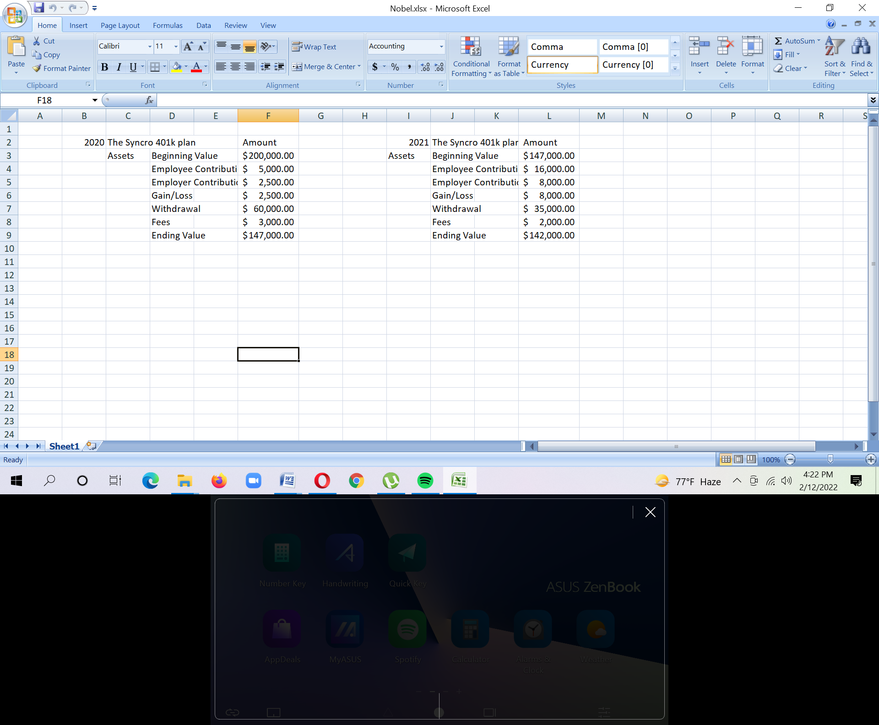

CHAPTER IV: CONCLUSIONS AND KEY FACTS

Recommendations for improving departmental operations
The BPO department of Datapath faced supernatural growth in the number of clients they work with. For this reason they are in need of a lot of human resource. However, they did not have a proper training manual and failed to give a clear idea of the work that the company actually does. They need to prepare proper training manuals for existing clients and softwares they work on to give a clear idea about the work that has to be done.

Key understanding
The U.S retirement plan industry is very big industry. They are using the retirement savings of thousands of employees and so have to monitored and they must operate within the guideline provided by concerned regulatory bodies. The guideline is very complex and requires a lot of time. So plan sponsors use services provided by TPAs to help them in the maintenance of compliance and avoid penalties.

5.3 Conclusion
Datapath is a company established by July Business Services to do their U.S end work and outsource their services to other TPAs. Working here requires a lot of focus and dedication as interns have to know about an industry they are not familiar with which is the U.S retirement plan industry. Persistence is the key here to succeed and build a career in this company.

Reference

- Retirement Plan Fundamentals-1, Published from ASPPA, edition 2008
- Retirement Plan Fundamentals-2, Published from ASPPA, edition 2008

- IRS (Internal Revenue Service) Reporting Guidelines for Retirement Benefit Plan, Published from IRS, edition 2008

Appendix-A:

