



INTERNSHIP REPORT ON “RECRUITMENT PROCESS OF
Daraz Bangladesh Ltd.”

Prepared for :
Md. Abul Mohaimen
Assistant Professor
School of Business & Economics
United International University

Prepared by:
Md. Nazmul Islam
ID: 111.142.165
BBA Program

Date of Submission: 26.03.2019

Table of Content

Letter of Transmittal ................................................................................................................ i
Acknowledgement.................................................................................................................. ii
Executive Summary ................................................................................................................. iii

Chapter one……..…………………………………………………….......................... 1-6
1.1 Introduction……………………………………………………………………………… 1
1.2 Introduction of the E-Commerce Industry …………………………………........... 1
1.3 Scope of the report....……………………………………………………………………. 2-3
1.4 Objectives of the report………………………………………………………………... 4
1.5 Sources of the information......………………………………………………………... 5
1.6 Research Design……………………………………………………………………….. 6
1.7 Methodology ................………………………………………………………………... 6
1.8 Goal of the study ......................………………………………………………………... 6
1.9 Limitation of the Report......…………………………………………………………….. 6
1.10 Absence of Experience............………………………………………………………... 6

Chapter two…………………………………………………..…………………………... 7-21
2.1 Company profile……………...………………………………………………………… 7
2.2 Parent company ………………………………….......................................................... 8
2.3 Rocket Internet....…………………………………………………………….....………. 8
2.4 Daraz Acquired by Alibaba Company...................……………………………………... 9
2.5 Daraz Bangladesh Crucial Departments........…………………………………………... 10
2.6 Blueprint of tasks office…………………………………………………………………. 11
2.7 Organogram ................………………………………………………………………...... 12
2.8 Daraz.com.bd the leading online market price in Bangladesh.......................................... 13
2.9 Place......………………………………………………………..............................…….. 14
2.10 Physical Evidence.....................………………………………………………………... 15
2.11 Process............................................................................................................................. 16
2.12 Categories....…………………………………………………..............................…….. 17
2.13 Tours and Travel Category.......………………………………………………………... 18
2.14 Seller Acquisition Process............................................................................................... 18
2.15 Payment Method.................................………………………..............................…….. 19
2.16 Vision and Mission..................………………………………………………………... 20
2.17 Slogan............................................................................................................................. 20
2.18 Company Objective.....………………………………………..............................…….. 20
2.19 Daraz Bangladesh Ltd. at a glance...…………………………………………………... 21
2.20 Job Description................................…………………………………………………... 21
Chapter three………………………………………………………………………………..... 22-28
3.1 Human resource…………………………………………………………………............. 22
3.2 HR planning…………………………………………………………………………….. 23
3.3 Recruitment………………………………………………………………………...…… 23
3.4 Training…………………………………………………………………………………. 24
3.5 Compensation and benefit………………………………………………………….. 24
3.6 Safety and security……………………………………………………………………… 25
3.7 SWOT analysis……………………………………………………………………………. 26
3.8 Job Responsibility………………………………………………………………… 27-28

Chapter four……………………………………………………………………………………..... 29-33
4.1 Observation………………………………………………………………………………..... 29
4.2 Recommendation…………………………………………………………………………… 29-30
4.3 Conclusion………………………………………………………………………………… 31
4.4 Reference………………………………………………………………………………….. 32
4.5 Index .................................................................................................................................... 33

Letter of Transmittal

Date: 26.03.2019
To: Md. Abul Mohaimen
Assistant Professor
School of Business & Economics
United International University

Sub: Submission of internship report on “Recruitment process of Daraz Bangladesh Ltd.”.

Dear Sir,

With due respect I would like to inform you that I am Md. Nazmul Islam from BBA program here in submission of my internship report. I might want to thank you for controlling me and helping me all through my temporary position program while finishing my BBA modified. The topic I have chosen which is “Recruitment process of Daraz Bangladesh Ltd”. I have tried my best to put and present all the things to make the report more perfect and informative. If any part of the assignment means inappropriate or inadequate please let me know I try to resolve.

I am very grateful to you for the way you guidance me to prepare the intern report more successfully. Please contract freely with me in the event that you have any questions. I would be happy to give any illumination with respect to the task.

Much obliged to you

Truly yours

……………………….
Md. Nazmul Islam
ID: 111.142.165
Program: BBA (Major in Human Resource Management)

Acknowledgement

I would like to acknowledge the guidance of Internship and placement committee for arranging such a nice program for creating practical or theoretical knowledge about learning and also thankful to some individual whose inspiration, motivation and proposal made it occurred. I am very thankful to my supervisor. General Manager (Admin and HR) to guide me to prepared internship report during internship period and without their help this may be very difficult for me to be accomplished my report. It may be very tough task for me to give the report a nice ending without the help of my advisor

I am grateful to Mr. Rahedul islam, Head of departments of Daraz Bangladesh Ltd. I also like to thank Mrs. Farhana Rafiq, Head of department of Daraz Bangladesh Ltd.. All of their cordial supports and efforts helps me to make this report accurately. And finally, I also express my sincere gratitude to all those who participated to prepare this report properly.

EXECUTIVE SUMMERY

Consistently we are seeing a critical proportion of web clients. Presently e-business have turned out to be most famous side among the general population of entire over the nation. For the vast majority of the general population in Bangladesh, Amazon, Alibaba, Flipkart are not outsider ideas. We have numerous online business adventures, for example, Pathao, Uber, click BD, bikroy.com, Priyo shop, daraz.com.bd, Rokamari.com, foodpanda, Hungry naki and so on. It is a developing industry, so there is a lot of segments to chip away at to make the online buy experience better. To improve an administration, issues should have been distinguished. With knowing the hazardous regions of Daraz.com Bangladesh in which Daraz should take a shot at, this paper has been composed. To show signs of improvement knowledge of the business with the goal that successful suggestion is given to the organization. Daraz Bangladesh propelled its activity in Bangladesh from 2015, they have become over the time. Be that as it may, there are a few obstructions in giving better client administration internet shopping. That is most disturbing for the organization. It's a focused and developing business sector, so on the off chance that the administration isn't sufficient, at that point it will be troublesome for the organization to keep the best position and to continue in the market over the long haul. A review has been led and we seen a lot of individuals in our nation are currently more worry about online buy, it is imperative to recognize what they are think and in which segment an organization is doing great or coming up short.


CHAPTER ONE

INTRODUCTION

1.1 Introduction
In order to fulfill my BBA program with major in Human Resource Management, I have experienced to work in a E-Commerce site Daraz Bangladesh Ltd. After completion the theoretical part I was assigned to work on human resource practices of Daraz Bangladesh Ltd. Here I was given with the combination of theoretical knowledge as well as practical knowledge field. I have tried to cover different contents of HR area during this internship period. I have enriched my knowledge on general HR aspects of the company as well as identified some issues which are being barriers in the growth of the company. A SWOT analysis on the HRM Practice of Daraz Bangladesh Ltd followed by discussing the critical points arisen during the work time and tried to put some recommendations on it according to my knowledge. My project was on the topic of HR policies of Daraz Bangladesh Ltd.

1.2 Introduction of the E-Commerce Industry

Electronic trade or web based business is a term for a business, or business exchange that includes the exchange of data over the web. It is right now a standout amongst the most imperative parts of the web to develop. Online business has become quickly Worldwide and furthermore in Bangladesh.

At present web administrations are accessible in Bangladesh. Its use for web based business by Bangladeshi makers to master just as to get to sources of info will be subject to their eagerness and capacity to utilize this medium just as that of the purchasers of definite items and the merchants of transitional merchandise and ventures. In Bangladesh, among the components of web based business, there is a restricted application and utilization of B2C web based business. Be that as it may, a critical part of absolute web based business sites are occupied with C2C online business which is closeout based trade between customers to shopper. Different fields are not yet much created in Bangladesh. There are numerous purposes for this, one basic reason this nation isn't so created and the greater part of its residents are poor and uneducated. It is very common that there are couple of clients who is eager and can shop in web. It may take a long time to be created in this part in Bangladesh, however there are proof discovered that it is additionally developing quickly and before long will reach at a prosperous stage (Economic improvement, 2009).

There are more than 2 billion web clients Worldwide in 2011 and it is gauge this number will surpass 3 billion by 2015 and the world B2C online business industry produced between $400 billion and $600 billion of every 2010 as per yStats.com, which evaluates the market will create some place from $700 billion and $950 billion of every 2015. At present in the time of 2018 we can completely express that the supposition was correct. Online life keeps on filling the B2B web based business showcase, which intends to help electronic business process productivity, reports T frameworks. Web based business is being considered as a different, gainful field business and mediator on-screen characters are refreshing their B2B plans of action, while grasping parts of web based life. Furthermore, upper hands decide if an organization can push ahead, E-trade is the correct apparatus for increasing upper hand now-a-days in Bangladesh.

Real retailers are presently opening their own sites which supplement their conventional blocks and-mortal outlets. A few retailers work exclusively over the Internet, particularly in Ecommerce (Face book business). Online retailers regularly sell items and administrations at a 3 critical markdown to those offered by conventional outlets. Purchasing on the web is advantageous. Customers can make their buys from the solace of their own homes and have them conveyed to their entryways. Sooner rather than later the limits among 'ordinary' and 'electronic' trade will turn out to be progressively obscured as an ever increasing number of organizations move areas of their activities onto Internet.

1.3 Scope of the report:

It was my great pleasure that during the Internship period, I got co-operation to discuss each and every area of the HR related activities of the company which includes some confidential data of the employee and some other major factors. So the scope of the report making was vast from my end. As an intern, I got every kind of facility to study and work hard on each and every aspects of human resource department and an extensive discussion with the present employees made it so easier for me to made an effective conclusion.

Significance of the Study

Internship report is required for fulfillment of BBA program. Which is contains 3 credits of total academic courses. A study can gather practical knowledge about the real job field like as HR institution. After complete the internship period a student must be make a report on his/her experience about the job. He tries to reflect his internship experience on report. By this internship program student can established contact and networking. Contact may help to get a join in practical life. This is, student can train and prepare themselves for the job market. Therefore, It’s obvious that the significance of internship I clearly justified as the crucial requirement of BBA student.

1.4 Objectives of the report:

There are two objectives of this report:
Broad objective: Experience and to gather an overall idea on HR functions of the E-commerce site.

Specific Objectives: Specific objectives are as follows -
- Finding and identify the HR core responsibilities and implementing in the right way to the right people.
- To acquire the depth knowledge on all the key areas of HR.
- To scan the practical scenario of the organization.
- To identify the opportunities and weakness of E-commerce site
- To propose changes for the development of the HR activities.

1.5 Sources of the information:

Primary source of data

- On the job experience
- Survey report
- Findings from the interview
- Global and internal reports.

Secondary source of data

- Daraz.com.bd
- Various articles relating general online company functions and management.
- Publications of different dailies and internet resources
- Daraz department’s employees service manual.

1.6 Research Design
This report is descriptive in nature, which focuses on HR Practices of Daraz Bangladesh.

1.7 Methodology:
Information was gathered through past reports, articles, documented records and very reliant on perception. Primary wellspring of information is open finished meeting and perception.

1.8 Goal of the Study:

To discover the fundamental fumble with respect to HR exercises completed in the organization. The result of the study can generally be used as an input for those who are interested in managing E-commerce industry to optimize their human resources process.

1.9 Limitations of the Report

- Large-scale inquire about was unrealistic because of brief time
- Relevant information and reports accumulation were very incomprehensible because of the association Confidentiality.
- The allocated people attempted to abstain from responding to numerous inquiries.
- Management is occupied with their day by day works. So all prerequisites can't be incorporated.
- As there are insufficient data in site, so data gathering was so troublesome.

1.10 Absence of Experience
To finish such sort of report a ton of experience required. In any case, I had next to no involvement in this working field. Amid the procedure of arrangement because of different limitations there might be some mixed up.

CHAPTER TWO

COMPANY PROFILE

2.1 Company Profile:

In 2012, Daraz began its activities as an online style retailer in Pakistan. It changed technique and moved towards turning into a general online commercial center in November 2014. Daraz In 2012, Daraz began its activities as an online style retailer in Pakistan. It changed technique and moved towards turning into a general online commercial center in November 2014. Daraz Group propelled activities in Bangladesh and Myanmar in January 2015 Daraz Group was at that point working in the South Asian areas of Pakistan, Bangladesh, and Myanmar. In July 2016, Daraz started tasks in Sri Lanka and Nepal.

In May 2018, Daraz Group reported that it had joined Alibaba Group's biological community for an undisclosed arrangement. This move comes around two years after Alibaba's procurement of Lazada Group. which was additionally a startup by Rocket Internet Group in South East Asian market. Alibaba Group additionally runs Singapore's RedMart and possesses stakes in India's Paytm.

Daraz Group's five provincial markets (Pakistan, Bangladesh, Nepal, Myanmar, and Sri Lanka) spread 460 million individuals with 60% of the populace in these areas are younger than 35. Alibaba Group gained Daraz Group's tasks in these locales of South Asia.

Bangladesh has an enormous people which pulls in a great deal of advertisers to offer their things. Be that as it may, since of nonattendance of creative ability, Bangladeshi customers still need various latest workplaces the propelled world offers. A Big piece of our people don't have the finding out about the most ideal usage of web isolated from use it only for web based life and that is changing into a test for the online associations. Our Government is attempting to give web all through the country, here the assembly is accepting a noteworthy activity in this division. As they are giving web access to remote zone and school and colleges, which will help in the headway of online business division of nation.

2.2 Parent Company

Daraz Bangladesh was brought into the nation by Rocket Internet and alluded as parent organization of Daraz Bangladesh Rocket Internet is a German Internet organization headquartered in Berlin. The organization produces online new businesses and cases shareholdings in various models of web retail organizations. The plan of action of rocket web is known as a start-up studio or an endeavor engineer. Rocket web plans to work outside the US and China. Rocket Internet has in excess of 30,000 representatives over the world and has involves in excess of 100 elements in 110 countries. Rocket Internet was established in Berlin in 2007 by three siblings: Marc, Oliver and Alexander Samwer. 2014, Rocket Internet changed its authoritative document from a GmbH (private restricted organization) to an AG (Public constrained organization).

2.3 Rocket Internet

- Started in 2004 by sequential business visionaries Alexander, Marc and Oliver Samwer.
- Incubated in excess of 100 quickly developing on the web organizations everywhere throughout the world since beginning
- Currently 30+ worldwide branch workplaces on each of the 5 mainlands from Africa to South East Asia
- Operated by a profoundly gifted group of Business Development, Operations, IT and Online specialists
- Currently 20,000+ representative in more than 60+ new companies far and wide.



2.4 Daraz Acquired by Alibaba Company

On the long stretch of May 2018Daraz Bangladesh has been completely obtained by Alibaba Group. Alibaba amass was established IN 1999 by 18 individuals driven by Jack Ma, a previous English educator from Hangzhou, China. The originators began the organization to advocate private companies, in the conviction that the Internet would even the odds by empowering little undertakings to use development and innovation to develop and contend all the more adequately in the household and worldwide economies. The acquisitions incorporate Daraz activities in Pakistan, Nepal, Sri Lanka and Myanmar.





The tasks will proceed under the Daraz brand name "Daraz will probably use Alibaba's authority and involvement in innovation, online business, portable installment and logistics to drive further development in the five South Asian markets that have a joined populace of more than 460 million.

2.5 Daraz Bangladesh Crucial Departments

Dependent upon the size, every affiliation requires a type of dynamic structure to alleviate the task suitably. Without the right definitive systems it ends up being actually difficult for the relationship to realize operational techniques and achieve the destinations. Being a worldwide affiliation and to deal with its activity easily Daraz has some committed division with the correct sort of individuals. The significant branches of Daraz Bangladesh are recorded underneath:

- Administration
- Business Development
- Customer Service
- Commercial
- Category Management
- Graphics and Design
- Human Resources
- Information Technology
- Issue and Resolution
- Finance
- Operations
- Onsite and Content Management
- Sales Management
- Marketing
- Public Relation
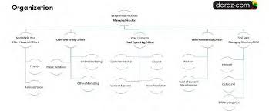

2.6 Blueprint of tasks office

The activities group of Daraz Bangladesh is the greatest branch of the organization which comprises of numerous offices inside it. A concise thought of the organogram is given underneath yet the full blueprint is referenced in the informative supplement segment.

- Head of Operations
- Operation Manager (Inbound)-
- Inventory
- Inbound
- After sales
- Shipping
- Operations excellence

- Operation Manager (Outbound)-
- Network
- Own fleet
- 3PL

2.7 ORGANOGRAM:
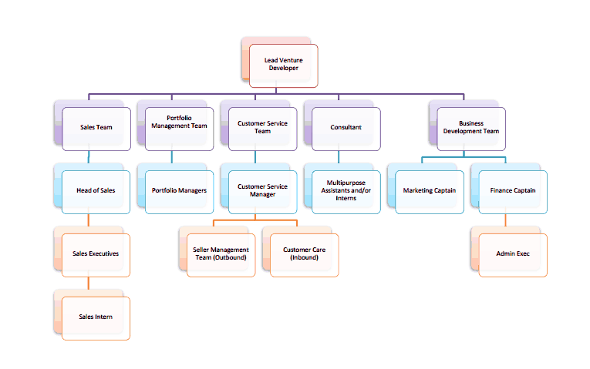

In the long stretch of July 2018 Daraz and Alibaba have converged to reinforce their situation in the developing Bangladeshi market. To catch more pieces of the overall industry this 2 organizations are cooperating. Presently they are called Alibaba Group. This merger additionally has occurred in Pakistan and Myanmar, Nepal, Srilanka. Co-CEO of Daraz Group Abu Sayed Anwar, stated, "Daraz and Alibaba have both assembled effective tasks in their separate markets. The merger is currently the subsequent stage to offer our merchants the most ideal answers for develop their online business, and to begin gaining by the cooperative energies between the stages."

* Source: (http://www.thedailystar.net/business/daraz-alibaba-combine more noteworthy market-get to 1246825)

2.8 DARAZ.COM.BD: The Leading Online Market Place in Bangladesh

In our creating monetary arrangement of Bangladesh, individuals are progressively proposed to go for options of solace and are considerably less required about cost while buying. Individuals getting progressively centered around different undertakings these days, thus, they scan for less troublesome, reliable and relevant web based buying alternatives in which they can shop at whatever point as online shops are open day in and day out. Along these lines, the capacity commercial center for present day on-line obtaining venture in Bangladesh currently arranged to get the likelihood, anyway the inquiry is if the market likewise outfitted to take inside the contributions. By the main overview it is obviously been imagined that Daraz Bangladesh is one of the main web based shopping sites favored by the Bangladeshi shopper.

2.9 Key Facts about Daraz Bangladesh Ltd.

- The total numbers of employees are about 1000+ employees. They are expanding every year. They do their delivery through third party. They have delivery companies associated with them. Such as: Sundarban Paribahan, Pathao, bidyut, 5 star etc. They have also established 19 hubs outside Dhaka.
- Daraz are as yet looking towards further improvement and extension so as to cover all parts of the business
- Low power cost.
- They have adequate proficient workforces, administered and coordinated by a very much organized strong supervisory group.
- Not just Daraz guarantees the best nature of the items yet in addition they treat security similarly for all
- Secure and cleanliness as their need region.
- They are furnished with firefighting administrations and keep watch on laborers.
- First guide confine has been given every office in consistent schedule.

2.9 Place:

As Daraz is an online shop, the buy occurs on through site. Along these lines, for this situation the spot of the deal is the site/virtual commercial center. Link: https://www.daraz.com.bd

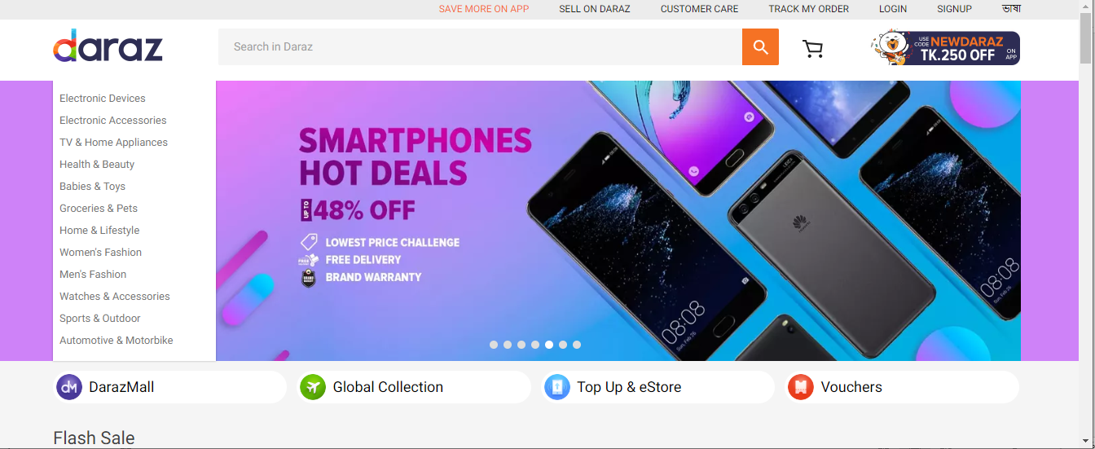

2.10 Physical Evidence:

They do not have a physical shop. But the brands which consumers can purchase through the website are as follows:
- Bata
- Yellow
- Apex
- Samsung
- Huawei
- Miyoko
- Shimizu
- Sony
- Dorjibari
- Beauty Bazar
- Pearl
- Time zone
- RB
- P&G
- Microsoft (Lumia)
- LG
- Redmi
- Noir
- Walton
- O2
- Occult
- Sports World

2.11 Process:

Online purchase process is different but easier or less time consuming then going to shops. Below I am stating some Daraz’s online purchase processes follows:

To maintain the process, they use different type of software like as Seller center, CRM, Warehouse module, Delivery Module.

- Seller Center: This software helps the seller to update their product stocks and prices by coordinating with the contact person from Daraz. It also helps the business development team and the sales team of Daraz to coordinate the offers and count of the sales, stocks and manage the stocks.

- CRM: This software helps customer service department to cater inbound and outbound call efficiently. Here is also a department which is Issue Resolution. Also, other software is including such as Zendesk, LMS, ZOHO for internal and agent to customer communication properly.

- Warehouse Module: There is a ware house and order management system to make it easier for pick-up of products, stocks, delivery process.

- Delivery Module: It helps the 3rd part provide tracking to the company of deliveries their making and their status .Daraz delivery the product In side Dhaka within 4-7 working days and outside Dhaka within 7-10 working days.

2.12 Categories

The Daraz Bangladesh site comprise 12 classifications and each classification got sub-classifications which help the buyer to scan for their ideal item and administrations. The classes are Women's Fashion, Men's Fashion, Phones and Tablets, TVs Audio and Cameras, Computing and Gaming, Appliances, Home and Living, Sports and Travel, Beauty and Health, Baby Kids and Toys, Grocer's Shop and different classifications. In the underlying stage the site concentrates more on the style part as the prime concern was to make the purchaser feel great about obtaining design things on the web. Steadily when the site created and picked up trust the site attempted to catch every single classification. In the present time individuals favor buying items online as well as they usually like administrations too and due to this up and coming pattern Daraz Bangladesh has presented Tours and Travel division. In this class there will be rundown of inns, resorts and travel offices who will give the best bundles and arrangements to Daraz purchasers.
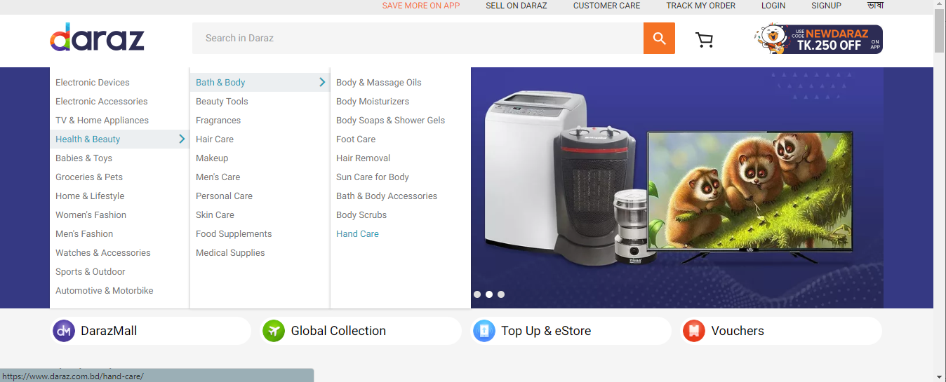
2.13 Tours and Travel Category

The Tours and Travel class has been ready of Daraz Bangladesh Website not over a year and inside this brief timeframe it has gotten a great deal of buyer's consideration as the Daraz Bangladesh giving the absolute best arrangements and bundles that they won't almost certainly get from some other stage. If someone one request/affirm their booking from Daraz site, beginning from the adventure each office and different administrations will be taken consideration. This classification incorporates visa handling administration, inns, resorts and air ticket and other visit related offices.

2.14 Seller Acquisition Process

Daraz Bangladesh does not give or deliver any item or administrations of their own. They fundamentally function as a media or as a seller. Daraz.com is essentially a stage where diverse merchants and proprietors give their item and use Daraz stage to sell their item. So the primary occupation of Daraz Bangaldesh is to obtain these merchants. Contingent upon the need and momentum showcase request the organization scan for items and dealers and after that peach them to influence their item to show up in the site. In each division there are a few terms and conditions which should be kept up and pursued by the two gatherings. Here the dealer stays as first gathering and the Daraz fill in as second gathering. Certain exchange and meeting held between these two gatherings to lead the business understanding. After the understanding is made between the two gatherings a dealer focus account has been made.

Dealer focus is essentially a site which both the vender and Daraz specialist can get to with the goal that they can track and make each update. All the item and administration subtleties have been transferred there including cost and subtleties. The two gatherings can roll out vital improvements as indicated by their advantageous. In the wake of transferring the item data, it takes 7 working days to get the item/administration live and been noticeable into the Daraz site. The vender can likewise get advised in the merchant focus and in their mail when any request to get set.

2.15 Payment Method

One of the primary worries of the vender and the principle issue that one-individual face while procuring a merchant is the installment technique. Daraz Bangladesh give 30days installment strategy. When the item gets sold the vender will get the installment of that request following 30 days through their bank installment framework. In spite of the fact that in Tours and travel area installment can be made inside 7 or 14 days. When we are gaining a brand or a known organization, we give some additional benefit to them. We do the business flawlessly we give security check to the vender as a security.
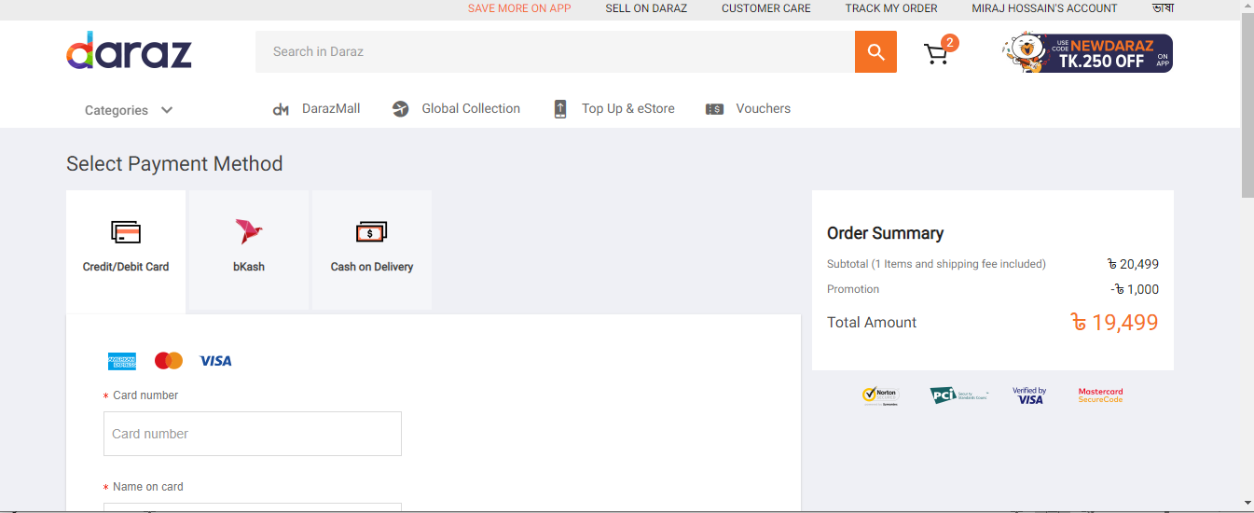

2.16 Vision and Mission

Mission: The organization's central goal is to turn into world's biggest web based business stage outside USA and China. The organization recognizes new plans of action, undiscovered markets and business people. Sustain them and attempt to set up the business.

Vision: Their vision is to catch the most extreme offer of purchaser web based shopping use in the market. Objective: they will likely give the best item in the best cost. Additionally, to present most recent items in the market for the clients.

2.17 Slogan:

“We build companies”

2.18 Company Objective

- Daraz Bangladesh have very strong managerial group and creating a friendly atmosphere among each other to achieve the company objectives.
- Daraz Bangladesh supports the national earning & solving unemployment problem, the objective of Daraz Bangladesh ltd. is human resource development for efficient management of E-commerce sector giving priority requirement of quality & in time shipment.
- Political instability & illiterate work force creates a major barriers which is a challenge for the company.

2.19 Daraz Bangladesh Ltd. at a glance

Company name- Daraz Bangladesh Ltd.
Office location(Head Quarter)-
Address:Tazwar Center,House No:34,Road No:19/1, Block, Banani,Dhaka-1213
Phone: 16492 (Help line)
Email:www.Daraz.com.bd

Dhanmondi Hub:
Address: House:8,Road-7/A,Dhanmondi,Dhaka- 1213
Phone: 16492 (Careline Number)
Email:www.Daraz.com.bd

Senior Manager: Farhana Rafiquzzaman
Manager: Rahedul Islam (Issue Resolution)

2.20 Job Description

The Job Description of Internship consisted of the following details :

Tenure of Employment : I was employed as an Onsite Intern of the company for the duration of three months.
Working Hours: Sunday to Thursday: 9.00 am – 6.00 pm Friday and Saturday off
Remuneration: The company paid a BDT 8,000 monthly during the Internship period. After finishing internship period salary increased.
Work Station: House-8, road-7/A, Daraz Bangladesh Ltd. Dhanmondi, Dhaka-1213.

CHAPTER THREE


OVERVIEW OF HR ACTIVITIES

3.1 Human Resource

The primary exercises of human asset the board is to design sagaciously, create, and directed terms or arrangements and projects intended to make speedy utilization of an association's HR. It is a piece of the board which is worried about the general population at work and with their relationship inside an undertaking. Viable use of HR obtaining objectives at minimum time, desirable working relationships among all members of the organization and maximum individual development are the core objective of Human Resource management. The core functional areas in human resource management are planning, recruiting, employees development and employee compensation with welfare and so on.

We realize that E-trade are growing up division in Bangladesh now a days.. In the event that the labor can not be overseen appropriately, at that point it can prompt downright terrible results that will upset our E-business site. The work that is done necessities exceptionally talented hands though the execution of legitimate preparing is required. At whatever point there is an uproar in light of pay issues it is the HR office that steps up to the plate of taking care of the situation.HR division needs to stay in contact with the gifted specialists so that at whatever point the need emerges for work they can be effectively enrolled without confronting the issues of preparing representatives from the begin. At that point ordinary representative are exiting their profession for different reason and new individuals are being selected in crisis premise, so the issue of enrollment is dependably in dynamic. All the HR strategies are especially dynamic by and by of Daraz Bangladesh Ltd.

3.2 HR Planning

To create HR systems, it is imperative to allude to accomplish the association's goal, and furthermore a reasonable mission or vision explanation. All together for the organization to achieve its objective of developing the association, it is basic that a HR vital arrangement is led, In straightforward words, HR the executives is built up an extension between best dimension the board mid dimension the board and lower levels the board of an association. Some HR experts utilize distinctive systems, for example, 'Labor Planning and Forecasting. To complete work and to complete the activity consummately are two unique things. Every one of the organizations dependably look for the second one in light of the fact that just splendidly done assignments can give the ideal result.

Daraz Bangladesh Ltd successfully maintains a proper manpower planning to run their company effectively and efficiently.

3.3 Recruitment

The Recruitment Unit group dependably center around organization's determination forms and improving its ability the board device to react to the requirement for fast and powerful enrollment, while maintaining organization's standards of equivalent chance, straightforwardness and reasonableness. Over the previous decade, specialists have demonstrated the way that the scouts ought to be progressively perceptive towards the primary period of the enrollment procedure as it can turn out to be to be exceptionally vital as far as choosing the ideal individuals to the correct position. Enlistment procedures might be upgraded to the degree that we can clarify how and when definite publicizing will influence candidate aims to apply to associations.

Daraz enlistment and choice strategy has been confined with the perspective on enrolling and choosing individuals who want to accomplish organization's vision and objective, and who will help with accomplishing the business vision. There are numerous rules to be considered as there is the issue of strikes because of different reasons. There is additionally an issue of individuals relinquishing their profession subsequent to getting the installment. The female worker is given greater need for enlistment process as they are less physical than the male representative.
3.4 Training

There is no uncertainty that directors at all dimensions of the association offer weight to the representative to create the preferred outcomes sooner rather over later. In this surge upper hand to be picked up by legitimately preparing and teaching their workforces that they have to contend in a worldwide economy. Furthermore, in light of scaling down the significance of powerful preparing is expanding each day. As the subsidence has harmed practically all the nation's economy on the planet the organizations are hoping to have less yet productive representatives. The blast of innovation in the working environment, strengthening, work groups, tight work markets and as a rule, the absence of top notch graduates are prepared to fill passage level positions. Along these lines, demonstrating the way that preparation can come to use in an exceptionally critical way.

3.5 Compensation and benefit

This specific part of an occupation likely holds more intrigue than everything else, and has the best effect on whether representatives remain or leave in that specific organization.The lion's share of the representatives work to support themselves monetarily and their family monetarily. Subsequently, this is without a doubt the most imperative factor that influenced the activity fulfillment. Advantages are dependably an incredible method to rouse the representatives. As far as HR it really intends to pay the activity holders for carrying out their responsibility. Pay likewise covers the parts of immaterial advantages, for example, occasion benefits, installment examinations, rewards, etc.

Daraz dependably attempt to be admission about remuneration and advantage bundles for their representative. Looking into current pay structure and distinguishing proof of remuneration plan standards with regards to best practices.Daraz dependably attempt to recognize representative of the month so representatives are persuaded to work exclusively to contend with one another. Survey inner value issue. Investigation showcase going rate and patterns to address outer intensity.

3.6 Safety and Security

Safety and security are very important for a company and Daraz Bangladesh are more conscious about this matter. In Bangladesh, safety is a very serious matter. If the company ensure the safeness then employee are encourage to work and work freely.

Daraz Bangladesh already has taken necessary action to protect theft such as hiring good quality guards. Smoking is strictly prohibited inside the organization premises and smoke Detectors are set in all departments. Fire practice is carried through trained volunteers selected in each department. Fire protection equipment’s have been provided in each department as per requirements.

3.7 SWOT Analysis

Without the representative it would be practically difficult to run any organization. These days the laborers know their value and are requesting increasingly regular yet the proprietors are not willing to fulfill their needs and subsequently we witness every one of these strikes and terrible showcases. This sort of undesired things upsets organizations' exercises. Thus, the HR division has a ton of work in their grasp and needs to ensure that the representatives are fulfilled and are carrying out their responsibility legitimately in such a case that they can't create the items or serve their client on time then they will miss the shipment.

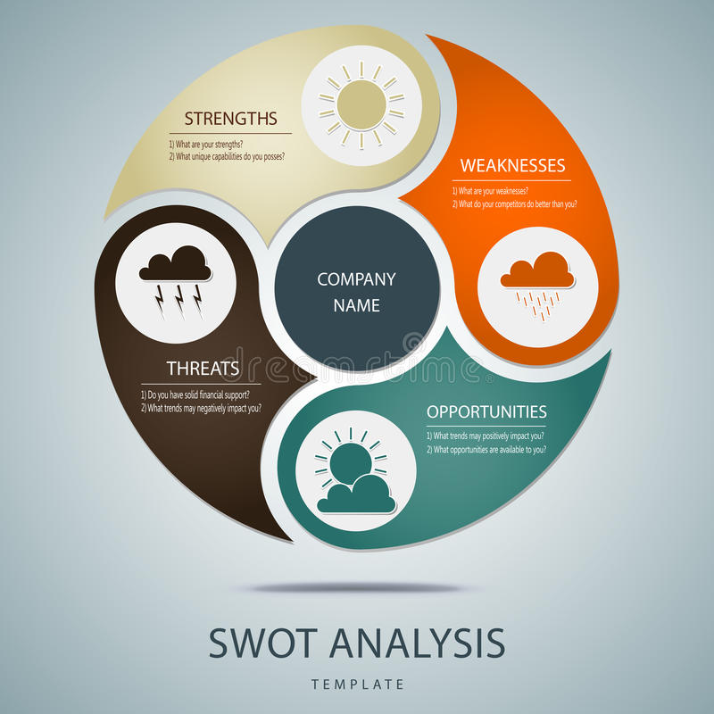

SRENGTH of this company is, they maintain a strict recruitment and selection process and they try to satisfy employees demand so that they are motivated to their work.

WEAKNESS is the company is that Daraz needs more HR personnel.

OPPORTUNITY is that they can increase their productivity by giving employees more benefits and employee turnover rate is too low.

THREAT is their weak HR department can create lot of problems among workers that will be a demotivation factor for the employee.

3.8 Job Responsibilities:

I had to go to totally different managers and departments to work out how the E-commers sites operates their works and the way all the department operates. However Brands offer chain, Brand, client Development are reticular and mutualist with one another. As Associate in Nursing intern of 60 minutes I had capable 60 minutes activity in details. At the identical time the way to inter-relate all the data’s from many departments and report it to the 60 minutes head. As Associate in Nursing intern I received all the support from my supervisor and that i was involved the achievement method of Daraz People's Republic of Bangladesh Ltd. I screened out the CVs of the candidates; short listed them and known as them for face to face interview. just in case of underneath graduate students their CVs aren't the same old formal CV however rather their national ID card or their academic background in the main covers it. composing interview dates, time and venue and panel for interview and coordinate consequently. however instead of the hiring there's typically the difficulty of sack or firing staff. once the orders aren't that abundant in our system, to chop the value the highest management must take the choice of what percentage staff to fireside from their position. It will persuade be a really agitated and unhealthy expertise likewise. As they're poor it's robust for anyone to appear them within the eye and hearth. several incidents happen wherever the worker goes courteously however typically things don’t go thus swimmingly, they have an inclination to argue. If any willdidates or staff thinks that he or she is discriminated underneath any circumstances then that person can report back to welfare government likewise.

While i used to be within the organization, I had to go to the organization to review the structure current men and resources. Competitive rating is that the pre-requisite for obtaining Associate in Nursing order. each order comes up with a technical sheet. (in a during a |in Associate in Nursing exceedingly in a very) technical sheet of an order everything are specifically mentioned.

My analysis is especially targeted on qualitative study supported observations of the full ’ 60 minutes department. throughout my berth amount I conjointly reviewed the 60 minutes policies of the corporate. The 60 minutes policies are as follows: normal Conduct a pair of staff are expected to conduct themselves on the duty in a very manner that contributes to operational effectiveness, productivity, safety and a harmonious work setting. If staff don't meet the company’s expectations of performance and/or conduct, corrective action, up to and as well as termination policy could also be taken. it's among management’s discretion to see what live would be acceptable underneath every circumstance. to watch all the activities the authority has put in CCTV camera all around. Harassment Policy today {this is this is often this will be} a significant issue and if any such incident takes place it can ruin the name of the corporate. thus it's strictly monitored by the authorities. however if any worker feels that he or she is subjected towards any such behavior then that person is liberal to complain it to the authority and therefore the authority take the strict call.

CHAPTER FOUR


4.1 Observation

What I found that-

- The merchant must be dynamic and learned so as to complete the entire procedure easily.
- Employees are paid a fixed sum for every month thus the organization are continually attempting to make them as hard as feasible for the cash's value.
- The organization some of the time masterminds diverse sort of session or preparing program with the goal that representatives are working gainfully.

4.2 Recommendations

In spite of the fact that the HR exercises of Daraz Bangladesh are completing a not too bad employment at the present, however there is extension to upgrade advancement both inside and remotely. To streamline and reinforce the general exercises of the organization the accompanying territories have been recognized:

- Firstly, they need to ensure their product quality. Even if they huge number of sellers but the product quality is not up to the mark. So, their products must be of good quality, matching their company goal.

- As they do not have sufficient their own delivery team, they are struggling to deliver faster or emergency deliveries. As this company has grown bigger with time. It is high time for them to create a strong personal delivery team and better follow-up teams to ensure timely deliveries. Customer buy from online to save their time. If that purpose is not served it becomes pointless for them to shop from Daraz.

- After complaining and returning default product, if customers will get prompt service and the mistakes are alternate effectively there is high chance that they will repurchase. Most importantly, they will think that company cares about their problem and always willing to fulfill their need. They will feel valued and will stay with the company. And later will have positive feedback.
- Many customers have complained that they are unsatisfied with customer service. Because they pay the high call rate if they called customer care. That means they are not available, follow-ups are not done properly, replies are not as prompt as expected and they do not have enough information about products or the process to reply promptly about them. As I am a customer service agent, from my own experience I can say that enough information about the products are not provided. And product status is often not provided promptly from the outbound team of Daraz supply chain. So, the service is delayed. A huge number of calls and queries are received every day. So, the number agents should be increased to ensure effective and prompt service from the department.

Recruiting more HR personnel

Presently the organization have many separate HR dept. Administrator dept. additionally functions as HR dept. As in this organization there is a tremendous need of HR, at that point there ought to be more HR faculty contracted so as to make the HR group progressively more grounded thus that the representatives can be dealt with for easily and every one of the activities in the organization capacities legitimately.

Providing more facilities to increase job satisfaction

More offices ought to be given to the representatives so as to expand the activity fulfillment in the organization. If the representatives are upbeat then they will feel increasingly roused towards work and in this way increment the efficiency over the long haul. Numerous offices can be given to the representatives, for example, medical advantages, infrequent courses of action amid celebrations, cooling, medicinal services and all the more vitally day care places for the female workers who have kids. The Reporting Officers must be progressively helpful, warm and amicable to HR office.

Introduce service employee career development

At first, the workers' necessities and requirements ought to be satisfied and afterward they can end up mindful of their client's needs. We gain from this that it will decrease worker turnover and can add to expanded consumer loyalty. This fragment likewise discusses the strengthening of the representatives. It is critical in light of the fact that it builds representatives 'inspiration in playing out their every day undertakings including taking care of client issues and taking care of administration disappointments, and it is identified with expanded bleeding edge administration worker execution also.

4.3 Conclusion

Last however not the least we can reach this determination that Daraz has a great deal of offers right now as there is no better options. Yet, when there will be a superior option there is a high shot that clients will switch and their deals will be diminished. The purpose for that is a large portion of the clients are disappointed with Daraz's execution. Numerous clients don't think that its dependable or trust commendable. There motivation to shop again from Daraz are not very many and inconsequential. In this way, ample opportunity has already past for Daraz to improve their administration contributions and make a faithful client base. So that if a major organization chooses to begin their task in Bangladesh, for example, Amazon, Daraz will have its devoted client base. This market is quickly developing and eccentric is constantly more shrewd to plan for the long run and assemble a solid, solid brand picture in clients mind. The breaking point of advancement in any segment of an association is essentially up to the sky as there is dependably opportunity to get better for each division constantly. In any case, to prop up with the flood of advancement one needs to benefit all conceivable open door accessible immediately. It's decent to realize that the organization has effectively settled itself of high notoriety with a client profile that incorporates the absolute best names in the business.Daraz Bangladesh is a commonly Asian provider with expanded client contacts, community oriented working strategy. This is an idealistic trace of future extension of Human Resource and Production Department. From the investigation it is additionally obvious to us about the items which are utilized by these clients. Thus, I feel pleased and sure to state that the entry level position I have experienced with Daraz Bangladesh Ltd. With their Human Resource Department has upgraded my insight, both hypothetical and functional and made my training completer and progressively down to earth.

4.4 Reference

- http://www.daraz.com.bd/about-us/
- http://www.btrc.gov.bd/content/internet-subscribers-bangladesh-march-2015
- https://www.facebook.com/DarazBangladesh/info
- http://www.daraz.com.bd
- http://www.thedailystar.net/daraz-com-bd-officially-starts-operation- 63854
- DESSLER, G. (2010) Human Resource Management. 11th edition, New Jersey: Prentice Hall.
- Alibaba.com official site
- Daraz offers discounts on Friday sales. (2015, December 04). Retrieved January 02, 2016, from http://www.thedailystar.net/business/daraz-offers-discounts-friday-sales- 182029
- Valarie A Zeithaml, Mary Jo Bitner, Dwayne D Gremler, Ajay Pandith, Service Marketing, 5th Edition,New Delhi, Tata McGraw Hill Education Private Limited
- http://www.thedailystar.net/daraz-com-bd-officially-starts-operation63854

4.5 INDEX
