
Letter of Acknowledgement
Women Banking Services of City Bank

Submitted by
Lamia Akter
111 151 019
Submitted to
Mofijul Hoq Masum
Assistant Professor (SOBE)
United International University
Date of Submission: 14th September, 2019
I would start by thanking the Almighty Allah for all his blessings.
Firstly, I want to sincerely thank my course instructor Mofiul Hoq Masum, United International University, Business & Economic School, for giving his unending support and providing the necessary help and instructions for the completion of the report. Without his help this report would never be done.
I would like to express my special gratitude to Mr. Imran Hossain Pervez, my Supervisor from City Bank who gave me much support and guidance all the way long in my internship period as well as in the time of my report completion.
Then I would like to thank my each and every colleague and staff members for their cooperation from “The City Bank” who made my life easier.
I am also grateful to my friends who helped me during completion of the report by giving their valuable suggestions and supply of important information which helped me to complete my report successfully.

Letter of Transmittal

14th September, 2019
Mofijul Hoq Masum
School of Business and Economics
United International University

Subject: Report on “Women banking services of City Bank”

Sir,
I am very pleased to submit you the report on “Women Banking services of City Bank”. I was arranged to prepare and submit this report as the partial fulfillment of the course “Internship” and as a prerequisite for the completion of BBA program.
In preparing this report, I have tried my level best and worked with utmost sincerity to gather information and make it as well structured as possible.
I have tried to discuss all the relevant points and information. In writing this report, which was the first of its kind, I have tried to go by your instructions and apply the concepts learnt in the class. However, I shall be glad to clarify any discrepancy that may arise.

Sincerely yours,
Lamia Akter

Declaration

I hereby declare that, the internship report entitled “Women Banking Services of City Bank” is prepared and submitted by me to United International University as a prerequisite for the completion of BBA program and a partial requirement for the Internship program, is carried out by me and prepared uniquely under the guidance of Mofijul Hoq Masum Sir.
I may also confirm that, this report is prepared only for my academic purpose not for any other purpose and it is also not submitted to any other university for any other interest of any third party.



Lamia Akter
ID: 111 151 019
United International University

Table of Contents
Table of Contents
Executive Summary 7
List of Acronyms 8
01. Introduction 10
1.1 Introduction 10
1.2 A brief introduction of the City Bank 11
1.3 Objectives of the Study 11
1.4 Rational of the study 12
1.5 Scope of the study 12
1.6 Limitations of the study 12
02. Methodology of the Study 15
03. Organizational Background and Industry Perspective 17
3.1 Background of Banking Industry 17
3.2 Background of City Bank 17
3.3 Mission, Vision & Values of City Bank 18
3.4 Management and Focus of City Bank 19
3.5 Operational Activities of City Bank 19
3.6 Services and Products 20
3.7 Organogram 21
3.8 SWOT 22
3.9 Objective Analysis 23
3.9.1. Professional skills gathered practically in an organization 23
3.9.2. Relating theoretical Learning 24
3.9.3. To explore things related to an organization 25
3.9.4. Knowing about an organizational culture, behavior, ethics, values and terms 26
3.9.5. To explore the women banking sector position of the organization 26
3.9.6. To explore CITYALO, the women banking branch of city bank 27
City Alo Vision 27
City Alo Mission 27
3.9.7. To Explore the bank perspective towards women development 30
3.9.8. Policy of Savings Account and Fixed Deposit under City Alo service 31
4.0 Findings and Analysis: 34
4.1 Customer Growth in 2019 in City Alo Service 34
4.2 Women Entrepreneur Involvement by City Alo 35
4.3 City Alo AMEX Card Services 37
5.0 Experience during internship period 42
6.1. Conclusion 44
6.2 Recommendations 45
07. Appendix 46

Executive Summary

From 1983 till the date City Bank did an evolutionary change in their management and technological advancement. Unlike other banks it has given importance in their bottom line officers to make them more successful. City bank Ltd. always gave emphasis on women development through their many activities now and then but at last they have introduced city alo as a women branch for city bank.
City alo is basically a dedicated women banking branch which is designed for women customers specially. This branch specially works for only women transactions, benefits, and development opportunities. It works in a way to be the best choice for women in Bangladesh as well as they want to be in a position where women can easily trust city bank as their trusted partner for future transactions and financial support.
From the beginning till the date city bank is working for many developments and they have made an amazing environment for women to work as well. Along with this, city bank is giving opportunities for underprivileged women to be helped by the city alo. The entrepreneurs of our country who don’t even get the good governance for their work city alo will advise them to make them succeed.
This report will be very much helpful to the person who has an interest in knowing about city alo; the women branch of city bank as well as about the basic works and offers by city bank to any women for their development.
I have made this report on the basis of information collected from the bank in person during internship. This report includes information for city alo the women branch banking sector especially for women. This also includes the basic information and services as well as operations by city bank. The opportunities given for women are available on this report with brief discussion.
Keywords: Women Banking, City Alo, Women Development

List of Acronyms

- CBL City Bank Ltd
- SME Small to medium enterprise
- AMEX American Express
- CEO Chief Executive Officer
- DMD Deputy Managing Director
- RMG Ready Made Garments]s
- CSR Corporate Social Responsibility
- ATM Automated Teller Machine
- CDM Cash Deposit Machine


“INTRODUCTION”

01. Introduction

1.1 Introduction
By the hand of 12 young businessmen back in 1983 city bank started its journey and now today they are getting the awards as the best bank in Bangladesh. The topic of the report is “women banking services of city bank”, which is basically associated with a service known as Cityalo given to the woman customers and only for their benefit it has many options and classifications to make their life easier. This service of city bank is known as women banking of city bank where the priority gives to them with customization. This topic is important in the perspective of empowering women of Bangladesh as most of the women in Bangladesh are illiterate and way long in distant from banking sector and financing helps. This service is helping to powering economies by investing in women sector in Bangladesh.

1.2 A brief introduction of the City Bank

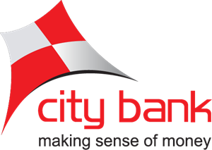

The City Bank was established in 1983 and still running so smoothly, has been a case study in evolution with pride. It has transformed so much from a traditional banking to a critically acclaimed multi-faced organization that focused on global best practices and always welcomes the technological developments and uses it in the banking services with more innovations. It has total 130 branches running all over Bangladesh, a working number of 3858 employees with over 1700000 customers. It is the sole franchisee of AMEX in Bangladesh. The city Bank has been awarded so many times as the best bank in BD, Best Investment Bank, best for premium banking services in Bangladesh and for many more reasons.

1.3 Objectives of the Study
Broad Objectives
The primary objective of this report is to complete the requirements of the internship program and explain the position of women banking and services of City Bank by exploring City Alo; the women banking branch.

Specific Objectives
- To explore CITYALO; the women banking branch of city bank
- To analyze the bank perspective towards women development
- To analyze the customer growth by women banking branch
- To relate theoretical learning in working area
- To explore the services available for women in the organization

1.4 Rational of the study

The report is prepared as a part of my internship program. The main rationale of the study is to enhance my knowledge on an origination in person by working there with a time specifications. Another reason of this report is to find the importance of women banking involvement in Bangladesh and the future necessity of women banking in our economic development.

1.5 Scope of the study

- As an intern it was an opportunity to see and collect all data in person
- Got a practical knowledge about the environment of the organization
- Data collection was easier as the staff and employees are much cooperative
- Responded and collected data were very helpful for the report
- All form city bank responded very well
- Any information needed from other branch got collected so fast by the supervisor help and cooperation

1.6 Limitations of the study

- The report is developed in a very short time period,
- Unable to cover all the sectors of the city bank
- Lack of skill and experience before in banking industry
- The appointed branch and women banking branch distance was very long
- Appointed on legal division of city bank where all seniors were lawyer who have a low knowledge about basic banking
- Some data were confidential and for safety city bank didn’t enclose this with their interns.
- There is no specific monetary fund to regular visit the corporate office of women banking
- As appointed branch and women bank branch are different, it was difficult to visit that branch regularly.
- Lack of experience made the collection of information lengthy and time consuming.

“Methodology”

02. Methodology of the Study
Data collection process:
The information of the report has been gathered in ways which can be classified as primary and secondary data. The basic collection of facts is treated as data.

- Primary data collection:
- Personal experience by meeting and greeting the customers from woman bank of city bank
- Face to face interaction with the staff and managers of the bank
- Personal investigation by talking with the desk employees.
- Collection of data through observing the behaviors of customers.
- A questionnaire through telephone to other branch

- Secondary Data collection:
- Data necessary from the website of city bank as well as from the website of city Alo
- Papers and files from the bank
- Books from library
- Other websites on women banking
- Annual report of city bank
- Entrepreneurship program of City Alo

Most of the data are collected in person as there was an opportunity to work with them practically and gather information directly from the customers and managers of the bank.

“Organizational Background and Industry Perspective”

03. Organizational Background and Industry Perspective

3.1 Background of Banking Industry
After independence in 1971, the banking industry of Bangladesh were enclosed with two branch offices of the former state bank of Pakistan with 17 large commercial banks, where some were controlled by foreigners. Immediately after independence the Bangladesh bank became the central bank of Bangladesh by the new government. The bank was responsible for the basic banking and financing work of Bangladesh.
Banks are the lungs of the financial system of Bangladesh. We cannot skip this thing in any matter when it is the matter of economical discussion of Bangladesh. The Bangladesh government has taken various and different types of effective and positive programs to make our baking sector more reliable and sound. We cannot ask for credit for performing economic activates without banks. The different segments of banks are influencing the different sides of the economy and enhancing it through the development.
3.2 Background of City Bank
The city bank is one of the oldest commercial banks in Bangladesh and running till now with much efforts and profits. Since 1983 with an authorized capital of Tk. 1.75 Billion the city bank is operating under the entrepreneurship of twelve young prominent & leading businessman of the country while their bravery and courage worked. The first branch of city bank is B.B Avenue Branch which is opened In Dhaka city with starting the journey of city bank on 27th March 1983. It was the effort of 13 local businessmen who became the entrepreneur and who braved the huge worries and risks with courage and interest that made the establishment and onward march of the bank possible. The capital and reserve were not that much at that time for them it was only 3.4 corer worth of capital, which now a respectable taka 330.77 corer. City bank was not among the banks that usually followed the traditional or decentralized based business where city bank followed a great it based strong backboned business. They followed real time banking, with segmentation in customers. City bank always focused on the millstone set for becoming the complete bank in Bangladesh.

3.3 Mission, Vision & Values of City Bank
Vision:
- The Financial Supermarket with a Winning Culture Offering Enjoyable Experiences
Mission:
- Offer wide array of products and services that differentiate and excite all customer segments
- Be the "Employer of choice" by offering an environment where people excel and leaders are created
- Continuously challenge processes and platforms to enhance effectiveness and efficiency
- Promote innovation and automation with a view to guaranteeing and enhancing excellence in service
- Ensure respect for community, good governance and compliance in everything we do
Core values:
- Result Driven
- Accountable & Transparent
- Courageous & Respectful
- Engaged & Inspired
- Focused on customer delight

3.4 Management and Focus of City Bank

The management committee of city bank consist of Managing Director and CEO, Additional Managing director, head of wholesale banking and head of SME small and micro finance, DMD, head of commercial trade and medium business, chief financial officer, chief operating officer, chief information officer, senior executive vice president and cluster head, RMG and textiles, chief risk officer, head of internal control and compliance, head of CRM and sustainable finance, head of legal, head of retail banking, head of human resource, chief economist and country business manager, company secretary and head of treasury.
City bank mainly focuses on winning the financial supermarket where they can provide the best experiences to the customers, though they focus on different social activities to make them mostly reliable and ethical. Like, Fighting Against Terrorism. By providing 50lacs city bank supported DMP safeguard on their project for the safety of people and properties of Dhaka city.
Even every year city bank stands beside the nation by contributing for the change in natural climates as well as to the government as the CSR activities. Through the support in disaster management, supporting the society, promoting science, literature to the society and schools and many more. City bank is giving importance continuously to win the customer heart with their social responsibly and offers and experiences to their valued customers. City bank have already 369 ATM+CDM, where they are providing seven priority centers and 2 airport lounges and their main focus on woman banking is more interesting where they are providing a totally different place for the woman to experience banking sector in a different manner which is CITYALO.

3.5 Operational Activities of City Bank

City bank limited is currently can be classified doing their activities in three parts by providing the loan and advances, doing the general banking and maintaining the foreign exchange dept. they are also following their online banking in every operational activities. As they are maintaining city bank explore which can be used from any place by the current employees with much confidentiality. They have also came up with a new software called ULIS which is basically a software where every legal documents and information are posted for the legitimate work as well as they are always operating in the help desk of city bank which are just before a call to16234 . So the basic operational activities can be divided as
- General banking
- Loan and advances
- Foreign exchange
- Online help

3.6 Services and Products

Currently CBL city bank Limited is providing different types of services to the customers;
- General Banking
- Retail Banking
- SME Banking
- Corporate Banking
- Women Banking
- Islamic banking
- Loans and advances
- Export-import
- Remittance
- Online banking

3.7 Organogram
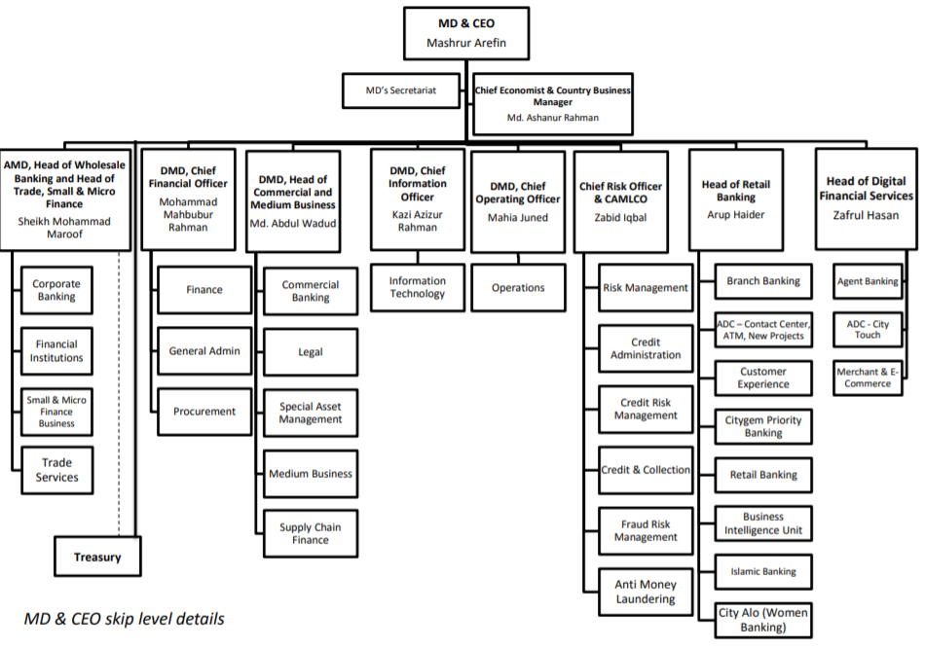
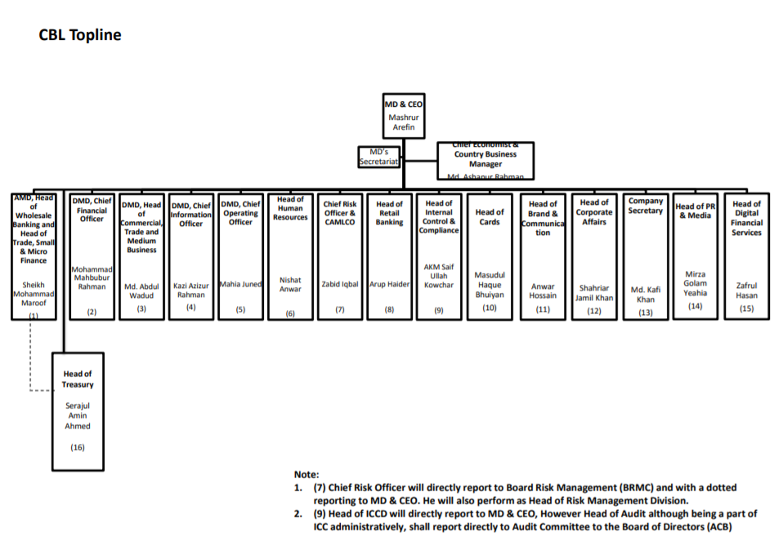

3.8 SWOT

3.9 Objective Analysis
The total process of internship offered by city bank and reported to United International University took me as a student in a process of studying practically in an organization and develop my practical knowledge by using my theatrical knowledge. The objectives that coved by the total process of my internship and report submission are calcified below.

3.9.1. Professional skills gathered practically in an organization

The process of my study by doing internship in city bank provided me a professional experience where it was easy to gather the knowledge that has been introduced me to my university throughout the theoretical basis. It helped me to learn the professional skills practically. It helped me to learn the skills are communication, collaboration, time management, adaptability, critical thinking, research and analysis, technical proficiency and many more.
- Communication
- Collaboration
- Time Management
- Adaptability
- Critical thinking
- Research and analysis
- Technical proficiency

Communication happened there in two ways written and orally. This skill is very much necessary in any sector to accomplish any process. The written communication was developed by different type of professional email processing and to talk with different clients from different places. The interview process and CV processing also can be included here as communication to enter to CBL as an intern.
Collaboration is a professional skill that has been built through collaborating with other interns and other employees, it is important to have the communication skill here to collaborate with other people for the sake of the company, bank “city bank”. It is necessary to set us towards the same goal to achieve it; it helped to learn how to collaborate with others and contribute the best to the bank.
Time management is the thing that’s most important in any professional place and even in personal life, through the internship process the time management has been taught very perfectly by city bank here. Through the 10-6 job holding position for three months taught how to manage time perfectly. The projects and assignments given by city bank always had a dead line to complete; even the data entry had a particular time period where I have to submit that completed.
Adaptability is a skill that is necessary banking sector to work as a multitasked. This study has been taught to be adaptable and wear multiple hats at a same time and to see works as goals.
Critical thinking refers to the ability to analyze a situation and evaluate this for a judgment. City bank as a professional field make me more organized in critical thinking which made me easier in thinking critically and give suggestion in proper way. The movement of thinking critically can be described as asking questions more and more to understand any problem. City bank gave me a platform to make me think more critically.
Research and analysis is a skill that should be achieved by any intern as city bank gives place to analyze any situation and give a judgment which basically makes the intern more effective in their analysis process and develop it in a way that will help them in their future professional areas.
Technical proficiency is basically too able to navigate the productivity in computer; where city bank given the duty to entry different types of data in software named ULIS.
- To analyze the customer growth by women banking branch

3.9.2. Relating theoretical Learning

Besides having many theoretical knowledge through learning in educational Institutions City bank gave a platform to use those learning practically. Where self-evaluate is literally a process to evaluate your own abilities and skills and value it or improve it. This evaluation can give an intern to learn in an organizational level. The professional works submitted and done by me for city bank was basically gave me a platform to self-evaluate. It is the process to commit and identify own qualities and issues that can be helpful later and definitely which can be improved for further better results. For a fresh graduate it is really important to recognize the abilities usually they are carrying for achieving their goal in an organization. City bank gave a place to self-evaluate in a way of three months where I could learn from my weakness and able to know about my hide abilities like my communication skill and about basic computer knowledge, it is the place where I could clearly find the areas where I need to do better and I need to improve in the running era. Theoretical learning cannot be fulfilled by practical guidance so it was recognized by the internship period.

3.9.3. To explore things related to an organization

An organizational experiment refers to the opportunity that’s given by the organization for knowing and exploring things regarding the organization. The city bank made a platform which gave a place to explore things related to an organizational environment, culture, and methods of practical knowledge. Things related to city bank like working methods or process of financing and so one should be known by an intern after completion of the internship as this is the place where they got direct chance to explore about banking sector as well as about City Bank. It is not possible for a fresher to get knowledge about professional communications through only academic knowledge rather than any organizational exploitation. City bank helped to learn about the professional communication, networking necessity as well as how to take constructive criticism in a well manner. It helped to learn the necessity of doing things more responsibly as the things around belongs to the bank only. It made more responsible to act in nature. Importance of a person should be acknowledged through the internship as every person is important when they can provide something and give something to the organization. It is necessary to be appreciated at the basic level of performance in internship as it is the first step of the future ladder. Exploring the organization like city bank gives a place to learn how they act and how they proceed which made me more responsible in many ways.

3.9.4. Knowing about an organizational culture, behavior, ethics, values and terms

As an intern only by academic knowledge and environment it is not possible to gather information about the basic culture terms ethics and values by an organization. Internship at city bank provided the chance of knowing about the ethics they follow, the terms they believe when they are serving a customer, the values they usually maintains and the environment that made the corporate culture more reliable. Ethics is an undivided part of an organization where in city bank it is maintained in a way of conduct which results good governance. It is basically a well based standard that is followed by people about choice of right and wrong. It is used usually in terms of rights, obligations, and benefits to society, fairness, or specific virtues. Where we talk about the organizational values in city bank it describes the core ethics and principles which the bank always maintain whatever the situation is and they also inspire the other employees to give their best efforts and constrain their actions. This maintained culture made city bank a place of positive environment where they maintain their norms culture and ethics in a well manner which results the behavior form the employees to the customers.

3.9.5. To explore the women banking sector position of the organization

By the internship period it has been always seen the equal position of women in the organization, CBL with men. Form the employees to the customers and even in top management it has been shown the importance of equality. Calculating the things offered by city bank it is now clear that they usually give preference to their woman customers as the way they give to a male customer. Doing internship in legal division of city bank it is almost harder to see any female employee working in the field of courts but again after analysis it has been clarified that there are many female lawyers are appointed in the bank with highest dignity and working position. And lastly when we talk about the branch named City Alo, through which they only serves the female customers who can be a mother, a house maker or a working woman.

3.9.6. To explore CITYALO, the women banking branch of city bank

City Alo offers its customer a unique working environment where they provide unique banking experience at the city alo women branch located at shanta skymark tower, Gulshan Avenue. Customers can just walk into the branch, grab a cup of coffee, relax in our lounge-type banking area and get their banking requirement met by the relationship managers. It is basically is the part of city bank women banking experiment where the women customers gets the most excellent services and actions related to their problems. City bank’s dedicated women banking division is city bank’s city alo.

City Alo Vision
- To empower women in Bangladesh to reach their true potential by being a trusted partner and thus become the ‘Bank of Choice’ for women

City Alo Mission
- To empower our women customers by giving financial assistance and support with specially designed savings, loans and other financial products
- To create a thriving community of women entrepreneurs in Bangladesh by offering a specially designed certified course with North South University developed only for budding women entrepreneurs in Bangladesh
- To accelerate our women customers professional lives by providing expert financial knowledge and advice through the City Alo website
- To connect and inspire women across Bangladesh by celebrating women achievers in Bangladesh


Currently city alo the women banking branch is providing four type of accounts
• City Alo General Savings Account
• City Alo High Value Savings Account
• City Alo Savings Delight Account
• City Alo Visa Debit Card
City Alo Loans Services:
SME S loan is Available for small-sized businesses operating in trading, manufacturing, services, non-farm activity, agriculture and agro-based industries, City Alo SME Small Loan is offering to the new women entrepreneurs to grow their business with more flexibility and cin a convenient way.
Personal loan: city alo provides personal loans to the extent where whatever the dream is or whatever the occasion is doesn’t matter, only the customers’ requirements matters.
Auto Loan: owning customer dream car is easily now with city bank auto loan for women to experience the most beautiful banking culture.
Home Loan: When you decide to own your home, we will help you make your dream come true by providing this service especially for women to experience to the maximum to make it true in nature.
City bike loan: to make the customer life speedy the city alo provide the city bike loan.
City bank’s women banking branch city alo provides two types of card services, one is city alo visa debit card and another is city alo amex credit card. The offers and benefits from city alo visa debit card are huge as it gives the bundled offers with exciting features. It gives the instant cash back facilities and discounts form selected merchants and also provide the privilege offers form various outlets across the country. Where the city alo amex credit card is made on the preference of women form the society. Any working class women will surely want to have this card in the basis of focusing on financial health and personal choices. It gives amazing vouchers and offers and discounts throughout the year where women can experience the most with it.
City Bank also provides the goals based DPS account where it give the great way to secure the financial future through flexible tenure. The interest rate is ranging from 6.50% to 8.00% and the monthly installment can be form BDT 500 – BDT 50,000.
City alo also provides a certification course to the general students to know how to start a business and to gather information about women banking and so one. City Bank and North South University have collaborated and developed a entrepreneurship course for potential and existing women entrepreneurs.in this course the students will receive exclusive entrepreneurial training and networking opportunities which will help them to gain skills that can be helpful to evaluate their personal and professional life.

3.9.7. To Explore the bank perspective towards women development

City bank has always been a bank who wanted to contribute in women sector. City alo has been a project for city bank whom with they directly given a position in Bangladesh for the women to enhance themselves with adding up their financial services.
City Bank has recently announced the launch of its dedicated women banking business division - ‘City Alo’ which is only dedicated to serve the women customers. With City Alo, the bank wants to ensure that every woman in Bangladesh will have access to financial products and services as well as every woman in BD who are not flexible to banking sector can easily transact through city alo.
City Alo targets four segments of women customers. They are women entrepreneurs, woman salaried employees, homemakers and women professionals like doctors, teachers and engineers. With City Alo products, customers will get free insurance facility, health card with discounts at clinics and hospitals across Bangladesh. For personal, auto, two-wheeler, home or SME loans, City Alo customers will enjoy reduced interest rate and lower processing fee.
City Alo customers can also open a goal-based DPS Account of flexible tenure. City Alo goes beyond conventional branch banking. Customers can walk into City Alo flagship branch, grab a cup of coffee from Gloria Jean’s Coffee Shop operates inside the branch premises and get their banking requirement met by expert relationship managers. Customers also avail banking services at City Alo Service Points available at 32 City Bank branches all across the country.
City Alo, also offers ‘City Alo certification program’ in partnership with North South University and International Financial Corporation (IFC) advisory services at a subsidized fee to enhance the financial literacy of women entrepreneurs. Online dedicated platforms are also arranged where customer can have more knowledge about city Alo services and can be connected.

City Alo was launched through a grand event hosted at its flagship women branch in Dhaka. The launch event was attended by Bank’s Chairman Aziz Al Kaiser and directors - Tabassum Kaiser, Syeda Shaireen Aziz, Savera H. Mahmood, Managing Director and CEO Mashrur Arefin, IFC Bangladesh Country Manager Wendy Werner and others. Former Advisor to Caretaker Government Geetiara Safya Chowdhury and Rokeya Afzal Rahman were also preset among others.

3.9.8. Policy of Savings Account and Fixed Deposit under City Alo service

Earn Up to 4.5% in Savings Account by City Alo Account
- Suppose the Initial savings is 500
- Length of investment 1 year
- Annual Interest rate 4.5%
- Monthly deposit 1000taka
- Total Amount deposited: 12500 Taka
- Interest Earned 319.53 Taka
- Total 12819.53 Taka
Earn Up to 9.5% in fixed deposit by City Alo Account
20,000 Fixed Deposit | 5 Year Period
9.5% Interest rate | At Monthly Compounding Frequency

Suppose the fixed deposit amount is 20000 taka. It’s the policy for 5 years which gave 9.5% interest rate which is higher than other banks at monthly compounding frequency.

Year | Opening Balance | Interest Earned | Closing Balance
1 | 20000 | 1985 | 21985
2 | 21985 | 2182 | 24167
3 | 24167 | 2399 | 26566
4 | 26566 | 2637 | 29203
5 | 29203 | 2898 | 32101
Through this approximate analysis we can find that after 5 years it can give a high interest.

“Findings & Analysis”

4.0 Findings and Analysis:

4.1 Customer Growth in 2019 in City Alo Service

There are a total 32 branches where the city alo services are provided to women customers for their development. From March 2019, after the launch of city alo service women from different places of the country made their accounts in city bank. The growth is high where these women were not included with any banking services. The total new customer of city alo service are 532 from all over the country as well as there are many other customers who are related with other services from city alo branch of city bank.

For city bank it’s a great achievement to make 532 new members of city alo service as well as to give them this service and make them involved with banking sector. City Alo service came in Bangladesh with a great vision to involve women sector with the banking area and give them a way to be an entrepreneur. From the beginning in 18th March 2019, city Alo came into knowledge to different types of women in Bangladesh. Where they thought to take services form City Alo- City Bank. From the March 2019 to April 2019 the total new accounts were 91, as at that time the service promotion was not that much displayed. Moving to the second month city alo got new 96 accounts from women from different sectors. The last information collected from Motijheel city bank that there were total 132 new accounts what makes us clear that the accounts involvement what makes the women involvement with banking sector is increasing month by month. The expected accounts to be opened till the month of December 2019 are as high as city Alo is also promoting themselves with different events.

4.2 Women Entrepreneur Involvement by City Alo

City Alo – the women banking branch of city bank with their main service which are the city alo accounts and with the certification course of city alo, main focus is to develop the women sector.
City Alo Entrepreneurship program fair was held on 28 and 29 September 2019, where 12 shop came in knowledge with their products to display and they became entrepreneur with the help of city alo service. This women entrepreneurship program basically aims to help to expand the business of women all worldwide. More than 200 women took participation in this program related to entrepreneurship. The visitors also could came here with free of cost which makes people understand that city alo aims to increase the understanding of entrepreneurship in case of women. This fair gave chance to women entrepreneurs to get with their variety of products under one roof. It gave also chance to connect with other entrepreneurs and customers as well.
Sheikh Mohammad Maroof, Additional Managing Director, City Bank Ltd, along with Mariam Javed Juhi, Head of City Alo - Women Banking, inaugurated the fair on September 28.
The participants of the fair are the 40 students who are graduated from the City Alo Certification course from city bank especially for women. They came up with total of 12 shops including their different types of products and services. The course was developed in partnership with North South University and with the support of International Finance Corporation (IFC)
Available Products:



“SHE LEADS”
On May 11, 2019 JCI Dhaka East came up with an event associating with City Alo called SHE LEADS which aims to acknowledge the female sovereignty. In this venet the main objective was to discuss and show the diversified options for women in workplace. Through different sessions by entrepreneurs from different place of Bangladesh shared their experiences and the challenges they have faced during their working period. It was an informative session by CITY ALO which gave aspiring women entrepreneurs to think about their available resources, legal options, financing models and regulations. “She Leads” is a platform to recognize and promote women entrepreneurship in Bangladesh and acknowledge their contributions in helping the country’s economy to move forward this event also included the financial and non-financial services offered by city Alo to the women entrepreneurs of Bangladesh. .
SHE LEADS by City Alo has begun with the motive to see women entrepreneurs in the future doing work with prosperity and which is contributing to the social, economic and environmental development of Bangladesh.

4.3 City Alo AMEX Card Services
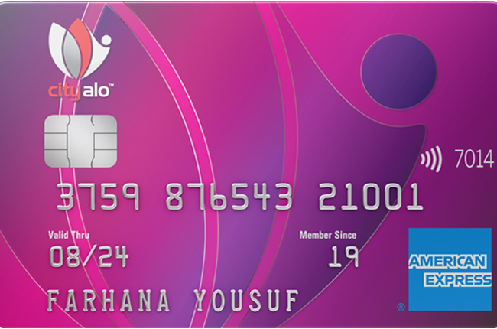

Welcome Benefits: | Complementary stay at Green View Golf Resort, Gazipur  many facilities for customer and family
Get one of these two offers
- Tk. 1,000 voucher at Persona Hair & Beauty Ltd.
Or
- Tk. 1,000 cash back on your first with purchase at Sheba.xyz

Cash back on all Purchases: | - Get Tk. 1.5 cash back on every Tk. 100 spent online  - Tk. 1 cash back on every Tk. 100/USD 2 spent anywhere else.

Complimentary companion buffet: | - Dhaka Regency Hotel & Resort  - Long Beach Suites Dhaka  - Six Seasons  - The Way Dhaka

Healthcare Benefits | The City Alo American Express® Card is giving you a huge healthcare support and benefits in hospitals in Dhaka.

United Hospital Limited: | - 10% savings on all radiology and imaging tests  - 5% savings on cabin charge for in-patients  - 35% savings on full body check-up packages  - 20% savings on all pathological tests

Labaid Cardiac Hospital and Labaid Specialized Hospital : | - 20% savings on all pathological tests (except PCR, DNA, RNA)  - 10% savings on all imaging tests  - 10% savings on room charge/bed rent

Telenor Health (Tonic): | 15% cash back on all packages available on the Telenor Health website

Access to City Bank American Express® International Lounge

At Hazrat Shahjalal International Airport, Dhaka service available at lounges with providing food, drinks and luxuries. Even 50% discount is available for the Customer and family when they are visiting up to 5 times a year.

Enjoy up to 33% on shopping, dining lodging on AMEX card of City Alo.

“Experience during Internship period”

5.0 Experience during internship period

I was appointed in legal division of city bank, 10 dilkusha, motijheel, Dhaka, where I have gained practical knowledge and experience by a working environment. It was an amazing opportunity to work with City Bank which is a leading bank in Bangladesh. I have worked there with software named ULIS. ULIS is software which is specially customized for legal department of city bank. In this software they usually keep the report of different cases and information regarding cases by the bank and against the bank.
As it was a first experience in the professional working area, it was pretty tough to expect anything. But with the help of my colleagues and other employees it was mostly easy and approachable to work in city bank. Apart from working area city bank helped us to join many indoor programs by the legal division which made an environment to meet with different personality of city bank and to make new bonds for future network.
If it is about learning then I will surely describe about my learning in each of the day in those three months. Few things are really crucial in professional world to work in and those are time management, communication, behavior, personality and lastly working hard is really important. During my internship it has been seen clearly that the bank is giving much importance on time, we used to punch our ID card when we are entering into the bank so it usually keeps record of our punctuality which directly made me much punctual. When it comes to communication, it was an important thing to know when you are working in an organization. Sometimes I have deal things with my colleagues and sometimes with my bosses, even sometime I have to deal with different type of messengers to covey massage.it was a great place where I got chance to communicate with different personality as well as with different sector of banking. Like branch banking, retail, SME banking. And lastly during my internship period I have automatically learned about behavior management with different personality at a time. I have acquired many skills through my internship and learned to apply those in different way in City Bank. Besides all of this city bank made a great platform for me to work anywhere in the near future. It just not gave me a platform to gather skills only but also it gave me the opportunity to make myself more eligible for a working place.
Lastly I am very much thankful to City Bank, who gave me an opportunity to work with them and learn many things which was not possible to acquire without practical environment like City Bank.

“Conclusion & Recommendations”

6.1. Conclusion

City bank as an organization has earned a reputed position in the banking industry in Bangladesh. Compared to other banks and their services city bank is now and even before they were giving the services with well structure and higher quality. City bank has become a well tech based bank who always tried to go with the technological advancement. It is relentless in pursuit of business innovations and improvements in all sectors. With a superior HRD they are working on their various sites to develop themselves to develop others. Through their maximum efforts city bank is only bank who is giving the service of American express along with other services.

Accordingly city bank has started its journey in women banking sector where they are known for best choice of any women who has interest on banking sector. City bank has created a platform for the women customers in a manner that is offering few same benefits and few new benefits with different features included with maximum support by the bank itself.

During the internship program I have tried my best to gather information related to this field of women banking but as I was assigned in the legal division of city bank it was pretty difficult for me to get all the information in person. But at last form the internship period it should be mentioned that my supervisor and other employees working in legal division have helped me a lot to know more and more about the position and respect towards the women employees and women customers.

6.2 Recommendations

- New Branch involvement of city Alo women Banking Services
Only 32 branches all over Bangladesh has the city Alo Service, more involvement can be possible
- City Alo Application Launched can be possible
City Bank has its own application named Citytouch, which makes transaction easier so in case of city Alo services as it has many offers, an application can be launched.
- Advertisement and events can be possible to promote city Alo women banking service
As it has only one branch in Gulshan, many potential customers do not know about the benefits and offerings of this service so the promotion can make this available to many customers.
- Online registration offering can be possible to make the service more lucrative
- New associations with different organization to give more facilities to the users.

07. Appendix
References:

- The following web site was accessed on
10th July 2019 | www.thecitybank.com
13th August 2019 | www.thecitybank.com
15th August 2019 | www.thecitybank.com
29th August 2019 | www.thecitybank.com
10th September 2019 | www.thecitybank.com

- The following web site was accessed on
10th July 2019 | www.cityalo.com
25th July 2019 | www.cityalo.com
12th August 2019 | www.cityalo.com
15th August 2019 | www.cityalo.com
9th September 2019 | www.cityalo.com
14th September 2019 | www.cityalo.com

