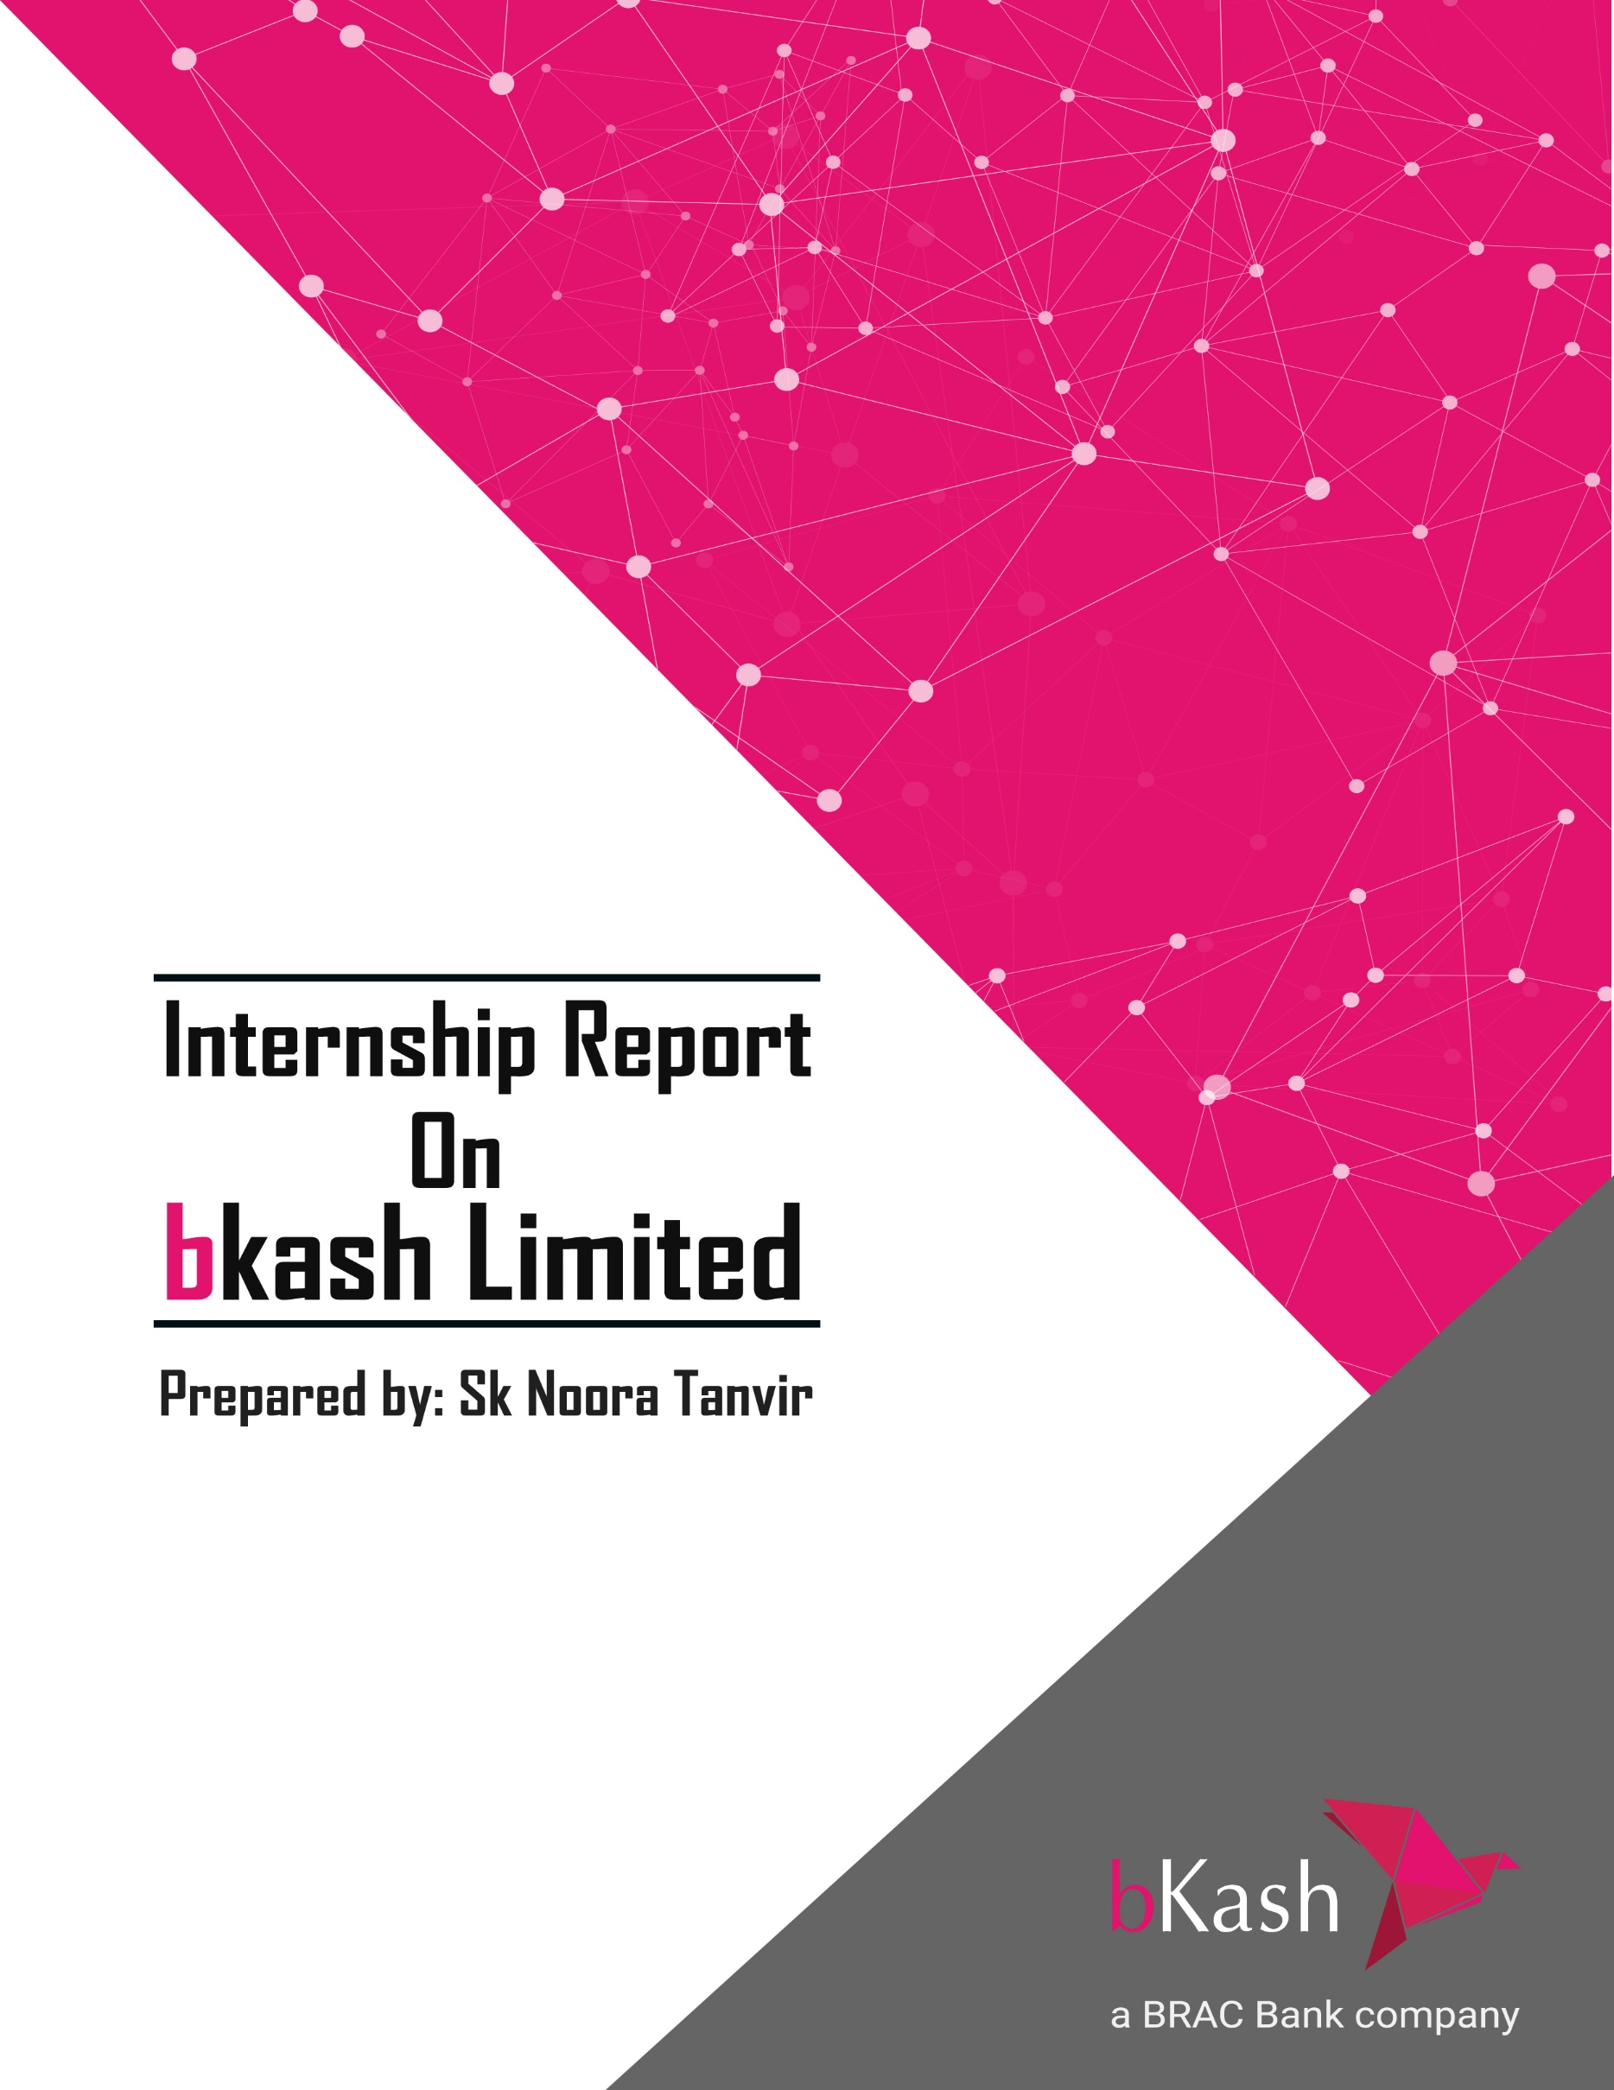

Internship Report
on
Financial Performance Analysis of “bKash Limited”

Submitted to:
Muhammad Enamul Haque
Assistant Professor – Finance
School of Business and Economics
United International University

Submitted by:
Sk Noora Tanvir
ID 111 171 245
Major – Finance
Program:BBA
School of Business and Economics


United International University
Date of Submission: 9th June 2021

Letter of Transmittal

9th June 2021
Muhammad Enamul Haque
Assistant Professor – Finance
School of Business and Economics
United International University

Subject: Submission of internship report on Financial Performance Analysis of “bKash Limited”.
Dear Sir,
With due respect, it is an honor for me to present my report titled Financial Performance Analysis of “bKash Limited”. I have collected information from the internet and books and am thankful to the websites which provided me the information for preparing the report. It was a great experience for me to do the report on such a topic. If you have further queries regarding the report, please let me know.
I hope that this “report” will be able to match your expectations.
Sincerely Yours,


Signature

Sk Noora Tanvir
ID: 111171245
Dept: BBA (Finance)
School of Business and Economics
United International University

Acknowledgment
First of all, I would like to thank the Almighty Allah for blessing me to complete the assignment in a safe and sound mind.
Secondly, I want to express my gratitude to my instructor, Muhammad Enamul Haque, Assistant Professor – Finance, School of Business and Economics, United International University. Enamul sir provided me continuous guidance and support and constructive observations throughout the report. His support, encouragement, and availability to discuss ideas and problems have contributed much to complete my report. I am also grateful for getting a chance to work in a department such as “External Affairs” in “bKash” and for getting the opportunity to work with such wonderful individuals. With the former in mind, I take this opportunity to express my deepest gratitude and special thanks to F.M. Tonmoy, General Manager, “External Affairs”, Md Mashuqur Rahman, Manager of the FDM “Fraud and Dispute Management”, Md Ariful Haque, Saif Sibgatullah, Ayman Hossain, Amir Hamza who, despite being extraordinarily busy with their personal tasks, they all took the time to guide and keep me on track and allow me to carry out my internship at “bKash Limited”.

Executive Summary
The report is about the Financial Performance Analysis of “bKash” Ltd. at “Shadhinata Tower”. I got the opportunity of four months with a trustworthy institution. The report starts with a company profile of “bKash”, where “bKash Limited” is a “Mobile Financial Service” company which was launched in 2011 as a subsidiary of Brac Bank Limited which was granted permission by the Bangladesh Bank. Then the following chapter shows the vision and mission of the company and also the corporate divisions. The third chapter includes the activities of “bKash”. How “bKash” works, the “CSR” activities are done by “bKash Limited”. And also, the organizational structure of “bKash” is followed by the “SWOT” analysis. It shows that the biggest strength of “bKash” is the number of the customer base as well as the number of agents. It has a first-mover advantage. However, “bKash” also charges more send money fees compared to its competitors. And also, Over the past few years, there has been an increase in fraudulent activity. If “bKash” takes it lightly, then it would be very difficult for “bKash” to gain customers in the long run after SWOT analysis comes to the Yearly performance analysis. For that, I chose ratio analysis, and it showed promising results. According to the calculation, the overall performance of “bKash” does not seem to be good as it is facing losses for two consecutive years, mainly due to rising operating costs. Next, in the last part of my report I wanted to make a comparison between “bKash Limited” and Brac Bank Limited as it is the parent company of “bKash Limited”. Where bKash lies only about 16% in terms of asset and about 15 % of the liabilities of Brac Bank. The results seem that “bKash Limited” only holds a minority in the parent company as such huge changes in the yearly stats of “bKash Limited” does not seem to affect Brac Banks yearly stats at all. Even more, Brac Bank made a higher profit than the last year when “bKash Limited” made the highest loss.

Table of Contents
Cover Page I
Letter of Transmittal II
Acknowledgment III
Executive Summary IV
Chapter – 1 (Introduction) 1
1.1 Company Background. 2
1.2 Origin of the Study. 2
1.3 Objective of the Report. 3
1.4 Methodology. 3
1.5 Scope of the Study. 3
1.6 Limitations. 3
Chapter – 2 (Overview of bKash Limited) 4
2.1 Mission. 5
2.2 Vision. 5
2.3 Corporate Divisions 6
2.4 Transfer of Money 7
2.5 bKash App: 8
2.6 Organizational Structure of bKash Limited. 9
Chapter – 3 (Qualitative Analysis) 10
3.1 SWOT Analysis: 11
Chapter – 4 (Quantitative Analysis) 13
4.1 Financial Performance Analysis of bKash Limited 14
4.2 Ratio Analysis 14
4.3 Comparison between Brac Bank & bKash Limited 23
Chapter – 5 (Discussion) 25
5.1 Conclusion 26
5.2 Bibliography 27

Chapter – 1
(Introduction)

1.1 Company Background.
“bKash Limited” is a “Mobile Financial Service” company. “Mobile Financial Service” means availing financial services and transactions with the help of a mobile phone. Therefore, this provides customers access to banking and other financial services.
“bKash Limited” is a “Mobile Financial Service” company which was launched in 2011 as a subsidiary of Brac Bank Limited which was granted permission by the Bangladesh Bank. “bKash Limited” is the first company to be launched as “MFS” which revolutionized the “Mobile Financial Industry of Bangladesh”. “bKash Limited” was granted licensed to be a “Financial Institution” by the Bangladesh Bank. The main aim of “bKash Limited is to provide low cost, safe and easy financial services to its customers. In order to provide the “MFS” bKash partnered up with the mobile network operators such as, “Grameenphone”, “Robi”, “Airtel” and lastly “Banglalink”. From its launch in 2011 to this day, bKash has about 50 million users that are registered. With the help of “bKash Limited” their customers can make transactions, paying utilities bill, recharging balance of mobile phones, do online shopping, make donations and lastly can also save money. Customers who have a minimum balance of TK1000 can enjoy about 4% annual interest, if they wish to save. In the recent times, bKash also introduced another service i.e., the remittance service. With the help of “Western Union”, which has affiliation with over 200 countries, the users of “bKash Limited” can receive money sent from other countries into their “bKash” account. As “bKash” has first mover advantage it has market share about 80% in the Bangladesh Economy. And also awarded as the No.1 “Mobile Financial Service” company across the globe.

1.2 Origin of the Study.
This report has been prepared as part of the fulfillment of the Bachelor of Business Administration(BBA) degree under the direct supervision of Muhammad Enamul Haque, Assistant Professor, School of Business and Economics. I analyzed the Financial Performance Analysis of “bKash Limited”. It is to mention that bKash is the number of one mobile financial services provider in Bangladesh.

1.3 Objective of the Report.
The main objective of making this report is to analyze the Financial Performance of bKash Limited. And also, to make a comparison of bKash Limited and Brac Bank Limited to analyze how much portion of Brac Bank, bKash Limited holds as a subsidiary to the Parent Company. Therefore, the report will be specifically made to provide a distinct image of the company itself about its performance as an individual and also as a subsidiary.

1.4 Methodology.
This report is made based on both theoretical and financial information, that is gathered from different websites including the “bKash Limited’s” own website along with Brac Bank’s Annual report site.
To analyze the Yearly “Financial Performance”, ratio analysis seemed the best way to measure the performance, given the number of resources in hand.

1.5 Scope of the Study.
I was assigned to the “Fraud & Dispute Management” team in the “External Affairs” department. Even though I was assigned to “External Affairs” my report includes the overcall company profile, SWOT analysis and the “Financial Performance of “bKash Limited”.

1.6 Limitations.
As I was assigned to the “External Affairs” department, it was a bit difficult to gather all the information’s than it would have been if I was assigned to the finance department. Only then I would have been able to depict a true picture of the financial analysis.

Chapter – 2
(Overview of bKash Limited)

2.1 Mission.
As it is the number 1 “MFS” in the globe its primary mission is to provide “Financial Services” to the peoples of Bangladesh at cheap, safe and convenient way possible. The aim of “bKash limited” is to increase the availability and opportunity of accessing the “Financial Service” and also to create a platform which will allow users of Bangladesh to commit safe transactions via “Mobile Financial Service”

2.2 Vision.
In Bangladesh about 1/3rd of the population lives in urban areas and 2/3rd of the population lives in rural areas. Since “bKash Limited” is situated in Bangladesh, the vision of “bKash’s” is to target the rural population of Bangladesh that does not have any access to the mainstream banking. This is the target segment of bKash.

2.3 Corporate Divisions
“bKash Limited” has several divisions, which are divided into different departments to carry out functions. The departments are then divided into several teams working together as a whole for the department. The divisions of “bKash” are shown below:

Figure 1: “Corporate Division” and its “Departments”
I got the opportunity to be an intern in the “External & Corporate Affairs Division” (ECAD), it is the largest divisions of “bKash”, with four departments divided into several teams. ECAD mostly works with “compliance”, “fraudulent activities” and works to mitigate risks associated with “bKash” and its operations. ECAD division of “bKash” follows the rules and regulations which is provided by the regulations of “Bangladesh Bank”.

2.4 Transfer of Money

- “Cash in”: Users can transfer money into their “bKash” accounts from “bKash” agents or ATMs. This does not incur any charge; the user gives money to the agent or transfers from ATMs; it automatically loads “e-money” into their “bKash” account.
- “Cash-out”: Customers can “withdraw” the amount they have in their account, and the withdrawal charge is generally TK 20 per TK 1000 of withdrawal.
- “Buy airtime”: “bKash” account users can directly buy airtime using any Mobile Network Operator using e-money from their account.
- “Payment”: “bKash” account users can also make payments to stores known as merchants' accounts directly through '“bKash” Payments.'
- “Send Money”: One “bKash” account user can transfer e-money to another “bKash” account using the “Send Money” option.
- “Remittance”: “bKash” has a strategic alliance with “Western Union” and “Mastercard” to enable the transfer of foreign remittance through “bKash” accounts, which is available 24/7, and people can send money from 200 countries to Bangladesh, which makes this service convenient for users to receive remittances.
- “Interest on Savings”: Customers who have a minimum balance of TK1000 can enjoy about 4% annual interest, if they wish to save.
- “Bank Transfer”: “bKash” account holders can transfer money from their bank accounts to their personal “bKash” accounts.

2.5 bKash App:
Before the launch of bKash app on mobile phones, users of bKash used bKash services through USSD codes through their mobile phones. bKash App for mobile phones was launched in 2018 to make transactions easier. With the help of the app users avail all the services that was available in USSD service along with more additional services like remittance service, adding money from credit card, making online payments and getting offers. Moreover, new users can open their bKash account with the help of bKash APP. Moreover, the cash out charges of users using app is TK15 per TK1000 whereas in USSD codes it is TK18.50 per TK1000. There are also more services that a user can avail with the help of bKash APP.

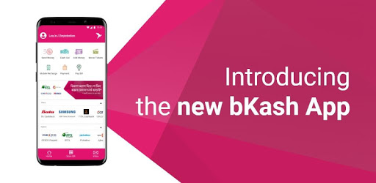

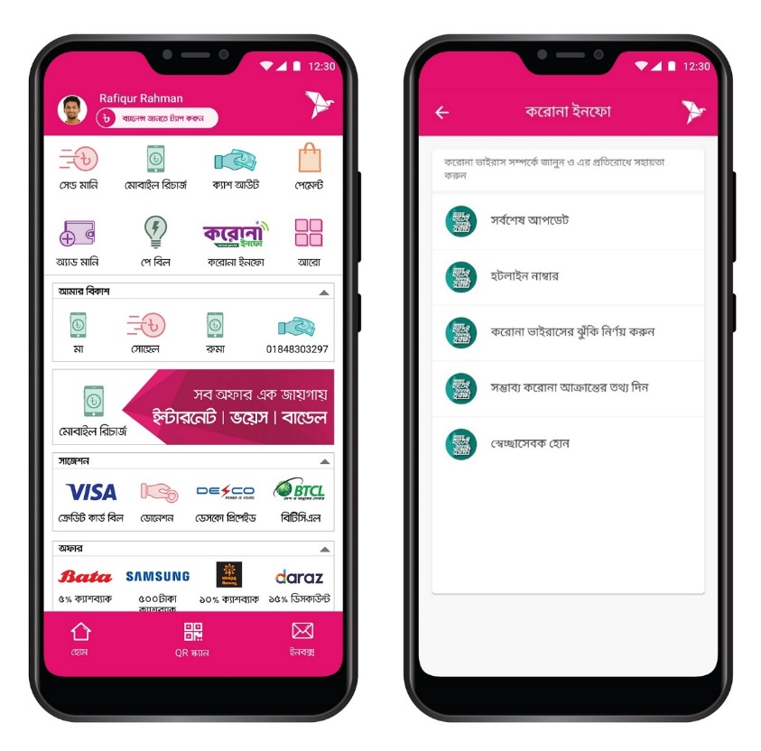

2.6 Organizational Structure of bKash Limited.
The organizational structure of bKash Limited is tall starting from Board of Directors to Officer Level. It is shown in a hierarchy manner below:

Chapter – 3
(Qualitative Analysis of bKash Limited)

3.1 SWOT Analysis:

In order to define and understand the firm’s condition. It would be wise to analyze the firms’ competitive aspects and also the general aspects of the firm in the “Mobile Financial Service” industry. Therefore, in order to depict the best picture of bKash’s current scenario, SWOT analysis is the perfect way to analyze firms’ competitive aspects and also the general aspects. This strategy is widely used throughout the world.

Strengths:
- First “mobile financial service provider” of Bangladesh.
- Has good relation with the only four biggest “mobile network operating” company in Bangladesh (“Robi”, “Grameenphone”, “Airtel”, “Banglalink”)
- Has Top-Notch Technology.
- Has a “first-mover” advantage.
- Has a wide customer base as well as a number of agents.
- 24/7 service
- Has a separate department for “Mistaken Transaction” and “Fraud” (“External Affairs”)
- The already established parent company (BRAC).

Weakness:
- “bKash” charges more send money fee compared to its competitor “Nagad”.
- The cash-out charge of “bKash” is higher compared to its competitor “Nagad”.

Opportunities:
- “bKash” target market is the rural people of Bangladesh who are deprived of banking by large “financial service providers”. As Bangladesh has a huge population, “bKash” has an enormous opportunity to expand its market share.
- Nowadays, due to “COVID – 19” online platforms like grocery shopping, online clothing, online food markets are getting huge customers. “bKash” can exploit this opportunity by affiliating with online shops and provide payment services. Therefore, more customers will be using “bKash” as a platform to make payments on online shopping.

Threats:
- Over the past few years, there has been an increase in “fraudulent activity”. If “bKash” takes it lightly, then it would be very difficult for “bKash” to gain customers in the long run.
- There are new competitors like “Nagad”, “Rocket”, “Upai” is emerging. Therefore, “bKash” has to be very careful and be efficient so that they can tackle this competition and lead in the market.

Chapter – 4
(Quantitative Analysis of bKash Limited)

4.1 Financial Performance Analysis of bKash Limited
In order to analyze the Financial Performance data of “bKash Limited”, I took information of 4 (FOUR) years from the annual report of bKash Limited. The source of information is the Statement of Financial Position & Statement of Comprehensive Income. Among all the calculation methods the “Ratio Analysis” is the best way to calculate a company's “Financial Performance”. And after that, there is also a comparison between bKash Limited and Brac Bank in order to analyze the significance of bKash Limited over Brac Bank.

4.2 Ratio Analysis
It is a quantitative method of analyzing the company's liquidity, operational efficiency, and profitability by analyzing its financial statements such as the balance sheet and income statement. Ratio analysis is a fundamental equity analysis. The ratios we included are:

4.2.1 Liquidity Ratios:
It is a financial ratio that is used to determine the company's ability to pay its debts without raising any external capital. The liquidity ratios include:
- Current ratio = “Current Assets/Current Liabilities”
It is a “liquidity ratio”. The “Current Ratio” is a measure of a company's current ability to pay short-term debts. It also indicates the investors as well as analysts on how to maximize current assets on the balance sheet in order to satisfy its debts.
Name of Ratios | Dec-31 2020 | Dec-31 2019 | Dec-31 2018 | Dec-31 2017
Current Ratio | 1.113063307 | 1.200098736 | 1.277190087 | 1.078168295

The current Ratio over the year from 2017-2020 is 1.08, 1.28, 1.20, 1.11, respectively. The standard ratio for a current ratio is 2:1. In 2017 the low ratio indicated that “bKash” was facing low efficiency and also having a bare minimum of current assets just to pay back its obligations. However, in 2018 & 2019, the ratio shows promising results and again fell in 2020.

- Working Capital = “Current Assets – Current Liabilities”
It is also called net working capital. It is the difference between current assets and current liabilities. It shows both effectiveness of an organization and also its monetary ability. A favorable “Positive” working capital indicates that the organization can pay its short-term obligations, whereas an unfavorable “Negative” “Working Capital” indicates that the organization cannot pay its “short-term” debts.
Name of Ratios | Dec-31 2020 | Dec-31 2019 | Dec-31 2018 | Dec-31 2017
Working Capital | 5,820,552,679 | 7,618,382,358 | 8,910,353,272 | 1,932,484,020

The working capital of “bKash” is low in the year 2017. However, it dramatically increased in the following year, which indicates that “bKash” is having profitable use of working capital. But it seems to have a declining trend after that up to the year 2020.

- Sales to Working Capital = “Sales/ Working Capital”
It indicates the turnover of the “working capital” every year. When a company’s working capital is low, it indicates an unprofitable use of working capital and vice versa.
Name of Ratios | Dec-31 2020 | Dec-31 2019 | Dec-31 2018 | Dec-31 2017
Sales to Working Capital | 3.963687616 | 2.793416488 | 2.16289273 | 8.028800783

In 2017, the sales to working capital skyrocketed compared to the upcoming years. It indicates that “bKash” was enjoying the supernormal profit. However, in the following year, 2018, the profit fell down dramatically, and the following years after that, the profits rose gradually, which indicates normal profit.

4.2.2 Leverage Ratios:
The leverage ratios show the proportion of the equity and debt with which the business's capital structure was formed. Common leverage ratios include the “debt-equity ratio”, “debt ratio”.
- Debt Ratio = “Total Debt/Total Assets”
It measures a company's maximum dept of leverage. It is the ratio of “Total Debt” to “Total Assets”, which is derived in percentage or in decimal format. The standard ratio should be below 1.
Name of Ratios | Dec-31 2020 | Dec-31 2019 | Dec-31 2018 | Dec-31 2017
Debt Ratio | 0.848919397 | 0.791615703 | 0.750355415 | 0.889557264

Overall, the ratios between 2017 – 2020 are below 1. It indicates that a large portion of assets is financed by equity. Which means the company has more assets than debt.

- Debt to Equity Ratio = Total Debt/Total Equity
It is used to calculate company's “Financial Leverage”. It is a ratio to which the company is able to measure whether the company is financed through debt or equity. Moreover, it also indicates the shareholders' ability to cover all its obligations if there's any loss. It is one kind of gearing ratio.
Name of Ratios | Dec-31 2020 | Dec-31 2019 | Dec-31 2018 | Dec-31 2017
Debt to Equity Ratio | 5.618983396 | 3.798826082 | 3.005694741 | 8.054466001

According to the table above, it is clear that the D/E ratios over the years 2017-2020 were above 1. It clearly indicates that “bKash” is using more debt than equity. Higher leverage ratios indicate that “bKash's” shareholders face high risk. In 2017 the D/E was the highest, and in 2018 it fell down by a great margin, but it is again increasing gradually. Greater D/E also suggests that “bKash” is able to enjoy high tax cuts.

4.2.3 Profitability Ratio
It is one of the important financial metrics that is used to measure the company's ability to generate income from “sales”, operations, etc. This ratio indicates how efficiently the organization creates profit and value for shareholders. A higher ratio indicates high profitability and vice versa.

- Net Profit Margin = “(Net Profit/Sales) * 100”
It is the measure of how much “profit” is generated as a percentage of sales. It also helps the investors to assess if a company is generating enough profits or not.
Name of Ratios | Dec-31 2020 | Dec-31 2019 | Dec-31 2018 | Dec-31 2017
Net Profit Margin | -0.03528108 | 0.029375369 | 0.009588728 | 0.031440611

Generally, among the four years, the net profit margin of “bKash” is low; it is continuously fluctuating. However, in 2020, the net profit margin is -0.04, which indicates that “bKash” is facing losses. Which if “bKash” management takes it likely, then it might take a severe unfavorable turn in this competitive market.

- Return on Assets = Profit After Tax/ Average Total Assets
It indicates that how profitable a company is relative to its assets. It also indicates how efficiently the company is using its assets to create income. The higher the ROA, the better it is for the company.
Name of Ratios | Dec-31 2020 | Dec-31 2019 | Dec-31 2018 | Dec-31 2017
Return on Assets | -0.013266306 | 0.012919025 | 0.004307974 | 0.01749342

The ROA is on continuous fluctuations over the years. The ROA fell by 0.3% in 2018, then again rose by a great margin, and in 2020 the ROA was negative. It indicates that the “bKash” was making losses in 2020.

- Return on Equity
It is a measure of financial performance, which is calculated by dividing Net Income by Equity. Higher ROE indicates that the administration is effective in using its value base and better return to financial specialists.
Name of Ratios | Dec-31 2020 | Dec-31 2019 | Dec-31 2018 | Dec-31 2017
Return on Equity | -0.087809459 | 0.061996153 | 0.017256428 | 0.158393573

The ROE is on continuous fluctuations over the years. The ROE fell by 14% in 2018, then again rose by a subtle margin, and in 2020 the ROE was negative. It indicates that the “bKash” was making losses in 2020.

4.2.4 Activity Ratios
The activity ratio is a financial measure that shows how “efficiently” a company is using the assets on its statement of financial position to generate revenues and profit.
- Total Asset Turnover Ratio:
It measures the value of a company's “revenues” with the value of its assets. The” asset turnover ratio” can be used as a measure of the efficiency from which a “company” is using assets to generate “revenue”.
Name of Ratios | Dec-31 2020 | Dec-31 2019 | Dec-31 2018 | Dec-31 2017
Total Asset Turnover | -0.01872275 | -0.030140646 | 0.003080356 | 0.025193466

In 2018, the Asset turnover fell by a great margin from 2017, and in the following 2years, the Asset Turnover is negative, leading to worsening the situation.

4.3 Comparison between Brac Bank & bKash Limited
To find out the performance of bKash Limited with respect to its parent company, lets compare the Financial Performance of Brac Bank and bKash Limited. And also, to find out how significantly the performance of Brac Bank changes when there is a chance in the performance of bKash Limited.
Calculation of Ratios (bKash Limited)
Name of Ratios | Dec-31 2020 | Dec-31 2019 | Dec-31 2018 | Dec-31 2017
Debt Ratio | 0.848919397 | 0.791615703 | 0.750355415 | 0.889557264
Debt to Equity Ratio | 5.618983396 | 3.798826082 | 3.005694741 | 8.054466001
Net Profit Margin | -3.53% | 2.94% | 0.96% | 3.14%
Return on Assets | -1.33% | 1.29% | 0.43% | 1.75%
Return on Equity | -8.78% | 6.20% | 1.73% | 15.84%
Total Asset Turnover | -1.87% | -3.01% | 0.31% | 2.52%

Calculation of Ratios (Brac Bank)
Name of Ratios | Dec-31 2020 | Dec-31 2019 | Dec-31 2018 | Dec-31 2017
Debt Ratio | 0.881874712 | 0.894643176 | 0.899694739 | 0.906905426
Debt to Equity Ratio | 7.465587821 | 8.491554143 | 8.969566832 | 9.741764602
Net Profit Margin | 39.90% | 37.54% | 41.04% | 43.22%
Return on Assets | 1.14% | 1.53% | 1.76% | 1.88%
Return on Equity | 9.67% | 14.51% | 17.53% | 20.20%
Total Asset Turnover | 2.86% | 4.07% | 4.29% | 4.35%

According to the calculations above, it seems that “bKash” tried to stay toe to toe with its parent company “Brac Bank” at the initial stage (2017) both the parent company and its subsidiary has a close debt ratio in 2017, “bKash” had 0.89, “Brac Bank” had 0.91, and it remained close over the years. However, in terms of debt-to-equity ratio, “bKash” has a more fluctuating ratio compared to Brac. In 2018 the debt-to-equity ratio of “bKash” fell drastically while Brac Banks changes slightly. If we analyze the net profit margin, in 2020, “bKash” net profit margin is -3.53%, i.e., loss but on the other hand, if we look at “Brac Banks” net profit margin then it rose from 37.54% to 39.90% from 2019 to 2020 Therefore, we can conclude from the overall calculation that “bKash” has very little to no impact on “Brac Bank”.
The proportion of bKash Limited in Brac Bank Limited
Name of the Ratio | 2,017 | 2018 | 2019 | 2020
Asset Ratio | 9.99% | 13.60% | 13.10% | 15.44%
Liabilities Ratio | 9.80% | 11.34% | 11.59% | 14.86%
Net Profit Ratio | 8.79% | 3.52% | 11.07% | -17.93%

According to the calculation above the detailed explanation of the results are given below:
- Asset Ratio: Over the years, the asset ratio of “bKash” with proportion to “Brac Bank” grew gradually. It indicates that the level of “bKash” assets in the “Brac Bank” portfolio is increasing gradually.
- Liabilities Ratio: The liabilities of “bKash” are also rising gradually. It indicates that the contribution of the liabilities of “bKash” over “Brac Bank” is gradually increasing. It may lead to a positive effect. An increase in liabilities can lead to a tax deduction.
- Net Profit Ratio: In this case, “bKash” lags in generating profit over the years, which is impacting Brac Bank’s overall Income statement. According to the table, it clearly indicates that in 2017 the profit ratio was highest among the four years. But in the upcoming years, it fell down drastically. Moreover, in 2020, “bKash” faced losses of significant value, which is clearly due to high operating costs and other expenses. If “bKash” is able to reduce these costs, then their performance will drastically improve.

Chapter5 – (Conclusion)

Conclusion

“bKash Limited” is the No. 1 “mobile financial service” company in the Globe. Despite having so many competitors, bKash Limited is still the No. 1 “Mobile Financial Service” company in Bangladesh. The aim of “bKash limited” is to increase the availability and opportunity of accessing the “Financial Service”. The vision of “bKash’s” is to target the rural population of Bangladesh. bKash is the first “mobile financial service provider” of Bangladesh. Therefore, it has first mover advantage and has good relation with the only four biggest “mobile network operating” company in Bangladesh (“Robi”, “Grameenphone”, “Airtel”, “Banglalink”). Upon doing the qualitative analysis I found that “bKash” target market is the rural people of Bangladesh who are deprived of banking by large “financial service providers”. As Bangladesh has a huge population, “bKash” has an enormous opportunity to expand its market share. And by doing quantitative analysis I found that the significant findings are the current ratio was the lowest in 2017, the working Capital was lowest in 2017 but skyrocketed in 2018 and then gradually fell, sales to Working capital ratio was the highest in 2017, then turned normal in the following years. The debt ratio was more or less the same throughout the years; the debt-to-Equity ratio was highest in 2017 (8.05), almost similar in 2018 & 2019. Net Profit Margin was negative in 2020 due to high costs as well as ROA & ROE. The analysis and findings conducted above for this report indicate few necessary steps that “bKash” can improve. Firstly, the company needs to increase its working capital. “bKash” needs to focus more on minimizing the costs and maximize profit. The total assets turnover is low and also negative in 2020; therefore, “bKash” needs to increase the total assets turnover.
Lastly, upon doing comparison between bKash Limited and its parent company Brac Bank Limited I found out that bKash lies only about 16% in terms of asset and about 15 % of the liabilities of Brac Bank. The results seem that “bKash Limited” only holds a minority in the parent company. Therefore, bKash is still holding a negligible position when it is compared to a wider platform where the successful companies are operating.

Bibliography

“bKash Limited” Annual Report from 2017-2020
“Brac Bank” Annual Report from 2017-2020
https://www.coursehero.com/
www.bKash.com
https://www.investopedia.com/

