Internship Report on:
Recruitment Practice & Performance Appraisal System Applied in Aarong & AAF
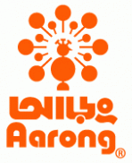
UNITED INTERNATIONAL UNIVERSITY


Course Code: INT 4399

INTERNSHIP REPORT on
Recruitment Practice & Performance Appraisal System Applied in Aarong & AAF

Submitted to:
Dr. Mohammad Badruddozza Mia
Associate Professor
United International University

Submitted by:
Sadia Zannat
ID No: 111 151 011
BBA, School of Business & Economics
United International University

Date of Submission:
10 May, 2019
Letter of Transmittal

10th May, 2019
Dr. Mohammad Badruddozza Mia
School of Business & Economics
United International University

Subject: Submission of internship report on Recruitment Practice and Performance Appraisal System applied in Aarong & AAF.

Dear Sir,
I am very pleased to submit my internship report on “HR practice (Recruitment & Performance Appraisal Procedures) in BRAC-Aarong & AAF”, the report is based on my internship program. It is likewise a compulsory for finishing of my graduation program. It is really a great pleasure to have the opportunity to submit my internship report on the experience I gained during my 3 months of internship periods at BRAC-Aarong. I have prepared this report in accordance with the instructions provided by you.
It was extremely a practical learning background for me to working in Aarong. I believe this learning and experience will help me a great deal later on.

I am extremely thankful to you for your cordial support during my internship report writing.

Sincerely yours,
Sadia Zannat
ID: 111 151 011
BBA, School of Business & Economics
United International University

Acknowledgment

“At first, I might want to pay in all seriousness Almighty ALLAH who made each progression effective and bailed me out in any sort of emergency. Then I might want to say thanks to Aarong Human Resource division for selecting me as an intern. I consider myself as fortunate on the grounds that I had the capacity to work with such dedicated individuals who gave me practical learning and made the start of my corporate life very fought. It is certain that finishing of this report would not be possible without their caring support.”

I am extremely thankful to my director S.M. Zahidul Islam (Manager, HRD) for helping me to comprehend the corporate standards and cultures in Aarong. I also want to thank my colleagues Monjori Monica Drong (Sr. Officer, HRD), Rutaba Fairuz (Sr. Officer, HRD), Shefa Binte Zakir (Officer, HRD) for helping me in every single step during my internship program. They helped me to adjust with the whole Human Resource Department of Aarong, so I could apply those lessons in my future calling.

Then I might want to pass my appreciation to Dr. Mohammad Badruddozza Mia who has been helped me during the internship period. He was constantly helpful and kind. I also want to say thanks to Career Counseling Centre (CCC) of United International University for their help.

Abbreviations:

• AAF- Ayesha Abed Foundation
• HR- Human Resource
• HRD- Human Resource Department
• JD- Job Description
• JS- Job Specification
• PMS- Performance Management System
• HRIS- Human Resource Information System
• EDMS- Electronics Documents Management System
• ERP- Enterprise Resource Planning
• MBO- Management by Objective

Table of Content
Contents
Chapter-01 1
1.0: Introduction: 2
1.1: Background Projection: 3
1.2: Objectives of The Report: 3
1.3: Scope of The Study: 4
1.4: Limitations of The Study: 4
1.5: Methodology: 5
1.6: Data Collection Technique: 5
Chapter-02 6
2.0. Company Overview: 7
2.1. History: 8
2.2. Logo: 10
2.3: Mission Statement: 11
2.4: Vision Statement: 11
2.5: Key Values: 11
2.6: Operational Network: 13
2.7: Organogram: 14
2.8: Products and Services of Aarong: 17
2.9: Awards: 18
Chapter-03 19
3.0: Literature Review: 20
3.1: Aarong HRD: 21
3.2: Working Area: 22
3.3: Working & Learning Method: 22
3.4.1: Recruitment & Selection Process: 23
3.4.2: Recruitment Practice of Aarong and AAF: 24
3.5.1: Performance Appraisal System: 27
3.5.2: Performance Appraisal System of Aarong & AAF: 28
Chapter-04 31
4.0: Analysis and Interpretation: 32
Chapter-05 40
5.0: Recommendations: 41
5.1: Conclusion: 41
5.2: Appendix: 42
5.3: Bibliography: 45

Executive Summary

“This report is an analysis of the recruitment practices and performance appraisal system followed by Aarong, Human Resource Department. Aarong is a gigantic association working with many representatives where Aarong HR office works as a solid power to deal with those a huge number of HR with their intense pound. Initial segment of this report incorporates little presentation about the report, objective, system, degree and constraint of the report.
The second part portrays about the affiliation, their history, and mission and vision verbalization. It also gives brief depiction of Ayesha Abed Foundation, Aarong's item offering, gifts controlled by Aarong, Aarong's logo, etc. This bit of the report gives a view about Aarong's character, their offerings and tremendous values to set up themselves as Bangladesh's fundamental lifestyle retail chain.
The third part of the report includes literature review and the detail list of works done by Aarong Human Resource Department. There are several teams in Human Resource Department which are recruitment and selection team, compensation management team, grievance and partition team, performance evaluation group, and Human Resource Information System group. Each group has their very own concentrated work. This part additionally examines about the comparison of established HR theories & actual execution evaluation and some different exercises that are led in Human Resource Department.
The fourth part includes analysis and interpretation of the survey questionnaire of Aarong employees.
The fifth part is the last part where the finish of the report is given. At that point the references of all the data and index are additionally given.”

Chapter-01
Introduction of The Report

1.0: Introduction:
Human Resource Management (HRM) is the function within an organization that focuses on the recruitment of, management of, and providing direction and guidance for the people who work in an organization. As you can imagine, all of the processes and programs that are touched by people are part of the HR kingdom. The workplace processes that interact with customers and potential employees are also components in the HR world.
The HRM department members provide the knowledge, necessary tools, training, administrative services, coaching, legal and management advice, and talent management oversight that the rest of the organization needs for successful operation.
Many HR departments are responsible for organization development that generates the culture of the organization. They are charged with oversight responsibilities to ensure that their organization appropriately builds teams and inspires employee empowerment.
HR staff members are partially responsible for ensuring that the organization has an overall mission, vision, and values that are shared and provide an overarching reason for employees to want to work for their organization. These elements are inspirational and help employees feel as if they are part of something that is bigger than themselves.”

The National Institute of Personnel Management (NIPM) of India has defined human resources – personnel management as “that part of management which is concerned with people at work and with their relationship within an enterprise. Its aim is to bring together and develop into an effective organization of the men and women who make up enterprise and having regard for the well – being of the individuals and of working groups, to enable them to make their best contribution to its success”.

1.1: Background Projection:
This internship report is prepared as a requirement for the fulfillment of my BBA program from United International University (UIU) under guidance of honorable faculty Dr. Mohammad Badruddozza Mia. The primary objective of the internship is to provide with a corporate experience to the students and a chance for transfer the theoretical learning in real life situation. Internship is a period of work experience offered by an employer to offer students an exposure to the actual working environment, often within a specific industry; which they can relate to their field of study. Since they preferred someone from Human Resource background, I was selected in the HR Department of Aarong as an intern. My internship journey was started from January 02, 2019.
The report titled, Recruitment-Selection practice and Performance-Appraisal System followed and applied in Aarong & AAF. I have collected all required information from some primary & secondary sources. I have tried my best to share information with relevance of the report, but due to privacy policies of selected organization and restricted access to information there still remains some limitation.”

1.2: Objectives of The Report:
There are two kinds of objectives in this internship report. Both are given underneath:
Broad Objective:
The main reason for this report is to represent my understanding of the set of work done and experiences gathered in the midst of the entire session of my internship program. It tends to find how practical this learning was in setting up a person for the exceptional difficulties which are going to occur in the real corporate world. In this way, the report has been set up to reflect the general information and understanding accumulated amidst the temporary job time frame.”

Specific Objective:
- To accumulate careful learning on enrollment and choice procedure of Aarong
- To make an analysis of human resource exercises of Aarong
- To satisfy the necessity of submitting internship report

1.3: Scope of The Study:
The report mainly focuses on the Human Resource activities of BRAC-Aarong, so there are some secret data of Human Resource department that they would prefer not to uncover. Amid the joining time frame an appointment letter is given to the new interns, where a few principles and guideline is given. One of them is that the interns needs to keep up the classification of interior data which they may run over while working in Aarong and they need to give their mark and satisfy the joining convention. So, secrecy of inward issues is carefully kept up in this report.”

1.4: Limitations of The Study:
This report has a few limitations, which are given beneath-
• “This report includes the recruitment and selection procedure of BRAC-Aarong. Though the association pursues different procedures for distinctive positions according to their need. So, every one of the distinctive procedures are not portrayed to maintain the repot progressively exact.”
• “Disclosing any internal confidential information with respect to the enrollment and choice procedure or some other HR action is completely disallowed by the principles of BRAC-Aarong. Thus, the internal data are not shared in this report.”
• “Aarong has a solid HR department with a great deal of responsibility. The entry level position time of three months is an actually quite short time to appropriately see each and every practices of the HR department. So, everything with respect to the HR exercises are examined according to my conception. There are some basic issues of a HR department to which I couldn't reach during my internship period or I couldn't get whole information, so those things are quickly talked about in this report.”

1.5: Methodology:
The sources of information and data which are being used in this report are primary and secondary sources.” They are given beneath-
Primary Sources:
“Primary sources were utilized to do the examination of enlistment and determination process and a few other human asset exercises. To accumulate essential data dialog with associates were finished. Some data were additionally taken through questions which were replied by the HR persons. Other than that, the majority of the essential sources were gathered from my reasonable perceptions and encounters of employment obligations and duties during the internship.”

Secondary Sources:
- COO- Chief Operation Officer
“Secondary information was utilized for data, for example, foundation, history, mission, vision, objective, logo, Ayesha Abed Foundation and other data. Some other data were gathered from the reports of past assistants who have worked in BRAC-Aarong. The optional information sources were for the most part gathered from authority site of Aarong which has been referenced in the reference area of this report.”

1.6: Data Collection Technique:
Primary Data:
- Conversation with the employees
Secondary Data:
- Aarong Website
- Articles regarding human resource
- Previous internship report of Aarong

Chapter-02
Company Overview

2.0. Company Overview:
“Aarong is a chain of retail outlet located in major cities in Bangladesh an enterprise of BRAC (Building Resources across Communities). Aarong means Bengali for ‘village fair’. It has started its journey in 1978. This moral brand started as a modest way to engage provincial artisans to rise above poverty. Today, with 20 retail locations crosswise over Bangladesh and more than 100 style and way of life product offerings, Aarong bolsters 65,000 craftsmans with reasonable terms of exchange. Reforming the retail business with exclusive expectations for quality and creativity, this notable brand mixes the customary with the contemporary in manners that never stop to win buyer request both at home and abroad.”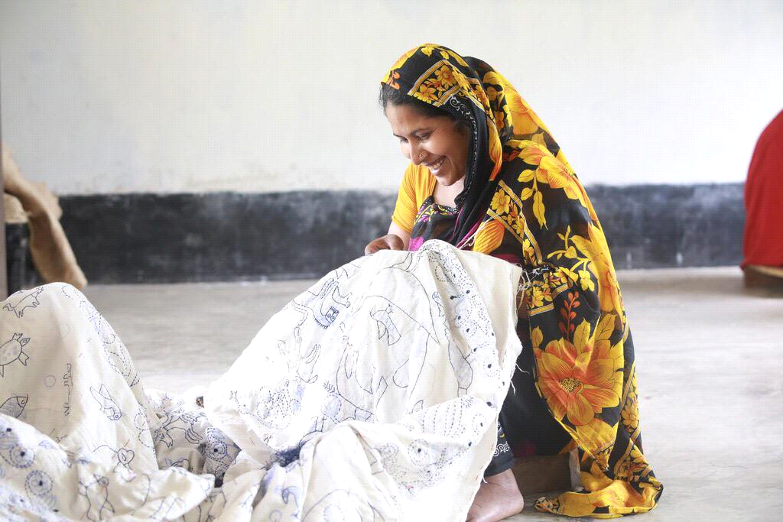
Figure: Nakshi Katha
“Its goal is to give a steady and profitable wellspring of work for the poor provincial individuals. Aarong set up in a dream to assist the crafts-mans with helping themselves by reestablishing their pride and confidence, restoring Bangladesh's conventional Art and Craft. Another point was to affirm the ladies right and to set up them as an important resource in the general public. In the process Aarong contributes extraordinarily to BRAC's objective of destitution mitigation and strengthening of poor people.”

2.1. History:

“Hope is an element in which people take action, and energize them out of poverty”
– Sir Fazle Hasan Abed

Amid the 1970s, BRAC was assessing every single possible result for elective kinds of productive occupation, especially for women, and the most ideal commercialization of articulations and works of art wound up being a promising decision. In 1976, Ayesha Abed, the life partner of Sir Fazle Hasan Abed, originator of BRAC (NGO) BRAC, began gigantic quantities of the critical activities of Aarong by recognizing and attempting diverse things with various works of art that women could convey at home, for instance, nakshikantha, weaved stock, cases, mats and things made of stick, bamboo and jute. Nevertheless, the two standard obstacles to changing make age into a profitable endeavor were keeping up extraordinary quality and suitable promoting

In 1978, BRAC went into a joint undertaking with the Mennonite Central Committee, the overall headway arm of the Mennonite Church, to open a shop in Dhaka called Aarong – signifying 'town reasonable.' ' The Mennonites had a long experience of conveying workmanship to make compensation and had set up a program called Ten Thousand Villages, which worked with skilled worker clusters the world over and sold their things through inventories and retail shops in the US and Canada. In the principle year the Mennonites assisted with the business side of the errand while BRAC endeavored to develop the capacities of town women and their things.

Amid the late 1970s and mid-1980s, BRAC focused on structure up Aarong's item contributions and creation limits. They began to study and list the plans and subjects of customary masterpieces by visiting verifiable focuses, old workmanship supervisors and private experts. They investigated distinctive roads in regards to indigenous structures and materials, changing them to possible new lines. They contracted expert craftsperson to help train town women and made a material structure and organization workshop in Manikganj to attempt diverse things with materials and advances in sewing, weaving and shading.

“AAF's first endeavor, the Manikganj center, was opened on 3 September 1983. The foundation buys meticulous work made by the town women, distinctive NGOs and workmanship creators. Despite starting the AAF, Aarong opened four retail outlets and began conveying somewhat dimension of stock to sensible trade relationship in the midst of the 1980s. By the mid to late 1980s Aarong began to ascend as a structure brand despite how Bangladesh was still new to the style business. Aarong was the essential brand to start dealing with photo shoots close by style appears, shows and changed kinds of media-focused events. Through these significant advancing exercises, Aarong had the ability to develop its notoriety and brand character inside the country. By the mid-1990s, Aarong transformed into the primary plan house in Bangladesh and had made a one-stop objective for focus to high society urban clients. Meanwhile, Aarong's thing plans returned client thought to the things and styles that are indigenous to Bangladesh. Its fashioners blended the standard with the contemporary in a way that considered buyers and started a change in examples, grasped by unending distinctive boutiques and stores.”

Amid the 1990s, Aarong kept on structure brand an incentive through plan shows and media consideration events. The rising recognizable nature of style in Bangladeshi society expected a catalyzing work in doing this. Aarong similarly continued broadening its age limit with the development of three new AAF centers. In any case, by the late 1990s and mid-2000s, Aarong stood up to a money related incident in light of reasonable organization and a nonappearance of advancement. Some place in the scope of 2001 and 2004, the association was remade to improve everything from costing, esteeming, structure and publicizing to new thing introductions and brand progressions. In 2004, its arrangements totaled about US$14 million. Aarong earned an advantage of US$1.96 million for BRAC which was dispersed among its cultivation, guidance, and prosperity programs, with the bigger part taking off to an exceptional program for the ultra-poor. In 2013, Aarong had crossed US$50 million in arrangements.
Ayesha Abed Foundation (AAF):
In 1982, the Ayesha Abed Foundation (AAF) was set up by family and buddies to respect the memory and work of the late Ayesha Abed who kicked the pail betraying her newborn child youngster, Shameran, and energetic young lady, Tamara. The foundation was made to develop women's capacities in various fortes through a fitting work environment, cash related and concentrated help and getting ready. At first it was enrolled with the organization to get outside philanthropic endowments and raise holds, anyway now works just as a bit of Aarong. The AAF board incorporates the eight family and buddies of the late Ayesha Abed. Its money related arrangement is a bit of the Aarong action under BRAC. The AAF masters are generally people from BRAC's town affiliation get-togethers or the gathering of the people. AAF's first endeavor, the Manikganj center, was opened on 3 September 1983. “The foundation buys careful work made by the town women, diverse NGOs and workmanship creators. Despite starting the AAF, Aarong opened four retail outlets and began conveying somewhat dimension of stock to sensible trade relationship in the midst of the 1980s. By the mid to late 1980s Aarong began to ascend as a plan brand despite how Bangladesh was still new to the style business.” Aarong was the important brand to start dealing with photo shoots close by style appears, shows and changed kinds of media-focused events. “Through these essential advancing exercises, Aarong had the ability to develop its popularity and brand character inside the country.” By the mid-1990s, Aarong transformed into the primary structure house in Bangladesh and had made a one-stop objective for focus to high society urban clients. “Meanwhile, Aarong's thing plans returned client thought to the things and styles that are indigenous to Bangladesh. Its fashioners blended the standard with the contemporary in a way that considered buyers and started a change in examples, grasped by perpetual distinctive boutiques and stores.”

Amid the 1990s, Aarong kept on structure brand an incentive through plan shows and media consideration events. “The rising recognizable nature of style in Bangladeshi society expected a catalyzing work in doing this. Aarong similarly continued expanding its age limit with the development of three new AAF centers.” In any case, by the late 1990s and mid-2000s, Aarong went up against a fiscal setback in view of reasonable organization and a nonattendance of improvement. Some place in the scope of 2001 and 2004, the association was revamped to improve everything from costing, esteeming, structure and publicizing to new thing introductions and brand progressions. In 2004, its arrangements totaled almost US$14 million. Aarong earned an advantage of US$1.96 million for BRAC which was scattered among its agriculture, guidance, and prosperity programs, with the bigger part taking off to an uncommon program for the ultra-poor. In 2013, Aarong had crossed US$50 million in arrangements.

2.2. Logo:
“The logo of Aarong symbolizes an image of a peacock. It is marvelously beautiful because of the shining, luminous, diversified colorful patterns in its tail. This logo of Aarong indicates that its products are as eye-catching and as unique as a peacock. There are two colors in the logo. One is black and another is orange. Black represents professionalism and the orange represents energy.”

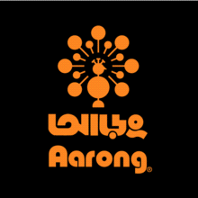
Figure: Aarong Logo

The logo of Ayesha Abed Foundation is straightforward and simple to clarify. The logo contains the 3 letters AAF (Ayesha Abed Foundation) in calligraphy. Indeed, even in the logo the name of the establishment is written in Bengali language too that makes the town individuals more solace with the organization.”
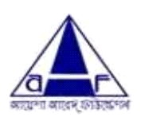
Figure: Ayesha Abed Foundation Logo

2.3: Mission Statement:
“To make Aarong the best in the world in providing a unique Bangladeshi lifestyle experience which promotes Bangladeshi pride while empowering people and protecting the environment.”

2.4: Vision Statement:
Aarong’s vision is to remain market leader throughout its business. Aarong expand its business in international arena. Aarong has a dream to develop more artisans of Bangladesh and make them dependent and attract more and more international customers toward Bangladeshi Culture.

2.5: Key Values:
Aarong’s values are same as BRAC. The key values are:

- Innovation: Aarong values the innovation that creates opportunities for the poor to lift themselves out of poverty. They strive to display global leadership in ground-breaking development initiatives.
- Integrity: Aarong values the integrity, because transparency and accountability are the most essential elements of our work ethic. With clear policies and procedures, they continue to display the utmost level of honesty in our financial dealings.
- Inclusiveness: They are committed to inclusiveness to ensure that they engage, support and recognize the value of all members of society, regardless of race, religion, gender, nationality, ethnicity, age, physical or mental ability, socioeconomic status and geography.
- Effectiveness: Aarong values effectiveness in all of their work, which constantly challenge themselves to perform better and to improve and deepen the impact of their interventions.

Figure: Key Values of Aarong

2.6: Operational Network:

Aarong task organize begins from the creation of the distinctive items which are sold in the retail outlets. The items are delivered under establishment for creation and gathering named Ayesha Abed Foundation. Ayesha Abed Foundation is arranged in Baniachong, Gorpara, Jamalpur, Jessore, Kushtia, Manikganj, Rajbari, Sherpur, Pabna, Pallobi, Kurigram, Nilphamari, Jhenaidah having 653 sub focuses crosswise over Bangladesh. In excess of forty thousand of the aggregate women of Aarong makers work straightforwardly for Aarong in these 13 generation focuses in and Twenty-five thousand free helpful gatherings and conventional family-based craftsmen additionally, showcase their artworks through Aarong.”
“Potters, Brass Workers, Jewelers, Jute laborers, Basket Weavers, Handloom Weavers, Silk Weavers, Wood Carvers, Leather specialists and different craftsmen with particular aptitudes from everywhere throughout the nation come to Aarong for promoting and bolster administrations (aarong.com).”
“After the accumulation of the items and entry in the outlet shoppers can purchase the items from the retailer outlets. This is the means by which the gathering and moving of the item go on. The tasks in the outlets are for the most part conveyed by the directors of the outlets. They primarily are mindful to deal with the outlet inventories, item moves, client administrations, installment accumulations, and workforce the executives. They oversee the outlet's execution and are specifically mindful to report the Cooperative Officer of Retail and Infrastructure for any sort of activity happens.”

2.7: Organogram:
“In this part, I will describe the organizational chart of HR department. According to the organizational detail, the senior director directly reports in BRAC Enterprises.”
Managing Director BRAC

Director Aarong, AAF & BDFP

HR Department

Design Studio
Finance Department

Retailed Department

CRM

Creative

Branding & Buzz

Public Relations

Marketing Research & Product development

E-commerce

Sustainability

Marketing Manager

Social Compliance
Marketing Department

Export Department

Logistic & Maintenance Department

Figure: Organogram of Aarong




Deputy General Manager (DGM)
Sr. Executive
Manager
Manager
Manager
Executive
Manager





Officer
Officer
Sr. Officer
Assist. Officer
Officer
Assist. Officer
HRM Department Assistant

Figure: Organogram of Aarong HR

Aarong HRD Teams:
The Aarong Human Resource office contains four groups and all of the groups are responsible for each area of work. The groups are-

Figure: Aarong HRD Teams

2.8: Products and Services of Aarong:
“Aarong started with the subject of making unadulterated silk and high quality nakshikantha. Over the long haul, it turned into the highest retail chain of Bangladesh together with design, way of life and family unit items. The merchandise can be isolated into littler classifications. Aarong provides various services to the production workers of Ayesha Abed Foundation.”
They are given underneath:
Products | Services
Women (Clothing and Accessories) | Legal support to employees
Men (Clothing and Accessories) | Free skills training
Kids (Clothing and Accessories) | Raw materials
NakshiKantha (Home Decor and Clothing) | Transportation of goods
Taaga (Youth Brand) | Quality Control
Herstory  (Exclusive Designer Line for women) | Storage
Herstory  (Exclusive Designer Line for women) | Management
Wedding  (Clothing, Accessories, Decor and Gift Card) | Finance
Wedding  (Clothing, Accessories, Decor and Gift Card) | Marketing and Public recognition
Home decor | Medical
Dairy item | Free medical checkup
Jewelry | Medicine supply
Leather item | Free eye checkup and glass supply
Taaga-Man | Treatment cost for severe illnesses
 | Day care center
 | Advance wage payment
 | Workers’ gratuity benefit
 | Workers’ welfare support

2.9: Awards:
Aarong was granted the Best Brand Award in the Fashion Boutique class at Bangladesh Brand Forum's yearly respect work. The Bangladesh Brand Forum's Best Brand Awards 2015 capacity was held at the Radisson Blu Hotel in the capital on Saturday, November 21, 2015.
Bangladesh Brand Forum united with Milward Brown and recognized best brands of Bangladesh for 2015 to perceive those brands that have accomplished stunningly essential statures in both business regard and purchaser tendency. Mohammad Abdur Rouf, Chief Operating Officer, BRAC-Aarong, went to the respect administration to get this regarded respect.
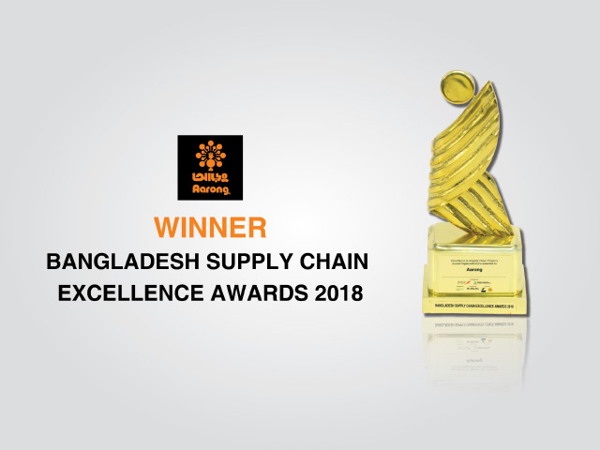
Aarong is the country's driving way of life retail store. Aarong is committed to accomplishing positive changes in the lives of hindered skilled workers and underprivileged countrywomen. This ethical brand began in 1978 as an unassuming method to empower nation skilled workers to rise above poverty. Today, with 15 retail stores transversely over Bangladesh and in excess of 100 structure and way of life item contributions, Aarong supports 65,000 skilled workers with sensible terms of trade. Changing the retail business with restrictive prerequisites for quality and imaginativeness, this prominent brand blends the traditional with the contemporary in habit that never stop to win customer offer both at home and abroad.
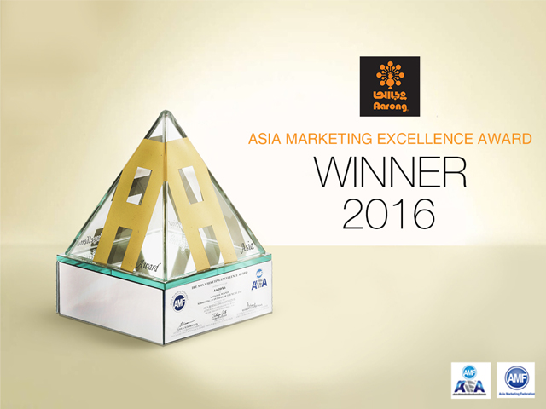
Aarong has received the Bangladesh Supply Chain Excellence Award 2018 in the category of “Excellence in supply chain finance” as a local organization at an event held at ICCB on 21st July, 2018. The event was jointly organized by IPDC Finance Ltd and Bangladesh Supply Chain Management Society.
Aarong has long prioritized the financial sustainability as it provided instant payments upon delivery of goods, low interest collateral free loans and regular orders throughout the years to support the producers and artisans. The awarding committee has recognized the efficiency of Aarong’s processes to ensure such principles through our ERP system which is integrated at all producer service points.

Chapter-03
Recruitment Practice & Performance Appraisal System
Applied in Aarong & AAF

3.0: Literature Review:
“HR is basically essential in the present contemporary associations since it incite elite administration using workers; by improving their dimensions of client's administration, profitability, development, benefits and quality control” (Armstrong, 2000).

As indicated by Story (1995) contends that “HR arranging today is a vital undertaking of each contemporary association's HR division. As indicated by him, HR arranging for the most part includes the ID of aptitudes and capability inside the association, the filling of distinguished skill holes, and the help of developments of representatives inside the association.”

“A fundamental piece of the HR arranging is the progression arranging which plans to guarantee the supply of people and filling of holes on senior key positions when they become empty and recharge skills to regions where they are most esteemed” (Wolfe, 1996).

“In association the framework that in charge of setting enhances abilities all through is alludes to as enrollment and determination forms. The procedure of enrollment and choice is a moral methodology by a firm to look for and pull in the most skillful and reasonable candidate for an empty position” (Analoui, 2007).

“The way toward choosing and holding potential workers is the best hierarchical aggressive fight in present day days” (Pfeffer, 1994).

“The administration of execution incorporates plan of work frameworks, assistance of information use, sharing and creation, and examination and reward frameworks” (Cardon and Stevens, 2004).

3.1: Aarong HRD:
“Aarong Center” is the head office of Aarong and AAF. “All the HR exercises occur primarily in Aarong Centre. Apart from the enlistment and choice group, Aarong HR division is in charge of numerous other essential works. Aarong has a lot of outlets around Bangladesh and keeping up all the HR of the significant number of outlets close by the head office staff and Ayesha Abed Foundation (AAF) agents is a massive test. Aarong has a standout amongst the most grounded HR office in Bangladeshi corporate world.”
The Aarong Human Resource office contains four groups and all of the groups are responsible for each area of work. The groups are-

Figure: Aarong HRD Teams

3.2: Working Area:
During my internship period, I worked on the following area:
- Recruitment & Selection: I collected resumes from a particular online job portal and screened those according to my supervisor’s guideline. I made single & detail list of shortlisted candidates for various position and then called them to inform about the examinations & interview. I assisted responsible HR officer in exam hall and coordinated the interview process. I maintained newly appointed staff personal file and give entry to the ERP software. I coordinated a field test of some candidates for the position of Driver.

- PMS: I sorted PMS forms which came from different departments and foundations and made sure that those are ready for further process. I assisted HR officers to input yearly obtained marks of each employees working in the organization. Sometimes I did a cross check. I observed how HR officers make annual performance report.

Other than the above described functional area, I worked on some other activities for the HRIS Operation team:
- I scanned necessary documents for further use
- I typed appointment letters and justification notes for various purpose

3.3: Working & Learning Method:
“During my internship period I was entrusted in the recruitment & selection team. Along these lines, I had the capacity to get ability with every single movement of the enrollment and hiring process. It was hard for me to find essentially all the human resource exercises performed by Aarong during the limited time of three months. Regardless, I was sufficiently honored and my senior colleagues were cordial to exhibit to me the general exercises of the HR office. Other than that, I have likewise got learning by watching exchange works out. So here I will signify an examination of the general HR practices subject to my sensible experience, learning and observation.”

3.4.1: Recruitment & Selection Process:
Recruitment is a process of finding and attracting the potential resources for filling up the vacant positions in an organization. It sources the candidates with the abilities and attitude, which are required for achieving the objectives of an organization.
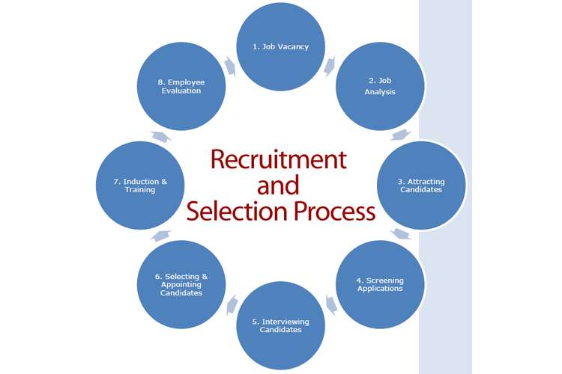
To increase the efficiency of hiring, it is recommended that the HR team of an organization follows the best practices (as shown in the following image). These practices ensure successful recruitment without any interruptions. In addition, these practices also ensure consistency and compliance in the recruitment process.

BRAC-Aarong follows the process accordingly in their own way. In the 1st step, when there is any job vacancy, the HRD gets requisition. They don’t need to do a job analysis all the time because most of the positions have individual JD & JS prepared previously. So, they can skip the 2nd step for some positions. On 3rd step, they attract candidates by advertising the job with appropriate JD & JS. They screen CVs in 4th step. Then on 5th step they take written test & interviews of candidates on the pre-fixed schedule. After interview when they get the best suit for the position, they offer job to the selected candidate & complete all the joining formalities. Then they deploy that employee to the concerned department. After deploying an employee, the process ends here. In 7th step, employees get on-the-job training or other trainings are conducted by the Training Department of Aarong.
The Recruitment & Selection Process in brief followed by Aarong is described below-

3.4.2: Recruitment Practice of Aarong and AAF:

“Recruitment & Selection Team” is in charge of picking the best fitted representative for Aarong and AAF. The team is divided into two sections:
- Project Staff Recruitment Team
- Management Staff Recruitment Team
The recruitment and selection process of Aarong is very much well arranged. They follow every step very strictly. The recruitment and selection of Aarong and AAF is totally unbiased.
- Requisition:
“The first step of Recruitment and Selection process of Aarong is receiving the requisition from other department for a vacant position. After collecting the requisition, they need to get approval from the COO and other authority. Then they prepare the job description and job specification for that specific position.”

- Advertisement in Different Media:
“After the demand endorsement, the second step is notice. In the stage of setting up the expected set of responsibilities and occupation determination the promotion part begins. Aarong give their advertisement through renowned newspapers, online media (most preferred is BD jobs.com) and posturing the job circular in different area. They use the posturing method basically for the lower level positions like driver, helper etc. In all the job circular they give a particular deadline and candidates must apply within that due date.”

- CV Screening:
“After the deadline of employment round they start gathering CVs from different sources. They gather CVs through email, BD jobs CV bank, Aarong CV box, inside CVs and reference CVs. CVs are organized depending on certain criteria, for example, instruction, qualification, experience, result and age limit, desired payment range etc.”

- Date Fixing:
After CV screening, they fix a date for the written test and interview for the candidates.

- Question Paper Preparing:
“It is a very essential and confidential part of Recruitment and Selection process. They have assigned a particular officer for preparing the question for the written test. They must need an approval from the DGM after preparing the question.” The question includes some specific criteria:

- Subject related knowledge
- Mathematics & Analytical ability
- English

- Calling Session:
“One of the officers from Recruitment and Selection team call selected candidate to inform them about the date of written test and interview, place of the exam, time, or if they have to bring something in the time of interview for example (CV, Portfolio in case of designer etc.). When the officer calls the candidate, they have to make sure if they are coming or not. On the basis of the candidate response they prepare questions for the exam.”

- Messaging Session:
“In this step they give a message on the candidate’s mobile number with detail information like the designation he or she applied for, date and time of the exam or interview, address of the place where the exam will take place.”

- Single & Detail list Preparing:
“The single list includes serial number, the candidates and their father’s name, contact number, space for their signature and remarks. The detail list includes their name, name of current or past organization, designation & experiences, educational qualification and name of institution. This list contains considerable competencies on the basis of which a candidate is given viva status. So, this rundown is imperative, through this rundown the meeting board individuals becomes acquainted with all the data initially about the competitor. This rundown is arranged in all respects cautiously.”
- Written Test & Result:
“In a large portion of the cases they step through composed examination and meeting around the same time. After the composed test the competitors are approached to hang tight for quite a while for the test outcome. At that point, the HR officer begins to check the contents. Based on composed test outcome, a portion of the hopefuls are chosen for the meeting. After the meeting they accumulated the composed test result with the meeting marks and the most noteworthy marks holder is chosen for the position. For some upper position they step through more exam, for example, introduction, PC test and so forth. To recruit a driver, candidates who passed interview, have to go through a medical check-up to be selected finally.”

- Offering Job:
“In this step one of the members from Recruitment and Selection team give a call to the selected candidate to inform about their selection. The candidate is informed about the company policies, benefits etc. If the candidate is interested for the job and accept the offer then they are given a date on which the candidate must join.”

- Joining Formalities:
“On the joining date the new employee needs to fulfill some formalities, for example, presenting their educational certificates, 5 copies of passport size photograph, CV, NID, nominee NID, blood group report etc.” At that point the employee needs to satisfy some structure, for example:
- History Form
- Joining Form
- Nominee Form
- Guardian Form
- Code of Conduct
- Reference Check

- Appointment Letter:
“On the day of joining the employee gets the appointment letter from the HR department. 3 copies of Appointment letter should be signed by the employee. Selected employee will keep the original copy & other 2 copies will be used in official purpose.”

- Preparing File:
“In this stage one HR officer keeps all the hardcopy documents of the employee in a file maintain a specific order & put remarks for any missing document.”

- Software Entry:
“At that point all data in regards to the employee is contributed to the ERP and HRMS programming. Data, for example, name, father's-mother's name, date of birth, present location, personal contact number, reference data, training data, nominee information are recorded to ERP.”

- Deployment of Employee:
“In this stage one HR officer takes the employee to his or her concerned department where he or she is going to work. The newly joined employee is then introduced with his supervisor & other existing employees.”

3.5.1: Performance Appraisal System:
The performance appraisal is the process of assessing employee performance by way of comparing present performance with already established standards which have been already communicated to employees, subsequently providing feedback to employees about their performance level for the purpose of improving their performance as needed by the organization.
“After knowing performance of employee, subsequently organization can decide whether training is needed to particular employee or to give promotion with additional pay hike.” “It is important for any manager to ensure that he or she periodically conducts a performance appraisal to establish the productivity of their employees. It is also an essential activity because it helps you in determining challenges and weak points of such workers so that you can find better ways of fixing them to enhance and yield desirable results ultimately. The process of Performance Appraisal is one that few look forward to.”
Every corporate sector should use performance appraisal as a tool for knowing about the employee and take decisions about particular employee. For the purpose of performance appraisal of employees there are different methods under the category of traditional methods and modern methods. Standard 6 steps of performance appraisal process are mentioned in following-

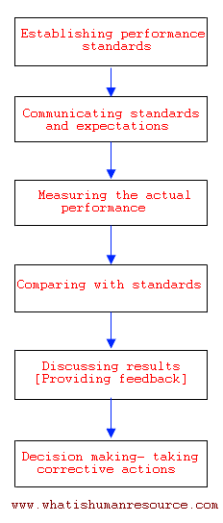

3.5.2: Performance Appraisal System of Aarong & AAF:

As a matter of fact, most managers do conduct Process of Performance Appraisal but not necessarily in the appropriate approach that it should be done. But, Aarong follows the standard approach of Performance Appraisal process.
“Performance appraisal is a critical factor of Aarong Human Resource Department. It is done once in a year. For various evaluation of employees Aarong has distinctive sort of execution examination structure for various dimension of workers,” for example –
- Appraisal structure A-for top-level
- Appraisal structure B-for mid-level.
- Appraisal structure C-for lower-level
- Appraisal structure for Sales Associate

In total of 100, each employee gets marks, and each range of mark has a meaning. Such as-
- 20- 32 - Unsatisfactory
- 33-52 - Improvement Needed
- 53-72 - Good
- 73-86 - Very Good
- 87-94 - Excellent
- 95-100 - Outstanding
“
Assessment are done based on certain capabilities, for example, job knowledge, respectability, time management, nature of work, imagination, initiative, expository capacity, correspondence, basic leadership ability, uplifting standards and so forth. After the appraiser gives marks, they likewise give remarks about representative for every competency, for example, territories where he/she should make improvement. At that point the appraiser composes worker's qualities and shortcomings.”

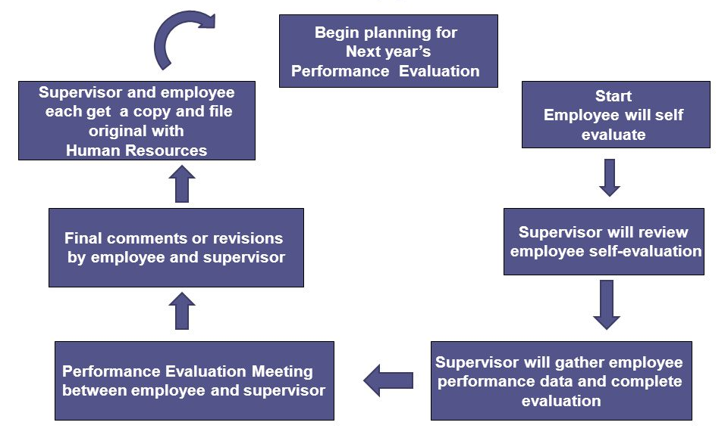
Here are the steps that Aarong follows to attain effective performance review of its each & every employee-
Setting objectives for yearly performance evaluation
Appraisal Form submission to HRD for final report

- Setting Objectives for Yearly Performance Evaluation: Aarong follows the MBO (Management by Objective) strategy. Supervisors set yearly (Jan-Dec) objective for every employee at the beginning of evaluation year.

- Communicating Objectives: In the midyear, a dialogue/feedback session takes place. This is kind of one to one communication between an employee & his/her supervisor. At that time, they discuss about the performance done so far & remaining objectives of that year.

- Employees’ Self-Evaluation: An employee can evaluate his/her performance in the appraisal form. There he/she mentions the objectives that are given to him/her & describes how effectively & efficiently he/she could perform accordingly.

- Reviewing Employees’ Self-Evaluation by Supervisor: Supervisor reviews employees’ self-evaluation, whether they are overrating or underrating themselves or not.

- Gathering Performance Data: Supervisors gather employees’ overall performance data & complete the evaluation form.

- Performance Evaluation Meeting Between Employee & Supervisor: Finally, the supervisor & each employee meet together to find out any lacking between prefixed objectives & actual performance. They also include required training or development plan mutually by which the employee can perform better next time.

- Final Comment: After the final meeting, employee gives comment on whether they are agreed/satisfied with their evaluation or not. Then supervisor concludes by giving the total performance-marks with value-marks & recommendation for that particular employee.

- Appraisal Form Submission: After accumulating all the appraisal forms of every employee, each department heads submit the forms to the HR department.

HRD Responsibilities on PMS:
When all the forms come to HRD, HR officers check all the forms. Then they prepare a year-end final performance-report which they call TOP SHEET for board where they include employees’ name, pin, designation, previous promotion & reward records, current salary, recommendations etc. HRD head also gives presentation on the most valuable information, e.g. financial growth, trend analysis, recommendation (promotion, slab, PIP), male-female ratio etc. Board members take decision about rewarding for best & taking corrective actions for poor performer on the basis of that top sheet. PMS works as the tool for determining whether employee is to be promoted, demoted or terminated (in case of very poor performance and no scope for improvement.)

Chapter-04
Analysis and Interpretation

4.0: Analysis and Interpretation:
Question-1. Gender
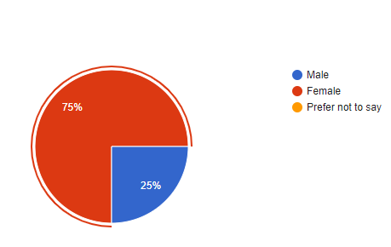
Interpretation: “Above graph shows that maximum of the respondents is female, Aarong HRD has 75% female employee and 25% male employee.”

Question-2. Aarong offers comfort in our physical workplace

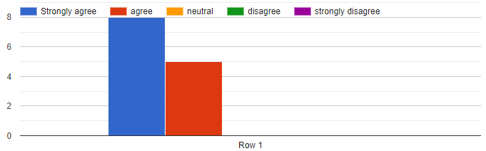

Interpretation: “From the above graph shows that most of the respondents was strongly agreed (8 respondents) with Aarong offers comfort in physical workplace. On the other hand, 5 respondents were agreed to this.”

Question-3. My group works well together to accomplish the organization's goals

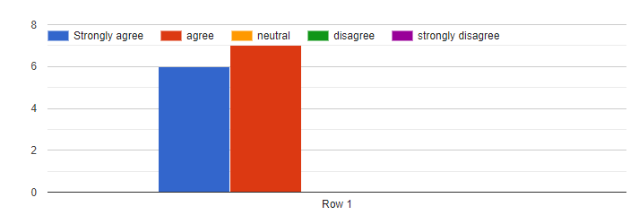
Interpretation: “From the above graph shows that most of the respondents was agreed (7 respondents) with my group works well together to accomplish the organization’s goal. On the other hand, 6 respondents were strongly agreed to this.”

Question-4. Aarong offer adequate opportunities for promotions and career development

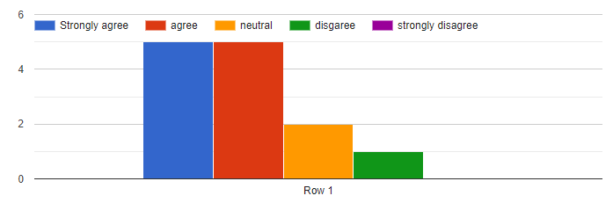

Interpretation: “From the above graph shows that most of the respondents was strongly agreed (5 respondents) and agreed (5 respondents) with Aarong offer adequate opportunities for promotions and career development. On the other hand, 2 respondents were neutral and 1 respondent was disagreed with this.”

Question-5. I see myself contributing to Aarong in the long run

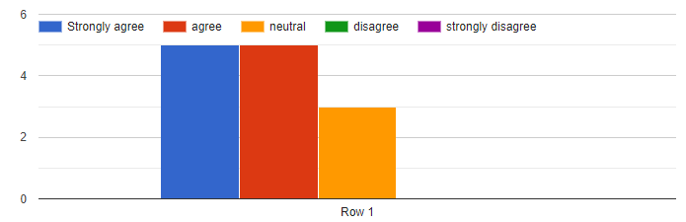

Interpretation: “From the above graph shows that equal number of respondents were strongly agreed (5 respondents) and agreed (5 respondents) with I see myself contributing to Aarong in the long run. On the other hand, 3 respondents were neutral to this.”

Question-6. I am compensated fairly for the work I do

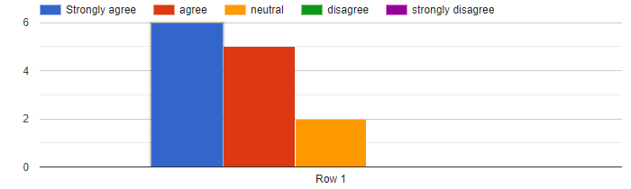
Interpretation: “From the above graph shows that most of the respondents were strongly agreed (6 respondents) and agreed (5 respondents) with I am compensated fairly for the work I do. On the other hand, 2 respondents were neutral to this.”

Question-7. I am provided with opportunities to improve my skills

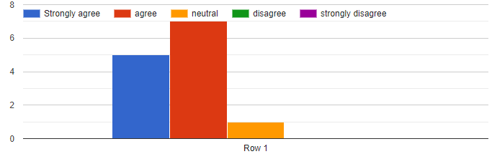
Interpretation: “From the above graph shows that most of the respondents were agreed (7 respondents) with I am provided with opportunities to improve my skills. 5 respondents were strongly agreed. On the other hand, 1 respondent was neutral to this.”

Question-8. I am treated fairly by my supervisor

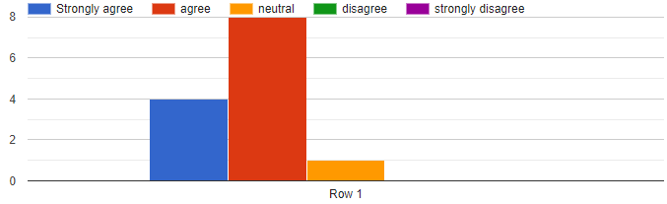
Interpretation: “From the above graph shows that most of the respondents were agreed (8 respondents) with I am treated fairly by my supervisor. 4 respondents were strongly agreed to this. On the other hand, 1 respondent was neutral to this.”

Question-9. My supervisor provides me with adequate feedback

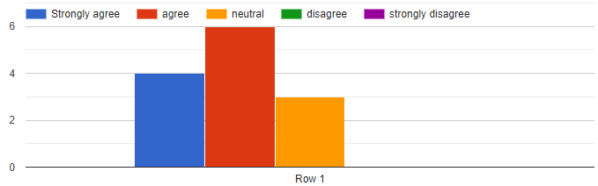
Interpretation: “From the above graph shows that most of the respondents were agreed (6 respondents) with my supervisor provides me with adequate feedback. 4 respondents were strongly agreed to this. On the other hand, 3 respondents were neutral to this.”

Question-10. I am recognized by my manager for my contributions

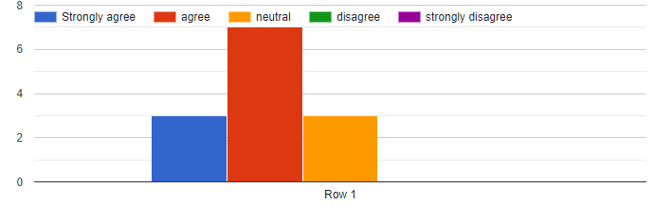
Interpretation: “From the above graph shows that most of the respondents were agree (7 respondents) with I am recognized by my manager for my contributions. On the other hand, 3 respondents were strongly agreed and 3 respondents were neutral to this.”

Question-11. My manager has set performance goals for my job

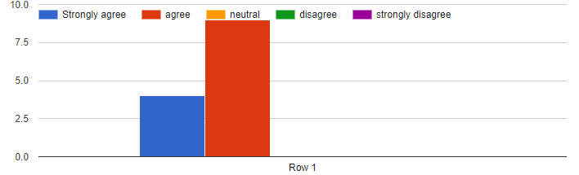

Interpretation: “From the above graph shows that most of the respondents were agreed (9 respondents) with my manager has set performance goals for my job. 4 respondents were strongly agreed to this.”

Question-12. The performance appraisal system at Aarong is unbiased
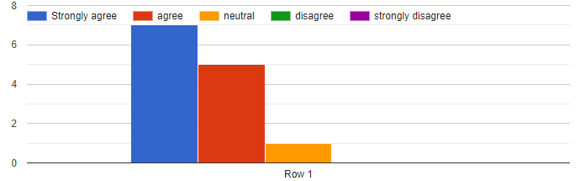
Interpretation: “From the above graph shows that most of the respondents were strongly agreed (7 respondents) and agreed (5 respondents) with the performance appraisal system at Aarong is unbiased. On the other hand, 1 respondent is neutral to this.”

Question-13. The employee recruitment and the selection process at Aarong is unbiased
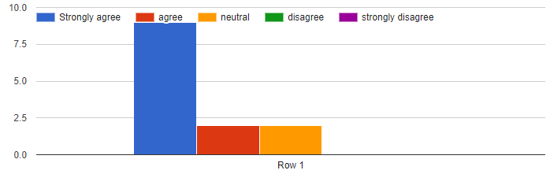
Interpretation: “From the above graph shows that most of the respondents were strongly agreed (9 respondents) with the employee recruitment and the selection process at Aarong is unbiased. On the other hand, 2 respondents were agreed and 2 respondents were neutral to this.”

Question-14. I have a clear understanding of the company pay policy

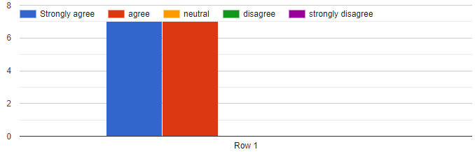
Interpretation: “From the above graph shows that most of the respondents were strongly agreed (7 respondents) and agreed (6 respondents) with I have a clear understanding of the company pay policy.”

Question-15. Aarong follows the employee law properly

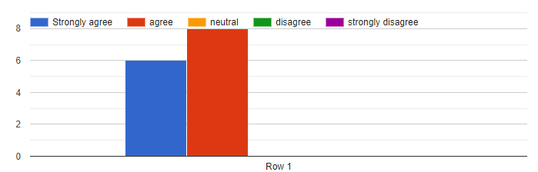

Interpretation: “From the above graph shows that most of the respondents were agreed (8 respondents) & strongly agreed (5 respondents) with Aarong follows the employee law properly.”

Question-16. The training provided by Aarong is effective for the employee

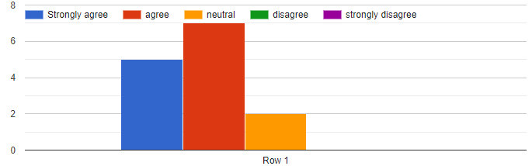
Interpretation: “From the above graph shows that most of the respondents were agreed (6 respondents) and strongly agreed (5 respondents) with the training provided by Aarong is effective for the employee. On the other hand, 2 respondents were neutral to this.”

Chapter-05
Recommendations and Conclusion

5.0: Recommendations:

This report additionally has some recommendations for Aarong & its HR department, which are mentioned underneath:
- “The HRD must assign a room only for the exam purposes. With the goal that after there will be a lot of opportunity for composed test it might no longer make any hustle for the sitting arrangement.”
- “HRIS, ERP and EDMS software program must be greater updated so that the personnel can perform smoothly.”
- “As the Aarong HRD need to perform a whole lot of work at a time they have to recruit more employees for Human aid branch. It is a hard mission for them to handle all of the things with minimum employee.”
- All the departments should be proactive to make & deliver the appraisal forms as soon as those are required. HRD has to wait a long for a number of appraisal forms of some department. That hinders the workforce to make the final report timely.
- “The symbol of Aarong should be used in terms of the board recruitment. A large portion of the general population do not know approximately Aarong workplace and Ayesha Abed Foundation. Though the use of the logo estimation of BRAC and Aarong it tends to be beneficial for effective recruitment.”

5.1: Conclusion:

“Aarong has a reputation globally. They earn it through many processes and hard works. They have maintained their Human Resource Department like their product quality from the beginning. Aarong might not have many different recruitment and selection techniques as other organizations but what they follow is very appropriate in terms of Bangladesh’s perspective and they are very strict and honest to their performance management system.”

5.2: Appendix:
HR survey questionnaire regarding employee satisfaction and HR policies of BRAC-Aarong

Name:
Designation:
Service duration at Aarong:
Gender:
- Male
- Female
- Prefer not to say

- Aarong offers comfort in our physical workplace.
- Strongly Agree
- Agree
- Neutral
- Disagree
- Strongly Disagree

- My group works well together to accomplish the organization's goals.
- Strongly Agree
- Agree
- Neutral
- Disagree
- Strongly Disagree

- Aarong offer adequate opportunities for promotions and career development.
- Strongly Agree
- Agree
- Neutral
- Disagree
- Strongly Disagree

- I see myself contributing to Aarong in the long run.
- Strongly Agree
- Agree
- Neutral
- Disagree
- Strongly Disagree

- I am compensated fairly for the work I do.
- Strongly Agree
- Agree
- Neutral
- Disagree
- Strongly Disagree

- I am provided with opportunities to improve my skills.
- Strongly Agree
- Agree
- Neutral
- Disagree
- Strongly Disagree

- I am treated fairly by my supervisor.
- Strongly Agree
- Agree
- Neutral
- Disagree
- Strongly Disagree

- My supervisor provides me with adequate feedback.
- Strongly Agree
- Agree
- Neutral
- Disagree
- Strongly Disagree
- I am recognized by my manager for my contributions.
- Strongly Agree
- Agree
- Neutral
- Disagree
- Strongly Disagree

- My manager has set performance goals for my job
- Strongly Agree
- Agree
- Neutral
- Disagree
- Strongly Disagree

- The Performance Appraisal System at Aarong is unbiased
- Strongly Agree
- Agree
- Neutral
- Disagree
- Strongly Disagree

- The employee recruitment and the selection process at Aarong is unbiased
- Strongly Agree
- Agree
- Neutral
- Disagree
- Strongly Disagree

- I have a clear understanding of the company pay policy
- Strongly Agree
- Agree
- Neutral
- Disagree
- Strongly Disagree

- Aarong follows the employee law properly
- Strongly Agree
- Agree
- Neutral
- Disagree
- Strongly Disagree

- The training provided by Aarong is effective for the employee
- Strongly Agree
- Agree
- Neutral
- Disagree
- Strongly Disagree

5.3: Bibliography:

Websites
- About Aarong, (2017) ,
https://www.aarong.com/about-aarong/
- Aarong. (10 march.2019) .retrieved from Wikipedia, https://en.wikipedia.org/wiki/Aarong
- Shefa, B. Z. F. (2017, April 19). Effectiveness of recruitment and selection process of Aarong& Ayesha Abed Foundation (A study on management staff). Retrieved from dspace.bracu.ac.bd: http://dspace.bracu.ac.bd/xmlui/bitstream/handle/10361/8442/12104083_BBA.pdf?sequence=1&isAllowed=y
- SUSAN M. HEATHFIELD (October 30, 2018). Beyond Hiring and Firing: What Is Human Resource Management?
https://www.thebalancecareers.com/what-is-human-resource-management-1918143

Books:
1. Armstrong, (2000). Human Resource. Ado and Wilson (1994, p 701).
2. Storey (1995). Human Resources Planning

