

A PROJECT REPORT ON

OVERALL PROMOTIONAL ACTIVITIES OF UBER BANGLADESH

25th July 2019
UNITED INTERNATIONAL UNIVERSITY
DHAKA, BANGLADESH
A PROJECT REPORT ON
THE OVERALL PROMOTIONAL ACTIVITIES OF UBER BANGLADESH
SUPERVISED BY
DR. MD. SHARIFUL ALAM
ASSOCIATE PROFESSOR,
SCHOOL OF BUSINESS AND ECONOMICS
UNITED INTERNATIONAL UNIVERSITY

PREPARED BY
MEHJABEEN MEHMOOD MAHEE
ID: 111141013
BBA PROGRAM
UNITED INTERNATIONAL UNIVERSITY
UNITED INTERNATIONAL UNIVERSITY

Letter of Transmittal
To,
Dr. Md. Shariful Alam
Associate Professor,
School of business and economics
United International University
Subject: Submission of project report on “The overall promotional activities of Uber Bangladesh”.
Dear Sir,
You will be glad to know that I have finished my project report on my concentrated area “UBER BANGLADESH” and I have worked on the title named “The overall promotional activities of Uber Bangladesh.” As a marketing student, the title was highly relevant to my field of study and I have learned and observed how the company set up its marketing activities in Bangladesh as a ride-sharing service provider. Uber started its operation in Bangladesh to save people's time in the busy Dhaka city. It shows the opportunities and then makes it the reality starting the indicated button, have created billions of moments of human connectivity, while people around the Dhaka city are wandering with the help of Uber's technology.
However, the advice and report format, I had received from you were proved essential to prepare the report. I am highly thankful for the time and concern you have provided to prepare my report well. Moreover, I want to assure you that all the information utilized in the latter part are true and relevant to the title. No information is directly copied from any publications, and all are aggregated to my last three months observations.
I, therefore, pray and hope that your honor would be kind enough to accept my project report and oblige thereby.
Sincerely yours,
Mehjabeen Mehmood Mahee
ID: 111141013
BBA program
United International University
Acknowledgement
At the very beginning of this project report, I want to thank my Almighty Allah as well as my parents for making me able to complete this four years of Bachelor of Business Administration (BBA) and help me to finish the project report as well.

First of all, I would like to show my gratitude to my respected course faculty and project supervisor Dr. Md. Shariful Alam, Associate Professor, School of Business and Economics, United International University for all of his concern and effort to motivate me to choose an important report title and for all the advice that I have received during the preparation of the project report.

Secondly, I want to show my heartfelt gratitude to Maisha Sufiya Khan, Marketing Manager, Uber Bangladesh for sharing all resources that were unavailable and difficult to aggregate and by the help of her, I get to know the marketing strategies that are already conducted by Uber to attract Bangladeshi market. I’m highly thankful for all of her valuable time and effort that she provided me to make my report accurately. Additionally, she also reviewed all the information that I have used in the report so that she can correct me if there are any mistakes exist.
Last but not the least, I want to thank all my friends who helped me to get leaf-let and brochures of UBER and some other ride sharing services. They also helped me to clear few concepts that I had found difficult to understand.

Executive Summary
The project report is a prerequisite for obtaining a degree in Bachelor of Business Administration (BBA) from the United International University (UIU).
Uber Technologies, Inc. is a US multinational transportation network company (TNC) that provides services such as peer-to-peer travel, passenger transportation, food delivery, and a bicycle sharing system. The company is headquartered in San Francisco and is present in 785 metropolitan areas around the world. Their platforms are accessible through their websites and mobile apps. In 2019, it is estimated that Uber has 110 million users worldwide, with a 69.0% market share in the United States for passenger transportation and a 25% market share for product food delivery. Uber has been so important in the collaborative economy that the industry has been transformed into "Uberisation" and many new companies have qualified their products as "Uber for X". Uber began its trip to Bangladesh on November 22, 2016.

The project report consists of five broad chapters. Chapter one is about the study introduction where one can get to know the study purpose, background, methodology, objectives, and limitations. The second chapter is about the literature review that makes several concepts of the study easier. Chapter three is about to describe Uber’s organization overview. The next and most important chapter named analysis and findings that analyze the promotional activities of Uber in a broad sense. The next and last chapter named recommendations and conclusion where I have shared a few recommendations based on my educational knowledge on Uber Bangladesh for the upcoming betterment of this brand.

Table of Contents
Chapter One: Introduction of the study
1.1 Background of the study 9
1.2 Scope of the study 9
1.3 Objectives of the study 9
1.4 Methodology of the study 10
1.5 Limitations of the study 10

Chapter Two: Literature Review
2.1 Definition of Promotion 13
2.2 The necessities of Promotion 13
a) Gather consumer in one place 13
b) Identification of Segment 13
c) Increase brand awareness 14
2.3 Ways to conduct promotions 14
2.4 Promotional mix 14
a) Personal sale promotion 15
b) Direct marketing 15
c) Advertising 16
d) Public relations 16
e) Sales promotions 16

Chapter Three: Organizational Overview
3.1 Background of the company 18
3.1.1 Mission of Uber 19
3.1.2 Core values of Uber 19
3.2 Products and Services of Uber 19

Chapter Four: Analysis and Findings
4.1 Promotion and marketing strategies 22
4.2 Uber’s promotion and marketing strategies 22
4.2.1 Launch phase: 23
4.2.2 Build-up phase 24
4.2.3 Amplification phase 25
4.2.4 Sustenance Phase 26
4.2.5 Growth Phase: 28

Chapter Five: Recommendations and Conclusion
5.1 Recommendations 31
5.2 Conclusion 32
Reference

Chapter One
Chapter one
Introduction of the study

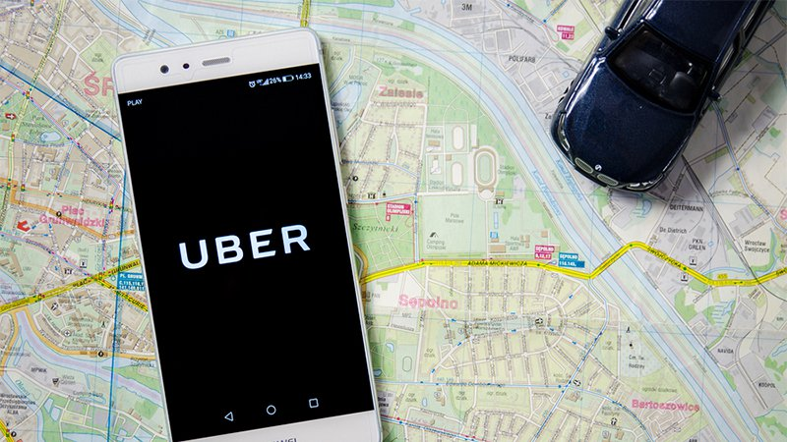

1.1 Background of the study
The project/internship report is a pre-requirement of achieving the Bachelor of Business administration (BBA) degree from United International University (UIU). Students have to choose either project or internship program at first of the semester. In an internship program, students are placed into an organization through the UIU Career Counsel (UIUCC) to work as an intern to learn practical work experience for three months. While working in the organization, students have to prepare their internship report according to their job responsibilities. On the other hand, the students who choose project, have to observe a particular company or a sector as a whole. According to the achieved observation of three months, they require to submit their thesis paper.
I chose project paper and got permitted from my honorable course faculty to prepare my project report on a bright international ride sharing company named UBER BANGLADESH. The title of my report that I have selected was “the overall promotional activities of Uber Bangladesh” as it is highly related to my field of study.

1.2 Scope of the study
The scope of the project is part of the project plan that includes specific project objectives, outcomes, features, functions, tasks, deadlines and finally a list of costs and documentation. In other words, it should be achieved and work must be done to complete the project. Any reader of these report can be benefitted through the understanding of how Uber capture its market share and what types of advertising strategies, as a foreign company, Uber utilized in Bangladesh. Bangladeshi ride sharing companies can compare their promotional strategies with Uber to find out their shortcomings in promotion side. Additionally, university students can compare their marketing concepts with the practical promotional activities performed by Uber.

1.3 Objectives of the study
Objectives are the goals that the report is trying to establish in the later. There are very important part for any reader who wants to know the report information in brief. The objectives of the report are separated into two parts.
- Primary objectives: The basic objective of creating this report is because of its pre-requirement of achieving the bachelor of BBA degree from United International University.
- Specific objectives:
- To analyze the overall ride sharing company as well as Uber Bangladesh.
- To analyze the promotional activities of Uber Bangladesh.
- To share few suggestions so that Uber can improve its promotional and marketing strategies.

1.4 Methodology of the study
The methodology are the techniques of gathering information and how I have analyzed the information to point out the report objectives. The methodologies are:
1.4.1 Data Collection Methods
The information and data that are being used in the report are collected from two sources. The sources are:
- Primary Sources: the primary sources are the most important source from where I have taken all the most important piece of information. The sources are:
- Through informal and formal communication from the Uber personnel.
- From my own earned personal observations using Uber rides.
- From the mobile application and website of Uber.

- Secondary Sources: these are the sources from what I have taken support to discuss on few concepts accurately. The sources are:
- Several and unpublished research paper on promotional activities.
- Several online blogs and website that write article on Uber.
- From Bangladeshi online and offline newspapers.

1.5 Limitations of the study
Each study has limits. By clarifying the limits of a study, it is up to the reader to better understand under what conditions they should be interpreted. Clear descriptions of the limitations of a study also show that the researcher has a comprehensive understanding of his study. Therefore, the limitations of this reports are:
- Lack of accurate information: it is difficult to gather information of promotional strategies of Uber rides as the Bangladesh corporate office of Uber didn’t allow students visit their head off during the day hour as they were too busy.
- Short project period: the project period is only three months of duration and gathering data for such an extensive topic in this short period of time was difficult.
- Lack of previous studies: there may be no research conducted on the promotional activities of Uber Bangladesh.
- Scope of discussion: I don’t have many years of experience of conducing researches and producing academic papers of such a large size individually, the scope and depth of discussions in my paper is compromised in many levels compared to the works of experienced scholars.
After all these difficulties somehow I have manage to aggregate all the valuable data to make my report a valuable one.

Chapter Two
Literature Review

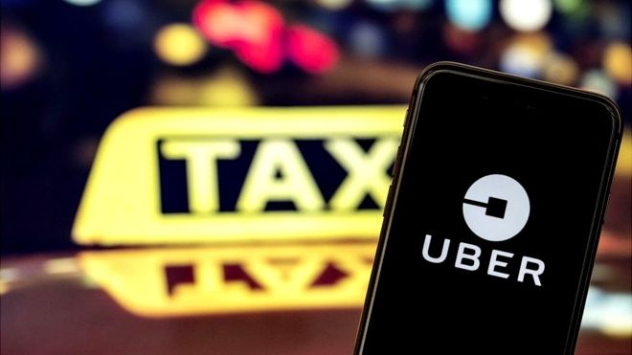

2.1 Definition of Promotion
In marketing, promotion communicates with the customers that try to influence it in the purchase of its products and/or services. In general, we promote our company, our products, and services trying to attract the attention of our target audience in the hope that it will do what we want (eg, look at our product, want to buy our product). You can promote your business, product or service in person, through direct sales or in a retail store, on the Internet, through a website or a social media platform, electronically by electronic mail or text message (SMS Marketing), to name but a few examples. The most popular professional communication channels, but the intent to influence the consumer is what defines the promotion and the difference of other communications with customers and/or customers.

2.2 The necessities of Promotion
Business promotion is an active process that must be carefully considered in order to achieve the best results. Small and medium businesses really need to understand the importance of promotion and marketing strategies. You can make the most of your workforce and develop strategies to promote your business and let it prosper.
Promotional strategies and marketing go hand in hand. The marketing of your brand or product will include different aspects of production, promotion, and sale of products to customers. The promotion is a key element to transfer the benefits of your product or service to customers. Well-designed marketing and promotion strategies ensure long-term success, attract more customers and drive business profitability. The benefits promotion provide are listed below:

a) Gather consumer in one place
The promotion helps to increase and gather consumer in one place. The more you promote your brand, the more customers know you and your business and the more they are interested in your products. The promotion can also be done by giving free samples that work wonders for customers! Test your product and end up coming to see you and make purchases.

b) Identification of Segment
If your marketing and promotion strategy is flexibly structured, you may not be able to target the "right" audience. Having a well-tested and well-planned marketing strategy and marketing plan can help you identify different consumer segments in the market and offer appropriate solutions to your customers.

c) Increase brand awareness
Promotions help create awareness. With the help of various media such as television, billboards, radio or local newspaper news, you can convey information about your brand and your business, allowing users to find more information about you.
While promotional strategies are very important, marketers and companies must consider some aspects of their marketing mix plan. It is essential that companies use the appropriate multimedia tool to target their customers. Nowadays, when social networks are the most effective tool on the online platform, promotion strategies should extend beyond radio, television and the press.

2.3 Ways to conduct promotions
Suppose, you are an organization that wants to grow and spread worldwide. You have carefully planned your company's entry into the new market, you have developed the right product or service and you think you can offer it at a profitable price. However, until you start selling your product, there is no need to take care of a significant part of your business that your business will not work with - that is, customers

Promotional mix
When creating marketing plans, the marketers usually uses a 4P template (which can also be found as a 5P template). 4P models include price, Place (location), product and promotion (afterward, models are developed to include people). So you define the price, the product and the place you want to sell it, but what about the promotion? How an organization could choose to promote its products and services, and a significant impact on sales. There are a number of ideas about how much money will be spent on advertising and the community's revenue for promotion.

Therefore, you will have to create your own promotional mix, once you have reached this stage in the business plan. The primary purpose of promotional mixing is to create brand awareness, but the most important thing is to create organizational goals and benefits. A promotional mix is ​​defined as effective if you can provide a clear and compulsory message that you have chosen the most appropriate method of promotion.
There are usually five elements involve in Promotional Mix. They are:

Chart: Components of Promotional Activities

a) Personal sale promotion
It is part of the promotional mix that provides for individual communication between buyers and customers (potential or already customers). Being personalized communication, it creates direct contact with potential customers and clients. Although it is considered one of the most expensive forms of promotion, it is also considered the most effective to the extent that it is possible to create and develop a seller-buyer relationship.

b) Direct marketing
While advertising targets a mass audience, direct marketing is aimed at potential customers and customers. Social media marketing, email marketing, internet marketing are all types of direct marketing used by companies. In recent times, they have become important in the promotional mix because people use the Internet much more than they did ten years ago. The company uses direct marketing to engage one-way communication with its customers regarding product announcements, special promotions, order confirmations and customer requests.

c) Advertising
Advertising is one of the key factors in the promotional mix that contributes to brand building and the way the market perceives the company. It is still an important part of the promotional mix due to the vast scope of advertising and the message you can send to your existing and potential customers. Good advertising can create a strong brand for the company. On the other hand, bad publicity with the wrong message can lead to brand or product failure.

d) Public relations
Finally, public relations allows an organization to influence a target audience and thus create a favorable and positive image for the company. The company tries to connect with the public by sharing information about the company and the product. If there is something wrong with the news, the public relations department must advance and rebuild the public image.

e) Sales promotions
Sales promotions are one of the most common types of promotion used by companies. Their main objective is to stimulate purchases and sales. Although it can potentially increase sales, it is also useful to inform potential customers about new products on the market or simply to win back old or lost customers. These examples include coupons, product samples and so on.
Chapter Three
The company overview: Uber Bangladesh

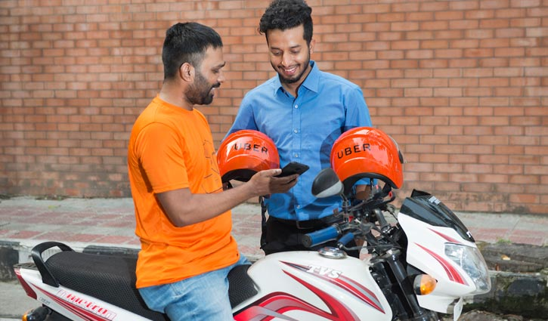

3.1 Background of the company
Uber Bangladesh is a transport service that provides service according to your request that brings a revolution in the global taxi industry. Uber's business model has created a unique document for a person who has just been in a smartphone and a taxi has gathered his dream as soon as possible. Uber is one of the few technology companies in the world that is worth more than $ 50 billion. Uber has already received an $8 billion capital fund and has 60 countries. Uber is an electronic warranty service that connects passengers with drivers. It is based in California, at Lavorano, as intermediaries in this way and drivers need to order cars, taxis or other types of transport via mobile devices. Garrett Camp and Travis are brain initiatives and the founder of Uber Cab in March 2009 as a founder of love for mobile phones. The client application can automatically request a travel request automatically. The interested Uber driver can communicate with the passengers and organize a collection. Uber does not have a taxi service for any vehicle for the company service. Uber drivers own private cars looking for the lunar platform. Including Dhaka and Chittagong, Uber works in 600 cities around the world.
Furthermore, Uber develops the market and manages UBER car transport and food delivery through mobile applications. And UBER has the simple objective of using technology to make our cities more accessible by reducing congestion and pollution. With them, it currently provides services in more than 500 cities in 74 countries, with an average of five million trips in UBER each day with its ambitions and objectives. UBER was launched in Bangladesh on November 22, 2016. Now, UBER is becoming a new mode of transportation with its luxury facilities.
Name of the organization | UBER
Type | Private held company
Industry | Transportation delivery(commerce)
Owner | Travis Kalanick, Garrett Camp
Founded | Mar-09
Headquarter | San Francisco, California
Founded in Bangladesh | 22nd November, 2016
Headquarter in Bangladesh | Road:12, Sector:12, 36 SonargongJanapath Road, Uttara, Dhaka-1230
Website | www.uber.com
Logo | 
Slogan | We will ride together
Helpline | 9612111777

3.1.1 Mission of Uber
The mission and vision of Uber is to make the transportation system affordable for everyone within the shortest possible time.

3.1.2 Core values of Uber
As an international multi-cultural organization Uber has 14 core values. They are list below:

3.2 Products and Services of Uber

Uber has introduced three types of transportation facilities in Bangladesh. They are:

3.3 Major Competitors of Uber
The major competitors of Uber in Bangladesh are listed below:

Chapter Four
Promotional Activities of Uber Bangladesh Limited

4.1 Promotion and marketing strategies
There are many definitions available on the Internet that explain what promotional strategy means. In simple terms, it is nothing more than a game plan to reach people and make them customers of the product or service provided by the company.

The promotion strategy is derived from the company's value proposition and covers all the company's offers: the value proposition and the relative message of the brand. Sometimes people confuse the promotion strategy with the marketing plan: here is a simple explanation of the difference between the two.

- Promotion Strategy: In marketing, Promotion strategies are designed to educate the public about your product, influence it to buy it, and establish a long-term relationship that allows it to be a loyal customer. Some means of communication include advertising, digital marketing, sales promotions, and public relations.
- Marketing plan: A marketing plan is a report that describes your marketing and promotion strategies for the next year, quarter or month. Typically, a marketing plan includes an overview of your company's marketing and advertising objectives. A description of your company's current marketing location.

4.2 Uber’s promotion and marketing strategies
From the very beginning, Uber's marketing and promotional strategy were not used to use traditional mass marketing methods such as television, the press, but promotional activities to educate and engage consumers. The Uber team were committed to offering a good product to its customers, to try to send it back.

Uber was an external stream that was very concerned about its promotion and marketing methods. The company has followed 5 phases to promote itself. The phases are:

Chart: 5 phases of Uber marketing strategy

    - Launch phase:
At the early stages of entering a new country market such as Bangladesh, Uber used two types of promotional strategy. They are:

- Influencer Marketing: Influencer marketing is a campaign that Uber uses to launch its services in any new city or country. They were tested with key influencers in each city to try Uber's service for the first time "in secret."
- In Bangladesh, they had collaborated with cricketers like Shakib Al Hasan, Mahmudullah, etc.
- In India, they had collaborated with cricketers and actors like Zaheer Khan, Ranvijay, Neha Dhupia, etc.
The same strategy was followed when launching its services in the United States, Pakistan.


- Free Rides: There could be nothing better than giving the customer a discount on the service they need, and that's exactly what Uber has done. Uber discounts customers on their first trip to Uber. The purpose of this exercise was simple: to give customers an idea of ​​their service and help them to adopt it.

    - Build-up phase
Have you ever wonder how a company go viral? It could not be utilizing the traditional promotional strategy that are delivered through the traditional newspaper or TV advertisements. Instead of spending billions of dollars on promotional activities and advancing traditional campaigns, Uber decided that consumers should spend money to give customers a first-hand service experience allowing them to try their product and services through referral marketing.
- Referral Marketing: Referral marketing methods are usually word of mouth. These types of sponsorship often occur spontaneously, but businesses can be influenced by appropriate strategies.
For Uber, the referrals went very well. The idea was to create a domino effect, in which a customer asked his family or friends to use the application and followed the same pattern.

For each referral ride you made, Uber awards credits for each referral reported to the contact person and the referee.

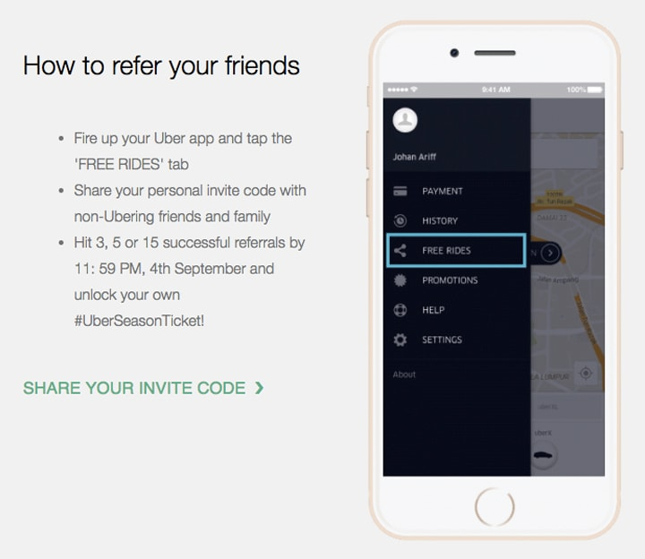

Amplification phase
It is important to create strategies to amplify the innovations and precious voices of people traditionally marginalized in emerging media so that their contributions remain "stagnant" in our minds. We must ensure that history reflects their contributions and that they are quite recognized. Uber, at its amplification stage has offered several service to its customers based on the interest of the country of its operation. For example, in Bangladesh, during Eid festival, Uber offered several discount plans to its service taker.

- Festival marketing, High discounts, and product development: After informing customers about what Uber is talking about, it's time to take advantage of all the engines and boost their launch by launching new services/cars, expanding their network of partners and expanding into new cities. Uber had something to offer everyone, from auto-rikshaws to cars, and cars to motorcycles. Uber launched services for all environments, at different prices that suited its budgets.
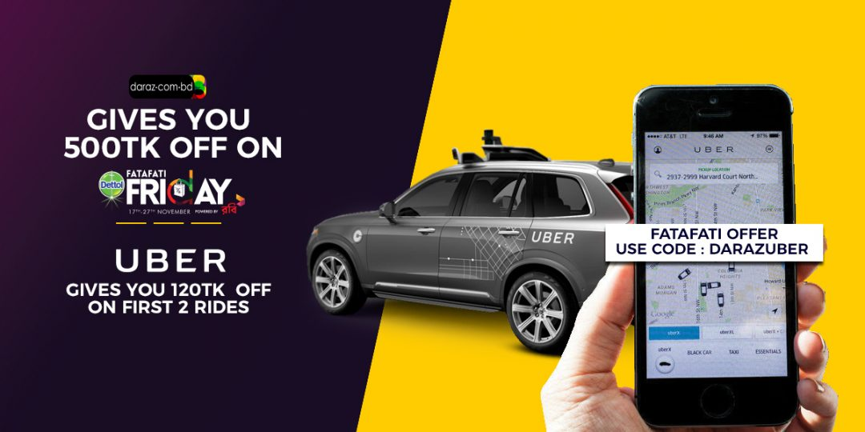

Uber had decided to be "available" to consumers when they needed it the most, which meant,

- Uber also offered to offer mothers a vacation change on mother’s day or lovers in a Uber Chopper on Valentine's Day.
- Uber even offered discounted trips for various cricket matches at Mirpur stadium and other key national events.
- Uber delivered kites to Makar Sakranti, free tours to Eid festivals and discount codes.

4.2.4 Sustenance Phase
Uber is an organization that has invested in the optimization of its business processes or in the implementation of processes with technology at different levels of maturity and recovery phases of the return on investment. To achieve sustainability in Bangladesh, Uber used some strategies.

- Strategic Alliances
After all, the right hooks and levers have been pulled and things moved north, you have to keep doing something to stay there. It was time to always be present in the eyes of customers, and the best way to do that was to create partnerships. The association had to integrate both partners and that's what Uber was looking for. Check out some of the really interesting strategic partnerships that Uber has opened and contributed to its journey.
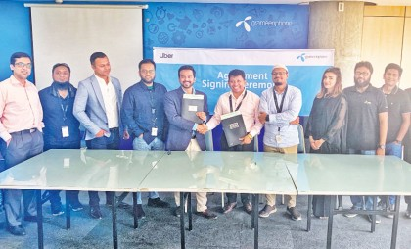

- Uber collaborated with GrameenPhone:
Uber has collaborated with Grameenphone in its business in Bangladesh. Yasir Azman, GrameenPhone's marketing director, said the partnership will allow GP customers to use the Uber service in a "very convenient" way. The State Minister for ICT, Zunaid Ahmed Palak, said he was "very happy" to have Uber in Dhaka as part of "our efforts to build smart cities".
"Uber will also give our community the convenience of being mounted at the touch of a button. Uber has the potential to offer untapped economic opportunities to Bangladesh," the minister said in a statement. Recently Uber also teamed up with one of the largest Bangladeshi online seller named Daraz.com.

Uber's stated goal is to "seamlessly connect passengers with drivers", but despite its growing popularity, the company has faced protests and disputes in countries such as Canada, France, Hong Kong, India, South Africa, the United States and the United Kingdom.

Growth Phase:
After all the efforts to establish and support the brand like Uber Bangladesh, the time has come to develop it and to grow, Uber needs to make sure that it does things that keep the brand above the customers.

- Marketing Campaigns:
What is the value of a campaign if it is not connected to the public! This is something that the Uber marketing team must have discussed before launching their campaigns.

Whether it's the ROAD SAFETY campaign or the EYE CHECK-UP campaign, Uber has tried to position itself as an inclusive, progressive brand and has also succeeded.

- Uber Is Being Local:
The last step of Uber's marketing strategy was to become local. Uber has tried to capture the pulse of each city in which it launches its service and, consequently, manage the appropriate content for consumers in that city or region and promoting the brand name through using helmets of Uber so that anyone can recognize the brand.
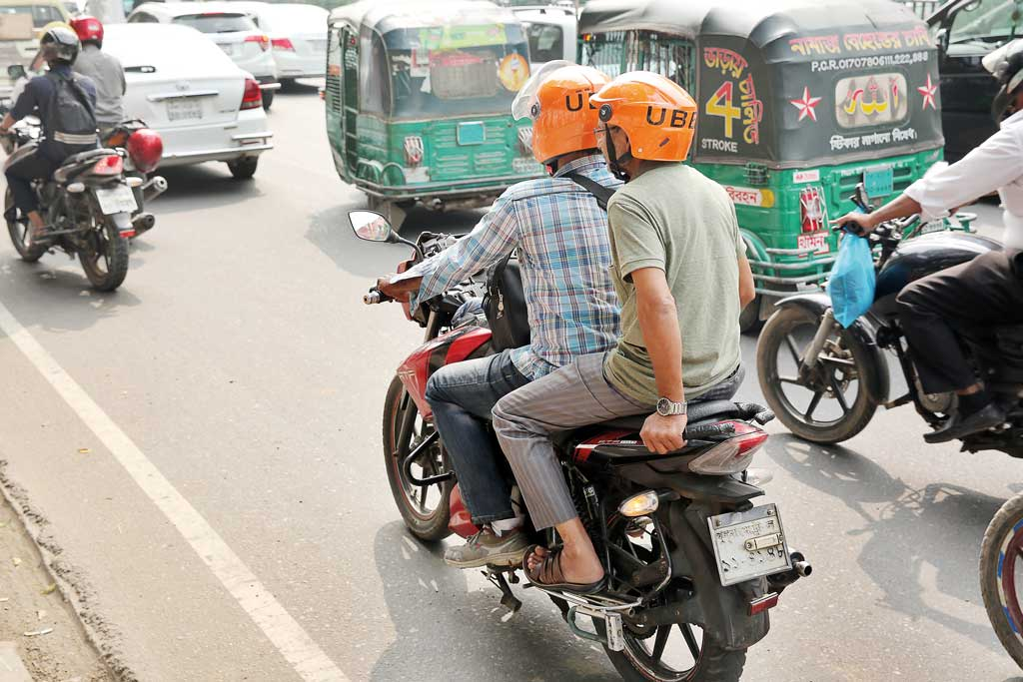

Chapter Five:
Recommendations and Conclusion

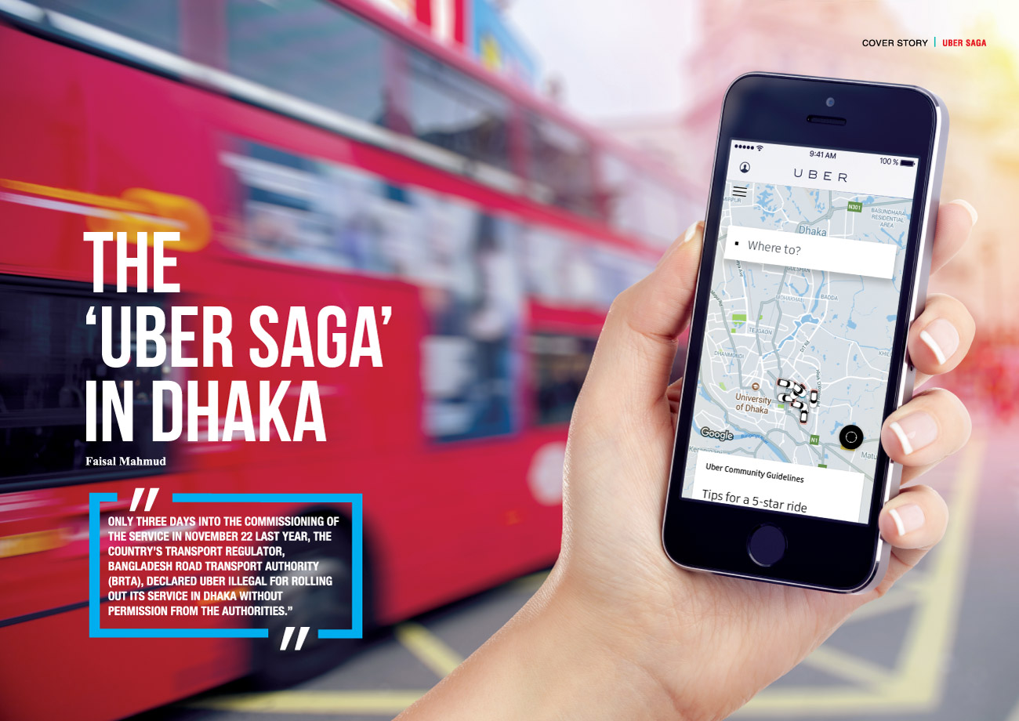

5.1 Recommendations
After the analysis and findings of Uber promotional activities performed in Bangladesh, I would like to share few recommendations to Uber Bangladesh for the upcoming betterment of this brand.
- In Bangladesh, there are a lot of external factors such as increased traffic, poor traffic services, lack of parking, increased income for consumers, and so on that acting in favor of the company. All these factors offer great opportunities for Uber to grow in the future.
- UBER has not yet expanded in many districts if Bangladesh. The company must turn to districts where it wants to expand and do everything possible to make this launch a success.
- In Bangladesh, there are a lot of national and public festivals are celebrated, Uber can target these festivals and offer promotional trips to expand its customers and can touch the emotional attachment with its consumer.
- Uber requires to introduce health and pension plan for its rider so that it can retain its riders for long term.
- Uber has to find out the lacking of its competitor like Pathao in Bangladesh so that it can generate new ideas and can offer new promotional activities to improve the rides for both customers and riders.
- Contribution in Bangladeshi roads can get high appreciation form the mass people of Bangladesh. To contribute to the society Uber can start tree-plantation on the foot-path and the borders of the road.
- Technological innovation plays a great role in Bangladesh, as the country somehow lagging behind in terms of the technical improvements. Uber need to invest more to generate more new solutions for Bangladeshi traffic problems.

5.2 Conclusion
Uber began his trip to Bangladesh on November 22, 2016. Uber has recently changed the transport ecosystem in major cities such as Dhaka and Chattogram and has created revenue opportunities for around a lakh in the last three years. The company continues its promotional activities using various marketing strategies.

New companies and large companies have shown great support to promote Uber within continuous movements. The reaction of the platform to consumers has been extremely positive, as evidenced by its overall social growth. However, how will cities be managed today and a complex process in the future? When listening to current needs and trends, it is equally important to plan for the future. The technology currently in the development stage can interfere with plans that are years of creation. During the urban planning process, accounting for future government trends should be considered to avoid surprises on the streets.

Reference
- Uber Staff. 2014. An Uber Impact: 20,000 Jobs Created on the Uber Platform Every Month. Uber Newsroom. Retrieved from https://newsroom.uber.com/an-uber-impact-20000-jobs-created-on-theuber-platform-every-month-2/
- Pullen, J. P. (2014). TIME: Everything you need to know about Uber. Retrieved from http://time.com/3556741/uber/
- "Uber Technologies, Inc. FORM S-1 REGISTRATION STATEMENT". U.S. Securities and Exchange Commission. April 11, 2019. Archived from the original on july 13, 2019. Retrieved July 14, 2019.
- Carson, Biz. "Uber's Secret Gold Mine: How Uber Eats Is Turning Into A Billion-Dollar Business To Rival Grubhub". Forbes. Archived from the original on july, 2019. Retrieved July 16, 2019.
- Dhaka Tribune, Newspaper, Article name: Uber launches new operation. Available at: https://www.dhakatribune.com/uncategorized/2016/11/22/uber-launches-operation-dhaka
- Propaganda and Promotional Activities; an Annotated Bibliography. By Harold D. Lasswell, Ralph D. Casey, and Bruce Lannes Smith. (Minneapolis: University of Minnesota Press. 1935. Pp. xvii, 450.)
- Paulo Albuquerque, Polykarpos Pavlidis, Udi Chatow, Kay-Yut Chen, Zainab Jamal (2016), book name: Evaluating Promotional Activities in an Online Two-Sided Market of User-Generated Content

