Internship Report On
“Current Human Resource Practices & Employee Attitude”

M.I Cement Factory Ltd.

Submitted To

Farhana Rashid
Assistant Professor
United International University, Bangladesh

Submitted By

Nusrat Jahan Nisi
ID: 111 142 278
Bachelor of Business Administration (BBA)
United International University, Bangladesh



Date of Submission: 18th October, 2019
Letter Of Transmittal

18th October, 2019

To,
Ms. Farhana Rashid
Assistant Professor
School of Business Studies
United International University
Dhaka, Bangladesh

Subject: Submission of Internship Report on “Current Human Resource Practices & Employee Attitude”.

Dear Madam,
I am delighted to present this report on “Current Human Resource Practices & Employee Attitude” for the fulfillment of period of intern.

This is to let you know that I had completed my internship at M.I Cement Factory Ltd. (Crown Cement). I have been working in the Human Resource Dept. with the supervision of GM (Head of HR), Mr. A B M Yusuf Ali Khan. It was most delight to work and learn new things from a helpful supervisor and in a friendly environment.

Completing this report has been really exciting & learning experience for me. I have come to know many unknown things, as I was working at the Head office, which I believe will be supportive to my academic & professional career in the future. During writing this report, I have learned to integrate plenty of information into a short precise volume. I have really enjoyed working on this report and I hope that my report will meet the level of your expectations.

I will try my best and will be obliged thereby, to provide you with any kind of explanation regarding the report.

Sincerely Yours,

…………………
Nusrat Jahan Nisi
ID- 111 142 278
School of Business Studies
United International University

Acknowledgements

At first, I would give thanks to the Almighty Allah for blessing me with the strength and patience for finally completing my internship and this report.
I want to thanks my Academic Supervisor, Ms. Farhana Rashid madam for giving me that chance complete my period of internship. I have been able to adjust and complete this report in a precise manner due to the guidance, support and counseling that she has provided me with during this time period. I have tried my best to implement her informative suggestions while doing my report.
I would also like to take this chance to the help provided to me by some employees of the company. My honest gratitude also goes to Mr. A B M Yousuf Ali Khan; General Manager; (HR) for providing me with information that was required to complete the report, and for guiding me properly throughout the period of my internship. I would also like to thank all the employees of MICFL who has supported me and co-operated with me during my internship period.

Finally my heartily gratitude and thanks go to each and every one who has helped and supported me unconditionally in the phase during the period of my internship.

Executive Summery

M. I. Cement Factory Ltd. is a public Ld. and one in all the leading makers of cement in People's Republic of Bangladesh. On December 31, 1994 it started its journey with the commitment for providing best quality cement to the country. Its brand "Crown Cement" has own renowned both home and abroad.

Besides in this study incorporated the history, I had try to incorporate a brief of how HR Department does their job in M. I. Cement Factory Ltd. (Crown Cement).

While making the intern report on Current HR Practices and Employee Attitude I have provided detailed information about HR practices at M. I. Cement Factory Ltd., HR outcome & employee attitude toward the organization.
I have coated all the connected factors with it and additionally to it I actually have tried to include the items that I actually have learned with the practices I actually have seen.
This report also provides a brief overview on HR outcome, practices, employee tendency of turnover etc. and my personal observation regarding the critical issues, the lacking of the HR Department and my recommendations for improving the total HR practices of M. I. Cement Factory.
Then I gave the complete information of how I did completed the study, how many of my respondents, problem during project analysis and running HR practices in M. I. Cement Factory Ltd. (Crown Cement). Then I reached in a conclusion which sum up all the analysis and finally I present that format I have introduced at M. I. Cement Factory Ltd.

Table of Contents
Title page No
CHAPTER – 01
Overview of Crown Cement Group
1.1 profile of Crown Cement Group 2
1.2 Organizational culture of Crown Cement Group 3
1.3 History of Crown Cement Group 3-4
1.4 Mission, Vision 4
1.5 Commitment 4-5
1.6 Goals 5-6
1.7 Product 6
1.8 Sister Concern of Crown Cement Group 7
1.9 Organogram of crown Cement Group 8

CHAPTER- 02
HR Practices in Crown Cement Group
2.1 Recruitment and Selection Process 10-16
2.2 Training & Development 17-19
2.3 Policies exist in Crown Cement Group 20-26
2.4 Compensation & Benefit 27-29
2.5 Performance Appraisal 29-31
2.6 Career development & Succession planning 32-37

CHAPTER-03
Theoretical Analysis of Crown Cement Group
3.1 Definitions of HRM 39
3.2 Characteristics of HRM 39
3.3 Various features of HRM 39-40
3.4 Scope of HRM 40-41
3.5 Objective of HRM 41
3.6 Functions of HRM 42-44

CHAPTER-04
Internship Experience
4.1 My Contribution at Crown Cement Group 46-47
4.2 My learning through the internship period and the efficiency gained 47-51

CHAPTER- 05
Findings and Analysis
5.1 General information analysis 53-55
5.2 Analysis on HRM practices 55-69
5.3 Analysis on perceived organizational support 69-72
5.4 Analysis on employee attitude & behavior 72-75
5.5 Analysis on Discretionary behavior 76-78
5.6 Analysis on Affective & Normative commitment 78-83
5.7 Analysis on Employee Turnover Tendency 83-85
5.8.1 Positive Findings 85-86
5.8.2 Negative Findings 86-87
5.9 Recommendation 87-88

Conclusion 89
References 90-91
Appendix 92-94

Chapter – 01
(Overview of the Organization)

  - Profile of M. I. Cement Factory Ltd. (Crown Cement Group)

M. I. Cement Factory Ltd. is a public Ld. and one amongst the leading makers of cement in Bangladesh. On New Year's Eve, 1994 it started its journey with the commitment for providing prime quality cement to the country. Its whole "Crown Cement" has own noted each reception and abroad. Initially the plant was put in with a capability of manufacturing 600tpd (ton per day) of Portland cement. With the passing of your time the demand of Crown Cement augmented day by day. Therefore the sponsors expanded the project thrice.

By means of quality Crown Cement presently gained acceptableness each reception and abroad that raised the requirement for increasing the plant from initial 600tpd (ton per day), 800tpd 2nd unit in 2002, 1400tpd third unit in 2006 and 3000tpd fourth unit in 2011 thereby raising the entire production capability to 5800tpd i.e. 1.740 million MT once a year.
The company has been listed in national capital exchange and city exchange in 2011.
Its high growth agenda are extremely appreciated by the shareholders, and have won investors trust. Its backward and forward integration endeavors have given new dimensions to its growth platform.
With this finish visible, the associate industrial units' viz., Crown compound material Ltd., Crown Power Generation Ltd., Crown Mariners Ltd., Crown Transportation Ltd., Crown Cement Concrete & Building Materials Ltd. have been set up and are already in operation. The company has also acquired a handy max size ocean going ship to facilitate transportation of raw materials from abroad. It is hopefully expected that these new growth platforms can facilitate creation of recent dimensions and frontiers to the mother company

M.I. Cement Factory Limited. Crown Cement pioneered in export of cement in 2003 and paved the way for earning hard-earned foreign currency. Recently Crown Cement Achieved the National Export Trophy (Gold) doubly for attaining the highest most place among the cement exporters in Bangladesh. The mill possesses well communications facility each through water and road. It is situated as West Mukterpur, Munshigonj on the bank of the river Dhaleswari. It is connected by a auriferous road (Dhaka- Munshigonj Highway) coupled with the total country.


The logo of the association symbolizes Inspiration. The Green shading symbolizes the national guide for opportunity and the logo is planned in a geometrical example image which itself is a rousing article. It enables the representatives to feel propelled; making them feel that on the off chance that they function admirably, they can't just add to the efficiency of the organization yet in addition carry greatness to the nation and motivate others to that also. This is without a doubt, a worth expansion to the way of life of the association also.
  - Crown Cement’s Organizational Culture: at a glance

- In Crown Cement, new framework reception is constantly welcome by its workers and businesses both.

- Any sort of progress is checked, and afterward whenever discovered positive, it is acknowledged which has come about for changes to increment throughout the years.

- The delayed consequence of such change is extremely profitable and adds to the general development of the association.

- Performing any new undertaking is conceivable with less or less exertion since gathering cohesiveness is extremely high and appropriation of work is carefully pursued.

- Learning any new thing is conceivable with less exertion.

- Employees are happy with the new arrangement of the association including every now and then for adjusting and actualizing these changes.
1.3 History MICFL
The company started off as a group of top ranking businessmen of the country set together who decided to establish a cement factory, when the sanctioned capacity of cement manufacturing plant was nearly double the demand of the country.
Corporate Profile of Crown Cement Group:
Status: | Public Limited Company
Incorporation of the Company: | 31st December 1994
Date of Commencement: | 31st December 1994
Subscription Open on: | 9th January 2011
Subscription closed: | 13th January 2011
Listed in Dhaka Stock Exchange: | 18th May 2011
Listed in Chittagong Stock Exchange: | 5th May 2011
Commercial Production: | 13th October 2000
Nature of Business: | Manufacturing and marketing of Ordinary Portland Cement and Portland Composite Cement.
Credit Rating: | Entity – AA3 Short Team – ST-2
Authorized Capital: | Tk. 500,00,00,000
Paid up Capital: | Tk. 100,00,00,000
Man Power: | 3329 permanent and 133 Casual
No. of Shareholders: | 34,554

  - Vision & Mission

Vision
Our vision is to make a contribution to the nation by creating opportunities in the arena of industrial growth and development of Bangladesh, and to provide a solid foundation for society's future.
Mission
As a modern cement company, we manufacture cement (Brand name: Crown Cement) to meet the needs of clients through innovative products & services that create value for all our stakeholders.

1.5 Commitment

- Stakeholders - Create feasible financial incentive for our investors by using a genuine and productive business system.

- Community – Committed to serve the general public through business creation, bolster network ventures and occasions, and be a mindful corporate native.

- Customers – Sender administration to our clients by utilizing best in class innovation, offering expanded items and seeking to satisfy their needs as well as could be expected.

- Employees – Be solid on the inalienable value of the representatives and respect our connections. Work together to celebrate and compensate the one of a kind foundations, perspectives, abilities, and gifts of everybody at the work place, at each level.

  - Goals
We will likely:

- Continually set the advanced benchmarks of most recent innovation in our industry to fulfill the requirements of clients through creative items and administrations.

- Contribute to the national economy and the framework improvement of the nation.

- Secure the most grounded situation in our applicable commercial centers through making quality item and operational greatness.

- Be agreeing to the top best providers, conveying expanded an incentive for both the organization and our clients.

- Be perceived as an alluring, regarded, organization and a business of first decision.

- Provide tremendous of vocation openings through aggressive compensation and advantages, preparing and advancement and an agreeable workplace.

- Empower our workers at each level, and meet them completely into our system.

- Continually show our pledge to maintainable natural presentation, and assume a master dynamic job in Corporate Social Responsibility (CSR) inside our effective reach.

- Achieve long haul monetary execution.

- Create verified speculation opportunity inside the nation.

- Enhance adaptability, and enhancement through the infiltration of new market sections.

- Improve regulatory and association structures to survey all business lines normally and build up the best practice in the business.

- Earn outside money through fare bond.

1.7 Products of Crown Cement Group
Crown Cement Factory basically produces 3 types of cement:
1. Portland Cement
2. Portland Composite Cement
3. Crown Izonil



1.8 Sister Concerns of M. I. Cement Factory Ltd
- Crown Transportation & Logistics Ltd. (CTLL)
- Crown Mariners Ltd. (CML)
- Crown Power Generation Ltd. (CPGL)
- Crown Cement Concrete and Building Products Ltd. (CCC&BPL)
- Crown Polymer Bagging Ltd. (CPBL)
- Crown Maritime & Shipping Services. (CMSS)
- Molla Ahad Shipping Lines. (MASL)

1.9 Organogram of Crown Cement Group

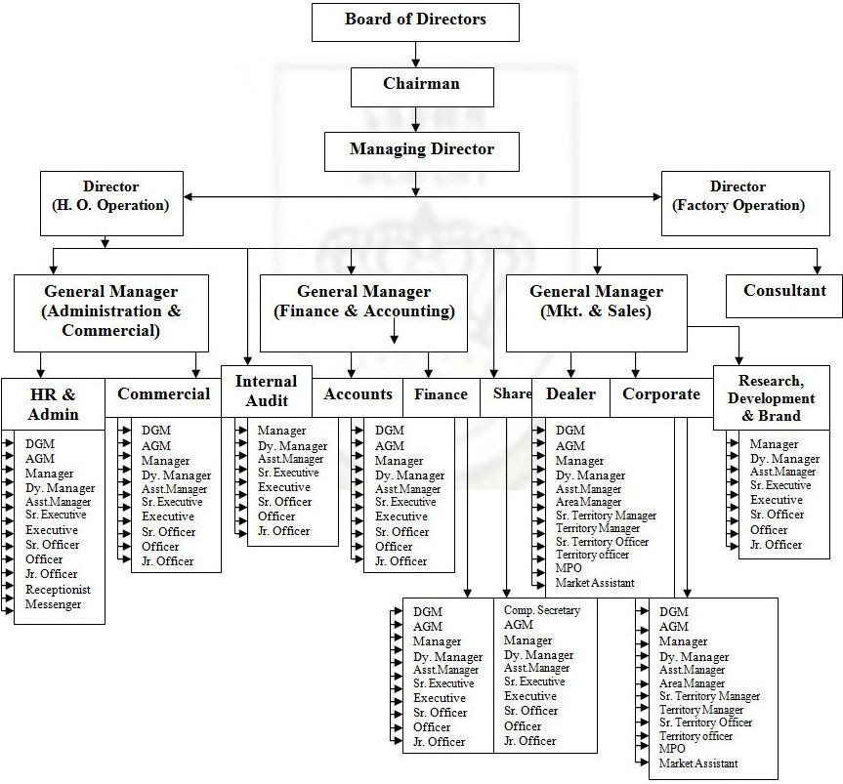

Chapter – 02
Human Resources Practices in M. I. Cement Factory Ltd

2.1 Recruitment and Selection
Employment Policy of M.I. Cement Factory Limited
M. I. Cement Factory Limited gives equivalent chance to every single Bangladeshi native. It accepts that so as to accomplish the Organization's objective, there must be effective HR. In this manner, the Organization gives most noteworthy consideration and endeavors in selecting profoundly qualified and skillful workers who are prepared to face difficulties in accomplishing Organization's objectives. The job of HR in regard to drawing in, holding and persuading qualified and skillful representatives is colossal. The execution and plan of a sound Employment Policy have extraordinary effect in the satisfaction of wanted destinations.

M. I. Cement Factory Limited business strategies are severe as in they don't permit any support, nepotism or extraordinary treatment to anybody.

Any sort of obstruction or attempt of impedance all through the usage of any progression of the enlisting strategy by any quarter is truly adapting to in accordance with the Organization approach.

Essential Recruitment Policies:

1. M. I. Concrete Factory Limited is resolved to enlist qualified and talented worker for empty positions.

2. All arrangements in M. I. Cement Factory Limited will affirm to its current situation with Grade and Salary level.

3. If there should be an occurrence of internationalism, M. I. Concrete Factory Limited may enlist senior representative from abroad in the event that appropriate national worker couldn't discover with the necessary ability, upon endorsed by Board of Directors.

4. The status of business can changed from legally binding to ordinary worker on the circumstance emerging from Organization need or on the ground of execution.

5. The M. I. Concrete Factory Limited inner candidate will be named to travel costs, as indicated by the HR arrangement, for the meeting held in other than his/her place of posting.

6. HR and the line supervisor will keep up appropriate secrecy of the usage of the enlistment procedure. No inquiry will be reacted or no information will be given in regards to the status of any enrollment until the whole procedure is finished.

7. HR will keep up a functioning database joining aptitudes stock of representatives that might be utilized as a beginning stage from enrollment to relieve.

8. It is a significant job with respect to HR to assess the viability of enlistment strategies, short-posting criteria, testing apparatuses being utilized and so on. Assessment is valuable for procuring steps and consequently receives better choice systems for the Organization.

9. Enlisting of relatives of representative is to be disheartened. The relative and companions are not contracted in a similar division/Section.

Be that as it may, with the composed endorsement of power, relatives of representative might be employed by the Company in another division/Section gave.

At the point when partner laborer turns into the relative of another by wedding, they'll update unit of time during this respect. On the off chance that anybody shrouds their marriage data, it will be seriously manage as indicated by the association approach.

Manpower need and requisition

The relevant department head completing a HR Requisition From and then submits it to the HR Department. There are 2 types of HR Requisition Forms. This form is to be initiated by the Head of the Department and is to be approved by Managing Director of the company.
Form “Requisition for Additional Manpower” is needed when the department requests for staff that is in addition to the currently approved strength shown in the approved Organizational Structure. This form is used for all additional manpower, even if the new position has received prior budgetary approval. This form needs to be approved by the Board of director, Vice President and above and by Managing Director for employees of other posts.
For additional manpower requisition, the departmental head must provide a document containing
(i) Job Description for the new post,
(ii) To give proper reason to explain that the job tasks for the newly requested post cannot be done by the existing manpower and, also are not listed as job responsibilities of any existing role, or overloads the person in the role for the existing position, etc.

Recruitment Sources
Inward sources:

MICFL's arrangement is to offer inclination to procure from inner competitors gave that the worker is equipped for the new empty position and furthermore meets the future prerequisites.

Arrangements are likewise made by the way of advancement, up degree or move with the endorsement of the position. Nobody is permitted to apply for arrangement during her trial time span. Advancing interior existing representatives premise of progression arranging may likewise be investigated. "Any difference in occupation won't settle on MICFL's pledge to the requirement for expert fitness and guidelines for greatness." M. I. Cement Factory Limited will be promoted through inward notification to the individual workplaces.

Outer sources:

At whatever point work opportunities are required to be promoted outside, the primary proverb will be to draw in a pool of contender to apply from which qualified possibility for employment opening can be picked. Additionally the whole enrollment procedure can be re-appropriated to a head chasing organization.

There are a number of external sources that will be used by the organization:
ϖ Newspaper advertisement
ϖ Website
ϖ Head Hunter
ϖ Outsourcing
ϖ Employee referrals
ϖ Walk-ins and Write-ins etc.

Advertisement for vacancies

Upon receipt from Associate in Nursing approved requisition time unit Department drafts an advert for that desired position in consultation with the top dog World Health Organization apply for the hands, and places the Advertisement in renowned daily country newspapers. HR consultants also can be appointed to find outside qualified candidates to fill the vacant position. The advertisement may also be given in some renowned Job portals.

Getting Applications
HR Department gathers employment forms/CV against every opportunity declaration. There ought to have a base given time span for application accepting. Applications won't be acknowledged those are gotten after then given timeframe. Under outrageous conditions, applications after cutoff time might be acknowledged given composed consent is given by the concerned division head.
Short posting of candidates:
Short posting of candidates is done based on assessing information on the application structure in the light of employment details of a vocation being publicized. There are general and specialized both employment criteria that an applicant needs to meet for thought of following stage of determination.
Short listing will be done by evaluating the following:
- Academic qualification: whether the candidate has the required educational qualification or not for the specific job.
- Relevant job experience and required skills: How far candidate’s most recent job experiences and skills match the job requirements of the position in question. The candidate may not have relevant experiences and skills that will not be considered during employee short listing for the job.

- Extra curriculum activity: Relevant extra curriculum actives can be considered to understand personal interest of the particular candidate and also the area he/ she good at. Basically to understand her personality that how well he will communicate.
Administering tests:
Short-listed candidates to be called for attending some test followed by formal interview.

Written Test: Written test addresses will be classified by HR with the meeting of line administrator. HR can pursue employment needs of the position and look after association, consistency and standard on the example of inquiries. The sort of inquiry will rely upon the position. Generally a blend of various and story addresses will be set in the composed test. The base required score in the composed test is half. Applicants who have qualified in the composed tests will be required the following controlling test.
Aptitude/Fitness Tests: This sort of test is utilized to quantify an individual's ability or capacity to adapt new things and play out a vocation appropriately. Inclination Test incorporates Critical, Verbal, and Numerical thinking.

Interview
Preliminary interview:
Interview will be conducted by the HR team along with the concerned departmental head. For junior officer level to Sr. Executive level these preliminary interview can be consider as final interview and assistant manager to above will go for final interview with company chairman. Employee recommendation from done by the interview committee will be sent to the Board for their approval.
Final interview:
Final interview and last of the selection process will be conducted by Chairmen of the company. For final selection a short list candidate along with grading of preliminary interview by the interview board will be sent to the company Chairman.

Shutting and Evaluation:
At this stage a sign is given that the meeting procedure is going to be end. The questioner assesses the presentation of the applicant by utilizing an evaluation structure and records their general impression dependent on notes taken during the session. An agreeing suggestion is made and sent to hour close by all papers for next strategy. The board individuals sign the Employment Approval Form.

Data and reference check:
When a starter decision call is made, HR will check the given data as gave in the Job application, for example, instructive foundation, work understanding, last business status. The perspective check is to get genuine data secretly about an imminent representative and looking for assessments from expert officials and past boss about his/her appropriateness for a vocation.
M. I. Cement Factory Limited power will demand the contender to tell about any criminal offense by the Court, just in the occasion the data appears to be so. M. I.Cement Factory Limited anticipates increasingly exact answers from the arbitrators in a standard configuration.

Final Selection and Employment Offer:
In light of positive report on wellbeing status from the restorative focus, and reference check, the competitor at last is chosen for arrangement. At this stage, they chose competitor is offered work with M. I. Concrete Factory Limited according to gave that all data is positive during the conclusion of her arrangement.
The idea of work will express that the significant terms and states of work with M. I. Cement Factory Limited.
Any supplier of business ought to be dependent upon a definitive reference counsel with this or last pioneer. A Personal Information Form must be topped off by the last chosen competitor. The structure contains detail data about the new contract and next the data will be included piece of HR database. The data gave during this sort ought to be valid and complete. Inability to give right data is dependent upon disciplinary activity as indicated by the association strategy.
Arrangement Authority

Arrangement authority is characterized as the privilege and obligation to take choices regarding enrollment, determination and the issuance and marking of all important correspondence with representative during procuring.

Discharge Order (for new representative)

Individual who is utilized with another association must give freedom/discharge letter to HR at the hour of getting together with M. I. Concrete Factory Limited. By no means, workers joining will be acknowledged without discharge request being delivered from the last boss. M. I. Bond Factory Limited dodges potential legitimate complicacy emerging due to renunciation of acquiescence by the individual's past manager.

Access to Personnel Information

All staff archives are classified and in this way, access to workers close to home record is confined to different representatives. Just Hr representative can access document with HR head authorization.

Access to particular modernized data is permitted up to certain level. Upon solicitations, representatives' classified data might be imparted to their individual supervisory power. On composed solicitation of a worker, HR Director may enable the representative to see his/her particular staff archives, (except for any classified records not to be imparted to him/her, reasons must be portrayed).

M. I. Concrete Factory Limited office will guarantee the best possible upkeep of exceptionally significant reports as to the representatives so that these can appropriately fill the need of review/legitimate necessities and be utilized as reference for future activity.
Re-employment
Employees, who already left M. I. Cement Factory Limited, are eligible for re-employment if he/she meets the present job requirements. All re-employment with M. I. Cement Factory Limited are subject to approval by the Director HR/Management.

Such candidate additionally is also} thought of on condition that there's vacancy and subject to his/her favorable performance record within the past and also if he/she meets the Company’s current job needs.
An employee who has dismissed or terminated or whose previous service record is not satisfactory is not eligible for re-employment with the organization.
Interns
Interns are the persons who perform special assignment in any particular field if Company business as part of their academic course. The intern is expected to perform specific activity under the agreed assignment on their own academic zone. The internship period will be maximum four months and at the end of the assignment, the intern will prepare a report that will be exclusive property of M. I. Cement Factory Limited.
The contents of the report won't be shared with outside individuals or organizations aside from the requesting institute.
The remuneration of the interns will be determined through negotiation. Here in crown cement the remuneration is 6k. If the performance of intern is satisfactory he or she may be hire on her desired department with the consent of department head.
Consultants
M. I. Cement Factory Limited hires such consultant to perform any special assignment that is specially required for the Company. The consultant must be a competent and quiet person with relevant background, skills and previous experience in the asking field of study. The result may be in the form of report preparation that will be examined how well the findings and recommendations of the report could be linked with Company’s future plan and strategy.
The remuneration and travel allowance should be standard and it will depend on the nature of the study result, the profile of the consultant and frequency of visit outside Dhaka.
The remuneration is negotiable, however, the adviser remuneration are determined per day or fastened term basis.
After the end of the specific assignment or work, consultant’s evaluation will be prepared that will be part of consultant’s personal file for future reference.

2.2 Training & Development
The Company accepts that appropriate types of training and watching out circumstances add to Human Resources Development (HRD) by the trail of redesigning the work abilities, existing possibilities and private development Which advantages worker and the Company both? Therefore, the Company causes workers to build up their aptitude and learning and furthermore improves their commitment to the Company. It is suggested that each and every representative ought to have chance to update their staff information and aptitude through HRD mediations which incorporate preparing, workshops, exposures, trade visits and some other type of improvement opportunity gave by the Company. Best workers will be given ordinary interior/outside preparing to help and prepare up their entire administration and authority expertise and learning in the specific Company.

Worker Development Assessment
- Representative's advancement might want zones should be referred to and transferred with the director as TNA all through the Performance Management framework (through yearly examination) each and viewing of crafted by the laborer by his/her boss.

- For all instructing, mentor abuse the Company's very own assets or time is dependent upon the structure might want and will be at interims the endorsed spending plan.

Worker Development set up and Budget

- Worker Development/Training might want Assessment could be a nonstop technique and will be done before plan of yearly spending plan. Each Unit and every division can direct a yearly training set up and Budget at the hour of spending arrangement.

- The instructing set up incorporates the training of specialist with regards to their level at individual and furthermore the Company level.

- Every Department ought to present a copy of their yearly instructing imagine to time unit training and Development Section in December (every year) to incorporate inside the Company's Annual instructing set up and spending plan.

Determination of staff for Training and Authority of decision

- It is that the duty of the managers to pick once or who should get preparing. For local level Training, different chiefs can advocate an assignment to the time unit Committee for endorsement through time unit Department.

- Training is fundamentally given at interims the nation. Astoundingly there is likewise might want for a couple of abroad preparing/visit for a couple of more elevated level staff. For abroad preparing/visit last decision and endorsement are made by leader with underwriting from the Board at interims the affirmed preparing set up and spending plan.

- Selection of worker for training ought to be primarily based on:
− The training are benefited the corporate still because the staff each.
− Skill, information and perspective enlargement in recent job.
− Additional skills for job or increase the responsibility.
− Need of the corporate to form special class of staff.
− Equal chance provided for all together with a gender balance.
- Probationary staff is ordinarily not eligible for a protracted workshop or training courses (longer than one week) except the Induction and Foundation coaching provided by the corporate. Any exception to the current ought to be in agreement by the upper authority.
- International coaching or visits are managed by the pinnacle of time unit once it's been projected by the supervisor and approved by the Board of director.
Local Training

- This refers to those HRD interventions control within the country. Supervisors are absolutely accountable for making certain that their worker receives access to coaching and development events in areas that are known for them.
- This is way valuable if the external coaching will offer experience or sharing of experiences that's not obtainable within the Company. for a few staff external coaching is also used to boost, update, or develop specific skills. The Company’s staff World Health Organization receive external coaching can after feedback to the colleagues and counterparts.
- Generic coaching can sit down with general coaching areas that are applicable to an outsized variety of the Company’s staff. The generic would like areas are known from strategic plans and individual development programs and evolving internal would like.
- This might embrace in house coaching to {the workers the workers the staff} by exploitation the abilities and knowledge of any senior employee, in house trainers or consultants. In-house coaching are designed and managed by the involved section or workplace together with time unit Department of the corporate.

Overseas training
This will refer with those events and interventions which will modify additional growth and development of staff and should need travel out of the country. This may be coordinated and organized by head of time unit.
New worker Orientation
An employee’s orientation to their department could be correct thanks to facilitate staff create an entire transition into the corporate. Associate degree orientation category is conducted as and once needed, expedited by personnel from time unit Department at the pinnacle workplace.

The modern category covers the following:
1. The Company’s Philosophy / summary of company
2. The Company’s Vision, mission, Goals
3. Brief summary of the Departments underneath the corporate, covering comes, systems, administration, etc.
4. The Company’s Operational Manual (related to the new employee’s job)
5. Key notes taken from the time unit Manual.
6. Q/A session
2.3 Compensation and advantages
General Guideline
- Company is sure to maintain compensation and advantages that are honest to any or all staff in keeping with their level and competitive within the native Marketplace and /or comparable organizations.

- Company management can monitor changes within the economy and job market to make sure that the compensation package is enough for attract recruit and retain top quality workers at intervals the monetary capability of the organization.

- In order to determine a rational and just pay and profit package the corporate management can review the employees’ compensation package on a daily basis. It depends on management call. .

Grades
- In order to include and maintain a rational and just pay and profit, Company have own grades for workers

- The organization could produce new position to satisfy its necessities and should attach to a grade commensurate to the position.

Pay Scale
Company maintains a pay scale applicable for every worker appointed by Company underneath completely different grades or levels. Company ought to review the pay scale on a daily basis and once felt necessary considering countries and company economic conditions and country budget.

Salary Components
The salary structure of an employee will be as per the following:

Basic Salary | 60 % of Gross salary
House Rent Allowance | 50 % of Basic salary
Conveyance Allowance | 5% of Basic Salary
Medical Allowance | 5% of Basic Salary
Total | 100%

Salary and Allowances
Salary and benefits include basic salary and other allowances that are paid by the company. It also includes other periodical payments accrued from time to time and other facilities offered by the employer.

Basic Salary:
Basic Salary means the basic pay of an employee depending the Company pay scale including the yearly benefit accrued to him as per the grade including increments.
House Rent Allowance
Unless otherwise stated, every Management Staff category employee shall be entitled to House Rent Allowance @ 50% of basic salary.
- The Board of Directors of Company may decide to change this rate considering the economic condition of the country and cost of housing-index of the country, if felt necessary. Basically on the time of country budgeting.

Conveyance Allowance
Every employee is eligible to Conveyance Allowance @ 5% of her basic salary.

Medical Allowance
Every employee is eligible to Medical Allowance @ 5% of her basic salary.

Car Benefit
- Managers or above who are working in Crown Cement are entitled for this loan in lieu of car benefit subject to satisfactory service minimum one year to the company.

- The offered loan amount for:
  - Manager/AGM/DGM : 20,00,000 BDT (Maximum Limit)
  - GM and above : 25,00, 000 BDT (Maximum Limit)

- After buying a car or having already personal car officials will receive allowance for Marketing People Tk. 35,000 ( Thirty five thousand taka) including and others Tk. 30,000 (Thirty Thousand Taka) fuel and driver’s salary ( except Tax, token , insurance ,repair and maintenance of the car)
Motorcycle Entitlement
The following rules will be applicable in connection with entitlement of motor cycle:

- In order to approve a new motor cycle, each employee should submit a proper application to the rightful authority through the departmental head. If the reason is satisfactory to the departmental head as well as after the completion of confirmation process of concerned employee, the departmental head will forward recommendation to the human resource departmental head.

- Motor Cycles will be only given to the employees of marketing and sales department. In case of other departments, it will be at the discretion of management.

- For buying motor cycles taka 1, 10,000 (one lac and ten thousand taka) is the limit.

- Company will give 30% of the motorcycle’s price. 70% will be given by the employee by 84 times installment in every month.

- Employees who will be taking the motor cycles must have valid driving license.

In case of Accident: For casualties caused by accident while on duty the management may pay a lump sum amount in local currency as per amount mentioned against each grade:
Grade Amount
GM 1, 50,000.00
DGM/AGM 1, 25,000.00
Manager/Sr. Manager 1, 00,000.00
Dy. Manager/Asst. Manager 90,000.00
Executive/Sr. Executive/STM/AM 80,000.00
Officer/Sr. Officer/TM/STO 70,000.00
Jr. Officer/Office Asst. /Market Asst. /TO 60,000.00
Messenger/Sr. Messenger 50,000.00

NB: Employees, who are given health insurance cover by the company, will be entitled to only the differential amount above the insurance coverage. If the insurance claim payment is equal or exceeds the above earmarked entitlement, the employee concerned will not be entitled to such benefit. They will be entitled special leave only and avail insurance coverage from insurance company.

Mobile Allowance
- For certain positions there is an operational need to ensure staff is constantly contactable. Authority will jointly approve the issuing of mobile phones to these members of employee.

- The Company provided phone is designed for Company use only. It is recognized however that the telephone service provision in Bangladesh is such that it importance the use of the mobile phones from time to time for personal call.

SL | Designation | Ceiling (TK)
01 | Executive Director | Actual Bill
02 | Sr. General Manager/ General Manager | Actual Bill
03 | Sr. Deputy General Manager / Deputy General Manager | Tk. 3,500/-
04 | Sr. Assistant General Manager / Assistant General Manager | Tk. 3,000/-
05 | Sr. Manager/ Manager | Tk. 3,000/-
06 | Dy. Manager | Tk. 2,500/-
07 | Asst. Manager/Zonal In Charge | Tk. 2,500/-
08 | Sr. Executive/Area Manager | Tk. 2,000/-
09 | Executive/STM | Tk. 1,500/-
10 | Senior Officer /TM | Tk. 1,400/-
11 | Officer/STO | Tk. 1,200/-
12 | Junior Officer /TO | Tk. 1,000/-
13 | MPO | Tk. 300/-
14 | Others | Tk. 500/- to 800/-

Festival Bonus
- All regular employees are entitled to festival bonus during two main festivals of each religion.
The festival bonus in any financial year will be equivalent to 2 basic salaries, payable during main festivals of different religions.
Special Allowance or Any Other Allowances
An employee may be granted Special Allowance at each fixed rate per month for
his/her technical expertise, additional responsibility or for any special work at a rate on daily monthly basis as may be determined by the competent authority from time to time.

Working Hours
- For management employees working hours will be 8 hours with ½ an hour break (9 am-5 pm) 6 full working days (Saturday to Thursday) and a full day off.

- Friday will be the full day off and Saturday will be the half day off for all employees.

- Company office will be remaining close on public holidays declared by the Government of Bangladesh except optional holiday. All other Sections remain open.

Provident Fund
- Company Staff Provident Fund is an equal contributory Provident Fund Account. Such payment or contribution by the employee will be made through deduction from monthly salary. Company will contribute at the same rate and the same amount to the Company Staff Provident Fund as contributed by the employees.
- Every permanent employee will contribute to the Company Provident Fund @ 10% of the monthly basic pay.

- Provident Fund will be governed by the Company employee Provident Fund Rules.

Gratuity
All confirmed employees will become eligible to receive gratuity payment on after completion of six years of continuous service with the Company. Gratuity allowance is payable on the basis of length of service and the basic salary of the concerned employee, according to the scale stated below:

Length of Service | Gratuity Base
6 years & above | 01 (one) months of basic pay of last drawn pay for each completed year

For the reason of calculation a period of more than six months will be considered as a full year.

Canteen Facility
The company provides canteen facility for every employee who wants to eat there where subsidized food is offered. There only serve lunch which has been cooked by company’s chief. If employee wants to eat company’s food he has to tick in the software where there is an option for lunch order. And also show the next day lunch menu.

Group Insurance:
- The company provides Group Life and Disability insurance at company’s cost for all permanent employees.

- Group insurance covers life, accidental death, permanent total disability and permanent/partial disability.

- The insurance amount is given by the detailed remuneration and benefits policy

Deductions
Company has the right to make necessary deductions from the employee’s salary in the following cases:

- Unauthorized absence from duty.

- More than 15 minutes late shall be marked as “Late” and late attendance for consecutive 3 days will deduct 1 day’s salary or adjustment of annual leave.

- Damage to or loss of goods expressly entrusted to the employee for custody or for loss of money for which he or she is accountable for where such damage or loss in directly attributable to his or her negligence or default.

- Contribution to Employees own Provident Fund.

- Income tax payable by the employees according to the Income Tax Act 1984.

- Realization of loans or advances.

- Any other deduction as may be necessary under any circumstances including recovery of cash not lodged and defalcation by staff / bearers.

2.4 Policies existing in HR department of Crown Cement Group
There are some policies which exist in HR department of M.I. Cement Factory which I am showing below:

- HR Manual 2010:

- Duties, Obligation & conduct of employees
- Employment Category
- Classification of Grade, position & Pay scale
- Employees benefit
- Employment
- Performance Appraisal, Increment, promotion
- Leave
- Disciplinary action
- Employee’s transition

- Procurement Policy 2013:

- Ethics & Business Conduct
- Supplier selection & relationship management
- Procurement process
- Departmental organogram
- Purchase strategy & plan
- Instant/ Cash purchase
- Mode of payment & so on

- Administrative Circular 2012:

- Travelling, Conveyance & Daily Allowances Rules,2012

- Car Policy 2014:(1st Revision October’17 and 2nd Revision August’18)

- Buying & uses policy

- Motorcycle Policy 2016: (updated 2018)

- Buying & uses policy

- Provident Fund (Deed of Trust and rule), 2010:

- Name of trustee members & their responsibility
- Definitions
- Eligibility of membership
- Percentage of deductions
- Payment after end of service
- Nominee declaration
- Investment/uses of fund

- Board of Circular for provident fund,2012:

- Updated percentage of deduction for contributory provident fund

- Provident Fund deduction policy for driver & security guard 2014:

- Non-eligibility for provident fund deduction policy for driver & security guard

- Mobile ceiling, 2011:

- Ceiling according to designation

- Mobile phone policy,2010:

- Uses & buying policy

Expense for gift on occasion of Wedding, 2011:

- Amount of taka according to designation and client grade

- Canteen Policy, 2015:

- Deduction of amount/ percentage
- Policy for distribution food, time, menu

- Overtime policy for Driver & Messenger, 2015:

- Payment working policy for holiday and after work time.

- Overtime for non-officer,2012:
- Allowances

- Employees daily Entertainment policy:
- Time & amount for snacks

- Bonus payment policy for probationary Employees,2010:
- Policy for payment & Calculation

2.5 Performance Appraisal
- The evaluation procedure is go for constantly creating execution.

- Every Staff will have a formal evaluation of execution two times every year and yearly additions will be connected to the person's presentation.

- In the yearly examination the reason for the present year are determined to the premise of common understanding.

- All examinations need to talk about with the Staff.

- All Staff will get a duplicate of the marked examination structure.

- HR office will take the yearly execution examination procedure further.

Performance Review

- The focuses of the Presentation execution are to be evaluated the delegates execution during the whole time span in association with his/her work.

- At the piece of the deal year from the date of his/her joining, the organization will do a review on the exhibition of the concerned specialist.

- On the reason of for the most part execution of the concerned agent expansion, headway or moreover minimization may be considered.

- Every the board staff part will approach his/her Presentation Evaluation sheet in order to give him/her opportunity to known his/her deficiency, with the objective that he/she can address himself/herself just as comment on the examination paper.

- Every the official's staff part is encouraged to share, in the overview system by including made comments the evaluation structure.

The organization staff people are in like manner asked to:

- Inquire about their display now and then.

- Accept additional obligations and show proactive

- Review chances for movement inside the division of occupation gathering; and Request help with structure up a goal arranged path for movement inside the division or Organization.

- Recommendation for expansion or potentially headway will be recommended by the line master reliant on execution evaluation and will be recorded on the Exhibition examination Structure.

- The Top administrative staff will embrace all growth, updating and headways.

Yearly Increment/Augmentation

- Normal yearly expansion will be conceded once every year to the agent who has completed one year's organization reliant on yearly execution assessment done by the master pay augmentations are proposed to see common execution and are thusly, not modified.

- Annual Addition will held every year (subject to adequate execution) from the date of joining which will be given after review of execution of the agents.

- Increments are regularly I adventure in exceptional cases more than one-advance enlargements may be recommended depending upon execution subject to support of the Governing body.

- An delegate who got forewarning letter as an issue of disciplinary action may not be given yearly expansion depending on gravity of the offense for which the letter was given and the proportion of advancement in the labourer’s presentation following the letter.

- However growth will be given depend upon association budgetary situation in the respected zone.

Promotion/Advancement in position

The principal rule to be seen in thinking about proposals for advancement is similar legitimacy. In evaluating merit, showed execution is the head thought. Execution is comprehended as the way in which a Staff Part satisfies work obligations and duties over the period since the last examination and/or advancement. Likewise by and large execution ought to be assessed. The key components in execution are those reflected in execution are those reflected in the performance audit.

- Promotion to a higher position will be viewed as when a staff's arrangement of obligations increments fundamentally. \

- The organization will give vocation the board administration to those Staff who, albeit qualified, has no immediate line of development.

- In request to elevate a staff to a higher evaluation the accompanying criteria ought to be fulfilled;

- An empty position with considerably more occupation obligations.

- Employee to be advanced has indicated required potential.

- Demonstrates the most grounded commitment.

2.6 Career Development & Succession Planning

In the context of condition of the relevant industry, the basic assets of a business organization are the talents of the organization. The cost of finding specific talent and replacing specific employees who leave is expensive and time consuming. As a result, the Company has the following procedure to ensure that they can continually develop and retain the talent that they groom through proper recognition and career enhancement. At the same time the Company needs to ensure that its operations do not become jeopardized due to the sudden departure of any key staff, so this policy also allows for some precautionary measures in terms of manpower planning.

Human Resources Planning

HR Arranging (HRP) is the way toward requiring an association's HR needs under changing conditions and building up the exercises important to fulfil those necessities. It guarantees that the correct quantities of individuals are capable at the ideal time and in the correct spots to shape the hierarchical plans into the real world. This procedure ends up key when a few endeavours are made to envision long haul HR supplies and requests in respect to changing conditions confronting the association and use HR advancement programs with an end goal to address HR issues.

HRP methodically conjecture an association's future interest for, and supply of, workers. By determining the number and kinds of representatives that will be required, the HR office can have better designs about its enlistment, choice, preparing, profession arranging and other related exercises. HRP - or business arranging, enables the division to staff the association with the correct individuals at the ideal time. Not exclusively would it be able to help organizations to meet its governmental policy regarding minorities in society objectives; viable HRP improves a division's capacity to react proactively and in a socially dependable way to the difficulties it faces.

HRP is gotten from short and long extend marketable strategies dependent on which an anticipated HRP is evaluated based on past records and master assessment of the top administration. This new projection is coordinated with the present information on HR. The information accumulation starts with an assessment of the present workers. At that point potential substitutions are recognized. Inner surpluses are decreased by typical wearing down, leaves of nonattendances, cutbacks, or end. Deficiencies are settled by looking for new workers in outside business sectors.

The information gathered for HRP can be utilized for the accompanying purposes:

❖ Improve the use of HR

❖ efficiently coordinate work force exercises and future authoritative destinations

❖ Achieve economies in contracting new representatives

❖ Expand the human asset the executives data base to help other faculty exercises and other hierarchical units

❖ Make major and effective requests on neighbourhood markets

❖ Coordinate diverse human asset the executives projects, for example, governmental policy regarding minorities in society plans and contracting needs.

HR arranging ought to be viewed as a progression of exercises, comprising of the accompanying:

- Forecasting: It is fundamentally about future HR necessities, either as far as scientific projections of patterns in the economy and advancements in the business, or of judgmental assessments dependent on explicit tentative arrangements of the organization.

- Inventorying: It presents HR and breaking down how much these assets are utilized ideally.

- Anticipating HR issues: By anticipating existing present assets into the future and contrasting them and the figure of necessities, to decide their sufficiency, both quantitatively and subjectively. This additionally takes into account typical turnover of representatives.

- Planning: The required projects of enrolment, choice, preparing, sending, use, move, advancement, improvement, inspiration and remuneration with the goal that future labour necessities can be met.

HRP requires significant time, staff and money related assets. The arrival for this speculation may not consent the consumption for doing a HRP consistently. So the Organization may at its own caution, set up a HRP at regular intervals. Obviously this will be changed if the Organization experiences a noteworthy change in its business target making the past HRP outdated.

The obligation regarding setting up the HRP lies with the Head of HR. Once started, the contribution from various directors in regards to their future labour needs is fused. The last HRP is submitted to the HR Advisory group for remarks and affirmed by the Top managerial staff.

Human Resources Information

So as to utilize the HR information superbly, it is imperative to refresh and oversee HR Data Framework in a deliberate way. The information can without much of a stretch overseen by a redid database to the administration choice procedure of the Organization in regards to HR. The accompanying data is basic so as to go to a sound and straightforward choice with respect to all HR issues such:

- Education records

- Basic Individual Data
- Training received
- Job history
- Performance rating
- Extraordinary grants accomplished

HR Office, with the assistance of the IT division, guarantees the structure, execution and keeps refreshing of the database.

Career Management
In view of the determined information, the administration chooses the career movement of the key worker. This can occur alongside the advancement or execution evaluation the two choices. Simultaneously, the administration might be choose to prep potential ability among the staff through preparing and improvement, and yet guaranteeing the maintenance of the said ability inside the Organization. The HR Board of trustees will audit and create organized Ability Recognizable proof Procedure alongside required advancement mediations in this association.

A portion of the means for Profession the board is as per the following:

- Plan – as indicated by the HRP, recognize positions which should be filled in the short and long run tasks in the Organization.

- Target – distinguish potential inner contender for those positions, ideally working in the situations to be filled.

- Prepare – Need to deliberately considering the advancement prerequisites of the potential competitors.

- Motivate – by reporting the positions inside to make a readiness to exceed expectations with the potential applicants.

- Finalize – the procedure by compensating the meriting staff the merited advancement.

Succession Planning

- Even with the most entrenched associations workers leave either through renunciation, end or even demise. A sudden wellbeing disease, for example, a heart assault, can prompt passing and change a corporate structure medium-term. The perpetual loss of a worker can have an enduring, harming impact on any business that isn't appropriately arranged.

- Unforeseen occasions including car crashes, plane blasts/crashes, and recreational disasters and coming about debilitation or demise of key representatives can likewise instantly affect an organization. Now and again, for example, when a plane accident or a besieging happens, an organization may even be stood up to with the loss of a few representatives on the double. Different events, for example, retirements, a startling renunciation, or delayed terminal sicknesses, will furnish organizations with some notification ahead of time of what is to come.

- Succession plans set up the character of the person who will venture in and accept the job of withdrew key representatives, enabling organizations to deal with the progress and keep performing. In any case, the result of a worker misfortune, especially when combined with the absence of a progression plan, can prompt corporate disorder, negative press inclusion, loss of clients, loss of piece of the overall industry, and low representative assurance.

At the point when to Set up the Arrangement for Succession

- The nature of death makes a genuine situation for organizations and requires a firm and powerful progression plan readiness. Except if managing an ordinary retirement or other arranged takeoff, it is troublesome if certainly feasible for an organization to know precisely when it will experience a worker misfortune. The takeoff can happen at any area or time, yet will at last produce a similar outcome: keep away from that the organization must take care of so as to effectively proceed with activities.

- Management and representative progression arranging are both equivalent significant issues. At the point when organizations develop, there is a worry about the hierarchical structure and being as effective and beneficial as could reasonably be expected. There is a worry for having the perfect individuals at the ideal spot at the opportune time. A few people will leave the organization, particularly in the present aggressive market circumstance. The executives need to constantly be on the quest for ability, groom them to proceed onward, and have they prepared in the proper procedures with the goal that when a position opens up they don't wind up over a barrel.

- Another issue that organizations must focus on is data sharing. A few representatives have information in their minds that lone they have. The Organization should ensure that nobody inside the Organization holds all the data for a specific procedure or occupation so the Organization isn't held prisoner when the representative says he is leaving the Organization.

- Information ought to be shared and people must train in the majority of the zones to guarantee that the business won't be at a misfortune if a worker leaves under any conditions.

- It isn't just an issue of having a progression plan set up, yet a hierarchical structure plan ought to likewise be built up for when the organization develops. This authoritative arrangement will guarantee that there is no miscommunication and that representatives won't deal with both their old and new positions at the same time.

Mitigations Measures

- Compile a rundown of places that require successors, representing short-and long haul needs. Incorporate occupations which are difficult to supplant.

- Establish an assessment procedure for all representatives with the possibility to be likely successors for each activity.

- Consider developing a positioning arrangement of progression for each position. Figure out who the main successor ought to be. Recognize at another person for each activity.

- If there is a situation without a correct successor, assess how the organization will fill the position.

- Make sure successors are prepared and adequately educated pretty much all parts of the position that they will conceivably accept.

- Never enable all work force to take a similar flight, car, or other method of transportation when out of the workplace on excursions for work.

- Caution representatives against taking an interest in dangerous exercises during non-business hours.

The Aftermath of Succession

- Evaluate how the successor is performing in his/her new limit. Consider getting a previous worker to prepare the successor or make staffing changes to cure any issues.

- Determine whether extra work force must be contracted to fill positions or not.

- Update the progression plan, adding representatives to the progression rundown to supplant the individuals who filled opportunities.

Chapter – 03
(Literature Review)

3.1 Definition of HRM

Dealing with the individuals at working environment Human Asset the executives (HRM) is the capacity inside an association that spotlights on enrollment of, the executives, and giving guidance for the individuals who work in the association. Human Asset The board can likewise be performed by line directors. Human Asset The executives is the authoritative capacity that manages issues identified with individuals, for example, pay, contracting, execution the board, association advancement, security, wellbeing, benefits, representative inspiration, correspondence, organization, and preparing.

Human Asset The executives (HRM) is the capacity inside an association that spotlights on enrollment of, the executives of, and giving guidance for the individuals who work in the association in creating individuals through work

HRM can be clarify as a methodology of getting, creating and keeping up skillful assets in the association with the goal that objectives of an association are accomplished in a compelling and proficient way.

At the end of the day HRM is a specialty of overseeing individuals in such a way, that they offer best to the association.

3.2 Nature (Qualities) of HRM

At the end of the day, HRM is worried about getting best outcomes with the coordinated effort of individuals and friends. It is an inside yet unmistakable piece of the board, worried about individuals at work and their connections inside the venture. HRM helps in achieving most extreme individual improvement, alluring working connection among representatives and businesses, workers and representatives, and compelling displaying of HR as appeared differently in relation to physical assets. It is the enrollment, choice, improvement, usage, remuneration and inspiration of HR by the association Human Asset The board is a procedure of uniting individuals and associations with the goal that the objectives of each are met.

3.3 The various features of HRM include

• Pervasive force

HRM nature is unavoidable. It is available in all ventures.

• Action oriented
It spotlights activity on consideration as opposed to on record keeping, composed systems or principles.

• Individually oriented
It attempts to support representatives and build up their potential completely. It urges them to give their best to the association.

• People oriented

It is about individuals at work, both as people and gatherings. It attempts to take care of individuals on allotted occupations to create great outcomes.

• Future oriented

It enables an association to meet its objectives later on by accommodating capable and well-spurred representatives.

• Integrating mechanism

It attempts to construct and keep up heartfelt relations between individuals working at different levels in the association.

• Inter disciplinary function

It is a multidisciplinary movement, using information and data sources drawn from brain science, financial aspects, and so forth

Consistent capacity:

HRM is anything but a one shot arrangement. It can't be polished just a single day seven days. It requires steady mindfulness in consistently tasks.

3.4 Extent of HRM

The extent of HRM is wide. The Indian Establishment of Staff the board has determined the extent of HRM subsequently:

1. Personnel aspect: This is worried about labor arranging, enlistment, determination, arrangement, move, advancement, preparing and improvement, cutback and conservation, compensation, motivators, profitability and so forth.

2. Welfare viewpoint: It manages working conditions and comforts, for example, containers, crèches, rest and breaks rooms, lodging, transport, medicinal help, training, wellbeing and security, entertainment offices, and so forth.

3. Mechanical relations aspect: This spreads association the board relations, joint interview, aggregate haggling, complaint and disciplinary methodology, settlement of debates, and so forth.

3.5 Human Resource Management:

Targets

• To assist the company with reaching its objectives.

• To guarantee compelling usage and most extreme improvement of HR.

• To guarantee regard for individuals. To distinguish and fulfill the requirements of people.

• To guarantee cooperation of individual objectives with those of the association.

• To accomplish and keep up standard high resolve among representatives.

• To give the association with well-prepared and well-inspired workers.

• To increment to the fullest the worker's activity fulfillment and self-realization.

• To create and keep up a nature of work life.

• To be morally and socially receptive to the necessities of society.

• To create by and large character of every representative in its multidimensional angle.

• To upgrade representative's abilities to play out the present employment.

• To be morally and socially receptive to the necessities of the

3.6 Functions of Human Resources Management

1. Staffing
The association can end up viable when it have the certified people, who are assigned for explicit position alongside the best possible spot and timing. This would make an association to accomplish its authoritative goals. Association gets such qualified representatives on time when its HR division performs successful staffing capacity.
Following are the significant exercises of the staffing capacity of HR office.
- Employment Investigation
- Human Asset Arranging (HRP)
- Enrollment
- Choice

• Job Examination
In employment investigation, methodical exertion is made to find out the information, aptitudes and obligations important to play out specific occupations in the association.
• Human Asset Arranging (HRP)
Human Asset Arranging is the efficient movement of staffing capacity, wherein the necessities of human asset are looked into so as to affirm that the required number of businesses with the require aptitudes and information are made accessible when they are required.
• Recruitment
Enrollment is the ceaseless procedure of drawing in and empowering generally huge number of candidates to apply for determined employments of the association.
• Selection
Choice is the last precise procedure through which the association recognizes the best people from a pool of candidates for the activity that can adequately satisfy the required criteria of playing out the ideal obligations in the association.
2. Human Asset Advancement
Elements of human asset the board incorporate another significant job of the Hr office where the preparation and advancement of the workers is directed alongside the profession arranging. For this reason, certain exercises including execution evaluations are played out that recognizes the requirements for preparing and improvement of the predefined representatives. The preparation is planned and given to furnish the representatives with the required abilities and information for their present places of the employments. While improvement is a lot more extensive than preparing in which the future part of workers are secured by giving them adequate and learning to perform increasingly complex obligations of future occupations.
The person just as the groups of representatives can profit by the human asset improvement which at last benefits the association by improving its whole execution. The human asset advancement isn't a discretionary action but instead it the need of the representatives just as association to cover the evolving aptitudes, employments and innovation of the world.
Profession arranging is substantially more advance movement in which the worker decide his vocation objectives and then he attempt to bring up the best possible intends to achieve those objectives. Associations likewise use vocation improvement in which appropriately qualified and experienced individuals are made accessible to the association when required. The exhibition appraisals are arranged to check the presentation level of the workers by dissecting the performed entrusted.

3. Remuneration and Advantages
The HR division has likewise duty to play out the capacity of pay and worker benefits. The pay is characterized as every one of the prizes that are acquired by the worker because of his business. These prizes may take any of the accompanying structures.

• Pay
The cash gotten by a worker for playing out his activity.
• Benefits
Advantages are those extra budgetary prizes that are gotten other than compensation. Advantages incorporate debilitated leaves, paid leaves, holiday& restorative protection.
•Non-monetary Prizes
There are likewise some non money related prizes that are profited by the representatives and which are non-fiscal in nature like wonderful workplace and delightedness of work performed and so forth.

4. Wellbeing and Wellbeing
Wellbeing and wellbeing is incorporated the elements of human asset the board performed by the Human Asset division of the association. In this capacity the security of the representative’s structure genuine mishaps in workplace is guaranteed. Wellbeing is minimal unique in relation to security so that it is identified with the typical physical and mental prosperity of representatives that make them free from the sickness. The security and medical problem of the representatives is extremely urgent for the HR division since representatives are resource of the association and their great wellbeing in a sheltered workplace guarantees the expanded profitability and adequacy of the association over the long haul.

5. Workers and Work Relations
The unionism of the workers is getting to be prevalent for a long time and now it winds up mandatory by law for the associations to pronounce an association of its representatives and deal with the association on specific issues. On the off chance that the workers of the association need to join the association, at that point the association doesn’t put weight on them for aversion. In spite of the fact that unionism is a prior idea which is additionally working in the private business yet at the same time numerous associations attempt to keep an association free condition since associations can wind up hurtful for the associations in the event that they are not appropriately dealt with.

Chapter-04
Internship Experience

4.1 My contribution At Crown Cement group (HR Department)

As an intern, I enjoyed a lot working with HR team. I make myself aligned with them and worked together from the beginning of my internship period. They welcomed me as their teammate not just an intern.

- I worked with Recruitment team- (CV shorting, interview phone call, Coordinating interview session).

- I also worked in training process like- (number of training occurred in month, training need for every different individual, number of participants, attendance of participants, total cost of training, induction program of new joined employee)

- I also did almost 185 Employee profile updates in Dream apps software and added required information & documents related to those employees.

- I have coordinated almost 6 interviews and manage everything from 1st to last.

- I basically run the daily operation of Dream apps software that basically contained each & every information of individual employee with the help of my supervisor.

- I have worked in KPI team with one of my teammates. I have collected KPI from every department at head office and made slides for presentation also I made 2 departmental KPI for trial basis.

- I have completed almost 15 peoples joining procedures from 1st to last.
- I have made all new joined employees Employee Id on Dream apps software who has been joined from (January-April)

- I have added Hierarchy for Administration, A&F department employees and whoever needed for required time.

- I have made Job Description for new employees.

- I have made 25 employees manual personal file and added required paper and document on basis of checklist which has been added in front of personal file& give tick mark on which document have on that particular file.

- I have included myself on making Appointment letter, Man power requisition, salary Note, Evaluation interview form etc.

- Other than that, I almost did what individual work I asked for by my supervisor & Team mates.

4.2 My learning through this period and the efficiency I have gained:
- Relate between Real HR work field scenario and Bookish HR knowledge:

I always wanted to work in a corporate culture that is why I chose Crown Cement Factory for complete my internship program so that I can learn corporate culture and can relate the real HR field scenario with bookish knowledge that I have gained in my whole BBA program.

- Manner & Etiquette:

For the first time I worked in corporate culture so I didn’t have any idea regarding the culture of corporate organization. There I learned how to talk in a formal way with everyone in office, how to dress up in a formal way

- Work under pressure:

I have learned how to do given work correctly under pressure and complete all those works correctly. And submit those within given time without any delay.

- Operate Dream apps software:
I have learnt there how to operate dream apps software where all Individual employees’ information consists and how to work with using that software.

Firstly I have to login here with the help of my employee id and password.
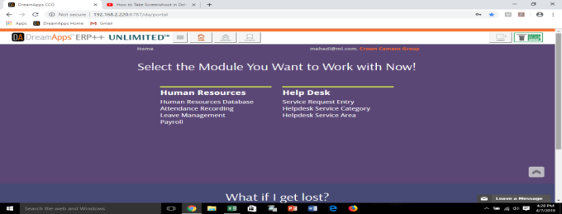
Then I have to chose in which module I want to work.
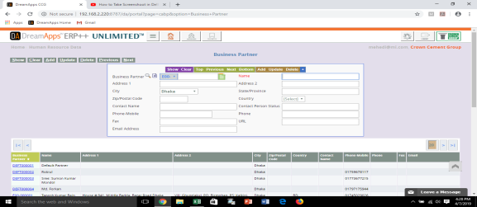

If I want to get information regarding any employee I have to put his employee id here.

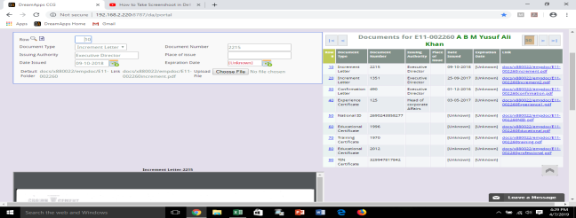

In this section employee’s certificate or document which has been kept into company are included here.
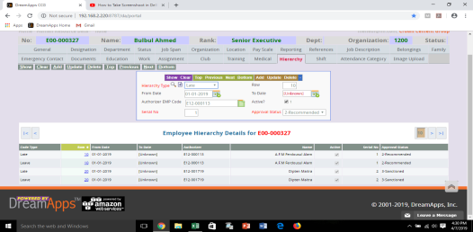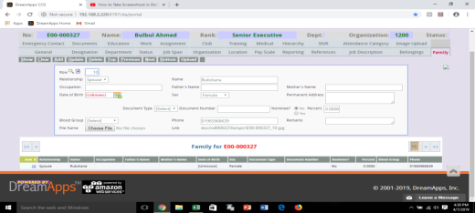

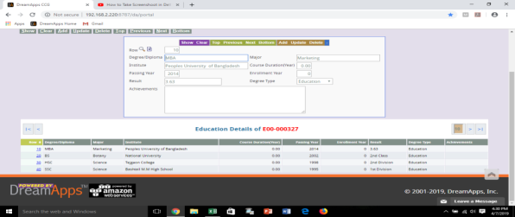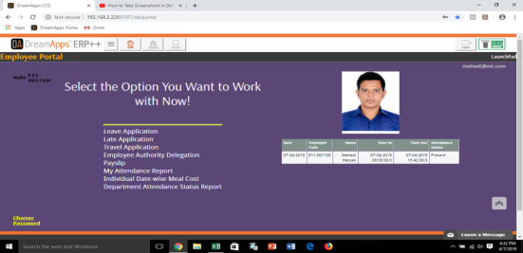
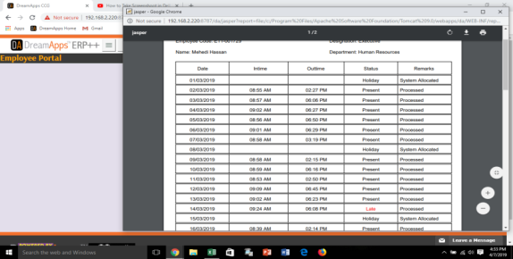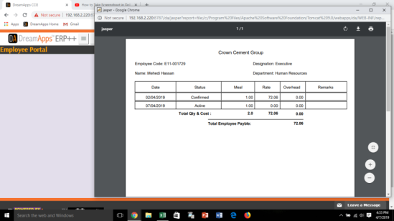

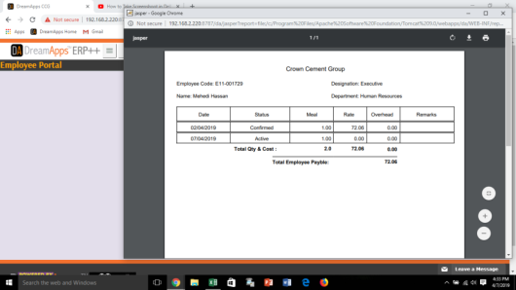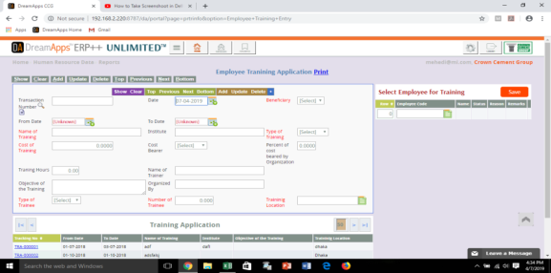

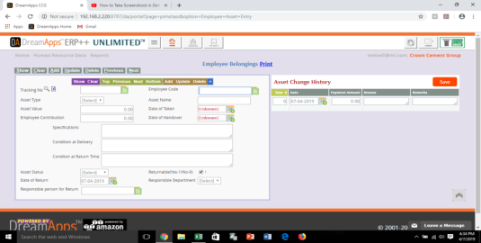
Basically I did my most of the work regarding this software.

- Employee Id:

I have learnt how to create new employee operating & punch id. I have created almost all new employees’ id that has been joined from January to April.

- Personal File:

I have learnt there how to make personal file of new joined employee and what required documents needed on that file according to checklist.

Chapter – 05
Findings of Study & Recommendation

5.1 General Information Analysis
Sample size: Total number of respondents are 20 (Twenty) employees.
- Level/Position
 |  | Frequency | Percent | Valid Percent | Cumulative Percent
Valid | Entry Level | 13 | 65.0 | 65.0 | 65.0
Valid | Mid Level | 7 | 35.0 | 35.0 | 100.0
Valid | Total | 20 | 100.0 | 100.0

Findings: Among the respondents, 65% of them are entry level and 35% of them are mid-level employees.
The mean point is 1.3500

- Gender
 |  | Frequency | Percent | Valid Percent | Cumulative Percent
Valid | Male | 12 | 60.0 | 60.0 | 60.0
Valid | Female | 8 | 40.0 | 40.0 | 100.0
Valid | Total | 20 | 100.0 | 100.0

Findings: Among the respondents, 60% of them are male and 40% of them are female employees.
The mean point is 1.400

- Marital Status
 |  | Frequency | Percent | Valid Percent | Cumulative Percent
Valid | Single | 10 | 50.0 | 50.0 | 50.0
Valid | Married | 10 | 50.0 | 50.0 | 100.0
Valid | Total | 20 | 100.0 | 100.0

Findings: Among the respondents, 50% of them are single and 50% of them are married employees.
The mean point is 1.5

- Age
 |  | Frequency | Percent | Valid Percent | Cumulative Percent
Valid | 20-30 years | 17 | 85.0 | 85.0 | 85.0
Valid | 31-40 years | 3 | 15.0 | 15.0 | 100.0
Valid | Total | 20 | 100.0 | 100.0

Findings: Among the respondents, 20 to 30 years old age respondents are 85% and 31 to 40 years old age respondents are 40%.
The mean point is1.1500

- Education
 |  | Frequency | Percent | Valid Percent | Cumulative Percent
Valid | Undergraduate Degree | 2 | 10.0 | 10.0 | 10.0
Valid | Post-graduate Degree | 13 | 65.0 | 65.0 | 75.0
Valid | Professional and other qualifications | 5 | 25.0 | 25.0 | 100.0
Valid | Total | 20 | 100.0 | 100.0

Findings: Among the respondents, 10 % of them have undergraduate degree, 65% of them have post-graduate degree and 5% of them have professional plus other qualification.
The mean point is 3.1500
- Experience
 |  | Frequency | Percent | Valid Percent | Cumulative Percent
Valid | 1-5 years | 19 | 95.0 | 95.0 | 95.0
Valid | 6-9 years | 1 | 5.0 | 5.0 | 100.0
Valid | Total | 20 | 100.0 | 100.0

Findings: Among the respondents, 95% of respondent have 01 to 05 years of working experience and 5% of respondent have 06 to 09 years of working experience.
The mean point is 1.0500

  - Analysis on Human Resource Management Practices
Total of 20 questions were asked through the survey to find out satisfactory level of Human Resource Management Practices in the organization.

- Our organization places the right person in the right job.
 |  | Frequency | Percent | Valid Percent | Cumulative Percent
Valid | Strongly Agree | 4 | 20.0 | 20.0 | 20.0
Valid | Agree | 11 | 55.0 | 55.0 | 75.0
Valid | Undecided | 3 | 15.0 | 15.0 | 90.0
Valid | Disagree | 2 | 10.0 | 10.0 | 100.0
Valid | Total | 20 | 100.0 | 100.0
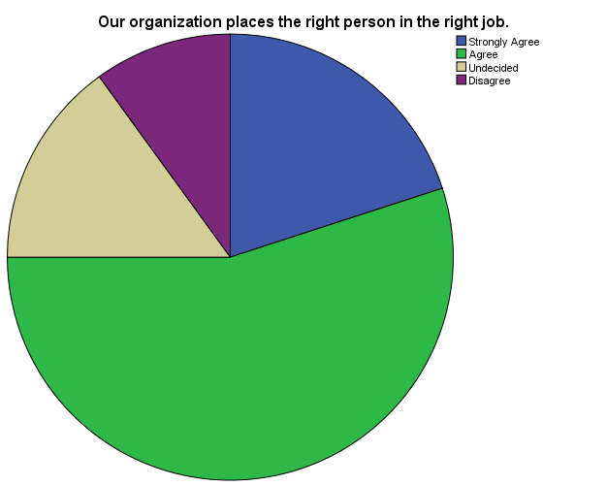
Findings: The question was asked about the placement of right person in the right job. Among the respondents, 20% of them Strongly Agree with the statement, 55% normally believe and Agree with the statement, 15%of them are in a position of undecided and 10% of them are disagree with the statement.

According to the majority we can state that most of the respondent is Agree with the statement.
The mean point is 2.1500

02. Adequate and relevant information about the organization and job is provided to the candidate at the time of recruitment.
 |  | Frequency | Percent | Valid Percent | Cumulative Percent
Valid | Strongly Agree | 7 | 35.0 | 35.0 | 35.0
Valid | Agree | 6 | 30.0 | 30.0 | 65.0
Valid | Undecided | 5 | 25.0 | 25.0 | 90.0
Valid | Disagree | 2 | 10.0 | 10.0 | 100.0
Valid | Total | 20 | 100.0 | 100.0
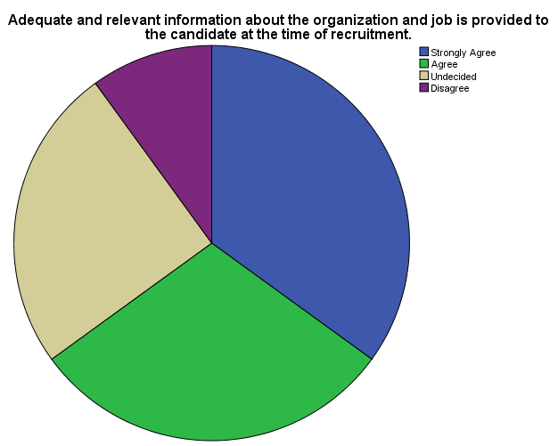

Findings: The question was asked about Adequate and relevant information about the organization and job is provided to the candidate at the time of recruitment. Among the respondents, 35% of them Strongly Agree with the statement, 30% normally believe and Agree with the statement, 25% of them are in a position of undecided and 10% of them are disagree with the statement.

According to the majority we can state that most of the respondent is Strongly Agree with the statement.
The mean point is 2.1000

03. Selection of a candidate in our organization is strictly based on his/her merit.
 |  | Frequency | Percent | Valid Percent | Cumulative Percent
Valid | Strongly Agree | 1 | 5.0 | 5.0 | 5.0
Valid | Agree | 14 | 70.0 | 70.0 | 75.0
Valid | Undecided | 3 | 15.0 | 15.0 | 90.0
Valid | Disagree | 2 | 10.0 | 10.0 | 100.0
Valid | Total | 20 | 100.0 | 100.0
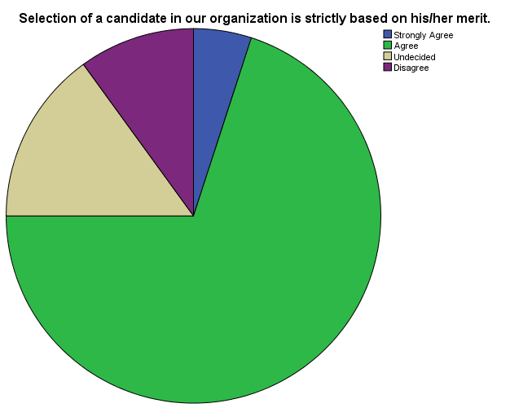

Findings: The question was asked a candidate of selection in our organization is strictly based on his/her merit. Among the respondents, 5% of them Strongly Agree with the statement, 70% normally believe and Agree with the statement, 15% of them are in a position of undecided and 10% of them are disagree with the statement.

According to the majority we can state that most of the respondent is Agree with the statement.
The mean point is 2.3000

04. The training needs of the employees in our organization are assessed on the basis of their performance appraisal.
 |  | Frequency | Percent | Valid Percent | Cumulative Percent
Valid | Strongly Agree | 2 | 10.0 | 10.0 | 10.0
Valid | Agree | 7 | 35.0 | 35.0 | 45.0
Valid | Undecided | 7 | 35.0 | 35.0 | 80.0
Valid | Disagree | 4 | 20.0 | 20.0 | 100.0
Valid | Total | 20 | 100.0 | 100.0
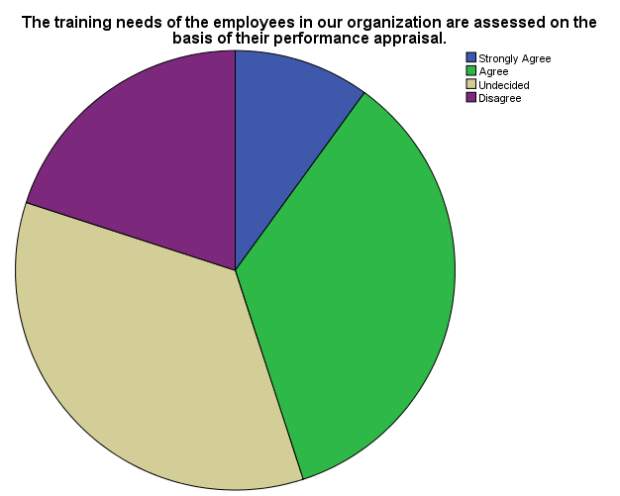

Findings: The question was asked about the training needs of the employees in our organization are assessed on the basis of their performance appraisal. Among the respondents, 10% of them Strongly Agree with the statement, 35% normally believe and Agree with the statement, 35% of them are in a position of undecided and 20% of them are disagree with the statement.

According to the majority between Agree and Undecided we can state that most of the respondent is in neutral position.
The mean point is 2.6500

05. Training in our organization includes social skills, general problem solving skills and broader knowledge of the organization and business.
 |  | Frequency | Percent | Valid Percent | Cumulative Percent
Valid | Strongly Agree | 1 | 5.0 | 5.0 | 5.0
Valid | Agree | 14 | 70.0 | 70.0 | 75.0
Valid | Undecided | 4 | 20.0 | 20.0 | 95.0
Valid | Disagree | 1 | 5.0 | 5.0 | 100.0
Valid | Total | 20 | 100.0 | 100.0
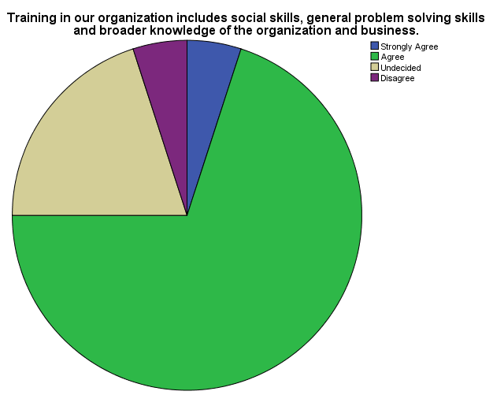

Findings: The question was asked about Training in our organization includes social skills, general problem solving skills and broader knowledge of the organization and business. Among the respondents, 5% of them Strongly Agree with the statement, 70% normally believe and Agree with the statement, 20% of them are in a position of undecided and 5% of them are disagree with the statement.

According to the majority we can state that most of the respondent is Agree with the statement.
The mean point is 2.2500

06. The contents of the training programs organized are always relevant to the changing needs of our jobs and our business.
 |  | Frequency | Percent | Valid Percent | Cumulative Percent
Valid | Strongly Agree | 4 | 20.0 | 20.0 | 20.0
Valid | Agree | 8 | 40.0 | 40.0 | 60.0
Valid | Undecided | 7 | 35.0 | 35.0 | 95.0
Valid | Disagree | 1 | 5.0 | 5.0 | 100.0
Valid | Total | 20 | 100.0 | 100.0
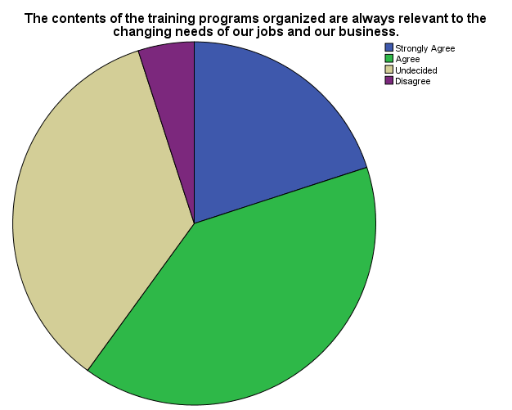
Findings: The question was asked about The contents of the training programs organized are always relevant to the changing needs of our jobs and our business. Among the respondents, 20% of them Strongly Agree with the statement, 40% normally believe and Agree with the statement, 35% of them are in a position of undecided and 5% of them are disagree with the statement.

According to the majority we can state that most of the respondent is Agree with the statement.
The mean point is 2.2500

07. We are assigned challenging jobs to charge our enthusiasm and develop our skills.
 |  | Frequency | Percent | Valid Percent | Cumulative Percent
Valid | Strongly Agree | 6 | 30.0 | 30.0 | 30.0
Valid | Agree | 9 | 45.0 | 45.0 | 75.0
Valid | Undecided | 4 | 20.0 | 20.0 | 95.0
Valid | Disagree | 1 | 5.0 | 5.0 | 100.0
Valid | Total | 20 | 100.0 | 100.0
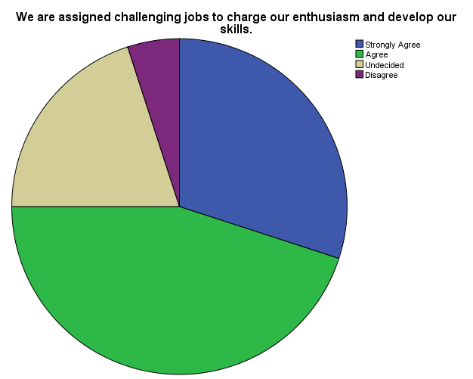

Findings: The question was asked about We are assigned challenging jobs to identify our enthusiasm and develop our skills. Among the respondents, 30% of them Strongly Agree with the statement, 45% normally believe and Agree with the statement, 20% of them are in a position of undecided and 5% of them are disagree with the statement.

According to the majority we can state that most of the respondent is Agree with the statement.
The mean point is 2.0000

08. We are encouraged to participate in various seminars and workshops etc.
 |  | Frequency | Percent | Valid Percent | Cumulative Percent
Valid | Strongly Agree | 2 | 10.0 | 10.0 | 10.0
Valid | Agree | 8 | 40.0 | 40.0 | 50.0
Valid | Undecided | 4 | 20.0 | 20.0 | 70.0
Valid | Disagree | 6 | 30.0 | 30.0 | 100.0
Valid | Total | 20 | 100.0 | 100.0
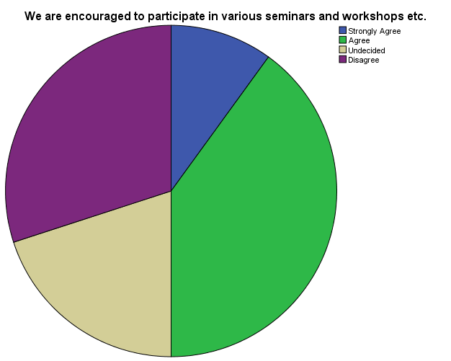

Findings: The question was asked about We are encouraged to participate in various seminars and workshops etc. Among the respondents, 10% of them Strongly Agree with the statement, 40% normally believe and Agree with the statement, 20% of them are in a position of undecided and 30% of them are disagree with the statement.

According to the majority we can state that most of the respondent is Agree with the statement.
The mean point is 2.7000

09. We are being paid adequately for the work we do.
 |  | Frequency | Percent | Valid Percent | Cumulative Percent
Valid | Strongly Agree | 1 | 5.0 | 5.0 | 5.0
Valid | Agree | 7 | 35.0 | 35.0 | 40.0
Valid | Undecided | 7 | 35.0 | 35.0 | 75.0
Valid | Disagree | 4 | 20.0 | 20.0 | 95.0
Valid | Strongly Disagree | 1 | 5.0 | 5.0 | 100.0
Valid | Total | 20 | 100.0 | 100.0
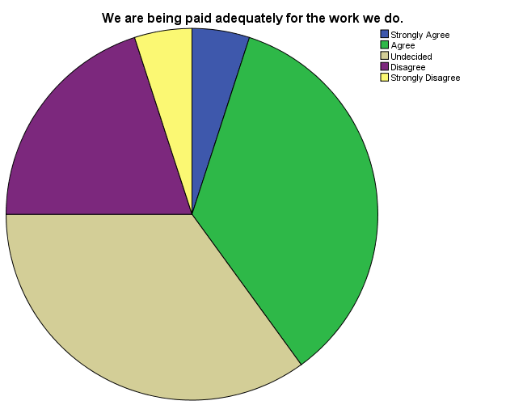

Findings: The question was asked about We are being paid adequately for the work we do. Among the respondents, 5% of them Strongly Agree with the statement, 35% normally believe and Agree with the statement, 35% of them are in a position of undecided, 20% of them are disagree with the statement & 5% of them are strongly disagree with the statement.

According to the majority we can state that most of the respondent is Agree with the statement.
The mean point is 2.8500

10. Pay increments offered by our organization are satisfactory.
 |  | Frequency | Percent | Valid Percent | Cumulative Percent
Valid | Strongly Agree | 3 | 15.0 | 15.0 | 15.0
Valid | Agree | 8 | 40.0 | 40.0 | 55.0
Valid | Undecided | 3 | 15.0 | 15.0 | 70.0
Valid | Disagree | 5 | 25.0 | 25.0 | 95.0
Valid | Strongly Disagree | 1 | 5.0 | 5.0 | 100.0
Valid | Total | 20 | 100.0 | 100.0
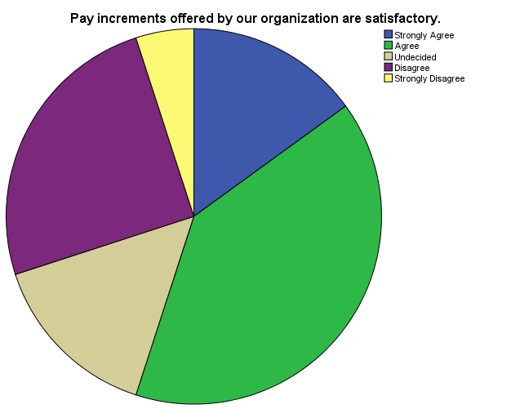

Findings: The question was asked about Pay increments offered by our organization are satisfactory. Among the respondents, 15% of them Strongly Agree with the statement, 40% normally believe and Agree with the statement, 15% of them are in a position of undecided 25% of them are disagree with the statement & and 5% of them are disagree with the statement.

According to the majority we can state that most of the respondent is Agree with the statement.
The mean point is 2.6500

11. Our organization makes all payments due to us in time.
 |  | Frequency | Percent | Valid Percent | Cumulative Percent
Valid | Strongly Agree | 9 | 45.0 | 45.0 | 45.0
Valid | Agree | 9 | 45.0 | 45.0 | 90.0
Valid | Undecided | 1 | 5.0 | 5.0 | 95.0
Valid | Disagree | 1 | 5.0 | 5.0 | 100.0
Valid | Total | 20 | 100.0 | 100.0
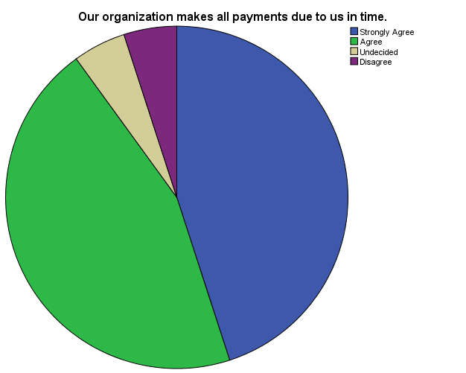
Findings: The question was asked about our organization makes all payments due to us in time. Among the respondents, 45% of them Strongly Agree with the statement, 45% normally believe and Agree with the statement, 5% of them are in a position of undecided and 5% of them are disagree with the statement.

According to the majority we can state that most of the respondent is Strongly Agree with the statement.
The mean point is 1.7000

12. Our organization follows the policy of matching pay with performance.
 |  | Frequency | Percent | Valid Percent | Cumulative Percent
Valid | Strongly Agree | 7 | 35.0 | 35.0 | 35.0
Valid | Agree | 5 | 25.0 | 25.0 | 60.0
Valid | Undecided | 4 | 20.0 | 20.0 | 80.0
Valid | Disagree | 4 | 20.0 | 20.0 | 100.0
Valid | Total | 20 | 100.0 | 100.0
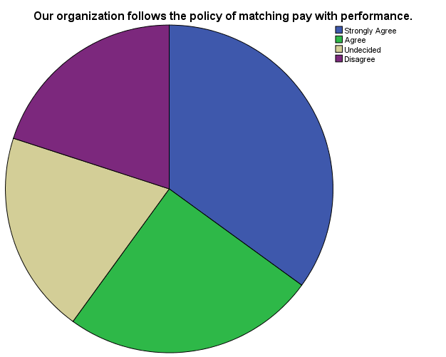

Findings: The question was asked about our organization follows the policy of matching pay with performance. Among the respondents, 35% of them Strongly Agree with the statement, 25% normally believe and Agree with the statement, 20% of them are in a position of undecided and 20% of them are disagree with the statement.

According to the majority we can state that most of the respondent is Strongly Agree with the statement.
The mean point is 2.2500

13. The pay we receive is competitive compared to that of employees doing similar work in other organizations.
 |  | Frequency | Percent | Valid Percent | Cumulative Percent
Valid | Agree | 10 | 50.0 | 50.0 | 50.0
Valid | Undecided | 4 | 20.0 | 20.0 | 70.0
Valid | Disagree | 3 | 15.0 | 15.0 | 85.0
Valid | Strongly Disagree | 3 | 15.0 | 15.0 | 100.0
Valid | Total | 20 | 100.0 | 100.0
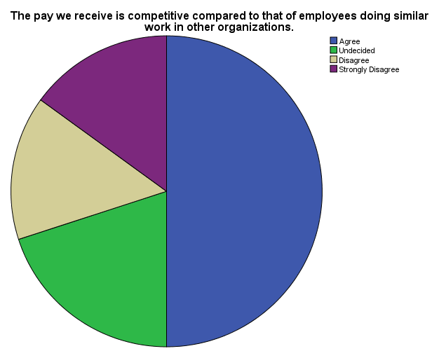
Findings: The question was asked about the pay we receive is competitive compared to that of employees doing similar work in other organizations. Among the respondents, 50% of them Agree with the statement, 20% of them are in a position of undecided, 15% of them are disagree with the statement, and 15% of them are strongly disagree with the statement.

According to the majority we can state that most of the respondent is Agree with the statement.
The mean point is 2.9500

14. We are satisfied with the benefits we receive.
 |  | Frequency | Percent | Valid Percent | Cumulative Percent
Valid | Strongly Agree | 5 | 25.0 | 25.0 | 25.0
Valid | Agree | 9 | 45.0 | 45.0 | 70.0
Valid | Undecided | 1 | 5.0 | 5.0 | 75.0
Valid | Disagree | 4 | 20.0 | 20.0 | 95.0
Valid | Strongly Disagree | 1 | 5.0 | 5.0 | 100.0
Valid | Total | 20 | 100.0 | 100.0
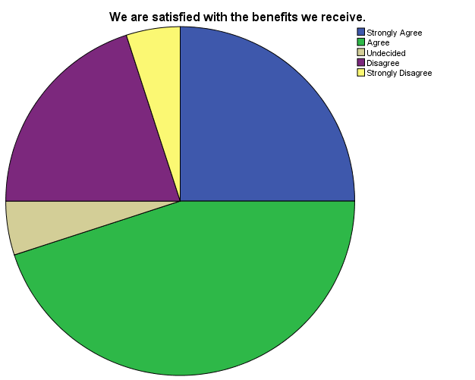
Findings: The question was asked about We are satisfied with the benefits we receive. Among the respondents, 25% of them Strongly Agree with the statement, 45% normally believe and Agree with the statement, 5% of them are in a position of undecided 20% of them are disagree with the statement and 5% of them are strongly disagree with the statement.

According to the majority we can state that most of the respondent is Agree with the statement.
The mean point is 2.3500

15. The benefits we receive in our organization are similar to what most of the other organizations in the industry provide to their employees.
 |  | Frequency | Percent | Valid Percent | Cumulative Percent
Valid | Strongly Agree | 5 | 25.0 | 25.0 | 25.0
Valid | Agree | 4 | 20.0 | 20.0 | 45.0
Valid | Undecided | 5 | 25.0 | 25.0 | 70.0
Valid | Disagree | 3 | 15.0 | 15.0 | 85.0
Valid | Strongly Disagree | 3 | 15.0 | 15.0 | 100.0
Valid | Total | 20 | 100.0 | 100.0
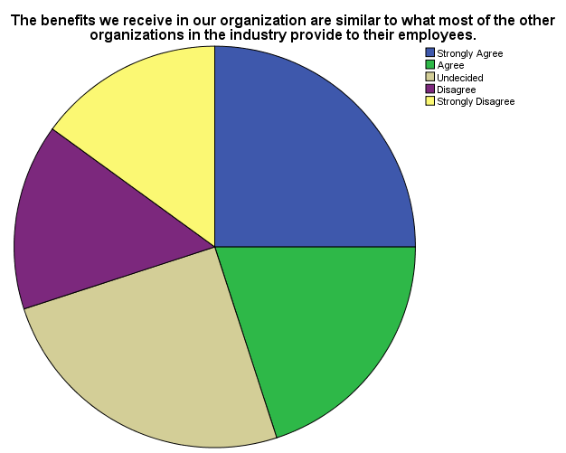
Findings: The question was asked about the benefits we receive in our organization are similar to what most of the other organizations in the industry provide to their employees. Among the respondents, 25% of them Strongly Agree with the statement, 20% normally believe and Agree with the statement, 25% of them are in a position of undecided, 15% of them are disagree with the statement and 15% of them are strongly disagree with the statement.

According to the majority we can state that most of the respondent is in neutral position.
The mean point is 2.7500

16. Rewards and incentives are fairly distributed in our organization.
 |  | Frequency | Percent | Valid Percent | Cumulative Percent
Valid | Strongly Agree | 1 | 5.0 | 5.0 | 5.0
Valid | Agree | 12 | 60.0 | 60.0 | 65.0
Valid | Undecided | 3 | 15.0 | 15.0 | 80.0
Valid | Disagree | 2 | 10.0 | 10.0 | 90.0
Valid | Strongly Disagree | 2 | 10.0 | 10.0 | 100.0
Valid | Total | 20 | 100.0 | 100.0
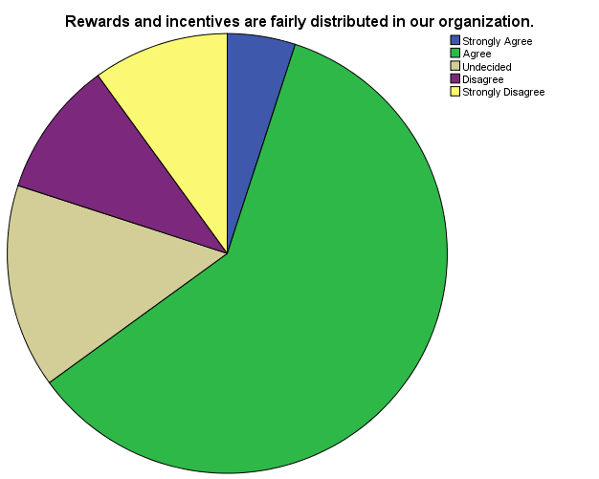

Findings: The question was asked about Rewards and incentives are fairly distributed in our organization. Among the respondents, 5% of them Strongly Agree with the statement, 60% normally believe and Agree with the statement, 15% of them are in a position of undecided, 10% of them are disagree with the statement and 10% of them are strongly disagree with the statement.

According to the majority we can state that most of the respondent is Agree with the statement.
The mean point is 2.6000

17. Rewards in our organization are strictly linked to employee performance.
 |  | Frequency | Percent | Valid Percent | Cumulative Percent
Valid | Agree | 9 | 45.0 | 45.0 | 45.0
Valid | Undecided | 2 | 10.0 | 10.0 | 55.0
Valid | Disagree | 7 | 35.0 | 35.0 | 90.0
Valid | Strongly Disagree | 2 | 10.0 | 10.0 | 100.0
Valid | Total | 20 | 100.0 | 100.0
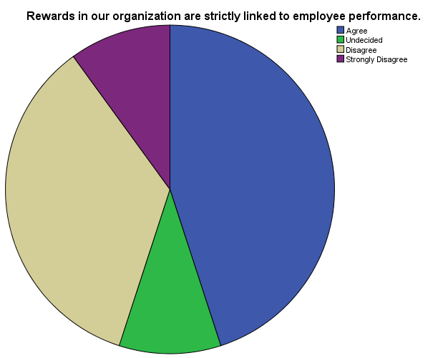
Findings: The question was asked about Rewards in our organization are strictly linked to employee performance. Among the respondents, 45% of them Agree with the statement, 10% of them are in a position of undecided 35% of them are disagree with the statement and 10% of them are strongly disagree with the statement.

According to the majority we can state that most of the respondent is agree with the statement.
The mean point is 3.1000

18. The existing reward and incentive plans do not motivate us for better performance.
 |  | Frequency | Percent | Valid Percent | Cumulative Percent
Valid | Strongly Agree | 1 | 5.0 | 5.0 | 5.0
Valid | Agree | 5 | 25.0 | 25.0 | 30.0
Valid | Undecided | 6 | 30.0 | 30.0 | 60.0
Valid | Disagree | 8 | 40.0 | 40.0 | 100.0
Valid | Total | 20 | 100.0 | 100.0
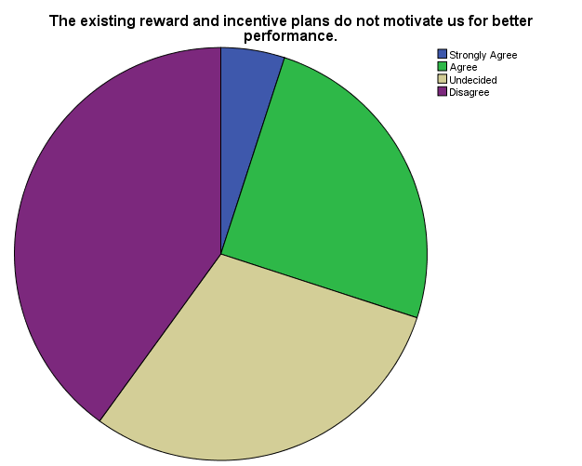
Findings: The question was asked about the existing reward and incentive plans do not motivate us for better performance. Among the respondents, 5% of them Strongly Agree with the statement, 25% normally believe and Agree with the statement, 30% of them are in a position of undecided and 40% of them are disagree with the statement.

According to the majority we can state that most of the respondent is Disagree with the statement.
The mean point is 3.0500

19. Our organization appraises the performance of its employees at regular intervals.
 |  | Frequency | Percent | Valid Percent | Cumulative Percent
Valid | Strongly Agree | 1 | 5.0 | 5.0 | 5.0
Valid | Agree | 9 | 45.0 | 45.0 | 50.0
Valid | Undecided | 6 | 30.0 | 30.0 | 80.0
Valid | Disagree | 3 | 15.0 | 15.0 | 95.0
Valid | Strongly Disagree | 1 | 5.0 | 5.0 | 100.0
Valid | Total | 20 | 100.0 | 100.0
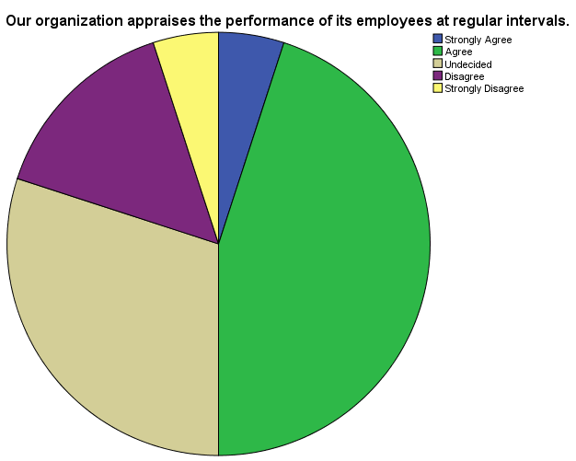
Findings: The question was asked about our organization appraises the performance of its employees at regular intervals. Among the respondents, 5% of them Strongly Agree with the statement, 45% normally believe and Agree with the statement, 30% of them are in a position of undecided 15% of them are disagree with the statement and 5% of them are strongly disagree with the statement.

According to the majority we can state that most of the respondent is Agree with the statement.
The mean point is 2.7000

20. Performance appraisal in our organization aims at improving employee performance and strengthening our job skills.
 |  | Frequency | Percent | Valid Percent | Cumulative Percent
Valid | Strongly Agree | 3 | 15.0 | 15.0 | 15.0
Valid | Agree | 11 | 55.0 | 55.0 | 70.0
Valid | Undecided | 2 | 10.0 | 10.0 | 80.0
Valid | Disagree | 3 | 15.0 | 15.0 | 95.0
Valid | Strongly Disagree | 1 | 5.0 | 5.0 | 100.0
Valid | Total | 20 | 100.0 | 100.0
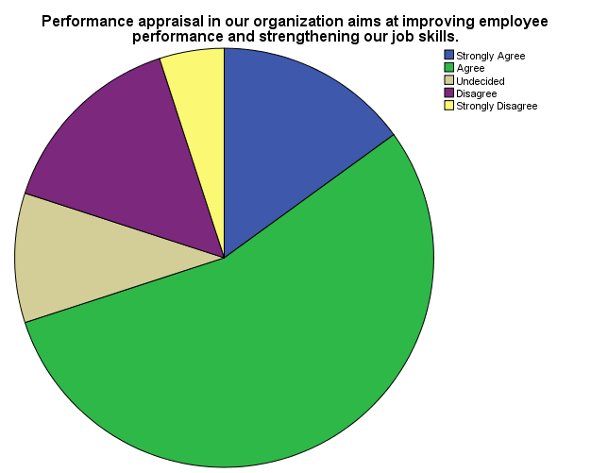
Findings: The question was asked about Performance appraisal in our organization aims at improving employee performance and strengthening our job skills. Among the respondents, 15% of them Strongly Agree with the statement, 55% normally believe and Agree with the statement, 10% of them are in a position of undecided 15% of them are disagree with the statement and 5% of them are strongly disagree with the statement.

According to the majority we can state that most of the respondent is Agree with the statement.
The mean point is 2.4000

5.3 Analysis on Perceived Organizational Support
Total of 07 questions were asked through the survey to find out perceived organizational support toward the employees.

01. The company values our contribution to its well being
 |  | Frequency | Percent | Valid Percent | Cumulative Percent
Valid | Strongly Agree | 2 | 10.0 | 10.0 | 10.0
Valid | Agree | 14 | 70.0 | 70.0 | 80.0
Valid | Undecided | 2 | 10.0 | 10.0 | 90.0
Valid | Disagree | 1 | 5.0 | 5.0 | 95.0
Valid | Strongly Disagree | 1 | 5.0 | 5.0 | 100.0
Valid | Total | 20 | 100.0 | 100.0

Findings: The question was asked about the company values our contribution to its well-being. Among the respondents, 10% of them Strongly Agree with the statement, 70% normally believe and Agree with the statement, 10% of them are in a position of undecided, 5% of them are disagree with the statement and 5% of them are strongly disagree with the statement.
According to the majority we can state that most of the respondent is Agree with the statement.
The mean point is 2.2500

02. The company strongly considers our goals and values
 |  | Frequency | Percent | Valid Percent | Cumulative Percent
Valid | Strongly Agree | 2 | 10.0 | 10.0 | 10.0
Valid | Agree | 14 | 70.0 | 70.0 | 80.0
Valid | Disagree | 4 | 20.0 | 20.0 | 100.0
Valid | Total | 20 | 100.0 | 100.0

Findings: The question was asked about the company strongly considers our goals and values. Among the respondents, 10% of them strongly Agree with the statement, 70% normally believe and Agree with the statement and 20% of them are disagree with the statement.

According to the majority we can state that most of the respondent is Agree with the statement.
The mean point is 2.3000

03. Our organization does not ignore complaints from its employees.
 |  | Frequency | Percent | Valid Percent | Cumulative Percent
Valid | Strongly Agree | 3 | 15.0 | 15.0 | 15.0
Valid | Agree | 9 | 45.0 | 45.0 | 60.0
Valid | Undecided | 6 | 30.0 | 30.0 | 90.0
Valid | Disagree | 2 | 10.0 | 10.0 | 100.0
Valid | Total | 20 | 100.0 | 100.0

Findings: The question was asked about our organization does not ignore complaints from its employees. Among the respondents, 15% of them Strongly Agree with the statement, 45% normally believe and Agree with the statement, 30% of them are in a position of undecided and 10% of them are disagree with the statement.

According to the majority we can state that most of the respondent is Agree with the statement.
The mean point is 2.3500

04. Our organization cares about our opinions.
 |  | Frequency | Percent | Valid Percent | Cumulative Percent
Valid | Strongly Agree | 1 | 5.0 | 5.0 | 5.0
Valid | Agree | 13 | 65.0 | 65.0 | 70.0
Valid | Undecided | 5 | 25.0 | 25.0 | 95.0
Valid | Disagree | 1 | 5.0 | 5.0 | 100.0
Valid | Total | 20 | 100.0 | 100.0

Findings: The question was asked about our organization cares about our opinions. Among the respondents, 5% of them Strongly Agree with the statement, 65% normally believe and Agree with the statement, 25% of them are in a position of undecided and 5% of them are disagree with the statement.

According to the majority we can state that most of the respondent is Agree with the statement.
The mean point is 2.3000

05. Our organization duly supports its employees facing any problem.
 |  | Frequency | Percent | Valid Percent | Cumulative Percent
Valid | Strongly Agree | 1 | 5.0 | 5.0 | 5.0
Valid | Agree | 14 | 70.0 | 70.0 | 75.0
Valid | Undecided | 4 | 20.0 | 20.0 | 95.0
Valid | Disagree | 1 | 5.0 | 5.0 | 100.0
Valid | Total | 20 | 100.0 | 100.0

Findings: The question was asked about our organization duly supports its employees facing any problem. Among the respondents, 5% of them Strongly Agree with the statement, 70% normally believe and Agree with the statement, 20% of them are in a position of undecided and 5% of them are disagree with the statement.

According to the majority we can state that most of the respondent is Agree with the statement.
The mean point is 2.2500

06. The organization cares for employees’ general satisfaction at work.
 |  | Frequency | Percent | Valid Percent | Cumulative Percent
Valid | Agree | 12 | 60.0 | 60.0 | 60.0
Valid | Undecided | 6 | 30.0 | 30.0 | 90.0
Valid | Disagree | 2 | 10.0 | 10.0 | 100.0
Valid | Total | 20 | 100.0 | 100.0

Findings: The question was asked about the organization cares for employees’ general satisfaction at work. Among the respondents, 60% of them Agree with the statement, 30% of them are in a position of undecided and 10% of them are disagree with the statement.

According to the majority we can state that most of the respondent is Agree with the statement.
The mean point is 2.5000

07. Each employee is treated with genuine respect.
 |  | Frequency | Percent | Valid Percent | Cumulative Percent
Valid | Strongly Agree | 1 | 5.0 | 5.0 | 5.0
Valid | Agree | 13 | 65.0 | 65.0 | 70.0
Valid | Undecided | 3 | 15.0 | 15.0 | 85.0
Valid | Disagree | 3 | 15.0 | 15.0 | 100.0
Valid | Total | 20 | 100.0 | 100.0

Findings: The question was asked about each employee is treated with genuine respect. Among the respondents, 5% of them Strongly Agree with the statement, 65% normally believe and Agree with the statement, 15% of them are in a position of undecided and 15% of them are disagree with the statement.

According to the majority we can state that most of the respondent is Agree with the statement.
The mean point is 2.4000

5.4 Analysis on Employee Attitudes and Behavior
Total of 07 questions were asked through the survey to find out Employee Attitudes and Behavior.
01. We trust the management for keeping the promises made to us.
 |  | Frequency | Percent | Valid Percent | Cumulative Percent
Valid | Strongly Agree | 3 | 15.0 | 15.0 | 15.0
Valid | Agree | 13 | 65.0 | 65.0 | 80.0
Valid | Undecided | 2 | 10.0 | 10.0 | 90.0
Valid | Disagree | 2 | 10.0 | 10.0 | 100.0
Valid | Total | 20 | 100.0 | 100.0

Findings: The question was asked about We trust the management for keeping the promises made to us. Among the respondents, 15% of them Strongly Agree with the statement, 65% normally believe and Agree with the statement, 10% of them are in a position of undecided and 10% of them are disagree with the statement.

According to the majority we can state that most of the respondent is Agree with the statement.
The mean point is 2.1500

02. We are confident that our organization has growth potential
 |  | Frequency | Percent | Valid Percent | Cumulative Percent
Valid | Strongly Agree | 3 | 15.0 | 15.0 | 15.0
Valid | Agree | 14 | 70.0 | 70.0 | 85.0
Valid | Undecided | 2 | 10.0 | 10.0 | 95.0
Valid | Strongly Disagree | 1 | 5.0 | 5.0 | 100.0
Valid | Total | 20 | 100.0 | 100.0

Findings: The question was asked about We are confident that our organization has growth potential. Among the respondents, 15% of them Strongly Agree with the statement, 70% normally believe and Agree with the statement, 10% of them are in a position of undecided and 5% of them are strongly disagree with the statement.

According to the majority we can state that most of the respondent is Agree with the statement.
The mean point is 2.1000

03. We trust the management for keeping the promises made to us.
 |  | Frequency | Percent | Valid Percent | Cumulative Percent
Valid | Strongly Agree | 3 | 15.0 | 15.0 | 15.0
Valid | Agree | 13 | 65.0 | 65.0 | 80.0
Valid | Undecided | 4 | 20.0 | 20.0 | 100.0
Valid | Total | 20 | 100.0 | 100.0

Findings: The question was asked about We trust the management for keeping the promises made to us. Among the respondents, 15% of them stronglyagree with the statement, 65% normally believe and agree with the statement and 20% of them are in a position of undecided.

According to the majority we can state that most of the respondent is Agree with the statement.
The mean point is 2.0500

04. We believe that our management follows policies and practices that serve combined interests of both employees and the organization.
 |  | Frequency | Percent | Valid Percent | Cumulative Percent
Valid | Strongly Agree | 6 | 30.0 | 30.0 | 30.0
Valid | Agree | 11 | 55.0 | 55.0 | 85.0
Valid | Undecided | 1 | 5.0 | 5.0 | 90.0
Valid | Disagree | 2 | 10.0 | 10.0 | 100.0
Valid | Total | 20 | 100.0 | 100.0

Findings: The question was asked about We believe that our management follows policies and practices that serve combined interests of both employees and the organization. Among the respondents, 30% of them Strongly Agree with the statement, 55% normally believe and Agree with the statement, 5% of them are in a position of undecided and 10% of them are disagree with the statement.

According to the majority we can state that most of the respondent is Agree with the statement.
The mean point is 1.9500

05. Management respects each employee’s ability and knowledge of the job
 |  | Frequency | Percent | Valid Percent | Cumulative Percent
Valid | Strongly Agree | 4 | 20.0 | 20.0 | 20.0
Valid | Agree | 12 | 60.0 | 60.0 | 80.0
Valid | Undecided | 2 | 10.0 | 10.0 | 90.0
Valid | Disagree | 2 | 10.0 | 10.0 | 100.0
Valid | Total | 20 | 100.0 | 100.0

Findings: The question was asked about Management respects each employee’s ability and knowledge of the job. Among the respondents, 20% of them Strongly Agree with the statement, 60% normally believe and Agree with the statement, 10% of them are in a position of undecided and 10% of them are disagree with the statement.

According to the majority we can state that most of the respondent is Agree with the statement.
The mean point is 2.1000

06. Most of my co-employees would perform their duty sincerely even if supervisor is not around
 |  | Frequency | Percent | Valid Percent | Cumulative Percent
Valid | Agree | 11 | 55.0 | 55.0 | 55.0
Valid | Undecided | 4 | 20.0 | 20.0 | 75.0
Valid | Disagree | 4 | 20.0 | 20.0 | 95.0
Valid | Strongly Disagree | 1 | 5.0 | 5.0 | 100.0
Valid | Total | 20 | 100.0 | 100.0

Findings: The question was asked about Most of my co-employees would perform their duty sincerely even if supervisor is not around. Among the respondents, , 55% normally believe and Agree with the statement, 20% of them are in a position of undecided 20% of them are disagree with the statement and 5% of them strongly disagree with the statement.

According to the majority we can state that most of the respondent is Agree with the statement.
The mean point is 2.7500

07. I have full confidence in the competencies of my co-employees
 |  | Frequency | Percent | Valid Percent | Cumulative Percent
Valid | Strongly Agree | 1 | 5.0 | 5.0 | 5.0
Valid | Agree | 11 | 55.0 | 55.0 | 60.0
Valid | Undecided | 5 | 25.0 | 25.0 | 85.0
Valid | Disagree | 3 | 15.0 | 15.0 | 100.0
Valid | Total | 20 | 100.0 | 100.0

Findings: The question was asked about I have full confidence in the competencies of my co-employees. Among the respondents, 5% of them Strongly Agree with the statement, 55% normally believe and Agree with the statement, 25% of them are in a position of undecided and 15% of them are disagree with the statement.

According to the majority we can state that most of the respondent is Agree with the statement.
The mean point is 2.5000

5.5 Analysis on Discretionary Behavior
Total of 07 questions were asked through the survey to find out Discretionary Behavior of the employees.

01. I help new workers, even when not asked to do so.
 |  | Frequency | Percent | Valid Percent | Cumulative Percent
Valid | Strongly Agree | 5 | 25.0 | 25.0 | 25.0
Valid | Agree | 10 | 50.0 | 50.0 | 75.0
Valid | Undecided | 3 | 15.0 | 15.0 | 90.0
Valid | Disagree | 2 | 10.0 | 10.0 | 100.0
Valid | Total | 20 | 100.0 | 100.0

Findings: The question was asked about I help new workers, even when not asked to do so. Among the respondents, 25% of them Strongly Agree with the statement, 50% normally believe and Agree with the statement, 15% of them are in a position of undecided and 10% of them are disagree with the statement.

According to the majority we can state that most of the respondent is Agree with the statement.
The mean point is 2.1000

02. Whenever my organization requires, I willingly stay at work till late
 |  | Frequency | Percent | Valid Percent | Cumulative Percent
Valid | Strongly Agree | 11 | 55.0 | 55.0 | 55.0
Valid | Agree | 5 | 25.0 | 25.0 | 80.0
Valid | Undecided | 3 | 15.0 | 15.0 | 95.0
Valid | Strongly Disagree | 1 | 5.0 | 5.0 | 100.0
Valid | Total | 20 | 100.0 | 100.0

Findings: The question was asked about whenever my organization requires, I willingly stay at work till late. Among the respondents, 55% of them Strongly Agree with the statement, 25% normally believe and Agree with the statement, 15% of them are in a position of undecided and 5% of them are strongly disagree with the statement.

According to the majority we can state that most of the respondent is Strongly Agree with the statement.
The mean point is 1.7500

03. I make suggestions for improvements.
 |  | Frequency | Percent | Valid Percent | Cumulative Percent
Valid | Strongly Agree | 8 | 40.0 | 40.0 | 40.0
Valid | Agree | 8 | 40.0 | 40.0 | 80.0
Valid | Undecided | 2 | 10.0 | 10.0 | 90.0
Valid | Disagree | 1 | 5.0 | 5.0 | 95.0
Valid | Strongly Disagree | 1 | 5.0 | 5.0 | 100.0
Valid | Total | 20 | 100.0 | 100.0

Findings: The question was asked about I make suggestions for improvements. Among the respondents, 40% of them Strongly Agree with the statement, 40% normally believe and Agree with the statement, 10% of them are in a position of undecided, 5% of them are disagree with the statement and 5% of them are strongly disagree with the statement.

According to the majority we can state that most of the respondent is Agree with the statement.
The mean point is 1.9500

04. I volunteer for things that are not part of the job.
 |  | Frequency | Percent | Valid Percent | Cumulative Percent
Valid | Strongly Agree | 3 | 15.0 | 15.0 | 15.0
Valid | Agree | 12 | 60.0 | 60.0 | 75.0
Valid | Undecided | 2 | 10.0 | 10.0 | 85.0
Valid | Disagree | 1 | 5.0 | 5.0 | 90.0
Valid | Strongly Disagree | 2 | 10.0 | 10.0 | 100.0
Valid | Total | 20 | 100.0 | 100.0

Findings: The question was asked about I volunteer for things that are not part of the job. Among the respondents, 15% of them Strongly Agree with the statement, 60% normally believe and Agree with the statement, 10% of them are in a position of undecided, 5% of them are disagree with the statement and 10% of them are strongly disagree with the statement.

According to the majority we can state that most of the respondent is Agree with the statement.
The mean point is 2.3500

05. I avoid taking up extra duties and responsibilities.
 |  | Frequency | Percent | Valid Percent | Cumulative Percent
Valid | Strongly Agree | 4 | 20.0 | 20.0 | 20.0
Valid | Agree | 1 | 5.0 | 5.0 | 25.0
Valid | Undecided | 8 | 40.0 | 40.0 | 65.0
Valid | Disagree | 4 | 20.0 | 20.0 | 85.0
Valid | Strongly Disagree | 3 | 15.0 | 15.0 | 100.0
Valid | Total | 20 | 100.0 | 100.0

Findings: The question was asked about I avoid taking up extra duties and responsibilities. Among the respondents, 20% of them Strongly Agree with the statement, 5% normally believe and Agree with the statement, 40% of them are in a position of undecided, 20% of them are disagree with the statement and 15% of them are strongly disagree with the statement.

According to the majority we can state that most of the respondent is in Neutral position.
The mean point is 3.0500

5.6 Analysis on Affective and Normative Commitment
Total of 10 questions were asked through the survey to find out Affective and Normative Commitment.

01. I would be very happy to spend the rest of my career with this organization
 |  | Frequency | Percent | Valid Percent | Cumulative Percent
Valid | Strongly Agree | 3 | 15.0 | 15.0 | 15.0
Valid | Agree | 8 | 40.0 | 40.0 | 55.0
Valid | Undecided | 5 | 25.0 | 25.0 | 80.0
Valid | Disagree | 4 | 20.0 | 20.0 | 100.0
Valid | Total | 20 | 100.0 | 100.0

Findings: The question was asked about I would be very happy to spend the rest of my career with this organization. Among the respondents, 15% of them Strongly Agree with the statement, 40% normally believe and Agree with the statement, 25% of them are in a position of undecided and 20% of them are disagree with the statement.

According to the majority we can state that most of the respondent is Agree with the statement.
The mean point is 2.5000

02. I enjoy discussing my organization with people outside of it.
 |  | Frequency | Percent | Valid Percent | Cumulative Percent
Valid | Strongly Agree | 6 | 30.0 | 30.0 | 30.0
Valid | Agree | 10 | 50.0 | 50.0 | 80.0
Valid | Undecided | 3 | 15.0 | 15.0 | 95.0
Valid | Strongly Disagree | 1 | 5.0 | 5.0 | 100.0
Valid | Total | 20 | 100.0 | 100.0

Findings: The question was asked about I enjoy discussing my organization with people outside of it. Among the respondents, 30% of them Strongly Agree with the statement, 50% normally believe and Agree with the statement, 15% of them are in a position of undecided and 5% of them are strongly disagree with the statement.

According to the majority we can state that most of the respondent is Agree with the statement.
The mean point is 2.0000

03. I really feel as if this organization’s problems are my own.
 |  | Frequency | Percent | Valid Percent | Cumulative Percent
Valid | Strongly Agree | 3 | 15.0 | 15.0 | 15.0
Valid | Agree | 12 | 60.0 | 60.0 | 75.0
Valid | Undecided | 4 | 20.0 | 20.0 | 95.0
Valid | Strongly Disagree | 1 | 5.0 | 5.0 | 100.0
Valid | Total | 20 | 100.0 | 100.0

Findings: The question was asked about I really feel as if this organization’s problems are my own. Among the respondents, 15% of them Strongly Agree with the statement, 60% normally believe and Agree with the statement, 20% of them are in a position of undecided and 5% of them are strongly disagree with the statement.

According to the majority we can state that most of the respondent is agree with the statement.
The mean point is 2.2000

04. I do not feel like a part of the family in my organization.
 |  | Frequency | Percent | Valid Percent | Cumulative Percent
Valid | Strongly Agree | 4 | 20.0 | 20.0 | 20.0
Valid | Agree | 3 | 15.0 | 15.0 | 35.0
Valid | Undecided | 6 | 30.0 | 30.0 | 65.0
Valid | Disagree | 6 | 30.0 | 30.0 | 95.0
Valid | Strongly Disagree | 1 | 5.0 | 5.0 | 100.0
Valid | Total | 20 | 100.0 | 100.0

Findings: The question was asked about I do not feel like a part of the family in my organization. Among the respondents, 20% of them Strongly Agree with the statement, 15% normally believe and Agree with the statement, 30% of them are in a position of undecided, 30% of them are disagree with the statement and5% of them are strongly disagree with the statement.

According to the majority we can state that most of the respondent is Disagree and in Neutral position with the statement.
The mean point is 2.8500

05. This organization has a great deal of personal meaning for me.
 |  | Frequency | Percent | Valid Percent | Cumulative Percent
Valid | Strongly Agree | 2 | 10.0 | 10.0 | 10.0
Valid | Agree | 10 | 50.0 | 50.0 | 60.0
Valid | Undecided | 7 | 35.0 | 35.0 | 95.0
Valid | Disagree | 1 | 5.0 | 5.0 | 100.0
Valid | Total | 20 | 100.0 | 100.0

Findings: The question was asked about the placement of right person in the right job. Among the respondents, 10% of them Strongly Agree with the statement, 50% normally believe and Agree with the statement, 35% of them are in a position of undecided and 5% of them are disagree with the statement.

According to the majority we can state that most of the respondent is Agree with the statement.
The mean point is 2.3500

06. I do not feel any obligation to remain with my current employer.
 |  | Frequency | Percent | Valid Percent | Cumulative Percent
Valid | Strongly Agree | 1 | 5.0 | 5.0 | 5.0
Valid | Agree | 11 | 55.0 | 55.0 | 60.0
Valid | Undecided | 5 | 25.0 | 25.0 | 85.0
Valid | Disagree | 3 | 15.0 | 15.0 | 100.0
Valid | Total | 20 | 100.0 | 100.0

Findings: The question was asked about I do not feel any obligation to remain with my current employer. Among the respondents, 5% of them Strongly Agree with the statement, 55% normally believe and Agree with the statement, 25% of them are in a position of undecided and 15% of them are disagree with the statement.

According to the majority we can state that most of the respondent is Agree with the statement.
The mean point is 2.5000

07. I would feel guilty if I leave my organization now.
 |  | Frequency | Percent | Valid Percent | Cumulative Percent
Valid | Agree | 7 | 35.0 | 35.0 | 35.0
Valid | Undecided | 5 | 25.0 | 25.0 | 60.0
Valid | Disagree | 6 | 30.0 | 30.0 | 90.0
Valid | Strongly Disagree | 2 | 10.0 | 10.0 | 100.0
Valid | Total | 20 | 100.0 | 100.0

Findings: The question was asked about I would feel guilty if I leave my organization now. Among the respondents, 35% of them Agree with the statement, 25% of them are in a position of undecided, 30% of them are disagree with the statement and 10% of them Strongly Disagree with the statement.

According to the majority we can state that most of the respondent is Agree with the statement.
The mean point is 3.1500

08. I would continue to work for this organization in future, as it deserves the same
 |  | Frequency | Percent | Valid Percent | Cumulative Percent
Valid | Strongly Agree | 5 | 25.0 | 25.0 | 25.0
Valid | Agree | 7 | 35.0 | 35.0 | 60.0
Valid | Undecided | 6 | 30.0 | 30.0 | 90.0
Valid | Disagree | 2 | 10.0 | 10.0 | 100.0
Valid | Total | 20 | 100.0 | 100.0

Findings: The question was asked about I would continue to work for this organization in future, as it deserves the same. Among the respondents, 25% of them Strongly Agree with the statement, 35% normally believe and Agree with the statement, 30% of them are in a position of undecided and 10% of them are disagree with the statement.

According to the majority we can state that most of the respondent is Agree with the statement.
The mean point is 2.2500

09. I would not leave my organization right now because I have a sense of obligation to the people in it.
 |  | Frequency | Percent | Valid Percent | Cumulative Percent
Valid | Strongly Agree | 5 | 25.0 | 25.0 | 25.0
Valid | Agree | 5 | 25.0 | 25.0 | 50.0
Valid | Undecided | 6 | 30.0 | 30.0 | 80.0
Valid | Disagree | 4 | 20.0 | 20.0 | 100.0
Valid | Total | 20 | 100.0 | 100.0

Findings: The question was asked about I would not leave my organization right now because I have a sense of obligation to the people in it. Among the respondents, 25% of them Strongly Agree with the statement, 25% normally believe and Agree with the statement, 30% of them are in a position of undecided and 20% of them are disagree with the statement.

According to the majority we can state that most of the respondent is in Neutral position.
The mean point is 2.4500

10. Too much in my life would be disrupted if I decided to leave my organization now.
 |  | Frequency | Percent | Valid Percent | Cumulative Percent
Valid | Strongly Agree | 3 | 15.0 | 15.0 | 15.0
Valid | Agree | 6 | 30.0 | 30.0 | 45.0
Valid | Undecided | 11 | 55.0 | 55.0 | 100.0
Valid | Total | 20 | 100.0 | 100.0

Findings: The question was asked about Too much in my life would be disrupted if I decided to leave my organization now. Among the respondents, 15% of them strongly Agree with the statement, 30% normally believe and agree with the statement, 55% of them are in a position of undecided.

According to the majority we can state that most of the respondent is in Neutral position.
The mean point is 2.4000

5.7 Analysis on Employee Turnover Tendency

01. Inclination to leave the organization
 |  | Frequency | Percent | Valid Percent | Cumulative Percent
Valid | Definitely no | 7 | 35.0 | 35.0 | 35.0
Valid | Probably no | 2 | 10.0 | 10.0 | 45.0
Valid | I can’t judge | 7 | 35.0 | 35.0 | 80.0
Valid | Probably yes | 2 | 10.0 | 10.0 | 90.0
Valid | Definitely yes | 2 | 10.0 | 10.0 | 100.0
Valid | Total | 20 | 100.0 | 100.0
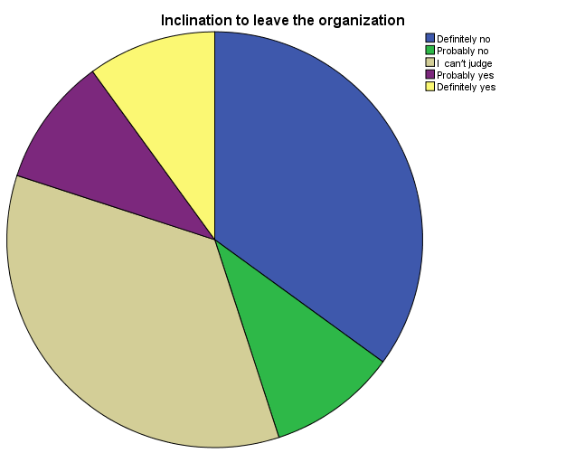

Findings: The question was asked about Inclination to leave the organization. Among the respondents, 45% of them have no tendency to leave the organization, 35% are in Neutral position and 20% of them have tendency to leave the organization.

The mean point is 2.5000

02. Do you have any alternatives for this job?
 |  | Frequency | Percent | Valid Percent | Cumulative Percent
Valid | Definitely no | 1 | 5.0 | 5.0 | 5.0
Valid | Probably no | 3 | 15.0 | 15.0 | 20.0
Valid | I can’t judge | 10 | 50.0 | 50.0 | 70.0
Valid | Probably yes | 5 | 25.0 | 25.0 | 95.0
Valid | Definitely yes | 1 | 5.0 | 5.0 | 100.0
Valid | Total | 20 | 100.0 | 100.0
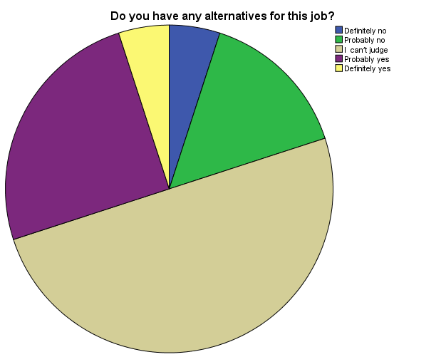
Findings: The question was asked about have any alternatives for this job. Among the respondents, 20% of them have no alternatives for this job, 50% of them are in Neutral position and 30% of them have alternatives for this job.

The mean point is 3.1000

03. Exploration of other job opportunities
 |  | Frequency | Percent | Valid Percent | Cumulative Percent
Valid | No, I am not interested. | 4 | 20.0 | 20.0 | 20.0
Valid | Sometimes I have a look at the advertisements. | 6 | 30.0 | 30.0 | 50.0
Valid | I can’t judge. | 3 | 15.0 | 15.0 | 65.0
Valid | I continuously seek information from advertisements, friends, relatives, etc | 4 | 20.0 | 20.0 | 85.0
Valid | I actively apply- submit CV and attend interview | 3 | 15.0 | 15.0 | 100.0
Valid | Total | 20 | 100.0 | 100.0
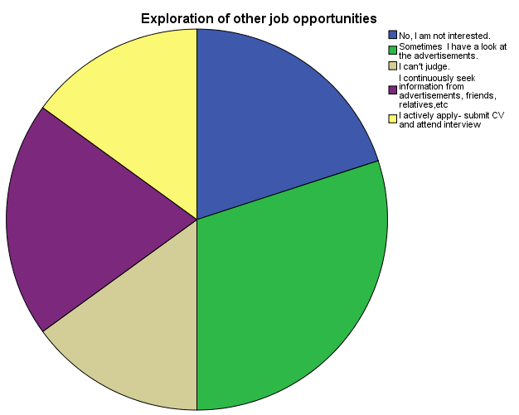
Findings: The question was asked about Exploration of other job opportunities. Among the respondents, 50% of them are positive, 15% of them are in Neutral position, 20% of them continuously seek information from advertisements, friends, relatives, etc and 30% of them attend interviews for new job. The mean point is 2.8000

  - Findings

    - Positive findings

- They are carefully keeping up the enlistment and choice procedure.

- They are utilizing current computerized innovation in their organization for make their representatives life simpler and dependable their item for their clients.

- They are especially agreeable with other each work force.

- They keep up a standard conduct with their clients and merchant.

- They have upheld to advance workmanship, culture in their office.

- They keep up tidiness in their office.

- Company proprietor is especially agreeable with their representative.

• They give reserve to exceptional youngster training, poor kid’s instruction, etc.

• Employee can impart their considerations to organization leading group of individuals effectively with no issue.

• Company has particularly refreshed IT framework and division.

• Employee doesn't have occupation hazard with no legitimate thinking.

5.8.2 Negative Findings

- They have lacking's between offices.

- They don't pursue completely the genuine enrollment and determination process.

- They don't have much mindfulness for all workers about the association's objectives and procedure.

- For worker fulfillment execution estimation and giving prize as per the individual execution is generally significant. This strategy isn't completely rehearses in Crown Cement.

- Employee doesn't think about the strategy, Flexible working hours and the reward framework plainly.

- I have seen some biasness exist there in the organization.

- Some individuals utilize their position control in some unlawful manner.

- Shortage of worker in promoting division.

- Some old Traditional standard exists in the organization.

- Canteen office isn't moderate

  - Recommendation

- Performance Management is a significant procedure whenever executed accurately. Mix-ups can be evaded by counseling specialists who have had understanding over numerous businesses and numerous usage.

- They should utilize 360 degree execution evaluation framework by which we can come to recognize what their friends and subordinates think about the representative.

- Employee should think about the strategy and the reward framework unmistakably that they can pay attention to it more.

- The criteria of estimation might be expanded in years a few and afterward proceeded onward to more tightly compensation linkages just as other further developed procedures, for example, Succession Planning, which draws on verifiable execution information

- Supervisors ought to comprehend and impart how the objectives of the association straightforwardly sway the representative's employment and execution.

- Needed to make much mindfulness for all workers about the association's objectives and system.

- Flexible working hours make it simpler for representatives to keep away from surge hour traffic, which is ensured to improve anybody's demeanor.

- Need more collaboration and connection inside offices.

- More preparing ought to be given.

- A steady corporate culture should be set up altogether.

- Job rotation, Job extension and Job improvement ought to be pursued.

Conclusion
Crown Cement Group is one of the top most leading cement companies in Bangladesh. Crown cement has a good reputation and trust worthiness for giving quality products to their customers. It was a great experience for me to work there. It was my first experiences to work in corporate field. I have learned to comply with bookish knowledge and practical experiences. People are heading towards corporate sector. So, it has become a challenge to select the right candidate that I being done successfully by human resource division. Every organization now-a-days maintains a human resource division. Crown cement group human resource department is very strong and active. I have discussed it through the whole report. A strong human resource department can change the whole company. Crown Cement Group is very popular to their customers. They are adding new cement formula and making new reliable product for their customers.

(References)

Books & Journals
Epstein, Marc, and Jean- François Manzoni. "Implementing Corporate Strategy : From Tableaux de Board to Balanced Scorecards."

European Management Journal, April 1998, pp. 190-203.

"Harvard Business Review." Harvard Business Review, 2002 to present (bimonthly).

Kaplan, Robert S, and David P. Norton. The Balanced Scorecard: Translating Strategy into Action. Harvard Business School Press, 1996.

Kaplan, Robert S., and David P. Norton. “Having Trouble with Your Strategy? Then Map It.” Harvard Business Review, September/October 2000, pp. 167-176.

Kaplan, Robert S., and David P. Norton. “Measuring the Strategic Readiness of Intangible Assets.” Harvard Business Review, February 2004, pp. 52-63.

Kaplan, Robert S., and David P.Norton. The Strategy-Focused Organization: How Balanced Scorecard Companies Thrive in the New Business Environment. Harvard Business School Press, 2000.

Kaplan, Robert S., and David P. Norton. Strategy Maps: Converting Intangible Assets into Tangible Outcomes. Harvard Business School Press, 2004.

Kaplan, Robert S., and David P. Norton. "Using the Balanced Scorecard as a Strategic Management System." Harvard Business Review, January/February 1996, pp. 75-85.

Niven, Paul. Balanced Scorecard Step-by-Step: Maximizing Performance and Maintaining Results. John Wiley & Sons, 2002.
HR Manual of M. I. Cement Factory Limited (Crown Cement).
M. I. Cement Annual Report 2016 - 2017.

Mello, Jeffry A., 2006. Human Resource Management, Second Edition.
Turner, Paul, 2002. HR Forecasting & Planning.

Mc Millan, J. D., and H. W. Doyel (1980). Performance Appraisal: Match the Tool to the Task, Personnel, 57 (4).

Fisher, Martin, 1997, Performance Appraisals.
(http://en.wikipedia.org/wiki/Performance_appraisal)
(http://www.cipd.co.uk/hr-topics/performance-management.aspx)
The website of Crown Cement : (http://www.crowncement.com)
(http://www.marketwatch.com/)

Appendix

Human Resource Management Practices and their outcomes

Dear respondent,
The present study is an endeavor to identify the various HRM practices and their relationship with selected outcomes in various organizations.

Below various statements related to HRM practices and their outcomes are listed.
Please express how far these practices and their outcomes are prevailing in your organization by indicating your level of agreement/ disagreement on a five point scale.
(Where SA= Strongly Agree, A=Agree, UD=Undecided, D= Disagree, SD=Strongly Disagree.)

The information provided by you will be used only for research (MBA) and not for any commercial activity. Please spare a few minutes from your valuable schedule and share your true feelings.

Confidentiality of the information provided will be ensured.

Name of the Organization: __________________________________________

Number of Employees (Approximately):_________________________

Position:___________________________

Level( Please tick) Entry Level Mid Level Top Level

Gender (Please tick) Male Female

Marital Status (Please tick) Single Married

Age (Please tick) 20-30 years 31-40years 41-50 years 51years -Above

Education (Please tick)
School certificate
Undergraduate Degree
Post-graduate degree
Professional and other qualifications
Experience
1-5years
6-9years
10years-above

Human Resource Management Practices
Our organization places the right person in the right job. |  |  |  |  |  |  |  |  |  | SA | A |  | UD |  | D | SD
Adequate and relevant information about the organization and job is provided to the candidate at the time of recruitment. |  |  |  |  |  |  |  |  |  | SA | A |  | UD |  | D | SD
Selection of a candidate in our organization is strictly based on his/her merit. |  |  |  |  |  |  |  |  |  | SA | A |  | UD |  | D | SD
The training needs of the employees in our organization are assessed on the basis of their performance appraisal. |  |  |  |  |  |  |  |  |  | SA | A |  | UD |  | D | SD
Training in our organization includes social skills, general problem solving skills and broader knowledge of the organization and business. |  |  |  |  |  |  |  |  |  | SA | A |  | UD |  | D | SD
The contents of the training programs organized are always relevant to the changing needs of our jobs and our business. |  |  |  |  |  |  |  |  |  | SA | A |  | UD |  | D | SD
We are assigned challenging jobs to charge our enthusiasm and develop our skills. |  |  |  |  |  |  |  |  |  | SA | A |  | UD |  | D | SD
We are encouraged to participate in various seminars and workshops etc. |  |  |  |  |  |  |  |  |  | SA | A |  | UD |  | D | SD
We are being paid adequately for the work we do. |  |  |  |  |  |  |  |  |  | SA | A |  | UD |  | D | SD
Pay increments offered by our organization are satisfactory. |  |  |  |  |  |  |  |  |  | SA | A |  | UD |  | D | SD
Our organization makes all payments due to us in time. |  |  |  |  |  |  |  |  |  | SA | A |  | UD |  | D | SD
Our organization follows the policy of matching pay with performance. |  |  |  |  |  |  |  |  |  | SA | A |  | UD |  | D | SD
The pay we receive is competitive compared to that of employees doing similar work in other organizations. |  |  |  |  |  |  |  |  |  | SA | A |  | UD |  | D | SD
We are satisfied with the benefits we receive. |  |  |  |  |  |  |  |  |  | SA | A |  | UD |  | D | SD
The benefits we receive in our organization are similar to what most of the other organizations in the industry provide to their employees. |  |  |  |  |  |  |  |  |  | SA | A |  | UD |  | D | SD
Rewards and incentives are fairly distributed in our organization. |  |  |  |  |  |  |  |  |  | SA | A |  | UD |  | D | SD
Rewards in our organization are strictly linked to employee performance. |  |  |  |  |  |  |  |  |  | SA | A |  | UD |  | D | SD
The existing reward and incentive plans do not motivate us for better performance. |  |  |  |  |  |  |  |  |  | SA | A |  | UD |  | D | SD
Our organization appraises the performance of its employees at regular intervals. |  |  |  |  |  |  |  |  |  | SA | A |  | UD |  | D | SD
Performance appraisal in our organization aims at improving employee performance and strengthening our job skills. |  |  |  |  |  |  |  |  |  | SA | A |  | UD |  | D | SD
Perceived Organizational Support
The company values our contribution to its well being |  |  |  |  |  |  |  |  |  | SA | A |  | UD |  | D | SD
The company strongly considers our goals and values |  |  |  |  |  |  |  |  |  | SA | A |  | UD |  | D | SD
Our organization does not ignore complaints from its employees. |  |  |  |  |  |  |  |  |  | SA | A |  | UD |  | D | SD
Our organization cares about our opinions. |  |  |  |  |  |  |  |  |  | SA | A |  | UD |  | D | SD
Our organization duly supports its employees facing any problem. |  |  |  |  |  |  |  |  |  | SA | A |  | UD |  | D | SD
The organization cares for employees’ general satisfaction at work. |  |  |  |  |  |  |  |  |  | SA | A |  | UD |  | D | SD
Each employee is treated with genuine respect. |  |  |  |  |  |  |  |  |  | SA | A |  | UD |  | D | SD
Employee attitudes and behavior
We trust the management for keeping the promises made to us. |  |  |  |  |  |  |  |  |  | SA | A |  | UD |  | D | SD
We are confident that our organization has growth potential |  |  |  |  |  |  |  |  |  | SA | A |  | UD |  | D | SD
We trust the management for keeping the promises made to us. |  |  |  |  |  |  |  |  |  | SA | A |  | UD |  | D | SD
We are confident that our organization has growth potential |  |  |  |  |  |  |  |  |  | SA | A |  | UD |  | D | SD
We believe that our management follows policies and practices that serve combined interests of both employees and the organization. |  |  |  |  |  |  |  |  |  | SA | A |  | UD |  | D | SD
Discretionary Behavior
I help new workers, even when not asked to do so. |  |  |  |  |  |  |  |  |  | SA | A |  | UD |  | D | SD
Whenever my organization requires, I willingly stay at work till late |  |  |  |  |  |  |  |  |  | SA | A |  | UD |  | D | SD
I make suggestions for improvements. |  |  |  |  |  |  |  |  |  | SA | A |  | UD |  | D | SD
I volunteer for things that are not part of the job. |  |  |  |  |  |  |  |  |  | SA | A |  | UD |  | D | SD
I avoid taking up extra duties and responsibilities. |  |  |  |  |  |  |  |  |  | SA | A |  | UD |  | D | SD
Whenever a need arises I stand up to protect the reputation of my organization |  |  |  |  |  |  |  |  |  | SA | A |  | UD |  | D | SD
I rarely try to correct a faulty procedure or practice. |  |  |  |  |  |  |  |  |  | SA | A |  | UD |  | D | SD
Affective and Normative Commitment
I would be very happy to spend the rest of my career with this organization |  |  |  |  |  |  |  |  | SA |  | A |  | UD |  | D | SD
I enjoy discussing my organization with people outside of it. |  |  |  |  |  |  |  |  | SA |  | A |  | UD |  | D | SD
I really feel as if this organization’s problems are my own. |  |  |  |  |  |  |  |  | SA |  | A |  | UD |  | D | SD
Inclination to leave the organization  (Please Tick) |  | Definitely no |  | Probably no |  | I can’t judge |  | Probably yes |  |  |  | Definitely yes
Do you have any alternatives for this job? |  | Definitely no |  | Probably no |  | I can’t judge |  | Probably yes |  |  |  | Definitely yes
Exploration of other job opportunities  (Please Tick) | No, I am not interested. |  | Sometimes  I have a look at the advertisements. |  | I can’t judge. |  | I continuously seek information from advertisements, friends, relatives, etc |  |  |  |  |  |  | I actively apply- submit CV and attend interview

THANK YOU FOR YOUR TIME

