Marketing Practices of Renata PLC: A Study on Pharmaceutical Marketing Operations

Tasnim Jahan

This report is submitted to the school of Business and Economics, United International University as a partial requirement for the degree fulfillment of Bachelor of Business Administration

Marketing Practices of Renata PLC: A Study on Pharmaceutical Marketing Operations

Submitted to:
Dr. Md. Shariful Alam
Professor

Submitted by:
Tasnim Jahan
111201213

School of Business and Economics
United international university

Date of submission: 9th May, 2026

Letter of transmittal

Date: 09.05.2026

Dr. Md. Shariful Alam,

Professor,

School of Business & Economics

United International University

Subject: Submission report about Marketing Practices of Renata PLC: A Study on Pharmaceutical Marketing Operations

Dear Sir,

I am submitting my internship report on “Marketing Practices of Renata PLC: A Study on Pharmaceutical Marketing Operations” that you have assigned me as an essential requirement of Internship program. I tried my level best to prepare an effective report by gathering knowledge from Renata PLC.

Yours obediently,

Tasnim Jahan
ID: 111 201 213

Certification of similarity index

Declaration of the student

The work and learning which is presented in the report on “Marketing Practices of Renata PLC: A Study on Pharmaceutical Marketing Operations” has been carried out by me under the supervision by “Dr. Md. Shariful Alam”, Professor, School of Business & Economics, United International University”. The report has not been previously submitted to the other university and other internship report. The report which I make, do not breach any copyright rules and any part is not copied from any source.

-------------------------
Tasnim Jahan
111201213

Acknowledgement

In the name of Almighty Allah, I express my sincere gratitude for enabling me to complete this internship report successfully.
I would like to convey my deepest appreciation to my respected academic supervisor, Dr. Md. Shariful Alam, Professor, School of Business and Economics, United International University, for his scholarly guidance, constructive feedback, and continuous support throughout the preparation of this report.
I also thankful to Md. Arifuzzam, Product Manager (Anti-Ulcerent Portfolio), Renata PLC. and Ahsanur Rahman Khan, Head of Marketing, Gastro Portfolio (Maxpro), Renata PLC. for guiding me to learn and work properly. They support me about understanding marketing in the pharmaceutical sector and way to work there.

Executive summary

I did my internship with Renata PLC in their Marketing Pharma Department at their Corporate Head Office in Mirpur-11, Dhaka. The aim of this report is to give an idea about activities of the Marketing Pharma Department, and analyze about the pharmaceutical industry of Bangladesh. The report provides detailed information about Renata PLC's history, operations, growth, products and market position. Renata PLC is one of the most important pharmaceutical companies of Bangladesh and has grown successfully in terms of business through quality products, excellent distribution networks, proper marketing strategies and business management practices. The current conditions such as competition, industry growth, technology and regulations. The internship experience section provides a description of what the intern actually did, in terms of activities, responsibilities, and duties, during the internship. The department's responsibilities include sales and market data organization, preparing presentations and reports, updating product and doctor information, documentation and support activities for promotions. My job experience included understanding brand management and marketing communication, sales coordination, and market analysis. Also, I learned about segmentation, targeting, positioning, branding, customer relationship management and market research were quite related to the departmental activities. I also gain knowledge of Communication, Team working, Analytical thinking, Time Management, Report writing and application of Microsoft Office. Overall, the internship at Renata PLC was a highly beneficial experience that helped me gain insight into the corporate world and build the skills needed for future success in my studies and career in the business industry.

Table of contents
Table of Contents
Letter of transmittal 3
Certification of similarity index 4
Declaration of the student 5
Acknowledgement 6
Executive summary 7
Table of contents 8
List of Figures 10
List of Tables 11
List of Abbreviation 12
CHAPTER I: INTRODUCTION 13
1.1 Background of the Report 13
1.2 Objectives of the Report 14
1.3 Motivation of the Report 14
1.4 Scope and limitations of the Report 15
CHAPTER II: COMPANY AND INDUSTRY PREVIEW 16
2.1 Company Analysis 16
2.1.1 Overview and history 16
2.1.2 Trend and growth 17
2.1.3 Customer mix 19
2.1.4 Product/service mix 20
2.1.5 Operations 21
2.1.6 SWOT analysis 22
2.2 Industry analysis 24
2.2.1 Specification of the industry 24
2.2.2 Size, trend, and maturity of the industry 25
2.2.3 External economic factors 25
2.2.4 Technological factors 26
2.2.5 Barriers to entry 27
2.2.6 Supplier Power 27
2.2.7 Buyer Power 28
2.2.8 Threat of Substitutes 28
2.2.9 Industry rivalry 29
CHAPTER III: INTERNSHIP EXPERIECNE 30
3.1 Position, duties, and responsibilities 30
3.2 Training 31
3.3 Contribution to departmental functions 33
3.4 Evaluation 34
3.5 Skills applied 35
3.6 New skills developed 35
3.7 Application of academic knowledge 37
CHAPTER IV: CONCLUSIONS AND KEY FACTS 38
4.1 Recommendations for improving departmental operations 38
4.2 Key understanding 39
4.3 Conclusion 40
Reference 41

List of Figures

Figure-1: Renata PLC Consolidated Revenue Growth ----------------------------------------- 17
Figure-2: Business Growth Indicators Mentioned in Annual Report ------------------------ 18
Figure-3: Renata PLC Net Turnover by Business Segment ---------------------------------- 18
Figure-4: Marketing Pharma Department Workflow -------------------------------------------- 21
Figure-5: Bangladesh Pharmaceutical Industry Snapshot ------------------------------------ 24
Figure-6: Internship Work Process in Marketing Pharma Department -------------------- 29

List of Tables

Table-1: Renata PLC Net Turnover by Business Segment ----------------------------------- 18
Table-2: Internship Training and Work Activity Schedule -------------------------------- 30, 31

List of Abbreviation

- PLC Public Limited Company
- DGDA Directorate General of Drug Administration
- BIDA Bangladesh Investment Development Authority
- API Active Pharmaceutical Ingredient
- SOP Standard Operating Procedure
- CRM Customer Relationship Management
- KPI Key Performance Indicator
- A&P Advertising and Promotion
- MIS Management Information System
- MR Medical Representative
- Rx Prescription
- ROI Return on Investment

CHAPTER I: INTRODUCTION

1.1 Background of the Report

Completed internship at Renata PLC, under the Marketing Pharma Department. In this report I have seen my own experience, profile of the organization, industry landscape, departmental functions and the link between academic marketing concepts and practice. Marketing pharmaceuticals is not the same as marketing a consumer product, as medicine is directly linked to health and wellbeing of the patients. The marketing team, for this reason, has to be so careful in sharing the product information, make it scientific, comply with internal approval and support the sales team to follow-up. The Marketing Pharma Department at Renata PLC is responsible for brand planning, market assessment, designing promotional programs, supporting doctor communications, coordinating the sales team and tracking the performance of the product. This report is based on secondary information, such as the Annual Report for Renata PLC, industry related materials from BIDA and CPD and learning from the internship. The experience in the internship also was reflected in the internship report.

1.2 Objectives of the Report

This report aims to share my experience of completing my internship in the Marketing Pharma Department of Renata PLC and to analyse the way marketing activities are being implemented in a pharmaceutical firm.
The specific objectives are:
- To explain the background, development and growth pattern, product portfolio, and main operational areas of Renata PLC.
- To understand the pharmaceutical business of Bangladesh with relevant company and industry level information.
- To describe about Marketing Pharma Department to aid in brand management and in the activities of sales.
- To provide a summary of responsibilities, training, work and learning outcomes during the internship time.
- To demonstrate the relationship between academic marketing learning and its implications for workplace activities.
- Propose a course of action for departmental work processes and internship learning opportunities.

1.3 Motivation of the Report

The reasons for the preparation of this report were twofold: firstly, it was stipulated as a requirement for the internship program and secondly, it was the practical learning that was provided at Renata PLC. I realized that when I joined the organization, pharmaceutical marketing is a well-structured activity which demands careful analysis, disciplined communication, compliance awareness and good team coordination. Renata PLC is a renowned name in the pharmaceutical industry of Bangladesh. As a part of the Marketing Pharma Department, I had a chance to witness the collaboration of brand teams, sales team, distributors’ support, and other teams to attain business objectives.

1.4 Scope and limitations of the Report

This report provides a description of the company profile, industry overview, activities of the marketing department, responsibilities of the internship, learning outcomes, recommendations and conclusion. Main focus is the Marketing Pharma Department of Renata PLC. The report looks at brand management, market research, promotional communication, sales support, customer groups, product categories and departmental workflow from the point of view of a marketing student. There are also some limitations in the report. Throughout the report, many internal facts and figures are confidential but the report has been based on publicly available information and general observations from the internship. Medical and regulatory issues are integral to pharmaceutical marketing, and the discussion is in business and marketing terms and not medical. Certain financial and market information may be subject to change.

CHAPTER II: COMPANY AND INDUSTRY PREVIEW

Company Analysis

2.1.1 Overview and history

Renata PLC is one of the big pharmaceutical firms in Bangladesh. Its inception was in 1972 as a subsidiary of Pfizer Corporation USA, called Pfizer Laboratories (Bangladesh) Limited. Pfizer Corporation sold its stake in the company in 1993 and it became Renata Limited. It later changed its name to Renata PLC in accordance with the Companies Act 1994 (2nd Amendment 2020) in 2023. Renata PLC is involved in the production, marketing and distribution of human medicines, animal health products, nutritional products, vaccines and contract manufactured products. The company also manufactures some general products for agencies like the UNICEF. It has some manufacturing units that have international regulatory approvals and quality certifications, such as ANVISA, WHO PQ, USFDA and MHRA. These approvals will bolster Renata's market presence and capability to sell locally and internationally. Renata PLC has its corporate office in Mirpur in Dhaka. The company has a well-established market position based on its extensive product line, its nationwide sales network, its brand image and its quality approach. The Annual Report of 2023-2024 states that the core business of the company is manufacturing, marketing, and distribution of pharmaceuticals, animal health products, contract manufacturing, agro-based, and consumer products both within and outside Bangladesh. All these factors – product quality, brand strength, communication with doctors, distribution availability, field-force efficiency and market intelligence – have an impact on Renata's performance from a marketing point of view. The Marketing Pharma Department is involved in these aspects through product strategies, preparation of promotional materials, and monitoring of competitor activities and support for the sales team.

2.1.2 Trend and growth

Renata PLC has been following a positive growth trend in recent years. In FY 2023–24, the Group recorded revenue of BDT 37.71 billion, while revenue in FY 2022–23 was BDT 32.97 billion. This indicates consolidated revenue growth of 14.4%. The revenue from standalone also increased 14.1% to BDT 37.50 billion. These statistics indicate that despite the competitive market and macroeconomic conditions, Renata kept its market position.
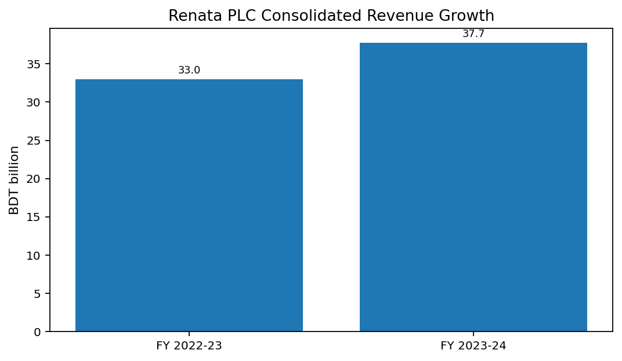

Figure-1: Renata PLC Consolidated Revenue Growth
The Annual Report further mentions that Renata’s pharmaceutical business grew by 12.2% year-on-year, whereas the overall industry growth was 7.2%. The company also held a 5.1% market share based on MAT Q2 2024 and moved to third position in prescription share. From a marketing viewpoint, prescription share is significant because it reflects doctor confidence, brand recall, and the effectiveness of the field force.

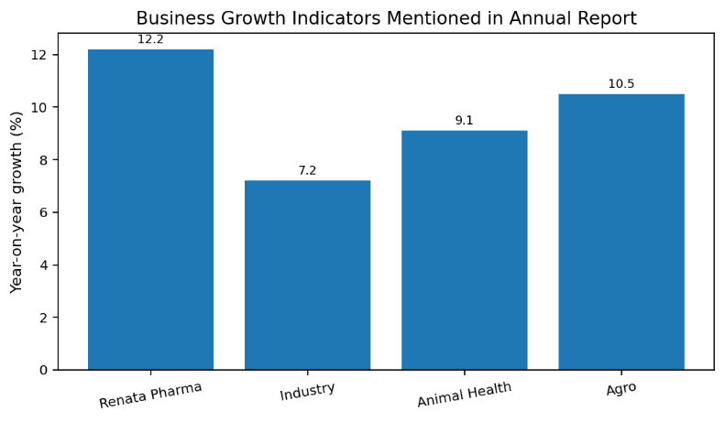

Figure-2: Business Growth Indicators Mentioned in Annual Report
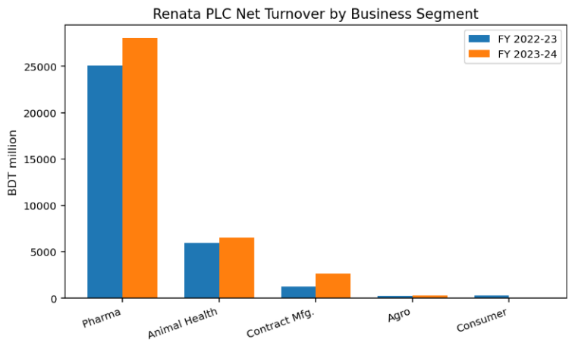

Figure-3: Renata PLC Net Turnover by Business Segment
Product diversification is another important growth trend for Renata PLC. The company has a broad portfolio consisting of many brands and products across different therapeutic segments. During FY 2023–24, Renata introduced 47 new products, particularly focusing on non-communicable disease treatment. This demonstrates that the company is trying to expand through both existing brands and new product development.
The table below presents Renata PLC’s net turnover by business segment.
Business Segment | FY 2023-24 Net Turnover (BDT) | FY 2022-23 Net Turnover (BDT)
Pharmaceutical products | 28,036,284,163 | 25,062,539,284
Animal health products | 6,519,214,267 | 5,974,289,670
Contract manufacturing | 2,661,588,789 | 1,266,183,135
Agro-based products | 276,312,063 | 250,135,125
Consumer products | 7,118,958 | 311,549,563
Total | 37,500,518,240 | 32,864,696,777

Table-1: Renata PLC Net Turnover by Business Segment

2.1.3 Customer mix

The Marketing Pharma Department is a customer-oriented department with a unique customer base. In pharmaceutical marketing, the company isn't in direct contact with patients as consumer product companies typically do with its end user. Rather, multiple stakeholder groups have a role in prescription decisions, product availability and purchasing.
Key customer / stakeholder groups are:
- Doctors and prescribers: They play a very significant role as prescription medicines rely on their professional judgment and recommendation.
- Retail chemists and pharmacies: They make products available at the retail level and are helpful in offering feedback on the demand, stock movements and competing brands.
- Medical promotion executives and medical sales teams: They present the approved product information to the doctors and get the feedback from the market.
- Patients / caregivers: These are the end users of the products, but face ethical and regulatory restrictions in interacting with them directly.

2.1.4 Product/service mix
Renata PLC has a wide variety of products and services. It offers a wide range of products and services, such as human pharmaceuticals, animal health medicines, nutritional products, vaccines, agro-based products, consumer products, and contract manufacturing services. Pharmaceutical portfolio includes anti-inflammatory products, anti-diabetic products, anti-cancer medicines, anti-inflammatory agents, neurological medicines.
The product mix is very pertinent for the Marketing Pharma Department since each category necessitates a different positioning strategy, promotion message, doctor segment.
Major parts of Renata’s product and service mix are:
- Human pharmaceuticals: Brand name generic drugs that are used in various therapeutic groups.
- Animal health products: Products related to animal health, including veterinary medicines and nutrition products, in which Renata has a strong market share.
- Nutritional and vaccines: Items that aid in the prevention of illness and in public health.
- Contract manufacturing: manufacturing services provided to institutional partners and other organizations.
The product and service mix is not just the number of products in the portfolio, when looking at pharmaceutical marketing. It also involves quality assurance, distribution support, training, market education, packaging and product life cycle management.

2.1.5 Operations

Renata PLC's activities require a high level of interaction between production, quality control, regulatory affairs, marketing, sales, distribution, finance, supply chain, and human resources. The primary role of the Marketing Pharma Department is to engage in brand strategy, promotions, sales support and performance analysis within the market.
A simplified workflow of the Marketing Pharma Department is presented below.
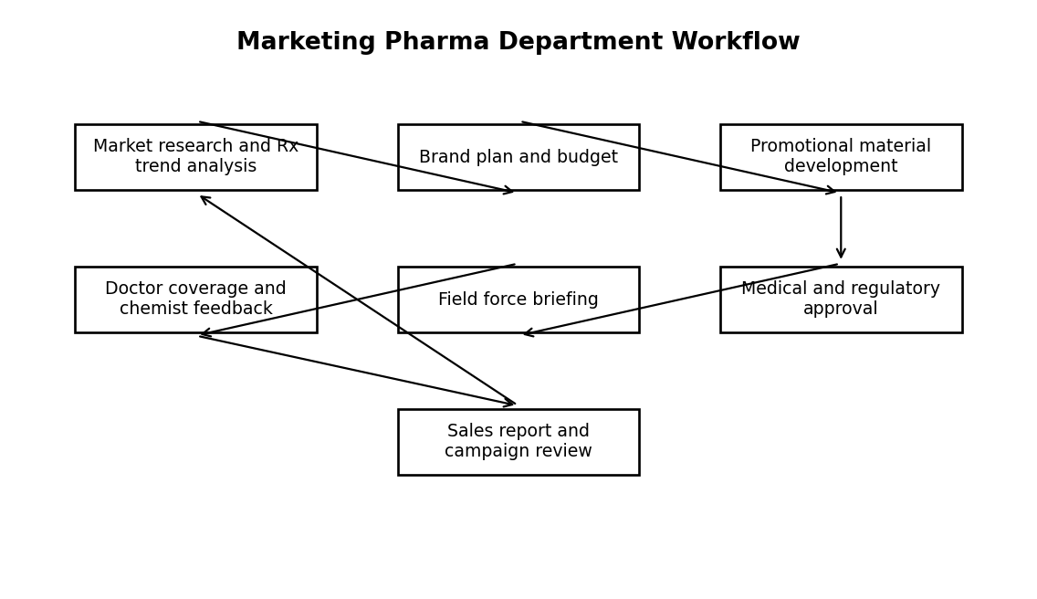
Figure-4: Marketing Pharma Department Workflow
Market research and Sales data review are normally the first step in marketing activities. A brand objective is determined, based on the analysis and a promotional strategy is developed. The department then creates promotional products like product statements, brand messages, visual aids, literature and reminder products. These materials go through an internal review and approval process prior to use in the field. The field force is then briefed, and the campaign is rolled out via doctor visits, chemist feedback, and sales coordination.

2.1.6 SWOT analysis

To identify the strengths, weaknesses, opportunities and threats of Renata PLC from both the business and marketing perspectives, SWOT analysis could be useful.
Strengths:
- Good brand reputation in the pharmaceutical market of Bangladesh.
- A broad product range across a wide range of therapeutic areas.
- Well-developed sales and distribution network.
- International certification and approval of selected facilities.
- A team of experienced leadership, management and marketing staff.
Renata's areas of strength are primarily related to quality, market reputation, coverage and portfolio diversity. It enables the company to continue providing new products.
Weaknesses:
- Significant reliance on heavily competitive prescription drug markets.
- Persistent requirement for marketing, distribution and field force productivity investments.
- Need to keep promotional materials current and based on sound scientific information.
- A high level of dependency on imported APIs in the industry.
- Complications with complicated coordination between marketing, sales, regulatory.

Opportunities:
- An increasing demand for chronic disease medicines in Bangladesh.
- Potential to expand business in emerging export markets.
- Opportunities for digital communications and e-detailing to doctors.
- New product introduction in attractive therapeutic areas.
- Improved adoption of data analytics for segmentation, targeting and performance monitoring.

Threats:
- Alterations to regulatory policies and drug pricing regulations.
- Macroeconomic pressure, inflation and currency depreciation. Input costs increase and possibly disruption of API supply.
- The danger of low ROI for promotional investments if they aren't data-driven.

Industry analysis

2.2.1 Specification of the industry
Renata PLC is part of the Bangladesh pharmaceutical industry. The pharmaceutical sector is among the highest important manufacturing industries of the country, as medicines are indispensable in the healthcare and national development. The sector covers the manufacturing, marketing, distribution and export of medicines, vaccines, nutritional products, veterinary products and other health-related products. The pharmaceutical industry in Bangladesh is in a great development, largely dominated by local companies. The industry also accounts for approximately 98% of the domestic market demand for medicines in the country and exports pharmaceutical products to over 150 countries, say BIDA. It indicates that the industry has moved from importing to manufacturing and export ready.
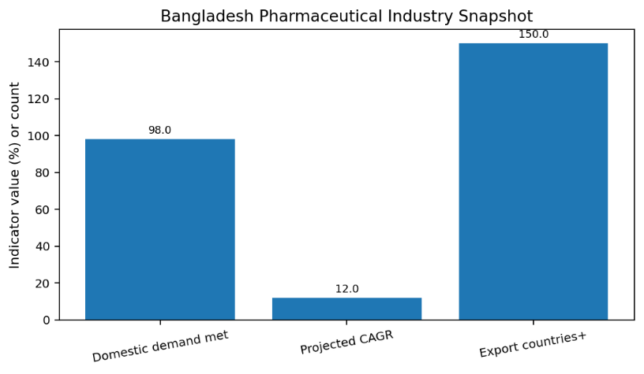

Figure-5: Bangladesh Pharmaceutical Industry Snapshot
The industry is supervised by government authorities, and companies must follow requirements related to quality, registration, and labeling, pricing, manufacturing, and promotional practices.

2.2.2 Size, trend, and maturity of the industry

The pharmaceutical sector of Bangladesh can be termed as a well-established but progressive industry. It already satisfies most of the domestic medicine needs, but still has room for further growth in new categories of medicines, exports, technology advancement, local production of APIs, and enhanced regulatory practices. The population size, the urbanization, the income, the expansion of awareness of health and treatment of chronic diseases are expected to increase demand. BIDA considers the sector as advanced industries of Bangladesh and expects the market to surpass USD 6 billion by 2025 with a compound annual growth rate of over 12%. CPD also points to TRIPS flexibilities and robust supply capacity that have benefitted the sector, but also to an LDC graduation and tougher IP-related requirements for the industry. The industry is currently focused on quality manufacturing, bioequivalence, entering into regulated export markets, specialized medicines, oncology, vaccines, digital promotion and greater engagement with doctors. Renata PLC sees opportunities in these trends for product development and market expansion.

2.2.3 External economic factors

The pharmaceutical industry is very sensitive to external economic conditions. The cost of producing, packaging, shipping and promoting the product may also increase because of inflation. A depreciation in the currency may affect the prices of imported API/excipients, machinery and technology. The cost of financing expansion projects can be affected by interest rates. According to the Annual Report of Renata PLC 2023/2024, the higher cost of electricity and diesel were responsible for the surge in energy-related costs which have the potential of impacting profitability. If it affects the marketing, then it may affect their marketing budgets, how they plan their marketing campaigns, product priorities and pricing. Demand for medicine tends to be more inelastic than the demand for a lot of non-essential consumer products even during a recession. Good brands, product availability and operations are more resilient during the tough times in business.

2.2.4 Technological factors

Pharma production and marketing is changing with technology. In manufacturing, businesses utilize current machinery, quality control processes, lab tests, electronic documentation, and automation. In marketing, technology enables sales analysis, doctor digital communication, customer relationship management (CRM), e-detailing, online training and performance dashboards. In the Marketing Pharma Department, technology helps them to track sales performance, create market reports, doctor segmentation, coverage of field force, monitoring of promotional activity and to study prescription patterns.

2.2.5 Barriers to entry

Pharmaceutical industry has high entry barriers. Regulatory approval, manufacturing facilities, quality management systems, skilled people, product registration, distribution capability, brand building resources and huge investment are required for a new organization. It also has to gain the trust of the doctors, chemists, institutions, and patients. Also, the market is already saturated and companies already have established connections with doctors and established brands. It takes time and hard work to build the share of prescription. High costs are also involved in quality certification and compliance but are necessary for long term operating. So it's harder to get into the pharmaceutical business than it is into many consumer goods businesses. As a well-known company these entry barriers offer some protection to Renata PLC. But competition is still keen amongst the existing pharmaceutical companies and the company should continue to build on their strengths of quality, innovation, marketing communication and product availability.

2.2.6 Supplier Power

The level of supplier power in the pharmaceutical industry can vary from moderate to high, depending on the type of input. There are numerous companies that depend on a range of imported APIs, packaging supplies, manufacturing machinery, laboratory equipment, and specialized technologies. If global API prices increase or production is impacted due to supply chain issues, production costs and product availability may be affected. CPD notes that Bangladesh’s pharmaceutical sector is highly relying on the imports of raw materials, particularly APIs, which underlines the need to increase local production capacity. To marketing departments, supplier related disruptions can result in stock shortages, product launches that are delayed and camp politics. Thus, marketing needs to work hand in hand with the members of the supply chain, production, and procurement.

2.2.7 Buyer Power

In pharmaceutical marketing, buyers can be powerful, in many ways. Physicians prescribe the medicine, chemists determine the availability and availability of possible brand substitutions, institutions have an influence on bulk purchases, and patients pay for the medicine. There are multiple brands within the same class of product and usually buyers are presented with several options. This puts the pricing, quality and service pressure and puts the trust on the brands. However, doctors' confidence and scientific communication can minimize switching for prescription products. Where strong and trusted brands are always available, they can keep demand going. Hence, the marketing department should make brand positioning, evidence-based communication, doctor relationship management and supply availability a priority.

2.2.8 Threat of Substitutes

There is a moderate threat of substitutes in this industry. Sometimes there's a choice of other brands of a generic drug offered by different firms that make the same drug under a different name. There may be other brands available, chemists might suggest an alternative, and the patient may opt for a more affordable alternative. Therefore, brand loyalty is important, as are quality perception, trust and availability. Substitutes, in the more general context, can also refer to lifestyle modification, preventive healthcare, natural remedies or alternative treatments for some diseases, nonexperimental medications, or over-the-counter treatments. For many diseases, however, the use of pharmaceuticals is still required. Consequently, the substitute threat is more at the brand level.

2.2.9 Industry rivalry

The pharmaceutical industry in Bangladesh is highly competitive. There are a number of strong local and multi-national companies working in the same therapeutic areas. Rivalry is fought over the quality of the products, the competition in price, distribution power, doctor coverage, communication through promotions, new product introductions, and brand reputation. Renata's pharmaceutical company expanded its growth faster than the industry, and strengthened its market position in prescription share. This means both doctor coverage and field force effectiveness, product strategy, market analysis, and brand investment are important factors for gaining competitive advantage in the industry.

CHAPTER III: INTERNSHIP EXPERIECNE

3.1 Position, duties, and responsibilities

As part of my internship with Renata PLC, my job was as Marketing Intern within the Marketing Pharma Department. The department provided hands-on experience in the field of pharmaceutical branding, market analysis, promotional planning, sales support, and office documentation. Watched the activity of senior officers and got acquainted with the general rules of the department. After some days I began to work with some tasks under supervision.
The work I did and my responsibilities were:
- Supporting marketing team in organizing data of sales and markets.
- Updating Doctor Lists, Product lists and Territory related information.
- Gathering competitor data from sources in the market and direct feedback.
- Assisting in the production of product and brand presentation materials.
- Examining promotional document files and preparing approved documents.
- Supporting documentation for campaign and CME.
- Supporting records checking samples and promotional items.
- Creating Daily Work Notebooks; Reporting to assigned supervisor
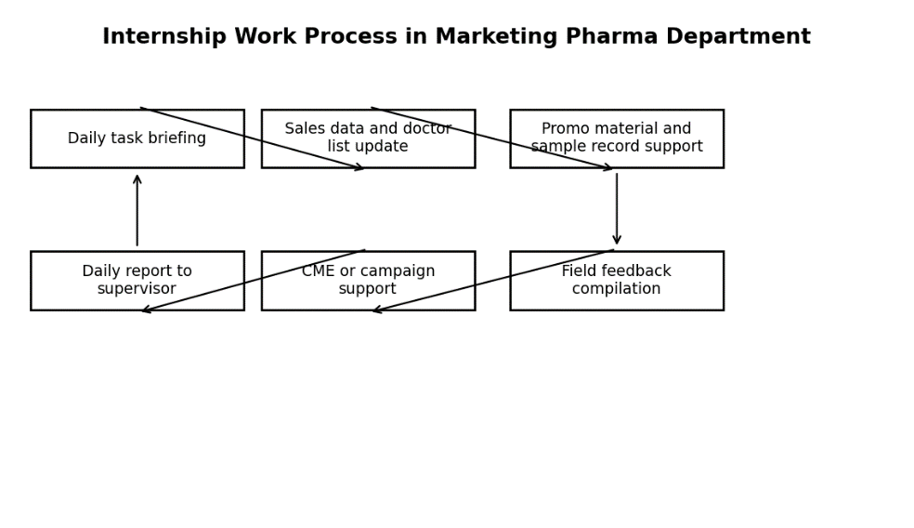

Figure-6: Internship Work Process in Marketing Pharma Department

3.2 Training

The internship training began with an orientation to the Renata PLC, the Marketing Pharma Department and the rules of the office. Company history, Department structure, Product categories, Brand planning, Sales force coordination and Communication ethics were all the things I learned about. The officers stated the principle of pharmaceutical marketing should be accurate, responsible and based on approved product information. The training was in the form of assignments. I was taught how to read sales reports, to organize the Excel sheets, update doctor information, figure out who the good prescribers are and how to compare product performance while creating short sales summaries. I also gained insight to the processes of creating, reviewing, approving and distributing promotional materials to the field force. I noticed that the department values data, and values communication as well. Marketing isn't a decision that is taken on instinct. The team utilizes sales trends, prescription information, field feedback, competition, product lifecycle stage and management objectives. This gave me an idea of how decisions are made in the pharma industry when it comes to practicality of marketing.
The student is contributing to the functions of the department. The student is helping to perform departmental duties.

Week/Phase | Training Area | Learning Outcome
Week 1 | Orientation and department introduction | Understood company culture, reporting system, and basic department work.
Week 2 | Product and brand overview | Learned product categories, brand positioning, and therapeutic focus areas.
Week 3 | Sales data and market analysis | Practiced Excel-based data organization and basic performance interpretation.
Week 4 | Promotional material and approval process | Understood the importance of approved claims and ethical communication.
Week 5 | Field force and doctor coverage support | Learned how marketing supports medical promotion executives and sales teams.
Week 6 onward | Campaign and reporting support | Prepared summaries, event support documents, and internship work notes.

Table-2: Internship Training and Work Activity Schedule

3.3 Contribution to departmental functions

In the internship, I helped with various activities of the Marketing Pharma Department under supervision. As an intern I attempted to perform all tasks assigned diligently and promptly. The following is a description of my contributions.
Support to market research and data:
- Compiled sales information in Excel by product, territory and time period.
- Created basic performance reports for some brands.
- Gathered competitor brand data from field feedback and secondary sources.
- Analyzed selected product categories for growth or decline.
Assisting in the development and promotion of the brand:
- Helped to organize Visual Aid files, Product leaflets and Records of promotional material.
- Assisted with PowerPoint slides for in-house discussion.
- Verified if the required files of the brand is present in the department folder.
- Assisted in the creation of short notes for product features, target doctors, and focus on the campaign.
Attends and documents events:
- Participates in events and documents events
- Supported with documentation activities for CME/doctor meeting.
- Went to class and completed attendance and checklist when needed.
- Organized files and assisted with departmental record keeping.
- Made internship notes each day based on learning.

3.4 Evaluation

My internship was assessed based on daily activities, timely performance, communication, and quick learning. Initially I had to be guided through many activities, but as time went on, I became more at ease to use Excel, product lists and simple documentation. It was good to have an interest in learning and to ask questions when I did not understand something, the officers appreciated this. In a corporate environment, I also found out that it was better to ask questions than to make a mistake when it is a right time to ask them. The internship was beneficial to the improvement of discipline, professionalism and confidence. I think that overall, I did well as I completed tasks on time, kept confidential, followed instructions and I tried to use knowledge of marketing in practical work. The internship also gave me an idea of what needs to be improved, in particular my skills in advanced excel, pharmaceutical terminology, presentation and data interpretation.

3.5 Skills applied

I used some of the skills that I have learned in school and practice during my internship. Communication skills were vital as I needed to communicate with officers, comprehend directions and report back clearly. Microsoft Excel is used for organizing sales data, doctor lists and product information. Documentation and presentation support were provided using Microsoft Word and PowerPoint.
Marketing knowledge was also used in various different ways; segmentation, targeting and positioning, brand management, market research, customer relationship management and promotional strategy, all of which helped me to understand the work of the department.

Other skills used while on the internship were:

Simple statistical analysis/report generation.

Formal communication and email writing.

Presentation preparation.

Time management and task prioritization.

3.6 New skills developed

I have learnt several new skills during the internship which will help me in the future career. I gained insight into pharmaceutical marketing; a very unique type of product marketing. I learned that all product claims must be accurate and approved and communication needs to be responsible. Learned to be more proficient with Excel. Was introduced to the skills of organizing data, working with formulas, filtering information, and creating basic summaries. Developed business writing skills through preparing notes, checklists.
During the internship, the following skills have been acquired:
- Knowing about the management of pharmaceutical brands.
- Making simple market and sales reports.
- Cleaning and analysis of data using Excel.
- Planning promotional and product documentation.
- knowing about good marketing ethics.

3.7 Application of academic knowledge

Knowledge which I have gathered from the BBA program helped me understand many activities of the Marketing Pharma Department. I learned about consumer behaviour, segmentation, targeting, positioning, branding, distribution, promotion and market research in marketing courses.
In doctor categorization, segmentation was done by type of doctor and those who prescribe medicine. In targeting, the marketing team targeted specific doctors or therapeutic areas. Positioning was used when a particular benefit or differentiation was ready to be communicated to the market via a brand message. The methods used for market research included competitor monitoring, sales trend analysis and field feedback.
The knowledge of brand management was very helpful as pharmaceutical brands require sustained support. Reminder campaigns, doctor education material, sales force briefing and market monitoring may be required. CRM also played a pivotal role as patient confidence and the long-term professional relationship were key factors in this industry. I also used business communication skills in report writing and in communicating with team members. I learned how to use Excel, Word and PowerPoint in computer application courses. Overall, it was seen that the internship was a proof of the fact that theoretical knowledge is the base and practical knowledge is gained through practical experience in the business world.

CHAPTER IV: CONCLUSIONS AND KEY FACTS

Recommendations for improving departmental operations

Based on my internship observation, I would like to make the following recommendations to make the departmental operations better:
- A short-written guide to internship can be provided by the department for interns to gain a better understanding of their assignments.
- A training plan can be created for interns on product overview, sales information, promotion materials and the basics of compliance.
- Records for promotional materials, sample records, and campaign files can be enhanced in a digital format.
- If feasible, short learning sessions can be held at marketing/sales coordination meetings for interns.
- CRM (Customer Relationship Management) and analytics can help improve the data-driven nature of doctor segmentation and campaign tracking.

4.2 Key understanding

The following are the key understandings gained from the internship:
- The basis of pharmaceutical marketing is trust, quality, scientific communication and ethical practice.
- Brand planning is an ongoing process encompassing research, strategy, execution and performance review.
- The sales data and feedback from the field is of key importance when planning marketing.
- Doctor cover and sharing of prescription are important factors of marketing success.
- There should be a clear and timely communication relationship between marketing and sales teams.
- Availability of product is crucial as well as promotional communication.
- Academic marketing theory is very applicable in the corporate world.
- Career success depends on professional conduct, on time, confidentiality and teamwork.

4.3 Conclusion

Overall, it has been a great learning experience for me being a BBA student with a marketing major as I worked in Renata PLC. It helped me to understand the working of marketing activities in the pharmaceutical field and how a large organization plans and executes its brand, market analysis, compliance work, sales support and promotional activities. Renata PLC is one of the top pharmaceutical firms in Bangladesh with a long list of products, well-established brand name, international certification, and increasing revenue. The Marketing Pharma Department is an important department to watch the performance of the brand, help the field team and increase the share of prescription by planned and ethical marketing activities. I also gained work skills like communication, working in a team, time management, formal behavior and confidentiality. It gave me an invaluable opportunity to relate theory to practice in a marketing career. Overall, my confidence has been boosted and prepared me for future career opportunities in the field of Marketing, Brand management, Sales, Market research and also in the pharmaceutical industry. The findings of this report are based on my experience, learning, analysis and understanding from the internship experience.

Reference

- Bangladesh Association of Pharmaceutical Industries. (n.d.). Official website. Retrieved May 4, 2026, from http://www.bapi-bd.com/

- Bangladesh Investment Development Authority. (n.d.). Pharmaceuticals & API sector. Retrieved May 4, 2026, from https://investbangladesh.gov.bd/investment-sector/pharma-api

- Centre for Policy Dialogue. (2025). Accelerating the growth of Bangladesh’s pharmaceutical industry. https://cpd.org.bd/resources/2025/01/Accelerating-the-Growth-of-Bangladeshs-Pharmaceutical-Industry.pdf

- Renata PLC. (n.d.). Annual reports. Retrieved May 4, 2026, from https://renata-ltd.com/annualreport

- Renata PLC. (n.d.). Official website. Retrieved May 4, 2026, from https://renata-ltd.com/

- TBS Report. (2024, September 28). Renata's revenue, profit surged by 14%, 55% in FY24.

- Retrieved May 4, 2026, from https://www.tbsnews.net/economy/stocks/renatas-revenue-profit-surged-14-55-fy24-952826

- United International University. (n.d.). DSpace institutional repository. Retrieved May 4, 2026, from https://dspace.uiu.ac.bd/

- Unknown author. (n.d.). Internship report final [PowerPoint slides]. SlideShare. Retrieved May 4, 2026, from https://www.slideshare.net/slideshow/internshipreportfinal-45743581/45743581

