Analysis of Recruitment, Selection Process and Employee’s Performance Evaluation in Aarong

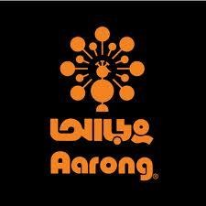

14 May, 2018

Letter of Transmittal

Farhana Rashid Assistant Professor
School of Business & Economics United International University.

Subject: Submission of Internship Report.

Dear Madam,

I have arranged an Internship Report on "Analyzing of Recruitment, Selection Process and Employee's performance Evaluation of Aarong" which I am submitting alongside this letter. It was a great experience to gain knowledge working under your guideline and setting up this report additionally improved my understanding about how to get ready and compose a report.

I am certain that this report will help you to comprehend the reason about my determination of the point and to get an understanding about the process of Recruitment, selection and employee's performance assessment of Aarong. I have attempted my best to take after your rules in setting up this report. I have displayed what I do accept to be most critical data to make my report as particular and rational as could reasonably be expected.

I trust that this report will satisfy your prerequisites. Much obliged to you for your kind thought and direction. I trust my exertion would fulfill you.

Sincerely yours,

Progya Labone Saha ID: 111-141-160

Acknowledgement

I have many thanks to make, when preparing the report, my respected supervisor Tahmina Hossain (Executive of HR of Aarong) provided proper guidance and invaluable comments on each of the sections of the report. She has greatly improved the readability of the text. I am pleased to thank all employees of HR department for their unconditional help.

My sincere thanks go to my supervisor Tahmina Hossain for letting me choose this topic and providing with his guidance and support which bring out an outcome of this report. I value her co- operation and sacrifice of valuable time.

I want to thank my family member for supporting me and empowering me in each conceivable path from the earliest starting point till the finish of my work. Last however not the minimum, I thank the GOD for keeping me healthy and fit and enable me to finish my report one time.

All through my internship I have learnt numerous things about the Aarong culture whose advantages are a long way past and I have created myself scholastically, professionally and socially.

Executive Summary

Aarong (A BRAC social enterprise) has established in 1978 with the visionary goal to change the lives of deprived artisans and underprivileged rural women by enlivening and encouraging their arts and crafts. Aarong represents the global village even in the naming. The Bengali word “Aarong” means, “a village fair or market.” It was established to help the marginalized people of Bangladesh. According to this organization lack of working capital, marketing support and opportunity for skills development are the three main obstacles for gainful employment in the rural areas. As it is a social enterprise, it provides some services to those low income and marginalized people in the rural areas or overcoming the three obstacles. Besides Aarong is protecting and promoting Bangladeshi product and they design products which contain the essence of Bangladeshi culture and beauty into every piece and pioneer in promoting the fashion industry of Bangladesh. At the beginning their target buyers were a few merchants of Dhaka.

Soon enough, Aarong started to grow and spread throughout the whole country, from one single shop to the biggest Bangladesh's biggest retail chains. Now Aarong has more than 100 product lines. Aarong provides the local and international public opportunity of owning a Bangladeshi handcrafted product.

As Aarong is the leading fashion house of Bangladesh, for conducting their business operations they need qualified staffs that would help them to run the business. This organization has a Human Resource Department (HR department) which ensures inflow of qualified human resources in the organization. Besides, this department performs some other activities. The core activities of HR department of Aarong are recruitment and selection of staffs, transfer of staffs, maintaining record of attendance of staffs, leave management, performance appraisal related activities, orientation prior to joining, placement of new staffs, job separation, and grievance management, approve loan, arranging travel authorization, providing allowances, arranging temporary staff salary, preparing visiting card and maintaining procedures of Aarong health care service.
.

I did my internship in the HR department of Aarong. The HR department is consisting of two departments. They are “Recruitment and Selection”, and “Training”. I used to work with recruitment and selection department. I was assigned for some responsibilities related to recruitment and selection of staffs. My duties & responsibilities as an internee was screening CVs, short listing, inviting candidates to attend interview session, checking out documents of selected candidates, checking out performance appraisal forms, checking out the leave matter of the staffs, preparing ID card and giving it to the employee, preparing appointment letters for newly joined staffs, preparing personal employee files, preparing confirmation letters, preparing transfer letters and preparing experience letters, preparing doctor slip, preparing power point slide for selected candidates, doing update the employee information and their job descriptions etc. In this report, the recruitment, selection and employee’s performance evaluation activities of HR department of Aarong are concentrated on. When staffs leave the organization, new positions are introduced or due to increase in responsibility, some departments need more people. The overall recruitment and selection activities of Aarong HR department go through a certain procedure. Those are detail described in this report.

Table of Contents:

Page

1. Letter of Transmittal ..........................................................................................................[1]

2. Acknowledgement .............................................................................................................[2]

3. Executive Summary ...........................................................................................................[3]

- Chapter-1
  - 1.1 Introduction 1
  - 1.2 Objective 1
  - 1.3 Methodology 2
  - 1.4 Scope 2
  - 1.5 Limitation 3
  - 1.6 Company Profile 3
    - 1.6.1 History of Aarong 5
    - 1.6.2 Aarong’s Timeline 6
    - 1.6.3 Organogram of the Aarong 7
    - 1.6.4 Overview About the Brand 8
    - 1.6.5 Aarong Logo 8
    - 1.6.6 Outlets 9
    - 1.6.7 Aarong Today 10
    - 1.6.8 Aarong Products 10
    - 1.6.9 Mission, Vision & Key Values 14
    - 1.6.10 Operational Network Organogram 15
- Chapter-2
  - 2.1 Existing Human Resource Management Activities of Aarong 17
    - 2.1.1 Recruitment & Selection Process in Aarong 18
    - 2.1.2 Confirmation Process 22
    - 2.1.3 The Transfer Process in Aarong 23
    - 2.1.4 The Leave Process in Aarong for Sale Associate 23
    - 2.1.5 The Performance Management System in Aarong 24
    - 2.1.6 The Loan Process in Aarong for Sale Associate 28
    - 2.1.7 The Travel Authorization in Aarong for Sale Associate 28
    - 2.1.8 The Internship Program in Aarong 29
  - 2.2 Analyzing Aarong Using Tools & Techniquies 32
    - 2.2.1 SWOT Analysis of Aarong 32
    - 2.2.2 Employee Performance & Compliance 34
    - 2.2.3 Competence Acquisition Analysis 35

- Chapter-3
  - 3.1 Findings & Recommendation 37
    - 3.1.1 Positive Findings 37
    - 3.1.2 Negative Findings 37
  - 3.2 Recommendation 38
  - 3.3 Conclusion 39
- References 40
- Appendix 41
- Performance Appraisal

Chapter-01

Introduction

According to my major subject, I have been selected in Aarong Human Resource Department under recruitment team as an intern. The courses related to Human Resource Management I had so far completed; helped me to break the wall between the academic knowledge and practical experience.
The report focuses on the core of the effectiveness of hiring process staff for management and employee’s performance evaluation in Aarong. Moreover, the critical analysis of the whole recruitment process and its effectiveness will be discussed in detail as well.

Objective

The objective of this report is to provide a clear vision of the overall recruitment process and performance evaluation of management staff in Aarong its effectiveness. However, I will divide the objective part into two divisions.
    - Broad objective is the general goals to be achieved on the basis of practical experience. To gather practical knowledge and experience about the recruitment and selection process and performance evaluation to get a general idea about different divisions of Aarong and learn the corporate environment and norms for near future fulfilling the academic regulations.

    - Specific objective will be the goals of this report. Discussing the general recruitment and selection process of Aarong. Making a picture of the effectiveness ratio of the recruitment process of Aarong to discuss the learning experience from Aarong.

Methodology

This report contains number of information related to recruitment process and overall HR department of Aarong. I have to go for both primary and secondary method to collect data and information.
    - Primary Data: To collect data related to recruitment effectiveness, I have to conduct “semi-structured interview” with HR Executive, Manager of Human Resource Department. Basically, the analysis part was based on the information I have collected through the interview which I have conducted. However, some information is provided on the experience I gathered in my internship period.

    - Secondary Data: This report contains the history, mission, vision; product related information, working procedure of Aarong, has been collected through the website and journals. Some information has taken from the other similar report which will be clarified in the literature review part.

Scope

The scope of this report includes the brief discussion on the particular recruitment and selection process of management staffs of Aarong. Along with the process, this report contains the effectiveness of the hiring and the analysis upon the findings.
However, the sales associate of Aarong is another biggest recruitment part of Aarong recruitment team which is not included in this report. Moreover, the other aspects of Aarong Human Resource Department were also not discussed briefly than providing a slight idea.

Limitation:

I have to go through some obstacles to finish this report properly. These difficulties have been considered as limitations. Such as-
- Lack of updated information: information taken as secondary source was not updated according to the changes.
- Confidential Information: Financial information, process related information, proper turn over related information is considered as confidential information as per BRAC and Aarong rule. So it was difficult to analyze these issues without having appropriate information.
- Limited knowledge area: in a period of 3 months, it was very difficult to understand the different aspects of Aarong HR rather understanding the procedure of particular department.
- Time Constraints: Understand a corporate culture within 3 months is very difficult. Hence, making an efficient report based on a short period experience is a big challenge indeed.

Company Profile

Being one of the Bangladesh’s largest fashion chains under the shelter of Bangladesh’s largest NGO BRAC, Aarong fights to uphold the marginalized people of Bangladesh. The initiative of the project sericulture was to provide empowerment to the rural poor women. BRAC came up with the dream of Aarong to support the artisans, who had skills but did not have the opportunity to use the skill. At the very beginning, the project started with just a few
women who used to produce silk and Nakshikatha, gradually Aarong started investing more to the artisans to produce handicraft products.

They have opened the first outlet in 1978 in Dhaka. Weaving together new open options for individuals with the skilled work of their artisans, Aarong has carved out an exceptional market segment and crafted hope for the crafters. Aarong started its journey in 1978, inspired by the principle, “To provide a stable and gainful source of employment for the underprivileged rural artisans, lift up the traditional identity and the commitment of quality service.” with the objective of supporting poverty stricken rural ladies so they could engage themselves by utilizing and further enhancing their skills. On the other hand, upholding the traditional of Bangladesh is another goal of Aarong.

Aarong is supporting more than 2000 villages by utilizing their artistic skills and helping in earning a living. Nearly 65000 rural artisans and handicraft producers works for Aarong. Most of them are women percentage 85%. At present Aarong have 13 production centers, those are called AAF (Ayesha Abed Foundation) and 653 sub centers across the country.

Aarong has more than 100 product lines. From clay pots to precious stone adornments, and silk and cotton textures to metal and calfskin stock, Aarong's immense scope of inventive items, sponsored by a powerful inventory network and dissemination arrange, makes Aarong really a family unit mark in Bangladesh. Including men’s products, women’s products, children’s products, home textile, home accessories, jewelry products, leather products, Herbal products and so on.

Recently Aarong opened their one more outlets in Mymensing. In total, now Aarong has 19 domestic outlets. In Dhaka Aarong has 11 outlets, except these outlets and others are in Bagura, Narayangonj, Chattagram, Sylhet, Kumilla and Khulna. Aarong has 1 franchise outlet in London. Aarong has export market since 1984. Aarong exports their products to Italy, U.K., Spain, Canada, Japan, Australia etc. 85% of the buyers of export market are leading fair trade buyers and 15% of the buyers are commercial buyers including London outlet.

History of Aarong:

“Hope is an element in which people take action, and energize them out of poverty”

– Sir Fazle Hasan Abed.

Aarong was introduced to eliminate poverty engaging the village woman throughout making handicrafts. In1976, BRAC world number one organization has taken this initiative to engage the women into empowerment. However, BRAC on that time observed that women are more engaging themselves in agricultural sector. Creating more opportunities as earning source and developing bunch of skilled workforce in 1978, BRAC established its sericulture project under the supervision of Ayesha Abed.

Initially, women working under AAF, started to produce high quality silk and silk products in Manikganj and hand stitched nakshi- katha in Jamalpur. On that period of time, the number of buyers of silk and nakshi katha were poor and on contrary there were not stable market place to sell those products. Keeping the situation ahead,
Aarong was launched in 1978, to create a linkage between in rural and urban people with products made by village women.
Aarong, which signifies village fair' in Bengali, has been working towards BRAC’s mission of poverty alleviation through economic development and human capacity building, with a specific focus on the empowerment of women. The retail procedure takes after a few stages: initial, a plan group conceptualizes the season's thought processes which are then sent to the rustic artisan for creation. Aarong consistently builds up the artisan' aptitudes through preparing projects, and leads quality control of the finished things previously they are purchased at a reasonable cost and after that sold crosswise over retail outlets in urban markets. By advancing the conventional retail process, Aarong endeavors to give an interestingly Bangladeshi way of life encounter while empowering social change. An as of made enthusiasm for Bangladeshi excellent things plots that Aarong has achieved this vision, and continues testing the retail business with its practical plan Aarong had its excursion with a topic of an edified, sound and equitable Bangladesh free from hunger, neediness, ecological and all types of abuse in light of age, sex, religion and Ethnicity. With the gigantic reaction and incredible course, it has achieved the pinnacle of progress. Presently Aarong has its 19 outlets in Dhaka, Narayangonj, Chattagram, Sylhet, Khulna, Bagura, Kumilla and Mymensing.Aarong’s Timeline:

1978 – Opened its first retail outlet in Dhaka, Bangladesh.

1982 – Established the Ayesha Abed Foundation, a network of production centers. 1983 – Opened a retail outlet in Chittagong, Bangladesh.
1985 – Opened a retail outlet in Sylhet, Bangladesh. 1987 – Entered the export market.
1995 – Opened a retail outlet in Khulna, Bangladesh. 1999 – Participated in its first international fashion show.
2001 – Launched a retail franchise in London, United Kingdom.

2003 – Launched its sub-brand ‘Taaga’, women’s western fusion wear.

2007 – Received Fair Trade certification from World Fair Trade Organization. 2008 – Celebrated its 30thanniversary with an exhibition series and fashion gala. 2009 – Received ‘Best Brand’ award from Super brands.
2011 – Opened its flagship outlet in Uttara, Dhaka, Bangladesh.

2012 – Opened a retail outlet in Comilla, Bangladesh, received UNESCO Award of Excellence. 2013 – Launch the Artisan Development Initiative, a BRAC holistic development program.
2014 – Opened a retail outlet in Jamuna Future Park, Dhaka, Bangladesh, launched e-commerce website, launched furniture line ‘Rattan’ and product line ‘Maternity Taaga
2015 – Opened retails outlets in Dhanmondi and Banani, Dhaka, Bangladesh 2016 – Awarded with the Marketing 3.0 Award Winner -2016.
2018 – Opened a retail outlet in Mymensing, Bangladesh.

Organogram of the Aarong:

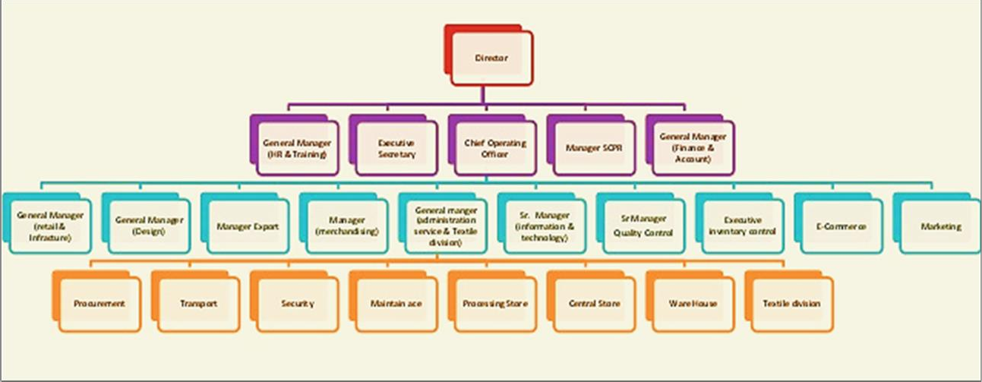
Aarong is the one of the biggest fashion house with 19 outlets around the country. Behind this fashion house Aarong has a corporate office and branches of Ayesha Abed foundation in several district. Here is the organogram of Aarong to have a look on the positon of the employee who are involved in different activities.

Figure-1: Organogram of Aarong

Analysis of Recruitment, Selection Process & Employee’s Performance Evaluation in Aarong Page | 7

Overview About the Brand:

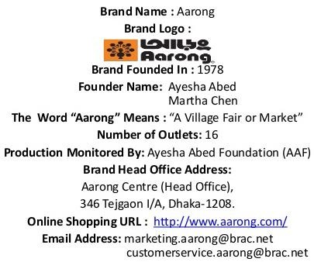

Aarong Logo:

The logo of Aarong demonstrates an orange peacock prospering its wings unmistakable in dark foundation. The peacock symbolizes the bright, shinning, differentiated product offering, item assortment of Aarong. Then again, the dark foundation mixes the conviction of custom and pattern together.

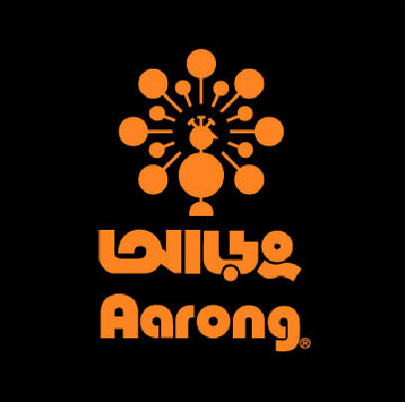

Outlets:

Aarong sells over 100 fashion and lifestyle product in their total 19 retail stores across Bangladesh.

Location | Date of inception | Closing date
- Shukrabad, Dhaka | 1978 | Closed sometime around 1980s
- Sholoshahar, Chittagong | 1983
- Moghbazar, Dhaka | 1984
- Zindabazar, Sylhet | 1985
- Lalmatia, Dhaka | 1989
- Khulna Town, Khulna | 1995
- Gulshan, Dhaka | 1997
- Wari, Dhaka | 1998 | 2016, changed location
- Uttara, Dhaka | 2001 | 2011, reopened as flagship
- Halishahar, Chittagong | 2008
- Mirpur, Dhaka | 2010
- Comilla Town, Comilla | 2012
- Chashara, Narayanganj | 2013
- Jamuna Future Park, Dhaka | 2014
- Dhanmondi-2, Dhaka | 2015
- Banani, Dhaka | 2015
- Bashabo, Dhaka | 2016
- Bashundara City | 2017
- Bogra | 2017
- Mymensing | 2018

Table-1: List of All Outlets Across Bangladesh

Aarong Today:

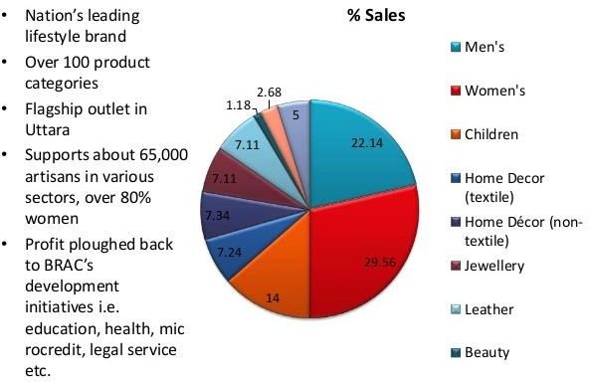

Aarong Product’s:

      - Women’s Product’s:

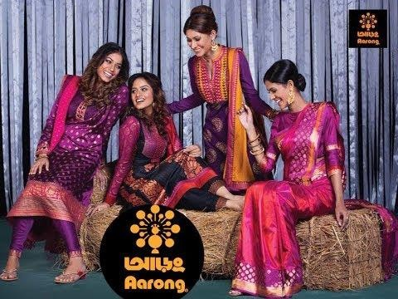
        - Traditional
        - Nightwear
        - Shawls/Scarves
        - Shoes
        - Bags
        - Fabrics
        - Accessories

Men’s Product’s:


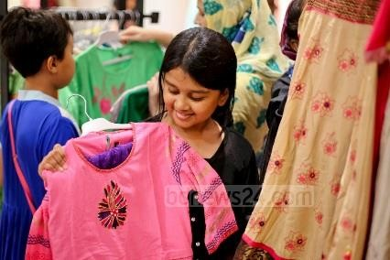
      - Children’s Product’s:

- Traditional
- Executive Shirts
- Fotua
- Short Kurta
- T-shirts
- Stoles/Shawls
- Sandals

- Clothes
- Toys
- Books
- Shoes

Textile’s Product’s:


      - Jeweler Product’s:



      - Leather’s Product’s:

  - Bed
  - Table
  - Living
  - Kitchen
  - Kids
  - Rugs
  - Fabrics

- Gold
- Silver
- Pearl
- Other

- Shoes
- Bags/Wallets
- Belts
- Boxes
- Photo Frames
- Office

Bamboo/Leaf Product’s:
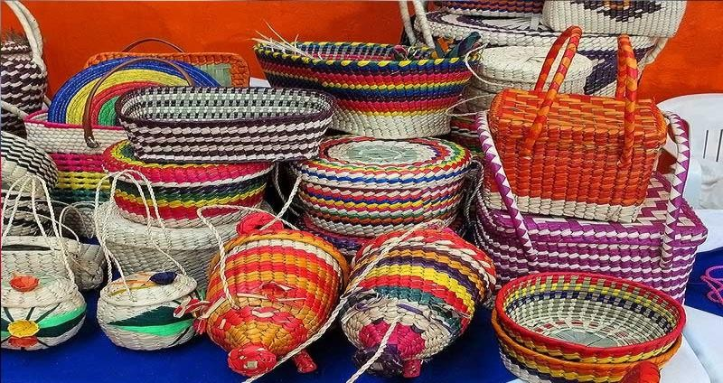

      - Dining Product’s:



      - Terracotta Product’s:

- Boxes
- Photo Frames
- Dry Decorative
- CD Racks
- Floor Mats

- Mats
- Napkin Holder
- Trays
- Place Mats
- Coasters

- Bowls and Platters
- Dining ware
- Glasses/Mugs
- Hot Plates
- Pitchers

Mission, Vision, And Key Values:

Aarong concern of BRAC is following the mission and vision of its mother company. The mission and vision of BRAC in simple word makes a poverty free earth with empowering and engaging people in skill labor.
- Mission- “Our mission is to empower people and communities in situations of poverty, illiteracy, disease and social injustice. Our interventions aim to achieve large scale, positive changes through economic and social programs that enable men and women to realize their potential.”

- Vision- “A world free from all forms of exploitation and discrimination where everyone has the opportunity to realize their potential”
- Especially, its vision is to build up them as world's one of the renowned reasonable exchange Fashion house, and to remain showcase pioneer all through its business. "Aarong" extended its business in worldwide field. "Aarong" has a fantasy to grow more artisan of Bangladesh and make them self-subordinate and draw in an ever increasing number of universal clients towards Bangladeshi culture.
- Key Values-The key value followed by Aarong is same as BRAC. This key value is benefitting both the company and the people related to Aarong around the country. The key value is divided in 4 parts-

- Innovation- Aarong believes in innovation and value the new trend with touch of tradition. Aarong value the innovation that created opportunity to eliminate the poverty. With the help of “innovation” Aarong strive to display ground breaking leadership.

- Integrity- Aarong value integrity as Aarong believes accountability and transparency is the core elements of their work ethics. In term of financial dealing Aarong provides the clearest policies.

- Inclusiveness- Aarong value incluseivess to ensure they recognize and engage all members in term of society, age, sex, gender, ethnicity etc.

- Effectiveness- Aarong value effectiveness in thirst of taking challenges to perform in better manner.


Innovation
Integrity
Values Inclusiveness
Effectiveness

Figure-2: Aarong’s Key Values

Operational Network Organogram:

Aarong operation network starts from the production of the different products, whi ch are sold in the retail outlets. The products are produced under foundation for production and assembling named Ayesha Abed Foundation. Ayesha Abed Foundation are situated in Baniachong, Gorpara, Jamalpur, Jessore, Kushtia, Manikganj, Rajbari, Sherpur, Pabna, Pallobi, Kurigram, Nilphamari, Jhenaidah having 653 sub centers across Bangladesh.

In excess of forty thousand of the aggregate ladies of Aarong makers work specifically for Aarong in these 13 creation focuses in and Twenty-five thousand autonomous agreeable gatherings and conventional family-based craftsman likewise showcase their artworks through Aarong. Potters, Metal Laborers, Diamond setters, Jute laborers, Container Weavers, Handloom Weavers, Silk Weavers, Wood Carvers, Calfskin specialists and different craftsman with particular aptitudes from everywhere throughout the nation come to Aarong for promoting and support After the gathering of the items and landing in the outlets shoppers can purchase the items from the retailed outlets. This is the manner by which the gathering and offering of the item goes on. The chiefs of the outlets principally convey the activities in the outlets. They predominantly are dependable to deal with the outlet inventories, item offers, client administrations, installment accumulations and staff administration. They regulate the outlet's execution and are straightforwardly capable to report the Main Helpful Officer of Retail and Framework for any sort of task happens.
The Organ gram of the operation network of outlets is given below:

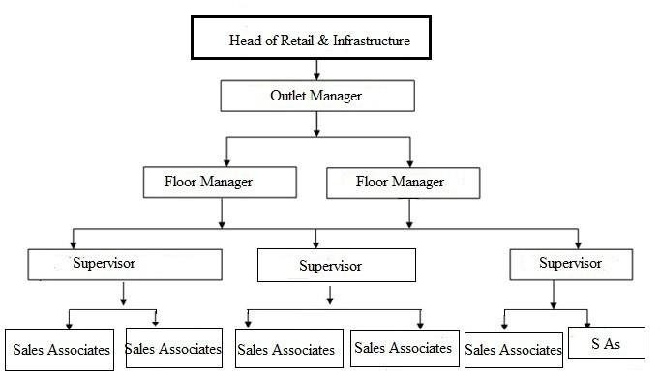

Figure-3: Organogram of the Operation Network of Outlets

Chapter-02

  - Existing Human Resource Management Activities of Aarong

Aarong and Ayesha Abed Foundation (AAF) has been employing a huge number of employee from all over the country and in some cases overseas employees. Here is the organogram of Aarong and AAF to look on the position of the employees who are involved in different Human Resource activities.
General Manager
HR & Training Department Aarong & Ayesha Abed Foundation
HR
Training
Executive
Aarong & AAF
Training Officer-1
Training Officer-2
Senior HR
Officer-1
Senior HR
Officer-2
HR
Officer-1
HR
Officer-2
HR
Assistant
Office
Assistant
Figure-4: Organogram of HR & Training
Department of Aarong & AAF

In Aarong, they are doing many HR activates for their organization. As like they are conducting all these activities for their outlets, for their sales associate
    - Recruitment and Selection
    - Confirmation for Sales associate
    - Leave Process
    - Transfer Process
    - Loan Process
    - Travel Authorization
    - Performance Appraisal
    - Internship Management

So in below I will discuss about these HR activities which are followed by Aarong.

Recruitment and Selection Process in Aarong

During my internship period my project task was to deal with the whole recruitment and selection process of the sales associates of “Aarong”. It follows a procedure where I played the active role in each and every step of this process. It helped me a lot with the practical knowledge of the recruitment and selection process. Though “Aarong” follows different process of recruitment and selection process, the steps of the recruitment and selection process of sales associates is given below and my job responsibilities were,

CV Sorting:
My internship period was the pick season for Aarong HR team, and they hire around 2000 temporary sales associates, for this, we had to sort around 50,000 CV’s according to the requirement of the organization and according to particular traits of the candidates. While sorting CV, the most important things I had to keep in my mind were,
      - The age of the candidate has to be above 18 according to the labor law
      - The candidates have to pass HSC examination and a student of undergrad level

Separating CVs According to Area:
After sorting CVs, I had to separate the CVs according to the location of the residence of the candidates. Aarong always try to give priority to the candidate’s ease of work. That’s why we divided the CVs keeping the location in mind, so that it becomes easy for the candidates to maintain the work schedule.

Calling for Interview:
After sorting and separating the CVs, I used to give a target to call a particular number of candidates for interview according to the requirement of the outlet. As all the outlets are not of same size, so the required number of staffs were different. I had to call to the candidates dialing the contact numbers given in the CV, had to tell them about the interview detail, for example, the specific location, time, floor and as per their query.

Listing the Candidates Details:
After completing the calls to the targeted number of candidates, I had to list their detail in Microsoft Excel work sheet. The information includes,
- Serial Number
- Candidate Name
- Father’s Name
- Education 5.Contact Number
- Address
- Time of Interview
- Selected
- Not Selected
- Waiting
- Remarks

Making Training List:
After the Interview session is Done, I had to collect the selected candidate’s CVs and make a list of them as they are going to attend a training for the post of sale associate. After each interview session, the numbers of training participants were around 50. After preparing the training list, I had to give the list to the training department.

Informing the Candidates After Final Selection:
After the training of the candidates, they need to sit for an exam. The training department prepares the result of the exam and gives the HR department the final result of the training. After getting the final result, I had to call the candidates to let them know if they are passed of failed and gave them a date to come with their educational certificates along with 2 references and photos to collect their joining card.

Giving Joining Card:
When the candidates come with their documents, I had to check their documents with the photocopy, had to check the references if those are valid or not. If everything is ok with the Requirement, I used to issue them a joining card. The card contains some information as, the name of the SA, Father’s name, Outlet name, Shift. Badge number and Joining date.

Listing the Final Sales Associates Detail:
After giving the joining card, I had to list the detail of the Sales associates in an Excel work sheet. The information includes, name of the SA, Father’s Name, Outlet name, Education, Shift, Joining Date and Gender. This list is made to keep record in the head office and to send the list to the outlets to match.

Maintaining the Documents:
After the joining of the sale associates I was asked to pack all the documents of the sales associates in some boxes maintaining the badge numbers. Because after ‘Eid, a huge number of temporary Sales associates are going to be hired as permanent.

Preparing Appointment Letters:
After joining in the workplace an appointment letter is provided from the organization. It is actually deed of working conditions. When the selected sales associates and café staffs join their work place that means outlets of Aarong, after some days they are provided with appointment letters as per the organization’s policy. My responsibility was preparing appointment letters for sales associates and some other posts like café staffs, helper etc. I prepared appointment letters for sales associates of different outlets.

Updating the HRMS Database:
After getting the appointment letters from the outlets having signed by the selected sales associates I had to update the HRMS database software which contains the information of each and every employee working in “Aarong”. In this software I had to fulfill the information both from the selected sales associates’ CV and also from the information provided in the appointment letter. In this software the selected sales associates are considered as the project staffs and after 6 months based on their performance they become either regular staff or terminated. This updated database software is used in future for any kind of HR activities which explains the status about the sales associates.

Hand Over the File to the HR Employee File Store:
At this stage I had to hand over the created file to the HR employee file store where the individual files of each and every sales associates are kept according to the outlet folder and maintaining the serial of assigned pin numbers.

At this stage after fulfilling all these twelve steps my project task came to an end. Every time when the recruitment for the sales associates took place, I had to follow these twelve steps and had to play my role effectively and efficiently.

Confirmation Process

There are two things which is maintain by sales associate during their work period and also observed by organization to their employees.
      - Probation period
      - Conformation Period

Probation period for 6 months for sales associate in Aarong outlets. After finishing 6 month working period senior level assess their employee’s performance. If their performance was good then they will give conformation letter to their employee, if their performance was not good then employee can’t continue their work in Aarong outlets.
There also some process which is maintain by organization for their sales associate in Aarong outlets.

Step 01:

After joining an employee his/her supervisor or outlet manager assessment them during their 6 month working time. But after finishing 4 month working period outlet manager assess their performance and make all information include and sign their form for S/A and send it to HR department in Aarong.

Step 02:

After singing form when those form came into HR department HR officers check it properly then if there is no problem then it will go to AGM, then GM in retail outlet for signing for approval. After getting approval then it has to sign by DGM in HR department.

Step 03:

When all senior level approved it then HR department give conformation letter to sales associate.

Step 04:

After getting conformation letter the employee’s Grade and salary structure will change.

The Transfer Process in Aarong

Transfer means moving or shifting staffs from one place to another place for job purpose. All the transfer related activities are performed by HR department in Aarong. In Aarong two types of transfer are seen. One is voluntary transfer and another is professional transfer. Sometimes staffs move from one department to another department for personal or physiological problem. It is voluntary transfer. Besides, staffs move from one location to another location and it is decided by the management from where to from and where to place. It is called professional transfer. After getting the staff’s request or department head’s request for transfer, HR department is responsible for doing all the activities of transfer such as transfer approval from department head and director, prepare transfer order, issue transfer order and file, and so on.

The Leave Process in Aarong for Sales Associate

In Aarong there are different types of leave facility for staffs. Those leave includes regular/earned leave, sick/accidental leave, maternity leave, paternity leave, higher study leave, extra ordinary leave, transfer leave and compulsory leave. Each sort of leave requires different rules. For example, in case of regular/earned leave, it is 20 days for administrative staffs, 24 days for outlet and field staffs, 42 days for service staffs in a year. In case of paternity leave, it is 7 days with pay leave for confirmed staffs and 7 days without pay leave for non-confirmed staffs. The paternity leave must be taken within one month and it is applicable only for two children. This way each types of leave has different rules and it varies depending on staff’s type. HR department maintains all the rules as they are authorized to perform all the leave related activities to avoid misuse of these leaves. The leave related activities in Aarong are providing leave form, taking approval from the staff’s head of the department, input data in the HRMS (Human Resource Management system) and other activities.

The Performance Management System in Aarong

Performance Management is critical for employee's professional improvement and to meet the company's or association's objectives or destinations and at last to add to the company's or company's prosperity. No business, regardless of whether a little firm, a major firm, a non-benefit association, an administration establishment or a private or open organization, ought to be absolved from having a formal Performance Management System. The framework ought to be founded on importance or representatives work, capability of worker, level of their employee.

In Aarong, Performance Management System begins with characterizing the activity and the obligation of each activity. This progression is the arranging stage, where the activity obligations are resolved and relying upon which the execution assessment is finished. In Aarong the execution of a worker is estimated by performance evaluation. For enhancing the execution of staff's performance appraisal is given. In Aarong performance execution is given to all regular staffs having a PIN (Personal Identity Number). The staff, provided one year of continuous service and their provided service is satisfactory, are entitled to get performance appraisal. It is a continuous process but performance of all staff is formally appraised once in a year. Basically in Aarong, performance is assessed for confirmation, yearly assessment, promotion, performance allowance, training needs assessment, termination etc. Performance is measured on the basis of activities performed by the employees and behavior of the employees.

Execution evaluation arrangement of Aarong is a redone technique consolidating Management by Objective (MBO) and Behaviorally Tied Down Rating Scale (BARS). The variables mulled over incorporate both the activity related abilities and individual qualities of the workers. For instance, an attribute like Job Knowledge might be judged on the scope of Excellent (5), Very great (4), Good (3), Improvement required (2) and Unsatisfactory (1).

Aarong beforehand utilized 3 sorts of PA frame to assess their worker's execution one is for their CS representative (head office), one for their outlet's business partners and one for their AAF's (generation focus) representative (this PA is like CS's PA shape, just logo is extraordinary) and one is for their business relate.

Aarong has kept up 3 levels of representative in their association, Top, Middle and Low Level of worker. Be that as it may, just a single normal PA frame was utilized for assessing every one of them (for head office and for AAF), which misleader the assessment of the workers as similar criteria for assessing their execution isn't fitting for every one of them. Thus, 3 diverse PA frame is produced for three level of representative (for CS and AAF and change the business partner's PA shape. The staff position of Aarong is demonstrated as follows:

AARONG’s Staff Position
 | Designation | Grade | Performance Appraisal Form
 | Managing Director |  | Grade A PA form A
1 | Director | 1 | Grade A PA form A
2 | Head of the Department | 2 | Grade A PA form A
3 | Deputy head of the Department | 3 | Grade A PA form A
4 | General Manager | 4 | Grade A PA form A
5 | Deputy General Manager | 5 | Grade A PA form A
6 | Senior Manager | 6 | Grade A PA form A
7 | Manager | 7 | Grade A PA form A
8 | Assistant Manager | 8 | Grade B PA form B
9 | Senior Executive | 9 | Grade B PA form B
10 | Executive | 10 | Grade B PA form B
11 | Officer | 11 | Grade B PA form B
12 | Officer | 12 | Grade B PA form B
13 | Assistant Officer | 13 | Grade B PA form B
14 | Assistant | 14 | Grade C PA form C
15 | Assistant | 15 | Grade C PA form C
16 | Assistant | 16 | Grade C PA form C
17 | Office Assistant | 17 | Grade C PA form C
18 | Office Assistant | 18 | Grade C PA form C
19 | Office Assistant | 19 | Grade C PA form C

Table-2: Aarong’s Staff Positions According Performance Management

On the basis of that employees are divided in 3 levels. Employees who belong to grade 1-7 is consider as upper level and for upper level Performance Appraisal Form A is followed, for middle level (grade 8-16) PA form B is followed, for bottom level of employees (grade 17-19) form C is followed.
Another PA form is introduced to evaluate the performance of the Sales associates working in different outlets of Aarong.

Assessment as per PA Form:
The normal assessment period is October to November each year. Every employee in that level will be appraised by their respective supervisor with the two broad criteria:

Relating to duties & responsibilities
- Relating to personal attributes & values
According to the Job Description, some major traits are rated to evaluate employee’s job related competencies. The traits are-
  - Job Knowledge
  - Quality of Job
  - Time Management
  - Integrity
  - Creativity and Initiative
  - Positive attitude and team spirit
  - Leadership and decision making ability
  - Analytical ability
  - Communication skills
  - Discipline
  - Gender Sensitivity

After providing the marks against 10 sections, the total accumulated marks (50) are put into the assessment form to make the next decision.

10 – 16 | 17 - 26 | 27 - 36 | 37 - 43 | 44 - 47 | 48 - 50
Unsatisfactory | Improvement Needed | Good | Very Good | Excellent | Outstanding

Table-3: Employee’s Performance Evaluation

There is an option in the assessment form to indicate whether the assessed Employee needs any training or not. If the supervisor thinks the staff needs training, then he/she should mention the name of the training.

Performance Appraisal System in the policy:
      - Performance Appraisal System in Aarong is a continuous process. But all performances will be formally appraised once a year.
      - The annual performance appraisal period of the confirm staff up is from October – November.
      - The Program Head will send the Performance Appraisal Form, filling them up, of the confirm employees to the HRD.
      - Before starting the appraisal process the supervisors will follow the employee Performance Appraisal directory properly.
      - On the Performance Appraisal Form the supervisor, discussing with the staff, will mention specifically the necessity of training for the staffs.
      - The first supervisor will ensure submitting the staff Appraisal Form on due time.
      - HRD will complete the task of consideration of the staff Performance Appraisal Form sent in October according to the basis of evaluation in November.
      - The appraisal form filled up by the authority would be preserved on the personal file of the employee.
      - Assembling the Training Need Assessments HRD will send them to the concerned Department to take necessary measures and peruse its implementation.

After the Assessment, the employee performance is rewarded or recognized by –
      - Confirmation
      - Increasing of probationary period
      - Increment
      - Promotion
      - Change in Designation
      - Termination etc.

The Loan Process in Aarong for Sales Associate

For financial safety of staffs, Aarong has loan facility. In this organization varieties of loan are given to the staffs such as staff loan, special loan, welfare fund loan, provident fund loan, higher education loan, car loan (only for BRAC staffs), home loan, motor cycle/bicycle loan and mobile loan. HR department handles all the procedures. According to the requirement of staffs, HR department provides loan forms and fill it up by the staffs, then check those forms with personal files, verify reasons for taking loan, submit necessary documents, check with accounts, take approval from the director etc. There is slide difference in the procedure based on type of loan. HR department performs all the steps of the procedure according to the organization’s policy and ensures the facility of providing loan to staffs.

The Travel Authorization in Aarong for Sales Associate

Travel authorization can be two types. One is travel authorization international and another is travel authorization within country. HR department provides travel authorization form to fill it up to the staff, and then they take permission from the director or head of the department (in case of travel authorization within country). After that the HR department calculate how much can be spent, how much pocket money is reasonable, how the staff has to stay there etc. Then the sends this calculation to the accounts and accounts provides the allowance to the staff. For documentation HR department preserve all the papers into a file. So it is the responsibility of HR department to ensure travel allowance.

The Internship Program in Aarong

An internship is an opportunity offered by an employer to potential employees, called interns, to work at a firm/company for a fixed, limited period of time.
      - Intern requisition from concern department
      - Collect CV form university and job fair

An intern should not be a replacement for a paid employee; however, they should have real goals and leave the opportunity with additional skills for their career.”

Criteria Most Often Used for Selecting Interns:
      - GPA
      - Major Subjects
      - Quality of Academic Programs
      - Age: 22 to 25

Types of Internship:
      - Own Interested
      - From University
      - From Outlet

Intern Recruitment Process:

Step 1
Application Process
(Application Form)

Step 2
Pre-Selection

Step 3
Interview Process

Step 4
Selection Process

Step 5
Internship Starts
(Performance Evaluation)

Joining of Intern:
      - Educational certificates
      - Forwarding letter from university
      - Picture
      - National ID Card

Record od Attendance and Time Duration:
      - Working days will be from Sunday to Thursday from 8.30am to 5.15pm
      - Moreover, working days and Time will be determined by the Supervisor
      - The intern will record attendance by the signing in the Attendance Register
      - Not eligible for Flexible time

Payment system:
An intern will be entitled to a fixed monthly salary according to the Appointment letter

Transport Facility:
An Intern will not be entitled for transport facility.

Leave:
Intern can enjoy leave if needed.

Report Type:
      - For University
      - For Organization

Future Career:
      - Offer the intern a permanent position in the organization; or
      - Thank the intern for their hard work and dedication, and write a letter of recommendation.

Analyzing Aarong Using Tools and Techniques

SWOT Analysis of Aarong:
SWOT analysis is a powerful technique for understanding organizations Strength & Weakness and looking for the Opportunities & Threats it may face. Used in a business context it helps organization carve a sustainable niche in a market. This analysis is mainly based on an imaginary situation.

Strengths:
- Strong financial foundation

- Legal enterprise

- Good brand image/ good awareness

- Handmade and unique products

- Traditional

- Dedicated workforce

- Socially responsible

- Backward linkage

- Fair trade leader

- Good office environment

- One stop shopping

Weaknesses:

- Dependence on BRAC (decision making)

- Decentralized production

- Lack of automation

- Lack of inter-departmental coordination

- Lack of standardization \ quality

- Lack of planning & implementation & follow up

- Lack of customer and other information

- Matching of skills with responsibilities and expectations

- Standard of customer service

- lack of parking space

- Space constraint

- Products do not appeal to the younger generation

- High production lead times

- Salary structure is low for sales staff High price (validate)

Opportunities:

- Automation

- Setup ultra-modern factory

- E commerce and m commerce

- New outlets (local and international)

- Develop exports

- New product lines

- Growing craft industry

- Growing middle class having purchasing power

- Abundance of artisans

- Franchise ventures

Threats:

- New competitors (local and global)

- Economic crisis

- Commitment of the political parties

- Smuggled goods

- Traffic jam

- Security

- Westernization

- Market may become price sensitive

Employee Performance and Compliance:

It’s no longer enough to check in with your employees for a once-yearly performance management meeting – up-to-the-minute employee performance data can support concerns or identify skill gaps, guide training and induction programs, and help manage key compliance reporting and risks. Engaged, high-performing employees are those who have the support of their leaders and peers every step of the way and are guided by real-time statistics highlighting their own successes and areas to improve.

Competency Acquisition Analysis:

The business environment is currently typified by rapid and ongoing change, which causes the future to be increasingly unpredictable and unsettled. Companies are struggling to maintain their competitive edge and to survive. It is therefore important that management should ensure that the necessary competencies and abilities are available to enable the coordination of both diversifies and specialized functions within the organization, providing for current and future requirements.
There are six steps of competency acquisition analysis:
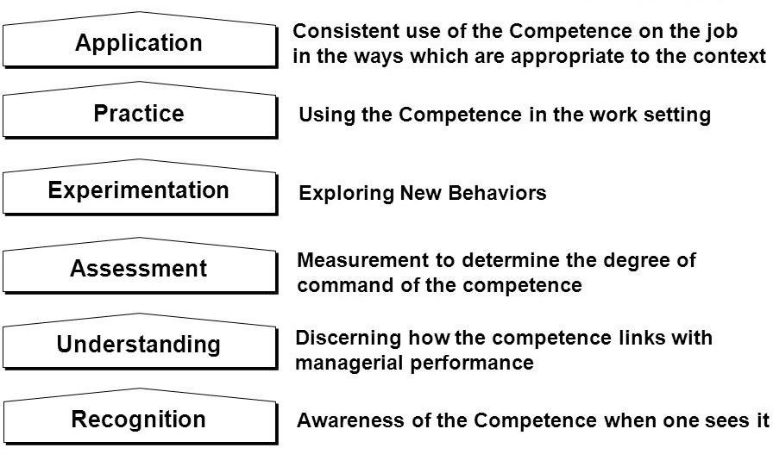

Application:

In order to application Aarong highly concern about it. They use the competency according to their appropriate jabs. They belief that the use of appropriate use of competency it will deliver quality outcomes. And they are always looking for new competency which will help them to take advantage among their competitors.

Practice:

Aarong is highly concern about competency and they always looking for new competency and when they found it they grab it and use for their organization. That is a very common practice in Aarong.

Experimentation:

Aarong gives chances to their new talented as well as their existing employees to show their new innovation. They give chances to explore the idea for the organization. And they belief that the new innovative ideas will help them to alive for very long term.

Assessment:

In order of assessment Aarong shows very positive behavior. When they implement their idea they evaluate each and every idea and assess which one is better for them and which one is working better than the others. After identifying the better one they highly encourage the idea and gives reward for that. And those whose are not so attracting for them they also encourage them to provide more innovative ideas for the future.

Understanding:

When Aarong found new competency they understanding it very well and links it with their managerial functions weather it match with it or not. If they found its not match with their managerial function, then they are not going to work with the competency.

Recognition:

In order of recognition Aarong shows very positive attitude because each and every competency is important for them. If they are not recognizing any of the competency, then that means they insult they competency. In that case they will not be able to find any kinds of new competency.

Chapter-03

Findings and Recommendations

Positive Findings:

- Great Working Environment.

- Great compensation policy for the fresher’s.

- Good team environment, values, work life balance.

- Any contradictions are handled efficiently by the top level managers.

- Many Facilities for women and they encourage women power.

- Employees of Aarong get 10% discount on any product using their pin.

- E-Commerce facilities get directly to their employee

Negative Findings:

Today fashion is not just a style statement but also the identity of who you are. So the creative people who works behind the Brands should not be treated as a telecom professional who will only think about target and punch card before 8:45am to 5:15pm. So, make a change, think out of the box. Not every employment has to be stay in cubicles bound with rules.

Modernize is the whole organization decision making and operational policy.

Recommendations

From the critical observation of the job role and responsibilities of HR department (Human Resource Department) of Aarong, some problems have been identified. For each problem some recommendations are suggested. Those recommendations are given below:
    - Aarong HR department should talk to the bdjobs website authority to solve the technical problem. They have an official site for gathering CVs (hr.outlet.aarong@brac.net). They should specify this site in their job commercial to send their CVs as a backup as they know about the technical issues of bdjobs site. Besides, they can specify their mailing in the commercial ad and gather printed copies of CVs of job applicants.

    - For staying away from data unavailability at the time of preparing appointment letters and confirmation letters they can record all the data of staffs in the HRMS (Human Resource Management System) programming. Rather than documenting they would entry all the essential data about staffs in that software. In addition, HR division of Aarong faces issue in counting salary of tempory staffs because of unavailability of data, they should record the data of temporary staffs in their HRMS programming. Also, their attendance to be recorded appropriately.

    - At the season of performance evaluation assessment form of every division they can give tenets of filling up those forms mentioning the last date of submission on those forms. In addition, before giving execution performance evaluation forms to department, HR branch of Aarong can prepare one-day preparation for staffs on the best way to evaluate the performance of staffs and how to ill up those forms.

    - There is no specific space or room for the examinations. Candidates need to sit on canteen to participate for examinations. An examination room is a much required.

    - There are no particular courses of action as a component of employee engagement. Workers in a corporation require something entertainment to face for forthcoming difficulties, however there are no facilities to energize with entertainment. Aarong can organize a little space for unwinding or gaming as a major aspect of reviving, and can attempt to decrease some workload.

Conclusion

Working with "Aarong" was a magnificent affair to have clear thought regarding HR works. "Aarong" HR office helped me to take in the absolute most and fundamental imperative stuffs which helped the temporary job in proficient life as well as in individual life. Taking part in different exercises given by the chief and by planning he enhanced my fearlessness. Numerous profitable guidelines from different representatives working under HR division which will help further to set the vocation in forthcoming days.

References

Noe, Raymond A. (2005). Employee Training and Development (3 rd ed). NewYork: McGraw Hill Companies Inc.
DeCenzo, David A.and Robbins, Stephen P. (2006). Fundamentals of Human Resource Management, Ninth. Edition. New York: John Wiley and Sons.
McBey, Kenneth J. and Belcourt, Monica. (2008). Strategic Human Resource Planning, Fourth Edition, United States, Nelson Education ltd
Interview with the HR officers of HR department of Aarong
Staffing the Contemporary Organization, Donald L. Caruth and Gall D. Handlogten, 2 nd Edition.
About Aarong, (2017), a Brac Social Enterprise Web site, Retrieved from http://www.aarong.com/about-aarong/
History, (12 May, 2018), Aarong, Wekipedia Web site, Retrived from http://en.wikipedia.org/wiki/Aarong
Photos &amp; product list, (2018), Facebook page, Retrived from http://www.facebook.com/BRAC.AARONG
HR policies and practice, (2018), Academia Web site, Retrieved from http://www.academia.edu/21328719/_HR_Policies_and_Practice_of_Aarong
Recruitment and selection procedure of aarong, (2018), Academia Web site, Retrieved from http://www.academia.edu/2031567/The_recruitment_and_selection_procedure_of_Aarn g_The_case_study_of_new_Moulvibazar_outlet

Appendix

Questionnaire

Respected madam,

As a part of my internship research report on “Recruitment, Selection Process and Employee’s performance evaluation of Aarong” I would like to gather some information from you which will help me in a depth study of the Report. I would be obliged if you co-operate with me in filling this questionnaire. Since the questionnaire is being used for academic purpose, the information gathered from you will be strictly confidential.
- What are the sources of recruitment and selection in Aarong?
  - Internal B. External C. Both

- Which method do you prefer for recruitment and selection?
  - Direct Recruitment & Selection B. Indirect Recruitment & Selection C. Third Party

- When do you prefer to go for manpower planning?
  - Yearly B. Quarterly C. Any time

- What are the sources for external sourcing among the following?
  - Data Bank B. Casual Application C. Placement Agencies D. Campus interviews

- What are the sources for internal sourcing among the following?
  - Contractual B. Interns C. Part time

- What forms of interview do you prefer?
  - Personal interview B. Board interview C. Video Conferencing D. Other

- How do you rate the HR practices of Aarong?
  - Very Good B. Good C. Average D. Bad

- Candidate’s willingness to join the Company.
  - Reputation of the Company B. Working Environment C. Salary Package E. Career Growth

- According to you what is the most reliable type of interview.
  - Behavioral B. Situational C. Structured D. Stress

- Do you conduct any of these tests?
  - Psychometric test B. Medical test C. Reference test check D. Other

- Are you satisfied with the present method being followed by the company for recruitment and selection?
  - Yes B. No

- Which category follow to measure Employee’s performance?

  - Target achieve B. Behavior C. Regularity Maintain D. Others aspects

- Who evaluate employee’s performance at first?
  - Outlet manager B. AGM C. GM D. HR Head

- Do you manage individual performance by performance appraisal?
  - Yes B. No

- Who does the performance management or performance appraisal in Aarong?

  - An individual B. A department C. Others

- How frequently do you go for performance appraisal?
  - Once a year B. Twice a year C. Thrice a year D. Other

- What are the existing performance appraisal systems is you are following? A.MBO B. 360 Degree feedback C. Graphic Rating Scale D. Other

- Do you have any reward system along with the performance appraisal?
  - Bonuses B. benefits C. Others

- Do you think this performance management system is actually helping to do individual performance evaluation?
  - Yes B. No

- Do you feel any difficulty when doing performance appraisal? If yes, then what are those?
  - Yes B. No C. Sometimes

- Is there any biasness or any chance of biasness in the appraisal process?
  - Yes B. No C. Sometimes

- “Performance management, the key of organizational success and individual performance” what do
Think about this statement?
  - Strongly agree B. Agree C. Disagree D. Strongly Disagree

 | Performance Appraisal Form
This form is for Sales Associate. This form is to be kept with the staff throughout the Appraisal period and submitted to the supervisor
¬
Annual |  |  | Special |  | Confirmation:
Review Period: From: |  |  |  | To:
Staff Information
Name of the staff: |  |  |  |  |  | PIN:
Outlet Name : |  |  |  |  |  | Present Grade:
Date of Joining: |  |  |  |  |  | Date of Last Grade Change:
Educational Qualification: |  |  |  |  |  | Joining date of present locaton:
Professional Qualification(if any): |  |  |  |  |  | Previous Location:
Fill in the following information if the staff's relative works in BRAC/Aarong:
Name: |  |  |  |  |  | PIN:
Designation: |  |  |  |  |  | Department:
Sales Associate Apprisal Form
Objectives for the period under review
Objectives |  |  |  | Key Performance Indicators |  |  |  | Rating(1-5) | Comments
To achieve department's sales target as per budget |  |  |  | Target Vs achievement
 |  |  |  | % Increase of basket value
To ensure conversion target with excellent customer satisfaction as per standard |  |  |  | % Incrase of conversion ratio
 |  |  |  | Increase invoice value with the help of cress selling and up selling
To maintain merchandising display as per visual merchandising standards |  |  |  | Follow planogram for merchandising
 |  |  |  | % of increase sale with help of VM
To mainain and follow standard POS operating process |  |  |  | % of error entry
 |  |  |  | time of billing
 |  |  |  | process management(MGD, MARC membership)
To handle customer queries, complaints and solve accordingly |  |  |  | Number of complaints/queries/request
 |  |  |  | Response and closure time
Total(25)
Develpoment plan for the period under review
Develpoment plan |  |  |  | easurable Succe |  | Responsible Person |  | Staff Comments
I agree with the above objectives and development plans
Employee Name: |  |  | Signature: | PIN: |  |  |  | Date:
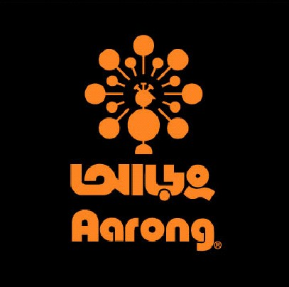

Supervisor’s Name: |  |  | Signature: | PIN: |  |  |  | Date:
Sales Associate Apprisal Form
Assessment on Values:

The Supervisor should write comments on how s/he assessed the staff on these values on evidence of observed behaviors and where the staff needs development. The Supervisor will first rating and comments each specific value scoring scale as mentioned in the apportioned box.
Values |  | Demonstrative Behavior |  |  |  |  | Ratings(1-5) | Comments
Integrity
 |  | Is honest and transparent in all actions
 |  | Treats everyone with respect and courtesy
Innovation
 |  | Displays willingness to learn and implement new methods, procedures and system
 |  | Accepts failure as an opportunity to learn
Inclusiveness
 |  | Treat everyone fairly without discrimination
 |  | Takes decisions keeping BRAC’s Broader Objectives in mind
Effectiveness
 |  | Take initiative and ownership in achieving results
 |  | Communicates relevant information regularly and effectively with stakeholders
Total(20)
Staff overall comments on values:
Employee Name: Signature: PIN: Date:
Sales Associate Apprisal Form
Employee Overall comments Based on objectives
Staff reflection/comments on overall achievements made so far including challenges and areas to be improved
Supervisor Overall comments Based on objectives
Supervisor review/feedback on overall Sales Associate’s achievements made so far and areas to be improved
i ) Overall Objective Rating

ii) Overall Values Rating
iii) Total Rating
Rating Scale
Outstanding = 5
Exceeds performance expectations = 4
Achieved expectations = 3
Does not fully meet standards = 2
Underperforming = 1
Sales Associate Apprisal Form
Final Evaluation
40-45 |  |  | 34-39 | 28-33 |  |  |  | 22-27
A+ |  |  | A | B |  |  |  | C
Recommendations:
Grade Change |  | Grade: From |  | To
Confirmation |  | Grade: From |  | To
Others |  | Details:
1st Supervisor |  |  |  | 2nd Supervisor
Name: |  |  |  | Name:
PIN: Designation: |  |  |  | PIN: Designation:
Head of Retail:
Comments: | Name: |  |  | PIN: | Signature: |  |  | Date:
Head of HR:
Comments: | Name: |  |  | PIN: | Signature: |  |  | Date:
Chief Operating Officer:
Comments: | Name: |  |  | PIN: | Signature: |  |  | Date:

