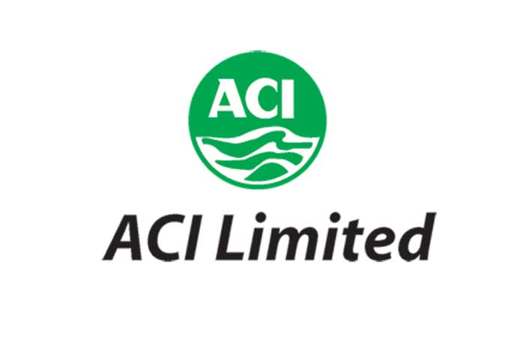

Report Topic Effects of Promotional Mix on Sales Performance of ACI Coil

Submitted to:
School of Business and Economics
United International University

Supervised by:
Md. Shariful Alam , PhD
Associate Professor
School of Business and Economics
United International University

Prepared by:
Baki Billah Samrat
ID : 111 132 043
Major: Marketing
School of Business and Economics
United International University


Date of Submission: November 6, 2018

Letter of Transmittal
06th November 2018

Md. Shariful Alam , PhD
Associate Professor
School of business and Economics
United International University
United City, Madani Avenue, Badda Dhaka 1212

Subject: Submission of Internship Report on Effects of Promotional Mix on Sales Performance of ACI Coil

Dear Sir,
It is my great pleasure to submit the internship affiliation report on Effects of Promotional Mix on Sales Performance of ACI Coil . This is a requirement for the fulfillment of the BBA degree.
Despite of several limitations, I hope that the paper has attained its purpose to a considerable extent. I am thankful to you for giving me the opportunity to do the report on this topic. I have done my level best to complete this report in time and with the quality of my expectation. I hope that you would be kind enough to accept my report. I will be happy to provide further clarification regarding this report.
I hope that my report will aid to make concrete decision and live up to your expectation.

Yours Sincerely,
-------------------------------
BakiBillahSamrat
ID: 111 132 043
Program: BBA

Acknowledgment
At first, I should thank Almighty Allah for enabling me to complete my internship report in time. I got appointed to work as an Intern at, ACI Limited. I worked on analyzing their Marketing and Branding activities and gathering experience of working in an office environment.
I would like to express my gratitude to my academic supervisor MD. Shariful Alam, PhD. From core of my heart for his kind support, guidance, constructive, supervision, instructions and advice and for motivating me to do this report.
I am also thankful to my Internship Supervisor, Md. Ashfaquazzaman, Consumer Brands Product Executive ACI Ltd, 227/A Ninakabbo Gulshan Tejgoanlink road Dhaka 1208, Bangladesh for supervising me and providing various key information and giving me the path to write a fruitful report also Brand Manager Jisan Ahmedand Senior product executive Zahirul Islam, to give a great guidance to me to make a faithful report and it is really very pleasure to me that he makes a correction of my report and give the correct solution always. I also thank him it was a great opportunity to do internship in such an organization like ACI Limited. I always felt that I was under guidance of highly qualified and experienced personnel. The experiences I have gathered will be very beneficial in my career.

Letter of Acceptance
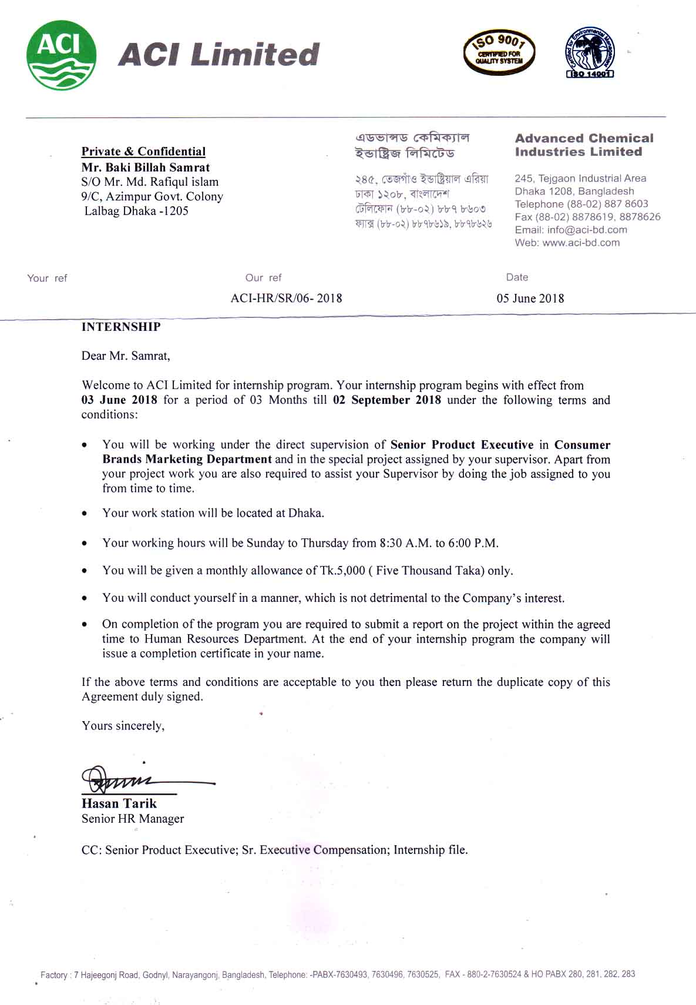
Table of Content:
Chapter 1
Sl. No. | Particulars |  |  | Pages
1 |  | Introductory Part |  | 1
 | 1.1 | Introduction to the Report |  | 1
 | 1.2 | Research Aims |  | 1
 | 1.3 | Research Objectives |  | 2
 | 1.4 | Scope of the report |  | 2
 | 1.5 | Methodology |  | 2-2
 | 1.6 | Limitations of the study |  | 3
 | 1.7 | Ethical Considerations |  | 3-4
 |  | Chapter 2
2 |  | Organizational Part |  | 5
 | 2.1 | Background of the Organization |  | 6
 | 2.1.2 | Historical Background |  | 7
 | 2.2 | Different Business Units |  | 8-14
 | 2.3 |  | Corporate information | 15
 |  | 2.3.2 | Corporate Information of the organization | 15
 | 2.4 | Corporate Governance |  | 16
 |  | 2.4.2 | The Management Committee and Board of Directors | 16-17
 |  | 2.4.3 | Organizational Organ Gram | 18
 | 2.5 | Mission & vision |  | 18-19
 | 2.6 | Company Values |  | 19
 | 2.7 | Fundamental Departments |  | 20
 | 2.8 | Quality Policy |  | 20
 | 2.9 | Environmental Policy |  | 21
 |  | Chapter 3
3 |  | Topic Part |  | 22
 | 3.1 | Sales performance |  | 23
 | 3.2 | Promotional Mix |  | 23
 | 3.3 | Elements of Promotional Mix |  | 23-27
 | 3.4 | Marketing Mix of ACI |  | 28-
 |  | 1 | Product | 28
 |  | 2 | Price | 29
 |  | 3 | Placing | 30
 |  | 4 | Promotion | 31-34
 |  | 5 | Process | 34
 |  | 6 | Packaging or Physical Evidence | 35
 |  | 7 | People | 36
 |  | Chapter 4
4 |  | (My Responsibility as an Intern) |  | 37
 | 4.1 | My responsibility as an Intern |  | 38
 | 4.2 | Internship program |  | 39
 | 4.3 | Internship Activities |  | 39
 | 4.4 | My Daily Routine |  | 40
 | 4.5 | Internship Position |  | 41
 |  | 4.5.2 | Primary Learning | 42
 |  | 4.5.3 | Secondary Learning | 42-44
 | 4.6 | Learning Experience |  | 45-46
 |  | Chapter 5
5 | Research Part |  |  | 47
 | 5.1 | Problem Statement |  | 48
 | 5.2 | Background of the Problem |  | 48
 | 5.3 | Project Timeline |  | 49-50
 | 5.4 | Budget Information |  | 51
 | 5.5 | Research Methodology |  | 51-52
 | 5.6 | Population |  | 52
 | 5.7 | Research Design |  | 52
 | 5.8 | Develop Independent Variables & Dependent Variables |  | 53
 | 5.9 | Data Analysis |  | 54
 | 5.10 | Questionnaire Scale & Hypothesis Development |  | 54-55
 | 5.11 | Hypothesis Testing |  | 56
 |  | 5.11.2 | Graphical Representation | 56-
 |  | 1 | Hypothesis 1 | 56
 |  | 2 | Hypothesis 2 | 57
 |  | 3 | Hypothesis 3 | 59
 |  | 4 | Hypothesis 4 | 60
 |  | 5 | Hypothesis 5 | 62
 | 5.12 | Findings |  | 63
 | 5.13 | Recommendations |  | 64
 | 5.14 | Conclusion |  | 65
 |  | Chapter 6 |  | 66
 | 6.1 | Bibliography |  | 67
 | 6.2 | Survey Questionnaire |  | 68
 | 6.3 | Abbreviation |  | 69

Executive Summary
ACI Limited is one of the most popular corporate names in Bangladesh. It is the most trusted brand as well as ensured quality product supplier. The report is designed on the basis on my theoretical knowledge and practical experience. It is designed to have a practical knowledge while passing through the theoretical understanding. The report is the result of three months working with ACI Limited.
The objective of this report titled as “Effects of Promotional Mix on Sales Performance of ACI Coil ” is focused on the overall Marketing mix, sales performance and improving promotional mix of ACI Coil. As their Mosquito Coil products performances are weak than other products the company needs to focus on developing the sales as well as they need to promote their product through the radio, television, newspaper, outdoor advertising and through other media to increase their coil sales.

At the end of my study, I have mentioned the finding according to the research part. Here I have mentioned some recommendations for ACI Coil about what activities they can follow. I hope they will be benefited from those recommendations and then overall conclusion is given according to my point of view.

Subject Keywords:
Marketing mix, sales performance, promotional mix of ACI Coil.

Part 1
INTRODUCTORY PART

1.1 Introduction to the Report:

This report is an Internship Report ready as an obligation to complete the BBA program of the School of Business and Economics (SOBE), UIU University. The main goal of the internship is to provide a working experience to the students and a chance for implementing of theoretical knowledge in actual situation. Students are placed in creativities, organizations, research institutions as well as development projects. The program concealments a period of 03 months of organizational accessory and 2 to 3 weeks of report finalization work. After the achieving four-year academic BBA program, the period of my organizational part was, by policy 03 months, starting from January 03, 2018. To complete my INT-4399 Practicum course, I was placed in ACI Limited, Dhaka for internship. To complete of the program, it is required to submit a report, which includes “Effects of Promotional Mix on Sales Performance of ACI Coil ”. Basically, the report is made based on primary data, secondary data and information about the company. The procedure and findings of the study are mainly exhibiting my volume for some creative and original approach to solving practical problems in today’s business. The report has been prepared in partial fulfillment of the requirement for the degree of Bachelors of Business Administration (BBA) at UIU (United International University),one of the best and first Private University of Bangladesh. The present report has been prepared on the basis of experience obtained throughout the internship period. My area of specialty is marketing and the area for this study is especially ACI Limited, Ninakabbo, 227/A, GulshanJejgaon link roadTejgaon, Dhaka-1208.

1.2 Research Aims:

The aim of my research is to find out the Effects of Promotional Mix on Sales Performance of ACI Coil .

1.3 Research Objectives:
The Research objectives are given below:
- To identify the reason for which ACI Coil current promotional activities are not providing desire result.
- To analyze the found reasons for which ACI Coil current promotional activities are not providing desire result.
- To recommend some initiatives based on the finding to improve sales performance of ACI Coil.

1.4 Scopes of the report:

The scope of the report covers the organizational overview and structure, background, objectives, basic functions, sales performance, Products analysis, Sales promotion, competitor analysis, trade marketing through push and merchandising items for market research of international packaging with unique through the Sales and Marketing department of ACI Consumer Division. And for that reason, that information was very much restrictive within the organization as this brand are going a very much completive Brands. Hence, my activities carried out by the CB (Consumer Brand) sales department. During my internship period, I tried my best to get the knowledge how they make strategy techniques to implement those in real situation. I am really thankful to my supervisor and other employee of all departments for supporting me and inspiriting me during Internship period.

1.5 Methodology:

Methodology is the process, technique or method of observation, survey and analysis. For Smooth and accurate study everyone has to follow some rules and regulation. The study assigns were collected from two sources:

1.5.1 Primary sources:
i. I have collected the primary data by interviewing different executives of ACI Ltd.
ii. Practical desk work.
iii. Face to Face conversation with sales representative, Distributors, Area Sales Manager and Zonal sales manager etc.
iv. Direct observations.

1.5.2 Secondary sources:

i. Website.

In my report I tried to minimize the usage of secondary data as much as possible. I have used secondary data only in the cases where it was not possible for me to use primary data.

1.6 Limitation of the Report:
ACI Limited is really a great place to gain practical knowledge. Though I have given extreme effort to prepare this report but during my report, I had to face some obstacles. They are as follows–
As we know that the internship’s duration is only 3 months. This is not enough time for doing a big research, which was not enough. For this reason, I wasn’t able to collect all information needed for this report. This was not enough information to go in-depth analysis.
While doing an internship, in many parts of my inquiry, my performance was stuck by some lacking in experience.

1.7 Ethical Considerations:
The whole report completed by my hard work. I got maximum information from my authorized supervisor, Staff and their website. I was very much regular during my internship period also kept regular communication with my supervisor.

PART 2
ORGANIZATIONAL PART

2.1 Background of the Organization:

ACI was established as the subsidiary of Imperial Chemical Industries (ICI) in the then East Pakistan in 1968. After independence the company has been incorporated in Bangladesh on the 24th of January 1973 as ICI Bangladesh Manufacturers Limited and also as Public Limited Company. This Company also obtained listing with Dhaka Stock Exchange on 28 December, 1976 and its first trading of shares took place on 9 March, 1994. Later on, 5 May, 1992, ICI PLC divested 70% of its shareholding to local management. Subsequently the company was registered in the name of Advanced Chemical Industries Limited. Listing with Chittagong Stock Exchange was made on 22 October 1995.

Bangladesh is a country which is small in size but large in population. ACI Limited is one of the most popular corporate names in Bangladesh. It is the most trusted brand as well as ensured quality product supplier. ACI Ltd plays an important role as a contributor to national economy. Along with this, they have left their footsteps in international platform through foreign investments, joint ventures and brand affiliations. ACI has been accepted as a founding member of the community of Global Growth Companies by the World Economic Forum which is the most prestigious business networking organization.



Figure 2.1: ACI Center, Main Office of ACI Limited.

ACI Limited stands for the name “Advanced Chemical Industries limited” which refers that they started their business with Pharmaceutical goods. After that they spread different brunches of product lines within their operation. [1]
Logo:
The logo of ACI Ltd is very fascinating. It is green in color and there are waves in the logo.

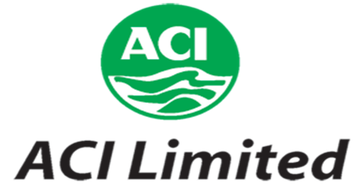

Figure 2.2: Logo of ACI Ltd.

2.1.2 Historical Background:

ACI Limited is one of the top companies in Bangladesh. It was established as a subsidiary of Imperial Chemical Industries (ICI) plc, U.K. in 1968. At that time, it was one of the oldest Industrial units in our country. After the liberation war, the enterprise was declared ‘abandoned’. Then it had been incorporated in Bangladesh on the 24 of January 1973 as ICI Bangladesh Manufacturers limited as a subsidiary of ICI. On 24 June 1973, the factory restarted its operations under the name ICI Bangladesh Manufactures Limited. On the 5 of May 1992, ICI Plc divested 70% of its share to local (Bangladeshi) management and hence ACI Limited came into existence. At present ACI is a leading corporate body in Bangladesh. It is a Public Limited Company with a total number of 15,550 shareholders, among which there are six foreign as well as fourteen local institutional shareholders. The company is diversified in to six major’s businesses. Besides, the company has a large list of international associates and partners with trade and business agreement. [2]

2.2 Different Business Units of ACI:
The figure below illustrates the different Business units of ACI Ltd.

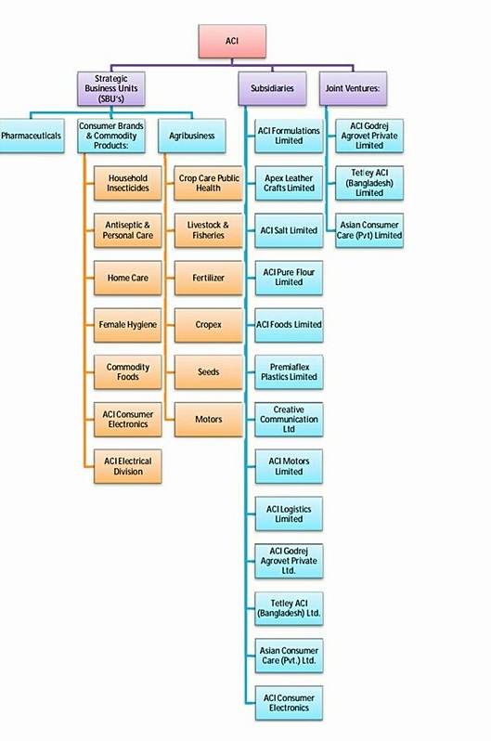

Figure 2.3: Business Unit of ACI Limited

1. Strategic Business Units:
My particular department exists under the ACI Consumer Brands Department.
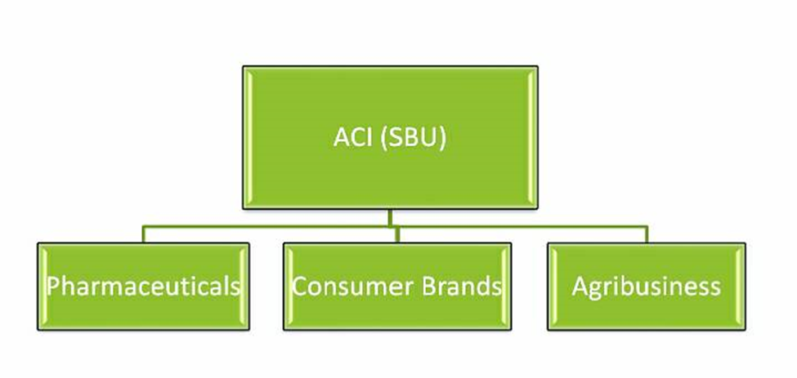

Figure2.4: SBUs of ACI Ltd.

1. Pharmaceuticals:

ACI has the legacy of ICI- world renowned British Multinational in providing the people of Bangladesh with good quality medicines and healthcare products. Its state-of-the art pharmaceutical plant represents Bangladesh's quest for a truly world class manufacturing facilities.

The comprehensive product range of ACI pharmaceuticals includes products from all major therapeutic classes and in various dosage forms like tablet, capsule, dry powder, liquid, cream, gel, ointment, ophthalmic and injectable. ACI Pharma also has state of the art plant on Novel Drug Delivery System (NDDS). It produces world class Modified Release drug and medicine to cater the requirement of pharmaceutical manufacturer of domestic and international market. It exports high quality pharmaceuticals to a good number of countries of Asia, Africa & South America.

Figure2.5: Pharmaceuticals of ACI Ltd.

2.Consumer Brands:

ACI Consumer Brands were initiated in 1995 with two major brands of the company – ACI Aerosol and Savlon. These are two of the most prestigious products which are enjoying the leadership position in the market. The division started to take new businesses through off shore trading as well as local manufacturing. In this process ACI Consumer Brands launched many new products and also bonded with Joint Venture business relationships with ‘Dabur India’ and ‘Tetley UK’ and attained international alliances with world renowned companies. The Consumer Brands Division boasts in having an unequivocal presence in consumers' heart with the market leading brands like ACI Aerosol, Savlon, ACI Mosquito Coil & ACI Pure Spices and Flour. With close to 80% market share in own categories, ACI Aerosol and Savlon are the persistent performers in keeping the household clean and free from germs and harmful insects.

The ACI mosquito coil has also emerged as a formidable opponent to both the mosquito and the competition, by providing effective and affordable solution to the conscious people of Bangladesh. A sound mind goes with a sound body-ACI believes in this age-old proverb and our young generation needs to grow up with healthy physique and sound mind who will lead the nation in future.

With this belief, ACI has entered into the commodity food business with “ACI Pure” Brand. The aim is to provide the purest of the food products to Bangladeshi consumers at affordable prices for which ACI has invested in very large scale in state-of-the-art manufacturing facilities for daily kitchen essentials like vacuum evaporated edible Salt, Spices and Flour. The products are delighting the consumers by providing 100% dirt free, pure and natural food ingredients which can compete against any international products. ACI Consumer Brands are successfully serving the consumer demand for foreign products in household and personal care category with the world-renowned product range of Colgate, Nivea &Dabur. With the proper distribution and marketing of ACI consumer brands, the world's No. 1 tea brand "Tetley" is now available to the consumers of Bangladesh. As a successful business, The ACI Consumer Brands are focused on achieving the consistent growth required to continue the success and to make ACI an even stronger company.

The Consumer Brands believe this is the best way to benefit the consumers, people and the shareholder of ACI. ACI Consumer Brands Strategic Business Unit is headed by the Executive Director, Mr. Syed Alamgir. MrAlamgir is regarded as an authoritarian personality in the area of Sales and Marketing in Bangladesh market. His track record has many successful brands which reached leadership position in different categories in the FMCG market. He is supported by a competent group of professionals working in the Marketing and Sales operations.

Commodity and Consumer brand products

i. Home Care
ii. Commodity foods
iii. Electronic Division
iv. Female Hygiene
v. Household Insecticides
vi. Antiseptic and Personal care

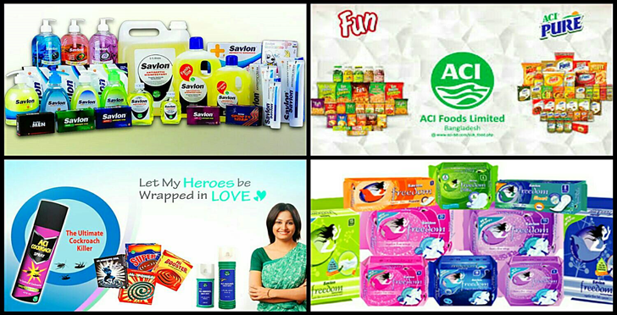

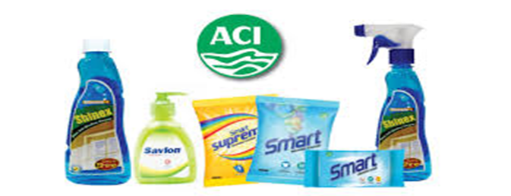
Figure2.6: Consumer Brand and Commodity Products of ACI Limited

3. Agribusiness:

ACI Agribusiness is the largest Integrator in Bangladesh in Agriculture, Livestock and Fisheries and deals with Crop Protection, Seed, and Fertilizer, Agric machineries, and Animal Health products. These businesses have glorified presence in Bangladesh. CC & PH supply, crop protection chemicals, Seed supplies Hybrid Rice, vegetable and Maize seeds, Fertilizer Supplies Micronutrient and Foiler fertilizer, Agric machineries supplies Tractors, Power Tiller and Harvester and Animal Health supplies high quality Nutritional, Veterinary and Poultry medicines and vaccines. ACI provides solution to the farmers through a large team of scientists & skilled professionals.

1. Cropex
2. Livestock and Fisheries
3. Fertilizer
4. Crop care public health
5 Motors
6. Seeds

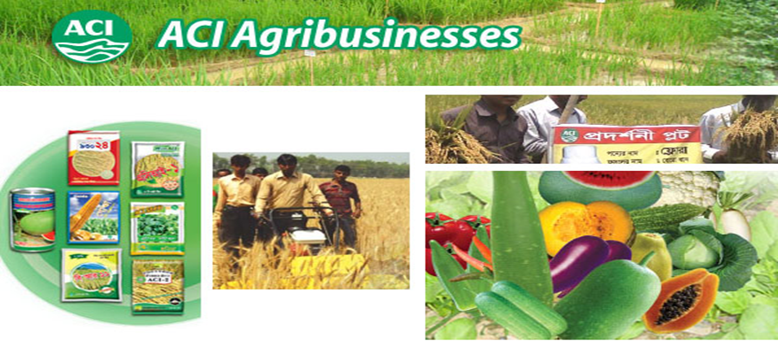

Figure 2.7: ACI Agribusinesses
2.Subsidiaries:

i. ACI Formulations Ltd.
ii. Apex Leather Crafts Ltd.
iii. ACI Pure Salt Ltd.
iv. ACI Pure Flour Ltd.
v. ACI Foods Ltd.
vi. Creative Communication Ltd.
vii. ACI Motors Ltd.
vii. ACI Electronics Ltd.
ix. ACI Logistics Ltd.
x. ACI Godrej Agrovet PVT Ltd.
xi. Tetley ACI Bangladesh Ltd.
xii. Asian Consumer Care Ltd.

3.Joint Venture:

i. ACI Godrej Agrovet PVT Ltd.
ii. Tetley ACI Bangladesh Ltd.
iii. Asian Consumer Care Ltd. [3]

2.3 Corporate Information:

ACI Plc of UK had a pharmaceutical business in Bangladesh. In 1992 the business was sold to management and the name of the Company changed to Advanced Chemical Industries (ACI) Limited. ACI inherited the rich ICI culture of product quality, customer service and social responsibility and continues to nurture. ACI is the first company in Bangladesh to obtain certification of ISO 9001 Quality Management System in 1995. ACI is also the first Company in Bangladesh to get certification of ISO 14001 Environmental Management System in 2000. ACI employees are proud of their work culture, business ethics and environmental consciousness. [4]

2.3.2 Corporate Information of the organization at a glance:

Company Name | Advanced Chemical Industries Limited
Nature of business | Manufacturing, Processing, Retail, Service
Founded | 1968
Location | ACI Center, 245 Tejgaon Industrial Area, Dhaka 1208
Headquarters | Dhaka
Fax | 880 2 8878619 & 8878626
E-mail | info@aci-bd.com
Logo | 
Directors | - Dr. ArifDowla - Group Managing Director  - Mr. AzmalHossain - Executive Director, Trade  - Dr. F. H. Ansarey - Executive Director, Agribusinesses  - Mr. Syed Alamgir – Executive Director, Consumer Brands

Table 2.3: Corporate Information of ACI Limited

2.4 Corporate Governance:

ACI is the first organization in Bangladesh to earn both the ISO 9001 certificate for Quality Management System in 1995 and the ISO 14001certification on Environmental Management in2000. It has received the award of best Enterprise of the year 2011. ACI has been accepted as a Founding Member of the Community of Global Growth Companies by the World Economic Forum which is the most prestigious business networking organization. [4]

2.4.1 Managing committee Board of Directors of Aci ltd.

The Management Committee
Name | Designation
Dr. ArifDowla | Managing Director
Dr. F H Ansarey | Executive Director, Agribusiness
Mr. Syed Alomgir | Executive Director, Consumer Brands
Mr. M. MohibuzZaman | Chief Operation Officer, Pharmaceuticals
Mr. PradipKarChowdhury | Executive Director, Finance and Planning
Mr. SabbirHasanNasir | Executive Director, Logistics
Mr. PriyatoshDatta | Director, Quality Assurance, Pharma
Mr. AbdusSadeque | Director, Marketing & sales, Pharma
Ms. Sheem Abed Rahman | Director, Corporate Affairs
Mr. Md. MonirHossain Khan | Financial Controller
Mr. Imam Ahmed Istiak | Director, Operation, Pharma

Table 2.4: The Management Committee
Board of Directors:

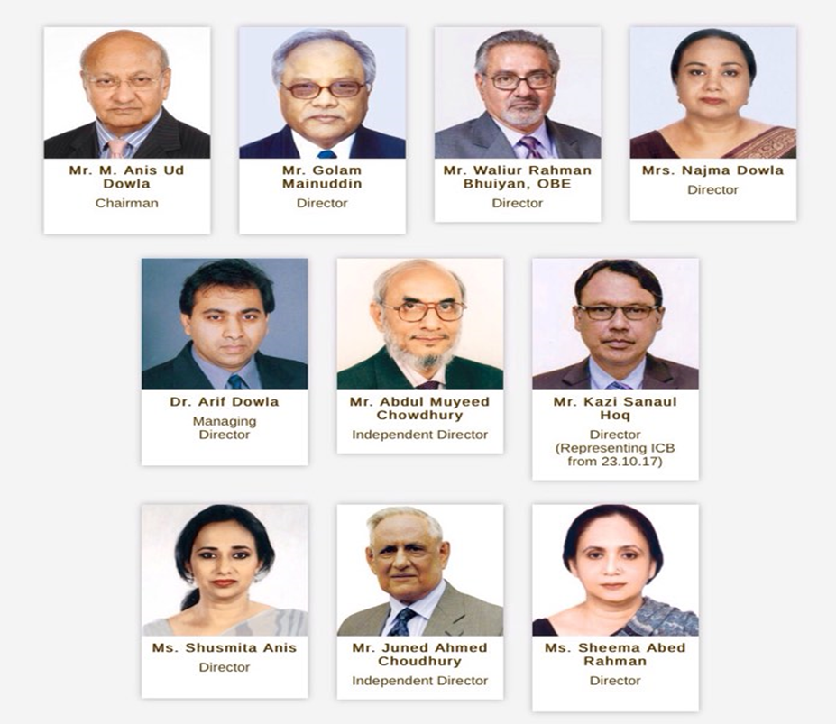

Figure 2.8: The Board of Directors [6]

2.4.3 Organizational Organ Gram:

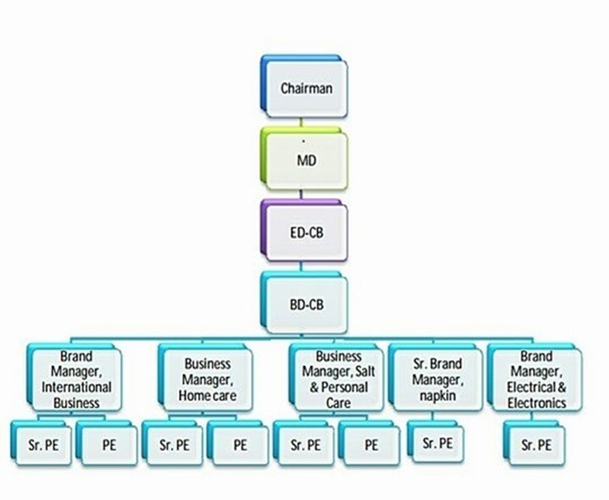
Figure 2.9: Organization Structure of ACI Consumer Brands

2.5 Mission and vision of ACI Limited:

2.5.1 Company Mission:

ACI's Mission is to enrich the quality of life of the people through responsible application of knowledge, technology and skills. ACI is committed to the pursuit of excellence through world-class products, innovative processes and empowered employees, to provide the highest level of satisfaction to our customers.

2.5.2 Company Vision:

To achieve the mission ACI will,
➢ Provide products and services of high and consistent quality, ensuring value for money to our customers.
➢ Endeavour to attain a position of leadership in each category of our businesses.
➢ Develop our employees by encouraging empowerment and rewarding innovation.
➢ Promote an environment for learning and personal growth.
➢ Attain a high level of productivity in all our operations through effective utilization of resources and adoption of appropriate technology.
➢ Promote inclusive growth by encouraging and assisting our distributors and suppliers in improving efficiency.
➢ Ensure superior return on investment through judicious use of resources and efficient operations, utilizing our core competencies.

2.6 Company Values:

The main values of ACI Ltd are:
➢ Customer Focus Quality
➢ Quality Customer Focus
➢ Fairness
➢ Innovation
➢ Customer improvement
➢ Transparency

2.7 Fundamental Departments of ACI:

• Administration Department
• Financing and Planning
• Commercial Department
• MIS
• Distribution
• Training and Development
• HR

2.8 Quality Policy:

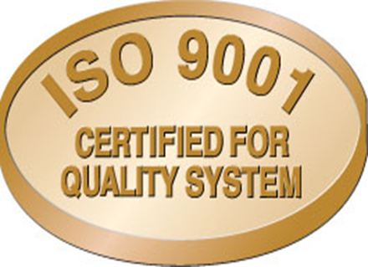
Figure 2.10: ISO 9001 Certified for Quality System

One of the important visions is to provide products and services of high and consistent quality, ensuring value for money to their customers.

2.9 Environmental Policy:

ACI has obtained ISO 14001 Certification for Environmental Management System.

ACI is committed about their formula and way to do their business will never herm environment, ensuring continual improvement in the utilization of resources and prevention of pollution or degradation of the environment. [7]

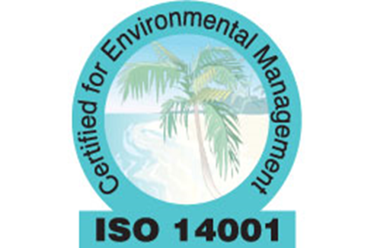
Figure 2.11: ISO 14001 Certified for Environmental Management

Part: 3
Topic Part

3.1 Sales Performance:

Sales performance uses raw data concerning the number of customers a sales associate speaks to compared with the number of actual sales. By reviewing the sales performance of an employee, a sales performance manager can determine his strengths and weaknesses. [8]

3.2. Promotional Mix:

The Promotional Mix refers to the blend of several promotional activities used by business to create, maintain and increase the demand for a product. (Business Dictionary) [9]

The Promotional Mix is the integration of Advertising, Personal Selling, Sales Promotion, Public Relations and Direct Marketing. The marketers need to view the following questions in order to have a balanced blend of these promotional tools. [10]

3.3 Elements of Promotional Mix:

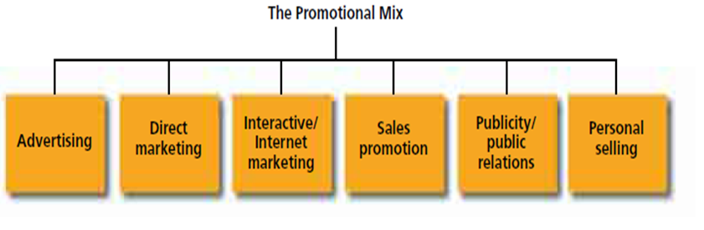
Figure 3.1: Elements of the promotional mix

3.3.1Advertising:

The word advertising comes from the Latin word "adverteremeaning” to turn the minds of towards”.
“According to American Marketing Association "advertising is any paid form of non- personal presentation and promotion of ideas, goods and services by an identified sponsor". [11]

Advertising is used for communicating business information to the present and prospective customers. It usually provides information about the advertising firm, its product qualities, place of availability of its products, etc. Advertisement is indispensable for both the sellers and the buyers. &however, it is more important for the sellers. In the modern age of large-scale production, producers cannot think of pushing sale of their products without advertising them. Advertisement supplements personal selling to a great extent. Advertising has acquired great importance in the modern world where tough competition in the market and fast changes. In Technology, we find fashion and taste in the customer. [12]

Advertising during TV programs can easily reach to the target customer. At the time of news and sponsoring TV programs that are watched by target markets. Also adds in radio, web sites, posters, labeled boxes, and also the product will promote itself with the attractive packing.

3.3.2Direct Marketing:

With the intent of technology, companies reach customers directly without any intermediaries or any paid medium. The e-mails, text messages, Fax, are some of the tools of direct marketing. The companies can send the emails and messages to the customers if they need to be informed about the new offerings or the sales promotion schemes. E.g. The Shopper stop send SMS to its members informing about the season end sales and extra benefits to the golden card holders.
Direct marketing as a component of the promotional mix. Direct marketing is much more than direct mail and mail order catalogs. It involves a variety of activities, including database management, direct selling, telemarketing, and direct response ads through direct mail, the Internet, and various broadcast and print media.

One of the major tools of direct marketing is direct response advertising, whereby a product is promoted through an ad that encourages the consumer to purchase directly from the manufacturer. Traditionally, direct mail has been the primary medium for direct-response advertising, although television and magazines have become increasingly important media.

3.3.3Internet Marketing:
As the new millennium begins, we are experiencing perhaps the most dynamic and revolutionary changes of any era in the history of marketing, as well as advertising and promotion. These changes are being driven by advances in technology and developments that have led to dramatic growth of communication through interactive media particularly the Internet. Interactive media allow for a back-and-forth flow of information whereby users can participate in and modify the form and content of the information they receive in real time. Unlike traditional forms of marketing communications such as advertising, which are one-way in nature, the new media allow users to perform a variety of functions such as receive and alter information and images, make inquiries, respond to questions, and, of course, make purchases. In addition to the Internet, other forms of interactive media include CD-ROMs, kiosks, and interactive television. However, the interactive medium that is having the greatest impact on marketing is the Internet, especially through the component known as the World Wide Web. [13]
3.3.4Sales promotion:
The next variable in the promotional mix is sales promotion, which is generally defined as those marketing activities that provide extra value or incentives to the sales force, the distributors, or the ultimate consumer and can stimulate immediate sales. Sales promotion is generally broken into two major categories: consumer-oriented and trade-oriented activities.
•Consumer-oriented sales promotion is targeted to the ultimate user of a product or service and includes couponing, sampling, premiums, rebates, contests, sweepstakes, and various point-of-purchase materials. These promotional tools encourage consumers to make an immediate purchase and thus can stimulate short term sales.

•Trade-oriented sales promotion is targeted toward marketing intermediaries such as wholesalers, distributors, and retailers. Promotional and merchandising allowances, price deals, sales contests, and trade shows are some of the promotional tools used to encourage the trade to stock and promote a company’s products.

3.3.5Publicity/Public Relations:

Another important component of an organization’s promotional mix is Publicity/ Public relations.

a. Publicity

Publicity refers to nonpersonal communications regarding an organization, product, service, or idea not directly paid for or run under identified sponsorship. It usually comes in the form of a news story, editorial, or announcement about an organization and its products and services. Like advertising, publicity involves non-personal communication to a mass audience, but unlike advertising, publicity is not directly paid for by the company. The company or organization attempts to get the media to cover or run a favorable story on a product, service, cause, or event to affect awareness, knowledge, opinions, and/or behavior. Techniques used to gain publicity include news releases, press conferences, feature articles, photographs, films, and videotapes.

b. Public Relations
It is important to recognize the distinction between publicity and public relations. When an organization systematically plans and distributes information in an attempt to control and manage its image and the nature of the publicity it receives, it is really engaging in a function known as public relations. Public relations are defined as “the management function which evaluates public attitudes, identifies the policies and procedures of an individual or organization with the public interest, and executes a program of action to earn public understanding and acceptance.”32 Public relations generally has a broader objective than publicity, as its purpose is to establish and maintain a positive image of the company among its various publics.

Public relations use publicity and a variety of other tools—including special publications, participation in community activities, fund-raising, sponsorship of special events, and various public affairs activities—to enhance an organization’s image.

3.3.6Personal Selling:
The final element of an organization’s promotional mix is personal selling, a form of person-to-person communication in which a seller attempts to assist and/or persuade prospective buyers to purchase the company’s product or service or to act on an idea. Advertising, personal selling involves direct contact between buyer and seller, either face-to-face or through some form of telecommunications such as telephone sales. This interaction gives the marketer communication flexibility; the seller can see or hear the potential buyer’s reactions and modify the message accordingly. The personal, individualized communication in personal selling allows the seller to tailor the message to the customer’s specific needs or situation.

Personal selling also involves more immediate and precise feedback because the impact of the sales presentation can generally be assessed from the customer’s reactions. If the feedback is unfavorable, the salesperson can modify the message. Personal selling efforts can also be targeted to specific markets and customer types that are the best prospects for the company’s product or service. [14]
3.4 Marketing Mix:
The marketing mix is the set of controllable, tactical marketing tools that a company uses to produce a desired response from its target market. It consists of everything that a company can do to influence demand for its product. It is also a tool to help marketing planning and execution.

To market the products every company needs to create a successful mix of right product at right price at the right place through the right promotion. Thus, marketing mix made up to 7Ps: product, price, place, and promotion, process, physical evidence and people. ACI Consumer brands has also created a good marketing mix to market their product and most importantly all the Ps are interrelated to each other. Now I will discuss about the 7Ps of ACI Consumer brands.
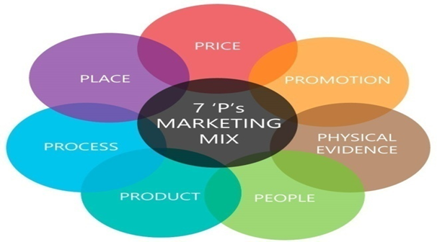
Picture 3.1: Marketing Mix

- Products:
Products are the key elements for the ACI Limited. ACI Limited is proud of the products that consist the part of the Consumer Brands division. The Consumer Brands Division boasts in having an unequivocal presence in consumers’ heart with the market leading Commodity Products like. Household Insecticides, Antiseptic and Personal car, Home Care, Female Hygiene, Commodity Foods, ACI Electronic Division. But I am going to described only the part of household insecticides products.

Household Insecticides:
ACI Limited is proud of the home care products of the Consumer Brands division. I choose only one product of ACI Mosquito Coil.
ACI Mosquito Coil:

ACI Mosquito Coil is another important product of the Home Care category of ACI Consumer Brands. ACI Mosquito Coil has different Brands based on different shape, color and fragrance and price. ACI Mosquito coil has the following brands:
•ACI Hi Power.
•ACI Super.
•ACI High Booster and
•ACI black fighter
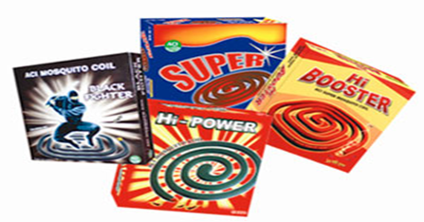
Picture 3.2: ACI Mosquito Coil
2. Price:

Price has a major role in developing a product. It’s also an important element in marketing mix because it is directly related to the revenue generation and all other parts of marketing mix. Pricing decisions are influenced by many objectives like profit, costs, organizational and marketing objectives and so on. To set the price of the ACI Coil follow the product carton-based pricing strategy. Though ACI is providing better quality than anyone in Bangladesh, they impose the same price for the customers. So, it makes them able to grab the highest market share in the country. However, the trade price differs based on the market demand of the product in various locations of the country.

The new product will launch for the mass market and thus price competitiveness may vary from other brands as ACI Consumer Brands is planning to focus and build their pricing strategy based on the products SKU size which may create competitive advantage for the brand and the organization.
CB Based Price List:
Given below the Household Insecticides Products Price List:
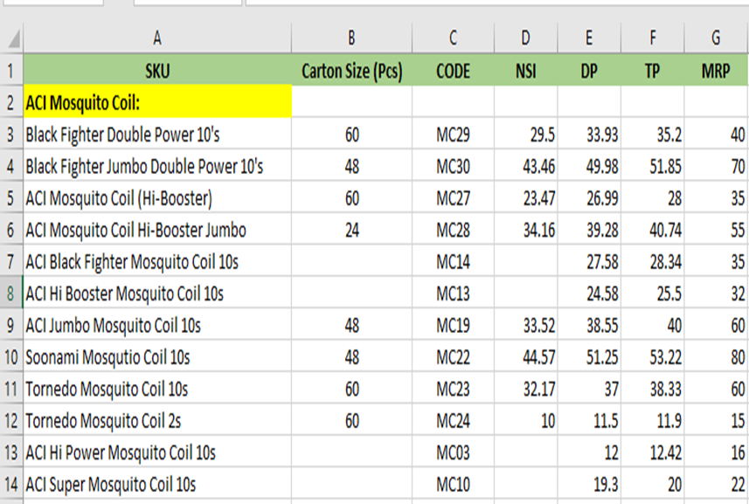

3.Place:

The place is connected with making available the products at a place where the customers demand. Thus, it is concerned with the stores or retailers where goods will be displayed and sold. ACI Limited has a distribution channel throughout the country. ACI Limited has their distribution points in almost every district. And every regional distribution point has their sub depots through which products are distributed to the retailers of the nearby areas.

Regional Distribution points are: Dhaka, Savar, Dinajpur, Faridpur, Jossore, Rangpur, Bogra, Rajshahi, Maymensingh, Tangail, Gazipur, Chittagong, Comilla, Bandarban, Maijdi, Cox’s Bazar, Narayangang, Comilla, Kustia, Khulna, Sreemangal, Sylhet, Chandpur etc.
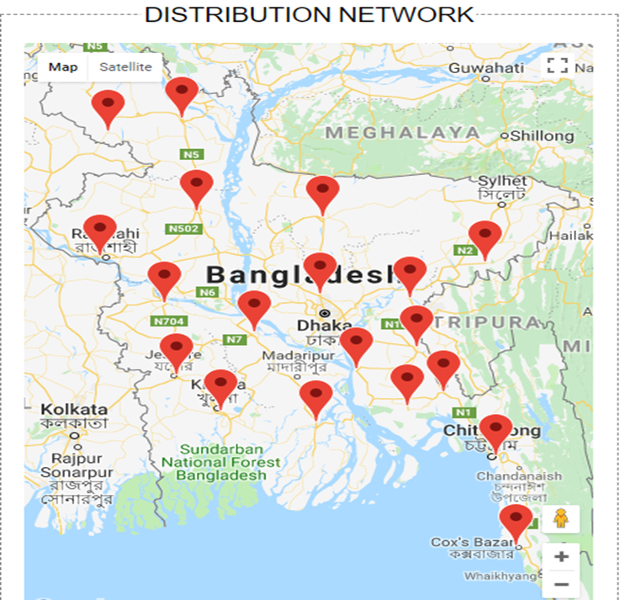
Picture 3.3: Distribution Network of ACI Limited

4. Promotion:

Promotion relates to communicating with customers it will provide information to assist them in making decision to buy the products. The cost associated with promotion often represents a sizeable proportion of the overall cost of producing an item. However, a successful promotional strategy helps to build long term relationship with increased sales due to promotion; costs are spread over a larger output. ACI Limited has TV Ads, Activation, Event, Conference program, corporate publication, social media and corporate advertising process to make the promotion of their brands. Again, very often the distributors and retailers are provided various trade offers and commissions to boost up sales. This is helpful because many people don’t care about the brand. They just buy what the sellers give them. So, if ACI provide offers and commissions the retailer or sellers will want to sale their products to hose customers.
TV Ads:
Television Ads is a span of television programming produced and paid for by an organization which conveys a message, typically to a market a product or service Limited made TV based on their products. ACI Coil try to publish their product through the Advertising.

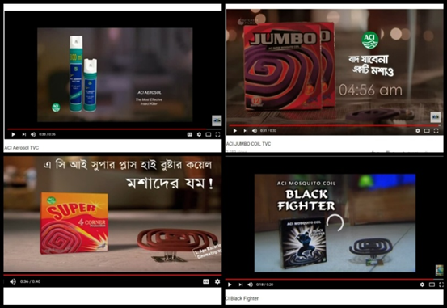
Picture 3.4: ACI Coil TV commercial Ads

Activation:
ACI Coil use their product promotion activation method to bring a brand message to life through a strategic, integrated campaign that leverage the full potential of a wide range of marketing communication tools in order to maximize results and provide the greatest return on their customer marketing investment. ACI Limited does different kinds of activation like- Market Activation, corporate activation etc.

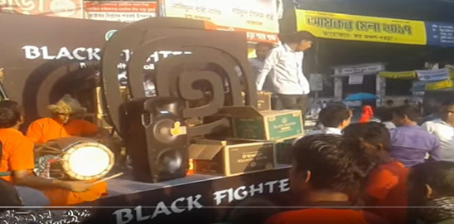
Picture3.5: Black Fighter Coil Promotion Activation

Conference Program:
A typically meeting of people with a shared interest, typically one that takes place over several days. Actually, it’s an idea sharing forum and conservation that includes experts who advice how to species in captivity. On last 19th February ACI Consumer Brands arranged CB Sales and Marketing conference with their sales peoples and employee. They are also going to be held press conference. The news show on the GTV Channel.

Picture 3.6: ACI sales and Marketing Conference program
Events:
ACI Limited also arranged different types of Events based on occasion.

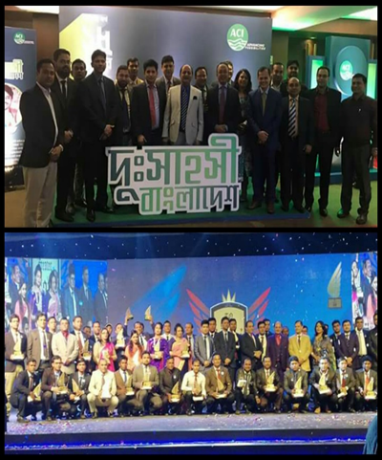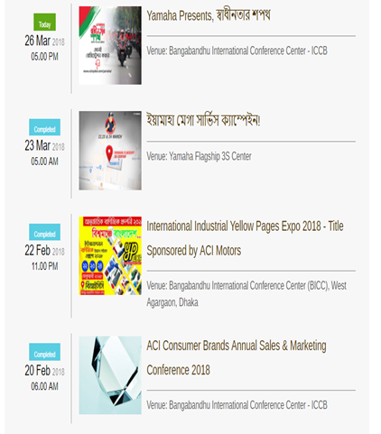
Picture 3.7: Some Events of ACI Limited
Display Pomotion in Super shop:
ACI stresses a lot on different forms of trade promotion. ACI pushes the product to retail stores, Super shop and offers discounts and other forms of promotional offers. These have been quite successful as retailers readily display coil, Aerosol and other brands from ACI. During the market audits that I conducted, it was seen that the promotional offers work and stock availability of ACI products was quite high. ACI recently conducted a wet market activation program in different wet markets across Dhaka City. This encouraged the retailers to keep more of products in market.
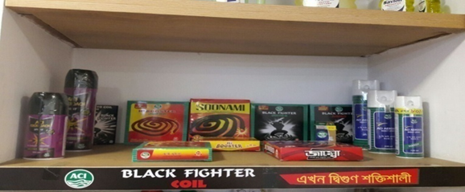
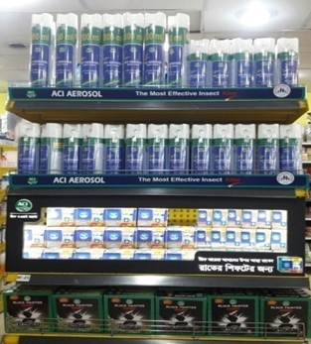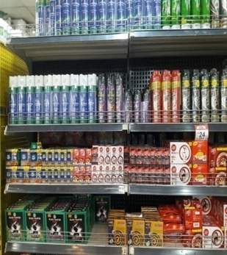
Picture 3.9:DisplayPromotional Super shop

5. Process:
This element of marketing mix looks at the systems used to deliver the service. It means all services need to be underpinned by early defined and efficient process. Because of that customer can identify the effectiveness of the company.
The products are first manufactured in the factory, from factory half of the products are sent directly to the distribution points to the retailers through some rented vehicle and then to the retailers. From the distributors point product distributed to retailer and retailer to the wholesaler and then it finally reach to the customer
The distribution process flow is shown by a flow chart below. And the distribution channel process is shown by a map bellow-
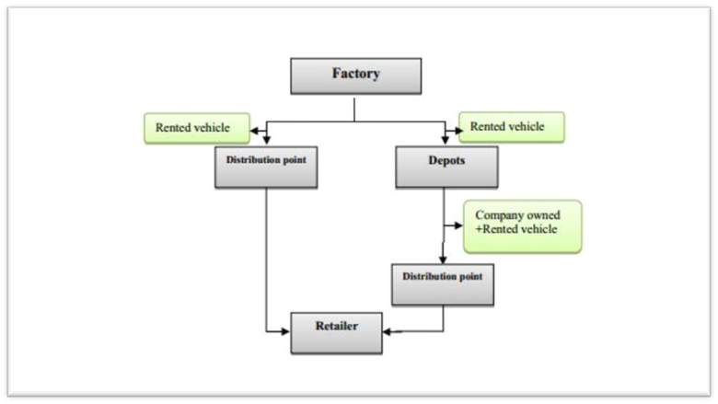
Flowchart 3.1: The distribution process flow of ACI Limited

6. Packaging or Physical Evidence:

Developing an eye-catching packaging for a product is one of the biggest challenges a marketer faces. As days passing by, marketers focus more on packaging thus consumers attract towards their products. There are varieties of coil packaging both traditional and creative available in the market.

As the physical evidence they maintain their factories and distribution centers which have lots of machinery cleanly and friendliness manner for employees. And they also provide t shirt and cap for their brand promoters.

7. People:
People are essential in the marketing of any product or service. From a marketing management perspective, it is important to ensure that employees represent the company in alignment with broader messaging strategies. In the Consumer Brand sales department of ACI Limited they have more than 100 people are working in different area of the Bangladesh to represent the company. When they are hired in the company then they are train by their supervisor to deliver superior service to the clients. The marketing people are always ready to give better services to the customer. CB Sales division tries to maintain good relationship with their valuable customer by providing high quality products along with a moderate price. Also handle to all the territories sales people and sales coordinators at together. They monitor the performance of all the sales peoples and sales coordinators and ensuing that processes are followed or not. They are also expected to supervise the shopkeepers as well as distributors.

Part: 4
My responsibility as an Intern

4.1 My responsibility as an intern:

This report is prepared for the requirement for successful completion of the Internship program. Implementing theoretical knowledge in practical situation and describing my work experience was the primary objective of this report. According to the requirements, of course fulfillment I joined in ACI Limited as an internee on the date of 3rd June, 2018. I have worked for three months in Sales Admin Department. In the period of my three months’ internship program, I have learned so many things. Although it’s a Private organization all the employee and stuff of the organization were very friendly and helpful.

4.2 Internship Program:

I did my Internship at ACI Limited which is situated at Nina Kabbo, 227/A, Tejgaon Industrial Area, Dhaka-1208, Bangladesh from 3rd June to 02ndSeptember 2018.My department was sales admin department under Consumer Brands division. In the time of internship period, I worked both in office and go to field work under the supervision of Ashfaquazzaman, product executive of ACI Sales. They have structure, space and opportunities for working of internship students. So, my main object is to understand their system of working in the marketing division.

4.3 Internship Activities:
As I worked both in office and field during my internship period, they divided my duties in two parts: Official Activities & Field Activities.

1. Official Activities:
In office, my duties are to maintain and observe about collecting Consumer brands sales activities data, Primary and secondary sales data entry in MS Excel sheet, making incentive sheet, create presentation based on ACI sales related topics. I always keep contact with area managers and territory managers to observe their requirements and stock. Attending ACI Sales and Marketing conference program 2018.

Picture 4.1: Official activities

2. Field Activities:
During my internship period, I went to field to visit distributer points. Within this period, I visited different distributer points like Gulshan, Uttara, and Gazipur under Dhaka area and collecting information. I talked with ASM (Area Sales Manager) and SR (Sales Representative) face to face conversation about total sales, product problem, the promotional activities, quality of the products, reasonable price, brand image, ECO percentage and product availabilities. And to find out what types of promotional activates ACI do. I also visited different market to know about ACI product demand and customer expectation to warding ACI product.

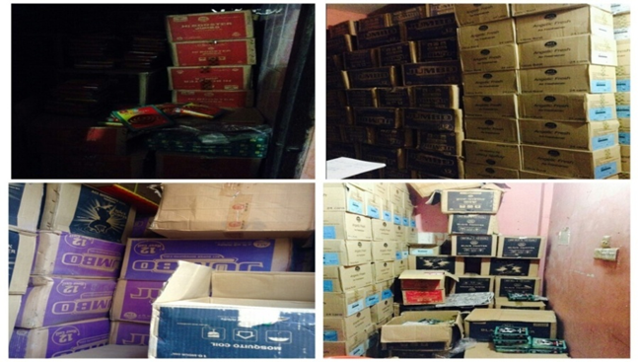
Picture 4.2: Product Coverage

4.4 My Daily Routine:

I joined in ACI Consumer Brands Division of ACI Limited on June 3, 2018 as an intern. After being an intern, my daily work was maintained very regularity. In this company I worked under the General Manager, taking the role of helping hand to his daily work, completing and checking the document, overseeing overall activities and performance of the workers and various marketing and promotional activities and performance of the company.

In the company my daily working time at 8:30am to 6pm, 5days a week. During that time my duty was to observe the sales performance and keep contact with zonal sales manager area managers and territory managers. During my working time I usually talk with my supervisors and other employee regarding business matter. I also acquired the corporate culture of ACI Limited. Maintaining a good relationship with supervisors, line managers and the Directors as well as others intern mate. We all intern mate helps each other a lot and maintain a good corporate environment. I got opportunity to work with very talented personal which will leave a great impact in my future career.

4.5Internship Position:

I have worked for three months with different sections. During my Internship period of ACI Limited I was gathered more knowledge which is related to my topic and I also knew the information which is not related to my topic. Actually, Internship project work is very important to the BBA students to grow knowledge and it helps to create more capabilities and Confidence of works in any situation or any business. Three months Internship is not enough time to learn everything of any business situation or anything; on the other hand, it is very effective course of a student to learn more. So, in a sentence I can say that, it is nothing but everything if I can learn or want to learn. Now, I would like to divide my all those learning into two categories. These are given below-
1. Primary learning
2. Secondary Learning
Here, a short description about those learning is given below for your kind perusal:
4.5.2 Primary Learning:

In primary learning I just learn about some basic things like:

•Organizational culture.
•How to behave with Colleagues, Clients and others.
•How to make a good relationship with another.
•Time management.
•How to deal with clients in Business conference.
•Contact with company’s employees.
•Maintaining rules and regulations.
•How to deal with ZSM, ASM & SR.
•How to deal with Brand promoters.
•What are the sales department do.

4.5.3 Secondary learning:

My internship organization ACI Limited is the private multinational organization, so there are huge activities and lots of work on various departments, so called they do all kinds of working task under sales departments. In this organization there are some departments to work like marketing department, Brand department, Finance department, HR department. My supervisor assigned me to handle and task of sales admin department. I worked different kind of section of ACI Limited. All working activities are not possible to show up because my working activities are depending on different situation. So, some exact working activities are shown below which was in my regular activities-

Distributer point visit:

During my internship period, I went to visit distributer points. Within this period, I visited different distributer point like Gulshan, Uttara, and Gazipur under Dhaka area and collecting information about total sales, product problem, the promotional activities, quality of the products, reasonable price, brand image, product availabilities and automation system.
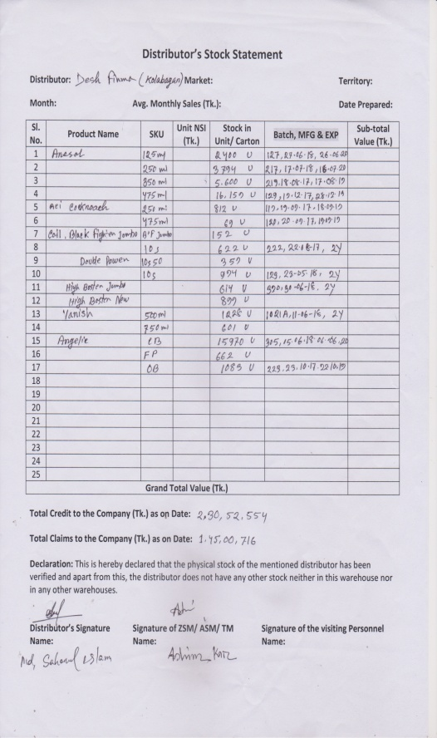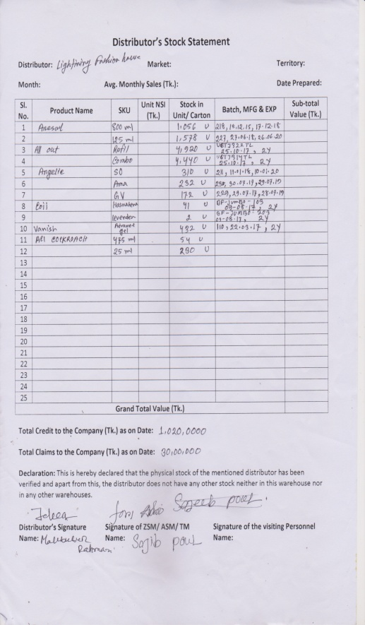

Picture 4.3:Stock Statement

Afterwards documenting the file, I usually make a report about it andsend it to my Supervisor.

Market Visit:
I have visited the different departmental stores and super shop to see the market position of ACI Consumer Brands product and also other brands relative products. I tried to gather information as much as I could be regarding the competitors and their future goal that helped in so many ways to make ACI Limited brand stronger than other and also complete my report.
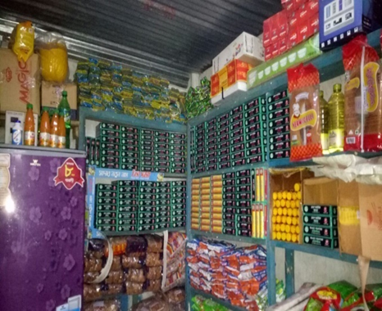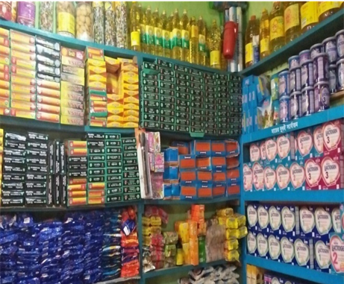
Picture 4.4: Storage products in Shop

Sales Analysis:

During my internship period I have analyzed the sales record of 2017- 2018 and tried to find out the present situation of sales and the possible way of develop the sales.

Maintaining Internal and External Relationship:

I had to maintain some internal and external relationship with ASM, ZSM, SR, and SS as i had to contact them before visiting the place under their territory.

Preparing sales related presentation:

Sometimes I prepared sales related presentations based on Consumer brand products, comparison between 2016 and 2017 achievement and upcoming plan.
Collecting Necessary Documents:

I have to collect document like distributors monthly sales, stock product, damage product and sales improvement. I had to collect ASM, ZSM phone number and their location from ACI server.

Preparing Incentive Sheet:

Sales Incentive is a formal scheme that used to promote or encourage sales manager by getting incentive price. If sales manager or sales coordinators achieve their targets than company give incentive to them. And I listed out the everyday GP, SP& CP sales all regions and territories to find out the incentive achiever.
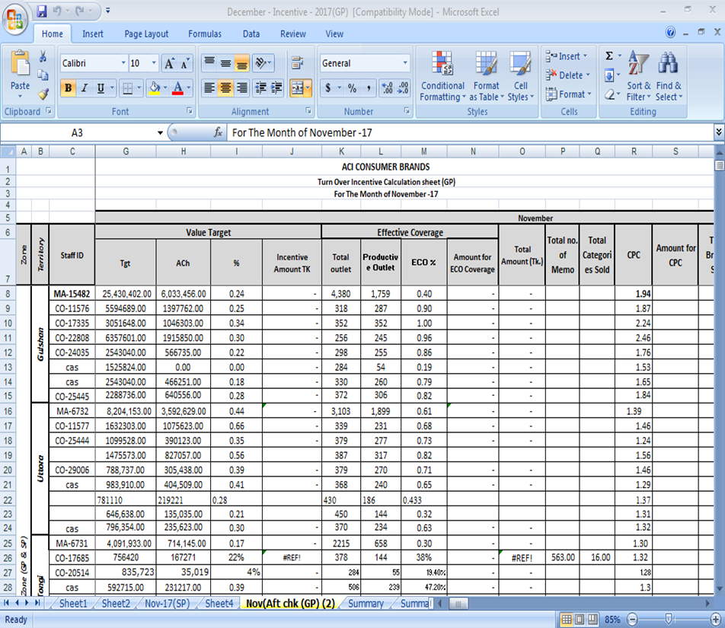
Picture 4.5: Incentive Sheet
Attending Sales Conference:

ACI sales Consumer Brand arrange sales conference program 2018 held at Bashundhara Convention City. All the sales people and marketing and brand team attend that program. In this conference sales people are motivated by their respective managers to develop their skills and it will help them to achieve their targets and goals. As I was here three months, for this I was get opportunity to attend that Conference.

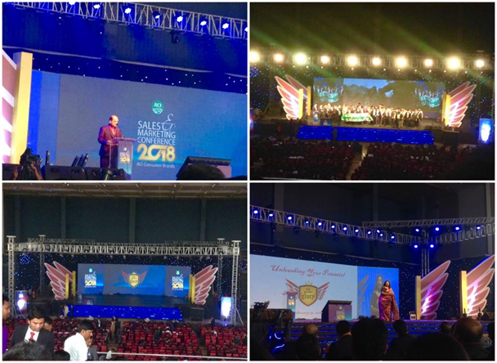
Picture 4.6: Attending Sales Conference

4.6 Learning Experience:

As a student of BBA program I had to perform an internship in a business organization. That was my first experience to work in corporate environment. I was very much confused as well as excited before joining in that company. But surprisingly I have found out everyone is friendly their and no work is so hard. My company supervisor was very helpful to me at every task. He made my tasks so easy and comfortable through his advice and suggestions. Everything gone so well in my internship period. I am grateful that it helps me to adjust with the professional work environment.

One of the most important things that I learn is how to communicate with people related to the business. I usually communicate with ASM, ZSA in regular basis. I communicate with my supervisor over phone and talk about what I found on market visit. I talk with my supervisor about business matter; abut future of the organization and many more things. During my internship period I also talk with other employee and tried to understand how they are doing their job. I have learn how ACI doing their promotional activities, sales activities and production activities.

Part: 5
Research Part

5.1 Problem Statement:

From my observation experience I have found the problem in their Sales and marketing sector “Inefficient promotional mix is hurting sales performance of ACI Coil”.

5.2 Background of the Problem:

This report is based on “Effects of Promotional Mix on Sales Performance of ACI Coil ”. The focus of the study is to analyzing the current market acceptance of ACI Limited based on the increasing sales performance, sales promotional Mix and also developing the advertising for market position. During my internship program at ACI Limited I had observed a major issue which was more sensitive to give close attention. As ACI Limited is popular brand but there are few products which are not popular in market Like Coil. Because of poor sale promotional actives like less powerful and effective advertising. Lack of less promotional mix and advertising (Social media/TVc ads, Newspaper, digital marketing and outdoor advertising) fall their sales. But now ACI Coil trying to overcome their lacking.

My objective of the research is to find out developing sales performance and sales promotion of ACI Coil and feedback of the market about their brand position. So, based on the objects of my study I make a Hypothesis Testing to research on it and in this research, I find out some relative Issues and give the solution for ACI Coil.

5.3 Project Line

To prepare these project 82 days were needed. The following table shows the time I had required in each step for the project.

Task | Day
Topic Selection | 7
Organization Part | 6
Topic Part | 10
Information Collection | 10
Actual Task Part | 5
Hypothesis and Questionnaire Development | 9
Survey and Personal Interview | 10
Data analysis & Conduct survey research | 10
Report development and Submission | 15

Table 5.1: Project Line

5.3.1 Graphically Representation of My Project Work:

 | Timeline
Task/ Date | June  3-11 | June  12-17 | June  18-28 | June 29 - Feb 8 | July 9-14 | July 15-23 | July24 – 5Aug | Aug 6 - 15 | Aug 16-Sep2
Topic Selection
Organization Part
Topic Part
Information Collection
Actual Task Part
Hypothesis and Questionnaire Development
Survey and Personal Interview
Data analysis & Conduct survey research
Report development and Submission

Figure 5.1: Gantt chart for Project Timeline

5.4 Budget Information:
SL. No | Particulars | Amount in Taka(Approximately)
1 | Transportation | 7500
2 | Mobile Bill | 600
3 | Internet | 500
4 | Printing, Photocopy | 1000
5 | Others | 500
 | Total = | 10,100 /=

Table 5.2: Budget Information

5.5 Research Methodology:
While I was conducting the study, I have collected various types of primary and secondary data. Data has been collected through different sources like by taking interviews to the customers. The questionnaire contained only Liker scale. Secondary information has been collected through different journals, books, research publications and organizational website.

5.5.1 Research Approach:
➢Survey

5.5.2 Type of research:
➢Quantitative.

5.5.3 Research Instrument:
➢Questionnaire with Structure questions.

5.5.4 Data Sources:
I collected my whole data based on two sources. These sources are given below

Primary Data:

By observing three months Internship project time of period I collected the primary data from the Employee and Clients of ACI Limited Through Structured Questionnaires. How I collect my Questionnaires from them is given below-
i. Talk with mySupervisor
ii. Discuss with the managers and staffs
iii. Face to face conversation with the customers.
iv. Conversation with the other people
v. Personal discussion with Salespeople and office employee.

Secondary Data:

Secondary data had been collected from various report like-
i. Website of ACI Limited
ii. Prospectus
iii. Published documents
iv. Some important files.

5.6 Population:
The population of this research project is defining as follow:
Elements :Retailers
Unit :Individual employees and sales people of ACILimited
Extent : Office: Nina Kabbo, 277/A, Tejgaon Industrial Area, Dhaka-1208
5.7 Research Design:
5.7.1 Sampling Plan:

After deciding my research approach, I design a sampling plan on three decisions including sampling Frame as follows-
Sample Unit :Retailers (Uttara, Gulshan, Gazipur).
Sample Frame :My sample frame is those people, who are employees &Customer include in ACI Limited.
Here Sample size, n= 42
Sampling Procedure :The respondents should be chosen in different sources and the procedure was Probability Sampling (Simple Random Sampling).

5.8 Develop Independent Variables & Dependent Variables:
Independent Variables

Dependent Variables
1. Social Media(e.g. Facebook & Company website)

2. TVc

3. Newspaper

4. Celebrity Ads(e.g. Movie & Drama celebrity)

5. OutdoorAdvertising (e.g. Billboard)

Will increase the sales performance of ACI Coil

Diagram 5.8: Independent Variables & Dependent Variables
5.9 Data Analysis:
Result Finding : MS Excel
Hypotheses Test : Z test

The following formula has been followed:
We know that,
Z test = ($\overline{X}$–μ) / (σ/√n)
Where,
µ = Mean Value
n = Sample Size
σ = Standard Deviation
($\overline{X}$) = Average

5.10Questionnaire Scale &Hypothesis Development:

A very crucial segment of a survey is hypothesis development and testing. The hypothesis is just a general statement with in-depth significance. It is presented before the respondents as a form of 5 Liker Scale. The hypothesis is very useful to figure out the thoughts of people regarding any particular issue.

Questionnaire Scale:

In order to analyze the responses a 5-point Liker Scale has been used.
Options to Respond | Weight
Strongly Disagree | 1
Disagree | 2
Neutral | 3
Agree | 4
Strongly Agree | 5
Table 5.3: Questionnaire Scale
Hypothesis Development:

H1: | Using social media Ads (e.g. Facebook& company Website) will increase the sales of ACI Coil.
H2: | Using Radio/ TVc Ads will increase the sales of ACI Coil.
H3: | Using Newspaper (e.g. Bangla &English) Advertisement will increase the sales of ACI Coil.
H4: | Using popular face on TVc (e.g. Movie & Drama celebrity) will increase the sales of ACI Coil.
H5: | Using Outdoor advertising (e.g. Billboard ads) will increase the sales of ACI Coil.
Table 4: Hypothesis Development

H1) Hᴏ: Using social media Ads will not increase the sales of ACI Coil
Hᴀ: Using social media Ads will increase the sales of ACI Coil.
H2) Hᴏ: Using Radio/ TVc Ads will not increase the sales of ACI Coil.
Hᴀ: Using Radio/ TVc Ads will increase the sales of ACI Coil.
H3) Hᴏ: Using Newspaper Advertisement will not increase the sales of ACI Coil.
Hᴀ: Using Newspaper Advertisement will increase the sales of ACI Coil.
H4) Hᴏ: Using popular face or celebrity on TVc will not increase the sales of ACI Coil.
Hᴀ: Using popular face or celebrity on TVc will increase the sales of ACI Coil.
H5) Hᴏ: Using Outdoor advertising will not increase the sales of ACI Coil.
H_{A}: Using Outdoor advertising will increase the sales of ACI Coil.

5.11 Hypothesis Testing:
Likert Scale |  | H1 | H2 | H3 | H4 | H5
Strongly Disagree (1) |  | 6 | 7 | 5 | 8 | 8
Disagree (2) |  | 5 | 4 | 7 | 7 | 3
Neutral (3) |  | 2 | 3 | 10 | 4 | 9
Agree (4) |  | 7 | 8 | 9 | 14 | 12
Strongly Agree (5) |  | 22 | 20 | 11 | 9 | 10
Calculation | Total | 172 | 156 | 140 | 135 | 139
Calculation | Average | 4.09 | 3.72 | 3.33 | 3.21 | 3.30
Calculation | Standard Deviation | 1.57 | 1.53 | 1.35 | 1.44 | 1.40
Calculation | Z Test | 6.63 | 5.17 | 3.81 | 5.84 | 3.63
Table 5.4: Hypothesis Testing (Summary of the Survey Respondents)

5.11.2 Graphical Representation:
Hypothesis #1:
Hᴏ: Using social media Ads will not increase the sales of ACI Coil.
Hᴀ: Using social media Ads will increase the sales of ACI Coil.

In other words,
H0: µ = 2.5
HA: µ >2.5
n=42
Since the sample size n > 30 so, I may use z - test.

Here,
$\overline{X}$=172/42=4.09
$$Standard deviation: =\sqrt{\frac{6{\left(1-4.09\right)}^{2}+5{\left(2-4.09\right)}^{2}+ 2{\left(3-4.09\right)}^{2}+7{\left(4-4.09 QUOTE \overline{x}\right)}^{2}+22{\left(5-4.09 QUOTE \overline{x}\right)}^{2}}{42}}$$
σ = 1.57

Z Calculation:

In a 5point scale µ is 2.5
Z =$\frac{\overline{x}–μ}{\frac{s}{\sqrt{n}}}$
= (4.09-2.5)/(1.57/√42)
=6.63

It has been observed that the tabulated value of Z_{0.05} = 1.645 and the calculated value of Z_{Cal} = 6.63 which is not within acceptable region so the Null hypothesis is rejected. And at 5% level of significance, it can be said that using social media Ads will be increased the sales of ACI Coil.

Figure 5.1: H#1, Respondent’s percentage towards using social media Ads will increase the sales of ACI Coil.
Hypothesis # 2
Hᴏ: Using Radio/ TVc Ads will not increase the sales of ACI Coil.
Hᴀ: Using Radio/ TVc Ads will increase the sales of ACI Coil.

In other words,
H₀: µ = 2.5
H_{A}: µ >2.5
n = 42
Since the sample size n > 30 so, I may use z - test.
Here,
$\overline{X}$ =156/42 = 3.72
$$Standard deviation =\sqrt{\frac{7{\left(1-3.72\right)}^{2}+4{\left(2-3.72\right)}^{2}+ 3{\left(3-3.72\right)}^{2}+8{\left(4-3.72 QUOTE \overline{x}\right)}^{2}+20{\left(5-3.72 QUOTE \overline{x}\right)}^{2}}{42}}$$
σ = 1.53

Z calculation:

In a 5 point scale µ is 2.5
Z =$\frac{\overline{x}–μ}{\frac{s}{\sqrt{n}}}$
=(3.72-2.5)/(1.53/√42)
= 5.17

It has been observed that the tabulated value of Z_{0.05} = 1.645 and the calculated value of Z_{cal} = 5.17 which is not within the acceptable region so the Null hypothesis is rejected. And at 5% level of significance, it can be said thatusing Radio/ TVc Ads will increase the sales of ACI Coil.

Figure 5.2: H#2, Respondent’s percentage towards using Radio/ TVc
Ads will increase the sales of ACI Coil.

Hypothesis # 3
Hᴏ: Using Newspaper Advertisement will not increase the sales of ACI Coil.
Hᴀ: Using Newspaper Advertisement will not increase the sales of ACI Coil.
In other words,
H₀: µ = 2.5
H_{A}: µ >2.5
n = 42
Since the sample size n > 30 so, I may use z - test.
Here,
$\overline{X}$ =140/42 = 3.33
$$Standard deviation =\sqrt{\frac{5{\left(1-3.33\right)}^{2}+7{\left(2-3.33\right)}^{2}+ 10{\left(3-3.33\right)}^{2}+9{\left(4-3.33 QUOTE \overline{x}\right)}^{2}+11{\left(5-3.33 QUOTE \overline{x}\right)}^{2}}{42}}$$
σ = 1.35

Z calculation:

In a 5 point scale µ is 2.5
Z =$\frac{\overline{x}–μ}{\frac{s}{\sqrt{n}}}$
=(3.33-2.5)/(1.35/√42)
= 3.81

It has been observed that the tabulated value of Z_{0.05} = 1.645 and the calculated value of Z_{cal} = 3.81 which is not within the acceptable region so the Null hypothesis is rejected. And at 5% level of significance, it can be said thatusingNewspaper Advertisement will increase the sales of ACI Coil.

Figure 5.3: H#3, Respondent’s percentage towards using Newspaper
Advertisement will increase the sales of ACI Coil.

Hypothesis # 4
Hᴏ:Using popular face or celebrity on TVc will not increase the sales of ACI Coil.
Hᴀ:Using popular face or celebrity on TVc will increase the sales of ACI Coil.
In other words,
H₀: µ = 2.5
H_{A}: µ >2.5
n = 42
Since the sample size n > 30 so, I may use z - test.
Here,
$\overline{X}$ =135/42 = 3.21
$$Standard deviation =\sqrt{\frac{8{\left(1-3.21\right)}^{2}+7{\left(2-3.21\right)}^{2}+ 4{\left(3-3.21\right)}^{2}+14{\left(4-3.21 QUOTE \overline{x}\right)}^{2}+9{\left(5-3.21 QUOTE \overline{x}\right)}^{2}}{42}}$$
σ = 1.44

Z calculation:

In a 5 point scale µ is 2.5
Z =$\frac{\overline{x}–μ}{\frac{s}{\sqrt{n}}}$
=(3.21-2.5)/(1.43/√42)
= 5.84

It has been observed that the tabulated value of Z_{0.05} = 1.645 and the calculated value of Z_{cal} = 5.84 which is not within the acceptable region so the Null hypothesis is rejected. And at 5% level of significance, it can be said thatusingpopular face celebrity on TVc will increase the sales of ACI Coil.

Figure 5.2: H#3, Respondent’s percentage towards usingpopular face celebrity will increase the sales of ACI Coil.

Hypothesis # 5
Hᴏ:UsingOutdoor Advertising will not increase the sales of ACI Coil.
Hᴀ:Using Outdoor Advertising will increase the sales of ACI Coil.
In other words,
H₀: µ = 2.5
H_{A}: µ >2.5
n = 42
Since the sample size n > 30 so, I may use z - test.
Here,
$\overline{X}$ =139/42 = 3.30
$$Standard deviation =\sqrt{\frac{8{\left(1-3.30\right)}^{2}+3{\left(2-3.30\right)}^{2}+ 9{\left(3-3.30\right)}^{2}+12{\left(4-3.30 QUOTE \overline{x}\right)}^{2}+10{\left(5-3.30 QUOTE \overline{x}\right)}^{2}}{42}}$$
σ = 1.40

Z calculation:

In a 5 point scale µ is 2.5
Z =$\frac{\overline{x}–μ}{\frac{s}{\sqrt{n}}}$
=(3.30 -2.5)/(1.40 /√42)
= 3.63

It has been observed that the tabulated value of Z_{0.05} = 1.645 and the calculated value of Z_{cal} = 3.63 which is not within the acceptable region so the Null hypothesis is rejected. And at 5% level of significance, it can be said thatusing Outdoor Advertising will increase the sales of ACI Coil.

Figure 5.2: H#3, Respondent’s view towards using Outdoor Advertising will increase the sales of ACI Coil.

5.12 Findings:
From hypothesis-1 it can be observed that 14% respondents are strongly disagreed, 12% respondents are disagreed, 5% respondents are neutral, 17% respondents are agreed and 52% respondents are strongly agreed which indicates that using social media Ads will increase the sales of ACI Coil.
It’s notified from hypothesis-2, 17% respondents are strongly disagreed, 9% respondents are disagreed, 7% respondents are neutral, 19% respondents are agreed and 48% respondents are strongly agreed which indicates that using Radio/ TVc Ads will increase the sales of ACI Coil.
From hypothesis-3 it is revealed that 12% respondents are strongly disagreed, 17% respondents are disagreed, 24% respondents are neutral, 21% respondents are agreed and 26% respondents are strongly agreed which indicates using Newspaper Advertisement will increase the sales of ACI Coil.
It’s observed from hypothesis-4, 19% respondents are strongly disagreed, 17% respondents are disagreed, 10% respondents are neutral, 33% respondents are agreed and 21% respondents are strongly agreed which indicates that using popular face or celebrity on TVc will increase the sales of ACI Coil.

From hypothesis-5 it can be seen that 19% respondents are strongly disagreed, 7% respondents are disagreed, 21% respondents are neutral, 29% respondents are agreed and 24% respondents are strongly agreed which indicates that using Outdoor advertising will increase the sales of ACI Coil.

5.13 Recommendation:

From my point of view, I have given some recommendations that may improve ACI Limited. They are given below:

• From hypothesis-1, it can be seen that 52% respondents were strongly agreed that using social media Ads will increase the sales of ACI Coil. But still 14% respondents were strongly disagreed. For this reason, ACI Limited should be using social media Ads (e.g. Facebook & company Website) that will increase their sales of coil.

•Radio/TVc ads also effective advertisement that can increase the sales which has been found from hypothesis-2, 9% of the respondents were disagreed on this statement. So, ACI Limited should that be using Radio/ TVc Ads will increase their sales of Coil.

• It has been noticed from hypothesis-3, Newspaper Advertisement will increase the sales but still there were 17% respondents who were disagreed on it. So, ACI Limited should keep working on newspaper advertising to improved their sales.

•It’s already seen from hypothesis-4, by popular face or celebrity on TVc will increase the sales of ACI Coil but still 17 % of the respondents were disagreed on it. So, ACI should keep their eyes on this matter for their continuous improvement.

•Outdoor advertising will increase the sales of ACI Coil but it has also found from hypothesis-5 that 7% of the respondents were disagreed with it. So, ACI should get to find out the reason behind of this for improving their Billboard ads.
5.14 Conclusion:
ACI Limited Bangladesh is popular Brand. But their Mosquito Coil products performances are weak than other products. Because of lake of promotion, competitors, quality etc. But now they are trying to improved their products. The reason behind their success can be described through their efficient marketing strategy. This strategy is described separately in the order of product, pricing, placing, production and promotion in this report. ACI Coil should relentlessly strive elevate the brand to become the number 1 consumer brands company in Bangladesh. Their aim is also to offer the people convenience through establishment of a large and extensive dealer network throughout the country. ACI Coil is continuously increase distribution channels. improving standard quality, through maintain high standards and commitment to creating outstanding opportunities for professional growth so that associates can achieve their highest potential. They are now focusing on developing their sales and promotional mix in the market. They are now following some marketing strategy. Ultimately, their goal of doing these activities is to persuade to increase their sales. They need to promote their products in various ways. In order to become the market leader, they must develop their strategy. However, ACI limited also faces many challenges in the near future. Specially they big plan for their Coil products as it is giving highest market share. Though they are doing some promotional activities for Coil but they should come up with even more ideas for their promotional mix. The company need to focus on develop the sales as well as they need to promote their product through the radio, television, newspaper, outdoor advertising and through other strategy. If ACI Coil is able to overcome all the difficulties mentioned above, there is no doubt that within a short period time, the company will have undefeatable advantages in the market. That’s the way ACI Coil achieve their success day by day.

Part: 6
Appendix

6.1 Bibliography:

1 | ACI background of Organization 2017, ACI Limited, viewed 17 June 2018, <http://www.aci-bd.com/about-us/company-profile.html>.
2 | ACI historical background 2018, ACI Limited, viewed 21 June 2018,  <http://www.aci-bd.com/about-us/company-profile.html>.
3 | ACI Strategic Business 2013, ACI Limited, viewed 21 June 2018,  <http://www.aci-bd.com/business-units2.php>.
4 | Corporate Governance 2016-2017, ACI Limited, viewed 22 June 2018, <http://www.aci-bd.com/corporate-governance-compliance-status>.
5 | Chairman’s Profile 2000 – 2018, Advanced Chemical Industries Limited, viewed 26 June 2018, <http://www.aci-bd.com/chairman.php>.
6 | The board of director 2013, ACI Limited, viewed 26 June 2018,  <www.aci-bd.com/acifl/the-board-of-directors.html‎>
7 | 2017, ACI Limited, viewed 10 July 2018,  <http://www.aci-bd.com>
8 | Sales performance definition2017, Bizfluent, viewed 26 Aug 2017,<https://bizfluent.com/facts-6945389-sales-performance-definition.html‎>.
9 | Sales performance 2016, Aero Leads, viewed 25 Aug2018, <https://aeroleads.com/blog/>.
10 | http://www.businessdictionary.com/definition/promotion-mix.html
11 | Promotion mix 2018, Wikipedia, viewed 22 Aug 2018  <https://en.wikipedia.org/wiki/Promotional mix‎>.
12 | William J. Stanton Monday, Aug 6, 2013, Mass Communication, viewed 14 Aug 2018,  <http://www.yourarticlelibrary.com/essay/advertisement-definition...of-advertisement/27984>.
13 | The State of Queensland 1995–2018, Queensland Government, viewed 2 Sep 2018,  <https://www.business.qld.gov.au/runningbusiness/marketingsales/.../advertising/types>.
14 | Promotion Mix 2018, Business Jargons, viewed 26 July 2018,  <https://businessjargons.com/>.
15 | Home care products 2010, Advanced Chemical Industries Limited. viewed 28 Aug 2018, <www.aci-bd.com/home-care-products.php‎>.

Survey Research Questionnaire
Dear Respondent,
Good day. I am a student of Bachelor of Business Administration from United International University. Please go through the following questionnaires and identify the appropriate response for each of them. Here I am doing my research on the following topic: “Effects of Promotional Mix on Sales Performance of ACI Coil ”. Please complete the following questionnaires.
Name……………………………………………………………………………………………
Age……………………………………………………………………………………………...
Gender…………………………………………………………….Q………………………….
Cell No………………………………………………………………………………………….
[Please put a tick mark for the following questions. Thanks a lot for your co-operation]
Question | Strongly Disagree (1) | Disagree (2) | Neither Disagree nor Agree (2) | Agree (4) | Strongly Agree (5)
Do you agree that using social media Ads will increase the sales of ACI Coil?
Do you agree that using Radio/ TVc Ads will increase the sales of ACI Coil?
Do you agree that using Newspaper Advertisement will increase the sales of ACI Coil?
Do you agree that using popular face or celebrity on TVc will increase the sales of ACI Coil?
Do you agree that using Outdoor Advertisingwill increase their sales of ACI Coil?

6.2 Abbreviation:
Abbreviations | Elaboration
UIU | United International University
SOBE | School of Business and Economics
BBA | Bachelor of Business Administration
Pvt. | Private
ACI Ltd. | Advanced Chemical Industries Limited
SR | Sales Represented
ZSM | Zonal Sales Manager
ASM | Area Sales Manager
SS | Sales Supervisor
ISO | International Organization for Standardization
GP | General Product
SP | Special Product
DP | Distributor Price
TP | Trade Price
MRP | Maximum Retail Price
SKU | Stock Keeping Unit
μ | Mean Value
n | Mean Value
σ | Standard Deviation
$$\overline{X}$$ | Average

