|CARE ME BD
Because we care

Internship Report on
“Sales & Marketing Activities of Care Me BD”

Name of the student
Borhan Uddin

This report is submitted to the school of Business and Economics, United International University as a partial requirement for the degree fulfillment of Bachelor of Business Administration
Internship Report
“Sales & Marketing Activities of Care Me BD”

Submitted To
Dr. Seyama Sultana
Associate Professor
Department of Marketing

Submitted To
Borhan Uddin
ID: 111 161 375
Major: Marketing
Trimester: Summer 2020


School of BUSINESS and ECONOMICS
UNITED INTERNATIONAL UNIVERSITY

Date of submission
13th October, 2020

Letter of transmittal

13th October, 2020
Dr. Seyama Sultana
Associate Professor,
Department of School of Business and Economics
United International University.
Subject: Submission of Internship report on “Sales & Marketing Strategies of Care Me BD.”
Dear Madam,
With due respect, I have pleasure to submit the internship report on “Sales & Marketing activities of Care Me BD” as a portion for the completion of INT 4399 course. I am delighted to inform you that this was certainly an interesting opportunity for me to work on CMB and also topic selected to enhance our practical knowledge. I want to thank you for giving me the chance to do the consideration. I tried my best to work on it with care and sincerity in order to make the report informative. I have put my sincere effort into giving this report a presentable form and making it informative.
Hence, I sincerely hope that the report wills fulfill your expectations and it’ll be outstandingly fulfilled for me in case you'll appreciate my dedication, exertion and acknowledge my internship report for the appropriate purpose.

Yours sincerely,
__________________________
Borhan Uddin
ID: 111 161 375
United International University

Declaration of the student

Hereby I am declared that,

- The presented internship report entitled "Sales & Marketing Activities" of Care Me BD (Online Shopping Store) is uniquely prepared by me after three months of work at Fortune Tech Ltd (Elephant Road Branch) has been completed.
- This Internship report has been prepared by my own work & study while my all academic course have been finished on 10th may at United International University.
- The report contains no previously published or written material from a third party; except where this is adequately cited by full and accurate reference.

- I assure you that the report is only for my academic - educational purposes not for any other purpose like any other degree or diploma at a university or other institution. It might not be utilized with the intrigued of the inverse party of the E-Commerce Company.
- All main sources of assistance and guidance, I have acknowledged.

Student’s Full Name & Signature:


Supervisor’s Full Name & Signature:

----------------------------------------------------------

Acknowledgement

Within the starting, I would begin expressing gratitude toward the all-powerful Allah for making me able to prepare my internship report. It was a colossal joy for me to prepare the internship report on “Sales & Marketing Activities of Care Me BD (CMB)”.
I would like to thank my supervisor Dr. Seyama Sultana, Associate Professor, Department of Business Administration, United International University Bangladesh.
Then I would like to place my gratitude to all marketing officers of FTL (Fortune Tech Limited) for enabling me to complete my internship in their regarded organization.
My honest admiration goes to Mr. Anisul Islam Sumon (Managing Director) Fortune Tech LTD for his valuable time, diligence and clues in preparing the report. I am thankful to Mr. Henoy, Business Development, Fortune Tech LTD. for supervising me.
During my training, all members of FTL supported me, gave time, direction & guidance for preparing the report. I really gratefully to them for their valuable responses.

Executive Summary

Care Me Bangladesh is a startup E- commerce company in Bangladesh. But they are bringing new items for their customers by following new trends & solution of problems by a product. Since, Care Me Bangladesh’s main target is to gain the top position in the top 10 list of E-commerce in the world; they are always trying to capture the E-commerce market with most effective way. In my analysis of external factors of Care Me, some of the factors such as Economic factors, Technological factors which are mostly affected to the company for running their business. But other factors do not have such an effect. In internal analysis, their strengths are good quality web site which is number one position in searching list, unique products variety which are solving the problems of customers. Weakness is – Creating brand awareness but they are working on it continuously. Threats are low internet accessibility in Bangladesh but their opportunity is because they are trying to solve the customers’ problem by giving unique products, the chance of the increasing market share is high in the E- commerce sector in Bangladesh.

Table of Contents

Contents
Letter of transmittal i
Declaration of the student ii
Acknowledgement iii
Executive Summary iv
Table of Contents v
List of Figures vii
Introduction: 2
1.1 Background of the Study 3
1.2 Objective of the report 3
1.3 Scope of the report 4
1.4 Limitations of the report 4
2.1 Company Analysis 7
2.1.1 Background of the Organization: 7
2.1.2 Fortune Tech Limited at a Glance: 8
2.1.3 Hierarchy of Fortune Tech Limited 9
2.1.4 Products & Services of Fortune Tech Limited 10
2.1.6 Overview of the Care Me BD 13
2.1.7 Mission, Vision & Objective of Care Me BD 15
2.1.8 Care Me BD at a Glance: 16
2.1.9 Trends & Growth of Care Me Bangladesh 17
2.1.10 Marketing Mix of Care Me Bangladesh 18
2.1.11 Internal Analysis 21
3.1 External Analysis 25
3.2.1 Political Factors 26
3.2.2 Economic Factors 26
3.2.3 Social Factors 26
3.2.4 Technological Factors 26
3.2.5 Environmental Factors 26
3.2.6 Legal Factors 26
3.2 Porter’s Five Forces 27
3.2.1 Bargaining Power of Suppliers (Low) 27
3.2.2 Threat of Substitutes (Low) 27
3.2.3 Bargaining Power of Buyers (Low) 28
3.2.4 Competitive Rivalry (Low) 29
4.1 Internship Program 32
4.1.1 Daily Routine 32
4.1.2 Use of Office Equipments 32
4.2 Description of the Job 32
4.2.1 Unique Product Research 32
4.2.2 Assist Promotional Activities 33
4.3 Training 33
5.1 Recommendations 35
5.2 Conclusions 36
References 37

List of Table
Table No | Title | Page No
Table 2.1 | Company (Fortune Tech) Overview | 08
Table 2.2 | Care Me BD at a Glance | 16

List of Figure
Figure No | Title | Page No
Figure 2.1 | Organization Structure of the Fortune Tech Limited | 09
Figure 2.2 | Fortune Tech’s Products & Services | 13
Figure 2.3 | Logo of Care Me | 19
Figure 2.4 | Mission & Vision of Care Me | 15
Figure 2.5 | Sales data report of Care Me from 2019 – 2020 | 17
Figure 2.6 | Marketing Mix(4ps) | 18
Figure 2.7 | Product Items of Care Me Bangladesh | 19
Figure 2.8 | SWOT ANALYSIS | 21
Figure 2.9 | Top using of Social Media Platforms for Advertising of Care Me Bangladesh | 22
Figure 3.1 | Forces in the Macro-Environment | 25
Figure 3.2: | Care Me Porter 5 forces | 27

List of Abbreviations
Short Form | Full Form
FTL | Fortune Tech Limited
CMB | Care Me Bangladesh
Ltd | Limited
AD | Advertisement
MD | Managing Director
Dept. | Department
SWOT | Strength, Weakness, Opportunity, Treat
UIU | United International University
BBA | Bachelor of Business Administration

Chapter I

Introduction

Current situation remains in a challenge despite growth
Information technology is an internal part of human life. As a result of internet system information technology has became easier and faster, with the advent of information entered the digital age business though online shopping are gaining popularity along the way about 55 million people I Bangladesh use the internet of which 22 percent people shop online, more than 15 lack customer enjoy the benefit of internet banking even a few years ago we could have no idea about digitalization just a few days ago some young entrepreneurs stood up and creates an online trading platforms using internet along with the huge impact of e-commerce on the world economy, it is also spreading in Bangladesh. The turnover in this sector at home and abroad has exceeded 1700 crore tk. e-commerce is growing commercially worldwide rapidly. As of 2018 , the ecommerce business has earned 25 trillion .if we want to transform Bangladesh to digital level ,we have to look at e commerce. Government has set some policies to improve or expend .the e-commerce business,consumer public cooperation for the overall improve meant of e-commerce, government policies, quality products, e-commerce site proper control, reliable transaction arrangements, supply high quality products must be needed commerce platform is future of business in Bangladesh there is a e commerce industry called e cab which start in 8 November 2015.
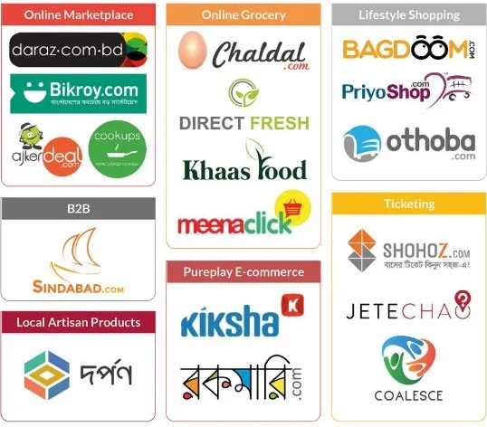
E – Commerce Platforms of Bangladesh

1.1 Background of the Study

For the BBA students, the Internship course of United International University is an Under-graduated obligation. Each of the professional degree needs not only theoretical knowledge but moreover needs practical knowledge to victory in this competitive world. To complete BBA program also need to do internship which is related to the experiment of the theoretical knowledge into the real-life circumstance. The most important reason for the internship is to complete the prerequisites of TNT 4399 (Internship) as a portion of my BBA programs additionally the student gets open to the elements to the work world.

The internship program and the study have following purpose:
- Gaining knowledge & experience of practical job life.
- To match up to the genuine situation with the books, lecture & lessons learned in United International University.
- To provide concentrated field practice permitting for hands-on computer work.
- Introducing with future work situations.
- To complete the prerequisite of Academic program.
My course administrator has advised me to develop a thorough understanding of the “Sales & marketing activities of Care Me BD” as I have completed my internship program from Fortune Tech Limited where my supervisor was Mr Anisul Islam Sumon (Managing Director of FTL).This report is the result of three months long internship program conducted in Fortune Tech Limited and is prepared as a requirement for the completion of the BBA program of United International University.

1.2 Objective of the report
1.2.1 General Objective:
This internship report is prepared primarily to complete the Bachelor of Business Administration (B.B.A) degree requisite under the Faculty of United International University.
1.2.2 Specific Objective:
More purposely, this learning entails the following aspects:
- To give a summary of Fortune Tech limited & Care Me Bangladesh.
- To focus on the various services, work environment and facilities provided by Fortune Tech ltd.
- To focus and discuss the Sales and Marketing activities of Care Me BD.
- Business Associations and Networking with Prospects through Online Platforms and Business Networking and Relationship Building via Key Marketing Initiatives
- To focus on the importance, benefits, reasons of Marketing strategies or activities of Care Me BD.

1.3 Scope of the report

The scope of the report is the Sales and Marketing activities of Care Me BD. The report covers details of Care Me BD's various services, overview, and various departments and divisions. The main focus is on the Sales and Marketing activities analysis. However the topic is related only to the Market Operation Division as I was allowed to work in this division.

1.4 Limitations of the report
- First problem was, since the information has to collect from the market operation department and the department is confidential for providing the information.
- Another main problem was, for the pandemic situation most the marketing activities like drop shipping activities, products research tasks had to be done from home which is why the three months of internship program seemed so short to me.

Chapter II

Company Overview

Company Analysis

This chapter highlights the overall background of the under study company, the overview of the company, their services and market conditions of Fortune Tech Limited & Care Me BD.

Background of the Organization:


The journey of Fortune Tech Limited started from 2014 as a digital marketing agency. They work primarily as –
- Product launching planning services,
- Lead generation services
- Developing Web site
- IT supporting services.
Their main mission is help to global business or companies to take decisions in critical problems or thinking activities for going to success path.
.

Fortune Tech Limited:

Company Profile

Company Name | Fortune Tech Limited
Country | Bangladesh
City | Dhaka
Managing Director | Mr. Anisul Islam Sumon
Corporate Head Office | Elephant Road Bata Signal , Sahera Tropical Center, Suite-8, 12th Floor,  Dhaka – 1205
Telephone | +8801613 830 710
Email | sumon@fortunetech.com.bd
Bank | Pubali Bank Ltd.  City Bank
Web | http://fortunetech.com.bd/  https://caremebd.com/
Sales & Marketing | Hotline  +8801613 830 710,  +8801713 830 710

Table 2.1: Company Overview

Hierarchy of Fortune Tech Limited

Figure 2.1: Organization Structure of the Fortune Tech Limited

Products & Services of Fortune Tech Limited

Figure 2.2: Fortune Tech’s Products & Services

Brands (Fortune Tech Limited)

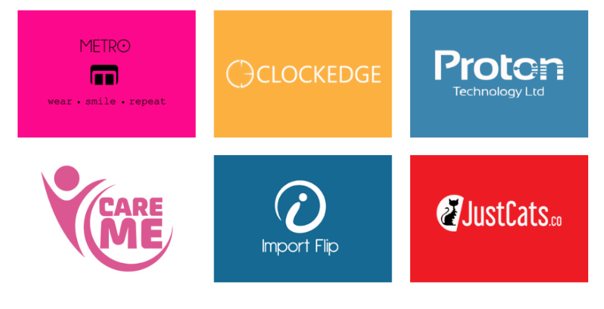
Have skills on   | Manufacture  Wholesaler and exporter of men,  Women  And children’s clothing/garments.
2.1.5.1 Metro Outfitters

2.1.5.2 Clockedge
Have skills on   | Content Marketing,  SEO Consultancy,  SEO Services,  Online Campaign Management,  Web Design,  App Store Optimization,  Social Media Marketing,  And Mobile Campaign Management

2.1.5.3 Proton Technology
Have skills on |   Security Solution,  Access Control,  CCTV Installation,  Gadgets,  Corporate Gifts

2.1.5.4 Import Flip
Have Skills on |   Freight service,  Warehousing  And sourcing

2.1.5.5 Justcats
Have Skills on |   Pet Products Supplier


Overview of the Care Me BD

Figure 2.3: Logo of Care Me

Care Me BD is a beauty and personal care brand in Bangladesh. They started their journey with the help of 'Fortune Tech Limited'. They continue their journey with cosmetics of various popular and reputed brands as well as all the interesting products of everyday use. There are some products that consumers may be looking for in their mind but any online shops in Bangladesh haven’t thought for marketing. They have brought those products only thinking of consumers. The main purpose of ‘Care Me’ is to provide consumers with a number of items that are used daily and make daily life easier.
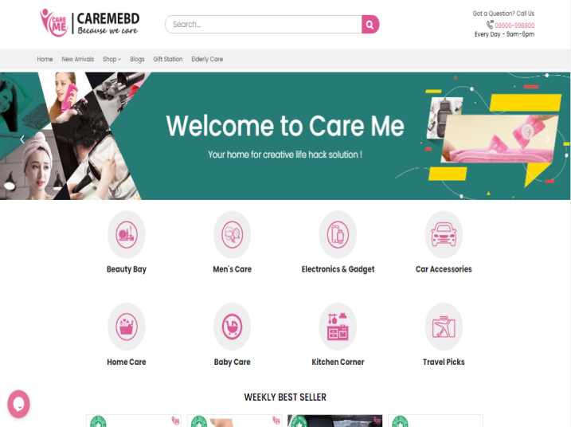
Their goal is to make consumers daily life less time consuming and less difficult. Care Me is not only just in name, but in action, is committed to being completely caring for consumers needs. They are completely uncompromising in terms of product quality, so in the first year alone, millions of customers have become regular customers there.
As a unique online shop in Bangladesh, the primary goal of ‘Care Me’ is to provide products that cater to the needs of all. They hope to see their selves as one of the top ten brands in the world in the future. As an online shop, ‘Care Me’ is committed to brightening the name of Bangladesh. Although they currently supply products from different countries, they hope that one day they will become self-sufficient in this country.

Mission, Vision & Objective of Care Me BD

Vision
Building a position in the list of top 10 brands in the future.

Mission
To provide consumers with a number of items that are used daily and make daily life easier.

Objective
To complete the mission and vision, there are some goals that need to be followed. So, Care Me Bangladesh in addition to try to focus on many objectives to attain its full potential and these are:
- Care me Bangladesh work to make everyday lifestyle easier and determines their advantages and disadvantages in product selection to the customers.
- By providing the distinctive items within the reasonable price which are useful for the consumers on their daily life activities & building strong relationship with loyal customers, Care Me Bangladesh tries to gaining the E- commerce market position.
- Improving customers experience by satisfying them with viably & effectively.
- Various arrangements will always be made to provide assistance to the buyers.
- Developing the E commerce industry in the Bangladesh with news trends.

Care Me BD:

Name of the comapny | Care Me BD
Foundation Year | 2017
Brief | Personal & beauty care brand
Website | http://caremebd.com
Location | Suite-8, 12th Floor, Sahera Tropical Center, Elephant Road Bata Signal, Dhaka – 1205.
Company Size | 20-55 staffs
Expertise’s | Exclusive life hacking products collection.

Table 2.2: Care Me BD Overview

Trends & Growth of Care Me Bangladesh

Sales Data Report of Care Me Bangladesh (Sep 2019 - Dec 2019)
Account | Account Code | Sep-19 | Oct-19 | Nov-19 | Dec-19
Account | Account Code | Total | Total | Total | Total
Operating Income
Discount |  | -27,746.00 | -32,128.50 | -38,606.08 | -110,929.75
Other Charges |  | -12,104.00 | -6,714.00 | -12,284.42 | -9,529.25
Sales |  | 3,530,030.00 | 3,188,825.00 | 1,752,166.50 | 2,702,890.00
Shipping Chare |  | 273,960.00 | 259,960.00 | 119,970.00 | 185,700.00
Sales Data Report of Care Me Bangladesh (Jan 2020 - Apr 2020)
Account | Account Code | Jan-20 | Feb-20 | Mar-20 | Apr-20
Account | Account Code | Total | Total | Total | Total
Operating Income
Discount |  | -41,399.70 | -13,045.60 | -6,299.55 | 0.00
Other Charges |  | -34,301.80 | -16,026.90 | -5,267.45 | 0.00
Sales |  | 2,674,792.50 | 1,840,284.50 | 697,531.00 | 0.00
Shipping Chare |  | 209,270.00 | 142,550.00 | 52,200.00 | 0.00
Sales Data Report of Care Me Bangladesh (May 2020 - Aug 2020)
Account | Account Code | May-20 | Jun-20 | Jul-20 | Aug-20
Account | Account Code | Total | Total | Total | Total
Operating Income
Discount |  | 0.00 | -9,841.00 | -8,976.15 | -38,014.55
Other Charges |  | 0.00 | -2,041.00 | -21,006.85 | -11,967.45
Sales |  | 0.00 | 2,741,765.00 | 2,903,780.00 | 4,168,355.00
Shipping Chare |  | 0.00 | 107,900.00 | 109,420.00 | 358,900.00

Figure 2.5: Sales data report of Care Me from 2019 – 2020

Marketing Mix of Care Me Bangladesh

Promotion

Place

Price

Product

Marketing Mix (4Ps)
Figure 2.6: Marketing Mix

The marketing mix is combination product, price, place & promotions that impact on customers’ needs wants and satisfaction.
Marketing 4ps described as follow:
Product
Product item is the foremost vital component of Care Me Bangladesh for gaining customer satisfaction. Care Me Bangladesh is a developing company. Care Me Bangladesh continuously conveys quality items to their clients.
So its items include –

Figure 2.7: Product Items of Care Me Bangladesh
Price:
Care Me Bangladesh’s product prices vary depends on the unique item, trends, product quality & service warranty as well as others facilities pricing decision should take taking into consideration account profit margins and probable pricing response of consumer and rival.
Care Me Bangladesh is using “Competitive pricing” Strategy.
- Most of the time product prices vary depends on the unique item, trends, product quality & service warranty.
- Prices changed when shipping cost is increased.

Place:
Care Me Bangladesh has earned a reputation by giving 5 years of quality service to the customers. Now, the company has designed and constructs big-budgeted E-commerce companies with high technology as well as modern facilities for online marketing. Their main aim is to satisfy their customer with more facilities in suitable places in Dhaka City.
Their items areas are given underneath:
1. Baridhara
2. Gulshan
3. Banani
4. Dhanmondi
5. West Dhanmondi
6. St Dhanmondi
7. Mohammadpur
8. Uttara
9. Basundhara
10. Banasree
11. And outside of Dhaka by courier service.
Promotion:
Care Me Bangladesh runs its special exercises for presenting its all products & services to the client. Promotional activity is one of the major components to increase its sales volume. CMB takes after distinctive to advance its items. Their Limited time exercises are the following:
Advertising: Advertising is the foremost viable limited time instrument to advance any items. CMB allow advertising of their items toss underneath methods:
- Electronic Media: Care Me Bangladesh use E-media for the Advertisement such as Face book, Instagram, Websites and others.
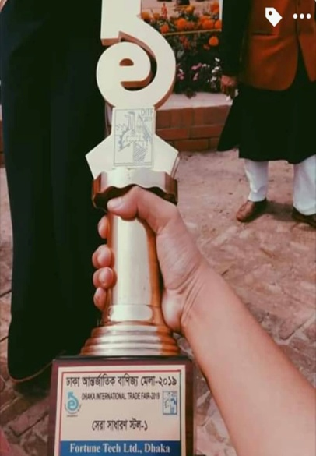
Sales Promotion: Sales promotion is the marketing exercise to attract their clients to extend sales of the products. Care Me BD does have sales promotional activities in which they offer occasionally by going to on few occasions as like Care Me Bangladesh reasonable in December each year. But it is controlled and is advertised every so often for a limited time for the clients. Moreover, discounts offer or prices less offer on the items are not offer frequently, they offer occasionally. They do sales promotion for a limited period of time to increase client demand or improve item availability. Examples incorporate item samples, prizes, coupons, challenges, and so on.

Internal Analysis
There are a lot of inside components influencing e-commerce businesses in Bangladesh. Here we tried to center on a few of the major components which have a coordinate impact on Care Me Bangladesh:
SWOT ANALYSIS


Strengths
- Top position in searching list & superior web site: Care Me Bangladesh includes a superior website among competitors like Ajker deal.com, Priyoshop.com etc.
- Branding modern items: Offering branding modern products here. Any second hand or restored goods, Care me Bangladesh does not sell.
- Dealing with famous brands in china: They deal with most famous branding companies of china like Alibaba.com, JD, Little Red Book, Taobao.

Product diversification: Care Me Bangladesh is always changing or expanding to their current products offering on the basis of trends, customer demand, and product solution.
- Social Marketing: Care Me of Bangladesh, they always try to engage their potential customers through Face book , Twitter , Instagram and You tube by posting various products review, product using tutorials, pricing, comments reply or any inquiries of customers, discount offers, customer service etc.

Figure 2.9: Top using of Social Media Platforms for Advertising of Care Me Bangladesh

Weakness
- Creating brand awareness: Most of the people are not listened the name of Care Me Bangladesh. They generally know Daraaz.com or Ajker deal.com

Opportunity
- Depending on online market: Today customers are trending to the shopping of the online platform. So, there is a possibility to increase sales & growth for Care Me Bangladesh.

Threats
- Internet accessibility: In our Bangladesh, internet accessibility is too much low. Most of the people cannot use the internet for buffering or low speed so Care Me Bangladesh is still can’t reach to the lot of potential customers for it.

Chapter III

Industry Analysis

External Analysis

MACRO ENVIRONMENTAL ANALYSIS
There are a part of macro-environmental components which impacts the e-commerce commerce of Bangladesh. Here we attempted to center on those major components which are influencing Care Me Bangladesh:

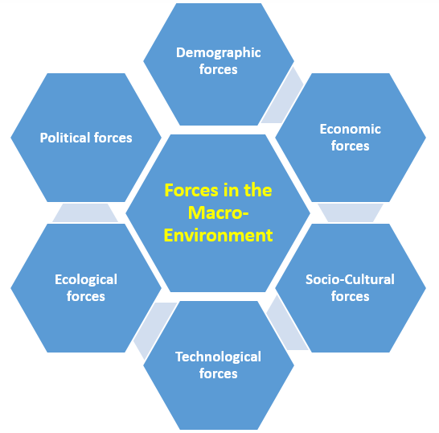
Figure 3.1: Forces in the Macro-Environment

Political Factors
Fore being Care Me Bangladesh is an internet based company, there are no political factors.

Economic Factors
For a less developing country, it’s a big challenge for gaining popularity for an E-commerce company. Unhealthy income, taxes in exporting goods & lack of financial resources can be affected on E-commerce companies. Care Me Bangladesh is also including here.

Social Factors
Social Factors are controlled by the differences in the position of the population. Social factors are formed according to the age and financial status of the population. By making these issues visible, traders working in product selection, marketing and creation have not yet been able to be the most confident in online products, if this idea is able to prove wrong, Care Me will easily capture the E commerce market in Bangladesh with faithfully.

Technological Factors
Technology is developing day by day. Everyone has Smartphone & most of the people now want to buy their liking products from online. So Care Me Bangladesh is centering on portable promoting to capture the market.

Environmental Factors
Biological and natural angles such as climate and climate alter are including in environmental factors, which may particularly influence businesses such as tourism, cultivating and insurance. Care me Bangladesh since it’s a web based E- commerce business this factor won’t be affected it.

Legal Factors
Legal variables incorporate separation rule, buyer rule, antitrust regulation, business rule, as well as physical condition and security act. These variables can influence working of a company, its costs, and products of a company. So, obviously Care Me Bangladesh should maintain these rules for running their business

Porter’s Five Forces
Porter's Five Forces could be a basic but capable apparatus for understanding the competitiveness of your business environment, and for distinguishing your strategy's potential profitability.
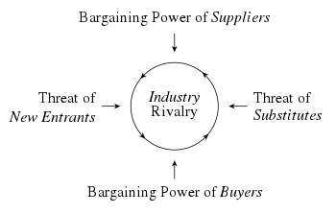

Bargaining Power of Suppliers (Low)
It based on when suppliers has the power of raising their products’ price, low quality of products, limited products of supplying. And for these many companies has not the power of bargaining with the suppliers.
Since, Care Me Bangladesh, all its products are imported from China & they build strong relations with many companies of China, their products suppliers are available, they can reduce the cost of the products & import the products in right time so Bargaining Power of Suppliers is low.

Threat of Substitutes (Low)
When customers can get or find out substitute products with a low price they shift or transfer on the products easily. It’s a big issue for a company if they are not able to bring variety on their product lines.
Care Me Bangladesh, The Company itself is working on substitute products. So the number of their substitute products is less.
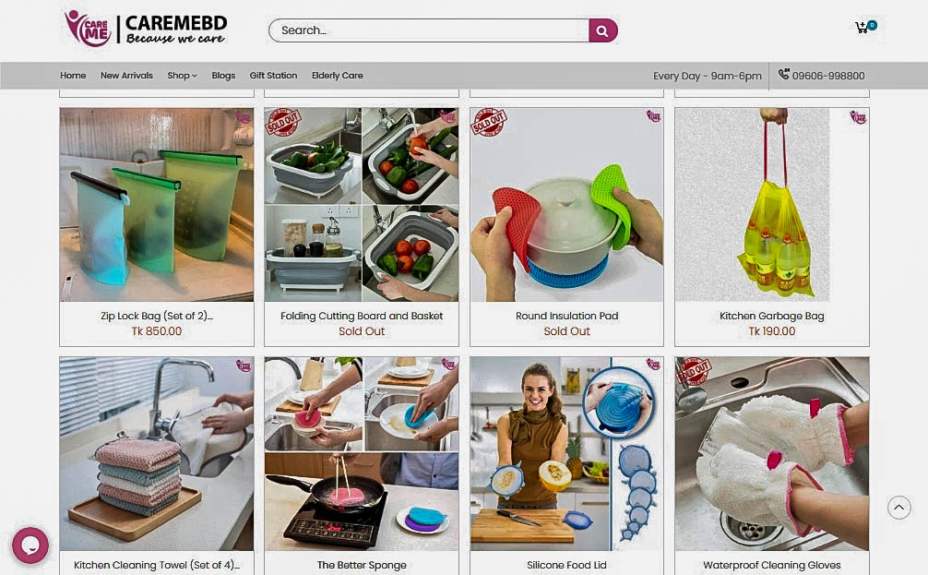

Bargaining Power of Buyers (Low)
When customers can get or find out substitute products with a low price & which are not the solution of the problems of products, they have a chance to bargaining with the price of their choosing items.
All Care Me’s products are new and necessary and usually not easily available in other markets and there is no pressure on the company to reduce the price as almost every product has quality and service quality.

Figure 3.2: Care Me Porter 5 forces

Competitive Rivalry (Low)
Care Me Bangladesh has launched many new & unique products to make the lifestyle of their customers easier and more fashionable. One of these are:

Magic Eye Shadow Stamp

Oil Sprayer Bottle

Disposable Face Towel

Aluminum Credit Card Holder

Charcoal Teeth Whitening Powder

Kitchen Folding Trash Can

Cleaning Steel Ball Brush

Retractable Funnel (Set of 2)

Stainless Steel Cleaning Paste

Scrubbing Brush

Magic Scotch Tape

Zip Lock Bag (Set of 2)

Meat Ball Maker
As there is less competition for these products in the market, competitive rivalry is low.

Chapter IV

Internship Experience

Internship Program
I had the opportunity to work at Fortune Tech Limited as an intern for three (03) months from 20th July 2020 to 20th October 2020 to complete my all academic courses of Bachelors of Business Administration (BBA) degree. Since my major is Marketing, I joined the FTL as a Marketing Executive. I completely included in marketing activities and generally, I worked elated to the product launching plans, drop shipping & marker research & trends of a product. So, in the below I’m taking about my internship experience where I have learnt from FTL during my Internship program.

Daily Routine
From the joining of my internship, I continuously attempt to preserve my regularity and be obedient. The main mission of this internship was to gain down to earth encounter, to gather company information, to recognizable with marketing activities, and understanding of the working environment. My daily work was begun from 9.30 am to 5.30 pm from home & sometimes from office due to the pandemic situation.

Use of Office Equipments
In FTL I was allowed to utilize all the sorts of apparatus of the office benefit. I was permitted to use a computer, Web, Google merchant center, Ad words’ ID to total my essential assignments.

Description of the Job
As I have worked within the marketing division, I completely included in marketing activities and generally I worked with all promotional activities and I was relegated to do the taking after employments regularly, those were:

Unique Product Research
One of my daily tasks was to find unique products for potential clients to make their daily lives much easier on the basis of trends, customers ‘demand & expectations.

Assist Promotional Activities
I have learned and worked generally the promotional tools and strategies from my 3-month internship program. In this period I have learned down to earth knowledge almost promotional blend and other promoting activities. During my internship, I do help them in numerous promotional exercises.
- Analyzing the costs of distinctive social media for Promotion.
- Assist in decision-making for giving Ads in Social Media.
- Post updates information on social media.

Training
- Create and execute imaginative coordinates marketing plans to extend brand awareness utilizing different channels.
- Understanding of the field: Planning, scheduling, budgeting & communicating with customers, observing them all field works activities, I understood during my Internship program.
- If there any mistakes, how to overcome: During my working days, I made mistakes but my senior colleagues & upper managements was exceptionally supportive, he instructed me with care. But at that point once more I did mistakes as well, so he made a few feedback which actually helped to act positive and learned how to handle these circumstances.
- Management of Time Skills: I am treated as a permanent employee during my Internship program. My work time was from 10.00 am to 6.00 pm. From here , I learned how to manage my time on under pressure of work, regularly complete my task on daily basis.

Chapter V

Conclusion & Key Facts

Recommendations
- In this competitive market, it is imperative for companies to outflank other companies additionally set a standard that's not effectively influenced by any new ventures. So distant, the finding recommends that in the event that an enormous plus fine-apparent company establishes in Bangladesh, there's an awfully lean possibility for Care Me Bangladesh to halt deals drop. To have an economical future, Care Me Bangladesh must make a faithful and cheerful client base. The variables which are working as boundaries for Care Me’s the development in addition to sustainability as well as the suggested arrangements be:
- First of all they have to maintain the level of diversity, product quality and guarantee in all their products. In order to reach the general public, the quality must always be improved even if there are few buyers, and then can build strong relationship & trust with their customers. Basically the quality of the product should always be attractive and quality.
- If the company gets a complaint or default about a product from a customer, change it and listen to the complaint seriously and need to change that soon. This will allow customers to understand that they are being evaluated and will not create a negative attitude towards the company.
- The pricing of the product must be appropriate. Pricing must be based on market value. In order to attract Care Me products, one must set attractive prices for great selling products.
- Another way of providing the unique & solution of products s to keep the customer's attention, so that without Care Me Bangladesh’s product, customers cannot think of an alternative to other products.
- As a final point Care Me Bangladesh should do more campaign & events in Shopping mall or university’s campus for building brand loyalty.

Conclusions
Care Me Bangladesh creates the possibility of creating and acquiring more shares in the business market. At one time the Care Me Bangladesh had to go the whole way to walk the path through heterogeneous thinking. But today Care Me Bangladesh has been able to reach out to various organizations from a weak position. In an E- commerce business, an E-commerce company should always maintain quality product diversity to uplift its position in the business. Care Me Bangladesh is making progress to make the dynamic life easier from the proper application of its name. In today's era of increasing internet demand, people want to get the product of their choice at home in a short time. By using this smart thinking & process, In an E-commerce business, Care Me Bangladesh will take Bangladesh to the top position & making their customer's life easier.

References

aheadworks. (n.d.). aheadworks. A Rave Digital Company. Retrieved from How to Make SWOT Analysis of Your Business: https://aheadworks.com/blog/ecommerce-swot-analysis/
BNBRANDING. (2020). The 4 Ps of Marketing – Plus one for Ecommerce. Retrieved from https://bnbranding.com/brandinsightblog/the-4-ps-of-marketing-for-ecommerce/
Brain Station. (2016-2018). Brain Station 23 . Retrieved from E- Commerce Business Scenario In Bangladesh: https://brainstation-23.com/e-commerce-business-scenario-in-bangladesh-2006-to-2018/
Care Me Bangladesh. (n.d.). Retrieved from Care Me Bangladesh: https://caremebd.com/
Fortune Tech Limited. (n.d.). Retrieved from Result Driven Digital Marketing in BD: http://fortunetech.com.bd/
MBN. (2020). MBN (Market Business News). Retrieved from What are marketing tools? Definition and examples: https://marketbusinessnews.com/financial-glossary/marketing-tools/
NOTESMATIC. (n.d.). NOTESMATIC. Retrieved from Five Forces Analysis of the Ecommerce Industry: https://notesmatic.com/2017/11/five-forces-analysis-ecommerce-industry/
Philip Kotler, G. A. (2017-2018). Principles of Marketing. South Asian: Dorling Kindersley (India) Pvt.Ltd.
Philip Kotler, K. L. (2017-2018). Marketing Management. South Asian: Dorling Kindersley Pvt Ltd.
Piercy, D. W. (2020-2021). Strategic Marketing. New York: Mcgraw-Hill.
Springer Link. (2020). Springer Link. Retrieved from Impact of external factors on determining E-commerce benefits among SMEs in Malaysia: https://link.springer.com/article/10.1186/s40497-018-0105-7

Appendix
