“FACTORS CONTRIBUTING IN GDP GROWTH RATE IN BANGLADESH”



United International University


FACTORS CONTRIBUTING IN GDP GROWTH RATE IN BANGLADESH
Guided Research: ECO 4395

Submitted By:
Noshin Nawar Mitu
Id: 121 152 009
School of Business and Economics
United International University

Supervisor:
Mohammad A. Ashraf
Associate Professor
School of Business & Economics
United International University

Abstract:
This analysis assesses the connection between per capita salaries, expansion rate, loan fee, FDI, global exchange, and monetary development rate in Bangladesh, by exploratory assessing dependable optional information of 2000 – 2019. In Bangladesh the primary object of the report to distinguish the real impact on per capita salaries, swelling rate, loan fee, worldwide exchange, FDI and monetary development rate. Various graphs have been utilized to show twenty-year information to decide the connection between per capita salaries, expansion rate, loan cost, FDI, global exchange, and financial development rate. It proposes that recommend that the positive relationship per capita salaries, expansion rate, loan fee, FDI, worldwide exchange, and financial development rate.

Keywords: per capita incomes; inflation rate; interest rate; FDI; international trade; economic growth rate.

Contents
Abstract: 1
1. Background of the study 4
1.1 Introduction: 4
1.2 Historical background of the report: 4
1.3 Purpose of the study: 5
1.4 Scope and limitations: 5
2. Literature review 6
2.1 Introduction: 6
2.2 Literature review: 6
3. Research and Methodology 8
3.1 Introduction: 8
3.2 Research Framework: 9
3.3 Data collection: 9
3.4 Data analysis: 10
4. Findings of the research 10
4.1 Introduction: 10
4.2 GDP in Bangladesh: 11
4.3 Contribution of factors to the economy: 14
4.3.1 Inflation: 14
4.3.2 Per capita income: 17
4.3.3 The Interest Rate: 18
4.3.4 Foreign Direct Investment (FDI): 21
4.4 Importance of GDP: 26
4.5 Other benefits of GDP 28
4.6 Limitations of GDP 30
5. Recommendations and Conclusion: 31
5.1 Recommendations 31
5.2 Conclusion 32
References: 33

1. Background of the study

1.1 Introduction:
There is some financial aspects data in life that accentuates all the macroeconomic clarifications of development. Maybe the most noteworthy thing is that as capital items aggregate, purchasers need to anticipate the future well to create a sum number of client items. To speak to the financial development, the entirety of absolute venture ought to be higher than the whole of cost, for example the hardware of an association is working very well for that it could get old following a year. Financial development shows an upswing of the result of a specific time that is expected by public GDP. Gross domestic product is the absolute market cost of merchandise or administrations which is created by the person of any nation for a year.

1.2 Historical background of the report:

The valuation technique has a relationship with the whole of identifying with the peach scale (center phase) of the yield for the completed products and ventures that are fabricated inside their own nation through monetary development over a particular time. “Financial development is a rebelliousness or business cycle and it might be an aspect of a business pattern. What's more, the most significant point for estimating or breaking down the monetary development rate for the GDP. In this examination, the analyst is attempted to make sure about "The components contributing GDP development rate in Bangladesh. Numerous components adding to GDP development rate, for example, swelling rate, FDI, populace development rate, fares and imports, work and joblessness rate, private settlements, per capita salary, modern development rate” (dspace.uiu.ac.bd, 2020).

1.3 Purpose of the study:

The purposes of this research are to analyze the current scenario and the factors which are subsidizing to the GDP growth rate in Bangladesh. This research started with an introduction that may be given a short overview of the background of this research and the current growth rate of GDP. The second part consists of an important part of the research that is the literature review. Then another chapter which is consists of the data and methodology including data study and results. Finally, this paper concludes the paper with commendations based on this report's research.

1.4 Scope and limitations:

Each investigation needs to defy a few imperatives and every assessment has some huge degree. This report speaks to any peruse to think about the variables that are adding to the GDP development rate in Bangladesh. A few impediments are given beneath:
- Time limitation that implies it requires some investment to set up the paper
- There is gigantic information however genuine data are restricted
- Lack of investigative devices

2. Literature review

2.1 Introduction:

This part is the inside on the assessment of the reason for the examination that convey forward in section one. Furthermore, significant of the aspect of this consider to discover the principle factors which are contributing GDP legitimately and by implication just as. So various composing review with respect to factors adding to GDP in given beneath:

2.2 Literature review:

The relationship with this investigation and prior examination has been started in this part and is thought of and utilized as direction for characterizing the relationship with GDP development and its causes” (pdfs.semanticscholar.org, n.d.). Consenting to a past consider appeared by expansion has majorly affected financial development. Thus it supports that expansion could be a superfluous variable towards GDP development and this thought also reinforces the unfriendly association among swelling and monetary development. (Whiteley, 2002) “Examined that the GDP growth rate and found an idealistic connection between pay per capita and economic expansion of 34 nations. All trust essentials are unquestionably associated, and they have the comparative noteworthy impact on monetary development”.
(Sethi, (2015)) “Finished that genuine hopeful association with per capita GDP and FDI of Bangladesh, paying a straightforward report established on information. In any case, the distinctive backslide examines appeared in their examination, utilizing a comparative informational index, proposed a confirmed however noticeably minor connection between per capita GDP and FDI of Bangladesh”.
(Touny, 2008) “Examined and studied the elements of substantial in Jordan in the period (1976-2000) utilizing the OLS and the dynamic variable methodologies. The genuine result indicated that per capita pay and GDP development rate have a positive outcome on holds, while terms of exchange, the genuine loan fee, and the expansion rate were started to affect the close of sparing”.
(Dua, 2002) “Studied the primary components of financing costs of India in the period digestion both nearby and unfamiliar components. They have battled that both nearby and unfamiliar elements which are affected the neighborhood genuine loan costs. The neighborhood genuine loan cost changed over by genuine government use, the real cash flexibly, unfamiliar loan fee, forward premium and swelling rate”.
(Modigliani, 1978) “Accepted that expansion has a likelihood power a couple of monetary consumptions. Consumptions simply like the assembling cost, the menu has involved a cost, incurred significant damage that is made attributable to the disarray and trouble of purchasers, unintentional expansion rate, diminishing of the gathering cash adjustments, and decrease in the practicality of the approximating course of action, and so on”.
“The fundamental for thoughtful the issues that motivation to increment also creates expansion” (Evan Davis, 1991). “Reflation should be demonstrated when an economy if there's a consistent ascent inside the degree of cost a least of three consecutive quite a while” (Hossain, 2018). Without various main purposes about these capitalists' related methods, measuring increase is the whole of the channels since an earning comes too fast increase and constant economic position and adjust source allocation due to the approach of inflation. The purpose moreover believes, begin with all inflation may be a business-related event. So, by using the contractionary economic forms and economic.
“The thoughts and potential instances of expansion in nations like Bangladesh are explained by financial investigators, framework makers, and multidimensional capital defenders' alternate points of view. A couple of them incorporate the tall development pace of GDP and the per capita GDP has come with respect to sought after draw swelling in Bangladesh as there has been adequate interest” (Batten, 2015). “The ammunition price is another major form that has affected the national cost factor. The middle-men or the perfect vendors produce cartels and install up prices certainly more expensive than that of the original brought on the basic goods like rice, oil, etc. making supplementary advantages by maintaining the cabinet” (Batten, 2015). A large portion of the settlement has its relationship with the development of the swelling rate. Over a definitive a few time, there ought to be a consistent current of remuneration. This presentation undoubtedly signifies incite request pull expansion in Bangladesh.
FDI has normally remained the most reason for supporting the financial activities of a network. There are a few questions with respect to the relationship in between FDI and monetary (GDP) development. (Anwar, 2011) “Signifying that FDI has a colossal impact on economic growth”. The research too supported (Herzer, 2008) as “they define that there's an actual association between economic growth and FDI”.

3. Research and Methodology

3.1 Introduction:

This research's try to interpret the data that report has been applied to Microsoft excel. And for visual presentation has been utilized Microsoft word to show several charts and tables.

3.2 Research Framework:

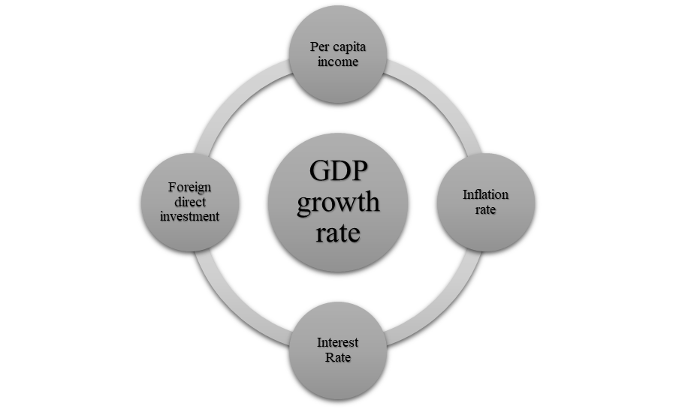

In this research four important factors have been selected to identify the measurement of contribution in GDP in Bangladesh.

3.3 Data collection:

The measurable and expository portion of this research has been prepared for securing on the based on secondary data. This information set has been prepared by consolidating reports from various authorizations. Many published journals have furthermore been appropriated for verification and concepts. All data have been composed from 2000 to 2019 Microsoft excel expectations have been utilized to tests where an econometric demonstrate has been which is indicated underneath. The show appeared the affiliation between the inflation rate, income per capita, interest rate, FDI, and GDP growth rate.

3.4 Data analysis:

In this assessment of the show, the impact every one of the segments to the development pace of GDP has been analyzed. In the exploration, the examples of separately figure finished on prolonged stretch of time, and the creation of the segments have perceived. For the separately every one of the figures, the current strategies that have should a critical effect on our economy have been perceived.

4. Findings of the research

4.1 Introduction:
The GDP is the business evaluation of every single end high and terms created inside a country in a settled timeframe. The GDP is formally recognized totals. The accompanying forms have been utilized to estimate the GDP:
$$\text{GDP}\text{= }\text{C}\text{ + }\text{I}\text{ + }\text{G}\text{ +}\left(\text{X}\text{ - }\text{M}\right)$$
Functioned out, the form for determining GDP will be:
$$GDP = private consumption + gross investment + government investment + government spending + \left(exports – imports\right).$$

4.2 GDP in Bangladesh:

GDP is a significant fair estimation for all finished goods and services in a provided period by parts of bearing found indoors in the country.
GDP is a recognized measurement to reach the achievement of an economy. As defined earlier in this research that economic growth was characterized as real GDP growth. After 1971, the economy of Bangladesh has undergone risky paces. In some cases, the country’s progress was destroyed by a hard time of federal precariousness and eliminating current disasters. The table under seems the end of actual GDP for the country for the period 2000-2019. It mentioned that there existed extensive changes in the growth rate of actual GDP over time (Figure 1). In 2000 Bangladesh capable to keep a growth rate of higher than 5%. The changes in the growth rate across time are slight. In 2006, the GDP increase rate was 6.9%. After that, the increase rate decline due to the poor foundation of the market, ineffective governance, and weak shipping. From 2013 to 2019 the GDP increase rate has been quickly expanded. The highest increase rate achieved at the end of the period availed from strong garment exports, large remittance inflows, and effective command opposition.
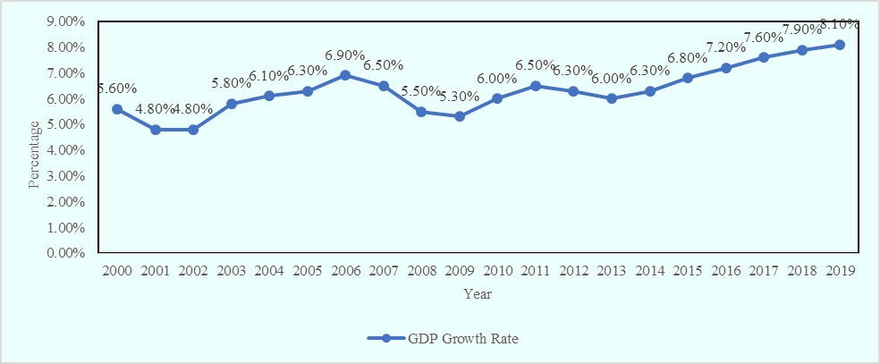
Sources: (tradingeconomics.com, n.d.)
Figure: 1
GDP Growth rate of Bangladesh
In this figure 2 performs the GDP (per bn. US$) of Bangladesh from 2000 to 2019. Ready to say that in 2000 the GDP of Bangladesh was 180.2 US$ (per bn.) but from 2000 until 2019 it was developing up and in 2019 it was 817.6 US$ (per bn.).

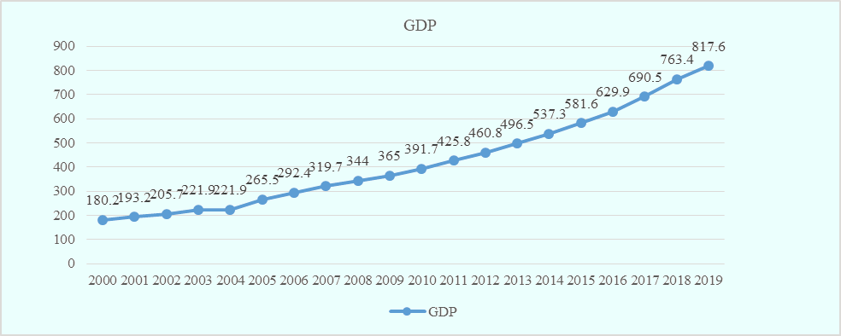
Sources: (tradingeconomics.com, n.d.)
Figure: 2
GDP of Bangladesh
As COVID-19 increases over the region, South Asia’s financial outlook is despondent. The region will possibly find its most extremely bad economic performance in the ultimate 40 a long period, with slight concentrations in all eight countries. The most current economic condition of South Asia Center has checked that regional extension will fall to a score between 1.8 and 2.8 percent in 2020, falling from a 6.3 percent growth forecasted last six months back. In this bad circumstance, the complete region might study a negative growth rate this year. This weakened figure will wait in 2021, with development may be delayed to float in 3.1 and 4.0 percent, falling from the past 6.7 percent evaluate.

Note: For the COVID-19 extensive, economic conditions inside nations also regions are runny and alter scheduled a day-by-day premise. The study in the most recent South Asia Economic Emphasis information is founded on the most recent state-level data nearby as of April 7, 2020.
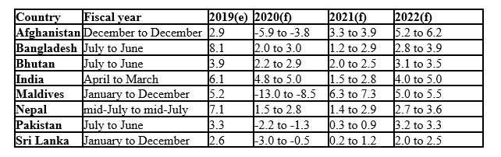
Sources: (worldbank.org, 2020)
Table: 1
GDP Growth Rate and forecast (in south Asia)

4.3 Contribution of factors to the economy:

4.3.1 Inflation:

Inflation may unkind either an increase inside the money supply or an increase in cost levels.
Inflation rate:
$$\frac{GDP deflator of current year-GDP deflator of base year}{GDP deflator of base year}×100$$
We have already listen about inflation; we continue learning about an increase in price compared to some benchmark. In fact, the money supply may be increased, which will more usually than not display itself at higher cost levels. It is basically a matter of time. For the scope of here, it will be going to deliberate inflation as covered by the center CPI, it is the standard evaluation of inflation used within the Bangladesh economic demands. Of more importance is the estimation of focus inflation. Center CPI prohibits nourishment and vitality from its equations since these goods appear more cost instability than the leftover portion of the CPI.
The connection between economic growth and inflation (GDP) works out similarly to a very fragile move. For the stock market stockholders, annual growth within the GDP is crucial. In the event, this in the overall economic result is declining, or merely holding consistent, most companies will not be able to extend their benefits, which is the initial operator of stock performance. If, as well enough GDP increase is additionally perilous because it will most possible issue with a rise in inflation, which dissolves stock showcase picks up by giving our capital (and expected corporate profits) less important. The largest economic scholars nowadays agree that 2.5%-3.5% GDP growth per year remains for that our economy may securely retain for generating negative side impacts.
Thinks about have appeared that over the past 20 a long time, yearly GDP growth rate over 2.5% has caused a 0.5% drop in unemployment for respectively rate point over 2.5%. It just like the way to murder two feathered individuals with one boulder — increment by and large growth whereas bringing down the unemployment rate. Tragically, be that as it may, this progressive connection begins to break down when business gets exceptionally moo, or close full work. Amazingly moo unemployment rates have demonstrated to be more exorbitant than important since an economy working at close full work will cause two critical things to ensue:
- Products and services may be incremented speedier than supply, initiating price to rise in aggregate demand.
- Companies ought to increase recompense as a result of the tight labor market. This increment more often than has not been approved on to customers within the frame of bigger costs as the business looks to make the most of the benefits.
The increase rate in GDP can be the main reason of inflation in the event that cleared out unchecked, runs the hazard of transforming into hyperinflation. This organize is input, it may quickly have ended up an input loop. Naturally, in the world, inflation has increasing, individuals may occupy more cash then they recognize that it will less valued within upcoming days. This creates spread increases in GDP in the passing period, carrying almost contribution of cost increments. Additionally, the effects of inflation are not shortest. In other words, 10% expansion has far than double as injurious as 5% inflation. In 2000- 2002 inflation rates were below 5%, after that it was increased in 2003 at 5.67%. From that time inflation rate didn’t control under 5%. In 2007 it reached almost 10% after that in 2011 inflation rate break it record to reach at 11.44%. The lessons are proceeded economies have cultured done by come across. And back approximately 20 a long time to discover a delayed period of tall inflation, which was as it were helped by successful done a difficult historical of tall unemployment and misplaced generation as possible volume sat sit still.
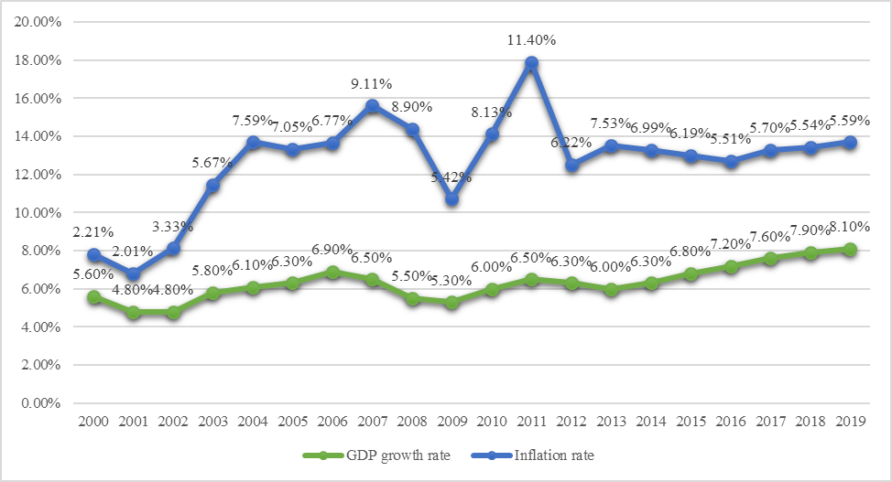
Sources: (Asia, n.d.)
Figure: 3
Inflation rate of Bangladesh

4.3.2 Per capita income:

Per capita income may be a degree of the sum of cash made per individual in a country or geographic locale. Per capita income can be utilized to decide the average per-person income for a range and to assess the typical of alive and excellence of life of the populace. Per capita income for a country is calculated by separating the country's national income by its populace.
Per capita income: $\frac{(Total income of area)}{(Total population)}$
“The basic suspicion of the life-cycle theory is that a person looks to make the most of the display esteem of period utility topic to the economical restriction. Usually, hypothesis forecasts that consumption of a definite season, and in this way to collect spare, on the basis of the desires practically whole life income. Approving this hypothesis, the whole life of an individual is inaccessible hooked on the occupied period and leaving period. The public remains expected to stand clear investors among the occupied period and dissevers amid the retirement period. The increase of per capita income drive to result of an increment of total standby reserves amount, those increments the whole time income and savings resources of more childish stage groups comparative to additional experienced age groups. The higher GDP increasing rate and per capita growth rate both are predicted to consume the higher replacement reserves sizes than countries with lower increase rates. If there's additional proves that the measure which is influence probable to decline as per capita income increases and may indeed ended up adverse for affluent nations where rumor openings and developments are abstemiously lower.” (Journals, n.d.).
The per capita gross national income rebounded more than 9% to $1,909 last financial year after $1,751 a year previous in Bangladesh. “The GNI suggests that the whole earnings of a country's peoples and industries including peoples foreign while remaining inhabited article (GDP) receipts under contemplation domestic cohort only. According to (bizdatainsight.com, n.d.) the per capita of GDP similar bound to $1,827 in 2018-19 from $1,675 to representation in the past year. In 1972 the GNI was only $120 and in 1982 it took a decade to double to $240. In 1992 it was only $320 which was increased only $80. The per capita GNI was $940 in 2012 and more than double to $1,909 in an extra 7 years.
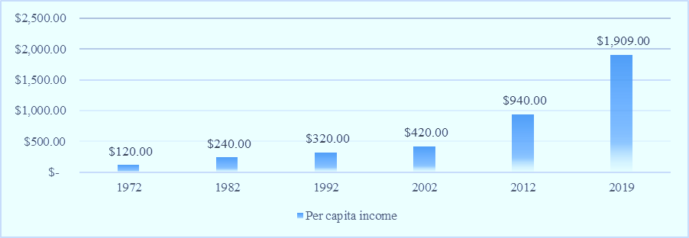
Sources: (Star, 2019)
Figure: 4
Income per capita of Bangladesh

4.3.3 The Interest Rate:

“The net effect of the actual interest rate on savings funds remains imprecise based on the life cycle concept. The net effect of the actual interest rate going on replacement funds may be deteriorated hooked on 2 effects. The replacement influence suggests, an interest rate increases the existing value of consumption comparative to established period cost, and thus affecting investment funds emphatically. The additional impact, that is called as the income impact, shows the family can be a net lender, also increment use and reduce parsimonious. In this manner which has expected that the reserve funds amount as it remained when the replacement influence overcomes the compensation influence on the interest rate will have an optimistic effect. In creating nations where economic marketplaces have still not healthy shaped, replacement influence remains expected can be huge notable than revenue impact, and from this time the actual interest rate is possible to consume a net optimistic effect on domestic replacement funds. In any case, the difficulty” (gifre, n.d.).
“The financial plan's assets consolidate this one has net external assets at that point net family unit affirmation. Staying private affirmation joins affirmation extended to the separated fragment and normal government and credit extended to the non-financial open division inside the state of hypotheses in short and long haul government protections and advances to state adventures; liabilities to general society and private portions inside the casing of stores with the dealing with a record structure are gotten out. Net family unit credit likewise incorporates credit to banking and nonbank cash related instruct. Family unit credit is the most vehicle through which changes inside the money gracefully are coordinated, with national bank advancing to the legislature normally having the principal imperative impact. The national bank can guide advancing to the private section in a couple of ways - for representation, by adjusting the incurred significant damage of the renegotiating workplaces it provides for banks, by changing publicize financing costs through open promote tasks, or by controlling the availability of credit through changes inside the spare necessities constrained on banks and roofs on the credit given by banks to the private portion. The genuine loan cost is used in various Monetary theories to explain such wonders as the capital flight, trade cycle and Financial air pockets. At the point when the genuine pace of premium is tall, that is demand for credit is tall, by then money will, all different things being ascend to, move from usage to venture reserves. Alternately, when the real rate of interest is moo, request will move from reserve funds to speculation and utilization” (data.isdb.org, n.d.).
“Genuine Loan fee data was point by point at 4.879 % in 2019. This records an augmentation from the past number of 3.839 % for 2018. Bangladesh's BD: Genuine Loan cost data is redesigned every year, averaging 5.673 % from Dec 1976 to 2019, with 44 observations. The data go to an unequaled tall of 34.758 % in 1976 and a record moo of - 11.637 % in 1978. Bangladesh's BD: Genuine Financing cost data stays dynamic status in CEIC and is itemized by World Bank. The data is classified underneath the overall Information base's Bangladesh rate is the crediting loan cost adjusted for enthusiasm as estimated by the Gross domestic product deflator. The terms and conditions associated with crediting rates change by country, nevertheless, confining their likeness” (20Ar). Various loan fees exist together in an economy, imitating thoughtful conditions, the terms controlling credits and stores, and differences inside the position and status of leasers and obligated people. In a couple of economies, financing costs are set by bearing or administrative fiat. In economies with inadequate business sectors, or where point by point apparent rates are not normal for fruitful rates, it might be problematic to get data on loan fees that reflect genuine exhibit trades.
The genuine interest rates may be calculated as $\frac{(i - P)}{(1 + P)}$, where I is the apparent advancing loan fee and P is the swelling rate (as estimated by the Gross domestic product deflator).

Sources: (Bangladesh Bank, n.d.)
Figure: 5
Interest rate of Bangladesh

4.3.4 Foreign Direct Investment (FDI):

FDI is a venture made by a firm or individual in one nation into business intrigues situated in another nation. For the most part, FDI happens when a financial specialist builds up remote business tasks or gets outside business resources in an outside organization. “Notwithstanding, FDIs are recognized from portfolio interests in which a financial specialist only buys values of outside based organizations. The IMF also believes a venture to be delegated FDI on the off chance that the Monetary authority holds a midway ownership portion of at smallest 10% and works out a huge entirety of organization control. This is regularly equivalent to the manner by which the Association of Monetary Co-activity and Improvement (OECD) describes FDI. Agreeing to the (OECD, n.d.) An external direct speculation try is an endeavor occupant in one economy and in which a theorist occupant in another economy has, either clearly or in an indirect way, 10% or a greater amount of its democratic control if it is united or the equal for a unincorporated venture. An ownership of at smallest 10% of the democratic control of the undertaking is regarded as the basic demonstrate that the Monetary pro has sufficient effect on have a fruitful voice in its administration from the meanings of the IMF and OECD, one normal essential in describing a theory as FDI is that the financial specialist's ownership must be at smallest 10%, which is furthermore an essential for holding impressive command over the endeavor.
As discussed some time as of late, FDI can offer help to fill the benefit fissure in a making country. As a making country, Bangladesh has for some time been aware of the need and hugeness of outside endeavor. Immediately after its autonomy from Pakistan in 1971, Bangladesh began endeavoring to attract FDI for motivations behind capital development and trade of advancement and data. The deluge of FDI has extended by and large since 1999, when the new mechanical game plan was gotten by the legislature of Bangladesh. The Leading body of Speculation (BOI) in Bangladesh, which was made for quick use of unused mechanical ventures, gives a wide run of organizations to outside Monetary pros checking system workplaces, imply and send out workplaces, banter assurance for distant Financial masters, and pre-venture guiding. BOI too gives cheerfulness organizations to going to outside examiners, for example, gathering at the plane terminal, lodging booking, and transportation strategies. FDI in Bangladesh is empowered in districts, for example, essentialness and control establishment, just as organizations, for example, broadcast communications, PCs, carrier and motor parts, materials, cultivating, and drugs (Unfamiliar Venture, 2009). Though these are supported fragments, far off theorists are free to contribute any portion of their decision however the "saved ventures, for example, arms and ammunition, forest farm, nuclear imperativeness, and printing money notes. In all divisions yet for the spared organizations, Bangladesh gives non-biased treatment among far off and neighborhood Monetary authorities. In a wide collection of respects, far off Financial masters welcome similar advantages as close by Monetary pros, checking a charge occasion, installment of sways, and concentrated expertise costs (Beames, Simon & Higgins, Peter & Nicol, Robbie).Outside theorists also acknowledge 100% unfamiliar worth and full bringing home of advantages. In extension to the FDI-accommodating methodology, the GOB has built up EPZs to flexibly beneficial inspiring powers to the distant examiners” (Rahman, 2015).
Foreign Direct Investment | 2017 | 2018 | 2019
FDI Inward Flow (million USD) | 2,152 | 3,613 | 1,597
FDI Stock (million USD) | 14,557 | 17,062 | 16,385
Number of Greenfield Investments*** | 19 | 28 | 18
Value of Greenfield Investments (million USD) | 692 | 5,267 | 5,762

Sources: (nordeatrade, n.d.)
Table: 2
FDI in Bangladesh

“FDI has been one of the significant driving qualities of development, industrialization, Monetary extension and helper change for various countries. Consequently, the greater part of the mechanical game plans of making a made country has begun to seriously rely upon draw. Nevertheless, consenting to the World Hypothesis Report of 2019, the later overall methodology atmosphere for trade and adventure has not been as sure contrasted with the past productive times of fare drove development and progression. There has been a declining incline in cross-fringe helpful theory. Last the year, overall stream of outside arrange adventure fell by 13 percent to US$ 1.3 trillion. This addresses the most diminished level since the overall cash related crisis and underlines the need of development in overall endeavors in this decade. What needs our essential review is reality that underneath these conditions there has been a risky development inside the use of phenomenal Monetary zones (SEZs) as a key methodology defiant for attracting adventure for mechanical progression. Consenting to the count of the Joined. Together Nations Gathering on Trade and Improvement (UNCTAD), up to by and by more than 5,400 SEZs have been made far and wide and in any event 500 more are inside the pipeline for the coming quite a while. Surely, despite the way that, inside the past, various SEZs have had a key impact in propelling assistant change and more important help in overall regard chains, there have additionally been various outlines of zones that didn't attract the normal number of Financial experts and got the chance to be costly disillusionments. Alongside a more problematic trade and hypothesis atmosphere, in later quite a while, SEZs go up against different difficulties too. For delineation, almost certainly, the fourth mechanical change may break up the noteworthiness of moo work costs, which usually has been one of the major serious central purposes of most SEZs. Thusly, SEZs will got the chance to take into thought these examples in their zeroed in on organizations and characterize reasonable strategies to alter in like way” (Sharmin, 2019).
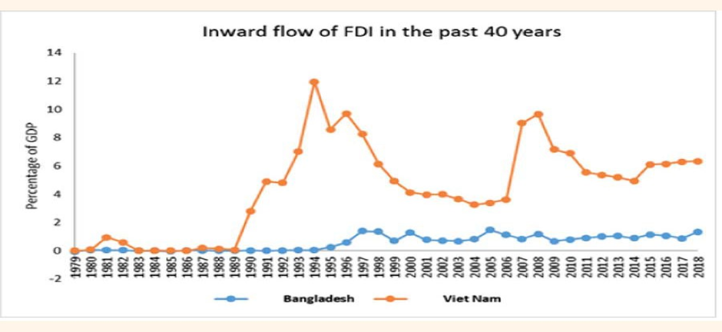
Sources: (Sharmin, 2019)
Figure: 6
FDI in the past 40 year Bangladesh
“Bangladesh, similar to various other making countries contains a changed mechanical methodology which focuses on exchange orchestrated and private section driven development. Bangladesh also offers a wide arrangement of liberal financial propelling powers and workplaces to attract distant Monetary Pros. Simultaneously, the focal point of Bangladesh's development approach excessively progressed around the production of higher number of SEZs. Regardless, given the current overall monetary and geo-political circumstance, solely focusing on the formation of SEZs probably won't be an ideal procedure. This can be since Bangladesh despite everything fuses various hindrances with regards to pulling in a consistent inflow of FDI. Bangladesh additionally consolidates far to go as far as opening up the for the most part limit needed to totally fitting the upside of FDI deluge. This especially holds extraordinary with regards to the circumstance of rivalry among Bangladesh and a couple of its rivals. Regardless of the way that, the FDI inundation in Bangladesh has gradually evolved over the long time, the country is as yet loosen removed behind. Inside the last Financial year, Bangladesh gotten its most raised actually total of FDI; agreeing to the national bank data, net FDI in 2018-19 remained at $3.88 billion as against $2.58 billion inside the previous year. Typically, since there has been a one-time theory of $1.47 billion inside the state of making sure about of Akij Gathering's tobacco business by the Japan Tobacco Inc. In light of everything, this endeavor is focused on the private feature and thusly there's obliged extent of choosing additional workers. Thusly, pros stress that this abrupt ascent in FDI may not basically decipher into a drawn out sure effect for the country. Given the current arrangement of difficulties, it is fundamental that Bangladesh sort out on grasping and realizing fitting changes to bring around an enduring inundation of FDI. At the moment, the country is fixating on advancing its situation inside the current overall records of business atmosphere. On one hand, this helpful degree surely justifies appreciation. Then again, we should too all in all observe at the more noteworthy picture. Since, in the end it is the absolute human capital of a country that for the most part chooses authentic seriousness. Consequently, on the off chance that Bangladesh needs to both pull in and procure the complete bit of leeway of extended FDI, it should first and superior put resources into quite a while people. Wild and brief term measures are probably going to require Bangladesh figuratively speaking a few strides ahead. In organize to oppose the serious truth of a logically globalized and insecure world, long haul fundamental orchestrating is needed to scale up prudent deluge of adventures” (Sharmin, 2019).

4.4 Importance of GDP:

Gross domestic product is satisfactory measure for an economy and with progress in assessment and nature of data, investigators and governments are endeavoring to find measures to strengthen Gross domestic product and make it a broad marker of public compensation. Complete public yield or Gross domestic product addresses the Monetary prosperity of a country. It presents a sum of a country's creation which contains all securing of items and adventures conveyed by a country and organizations used by individuals, firms, outcasts and the managing bodies.
GDP includes client spending, Speculation utilization, government spending and net passages along these lines it delineates an exhaustive picture of an economy because of which it gives an information to Monetary masters which includes the example of the economy by seeing Gross domestic product levels as a record:
- Gross homegrown item is used as a marker for most governments and monetary bosses for organizing and system definition.
- In the occasion of Gross domestic product, each part is given the weight of its relative expense. In feature Monetary issues it clicks as expenses reflect both insignificant cost of the creator and unimportant utility for the buyer, for instance people sell at a worth that others are anxious to pay.
Calculation of Gross domestic product invigorates the generally of the economy. A negative Gross domestic product development portrays terrible signs for the economy. Financial examiners separate Gross domestic product to check whether the economy is in plunge, wretchedness or impact. Gross domestic product is worthy measure for an economy and with progress in investigation and nature of data, investigators and governments are endeavoring to find measures to sustain Gross domestic product and make it a comprehensive pointer of public compensation.

4.5 Other benefits of GDP:

“Quicker increase in GDP (Gross domestic product) grows the general size of the economy and fortifies monetary conditions. Extensively shared development in per capita Gross domestic product expands the commonplace American's material way of life. Yet, Gross domestic product isn't intended to be a proportion of monetary government assistance, and different contemplations are significant in completely surveying the expenses and advantages of strategy changes” (Center on Budget and Policy Priorities, n.d.).
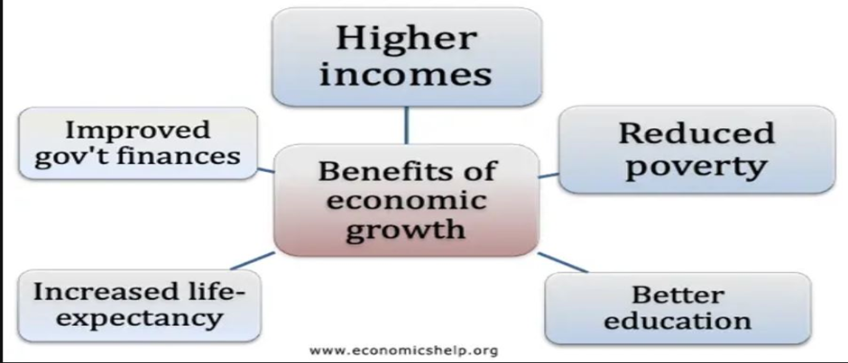
Sources: (Economicshelp.org, n.d.)
Figure: 7
Benefits of economics growth
- Higher salary: Monetary development engages buyers to use more product and adventures and acknowledge better lifestyles. Monetary development during the 20th Century was a main issue in diminishing out and out degrees of desperation and enabling a climb in future.
- Lower joblessness: With better return and positive Financial development, firms will all in all use more workers making more prominent business.
- Lower government obtaining: Financial development makes higher obligation earnings, and there is less need to consume money on focal points, for instance, joblessness advantage. Thusly monetary development helps with diminishing government getting. Financial development moreover expect work in paying off past duties to Gross domestic product extents.
- Improved open organizations: Higher Monetary development prompts higher evaluation wages and this engages the council can spend more on open organizations, for instance, human administrations and guidance e.t.c. This can engage better standards for regular solaces, for instance, extended future, higher paces of training and a more important perception of metropolitan and strategy driven issues.
- Money can be spent on guaranteeing the earth: With higher monetary development an overall population can give more advantages for progressing reusing and the usage of supportable resources.
- Speculation: Monetary development urges firms to contribute, in order to satisfy future need. Higher endeavor assembles the degree for future Monetary development – making an upstanding example of financial development/hypothesis.
- Expanded inventive work: High monetary development prompts extended profitability for firms, enabling also spending on imaginative work. In like manner, proceeded with Financial development fabricates sureness and urges firms to confront difficulties and upgrade.
- Economic new development: The best factor for progressing Financial headway is proceeded with monetary development. Monetary development in south-east Asia over the span of late decades has expected a huge activity in diminishing all out degrees of dejection – extending future.

4.6 Limitations of GDP:

GDP is a useful marker of a nation's Financial introduction, and it is the most normally used extent of success. Regardless, it has some critical limitations, including:
- The dismissal of non-feature trades
- The failure to speak to or address the degree of pay uniqueness in the open eye
- The powerlessness to determine if the nation's pace of development is viable or not
- The failure to speak to the costs constrained on human prosperity and the earth of negative externalities rising up out of the creation or usage of the nation's yield
- Rewarding the replacement of weakened capital identical to the creation of new capital

5. Recommendations and Conclusion:

5.1 Recommendations

Financial development is assessed by an extension in GDP, which is portrayed as the combined assessment things being what they are and organizations made inside a country in a year.
- Numerous powers add to financial development. Regardless, there is no single factor that dependably spikes the ideal or ideal proportion of development required for an economy. Appallingly, declines are an unavoidable truth and can be achieved by exogenous components, for instance, worldwide and geo-budgetary events
- Government authorities, world pioneers, and Monetary experts have for the most part talked about the ideal development rate and how to achieve it. It's basic to think how an economy creates, which implies what or who are the individuals that make an economy push ahead.
- In Bangladesh, monetary development is driven generally by shopper spending and business venture. In the event that purchasers are purchasing homes, for instance, home developers, temporary workers, and development laborers will encounter monetary development. Organizations likewise drive the economy when they recruit laborers, raise compensation, and put resources into developing their business.
- Other factors help advance shopper and business spending and flourishing. Banks, for instance, loan cash to organizations and buyers. As organizations approach credit, they may back another creation office, purchase another armada of trucks, or start another product offering or administration. The spending and business ventures, thus, effect sly affect the organizations in question. Nonetheless, the development additionally reaches out to those working with the organizations, remembering for the above model, the bank representatives and the truck maker.

5.2 Conclusion

This paper has shown an investigation for choosing the figure impacting Gross Domestic Product (GDP) in Bangladesh. For this consider helper data are gathered from World Bank, ADB, Wikipedia and different sources from year 2000 to 2019. In view of the outcome we will say that the GDP of Bangladesh twist sunken up. for example, in this consider it tends to be reasoned that net venture assets and work power signify is to be quantifiably basic factors inside the explanation of GDP development in Bangladesh and the net save finances incorporates a positive relationship with GDP. Though different factors, for example, cost development and FDI are insignificant segments. It doesn't pitiless different factors are not basic or significant. It likely could be since of compelled get to the availability to the data and lost data on the specific elements. From the last hardly any quite a while the Economic development of Bangladesh has been achieving attainable GDP development. The foundation of the GDP development in Bangladesh is "acceptable organization. So incredible organization can have essential impact to the economy of Bangladesh.

References:
(n.d.). Retrieved June 15, 2020, from pdfs.semanticscholar.org.
(n.d.). Retrieved June 04, 2020, from bizdatainsight.com: www.bizdatainsight.com
(n.d.). Retrieved June 4, 2020, from gifre.
(n.d.). Arab Academy for Science,. Retrieved June 05, 2020, from https://www.aast.edu/en/index.php
(n.d.). Retrieved June 05, 2020, from Bangladesh Bank: https://www.bb.org.bd/econdata/intrate.php
(n.d.). Retrieved June 05, 2020, from OECD: https://www.oecd.org/development/dcr2012.htm
(n.d.). Retrieved June 06, 2020, from nordeatrade: https://www.nordeatrade.com/en
(n.d.). Retrieved June 10, 2020, from Center on Budget and Policy Priorities: https://www.cbpp.org/economy/economic-growth-causes-benefits-and-current-limits
(n.d.). Retrieved June 10, 2020, from Economicshelp.org: https://www.economicshelp.org/
Anwar, S. &. (2011). Financial development, foreign investment and economic growth in Malaysia. Journal of Asian Economics, 22, 335-342. doi:10.1016/j.asieco.2011.04.001
Asia. (n.d.). Retrieved June 02, 2020, from Worlddata.info: https://www.worlddata.info/asia/bangladesh/inflation-rates.php
Batten, A. &. (2015, 01 01). The Financial Systems of Financially Less Developed Asian Economies: Key Features and Reform Priorities. SSRN Electronic Journal. doi:10.2139/ssrn.2707524
Beames, Simon & Higgins, Peter & Nicol, Robbie. (n.d.). Learning outside the classroom: Theory and guidelines for practice. Learning Outside the Classroom: Theory and Guidelines for Practice. 10, 1-127. doi:4324/9780203816011
data.isdb.org. (n.d.). Retrieved June 03, 2020, from data.isdb.org: https://www.isdb.org/projects/data
dspace.uiu.ac.bd. (2020). dspace.uiu.ac.bd. Retrieved from www.dspace.uiu.ac.bd.
Dua, P. &. (2002, Feb 02). Interest rate determination in India: Domestic and external factors. Journal of Policy Modeling, 24, 853-875. doi:10.1016/S0161-8938(02)00172-2
Evan Davis, S. F. (1991, June). Who are the world's most successful companies? Business Strategy Review, 2(2), 1-26. Retrieved May 30, 2020, from https://doi.org/10.1111/j.1467-8616.1991.tb00150.x
Herzer, D. (2008, 07 01). The long-run relationship between outward FDI and domestic output: Evidence from panel data. Economics Letters, 100, 146-149. doi:10.1016/j.econlet.2007.12.004
Hossain, T. &. (2018, 09 27). An Economic Analysis of the Determinants of Inflation in Bangladesh. Retrieved June 01, 2020, from https://www.researchgate.net/publication/327919988_An_Economic_Analysis_of_the_Determinants_of_Inflation_in_Bangladesh/citation/download
Journals. (n.d.). Retrieved June 2, 2020, from girfre.org: http://www.gifre.org/
Modigliani, S. F. (1978, December 01). Towards an understanding of the real effects and costs of inflation. Review of World Economics, 114, 810-833. doi:https://doi.org/10.1007/BF02696381
Rahman, A. (2015). Impact of Foreign Direct Investment on Economic Growth: Empirical . International Journal of Economics and Finance Evidence from Bangladesh. Retrieved June 6, 2020
Sethi, N. &. ((2015)). FDI and Economic Growth: An Empirical Investigation of India and Bangladesh. Journal of Finance and Accounting, 2. doi:10.17492/mudra.v2i1.6440
Sharmin, R. F. (2019). FDI policy of Bangladesh—a review. The Financial Express. Retrieved June 06, 2020, from The Financial Express: https://thefinancialexpress.com.bd/views/fdi-policy-of-bangladesha-review-1577805006
Star, T. D. (2019). Per capita income hits $1,909. Dhaka: The Daily Star. Retrieved June 3, 2020, from https://www.thedailystar.net/business/news/capita-income-hits-1909-1717606
The World Bank Group. (2020). worldbank.org. Retrieved May 16, 2020, from www.worldbank.org: www.worldbank.org
Touny, M. (2008). Determinants of Domestic Saving Performance in Egypt: An Empirical Study. Journal of Commercial Studies and Researches, 17-42. Retrieved May 29, 2020
tradingeconomics.com. (n.d.). Retrieved June 01, 2020, from tradingeconomics.com: https://tradingeconomics.com/bangladesh/gdp
Whiteley, P. F. (2002, Feb 26). Economic Growth and Social Capital. Political Studies, 443-466. doi: https://doi.org/10.1111/1467-9248.00269

