Internship Report

On

Marketing Practices of Asiatic Marketing Communications Limited
An Internship Report Submitted to the School of Business and Economics in Partial Fulfillment of the Requirements for the Degree of Bachelor of Business Administration.

Submitted To:
Md. Kaium Hossain
Assistant Professor
School of Business and Economics

Submitted By:
Sumaiya Chowdhury
ID: 111 143 124
Major in Marketing

Date of Submission
24th April 2019

Marketing Practices of Asiatic Marketing Communications Limited

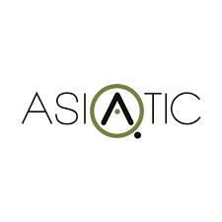

Letter of Transmittal

24th April 2019
Md. Kaium Hossain
Assistant Professor
School of Business and Economics
United International University
Satarkul, Vatara, Dhaka-1213
Subject: Submission of Internship Report.

Dear Sir,
I have completed my internship under your supervision. My major is Marketing and I was appointed as an intern at Asiatic Marketing Communications Limited from 17thJanuary, 2019 to 14thApril 2019.I am submitting my internship report titled “Marketing Practices of Asiatic Marketing Communications Limited” following the guidelines provided by you. This report is a reflection of my working experience at Asiatic, the office environment, the people I worked with and also the knowledge I gathered while working there as an intern.
I hope you will find this report up to the mark as your expectation and my work as an intern satisfactory. Thank you for guiding me with the internship and being patient throughout the trimester.
Sincerely,
Sumaiya Chowdhury
ID: 111 143 124
Bachelor of Business Administration
United International University
E-mail: sumaiyapew@gmail.com

Acknowledgement
At the very beginning, I would like to express my gratitude to the Almighty Allah for blessing me enough to complete this report. This Internship report is a result of many others help and guidance. I am obliged to these people for their suggestions, support and opinions on how to make this report better. I would like to take this opportunity to express my sincere gratitude to these people.
First of all, I would like to thank my Internship Supervisor, Md. Kaium Hossain, Assistant Professor of SOBE at United International University for his guidelines and suggestions on writing this report. He has been patient throughout my internship period and guided me well.
Then, I would like to thank my Organizational Supervisor at Asiatic Digital Marketing Communication Limited Mr. Didarul Alam Khan, Associate Director of Asiatic JWT. He has helped me by giving his opinions on how I can do better. I thank him for being motivating and helpful towards me. I would also like to thank Mr. Tonmoy Das and Mr. Fahad Hasan who are Account Executive of Community Engagement Department. They reviewed my work also taught me the basics from day one.
Last but not the least, I would like to thank my family members for encouraging me always. This internship would not be possible without their continuous support. All of them extended their help and guidance which helped me to complete this report. I expect that it will help me in future.

Sumaiya Chowdhury
ID: 111 143 124

Table of Contents

1.0 Introduction 6
1.1 Origin of the study 6
1.2 Purpose of the study 6
1.3 Objectives of the study 9
1.3.1 Broad Objective 9
1.3.2 Specific Objectives 9
1.4 Methodology of the data collection 10
1.4.1 Primary Sources 10
1.4.2 Secondary Sources 10
1.5 Limitations of the study 11
2.0 Company Profile 13
2.1 Organizational structure 15
2.2 Departmental activities of Asiatic Digital 16
2.3 SWOT Analysis of Asiatic 18
3.0 Analysis and Findings 20
4.0 Conclusion 26
4.1 Recommendations 27
References 28

Executive Summary

I have prepared my report based on the three months of an internship program that I have finished in Asiatic Marketing Communications Limited under the Community Engagement Department. I took up the internship as it is a requirement for completing my undergraduate BBA degree.
Chapter 1 includes an introduction, the purpose of the study, objectives of the study, and sources of data collection and limitations of the study. Chapter 2 consists of the elaborate description of the company, company profile, organizational structure, departmental activities and analysis of the services they provide with SWOT Analysis. In Chapter 3, there are analysis and findings of communication works of digital marketing. I also explained my overall experience of the internship program. This is solely my personal view and the things I have come across while working in the company as an intern. Here, I wrote about my assigned duties, job responsibilities and the office environment. Chapter 4 includes the conclusion and recommendations for the company and the Community Engagement Department. I have been working here only for three months, but I have come to gather a lot of knowledge regarding how digital marketing agencies work. I tried to find the shortcomings and also provided the probable solutions using my understanding from the internship period.

Chapter One: Introduction

Introduction

Asiatic is one of the leading Digital marketing communication firms of Bangladesh. They started their journey over four decades ago in the country. Asiatic has been able to create a spectacular reputation with the leading corporate houses, industrial organizations, NGOs, Government bodies, industrialists, entrepreneurs and marketers. I was fortunate enough to witness the changing process first hand. To overcome the changes, I also learned how to deal with ever changing market place. Advancement of BTL marketing communication were required and so we need to make the best use of the modern marketing tool-the Digital site with an aim of finding the right target group at the right target place in this era. Any sort of campaigns at the moments, even campaigns that are BTL, is launched keeping in mind that the digital sphere is where almost all the target groups frequent. As the communication processes in today’s world have become more integrated and targeted than ever before, the use of the digital marketing process for achieving greater effectiveness in BTL campaigns in the key driver and the RIO is also higher. They reach more consumers through the campaign and engagement; as a result, engagement with customers is high.

  - Origin of the study
I took up the internship as it is a prerequisite for finishing my undergraduate BBA degree. I have come to accumulate a great deal of information regarding how digital marketing agencies work in practical. I endeavored to discover the shortcomings, weaknesses and furthermore giving the probable solutions utilizing my knowledge from the internship period. Here I have done monthly report and sentiment analysis of Marico Bangladesh Brand pages as well BRAC Bank pages.

1.2 Purpose of the Study

I got the internship circular from Facebook Page Vacancy Announcement. I sent my CV via Email and received a call 2 days later. I was told to appear for an exam at the Asiatic Digital office on 13th January, 2019. After selection of written test, Mr. Didarul Alam Khan, Associate Director of Asiatic JWT took my interview and I got selected.
Community Engagement Department is more about communicating with the target customers by engaging them in daily interaction and communication using the social media platform. The goal is to make the customers more interested about the product and drive them to physical stores. It creates a brand awareness more so that the sale and profit increases.
As an internee of the Community Engagement Department, I was assigned to work towards the goal of more customer engagement on Facebook daily. I was appointed in the Marico Bangladesh Limited team to observe all Facebook pages and planning different strategy for the Brand according to consumer report. I also handled critical consumers and engaged with them as per their communication. Under Marico Bangladesh Limited, they have 9 different Facebook pages initially. My perception of agencies was very similar to the one I experienced. I had prior idea from my seniors about the work load and work environment of an agency. I experienced the semi-formal office environment there that I have heard so much from others. The real experience was far better than what I heard earlier from others. It was so much fun loving and cooperative working environment.

Job Responsibilities

- Giving replies to queries on various brand pages on time and increasing response rate
- Follow the guideline provided by brands on brand engagement with customers
- Make conversations with customers/followers and clients
- Engaged with target consumers and give feedback as soon as possible
- Prepare brand engagement reports with data
- Prepare regular reports of request files
- Attend training programs arranged by clients on brand values and community management guidelines
- Maintaining punctuality and work on scheduled roster basis daily
- Doing creative work regarding engagement and have the ability to solve various problems regarding problematic customers by communicating with them
- Monitor the overall work of community management team and inform the supervisor regarding any kind of mismanagement on data.

Observation:

At the very beginning I was assigned to look after the community engagement of 10 Brands of
Marico Bangladesh. Those are:

- Bio-Oil

- Hair & Care

- Parachute Advansed

- Parachute Advansed Extra Care

- Parachute Advansed Beliphool

- Parachute Advansed Aloe Vera

- Parachute Advansed Ayurvedic Gold

- Parachute Advansed Body Lotion

- Just for Baby (Baby Oil, Baby Lotion & Baby Wash)

- LIVON Bangladesh

Brands I have worked for

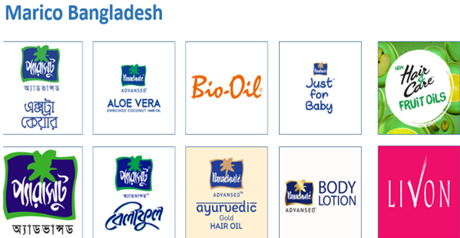
Gradually I looked after BRAC Bank Limited page and BRAC Bank TARA page. Initially I was given 3 days training session to get along with the responsibilities. I was provided a sample template to get idea about the response pattern. The first thing I needed to ensure was that I have a thorough idea about the company and the brands. Each response has to be unique. The main purpose of this community engagement team is to give the consumer more realistic based answer rather than robotic answer so that they can satisfy with the service.
After completion of each month, my core duty for Marico Bangladesh was to prepare a monthly report on sentiment analysis of each brands. In the report I summarized all the response quantity and categorized them accordingly. By doing this, it helps the client to find out the area of improvement and where there is possibility to do more business by solving issues.
BRAC Bank limited requires both daily and monthly report. On daily basis I sent them the consumer request file which includes the consumer interest on Loan, Service cards, complaints etc. At the end of a month I gave them sentiment analysis of that entire month.

1.3 Objectives of the study

1.3.1 Broad Objective: To know the Marketing Practices of Asiatic Marketing Communication Limited.
1.3.2 Specific Objectives:
- To know about the departmental activities of Asiatic Marketing Communication Limited.
- To analyze the strength, weakness, opportunity and threats.
- To know the Marketing Practices of Asiatic
- To make some recommendations on marketing practices of Asiatic Communication Limited.

1.4 Methodology of the data collection

Putting the acquired knowledge from the university into practice, as well as the knowledge and skill gathered from the organization, I have prepared the report. Firstly, the topic was assigned and accordingly to the topic relevant data were attained on the issue at hand. At first the topic of the report and objectives of the study were identified and accordingly appropriate data were collected on the subject on hand.

Sources of the Data

Data were collected from various sources in order to complete the whole report. There are two sources from which I have collected the data.
- Primary source and
- Secondary source

1.4.1 Primary Sources

- Practical desk work
- Personal experience gained by visiting & working with different people
- Interviewing directly with other colleagues and gather a range of experience from conversation

1.4.2 Secondary Sources

Studying suitable documents of various wings of Asiatic 3sixty group gathering and other diverse elements. For completing this report both the information was taken into consideration and analyzed accordingly. Web help is likewise taken to get the data about the commitment and correspondence with the customers. Here I additionally conversed with my supervisor to gather vital data in regards to the works and brands.

1.5 Limitations of the study

- Lack of time limiting me from gathering more information. Moreover, I was not ready to study the current information at greater depth.
- I was not able to incorporate furthermore analytics that is not mentioned here.
- There was another issue of confidentiality while preparing the report. As a result, I was not able to add the data which were misused and couldn't refer to all the names of the tasks I was included in where the Digital Marketing procedures were utilized.
- The most significant difficulty was that I was put in a scheduled roster for my internship.
- Location maintenance was also a barrier for me.
- I faced challenges to cope up with a particular department in an emergency. Since I wasn’t aware of their operation at all. The organization didn’t introduce me the other wings, their functional area, and operational process.

Chapter Two:
The organization

2.0 Company Profile
The journey of Asiatic 3sixty began in 1966. The office was called East Asiatic around then. In those days, there was no understanding of brands. They offered administration to nonexclusive organizations like making efforts for various business. Bit by bit, they turned into the office called Asiatic 3sixty.With constant hard work Asiatic has become one of the biggest and driving showcasing correspondences firms in Bangladesh. It is called Asiatic 3sixty in light of the fact that the firm offers 360-degree marketing solutions to the clients.
Asiatic made a universal association with J. Walter Thompson in the year 1996.The office was renamed Asiatic JWT in 2005 which originates from J. Walter Thompson. JWT is the fourth biggest marketing agency on the planet and working together more than 90 nations with almost 10,000 representatives. They have a customer base of 1200 and tallying. The association was the center explanation for transforming Asiatic 3sixty into Asiatic JWT.
Asiatic is helmed by eminent artist Mr. Aly Zaker. He is the Current Chairman and Managing Director of the firm. Mrs.Sara Zaker is the Vice Chairman. Iresh Zaker and Ferdous Hasan Neville are the Managing Directors of the office.
Asiatic has a wide scope of administrations to offer to the customers. The firm isn't just into making promotions for customers. Their work ranges from Social Communication, Media, PR exercises, and Production Houses, Printing and Broadcast channels like Radio Shadhin and so on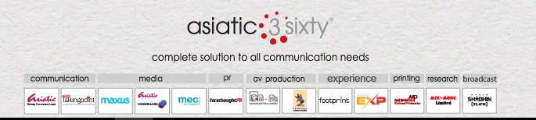
Vision: To create a work culture that inspires us to be curious, stay hungry and motivated, so that we can create extraordinary ideas that people would love to spend time.
Mission: Keep evolving in size and dimension and provide complete solutions to your communication needs in ever changing landscape.

Asiatic Digital
Asiatic Digital is the digital marketing solution provider of clients. Asiatic Digital is wing of Asiatic 3sixty. It has its own operational activities and has the capability to work independently in the firm. Asiatic Digital was born out of necessity to make easier for the brands to compete and sustain in the business. Asiatic Digital now become a successful leading digital marketing agency in Bangladesh.
Clients
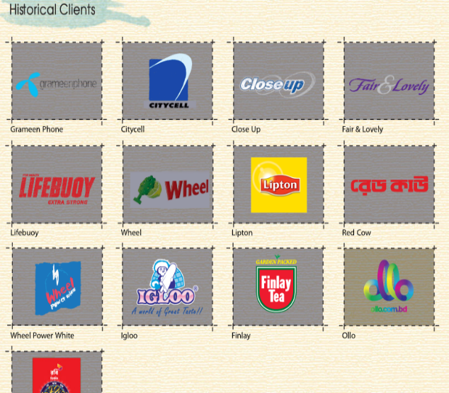
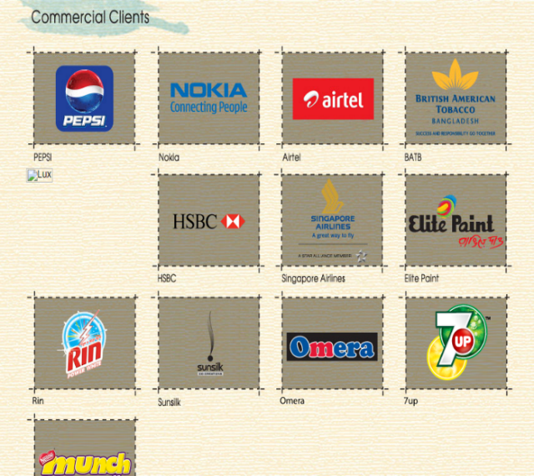

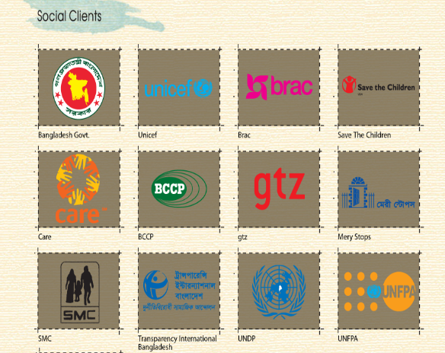

Figure: Some of the clients of Asiatic

Asiatic Digital also works for some social causes which are associated with different brands. Some of the clients are listed below:
- Bangladesh Government
- BRAC
- UNICEF
- Save the children
- SMC
- Care
- UNFPA
- UNCP
- Transparency International Bangladesh etc.

2.1 Organizational Structure

Chief Digital Strategist

Creative and Art
Account Servicing and Planning
Media Buying

Content Development
Creative Concept Developmentt
Senior Manager
Media Analyst

Senior Art Director
Creative Director
Supervisor
Chief Servicing

Response Management
Associate Art Director
Video Production Executive
Copywriter
Copywriter
Executive
Executive
Senior Executive

Executive

2.2 Departmental activities of Asiatic Digital

There are fundamentally four divisions in Asiatic Marketing Communication Limited. The Client Service group which keeps up correspondences with customers.

Their primary goal is to recognize the customer needs. They are the middle person between the client and the creative team. There is the innovative group which plans the advertisements according to the client’s rule.
At that point comes the Community Engagement Department which conveys the majority of this straightforwardly to the clients through social media platform. The HR Department finds the qualified candidates for the organization and recruit them. They take care of the recruitment as well as the employee benefits, compensations, overtime payment etc. They also regulate the work of the interns.

Services Provided by Asiatic Digital

Asiatic Digital is one of the leading agencies of Bangladesh. Their B2B base is the most grounded in the business. They give a 360-degree solution to the business and furthermore help them to promote themselves. Many driving organizations are clients of Asiatic Digital such as Igloo, PRAN, Samsung, Singer, Nestle, Asian paints, SMC and so forth.
They give basically benefits from the Client Service, Creative and Community Engagement Department. Client Service group makes a contact among client and the Creative Team. Creative team structures the entire concept according to the client. They are the main power behind the accomplishment of the organization. Community Engagement Department publishes the communications and conveys the message directly to the client through posts by means of Facebook.

Functions of the department

Client Service
Creative | Copywriting | Content

Planning
Improvise Content according to the brand | Set Brand Image | Work in product placement | Develop Strategy | Campaign planning

Media Buying
Page boosting | Reaching targeted number of consumers | Manage monetary slots

Web and App
Web development | Campaign design | App develop related to campaign or brand requirement

CRM
Communication with the end users | Query Management | Preparing reports based on consumer feedback | Communicate with brands where they need | Improvements if necessary

2.3 SWOT Analysis of Asiatic

Strengths | Weaknesses
- One of the leading marketing communication firms  - High reputation for quality work  - Goodwill of the Chairman Mr. Aly Zaker and the other Directors  - Creativity with which different types of communications are made  - Offering a wide range of services to the client  - Hiring and nurturing talented marketing minds of the country | - Operating in a very competitive business  - Low market shares due to competitive nature of the business
Opportunities | Threats
- Online advertising is a new source of generating revenues  - Adapting new strategies for market research using more data will bring more revenue | - Severe competition by other agencies like Grey advertising, Magnito Digital, Oglivy Bangladesh etc.  - High cost for niche clients like Samsung, Nestle Bangladesh.

Chapter Three:
Analysis and Findings

3.0 Market
Market is the combination of actual and potential buyers. There are many types of market like physical market like buying and selling product in physical stores, department stores shop etc. Non-physical market is also there like communicating with customers through internet. There is a black market also where illegal products are sold. Knowledge market is also there where knowledge and information are shared in the market.

Asiatic Digital communicate with non-physical market and communicate with customer through internet and get feedback from them. They mainly target the young generation through different campaigns and contest. They hold different attractive contents to attract customers to engage them more.
3.1 Segmentation, Targeting and Positioning (STP)
Segmentation: Segmentation refers to the process of dividing the market of consumers into groups based on one or more shared internal or external characteristics. Market Segmentation is a concept which builds up a setup into smaller segments with similar taste, preferences and demands. One market segment is different from another segment. A market segment comprises of individuals who have similar interests. Individuals respond in a similar way to the fluctuations in the market.
Basis of Market Segmentation: Segmentation based on age, gender, income, marital status, occupation. There are Psychographic segmentation, Behavioristic Segmentation, Geographic Segmentation. Market segmentation helps to make strategy in market, build promotional strategies, knows the tastes of the individuals of a particular market segment.
Targeting: After segmentation the next stage is targeting. Target market defines segmenting different markets into sub set of customers. It can be increasing your sales, marketing efforts at specific groups of consumers. Through targeting we can do promotion, pricing, and distribution of your products and make services easier and more cost-effective.
Targeting includes Undifferentiated, differentiated and Concentrated strategy. Asiatic Marketing communication limited focuses mainly on Concentrated strategy in which they target on specific segment to engage with customers. They design their promotional messages in a way that that communicates the benefits to specific consumer group. For example: They had a ‘DEW KHAO, BIKE PAW’, Free sample of Parachute Advansed Extra Care, ‘Beliphool Nondini’ Facebook campaigns that target mainly the male and female young generation that participate in the campaign.
Positioning: Positioning defines creating a distinctive image on consumers mind. There should be a clear idea of how the idea works in target market. Before making a position on customers mind, marketers should be conscious about how the consumer will respond to your service.
Asiatic Marketing Communications Limited mainly focuses on quality position by engaging with their valuable consumer and maintaining their quality of communication. The company knows how to maintain their community in a better way that facilitate the positioning strategy.

3.2 Marketing Mix
Marketing mix is mainly defining by the 4p’s. Product, price, place, promotion are the tools here. Marketing mix helps the marketer to execute their plan by putting the right product at the right place.
Product is an intangible good that seem to meet customers’ needs and wants. Product life cycle and its various staged holds a great challenge for the marketers to execute their plan.
Price is the actual amount that consumer agree to pay for a product that satisfy their needs. By adding profit with cost, we can price the product. There are other several elements like promotional strategy by which Asiatic Marketing Communication Limited advertise their products and give promotional messages only to them who are interested in it. The service marketing mix is known as an extended marketing mix includes other elements.

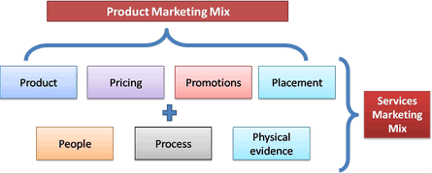
People is another element of service marketing mix. When I am an employee of Asiatic and my behaviors toward consumer defines me. Service process is the way in which a service is delivered to the end customer. When Asiatic Courier sends a parcel to consumer to their doorstep it is called the process of how the service is being delivered. Physical evidence provides a great deal in marketing. I worked on Asiatic Marketing communication Limited where playing music, working in a different environment, encouraging employees was there. A nice and amazing environment of Asiatic hold a great deal for the employees to serve the best toward the organization.

3.3Findings
Asiatic Marketing Communication Limited segment their customer based on age, gender to engage them more. They also segment them based on location and behavioral characteristics. The marketing agency industry is a risky business as it only ensures an above average return. This is why the agencies always follow cost cutting financial strategy to operate their business. The industry is operating only based on the need of different company’s necessity to reach their customers and engage them with their products or services. Advertising agencies are doing this very thing for their clients. Now, the digital marketing process has come to the picture and agencies have big advantage on it as clients depend on them for advertising their products digitally. Social media platforms like Facebook, Twitter, and YouTube, LinkedIn, Google plus, are here to stay and there is going to be long time before they turn into fads. New innovations are growing rapidly as a result digital marketing is going to be a great part of this arena.

Overview of the key competitors
Advertising has been a way to promote products in a wide range for a long time now in target market. Digital marketing is the interest of the new period now for publicizing. Most people specially the new generation like to connect through social media platforms rather than calling or meeting someone directly. This makes the digital marketing sector more attractive ground for business. There are a lot of competitors of Asiatic Marketing Communication Limited like Grey advertising, Magnito Digital, Oglivy Bangladesh and so forth.
Here are some of my works at Asiatic Digital, BRAC Bank Data Analysis and Marico Bangladesh Limited Power point works. I analyzed the data and insert sentiment analysis based on monthly engagement and communication with the clients. I went through all inbox analysis and comment analysis throughout the report and accumulate a great deal of learning working here.

Key Performance & Task
- Daily report
- Getting touch important consumer trough Inbox
- Try to treat them to loyal
- Get feedback from consumer and put on track sheet with noted
- Completed whole month report.
- All the report made in excel file
- Shown previous data on PPT

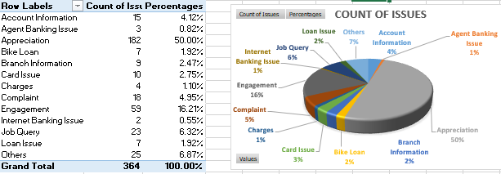
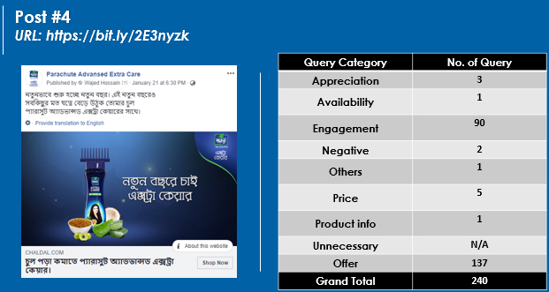

Chapter Four:
Conclusion and Recommendations

4.0 Conclusion

Through the Internship Program at Asiatic Marketing Communication Ltd. I had an extraordinary learning about marketing practices in communication. It has furnished me well with the circumstance of the promoting office world work environment. I tried to actualize my scholarly information with my work as much as I could with Asiatic Marketing Communication Ltd. By doing as such it upgraded my working capabilities, made social improvement, and developed my abilities and specialized aptitudes which will be useful later on to accept an essential part in my corporate business.
Before my entry level position, I didn't think a lot about the promoting office works and its lifestyle. I was astonishing regarding my skills however I handles a few issues along the way regarding my work. This will add extraordinary learning compared to different experiences of my understudy life!
It is the first workplace where I have encountered working in an office as an Internee. I am going to miss working in here, my colleagues, the working environment and seniors who made my work simple with so much fun consistently. I have truly made very fond memories and experiences with my colleagues and also with other team members as I felt comfortable working with them. My internship learning gave me point of view on how an agency works so I accumulated wide range of knowledge about the now booming Digital Marketing segment and learnt a incredible experience of work that will help me in future.

4.1 Recommendations

Since CRM department is do TTL, so all digital marketing facts, tools should be familiar to the employee. Some recommendation from my observations is:
- Employees should be introduced with some significant social media engagement tools that will help to run the community engagement operation smoothly and properly. Such tools are: Loomly, Squarelovin, Sortender, CrowdTangle, Buffer, Hootsuite, Social Pilot, HubSpot, Radian6 etc. They should also focus more on pricing strategy.

- Arrange in-house training session on different digital marketing topic. These will help to improve the quality of the employees. Beside that company can come forward to help to do some online courses. It will be beneficial for both the company and the individual.

- Cross-departmental training is a very important practice for employee development. It will remove the monotony of the employees regarding work. By swapping departments will help the employees to know about the works and duties properly. Organization will also be benefitted at some stage also. In terms to internally recruitment, based on the performance they can easily make better choice and the employee will have idea about the working area and the environment.

- Developing soft skills are similar to personal development. If soft skills like good communication ability, ethics development, problem solving skill, time management, and conflict management can be develop it will bring good for the personal life. A person with these qualities is a team player. He makes a team strong and brings out the best for the organization.

- Supervisor development is the most necessary steps for any organization. Even I did my internship under an account executive. He supervised me the whole time. If he wasn’t trained properly, I wouldn’t learn so many things about digital marketing. Before empowering the front-line employees, middle line employees should be empowered.

- Problem solving and decision making is one of the crucial factors. If employees are involved in decision making process, they will understand the depth and how the process is done.

References
http://www.asiatic360.com/
https://www.asiatic360.com/amcl/client-list.html
https://www.asiatic360.com/amcl/people-behind-company.html
http://bangladeshtalks.com/2011/06/overview-of-asiatic-marketing-communication-limited-bangladesh/
http://www.assignmentpoint.com/business/marketing-business/report-on-grey-advertising-bangladesh-Limitedhtml
http://bangladeshbusinessdir.com/ogilvy-bangladesh/
https://idlc.com/mbr/article.php?id=115
https://www.cleverism.com/understanding-marketing-mix-concept-4ps/
https://study.com/academy/lesson/positioning-strategy-definition-examples.html

