Internship Report
On

Marketing Strategies
Of Care Me Bangladesh


Internship Report
On
Marketing Strategies of Care Me Bangladesh
Course code: INT 4399

Submitted To
Muhammad Hasan Al-Mamun
Assistant Professor
School of Business and Economics
United International University

Submitted By
Md. Shafiquzzaman Bappy
ID: 111 161 065
BBA Program
School of Business and Economics
United International University

Date of Submission

July 18, 2021

Letter of Transmittal
18th July, 2021
Muhammad Hasan Al-Mamun
Assistant Professor,
School of Business and Economics (SOBE),
United International University,
Subject: Submission of Internship Report on “Marketing Strategies of Care Me Bangladesh.”
Dear Sir,
I would like to inform you that I have completed my internship report on Marketing Strategies of Care Me Bangladesh. In this report, I have followed the guidelines that were provided from you and our university, and I have also applied some of concepts and skills that I acquired from my courses. The provided contents here are all my own, though some information has been taken from different sources to complete my internship report. I am submitting the report for your gracious perusal and acceptance. I will be Thankful, if you mercifully accept this internship report. Thanks to you for your cooperation and guideline.
Sincerely yours,
Md. Shafiquzzaman Bappy
ID: 111 161 065
BBA Program
School of Business and Economics
United International University


Acknowledgment

First, I would like to express to Almighty Allah my deep gratitude for blessing me with the intelligence and patience needed to complete the study.
I would be delighted to convey my heartiest gratefulness to Muhammad Hasan Al-Mamun, Assistant Professor, School of Business and Ecobnomics, United International University for his significant direction and astute advice. Without his assistance, it would not have been conceivable to finish this report. I express gratitude toward him for letting me pick this topic and giving his directions and supports which draw out a result of this report. I value his patient guidance and immense supports.
I have an abundance of thanks to making. While setting up this report my supervisor from Care Me Bangladesh, Anisul Islam Sumon (Managing Director of Fortune Tech Limited & Care Me BD) gave significant data and precious remarks on each of the segments of this report. Much gratitude goes to Md. Borhan Uddin (Senior Executive, Care Me BD) whose advice and support smoothened the path for this report.
There may be some flaws in this paper, despite my earnest efforts. For any unintended errors, I apologize.

Table of Contents

Executive Summary v
Chapter 01: Introduction of the study
1.1 Introduction of the Report 2
1.2 Context of the study 3
1.3 Statement of the problem 3
1.4 Scope & Limitation of the study 4
Chapter 02: Background of the organization
2.1 Take a look at Care Me BD 6
2.2 History of Care Me Bangladesh 7
2.3 Mission, Vision & Core Values of Care Me Bangladesh 8
2.4 Sales & Revenue Data of Care Me Bangladesh 9
2.5 Internal & External Analysis 10
2.5.1 SWOT Analysis of Care Me Bangladesh 11
2.5.2 PESTEL Analysis 12
2.6 Competitive Analysis 14
Chapter 03: Objectives & Methodology of the study
3.1 Objectives of the study 17
3.1.1 Broad Objectives 17
3.1.2 Specific Objective 17
3.2 The methodology of the study 17
Chapter 04: Findings & Analysis
4.1 STP Process of Care Me Bangladesh 22
4.1.1 Segmentation 22
4.1.2 Target Customers 24
4.1.3 Positioning 24
4.2 Marketing Mix of Care Me Bangladesh 27
4.2.1 Products & Services of Care Me Bangladesh 27
4.2.2 Prices 31
4.2.3 Places 32
4.2.4 Promotion 32
4.2.4.1 Offline Promotional Activities of Care Me Bangladesh 33
4.2.4.1.1 Hair Building Fiber in Bashundhora City Shopping Mall 33
4.2.4.1.2 DITF Events 34
4.2.4.1.3 Promotional Campaign on various Distributional Channel 34
4.2.4.2 Promotional Activities of Care Me Bangladesh in Online 35
4.2.4.2.1 Black Friday Campaign 36
4.2.4.2.2 Shaadin Offer Campaign 37
4.2.4.2.3 Bijoy Dhamaka Offer 38
4.2.4.2.4 11.11 MEGA Sale 38
4.2.5 Physical Evidence 39
4.2.6 People 39
4.2.7 Process 40
Chapter 05: Recommendations & Conclusion
5.1 Recommendation 43
5.2 Conclusion 43
References 44
Appendix 46
Interview Questions 48

Executive Summary
Care Me Bangladesh is one of fastest growing e-commerce company in the e-commerce industry of Bangladesh. Their main purpose is to make the lifestyle easier by providing life hack solutions. They are always striving to capture the e-commerce market with their effective strategies with distinctive capabilities. With a vision of building top position in the E-commerce world, they continuously develop their online shopping store with a variety of products and easy-to-receive services. In Bangladesh, on the e-commerce market place, Priyoshop, Ajker deal.com, Kaymu are the major competitors for them. In this report on the findings & analysis part, I have elaborated on the target marketing process of Care Me Bangladesh. They captured the market on the basis of middle & upper classes people on more than 50 districts of Bangladesh through online platforms where their target customers are people all ages who are seeking products or services for making their lifestyle easier and getting easy solutions to the their problems. On their pursuit of business excellence, Care Me Bangladesh is always trying to develop & fill their online store by bringing different and unique products and services with differentiated features. They also positioned their business by creating an attractive brand story and by using the power of social media. In the case of setting prices of their products & services, they follow customer-value based pricing strategy. They also give discount offers on seasonal and occasional basis. For communicating with their customers and delivering their branding messages, they do various promotional activities in both online & offline media. In order to able to dominate the highly competitive e-commerce market, they need to focus on the core competencies, assure the proper utilization of the organizational resources, and develop distinctive capabilities to deliver superior customer value.
Key Words: Marketing Strategy, Care Me Bangladesh

CHAPTER 01
INTRODUCTION

Introduction of the Report
Even 10 to 15years ago, no one in our country ever imagined that E-commerce would be as popular as it is today. Almost all our customers in Bangladesh want to see or touch their products before purchasing it. Even then E-commerce has spread day by day in the traditional market place of Bangladesh as well as becoming quite popular among the online customers. The main reason for being heavy traffic jam in Bangladesh, customers suffer very difficult to buy goods from one place to another, as well as waste a lot of their time and energy. In this case, just as customers who purchase their products from online, they are benefited from saving their valuable time & also energy. E-commerce markets are gaining such popularity and acceptance among online customers only because of the advancement of technology in the last 20 years. Bangladesh has different types of e-commerce sector, the most notable of which:
- Instant Messaging
- Digital Wallet
- Social Networking
- Electronic Tickets
- Supply Chain & Logistics
- Payment Systems
- Online Shopping
- Online Banking etc
Although e-commerce was launched many years ago, it has been growing in popularity from 2013. Many consumers in our country are not familiar with e-commerce because they always prefer to be confined to their traditional market. Many e-commerce companies or online sites have taken great initiative to introduce this new e-commerce sector to all the people of Bangladesh. In that case, Care Me BD is a trusted and reputable company or online shopping site which is becoming more popular to the online customers. And the main reason for this that customers can easily get the product of their choice from Alibaba, Amazon & many well known brand from Dubai in a short time by Care Me online sites.

Context of the study
For a requirement of completing the Bachelor degree of Administration, the internship report is important to prepare. After completion of 120 credits of BBA program, my internship period was started at my workplace, Care Me Bangladesh as a Marketing Executive. My supervisor was Borhan Uddin & Anisul Isalm. My internship course instructor Muhammad Hasan Al-Mamun, Assistant Professor of United International University allowed me to select a field that I was interested in when choosing a topic for making the report. Since my interest was more about online platforms’ marketing or digital marketing, I selected the topic “Marketing Strategies of Care Me Bangladesh, A Perspective of E-commerce business, nowadays online shopping, digital marketing is growing on day by day and gaining maximum popularity among the people. So, I am preparing my internship report in this sector which plays a role in my future practical or job world.
- For gathering and trying to coordinate detailed information more about work's responsibility.
- To learn more about the world of business and can be explored it.
- Taking the realistic scenarios and comparing them to the lessons learned.
- To meet the requirements of the BBA program & can be satisfied.

Statement of the problem
Care Me BD is mainly owned by Fortune Tech Limited of Bangladesh. It mainly focuses on the development & support of E-commerce business in Bangladesh. The company is currently gaining a foothold in the fast growing online marketplace in Bangladesh. They are running their business activities in Bangladesh & USA. A wide range of customers’ kitchen essential items, electronics, personal caring products, beauty-fashion & lifestyle products are hosted by Care Me BD. As a result online customers have benefited from the personalization & protection of the customers’ experience with Care Me BD. Care Me BD promises best quality products, easy return & money back & fast home delivery to its customers. It not only solves retail for optimal convenience but also solves many barriers digitalization that allow customers to shop on online platform. I am currently doing my internship period and gaining experience as a sales & Marketing Executive from Care Me BD. The marketing & sales strategies and activities that Care Me BD also follows that are almost different from those other traditional or analogue marketing strategies & activities. I have faced a variety of challenges while working on the marketing team of this company and I will discuss the challenges, findings & recommendation throughout this report.

Scope & Limitation of the study
The primary goal of this report is to provide a reflection on my internship experience. And the main goal of my internship at Care Me BD was to gain practical knowledge and experience, as well as to gain a better understanding of the working environment. Since, I did my internship program in the Sales & Marketing department, and I had relatively easy access to information about the department's functional and operational activities. In this internship report, I have attempted to highlight the overall sales & marketing strategies and their service marketing strategies. Since the majority of our country's customers have benefited from ecommerce companies since COVID 19, I've tried to come up with some solutions to these issues in order to ensure the delivery of high-quality products from Care Me BD and the ease with which we can serve our customers.
However, there is one limitation, I encountered while preparing this report and that is information confidentiality. Because I work from home a lot of the time, I had a lot of difficulty connecting practical working activities and academic knowledge during prepare the report.

CHAPTER 02
Company Analysis

Take a look at Care Me BD



Care Me is a beauty and personal care brand in Bangladesh. They started their journey with the Fortune Tech Limited. They continue their journey with some of the most popular and well-known brands of cosmetics from different countries as well as attracting & unique products which are used in our daily lives. There are some products items that customers may be seeking on their minds to get but these items have not thought of marketing any online shop in Bangladesh. That’s why Care Me BD brought these products & items by only thinking about the solving of customers’ problem. The main purpose of the Care Me BD is to provide with a number of unique problem solving items & products to their clients & customers that are used daily & make everyday life easier. Their goal is to make customers’ life less time consuming and also make it less difficult.

History of Care Me Bangladesh




Anisul Islam Sumon,
Managing Director of Fortune Tech Limited & Care Me Bangladesh
Care Me Bangladesh started their journey in January 2017 with a single product. Then after getting huge response from the customers & consumers, they gradually increase the number of products which is now more than 1000. After participating in the first Dhaka International Trade Fair in 2018 and winning the 1st place in the general category, the plan of take Care Me Bangladesh to a higher level began to be implemented. Then gradually they started to build wholesale and commercial business from retail. They set foot from online to offline to expand their popularity.
They have products in more than 100 shops inside and outside Dhaka and in the country’s renewed super shop “MINABAZAR” and various super shops. Their main target is to bring their products to the hands of customers all over the country in the future.
For the convenience of the customers and meet the demand, they have come up with the facility of Aliexpress & Alibaba for any product request. Their aim is to deliver international branded products to the customer in the fastest time & at the reasonable price.

Mission, Vision & Core Values of Care Me Bangladesh

Vision
The Company’s vision is to build a position in the top list of e-commerce platform & also build a brand positioning in the future.

Mission
Provide with a number of unique and problem solving items & products to their clients & customers that are used in daily lifestyle & make their life easier.

Figure 2.1: Mission & Vision of Care Me Bangladesh

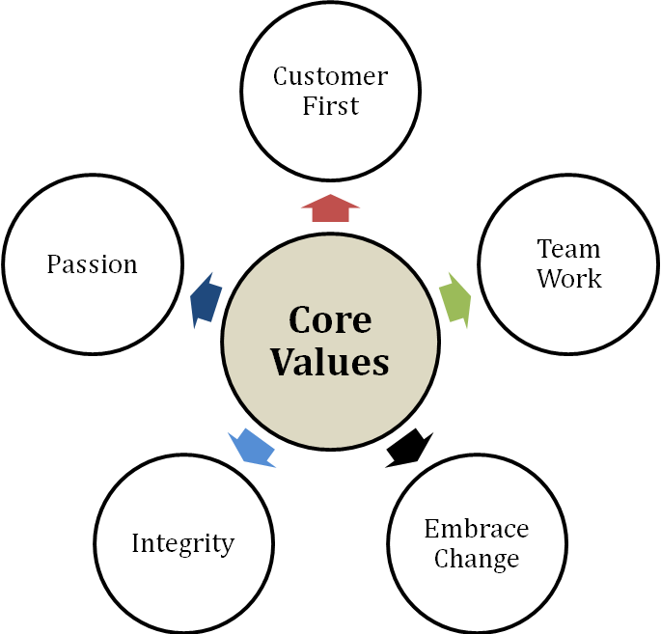

Figure 2.2: Core Values of Care Me Bangladesh

- Customer First: The interests of its users & paying customers are the first priority of the company.
- Team Work: Care Me Bangladesh expects their employees work together as a team.
- Embrace Change: The Company consequently tries to make their employees flexible, innovative & adapt to new conditions, technologies & practices.
- Integrity: Trust is an important factor in the market place. In the case of, Care Me Bangladesh always tries to maintain the best standards of integrity & keep their commitments.
- Passion: Care Me Bangladesh brings new products & develops new services for their clients & customers so the employees of Care Me BD are always encouraged to act with passion.

Sales & Revenue Data of Care Me Bangladesh

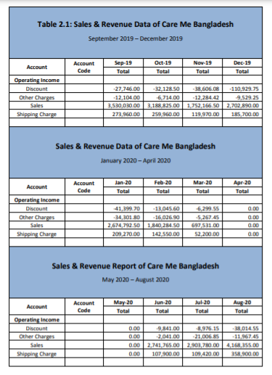

Internal & External Analysis

SWOT Analysis of Care Me Bangladesh
SWOT analysis is a good way to analyze the current situation of an organization and how it can be developed in the future.
Strength | - Superior & Attractive Website in the top position on Google’s searching list among competitors.  - All items & products are Care Me branded with unique features & varieties of products.  - Brand warranty with fast delivery in whole Bangladesh.  - Refund on damaging products  - Easy & free register.
Weakness | - Low Brand recognition  - High turnover rate
Opportunity | - Emerging online market.  - Customers’ Positive Review
Threats | - Upcoming International giant company “Amazon”.  - Lower Internet accessibility.  - Fake Review of customers.

Figure 2.4: SWOT Analysis of Care Me Bangladesh

PESTEL Analysis
We use PESTEL analysis to analyze the macro environment external factors (external marketing environment factors) that are outside of a particular business to do any kind of business analysis.

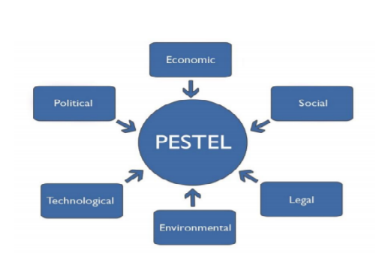
Figure 2.5: Understanding of PESTEL Analysis

Political Factors
Care Me Bangladesh is an online shopping store where customers can purchase their choosing products & services through internet. So for being an internet based business, there are no political issues that impact on their marketing & sales activities.

Economic Factors

Economically, Bangladesh is growing but not stable till now. So in the case of considering the factors of-

Economic Growth

Exchanges Rate

Interest Rate

Taxes Rate

Inflation

Income of customers &

Purchasing power, it’s an always big challenge for Care Me Bangladesh to build their sustainable business.

Social Factors
Attitude & common belief of the population are in the area of social factors which are involved:
- Population Growth
- Career Attitudes
- Age Distribution
- Social belief
- & so on.
These factors influence to the customers on a particular interest on their purchasing or buying anything.
Most of the people cannot trust on online shopping company. If Care Me Bangladesh can capture on this factor they can gain the more market share & new customers.

Technological Factors
Technology is developing day by day. Everyone has Smartphone & most of the people now want to buy their liking products from online. So Care Me Bangladesh is centering on portable promoting to capture the market.

Environmental Factors
Biological and natural angles such as climate and climate alter are including in environmental factors, which may particularly influence businesses such as tourism, cultivating and insurance. Care me Bangladesh since it’s a web based E- commerce business this factor won’t be affected it.

Legal Factors
Legal variables incorporate separation rule, buyer rule, antitrust regulation, business rule, as well as physical condition and security act. These variables can influence working of a company, its costs, and products of a company. So, obviously Care Me Bangladesh should maintain these rules for running their business.

Competitors Analysis
For running a business smoothly, a company should more focus on various things which relative with their profitability as like company must need to analyze the forecast & by using SWOT analysis, company finds out its’ strengths & weakness and also identifies the potential opportunity & threats.
Whether for identifying the top major competitors which are doing the similar business, competitive analysis must need to analyze. By using this, company identifies the competitors’ strengths, weakness & their marketing strategies which are related to their products, services & marketing activities & strategies.
Care Me Bangladesh, their e-commerce business is growing faster & uprising online shop from the beginning in Dhaka with a product. Now they have 1000 products in their online stores & all items are trendier & unique features. Their innovative product ideas & expansion the Varity of products & services has been hit so far. But as a E-commerce company for them, the major competitors are Ajker Deal & Priyoshop.
By using a chart, considering e-commerce business some highlights of the major competitors’ companies are given below:

Company  Name | Target Market | Price | Distribution Method | Website Design | Advertising Platform | Language
Care Me Bangladesh | - Mass Market  - 1st Hand buyer | Competitive | -Online Market Place  -Wholesaler  -Direct Sales  -Home delivery | Most Attractive | -Face book  -Twitter  -Instagram | -English  -Bangla
Ajker Deal | - Mass Market  - 1st Hand buyer | Competitive | Home delivery | Very Attractive | -TV  -Face book  -Twitter  -Instagram | -English  -Bangla
Kaymu | -Mass Market  -1st hand buyer  -2nd hand buyer | Lowest | Home delivery | Not up to the Mark | Face book | English
Priyoshop | -Mass Market  -1st hand buyer | Competitive | Home delivery | Attractive | Face book  -Twitter  -Instagram | English

Table 2.2: Competitor Analysis

CHAPTER 03
Objectives
&
The Methodology of the Study

Objectives of the study

Broad Objectives
Care Me BD is currently the fastest growing e-commerce company and site in Bangladesh's e-commerce industry. So, in this internship report, my study's main goal is to discover Care Me BD's overall sales and marketing strategies, as well as their service marketing strategies, which are implemented by the company.

Specific Objective
The following objectives are the specific objectives of this study:
- To gain a better understanding of the business environment and how it affects their sales and marketing strategies.
- To learn about the company's adjusting strategies, which are tailored to their competitive environment and can help them increase their profits?
- To know about their STP process
- To know about their Marketing Mix application
- To learn about Care Me BD's promotional activities, both online and offline
- To know about their service marketing strategies which are followed by them?

The methodology of the study

Topic Selection: The topic was approved by my internship course supervisor and it was complete discussed with him where sir provided his point of view so that an efficient report could be made.
Overview of the data collecting & using
Qualitative data collection methods like group discussions, interviews, observations & annual report of the Care Me BD, marketing report revision & company’s documents have been be used in this study.
The following of basic overview of the data collection and analysis are used to prepare this report:
1. Type of the data: This report is prepared by using primary & secondary data.
Primary Data: The primary data has been collected thorough interviews & discussions with supervisors, cross functional team, marketing teams, senior colleagues, customers and hand on experience & direct observations on internship, practical working tasks & overall sales & marketing activities of Care Me Bangladesh.
Secondary Data: Online Publications & Online documents, reports, journal, newspaper, articles, academic knowledge and various websites.
2. Data Source: The method specifies how data is processed and interpreted. I got the data after going through the various databases that helped me write this report. It divides the foundation into two parts:
Primary Sources of Data: For the first time when the information gathered is considered primary data. The following are some of the methods used to collect such information:
- Face-to-face contact & group discussions with the respective officers and employees of the company. Informal dialogue with the customers.
- Practical working tasks on sales & marketing department of Care Me Bangladesh.
Secondary Sources of Data: The following sources have been used for collecting the secondary data, include:
- Care Me BD's Annual & Marketing Report,
- Official Care Me BD's website,
- Care Me BD's marketing, sales & operational & functional related papers.
3. Sampling Technique & the sample size
Non- probability technique have been used for studying & analyzing the selected topic of Marketing Strategies of Care Me Bangladesh and a number of group was participated on interviews, individual or group discussions for studying this analysis which means n (Sample Size) was 5 to 8 participants.

4. Method of Data Collection
Data was collected from a number of groups of Care Me BD participants in this study through group discussions, interviews, and observation and experience with various sales and marketing activities.
5. Data Analysis & Presentation
I have not included any numerical values in this internship report because the following report is a descriptive type report. The report focuses on a real-world scenario. To describe the current situation, STP process, application of marketing mix (7ps) and their marketing & sales policies, activities & strategies, I mostly used verbal analysis and also few modalities have been used for analyzing & presenting the data.

CHAPTER 04
Findings & Analysis

STP Process of Care Me Bangladesh

Segmentation
Market segmentation or customer segmentation is an important part for starting or running a business because based on the assumptions of a customer’s various characters, behaviors, responses, the company’s marketing departments prepare their marketing tasks. Market segmentation or customer segmentation whatever you say, it helps to give you an accurate idea of what can be done about marketing overall and what the consequences might be. Care Me Bangladesh divides their e-commerce business by their customer segmentation into a few groups to find out some of their similarities which simplifies their marketing related offerings which are very relevant and well- responding by customers. These segmentations are given below with a table & explanation:
Type of Segmentation | Segmentation Criteria | Care Me BD Target Customer Segment
Geographic | Region | More than 50 districts of Bangladesh
Geographic | Density | Urban Area
Demographic | Age | All ages
Demographic | Gender | Both Males & Females
Demographic | Life-cycle stage | Bachelor Stage young, single people not living at home
Demographic | Life-cycle stage | Newly Married Couples young, no children
Demographic | Life-cycle stage | youngest child under six
Demographic | Life-cycle stage | youngest child six or over
Demographic | Life-cycle stage | older married couples with dependent children
Demographic | Life-cycle stage | older married couples, no children living with them
Demographic | Life-cycle stage | older married couples, retired, no children living at home
Demographic | Occupation | Bankers, employees, housewives, professional, students
Behavioral | Degree of loyalty | Hard core loyal
Behavioral | Degree of loyalty | Soft core loyal
Behavioral | Degree of loyalty | Switchers
Behavioral | Benefits sought | Widest range of products
Behavioral | Benefits sought | Convenience of online purchasing
Behavioral | Benefits sought | Competitive prices
Behavioral | Personality | Easygoing, determined and ambitious
 | User status | non-users, potential users, first-time users, regular users, or ex-users of a product
Psychographic | Social class | All social classes: lower class, working class, middle class and upper class
Psychographic | Lifestyle | Resigned, Struggler, Mainstreamer, Aspirer, Succeeded, Explorer  Reformer

Table 2.3: STP Analysis
Geographic Segmentation: Basically, Care Me Bangladesh tries to capture the whole Bangladesh markets by targeting whole sales & retailers by building their brands reputation. So in the starting of their business, they basically try to capture the online markets in the overall area of Bangladesh. According to their 2019’s report, Care Me Bangladesh has 90%sales in online & 63% sales in Dhaka zone. They are covered the other areas includes Chittagong (12%), Sylhet (10%) & other districts of Bangladesh (13%).
Demographic Segmentation: They mainly target the upper & middle class family’s customers who are able to access to the web * internet browsers and are more likely to purchase shopping from online and all ages of customers are including this segmentation.
Psychographic Segmentation: Care Me Bangladesh targets the online customers who prefer to purchase unique, trendy, and caring & life hacking products from trusted online site in an affordable price & they are middle & upper class working customers.
Behavioral Segmentation: Internet savvy customers are the main targeted customers for Care Me Bangladesh who are prefer & are more likely to shopping from online. For attracting the customers, Care Me Bangladesh gives various discounts & coupon codes on occasionally. On the basis of behavioral segmentation their target customers are high spenders, coupon lovers, on time users, trendy customers who are aware to the brand & quality of the products & services and also want to get unique products or items for their easy lifestyles.

Target Customers
Care Me Bangladesh targets the customers who are more likely to purchase shopping from online & who have access to financial tolls such as Bkash, Rocket, debit or credit card users. Their products & items are offered in sale by displaying or suggesting on the various social platforms like face book pages, instragram & their websites for all ages target customers like old, young and babies. Their online shopping store is designed in such a way that their target customers can easily visit and every type of product is provided with quality, price, usage method along with Bengali & English translation with each product or service.

Positioning
From the pandemic situation, e-commerce business of Bangladesh is becoming more popular to the all people. A lot of people prepare to online shopping. In the case of, their time & energy cost are saving. For any business, positioning is very important because success of the business leads to the advantageous & transparent position in the mind of the customers.
Care Me Bangladesh is still trying to apply various strategies for positioning their business. These are discussed below:
Bringing Differentiation of Products’ Store: They continue add their online store with cosmetics of various popular well- known brands from home and abroad as well as the interesting, necessary & unique products and items of everyday use. They always try to bring innovative products which are trendier to the peoples and make their lifestyle easier. Some of these products are shown below:
  - Windproof USB Lighter - Black
  - Shoe Drying Hanger
  - Acrylic Spice Jar
  - Kitchen Glass Oil Spray Bottle
  - Rotating Spice Organizer
  - 360-Degree Rotating Hook
Brand Story: Providing to the customers with a number of holistic unique products that are used daily & make their everyday life easier is the main target of Care Me Bangladesh. “Care Me” is not only in name but also in deeds they are determined to take full care of customer needs.
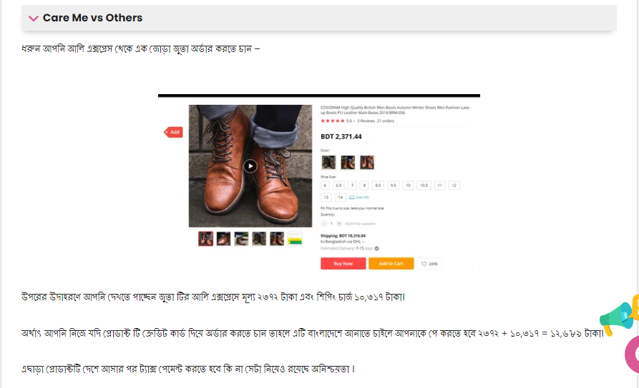
The Power of Social Media: Considering in Bangladesh, 70% users spend around one to two hours on social networking sites & 24% users spend more than 5hours. So using this, Care Me Bangladesh takes a great opportunity to display their products inform of the customers through various platforms like Instagram, YouTube, Face book about the products related information, offers, price & reputation of the company, customers feedback etc. Simply put, for gaining the competitive market, Care Me Bangladesh continues to use the power of various social media to build their organization’s reputation in where a small budget is used for it. They always try to engage their target customers with their various offers & information about the trendy & new products.
Implementing Different Marketing Strategies: Care me Bangladesh, they want online shoppers in Bangladesh to be able to easily identify their brand, know about their stories, buy their products from online stores and think about these things to make sure their online store is visible with most attractive. They focus on various types of optimizations, PPC, long keyword research to keep their online store’s page in the top rankings on Google. Several activities & strategies which are followed by Care Me Bangladesh & these are given below:
- Guest Blogging: They create good quality content to increase the domain authority of their website as well as create back link which are especially helpful in building customers’ credibility and driving traffic.
- Video Marketing: They make various videos separately for each of their products, giving all the information about the product, guidelines of uses & how to order these products. Through such video posts everyday they can engage their target customers toward their products & items as well as generate their sales.
- Website Performance: The online website or store is enough good with other e-commerce company in Bangladesh so that their target customer can easily visit their websites by scrolling do shopping from there with comfortably and for sustainable business, Care Me Bangladesh always focus on creating good contents, keywords research, tags rather than page boosting.

Marketing Mix of Care Me Bangladesh

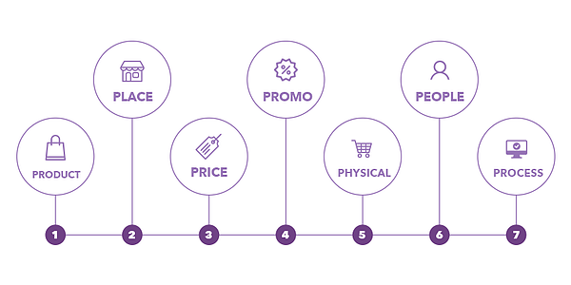

Figure 2.6: Marketing Mix of 7ps

The combination of 7 components of products or services, price, promotion, place, physical evidence, people & process which are used to meet the demand in the target market is called Marketing Mix that means it is a combination of all the steps of strategies that a company uses to promote its brand or products/services.
7ps of Marketing Mix are described below:

Products & Services of Care Me Bangladesh
Products: In the case of generating innovative product ideas, Care Me Bangladesh is building their position with a short time in the E-commerce market place of Bangladesh. There are some products items that customers may be seeking on their minds to get but these items have not thought of marketing any online shop in Bangladesh. Considering these things Care Me BD brought these products & items by only thinking about the solving of customers’ problem. The main purpose of the Care Me BD is to provide with a number of unique problem solving items & products to their clients & customers that are used daily & make everyday life easier.
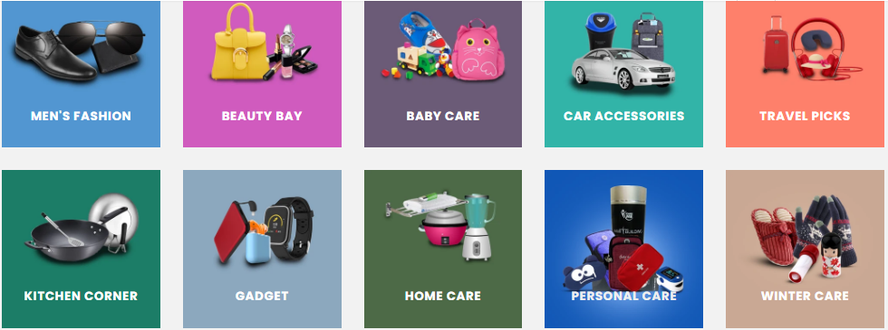
They have 1000 of products of their own brand in their online shopping stores which are unique & best quality products. Some of the products & services are listed below:
Table 2.4: Products & Services of Care Me Bangladesh

Men’s  Products | Beauty Bay | Children’s  Products | Travel Picks | HOME CARE
Business Wallet | Beauty Care Massager | Baby Accessories | Electric Air Pump | Leak Stopping Waterproof
Mini Card Holder | Eyebrow & Facial Hair Trimmer | Bath Tube | Eco-Friendly Portable Cup | 380ml Juice Blender
Aluminum Credit Card Holder | Cosmetic Storage Box | Kids Writing Posture Tool | Mini Travel Backpack | Hand-free Floor Cleaning Mop
Windproof USB lighter | Ladies Boat Socks (Set of 5) | Remote Control Speed Boat | BBQ Grill Mat | Portable Mini Electric Sewing
Nail Clipper Set | 7 in 1 Nail Buffer ( Set of 2) | Kids Learning Tablet | Hanging Passport Bag - Blue | Mini Cereal Dispenser
Shoe Cleaning Brush | Bio Aqua Facial Mask (Set of 3) | Kids Learning Computer | Travel Perfume Atomizer | Sprayer Glass Cleaner
 | Crystal Eye Mask ( Set of 3 ) | BABY SCHOOL SUPPLIES | Travel Neck Pillow | Stainless Steel Tableware Set
 | Makeup Sponge | Kids Cartoon Style School Bag |  | Green Apple Tea Cup Set
 | Disposable Face Towel | Pattern Stationery Set |  | 3 Layer Dish Drainer Rack
 | Japanese Lip Balm | Cartoon Character Stationery |  | Door Stop Alarm
 |  | BABY NURSING |  | Portable 5 Tier Shoe Rack
 |  | Nursing Pillow |  | Automatic Door Closer - Black
 |  | Kids Life Jacket
And so many Items & Products are available in Care Me BD

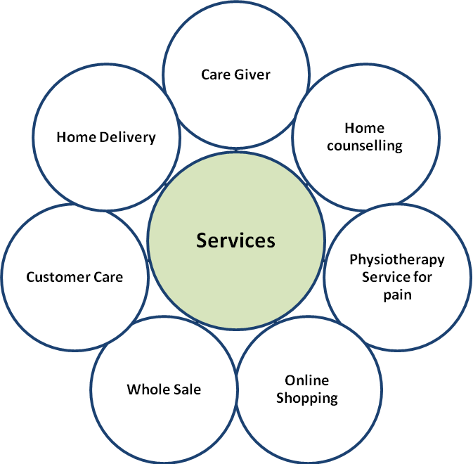

Figure 2.6: Providing Service from Care Me Bangladesh

(a) Care Me Bangladesh, Professional Caregiver Service
- Care Giver Services: It is the responsibility of care givers of Care Me Bangladesh to assist the elderly who are unable to walk properly in their daily work. Their trained care mangers choose caregivers to take care of your loved ones just like you. Affection, compassion & sympathy this three things are the main centers of their service staff.

- Home Counseling Services: Those who suffer from various physical & mental problems due to old age, Care givers take care those elderly, help them, and keep in touch with their families and doctors on a regular basis.

- Physiotherapy Service for pain: Their experienced physiotherapists provide services at home. Each package of this service is designed with utmost care to understand your needs. Customer satisfaction is the main priority of them.
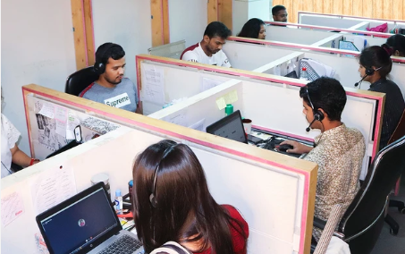
(b) Customer Care Services: Care Me Bangladesh’ customer care representatives regularly build a contact with their clients & customers over phone call or live chat. They provide accurate information about their products & services. If there is any claim about delivery products or services related issues, they try to solve it & also try to satisfy them. They ask to their customers how to develop their products & services so that they are satisfied & stay with Care Me Bangladesh. They also let know their regular customers if there are any offers on their products & services.
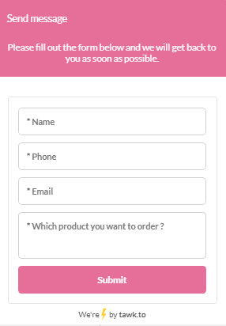
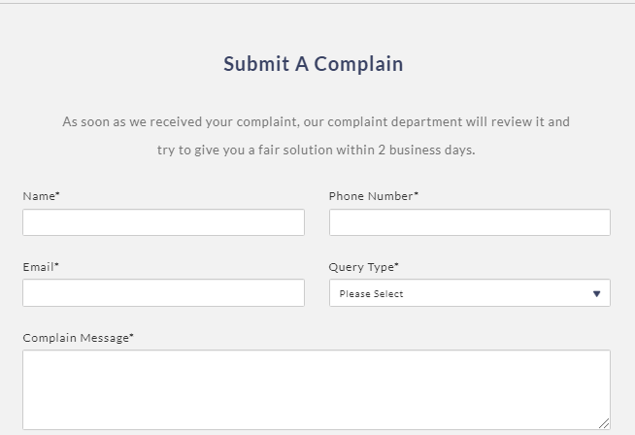
Live Chat Box
Complaint box regarding products or service related issues

(c) Fast Delivery Services:
They delivery their products by taking the help of other third party delivery services within 1 to 2 days.
(c) Wholesale (B2B) Services:
For growing long time sustainable business, increasing sales volume and also gaining higher profits, Care Me Bangladesh provide wholesale or B2B services.
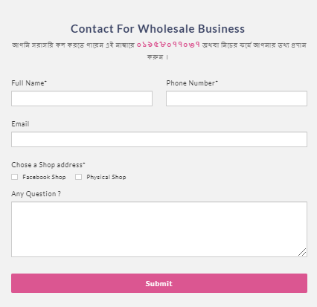

Prices
Since Care Me Bangladesh has a large number of products & items and one product differs from another, they use Price Discrimination strategy for setting their products’ prices. For example:
- Setting High Prices: When the products is unique or trendier and is not available in local market or finding the product is difficult from the local market or other online shops, they set high prices on that product. Some of the trendier & unique products & their prices are given below:
Product | Price (BDT)
Keychain Data Cable - Brown | 250
Fire Safety Blanket | 750
Hand-free Floor Cleaning Mop | 850
Wireless Digital Door Chime | 950
Car Vacuum Cleaner | 1,350
3D Cat Heater | 1,700
- Wholesale Prices: They set a wholesale price when their clients & customers purchase a large number product.

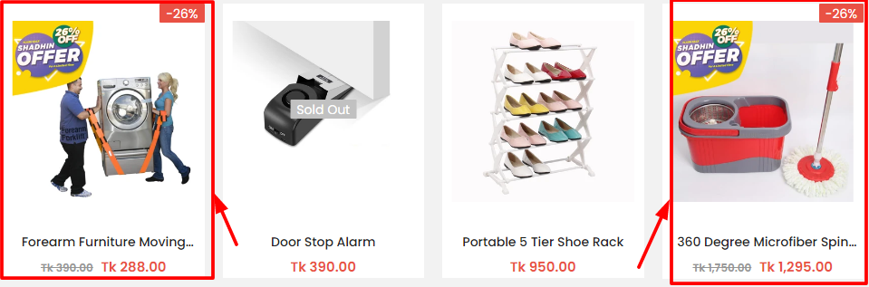
- Setting prices based on customers: They collect the data of past & real time customers then segment the customers and on the basis of data, they generate their products’ prices to each segment. Sometimes for gaining new customers they offer discount prices on their products in seasonally or occasionally to selling in different people.

- Delivery Charge: In Dhaka city they charge 50 taka for delivery the products & in outside they charge 100 taka.

Places
Care Me Bangladesh, besides placing their business on online platforms by building a professional e-commerce web site, their products are available in more than 100 shops inside and outside Dhaka and in the country’s renewed super shop “MINABAZAR” and various super shops. Their main target is to bring their products to the hands of customers all over the country in the future.

Promotion
Care Me Bangladesh does different types of promotional activities on online & offline. In online they mainly focus on social media platforms which are Face Book & Instragram & their own websites. They basically display & show their products & services related articles, blogs, videos & photos to the customers, try to visual them by following Advertorial Strategy (Advertisement + Tutorials) like about –
- The necessity of the products,
- How to solve their problems by using products or
- How to make their lifestyle easier and smart,
- Tutorials for using the products, branding information etc.
In offline their sales, marketing & customer care services find out the lead for wholesale & they follow up regularly visit the market & do their promotional activities to capture the wholesale market.
To gaining a competitive market place in e-commerce sector of Bangladesh, Care Me Bangladesh follows some of promotional strategies which are discussed below:

Offline Promotional Activities of Care Me Bangladesh
Offline advertising is a marketing activity which involves that an advertising about a business outside of the internet. By this, the main purpose of the business, products & services related promotional messaging can quickly & effectively deliver to the customers. It does not require to participation on the Internet. These types of disconnected promotional activities include:
- Various events in Shopping Mall, trade fair, distribution channel.
- Discount coupons,
- Vouchers coupons,
- Wholesale promos etc.
Some of the off-line promotional activities of Care Me Bangladesh are:

Hair Building Fiber in Bashundhora City Shopping Mall
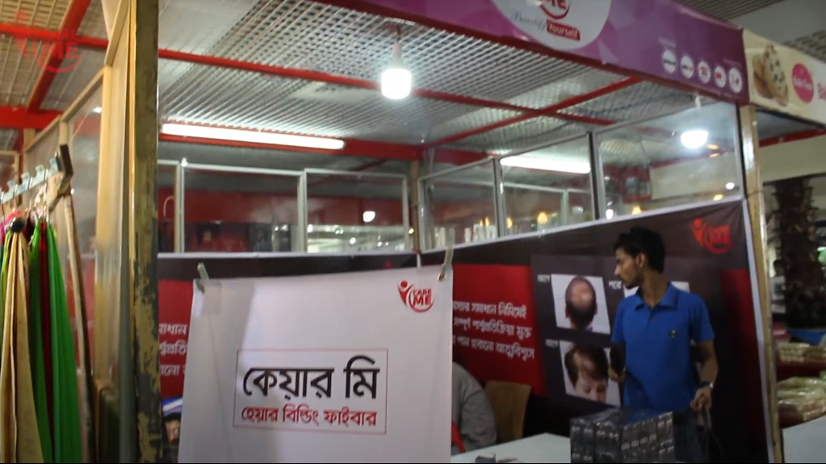
Care Me Bangladesh’s journey begins with only this product which was “Hair Fiber” and they did their campaign in Bashundhora City complex by arranging a stall & introduced the customers about their products & services and their brand’s name. The success of their products campaign that year was largely due to the fact later they involved many of the offline promotional campaign.

Hair Fiber Building Campaign in Bashundhora

DITF Events

Next, they came to present their customers with a wide variety of products and services thorough a stall at the Dhaka International Trade Fair (DITF). They camped all the month that year about their new innovative products, services, product quality, features etc. They run their offline promotional marketing activities all the month with displaying their products & service related ads on the Large TV Screen beside their stall. Also their sales & marketing representatives give & deliver the messages of their new unique products, services. They also offered a special discount on their all products & services throughout the month.
For the that year for selling innovating & good quality products & services, Care Me Bangladesh got the prize for being Top General Stall under their parent company Fortune Tech Limited.

Promotional Campaign on various Distributional Channel
They run their promotions in various shopping mall shops and in big super shops like Shwapno, Mina bazaar in Dhaka and outside of Dhaka. If a retailers or wholesalers sell their branding products & items, they got a certain percentage of commission for that.



Wholesaler’s clients of Care Me Bangladesh

Promotional Activities of Care Me Bangladesh in Online
E-commerce companies have to involve in various advertising, marketing & promotional activities on various online platforms in order to attract about the company’s products, services or brands & also get the customers’ attention. They have to promote their business in online in order to customers purchase their choosing products or services than from others. Sales promotion is also a part of overall promotional activities.
There are some types of promotional activities are given below:
- Above the line promotion includes:
- Advertising
Schemes
Price Reduction
Contests
- Instance Acquisition
- Consumer promotions

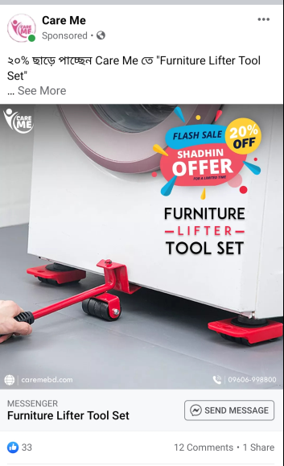
- Below the line promotion includes:
- Discount rate
- Freebies
- Awards
- Coupon Codes
- Promo Codes etc
As an e-commerce company, Care Me Bangladesh most of the advertising & promotional activities & campaigns take place on online platforms including Face Book, Instagram and their own websites. Whenever people scroll through their Face book or Instagram newsfeed and see Care Me Bangladesh’s attractive ads, where links are mentioned & by clicking the links automatically visitors get to see their giving attractive offers, information about the products & services.
Some of the online promotional activities of Care Me Bangladesh are discussed below:

Black Friday Campaign

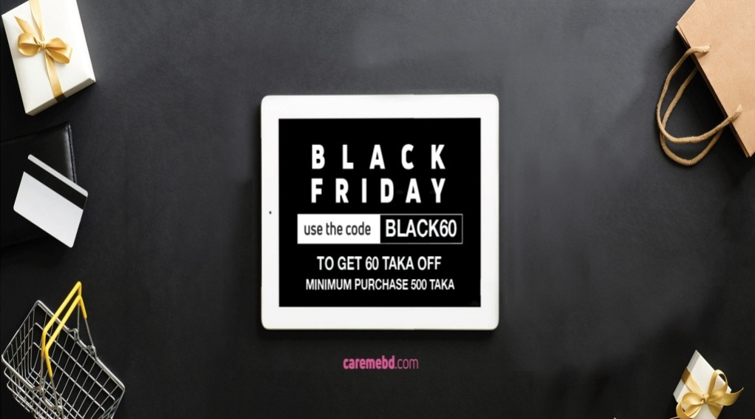
Care Me Bangladesh launches their Black Friday campaign in Bangladesh & there are some key features of this which has been given below:
- At the month of November in the every year, Black Friday campaign is launched by Care Me BD.
- From November 25 to November 27 is the duration of this campaign.
- During on this campaign, all the sorts of their items & products are sold.
- The discount is up to 60 taka on their every products & services during this campaign. For getting the discounts, they instructed to the customers to use a code which is BLACK 60.

Shaadin Offer Campaign

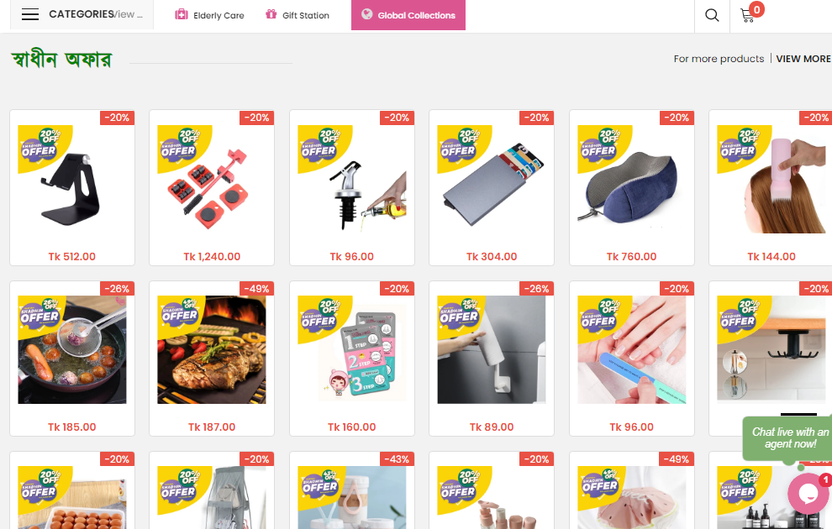
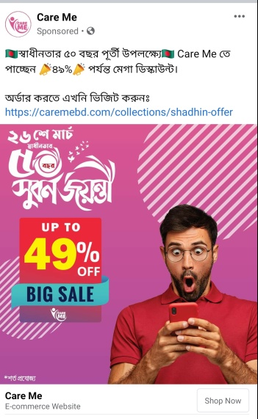

On the Independence Day of the golden jubilee of Bangladesh, Care Me Bangladesh is offering discount up to 49% on all their products and services which are available to their customers throughout the March month of each year.

Bijoy Dhamaka Offer
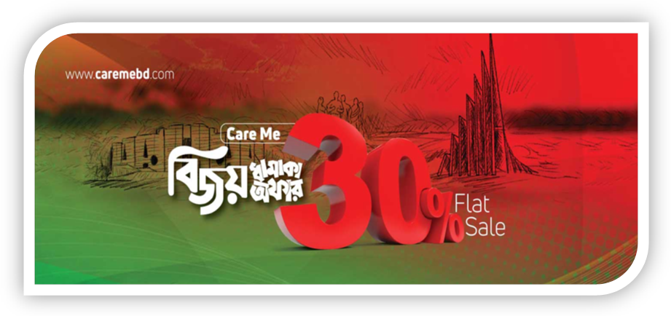
On the Victory Day of Bangladesh, Care Me Bangladesh is offering discount up to 30% on all their products and services which are available to their customers throughout the December month of each year.

11.11 MEGA Sale
This is a successful promotional campaign for Care Me Bangladesh. Every year on the 11th November, Care Me Bangladesh is offering discount up to 80% on all their products and services which are available to their customers and customers also get their ordering products by 11 taka delivery charge.


Physical Evidence
Care Me Bangladesh’s biggest & most attractive physical presence its Website. Their website is built and developed in such a way that their customers can buy the products of their choice at ease.
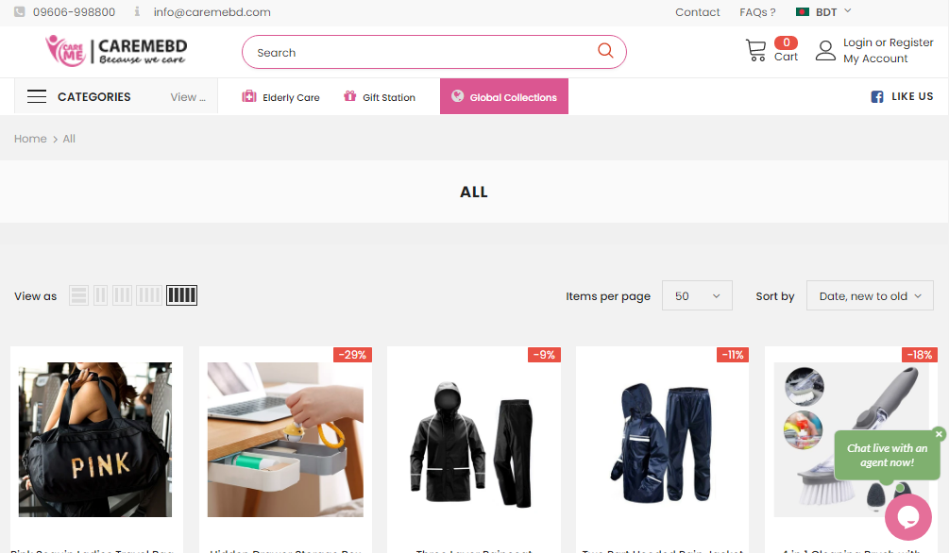

People
They have more skilled employees who are expert on-
- SEO optimization,
- Drop shipping products listing,
- Developing websites,
- Developing products & services and also marketing activities,
- Customer care service.

Process
Online Shopping Website of Care Me Bangladesh
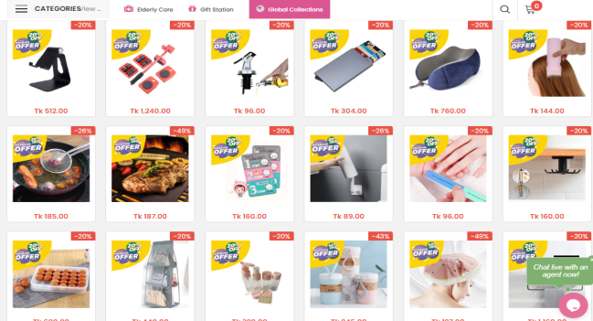



Places money for particular products or services

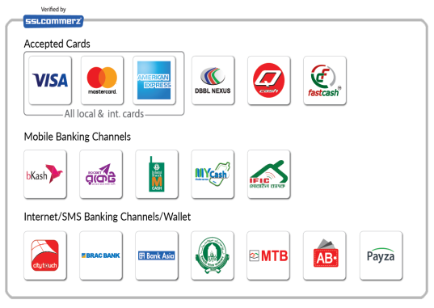


Order Placed by customers
Shopping Chart

Shipment to Customers
Order is completed
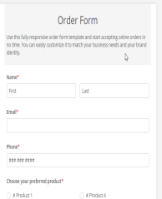
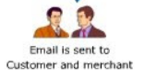

Sent to warehouse for fulfillment

Shipping carrier picks up Shipment

Figure 2.5: Online Shopping Structure Care Me Bangladesh
Care Me Bangladesh has more than 1000 products of its own brand and they display on their won e-commerce website the quality & quantity of all products, other information related to features of the products with good quality pictures for their customers. From Care Me Bangladesh’s own e-commerce website, customers can easily purchase their choosing products & items at home through credit card, debit card, mobile banking or cash on delivery.
They delivery their products by taking the help of other third party delivery services within 1 to 2 days. If there is any defect on their products or of the quality or quantity is incorrect, they will replace the products for free as soon as possible.
If there is any defect after opening the packet of the product, they will replace if for free to their valuable customers but if the customers want to return the product due to not liking, in the case of customers must pay to delivery charge.
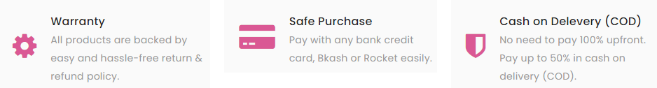

CHAPTER 05
Recommendations & Conclusion

Recommendation
Since Care Me Bangladesh is an e-commerce company so within 3 months of internship period, it’s difficult to find out any problems in Care Me Bangladesh on which I will give recommendations. Care Me Bangladesh is fastest growing business in e-commerce sector of Bangladesh. Some recommendations are given below based on my study in this report which I have tried to find out.
- Company should concern about their competitors prices & bundle package of the products.
- The duration of the some campaigns should be extended.
- For encouraging selling, they need to give discount rate on some combination of the branding products for retailers & wholesalers distributors.
- They need to give ads on TV channels & YouTube channels. They can also create some TVCs for it on a regular basis.
- They can create a YouTube platform where there have customers review & their sales representative will provide information about their new or upcoming branding products.

Conclusion
Care Me Bangladesh creates the possibility of creating and acquiring more shares in the business market. At one time the Care Me Bangladesh had to go the whole way to walk the path through heterogeneous thinking. But today Care Me Bangladesh has been able to reach out to various organizations from a weak position. In an E- commerce sector, an E-commerce company should always maintain quality product diversity to uplift its position in the business. Care Me Bangladesh is making progress to make the dynamic life easier from the proper application of its name. In today's era of increasing internet demand, people want to get the product of their choice at home in a short time. By using this smart thinking & process on STP marketing policies & products & services, pricing strategy & promotional strategies like online campaign & activities to attract new customers, it can be said that Care Me Bangladesh will take Bangladesh to the top position & making their customer's life easier.

References

- Anisul Islam Sumon ,
Managing Director,
Fortune Tech Limited & Care Me Bangladesh
Elephant Road
Dhaka- 1205

- Borhan Uddin ,
Senior Marketing Executive,
Fortune Tech Limited
Elephant Road
Dhaka- 1205

Supplementary Part
How To Do a Competitive Analysis for Ecommerce. (2019, June 27). Retrieved from CONVERSIFIC: https://www.conversific.com/blog/how-to-do-a-competitive-analysis-in-ecommerce/
14 Ecommerce Marketing Strategies Your Business Should Be Using. (2019, May 16). Retrieved from Disruptive Advertising: https://www.disruptiveadvertising.com/ppc/ecommerce/ecommerce-marketing-strategies/
Bush, T. ( 2019, Sep 09). SWOT Analysis of the eCommerce Industry. Retrieved from PESTEL ANALYSIS: https://pestleanalysis.com/swot-analysis-of-ecommerce-industry/
Perricone, C. (2019). Everything You Need to Know About Ecommerce Marketing. ECOMMERCE PLANNING KIT, 30-40.
Poter's Five Forces Model in E-Commerce. (n.d.). Retrieved from 123 Help Me.
Shewan, D. (2020, September 21). 25 Ways to Increase Online Sales. Retrieved from Word Stream (Online Advertising Made Easy): https://www.wordstream.com/blog/ws/2016/02/03/increase-sales-online
Smith, L. (2021, February 21). 12 Goal-Crushing Ecommerce Marketing Strategies for 2020. Retrieved from Word Stream (Online Advertising Made Easy): https://www.wordstream.com/blog/ws/2019/12/18/ecommerce-marketing-strategies
SWOT ANALYSIS AND ITS BENEFITS TO ECOMMERCE. (2013, April 13). Retrieved from E-Commerce, Strategy Plus: https://www.strategy-plus.net/articles/ecommerce-swot-analysis/
The 7 Ps of Marketing – Plus one for Ecommerce. (2020, July 16). Retrieved from Brand Insight Blog: https://bnbranding.com/brandinsightblog/the-7-ps-of-marketing-for-ecommerce/
Traver, K. C. (017 ). E- Commerce. Business. Technology. Societ (13th Edition). New York : Pearson.
Wang, D. (2018, July 21). Ecommerce Marketing Essentials: 17 Actionable Tactics to Drive More Sales. Retrieved from Shopify Blog: https://www.shopify.com/blog/ecommerce-marketing
Widmer, B. (2018, December 09). How To Find The Perfect Ecommerce Marketing Mix For Your Store. Retrieved from SUMO: https://sumo.com/stories/ecommerce-marketing-mix

Appendix
Some of the working actitivies are given below which are related to products & supplier sourcing activities:
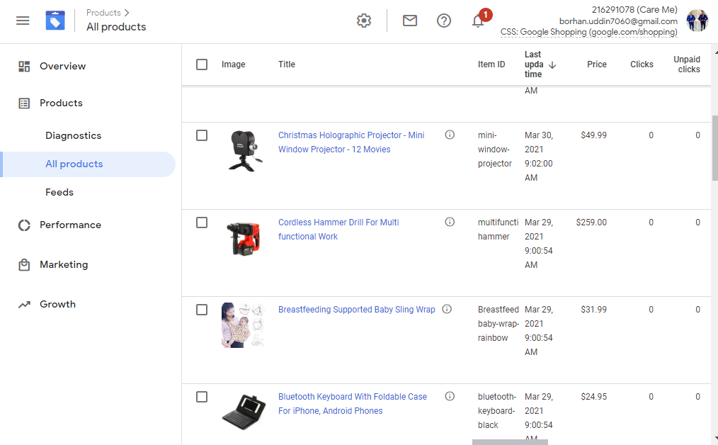
Google Merchant Center Website
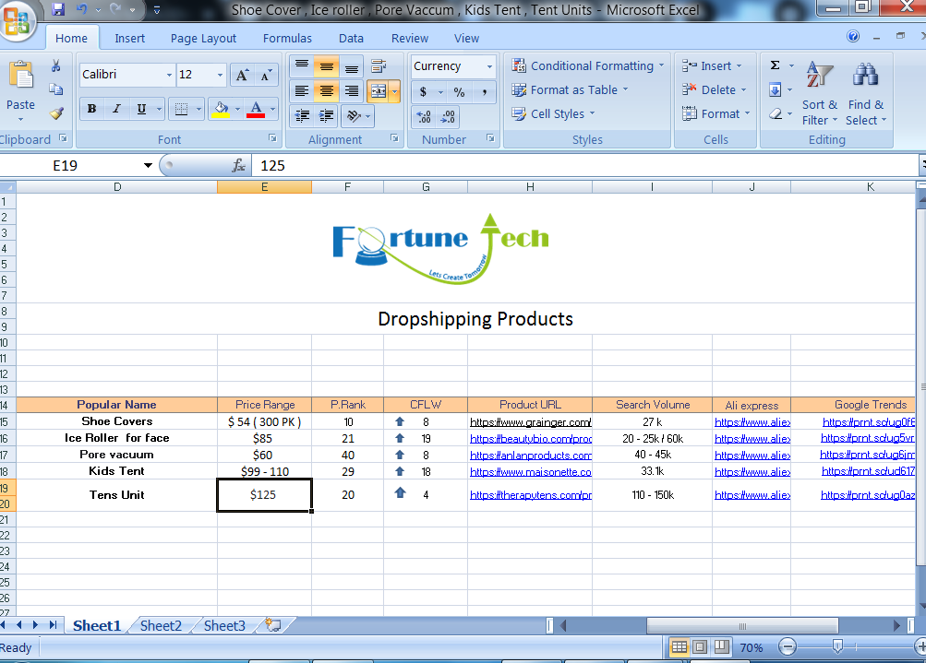
Listing the products based on searching volume, trends, price & suppliers

Internship Certificate
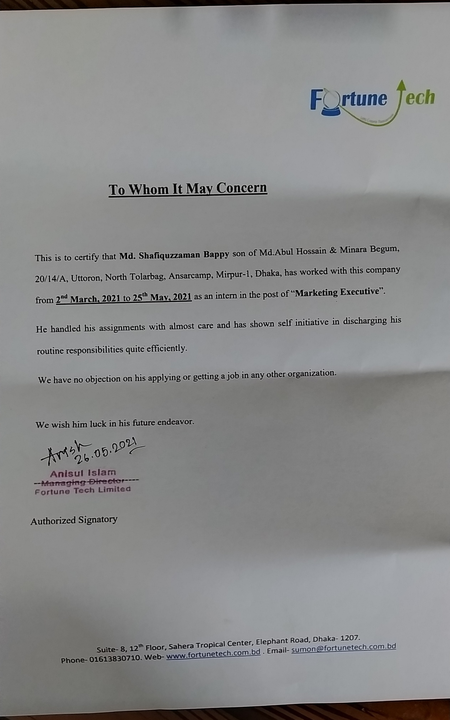

Interview Questions

