

Internship Report On

“Implications of Accounting Information System in CodersTrust Bangladesh”


“Learn a skill, Make a living, Anytime, Anywhere”

“Implications of Accounting Information System in CodersTrust Bangladesh”

Supervised By:
Lamia Alam
Assistant Professor
School of Business & Economics
United International University
Submitted By:
Iffat Zahan
ID: 111 161 158
Major: Accounting Trimester: 13th
Bachelor of Business Administration
United International University

Date of Submission: February 4, 2021
 UNITED INTERNATIONAL UNIVERSITY

Letter of Transmittal
February 4, 2021
Lamia Alam
Assistant Professor
School of Business & Economics
United International University
Subject: Submission of Internship Report.
Dear Madam,
With due respect & esteem, I am pleased to state that, the internship report which I am submitting is on the“Implication of Accounting Information System in CodersTrust Bangladesh.” In CodersTrust Bangladesh I have viably finished my three months internship and during my internship program, I have for all intents and performed the Software system of CodersTrust under the supervision of Md. Habib Chowdhury, Assistant Accounts Manager of Finance Department and have assembled the data of the manners in which the organization utilizes divers programming.
In my whole internship period, I was responsible for keeping records off all transactions through software under Finance department, which is a crucial process of accounting system for any kind of successful company. Besides, I allowed the chance of taking with various corporate people who are accountable for finance and accounting area of a specific organization. During forming this report, I have gathered all the information from my own encounters and from other solid sources so that this report should be useful and creative to others.
I would like to accept this open door to gratitude you for all the help and guidelines that you have given, which I desire to keep getting later.

Sincerely yours,
Iffat Zahan
ID No: 111 161 158
BBA Program
United International University

Declaration of Student
The title of the internship report which I have worked on the "Implication of Accounting Information system in CodersTrust Bangladesh” submitted as some prerequisite for finishing of the degree of Bachelor of Business Administration (BBA), has been set up without the help from anyone else exclusively.
The report was prepared by taking the guidelines from, Lamia Alam, Assistant Professor, School of Business & Economics (SOBE), United International University.
I have attempted to give applicable data from various solid resources to make the report more pertinent and more grounded. This report has been arranged totally dependent on the work experience of mine as an Intern in CodersTrust Bangladesh



……………………………..

Iffat Zahan
ID: 111161158
School of Business & Economics
United International University

Acknowledgement
While setting up this report over the three months, I have brought about numerous obligations of appreciations. In doing my internship report, the fruitful achievement of this report is the outcome of the commitment of number of individuals who gave their significant time from their bustling timetable to direct me. I might want to stretch out my heartiest appreciation to each one of the individuals who have share their valuable cogitation, time, and recommendations to set up the report and support me straightforwardly or by implications added to the fruition of the report.
In any case, I might want to express gratitude toward Almighty Allah for all the potency, and with the assistance of Almighty Allah and the good wishes from my parents, at last I have effectively done my internship program of three months in CodersTrust Bangladesh.
Besides, I might want to repay my significant regard to my scholastic director Lamia Alam, Assistant Professor, School of Business & Economics (SOBE), United International University, because of her liberal and thoughtful direction. While preparing the report I have faced several petty and extensive issues, and my supervisor assist me very clearly for that I am additionally appreciative to her.
Simultaneously, I likewise pay my generously appreciation to Md Ziaul Haque, Head of Accounts, CodersTrust Bangladesh, who has selected me for this significant position and expended his assistance by indicating the privilege and affected way to me. An extremely extraordinary appreciation goes to my association administration Md. Habib Chowdhury, Assistant Accountants Manager, CodersTrust Bangladesh, who caused me during my work residency and made my experience a life-changing one. And his helping made my internship venture more productive by acquiring viable information.
Besides, I might want to give gratitude to all the officers of accounts department for helping me and providing me the rules and regulations and the recommendations throughout the precious three months. At last, I need to express my special gratitude towards the remaining assistants from various dissemination focuses for their help by sharing their encounters and also want to give my unique gratitude to CodersTrust Bangladesh, for giving me the particular possibility to complete my internship.

Executive Summary
Outsourcing is an exceptionally well-known medium as an alternative income source nowadays. It is conceivable to procure by working at home alongside considers or even after retirement just by utilizing technology and has led the new generation towards success through technical training. There is no option in contrast to ability advancement through technical trainings for using accessible chances. CodersTrust Bangladesh has brought the change over the educated and uneducated young people of Bangladesh into a proficient and profitable workforce which will have a significant impact on the financial improvement of Bangladesh.
CodersTrust Bangladesh started its journey in 2015 in Bangladesh officially and it grabs people attraction and popularity gradually. It has made many people self- employed and it is well reputed for keeping their flawless focus on work quality.
As I accomplished my internship under Finance Department as an Accounts intern at CodersTrust Bangladesh therefore while I was setting up the report, I have attempted to bring conceivable data with respect to that department and its functions.
At First, I have discussed about the introduction of my report. Then I provide the Background of CodersTrust Bangladesh. After that I have briefly discussed about Objectives about this report, then I have discussed how I have gathered all the data, additionally the limitations what I face during preparing the report.
Likewise, I have given the overview of Accounting Information System and its contemplation in Bangladesh. Then I have discussed about the profile of the company, their mission vision, product, and service and their organogram structure & I have also shortly described about my work and responsibilities which I did into my three months internship period and where I discussed about how the accounts department do its functions. Then I have discussed the main part of my report which is findings and analysis that basically reflects how the company is using the software named QuickBooks, and its adhesion in the company. Finally, I finished up by mentioning the positive approaches and drawbacks of the software that are being used in company and recommend some solution to solve issues and provide conclusion.

Table of Content:

Letter of Transmittal iii
Declaration of Student iv
Acknowledgement v
Executive Summary vi
Chapter 1 1
Introduction 1
1.1 Background of the study: 2
1.2 Objectives of the study: 3
1.3 Rational of the study: 3
1.4 Methodology of the Study: 4
1.4.1 Data Sources: 4
1.4.2 Data Collection Process: 4
1.4.3 Types of Data: 5
1.5 Scope of the Report: 5
1.6 Limitation of the Report: 6
1.7 Literature Review: 6
Chapter 2 8
Overview of Accounting Information System 8
2.1 Accounting Information System: 9
2.2 Advantages of Accounting Information System: 9
2.3 Disadvantages of Accounting Information System: 10
2.4 Accounting Information System in Bangladesh: 11
• BIZway Software: 11
• Troyee: 12
• Tally: 12
• Smart Software Limited: 12
• Techneo360: 13
• ZAMAN IT: 13
Chapter 3 14
Industry & Company Overview 14
3.1 Industry Overview: 15
3.2 Mission: 17
3.3 Vision: 17
3.4 CoderTrust Organogram: 18
3.5 Product or Service: 18
3.6 Strength of CodersTrust Bangladesh: 20
3.7 Weakness of CodersTrust Bangladesh: 21
3.8 Opportunity of CodersTrust Bangladesh: 22
3.9 Threat of CodersTrust Bangladesh: 22
Chapter 4 24
Job Responsibility 24
4.1 Description of the Job and Responsibility: 25
4.2 Different Aspect of the Job and Observation: 25
Keeping Record & Updating of Daily Sales: 26
Preparing Money Receipt: 26
Solving the Problem of Problematic Data: 26
Keeping Update on Zoho CRM & QuickBooks for Daily Sales: 27
Collecting of Due Amount and Keeping Record of All Payment: 27
Doing Bank Reconciliation: 27
Chapter 5 28
Findings and Analysis 28
Findings and Analysis: 29
5.1 Accounting Information System in CodersTrust: 30
5.2 QuickBooks Software: 30
5.2.1 The use of QuickBooks Software in CodersTrust: 30
▪ Sales: 31
• Income: 32
▪ Report: 33
▪ Expense: 35
5.3 Advantages of QuickBooks software: 37
5.4 Disadvantages of QuickBooks Software: 38
Chapter 6 39
Conclusion & Recommendation 39
6.1 Conclusion: 40
6.2 Recommendation: 41
References: 42

List of Tables & Figures:
Figure 1: Organogram of CodersTrust 18
Figure 2: Chart of Accounts 31
Figure 3: Invoice 32
Figure 4: Receive Payment 33
Figure 5: Financial Statement of CodersTrust Bangladesh 34
Figure 6: QuickBooks Software Dashboard (CodersTrust) 35
Figure 7: Bill & Bill Payment 36
Figure 8: Vendor Expense 37

Table 1: List of Product & Service 20

Chapter 1

Introduction

1.1 Background of the study:
Many flourishing countries like Bangladesh are concentrating on making digital economy by using advanced outsourcing, with the preceding of speedy digitalization. These changes of a nation’s economy not only just conduct development in its administration industry but also powers homegrown opening for works, empowering speedy financial development. Outsourcing occupation incorporate everything from PC programming to website architecture, charge planning and improvement of site design. It has produced a wide scope of new doors for individuals in developing business sectors which didn’t exist earlier. For many Bangladeshi individuals outsourcing has become a well-known career option and also offering another and adaptable kind of income that suits their ways of lifestyle. Outsourcing offers numerous points of interest like, any freelancer can independently choose customers and projects, easily can admittance to the worldwide market and adaptability over any area. (A freelancing boom is reshaping Bangladesh and its economy, 2019)
CodersTrust is a worldwide organization works in mixed digitally obtain and experience stage for individuals ready to update the aptitudes to do jobs at organization by updating their skills or can earn money by doing jobs at residence from home in a few outsourcing job classes. The company intends to change issues of different social problems of admittance to instruction and youth who are joblessness into an “Investible Opportunity.” In Dhaka CodersTrust is the only international skill advancement organization which has a reputation as a freelancing training center where unskilled people are transferred into skilled independently employed experts. (About CodersTrust Bangladesh, 2020)
This report was established as a prerequisite for the outcome of the BBA within the Department of Business Administration, in United International University. I complied this report and used some of the regular data I gathered from the day to day work, based on my three months in a long internship program at CodersTrust Bangladesh. I focused on their software system, in my report. Most of the time I have to deal with different software like, QuickBooks, Zoho, since I work in the accounts department. This report will assist candidates to comprehend the use of software in an organization, the benefits of using the software and also some drawbacks of using the software.

1.2 Objectives of the study:
The objectives set out an important goal that we set during the internship period that we expect to achieve by the end of this report. In any report the objectives of the audit are the most important reason, the whole report is designed based on those objectives. The objectives of any report should be resolved to consider the time accessible, the foundation, and different assets which is essential for the study.
Broad Objectives: The broad objectives of the report are-
- Gain practical experience in carrying out work duties and learning approaches.
- Know how a company manages its internal control system by using accounting information system.
- Developing the skill set that contributes significantly to the success of the organization.
- Degree in Business Administration after completing the internship program and submitting the report.
Specific objectives: The main purposes for preparing the report and an analysis of the title “Implication of Accounting Information System in CodersTrust Bangladesh” is the specific objective of this report.
- To know accounting software, what they are using.
- To know about the betterment of using the software.
- To know about the disadvantage of utilizing the software.
- To know, how to oversee various sorts of articulation by utilizing the software.
- To share my own recommendation as an accounting intern how they can improve their accounts department for the betterment of the company’s future.

1.3 Rational of the study:
In CodersTrust Bangladesh I worked as an employee and where I worked in the accounting department. I have done my best to finish this report correctly. I have tried to share all the relevant information from my topic “Implication of Accounting Information System in CodersTrust Bangladesh”, in this report. In this report, I have shared qualitative and quantitative information which basically represent that the report is the exploratory report.
Study rationality is a set of reasons or stable institutions that can show readers why their research is necessary to contribute to the same field of research. To understand the impact of accounting information systems in CodersTrust Bangladesh, as this is the purpose of preparing this report and to understand the importance of accounting information system is very crucial. For any association, the system of accounting information is considered to be one of the most important frameworks. At various point, its point is to give the essential data to administrators. The purpose of the system is to collect or record data to know the impact of the organization and basically the accounting information system is computer-based system. The essential reason of a bookkeeping data framework is to record each day of activities that occur in the association so the unit can report, screen, and settle on a significant choice. Any organization can prepare financial statements based on financial data, through an accounting information system. (Define and Describe the Components of an Accounting Information System, n.d.)

1.4 Methodology of the Study:
The nature of information and data for any research, create a decision which help to originate an effective and capable system for research. This technique is not same as method because this technique isn’t expected to give a solution. It gives hypothetical premise to understanding which strategy, techniques, or practices can be used for a particular circumstance. To get done this report viably, here I have endeavored some successive strategy and techniques for activities. While doing this report I have accumulated the data from different sources, some information I have assembled from the company where I have done my internship and some information I have assembled from different assistant sources. Solidifying and exploring most of that information I essentially think about this report.
1.4.1 Data Sources: In order to incorporate the various research models in a logical and reasonable way, I have chosen general methods which is related to research design. In this way, he assures the user of the report that we will competently address the search queries. It also covers several methods in the report, such as data collection, analysis and types.
1.4.2 Data Collection Process: The information in this report is gathered from a relatively diverse source. In view of the wellsprings of information, the information assortment interaction can be isolated into two expansive parts. They are portrayed in under-

Primary Sources:
- From academic espial and experience.
- From formal and casual discussion with the CodersTrust Bangladesh executives and employees.
- From individual work experience of various programing in CodersTrust Bangladesh.
- From a few weeks after week and month to month deals report, distributions, and various reports of CodersTrust.

Secondary Sources:
- From official trust information.
- From the company’s website.
- From various articles distributed on framework plan in bookkeeping.
- From the QuickBooks and Zoho software official website.
- From various CodersTrust paper.
1.4.3 Types of Data: By utilizing both Qualitative and Quantitative information, essentially I have arranged this report. The harsh and attributes of information is characterized as subjective information. Generally, through examining any idea it organizes and shows data. By noticing, taking individuals meetings, examining with board bunches such as information is accumulated, while doing this report I have additionally attempted to assemble the data through along these lines. Then again, quantitative information is essentially the mathematical information. Since I worked in the department of accounting and based my report on that, I also collected Quantitative data.

1.5 Scope of the Report:
This report urges me to understand the undeniable constant experience about the action of programming arrangement of CodersTrust Bangladesh and furthermore unequivocally express how different organizations like this organization submit this movement. It in like manner urge us to follow pay, costs, just as for settling on any key monetary choice it will assist with getting to monetary circumstance without any problem.
Likewise, while doing the temporary job when they have fundamentally prepared me for QuickBooks and Zoho software exercise, which is exceptionally huge for me just as, for that I have figured out how to do programming functions effectively instead of physically. Hence it has gotten simple for me to do my report dependent on that specific thing.
As I have managed my job under an eminent organization and accumulated insight, which is one my scope which I have gotten in my internship period. It additionally encourages me to assemble my correspondence expertise more grounded, in light of the fact that for setting up this report I need to do correspondence with my seniors.

1.6 Limitation of the Report:
The issues or difficulties that faced by the creators of the study experienced while setting up the investigation is the impediment of the investigation or report. According to different kinds of report constraints may vary. The makers commonly present their errors on the grounds that no report is completely coordinated or doesn’t get each and every conceivable perspective. In this report, I faced a couple of requirements while doing this report, which are given underneath -
- Inside the three months of my internship period the report was made, so it was extremely hard to plan such long report inside this brief timeframe.
- During the pandemic circumstance of Covid-19, I have begun my internship, for that they gave me the privilege to work from home. For that reason, collecting information from different sources was very difficult for me.
- Zoho software is offered to several organization, at the same time several organizations use it in different way. Utilizing this software is an intricate errand. And furthermore, portraying it in the report is additionally something troublesome to share.
- The hardiest thing is to focus or describe all the software’s activity in a report. Because, as an intern I did not get all access to use all the software in that way the other permanent employees are doing. For that reason, I have faced some problems to gather information.

1.7 Literature Review:
The financial data and supports choice assignments in the coordination setting authoritative exercises controls and vital dynamic provide by the accounting information system in an organization. The preface of accounting information system is conclusive for leading and performing the internal control system of an organization. A significant inquiry in the field of bookkeeping and the board dynamic concerns the attack of bookkeeping data with hierarchical necessities for data correspondence and control. To deal with the complication and incertitude, accounting information system is the most useful decision constructive tools. Before taking any crucial decision, the system helps the manager to comprehend their duties more definitely and help to assuage the incertitude.
Basically, the system of accounting information is based on computer which helps to process financial data, and backing choice undertakings in the coordination setting, hierarchical exercise control and vital dynamic. The quality of financial statement will enhance if the accounting information is efficient. The decision-making process, internal control system of the organization and the financial reports of an organization depend on how the organization is implementing the accounting information system. (Digital Library, 2020)
The era in which we are living is fascinating with difficulties and challenges. The way of our life and perspective is defining now through information technology. The changes of technology opening unlimited opportunities to grow the intellectual, scholarly, and proficient dreams. Today it is not a big deal that we are implementing the accounting information system for not just accentuating the mechanics and elements of accounting yet additionally consolidating the chances of inventive uses of IT. Accounting Information System have really become data frameworks for dynamic and control on account of expanding utilizations of data innovation. Remarkable, adaptable, efficient and easy to understand hardware and software have opened up nowadays, this coherent a plan where a solitary framework can uphold accounting and operational requirements. In entirely, the current accounting frameworks are intently integrated with and may even be completely coordinated with other data frameworks. An effective accounting information system perform activities through a selective stages. Cost adequacy, valuable yield and adaptability these standards help to create effective and efficient accounting information system. (Accounting Information System of the Financial Institutions in Bangladesh: An Evaluation, 2008)

Chapter 2

Overview of Accounting Information System

2.1 Accounting Information System:
To assemble, reserve, direct, control and report all the financial data an association or business utilize a design and the data. The accountants, specialists, business examiners, regulators, reviewers, governor, chief financial officer, and assessment workplace, the data can be utilized by them. Fundamentally, this is a PC based procedure for following accounting development identified with information advancement assets. The usage of Generally Accepted Accounting Principles is one of the examples of an Accounting Information System unties standard accounting practices.(Accounting Information System (AIS), 2020)
Since PC and PC programming that assist us monitoring the accounting exchanges which have gotten decently modest, we ordinarily mean a motorized bookkeeping framework when we institute accounting information system, today. The upside of using a modernized structure of accounting which surpass the costs of getting one, and for all intents and purposes all associations, even narrow one, can remain to and do use a motorized system of accounting. This is not to suggest that the paper-based or manual accounting system and cycles have evaporated. Both non computerized and computerized systems have been used by most of the organization.
To ensure the most raised degree of precision in an associations monetary exchanges and record keeping, similarly as make money related data successfully available to the people who genuinely need permission to everything while at the same time keeping data immaculate and secure which phenomenally arranged bookkeepers who work all around with bookkeeping data framework. An accounting information system is a means of tracking the business and accounting activities of your organization. Individuals, systems and management, information, programming, database updating, and internal control are the six basic components which basically consists of this typical framework.

2.2 Advantages of Accounting Information System:
Accounting Information System is otherwise called the modernized arrangement of continuing to account data. Everyone ought to use this sort of structure to administer and introduce their records, at some stage. The upsides of accounting information system are given underneath-
- For little medium association utilizing the method of accounting data framework will limit the time. Accomplishing a work by manual interaction is very time taking rather utilizing software.
- Software utilizing action is less blunders than manual. Figuring of pay, cost, VAT, reconciliation, change is very intense on the off chance that it done physically, individual can do botch. Utilizing software these figuring has become mistake free and precisely.
- Many web based accounting framework engage mechanized receipt, credit and invoice which will dispense with time spent making manual receipts, credits, and invoices.
- Numerous computerized accounting framework are cloud-based, which infers that anyone can download the applications from PDA and tablets. Which help to monitor the records any time without any problem.
- The system of accounting information also helps sometimes to reduce the cost of the organization. At past every organization need more manpower to do task but now they can do that task in less manpower because organizations are using software for doing their task.

2.3 Disadvantages of Accounting Information System:
For any association to success in the long run, a feasible system of accounting information is important. There is no way to choose how well the organization is doing without ways of monitoring what is happening. Data mining software is used to record financial activity on any specific business activity. This system can store, import, share information, and process the information. However, there are some limitations to the implementation of this system -
- Learning an accounting information system is difficult and time-consuming. Because this system is totally computerized and the parts used for information system are a bit challenging, as not everyone uses this properly. To understand them or to train them it will take too much time.
- As this is totally computerized system there will be always a risk of losing information or data. It is quite possible to loss all the data in the framework. In this system company store their financial information for years. In the event that a crash happens, it makes a significance detriment to the company.
- To have relationships with popular companies, they often change their business model which affects the financial system. The accounting information system should be checked regularly for changes. But this study will take more time and is more expensive.
- Most information must be entered manually, so it can be inaccurate if not check properly. If any faulty occurred, it will be difficult to find out.
- From the efficient operation of the accounting information system all companies must purchase expensive software. In addition, there are costs of maintenance, alterations and training.

2.4 Accounting Information System in Bangladesh:
Accounting Information System involves the use of various accounting software, so that each organization can carry out its work smoothly. In the world of accounting software, small business can use container registration without much equipment. As a business develops, the system of accounting become more mind boggling and for that reason the new software system of accounting which named enterprise resource planning is frequently required.
There is different type of accounting software needed for various type of organization. In Bangladesh previously, no company or organization uses software, they even don’t know the use of such accounting software. The impact of accounting software gradually being implemented in a number of small, medium and also large organization. The software used in Bangladesh is given below-
- BIZway Software: This software is known as the number one accounting software in Bangladesh. And known as the specialized brand for accounting software. The software has started its journey in 2002 and serving more than 8000 countries currently. Their critical phenomena are, least in cost and most elevated by deals. This software is the most user-friendly software. (BizwaySoftware, n.d.) The software is providing several products, which are-
- Integrated Accounting Software.
- Production Management Software.
- Real Estate Management Software.
- Service Management Software.
- Troyee: On 14th September 2005, the software Troyee launched officially. This software is used in the field of Integrated Accounts-Inventory, Manufacturing & MIS Software. The software has replaced the use of pen and ledger book with multi dimension database, keyboard, and mouse. The software system has also digitalized the day-to-day operation. By using this software an organization can handle multiple branch financial statement, can easily back-up and restore data, also it has strong security management of data and the installation process is easier than other software. (Troyee , 2016)The products which can be used by using this software are-
- Troyee Enterprise.
- VAT Management Software.
- Troyee Payroll.
- Fixed Assets Management Software.
- Troyee Lite.
- Tally: A business software that comprehends, oversees, and make the business less difficult regularly. The company is innovation and technology-based organization, who deliver business software for small and medium business. Tally’s item obliges a great many clients across ventures in more than 100 nations. This organization has 28000 partners convey unparalleled client experience in sales, support, and services.
Tally endeavors to convey advancement and greatness in enterprise resource planning software for miniature and medium organization. The software will help to create invoices in an easy way, help to avoid human errors and proposes remedial strategy, and automatically accommodate the books of records with the bank statement. (Tally, 2020)The product which is providing by software is given below-
- Tally Prime.
- Tally Prime Server.
- Smart Software Limited: This service company provide Software, Website and Mobile Application services. Since 2014, it has become the best software development company in Bangladesh by gaining faith from customers. This software system provides interactive and cost-effective solution. The software tries to deliver creative and reliable solution and give opportunity to create customize software solution. This software system has brought so many smart solutions, as Smart ERP, Smart Account, Smart HRM and Smart POS. (Smart Software Ltd, 2020)The services which they are providing are given below-
- Production Costing Software.
- Enterprise Resource Planning.
- Point of Sales.
- Customer Relationship Management.
- Account Management Software.
- Techneo360: For any business as small, medium, or corporate Accounting and Inventory Software is a crucial tool. Small company or organization spend most of their time in providing service to their customer, do not focus on properly in doing invoices and different financial reports. To reduce this problem of the organization owner Techneo360 has brought the software of Accounting & Inventory Software. This software is known as the best software development company for providing high quality accounting software solution in Bangladesh. (Techneo360, 2020)
- ZAMAN IT: This company is the concern of ZAMAN Group and among pioneers in Bangladesh, the United States, Canada, the United Kingdom, and the United Arab Emirates they grant web administration for small and medium sized organizations to compete in the modern world at its peak. The software helps web businesspeople reach their customers through the computer space and helps entrepreneurs establish an internet presence without the hassle of innovation. (ZAMAN IT, 2020)

Chapter 3

Industry & Company Overview

3.1 Industry Overview:
“CodersTrust Bangladesh is a multinational company which helps to learn and earn different skills which is globally demanded and helps to earn money by finding jobs or by improving career. Mr. Aziz Ahmad the worldwide business pioneer who established the company a glad Bangladeshi- American visionary with a fantasy to carry fruitful instruction to carry applied instruction to the mass populace at a reasonable cost, engaging people by breaking the conventional profession difficulties to make neighborhood labor force meet the necessities of worldwide ability interest, and to assist them with making money by learning current advanced aptitudes. Alongside the fellow benefactor, Danish Military Captain Ferdinand Kearwolf, they taken their initiated and its activity from Denmark from 2013 in emergence of Sir Richard Baranson and Morten Lund dependent their standards & convictions so that they can build IT ability improvement open to everyday almost the globe. CodersTrust fixed an objective to commit the nearby labor force symposium the prerequisites of worldwide ability interest.
In Copenhagen, Denmark the CodersTrust Company is settled. Understanding the monetary development capability of re-appropriating in non-industrial nations, CodersTrust began its activity in Bangladesh in 2015. The organization at present has activities in four nations-
USA
Denmark
Bangladesh
Kosovo

Also, it overseen ventures in different 11 district nations across Asia & Europe like, India, Malaysia, Bhutan, Kosovo, Bangladesh, Iraq, Poland, Honduras, Kenya, and Jordan.
Since they start of excursion, the association has had set up a total digitalized Multimedia Training Center to add to the Business Process Outsourcing (BPO) industry in Bangladesh. CodersTrust Bangladesh drives itself as a solid power combined with makers and amp, producers, manufacturers and programmers, guides, and understudies worldwide with a great many Developers, Designers, Programmers Online Marketers, Editors, and so forth. In Bangladesh CodersTrust Bangladesh presently has 5 working grounds, there are 108 representatives altogether, among whom 82 are functioning as full-clocks and rest individuals are utilized as seasonal workers.
Since the initiation started, CodersTrust Bangladesh has made numerous individuals independently employed by contributing worldwide online IT occupations and got eminent for IT rethinking yields. Up around now, CodersTrust Bangladesh is all around rumored for maintain the impeccable spotlight on turn out quality for an uncommon yield in the ICT business. Furthermore, CodersTrust is the lone IT preparing focus in Bangladesh that creates worldwide aptitudes. The activity of this company is IT related which has been molded to terest-
- Enhance the lives of meriting individuals over the nation to monetary freedom bringing about financial strengthening by delivering worldwide aptitude advancement preparing administration and knowledgeable materials.
- Assist individuals through abilities to include into global high outsourcing locales through giving essential rules, supports, and answers for increment web based acquiring openings in Bangladesh.
CodersTrust presently has four branches in Dhaka Bangladesh and on that branches they provide training on more than 11 courses, they are-

CodersTrust Bangladesh has experience of working being developed activities in organization with UNDP, the World Bank, BRAC, The Rockefeller Foundation, and save the Children among others. Presently executing two expertise improvement ventures in organization with Palli Karma-Sahayak Foundation (PKSF) and Dutch Foundation, one planning to create ability of 1000 ladies for outsourcing commercial center by the end of 2020.
Mission of CodersTrust Bangladesh is to offer palatable assistance of our expert zones with legal works on keeping up respectability and sets of principles. CodersTrust Bangladesh has faith in a general public and nation advancement were having the proverb as-
“Learn a skill, Make a living, Anytime, Anywhere.”
CodersTrust accepts that putting resources into the training of adolescents is something everybody will profit by. The neighborhood and independent market may have more qualified subject matters expert, the understudies of ours may bring their income.
The CodersTrust is in excess of a tech organization. It is an assistance situated association to improve lives and to ease work designs. It very well might be considered as an aggregate power of Inventors and Makers, Authors and Hackers, Counsellor and Scholars around the world. CodersTrust is the solitary global expertise advancement foundation in Bangladesh alongside the standing of the outsourcing preparing focuses in Dhaka, where untalented human asset is moved into gifted independently employed experts.
Its activity is based on the IT business and for that Bangladesh IT Institute has been formed as to enhance the existence of meriting individuals all over the nation unto monetary autonomy bringing about financial strengthening by delivering global aptitude advancement preparing administrations and learning materials.
It causes capable individuals to include in worldwide top outsourcing locales by furnishing with important rules, supports, and arrangements to speed up the advancement of plausible online work openings in Bangladesh.” (CodersTrust Bangladesh, 2020)

3.2 Mission:
The mission of CodersTrust is given below-
- To be the best proficient consultancy association.
- To be the solitary re-appropriated arrangement and backing supplier.
- To be the provider of bleeding edge answers for advancing a digitalized country.
- To be a proficient instruction / preparing supplier to guarantee quality and cost investment funds.
- To be a supplier of preparing administrations for creating elite abilities.
- To make paid instruction accessible and available on the internet.
- To overcome the difficulties of joblessness.

3.3 Vision:
Equivalent open doors for work and paid training are at present restricted to individuals brought into the world in some creating and immature nations like Bangladesh, while a large number of individuals in agricultural nations are denied admittance to schooling. CodersTrust trusts in an organization and public advancement with the saying “Learn a skill, Make a living, Anytime, Anywhere”. As an ability’s advancement preparing focus in Bangladesh, the foundation accepts that putting resources into the training of our younger starts is something that everybody will profit by. The neighborhood and free market will have more talented laborers, its understudies will build their pay and CodersTrust will bring in cash to grow the support of more individuals. CodersTrust fundamental dreams are-
- To defeat the boundaries of youth joblessness with an effective presence in the neighborhood work market and different autonomous sites, for example, Freelancer, Fiverr, Upwork, PeoplePerHour and so on contributing on the web to bring in cash in Bangladesh by chipping away at their own.
- To decrease snags and make accessible the reevaluated instruction, preparing, and aptitude advancement for all ages and genders with top level salary possibilities for monetary improvement.

3.4 CoderTrust Organogram:

Figure 1: Organogram of CodersTrust

3.5 Product or Service:
CodersTrust has planned a great deal of aptitude improvement programs that place appeal in the independent market and give serious income prospects to jobless understudies. Contingent upon the substance and trouble level of the program, CodersTrust proposes an aggregate of nine projects, going from a quarter of a year to ten months, and the association offers selective individual courses and workshops to urge youngsters to take an interest in their agreements. To boost the offices of workers, individuals with incapacities, housewives and others, the organization offers online techniques, lessens administration charges by half, and particularly offers free projects to confide in developers consistently. Prior to picking one of the courses offered, CodersTrust access understudies to comprehend their actual potential and capacity and proposes courses in like manner. To fulfill the developing need for social advertising and online activities the organization offers regular courses as well as diploma courses including, web design, graphic design, and digital marketing. Recorded beneath are the courses offered by the CodersTrust-
Course Title | Duration/Hour | Area
Graphics Design | Three Months / 72hours | Adobe Illustrator & Adobe Photoshop
Responsive Web Design | Four Months / 96hours | Html/CSS/Bootstrap/JS/Query/Word Press Basic
Advance Web Development | Five Months / 120hours | PHP/MySQL/Laravel
WordPress Theme Development | Five Months / 120hours | Theme Customization & Development, Plug in Customization & Development
Accounts Management System | Three Months / 72hours | QuickBooks, Xero
WordPress Theme Customization | Three Months / 72hours | Premium Theme & Plug in
Digital Marketing | Three Months / 72hours | YouTube, Facebook, Google, Adwards, Email, Affiliate
Android App Development | Three Months / 72hours | API Integration, Working with Sensors, Google Map, AdMob
Facebook Marketing | One Month / 16hours
Diploma in Professional Freelancing | Ten Months | Graphics Design, Responsive Web Design & Digital Marketing
Diploma in Web Development | Eleven Months | Graphics Design, Responsive web Design & Advance Web Development
Diploma in Entrepreneurship | Nine Months | Graphics Design, WordPress Theme Customization & Digital marketing
Table 1: List of Product & Service

3.6 Strength of CodersTrust Bangladesh:
Strength is the positive credits or markers and assets inside an organization which helps to become successful. The organization’s qualities are the apparatuses used to oppose dangers and botched chances, so the general significance is critical. To make a total rundown of advantages, look at each practical zone of the association, for example, account, assembling or tasks, promoting and HR. The inclinations are that types of ascribes of the association that can practice them work more successfully than the resistance. The strength of CodersTrust Bangladesh is-
- The company is considered as worldwide association, CodersTrust Bangladesh appreciates a brilliant standing in different business sectors other than the industrial hub in Bangladesh. It has a solid supervisory crew and individuals who can oversee representatives and clients well.
- CodersTrust Bangladesh has a higher understudy achievement rate than other specialized foundation in Bangladesh as the association consistently ensures quality and accessibility all through the cycle of each phase of learning. Quality and accessibility have been continued in few zones, for example, mentors who are highly qualified, strong management team, solid understudy supportive network and also participation and joint effort with numerous nearby and worldwide goliaths like, UNDP, Bank World, Robi Axiata, Danida.
- CodersTrust Bangladesh offers a ground-breaking emotionally supportive network for understudies. These frameworks incorporate ELMS talents, every minute of every day online understudy uphold, understudy uphold gathering, example of overcoming adversity gathering, blog, Facebook – based individual cluster handling gathering, Facebook gathering. Different emotionally supportive networks give understudies various kinds of administration with no shrouded costs. In addition, anybody can straightforwardly get to CodersTrust Bangladesh whenever from an Internet work area. They worked with neighborhood universities, preparing focuses, and even bistros to make an actual space where understudies can meet to contemplate and bring in cash on the web.
- Coderstrust is more than an innovation organization. CodersTrust is about individuals improving life and changing the way individuals work. It is a group of guides and analyzers, developers, and understudies from more than 22 nations around the globe. They help individuals help themselves by allowing them the chance to monetarily improve their lives through instruction.

3.7 Weakness of CodersTrust Bangladesh:
An organization weakness is an asset or cycle that your business does not have however which should be effective. A company’s capacity to arrive at its maximum capacity limit by the weakness. The weakness lies in the inward characteristics and assets of a business neutralizing a positive result. The weakness of CodersTrust Bangladesh is recorded beneath-
- The high staff turnover rate is the fundamental weakness of CodersTrust Bangladesh, as the organization basically enlists numerous passage level workers who don’t plan to remain in their positions for long. A portion of your workers may remain with your organization if possible and some may take up administrative positions. Others may appreciate filling in as a drawn-out wellspring of extra pay or as a low-stress retirement work.
- The second highest weakness of CodersTrust Bangladesh is the high dropout pace of understudies because of fatigue, monetary or family issue, and remaining task on hand and so forth.
- CodersTrust Bangladesh doesn’t advance any online help. They are not exceptionally dynamic in advanced showcasing through online media and different stages like Google ads and so on they can advance their current and future online courses and administrations to understudies and can visible the benefits of receiving courses and utilizing the administration through online.
- Some cutoff points to receiving numerous courses for understudies. Understudies should have the fundamental information to take the courses. Some essential courses are required. The programming language is the thing that understudies need to know in like manner to take a seminar on CodersTrust.

3.8 Opportunity of CodersTrust Bangladesh:
A company opportunity that encompasses the deal or lease of any item, administration or gear will permit the authorized purchaser to begin a company. A business opportunity is, to lay it out plainly, a business interest in bundles that permits the purchaser to begin a business. The opportunity of CodersTrust Bangladesh are recorded beneath-
- CodersTrust Bangladesh offers essential and transitional course in IT and business to test the overall capacities of the individuals of this nation, currently. The establishment may offer a higher or progressed course level just as a high-level course at the current level. The organization has what it takes to build up this opportunity as it is a worldwide chain business.
- Many understudies are inaccessible nearby because of provincial and different variables. For them, CodersTrust Bangladesh can upgrade the preparation framework so everybody can profit for it. The off grounds preparing framework is uncommon in Bangladesh. So, this is an incredible opportunity to spread your business with interesting character.
- CodersTrust Bangladesh will before long dispatch its different branches the nation over. They have that opportunity to serve their clients the nation over. This administration isn’t accessible to other online course suppliers. So, this is an incredible opportunity for this association to offer types of assistance nearby.

3.9 Threat of CodersTrust Bangladesh:
Threat are the external factor that influence an organization’s presentation and bargain the elements prosperity. The most observable impact would be a decrease in corporate deals. The most observable impact would be a decrease in corporate deals. Frequently an organization faces a few threats notwithstanding the opposition when dealing with various issues. This lessens market openings or prompt lower benefits. Expected threats to CodersTrust Bangladesh are recorded beneath-
- The number of preparing foundations in Bangladesh is expanding step by step. A significant number of them are privatized or nationalized. Along this lines, CodersTrust Bangladesh is probably going to have high weight which could decrease benefits in the near future.
- CodersTrust Bangladesh is accepting undesirable surveys from a portion of its understudies and understudies from other preparing establishments, on the welfare of the association in Bangladesh it could have solid opposite effects.
- In the Bangladesh’s monetary condition there is no stabilize. In any case this system is gradually expanding. But the monetary status of the typical public in CodersTrust Bangladesh is few. Therefore, there is chance for general society that they can change through CodersTrust to different brands in Bangladesh.

Chapter 4

Job Responsibility

4.1 Description of the Job and Responsibility:
Like, other companies CodersTrust Bangladesh has also several departments, to do them properly they structured their department in various way. As they provide various service to various segment of people. The company has designated their marketing department as business developer. In this department basically the business developer convinces the customer to take their services by showing the positive aspects of taking those services. The HR management team manages everything under the company, they try to solve the problem of their employees, keep all the updates of their employees. They also have student affairs team to give guideline to their students and try their level best to solve their student’s problem. The accounts department keep record the financial condition of the company. The digital marketing team focus on the IT part of the company.
Among all those department I am in the Accounts department and my responsibility is to keep record of the daily sales in the Google sheet, preparing MR of that daily sales, preparing invoices and also receive payments of each sales. Furthermore, I have assigned to keep the record of payment of the customer in the basis of how they are paying. As it is the center division and thusly the errand, I needed to do was a lot of significant & needed to keep up with incredible consideration. Here I have shortly described about the details of job description of my internship:
Terms of Employment: In CodersTrust Bangladesh, I was worked as an account intern for three months specific time. And my working hour was from Sunday to Thursday from 10.00 am – 6.00 pm.
Place of Work: The fundamental workplace of mine was at the Banani Branch of CodersTrust Bangladesh which is at House No: 82, Road No: 19/A Block-E, Banani, Dhaka, during the time of my internship. They give the opportunity to work from home because of COVID-19 situation and give me fully support to complete my internship flawlessly.

4.2 Different Aspect of the Job and Observation:
Accounts department mainly manage all CodersTrust company’s customers sales data, their payment data, do bank reconciliation and all the financial record of the company. The head, accounts manager and other employees all conduct the whole responsibility of the job and various problems unitedly. Those are given underneath-

- Keeping record and updating of daily sales.
- Preparing Money Receipt.
- Solving the problem of problematic sales.
- Keeping update on Zoho CRM & QuickBooks for daily sales.
- Collecting of due amount and keeping record of all payment.
- Doing Bank Reconciliation.
I have no work to do in the 1st month as I have joined on 24th August 2020. The 1st moth was my training period to know how I have to do the tasks without doing error. In the following month, my supervisor has set up several tasks which I have always tried to fulfil.
Keeping Record & Updating of Daily Sales: My 1st task is to keep proper record of daily sales. The business developer, they sale the service more than 15 to 20 customers from their target customers. In every branch the business developer of each branch tries to convince and sale their service. After selling, they gave their customers Name, ID, E-mail, Payment details in our official group (Slack). As I am working in the head office, so I do most of the task on that branch. By getting the information I cross checked the details then I have to update it to the Google Sheet which named “Monthly Revenue Scorecard.” And end of the day, have to give the record of daily sales to our CEO and Chairman.
Preparing Money Receipt: After sale, when I verified the information and update it on the sheet at a time, I have to prepare money receipts also. In our company mainly we follow both manual and digitalized system of preparing money receipt. Preparing of money receipt is very crucial and it maintained this company strictly. And I have to prepare the daily sales money receipt in daily basis and also have to update the number of money receipts in the Google sheet.
Solving the Problem of Problematic Data: While checking the data sometimes I found many problems. Sometimes there is ID missing, the name of the customer is not matching with the Zoho CRM software (where all the information is kept accurately). Some major problems are payment amount issue, like a customer have to pay 2000 but the customer has paid 1500 and the business developer has given update on the revenue sheet that the customer has paid 2000. While checking the BKash account if we did not find the amount it will create massive problem and this type of issues are considered as major issues. So, I have to solve this problem very consciously.
Keeping Update on Zoho CRM & QuickBooks for Daily Sales: After updating the monthly revenue sheet, we the team of accounts department have to prepare invoices and receive payments for each sale. At first, I update the Zoho CRM. The business developer team create ID for their customer by giving their name, e-mail and so on. After that we the team of accounts update their payment system. A customer can pay the payment in three installment bases. For that reason, I have to update the payment data there to understand how the customer is paying and how many times they are paying. For every customer I have to prepare invoices in the QuickBooks by giving their Name, ID, Course Name, Batch Name, and the price of that course. After that, I prepare the receive payments of each invoices which I have created by giving the Transaction ID, Payment Method.
Collecting of Due Amount and Keeping Record of All Payment: In every month, we have to collect the due amount of customer. After collecting the due amount, we have to keep record about that and have to give the report to our department head. My task is to give call to the customer and convince them to give the amount on the due collection date which has been given. Another task of mine is keep all the payment data in a separate file. As our customer can pay through bKash, Nagad, Rocket, POS, Website, Card, Cheque and Cash. Most of the customer pay through bKash and website. For that reason, I have to prepare a sheet where I record the bKash and website payment by the customer name, their ID, and money receipt number. After deducting the bKash charges what will be the amount, we will get that have to be recorded properly.
Doing Bank Reconciliation: Bank Reconciliation is the most vital work of our department. In our company all the payment we get from our customer, deposit it in the bank. All the bank related activities are done under “Bank Asia.” After the end of a month, we collect a statement from bank of how much cash we have deposited on that month. And recheck it with the receive payment of QuickBooks account. If there any mismatch found than we have to recheck all the sale and have to find out that if we have completed all the receive payments properly or not. It is very crucial to match the bank statement with the Bank deposit we create through using the software of QuickBooks.

Chapter 5

Findings and Analysis

Findings and Analysis:
CodersTrust has various types of department and various departments have expanded obligations and activities. Under the department of accounts, I have fulfilled my internship, so that I can get significant data and accomplish my goal prerequisites. I have conversed with various people so that I can gather valuable information and based on that I can complete to prepare my report.
Within this three-month internship period, I have observed many things of this freelancer and outsourcing training center. The department of accounting of CodersTrust Bangladesh basically do their activities by using various software. While doing the activities I have observed some flaws and positive aspects of CodersTrust Bangladesh. Basically, while working in the software, sometimes I faced a lot of difficulties and sometimes I faced benefits of using it. As working in accounting department my main task is to keep record of financial statement of CodersTrust Bangladesh but using the software of QuickBooks this task has become easier for me. I do not need to prepare separate balance sheet, profit loss statement, after updating all the income and expenses and the assets and liabilities of our company the software automatically generates the financial statement, which give assurance us that the statement is error free and also which saves our time. Also, anyone can easily know about the costs of goods sold, gross profit, total current and fixed assets, liabilities. By using the software, the company is also getting another benefit which is, if they do these activities by using manpower it will be costly for them because more employees means have to give wages and using a particular software means have to give a fixed subscription fee which is very slight. Last but not the least there is a high chance of error if they do the activities manually. While using the software of QuickBooks sometimes we face some problems, like at first all the members of accounts department use a single ID of QuickBooks, for this most of the time the QuickBooks authority block the ID for using it from different sources which creates a major problem in our task. Another thing is, as using software is a new thing for all of us and our company don’t have any expert for training this software, for that reason it was difficult for me to learn the activities of software properly. The chart of account which is fixed in the software is not that much well organized.

5.1 Accounting Information System in CodersTrust:
Accounting Information System has become an important part of an organization, which help to record, store, analyze, and report financial information, which will help to know about the financial situation of an organization.
CodersTrust Bangladesh continues its Accounting Information System by using different accounting software. Basically, the company is using the QuickBooks software. The company is using another software Zoho CRM software for keeping the record of their customers, their payment details and many more things. And they are using the QuickBooks software for keeping their product details, income, expenses, and sales and so on.
5.2 QuickBooks Software:
This software is an accounting programming pack which is made and publicized by intuit. On a very basic level of pretty much nothing and medium estimated association this software things are proposed. The software offers premises accounting applications which is similar as cloud-based transformations that recognize installments of business, regulate, and take care of bills, and finance capacities(QuickBooks, 2020) The CodersTrust is also using this software for maintaining these things properly. As I am working in accounts department their so most of the time, I have to do work on QuickBooks software. The company is paying a subscription fee for using this software and every accounts team has their own QuickBooks account.
5.2.1 The use of QuickBooks Software in CodersTrust: Basically, small or medium size organization use this software for keeping the record of their products, income, expenses, bank deposit, inventory and also can know about the financial statement of any organization. CodersTrust also using this software for doing their activities smoothly. Here I am going to describe about how the company is using this software-
- Accounting: There is a highlight called accounting where incorporates some different capacities. Like Chart of Accounts and Reconciliations.
- Chart of Accounts: This system is the list of classifications utilized by an association to order and recognize the fixed assets and liabilities. Prior to beginning utilizing this application above all else the organization need to make chart of accounts. CodersTrust recorded of their fixed assets, liabilities, and equity in their chart of accounts. Without arrange the information organization can’t keep up any product. Subsequent to making the outline of records we input information or accounting the passages appropriately in any case the outcome will show some unacceptable answer.
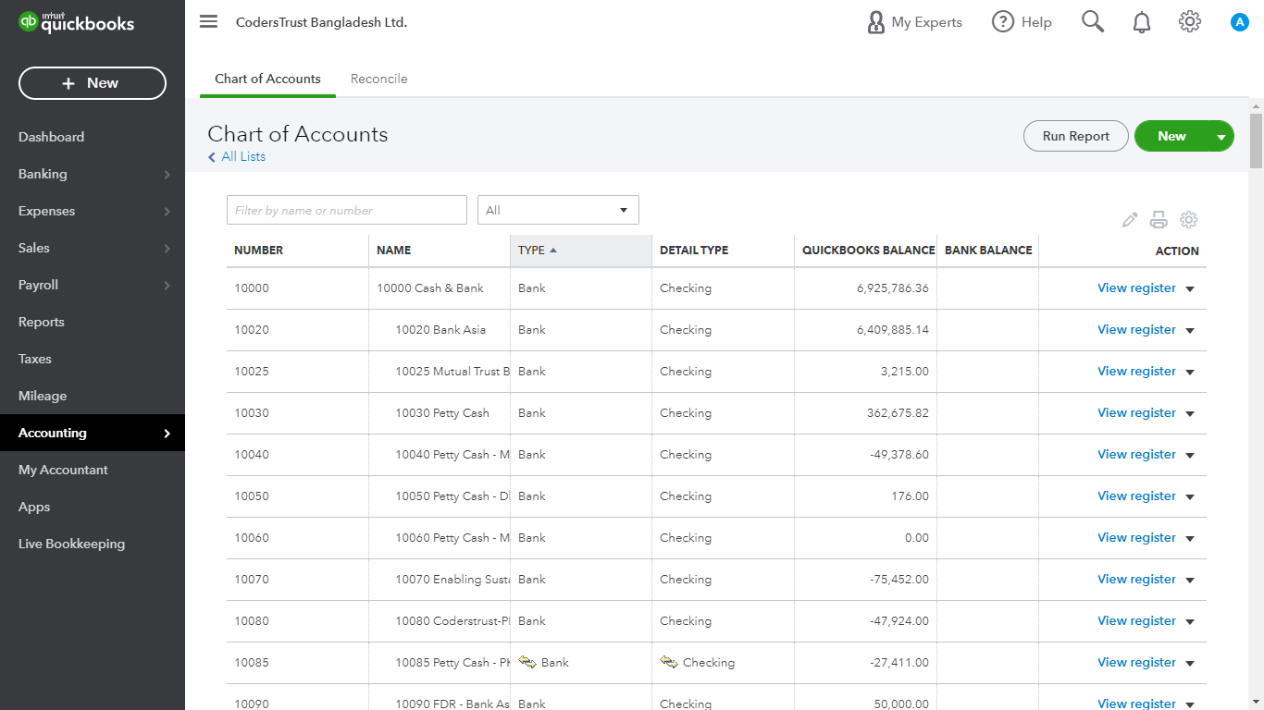
Figure 2: Chart of Accounts
- Reconciliation: The organization figure the bank related exchanges. So that, organization recognize the contrast among bank and money exchanges for lessening the blunders.
- Sales: Many other components are included here as, Invoices, Customers, Products and Services. Now the question is how CodersTrust manage this system?
- Products & Services: In the product and service part they individually create the service name which they give to their customers. Basically, the company is providing services of online and offline. And give training of several courses like, Diploma, Digital Marketing, Graphics Design, Responsive Web Design, and Advanced Excel and so on.
- Customers: Here they keep the information of their customer. In our company we basically follow a format of keeping the customer information. First, we use the customer name and then customer ID. So that we can easily track the customer by using their ID.
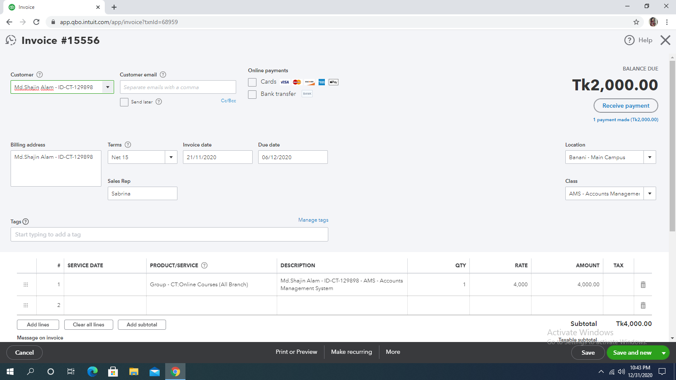
- Invoices: After creating the customer information we prepare separate invoices foe every particular customers. Here, we give customer information in the customer section, then we give customer e-mail in the e-mail section, then we give invoice date which we be the selling date of the service towards customer, the terms will be net 15, in the location sector will give the branch name (Banani, Mirpur, Dhanmondi), in the sales representative will give the name of the business developer, in the class section we give the service name which the customer is taking, in the product/service we input is the customer is taking online or offline service, in the description we simply give the customer
Figure 3: Invoice

information and course name, and rate will be the amount of that course. Thus, we create invoice for each customer and then save the invoice.
- Income: Every organization wants to keep the record of their income so that they can easily understand the profit and loss situation. CodersTrust keep their income record by doing receive payment.
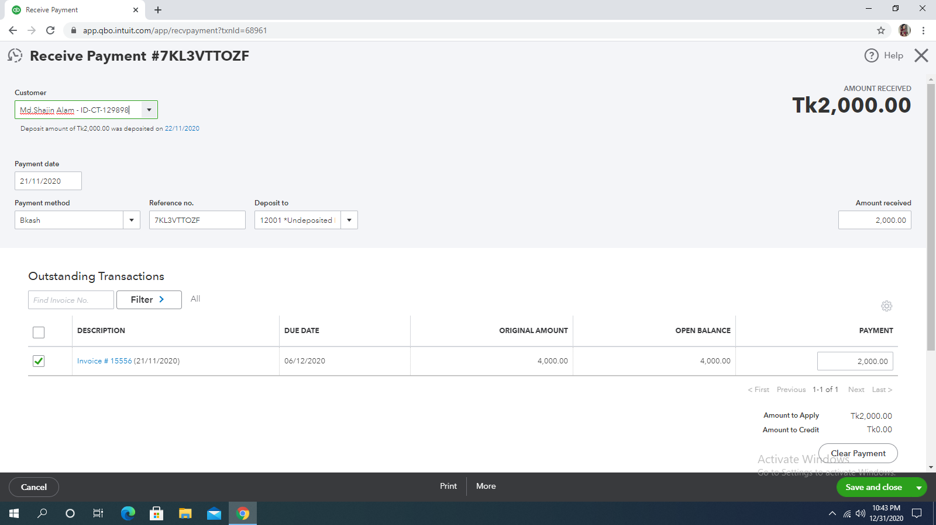
- Receive Payment: This system helps to record that how much the company is receiving from their customers. Here we give the customer information, then we give the payment date of receiving the money, then we give the payment method like, is the customer is paying through bKash, Website, Card, Cash, Rocket, Bank Deposit, Nagad, and then the transaction Id must be given in the reference no, in the deposit to we give in which portion we want to deposit our money and finally we give the amount which we received from customer and thus we create the receive payment.
- Figure 4: Receive Payment

- Report: in this part CodersTrust can think about their every monetary report and results. As we probably are aware in accounting there are three kinds of report address the association by and large monetary condition, like Profit and loss Statement, Balance Sheet Statement, and Cash Flow Statement. Same as after given the legitimate contribution of exchange section the QuickBooks programming share the programmed yield. At the point when we check those reports for dissect then we open this report alternative and gather the require discoveries through those reports. In this cycle CodersTrust keep up their budget summary and reports.
Financial statement examination can profit associations from various perspective. It outfits inside and external accomplices with the chance to make an informed decision which concern in contributing. This similarly gives advancing associations an unprejudiced perspective on a business monetary wellbeing, which is helpful for settling loaning choice. At long last financial statement analysis assists with issue of corporate administration also. The company’s financial statement is still in negative equilibrium since they are spending their money to get the spot on the lookout and to accomplish their goal.
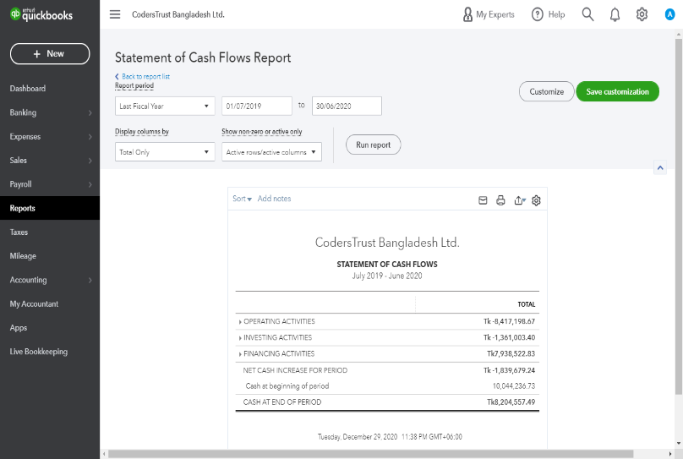
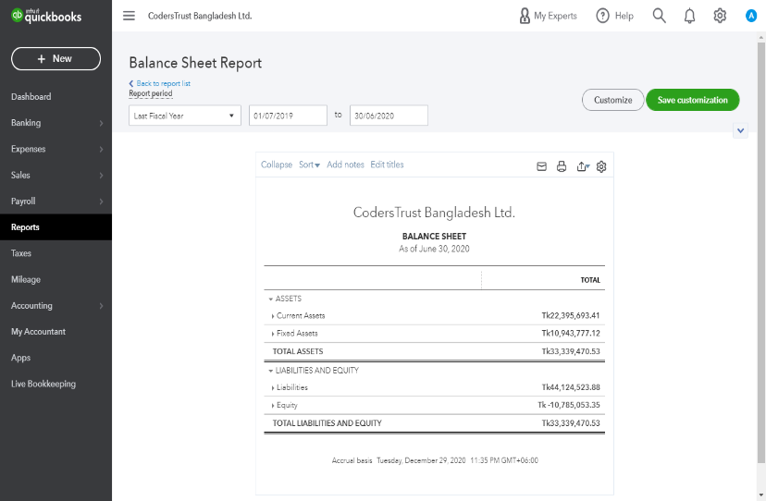
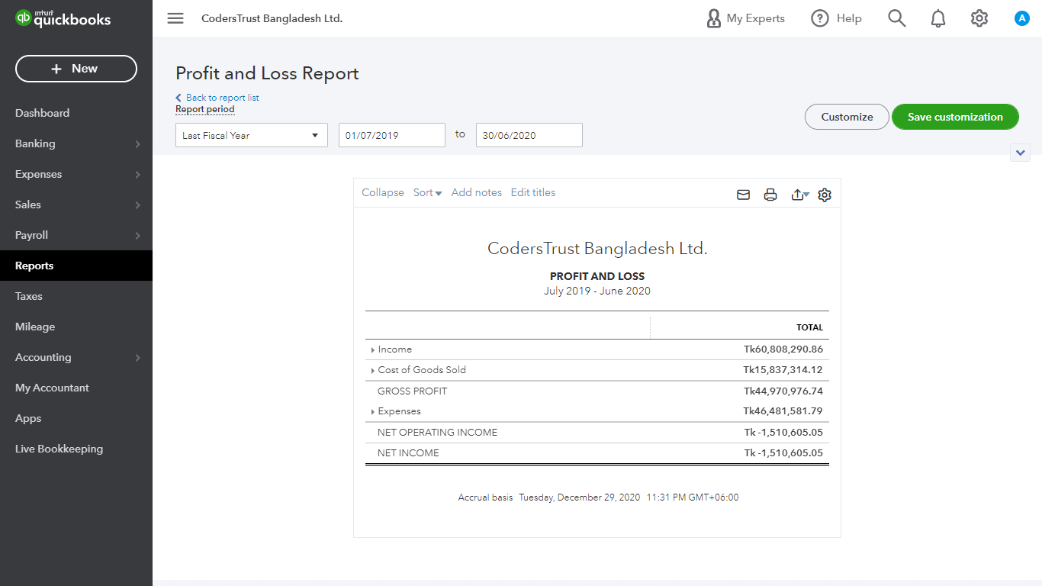
Figure 5: Financial Statement of CodersTrust Bangladesh
The QuickBooks has likewise Dashboard, which mirror the short concise of the situation of financial of the association. It looks engaging anybody undoubtedly get about it. In short if somebody needs to think about the organization initially, at that point this dashboard is sufficient.

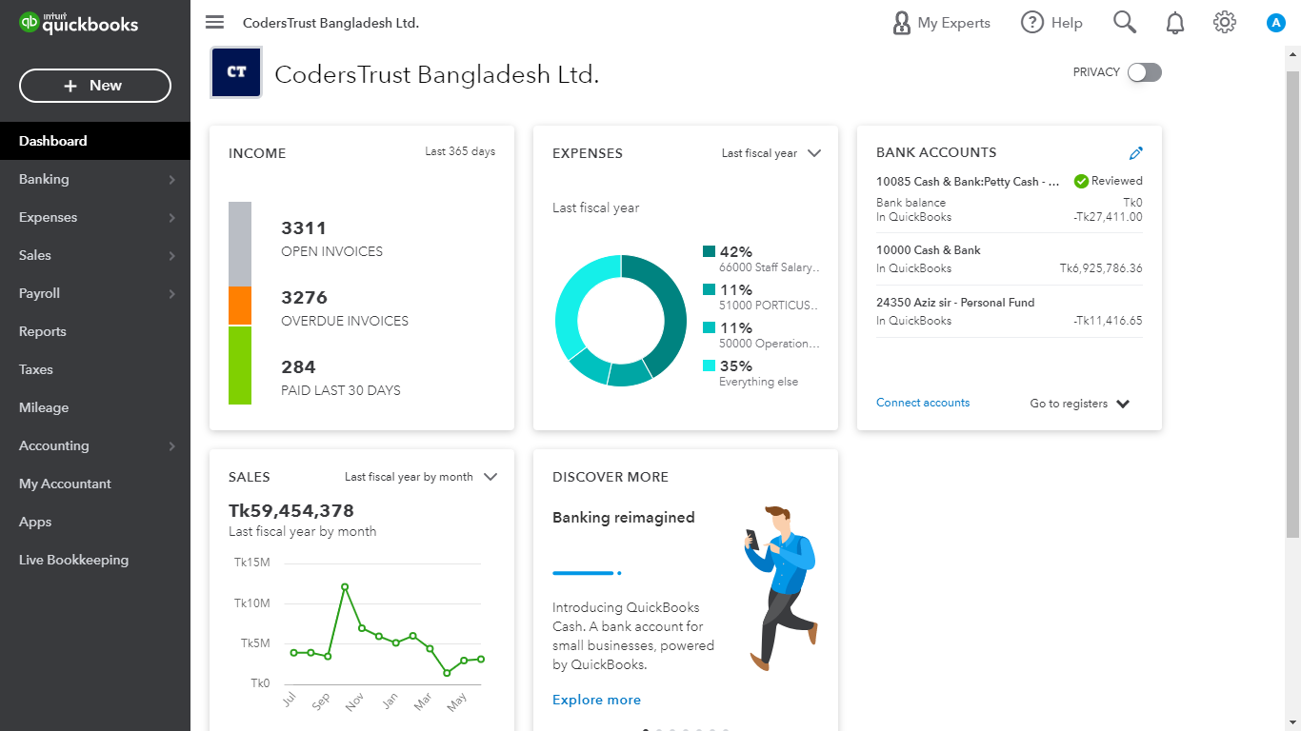
- Expense: CodersTrust updated their daily expenditure through QuickBooks software. Basically, the company spend their expense in Petty cash of each branch and also buying different essential things for company. Their expenditure is based on different expenses categories- Salary & Wages, Meals & Entertainment, Rent expense, Conveyance, and other expense.
Figure 6: QuickBooks Software Dashboard (CodersTrust)
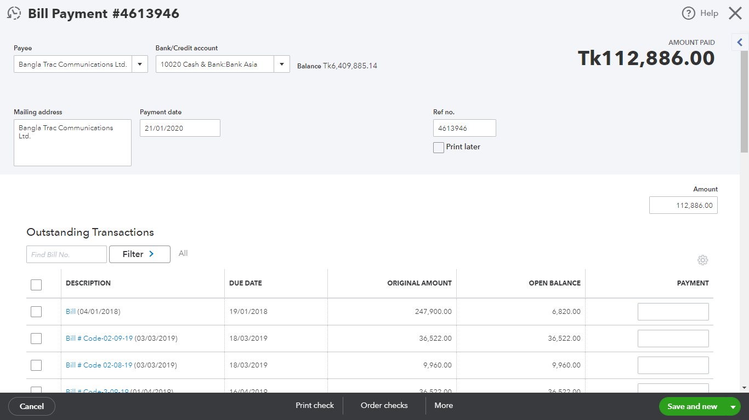
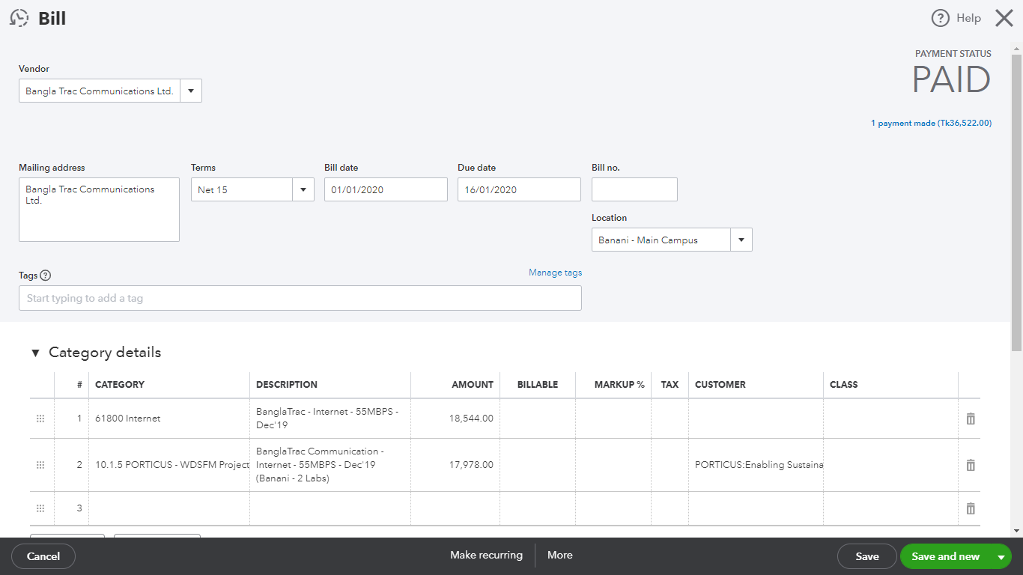
- Bill & Bill Payment: If the company purchase anything then they separately create bill for each expense. And when they pay the bill from where they bought also keep the record of payment as bill payment. Whenever they are giving any amount to their employee for meals also keep update in the expense as bill payment. All the records they keep in the expense sector. Like, Bangla Trac Communication Ltd they provide us internet connection and we keep all the bill and bill payment details by keeping their name of each months. This process helps us to track all the expense sector of our company.

Figure 7: Bill & Bill Payment

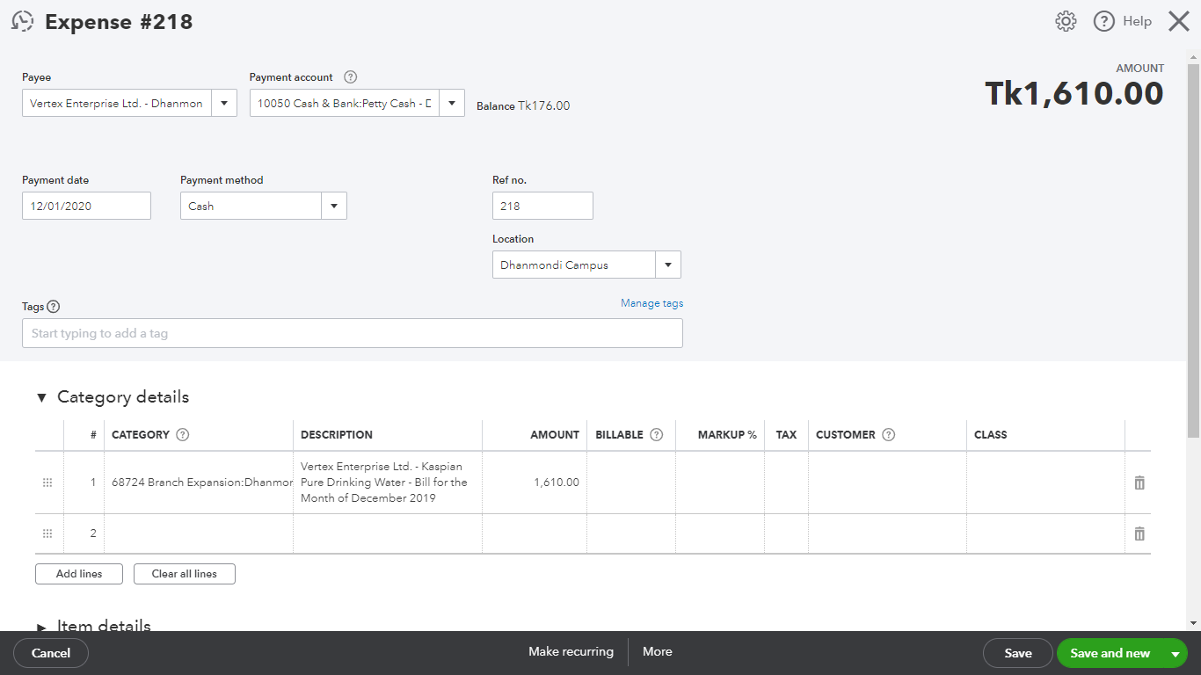
- Vendors: In our company we also have many vendors, like Vertex Enterprise Ltd, from them we have bought water purifier. For that reason, we kept record of that expense. Like this all the vendor record are kept as the list of vendor expense.
Figure 8: Vendor Expense

5.3 Advantages of QuickBooks software:
QuickBooks is generally viewed as extremely incredible and valuable programming for some organization. This software has become a crucial software for some organization & company because the software saves money and time. This software really improves also smooths out the bookkeeping, subsequent and uncovering and for the most part, and guarantees that the route toward managing the association finances will be much less difficult. Here are the advantages of QuickBooks –
- The process of using this software is comparatively easy than other software. And the software is easy to understand.
- The software is bringing safety and adapting new technology system regarding software. It tends to be gotten to from an advanced gadget which makes the life of the entrepreneurs a lot simpler.
- The software increase the efficiency by integrating many tools. By using this software any user can save their time.
- The software will help to take better decision because the reports which represent through the software is clean and comprehensive.
- Reduce manual paperwork cost.

5.4 Disadvantages of QuickBooks Software:
Everybody would concur that QuickBooks is an incredible starting framework for new and independent ventures. For any startup business, most important thing is to know whether they need any software. Based on the need for managing accounting and financial software purchase is needed. For this QuickBooks is the consistent decision. But the software has some limitations too-
- The software is made based on the mindset of small business, so large size business cannot use this software at all.
- There is also risk of losing the important data or information, because the data is not back-up frequently.
- The system of the software is not much well.
- The design tools of the invoices and receive payments are not much enough.
- The transactions are limited in this software.
- Some features design is unclear to understand.

Chapter 6

Conclusion & Recommendation

6.1 Conclusion:
Bangladesh has stood itself among the main thirty outsourcing centers which implies the interest of Bangladeshi freelancers towards the market of outsourcing. The public authority is investing a lot of energy into the prospering of the IT business though unfamiliar financial specialists are seeing savvy openings through the Bangladeshi outsourcers. CodersTrust Bangladesh has started the interest of outsourcing into the mind of Bangladesh people. Outsourcing was not that much known to anyone, prior to CodersTrust Bangladesh. CodersTrust is a Danish organization working its branch in Bangladesh to create abilities and online information to the denied and oppressed understudies of Bangladesh. The association is offering an assortment of instructional classes intended to build up understudies’ information and abilities with the goal that it can hold its understudies and pull in more likely understudies. To explore the idea of Accounting Information System and to explore the implication of accounting information system in CodersTrust Bangladesh is the motive of preparing this report. Here, also suggesting some recommendation so that the Accounting Information System in CodersTrust Bangladesh can be improved. After the analysis, it is found that Accounting Information System is the part to record, store, analyze, and report financial information and CodersTrust use software to keep all the financial information error free and also to know about the financial condition of the company easily. CodersTrust is using QuickBooks software for keeping all the financial information. Through using this software they are keeping record of their daily sales by preparing invoices, keeping record of their income by preparing receive payments, the expenses that is incurring daily, and also the most important thing is doing bank reconciliation. However, the company should focus on using their software, which will help them to record all the financial information then now.

6.2 Recommendation:
It is extremely urgent for organization to surpass different organization and furthermore set a benchmark, and this is not spontaneously affected by other competitors in this competitive market. CodersTrust is a great service provider and it has that ability to become even bigger and better. Though there is a few obstacles CodersTrust is facing but they need to change a few of their strategies to overcome those obstacles. Some of the barriers which hampers CodersTrust enhancement and sustainability and the solutions which is given as recommendation are given below:
- As the company is using the software by paying subscription fee, the company can use better software than QuickBooks. QuickBooks has some drawbacks; the software is not that much user friendly. For their betterment they can use better software like, Xero, FreshBooks, and Wave.
- Regarding abilities and information, employees are generally unique in relation to one another. A few people need to attempt a fresh new situation and begin utilizing it immediately. Others are more doubtful about the better approach for working. The project administrator should have systems on the most proficient method to deal with the two kinds. CodersTrust Bangladesh can pick a suppliers homeroom type preparing or they can relegate a supervisor for training. The association ought to likewise remember a prologue to its software for the way toward enlisting new employees. Along these line, new staff will figure out how to utilize software from the earliest starting point.
- CodersTrust Bangladesh should focus on more keeping the proper documents and data. While working in this company the data through which we work, I found them as not in proper way. For this reason, I highly advise them to keep proper data and documentation.
- Since QuickBooks software automatically shares all the financial reports based on transaction, so responsible accountant should be aware about proper distribution of transaction factors otherwise based on wrong transaction the software will give wrong report.
- In chart of accounts, I faced some lack of category that’s why I’ll recommend them to use the updated software. As the company is using the software by paying fees. So, they can use better software then QuickBooks.

References:
- A freelancing boom is reshaping Bangladesh and its economy. (2019). Retrieved from https://theprint.in/world/a-freelancing-boom-is-reshaping-bangladesh-and-its-economy/252971/.
- A freelancing boom is reshaping Bangladesh and its economy. (2019, June 23). Retrieved from ThePrint Web Site: https://theprint.in/world/a-freelancing-boom-is-reshaping-bangladesh-and-its-economy/252971/
- About CodersTrust Bangladesh. (2020). Retrieved from CodersTrust Bangladesh Website: https://coderstrustbd.com/
- Accounting Information System (AIS). (2020, November 19). Retrieved from Investopedia: https://www.investopedia.com/terms/a/accounting-information-system-ais.asp
- Accounting Information System of the Financial Institutions in Bangladesh: An Evaluation. (2008, December). Retrieved from Research Gate: https://www.researchgate.net/publication/228271373_Accounting_Information_System_of_the_Financial_Institutions_in_Bangladesh_An_Evaluation
- BizwaySoftware. (n.d.). Retrieved from bizsoftware web site: http://bizwaysoftware.com/
- co...LT, n. E.-o. (2001). japan.
- CodersTrust Bangladesh. (2020). Retrieved from CodersTrust Bangladesh Web site: https://coderstrustbd.com/
- Company, M. (2014). Bangladesh.
- Define and Describe the Components of an Accounting Information System. (n.d.). Retrieved from BCcampus Web Site: https://opentextbc.ca/principlesofaccountingv1openstax/chapter/define-and-describe-the-components-of-an-accounting-information-system-2/
- Digital Library. (2020, May 11). Retrieved from eprints: http://digital.library.ump.ac.id/637/1/FACTORS_THAT_AFFECT_ACCOUNTING_INFORMATION_SYSTEM_.pdf
- pen, h. t. (2014). America.
- QuickBooks. (2020). Retrieved from Wikipedia: https://en.wikipedia.org/wiki/QuickBooks
- Smart Software Ltd. (2020). Retrieved from Smart Software Ltd Web Site: https://www.smartsoftware.com.bd/account-management-system
- Tally. (2020). Retrieved from Tally Web Site : https://tallysolutions.com/bd/en/about-tally/
- Techneo360. (2020). Retrieved from Techneo360 Web Site: https://www.techneo360.com/accounting-inventory-software/
- Troyee . (2016). Retrieved from Troyee Web Site: https://troyee.com/
- ZAMAN IT. (2020). Retrieved from ZAMAN IT Web Site: https://www.zaman-it.com/not-found

