An analysis of critical success factors in small and medium enterprise banking in Bangladesh- A case study of United Finance Ltd.’’




Internship report on
An analysis of critical success factors in small and medium enterprise banking in Bangladesh- A case study of United Finance Ltd.

Submitted to:
Ziaul Karim
Assistant Professor
United International University.

Submitted by
Joy Krishna deb
ID 11 143 225

Date of Submission: 01-06-2020

Letter of transmittal

1st April, 2020
Ziaul Karim
School of Business & Economics
United International University
Subject: Submission of Internship Report.
Dear Sir,
With due to respect, I am submitting my internship report topic “An analysis of critical success factors in small and medium enterprise banking in Bangladesh- A Case study of UFL” which is part of my course requirement for the degree of Bachelor of business administration. My job was held in the branch office.
This report describes the united finance Ltd. service quality to achieve success in small and medium banking. I tried my best to prepare this report sincerely and correctly.
I hope that you will like this report. In this case it will be meaningful to me. In any case, if you need any explanation or clarification in this report please contract.
Sincerely yours,
Joy Krishna Deb
Id 111 143 225

Acknowledgement
My warmth gratitude goes to many people whose affable cooperation and advice helped Sabrina Mehnaz for her cardinal cooperation in preparing this report.
I would like to thank other employees of my office. I also thank to Farizma Hossain, Management Trainee in Human Resource department of United Finance Ltd. Also, I express my deep gratefulness to all employees of United Finance Ltd, for their cooperation to collect various required supportive from various sources and helped me to complete this internship report.
Finally, I express my deep gratefulness to my supervisor Ziaul Karim. I am very much glad to him for helping me to complete this report.
Executive Summary
Bangladesh is a developing country, yet the national disaster and political distress sluggish the industrial development and financial development of the country. In spite of all barriers, the development of a finance company is to indicate the bright prospect of our economy. This is the purpose behind doing the report on the financial articles.
The report will describe the outline of a few articles on the financial organizations in Bangladesh and the connection of those articles with the financial organizations. The beginning of this report will show the origin of the report, methodology, Literature review, and limitation of the report. The organization's background is shown in chapter two of the report. In this part mainly describe the key person, objectives, vision, mission, goals, target market, organization structure, success level, values, advantages, and career. United Finance limited all products, cost management, organization performance, and risk management describe in chapter 3. Graphically representation on the financial condition of UFL shown in Chapter 4 which includes Debt to equity, Debt to assets, Equity, Net Profit, ROA, ROE, and loan facility. Employee befits include in chapter 5 and chapter 6 added the revenue collection process. Chapter 7 which includes an overview of NBFIS, beginning of NBFIS, development & activities of NBFIS. Finally include findings, recommendations, and conclusion.

Abstract
This study show that the impact of entrepreneur and characteristics of small and medium enterprise business success factor in Bangladesh. This study depends on overview of a small and medium enterprise business firms. There are two theories are proposed to test. The entrepreneur found to be a critical success factor for business of SMEs in Bangladesh. Therefore characteristics of small and medium enterprise business aren’t found to be a critical success factor for business of SMEs in Bangladesh. This study result shows the demographic factors that only one which operated in organization. SME Banking more successful in long term. On the other hand, short term operated less successful. The studies show that implication of policy maker and entrepreneur.
Keyword: SMEs, Small Banking Success, Business characteristics and entrepreneur, Bangladesh

Table of Contents
Chapter1. Introduction 1
1.1 Origin of the report 1
1.2 Objective of the report 1
1.2.1 Overall objective 1
1.2.2 Specific objective 1
1.3 Methodology 1
1.3.1 Primary 2
1.4 Literature review 2
1.6 Limitations of the report 4
Chapter: 2 United Finance Ltd. Background (UFL) 6
2.2.1 Vision 9
2.2.2 Mission 9
2.2.3Goals 9
2.3 Target Market 9
2.4 Succeed at Every Level 10
2.5 OUR VALUES 11
2.5.1 Integrity 11
2.5.2 Meritocracy 11
2.5.3 Learning 11
2.5.4 Teamwork 11
2.5.5 Passion 11
2.6 Advantages 11
2.6.1 Learning Opportunity 11
2.6.2 Job Training 11
2.6.3 Guiding 11
2.6.4 Out of Office Activities 12
2.7 Career 12
2.7.1 Our Recruitment Policy 12
2.7.2 Regular Employee 12
2.7.3 Contractual Employee 12
2.7.4 Internship 12
Chapter 3 Products of united finance Ltd 13
3.1.1 Assets 13
3.1.1.1 Working Capital Solutions (Short – Term): 13
Assets Financing Options (Long Term 19
3.1.2 Liability Product 23
3.1.2.1 Affordable HOME LOAN: 23
3.1.2.2 Home Loan 24
Deposit Products: 25
3.1.2.1 Insured Deposit Scheme (IDS) 25
3.2 Cost Administration: 30
3.4 Risk Management: 31
3.4.1 Pre-emptive Risk management 31
3.4.2 Contemporaneous Risk Management 31
3.4.3 31
3.5 Sustainable Initiative: 32
Chapter-4 Financial condition of UFL 33
4.1 Analysis of Debt to Equity of UFL 33
4.2 Analysis of Debt to Asset of UFL 35
4.3 Analysis of Equity Multiplier Of UFL 37
4.4 Analysis of net profit 39
4.5 Analysis of ROA of UFL 40
4.6 Analysis of ROE of UFL 41
4.7 Loan Facilities 42
4.8 Geographical location wise lease, loan and advance 43
4.9 Geographical area wise lease, loan and advances (Inside Bangladesh Rural): 44
4.10 Analysis by security from borrowing from banks, other financial institution and agents: 45
Chapter 5 Employee benefits 46
5.1 Short term benefits 46
5.2 Post emplacement benefit 46
5.2.1 Provident fund 46
5.2.2 Gratuity fund 46
5.2.3 Other long Term benefits 46
Chapter 6 Revenue recognition 47
6.1 Interest Income 47
6.2 Lease Income 47
6.3 Income from long and short term finance: 47
6.4 Income from dividend: 47
6.5 Income from deposit 47
6.6 Fee based salary 47
Fee based income is recognized as revenue when it is received. 47
6.7 Interest paid on Deposit, borrowing, and so forth. 47
6.8 Impairment of Assets: 48
Chapter 7 NBFIs in Bangladesh 49
7.1 Overview of Bangladeshi NBFIs 49
7.2 Leasing industry in Bangladesh: 49
Findings 50
Recommendation 51
Conclusion 52
References 53

List of Table
Table 2.1 Key person | 7

List of Figure
Figure 1 Organizational Structure | 10
Figure 3.1 Products of united finance Ltd. | 13
Figure 3.2: Procedure of Credit-Sale Financing | 14
Figure 3.3 : Procedure of Distributor Finance | 16
Figure 3.4 Procedure of short term Revolving | 18
Figure 3.5 Procedure of Lease financing | 20
Figure 3.6 Procedure of Term Loan | 22
Figure 4.1 Debt to Equity | 33
Figure 4.2Analysis of Debt to Asset of UFL | 35
Figure 4.3 Equity Of UFL | 37
Figure 4.4 Analysis of Net Profit | 39
Figure 4.5 Analysis of ROA | 40
Figure 4.6 Analysis of ROE | 41
Figure 4.7 Loan Facilities of united finance | 42
Figure 4.8 Geographical location wise rent | 43
Figure 4.9 Geographical area wise lease, loan and advances (Inside Bangladesh Rural) | 44
Figure: 4.10 Analysis from borrowing from banks, other financial institution and agents | 45

Chapter1. Introduction
  - Origin of the report:
Today’s business world is very dynamic and competitive therefore organizations looking for talented, innovative, ingenious graduates who belong to high degree of adaptability quality. At present business, graduates are the core part of business world. All business graduates need to know theoretical and practical knowledge to manage business activity properly. To be familiar with organization culture and to obtain some practical knowledge about an organization, a business student must prepare a project report which is a part of the BBA program. As a part of the BBA program at United International University, the course Internship consists of 3 credits. This internship report must do on a topic and must be submitted to a
1.2 Objective of the report:
The objective of this report can be separated into two segments, for example, overall objective and specific objective. These two portions are described below.
    - Overall objective:
The overall objectives of the internship report about the small and medium enterprise banking in Bangladesh.
    - Specific objective:
- To know about the general information about the finance company
- To know about the products of the company.
- To know the finance procedure
- To know the Company’s financial condition
- To learn how to make a feasible report.
- To explore some of the recent issues in finance company in Bangladesh

  - Methodology:
There are two source of resources primary and secondary are given below.
    - Primary: Primary information can be gathered from various sources. The method that are use to collect primary data in my report are below
- Conversation with separate employee of United finance Ltd.
- Discussion with the supervisor.
- Other Expert
    - 1.3.2 Secondary: Secondary data is one kind of quantitative data that has been already collected by someone else for purpose. The method that are use to collect secondary data in my report are below
1. Yearly report of United Finance Ltd
2. Web site: www.unitedfinance.com.bd
3. Previous report
4. Information collected in other web sites.

1.4 Literature review
Introduction
Research into small and medium sized enterprises (SMEs) has grown during the last decade. A huge majority of firms worldwide are SMEs, and that they play a big role within the economy. Consequently, the performance of the SME sector is closely related to the performance of the people. SMEs account for a large proportion of the total establishments in various sectors in Bangladesh. We know that most of the study focuses on large company. Some large company getting success and other fail. In Bangladesh, despite the very fact that some SMEs are growing and are successful, some of others have been decline. What factors affect business success among SMEs? This study show that the impact of entrepreneur and characteristics of small and medium enterprise business success factor in Bangladesh. Previous studies handling the conditions of successful business have focused on large companies instead of SMEs. However, changes within the environment cause more uncertainty in SMEs than in large companies.
The SME sector performance refers to the SME sector's success in the market. SMEs sector performance characterized the company’s ability. Every company's success relates to the achievements of the organization's goal and objective. Success is the key to every business. Success and failure are often interpreted as measures of good management. The financial performances of the SMEs refer to business success. However, there's no universally accepted definition of success, and business success has been interpreted in some ways .There is a minimum of two important dimensions of success: 1) financial vs. other success; and 2) short- vs. long-term success. Success can be different forms, survival, profit; return on investment, sales growth, number of employed, happiness, reputation, and so on. In other words, successes are often seen to possess different meanings by different people.
SMEs contribution in Bangladesh economy
BSCIC estimates suggest that there are currently more than 50000 small industries and cottage industries. The recent private sector survey estimates the contribution of the micro, small, and medium enterprises is 20-25% of GDP. Planning commission surveys estimate those small cottage industries between 100,000 to 150,000. That variation of BSCIC and planning commission survey estimate of the number of SMEs might be due to at least two reasons (1) different definition of SMEs (2) different coverage of SMEs family. There is an urgent need to set of definition for SMEs by all government agencies to help formulation SMEs policies.
Entrepreneur characteristic
Entrepreneur plays an important role in SMEs sector to ensure the business success. Entrepreneur refers to the individual characteristic, Demographic characteristic, personal traits, entrepreneur readiness. Several previous studies found that demographic characteristic such as age, gender, background, education, work experience, impact on the entrepreneurial intention.
Demographic characteristic
Studies found that 25 to 45 year’s age range were the most successful entrepreneurial active. Another study in India disclosed that successful entrepreneur were relatively younger in age. A study found that female entrepreneur less likely to be founder of new business than male. Another study found that male were generally higher entrepreneurial intention than female.
Individual characteristic
Business success has been classified into three categories: the characteristic of the owner manager, environmental characteristic and firm. The individuals characteristic like that age, education, Industry knowledge, managerial experience and social skill of the manager/ owner.
Development of Hypotheses
Based on the literature review the following hypotheses are given:
H1 Positive relationship between Entrepreneur characteristic and SMEs business success
H2 Positive relationship between characteristics of small and medium enterprise and SMEs business success
Conclusion
The study finds out entrepreneur characteristic characteristics of small and medium enterprise business success factors in Bangladesh and also found entrepreneurs have a significant effect on the business success of Bangladesh. The SMEs business owners need to know their products and services, personally, he involved in business, should strict the business, define market clearly and pay attention to details. SMEs need to ensure a strong social network and government relation to achieve business success. Successful business organization communicates with their customers, suppliers, workers. Business cooperation also enables the improvement of a small firm's strategic position enters the international market, reduces cost, and copes up with the new technologies.

1.5 Scope of the report: By preparing this project paper based on the ‘"analysis of critical success factors in small and medium enterprise”
Which can give the way to get familiarize with the overall finance organization. It gives the real picture of finance system and procedure of Bangladesh. This report has limited information but i can assure that I have tried my best to describe every part of my job in this report.
1.6 Limitations of the report There were some limitations of this report. Those limitations are described in below –

- As a Non-Financial organization, it has some restrictions to serve all the real data of the organization to the general people as a result the study mostly depends on official files, annual report and websites.
- Unavailability of up-to-date information.
- Enough information is not available in the annual report of United Finance Ltd.
- Anything which will adversely affect the image of the organization could not be disclosed.

Chapter: 2 United Finance Ltd. Background (UFL)

UFL start their business as United Leasing Company Limited in 1989 with a single product focus. Duncan Brother Limited is a well establishment company working in Bangladesh for more than 152 year. In 1995, the UFL obtain license from Bangladesh Bank as a financial organization. It has been listed A category share in Dhaka Stock Exchange. UFL is the main thirteen financial organizations permitted by the Government to take Public Sector deposit.
At first UFL focused on lease finance to the medium size clients but over the year it has diversified product range from corporate to individual. The UFL start their leasing organization with just a single office in the Dhaka. At a time the company expends business whole over the country. Now UFL works through 23 branch office all over the country and every one of the 64 district under its financial coverage.
United Leasing Company changes the company name to United Finance Limited in 2014. They change the company name to expend business. Now they are not only a leasing company but also a financial organization in the country.
United Finance Ltd Milestones:
- United Finance Ltd was established in 1989.
- Start of operation, September 12, 1989.
- Public Issue of share, March 28, 1994.
- Dhaka Stock Exchange (DSE) June 23, 1994.
- First dividend declared, April 20, 1995.
- Authorized capital increased, May 18, 2000.
- Launch of Fixed Investment Products, September 2005.
- Start of Credit Sale Finance Operation, October 3, 2005.
- Start of extend Head Office (Noor Tower), June 13, 2008.
- Training Center (Northern S.R. Tower), May 15, 2010.
- Affordable Home Loan Operation, September 2011.
- Authorized capital increased, November 24, 2011.
- Distributor Financing Operation, April 2012.
- Changing the name to United Finance Ltd, November 13, 2014. (United Finance Limited, 2015).

Table 2.1 Key person:
Name/ Title | Current Board Membership
Imran Ahmed, 66 Chairman | UFL. Bangladesh, Duncan Brother Limited., Duncan Product Limited., Laungla Sylhet Tea Company. Limited., Eastland Camelia Limited., Octaviaus Steel and Company. of Bd Limited., Surmah Valley TEA Company. Limited., Amo Tea Company. Limited., The Chandpore Tea Company. Limited., The Mazdehee Tea Company. Limited., The Allynugger Tea Company. Limited., Chittagong Warehouses Limited., Duncan Properties Limited. Bangladesh, The Lungla Sylhet Tea Company. Limited.
Syed Kaiser Tamiz Amin( MD) | UFL .
Abdur Rouf bhuiya, 80 Director | Camelia Duncan Foundation, United Finance Limited. Bangladesh, Laungla Sylhet Tea Company. Limited., Amoo Tea Company. Limited., The Chadpore Tea Company. Limited., The Mazdehe Tea Company. Limited., Octaviaus Steel and Company. of Bd Limited., Duncan Brother Bangladesh Limited., Duncan Product Limited., Eastland Camelia Limited., The Alynugger Tea Company. Limited., Chittagong Warehouses Limited., Duncan Properties Limited. Bangladesh, The Laungla Sylhet Tea Company. Limited.
M M Alam (Independent director ) | UFL
AFM Misfaqus Samad Chawdhury, Director | UFL
Lutful Hakim Khan, Director | UFL. National Broker Limited.
Susan Ann Walker 52 Director | Lawrrie Group Plc, Eastern Produce Investments Limited
C K Hayder Director | Global Leasing Securities Limited., United Finance Limited. Bangladesh
A F Nesaruddin, Director | UFL. Bangladesh Khulna Water Supply and Sewerage Authority, Singer Bangladesh Limited.

2.2 Objects of the Organization
The objective of the company to helps the development of productive private sector industries particularly in their balancing and modernizing programs. The company mainly extends lease financing for machinery, equipment to the industries & vehicles for commercial purposes. In addition, it also provides project finance for the expansion of the business. The primary objective of the company is to provide leases to different commercial organizations. The company also investment for all kind of manufacturing industry and vehicle purchases.

2.2.1 Vision
To be the main great specialist co-ops in the business sectors we distribute.

2.2.2 Mission
- Dedicate ceaseless exertion to raise items and administrations for continuing serious end.
- Assure service excellence by leveraging motivated human resources and technologies.
- Assure sound, financial performance and adequate return on investment to manage risk.

2.2.3Goals
- Customers: Provide better service quality to achieve customer satisfaction in terms of timely delivery, fairness treatment and value addition.
- Risk Management: Actively manage the risk and adhere international practices.
- Sharer: Growth in earning per share.
- Employee: Create a good working environment; provide training to all employees for better service.

2.3 Target Market
The company provides its loan facility in certain sectors of the market. The market is diversified and identifiable for the clients and customers as well. Therefore the market classified into parts and the classification as following:
- Short and medium range organizations
- Low profile good and potential performers
Main target
- Company who have potential, sincerity, and devotion
- Company who need investment in equipment to growth

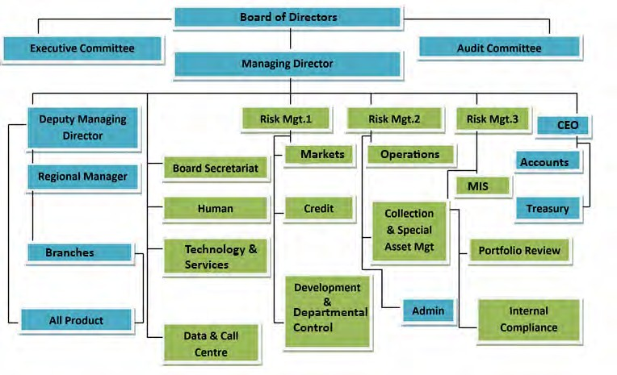
Figure 1 Organizational Structure:
Figure 1: Organizational Hierarchy 15

2.4 Succeed at Every Level:
Every employee treated like a family. Here is a good working environment. The colleagues welcome you to the organization. Every member of this organization is very helpful. The culture of the organization support learning each employee.

2.5 OUR VALUES
2.5.1 Integrity: We do things the right way, without compromise, the first time – every time. We are direct, conclusive and, above all, accountable. We practice sound judgment and common sense that conforms to the letter and spirit of the law at all times.
2.5.2 Meritocracy: We create opportunities for ourselves and each other by consistently making career and compensation decisions on the merits, recognizing that doing so attracts and retains the best and brightest.
2.5.3 Learning: The organization driven ideas rooted in imagination and innovation; a continues curiosity to attain skill, knowledge. The company improves feedback and opportunity for self improvement that improves and transforms the environment around us.
2.5.4 Teamwork: We seek individuals to share their opinions and ideas because together we can produce more. But teamwork doesn't just benefit the organization; collaboration can also increase job satisfaction and lead to better results.
2.5.5 Passion: We demand passion for work in each person. It fulfills both the adventure of newness and creativity. We believe that passion keep us more motivated all time.
2.6 Advantages:
2.6.1 Learning Opportunity: The Company provides learning opportunity for all employees to gain theoretical knowledge. Continues training both from home and abroad to improve knowledge.
2.6.2 Job Training: The first year every employee opportunity to work several departments for getting idea about financial sector into comprehensive one. Then engage every employee in the corporate world.

2.6.3 Guiding: The supervisor paying attention to employee concern related his/ her performance. Supervisor and colleagues helps their team member to reduce grievance.
2.6.4 Out of Office Activities: Out of office activity like as picnic, family day, sports event etc refresh every employee mind. It is an internal part of office culture.

2.7 Career
2.7.1 Our Recruitment Policy: The recruitment policy of United Finance Ltd is to usually recruit employees at the entry level and nurtures them with proper guidance and training so that they are properly equipped to take any responsibility. Through the process their performance is duly evaluated to promote them to the next level.
Career Choices for the Applicants in United Finance Ltd: United Finance Ltd gives the Applicants 3 types of choices -
2.7.2 Regular Employee: The Permanents employees of the United Finance Ltd. The Applicants who can apply for this position are given below –
- Students complete graduation/post-graduation a person can apply for regular position.
- Regular employee vacancy open for all functional and support department

2.7.3 Contractual Employee: This is a Contractual Agreement. In this agreement there is a certain period and for this time the employees are hired. The Applicants who can apply for this position are given below-
- Newly graduate from any department such as BBA, MBA, and CSE students can apply for this position.
- Even students can apply this position.
2.7.4 Internship: The students who works in an organization to gain work experience and requirement for a qualification.
- 3-6 months internship program offered by united finance
- Students assigned with specific department for guidance and completion of his/her internship

Chapter 3 Products of united finance Ltd

Figure 3.1
There are two types of products-
Figure 3.1 Products of united finance Ltd.
3.1.1 Assets: The products of Assets can be two types. Those are Working Capital Solutions (Short –Term) and Asset Financing Options (Long-Term). The detail information about Asset Products of United Finance Ltd is given below.
3.1.1.1 Working Capital Solutions (Short – Term): This is the products that United Finance Ltd gives for the short-term period. The detail information of those products is given below-
1. CREDIT SALE FINANCING: Credit-Sale Financing is a mode of financing receivables arising out of supply of goods or delivery of services on credit. The descriptive part of Credit-Sale Financing is given below -
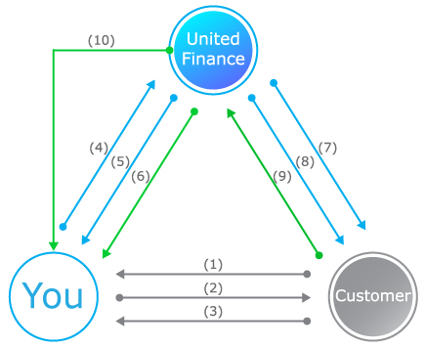
Figure 3.2: Procedure of Credit-Sale Financing
Products Overview: Here the detailed information about this product is given. Who is target customer, financial conditions, repayment system everything regarding these products is given below -
a) Purpose: To meet working capital requirements by financing the client’s procurement from suppliers.
b) Target customer: Small/medium/large traders involved in distributorship that procures goods from importer/manufacturers after payment of cash/pay order.
c) Finance Amount: Determined by considering the frequency of client’s average procurement and amount per procurement from the supplier(s) in a trade cycle of the client.
d) Facility Tenure: One year and renewable, based on performance.
e) Repayment: Repayment is made on or before the maturity of each individual drawdown through postdated cheque or BEFTN.
f) Security: Personal guarantee, one cheque covering total finance amount, hypothecation, or registered charge on inventory, receivables, and cash. Additional security is required for financing stock holding or limits above the collateral-free limit.
g) *IADA: Noninterest-bearing account, maintained by the clients, the balance of which is used to adjust interest and other charges. The balance of the account determined by the prevailing schedule of fees and charges.
h) Maximum Drawdown Amount: Highest monthly average calculated from last 12 months raw material purchase excluding the seasonal/festival procurement.
I) Festival/Seasonal Drawdown Amount: Peak/Seasonal procurement from the last 12 months purchases trend or Importer/Manufacturer which can be drawn only one month before the specific season/festivals.
j) Drawdown Frequency: Maximum two drawdown’s per week for each supplier based on the trade cycle and procurement pattern from importer/manufacturers. (United Finance Limited, 2005).
2. Distributor Financing: Distributor Finance is a revolving working capital facility for distributors of local and multinational FMCG products. The facility offers distribution businesses to make procurement from suppliers. The descriptive part of Distributor Financing is given below-
-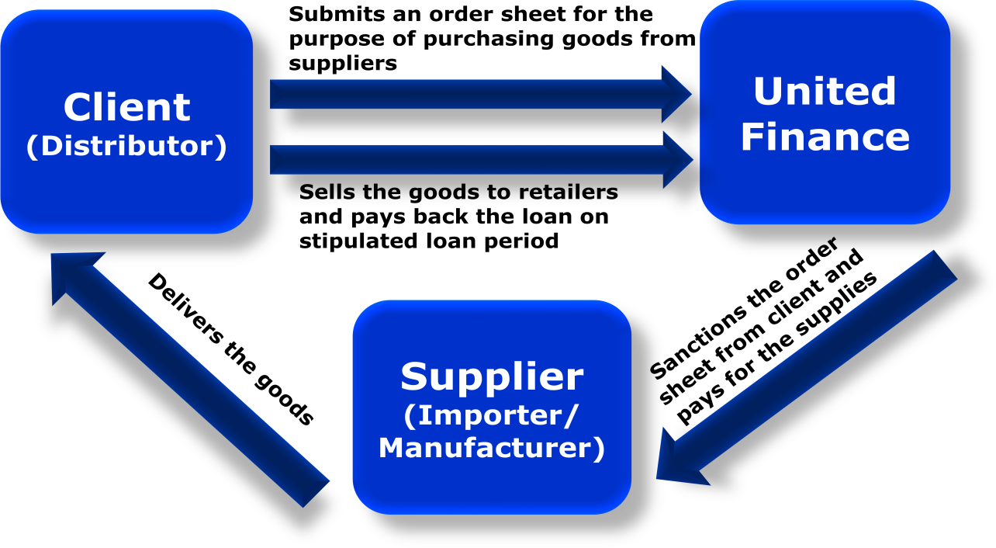
Figure 3.3 : Procedure of Distributor Finance
Product Overview: Here the detailed information about this product is given. Who is target customer, financial conditions, repayment system everything regarding these products are given below -
a) Purpose: To meet working capital requirements by financing the client’s procurement from suppliers.
b) Target client: Small/medium/large traders involved in distributorship that procures goods from importer/manufacturers after payment of cash/pay order.
c) Finance Amount: Determined by considering the frequency of client’s average procurement and amount per procurement from the supplier(s) in a trade cycle of the client.
d) Facility Tenure: One year and renewable, based on performance.
e) *IADA (Interest Adjustment Deposit Account): Noninterest-bearing account, maintained by the clients, the balance of which is used to adjust interest and other charges. The balance of the account determined by the prevailing schedule of fees and charges.
f) Repayment: Repayment is made on or before the maturity of each individual drawdown through postdated cheque or BEFTN.
g) Security: Personal guarantee, one cheque covering total finance amount, hypothecation, or registered charge on inventory, receivables, and cash. Additional security is required for financing stock holding or limits above the collateral-free limit.
h) Maximum Drawdown Amount: Highest monthly average calculated from last 12 months raw material purchase excluding the seasonal/festival procurement.
I) Festival/Seasonal Drawdown Amount Peak/Seasonal procurement from the last 12 months purchases trend or Importer/Manufacturer which can be drawn only one month before the specific season/festivals.
j) Drawdown Frequency: Drawdown Frequency: Maximum two drawdowns per week for each supplier based on the trade cycle and procurement pattern from importer/manufacturers. (United Finance Limited, 2015)
Short term revolving: The revolving loan is a tailor-made credit facility, specifically designed for the companies with seasonal activity, which need to cover their temporary liquidity gaps, until the collection of the commercial receivables. The descriptive part of Short Term Revolving is given below -
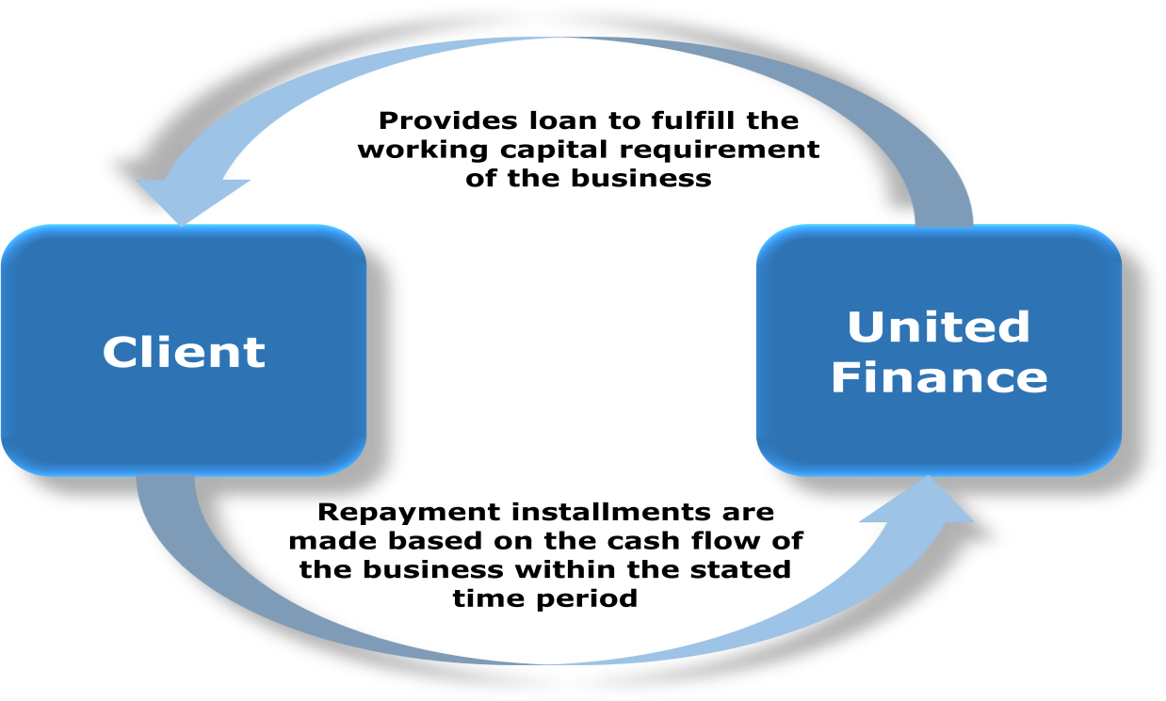
Figure 3.4 Procedure of short term revolving
Product Overview: Here the detailed information about this product is given. Who is target customer, financial conditions, repayment system everything regarding these products are given below -
- Purpose: To meet the working capital requirement.
- Target Customer: Small/medium/large-sized manufacturing/trading/service-oriented businesses involved in a regular supply of goods/services to its buyer(s) on credit.
- Finance Amount: Limit maybe 100% of net required working capital or 70% of total inventory and receivables of the previous year or a total of the work order in hand, whichever is lower.
- Facility residency: One year and renewable, based on performance.
- IADA: Noninterest-bearing account, maintained by the clients, the balance of which is used to adjust interest and other charges. The balance of the account determined by the prevailing schedule of fees and charges.
- Repayment: Repayment is made on or before the maturity of each individual drawdown through postdated cheque or BEFTN.
- Security: Personal guarantee, one cheque covering total finance amount, hypothecation, or registered charge on inventory, receivables, and cash. For facility above the collateral-free limit, acceptable collateral i.e. Land mortgage is required.
- Maximum Drawdown Amount: Highest monthly average calculated from last 12 months raw material purchase excluding the seasonal/festival procurement.
- Minimum Drawdown Amount: Lowest monthly average calculated from last 12 months raw material purchase excluding the seasonal/festival procurement.
- Festival/Seasonal Drawdown: Peak/Seasonal procurement from the last 12 months purchases trend or Importer/Manufacturer which can be drawn only one month before the specific season/festivals.

Assets Financing Options (Long Term).
This is the products that United Finance Ltd gives for the short-term period. The detail information about those products is given below-
Lease: United Finance Ltd Offers Lease financing facility to the large, medium & small enterprises to procure assets i.e. machinery, vehicle to expand or modernize their business operation. The descriptive part of the Lease is given below -

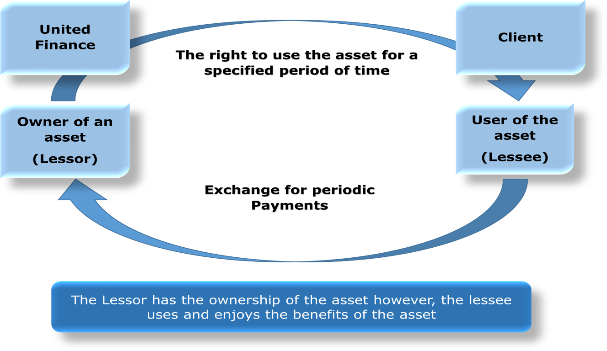
Figure 3.5 Procedure of Lease financing
Product Overview: Here the detailed information about this product is given. The types of lease, who is target customer, financial conditions, repayment system everything regarding these products are given below -
Types of Lease:
- Finance Lease: This lease is a contract that allows a lessor to the temporary use of an asset. The lessee enjoys benefits from the asset.
- Operating Lease: Operating lease an asset, but does not convey rights of ownership of the asset. It represents an off-balance sheet financing of assets, where a leased asset and associated liabilities of future rent payments are not included on the balance sheet of a company.

- Purpose: Increases revenue generating reduces the costs. Hence increases profit generation.
- Target Customers: Small/Medium/Large industries included in manufacturing/services/trade businesses.
- Finance Amount: The minimum amount of finance is 100,000 Tk. & maximum ups to the entire cost of the asset. A maximum of 80% of assets are financed for small businesses.
- Facility Tenure: Minimum 12months - Maximum 60months.
- Execution: The repayment against a leased facility must start within 12months of the first disbursement.
- Repayment: Equal monthly installment or structured payment based on the cash flow of the business.
- Prepayment: Full or partial payment may be accepted at any time before the maturity of the facility.
- Security: Ownership of the leased asset is primary security. A personal guarantor or cheque covering receivables can act as additional security.

Term Loan: United Finance Ltd Offer Term Finance which is a cash financing facility to meet the long-term investment needs of the large, medium & small enterprises of the country for expansion of their business operation. The descriptive part of Term Loan is given below -
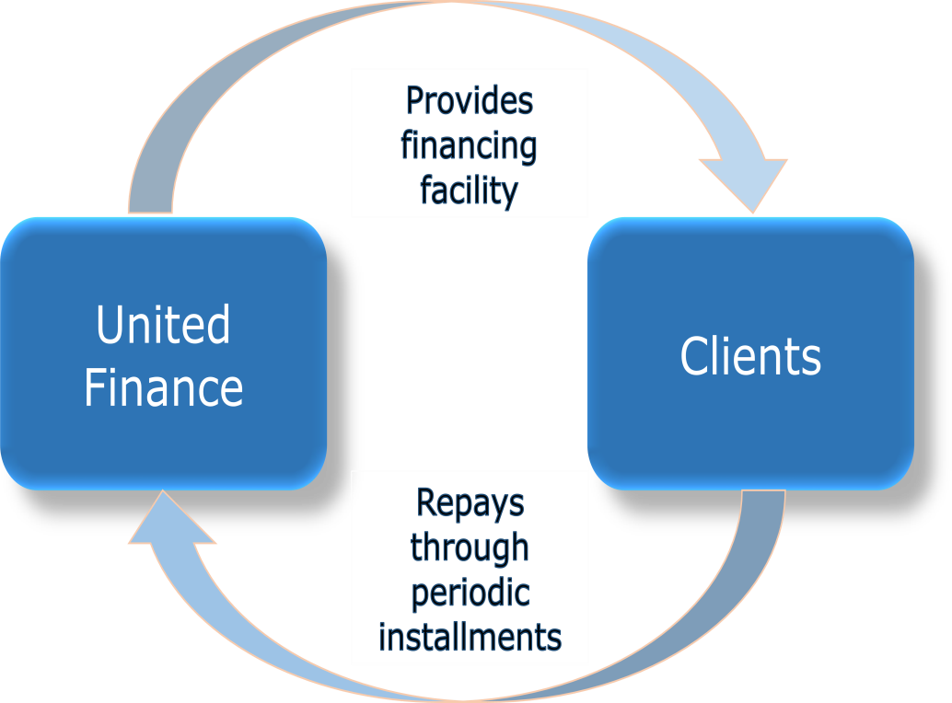
Figure 3.6 Procedure of Term Loan
Product Overview: Here the detailed information about this product is given. Who is target customer, financial conditions, repayment system everything regarding these products are given below -
- Purpose: Cash finance to fulfill business requirements.
- Target Customer: Medium/large industries involved in service/trade/manufacturing businesses.
- Finance Amount: Minimum Tk. 100,000 – maximum as per requirement & security coverage.
- Facility Tenure: Minimum 12months – maximum 60months.
- Execution: The repayment against a loan facility must start within 12months of the first disbursement.
- Prepayment: Full or partial payment may be accepted at any time before the maturity of the facility.
- Repayment: Equal monthly installment or structured payment based on the cash flow of the business.
- Security: Personal guarantee, one cheque bearing total receivable amount along with interest, land mortgage, etc. can be forms of security.

3.1.2 Liability Product

3.1.2.1 Affordable HOME LOAN:
United Finance Ltd.’s Affordable Home Loan is a housing finance solution that has been catered to suit your needs. With many attractive benefits, the home you always wanted is no longer a dream.
Product Overview: the detailed information about this product is given. Who is target customer, financial conditions, repayment system everything regarding these products is given below -
- Purpose: Construction/ expansion/ repair/ renovation/ purchase of home or apartment, development/purchase/renovation of offices for professionals & under special consideration development of commercial space.
- Target Customer: Salaried individuals, self-employed individuals or businessmen of middle and higher middle-income groups.
- Finance Amount: Minimum loan Tk. 1 Lac- Maximum loan amount will be Tk. 50 Lac (subject to a maximum loan to value ratio).
- Facility residency: The maximum tenure will be determined by the age of the applicant. However, the loan must expire on or before the 58th birthday of the applicant.
- Interest rate: Adjustable interest rate based on the prevailing Annual Profit Term Deposit rate of United Finance Ltd.
- Interest during Construction Period (IDCP): IDCP will be the same rate as the interest rate and will be calculated on the disbursed loan amount and is encouraged to be paid monthly.
- Disbursement: Funds are disbursed either in a single payment or in different trenches. Trenches will be decided by United Finance Ltd with reference to the need or progress of the work of the house.
- Repayment: Loan installment will be based on the income and expenditure of the client. The entire loan is to be repaid through EMI comprising of principal and interest calculate done the basis of the monthly rests at the prevailing interest rate and is rounded off to the next taka.
- Mode of installment: The facility can be repaid through cheques or BEFTN.
- Prepayment: Partial prepayments are allowed on the anniversary of loan and United Finance Ltd must be informed 45 days prior in writing. During any other time, charges will be applicable as per the prevailing Schedule of Fees and Charges. Full prepayment is not allowed before six loan installments. After that, full prepayment can be made with final adjustment fees as per the prevailing Schedule of Fees and Charges.
- Security: Registered mortgage of the property financed will be the primary security. Security also includes a personal guarantee.

3.1.2.2 Home Loan:
Product Overview: the detailed information about this product is given. Who is target customer, financial conditions, repayment system everything regarding these products are given below -
- Purpose: Construction/ expansion/ repair/ renovation/ purchase of home or apartment.
- Target Customer: Salaried individuals, self-employed individuals, or businessmen of middle and higher middle-income groups.
- Finance Amount: Minimum loan Tk. 5 Lac- Maximum loan amount will be Tk. 200 Lac (subject to a maximum loan to value ratio).
- Facility tenure: The maximum tenure will be determined by the age of the applicant. However, the loan must expire on or before the 65th birthday of the applicant.
- Interest rate: Adjustable interest rate based on the prevailing Annual Profit Term Deposit rate of United Finance Ltd.
- Interest during Construction Period (IDCP): IDCP will be the same rate as the interest rate and will be calculated on the disbursed loan amount and is encouraged to be paid monthly.
- Disbursement: Funds are disbursed either in a single payment or in different trenches. Trenches will be decided by United Finance Ltd with reference to the need or progress of the work of the house.
- Repayment: Loan installment will be based on the income and expenditure of the client. The entire loan is to be repaid through EMI comprising of principal and interest calculate done the basis of monthly rests at the prevailing interest rate and is rounded off to the next taka.
- Mode of payment: The facility can be repaid through cheques or BEFTN.
- Prepayment: Full or partial prepayment is allowed any time after payment of the first 6 installments. Prepayment premium and other charges will be applicable as per the prevailing Schedule of Fees and Charges. For full prepayment, a final adjustment fee as per the prevailing schedule of Fees and Charges, settlement charges of transferring the ownership and related costs at actual will be charged during the final termination
- Security: Registered mortgage of the property financed will be the primary security. Security also includes a personal guarantee of the successor and one relative.
3.1.2 Liabilities: The liabilities product of United Finance is different types of deposit. The deposits of United Finance are given below:

Deposit Products:

3.1.2.1 Insured Deposit Scheme (IDS)

It is a unique monthly savings scheme that gives the depositor an opportunity to save money for the future as well as provide peace of mind that the scheme benefit will be paid even in the case of the sudden demise of the first depositor. The monthly installments have built-in life insurance coverage.
Benefits of Insured Deposit Scheme (IDS):
- Safe investment with high returns.
- Insured Deposit Scheme is allowed only for individuals.
- Premature encashment allowed after completion of minimum duration (3 months).
- No incidental costs.
Eligibility Criteria:
- Any Bangladeshi citizen can apply.
- Age range between 18 to 56 years.
Features of Insured Deposit Scheme (IDS):
- A depositor can save Tk. 1,000 (minimum) to Tk. 25,000 (maximum) per month.
- Tenure is 3 to 5 years.
Insured Educational Support Scheme ( IESS)
It is a monthly savings scheme which gives the opportunity to depositors toward building deposit over time. The depositors will get the money back a period for future expenses like college or university education.
Benefits of Insured Education Support Scheme (IESS):
Safe investment with high returns.
- Premature encashment allowed after completion of minimum duration (3 months).
- Best consumer service.
- No incidental costs.
Eligible criteria
- The insured Education Support Scheme is allowed only for individuals.
- Any Bangladeshi citizen can apply.
- Age range between 18 to 56 years.

Features of Insured Education Support Scheme (IESS):
The scheme is designed with the tenure starting from 66 months to 108 months.
- A depositor can save from Tk. 2,000 (minimum) up to Tk. 25,000 (maximum) per month.
- Tenure is 3 years (36 months), 4 years (48 months), and 5 years (60 months).
- Built-in life insurance coverage assures the maturity value of the deposit in case of the first depositor’s demise due to any cause.
Shanchoy Scheme (SS)
Shanchoy Scheme is a deposit investment product where individuals can deposit monthly and at maturity, individuals will get the principal amount along with profit.
Benefits of Shanchoy Scheme:
- Safe investment with high returns.
- Premature encashment is allowed after the completion of the minimum duration (3 months).
- Shanchoy Scheme is allowed only for individual depositors (e.g. housewives, students, teachers, doctors, architects, lawyers, consultants, etc.).
- Quick Loan Facility is available as per the prevailing rules and regulations of United Finance Ltd.
Features of Shanchoy Scheme:
- Shanchoy Scheme does not require an initial deposit.
- Monthly deposit starting from Tk. 500 up to Tk. 10,000.
- Tenure is a minimum of 3 years up to a maximum of 7 years.
- The maturity benefit is Tk. 20,403 (minimum) up to Tk. 1,128,607 (maximum).
Easy Millionaire Scheme:
Easy Millionaire Scheme is a deposit investment product where any person can make fixed monthly deposits and at maturity, the person will get more than Tk. 1 million, depending on the monthly deposit amount.
Benefits of Easy Millionaire Scheme:
- Safe investment with high returns.
- A flexible and diversified product tailored for individual needs.
- Premature encashment is allowed after the completion of the minimum duration (3 months).
- Easy Millionaire Scheme is allowed for both individual and institutional depositors (e.g. housewives, students, businessmen, institutions, NGOs, Clubs, Provident Fund, Gratuity Fund, WPPF, etc.).
Features of Easy Millionaire Scheme:
- Easy Millionaire Scheme does not require an initial deposit.
- Monthly deposit starting from Tk. 5,000 up to Tk. 1,000,000.
- Tenure is a minimum of 3 years up to a maximum of 10 years and 10 months.
- The maturity benefit is Tk. 1,020,145 (minimum) up to Tk. 158,479,066 (maximum).
Millionaire plus Scheme
Millionaire Plus Scheme is a deposit investment product where any person can make an initial deposit at the beginning along with fixed monthly installment deposits and at maturity, the investor will get more than Tk. 1 million.
Benefits of Millionaire Plus Scheme:
  - Safe investment with high returns.
  - Premature encashment is allowed after the completion of the minimum duration (3 months).
  - Millionaire Plus Scheme is allowed for both individual and institutional depositors (e.g. housewives, students, businessmen, institutions, NGOs, Clubs, Provident Fund, Gratuity Fund, WPPF, etc.).
  - Quick Loan Facility is available as per the prevailing rules and regulations of United Finance Ltd.

Features of Millionaire Plus Scheme:
- Millionaire Plus Scheme requires an initial deposit starting from Tk. 50,000 up to Tk. 2,000,000.
- Monthly deposit starting from Tk. 5,000 up to Tk. 500,000.
- Tenure is a minimum of 3 years up to a maximum of 7 years.
- The maturity benefit is Tk. 1,004,072 (minimum) up to Tk. 59,948,508 (maximum).
Earner Schemes
Earner scheme is best for senior citizens who wish to preserve their retirement funds and at the same time want to earn interest to meet recurring expenses.
Benefits of Earner Schemes:
- Safe investment with fixed regular returns.

- No incidental costs.
- Any Individual or Firm or Corporate House is eligible to participate in the Deposit Scheme of United Finance Ltd.
- The maximum loan facility is 60% of the investment amount (conditions apply).
Features of Earner Schemes:
- The minimum deposit amount for quarterly and monthly earner deposit scheme is Tk 50,000/-.
- The term of the scheme ranges from 12 months to 60 months.
- Earner Scheme is available for both individual and institutional customers.
Term Deposit Schemes
Under this scheme, any person can deposit money for a fixed period, and interest is capitalized with the principal at each year.

Benefits of Term Deposit Schemes:
- Safe investment.
- High Return.
- No incidental costs.
- Premature encashment allowed after completion of minimum duration.
- Any Individual or Firm or Corporate House is eligible to participate in the Deposit Scheme of United Finance Ltd.
- Loan facility up to 80%-90% of the investment amount.
Features of Term Deposit Schemes:
- Senior citizens (individuals aged 57+) will get a 0.25% higher profit rate.

3.2 Cost Administration:

The sourcing and retention of deposits was a major challenge for all financial institutions in 2018. Through prudent liquidity management, your Company was able to sustain its deposit. However the cost of deposits increased for all banks and financial institutions. The interest expense of your Company increased by 32.20% against an increase in interest income of 29.14%.Salaries and allowances increased by 8.81% mainly due to the deployment of additional human resources to accommodate the expansion of your Company’s distribution network through the addition of 3 new branches. On the other hand, rental expenses decreased by 19.14% due to the relocation of support units from rented space to Company-owned premises in the fourth quarter of 2017. Other costs increased in tandem with growing business volumes and the impact of inflation. In all, total operating costs increased by 9.38%.

3.4 Risk Management:
Risk is an inherent part of your Company’s activities and is managed through a process of constant and ongoing identification, measurement, and monitoring. The Company addressed its three key risk management components during 2018 as follows:

3.4.1 Pre-emptive Risk management
Standard operating procedures (SOP) were in place to bring efficiency in day to day operational activities. Business and operational processes were further strengthened during the year. These activities are helping to create a solid operational foundation that will enable the Company to achieve robust growth in its chosen areas in the future. The Company continued to enhance the capacity of its human resources in 2018. During the year, the Company provided in-house, local and foreign training equivalent to 481 man-days, to 250 employees.

3.4.2 Contemporaneous Risk Management
The loan collection, follow up and recovery activities of the Company were further strengthened by the deployment of additional personnel at the branch level.
3.4.3 Post-facto Risk Management:
The Company’s Research and Advisory Services continued to enable the management to take informed and strategic business decisions. The initiatives taken by your Company to use data analytics in decision making and performance evaluation is expected to significantly improve its operational efficiency in the coming years.Both Compliance and Internal Audit activities were bolstered by the adoption of more rigorous audit standards thereby allowing the Board Audit Committee to exercise oversight over the activities of the Company.Your Company’s risk management policies have been established in accordance with Central Bank guidelines to identify and analyze risks and set appropriate benchmarks in order to monitor and control various levels of risk. Risk management policies and systems were reviewed during 2018 to reflect changes in market conditions and the consequential impacts on the activities of the Company. The Company aims to maintain an effective control environment at all times.

3.5 Sustainable Initiative:
The Company places great importance on the environment and is committed to advance sustainability by considering not only the environmental but also the social and governance aspects in our operations. In recognizing the risks posed to the community by unchecked climate change and environmental degradation, the Company supports sustainability ventures wherever possible, be it through financing and internal day-to-day activities, or through developing a strong company culture. To this end, the Company has prepared a sustainability report in line with global GRI standards which has been included in this Annual Report.

Chapter-4 Financial condition of UFL

4.1 Analysis of Debt to Equity of UFL
Debt to Equity Ratio
6.99
6.2
6.95.6
5.67
6.7
5.5
6.34.9
4.99
4.29
3.77
2014
2015
2016
2017
2018
Industry Average UFL

 | 2014 | 2015 | 2016 | 2017 | 2018
Industry Avg. | 3.77 | 4.29 | 4.99 | 5.67 | 6.99
United Finance | 5.5 | 6.2 | 6.3 | 6.9 | 6.7
Figure 4.1 Debt to Equity
Analysis:
From the diagram and determined information it is seen that
- In 2014, 2015, 2016, 2017and 2018 the average debt equity ratio of united finance Ltd. was more than industry average (except 2018) and the difference is bit high for majority studied years : 2014: 5.5>3.77 ; 2015: 6.2>4.29; 2016: 6.3>4.99; 2017: 6.9>5.67and the special case 2018: 6.7<6.9which is - 0.29.

- So it is seen form the five years data (2012-2016) that the Debt to Equity Ratio of UFL was almost always higher than the industry, but as it is a leverage ratio the higher value does not ensure that its performance is better than the other NBFI of this industry. As well as the higher leverage does not depicts that its performance is lower and it cannot be said that UFL is burdened by debt financing. Since, NBFIs are valued differently because they utilize debt as a sort of raw material rather than for reinvestment so higher value of

Debt to Equity of UFL does not depicts that its financial performance is poor. UFL’s debt to equity ratio is not very much different from the industry average in the recent years so it can be said the amount of debt financing to equity financing is acceptable. Side by side it is observed that overall Debt to Equity ratio of UFL is slightly higher than the industry and it incurs more risk than usual because of financial leverage and a bit vulnerable than the other players of the industry.

4.2 Analysis of Debt to Asset of UFL
Debt to Asset Ratio
86.81%
84.45%
84.69%
85.8419%
83.46%
82.87%
80.57%
77.73%
75.41%
2014
2015
2016
2017
2018
Industry Average UFL

 | 2014 | 2015 | 2016 | 2017 | 2018
Industry Avg. | 75.4% | 77.7% | 80.5% | 82.8% | 85.4%
United Finance | 83.4% | 84.4% | 84.6% | 86.8% | 85.8%
Figure 4.2Analysis of Debt to Asset of UFL
Analysis:
However, in this circumstance it can conclude that:
- In 2014, 2015, 2016, 2017and 2018the average Debt Assets ratio of United Finance was more than industry average and the difference is high: 2014: 83.4%> 75.4% which is 8.%; 2015: 84.4% > 77.7% which is 6.7%; 2016: 84.6%>80.5% which is 4.1%; 2017: 86.8%>82.8% which is 3.9% and 2018: 85.8%>85.4% which is 0.4%.

- So it is seen form the five years data (2012-2016) that the Debt to Asset Ratio of UFL was always higher than the industry, but as it is a leverage ratio the higher value does not ensure that it’s good or bad performance. Average of debt to asset ratio of UFL over five year is 85.04%, that is major portion of its asset is funded by debt financing but it is not peculiar since the NBFIs are mostly run by the borrowed funds of customers, and UFL’s debt to asset ratio is not very much different from the industry average so it can be said the amount of debt financing for procuring asset is acceptable. Side by side it is observed that overall Debt to Asset ratio of UFL is slightly higher than the industry and it incurs more risk than usual because of financial leverage and a bit vulnerable than the other players of the industry.

4.3 Analysis of Equity Multiplier Of UFL
Equity Multiplier
7.99
7.18
6.67
7.05
6.05
6.43
6.53
5.99
5.29
4.77
2014
20154
2016
2017
2018
Industry Average UFL

 | 2014 | 2015 | 2016 | 2017 | 2018
Industry Avg. | 4.7 | 5.2 | 5.9 | 6.6 | 7.9
United Finance | 6.0 | 6.4 | 6.5 | 7.1 | 7.0
Figure 4.3 Equity Multiplier Of UFL
Analysis:
However, In this circumstance it can conclude that:
a) In 2014, 2015, 2016, 2017and 2018the average Equity of United Finance Ltd. was higher than the industry average but the difference is slightly higher than industry average: 2014: 6.0>4.7; 2015: 6.4>5.2; 2016: 6.5>5.9; 2017: 7.1>6.6 and the exception 2018: 7.0<7.9.
b) Average of debt to equity multiplier of UFL over five year is 6.648, that is major portion of its asset is funded by debt financing but it is not peculiar since the NBFI’s are mostly run by the borrowed funds of customers, and UFL’s equity multiplier is slightly higher than industry average so it can be said the amount of debt financing for procuring asset is acceptable. Side by side it is observed that equity multiplier of UFL is slightly higher than the industry and it incurs a bit more risk than usual because of financial leverage and a bit vulnerable than the other players of the industry.

4.4 Analysis of net profit
Net Profit Margin
41.87%

35.43%
34.30%
31.86%
30.02%
33.43%
36.03%
31.95%
321.1315%
2014
2015
2016
2017
2018
Industry Average UFL

 | 2014 | 2015 | 2016 | 2017 | 2018
Industry Avg. | 41.8% | 30.0% | 33.4% | 31.9% | 31.3%
United Finance | 35.4% | 31.8% | 34.3% | 36.0% | 32.1%
Figure 4.4 Analysis of Net Profit
Analysis:
- In the year 2014-2018 net profit margin of United Finance Ltd. is higher than the average other Non Bank industry (31.8%>30.0%, 34.3%>33.4%, 36.0%>31.9%, 32.1%> 31.3%)
- The average net profit margin of UFL is 33.95% which means that 33.95 paisa of net income comes from every taka of sales of UFL.
- Average of five year’s net profit of private commercial NBFI of Bangladesh is 33.72% where else UFL’s average net profit margin is 33.95%, so the performance is a bit better than the performance of other NBFIs of Bangladesh.

4.5 Analysis of ROA of UFL
ROA
2.47%
1.94%
2.04%
1.91%
1.71%
1.77%
1.68%
1.46%
1.510%
2014
20158
2016
2017
2018
Industry Average UFL

 | 2014 | 2015 | 2016 | 2017 | 2018
Industry Avg. | 2.4% | 1.4% | 1.7% | 1.6% | 1.5%
United Finance | 1.9% | 1.9% | 2.0% | 1.7% | 1.5%
Figure 4.5 Analysis of ROA
Analysis:
- Year 2014-2018 Return on assets of United Finance Ltd. was more than the average (except of 2014) of the different Non Bank (1.9% <1.9%, 1.9% >1.4%, 2.0%> 1.7%, 1.7%> 1.6%, 1.5%> 1.5%)
- The average of five year’s ROA of other NBFI is 1.76% where else UFL’s average ROA is 1.83% which is relatively higher than the performance of the average NBFI. So the UFL total asset is generating higher returns than other private commercials NBFI.

4.6 Analysis of ROE of UFL
ROE
13.35%
11.72%
12.30%
12.72%
11.26%
10.52%
9.62%
7.59%
1.510%
2014
2015
2016
2017
2018
Industry Average UFL
 | 2014 | 2015 | 2016 | 2017 | 2018
Industry Avg. | 11.2% | 7.5% | 9.6% | 10.5% | 1.5%
United Finance | 11.7% | 12.3% | 13.3% | 12.7% | 1.5%
Figure 4.6 Analysis of ROE
Investigation:
- Year 2014-2018 Return on equity of United Finance Ltd. was more than average of the Non bank of BD (11.7%>11.2%, 12.3%>7.5%, 13.3%>9.6%, 1.5%>1.5%)
- Average of five year’s ROE of NBFI of Bangladesh is 8.10% where else UFL’s average ROE is 10.32% that is the performance is relatively higher than the performance of the other private NBFI. So the equity or shareholders of UFL are earning relatively more than the other private NBFI of Bangladesh.

4.7 Loan Facilities

Figure 4.7 Loan Facilities of united finance
Source: United Finance Financial statement
In this graph, there are three types of loans that are provided by United Finance Ltd Limited. Those are Term loan, Home loan, Short term loan, and CSF advances. As the graph shows most sources of funds of United Finance Ltd are invested in a Term loan. In terms of loans, they invest 49% of funds. After term loan, they give loans in Short term loan and CSF advances which is 45%. These two loans take a huge amount of their total loanable fund. Another sector of loan is a Home loan which is 6%. Only a small amount of money is used to give loans in this sector

4.8 Geographical location wise lease, loan and advance
Figure 4.8 Geographical location wise rent
Source: United Finance Financial statement
Geographical area shrewd rent, advances and advances (Inside Bangladesh Urban )
Most of the lease, loans, and advances based on Geographical basis are given in Dhaka Division. More than half the amount of lease, loans, and advances are given in Dhaka Division which is 66%. After Dhaka Division, United Finance Ltd gives loans in Chittagong Division which is 19%. But this is very low compare to the Dhaka Division. They also give loans to other divisions. But that is not a huge amount. They give loan in Khulna Division, Rajshahi Division, Rangpur Division, Barisal Division, Sylhet Division but the average percentage of giving loan are below than 7%. Especially the Sylhet Division and Barisal Division are nearly 1% of the total loan amount.

4.9 Geographical area wise lease, loan and advances (Inside Bangladesh Rural):
Figure 4.9 Geographical area wise lease, loan and advances (Inside Bangladesh Rural)
Source: United Finance Financial statement
In rural areas, they give more loans and advances in the Chittagong Division. A huge amount of money is given in the Chittagong Division. The Average percentage of loans in the Chittagong Division that United Finance Ltd Gave is 26.18%. In Rangpur, they gave 3.92% of the loan. In Rajshahi Division, they give 1.26% of loans and in Barisal Division they give 1.96% of loans.

4.10 Analysis by security from borrowing from banks, other financial institution and agents:

Figure: 4.10 Analysis from borrowing from banks, other financial institution and agents

Source: United Finance Financial statement
The security against the borrowing of the fund in United Finance Ltd are Secured (FDR pledged as security), Secured (Corporate guarantee) and Unsecured. The security which is used more is Secured (FDR pledged as security). The percentage is 56%. And the security which is least is Secured (Corporate guarantee) which is near to 3%. Unsecured securities are used more compare to the Secured (Corporate guarantee). And the percentage is 41%.
Earnings per Share:
The Earning per Share of a company fluctuate every year than this become risky for the investor to invest that company. If the Earning per Share of a company is 20tk but the next year it becomes 6tk than investors are not interested to purchase the share of that company. Because, the share become riskier for the investors.

Chapter 5 Employee benefits

5.1 Short term benefits
The company provides every month salaries, two festival bonuses, and allowances in the every financial year. Which associated service are rendered by the employee of the company.

5.2 Post emplacement benefit

5.2.1 Provident fund
A helping provident fund operated by the company on equal participation of the company and employee. The fund is recognized by the National board of revenue and is administered by a board of trustees.

5.2.2 Gratuity fund
Gratuity fund maintain by the company to motive employee for long term relationship. This scheme is applicable for all permanent employees who have completed their services for five years without any break. Provision for gratuity is made annually considering its eligible employee available at the end of the year.

5.2.3 Other long Term benefits
The Company operates a life insurance scheme for all permanent employees. It maintains a health insurance scheme for all of its permanent employees, their spouse and children.

Chapter 6 Revenue recognition

6.1 Interest Income
Interest income comprises of interest income from lease, loans and advances and interest on placement of fund with banks and other financial institutions. Interest due is recognized on accrual basis using the effective interest method. Interest due over ninety days is not recognized as revenue rather it is recognized as interest suspense. Suspended interest is recognized as income on cash basis when it is received.

6.2 Lease Income
The excess of gross lease rentals receivable over the cost of the leased asset represents the total unearned income at the time of execution of lease. The unearned income is allocated over the period of lease in a pattern reflecting a constant return on the net investment.

6.3 Income from long and short term finance:
Income from long and short term finance is recognized as revenue when the interest is due. Interest due over ninety days is not recognized as revenue rather it is recognized as interest suspense. Suspended interest is recognized as income on cash basis when it is received.

6.4 Income from dividend:
Dividend income from investment in equity shares is recognized when the right to receive the payment is established. Dividend income from preference shares is recognized on accrual basis considering the establishment of right to receive the same.

6.5 Income from deposit
Interests from short term deposits and fixed deposits are recognized on accrual basis taking into account the principal outstanding and the effective interest rate.

6.6 Fee based salary

Fee based income is recognized as revenue when it is received.

6.7 Interest paid on Deposit, borrowing, and so forth.
Interest paid comprises of the interest payable on external borrowing, individual and institutional deposits and direct deposit expenses and are recognized as they accrue.

6.8 Impairment of Assets:
The carrying amount of the property, plant and equipment and intangible assets are reviewed at each balance sheet date or whenever there is any indication of impairment. If any such indication exists, the assets recoverable amount is estimated. An impairment loss is recognized whenever the carrying amount of the asset exceeds its recoverable amount. Impairment losses, if any, are recognized in the profit and loss account.

Chapter 7 NBFIs in Bangladesh

7.1 Overview of Bangladeshi NBFIs
Non Bank financial companies, NBFI are financial institution that provide banking service but do not hold a banking license. All operational activities of this institution follow by the Bangladesh Bank rules and regulations. Non Bank financial institution plays an important role for various sectors to meet their financial needs and also helps economic development of a country. Banking sector and NBFIS both play an important role for influencing people to deposit money. Their involvement in the process generally makes each other competitors and tries to achieve the same goals. They are also tried to develop their own business and venture into an area where others are not operate their business. There are different types of non bank financial institution such as insurance company, finance company those dealing with mutual funds. NBFIS controlled by the financial act of 1993 FIA’93. They provide loan for industry, agriculture, housing, and real estate business. Non-bank institution offers high rates to attract the client for increasing deposit while banks are struggling to offer high return on deposit.

7.2 Leasing industry in Bangladesh:

As Bangladesh is an emerging developing country, many foreign Leasing company are coming in Bangladesh. This is good news that foreign investment will increase but also alarming for local company as competition will increase too. That’s why local company need to careful about this matter and should take necessary steps so that they can compete with foreign companies. As steps they should consider their service of quality, acquiring faith of people etc.
Sri Lanka's People's Leasing to enter Bangladesh: People's Leasing and Finance Plc, Sri Lanka's largest non-bank lender, is entering Bangladesh, with domestic credit volumes also expected to grow to 15 percent in 2016. People's Leasing has entered into a deal with Alliance Leasing and Finance Company to buy a 51 percent stake, the firm said in a stock exchange according to Chief Executive D P Kumarage, in 2016, the firm was expecting 10 to 15 percent growth in its leasing business, despite an increase in the loan-to-value ratio for leases. According to Bangladesh Bank rules, directors of banks and financial institutions or their family members cannot take loans from their own companies. People's leasing and Finance Services face loan-loss problem for breaking the rules of Central Bank and suffers for inadequate deposit although they offer higher returns. Bangladesh Bank provisions for the directors of banks and financial institutions or their family members cannot take loans from their own companies. But in People’s leasing and Finance Services five directors took loan almost 400 cores and didn’t pay back. That’s why they were removed from the institution. To avoid arrests, warrant one of the directors offers to pay 100 cores and the Anti-Corruption Commission inform this to Bangladesh Bank. Bangladesh Bank suggests the organization to make new directors board by removing those directors. This kind of event will decrease the faith of people from leasing company. Other directors of other company will get the courage to break the rules of Bangladesh Bank But one positive side is that Bangladesh Bank has taken right step to tackle this kind of situation.
Three non-bank financial institutions' reckless lending has pushed up the overall industry's nonperforming loans. The NBFIs are: First Finance, BIFC and People's Leasing and Financial Services. Reliance finance is another one company their situation was very bad according to the industry insiders.

Findings:
In the analysis of financial statement of United Finance Ltd. some findings have found which are given below-
- From the comparison between the industry average and UFL; it is found that the though debt to equity ratio is slightly higher than the industry average, however it is going on same way we say that NBFIS are right track to carry their business.
- From the comparison between the industry average and UFL; it is found that the debt to total asset ratio of UFL is higher than industry average and UFL is taking the higher risk. However, it is found that, the current trend is that the industry average is going higher or taking higher risk but UFL hold their risk level in almost same position.
- From the comparison between the industry average and UFL; it is found that the equity multiplier of UFL is more or less similar to the industry average. The risk of UFL is not so much for this similarity.
- From the comparison between the industry average and UFL; it is found that UFL’s net profit margin is slightly higher than the industry average of net profit margin. So UFL is doing slightly better than the overall industry.
- From the comparison between the industry average and UFL; it is found that the return on asset of UFL is slightly higher than the industry average. In this UFL have also doing slightly better than the overall industry
- From the comparison between the industry average and UFL; it is found that the return on equity of UFL is higher than the industry. So it should maintain the position and try to improve it to further extent.
Recommendation:
It is a very common issue in any company to operate its business. There must be problems to operate an organization. The following step can be solve this kind of problem.
- Bangladesh Bank need to strict particularly to the directors of non-bank institution so that every non-bank financial institution follows the rules of central bank accordingly and loan default occurrence can be reduced.
- Government-owned companies have many unused lands and every year they are facing loss. Either Govt. do something to make profitable of those companies or sell the companies to private organization as many private organization show their eagerness to buy Govt. owned company.
- For collecting more deposit only increasing the return rate will not always be fruitful if people don’t have enough knowledge about the organization. So, it is necessary to increase publicity as people can easily identify the organization.
- The profitability (Net profit, ROA, ROE) of UFL is moderately higher than industry average in previous years; however there is a scope for improvement because the profitability is not that higher than the industry. So it can be say that they are going good and UFL should make sure that the existing growth rate is increased gradually in a steady pace. UFL have to take some initiatives to improve profitability and for this they should follow the base line of cost minimization and increase of profit.
- It should be more concern in their management quality to improve its satisfactory position. The total success depends on the direction of the management so they have to expert and highly experienced in this sector.

Conclusion:
Finance company plays an important role in development of our economy. Bangladesh Bank and government play a vital role for this sector by regulating the overall monetary system. Bangladesh Bank setting rules and regulations in the activity for this sector. In recent years of this sector, UFL has shown better performance comparing with other first generation NBFIs. It was great pleaser for to do internship program in reputed organization like UFL.
Overall, the new most made oppressive attempt is that my outward-looking in place goals and abbreviations of what is happening.
The solvency of UFL is higher than the industry so it is better for UFL to decrease the debt financing and minimize the risk they are taking on the other hand the profitability of UFL is slightly higher than industry average so UFL have to maintain the existing position and side-by-side they have to take the initiatives to improve this so that they can perform better than the present situation. Finally, this report will help the UFL to get the overall performance in this sector.

References

United Finance Limited. (2015). CHAIRMAN STATEMENT. Retrieved from United Finance. https://www.unitedfinance.com.bd/financial/ar2018.pdf
United Finance Limited. DISTRIBUTOR FINANCE. from : https://www.unitedfinance.com.bd/distributorfinance.html
United Finance Limited CAREER. Retrieved from United Finance Limited: https://www.unitedfinance.com.bd/career.html
United Finance Limited CREDIT-SALE FINANCING. from: https://www.unitedfinance.com.bd/creditsalefinancing.html
United Finance Limited Annual Report [online], Available from: https://www.unitedfinance.com.bd/irfrpt.html
https://economynext.com/sri-lankas-peoples-leasing-to-enter-bangladesh-4770/
https://www.thedailystar.net/frontpage/single-digit-loan-and-bank-deposits-will-effective-soon-bangladesh-1860631

