Customer Relationship Management (CRM) software used by “Mutual Trust Bank” (MTB)

Mashfik Uddin Khan

This report is submitted to the school of Business and Economics, United International University as a partial requirement for the degree fulfillment of Bachelor of Business Administration
Submission Date: 18th September, 2022
Customer Relationship Management (CRM) software used by “Mutual Trust Bank” (MTB)

Submitted to:
Name: Ahmed Imran Kabir
Lecturer
School of Business & Economics,
United International University School

Submitted by:
Name: Mashfik Uddin Khan
Id: 111 171 164
Major: Management Information System (MIS)
Trimester: Summer 2022

School of Business and Economics



United international university

Letter of transmittal
Date: 18th September, 2022
Ahmed Imran Kabir
Lecturer
School Of Business & Economics
United International University

Subject: Letter of Transmittal
Dear sir,
With due respect, I beg to state that I, Mashfik Uddin Khan ID: 111 171 164 a United International University student, submit my report entitled “CRM software used in Mutual Trust Bank” as a requirement for the internship report.
The motive of this report is to understand the software system used by MTB to organize their customer relationship. The report shows how they are different from other organizations’ CRM software and what is the scope of improvements when compared.
I hope that the report will reflect my internship experience thoroughly in a satisfactory manner.
Sincerely
Mashfik Uddin Khan
ID: 111 171 164

Declaration Of Student

I hereby declare that the project entitled “Customer Relationship Management (CRM) Software used by Mutual Trust Bank (MTB)” submitted to United International University under the guidance of Ahmed Imran Kabir Lecturer of United International University is an original document done by me, and this report is submitted in the partial fulfillment of the requirements for the award of the degree of Bachelor of Business Administration (BBA). The information, strategies, and methodology used in this report are completely done by me and were not submitted to any other educational institute.
Mashfik Uddin Khan
ID: 111171164
Major: Management Information System (MIS)
United international university

Acknowledgment

I would like to express my utmost gratitude towards my supervisor Ahmed Imran Kabir sir for dispensing his invaluable guidance, instructions, and suggestions throughout this report.
I would also like to express my gratitude towards Almighty Allah, my family, my supervisor at MTB also other fellow interns mineworking on this report have enlightened me in many ways as I moved forward and gave me rich knowledge on the vast learning of the banking sector.

Executive Summary

This internship report sums up the tasks done by CRM software in the organization I am currently doing my internship in. The report highlights the major tasks like storing customer records, including transaction details, customer profile information, and basic documents that the bank needs for opening an account. MTB doesn’t have individual software for CRM they use software developed by Tata Consultancy Services (TCS) which is a renowned IT service provider for the business organization. They are a leading software development organization that develops software based on client preference. The software is multifunctional but isn’t multi-tasking enabled and requires much expertise to operate. Without technical knowledge about the software, it is not possible to operate. CRM software is integrated into TCS rather than independent software, which is sometimes a bit more of a hassle.

Table of Contents
Letter of transmittal 3
Declaration Of Student 4
Acknowledgment 5
Executive Summary 6
Chapter I: Introduction 9
I.1 Background of the report 9
I.2 Objective of the report 9
I.3 Motivation of the report 9
I.4 Scopes and limitations of the report 9
Chapter II: Company and industry preview 10
II.1 Company analysis 10
II.2 History of MTB 10
II.3 Vision of MTB 12
II.4 Mission of MTB 13
II.5 MTB slogan 13
II.6 Departments of MTB 13
II.7 Individuals of MTB 13
II.8 Products and services 15
Chapter III: CRM software used in MTB 18
III.1 History of TCS 18
III.2 Products, platforms, and services offered by TCS 19
III.3 TCS BaNCS 20
III.4 Offered services by TCS BaNCS to MTB 20
Chapter IV: Internship experience 22
IV.1 My Job in MTB 22
IV.2 My Assignment & Contribution 22
IV.3 Lessons from Internship Experience 23
IV.4 Skills gained from Internship Experience 23
IV.5 Academic learning & Experiential learning 25
Chapter V: Conclusion and key facts 26
V.1 Recommendation 26
V.2 Key understanding 26
V.3 Conclusion 26
References 27
Appendix 29
Progress report 38

Chapter I: Introduction

I.1 Background of the report
This report is a brief explanation of what sort of software is being used by a particular segment of organizations to understand how they are digitally storing records of their clients and using that information to reach out to resolve any particular issue they are facing. For instance, the organization I am interning in is a bank, and it is renowned in the banking sector. The bank is a Mutual trust bank (MTB) formed by a group of individuals. MTB uses Tata Consultancy Services to develop a software named TCS named after the company. The software has its database where it stores every information, for example, customer information, transaction information, and every information related to the account from the day it was opened. But the software is not only used for customer relationship purposes it is also used for document passing authorization to send the documents that fulfill the requirement for opening an account. This report elaborates on how the software works and the improvements needed to make it more refined and reliable so that it can have an upper hand over its rivals.

I.2 Objective of the report
The objective of this report is to know about the CRM software used by MTB and how it works to understand its functions as well as its weaknesses so that they can be refined for better usability and reliability for avoiding future problems that might occur due the lacking of improvements that should be done for stability.

I.3 Motivation of the report
The motive of this report is to have a wide knowledge of CRM software and how they work to use that knowledge to implement it in any CRM software of any organization to understand the basic concept and useability of CRM software. Because the world is advancing and almost every organization is digital nowadays and for that, they need different software that will keep track of the different sectors. CRM is one of the core software as it stores information of the clients of that organization.

I.4 Scopes and limitations of the report
The report is based on the knowledge of the user of the CRM software used in MTB. As the software is used for storing the information of their clients and those pieces of information are confidential and cannot be disclosed to any individual outside the organization. So, most of the information is vague as they are based on the information collected from the employees who use that software daily to update, delete and store information of existing as well as new clients. This limits the outcome of the report as the report lacks authentic information for confidentiality purposes.

Chapter II: Company and industry preview

II.1 Company analysis
A company's financial system would be severely hampered without the services of a bank. Financial institutions are often compared to the lifeblood of economies. A bank does not produce new currency, but it does help get existing currency moving around within a country. These days, a bank is a necessary part of any financial transaction, whether it's a business deal, an individual exchange, or a monetary exchange between countries. "A bank is a financial intermediary - a dealer in loans and debts," as defined by Cairncross. Everyone knows that the lifeblood of any nation's commercial and industrial activities is its banking system. They also guarantee financial resources and ease the movement of money. However, banks offer a wide range of services that are invaluable to the smooth operation of any business. Locker rental, deposit services, letters of credit, electronic funds transfers, and performance guarantees are just some of the additional services a bank provides to its clientele. Each day, the convenience of today's banking services raises the bar higher for human living standards. Financial institutions like banks make it easier to borrow money for various purposes, such as buying a house or car, farming, or starting a business. It's one way the bank helps raise our living standards.

II.2 History of MTB
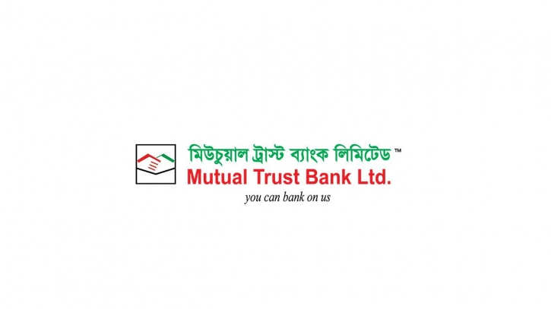
The firm received a license under the Banking Companies Act of 1991 from Bangladesh Bank on October 5, 1999. In 1999, MTB started banking. The company began its banking operations to gradually carry out its banking businesses, such as wholesale, retail, international trade financing, SME banking, NRB banking, off-shore banking, privilege banking, agent banking, etc., and recently launched its Islamic Banking wing, as envisioned in the memorandum of association and licensed by Bangladesh Bank under the Banking Companies Act, 1991. The bank's main office is located at MTB Centre, Gulshan 1, Dhaka-1212. For international commerce, the bank has nearly 400 overseas correspondent banks. MTB was established in 1999 by the Companies Act of 1994, with a BDT 1 billion authorized share capital divided into 10 million BDT 100 ordinary shares.
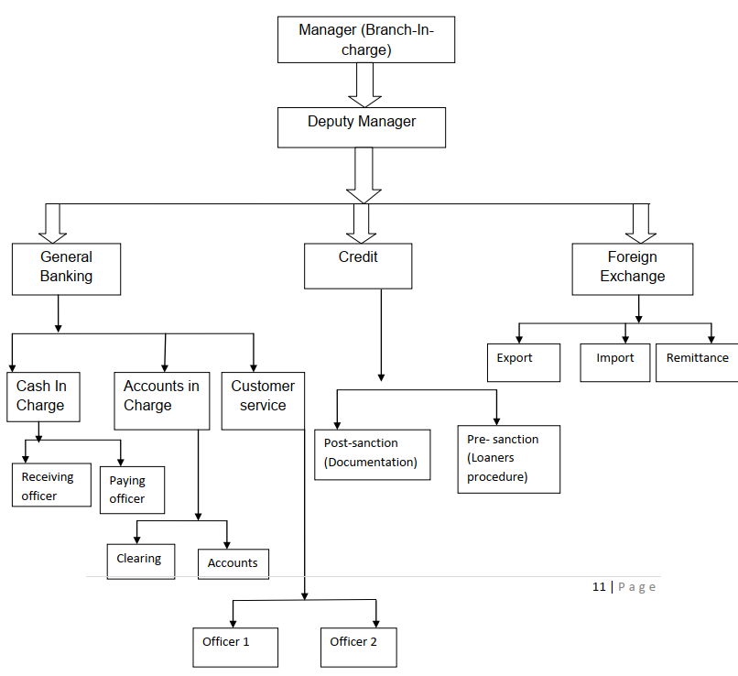
Hierarchy of Mutual Trust Bank (Panthapath Branch)
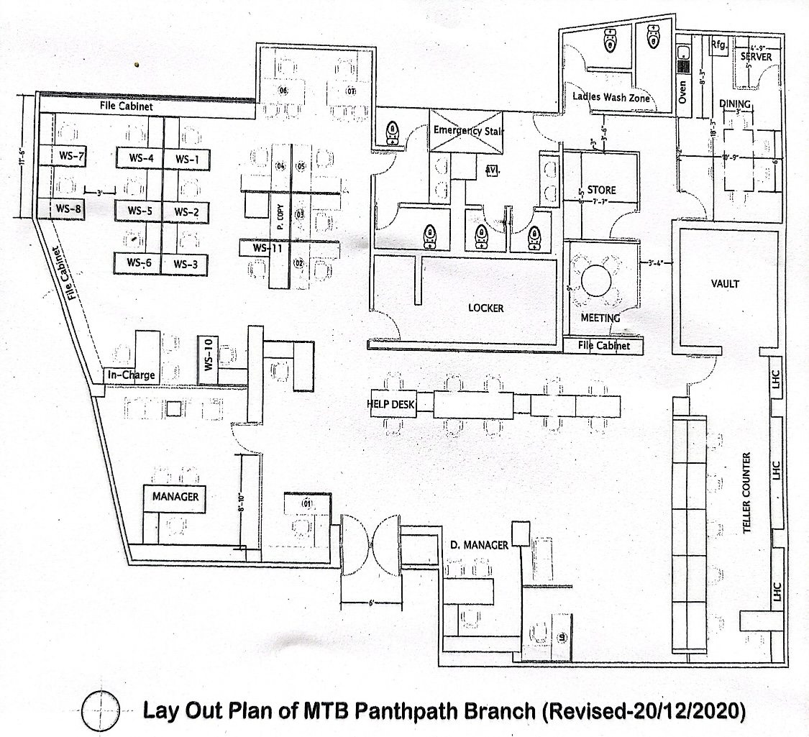
Lay Out of MTB

II.3 Vision of MTB
MTB3V, a well-known philosophy, serves as the foundation for Mutual Trust Bank's vision.
We Imagine that MTB is:
- The Bank of Choice
- A Bank of True World-Class
- One of Bangladesh's top-performing banks

II.4 Mission of MTB
"We strive to be the most acclaimed financial institution in the nation, regarded as a dynamic, creative, and customer-focused business that offers a variety of goods and services in the pursuit of excellence and to generate an exceptional economic value," the company's mission statement reads.

II.5 MTB slogan
“You Can Bank on Us”

II.6 Departments of MTB
The bank is divided into three departments.
- General Banking (GB)
- Forex Exchange
- Credit

II.7 Individuals of MTB
MD. Khairul Islam - Branch Manager (BM)
MD. Shakhawat Hossain - Deputy Manager (DM) – He required me to write the check and credit card slips.
Mohammad Shibbirul Islam Bhuiyan - Assistant Vice President – He required me to make an Inward Remittance Performance Register.
Serial No | Document Sending Date | Category | Beneficiary Name | Beneficiary Account | Remittance Currency | Remittance Amount (USD) | Rate | Realized Amount | Sender Name | Purpose | Memo | Value Date
1/N FOB/PRB/AUG/2022 | 01.08.2022 | IT | XYZ | 1234567890 | USD | 1101.61 | 93.75 | 103275.94 | ABC | Sea Freight | 312456 | 01.08.2022

Masud Kaiser – Junior Assistant Vice President
Nasreen Akhter – First Assistant Vice President
MD. Sariful Islam – Relationship Officer – He taught me how to open individual and non-individual accounts.
Nazmun Naher Lima – Customer Service Officer - She told me to fill all incomplete documents and record all the debit card data in both excel and word files.
SL NO | Date | Customer’s Name | A/C NO | Register’s Position | Remarks/Receive Date | Mobile
1 | 26/07/2022 | XYZ | 1311****30214 | Received | 26/08/2022 | 01*******54

MD. Golam Rabby – Associate
Mohammad Jahirul Alam – Assistant Relationship Manager – I learned how to give customer service and how to destroy debit cards under him. I called all the customers who haven’t received their debit cards yet.
Serial | Client | Account Number | Card Number | Card Holder Name | Branch Name | Mobile Number
1 | 123456 | 000325647810 | 456123******2634 | XYZ | Panthapath Branch | 880(17111)00000

Rockibuzaman – Designation Officer
Rupa Roy – Accounts Officer
MD. Rayhan Siddique – Associate RM
MD. Zahid Mahmud Khan – Associate RM
Sabina Yeasmin – Senior Business Development Officer - She taught me how to fill student bank account.
Sabina Sharmin – AVP & Senior Relationship Manager
Saidur Rahman Razib – Junior Officer
At MTB, I had the honor of working with so many wonderful people. I received support and encouragement from everyone at the branch while I finished my internship. MD. Sariful Islam, who oversaw the general banking section, was my immediate boss. He always provided me with sufficient office guidance and directions on how to act in this division. He persevered in encouraging me and gave me lessons that affected the way I see the world. When I erred or didn't understand, he used to gently reprimand me, which helped me grow. Overall, I couldn't have successfully finished my internship without the help of my peers.

II.8 Products and services
The following services and financial products are offered by Mutual Trust Bank:
Retail Banking
- Deposit Product
- Loan Product
- MTB Card.

- Deposit Product
- Savings Account
- Individual Account
- Brick by Brick
- Fixed Deposit
- Monthly Benefit Plan
- MTB Senior
- MTB Inspire
- FDR
- MTB Ruby
- MTB Double Saver Plan
- MTB Millionaire Plan

- Loan Product
- MTB Personal Loan
- MTB Auto Loan
- MTB Home Loan
- MTB Card
- Debit Card
- Credit Card
Corporate Banking
- Team Finance
- Trade Finance
- Working Capital Finance

SME Banking
- MTB Bhagyoboti
- MTB Krishi
- MTB Mousumi
- MTB Revolving Loan
- MTB Small Business Loan
- Micro Digoon
Treasury Service
- Money Market
- DIBOR
- Foreign Exchange
- Primary Dealers
MTB Services
- Corporate Banking
- Institutional Banking
- Off-Shore Banking
- Investment Banking
- Merchant Banking. 6
- Securities Trading and Brokerage Service
- SME Banking
- Comer Banking
- Card Services
- Leasing
- Services Non-Resident Bangladesh (NRBs)

Chapter III: CRM software used in MTB

III.1 History of TCS
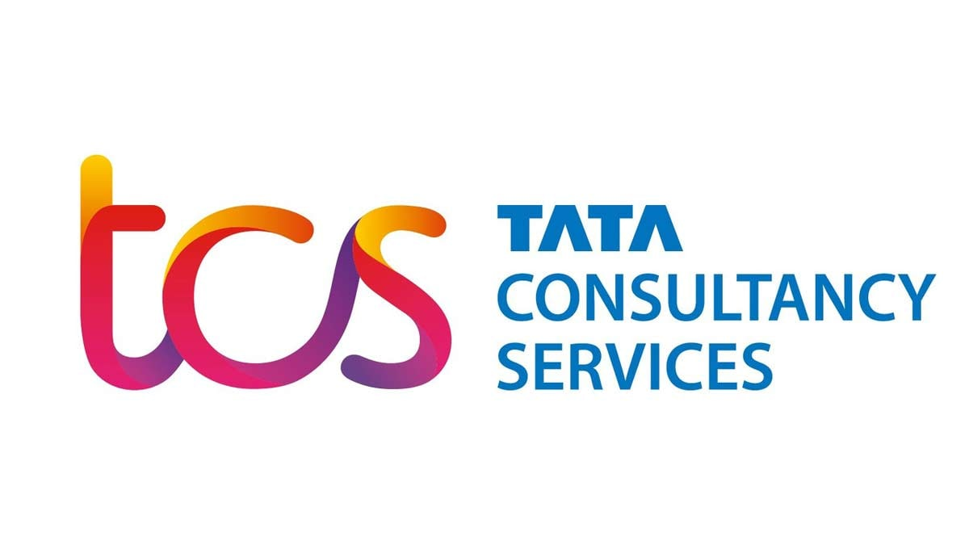
Tata Consultancy Services, a member of the Tata Group, was founded in 1968 and has developed to become the biggest IT services company in Asia as a result of its track record of exceptional service, cooperative relationships, innovation, and corporate responsibility. Jamsetji Tata founded it in 1848, and it is currently regarded as one of India's most prestigious institutions. Their goals are in line with the Tata Group's long-standing dedication to excellence. By offering cutting-edge, best-in-class colting, IT solutions, and services, we aim to assist clients in achieving their business goals while also actively involving all stakeholders in a beneficial partnership. TCS is unrivaled in its capacity to provide top-notch services and solutions. They are the first organization in the world to use the most exacting assessment technique, SCAMPISM, to achieve an enterprise-wide Maturity Level 5 on both CMMI and P-CMM. Additionally, TCS' Integrated Quality Management System (iQMS) blends process, people, and technology maturity using a variety of recognized frameworks and procedures, such as IEEE, ISO 9001:2000, CMMI, SW-CMM, P-CMM, and 6-Sigma. According to market capitalization, TCS is one of the biggest Indian corporations. Currently, TCS is among the most valuable IT services brands globally. 70% of Tata Son's dividends are produced by TCS alone. The parent company recently decided to sell TCS shares in a bulk transaction valued at $1.25 billion. TCS is the highest-ranked IT services provider and the top Indian firm in 2015, according to Forbes' list of the world's most innovative companies. TCS is placed 64th overall. By revenue, it ranks as the ninth-largest provider of IT services worldwide. It is listed as number 10 on the Fortune India 500 list as of 2017. TCS became the first Indian IT business to surpass a $100 billion market capitalization in April 2018.

III.2 Products, platforms, and services offered by TCS
TCS develops a wide range of goods, including software, mobile apps, and websites. Businesses all across the world utilize their products to increase efficiency and production. TCS is well-known for its high-quality workmanship and excellent customer service.
Products:
- TCS BaNCS™
- CHROMA™
- TCS Connected Intelligence Platform™
- TCS Customer Intelligence & Insights™
- ignio™
- TCS Intelligent Urban Exchange™
- TCS iON™
- Jile™
- TCS MasterCraft™
- TCS OmniStore™
- TCS Optumera™
- Quartz - The Smart Ledgers™
- TAP™
Platforms:
- TCS ADD™
- TCS BFSI Platforms
- ERP on Cloud
- TCS HOBS™
Services:
- Analytics and Insights
- Automation & AI
- Blockchain
- Cloud
- Cognitive Business Operations
- Colting
- Cyber Security
- Enterprise Applications
- IOT & Digital Engineering
- Quality Engineering
- TCS Interactive
- Sustainability Services

III.3 TCS BaNCS

With a superior and comprehensive suite of solutions for banks, capital market companies, insurance companies, and other diverse financial institutions, TCS BaNCS, a division of Tata Consultancy Services, supports transformation in the financial services industry. The TCS BaNCS family's solutions have all been created to seamlessly connect with current business models, enterprise infrastructures, and technological architectures. TCS BaNCS, a platform of preference for financial institutions of all sizes worldwide, responds to crucial industry demands and facilitates business transformation by offering clients scalable, adaptable, market-ready solutions. This component-based product suite, which is built on an open architecture, makes use of service-oriented and event-driven architectures. This product suite provides one of the most comprehensive end-to-end functions for financial services, based on TCS' in-depth market insight from many engagements with more than 280 clients in 80 countries.

III.4 Offered services by TCS BaNCS to MTB
In MTB TCS is the core banking software that is used for
- Account opening/closing
- Transactions
- Documents posting and authorization
- Customer-related data update, delete and change.
- Transfer of cheque/card, account, and cash
- Transaction profiling
- Real-time gross settlement (RTGS)
- Bangladesh Electronic Funds Transfer Network (BEFTN)
As the software is used for various confidential data transfers, I couldn’t manage the pictures on its dashboard but I have managed some similar pictures
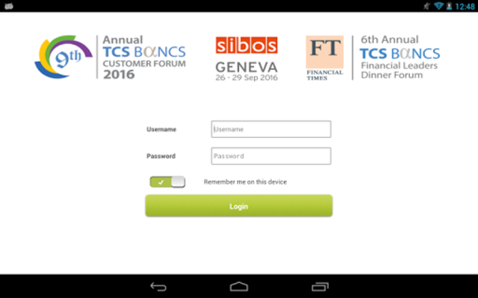
Login Interface

TCS BaNCS may be the best software for core banking but as per some users it seems like it has some major disadvantages like
- The data entry process is time-coming
- Without technical knowledge or training about BaNCS, it is quite difficult to operate
- Unstable crashes while working in hence time-coming
- Costly as without training or knowledge can’t be operated to its full potential
- Unable to multitask
Advantages
- Core all-in-one software
- Cuts down the cost of purchasing different apps for different operation
- Multifunctional
As the CRM software is integrated into the core banking software rather than being an individual app sometimes it’s a hassle to change, update or delete any data. As the internet speed is not up to the mark in |Bangladesh in most scenarios it takes time to load the interface and as the software is all in one it takes a hefty amount of time to load for which sometimes the employees face difficulty to serve the customers because of the loading time. When a client provides the necessary documents to open an account the customer relationship officers ask them to sign the necessary pages once they sign it the customer relationship officer then uses TCS BaNCS to verify their NID so that they can fill up the account opening form with accurate information. After filling up the form they use the official seal to authenticate it and sent it to the authorizing officer who’ll provide a unique customer code using TCS BaNCS and write that code in the accounting opening form. Then the whole form has to be scanned into segments so that the scanned PDF file can be sent using TCS BaNCS to the server where the soft copies are stored and verified by the officials who will grant permission for the account to be opened. MTB has a policy that cheque and debit card is mandatory with every account so when an account is opened the debit card and the cheque issued for that account arrive at the branch a week after opening that account. The chequebook issued for that account is also authorized by the TCS BaNCS software. Almost every step is completed using TCS BaNCS in MTB even when the segmented PDF format of the account opening form is sent for authorization the deputy manager authorization is needed first which is authorized by TCS BaNCS. From my understanding, there are some key points that I would like to mention that give a proper idea of the advantages and disadvantages of TCS BaNCS
- Centralized software.
- User-friendly to those who know of it.
- Requires strong network connection.
- During a power cut, the system doesn’t save the data entered before the power cut.
- Requires a large server to store data.
- Multifunction makes it highly compatible for cost cut down.

Chapter IV: Internship experience

IV.1 My Job in MTB

The Panthapath branch of MTB offered me a job in their general banking department. It's the place where any banking interactions must begin. This section offers a wide variety of assistance including account opening, pay order issuance, bank statement delivery, debit/credit card delivery, and more. In addition to being able to check their balance and get a copy of their statement, customers can get answers to any questions they may have about banking here as well. Throughout my internship, I have helped out in a variety of different areas of the bank. Even though I was never officially transferred to any specific department, I was exposed to multiple divisions at once. I was also tasked with answering customers' inquiries about their accounts and other matters. I was able to provide direct service to the clientele. As a bonus, I was always available to assist clients who needed assistance with things like filling out deposit slips, writing checks, or anything else.

IV.2 My Assignment & Contribution
Detailed descriptions of my work and contributions in various areas of banking are provided below-
- Opening both individual & nonindividual accounts
- Customer service
- Filling out incomplete forms
- Filling KYC
- Writing cheque & pay order
- completion of missing documentation for existing account opening forms
- Calling customers for debit cards, and credit cards and delivering them along with the
PIN when a customer comes to collect it
- Putting a seal on the checkbook
- Recording inward register
- Receiving calls
- Scanning files
- Recording the remittance inwards.

IV.3 Lessons from Internship Experience
Some of my internship experiences have helped me reflect on my growth and the evolution of the banking industry. I believe this will be instrumental in my professional development going forward. Certain ones of them were-
- Becoming more socially aware as I've formed strong bonds with coworkers and even some customers.
- Always being on time for work is essential in the banking industry, as employees are expected to arrive at the office by 10 am and wrap up their customer service duties by 5 pm daily.
- I learned a lot about the banking system by taking the advice of senior officers and listening to them.
- Being proactive requires the ability to multitask.
- I've learned to set priorities so I can give my best effort at work.
- I gained valuable insight from my mistakes, and I took extra care in the future to avoid repeating them.
- It is my responsibility to respond to every one of my customers' questions, so I must exercise extreme patience whenever I interact with them.
- I learned to be professional and to treat my seniors with respect.
- Maintaining composure and reason in trying circumstances.
- I found that being a good listener was crucial to earning my customers' confidence.

IV.4 Skills gained from Internship Experience
  - Management and Professional Skills - This was by far the most important and challenging skill that I was able to pick up on the subject of general banking. Daily, customers would come to a bank who came from a variety of different places and had a variety of different attitudes. Not everyone had access to education or had a solid understanding of how to set up an account. Therefore, I needed to acquire the skills of the art of placating, convincing, and establishing good relationships with them. In addition, the majority of customers did not supply all of the essential documents when they opened their accounts. As a result, I needed to investigate who would give the documents later and who would be late in submitting their work. Another significant implication for me was the realization that individuals' behaviors can vary greatly from one another. Therefore, I must interact with them in a manner that is congruent with their demands and requirements while also preserving my professional demeanor.

  - Technical Skills - During my internship, I gained extensive experience with both Microsoft Excel and Outlook. While I was familiar with excel, this was my first time using outlook in a practical scenario. It was quite difficult for me to do the assignment in excel, which is both crucial and delicate. I used YouTube as a resource and put what I learned into practice at home so the bank employee would have no cause for complaint. There were moments when I lost my understanding of how to use or analyze some data, and in those situations, I sought assistance from Kaiser Sir, who is an expert in these tasks.
  - Conflict Management - Customers have occasionally behaved rudely. They portray it as being our fault, but it is their fault. The bank employee forewarned me on my first day that situations of this nature will arise and that we should always maintain our composure because doing so would give customers a negative picture of the bank. At first, I had trouble mastering the art of being calm in any situation, but I eventually learned to adjust to the circumstances. Additionally, there were times when the bank employees were excessively abrasive with the intern. I never lost my calm, but I always attempted to make them see my point of view. If I was at fault, I apologized, and if there was a misunderstanding, I sought to explain my argument to them using good reasoning.
  - Communication Skills - I had to speak with several clients about opening accounts, FDR, and receiving debit cards among other things. I was initially hesitant to face any client or speak with any client over the phone. It's because I believe we lack communication skills and never strive to improve them on our own as long as we don't get pushed. I had to talk to many people daily and made calls to over 50-60 individuals on average. So, these interactions with the clients helped me overcome my fear of communicating. In my personal life, I believe I am more open to talking to individuals right now.
  - Time Management - We had to arrive at the workplace at 10 a.m. and business hours concluded at 6 p.m. But, as an intern, I used to leave at 4 p.m. I had to get up at 8 a.m. every day, which made me sleep early at night. Sleeping and waking up early have now become a habit for me. The officials also assigned us a large number of tasks. So, I set aside time for each assignment. This assists me in better managing my time.

IV.5 Academic learning & Experiential learning
While doing the internship I hadn’t found much that I could relate to the banking sector from my academic learning. We only received theoretical concepts from academic learning. But the real-world experience I received from working as an intern was different from my academic learning. Because the reality is influenced by a variety of outside influences and because human behavior is unpredictable it was harder and more complex to make decisions. Academic learning may provide us with some insights into how to cope with challenges, complexity, human behavior, client handling, balancing personal and professional life, and so on, but when we apply those lessons in real life, everything is very different and much more complex to deal with. People must adjust or adapt to meet demands in the workplace. I identified certain terminology because I had to do finance, so I came across some terms that I was familiar with while filling out FDR forms.

Chapter V: Conclusion and key facts

V.1 Recommendation
MTB should use a network connection suitable for their software using as a poor connection will lead to poor service for the customers and customer dissatisfaction can lead to disastrous situations for the organization. Because poor network connection will make the software more unstable and choppier and lead to more instability and as it is core banking software it may cause conflicts in other processes. Every employee should be trained beforehand so that they can use the full potential of the software and achieve the optimum results. Last but not least they should pay attention to maintenance as it can help avoid future conflicts.

V.2 Key understanding
From my experience, it is clear that MTB is using one of the finest technologies for its core banking. It helped them to cut down the cost of purchasing individual software and the cost to train their employees on how to use TCS BaNCS. As TCS BaNCS is used by MTB only the employee retention rate is higher as the knowledge gained can’t be implemented anywhere else. So, the strategy worked well for them almost perfectly but the instability is the barrier stopping them to be perfect. Even some of the employees have the same point of view as they know the potential of this software but can’t use it to its full potential.

V.3 Conclusion
It was a great opportunity for me that helped me to acquire some great skills as well as brush up on my existing skills. This report helped me to understand the banking sector in-depth and their daily workflow as a student we may have ideas on what a bank does but truly it’s just an abstract idea. Working as an intern in MTB gave me insights into how difficult it is to handle day-to-day customers with different attitudes and gather necessary documents as a major number of the population is illiterate. Most of them can’t provide or don’t know the papers required for opening an account as a result the employees have to go through a series of questions so that they can help the to open an account. It is up to each branch to also keep track of suspicious transaction activity as most of the illegal activities are done through cash mode but the fund is transferred by a regular savings account and notified to Bangladesh Bank in case of such a situation. Banks not only help us to save our money they also help the country to be financially stable to have a positive impact in a fiscal year.

References
Fahima. (n.d.). An Analysis Of Customer Satisfaction In Mutual Trust Bank Limited http://dspace.uiu.ac.bd/bitstream/handle/52243/1442/Internship-report-on-MTB-Final_Fahima.pdf?sequence=1&isAllowed=y
Prachi, S. N. (n.d.). General Banking of Mutual Trust Bank
https://www.academia.edu/34858954/Internship_report_On_General_banking_Of_Mutual_Trust_Bank
Report, M. A. (n.d.). Annual Report 2021
https://www.mutualtrustbank.com/investor-relations/annual-report/
SHARMA, A. (2013, AUGUST 31). GENERAL BANKING AND PERFORMANCE EVOLUTION OF MUTUAL TRUST BANK LIMITED (MTBL)
http://dspace.bracu.ac.bd/xmlui/bitstream/handle/10361/3181/11164071.pdf?sequence=1
TCS BaNCS. (2022, July 6). In Wikipedia.
https://en.wikipedia.org/wiki/TCS_BaNCS
P., TI. (2013, August 7). TCS deploys its core banking solutions for a Chinese bank. The Economic Times.
https://economictimes.indiatimes.com/tech/ites/tcs-deploys-its-core-banking-solutions-for-chinese-bank/articleshow/21674694.cms

Gartner, Inc. (n.d.). Tata Consultancy Services (TCS) TCS BaNCS Reviews, Ratings & Features 2022 | Gartner Peer Insights.
https://www.gartner.com/reviews/market/global-retail-core-banking/vendor/tata-consultancy-services-tcs/product/tcs-bancs/reviews?marketSeoName=global-retail-core-banking&vendorSeoName=tata-consultancy-services-tcs&productSeoName=tcs-bancs
Business Standard. (n.d.). Tata Consultancy Services Ltd.
https://www.business-standard.com/company/tcs-5400/information/company-history
TCS 50: All About History and Evolution of the Company. (n.d.).
https://www.tcs.com/tcs-50

Appendix

Week 1 Journal
Work Done
I recorded all the files and offered customer service this week.
The office hour is from 10 AM to 4 PM. The bank receives tons of files within this time, all of which need to be registered. After obtaining the original document, I must first determine if the file pertains to the department of general banking or foreign exchange. The receiving seal is then applied to that piece of paper. The seal must then be inscribed with the date and the moment of receipt. The next action is to record the time and date in the log. If the file pertains to the general banking division, it must be entered in the general banking book and if it pertains to foreign exchange, it must be entered in the forex book. After that, I need to find the company’s name, subject, account number, and the amount and record it all in the book. After the In-Charge has signed and marked the paper, I need to deliver the documents to the appropriate department.
And as for customer service I had to call all the customers who had not received their credit cards.

Learning
I am still learning how to open a savings account, filling an LC form, and FDR.

Challenges Faced
Filling an LC form is tiring as it required a lot of fields and I find those fields hard as they are very sensitive. If I fill in any incorrect number, then the customer has to sign on that page just as proof that we did not change any numbers. The bank extremely discourages this so it is very challenging to fill LC or savings account forms. Also, customer service is very tiring, and communicating with them is also challenging as some of the customers don’t want to listen or understand so it is very hard to communicate.

Week 2 Journal
Work Done
I learned how to start a savings account this past week. A client must provide a passport-sized photo, a copy of their NID card, designation, and other documents to start a savings account. I then had to complete a form that asked for information such as the client's name, designation, NID number, salary, initial deposit, nominee name and percentage, permanent address, and professional address.
Then I need to verify the NID of the client. The If everything checks out the procedure should continue. If not, a different form is required for the mismatch, and the customer must fill it out.
The sanction screening must be completed after verification. The bank verifies that the client is not affiliated with any terrorist organizations through this screening.
The next step is to score the client. The KYC (Know Your Customer) form must be completed. The bank chose 15 as their benchmark figure. The client will be considered a low-risk customer if the number is less than 15, but a risky comer if the number is greater than 15.
The authorized officer will take care of everything else. We only handle the above processes.

Learning
This week, I learned how to fill this savings account and deal with clients who haven't taken their checkbooks or debit cards yet.

Challenges faced
I find it challenging to fill out the information boxes on the savings account since they are very small. Therefore, I'm constantly worried that I'll enter the incorrect letter or number in the box. Additionally, the staff members occasionally become annoyed if we ask questions because they assume we already know everything about these forms.
Week 3 Journal
Work Done

This week, I learned about the Bangladesh Electronic Funds Transfer Network (BEFTN). BEFTN is a multilateral electronic clearing system that facilitates the exchange of debit and credit payment instructions between Scheduled Banks.

Learning

BEFTN is a multilateral electronic clearing system where scheduled banks can exchange debit and credit payment instructions. There are two varieties of BEFTN: inward BEFTN (inside the same bank) and outward BEFTN (between different banks). We must perform two-step authentication actions to generate BEFTN. We sign in to the creator website first, and then the checker page. After entering the creator page, we fill in all the necessary details, like the name of the bank, the name of the branch, the account number, and the amount, among other things. Following that, we will visit the checker page and verify each piece of information once again. The process will be finished by choosing the detailed settlement report option, entering the settlement date, and submitting it. The BEFTN will be approved by the local office after being submitted.

Challenges faced

The main challenge I have with BEFTN is that occasionally the system crashes when I'm entering data into the MICR, making me re-enter everything.

Week 4 Journal
Work Done

This week I learned how to fill out an LC form. The full form of LC is “Letter of Credit”. A letter of credit is a document issued by a bank or financial institution that ensures that a seller will receive payment from a buyer on time and in full. Letters of credit are commonly used in international trade. This procedure is done by the Forex section of the bank.

Learning

I had to initially enter the applicant's entire name, address, and phone number. The beneficiary section must then be completed the applicant has to give an IRC number and has to address if he wants his products by swift or local courier or in other ways. The draft must then be marked. The majority of candidates select "At Sight" as an option. Other than at Sight, I have yet to see someone select "shipment/negotiations/acceptance." The currency and amount must then be mentioned by the applicants in both words and numbers. He must then mention the allowance of Tolerance, the presentation period, the expiry date, and the last date of shipment. It is necessary to mention the trade term. There were numerous trade terms available, including FOB, CIF, CFR, CPT, and CIP, and if applicants desired other terms, they had to list them under the "Others" option. The good's name, description, etc., must then be filled up. It is necessary to state the product's "country of origin, HS code number, Proforma invoice/Indent code number." If the buyer or seller will pay for the insurance, that fact must be mentioned. The insurance company's description must then be mentioned. That's all I have done. The rest of the part was done by the officials.

Observations

There were different sections for the seller and buyer. Also, the beneficiary has to be mentioned. It might be easy for the officials to understand which section is for whom but as an intern, it was hard for me to understand which part is for the applicants and which is for the beneficiary or the buyers.
Week 5 Journal
Work Done

This week I learned how to fill “Credit Card Application Form.”

Learning

There were many sections in this form such as “Personal Information, Professional Information, References, etc.” I filled these sections the rest were for the officials. At first, I had to fill in the applicant's name, parent’s name, spouse's name, marital status, nationality, NID number, present and permanent address, etc. Then I had to go for the professional information which consists of “name of the organization, designation, department, length of business experience” etc. Then the last part was reference which consists of “name of the referee (1) & name of the referee (2), their relationship with the applicants, address, etc. The rest of the part was filled by the bank officials.

Observations

It was an easy task but I had to fill the application very carefully because if I filled the blocks with any wrong information then the applicant has to give their signature to ere we did not change any information. This thing is a hassle for both the bank officials and the applicant.

Week 6 Journal
Work Done

This week I learned how to do checks clearing. Cheque clearing is the process of transferring money from the bank that issued the cheque to the bank where it was posted.
Learning

When we receive a check for clearing, we first make sure that all of the information on the check is accurate, and then we make sure that the information on the deposit slip is accurate. We put a receiving seal on the deposit slip and give it to the depositor if all the information is accurate. Next, we decide if the check is for a regular value (less than 500,000/-) or a high value (greater than 500,000/-). If the value is regular, all processing must be finished by 11.30 a.m.; if the value is high, processing must be finished by noon. The branch seal, the endorsement seal, and the clearing seal are applied to the check first. The second step is scanning the check using
We scan it with a scanner, upload it to the MICR, and then input all of the data from the MICR with a check. After that, we send a request for authorization to the CSM via the MICR website. Then, assuming everything is in order, the CSM will review all the data. After reviewing everything, the CSM will provide his or her approval if everything is in order. We must wait till 4 p.m. for the clearing report after the cheque was approved and forwarded to the Bangladesh Bank clearing house using the MICR interface. After that, we get a clearing report that states whether the check was honored or not. The balance will be added to the client's account if the check is honored; however, if the check is dishonored, there is a reason mentioned on the report that we must provide to the client.

Observations

Customers get annoyed if their cheque gets dishonored and they question what went wrong and how they fix this. Also, sometimes they blame the bank officials for not getting approval for their cheque.

Week 7 Journal
Work Done

This week I haven’t done or learned any new tasks. This week I filled out some account opening forms.

Learning

I noticed this week there were fewer customers compared to previous weeks. So, all I did is I filled some account opening forms and from 10 am to 1 pm every work was completed assigned to me. Then I and the other interns left because we had no work to do.

Observations

No observation.
Week 8 Journal
Work Done

This week all I did is filling the savings account.

Learning

A client must provide a passport-sized photo, a copy of their NID card, designation, and other documents to start a savings account. I then had to complete a form that asked for information such as the client's name, designation, NID number, salary, initial deposit, nominee name and percentage, permanent address, and professional address.
Then I need to verify the NID of the client. The If everything checks out the procedure should continue. If not, a different form is required for the mismatch, and the customer must fill it out.
The sanction screening must be completed after verification. The bank verifies that the client is not affiliated with any terrorist organizations through this screening.
The next step is to score the client. The KYC (Know Your Customer) form must be completed. The bank chose 15 as their benchmark figure. The client will be considered a low-risk customer if the number is less than 15, but a risky comer if the number is greater than 15.
The authorized officer will take care of everything else. We only handle the above processes.

Observations

Customers don’t want to fill these papers on their own. As we need to fill the papers there are always some risks to make a mistake. If we make any mistakes, then the customer needs to sign beside the mistake. So, opening a savings account is always very distressing.

Week 9 Journal
Work Done

This week I registered all the debit card data in both excel and word files.

Learning

I needed to create 7 rows in both the excel and word files which consisted of SL No (serial number of the customer), date (The date customer came to open an account), customers name, A/C No (account number of the customer), Register’s Position (This will consist of 2 options. One is R which means Received and another is D which means Destroyed. If any customer doesn’t receive their debit card within 3 months after issue, then the debit card will get destroyed by the bank.), Receive Date and Mobile No.

SL NO | Date | Customer’s Name | A/C NO | Register’s Position | Remarks/Receive Date | Mobile
1 | 26/07/2022 | Samin Khan | 1311****30214 | Received | 26/08/2022 | 01*******54

Observations

This was easy but very tiresome work. I have registered more than 700 customers’ data from the record book.

Week 10 Journal
Work Done

This week I filled out some savings forms, and individuals form and recorded the debit card’s record.

Learning

These are the task I have been doing since week 1 so there was nothing new to learn. The Junior assistant vice president told me he will teach me the anti-money laundering task but due to bank renovation, he couldn’t do so.

Progress report
