Internship report on
Sme activities of grameen bank




Course Title: Internship
Course Code: INT 4399

Prepared For:
Mosabbir Uddin Ahmad
Assistant Professor
School of Business and Economics
United International University
Prepared By:
Nanjiba Ibnat
ID: 111 171 093

Date of Submission: 18.03.2022

Letter of Transmittal
March 18, 2022

Mr. Mosabbir Uddin Ahmad
Assistant Professor
School of Business and Economics United International University

Subject: Submission of Internship Report.

Respected Sir,

I am honored to share my internship report on SME Activities of Grameen Bank. This report has been prepared for explaining the experience of my internship period and what I learned and gained from the internship. So, I attempted to gather information to make this report as useful and effective as feasible. This study has allowed me to gather extended knowledge on the working procedure of identifying the relationship between dependent and independent variables about the practical world. This term paper was written by your instructions and criteria. I did my best to confirm my work according to your structures. If the content of the report is acceptable to you, I would be highly obliged.

I hope you will appreciate my efforts and information-gathering approach in preparing this report and that will meet your expectations.
Thanks and Regards.

Sincerely Yours,

Nanjiba Ibnat
Id- 111 171 093

Acknowledgement

I would like to begin by thanking Allah Almighty for all of His blessings. Knowledge has no boundaries and there is no end to it. We must apply our knowledge and concepts in our job lives if we wish to raise correct knowledge. This is what I discovered while working on my internship report. I completed my internship with Grameen Bank, which is regarded as one of Bangladesh's greatest microfinance institutions. The colleagues and the staff of the organization were so cooperative and helpful. I am grateful and fortunate to have the opportunity to work in a dynamic, friendly, and demanding atmosphere. It was a great chance for me for learning and professional development. Then, I sincerely express my thanks and gratitude to my honorable and respected supervisor Sir Mr. Mosabbir Uddin Ahmad, Associate Professor, School of Business & Economies, United International University for his encouragement, support, teachings and supervision me from the beginning until the last day in conducting my internship program successfully. I am so much thankful to my Supervisor of the Grameen Bank; Mohammad Mizanur Rahman, Principal Officer, International Program Department. I would not have been able to work as an intern at the bank and prepare the report without his active supervision and encouragement. His practical and hypothetical assistance has surely aided me during my internship period. Last but not least, a mount thanks to my fellow colleagues and my parents for supporting and encouraging me to accomplish my internship successfully.

Table Of Contents

Executive Summary 7
Introduction 8
1.1 Introduction of the Report: 9
1.2Background of the Study: 9
1.3 Rationale of the study: 10
1.4 Objectives of the study: 10
1.5 Scope of the study 10
1.6 Limitations of the study: 11
1.7 Methodology: 11
Overview Of Grameen Bank 12
2.1 Organization Profile: 13
2.2 History of Grameen Bank 13
2.3 Objectives of the organization 14
2.3.1 Mission of Grameen Bank 14
2.3.2 Vision of Grameen Bank 14
Model of Grameen Bank 15
2.4 The Success of Grameen Bank 15
2.5 Products and Services of the organization 16
2.5.1 Basic Loan 16
2.5.2 Housing Loan 17
2.5.3 Higher Education Loan 17
2.5.4 Struggling Members loan 17
2.6 Formation of Group and Center 18
2.7 Organizational Structure of Grameen Bank: 18
2.7.1 Operation Procedure of GB Microcredit 19
2.7.2 Composition of GB Board of Directors 19
2.7.3Organogram of Grameen Bank operation 20
2.8 Profitability of Grameen Bank: 20
2.8.1 Net Profit Margin 21
2.8.2 ROA(Return on Asset): 21
2.8.3 ROE-Return on Equity 22
2.8.4 Cost Income Ratio 22
Experience of Internship 23
3.1 Theoretical office learning 24
3.2 Practical on-field learning: 25
Differentiation of MFIs 27
4.1 Micro Finance Sector in Bangladesh 28
4.1.1 Similarity of GB,BRAC,ASA,PROSHIKA 30
4.1.2 Dissimilarity of GB,BRAC,ASA,PROSHIKA 32
Recommendation & Conclusion 36
5.1Recommendation 37
5.1.1 Improving organizational operations 37
5.1.2Improving departmental operations 37
5.2 Conclusion 39
5.3 References 40
Appendix 41

Executive Summary
The research supports the objective of demonstrating the impact of microcredit on the poor. Pioneer of microfinance Professor Muhammad Yunus invented a Bangladeshi banking which has grown the importance as a development tool to alleviate poverty, empower women, and foster entrepreneurship in developing countries. The purpose of this paper is to determine the influence of Grameen Bank's micro-credit facilities in eliminating the poverty and empowering the poor women. All of Grameen Bank's activities are aimed at the rural poor who are functionally landless. Non-governmental organizations (NGOs) are all participating in microfinance, but they are not regulated or monitored in the same way that Grameen Bank is. All MFIs use identical on-site loan disbursement and weekly collection techniques by organizing village organizations or centers, and they give generally small, uncollateralized one-year term loans to individuals belonging to jointly liable peer groups. There is also an investigation of the microfinance sector in Bangladesh, which revealed similarities and differences between the microfinance industry in Bangladesh and Grameen Bank, their targeted customers, competitors, operational activities etc. According to my research, there is a significant difficulty in the MFI sector, such as when an MFI provides a loan, if they do not have funds, they must obtain funds from other banks, and if the interest rate rises, it will have a significant negative impact on the operation of the institution. If the government boosted funding for NGOs and microfinance institutions, rural poor people will be benefited because they have a significant impact on our economy. They assist rural communities by giving loans with no collateral. During my internship, I discovered that Grameen Bank workers are not advanced at adopting new technologies, so authorities of the bank need to teach them about new technologies and to adapt with them it in order to make employees and members more productive and efficient. Despite various lacking in its operations, Grameen Bank's effective and efficient managerial abilities, innovative approach, and decentralized institutional patterns are remarkable. Grameen Bank has the most members of all the Micro Finance Institutes in Bangladesh, thanks to its innovation of alternative ways to finance the poor and ongoing attempts to produce new goods and services. I made every effort to make this report as informative as possible. I'm hoping that this paper will aid in future studies.

Chapter 1

Introduction

1.1 Introduction of the Report:

In rural places around the world where formal finance is unavailable, micro-credit is viewed as an effective tool for poverty alleviation. A great number of studies have been carried out to assess the effectiveness of the microcredit program. While some researchers discovered beneficial effects of microfinance programs in impoverished areas of the world, others discovered negative effects or no influence at all. However, many Non-Government Organizations (NGO) or Micro Finance Institutes (MFIs) in Bangladesh offer micro-credit programs in rural areas. Even if they had an investment opportunity, poor and landless people (especially rural women) couldn't receive a loan from a bank at one time. Grameen Bank has changed the banking system by eliminating all collateral requirements and establishing a financial system based on mutual trust, accountability, involvement, and creativity. Although micro-credit programs are well acknowledged and frequently used technique of rural development around the world, no specific structure of the program has yet to be determined as the best effective in ensuring quick rural development. There have been few studies that compare the similarities and differences between the programs implemented by different MFIs or NGOs which I analyzed will see in the details in chapter four.
I did my internship at Grameen Bank, where I learned about the numerous types of loans they offer and how they run their business. I used a lot of practical knowledge from my day-to-day operations in the organization to write the report. In my report, I mostly concentrated on introducing Grameen Bank to everyone, my internship experience, and the distinctions between Grameen Bank and other MFIs in Bangladesh (BRAC,ASA,PROSHIKA). I prepared the report using a blend of practical and theoretical experience.

1.2Background of the research:

Grameen Bank was established in Bangladesh as the first microfinance and community development bank. They gives poor people low-interest loans without requiring collateral. Professor Muhammad Yunus established the Grameen Bank in 1976 as a research process to figure out how to create a credit distribution system that would allow the rural poor to use banking services. Grameen Bank was granted independence by national legislation in October 1983. In 1998, Grameen Bank received Low-cost Housing Program from the World Habitat Award. In 2006, the Nobel Peace Prize was jointly awarded to the bank's founder and also to Professor Muhammad Yunus,("The Nobel Peace Prize for 2006," 13 October 2006). The Bank maintains a position of 97% in Bangladesh communities. Their success has prompted initiatives in more than 40 countries, including a World Bank plan to fund Grameen-type programs.

1.3 Significance of the report:

Since it was recognized as a powerful weapon in the fight against poverty and a significant opportunity for women's empowerment, microcredit has become a modern phenomenon in Bangladesh. Grameen Bank is generally referred as the forerunner of modern finance. Working in such a well-known corporation and conducting research on its main activities and economic impact was a fantastic experience for me as a business student. The research focused at Grameen Bank's microcredit program as well as the impact of other Bangladeshi microfinance institutions on poverty alleviation and women empowerment.

1.4 Research Objectives:

Objectives serve as evidence of a researcher's clear sense of purpose and direction.In view of the research issue, the priorities of this research are-
Broad objective
- Gain an understanding of how a microcredit program helps people to get out from poverty;
- To have a better understanding of how a microcredit program empowers women.

Specific objectives
- To discover how Bangladesh's microcredit initiative helps underprivileged rural women to get better in their living situations.
- To determine the primary activities of Bangladesh's microfinance institutions.
- To get knowledge of the microcredit programs offered by various MFIs in Bangladesh.

1.5 Scope of the research:
During my time as an intern at Grameen Bank's Head Office in Mirpur-02, I worked in the Head Office's International Program department.In my study, I attempted to highlight Grameen Bank's general banking operations as well as the contrasts between Grameen Bank and other microfinance institutions in Bangladesh.I visited branch offices of the bank in order to obtain important information for my research, and I received polite cooperation and support from them when I need certain data.Despite the fact that all of the personnel at the Head Office were overworked, they always provided me with the information I needed when I asked for it.Because of the employees of the Grameen Bank, I successfully prepared my report.

1.6 Limitations of the report:

The following are some of the limitations that were observed while doing this research:

- Restriction of some confidential information.
- Because the respondents were uneducated, conducting a survey in villages was extremely challenging. It is quite difficult for them to provide a clear response to the questionnaire.
- Unavailability of appropriate journals.
- It was hard to collect comprehensive information within a short period of time.
- Three months is insufficient to develop a full understanding of everything.

1.7 Methodology:

It's one of the most important part of making a qualityful report within a short period of time.However, I attempted to use both primary and secondary data in order to make the report interesting.I was able to complete my report properly by utilizing and evaluating the data.

Primary Data
With the support of my supervisor, I gathered original data straight from the organization.I spoke with Grameen Bank members to learn more about the bank's detailed offerings.

Secondary Data
I collected secondary data from different sources.The sources are-
- Grameen Bank Website
- Annual report of Grameen Bank (2015-2019)
- Prospectus of Grameen Bank
- Different articles, journals and newspaper.

Chapter 2

Overview of Grameen Bank

2.1 Organization Profile:

Grameen Bank was established in 1983 under a special law with the support of the Bangladesh Bank. It's the only MFI with a microfinance special bank license in Bangladesh. The other MFIs in Bangladesh are non-governmental organizations (NGOs) that are registered with the NGO Affairs Bureau (NGOAB) and now with the MRA (Microfinance Industry Report: Bangladesh, 2009). It is owned and operated exclusively for the bank's underprivileged borrowers, the majority of whom are women. The government owns only 6% of Grameen Bank's total stock and the borrowers own the remaining 94 % of the bank's entire equity. GB has created a financial system based on mutual trust, accountability, involvement, and creativity, in opposition to typical banking methods, by eliminating the need for collateral. Members are the borrowers of Grameen Bank. It provides credit to the poorest of the poor in Bangladesh's rural areas without requiring any security. In the United Kingdom, credit is a cost-effective weapon in the fight against poverty, and it functions as a catalyst in the overall improvement of impoverished people's socio-economic conditions.Grameen Bank model has been widely adopted in both rich and developing countries around the world. The technique has been applied by China, India, Pakistan, Sri Lanka, African countries, the United States, Canada, and Germany, depending on the suitability of their respective countries.So, Grameen Bank is a microfinance institution that gives small loans to the needy without demanding collateral.As a result, it is known as a poor bank.

2.2 History of Grameen Bank

In 1976, Dr. Muhammad Yunus established the Grameen Bank as a Grameen Bank project in the village of Jobra, in the Chittagong district of Bangladesh. After the success of Tangail project, the concept was spread to a number of other areas around the country. The Bangladesh government approved a legislation establishing GB as an autonomous bank on October 2, 1983. In 2006, the Nobel Peace Prize was jointly presented to the founder of GB and also to Professor Muhammad Yunus. The Bank's reach is expanding across the country. Grameen Bank has around 2,100 branches by 2006. Its success has encouraged similar efforts in more than 40 countries throughout the world, including a World Bank plan to subsidize Grameen-type operations. The central bank of Bangladesh provided Grameen bank with the majority of its funding by the mid-1990's.The 'Grameen Bank Act,' which replaced the Grameen Bank Ordinance, 1983 and in 2013, the government gave the authority to them for creating rules for any part of the bank's operation.

2.3 Objectives of the organization

Grameen Bank's basic motive is to provide complete financial services to the poor, enabling them to achieve their full potential and break them free from the poverty. The following are the goals that the GB has set for itself:
- Extend collateral and guarantee free banking services to the rural bottom poor.
- Free poor people from the exploitation of money lenders.
- Create self-employment for the vast unutilized and underutilized manpower resources of Bangladesh
- Organize the disadvantaged people into small federation for mutual support and self-sustained socio-economic development.
- Empowering poor women and involving them in economic activities.

2.3.1 Mission of The Grameen Bank
By offering complete financial services, the poor are empowered to reach their full potential and break free from the poverty cycle.

2.3.2 Vision of The Grameen Bank
Banking for the poor - This emphasizes that this bank is only dedicated to helping out the poor people of the rural area to eradicate poverty and make the poor earn by themselves.



Overview of Grameen Bank | Monthly update of Grameen Bank :January 2022
Organization type: | Financial services
Founded in: | October, 1983
Headquarter: | Dhaka, Bangladesh
The number of branches: | 2.568
The number of centers: | 1,35,861
The number of villages served: | 81,678
The number of groups: | 1,423,178
The number of members: | 9,558,524
Area served in: | Bangladesh
Type of products: | Microfinance
The number of members: | 20138
Organization Website: | www.grameen.com

Table -2.1: An overview of Grameen Bank

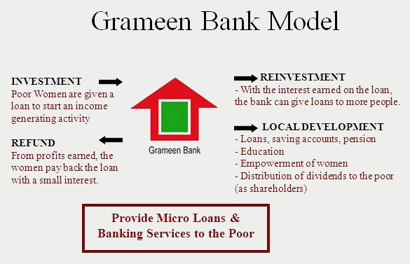
Model of Grameen Bank
Figure 2.2: Grameen Bank Model

2.4 The Success of Grameen Bank

Grameen Bank's achievements can be judged on both social and financial levels. Grameen Bank began as a hands-on study project in the village of Jobra, near Chittagong University. From 1979 to 1982, the concept was replicated in five Bangladeshi regions after three years of experience. Professor Muhammad Yunus achieved his objectives by collaborating with commercial banks, Rural Bank, Bank of Bangladesh (National Bank of Bangladesh) and the International Fund for Agricultural Development (IFAD). In September 1983, the initiative was designated as a specialized agency under government control.Grameen Bank's branches have significantly expanded since then. By February 1987, about 298 branches had begun to cover over 6% of the landscape.And now in 2022 there are 2568 branches in Bangladesh. More than 40 countries have implemented the Grameen model.

2.5 Products and Services of Grameen Bank

Grameen Bank offers 4 types of loan products to the members and also the non-members of GB.They are:

Basic loan, 2) Housing loan, 3) Higher education loan, 4) Struggling members (beggars) loan

2.5.1 Basic Loan

The Basic Loan is the initial loan given to all members when they join in the Bank. This is between 30k to 40k taka, depending on the borrowers needs, and has a flexible weekly repayment schedule between 3months and 3 years. The rate of interest is 20% on declining balance or 10% at a flat rate. The reason for this high Interest rate is due to the high operation cost, and in fact is much lower that the Microfinance Authority’s cap of 27%.

Microenterprise loan is a branch of Basic Loan. For a variety of reasons, such as proximity to the market, the existence of an experienced male member in the family, and so on, the majority of business borrowers move faster than others.Micro-enterprise loans are available from Grameen Bank for these successful migrants. There are no restrictions on how much money you can borrow. Other significant commercial sectors include a grocery store, a medical store, a dairy farm, a baby-taxi for transportation, and a stone business for construction. After two years, the borrowers are given a basic loan for expanding their firm if they require it. The repayment period is similar as the Basic loan.
A flexible loan, also known as a rescheduling loan, allows a borrower to reduce the size of his or her installment if he or she cannot pay his or her weekly installment that he or she offered to pay. This is a supplementary debt that is merely utilized to divert attention away from the original loan. When a borrower defaults on a basic loan and refuses to switch to a flexible loan, he or she is considered a willing defaulter.

2.5.2 Housing Loan
Grameen Bank developed the house loan in 1984.Because this loan is granted to assist borrowers to build a house with an interest rate. Now, it has become a very appealing program for borrowers.A member can borrow money to build a house at an 8% interest rate on a decreasing amount repaid over 3-4 years. The repayment period is limited to ten years.The minimum house loan amount is Tk 30000 and the maximum loan amount is Tk 60000. Housing loans have been used to construct more than 7,61,000 homes as of January 2022.A total amount of Tk 7,54,11,000 billion has been disbursed for housing loans.
Grameen Bank are giving four types of housing loan and they are -

Name of the loan Amount (Tk)DurationInstallment/1000tk
Pre-basic housing loan | Up to 30000 | 3years
Basic housing loan | 30000-40000 | 3years
Small housing loan | 40000-50000 | 3years
Complete housing loan | 50000-60000 | 5years

2.5.3 Higher Education Loan
Higher education loans are offered to students who complete a post secondary level of education and the benefits are given to them is covering tuition, maintenance, and other school expenditures. Grameen Bank created the Higher Education Loan program in 1997 to provide greater possibilities for its borrowers' talented children to pursue higher education. Children of borrowers enrolling in medical school, engineering school, honors and master's degree programs, agricultural schools, textile engineering, and other higher education programs at any public institution in Bangladesh are eligible to apply for this loan. The loans are meant to cover all expenses incurred by students from the start of their courses until the finish, including entry fees, course fees, required stationary, accommodation and food, and other relevant expenses.Over 16,53,17,000 students from various fields have obtained loans totaling USD 1,653.17 million under this scheme as the data of January 2022.

2.5.4 Struggling Members loan
Grameen Bank has launched a unique initiative for beggars called the Struggling Members Program. This loan is given to beggars and street people with no interest. Begging is a poor person's last alternative for survival, unless he or she commits to crime or other unlawful acts. There are disabled, blind, and retarded people among the beggars, as well as elderly people in poor health.Grameen Bank introduced the Struggling Members Program, a special initiative for beggars, in 2002.Over 83254 beggars have enrolled in the scheme, with a total of BDT 183.89 million disbursed to date.There is no interest levied and no set repayment period.They are exempt from general laws and regulations, and they are not need to organize a group in order to become a GB borrower.

2.6 Formation of Group and Center
Potential borrowers must join a group to become a member of Grameen Bank and be eligible for a loan.Then five individuals from five separate families living in same village can be a group. GB considers those people who are landless and asset less people Individuals execute loan contracts, but the group plays an important role in the delivery and recovery of the funds.In every village a central leader is must. A center leader task is to take information from the members then he/she has to tell this information to the center manager.

2.7 Organizational Structure of Grameen Bank:

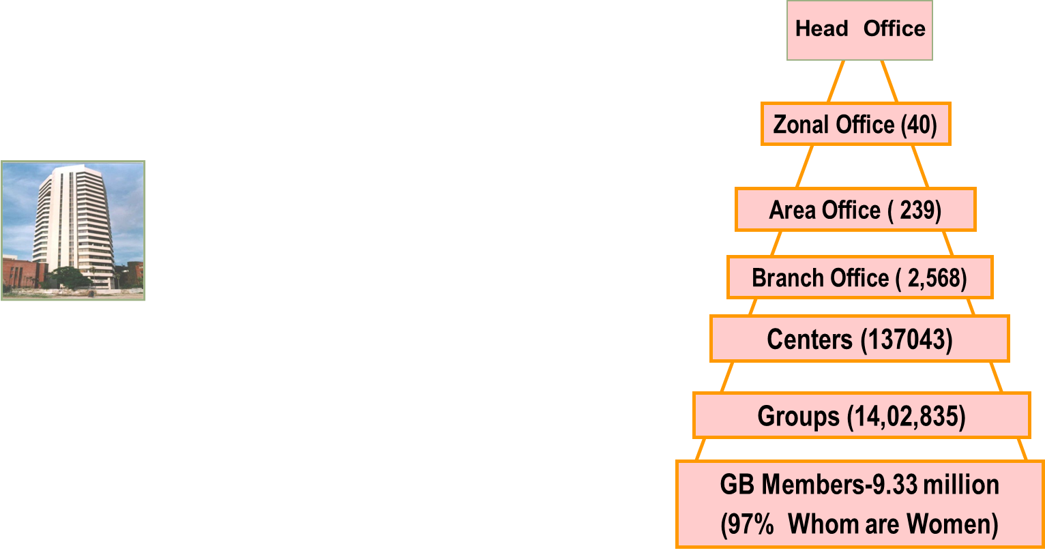

This is the organizational structure of Grameen Bank.The way this chart have showed is actually maintain every employee of Grameen Bank from top to bottom.

2.7.1 Operation Procedure of GB Microcredit





2.7.2 Composition of GB Board of Directors
Borrowers' Elected Representatives | 9
Government Nominees including Chairman | 3
Ex-Officio Managing Director | 1
Total GB Board of Directors | 13

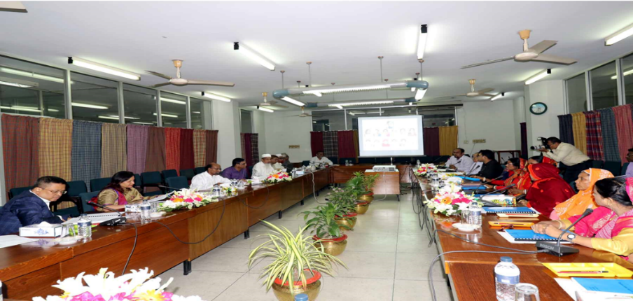

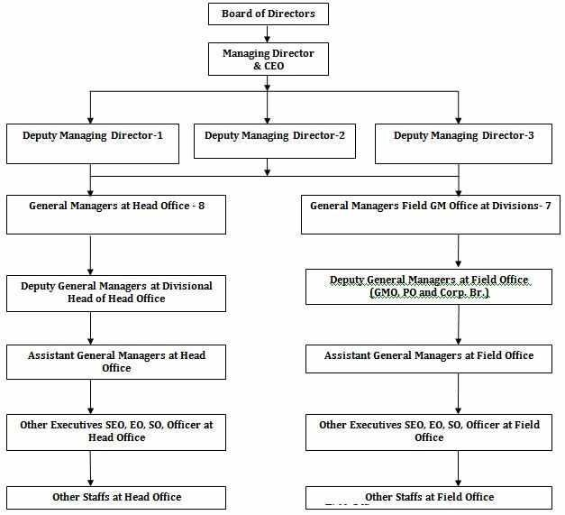
2.7.3Organogram of Grameen Bank operation

2.8 Profitability of Grameen Bank:

It evaluates a bank's profits based on a set of sales, assets, and the owner's investment and share value. As a result of the new pay scales, employees are motivated to invest more in loans and loan repayments. If we look back at the bank's history, we can observe that the activity is decreased in 2013 and 2014 due to uncertainties influencing profit margins.Because it owned a 25% interest in the bank, the government earned a dividend of 583 million tons in 2015.The remaining dividend was distributed to the bank's 62 Lac shareholders.While the bank is financially well, other issues have impacted its operations. Because the nine elected directors' terms expired in February 2016, the bank's borrowers, who own 75% of the company, are not represented on the board.Since then, there has been no election to choose directors from among the borrowers. Another issue is that since Professor Yunus left the bank in 2011, the bank has been run by an interim managing director. However, after all of this issues we can observe that Grameen Bank continues to be the most successful MFI in Bangladesh.
2.8.1 Net Profit Margin: After all expenses, including taxes, are removed, the net profit margin is the proportion of income that remains in thr organization.The greater the organization's bottom line, the larger the net profit margin.

Comment: The graph depicts how GB's net profit margin changed over the year. The net profit margin ratio has decreased from 9.81 percent in 2013 to 0.16 percent in 2015. In contrast, the net profit margin has increased from 0.16 percent in 2015 to 19.39 percent in 2019.As a result of Covid-19, it dropped to 16%.

2.8.2 Return on Asset: The return on assets (ROA) of Grameen Bank shows how efficiently the bank is generating profit from its assets. It’s computed by dividing the bank's annual earnings by its total assets to get the return on asset.

Comment: The return on asset ratio has shifted throughout time.In 2008, the highest return on asset (ROA) was 1.58 percent. However, from 2005 and 2014, the return on asset was at its lowest, at.22%.It increased in 2019 and then fell in 2020, from 1.65 percent to 1.40 percent.

2.8.3 Return on Equity: The return on equity ratio evaluates an organization's profitability or how much money it makes.Also, how much money did the shareholders invest in the organization.

Comment: The return on equity ratio has fluctuated throughout time.In 2006, the highest return on equity (ROE) was 25.83%.The return on equity, on the other hand, has dropped from 13.65% in 2013 to 0.22 percent in 2015.It increased to 24.09 percent in 2019 before dropping to 14.96 percent in 2020.
2.8.4 Cost Income Ratio: The Cost Income Ratio (CIR) illustrates the connection between the income and the cost of obtaining income. The lower a bank's CIR ratio, the more efficient it is.It also assesses management's ability to keep costs under control.

Comment: The graph shows how Grameen Bank's cost-income ratio has changed over time.The cost-income ratio, went from 40.31 percent in 2007 to 79.92 percent in 2010. It suggests that the bank's cost to income ratio was not reduced. It was highest in 2016, then dropped to 67.90 percent in 2017.

In light of these figures, it can be concluded that GB is performing admirably in the microfinance banking market. They have a favorable profitability ratio, as well as a favorable return on assets and equity. Despite a minor increase in their cost-to-income ratio, the bank's overall financial health is excellent.

Chapter 3

Experience of Internship

Recently I completed my three month internship from Grameen Bank.It was quite interesting to me as it was the first experience of my life to do work in an office. The internship program of Grameen Bank was a little different then the other instituitions internship because they offer training program to the interns. I have completed my internship successfully from Grameen Bank and gathered a lot of experience. The main thing of this internship is learning and to understand the Grameen Bank process of microfinance and see its application in the country.After the training program of Grameen Bank it is mandatory for all intern to attend an exam where I got the highest mark among all the interns and also gave a presentation infront of the all emplyees of the international program department of Grameen Bank and they gave me a big applause because of giving the best presentation.That was the best achievement of my life.

My internship experience can be split into four parts:
- Theoretical office learning
- Practical on-field learning
- Organizational learning
- Communicational learning
- Technical and Analytical Skill

3.1 Theoretical office learning
During the three months, I took part in several briefings, orientational meetings, and discussions on the operation and history of Grameen Bank. This included discussions on the historical growth and changes in the Bank’s operations, as well as briefings on several loan and deposit services that are available for members and non-members. Some meetings were very abstract, talking about the meaning and existence of the bank. This included discussions on the purpose of finance, the growth of microfinance in the region and internationally, and lectures on microfinance can be repurposed to developed, emerging and developing countries all over the world. On the other hand, some meetings and discussions were very nuanced on the specifics of the repayment program. This included using finance software and previous examples to see how the repayment program and savings program works. I especially found the organizational structure of the bank very interesting, with the group-branch-area-head structure and the way these separate departments have very important responsibilities and function as an individual unit. Moreover, the concept that the majority of the ownership is with the borrowers is very fascinating, as it is a completely different ownership structure from the traditional companies. The Grameen Bank officials were extremely helpful with answering all of our queries as well as shaping the program to suit our groups desire to visit the field more and understand the changes to people’s lives.

3.2 Practical on-field learning:
Grameen Bank give an opportunity to the interns to have a day field trip and gain practical experience away from the office. This included attending meetings in villages as well as visiting branch and area offices. When we attended the village Grameen centers, we were able to participate and view how the meeting process, and actually understand the grass root operations of the Bank. Most of the time after the meeting, we had the chance to be able to talk to some of the Bank’s members, and understand their experience with the Bank. We visited their businesses, ranging from cow farming operations to the gas plantation from the cow’s dung in the village. It was truly fascinating to understand the breadth of the types of businesses they conduct, and how it is enabled by the Grameen Bank. When we were not in contact with the villagers and their operations, we were in the branch and area offices, understanding their key roles in the Grameen Bank operations. We were able to view past records that they have, help them input data and create new loans for the members that they have. We also got to talk to the office managers, and understand their path through the Bank and their daily jobs.After the field trip I had the chance to work on a report which was all about expressing the experience from the field visit under the guidance of my supervisor Sir Mohammad Mizanur Rahman.
Organizational learning:
I joined Grameen Bank, Head office on 29th August 2021. Throughout my time there, I have earned a lot of organizational skill which will be helpful for me. The things I learned from Grameen Bank is how to manage hierarchy of control, co-operation and co-ordination among various departments and also learnt how a HR department work in a special Bank.I had a meeting with Grameen Bank's Managing Director and worked at the front desk, in the International Program Department, and assisted clients by delivering information.

Communicational learning:
I think this was the most unique experience by doing my internship in Grameen Bank. Because here I observed my coordinators and other employees of the bank to learn how the information are passed from top to bottom for banking purpose. Grameen Bank invited us to attend a meeting of Grameen Bank with other organizations , where I learnt how to communicate and how to deal with the other organizations.

Technical and Analytical Skill:
The skills or knowledge which I gathered during my internship will be so effective for my future job. Because here I learned how to tackle and act under different problems, how technically you need to attract the consumers and also how to convince them to stay loyal with the bank.

Lastly, I would like to thank everyone at the Grameen Bank and the International Department for giving me the chance to be a participant in their internship program. Throughout the internship, everyone I met was really helpful and friendly.I owe them a debt of appreciation as well. I also would like to thank Mohammad Mizanur Rahman for helping to organise everything and making me comfortable enough to truly learn and be valuable to the organization.

Chapter 4

Differentiation of MFIs

4.1 Micro Finance Sector in Bangladesh

Microcredit programs (MCP) are offered in Bangladesh by a number of government-owned financial institutions (nationalized commercial banks and specialized banks), as well as specialized government agencies and non-governmental organizations (NGOs). During the 1990s, the MFI industry had extraordinary expansion in terms of both the number of MFIs and overall membership, which continues to this day. Microcredit began as a group-based, highly supervised lending program for impoverished individuals, particularly poor women. It was started as a test programme by Grameen Bank in 1976. Grameen Bank now holds 87 percent of the sector's total reserves and 81 percent of its outstanding loans. Around 800 non-governmental groups, four nationalized commercial banks, and specialized financial institutions such as Bangladesh Krishi Bank (BKB), Rajshahi Krishi Unnayan Bank (RAKUB), and Umemployment Bank are now running microcredit programs. Microcredit financial services are used by the poor to engage in a variety of income-generating activities, and microcredit programs directly assist around 30 million impoverished individuals.Around thirteen million underprivileged households in Bangladesh have access to financing thanks to the microfinance industry. Except for conventional banks and government-sponsored programs, all of these entities had a 95% recovery rate.
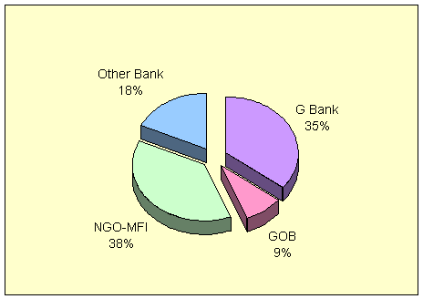
This is a graph of cumulative loan disbursement by the micro finance institutes. The government program’s outstanding microfinance balance is BDT 7.46 billion, Grameen Bank's outstanding balance is BDT 12.73 billion, and the outstanding balance of other banks is BDT 7.55 billion. Grameen Bank, BRAC, ASA, and Proshika are the top four MFIs in terms of loan disbursement, outstanding loans, and saving mobilization. More than 70% of the market was served by the top four financial institutions, including Grameen Bank.
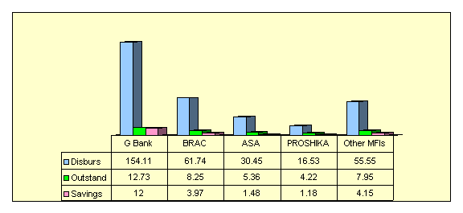
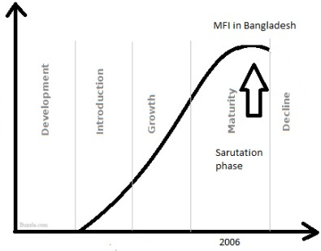
This sector's credit services are divided into six categories and they are: 1) general microcredit for small-scale self-employment, 2) microenterprise loans, 3) ultra-poor loans, 4) agricultural loans, 5) seasonal loans, and 6) disaster management loans. The functionally landless rural poor are the objective of all of the programs. By forming village organizations or centers, all MFIs use the same on-site loan disbursement and weekly collection tactics, and lend out small, uncollateralized one-year term loans to individuals who are part of jointly liable peer groups. Between the time of 1995 to 2006, they grew to a significant number of members, and now they are in the maturation stage.
Saturation
phase
This is the graph of Life cycle of MFI in Bangladesh. And we can see from the graph that they are in the Saturation Phase of Maturity Phase from 2006 to 2020.

There are some similarities and dissimilarities of the MFIs. As we all know Grameen Bank, BRAC, ASA, and Proshika are the top four microfinance institutions in terms of loan disbursement, outstanding loans, and savings mobilization.So, Now I am going to show you the Difference between this Top four industries and want to clear the activities of the MFIs. I will start with the similarities of this industries-

4.1.1 Similarity of GB, BRAC, ASA, PROSHIKA
Grameen Bank, Brac, Asa, Proshika are some of many Microfinance Service Providers (MSPs) in Bangladesh. Although Bangladesh has thousands of microfinance institutions (MFIs), the business is mainly dominated by four major MFIs (BRAC, Grameen, ASA, and Proshika). All of the programs, they are providing actually the rural poor people who are functionally landless. Some other similarities between this top four MFIs are given below-

Activities- Bangladesh leads the microfinance business in terms of outreach, outstanding loans, savings, and successful service delivery. GB,BRAC, and Proshika work in a range of fields, including Peoples Organization Building, Education, Training, Health, Legal and Aid Services, Environmental Protection, and Microfinance, with the purpose of human development and impoverished empowerment. Group-based lending methodology is used by Grameen Bank and ASA, as well as BRAC. The success of microfinance programs for sustainable development for Bangladesh's rural poor has been demonstrated by GB,BRAC,ASA, and PROSHIKA. GB, BRAC, and ASA have all reached out to the "very poor," particularly the women, through their specific loan schemes. GB, BRAC, and ASA (ASA has a male micro-credit program) largely target rural women, offering small loans for income-generating activities and bringing about meaningful change in their lives.

Operational Mechanism- GB, BRAC, and ASA have provided microfinance services before and have a good experience in this sector. They offer microcredit, savings, micro-insurance, and education to disadvantaged people who are unable to acquire credit from typical private banks.

Services- Similar services of GB,BRAC,ASA,PROSHIKA offers are – credit and education.On the other hand GB,BRAC and ASA hasa few more similarity rather than PROSHIKA and they are insurance and saving service.GB,BRAC and PROSHIKA also have some few similarities like training and health service.Along with this services PROSHIKA and BRAC has so other similarities on their service as- social development,advocacy and human resource development. ASA,BRAC and GB give weakly basic loan to their customers. ASA,BRAC, and PROSHIKA services are strictly targeted to a well-defined set of clients.
Development- Microfinance approaches of GB, BRAC, PROSHIKA, and ASA established their organizational work so successfully in villages, even in slum areas, and implemented many different development projects in order to stabilize and bring a good change to rural life. Most measures, such as loan disbursement, loan size per borrower, net savings per microfinance institution (MFI), and loan outstanding per MFI, saw considerable increases in Bangladesh. Bangladesh has experienced considerable socioeconomic and economic progress in recent decades, thanks to these four MFIs. BRAC, ASA, and Grameen Bank share some financial similarities, including ROE, OSS, and FSS.They have made a substantial contribution to the long-term success of GB, BRAC, and ASA.
Particular | GB | BRAC | ASA
Disbursement (in million dollar) | 1151.00 | 565.69 | 898.39
Outstanding (in million dollar) | 792.00 | 655.28 | 457.60
Repayment rate (%) | 97.00 | 99.47 | 99.64
Return on Equity (ROE %) | 5.64 | 4.73 | 3.57
Operational Self Sufficiency (OSS %) | 102.63 | 105.00 | 140.27
Financial Self-Sufficiency （FSS） | 99.21 | 111.48 | 110.63
Savings (in million dollar) | 1205.95 | 268.59 | 68.45
Net profit (in million dollar) | 5.38
The three institutions- GB, BRAC, and ASA, have 97, 98, and 88 percent active women borrowers, respectively, demonstrating their dedication to women's empowerment. MFIs supported by PKSF, such as Grameen Bank, BRAC, ASA, PROSHIKA, and several local MFIs, have played a critical role in ensuring access to credit and enterprise development in Bangladesh.

4.1.2 Dissimilarity of GB,BRAC,ASA,PROSHIKA
The number of borrowers and members differs between the four MFIs, as does the range of services they provide. Proshika and BRAC provide a wide range of services to its members, whilst Grameen and ASA specialize in microfinance. Unlike Grameen Bank, ASA does not provide the option of rescheduling the loans with the late customers.Like this differences this four MFIs have other dissimilarities which are given below-

Operational Mechanism – GB charges a 20% interest rate on their loan, while BRAC charges a 25% interest rate. Grameen Bank is a one-of-a-kind bank that offers loans to the poor, particularly women in groups of five.BRAC is a private development organization that provides financial and social services to the poor in groups of thirty to forty people. Meanwhile, as a fully-fledged microfinance institution, ASA provides individual loans to groups of 30-40 persons with no group co-liability. PROSHIKA encourages village residents to form samitis, or self-organized groups. Now I will show you some operation mechanism of Grameen Bank, ASA and BRAC –

Particular | GB | BRAC | ASA
Group | 5 members | 30- 40 members | 30-40 members
Group function | weekly meeting, information sharing and discussions | Weekly meeting, information sharing, legal aid and health issues | Weekly meeting, information sharing
Loans | Group and individual | Group and individual | Individual
Lending decision | Area office | Branch office | Branch office up to certain level
Approval Procedure | After becoming familiar with "sixteenth decisions," the application is accepted and approved at the center meeting. The first two members are given loans and after six weeks of repayment, the remaining members of the group are permitted to borrow. | Must be a VO member and need to save on a regular basis; loans are approved based on the borrower's ability to use the money, the type of business, and the profitability of IGAs. | ASA members are eligible for a loan after saving a prescribed amount for three months in an ASA branch office.
Liability | Group and individual | Group and individual | Individual
Collateral | Free, no group members are responsible to pay on behalf of others | C o l l a t e r a l f r e e , n o l e g a l documents required | Collateral free
Service | Door steps | Door steps | Door steps
Repayment | Usually held once a week in the center, the solidarity group acts as a pressure group to ensure repayment; in addition field personnel may visit borrowers' homes in the event of default. | The solidarity group meets weekly in the center and acts as a pressure group to ensure repayment. In addition, field personnel may visit borrowers' homes if they default. | Weekly at the center meeting; monthly for SEL and male loans, with the first installment due after 15 days and the SEL after one month; field personnel may visit borrowers' homes if they default.
Interest rate | Varies (10-15%) flat rate | Varies (10-15%) flat rate | Varies (10-15%) flat rate
Supervision | Having been taught how to use the loans and having knowledge of 16 GB's decisions | Extensive training in occupational skill development, as well as supervision of the borrower's business | Training is not provided, and supervision is carried out in the borrower's businesses.

Product Diversity- BRAC, GB, and ASA provide support service to the underprivileged, but PROSHIKA is a human development center.GB, BRAC, and ASA have segmented their loan and savings programs to cater to various socioeconomic groups.Individual loans are given to villagers in groups by GB and BRAC, although GB gives loans to groups of five individuals and BRAC offers loans to groups of forty people, wheres ASA only gives individual loans to groups of 30-40 people. GB also provides remittance and social business, which are services that no other MFI provides. GB provides specific services for beggars, educational programs for members' children, and social enterprise, which are not offered by other MFIs in Bangladesh.GB's visits clients at their homes rather than having them come to the office, whereas other institutions need consumers come to their office to receive their services.
Objectives- Objectives of the MFI’s is quite different from each instituition . For example, BRAC's interventions are aimed at bringing about large-scale beneficial changes through economic and social programs that assist both women and men in realizing their full potential. BRAC's main objectives are to reduce poverty and empower the underprivileged. Where Grameen Bank is only concerned about the poor people.Their objectives all about poor people development.So let’s see the objectives of this instituition. Grameen Bank provides free banking services to the rural poor, freeing them from the exploitation of money lenders, creates self-employment opportunities for Bangladesh's vast untapped and underutilized manpower resources, organizes disadvantaged people into small federations for mutual support and self-sustained socio-economic development and most importantly, empowering and involving poor women in economic activities. Asa’s objectives are little bit different from the above two industries because ASA is associated for Social Advancement. They concentrated on increasing awareness and forming groups for the poor, with the goal of achieving integrated development through the assertion of poor rights, education, mini-irrigation, primary health, and credit for revenue generation, among other things. The objectives of Proshika is different from the other MFI’s though they also work for the poor but their objectives are quite different from the other. So, PROSHIKA's objectives include structural poverty reduction, environmental protection and regeneration, enhanced women's status, public involvement, people's capacity to gain and practice democratic and human rights and finally, the development of poor people's leadership.

In Bangladesh, the MFI sector performed admirably. Their customer base grew year after year. GB, BRAC, ASA, PROSHIKA, and other MFIs were founded to help the impoverished with financial and other assistance. They provide microcredit, savings, and social services to the underprivileged who are unable to access these services through traditional banks. These MFIs have shown their capacity to manage successfully and efficiently their innovative management strategies and decentralized management systems. Their microfinance clients, particularly women, have proved their capacity to use loans, repay them on time, keep good credit, and be honest. And all of this have helped to expand the microfinance business's scope in a sustainable manner. People have contributed to the success of the microfinance sector in their different roles. GB, BRAC, PROSHIKA, ASA, and other MFIs' microfinance methods have allowed them to work successfully in rural and slum areas in the world's poorest countries. It is unbelievable to think that a impoverished country (such as Bangladesh) is thought to be capable of developing its own path to poverty alleviation.

Chapter 5

Recommendation and Conclusion

5.1Recommendation

Although the way Grameen Bank organizes their approach system is excellent and recognized, I believe there are still certain flaws that must be addressed in order for the bank to grow and improve. As we all know that Grameen Bank is among the top four MFI’s in Bangladesh so, If Grameen Bank wants to be a number one Micro Finance Industry in Bangladesh then they need to improve things in some areas for their betterment.

5.1.1 Improving organizational operations

- Despite the fact that Grameen Bank is a prominent advocate for women's empowerment, the number of women employed by the bank is small and needs to grow.
- People and institutions should be free from all of the negative perceptions.
- Determine the actual cost and an acceptable service charge for each product which are offered.
- The credit deliver system should be improved.
- GB authorities should take some steps to improve members' knowledge and efficiency through appropriate training courses.
- Bank officers should pay visits to the projects on a regular basis.
- Grameen Bank should not charge any down payment for the loan
- The limit of Household loan should be increased
- Maintaining a recovery team is essential for proper investigation by the employee not
working.
- They should increase more new sector for loan disbursement.

5.1.2Improving departmental operations

    - They need to open more branches in the city so that impoverished individuals who live in slums and are jobless can receive assistance.There aren't many branches in the city, but there are many poor people in every city in Bangladesh.They are in desperate need of assistance. They require suitable guidance in order to carry out their tasks. If they begin working for the city, their membership will grow even more.
    - Need to hire a few additional workers for the Department of International Programs. Because the pressure in this department is much high. It’s not possible for one people in front desk to handle. They have too many foreign and local clients, so it’s important.
    - They'll have to start offering mobile banking services. Because the majority of their consumers are from rural areas, they all have cell phones. If they can connect with their customers by mobile banking service, this would help rural people a lot. Their charge interest rate is too much low compare to other bank. So they can be benefited by doing mobile banking service at lower cost compare to other competitors in market.
    - They must begin all transaction entry procedures using an internet platform. This would be more convenient. Because the data came from branch office to head office need almost one week. Now internet connection availability and technology is easy to get. Every branch manager need to be connected through the branch to head office by using up-to-date transection entry process.

5.2 Conclusion

Poor people's livelihoods are difficult to improve. To help the impoverished Muhammed Yunus created Grameen Bank in 1976 in the village of Jobra, Bangladesh. GB provides financing to the poorest of the poor in rural Bangladesh with no collateral. They've shown that the poor can be bankable and they're capable of making sound business decisions when it comes to using their loans and returning them on time. Microcredit has been spread across the country by a variety of government and non-governmental institutions over the last three decades with Grameen Bank playing a key role in putting the concept into practice. Bangladesh's socioeconomic structure, particularly in rural areas, has been significantly influenced by Grameen Bank.They use micro-credit to empower Bangladeshi rural women, and as a result, they are creating new entrepreneurs and self-sufficient people. The Grameen Bank model has been widely adopted throughout the world, in both developed and developing countries.China, India, Pakistan, Sri Lanka, African countries, the United States, Canada, and Germany all have used the method, depending on the flexibility of their respective countries.
In this report, I attempted to represent the Grameen Bank as well as the contrasts between the Grameen Bank and the other MFI sectors in Bangladesh. In Bangladesh, the MFI sector performed admirably. Every year, the number of clients and branches grew. Using MFI's services, poor people can take care of their health and education, and they can also enable MFI to be more sustainable by paying their dues on time. Grameen Bank, BRAC, PROSHIKA, and ASA, among other MSPs, have been able to show that microfinance can help Bangladesh's rural poor to achieve long-term development. Microfinance success is thought to be impossible to attain without the active participation of the Bangladeshi people, particularly women.The credit culture, discipline, and commitment towards maintaining regular repayment and compliance with microfinance provider norms are noticeable. As an intern I can say that Grameen Bank borrowers must be efficient and capable of diversifying into new businesses as the economy grows. Through skill training, technology and promoting their market, they can assist borrowers in their business development. It will help them in the promotion of their products' marketing by identifying and tapping potential local and international markets. Finally, I'd like to point out that GB is fostering a beneficial association between poverty reduction, women's empowerment, and microcredit access.

5.3 References

- https://www.bb.org.bd/saarcfinance/seminar/cpbdesh.php
- https://citeseerx.ist.psu.edu/viewdoc/download?doi=10.1.1.145.5924&rep=rep1&type=pdf
- https://grameenbank.org/data-and-report/balance-sheet-1983-2019-in-bdt/
- https://grameenbank.org/data-and-report/past-five-years-at-a-glance-2015-2019-in-bdt/
- https://en.banglapedia.org/index.php/Microcredit
- https://grameenbank.org/

Appendix
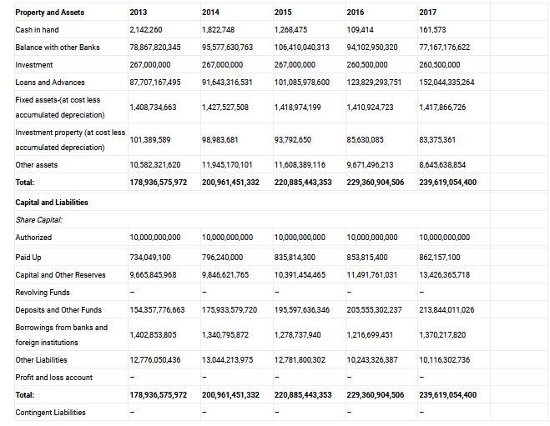
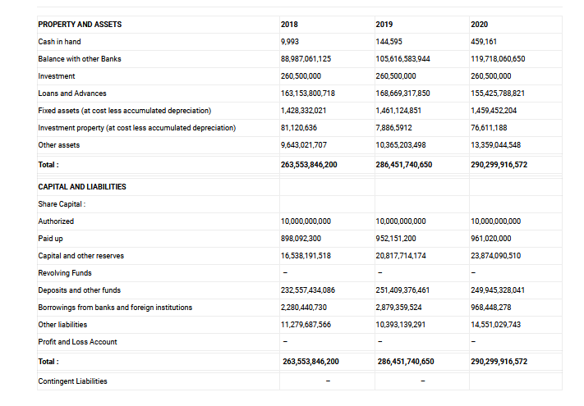

Photo Gallery
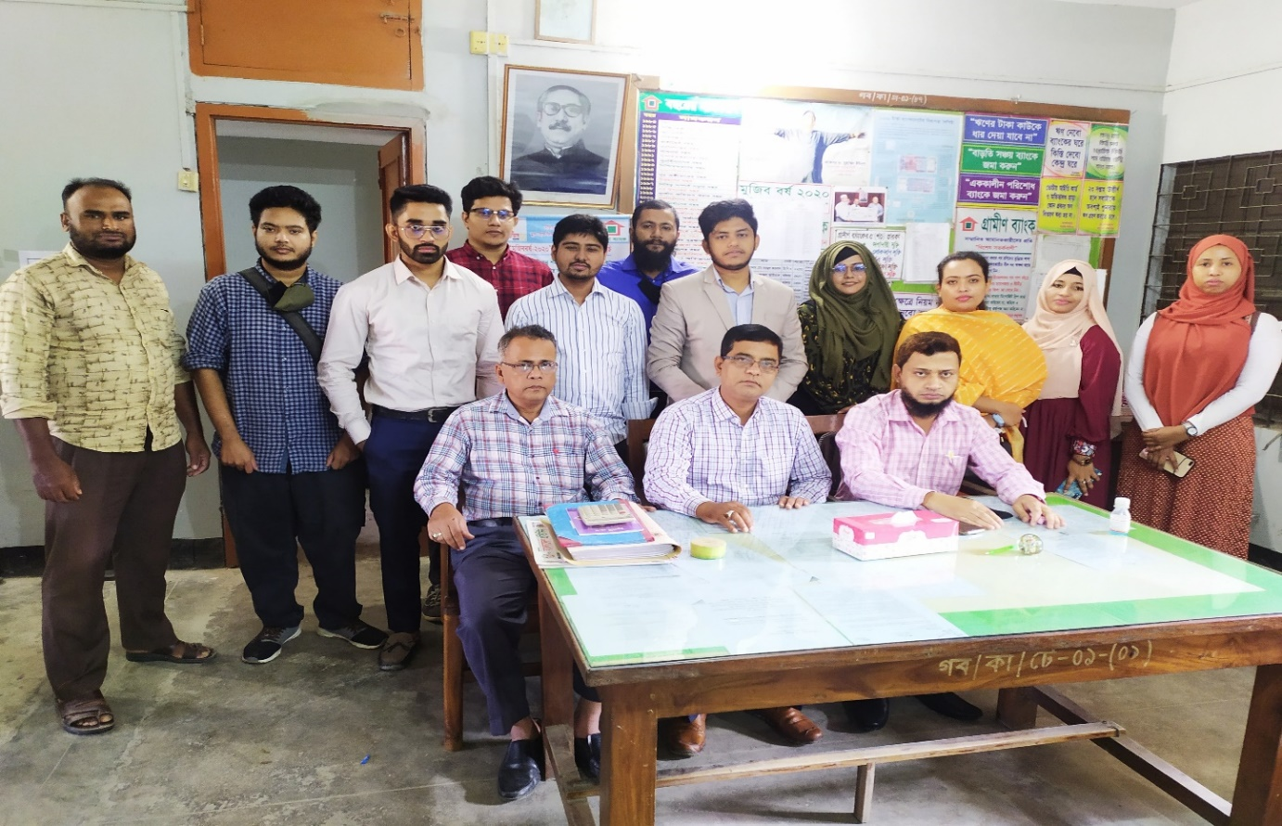
A group photo with Interns and staffs of the Grameen Bank Damrai Branch, Manikgonj

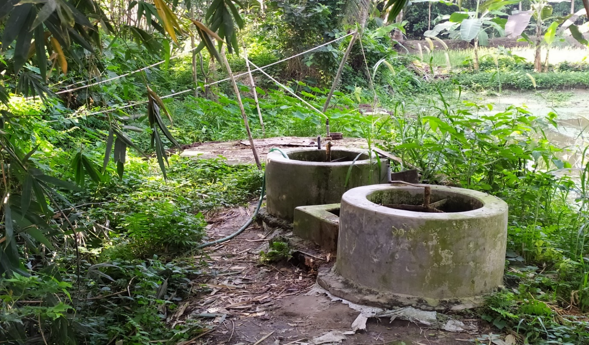
Gas plant- this gas made from the Cow’s Dung

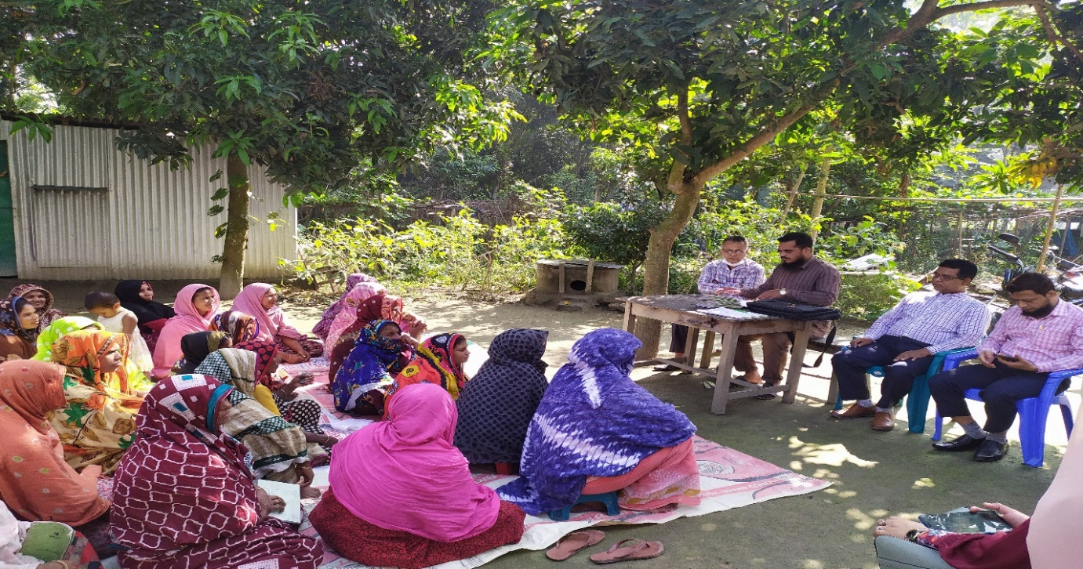
Central meeting of Chapil village

