Internship Report
On
“Customer Satisfaction with the Information System of
Al-Arafah Islami Bank Ltd (aibl)”



Internship Report On
“Customer Satisfaction with the Information System Of
Al-Arafah Islami Bank Limited (aibl)”

Prepared For:
Dr. Mohammad Badruddozza Mia
Professor
School of Business and Economics
United International University
Prepared By:
Suraya Akter
111163067
Major in MIS


School of Business and Economics
United International University

Date of submission:
20-06-2021

Letter of Transmittal
Date: 20-06-2021
To
Dr. Mohammad Badruddozza Mia
Professor
School of Business and Economics
United International University
Subject: Submission of Internship Report on Customer Satisfaction with the Information System of Al-Arafah Islami Bank Limited.
Dear Sir,
It is a great pleasure to submit my internship report which is based on “Customer Satisfaction with the Information System of Al-Arafah Islami Bank Limited” under your superintendence. As per the requirement of Bachelor of Business Administration (BBA), I have completed the Internship in Al-Arafah Islami Bank Limited, Mouchak Branch. This report is basically an analysis-based project where the customer of Al-Arafah Islami Bank fill the survey form which I am able to make in depth analysis.
Throughout the report, I have tried to provide accurate information and tried to follow your suggestion that you have suggested. Also, I tried to give my level best to make this report informative. I sincerely believe that this report would satisfy and meet the requirements.
I am very thankful to you for your cooperation during completing this report.
Thank you.
Sincerely yours,

Suraya Akter
ID: 111 163 067
School of Business and Economics
United International University

Certification of Similarity Index

Declaration of the student
I hereby declare that the internship report presented with titled “Customer Satisfaction with the Information system of Al-Arafah Islami Bank Limited” is prepared by me after the completion of three months’ work at Al-Arafah Islami Bank, Mouchak Branch, Dhaka.

I also declare that the report is prepared for my academic requirement, not for any other purposes.

Name: Suraya Akter
ID: 111 163 067
BBA
Major in MIS
United International University

Acknowledgement
Firstly, I would like to express my gratitude to Almighty Allah who gave me the strength and opportunity to complete this report successfully within the selected time.
Secondly, I would to like to express my gratitude to my honorable Internship supervisor Dr. Mohammad Badruddozza Mia, Professor, School of Business and Economics, United International University whose inspiration, direction and valuable suggestion helped me a lot to completing this report.
After that, my deepest appreciation and special thanks goes to Mr. Mominur Rahman Khan (Executive Officer), Imtiaz Mohammad Saleh (Principal officer) and Md. Golam Rahman (Executive officer) of Al-Arafah Islami Bank Limited (Mouchak Branch) for their cooperation and guidance which helped me a lot in my whole internship period. Also, I would like to thank other employees and staffs for their support, encouragement throughout my internship period and helped me out to fill the survey form.
At last, I am also thankful to those who were involved and helped me both directly and indirectly for preparing my report.

Executive Summary
This report is based on customer satisfaction analysis which has basically 2 parts: the first one is Informational system analysis and another one is operational system analysis. But this report is mainly focused on “Customer Satisfaction with the Information System of Al-Arafah Islami Bank Limited” which highlights information system (Online service, ATM service etc.) and my target in this report has to figure out the answer whether the customer is satisfied or not with their information system and also the employee is satisfied or not with the operational system of Al-Arafah Islami Bank. I have collected data from both customers and employees of Al-Arafah Islami Bank.
At first, I have created a survey questionnaire for my analysis. For the main part of this report, I have collected data form customer and besides that I have also collected data from employees. For customer, there are 27- survey questionnaire in the first part which is divided by four main sub-category (Quality of Service, Customer Support, Ease of Use, Security & Privacy, Overall satisfaction) and for employees, there are 10- survey questionnaire in the second part. The survey was taken in 2 ways- by using printed form which I was created in Microsoft word and by using google form for those who want to fill the form through online. After that, I was used IBM SPSS-26 version, a statistical software for my analysis.
In this report, I tried my best to collect possible data and analyze those data carefully through some statistical method, interpreting the satisfaction level of the customers and employees. Besides that, there have some limitations which I was faced to collect the data from customer because of the pandemic situation. Though, I tried to create an accurate picture of the customer satisfaction level.

Table of Contents
Chapter-1 (Introduction) 1
1.1 Background 2
1.2 Objective 2
1.3 Limitations 2
Chapter-2 (Company Overview) 3
2.1 Profile 4
2.2 Vision 4
2.3 Mission 4
Chapter-3 (Methodology) 5
3.1 Sample and Data Collection 6
3.2 Hypothesis Development 6
3.3 Data Analysis 7
Chapter-4 (Literature Review) 8
Chapter-5 (Data Analysis and Interpretation) 11
(Part-1) 11
5.1 Demographic characteristics of the customer 12
5.2 Behavioral characteristics of the customer 13
5.3 Analyzing the customers response towards the variables 15
5.4 Variables’ significance and hypotheses testing 19
Chapter-5 (Part-2) 23
5.5 Demographic & Behavioral characteristics of the Employee 25
5.6 Analyzing Employee’s response towards the variables 27
Chapter-6 (Conclusion & Recommendation) 29
6.1 Conclusion 30
6.2 Recommendations 30
Chapter-7 (References) 31
Appendix 0

List of Figures
Figure 1: Conceptual model of analysis (Customer satisfaction) 7
Figure 2: Conceptual model of analysis (Employee satisfaction) 24

List of Tables
Table 1: Demographic characteristics of the customer 12
Table 2: Behavioral characteristics of the customer 13
Table 3: Customers perception towards the variables 15
Table 4: Frequencies, Means and Percentage of the variables 17
Table 5: Paired Sample Correlation 19
Table 6: Variables Correlations (Pearson’s Correlation Test) 20
Table 7: Accepting Hypotheses 22
Table 8: Demographic & Behavioral characteristics of the Employee 25
Table 9: Analyzing Employee’s response towards the variables 27

List of Abbreviation
Name | Abbreviation
AIBL | Al-Arafah Islami Bank
EFT | Electronic Fund Transfer
ATM | Automated Teller Machine
TQM | Total Quality Management
BACPS | Bangladesh Automated Cheque Processing System
LC | Letter of Credit
AD | Authorized Dealer

Chapter-1 (Introduction)

As my topic is about Customer satisfaction of the information system of Al-Arafah Islami Bank so I have tried to gather information about their information system and operational system which plays an important role to run the activities of a bank. Sometimes it become so difficult to manage those systems perfectly. Mainly those systems are controlled by the head office of AIBL. If any problem occurred to run those system, then head office will fix the problem and for that reason sometimes it is time consuming.

1.1 Background
I have prepared this report based on survey including total 37 questions which is divided into two parts: First part is based on information system which contains 27- questions and the second part is based on operational system which contains 10- questions. It takes almost one and a half month to complete this report. During this period, I have collected data, analyze those data with SPSS and evaluate the ultimate result. I have collected data from both customers and employees of AIBL.

1.2 Objective
- To measure the overall customer satisfaction with the information system of AIBL.
- To measure the employee satisfaction with the operational system of AIBL.
- To learn how a bank conduct online banking activity.
- To prepare the analysis-based report.
- To learn about data analysis.
- To gain knowledge and experience by working on this report.

1.3 Limitations
- Because of the Covid-19 pandemic situation, Government declared strict lockdown and that’s why the number of customers in bank is decreased than before. So, my data collection was hampered.
- As some people of AIBL cannot understand English very well that’s why I faced a lot of trouble to explain to them.
- The sample size was smaller that’s why outcome might be wrong.

Chapter-2 (Company Overview)

2.1 Profile

Al-Arafah Islami Bank was inaugurated as a private limited company with the objective of gaining prosperity by obeying the way guided by Allah and the path shown by his Rasul (SM). The bank started its operation from 27 September, 1995. The approved capital of the Bank is Tk 15000.00 million and the refined-up capital is Tk. 10440.22 million as on 31 December, 2018. The sponsors of the Bank are Famous Islamic Scholars and Virtuous Businessman of the country.
AIBL follows Shariah based law and for that reason their operations are quite different from other banks activities. The bank has a several layouts of products and services to satisfy customer needs. They have 184 branches and 25 AD branches all over the country.

2.2 Vision

To be a pioneer in Islamic Banking in Bangladesh and contribute significant towards the national economy.

2.3 Mission

- Gaining the satisfaction of Almighty Allah both here and hereafter.
- Follows Shariah Based Banking Practices.
- Quality of financial services of the modern technology.
- Provide fast and efficient customer service.
- Equable and constant growth.

Chapter-3 (Methodology)

3.1 Sample and Data Collection
As there have two parts in this report so for the first part, the sample size of this report is 56 and for the second part the sample size of this report is 18. All of the population of the study are the customers and employees of AIBL (Mouchak Branch). The sample was collected in two ways- by using printed form which I was created in Microsoft word for bank customers and employees for face-to-face interaction and by using google form for those who are actually the customer of AIBL but not face to face interaction. It was a big problem for collect data through offline due to Covid-19 pandemic because the customer of the bank is decreased than before. But in normal situation, the sample size would be much higher. Also, the outcome would be more accurate. The survey takes 7 days because of this pandemic situation.

3.2 Hypothesis Development
For the main and first part of this report, I have developed four basic hypotheses to complete the analysis of customer satisfaction with the information system of Al-Arafah Islami Bank. The hypotheses are developed depending on the following variables:
V1. Quality of service
V2. Customer support
V3. Ease of use
V4. Security & privacy
V5. Overall satisfaction
And the hypotheses are:
H1. There is a positive and significant relationship between the Quality of service and Overall Satisfaction
H2. There is a positive and significant relationship between the customer support and Overall Satisfaction
H3. There is a positive and significant relationship between the ease of use and Overall Satisfaction
H4. There is a positive and significant relationship between the security & privacy and Overall Satisfaction
Each hypothesis consists of several questions related to the hypotheses.

Customer support
- Up to date wallet app
- Customer welfare
- Support customer for using card
- Fulfillment
Quality of service
- EFT service
- ATM service
- Responsiveness
- Ability to pay bills

Customer satisfaction with the information system of Al-Arafah Islami Bank Ltd

Security & privacy
- Secured network
- Customer’s privacy
- Monetary transaction
- Cards safe
Ease of use
- ATM service
- Wallet app
- Navigate website
- Flexibility

Figure 1: Conceptual model of analysis (Customer satisfaction)

3.3 Data Analysis

Data collected via the survey are analyzed by using IBM SPSS 26-version, a statistical analysis tool. I have done the demographic data, behavioral characteristics and hypothesis testing by this. Mean, coefficient of correlations, frequencies were computed by SPSS. Variables were also tested. All these tests, computations and calculations helped me analyze the data in depth. In addition, it helped me to analyze the data and make decisions about the report. Also, I took help from google form data analysis, especially the charts and graphs prepared automatically by google based on the survey data to understand deeply about the data.

Chapter-4 (Literature Review)

There are a lot of studies to show the satisfaction level of customers in bank. All the studies are based on some common factors like Quality of Services, Customer Support, Ease of Use, Security & Privacy. I will try to define all the factors in brief.
Customer satisfaction, which determine an actual system for value of enterprises and organizations. It serves the advancement of a customer-centered management and culture. Assessment of customer satisfaction represents a proximate, significant and motive response about clients’ fondness and hope. (Mihelis, G., Grigoroudis, E., Siskos, Y., Politis, Y., & Malandrakis, Y; 2001)
Customer satisfaction is an important thing for both academic and bankers. It is all about quality of service, hope, performance, ease of use as important factors. (Jamal, A., & Naser, K; 2002)
There are some factors which refers customer satisfaction specifically in online banking and this is the important and rapid-developing system of doing banking. The factors are availability, compatibility, security & privacy, user-interface, system speed, fees have impact on customer satisfaction but the other factors have no remarkable impact. (Machogu, A. M., & Okiko, L.; 2015).
There is a great relationship between quality of online service, belief and satisfaction of customer. Quality of online banking service has massive influence based on belief. Online Banking privacy & security in online, fulfillment of the information, flexibility of the system are the important factors of quality of service and those have big impact on belief. Banks should be more cautious about the security & privacy of customers personal transaction. (Kundu, S., & Datta, S. K.; 2015)
To satisfy customers, online banking is an effective and appropriate instrument for banking sector. Online banking service is a common service for all banks to provide quickly and dependable service for customer. With rapid technology development, online banking take advantage of leading banking transactions. The main problem with online banking is customers satisfaction who are recently using Internet banking. Customer satisfaction is an important factor for banks to retain their competitive advantage. There are 4 factors to fulfill customer satisfaction towards online banking which are cloud services, privacy & security, e-learning and quality of service. (Li, F., Lu, H., Hou, M., Cui, K., & Darbandi, M.; 2021)
There are six factors of customer satisfaction and they are Ease of use, user-interface, flexibility of the system, security & privacy, fulfilment of the information and customer support which have massive impact on customer satisfaction but Ease of use does not have that much impact on customer satisfaction. For high experience group, user-interface, flexibility of the system, security & privacy, fulfilment of the information was remarkably higher. For low experience group, Customer support was remarkably higher. (Yoon, C.; 2010)
For online banking, management should focus on user-interface of the website to seek attention of the existing customer and new customer also. The management should take necessary steps to improve the privacy & security of online bank accounts where customers can retain long-term relationships with the use of online banking. Online banks should provide more dependable services so that customers feel more secure and confident. The management should solve the problems of customers quickly. (Raza, SA., Jawaid, ST., Hassan, A.; 2015)
Advancement of technology have created online banking channel. Online banking services has been grown up rapidly in the world. The leading countries, the number of online banking contracts go beyond 50 percent. (Pikkarainen, T., Pikkarainen, K., Karjaluoto, H. & Pahnila, S.; 2004)
At present, banking services are not only brick structure but also click structure. Because of advancement of technology, online banking channels has changed the way of banking services. Banking is a customer-centered service sector and customer satisfaction has become the most significant factor of any banking sector due to extensive competition. By providing best quality of services, Banks are more determined to hold their existing customers to manage customer satisfaction. Traditional banking has taken place to online banking rapidly. (Munish Kumar, 2016)

Chapter-5 (Data Analysis and Interpretation)

(Part-1)

Customer Satisfaction with the Information System of
Al-Arafah Islami Bank (aibl)
Data was analyzed by IBM SPSS 26-version. Frequencies, Percentages, Mean, Coefficient etc. were used to test the hypotheses and variables. Significant and positive relationship between the variables were also tested.

5.1 Demographic characteristics of the customer
Table 1: Demographic characteristics of the customer
Demographics | Frequency | Percentage | Cumulative percentage
Gender  Male  Female  Total | 30  26  56 | 53.6  46.4  100 | 53.6  100
Age group  Below 18  18-25  26-35  36-45  Above 45  Total | 0  19  27  8  2  56 | 0  33.9  48.2  14.3  3.6  100 | 0  33.9  82.1  96.4  100
Occupations  Student  Service holder  Businessman  Self-employed  Housewife  Others  Total | 13  20  3  9  7  4  56 | 23.2  35.7  5.4  16.1  12.5  7.1  100 | 23.2  58.9  64.3  80.4  92.9  100
According to the analysis, we can see on ‘Table-1’ that,
About Gender, 53.6% of the population are Male and 46.4% are Female.
About Age group, 33.9% of the population belong to the age group 18-25, 48.2% of the population belong to the age group 26-35, 14.3% of the population belong to the age group 36-45 and 3.6% of the population belong to the age above 45.
About their Occupation, 23.2% of the population are Student, 35.7% of the population are Service holder, 5.4% of the population are Businessman, 16.1% of the population are Self-employed, 12.5% of the population are Housewife and 7.1% of the population are others.

5.2 Behavioral characteristics of the customer
Table 2: Behavioral characteristics of the customer
Behavioral characteristics | Frequency | Percentage | Cumulative percentage
Preference  Traditional banking  Online banking  Both  Total  Internet banking usage  Regularly  Sometimes  Never  Total  Getting information from website  Yes  No  Often  Total | 7  20  29  56  23  32  1  56  19  8  29  56 | 12.5  35.7  51.8  100  41.1  57.1  1.8  100  33.9  14.3  51.8  100 | 12.5  48.2  100  41.1  98.2  100  33.9  48.2  100

Online service  Yes  No  Maybe  Total  Know about Islamic wallet app  Yes  No  Total  Check account balance  through Islamic Wallet app  Yes  No  Total  Webmail service  Yes  No  Total | 43  0  13  56  14  42  56  12  44  56  19  37  56 | 76.8  0  23.2  100  25  75  100  21.4  78.6  100  33.9  66.1  100 | 76.8  0  100  25  100  21.4  100  33.9  100

In ‘Table-2’ we can see that,
About Preference, 12.5% of the population prefer traditional banking, 35.7% of the population prefer online banking and 51.8% of the population prefer both traditional banking and online banking.
About Internet Banking Usage, 41.1% of the population uses internet banking regularly, 57.1% of the population uses internet banking sometimes and 1.8% of the population uses internet banking never.
About Getting Information from Website, 33.9% of the population get information from website, 14.3% of the population don’t get information from website, 51.8% of the population often get information from website.
About Online Service, 76.8% of the population said that AIBL provide online service and 23.2% of the population said that maybe AIBL provide online service.
About Islamic Wallet App, 25% of the population know about Islamic Wallet app and 75% of the population don’t know about Islamic Wallet app.
About Check Account Balance through Islamic Wallet App, 21.4% of the population check account balance through Islamic Wallet app 78.6% of the population don’t check account balance through Islamic Wallet app.
About Webmail Service, 33.9% of the population use webmail of AIBL for any kind of issue and 66.1% of the population don’t use webmail of AIBL for any kind of issue.

5.3 Analyzing the customers response towards the variables
Table 3: Customers perception towards the variables
Variables | Statistics
Variables | N  (Number of population) |  | Mean | Std. Deviation | Minimum | Maximum
Variables | Valid | Missing
Quality of service  Quality of EFT system  ATM service  Responsiveness  Ability to pay bills  Customer support  Up to date Islamic wallet app  Customer welfare  Support customer about using card  Fulfillment  Ease of use  Usage of ATM  Usage of Islamic Wallet App  Navigate website  Flexibility  Security & privacy  Secured network  Customer’s privacy  Monetary transaction  Cards are safe to use  Overall satisfaction | 56  56  56  56  56  56  56  56  56  56  56  56  56  56  56  56  56  56  56  56  56 | 0  0  0  0  0  0  0  0  0  0  0  0  0  0  0  0  0  0  0  0  0 | 3.6473  3.8750  3.0536  3.0836  3.8571  3.7946  3.2679  4.1071  4.0839  3.7143  3.4554  3.3571  3.1786  3.4286  3.8571  4.1295  4.0536  4.2679  4.1429  4.0536  4.0536 | 0.433738  0.634250  0.882551  0.585263  0.553619  0.537475  0.700417  0.927922  0.920016  0.652667  0.564292  0.818615  0.741182  0.759357  0.553619  0.553619  0.724121  0.774387  0.772918  0.519428  0.585263 | 3.00  3.00  1.00  3.00  3.00  2.50  2.00  1.00  1.00  2.00  1.50  1.00  1.00  1.00  3.00  3.00  3.00  3.00  2.00  3.00  3.00 | 4.50  5.00  5.00  5.00  5.00  4.75  5.00  5.00  5.00  5.00  5.00  5.00  5.00  5.00  5.00  5.00  5.00  5.00  5.00  5.00  5.00

Table 4: Frequencies, Means and Percentage of the variables
Variables | Overall satisfaction
Variables | Strongly  disagree |  | Disagree |  | Neither agree nor disagree |  | Agree |  | Strongly agree |  | Mean
Variables | R | % | R | % | R | % | R | % | R | % | 3.8750  3.0536  3.0836  3.8571  3.6473  3.2679  4.1071  4.0839  3.7143  3.7946  3.3571  3.1786  3.4286  3.8571  3.4554  4.0536  4.2679  4.1429  4.0536  4.1295  4.0536
Quality of service  (Highly dissatisfied, Dissatisfied, Neutral, Satisfied, highly satisfied)  1.Quality of EFT  2. ATM service  3. Responsiveness  4. Ability to pay bills  Overall mean  Custom support  1. Islamic Wallet App  2. Customer welfare  3. Support customer about using cards  4. Fulfillment  (Highly dissatisfied, Dissatisfied, Neutral, Satisfied, highly satisfied)  Overall mean  Ease of use  1. Usage of ATM  2. Usage of Islamic Wallet App  3. Navigate website  4. Flexibility  (Highly dissatisfied, Dissatisfied, Neutral, Satisfied, highly satisfied)  Overall mean  Security & privacy  1. Secured network  2. Customers’ privacy  3. Monetary transaction  4. Cards are safe to use  Overall mean  Overall satisfaction | -  1  -  -  -  -  2  2  -  -  2  2  2  -  -  -  -  -  -  -  - | -  1.8  -  -  -  -  3.6  3.6  -  -  3.6  3.6  3.6  -  -  -  -  -  -  -  - | -  18  -  -  -  6  -  -  1  -  2  4  1  -  -  -  -  1  -  -  - | -  32.1  -  -  -  10.7  -  -  1.8  -  3.6  7.1  1.8  -  -  -  -  1.8  -  -  - | 15  22  16  13  -  31  9  9  19  -  30  33  26  13  -  13  11  10  6  -  - | 26.8  39.3  28.6  23.2  -  55.4  16.1  16.1  33.9  -  53.6  58.9  46.4  23.2  -  23.2  19.6  17.9  10.7  -  - | 30  13  35  38  -  17  24  25  31  -  18  16  25  38  -  27  19  25  41  -  - | 53.6  23.2  62.5  67.9  -  30.4  42.9  44.6  55.4  -  32.1  28.6  44.6  67.9  -  48.2  33.9  44.6  73.2  -  - | 11  2  5  5  -  2  21  20  5  -  4  1  2  5  -  16  26  20  9  -  - | 19.6  3.6  8.9  8.9  -  3.6  37.5  35.7  8.9  -  7.1  1.8  3.6  8.9  -  28.6  46.4  35.7  16.1  -  -

Here from ‘Table- 3’ and ‘Table- 4’,
The overall mean for Overall satisfaction is ‘4.0536’. That means Overall satisfaction level of the customers is almost satisfied.
The overall mean for ‘Quality of Service’ is ‘3.6473’. That means customers’ reaction towards ‘Quality of Service’ is above neutral.
The overall mean for ‘Customer Support’ is ‘3.7946’ which means customers’ reaction towards is above neutral.
The overall mean for ‘Ease of Use’ is ‘3.4554’. That means customers’ reaction towards ‘Ease of Use’ is almost neutral.
The overall mean for ‘Security and Privacy’ is ‘4.1295’. That means customers’ reaction towards ‘Security and Privacy’ is satisfied.
In the end, we can say that customers’ reaction towards the overall satisfaction is satisfied. They are quite satisfied with their information system.

5.4 Variables’ significance and hypotheses testing
Table 5: Paired Sample Correlation
Paired sample correlation
 |  | N | Correlation | Significance
Pair 1 | Quality of service & overall customer satisfaction | 56 | .667 | .0000000203189
Pair 2 | Customer support & overall customer satisfaction | 56 | .657 | .0000000382178
Pair 3 | Ease of use & overall customer satisfaction | 56 | .338 | .0109179137686
Pair 4 | Security and privacy & overall customer satisfaction | 56 | .746 | .0000000000424

In ‘Pair 1’ correlation between Quality of Service & Overall Satisfaction with their Online Service is positive. Same for all the pairs. We know correlation is counted between -1 to 1. Where -1 shows extremely negative correlation and 1 shows extremely positive correlation.
Here the correlation for pair 1 to pair 4 are- 0.667, 0.657, 0.338 and 0.746 accordingly. All the results are above 0.5 except pair 3 but shows positive correlation between the hypotheses. Therefore, we can say that the correlation between most of the hypotheses is satisfying.
Table 6: Variables Correlations (Pearson’s Correlation Test)
 |  | Quality of service | Customer support | Ease of use | Security & privacy | Overall satisfaction
Quality of service  Customer support  Ease of use  Security & privacy  Overall satisfaction | Pearson correlation | 1 | .727** | .478** | .663** | .667**
 | Sig. (2-tailed) |  | .0000000002266 | .0001966902640 | .0000000266905 | .0000000203189
 | N  Pearson correlation | 56  .727** | 56  1 | 56  .677** | 56  .757** | 56  .657**
 | Sig. (2-tailed) | .0000000002266 |  | .0000000098744 | .0000000000152 | .0000000382178
 | N | 56 | 56 | 56 | 56 | 56
 | Pearson correlation | .478** | .677** | 1 | .414** | .338*
 | Sig. (2-tailed) | .0001966902640 | .0000000098744 |  | .0015068899016 | .0109179137686
 | N | 56 | 56 | 56 | 56 | 56
 | Pearson correlation | .663** | .757** | .414** | 1 | .746**
 | Sig. (2-tailed) | .0000000266905 | .0000000000152 | .0015068899016 |  | .0000000000424
 | N | 56 | 56 | 56 | 56 | 56
 | Pearson correlation | .667** | .657** | .338* | .746** | 1
 | Sig. (2-tailed) | .0000000203189 | .0000000382178 | .0109179137686 | .0000000000424
 | N | 56 | 56 | 56 | 56 | 56
**Correlation is significant at the 0.01 level (2-tailed)
* Correlation is significant at the 0.05 level (2-tailed)
The results are-
Quality of service Overall satisfaction 0.667
Customer support Overall satisfaction 0.657
Ease of use Overall satisfaction 0.338
Security & privacy Overall satisfaction 0.746
In Pair-1 correlation between Quality of Service and Overall Satisfaction with their online service is 0.667 which is positive correlation and the result is above 0.5. If we see the significance, the significance of this pair is 0.0000000203189 which is much below than 0.01 We all know that ‘Much below the significance level than 0.01, more significant the correlations are’. So, the correlation between Quality of Service and Overall Satisfaction is satisfying and significant.
In Pair-2 correlation between Customer Support and Overall Satisfaction with their online service is 0.657 which is also positive correlation and the result is also above 0.5. If we see the significance, the significance of this pair is 0.0000000382178 which is much below than 0.01. So, the correlation between Customer Support and Overall Satisfaction is satisfying and significant.
In Pair-3 correlation between Ease of Use and Overall Satisfaction with their online service is 0.338 which is positive correlation but the result is below 0.5. It means neutral result. If we see the significance, the significance of this pair is 0.0109179137686 which is not that much below than 0.01. So, the correlation between Ease of Use and Overall Satisfaction is not satisfying and significant.
In Pair-4 correlation between Security & Privacy and Overall Satisfaction with their online service is 0.746 which is positive correlation and the result is much above than 0.5. If we see the significance, the significance of this pair is 0.0000000000424 which is much below than 0.01. So, the correlation between Security & Privacy and Overall Satisfaction is satisfying and significant.

Table 7: Accepting Hypotheses
Hypotheses No. | Hypotheses Name | Accepted or rejected
H1 | There is a positive and significant relationship between the Quality of service and Overall Satisfaction | Accepted
H2 | There is a positive and significant relationship between the Customer support and Overall Satisfaction | Accepted
H3 | The relationship between the Ease of use and Overall Satisfaction is not positive but significant | Rejected
H4 | There is a positive and significant relationship between the Security & privacy and Overall satisfaction | Accepted
In Hypotheses 1, There is a positive and significant relationship between the Quality of Service and Overall Satisfaction. So, the hypothesis is accepted.
In Hypotheses 2, There is a positive and significant relationship between the Customer Support and Overall Satisfaction. So, the hypothesis is accepted.
In Hypotheses 3, There is not a positive but significant relationship between the Ease of Use and Overall Satisfaction. So, the hypothesis is rejected.
In Hypotheses 4, There is a positive and significant relationship between the Security & Privacy and Overall Satisfaction. So, the hypothesis is accepted.

Chapter-5 (Part-2)

Employee Satisfaction with the Operational System of Al-Arafah Islami Bank (aibl)

In the second part of the report, I was collected data from all the employees of AIBL (Mouchak branch) and then analyzed the data by Google form. In this part I was analyzed employee satisfaction with the operational system of AIBL. For employees, there are 10-survey questionnaire in this part and the sample size of this part is 17. The sample was collected in two ways- by using printed form which I was created in Microsoft word for bank employees for face-to-face interaction and by using google form for those who are actually the work in AIBL (Mouchak branch) but not face to face interaction. Here have two variables and they are ‘Employee Support’ and ‘Ease of Use’.
Employee support
- DocuDEX software is up to date
- BACPS software is up to date
- Ababil software is up to date

Ease of use
- Usage of DocuDEX software
- Usage of BACPS software
- Usage of Ababil software

Employee Satisfaction with the Operational System of Al-Arafah Islami Bank Ltd

Figure 2: Conceptual model of analysis (Employee satisfaction)

5.5 Demographic & Behavioral characteristics of the Employee
Table 8: Demographic & Behavioral characteristics of the Employee
Variables | R | Percentage
Demographic characteristics:  Gender  Male  Female  Age group  Below 18  18-25  26-35  36-45  Above 45  Occupation  Student  Service holder  Businessman  Self employed  Housewife  Others  Behavioral characteristics:  Preferences  Traditional banking  Online banking  Both | 15  2  -  -  10  7  -  -  17  -  -  -  -  -  -  17 | 88.2  11.8  -  -  58.8  41.2  -  -  100  -  -  -  -  -  -  100

According to the analysis, we can see on ‘Table-8’ that,
About Gender, 88.2% of the population are Male and 11.8% are Female.
About Age Group, 58.8% of the population belong to the age group 26-35 and 41.2% of the population belong to the age group 36-45.
About their Occupation, 100% of the population are Service holder.
About their preference, they all are prefer both traditional banking and online banking.
DocuDEX software
DocuDEX software is use in Foreign Exchange Department at AIBL for LC related activities. There have two parties (Checker & Maker) who involve in making and checking the LC document. At first the full LC document is created by the maker then this document is sent to the checker for check and if everything is ok then verify the document and then again sent it to the maker. After that, all the document is sent to the AD branch for the next process.
DocuDEX software is up to date, well-organized, simple, user-friendly, secured and employees are satisfied with the usage of the software.
BACPS software
BACPS software is use for cheque clearing. There have also two parties (Checker & Maker) who involve in checking and making the cheque.
BACPS software is up to date, well-organized, simple, secured, user-friendly and employees are highly satisfied with the usage of the software.
Ababil software
Ababil software is use for all other activities i.e., investment or account opening.
Usage of this software, employees have both satisfaction and dissatisfaction reaction. Sometimes this software is in huge traffic issue and at that time this software work slowly which is time-consuming. So, this software should be updated.
Otherwise, this software is user-friendly, simple, secured and well-organized.

5.6 Analyzing Employee’s response towards the variables
Table 9: Analyzing Employee’s response towards the variables
Variables | Overall satisfaction
Variables | Highly dissatisfied |  | Dissatisfied |  | Neutral |  | Satisfied |  | Highly satisfied
Variables | R | % | R | % | R | % | R | % | R | %
Employee support:  (Strongly disagree, Disagree, neither agree nor disagree, Agree, strongly agree)  DocuDEX software is up to date  BACPS software is up to date  Ababil software is up to date  Ease of use:  Usage of DocuDEX software  Usage of BACPS software  Usage of Ababil software | -  -  -  -  -  - | -  -  -  -  -  - | -  -  -  -  -  - | -  -  -  -  -  - | -  -  2  -  -  3 | -  -  11.8  -  -  17.6 | 7  5  15  9  8  11 | 41.2  29.4  88.2  52.9  47.1  64.7 | 10  12  -  8  9  3 | 58.8  70.6  -  47.1  52.9  17.6

According to the analysis, we can see on ‘Table-9’ that,
About DocuDEX software (Employee Support), 41.2% of the population is agree that DocuDEX software is up to date and 58.8% of the population is strongly agree that DocuDEX software is up to date.

About BACPS software (Employee Support), 29.4% of the population is agree that BACPS software is up to date and 70.6% of the population is agree that BACPS software is up to date.
About Ababil software (Employee Support), 88.2% of the population is agree that Ababil software is up to date and 11.8% of the population says neither agree nor disagree that Ababil software is up to date.
That means this software have some problem and the problem is when this software is in huge traffic at that time this software work slowly. So, this software should be updated.
About DocuDEX software (Ease of Use), 52.9% of the population is satisfied with the use of DocuDEX software and 47.1% of the population is highly satisfied with the use of DocuDEX software.
About BACPS software (Ease of Use), 47.1% of the population is satisfied with the use of BACPS software and 52.9% of the population is highly satisfied with the use of BACPS software.
About Ababil software (Ease of Use), 17.6% of the population is neutral with the use of Ababil software, 64.7% of the population is satisfied with the use of Ababil software and 17.6% of the population highly satisfied with the use of Ababil software. That means Employees are satisfied with the use of Ababil software because this software is user-friendly, simple, secured and well-organized.

Chapter-6 (Conclusion & Recommendation)

6.1 Conclusion
The objective of this report is to understand the Customers Satisfaction with the Information System of AIBL. In spite of some limitations, somehow the report is successfully done and achieved its objective. To do this report, I had some limitations as well as the pandemic situation was itself a limitation. The sample size was not significant. It was started with a simple survey. Customers provided their opinion by attending the survey. Later the outcome of the survey was analyzed by IBM SPSS 26-version. In the first step, means and frequencies of the variables helped to understand the customers satisfaction level. Customers were satisfied with their Security & privacy and it is accepted. They have almost neutral reaction towards Ease of Use but it is rejected. They have above neutral reaction towards Quality of Service and Customer Support and those are also accepted. These variables influenced the overall satisfaction and this study shows that the overall satisfaction was satisfied.
Lastly, correlations between the variables were measured. I used ‘Paired Samples Correlations and Pearson’s Correlation Test’ which was essential to prove the reliability and acceptability of this project. According to the results, Ease of Use has the least impact on the overall satisfaction. Satisfaction of the privacy & security has the most impact on the overall satisfaction. Quality of Service and Customer Support influenced second and third most accordingly on the overall satisfaction.

6.2 Recommendations
After observing and interpreting the analysis, I can suggest some recommendations to improve their information system. They are-
- ATM service should be improved because customers are very much dissatisfied with their ATM service. Authority should be concern about maintenance of ATM Booth.
- As customer does not know very much about their Islamic Wallet App that’s why at first let them know about this app clearly and encourage them to use this app.
- AIBL authority does not concern about branding that’s why they are falling behind rather than other banks. So, authority should be focus on branding their service what they provide to their customer.
- Ababil software should be updated.

Chapter-7 (References)

1. Chandio, F., Irani, Z., Zeki, A., Shah, A., & Shah, S. (2017). Online banking information systems acceptance: An empirical examination of system characteristics and web security. Information Systems Management, 34(1), 50-64.
2. G.MihelisaE.GrigoroudisbY.SiskosbY.PolitisbY.Malandrakisb. (2001). Customer satisfaction measurement in the private bank sector. https://www.sciencedirect.com/science/journal/03772217, 347-360.
3. Jamal, A., & Naser, K. (2002). Customer satisfaction and retail banking: an assessment of some of the key antecedents of customer satisfaction in retail banking. International journal of bank marketing.
4. Kadir, H., Rahmani, N., & Masinaei, R. (2011). Impacts of service quality on customer satisfaction: study of online banking and ATM services in Malaysia. International Journal of Trade, Economics and Finance, 2(1), 1.
5. Li, F., Lu, H., Hou, M., Cui, K., & Darbandi, M. (2021). Customer satisfaction with bank services: The role of cloud services, security, e-learning and service quality. Technology in Society, 64, 101487.
6. Mihelis, G., Grigoroudis, E., Siskos, Y., Politis, Y., & Malandrakis, Y. (2001). Customer satisfaction measurement in the private bank sector. European Journal of Operational Research, 130(2), 347-360.
7. Mihelis, G., Grigoroudis, E., Siskos, Y., Politis, Y., & Malandrakis, Y. (2001). Customer satisfaction measurement in the private bank sector. European Journal of Operational Research, 130(2), 347-360.
8. Nupur, J. (2010). E-Banking and Customers’ Satisfaction in Bangladesh: An Analysis. International Review of Business Research Papers, 6, 145-156.
9. Pikkarainen, T., Pikkarainen, K., Karjaluoto, H., & Pahnila, S. (2004). Consumer acceptance of online banking: an extension of the technology acceptance model. Internet research.
10. Raza, S., Jawaid, S., & Hassan, A. (2015). Internet banking and customer satisfaction in Pakistan. Qualitative Research in Financial Markets.
11. Shanka, M. (2012). Bank service quality, customer satisfaction and loyalty in Ethiopian banking sector. Journal of Business Administration and Management Sciences Research, 1(1), 001-009.
12. Yoon, C. (2010). Antecedents of customer satisfaction with online banking in China: The effects of experience. Computers in Human Behavior, 26(6), 1296-1304.

Appendix
Survey Questionnaire (Part-1)
No. | Questions | Options
1 | Gender | - Male  - Female  - Other
2 | Age group | - Below 18  - 18-25  - 26-35  - 36-45  - Above 45
3 | Occupations | - Student  - Service holder  - Businessman  - Self Employed  - Housewife  - Others
4 | What do you prefer? | - Traditional banking  - Online banking  - Both
5 | Internet banking usage | - Regularly  - Sometimes  - Never
6 | Do you get all information easily from Al-Arafah Islami bank's website? | - Yes  - No  - Often
7 | Does Al-Arafah Islami Bank provide online service? | - Yes  - No  - Maybe
8 | Do you know about Islamic wallet app? | - Yes  - No
9 | Do you check account balance through Islamic Wallet app? | - Yes  - No
10 | Do you use webmail of Al-Arafah Islami Bank for any kind of issue? | - Yes  - No
(Quality of EFT)  11  12  13  14 | - Quality of EFT system  - ATM service  - Responsiveness  - Ability to pay bills | 1-5 (Highly Dissatisfied-Highly satisfied)  1-5 (Highly Dissatisfied-Highly satisfied)  1-5 (Highly Dissatisfied-Highly satisfied)  1-5 (Highly Dissatisfied-Highly satisfied)
(Customer Support)  15  16  17  18 | -Up to date Islamic wallet app  - Customer welfare  - Support customer about using card  - Fulfillment | 1-5 (Strongly Disagree-Strongly agree)  1-5 (Strongly Disagree-Strongly agree)  1-5 (Strongly Disagree-Strongly agree)  1-5 (Highly Dissatisfied-Highly satisfied)
(Ease of Use)  19  20  21  22 | - Usage of ATM  - Usage of Islamic Wallet App  - Navigate website  - Flexibility | 1-5 (Strongly Disagree-Strongly agree)  1-5 (Strongly Disagree-Strongly agree)  1-5 (Strongly Disagree-Strongly agree)  1-5 (Highly Dissatisfied-Highly satisfied)
(Security & Privacy)  23  24  25  26 | - Secured network  - Customer’s privacy  - Monetary transaction  - Cards are safe to use | 1-5 (Strongly Disagree-Strongly agree)  1-5 (Strongly Disagree-Strongly agree)  1-5 (Strongly Disagree-Strongly agree)  1-5 (Strongly Disagree-Strongly agree)
(Overall satisfaction)  27 | - Overall satisfaction | 1-5 (Strongly Disagree-Strongly agree)
Survey questionnaire (Part-2)
No. | Questions | Options
1 | Gender | - Male  - Female  - Other
2 | Age group | - Below 18  - 18-25  - 26-35  - 36-45  - Above 45
3 | Occupations | - Student  - Service holder  - Businessman  - Self Employed  - Housewife  - Others
4 | What do you prefer? | - Traditional banking  - Online banking  - Both
(Employee support)  5  6  7 | - DocuDEX software is up to date  - BACPS software is up to date  - Ababil software is up to date | 1-5 (Strongly Disagree-Strongly agree)  1-5 (Strongly Disagree-Strongly agree)  1-5 (Strongly Disagree-Strongly agree)
(Ease of Use)  8  9  10 | - Usage of DocuDEX software  - Usage of BACPS software  - Usage of Ababil software | 1-5 (Highly Dissatisfied-Highly satisfied)  1-5 (Highly Dissatisfied-Highly satisfied)  1-5 (Highly Dissatisfied-Highly satisfied)

Part-1
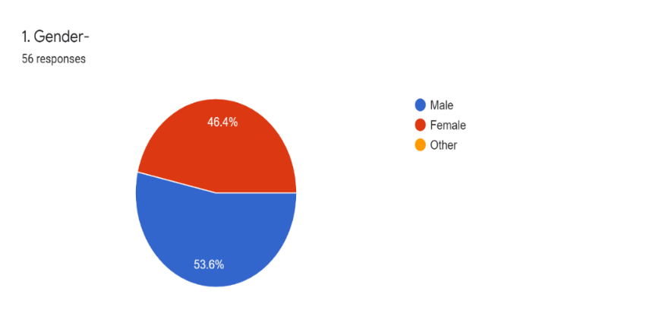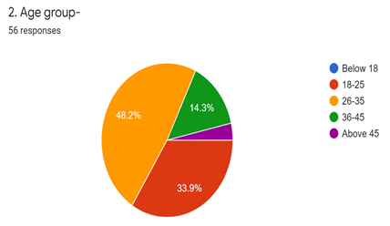
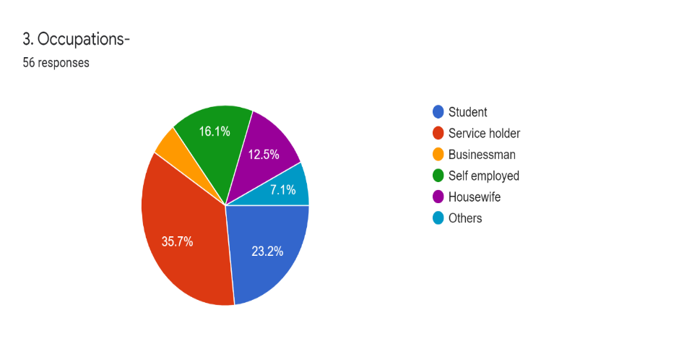
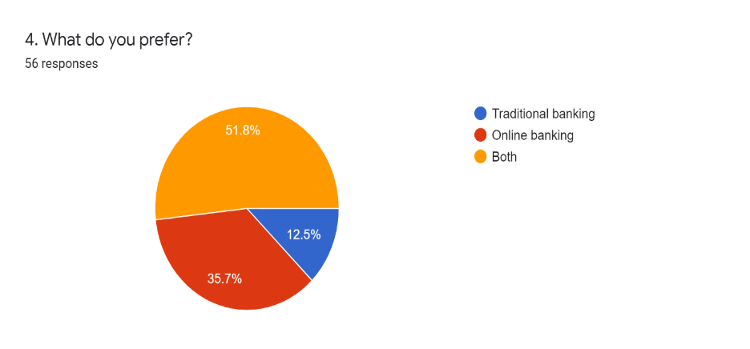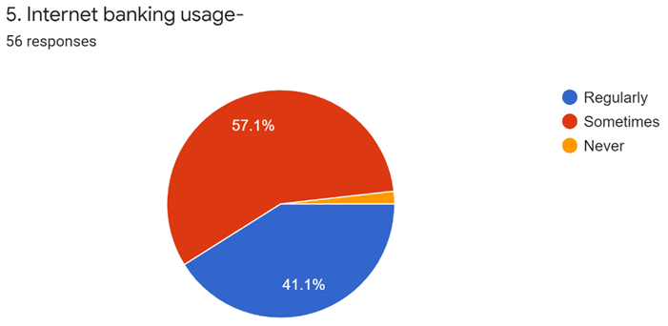
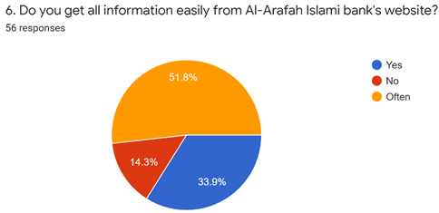
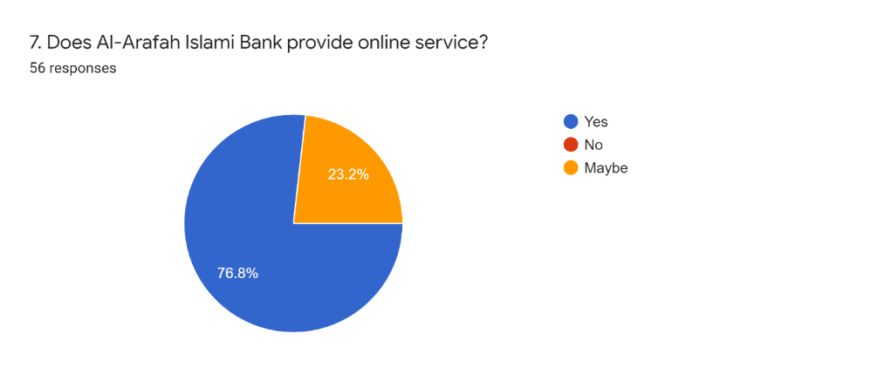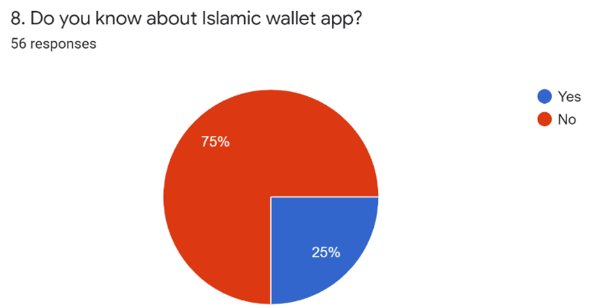
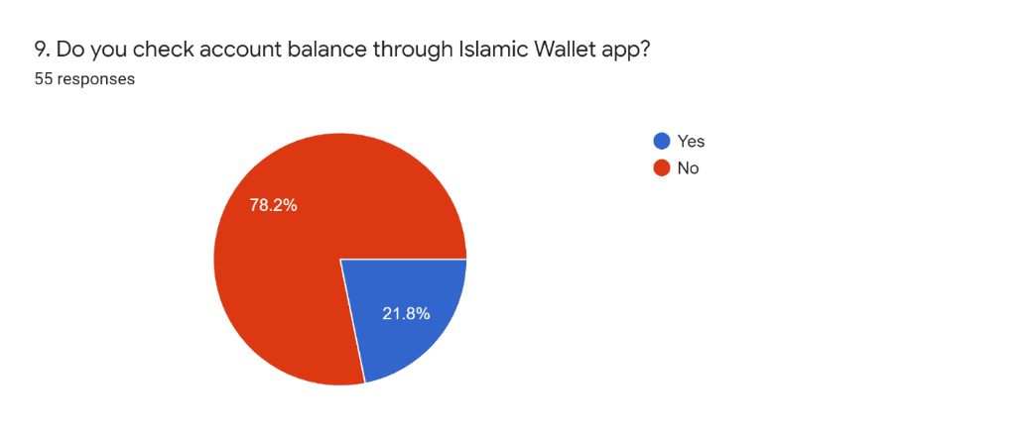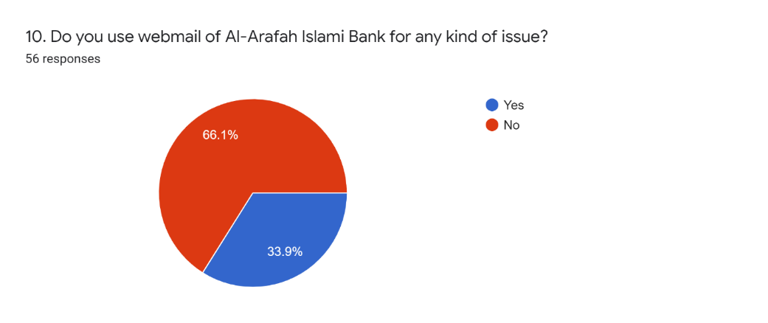
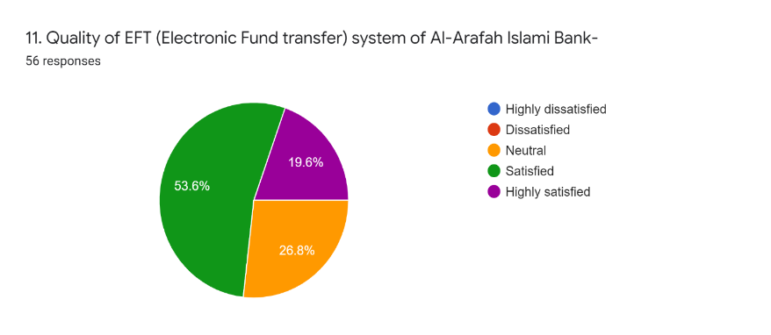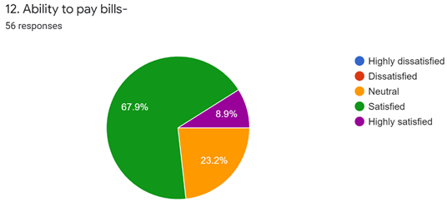
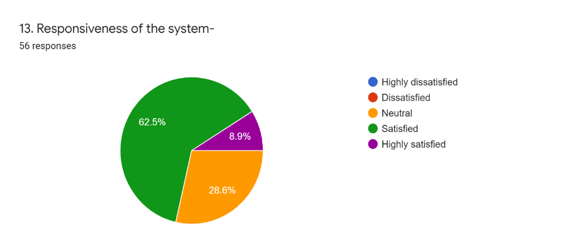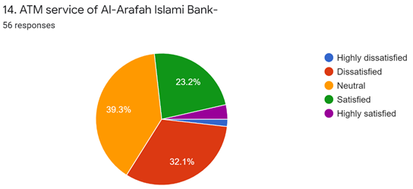
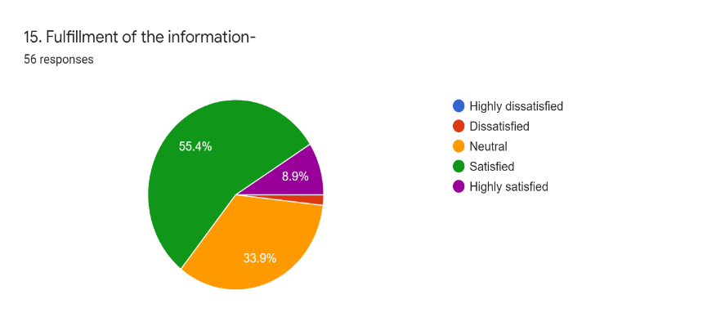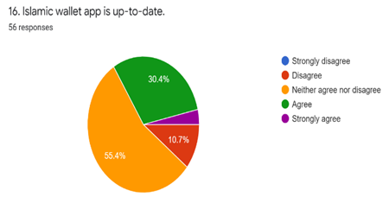
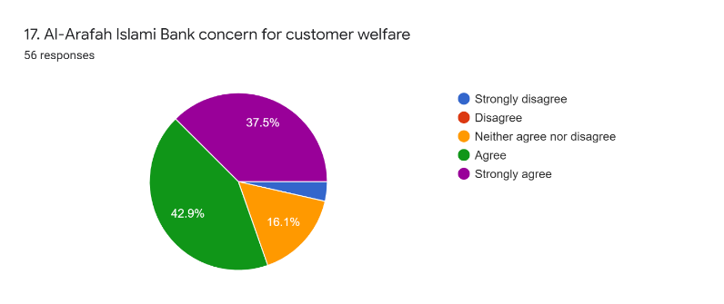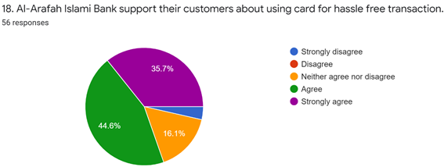
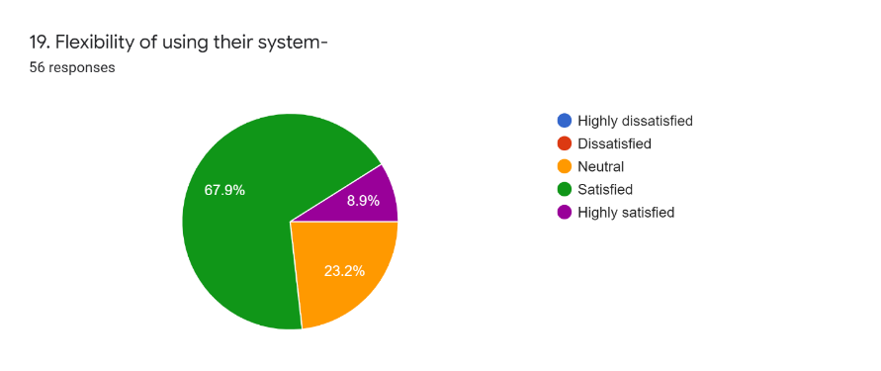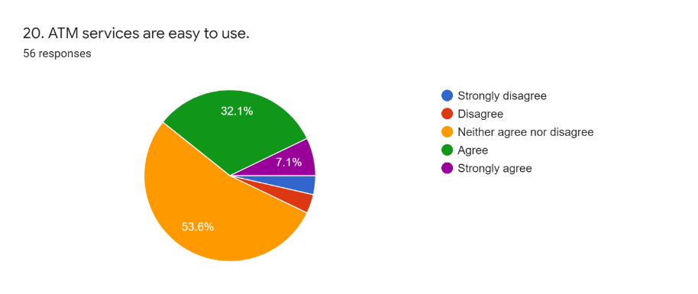
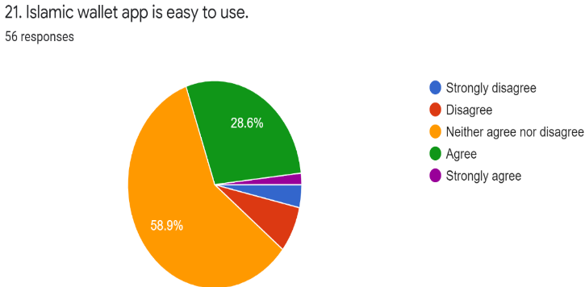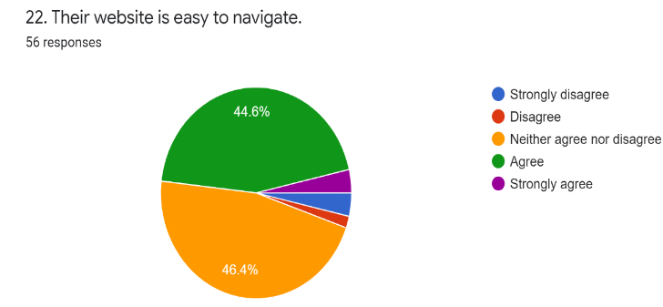
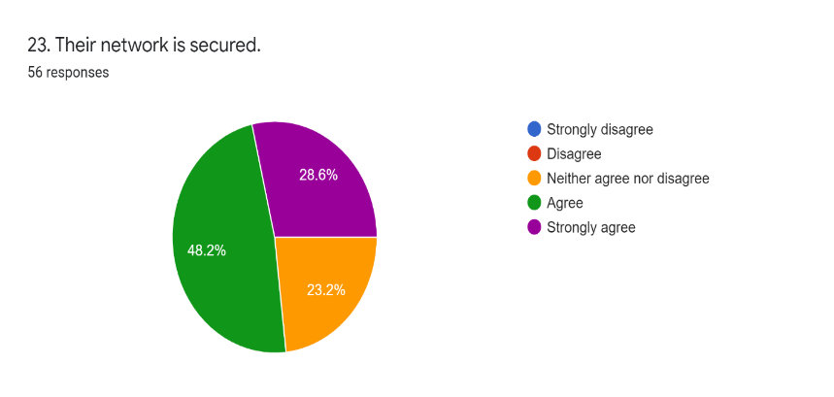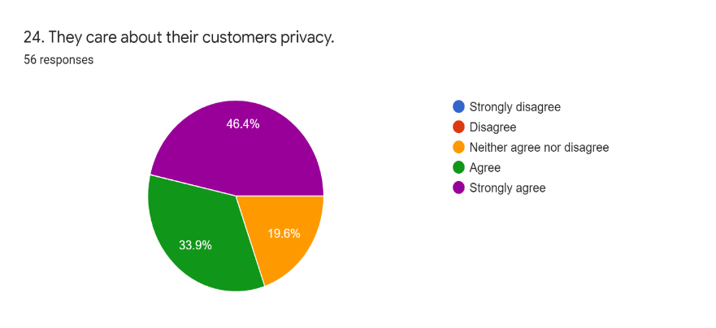
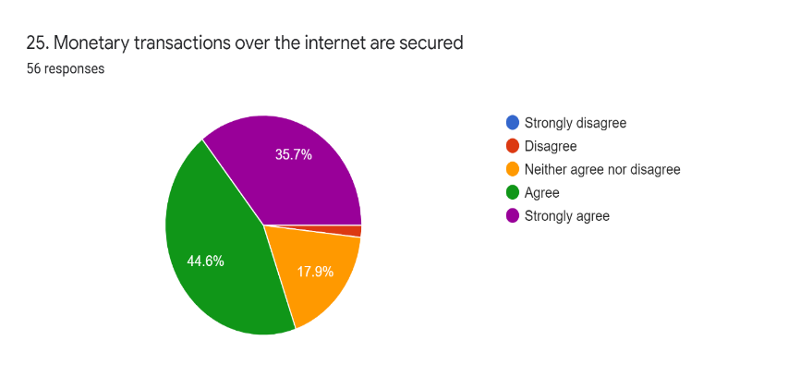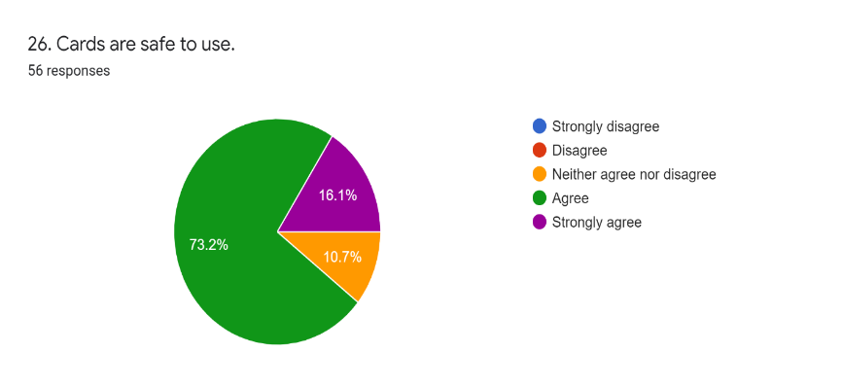
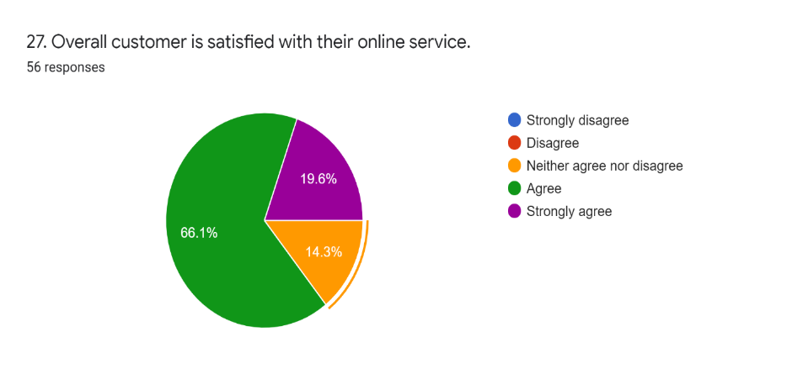

Part-2
