Online Job Portal Services for Job: A Case of atB Jobs Bangladesh

Samira Shahid

The Report is submitted to the School of Business and Economics, United International University, as a partial requirement for the fulfillment of the degree of Bachelor of Business Administration

Online Job Portal Services for Job: A Case of atB Jobs Bangladesh

Submitted By
Samira Shahid
ID: 111191079
School of Business & Economics
United International University

Supervised by
Dr. Kawsar Ahmmed
Professor
School of Business & Economics
United International University

Submission Date: 03 August 2025

Letter of Submission

August 3, 2025

To
Dr. Kawsar Ahmmed
Professor
School of Business & Economics
United International University (UIU)

Subject: Submission of Internship Report on “Online Job Portal Services for Job: A Case of atB Jobs Bangladesh”

Dear Sir,
I am pleased to submit my internship report on “Online Job Portal Services for Job: A Case of atB Jobs Bangladesh”. During my internship, I had the privilege of working in the Operations Division of atB. With the help of Ms. Rabab, Operations and Tele (OPS) Executive of atB Jobs, and other employees of the company, I fulfilled all the conditions you proposed for this internship. Working with the operations team of this company, I gained a wealth of practical insights that may be useful in my future career. This report aims to provide a clear understanding of my learning experience at atB Jobs. I want to express my appreciation for your time and assistance during this internship. I have made sure all the requirements for the course have been met and would like to know your opinion on the report.

Sincerely,
Samira Shahid
ID: 111191079

Acknowledgement

First and foremost, I would like to express my sincere gratitude to the Almighty Allah for His abundant blessings and guidance throughout my internship and the completion of this report. Thanks to His grace, all of this was made possible. I am extremely grateful for the support and encouragement I have received from various individuals during my internship at atB jobs. I am grateful for their invaluable guidance and assistance, and their contributions have made a significant impact on me. I would like to express my deepest gratitude to my internship supervisor To Prof. Dr. Kawsar Ahmmed for his direction and feedback that aided me in overcoming the difficulties of this internship. He was always supportive and offered many ideas on how things could be done that helped this report remain on track and of high quality. He always encouraged me and provided numerous creative solutions to problems that kept this report on schedule and of good quality. I would like to express my sincere thanks to at atB jobs and especially the management for providing me the opportunity to intern with them. Indeed, it is such an organization, and from the experience acquired here, it has helped me in my professional and career progression as I venture into the corporate world. I feel blessed to thank all those of the at atB jobs who made my internship so engaging and informative. Their willingness to share their knowledge were greatly appreciated and the experiences of this internship proved to be very rewarding indeed. In conclusion, I would like to express my sincere appreciation to United International University (UIU) for creating such an internship program through which the students like me come closer to the business world. I have benefited a lot from this program, especially being able to link between what I learned in class and practical business experience, and I feel honored to have been in this program.

Executive Summary
Online job portal services streamline the recruitment process by connecting employers with qualified candidates through a digital platform. These portals offer features such as resume screening, job alerts, and application tracking, enhancing both efficiency and accessibility. In regions like Bangladesh, bilingual interfaces and localized listings can further support inclusive employment opportunities. The purpose of this report is to present an in-depth overview of my professional experience at atB Jobs Bangladesh, an emerging online job portal dedicated to connecting job seekers with employers in Bangladesh. The organization, founded in 2019, operates primarily through digital platforms and has positioned itself as a key player in the informal recruitment sector by leveraging social media and technology. The report outlines the company’s mission to simplify the hiring process through a user-friendly job portal and mobile application, offering services such as job listings, resume filtering, career advice, and recruitment support. With a growing reputation and strong social media presence, atB Jobs Bangladesh aims to address major employment challenges by improving accessibility and relevance in job matching.
During the internship, I have worked within the Operations Division and was exposed to various functions, including telesales, customer handling, marketing, and internal coordination. This hands-on experience provided valuable insights into the recruitment industry, corporate discipline, and the operational challenges faced by job portals. A comprehensive SWOT analysis in the report identifies key strengths such as its social media influence and community engagement, while also pointing out weaknesses like the lack of a structured revenue model and verification processes. The report emphasizes opportunities for strategic partnerships, monetization, and technological upgrades, while also acknowledging threats from market saturation and platform dependence. Key challenges identified include digital literacy barriers, sustainability of informal structures, and the need for regulatory clarity. However, the report recommends strategies such as introducing employer verification, expanding service offerings, and adopting monetization through premium listings or employer subscriptions.
In conclusion, the internship provided a meaningful learning experience, highlighting both the practical aspects of recruitment operations and the broader structural issues in Bangladesh’s job market. With strategic improvements, atB Jobs Bangladesh holds strong potential to become a formal and impactful player in the national employment landscape.

Keywords: Online, Job Portal Services, Employment, atB Jobs, Bangladesh

Table of Contents
Letter of Submission 1
Acknowledgement 2
Executive Summary 3
Chapter One 6
Introduction 6
1.1 Primer 7
1.2 Objectives of the study 8
1.3 Motivations of the study 9
1.4 Limitations of the study 11
Chapter Two 12
Industry Overview 12
2.1 Specification of the Industry 13
2.2 Size, Trend & Maturity of the Industry in Bangladesh 13
2.3 Technological Factors 14
2.4 Political, Legal, and Regulatory Factors 15
2.5 Summary of Challenges & Opportunities 16
Chapter Three 17
Company Overview: atB Jobs Bangladesh 17
3.1 Company Summary 18
3.2 Vision, Mission, and Objectives 19
3.3 Corporate Division/Department 21
3.4 Product Lines or Services 24
3.5 Operation Details 25
3.6 Customer Mix 26
3.7 Product/Service Mix 27
3.8 Service Quality 28
3.9 SWOT Analysis 29
3.10 Strategies to Meet Challenges and Leverage Opportunities 31

Chapter Four 32
Online Job Portal Services: A Sketch & Analysis 32
4.1 Introduction 33
4.2 atB Jobs & Online Job Portal Service: 34
4.3 Current Scenario of Online Job Portal Service 35
4.4 Factors affecting the effectiveness of the online job portal service: 36
4.5 Practices for atB Jobs for improved client experience: 38
Chapter Five 41
Internship Experience, Recommendation & Conclusion 41
5.1 Internship Experience Details: 42
5.2 Responsibility 42
5.3 Difficulties 43
5.4 Recommendations 45
5.5 Conclusion 46
5.6 References 47

Chapter One

Introduction

1.1 Primer
An online job portal is a digital platform that connects job seekers with employers. It allows individuals to search and apply for job opportunities, while enabling companies to post vacancies and find suitable candidates efficiently. Wide range of job openings across industries, roles, and locations. Advanced filters for skills, experience, salary, location, and job type. Job seekers can create and upload resumes for easy application. Tools for companies to post jobs, review applications, and shortlist candidates. Job seekers get alerts for new opportunities matching their profile. Candidates can track their application status in real time. Employee Self-Service (ESS) is a widely used HR tool that enables employees to manage different job-related activities. A self-service portal for employees in the IT sector enables staff to independently handle personal HR-related activities. It usually encompasses functions such as leave applications, time monitoring, benefits administration, and availability of company guidelines. Security protocols must be strong to protect confidential employee information. The employee self-service portal in the IT sector acts as a unified platform, allowing employees to independently manage multiple HR functions. The main goal of introducing an employee self-service portal in the information technology field is to improve operational efficiency and employee contentment by offering a unified platform. This study examines essential aspects such as leave management, time tracking, and benefits administration, highlighting the importance of strong security protocols to protect sensitive employee data.

1.2 Objectives of the study

To Share Practical Internship Experience

The report documents the intern's hands-on experience at atB Jobs Bangladesh, especially within the Operations Division. It covers real-world tasks such as telesales support, customer interaction, job posting, and platform navigation. The intern reflects on how they learned discipline, time management, and corporate behavior—skills not taught in the classroom.

To Understand the Internal Workings of a Job Portal

The report explores the organizational structure of atB, including its departments such as Technical Team, Sales & Marketing, HR, Customer Support, etc. It details operational processes: how job postings are created, how applicants are matched, and how companies interact with the system. It outlines the roles of key team members, showcasing the teamwork behind the platform's daily operations.

To Analyze the Online Recruitment Industry in Bangladesh

The report examines industry dynamics, such as: Growth in digital hiring platforms. The increasing use of mobile-first job search tools. A large unemployed youth population (over 10% of graduates).

Competition from other platforms (Bdjobs, Kormo, LinkedIn). It emphasizes the informal nature of many community-driven recruitment platforms like atB.

To Evaluate the Use of Technology in Recruitment

atB Jobs uses smart tools for: Job matching based on resumes and candidate profiles. Mobile applications for job search. Online systems that support employers with filters, shortlisting, and communication tools. The report assesses the importance of AI, ATS (Applicant Tracking Systems), and cyber security for future scalability.

To Reflect on Career Readiness and Learning Outcomes

The report serves as a bridge between academic learning and professional application. The intern explains how they grew professionally by: Learning marketing concepts in practice. Understanding customer psychology in telesales. Gaining clarity about the local job market and recruitment trends.

To Recommend Strategic Improvements

The intern suggests several ways for atB Jobs to evolve: Introduce employer verification systems to build trust. Expand services to include career counseling, resume writing, and skill development webinars. Develop a monetization model for long-term sustainability. Reduce reliance on Facebook by building a dedicated platform.

1.3 Motivations of the study

- Bridge between Theory and Practice
To apply academic knowledge from business and economics courses in a real-world corporate environment and observe how theoretical concepts operate in practice.

- Understand the Recruitment Industry
To gain deeper insight into the functioning of online job portals and explore how platforms like atB Jobs contribute to employment generation in Bangladesh.

- Enhance Career Readiness
To develop soft skills (communication, discipline, adaptability) and hard skills (marketing, customer handling, operations management) for future professional success.

- Explore the Digital Job Market
To investigate the role of digital tools and mobile applications in transforming the job-seeking and hiring experience for both candidates and employers.

- Contribute to Organizational Growth
To observe internal processes and identify areas where improvements or innovations can enhance user experience and operational efficiency.

- Fulfill Academic Requirement
To meet the curriculum requirement for completing a bachelor’s degree at United International University (UIU) through a supervised internship and a report.

- Develop Analytical Thinking
To assess the strengths, weaknesses, opportunities, and threats (SWOT) of the organization and propose strategic solutions.

- Document Personal Growth
To reflect on the learning journey, including the challenges faced and how they were overcome, to encourage continuous self-improvement.

1.4 Limitations of the study

The internship focused primarily on the Operations Division (e.g., telesales, support, job posting), so insights from other departments like IT, HR, or marketing may be missing or superficial.
- Short Internship Duration
A limited internship period (likely 3 months) restricted the depth of exposure to long-term strategies, performance metrics, or full-cycle hiring processes.
- Informal Work Environment
Since atB Jobs operates as a community-based job-sharing platform, many of its practices are informal or unstructured. This limited the intern's exposure to formal HR systems or structured corporate protocols.
- Lack of Quantitative Data
The report does not include statistical analysis, user satisfaction data, or measurable outcomes (e.g., number of hires, app usage stats), which weakens its analytical depth.
- Single-Organization Focus
The report only explores atB Jobs without comparing it to other job portals like Bdjobs, LinkedIn, or Kormo, limiting broader industry benchmarking.
- Dependence on Subjective Observations
Much of the report is based on personal experience and perceptions rather than empirical evidence or third-party evaluation.

- Generalized Recommendations
Some suggestions (e.g., adding webinars, improving verification) are useful but lack technical feasibility studies or cost-benefit analysis.
- Limited Access to Internal Strategy
As an intern, access to sensitive business strategies, financial data, or internal analytics may have been restricted, limiting deeper insights.

Chapter Two

Industry Overview

2.1 Specification of the Industry

atB Jobs Bangladesh functions within the recruitment and employment services sector, which includes job boards, talent acquisition platforms, and HR service providers. The main emphasis of the group is:

- Offering relevant job opportunities in administrative, human resources, social media, and operational positions.

- Connecting employers with job seekers.

- Mainly utilizing online channels and social media sites (e.g., Facebook, LinkedIn).

- Helping companies by enhancing job opening exposure and speeding up the recruitment process.

- To identify the importance of the recruitment and selection process.

- To measure the strengths and weaknesses of ACI’s recruitment and selection process;

- To find out the opportunities and threats of the recruitment and selection process;

- To know how to select a suitable source to communicate with candidates;

- To know how to get potential candidates for an organization;

2.2 Size, Trend & Maturity of the Industry in Bangladesh

Size
    - Bangladesh features a large youth labor force—more than 60% are under 35.
    - More than 10% of recent graduates are without jobs, indicating a substantial need for services that assist in finding employment.
    - An increasing number of recruitment platforms showcase leading players, such as Bdjobs.com, JobsA1, Chakri.com, and, more recently, socially-driven groups like atB Jobs Bangladesh.

Trend

The hiring process is becoming more digital: job sharing is transitioning from physical boards to online communities.

There is an increasing trend in using Facebook groups, WhatsApp, and Telegram channels for immediate job postings.

A movement is emerging towards recruitment services tailored to specific sectors (technology, administration, media, etc.).

The popularity of remote and hybrid work formats is rising after COVID.

Maturity

- Although the formal employment sector is quite advanced, community-driven, informal models like atB Jobs Bangladesh are still in their early stages.
- Many employers' preference for direct hires or informal referrals limits the extensive use of online recruitment tools.
- Candidate screening, verification, and transparency on unofficial platforms have limitations.

2.3 Technological Factors

- Social Media Integration: atB Jobs Bangladesh utilizes Facebook and other platforms to share job vacancies.
- Applicant tracking systems, or ATS, remain rare among SMEs but are slowly becoming more popular.
- Prioritizing mobile design: essential since most job seekers access job listings through smartphones.
- Data analytics: While still not widely adopted by community organizations, this technology could greatly improve the alignment of job seekers with employers.
- Cyber security & Fraud Prevention: Community job boards face risks of exploitation, phishing attempts, and fraudulent listings.

2.4 Political, Legal, and Regulatory Factors

- Labor regulations: The Bangladesh Labour Act (2006) regulates this domain, yet gig and informal workers remain only partially protected.
- Lack of regulations overseeing employment platforms and groups: Unofficial job-sharing networks, like atB Jobs Bangladesh, operate without clear legal guidelines.
- Fraud Prevention: Individuals looking for jobs through informal or semi-formal job-sharing groups have limited legal safeguards.
- Government Programs: Although not directly managing recruitment agencies, the Ministry of Labor and the ICT Division encourage skill enhancement and employment opportunities.

Moderate to High Rivalry
- Rivaling official job platforms like Kormo Jobs, LinkedIn, and Bdjobs.com.
- The high volume of new Facebook groups posting job opportunities leads to saturation.
- The credibility and trustworthiness of postings serve as key differentiators.
- Informal groups might struggle with sustainability due to ambiguous business models and insufficient monetization.

2.5 Summary of Challenges & Opportunities

Challenges
- Verifying the authenticity of employers and job listings. Lack of a profit model, most unstructured groups do not generate revenue. Job seekers in remote regions possess limited digital skills.
- Sustainability concerns—community organizations primarily rely on the commitment of managers and facilitators;
- Lack of regulations—absence of legal assistance for addressing fraud or complaints.

Opportunities

- A large number of individuals are seeking employment, especially new graduates.
- Opportunity for partnership with businesses, nonprofit organizations, or governmental programs;
- Economical, expandable social media framework
- Expansion into career services (skills training, interview coaching, and CV evaluations);
- Opportunities for generating income via ads, premium job postings, or employer memberships

atB Jobs Bangladesh illustrates an increasing trend of informal, community-based job platforms employing digital tools to link employers with job seekers. Although the group tackles genuine challenges in the labor market, it functions in an area characterized by a lack of formal regulation, advanced technology, and a reliable business model. The future depends on establishing trust, refining verification methods, and potentially connecting with more formal structures or digital platforms to increase its effectiveness.

Chapter Three
Company Overview: atB Jobs Bangladesh

3.1 Company Summary:

atB Jobs Bangladesh is a job platform that assists job hunters and businesses in connecting effortlessly. It began in 2019 with the goal of simplifying job searching and recruitment in Bangladesh. The firm links skilled individuals with reputable businesses across various sectors. atB Jobs Bangladesh provides numerous opportunities, whether one seeks a full-time position, part-time employment, or an internship. The organization is situated at MMK Akash Avenue, Plot-12, Kamal Ataturk Avenue, Gulshan-2, and Dhaka-1212. Their objective is to minimize the challenges individuals encounter when searching for jobs or recruiting staff. They think that the ideal job can transform a person's life, and the perfect employee can contribute to a company's growth. This is the reason they strive to create a platform that aids both job seekers and employers. atB Jobs Bangladesh additionally offers a mobile application.



The application is created to assist individuals in Bangladesh in applying for jobs conveniently via their mobile devices. It pairs candidates with positions that align with their skills and experience. This speeds up the process and improves it for all involved. The firm additionally offers assistance to businesses throughout the recruitment process. Employers can publish job listings, handle applications, and choose the most qualified candidates using the system. This spares them time and energy. With time, atB Jobs Bangladesh has established a solid reputation for being dependable and easy to use. They keep enhancing their services to assist more individuals in finding employment and developing careers. Their mission is straightforward: to address recruitment challenges in Bangladesh and enhance job prospects for everyone. In straightforward terms, atB Jobs Bangladesh acts as a valuable link connecting job seekers with companies, streamlining and accelerating the hiring process.

3.2 Vision, Mission, and Objectives:

Vision:
atB Jobs Bangladesh aims to be the most reliable job platform in Bangladesh. They aim to create a future where everyone can discover the ideal job without anxiety. atB is convinced that each individual possesses talent, and every organization requires the right individuals to thrive. They aspire to decrease unemployment and simplify job searching while ensuring fairness. Their goal is to link individuals to improved opportunities and assist businesses in creating robust teams. In the future, they aspire to play a crucial role in Bangladesh’s job market by leveraging technology and innovative concepts to foster career development.

Mission:
atB Jobs Bangladesh aims to address employment challenges in an intelligent and straightforward manner. They strive to simplify the hiring process for job seekers and businesses alike. Their aim is to provide a platform that is quick, useful, and easy to navigate. They aim to provide job seekers with resources to discover the top positions and assist companies in swiftly locating talented individuals. Through the implementation of digital tools such as mobile applications and web-based platforms, they seek to facilitate the job search process. Their goal is to assist both recent graduates and seasoned professionals in establishing thriving careers in Bangladesh.


Objectives: The primary goals of atB Jobs Bangladesh are distinct and concentrated. Initially, their goal is to link job seekers to suitable positions aligned with their abilities and preferences. Secondly, their goal is to assist companies in swiftly and effortlessly locating qualified candidates. Third, they aim to leverage technology to streamline and expedite job searching and hiring. Fourth, they aim to decrease unemployment in Bangladesh by creating additional job opportunities. Finally, their goal is to establish a robust network of job seekers and employers, providing advice, information, and assistance to enable both parties to thrive and prosper in the competitive job market.

3.3 Corporate Division/Department:

This organogram serves as a visual depiction of the organization's structure, illustrating the hierarchy and connections among various roles and departments. Considering standard organizational frameworks and accessible data, here’s a broad summary of their team:

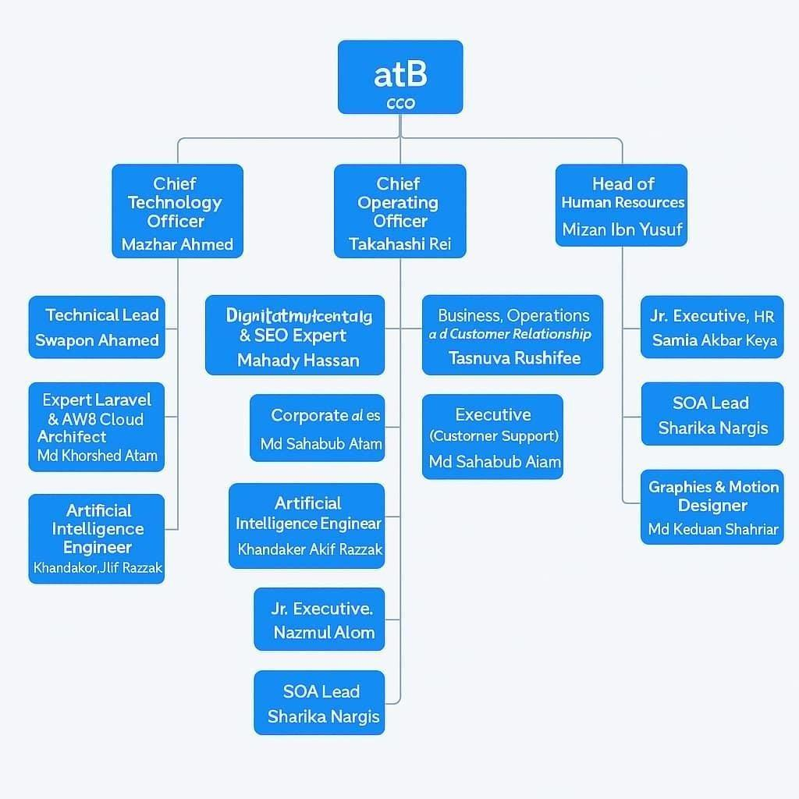

Figure 1.1: Organogram of atB

Leadership Team:

Chief Executive Officer (CEO): Shunki Sugaya leads the company, overseeing overall strategy and operations.
Chief Technology Officer (CTO): Mazhar Ahmed manages the technological direction and development.
Chief Operating Officer (COO): Takahashi Rei is responsible for daily operations and ensuring efficient processes.
Technical Team:

Technical Lead: Swapon Ahamed oversees technical projects and development.

Expert Laravel & AWS Cloud Architect: Md Khorshed Alam specializes in backend development and cloud solutions.
Artificial Intelligence Engineer: Khandaker Akif Razzak focuses on AI-related projects. Marketing and Sales Team:
Digital Marketing & SEO Expert: Mahady Hassan leads online marketing strategies. Corporate Sales: Mustafizur Rahman handles corporate client relationships.
ATB Financial

B2B Marketing Executives: Shake Md Akher Niloy and Mohammed Ali Hassan Sharif focus on business-to-business marketing initiatives.
Human Resources:

Head of Human Resources: Mizan Ibn Yusuf manages HR policies and staff welfare. Jr. Executive, HR: Samia Akbar Keya assists in HR operations.
Customer Support and Operations:

Business Operations and Customer Relationship: Tasnuva Rushafee ensures smooth operations and client satisfaction.
Executive (Customer Support): Md Sahabub Aiam addresses customer inquiries and support.

Design and Quality Assurance:

Sr. UI/UX Engineer: Nazmul Alom focuses on user interface and experience design. SQA Lead: Sharika Nargis leads software quality assurance efforts.
Graphics & Motion Designer: Md Reduan Shahriar creates visual content.

3.4 Product Lines or Services:

atB Jobs Bangladesh provides various useful services and resources that simplify the job market for both job seekers and employers. Their primary offering is a digital job platform where candidates can discover job listings aligned with their skills, experience, and interests. Candidates can set up a profile, submit their resume, and apply for positions directly via the website or mobile application. The platform is intended to be user-friendly, particularly for individuals in Bangladesh.

A key service they provide is job matching, in which the system suggests positions to candidates that align with their profiles. This conserves time and assists candidates in applying for suitable positions. They provide career guidance, assisting job hunters in enhancing their resumes and getting ready for interviews. AtB Jobs Bangladesh offers recruitment services for businesses. Employers can advertise job openings, monitor applications, and select the most suitable candidates from a vast pool. The platform offers features such as resume screening, candidate shortlisting, and tracking applicants to streamline and accelerate the hiring process. This service benefits businesses of every size.

A significant aspect is their mobile application, specifically tailored for job applicants in Bangladesh. It enables users to look for jobs, submit applications swiftly, and get immediate notifications about fresh opportunities. They additionally provide tailored recruitment solutions for major companies. These services could involve assistance with mass recruitment, promoting job advertisements, and aiding organizations in locating elite candidates from particular sectors such as IT, marketing, or customer support.
In summary, atB Jobs Bangladesh offers complete assistance for both job seekers and employers. Their services encompass everything from job hunting to recruitment, streamlining the entire process to be easier, quicker, and more efficient for all parties involved. Their objective is to enhance the recruitment system in Bangladesh through intelligent technology and beneficial assistance.

3.5 Operation Details:

atB Jobs Bangladesh conducts its activities through digital resources, a proficient team, and a transparent framework to link job seekers with employers. Their tasks are primarily conducted online via their website and mobile application, which serve as the company's main offerings. The whole process relies on intelligent technology and collaboration.

Initially, employers sign up on the platform and list job vacancies. They encompass specifics such as job title, duties, necessary skills, compensation, and place. The sales and marketing team of the company might contact businesses and provide recruitment assistance services, aiding them in promoting their job openings more efficiently.

Job seekers then set up accounts, submit their resumes, and provide details about their skills, education, and work experience. The system utilizes this data to align candidates with appropriate jobs through filters and intelligent search tools. This conserves time for both the job seekers and the companies.
After a candidate submits their application, the HR and support teams assist in facilitating the communication between the two parties. Employers can access applicants’ profiles, create a shortlist, and schedule interviews directly via the platform.

In the background, the technical team ensures the system operates seamlessly. They manage all software creation, resolve issues, and frequently enhance the platform. The UI/UX designers aim to ensure the website and app are user-friendly, whereas the AI team enhances job matching.

The support team is always available to assist users encountering issues with the site or application. In summary, atB Jobs Bangladesh focuses on team collaboration, intelligent technology, and online communication. Each division—technical, HR, marketing, and customer support—collaborates to ensure that job seekers and employers can quickly and seamlessly connect on their platform.

3.6 Customer Mix

atB Jobs Bangladesh serves two primary customer segments:

- Job Seekers

- Recent graduates and entry-level applicants seeking administrative, customer service, or internship positions.
- Professionals at the mid-level are looking for new positions in operations, marketing, sales, and human resources.
- Remote workers and freelancers are searching for online and flexible jobs.

- Employers/Companies

- Startups and SMEs are seeking quick, informal hiring solutions with tight budgets.

- To fill urgent openings, recruiters and HR specialists post job advertisements.

- The hiring of program-based positions by NGOs and development organizations.

3.7 Product/Service Mix

atB Jobs Bangladesh offers the following services (largely informal and community-driven):

- Job Sharing Services

  - Selected job postings that are frequently shared on social media.
  - Positions include sales, HR operations, moderators, and executive assistants.

- Referral and Networking Support

  - Peer recommendations can occasionally result in interviews or shortlisting
  - Community comments and shares aid in post circulation for increased visibility.

- Career Support (Informal)

  - Job seekers frequently ask for role clarification or career advice in the comments section.
  - Admins or senior group members occasionally offer resume tips, post insights, and guidance.
Despite being unstructured and unpaid, these services are extremely valuable because of their low barriers to access, community trust, and real-time availability.

3.8 Service Quality

While atB Jobs Bangladesh does not offer structured, paid services, its perceived service quality is driven by:
    - Job Posting Speed: The group is responsible for routine job browsing due to its daily and frequent updates.
    - Relevance of Listings: Generally speaking, posts match the qualifications that local candidates are looking for.
    - Community Engagement: User trust is increased through responsive conversations.
    - Accessibility: Facebook and Messenger make it completely free and mobile-friendly.

Limitations:

    - Occasional phony or deceptive posts result from the lack of official employer verification.
    - There is no system in place to track applications or provide candidates with feedback.
    - No tools for direct employer-candidate matching.

3.9 SWOT Analysis:

Performing a SWOT analysis is a standard approach when starting a new agency, making major adjustments, or tackling issues. It offers a comprehensive perspective of your business environment.
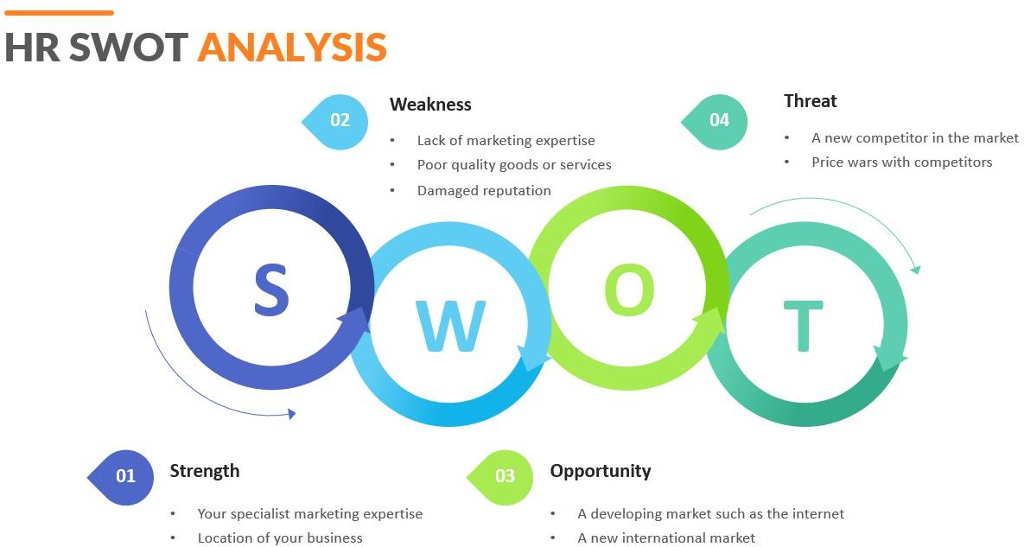
Grasping these four essential components allows you to enhance decision-making, establish priorities, and develop strategies that capitalize on your strengths while addressing your weaknesses.

Strengths | Weaknesses | Opportunities | Threats
Firm social media presence | No business model and an informal structure | Increasing demand for access to informal employment | Competition from other groups that share jobs
Job sharing that is quick, easy, and free | No confirmation from the employer or candidate | Partnerships with startups or NGOs | Risk of fraud or scams harming one's reputation
Young professionals' high level of engagement | No monetization or revenue generation | Presenting a first-rate CV or employment services | Platform reliance (e.g., Facebook policy)
Developing trust via community input | restricted reach outside of admin/mod roles | The addition of webinars or training | Excessive competition causes user fatigue.

3.10 Strategies to Meet Challenges and Leverage Opportunities

Based on the SWOT analysis, the following strategies are recommended:

- Introduce Verification and Trust Mechanisms
    - Establish a simple badge system or employer verification form to boost trust.
    - Badge the community to explosion questionable job postings.

- Develop Services to Include Talent Development

    - Start resume clinics, webinars, or online workshops.
    - Cooperate with each other on career development advantages with nearby training providers.
- Monetization Strategy

    - Provide employers entrance to premium job placement options.
    - Charge a subscription for application guidelines or CV writing services.

- Construct a Scalable Stage

    - To lessen dependency on social media algorithms, think about creating a simple web or mobile application.
    - To enhance the user experience, include filters, category tags, or keyword search.

- Form Strategic Partnerships

    - Work together on employment-related government initiatives, universities, and NGOs.
    - Involve HR professionals or recruitment consultants to help with job duration.

Chapter Four

Online Job Portal Services: A Sketch and Analysis

4.1 Introduction
"Online Job portal" is a digital platform that assists users in locating employment through search parameters such as desired location, job category, work profile, and salary packages. This function is designed to enhance the timely arrival and ease for those seeking employment. Furthermore, our platform provides advantages for both job applicants and employers. It is commonly known as a career gateway. It is a contemporary term for an internet job platform that assists job seekers in finding employment and supports companies in their search for the right candidates. Job portals enable candidates to set up their profiles by posting their resumes on the platform. The employer can view the profile whenever there is a job opening. It is an easier method of searching for a job. Job seekers can search for employment opportunities close to their area, whereas employers and recruiters can publish job postings that include comprehensive descriptions and qualifications to draw in suitable applicants for their vacancies. This platform is referred to as a career portal, functioning as a contemporary equivalent of an online job board. It offers a platform for job seekers to look for work and for employers to discover appropriate candidates. The portal serves as a link between candidates and employers, streamlining the hiring process by enabling applicants to apply for jobs that align with their skills and preferences.

4.2 atB Jobs & Online Job Portal Service:

atB Jobs Bangladesh is a recruitment agency and platform located in Gulshan, Dhaka, founded in approximately 2022, dedicated to filling positions in technology, design, and leadership with clear salary and opportunity listings Tap Talent. ATB LAB LTD. runs this service, offering a complimentary platform for job seekers to register, explore more than 10,000 current job postings, apply filters according to their choices, and create or upload CVs directly through the app. atB Jobs Bangladesh is organizing a Job Fair on August 22, 2025, at the ICCB in Bashundhara, Dhaka — showcasing MNCs, Japanese companies, and top employers from LinkedIn. They will also hold "Direct Connect 3.0" on July 25, 2025, a recruitment meeting for networking and career advancement in Dhaka’s Gulshan region.

The Online Job Portal is among the largest commercial and informational websites offering its services to a diverse range of individuals. In this competitive age, the education level among individuals is rising, which leads to a reduction in job opportunities for them. The firms are looking for individuals who excel in their areas of expertise. At that point, it becomes challenging to locate individuals who possess enough intelligence to be employed. The effort for the companies also rises to locate individuals who can meet their needs. Considering these issues, one might contemplate the procedure that can manage this task and simplify the work. This initiative focuses on automating the digital hiring process. The complete process is overseen by a system that streamlines the recruitment procedure. Candidates may submit applications for job openings within the company according to the vacancies available that interest them. The system streamlines the application process, enhancing efficiency for applicants and the organization. The administrator has complete control over supervising and handling every element of the recruitment process, guaranteeing that all operations proceed seamlessly. Nonetheless, the assessment stage is not under the administrator's authority. The evaluation process varies between companies, with unique criteria and steps that lack standardization, making them hard to forecast or automate. Consequently, although the system manages the majority of recruitment activities, the assessment procedure remains tailored to the company and adaptable. It also encompasses the layers on the administrator side, meaning that the privileges will significantly influence the functionalities provided to various admin levels.

4.3 Current Scenario of Online Job Portal Service
The current scenario of online job portal services (as of mid-2025) reflects rapid technological evolution, user behavior changes, and shifting employer expectations. Here's a clear overview:
AI-Powered Matching & Screening
- Resume parsing, AI-powered candidate suggestions, and skill-centric filtering are becoming commonplace.
- Instruments such as ChatGPT are being utilized for enhancing CVs, preparing for interviews, and suggesting job opportunities (e.g., LinkedIn’s AI assistant and bdjobs employing chatbots).

Skill-Based Hiring Overtakes Degree-Based Hiring
- Nowadays, platforms emphasize skills, certifications, and portfolio links rather than academic degrees.
- Job platforms such as Turing, TopTal, and Fiver Pro focus on proven capability through coding assessments or design portfolios.
Remote & Hybrid Job Focus
- Remote job filters are now essential features.
- Portals like We Work Remotely, Remote OK, and FlexJobs are booming.
- Regional players like Bdjobs, atB Jobs, and Jobike now offer more hybrid listings post-pandemic.

4.4 Factors affecting the effectiveness of the online job portal service:
The effectiveness of an online job portal service is influenced by a combination of technical, user-centered, and market-related factors. Here’s a breakdown of key factors:

Job Matching Accuracy
- Algorithm efficiency: AI or matching algorithms that accurately link candidates with suitable jobs.
- Resume parsing: Quality of automated parsing to extract relevant information from CVs.
- Personalization: Tailored job recommendations based on user behavior and profile data.

Job Listings Quality and Quantity
- Volume of listings: A large, diverse database of current job opportunities.
- Listing authenticity: Verification of employers to avoid scams or fake postings.
- Industry coverage: Range of sectors and job levels offered.

Employer Engagement
- Recruiter activity: Level of engagement and response from employers.
- Employer tools: Features like applicant tracking, analytics, and communication support.
- Reputation of employers: Trustworthiness and attractiveness of companies posting jobs.

User Base and Reach
- Active users: Number of job seekers and recruiters regularly using the platform.
- Geographic scope: Whether it serves local, national, or global markets.
- Network effect: More users attract more listings and vice versa.

Technical Performance
- Speed and uptime: Website/app loading time and server reliability.
- Security: Protection of personal and company data (encryption, two-factor authentication).
- Integration: API and integration capabilities with LinkedIn, email systems, and CRM tools.

Support and Services
- Customer support: Availability of live chat, email, or phone assistance.
- Career tools: Resume builders, interview prep guides, and career counseling.
- User feedback systems: Mechanisms for users to rate or review employers and the platform.

Marketing and Visibility
- SEO and SEM: Visibility in search engines to attract users.
- Social media presence: Engagement on platforms like LinkedIn, Facebook, and X (formerly Twitter).
- Referral systems: Incentives to invite other users or employers.
Pricing Model
- Affordability for employers: Competitive and flexible pricing structures.
- Free features for job seekers: Accessibility of core features without paywalls.
- Premium options: Value-added services for a fee (e.g., featured listings, resume boosts).

4.5 Practices for atB Jobs for improved client experience:
Improving client experience at atB Jobs—whether it’s a staffing agency, gig platform, or HR services firm—requires a strategic mix of communication, process optimization, and technology. Here are practical, actionable practices to enhance the client experience:

Client Onboarding Excellence
- Customized onboarding: Tailor the onboarding process to the specific client’s industry and needs.
- Expectations alignment: Clearly define the scope, timelines, and metrics of success.
- Welcome packet: Provide a branded welcome kit with contact info, service outlines, and FAQs.

Clear & Consistent Communication
- Dedicated account manager: Assign a single point of contact for accountability and familiarity.
- Regular updates: Weekly or biweekly status updates, even when there’s no major change.
- Multi-channel support: Ensure communication via email, phone, chat, or a client portal.
Candidate Quality & Fit
- Pre-screening rigor: Use assessments, background checks, and soft-skill evaluations.
- Client feedback loop: After each placement, collect feedback and adapt future selections accordingly.
- Cultural fit awareness: Match not just skills but alignment with company values and work style.

Technology Integration
- Client portal: Let clients view candidate pipelines, interview schedules, and performance reports.
- Automation: Automate repetitive updates like interview reminders, job status changes, etc.
- Data analytics: Provide clients with insights on hiring trends, time-to-hire, and candidate satisfaction.

Speed & Responsiveness
- Fast turnaround: Streamline internal processes to present qualified candidates faster.
- Response SLA: Commit to responding to all client inquiries within a set timeframe (e.g., 24 hours).
- Emergency staffing: Offer expedited solutions for urgent hiring needs.

Proactive Problem-Solving
- Anticipate issues: Spot potential mismatches or delays before they escalate.
- Client advisory: Offer suggestions on job descriptions, salaries, or industry trends.
- Ownership of errors: If something goes wrong, take responsibility and fix it quickly.

Client Retention & Loyalty
- Regular check-ins: Quarterly business reviews to align goals and measure satisfaction.
- Client satisfaction surveys: Use brief, regular surveys to gauge performance and gather ideas.
- Loyalty rewards: Discounts or perks for long-term partnerships.

Training & Education
- Client education: Webinars or content to help clients understand hiring trends or market rates.
- Internal training: Ensure your team is trained in soft skills, empathy, and client engagement.

Brand Consistency & Transparency
- Professional presentation: Consistent branding across reports, emails, and interactions.
- Transparency: Be upfront about candidate availability, pricing, and timelines.

Continuous Improvement
- Review & refine: Analyze client feedback and performance data monthly or quarterly.
- Innovation mindset: Regularly introduce improvements, new services, or technologies.

Chapter Five

Internship Experience, Recommendation & Conclusion

5.1 Internship Experience Details:

I have completed my internship at atB Jobs. This is a job portal and advertising company based in Bangladesh. They specialize in connecting job seekers with employers, offering a range of opportunities across various industries. They offer customer care support and can be contacted during business hours, according to their website.

I have learned a lot from here. I have learned about corporate life, what an office environment, how to work, how to adapt to corporate life, what level of job seekers we have in Bangladesh, how to find a job, how to do management, and I have learned a lot about the field of marketing. I have also learned how to handle customers in telesales, how to support them, how to understand their network, and how to link with other companies. Through my internship here, I have become very aware of maintaining discipline in my personal life and office time. Working here as an intern has taken my work experience in corporate life to a new level.

5.2 Responsibility:

This time the majority recruitment professionals mentioned that they need an online job portal website for their hiring needs. Right from allowing the candidates to view the requirement to having the candidate apply for the job and assessment and applicant tracking, an effective job portal website design allows for each step in the candidate’s hiring journey.

Self-Centric admin module.

One-click or easy registration process.

Job application process.

Resume search engine.

Job posting.

Text, audio, and video chat integration.

Application Tracking System (ATS) and Re-engagement.

Content management systems and marketing templates.

Multiple languages and SEO optimized.

5.3 Difficulties:
As an internship student I have faced specific challenges on online job portals due to limited experience and unfamiliarity with professional hiring systems. Here's a breakdown of the key difficulties faced by internship students:

Lack of Experience
- Most portals and listings prefer candidates with prior work experience.
- Even internship listings sometimes expect relevant coursework or skills the student hasn't developed yet.

➤ Result:
Students feel underqualified and discouraged from applying.

Overwhelming Competition
- Internship roles receive large numbers of applications from students across regions or countries.
- Students from prestigious universities may have an advantage, making it harder for others.

Limited Internship Listings
- Many job portals are focused on full-time or experienced roles.
- Internship opportunities are often buried or not clearly marked.

Poorly Defined Roles
- Some internship listings lack clear job descriptions or responsibilities.
- Students don’t know what’s expected or whether the internship matches their goals.

Unpaid or Exploitative Internships
- Many listings are unpaid or offer little learning experience.
- Some are scams offering “certificates” for a fee or requiring unnecessary personal info.

Lack of Guidance
- Students may be unfamiliar with how to write resumes, cover letters, or navigate application systems.
- There's little mentorship or feedback on rejections.

Inadequate Search Filters
- Most job portals don't allow users to filter for internships, part-time, or student-friendly jobs effectively.

Delayed or No Responses
- Many students apply and never hear back.
- Without feedback, it’s hard to improve for the next opportunity.

Technical and Soft Skill Gaps
- Listings often require technical tools (e.g., Excel, Python, and Canva) or soft skills (e.g., communication, teamwork) that students haven’t yet developed.
- They may struggle to identify which skills are truly necessary.

Uncertainty around Location and Remote Options
- Students often want remote internships or those near their city, but many listings don't mention location clearly.
- They risk applying to irrelevant jobs.

5.4 Recommendations:

To effectively carry out online recruitment, all national and multinational organizations and other workplaces must begin their recruitment processes online. The procedure should begin with posting the position on the employment website. This will promote openness within the organization during the hiring procedure.

The expense of listing a new position on the job site needs to be lowered to encourage smaller companies to advertise their job vacancies on the job website.

The internet connection cost in Bangladesh should remain low to encourage job seekers and employers to extensively utilize the online recruitment platform.

Job applicants should be prompted to submit accurate information online to reduce issues related to incomplete data.

Job websites must ensure the confidentiality of applicants' information as it has become widespread for them to sell the email addresses and mobile numbers of various applicants to third parties without informing the job seekers.

Organizations in Bangladesh ought to proactively implement the entire online recruitment process, from gathering applications to conducting various tests and interviews systematically.

5.5 Conclusion:

atB Jobs Bangladesh has built a valued online community that tackles authentic challenges in the local job market, especially for recent graduates and small to medium enterprises. Despite its size, sustainability, and verification challenges, the platform holds great potential. By incorporating basic verification, broadening its services, and exploring revenue-generating strategies, atB Jobs can evolve into a more formal and impactful recruitment platform in Bangladesh. The research aims to explore the online recruitment situation in Bangladesh. The research establishes a theoretical model of online hiring for HR practices in Bangladesh that begins with soliciting applications and concludes with the final selection. The research uncovers the distinction. Between conventional and online recruitment, which can be summed up as: whereas the conventional recruitment process can be lengthy and time-consuming; however, the online recruitment method is faster and more economical. Advantages and disadvantages of internet hiring from the viewpoints of employers and job seekers have also been outlined in this research. Certain suggestions, such as starting the online recruitment procedure in each country and global entity, a decrease in internet usage fees, and confidentiality of data of all candidates, are, among other aspects, highlighted in this research. The research has constraints. It relies on secondary data to illustrate the online recruitment situation in Bangladesh. The research presents opportunities for additional exploration and examination through direct surveys regarding organizations, job applicants, employment websites, recruitment firms, online resource service providers, and others for matters related to policy and decision-making.

References:

- Strategic Human Resource Management: A Three-Stage Process Model and Its Influencing Factors Krishnan, Sandeep K.; Singh, Manjari. South Asian Journal of Management, Vol. 18, No. 1, January-March 2011.
- Aswathappa. K. Human Resource and Personal Management, 1997, TATA Me Graw hill Publishing Company Limited, New Delhi.
- The Manager's Guide to HR: Hiring, Firing, Performance Evaluations, Documentation, Benefits, and Everything Else You Need to Know Max Muller. AMACOM, 2009
- P Yogi, O Rizal, Ahmadi, OS Suharyo. 2017. Feasibility analysis of naval base relocation using SWOT and AHP method to support the main duties operation” Defense Resources Management.
- Tambunan, Toman Sony. 2020. “SWOT Analysis for Tourism Development Strategy of Samosir Regency” TIJAB (The International Journal of Applied Business). Vol. 4 No. 2
- Beulen, E. (2009). The contribution of a global service provider's human resources information system (HRIS) to staff retention in emerging markets: Comparing issues and implications in six developing countries. Information Technology & People (West Linn, Or.), 22(3), 270-288.
- Houghton, K. R., Foth, M., & Hearn, G. (2018). Working from the other office: Trialling Co‐Working spaces for public servants. Australian Journal of Public Administration, 77(4), 757-778.
- Nonaka, I., & Takeuchi, H. (1995). The knowledge-creating company: How Japanese companies create the dynamics of innovation. New York: Oxford University Press.
- David, F. R., Creek, S. A., & David, F. R. (2019). What is the key to effective SWOT analysis, including AQCD factors. SAM Advanced Management Journal, 84(1), 25–35.
- Karim, M. M., Choudhury, M. M., & Latif, W. Bin. (2019). The impact of training and development on employees’ performance: An analysis of quantitative data. Noble International Journal of Business and Management Research, 3(2), 25–33.
- Obiekwe, O. (2018). Human capital development and organizational survival: A theoretical review. International Journal of Management and Sustainability, 7(4), 194– 203.
- Willy S , Attelie O . Supervision of Human Resource Management during the Covid 19 Pandemic[J]. Information-integrated Global Society Studies, 2021(3).
- Zeng X . Exploring the Factors Influencing the Effectiveness of Employee Recognition: An Analysis of Recognition Practices in Chinese Businesses[J]. Contemporary Social Sciences , 2021(1):25.
- I Koiiarová, Z Kádeková, P Tarchoň. Leadership and Motivation as Important Aspects of the International Company's Corporate Culture[J]. Sustainability, 2021, 13.

