INTERNSHIP REPORT
ON

Retail Banking Activities of The City Bank Limited

United International University
Internship Report
Programme - BBA
Fall-2018

Submitted To
Muhammad Enamul Haque
Assistant Professor
School of Business and Economics

Submitted By
Tanzila Akther
ID: 111 151 285

Date of Submission
5th January 2019

Letter of Transmittal

5th January 2019
Muhammad Enamul Haque
Assistant Professor
United International University

Sir,
As a part of my course prerequisite for fall 2018, I be situated eager to submit internship report. The subject of my report is Retail Banking Activities of City Bank Ltd (CBL). Now looking forward to your gentle appraisal concerning this report.
For preparing this report with appropriate information I have given my best effort in collecting data from The City Bank Ltd (Moghbazar Branch), with some other applicable sources throughout my total internship term., I have given wholly my best effort to consume the best preference of study the retail banking activities of CBL. The data that I have collected in this internship would drive apparently in helping myself to the real-world of careers.
Despite several insufficiencies, I tried my best to cover the over-all pertinent affairs. Besides this obviously It is quite well-intentioned to remark that deprived of your kind-hearted cooperation and guidance it could not be possible to complete this paper. For any sort of quarry that is essential for this report, I would be grateful and pleased to answer.

Sincerely yours,

Tanzila Akther
ID: 111 151 285

Acknowledgement
For me this internship term has been a very decent and fresh experience, it helped to relate between theoretical knowledge with practical world of corporate. It teaches me o lot about workplace environment and code of conduct with enlarging my self-confidence, self-control 7 social skill.
Primarily, I am thankful and express my deep concern of gratefulness to my respectful advisor Muhammad Enamul Haque for his gentle and useful direction. By which I have been able to make a decent and authentic report which is related to the actual practical world.
I am forfeiture my gentle respect to Md. Nurul Absar (Branch Manager) under who helped me to learn a portion of real-world facts about the retail banking and general banking activities. Beside this, I myself too very indebted to other staffs of The City Bank Ltd. of Moghbazar branch in additionally Rubana Kabir, Business operation Manager, because of their collaboration and guidelines in receiving the essential materials.

Executive Summary
There are four basic dynamic and substantial banking dissections that can be categorized for The City bank like Corporate Banking, Investment Banking, Retail Banking, and Treasury Banking SME Banking. This report plans to describe the retail banking activities of deposit schemes and its asylums feature around retail banking actions accomplishes by the bank. Also, it also contains over-all info of CBL, economic information, findings & knowledge points.
Retail banking mentions to finance in which banking organizations perform businesses straight through customers, somewhat than companies or additional banks. Facilities existing contain savings and glance accounts, credit cards, debit cards, mortgages as well as personal loans and so forth. In this report I have analyzed the deposit scheme of The City bank. There are three key deposit schemes analyzed. Results show that among the major deposit schemes I studied (Savings, Current, and Fixed Deposit), fixed deposit holds the major portion around 65 percent of total deposit of the bank. Although savings and current deposits hold small portion of total deposits, but they are showing relatively better growth potential over the years compared to fixed deposit in yearly basis. Fixed deposit scheme of CBL shows 0.9 percent fall from year 2013 to 2017 where other deposits increased by around 0.40 percent from previous years.

TABLE OF CONTENT
Contents
CHAPTER-1 ………………………………………………………………………………………………………………………………… (2-3)
Introduction 2
1.1 Origin of The Report: 2
1.2 purpose of The Report: 2
1.3 Scope of Study: 2
1.4 Methodology: 3
1.5 Limitations of the Study: 3
CHAPTER-2 ………………………………………………………………………………………………………………………………. (4-11)
COMPANY PROFILE 5
2.1 Background of The City Bank Ltd: 5
2.2 Corporate profile of The City Bank Ltd: 7
2.3 Divisions of The City Bank Ltd: 8
2.4 Products Offered by CBL: 8
CHAPTER-3 ……………………………………………………………………………………………………………………………. (10-17)
Retail banking activities of the city bank ltd 11
3.1 Retail Banking Activities of CBL: 11
3.1.2 Generally Retail Banking Division of City Bank contains following Sections and activities: 12
3.2 Deposit Section 12
3.2.1 Current A/C: 13
3.2.2 Savings A/C: 13
3.2.3 Fixed Deposit: 15
3.3 NRB (Non-Resident Business): 16
3.4 Loan 17
3.5 Cards: 17
CHAPTER-4.………………………………………………………………………………………………………………………….…. (18-28)
Analysis of the deposit section of The City Bank Ltd. 19
4.2 Individual Deposit product Analysis 21
4.2.1 Savings deposits 21
4.2.2 CURRENT DEPOSIT 26
4.2.3 FIXED DEPOSIT 29
CHAPTER-5 ………………………………………………………………………………………………………………………….… (36-37)
Findings & conclusions 37

(Introduction)
CHAPTER-1

Introduction

Origin of The Report:
As part deed for the prerequisite of the Bachelor of Business Administration (BBA) program this report is made. And my respectful supervisor has directed myself toward prepare this report about Retail Banking activities of The City Bank Ltd. Therefore, I take part in “City Bank Ltd.” on Moghbazar branch & functioned through a better grade of qualification. And finally, appropriately give in to this report inside outstanding time.

Objectives of The Report:

Primary objective:
- Primary objective of this report is to analysis the various deposit scheme of CBL.
- To realize the major and minor elements of deposit scheme
- Analysis of the growth potential of CBLs’ various deposit scheme.
Secondary objectives:
- To examine and understand the overall Activities especially Retail Banking.
- To recognize basic goings-on of banking activities of CBL.
- Getting relate the advantages and disadvantages of retail banking.

Scope of Study:

This report is built about retail banking events of CBL for the year 2018. Retail banking activities involves of deposits, loan, credit card, debit card, along with foreign transmittal. And, concealments the officialdoms erection, dissimilar section of The City Bank Ltd. Central portion for this report contains the “Retail banking activities of City Bank Ltd.”.

1.4 Methodology:

This full internship report arranged depending understanding gathered throughout internship period. For collecting data of this report, I have collected data from various source and various division of the city bank and other banks. I have presented my data collection through various chart and graphs. For preparing a genuine & reliable report I personally have studies entirely the available corporation’s data from firm’s website, past records and another applicable thing. Most importantly I have collected data through conversation with the banks’ staff and governing bodies.

Primary Sources
- Conversation done by the administration’s stuff along with administrators in the Headquarters also staffs of the Moghbazar branch.
- Direct conversation with the clients of the bank.
- Reflection of various related records.
- Straight supervision of regular goings-on.

1.4.2 Secondary Sources:
- City Bank Ltds’ officials histories.
- Various years yearly available reports of CBL
- The City Bank Ltds’ Official website
- Various information available about the bank.

Limitations of the Study:

There is existing some limitation contain in this report:
- Restriction on acquisition of The City Banks’ Ltd financial information
- limitation of the furthermost recent statistical data.
- Limitation of information that are mandatory for report creation, as they will not reveal internal info.
- As of for this information lacking’s, few assumptions are taken So, here can remain few errors on this report.
- There is also a limitation of time.

(Company Profile)
CHAPTER-2

COMPANY PROFILE

2.1 Background of The City Bank Ltd:

The City Bank Limited (CBL) is the initial and oldest private sector Bank in Bangladesh. The Bank started its operation in 1983 underneath the entrepreneurship of 12 prominent & foremost businessman of the country along with an authorized capital of Tk. 1.75 Billion. The moral and virtuous intention of the bank behind this starting was to ensure qualitative fluctuations in the range of Financial management and Banking activities. And right now, The City Bank Ltd is serving its clients at home & overseas with 120 branches spread all over the country which contain 99 online branches, one developed Islamic banking branch, one SME facility focus and 11 SME/Agri branches serving across the country & nearby three hundred oversea correspondences casing the complete major towns and business centre of the world.

The service area includes widespread expanded areas of commerce, trade & industry which tailored to meet the detailed needs of the clients and are illustrious to an exceptional level of rapid and personal attention. The Bank has long-drawn-out the ranges of its services. City Bank has introduced some innovative Banking products such as Duel Currency Credit Cards, which is introduced by the Bank for the first time in Bangladesh. And other services are Online services, real-time Internet, Phone, SMS, other Banking systems & ATM which is successful in creating attraction among the customers. In November 2009 The City Bank launched American Express Gold Credit card & American Express Credit Card. The City Bank has received national & international gratitude. The City Bank Limited was one of the twelve Banks of Bangladesh amongst the 500 Banks in Asia for its deposit & profit, an asset as assessed by "ASIA WEEK" In the Year 2000. Other than that, the Prime Minister of the People's Republic of Bangladesh awarded City Bank as the "Top Ten Company" honour from It is a top bank among the first-born five Commercial Banks in the country which started their operations in 1983. City Bank is one of the oldest private Commercial Banks operating in Bangladesh. City Bank is among the very few local banks which do not follow the traditional, decentralized, geographically managed, Branch based business or profit model. Instead, the bank manages its business and operation vertically from the head office through 4 distinct business divisions namely
- Corporate Investment Banking
- Retail Banking (including cards)
- Treasury & Market Risks &
- SME Banking
Underneath a real-time online banking stage, these 4 business divisions are braced at the back by a healthy service delivery or processes setup and a shrewd IT Backbone. Such a centralized operating model & commercial segment-based business ensure treatment & facilities to the bank's different customer segments.
The bank currently has 86 online branches spread across the length & breadth of the country that include a fully-fledged Islamic
- Continuously challenge processes and platforms to enhance effectiveness and efficiency
- Promote innovation and automation with a view to guaranteeing and enhancing excellence in service
- Ensure respect for community, good governance and compliance in everything we do

2.1.1 Values of The City Bank Ltd:

The city bank ltd believe that their Mission and Vision can solitary be fully achieved if the projected behaviour of their employees is visibly defined. Their core value-system includes the following:
- Results Driven
- Accountable and Transparent
- Engaged and Inspired
- Customer Delight
- Courageous and Respectful

2.1.2 Objectives of The City Bank Ltd:

Strategic Objectives:
- Accomplish positive Economic Value Added (EVA) to each year.
- Be the market trailblazer in product revolution.
- Be one of the top five Financial Institutions in Bangladesh in terms of market share in all significant market segments they serve.
- In terms of cost efficiency, be one of the peaks three Financial Institutions in Bangladesh
Financial Objectives:
- Realize a return on shareholders‟ equity of 20% or more on average.

2.2 Corporate profile of The City Bank Ltd:

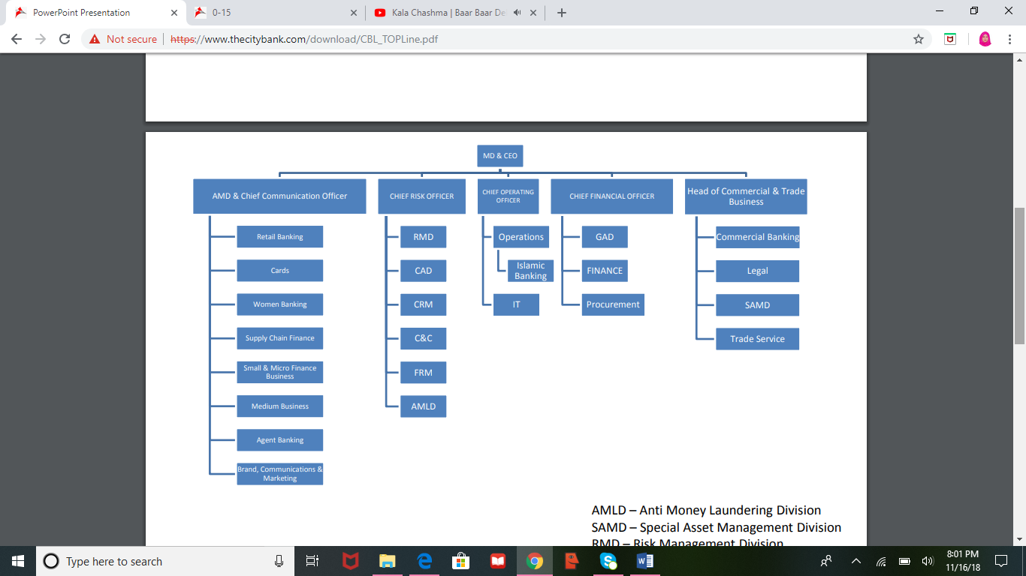

2.3 Divisions of The City Bank Ltd:

It would be very problematic to control the organization effectively If the works are not planned considering their interrelationship & are not allocated in a department. If the divisions are not tailored for the works, there would be the hit-or-miss situation and the performance of a division would not be measured. The City Bank Limited organizes this work very well. There are:

2.4 Products Offered by CBL:

City Bank Ltd. is one of the rapid budding commercial banks in the country. The city bank ltd is competing in the market with an extensive range of services and product that plays a dynamic role in its accomplishment. The CBL focusses the following classes of banking services-

Retail Banking Activities of The City Bank Ltd.
CHAPTER-3

Retail banking activities of the city bank ltd

3.1 Retail Banking Activities of CBL:

City Bank Ltd. has started its journey in Retail Banking. So far more than 700 staffs have been trained on the dynamic concepts of service superiority and sales. In the product side Debit card and credit has been introduced, ATM fleet has been launched, SMS Banking has been presented, online banking app has been created (city touch), Three new deposit services have been introduced, multiple in the effort to build a Retail Banking brand namely “City Retail Happiness Counts”.
3.1.1 Definition of retail banking: This type of banking denotes to banking in which banking organizations perform transactions directly with customers, rather than companies or other banks. Services presented include savings and checking accounts, debit cards & credit cards mortgages as well as personal loans, and so forth. Retail banking Activities is a banking facility that is geared mostly toward separate consumers. Usually, retail banking is made accessible by commercial service banks, as well as smaller communal banks. banking, Retail banking concentrations strictly on customer markets. A wide variety of personal banking facilities, counting offering savings and inspection accounts, debit and credit cards, as well as bill paying services are provided by retail banking. Through retail banking, mortgages and personal loans may also obtain by customers. Although retail banking is, for the greatest part, mass-market driven, numerous retail banking services may also spread to small and medium-sized businesses. Nowadays much of retail banking is rationalized electronically via Automated Teller Machines (ATMs) or concluded virtual retail banking also known as online banking.
Retail banking goals are to be the one-stop yard for as many financial services as thinkable on behalf of retail clients. Nearly retail banks have a uniform made a push into asset services such as brokerage accounts, wealth management, private banking besides retirement planning. While some of these subsidiary services are subcontracted to third parties (often for supervisory reasons), they often entwine with fundamental retail banking accounts like inspection and savings to permit for easier maintenance and transfers.

3.1.2 Generally Retail Banking Division of City Bank contains following Sections and activities:

- Deposit Section
- NRB (Non-Resident Business)
- Loan Section and
- Card Section

3.2 Deposit Section

Maximum people keep bank A/C, it could be an individual account or commercial account, for making their everyday financial events. Clients usage these A/C to deposit & withdraw reserves in a consistent basis. For meeting client’s expectancy, The City bank Ltd make available numerous diverse categories of accounts:
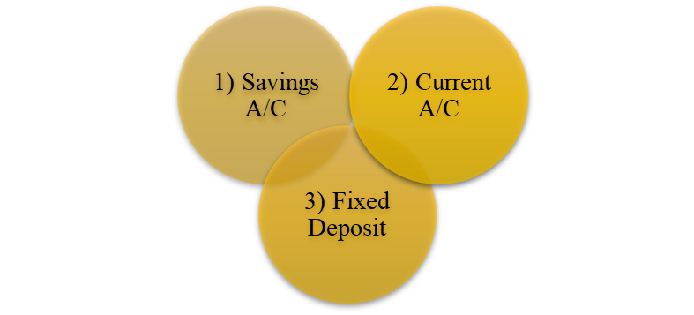

3.2.1 Current A/C:

In current account there is no restriction on withdrawal, but it also does not have interest. Mostly individuals who need more often transaction for personal or business purpose need to open this kind of account. There are two types of current account.
- Personal
- Business

3.2.2 Savings A/C:

There is various kind of savings account provided by CBL. Which provides tailor made services for the customers. And city bank is keepings its savings facility in a better position for the past few years. Some of the city banks saving A/C featured are:
- General Savings
- City Onayash
- City Shomriddhi
- Other Special Accounts
- City Savings Delight
- City Ichchapurun
- City Digun Praptee
- City Bunon
- City Youth School Plan
- City Projonmo

General Savings:
Its A common kind of savings account with interest facility. This kind of account have a limit of withdrawal. At a moment a person cannot withdraw more than 25% of his/her total balance.

City Onayash:
It is same as general savings account, but its new feture is its provide interest on each month basis with a condition of minimum balance of 25000 tk.
.

City Shomriddhi:
It can be called an excellent DPS service providing markedly extra striking service to the customers compare to the other widespread DPS services provided by others. Eligibility: Nationality: Bangladeshi, Age: At least 18 years, Interest Rate: Term Interest Rate 3 (Three) Years 9.75 5 (Five) Years 9.75 7 (Seven) Years 9.75 10 (Ten) Years 9.75
- Other Special Accounts: the other kind of special tailor-made bank account service offered by the city bank limited are:
- City Savings Delight:
Providing 8% interest on daily basis savings, City savings delight provides the most recent innovative facility with the service of City Maxx card. Encouraging people to labeling up savings capacity.
- City Projonmo:
City projonmo a product for children, providing them protection intended for their future. It can be opened by Custodian of any youngster for their future. It is a monthly deposit scheme.

- City Ichchapurun:
In this account interest is appreciate in each month which is accumulated in fixed deposit account. This service allows making interest and appreciating interest each month that accumulates in a fixed deposit account.

- City Bunon:
It is a special kind of account for garments worker, to help them to safe money with minimum cost. This account charges least amount of cost. And, can eligible for debit card and cheque book facility
- City Digun Praptee:
It is a long-term deposit scheme with double benefit. It will make the deposit portion double by increasing its value label for holding money in the account.
- City Youth School Plan:
This account is obviously for students below the age of 18. This account charges the least cost with card facility. It encourages young generation to save money for future. For open this account a valid student ID card is mandatory.

3.2.3 Fixed Deposit (FD):

It is a long-term savings scheme with interest. And city bank provides vast types of FD service. In term of maturity types of FD in CBL are:
- 1 month
- 3 months
- 6 months
- 1 Year
- 02 Years
- 03 Years
- 5 years & over

3.3 NRB (Non-Resident Business):

For fast, protected & easy money transfers to a wide range of destinations City Bank’s Foreign Remittance part meets growing consumer needs. Being a dedicated bank to its clienteles, CBL goes all the distances to remit peoples hard-earned money securely to the loved ones. With CBL, separately from a variety of high-class modem transmittal solutions, customers will get peacetime of mind which is believed counts to be furthermost.
Facility:
The City Bank Limited has 86 online undergrowth diagonally the country; also, the Bank has a durable remittance network through other foremost banks of the country. Therefore, wherever customer account is, they can guide money instantly. The Foreign remittance facility personnel will be there to help customers out. If anyone is not an account holder, then gratify open an account of their choice with CBL to accept remittance at most basic convenience. CBL knows the value of their precious time. That's why they have complete the payment process simple & relaxed. Customers have the pleasure of enchasing the forwarded money rapidly from Branch counter deprived of going through in the least hassle. If anyone is an account container of City Bank, can promptly credit the currency to their account or reimbursement cash to the receiver.

3.4 Loan
There are various types of loan facilities provided by the city bank limited:

3.5 Cards:

City bank provides the facility of dual currency cards. Both in debit card and credit. And it has massive response from customers.
Debit Card | Credit Card
Master Debit Card  Debit Card  City Max Debit Card  Visa Debit Card | American Express Cards  City MAXX Card  Visa Gold Local  Visa Platinum Card  Visa Gold Dual  Visa Classic Dual  Visa Classic Local

Analysis of Deposit Section of The City Bank Ltd.
CHAPTER-4

Analysis of the deposit section of The City Bank Ltd.

The city bank ltd keep and manage their deposits very well. And keeping a strength position on deposits. As we described earlier in the report, there is three kinds of deposit services available at the city bank Ltd. The histories show the following deposits positions of CBL
As discussed earlier there are 3 kinds of deposits
- Current A/C
- Savings A/C
- Fixed Deposits
Deposit

- Below graphs shows the percentage of various types of deposits throughout the past five years as a proportionate of total deposit:
Total Deposit scheme view from its various types are showed in this graph
Years | 2013 | 2014 | 2015 | 2016 | 2017
Savings A/C | 18% | 20% | 22% | 20% | 22%
Current A/C | 10% | 12% | 14% | 14% | 14%
Fixed Deposit | 72% | 68% | 63% | 66% | 65%

As in the following graph indicates that CBL has done a great job in its deposit’s classes. In all the five years fixed deposits holds the largest portion, although the percentage of fixed deposit is screening a decreasing rate. In term of number its decreases by .09% from the year 2013 to 2017. CBL must take a stand to stop this decreasing rate of FD. All current and saving account has improved its figures during the years. We can see current A/C proportion increase by .40% & saving A/C raised by 0.22% which means its growing year by year. Saving deposits fluctuation remains among 18% to 22% around the five-year span with growth of .22% from the year 2013 to 2017. That means CBLs’ saving deposit progress needs more stimulation. CBL must put more emphasis on its savings deposit to gain larger growth in this section

4.2 Individual Deposit product Analysis

In this part I will demonstrate the situation of each deposit section of CBL, which will reflect the contribution of each scheme in total deposit along with a whole view.


4.2.1 Savings deposits

There is various kind of savings account provided by CBL which provides tailor made services for the customers.
- Below graph shows saving deposits proportion in total deposits throughout the years:
Years | 2013 | 2014 | 2015 | 2016 | 2017
Savings A/C | 18% | 20% | 22% | 20% | 22%

The saving deposit has moderately improved its statistics during the years. We can see its upward year by year but slowly. Saving deposits fluctuation remains among 18% to 22% around the five-year span with growth of .22% from the year 2013 to 2017. That means CBLs’ saving deposit advancement needs more stimulus.
There are various kind of Savings deposits they are, the contribution of each part is showen in below graphs:

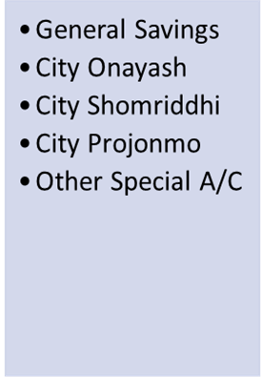
- General Savings
General savings is a normal savings account providing interest yearly basis and limit ectraction on twofold in a week.
- The proportion of general savings deposit among all the savings deposits
Years | 2017 | 2016 | 2015 | 2014 | 2013
General Savings | 90.21% | 86.20% | 86.19% | 86.44% | 86.20%

As we can see general savings holds more than 80% of total savings. And its label is raising year by year. And it has increased by 4% from year 2013 to 2017. It’s the main source of savings for CBL.

- City Onayash
This special kind of account provides interest on daily basis. And its prerequisites are keeping 25000 taka as minimum balance.
- Proportion of City Onayash deposit among all the savings deposits
Years | 2017 | 2016 | 2015 | 2014 | 2013
City Onayash | 0.02% | 0.02% | 0.03% | 0.05% | 0.08%

city onayash Savings A/C grew little by the passing of year. It fluctuates among .02% to .08%. This product of CBL need special action.
- City Shomriddhi
“City Shomridhdhi” an exceptional service that provide DPS facility markedly very much striking than the widespread other DPS services available in the current marketplace.
- The proportion of City Shomriddhi deposit among all the savings deposits

Years | 2017 | 2016 | 2015 | 2014 | 2013
City Shomriddhi | 9.09% | 13.20% | 13.14% | 12.81% | 12.94%

Other than other savings a/c city shomriddhi shows the second-best position in savings deposits. It grew up by 0.42% by the passing of year.
- Other Special A/C
the other kind of special tailor-made bank account service offered by the city bank limited are: City Ichchapurun, City Projonmo, City Digun Praptee, City Bunon, , City Youth School Plan & City Savings Delight.
- The proportion of Other special AC in total Saving Deposit
Years | 2017 | 2016 | 2015 | 2014 | 2013
Other special A/C | 0.68% | 0.58% | 0.64% | 0.70% | 0.78%

Other kind of special account of CBL holds a minimum label for total savings and its remains mostly among .60 to .80% throughout the five year span. So, this section of savings deposit needs special care.
- The proportion of various types of savings deposits in total savings deposit scheme:
Below graph shows the overall picture of the various kind of savings deposit in a single graph

Above graph denote that Among the savings deposits general saving A/C comprise of more than 85% through the year 2013 to 2017 & its expansions a more significant position as 90% in the year 2017 which signposts that it increased by almost 4%. Whereas city onayash and city shomriddhi Savings A/C grew little by the passing of the year. It fluctuates among .20% to 12%. Besides city other special A/C does a little bit progress through the year 2013 to 2017 by 0.14%. That indicates that CBL must be much focused on its other savings product than general savings A/C.

4.2.2 CURRENT DEPOSIT

Non-interest-bearing transaction account are called current account Opened by persons needing often transaction.
- The proportion of current deposit among total deposit is showing below

Current deposits seem to have very much lower growth than savings and FD. It remains almost the same percentage for the year 2015, 2016, 2017. And it has a growth of 0.4% from the year 2013 to 2017.
There are two types of current A/C:

much higher than the personal A/c CBL, have too much concern about its business Current A/c growth.
- Personal Current A/C:
This account can be open for the personal transaction if any customers want it. It bears no interest.
- The proportion of Personal current account among the total of total current accounts

Years | 2013 | 2014 | 2015 | 2016 | 2017
Personal current A/C | 24% | 28% | 33% | 33% | 39%

Although current personal deposit holds a small portion of the total current deposit, it is showing progress by passing of each year. It increased by 0.62% in the year 2017 from the year 2013.
- Business Current A/C:
This type of accounts is opened for business tractions. This A/C also does not provide any interest.

- The proportion of business current account among the total of total current accounts
Year | 2013 | 2014 | 2015 | 2016 | 2017
Business Current A/C | 76% | 72% | 67% | 67% | 61%

The business current deposit has some fluctuation over the five-year period. Although it has a higher proportion among current deposits. And it has decreased by 0.19% from the year 2013.
- The proportion of various types of current deposits among total Current deposits
Below graph shows the overall picture of the various kind of savings deposit in a single graph
Year | 2013 | 2014 | 2015 | 2016 | 2017
Personal Current A/C | 24% | 28% | 33% | 33% | 39%
Business Current A/C | 76% | 72% | 67% | 67% | 61%

Above graph presented that throughout the past five years business current a/c relics higher than personal current a/c. Although the proportion of personal current a/c growths a little from 2013 to 2017. In term of numbers it grows 66% from 2013. Besides the bigger share of current a/c (business a/c) decreases by 20% from the year 2013 to 2017. As the business transaction is

4.2.3 FIXED DEPOSIT

The city bank provides FD services for various tenor and amount with a better market competitive interest rate
- The proportion of fixed deposit among total deposit
Years | 2013 | 2014 | 2015 | 2016 | 2017
Fixed Deposit | 72% | 68% | 63% | 66% | 65%

Fixed deposits are showing bigger proportion of total deposits with a decreasing level by the years passings. Its decreased by 0.09% from the year 2013 to 2017.
In terms of maturity, there is various kind of Fixed Deposits. All of which provides various interest rate with various maturity period.
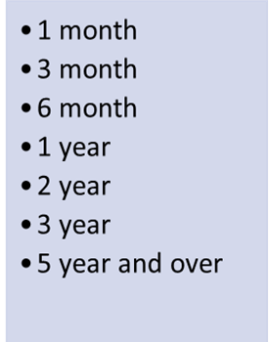
- 1-Month FD:
It is a one-month fixed deposit with 6.75% interest.
- The proportion of 1-month maturity FD among total FD
Years | 2013 | 2014 | 2015 | 2016 | 2017
1 month FD | 7% | 8% | 2% | 0% | 3%

1-month FDs’ has very lower proportion among another maturity FDs’. And its also showing a decreasing level of 0.57% from previous years.
- 3-Month FD:
It is a three-month fixed deposit with 6.75% interest.
- The proportion of 3-months maturity FD among total FD
Years | 2013 | 2014 | 2015 | 2016 | 2017
3 months FD | 5% | 38% | 12% | 1% | 0%

Like 1-month FD, 3-month maturities FD also shows lower parts in total. And it is decreasing imperiously at the year 2016 and 2017. Its decreasing percentage is 0.98% from the year 2013 to 2017.
- 6-Month FD:
It is a six-month fixed deposit with 6.75% interest.
- The proportion of 6-months FD in total fixed deposits
Years | 2013 | 2014 | 2015 | 2016 | 2017
6 months FD | 8% | 23% | 4% | 5% | 25%

Six-month FDs’ have too much fluctuation among the past five years with the lowest percentage in the year 2015. And highest in 2017. It is showing an increasing level of growth of 2.12% from the year 2013 to 2017.

- 1-Year FD:
It is a one-year fixed deposit with 8.75% interest.
- A portion of 1-year FD to the total FD
Years | 2013 | 2014 | 2015 | 2016 | 2017
1-year FD | 5% | 4% | 14% | 3% | 25%

1-year FD is in a good position and it has a great improvement in the year 2017 which is 4% higher than the year 2013. Which means with little bit more effort it can have a great number.
- 2-years FD:
It is a two-year fixed deposit with 8.75% interest.
- The proportion of 2-year FD to total FD
Years | 2013 | 2014 | 2015 | 2016 | 2017
2-year FD | 0% | 2% | 5% | 39% | 14%

FD with 2-years maturity have fluctuation over the five-year span. It has a dull performance in year 2013 and 2014. And improved a little bit in year 2016, But again decreases its level in year 2017. That means it has no consistent growth.
- 3-Years FD:
It is a three-year fixed deposit with 8.75% interest.
- Portion of 3-years maturity FD in total FD
Years | 2013 | 2014 | 2015 | 2016 | 2017
3-year FD | 0% | 2% | 6% | 0% | 1%

3-years maturity FD has a very little portion in total FD with no growth potentials. And it remains mostly among 1% to 6%. It has a high portion in the year 2015 only. CBL needs to concenter to this scheme more carefully.
- 5-years & above:
It is a five-year & above-fixed deposit with 8.75% interest.
- A portion of 5-Years and above maturity FD to total FD value

Years | 2013 | 2014 | 2015 | 2016 | 2017
5 year and above | 74% | 25% | 58% | 52% | 32%

Holding a higher portion of total FD, 5-years & above FD having decreasing growth potential. It decreased by .60% from the year 2013 to the year 2017. As CBL main deposit source is FD and 5-years & above FD holds the greater portion, CBL needs to improve its percentage, nevertheless.

- The proportion of various maturities fixed deposits as a proportionate of total Fixed deposit are showing below

Below graph shows the overall picture of various maturities FD as a total proportion of FD scheme.
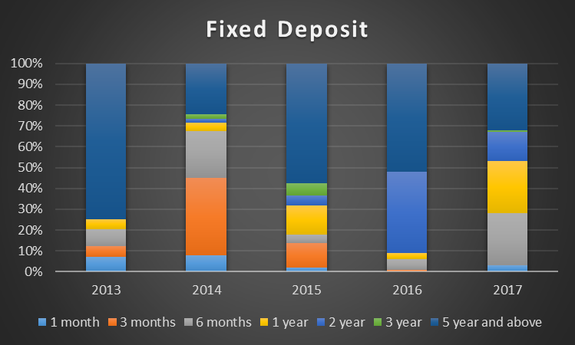

This graph specifies that CBL has huge fluctuation in its FD scheme. Among the maturities ‘5 years and above’ segment holds the maximum figure in total FD collection. Although long-term FD deposits percentage is screening decreasing marker from 74% to 32% which means it has a declining level of around 57%. Besides, short-term FD (from 1 month to 6 months) has massive fluctuation display no consistency level. Another medium term (1 to 3 Years) showing little bit better position throughout the five-year span. CBL must make a more concern look for its overall fixed deposit portion.

Findings & Conclusions
CHAPTER-5

Findings & conclusions

In Bangladesh the city bank limited received a reputation of being a top ranked association. Compare to the other local of foreign bank in Bangladesh CBL is more organized and promised bank. CBL is very much concerned about its innovation and improvement with super service. It has been a royal partner of its clients for past few years.
The bank has a capable and dynamic experienced human resource with which it can achieve greater accomplishment. The City Bank Ltd is the innovator of presenting numerous novel Services like online banking software “city touch”, along with Special tailor-made bank A/C and American Express Credit Card facilities in the banking segment of Bangladesh
According to my observation, City bank gets its maximum value of deposits from fixed deposits. That means its good at keeping customers convince in saving their money to the bank. So, the CBL should maintain the FD in maximum priority to have a consistent level. And need to make a more careful view on a savings account and current account. As current and savings accounts showing better growth potentials then FD that’s means it can do further better in care of more concentration.
Throughout the internship term I have tried my best to learn corporate knowledge that is valuable for my future career. Al though all the division and segments are covered partially in the period, but it is not possible to fully cover up all the functions of the firm deeply. Because of limitation of time and disclosure full motive of this internship could not be achieved. Yet, the best efforts have been given to achieve full advantage of the internship programmed within this specific time period.

BIBLIOGRAPHY

- City Bank official website, https://www.thecitybank.com.bd/eoi.php
- https://www.thecitybank.com.bd/corporate_banking.php
- https://www.citytouch.com.bd:8443/ibs_retail/
- Rose, P. S. (n.d.). Commercial Bank management
- Annual report-2014, The City Bank Limited.
- Annual report-2015, The City Bank Limited
- Annual report-2016, The City Bank Limited.
- Annual report-2017, The City Bank Limited.

