INTERNSHIP REPORT
ON
Rangs Industries Ltd.


Submitted To:
Dr. Seyama Sultana
Assistant Professor
School of Business & Economics

Submitted By:
Md. Ashraful Alam
ID: 111 132 205



United International University
Date of Submission: August 11, 2018

Letter of transmittal

11th August, 2018
Dr. Seyama Sultana
Assistant professor
School of Business & Economics
United International University

Dear MAM,
I would like to take this opportunity to thank you for the guidance and support you have provided me for the completion of this report. Without your help, this report would have been impossible to complete. With deep gratitude, I also acknowledge the help provided by Golam Sazid Rizwan, and my supervisor at Rangs Industry Ltd.
To prepare the report I collected what I believe to be most relevant information what make report as descriptive and reliable as possible. I have concentrated to my best effort to achieve the objective of the report and hope that my endeavor will serve the purpose. The practical knowledge and experience gathered during report preparation will immeasurably help in my future professional life. I request you to excuse me for any mistake that may occur in the report despite of my best effort.
I would really appreciate if you enlighten me with your thoughts and views regarding the report. Also, if you wish to enquire about an aspect of my report, I would gladly answer your queries.
Thank you again for your support and patience.
Yours Sincerely,
Md Ashraful Alam
ID: 111 132 205
United International University

Executive Summary

My internship report was about Rangs Industry Ltd and Its Product Management Department Where I have worked for a period of 3 months. In this report I have described about the industry overview, company profile, my internship experience, job responsibilities and function of each individual departments, problems I have faced in my work place and analyze those problems with relevant theories. I also gave some recommendation about how to solve the problems.
In this report I have broadly described about the Rangs industry ltd and each of its department. Rangs industry has about six different departments and I tried to describe each department’s work activities as accurate as possible.
The report is a result of my three months long internship program which I conducted at Rangs Industry and it is made for the accomplishment of the internship program as required by the Business School of United International University. I also try to describe the benefits or importance of doing internship in a reputed company like Rangs Industry.

Table of Content

Table of Contents
Chapter 1 5
Introduction 5
1.1 Introduction 5
1.2 Background of the Study 6
1.3 Rational 7
Chapter 2 9
Literature Review 9
2.1 Relevant Other Literature (Industry Overview and Company Overview) 9
2.1.1 Industry Overview 9
2.1.2 Company Overview: 10
CHAPTER 3 19
Job Responsibility 19
My Responsibility of the job 19
Product Management - Core stocky and DMS sales data entry 19
DMS – Distribution Management System 20
Chapter 4 21
Findings or Outcomes 21
Chapter 5 23
Conclusion and Recommendation 23
5.1 Conclusion 23
5.2 Recommendation 24
Reference 26
Appendix 27

Chapter 1

Introduction

1.1 Introduction
Rangs group is a diversified and growing group of companies representing global brand in Bangladesh. Rangs is a well-Recognized name in business sector in Bangladesh since 1979. Rangs group is one of the premier conglomerates in Bangladesh. With Headquarter in Tejgaon, Dhaka, they conduct business countrywide. Driven by the passion to be the best and with a team of unique professionals, it brings trusted brand of the world within the reach of everyone in Bangladesh. Rangs group believe in delivering operational excellence to meet commitment. For the progression of its mission it has diversified and grown to be one of the largest industries and trading conglomerates in the country under the same management. With diversification and a rich variation of products it has earned repute among Bangladeshi people as a distributor of premier and quality products and service.
Rangs Industries Ltd (RIL) is one of the biggest players in the electronics industry in Bangladesh that was established in 1979, had spread its wings all over the country and has workforce of more than 700 and is a pioneer in the Electronics market. RIL is one of the sister concerns of Rangs Group of Companies (RGC), which is one of the most reputed and largest groups in Bangladesh. The company was registered under the Companies Act of 1913 and was incorporated in Bangladesh on 11th April, 1985. Rangs are importer and seller of Refrigerator, Freezer, Air Conditioner, Generator, Washing Machine and other electrical home appliances. All the products are being sold through wide range of network 36 Sales centers and more than 150 authorized dealers throughout the country. Rangs Industries Limited deals with plentiful products of which has about 10 global brands such as Samsung, Toshiba, Sharp, Hitachi, Panasonic and Sony, along with its own brand Toshin. Rangs Industries Limited has highly skill, well trained & experienced workforce at all departments who are working all departments all over Bangladesh.

1.2 Background of the Study

Electronics industry in Bangladesh are in growth stage. There are some other new things to be introduced in these sectors consumers buying behavior changes on an outlet due to price, quality and service so to understand the problem and their perception this report is prepared. In a developing country like Bangladesh, all the companies that are distributing the electronic products are equal player. But some are more equal than others. The report will be intended to provide background information on electronics industries in Bangladesh; they will be on the products Television, Air condition, Refrigerators and others home & kitchen appliances. There are two objectives of this study
Broad Objectives: The main objectives of the study are to understand the customers and the marketing activities of Rangs Industry Ltd. And have a knowledge about the electronics market.
Specific Objectives: The units or samples of the study will be taken from the basic industry Rangs Industry is currently operating. To successfully satisfy the board study, some objective should be carried out
- To understand how institution business run
- To understand the market in terms of competition and major player
- To understand the aptitude of buyer or the motivational factors that drive them most when the buy product
- To find out the position of Rangs Product in the electronics market
- To identify customer preferences on the outlets
- To make SWOT analysis of Rangs outlets and others
- To find out the size of market
- To find out the customer perception of Rangs products
- To find out the potential market that is yet un-served by Rangs Group
These are small queries and aggregation of those will answer the whole or board query. From my internship program I can understand these things about the market situation of Rangs industry ltd. The main objective of the study was to understand the customers buying behavior at Rangs Industry Ltd. Outlet & to find the possible ways that will enhance the image of Rangs Industry Ltd. The report work is a comprehensive study of the marketing activities about the RIL. The reports focuses on the overall company’s activities and customer satisfaction on the Rangs service and their products.

1.3 Rational

This report is a part of academic program. The internship program is a required course for the students who are completing BBA. It is a program with duration of three months. Doing Internship in a company enables us to gain first hand exposure of working in the real world. It also allows us to harness the skill, knowledge, and theoretical practice we learnt in university. We can acquire endless amount of education in our life, however that knowledge does not always translate to the working life. I did my internship program from RANGS Industry Ltd. For 3 months. I choose RANGS industry ltd as my internship program because here I can gather a huge knowledge about corporate world and also electronics industry.
During my internship period I visit many organizations, clients and specially I survey or conduct a report about electrics FAN condition in the existing market of Bangladesh. A meeting was held with CEO, GM and Product Manager where I was the presenter to tell about My FAN documentary. Based on my survey information about Electric FAN, RANGS industry Launch a new FAN brand in the market. So from there I can gather a good knowledge about FAN market. I can understand how to handle the existing customer and how to manage tough situation when you face a business related problems. I can learn how to get help from office colleagues, how to submit a report to boss. After completion of internship my presentation skill is better now from before because you have to present your activities to the boss of your office. So I think internship is important for a student after completion his graduation and before entering a job market. The importance of doing internship in Rangs industry is, a student could learn about MS Excel a lot. Doing an internship anyone can exposes him to new people in a more controlled and stable environment. Doing internship, we can know ourselves, our goal and how to best achieve them.

Chapter 2

Literature Review

2.1 Relevant Other Literature (Industry Overview and Company Overview)

2.1.1 Industry Overview: Rangs industry is basically electronic industry company in Bangladesh. Electronic industry in Bangladesh is one of the fasted growing industries in the country with great potential. There are many company exist and compete along with Rangs industry Ltd. In Bangladesh there are many companies like
- Transcom Digital
- Esquire electronics
- M.K electronics
- Fair electronics ltd
- AC world Electronics
- Singer Bangladesh
- LG Eco plus
- Best Electronics
- Electro Mart
- ASTRA
- Sony RANGS
All these company import all their electronics and home appliances products from outside of Bangladesh like china, Singapore, Thailand, Japan and others country.
RIL have a new competitor which is ASTRA. A new brand which is a sister concern of RANCON company ltd. So from now RANCON have two electronics company. This is a Bangladeshi made products. There is also some own country brand like Walton, Marcelle, My One, Vision and other company produces their product in this country. Among these company TRANSCOM dominating the others companies in this industry. Transcom lead the No 1 position in this industry. TRANSCOM Electronics have more showroom over the country than other companies. Rangs Industry is in Number 2 position but they try to improving more to become a No one in the market. Brands that TRANSCOM exist Samsung, Whirlpool, Philips and their own brand Transtec. Brands of Rangs Industry is SANSUNG, TOSHIBA, TOSHIN, MEDIA, GENERAL and SONY. And most of the company’s main Brand are SAMSUNG and SONY. Others company like Walton can be a big threat for both TRANSCOM and RANGS Industry ltd.
WALTON doing good business in these industry right now because they have country made product that offer customers low price compare to other international branded products. Best Electronics have more branded products from other companies. They have Hitachi, Sharp, Conion, Samsung, Panasonic, Lenovo, Midea Micro-max, Philips and more. ESQUIRE Ltd is also the leading company in this industry. Their main brand is GENEREL and Sharp. By the 2000s, few local companies began to export locally manufactured electronic home appliances abroad. Walton is the largest contributor among them. Otherwise some companies like Best electronics, Electro mart, and Electra Ltd. sales country owned manufacturing electronics home appliances products like MY ONE, Vision and so on.
MK Electronics is also a leading organization in this sector. They started their journey from 1983. They have lots of branded products but their main brand is Samsung, Sony, Siemens and Hitachi. Rangs Industry ltd. Is basically run their business by importing products from others country. Rangs industry also has their own brand is TOSHIN. TOSHIN brand have all kinds of electronic home appliances like TV, Freezers, Refrigerator, Air condition, Micro oven and other appliances. In this electronics industry Rangs industry have many competitors like Transcom Electronics, Best electronics, MK electronics and also our Local brand Walton.

2.1.2 Company Overview: Rangs Industries Ltd (RIL) is one of the biggest players in the electronics industry in Bangladesh that was established in 1979, had spread its wings all over the country and has workforce of more than 700 and is a pioneer in the Electronics market. RIL is one of the sister concerns of Rangs Group of Companies (RGC), which is one of the most reputed and largest groups in Bangladesh. Now Rangs Industry has 33 showrooms all over Bangladesh.
The company was registered under the Companies Act of 1913 and was incorporated in Bangladesh on 11th April, 1985. Rangs are importer and seller of Refrigerator, Freezer, Air Conditioner, Generator, Washing Machine and other electrical home appliances. All the products are being sold through wide range of network 36 Sales centers and more than 150 authorized dealers throughout the country. Rangs Industries Limited deals with plentiful products of which has about 10 global brands such as Samsung, Toshiba, Sharp, Hitachi, Panasonic and Sony, along with its own brand Toshin. Rangs Industries Limited has highly skill, well trained & experienced workforce at all departments who are working all departments all over Bangladesh. RANGS Industry have a strong website through which they sales their product as a online media. They have a 24/7 call center service for their customer. Customer can order their interested product from their own home through online and sales team try their best to reach the product to customer door as soon as possible.

- Vision: To assemble more globally renowned brands and to increase more showrooms and dealer around the country to provide on different extension to the consumer.
- Mission: We constantly strive to implement the practical initiatives required to achieve our vision guided by relentless focus on our values. In doing this, we deliver operational excellence in every corner of the company and meet or exceed our commitments to the community we serve.

Corporate Divisions

- Marketing Department- leads and oversees the sales and marketing activities, meet monthly targets, maximize the market share, revenue and profitability by developing marketing strategies. They create and execute strategic marketing and sales plans yearly to achieve corporate objectives for all products and services.
- Finance Department- the finance departments monitors and controls companywide finance and procurement activities. The prepare financial statement while complying with requirements of international financial reporting standard, Bangladesh Accounting Standards and other related local legislations. Business review is conducted to analyze risk exposure and financial reviews provide monthly results internally. They provide consultancy and all other support to all other department.
- Product Management Department- the product management department team is responsible for making product decision and often is the chef resources for the rest of the organization when deep product expertise is required. This includes supporting the organizations that help bring the product to market and work directly with customers namely marketing, sales and support. Product team member also set the products price and distribute the products among all showroom according the showrooms sales target. They also responsible for setting sales target for all showroom and giving advice for all showroom manager for achieving this target.
- HR Department- HR Department is responsible for all HR functions of Rangs Industry Ltd such as HR planning, recruit best Employees, Training employees, provide motivation to employee, setting compensation plan, setting salary package and others HR related activities.
- IT Department- Maintains IT strategies by handling staff, researching and executing technological strategic solution, Update ERP on a daily basis, update RIL website and IT related activities.
- Call Center Department- there are four members in call center department. Their main work to receive the phone call from the customer and rightly answer customer’s quarries and provide information about RIL products. They also responsible to call loyal customer about the companies offer and discount.

Details of the product lines of Rangs Group
Rangs group has multiple business sectors such as Automobiles, Electronics, Finance, Securities and Banking, Fisheries, Garments, ICT, Insurance, Media and Publications, Petrochemicals, Pharmaceutical, Real Estate, Services, Maintenance & Securities, Telecom. Some Brands of Rangs group are Mercedes Benz, Mitsubishi, Suzuki, Zotye, JMC, Mahindra, Rankstel, Samsung, and Shell Lubricants.

Details of the Product of Rangs Industries Limited
Rangs Industries Limited is the distributors of Toshiba & Samsung Household Appliance in Bangladesh and engaged in assembling LCD/LED TV, Refrigerators, Washing Machine, Microwave, and Home appliances (TOSHIBA, SAMSUNG, TOSHIN, PANASONIC Brand) by importing those in CKD and SKD form which are being sold in the market on value addition. Rangs offers various non-inverter freezers from Toshin, inverter and non- inverters refrigerators from Samsung, Toshiba & Toshin. Rangs, have a wide range of cooling systems with various parameters such as cooling capacity, electrical requirements, energy efficiency, maintenance and price among other things when purchasing an Air Conditioner. The AC brands are (Samsung, Toshiba, Panasonic, and Toshin)

- TV –LED, Smart, 3D, Curved
- Refrigerators & Freezers – Inverter & Non Inverter, Capacity 101L – 800L.
- Washing Machine – Capacity 6kg – 12kg
- Air Conditioner – 1Ton, 1.5 Ton & 2 Ton
- Microwave – Capacity 20L-28L
- Home Appliances

Recently RANGS industry come to market their new products which is sealing FAN. For this I visited the market and take a brief idea about the FAN which already existing in the market right now and about their price. Rangs industry already deal with a company about going fot FAN production.
All the products pictures of Rangs industries are given in the appendix part.

All showroom locations of Rangs Industries

SL | Region | Showroom
1 | Dhaka | Stadium
2 | Dhaka | Kakrail
3 | Dhaka | Laxmibazar
4 | Dhaka | Rumpura
5 | Dhaka | Kalabagan
6 | Dhaka | Jatrabari
7 | Dhaka | Lalbagh
8 | Dhaka | Uttara
9 | Dhaka | Mirpur
10 | Dhaka | Ibrahimpur
11 | Dhaka | Dhanmondi
12 | Dhaka | Badda
13 |  | Gulshan
14 |  | Shamoly
15 | Chittagong | New Market
16 | Chittagong | Jamal Khan
17 | Chittagong | Cox' Bazar
18 |  | GEC More
19 | Comilla | Sylhet
20 | Comilla | Moulvibazar
21 | Comilla | Feni
22 | Comilla | Kishoregonj
23 | Comilla | Comilla (New)
24 | Comilla | Comilla (Old)
25 | South Region | Jessore
26 | South Region | Khulna (New)
27 | South Region | Khulna(Old)
28 | South Region | Faridpur
29 | South Region | Barisal
30 | North Region | Bogra
31 | North Region | Rajshahi
32 | North Region | Chowmohoni
33 | North Region | Dinajpur
34 | North Region | Natore
35 | North Region | Pabna

Organizational Hierarchy

Operation Details

The management of Rangs Industry Ltd (RIL) is dedicated to its commitment of quality and all employees of the organization fellow documented procedure to ensure quality standard. The strengths of RIL are in their fully dedicated and quality team of sales personnel. The team has some of the best salesman, marketing professionals, financial expert. Each area of work of departmentalized on a purely functional basis and is directed to achieve quality superiority. I was working with the product management department. The duties this department takes are:

- Forecasting what product should be brought and managing product lines from strategic planning
- Developing a companywide plan, where the product team works with the entire department to execute the plan
- How much stocks of products should be in the warehouse and in the showrooms.
- How to compete with the competition with the same products
- What prices should be given to the product in order to maintain profitability
- Recommends the nature and scope of present and future product lines by reviewing product specifications and requirements

The office of Rangs Industries Limited is consisting of over 70 employees who are engaged in different kinds of operations. All employees have their own responsibility to finish their assigned work timely and submit a report over their work to their immediate supervisor or boss.

CHAPTER 3

Job Responsibility

My Responsibility of the job

Every Intern student in an organization is placed to a specific post for 3 months. During that time, they accomplish specific objectives that will add value to the company’s operation. I was placed to the Product department of Rangs Industry Ltd. Where I was responsible for two kinds of job. One is to phone call every showroom manager and give them to advice and tell to achieve their target. That means gives them a better solution how best way they increase their everyday sales. And second one is to update Core Stocky and Samsung DMS System.

Product Management - Core stocky and DMS sales data entry
I was assigned to give sales using core stocky and DMS to assist in distribution. Core stocky is a powerful solution that maximizes the productivity of the distributors, while reducing his operational cost. The solution is designed to maintain detailed information regarding the product, the manufacturer, the retailer and the supplier. Core stocky is empowered with flexibility and innovative, thereby continually improving on business values. The system is robust and maintains the transfer and supply details of all products within the distribution chain form the manufacturer to retailors.
A non-exclusive distributor finds it difficult to maintain activities related to many companies as the style of functioning differs from company to company.it is essential for a distributor to have a solution, which can handle all the operation from inventory control to financial accounting, keeping in mind the operational differences of various company. Core stocky, at the distributor level enables easy tracking of the entire inventory, automatic updating of financial transaction, report generation, analyzer and their easy transmission (the system takes care of generating reports and sending them to the respective companies through email).

DMS – Distribution Management System
Samsung electronics limited has their own Distribution Management System where they collect all the data details from all showrooms of Rangs Industry Ltd. Through core stocky. The definitive assignment is to give sales through DMS. DMS collect all the showroom data from core stocky and then the sales are given according to actually how many product are sold.
Throughout my Internship I learned how to use core stocky software and DMS. I gave sales of Samsung product by core stocky software and transfer the product through DMS.
As I have mentioned that I have responsible for two kinds of jobs. First one I have already described and the second one is to conduct a research like
- To help the showroom manager to perform their day to day job for example by providing stock information.
- To check outstanding stocks for assessing the current stock situation on a day to day basis
- Making presentation for the employees on specific product or business operation
Technical skills: During the three months of my internship, I used MS Excel extensively which made more efficient and proficient in using different application of MS Excel like conditional Formatting, filtering, sorting, Pivot Table and many more.

Chapter 4

Findings or Outcomes

Training is a systematic process through which an organizations human resources gain knowledge and develop skills by proper guidelines and practical activities that result in improved corporate performance. During my internship in Rangs Industry I found or face some of the problems which I think the company should be solved as soon as possible for the company growth.
Performance Gap- Lack of Technical Knowledge goes with a theory which is ‘Performance Gap’. Performance Gap goes with me problem because of lack of technical knowledge and training created performance gap for me at my workplace and also the new employees who are being hired. Employees need to find a way to teach young worker faster. I learned the entire software process from the product manager. But he was unable to assist me suitably due to his busy with other works. So it took me more time than usual to learn the overall process. Before joining as intern, this job was done by individual. The software was new to them initially and they had to learn the entire method which made them delay their other works. After I joined I looked after the Core Stocky-DMS sales entirely.
Service Gap- Delivering high quality service is one of the attributes electrical and electronic compliances company. Company who are cannot offer decent service or after sales service are difficult to sustain in a competitive market. The service team needs to identify the gap between what the customer expects and what actual service provided at different stages after purchasing the product. More problems arrive if employees cannot deliver the support requires for customer. This can happen from the employees due to lack of knowledge, lack of unified team.
Customer expectation of service- if service drops below adequate service then customer will be frustrated and most likely be dissatisfied with the company. The call center support of rangs is really feeble; they have very less idea how to help customer. They don’t know about the discount policies of the product; which products are in which showroom. Not having a good support from the call center can lead to conflict between two bosses – organization VS client. Conflict is greatest when the employee believes organization is wrong in its policies.
Communication Gap- From top level to department heads and to employees the flow of information is not quite clear because of less communication, resource and idea sharing. These things happen because there is no monthly meeting to clarify the modalities and increase Motivation of employees. This problem is not just for marketing department.
Improper work assigning- people should be assigning with concerned departmental work that he/she is associated with. The reason I am pointing out this as a problem because I have noticed sometime employees of product department are being assigned to work which should be done by it department. Work of it and product is totally different, for which there have been delays in work that reduce the work efficiency.

Chapter 5

Conclusion and Recommendation

5.1 Conclusion

Rangs Industry Ltd is growing their business by expanding their different products line. RIL is becoming a successful organization by getting more customer response day by day and they will achieve more success in coming future which can be expected through their business statistics. Skilled management and dedicated employees are assisting Rangs to a peak of great achievement. Rangs industry is becoming successful by focusing more on branded products and providing the best and quality products to their customer.

The internship program has provided me with the scenario of the real corporate world. I tried to implement my academic knowledge as much as I could at Rangs Industries. So it enhanced my communication skills, product knowledge made interpersonal development, and also developed my analytical and technical skills which will come handy in the future to play a major role in my corporate career. Before my internship I did not know about the corporate world and its culture, but soon after I was enrolled as an intern in Rangs Industries. I have learnt a lot from them and I can proudly say that I have successfully gained a lot from this internship and look forward to utilize skills and knowledge that I have gained properly to achieve an advanced corporate career. As the days passed I became very close to my departments member, more ever I became very close to our CEO. The opportunity I was given still surprise me. The whole working experience made me more loyal and create a new bonding with Rangs Industries. If Rangs Industry offers more training for their interns and also occasionally to their permanent employees, the training would be benefit both the the company and its employees. The benefits would include Increase productivity, enhance in performance, Employee satisfaction and they would be up to date.
Last but not the least throughout this fruitful internship program I have learned a lot and got a connection to my studies. I got a opportunities to relate my academic knowledge to reality of market. I am pleased that I was a part of Rangs Industry Ltd. I can assure that what I have learned in reality; cannot be learned by studying books.

5.2 Recommendation

It was a good learning experience working at Rangs Industries Ltd. I was surprised by the product analyst. The recommendation is given below to solve the problem I faced and the company is facing as an organization.
- Rangs industries should arrange a lot of training schedules, seminar and workshop for their employees to make their work more effective and efficient. So that there are less number of performance gap among the employees.
- More group team meeting- There should be more meeting in product department to stay in track with everyone in the team to generate more good works. Because same department works are interrelated, so that if someone is not aware of something which creates miscommunication. So to stay on track I think 3 meeting in a month should be incorporated.
- Recruit more employees- There should right and more employees to handle the pressure and smoothness of work because excessive amount of workloads on single persons will hamper the quality of result. So to have better efficiency in work product dept. should hire more employees to have better result than ever.
- Hire expert communication manager- Because whole business depends on showroom and dealers of RIL. So to maintain good communication with showroom manager, ASMS a good communication is needed. A communication manager should be there when they need anything or for any query for 24/7 via mobile as well because if keep SR manager and ASM manager keep happy RIL business will grow.
- The showroom design should be renovated to increase more sales. While renovating a branch showroom can be a huge expense, the work is likely to result in a big boost in your bottom line. New customer’s perception of the retail environment –including its atmosphere and layout are much higher than those existing customer.
- Assignment of relevant work to the employees- An employee should be assigned to the work which he/she can pull off and done it quickly. Because in an organization everything run on a prompt delivery, for which delegator need to understand and associate someone who will know the work process.
- Rangs industries should increase advertising level in many sector (online, Newspaper, Magazine)
- Each department should be well informed regarding their goals and objectives. Moreover, each department of RIL should have a strong communication system, exchange their views, ideas for the betterment of the company.
- Upgration of hardware – There should be provided is a better specification and up to date, so that is easier to work smoothly. There have been several times when I had to really struggle to get my work done during shifting from one task to another due to its continues lags.
- There should not be shortage of product. Sometimes the sales are stuck due to shortage of products the area sales manager and the regional manager wants for which the area sales manager cannot achieve their target.
The branch manager must have product knowledge. The product manager should have visit all the showroom to train the branch manager about all product. The more trained the employee are about the product more sales will acquire.

Reference

- https://en.wikipedia.org/wiki/Rangs_Group
- http://www.bangladeshdir.com/business-finance/electronics/rangs-industries-ltd/
- Golam Sazid Rizwan, Product Manager, Rangs Industry Ltd.
- Sadman sakib, Product Manager, Rangs Industry Ltd.

Appendix

Products of Rangs Industry Ltd.

Television-
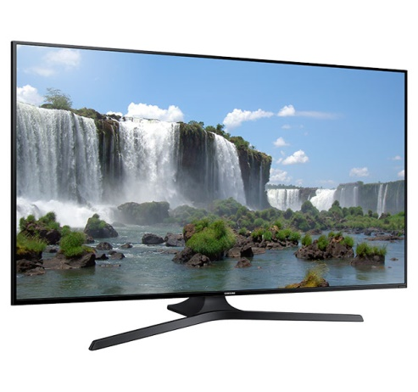
Refrigerator-

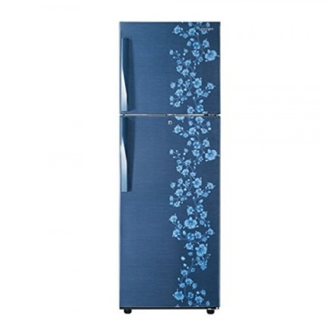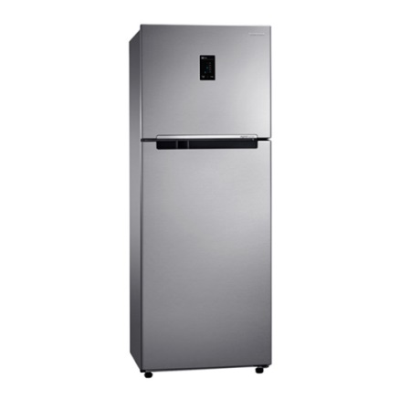

Air Condition-
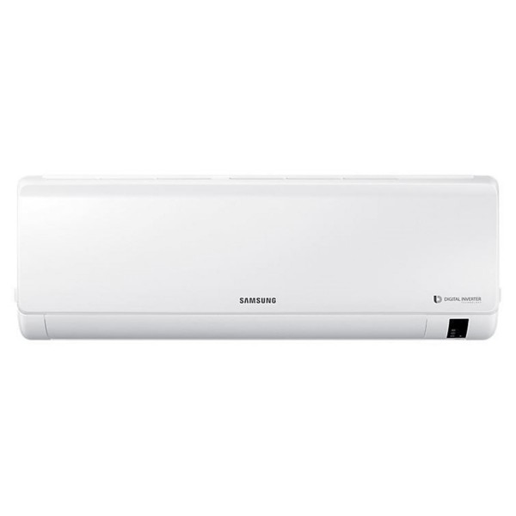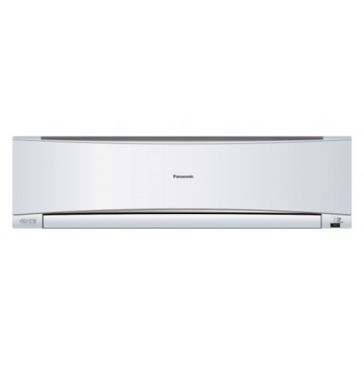
Micro oven-
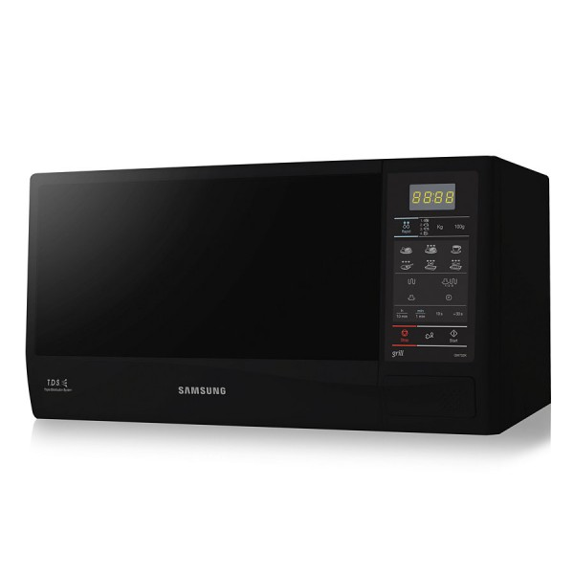

Internship completion Certificate

