The Impact of Money Laundering on Economic and Financial Stability of Developing Country: Evidence from Bangladesh

Submitted To
Dr. Mofijul Hoq Masum, FCMA
Associate professor & Director,IQAC
School of Business & Economics(SoBE)

Submitted By
Sharmin Masrura Khanom
111 191 012

School of Business and Economics
United International University


Date of Submission:
08 March, 2026

Letter of Transmittal

Dr. Mofijul Hoq Masum, FCMA
Associate professor & Director,IQAC
School of Business & Economics(SoBE)
United International University

Subject: Submission of project paper.

Dear sir
I have the honor to state that, I have prepared this project on “The Impact of Money Laundering on Economic and Financial Stability of Developing Country: Evidence from Bangladesh”. It’s a great pleasure to carry out the project under your supervision. I have covered all the necessary elements in this paper.
This report has been both an enjoyable and highly insightful experience. Your supervisor provided valuable academic insight and support which greatly contributed to the development and improvement of this paper. I have worked diligently to ensure that this report is comprehensive and meaningful within the constraints of this assignment.

Yours sincerely
Sharmin Masrura Khanom
Id- 114 191 012,
BBA in AIS,
United International University

Declaration of the Student

Shamin Masrura Khanom declare that the project report “The Impact of Money Laundering on Economic and Financial Stability of Developing Country: Evidence from Bangladesh” submitted by me to United International University partial completion of the requirement for the award of the degree Bachelor of Business Administration in Accounting & Information Systems (BBA IN AIS) is record of project work carried out by me under the guidance of Dr. Mofijul Hoq Masum, FCMA Associate professor Associate professor & Director, IQAC School of Business & Economics (SoBE), UIU.

I declare that, I have created this project appraisal solely for my educational purposes. I might not be accustomed to considering the interests of the opposing the corporation.

Signature
Sharmin Masrura Khanom
Id 114 191 012

Letter of Acknowledgement

Frist, I would like to express my thankfulness and praiseworthy all might Allah for helping me in every moment of life. I would like to express my sincere gratitude and cordial thanks to the academic supervisor Dr. Mofijul Hoq Masum, FCMA Associate professor & Director,IQAC School of Business & Economics, United International University (UIU). Through his constant supervision, Valuable Instruction and helpful advice, able to complete this project paper properly.

I express my all gratitude to everyone to everyone who has support valuable guidance suggestion and advices to preparing the report.

Sharmin Masrura Khanom
Id 114 191 012

Table of Contents
Letter of Transmittal 2
Declaration of the Student 3
Letter of Acknowledgement 4
List of Abbreviations 8
Executive summary 9
Chapter One 10
1.1 Introduction: 11
1.2 Background of the study: 12
1.3 Financial stability: 12
1.4 Rational of the study: 14
1.5 Money laundering: 14
1.6 Limitation of the study: 17
Chapter two 18
2.1 Objectives of the study: 19
2.1.1 Broad objective: 19
2.1.2 Specific objective: 19
Chapter three 20
3.1 Methodology of the Study: 21
3.1.1 Data design: 21
3.1.2 Analytical tools: 22
Chapter four 25
4.1 Literature review: 26
4.2 Money Laundering Role of Acquisition: 27
4.1.2 Money Laundering Prevention Act: 27
4.3 Money laundering and risk analysis: 28
4.4 Money laundering and Risk Analysis: 32
Chapter five 34
5.1 Findings and Analysis of the Study: 35
5.1.1 General Findings: 35
5.2 Global Challenge: 35
5.3 Money laundering Throw hundy: 36
5.4 Frequently Use Money Tracking: 38
5.4.1 Common methods of money Laundering: 38
5.4.2 Stock Markets: 39
5.4.3 Agricultural products: 40
5.4.4 Property markets: 41
5.4.5 Creating bogus companies: 41
Chapter six 43
Recommendation 44
Conclusion 46

List of figure
Figure 1: Shocks of money laundering 12
Figure 2: Money Laundering cycle 13
Figure 3: Methodology data design 19
Figure 4: Money laundering data analysis of the SAARC countries (year 2008-2012) 20
Figure 5: Global anti-money laundering market analyses report (2018-2030) 21
Figure 6: Risk analysis in money laundering 22
Figure 7: Global Forecast 2022 to 2028 26
Figure 8: Hundi Analysis 29
Figure 9: Popular activity of money laundering 30

List of Abbreviations

BFIU | Bangladesh financial intelligence Unit
AML | Anti-Money Laundering
GDP | Gross Domestic Product
CTF | Counter-Terrorist Financing
FATF | Financial Actions Task Force
GFI | Global Financial Integrity
SAARC | South Asian Association for Regional Cooperation
USD | United States Dollar

Executive summary

This study investigates the impact of money laundering on the economic and the financial stability of developing countries with a specific focused on Bangladesh. Money laundering is a serious problem for the developing countries. It harms the economy and the financial system. In this paper find that how money laundering affects the economic and financial stability of Bangladesh country with a growing financial sector. In this paper they explains how illegal money from activities corruption, crime enters the formal financial system and creates money to move out of the country reduces government income and increases the gap between rich to poor and it also creates to ricks for bank and financial institutions b making the financial system unstable and weakening trust in regulations. This paper is based on information from official reports research papers and other reliable sources. This is also findings Money laundering prevention ACT that show that although laws and policies against money laundering exist in Bangladesh. It enforcement and poor coordination among authorities reduce their effectiveness. The study of money laundering serious damages Bangladesh economic growth and financial stability. Strong law enforcement, better cooperation between institutions and greater public awareness are needed to control money laundering. Taking strong action against money laundering will help protect the financial system support sustainable development in Bangladesh.

Key Word: Money Laundering, Financial Stability, Money Laundering Prevention ACT, SAARC countries, Anti-Money Laundering.

Chapter One

1.1 Introduction:
Money laundering is a financial practice that poses a significant threat to the economic and financial stability of developing countries with Bangladesh serving as a pertinent case study. As Bangladesh endeavors to foster economic growth and global integration, the insidious effects of money laundering saturate its financial landscape. It’s also funds concealed within the legitimist economy distort financial indicators jeopardize banking systems and hinder unfamiliar investments and all of these are critical segments for the sustainable development of a nation. So this study delves into the specific ramifications of money laundering in Bangladesh mining to unravel the complexities. Its impact on various economic sectors. By analyzing historical contexts, regulatory responses and the broader global dynamics at play, this research seeks to contribute understandings that can inform policy measure and fortify the economic resilience of Bangladesh in the face of financial activities.
Money laundering is not confined to specific areas. It is a global challenge that impacts economies worldwide. Illegal organizations, corrupt individuals, and even terrorists manipulate money laundering to funds their actions. The alleviation of transferring funds across boundaries and the interconnected nature of the international financial system contribute to the global scope of this issue.
Developing countries are often faced with the challenge of enduring a disproportionate burden of money laundering. This is especially due to weak regulatory framework, poor government, and limited resources for enforcement. The GFI highlights several methods employed for money laundering in Bangladesh, including over-invoicing of imported goods, under-invoicing of exported products, the use of informal remittance channels (Hundi), and involvement in Voice Over Internet Protocol (VOIP) businesses.
Bangladesh was the first country in South Asia to enact the Money Laundering Prevention Act in 2002, under the guidance of the G7- based Financial Action Task Force (FATF). However, subsequent amendment have been insufficient, and there are limited panel provisions under the law. The issue of money laundering in Bangladesh in multifaceted and requires a comprehensive approach to address. It’s vital to consider the complex interplay of economic solutions. Strengthening legal frameworks and enforcement mechanisms is a crucial step, but it’s also important to foster international collaboration to curb illicit financial activities and ensure the stability of Bangladesh’s economy.

1.2 Background of the study:
Money laundering poses a significant threat to the economic and financial stability of developing countries with Bangladesh being no exception. As a process that enables the integration of illicitly obtained funds into the legal economy and money laundering damages the integrity of financial systems, fosters corruption and hampers sustainable development. Developing nation including Bangladesh often grapple with challenges such as weak regulatory framework and limited resources making them easy to experiencing economic growth but facing issues of corruption and weak governance understanding the implication of money laundering is crucial. Bangladesh financial intelligence Unit (BFIU) and specific cases will shed light on the extent of the problem and the impact on economic and financial stability. Addressing this issue is paramount for the sustainable growth of Bangladesh and other developing nations, anti-money laundering measures and international cooperation to mitigate the adverse outcomes on their economies.

1.3 Financial stability:
Money laundering significantly risks the economic and financial stability of developing countries including Bangladesh. The confidential nature of money laundering operations acquired funds to infiltrate the legitimate financial system creating a ripple effect on the overall stability of the country economy .in the context of Bangladesh where economic growth is underway. The impact of money laundering deepens challenges. Financial stability is compromised as these illegal activities distort market mechanisms factor corruption and erode into money laundering channels reduces the capital available for substantial funds into money laundering channels reduces the capital available economic development. So that the repercussions of money laundering on financial stability are imperative for Bangladesh to fortify its economic foundations and foster long-term prosperity.

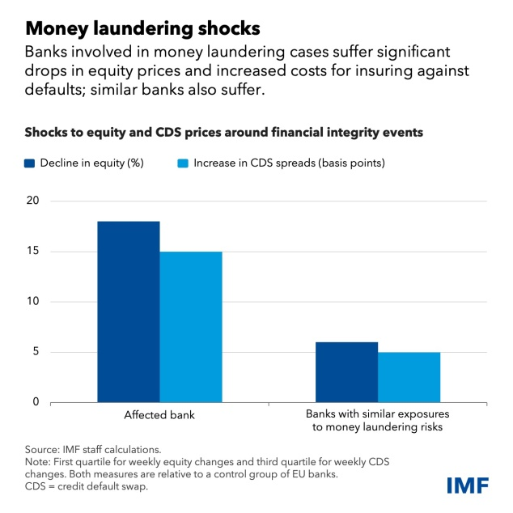
Figure 1: Shocks of money laundering

In the context of the Fund’s established focus on macroeconomics and the intersection of financial stability and integrity risks, a collaborative project with the other countries aims to enhance the understanding and quantification of the impact of money laundering shocks on financial stability. The examination of data pertaining to regional money laundering cases uncovers a detectable trend: banks contending with financial integrity issues experienced important stock price declines, heightened perceived credit risks, and drops in deposits, affecting their liquidity. The repercussions extended beyond individual banks, with money laundering shocks triggering equity price declines and increasing the cost of insuring against corporate defaults. As evidenced by credit default swap prices. This not only impacted the directly affected banks but also led to important spillover effects on other key regional banks, underscoring contagion dynamic within the banking system. This collaborative the boarder regional implications of money laundering on financial stability, emphasizing the need for effective measures to mitigate these risks and protect the overall health of the financial sector.

1.4 Rational of the study:
The rational for investigating the impact of money laundering on the economic and financial stability of developing countries, particularly in the context of Bangladesh is rooted in the critical need to address a pervasive threat to sustainable development. Money laundering not only undermines the integrity of financial system but also poses a significant risk to the economic well-being of developing nations. In the case of Bangladesh a thorough examination of the consequences of money laundering is essential to comprehend its specific implications and challenges within the country economic landscape. The study aims to policymaker’s regulatory bodies and financial institutions with crucial insights necessary for devising targeted strategies. The ultimate goal is to strengthen the resilience of Bangladesh’s economy, financial stability and contribute valuable knowledge that can be applied to similarly situate developing nations striving for sustained and inclusive economic growth.

1.5 Money laundering:
Money laundering is a process by which individuals or entities disguise the origins of illegal practical involves a series of compels financial transaction with the aim of concealing the true nature of the illicit acquired money. Money laundering typically consists of three main stages
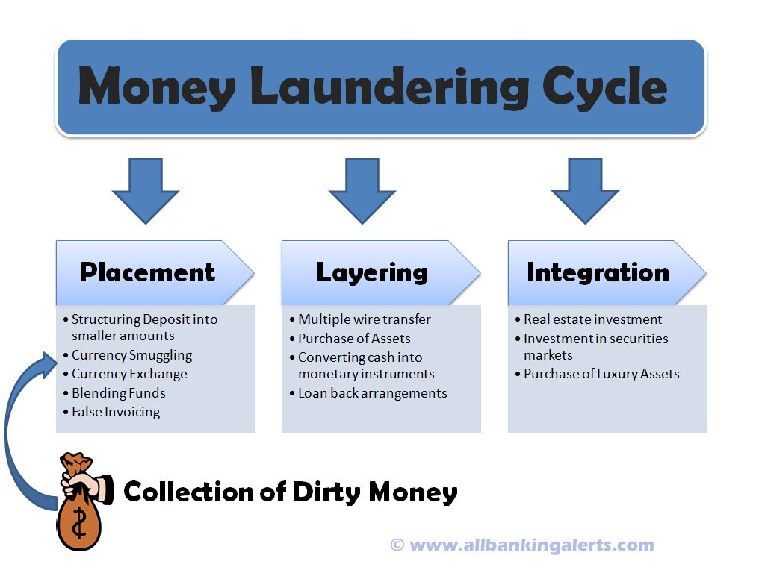
Figure 2 Money Laundering cycle

1.5.1 Placement:

It’s a represents the initial phases in the money laundering process where in the sounds are introduced into the financial system. This is executed by funding the dirty money into circulation through various channels such as financial institution, casinos, shops, bureau de changes and other businesses. The primary object of placement is to relieve criminals of the burden of safeguarding larger sums of cash by integration them into the legitimate financial system. Different techniques are employed during placement including currency smuggling or smurfing. So involves keeping transaction amount below Anti-Money Laundering (AML)reporting thresholds to avoid arousing suspicion. Money laundering may use methods such as loan or credit card repayment , currency exchange in foreign markets ,blending funds with legitimate business receipts through fronts or cash-based enterprises owned by criminal organizations an engaging in false invoicing to obscure the illicit origin of funds.

1.5.2 Layering:

It’s the second step in the money laundering process aiming to distance illegally obtained funds from their sources and complicate the detection of the activities. This involves intricate financial transaction moving founds internationally, converting cash into various forms like monetary instruments, arranging loans and purchasing assets. The main goal is to create a complex trail that makes it challenging for law enforcement to trace the origin of illegal proceeds and maintain as mush distance as possible from their source. It methods of layering vary but often include a combination of financial moves as transferring funds between different banks or accounts converting large sums into different currencies buying and selling assets in jurisdictions with weak financial regulations. Criminals may also use shell companies trusts accounts to hide the true ownership of the funds and to disguise the link between the money and its criminal source. Another financial instruments to further distance the funds from their illegal origins. Money laundering may also engage in trade based laundering. Layering is designed to create confusion and delay the detection of illicit activity by authorities. The more complex and opaque the transactions the harder it becomes for regulators and law enforcement agencies to trace the money back to its source. This phase can involve a significant number of transactions over extended periods to minimize the changes of detection.

1.5.3 Integration:

This is the last phases of the money laundering process is integration. The funds re-enter the possession of the owner or criminal seemingly origination from legitimate sources and seamlessly integrate into the financial system. The objective is to make the money appear as though it comes from normal business or trade earnings. Common methods of integration include investing in stock, commodities, gold, real estate and other assets. So this step completes the money laundering cycle are allowing the launderer to achieve their goal without attracting the attention of law enforcement agencies. The funds are often invested in legitimate business ventures high value assets like real estate and financial instruments stocks and bonds. Criminals may purchase of good cars art jewelry can later be resold for legitimate profile. They may also use the money to fund the expansion of legitimate businesses of the funds were earned through lawful business activity. It investment the enterprises of criminals to blend their illicit earning seamlessly into the broader economy. It funds can be integrated by opening legitimate bank accounts in various countries investing in long term financial project of high consumer purchases with this fund now appearing legitimate can be transferred suspicion. The money is virtually indistinguishable from legitimate earning for authorities to trace its trace of criminal origins. It is the culmination of the money laundering process with the opportunity to enjoy the proceeds of their illegal activities without facing prosecution.

1.6 Limitation of the study:
- Limited availability of accurate and comprehensive data on money laundering activities in Bangladesh.
- Potential challenges in assessing the true effectiveness of existing regulatory frameworks in combating money laundering.
- The direct impact of money laundering is difficulty amidst the complexity of global financial systems.
- Money laundering constraints in predicting future trends and the success of preventive measures.
- The dynamic nature of financial crimes may lead of difficulties in capturing evolving attentive measures.
- Interactions with the unique socioeconomic context of Bangladesh, such as poverty and political instability challenges in analysis.
- Possible limitation findings to other developing countries due to specific of dynamics in Bangladesh.
- Money laundering is the legal penalties is not be stringent enough to deter potential offenders. So the inadequacy of punitive measures can contribute to a culture of impunity

Chapter two

2.1 Objectives of the study:

2.1.1 Broad objective:

To assess and investigate analyze the multifaceted impact of money laundering on the economic and financial stability of developing countries with a particular focus on the context of Bangladesh.

2.1.2 Specific objective:

- To assess the specific vulnerabilities within the financial systems of developing countries particularly in Bangladesh that make them susceptible to money laundering.
- To identify and evaluate the effectiveness of existing countermen measures and anti-money laundering policies in measures aimed at reducing the impact of money laundering on the economic well-being and financial stability of developing countries like Bangladesh.
- To analyze money laundering activities affect the macroeconomic indicators of Bangladesh including GDP growth inflation and employment rates.

Chapter three

3.1 Methodology of the Study:

3.1.1 Data design:

The study employs a combination of primary and secondary date. Primary data is collected through stakeholder interviews, surveys and case studies specific to Bangladesh. Secondary data includes economic indicators, financial reports and regulatory documents obtained from reliable sources. This dual- data approach ensures a comprehensive understanding of the impact of money laundering. this methodology of money laundering we can search lots of process and thesis paper then we can find the moral of the money laundering and understanding the impact of money laundering in Bangladesh. money laundering is a process which is individual or entire design and integration. And it help us to know about our country and working proposes.
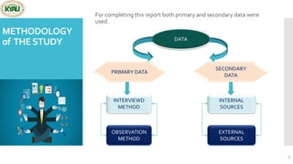
Figure 3 Methodology data design

3.1.2 Analytical tools:

Data analyzed using statistical tools such as regression analysis to identify correlations between money laundering activities and economic indicators. Its thematic coding and content analysis to extract meaningful patterns and insights from interviews surveys and case studies.

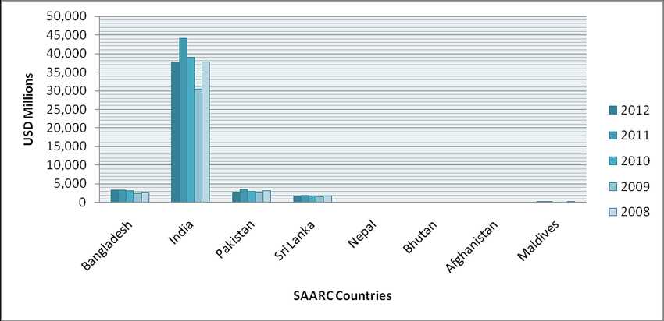

Figure 4 : : Money laundering data analysis of the SAARC countries (year 2008-2012)

In this diagram 2008 to 2012 to analysis of money laundering trends in the SAARC countries rivals significant challenges in the regions financial landscape. So specific figures by country compiled data complex interplay of economic. Diagram saws that Bangladesh has 2500 USD millions of money laundering. India has 45000 USD millions, Pakistan has 3000/4000 USD millions, Sri Lanka have 1500/2000 USD millions, Nepal , Bhutan, Afghanistan , Maldives they have not any money laundering. India have most highest year 2011. International cooperation and information-sharing among SAARC nations as well as with global organization like the financial action task force (FATF) and its played a crucial role in addressing these challenges. Specific figures and data for each SAARC country during this essential of dynamic money laundering.

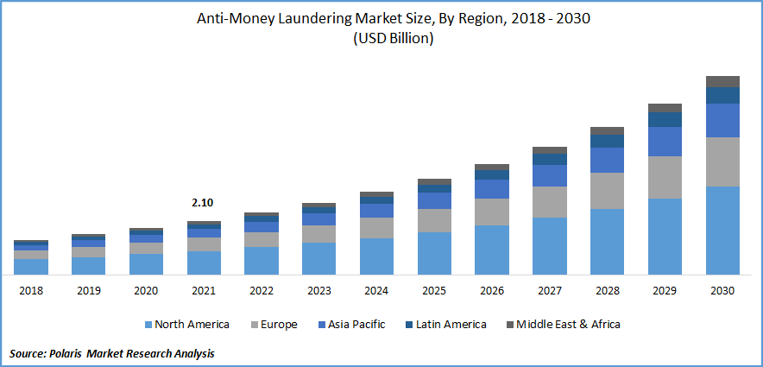
Figure 5: Global anti-money laundering market analyses report (2018-2030)

The global anti-money laundering (AML) marketing is significant growth from 2018 to 2030. It propelled by a confluence of factors. Increasing financial crimes, regulatory stringency and heightened among financial institutions drive the demand for advanced AML solutions and services. The market is shift with the integration of cutting-edge technologies such as intelligence, machine learning and block chain to enhance the efficacy of money laundering detection and prevention. Developed regions, notably north America and Europe are anticipated to lead the market due to their robust regulatory framework and sophisticated pivotal financial. Economic emerging are becoming increasingly pivotal contributors as they strengthen their AML measures to align with global standards. So the period from 2018 to 2030 is a dynamic landscape marked by technological innovation regulatory evolution and collaboration between public and private sectors. The evolving challenges posed by money laundering activities on a global scale.

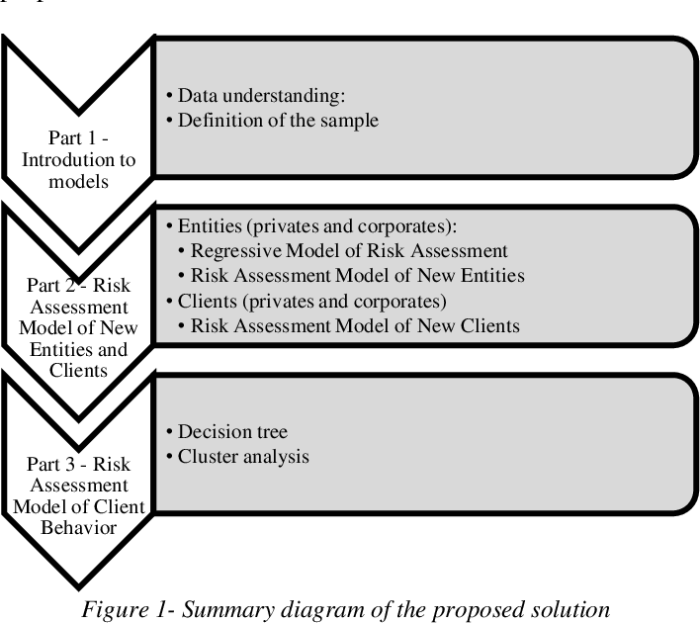
Figure 6 : Risk analysis in money laundering

Risk analysis in money laundering is a process of financial institutions to identify assess of potential to their compliance. It involves of various factors of customer profiles product and services the context in which a financial institution operates. There are three models those are introduction to models which is data understanding and definition of the sample. Second part is assessment model of new entities and clients which entitles (privates and corporates), regressive model of risk assessment, risk assessment model of new entities , clients privates and corporation and risk assessment model of new clients. And the last part is risk assessment model of client behavior which is under the decision tree and cloister analysis. Those are the very important of money laundering risk.

Chapter four

4.1 Literature review:
Money laundering stands as a critical challenge with far-reaching implication for the economic and financial stability of developing countries and Bangladesh is no exception. This literature review aims to delve into the consequences of money laundering exploring its impact on economic. Its impact on economic growth financial stability, frameworks and the broader socio-economic landscape.
The economic consequences of money laundering in developing nations are profound. Financial flows divert resources away from legitimate economic activities, hindering sustainable. The nature of money laundering also nurtures of cycle that perpetuates economic challenges and inequality. So the impact is particularly countries like Bangladesh where economic growth is essential for poverty alleviation.
Effective regulatory frameworks are crucial in addressing money laundering. In there are many developing countries including Bangladesh are weak legal and regulatory structures create valuable illicit financial activities. These framework and improving enforcement mechanisms are steps in mitigating the impact. Anti-money laundering (AML) and counter-terrorist financing (CTF) are imperative to protect economic and financial stability.
The transnational nature of money laundering international cooperation .its developing countries often face challenging through information sharing capacity building and standardizing AML/CTF measures is for combating the cross- border impact of money laundering.
Money laundering extends beyond economic and financial realms the broader socioeconomic landscape. The funds generated through illicit activates offend support organized crime and terrorism to social unrest. Money laundering is a holistic approach in developing countries should consider both economic and social dimensions.
So that the underscores the intricate of challenges posed by money laundering in developing countries with a focus on Bangladesh. The strengthening of regulatory frameworks fostering international cooperation and addressing both economic and social dimensions for sustainable development.

4.2 Money Laundering Role of Acquisition:
The practical analysis showed that efficient legal framework with good corporate governance reduce and high- innovative capacity contribute negative pervasiveness of money laundering activities. By analyzing historical contexts, regulatory and the broader global dynamics at play this research seeks to contribute understandings that can inform policy measure and fortify the economic resilience of Bangladesh in the face of financial activities. Findings and analyses often vary on the region, the financial sector, and the methods employed by illegal sides. Some trends and considerations include:

4.1.2 Money Laundering Prevention Act:
Lack of regulatory mechanisms, legal complexities and organization and organizational dysfunction have led to a massive increase in money laundering violations in Bangladesh.
Money Laundering Prevention Act, 2012 is the most significant addition. Section 2(v) under of Acts, 2012 defines to main elements those are purpose and detailed explanation of commission of crime. This act mainly defines when someone try to do money laundering in the illegal ways by avoids the Act’s requirements.
Section 4(2) under of Acts 2012 defines the punishment for money laundering. And imprisonment for this crime four to twelve years and a fine is double equal the asset or to million BDT.
Section 4(3) under of Acts 2012 defines the orders the court to confiscate any assists related to money laundering on behalf of the state. The amount of fine imposed is relatively small compared to the current value of the laundered money. A better solution is to apply a penalty equal to the current value of the total assets using laundered money.
Section 6 of the Act presenting the penalty of divulging information relating to investigation with ill-intent which may be imprisonment for to years and fine which may extend to fifty thousand BDT or both. Section 8 addressing the penalty for deliberately supplying wrong information about the source which is a maximum imprisonment of three years and a fine of up to fifty thousand BDT.
There have also some Sections in this Acts. These are:
Money Laundering Prevention Act, 2015 have some correction from 2012 Acts. These are:
Section 5(2): Bangladesh bank to Bangladesh Financial Intelligence Unit.
Section(i) shall be substituted section (i) “investigating agency” means, subject to any other provision of this Act, (b) investigating agencies empowered under the relevant Act to investigate ‘related offences’ referred to in Section(x):
Provided that all the related crimes which are investigate able by the Bangladesh Police shall be investigated by the Criminal Investigation Department of the Bangladesh Police. Section(a) one or more investigative agencies referred to in sub-section(b) empowered by the Bangladesh Financial Intelligence Unit in consultation with the Government.
Act 2012 Section(5)(4) correction. The Act(b) for sub-section(4) the following sub-section(4) shall be substituted that Section(4) provision of section 27, if any entity commits or attempts, assists or conspires to commit an offense under this Act, sub-section.
Section (2) shall be taken in accordance with the provisions thereof and a fine of not less than double the value of the property involved in the offense or twenty lakhs, whichever is more, shall be imposed and the registration of the said establishment shall be cancelled; Provided that the said entity within the period fixed by the court.

4.3 Money laundering and risk analysis:
Advancements in technology and the increasingly global of business have prompted accountants to adopt new tools and stay alert to the rise of sophisticated crimes such as privacy violations, cybercrime hacking drug trafficking and international money laundering As key players in fight against money laundering (AML) for the responsible the business transactions are legitimate and for promptly reporting any activities to the authorities. It is vital for accountants to stay informed about the lates regulations concerning money laundering terrorist financing and cybercrime.
All of those money laundering dose not have a direct impact on financial statements failing to report such activities in a timely manner can lead to consequences for audit firms. So as Example of KPMG Malaysia which faced legal action from the ministry of finance of Malaysia and development bread for not reporting fraud risks during the 2009 and 2014 audit. Such situations could have been avoided had KPMG gather sufficient evidence to support their audit finding.
While accountants are not specifically required to design audit procedures aimed at detecting money laundering activities, statement on auditing standard (SAS) mandates auditors to be aware of any suspicious activity report during audits. Therefore, accountants must act as money laundering entities as they are frequently consulted by organization and individuals for advice on business regulatory and compliance issues.
As front-line defenders, accountants must implement preventive measures to ensure their companies are not used for money laundering activities. These measures include conducting risk assessments, performing customer due diligence (CDD), submitting suspicious transaction reports (STRs) and maintaining proper transactions to facilitate their operations such as depositing or withdrawing cash engaging in foreign exchange issuing cashing checks busying for selling stocks trading property and processing international funds transfers.
One significant indicator of potential money laundering activities is related-party transactions, which involve dealings between a corporation and its management, owners, immediate family members of affiliates. Accountants should assess the appropriateness of accounting processes and disclosures related to such transaction. Potential fraud risks include abnormal corporate structures special purpose entities controlled by management asset transfer at unusual pries and the use of compels equity transactions.
Companies are intermediaries in money laundering operations. So their responsibilities accountants should be verify the legitimacy of companies involved in financial transitions. To address this risk the financial action task force (FATF) strengthened its requirements for beneficial ownership reporting in 2012. Accountants are encouraged to assist in beneficial ownership reporting and help firms establish internal policies for tracking price Waterhouse coopers.
The complexity of detecting money laundering risk has increased during the COVID-19 pandemic as businesses have embraced digital transformation. The rise of e-commerce has provided new opportunities for money laundering actives are conducted online bypassing traditional financial institutions.it is not require intermediaries to transaction conducted through financial institutions. E-commerce platforms are less regulated than financial intuitions allowing criminals to use these systems to launder proceeds from activities as drug trafficking tax evasion and corruption. Despite new regulations and risk indicators to find ways to circumvent these measures. common money laundering techniques include wire transfers fake accounts false smurfing shell companies and alternative remittance systems.
Online money laundering often referred to as differs from traditional methods by taking advantage of the borderless and rapid nature of online transactions. This makes it more challenging to detect as perpetrators can carry out illicit activities from any location with internet access. Cyber-laundering can involve various financial transactions, and money exchange transfers including. Perpetrators tend to favor quick and efficient methods to launder criminal proceed. Cybercriminals are often well-educated and technically skilled employing sophisticated and unconventional methods. With cloud computing regulation still being developed.it is difficult to trace the physical location of date stored on public cloud services further complicating efforts to detect activities.
So accountants have a vital role in preventing money laundering by staying vigilant adhering to regulatory guidelines and implementing effective preventive measures. So money laundering risks especially those associated with digital platform becomes more complex accountants must continuously adapt and remain alert to emerging threats. They have possible risks.

category | Risk indicator | source
Affiliate Transactions | - Organizational structure of the company  - Special purpose entity influenced or controlled by management.  - Transfer of assets to related parties in amounts significantly different from their market value.  - Special purpose entities used to intentionally misrepresent the financial status or performance of the reporting entity  - Complication equity transaction.  - Transactions that are unnecessarily complex.  - Uncommon large discounts returns or circular transaction like sale and repurchase agreements and management services with no transparency. | ACCA Global 2015,ICAEW 2010,Marks 2020
Beneficial ownership | - Structure of ownership.  - Use of bearer shares and nominee shareholder arrangements.  - Type of business activity.  - Legal structure.  - Evidence of existence.  - Corporate structure or arrangement.  - Individuals holding control. | FATF (2019)
E-commerce | - Electronic money transfers.  - Opening bank accounts under fictitious names.  - Creating fraudulent invoices.  - Structuring transactions to avoid detection.  - Empty or inactive companies.  - Non-traditional money transfer systems. | Buchanan & Zabala (2017)

Accountants are advised to take into account the risk indicators of money laundering when making judgments related to money laundering. These indicates address risks both before and after covid-19 pandemic encompassing issues related to money laundering financing and cybercrime. Accountants should strengthen their professional when making decisions.

4.4 Money laundering and Risk Analysis:
Money laundering facilitates various activities including tax evasion corruption drug and human trafficking and terrorism by enabling the transfer or holding of funds necessary to carry out these crimes. A common motive behind money laundering operation is the need to control profits hide the true ownership and origin of these funds and alter the form to the illegal proceeds. A successful money laundering process occurs when criminals manage to transform illegal gains into clean money.
Professional judgment is typically made by specialists such as bank analysts. One important element of judgment is the closeness or proximity between two parties of decision making processes. A thorough and careful assessment is necessary before making any judgment to ensure that the decision is appropriate for the specific issue at hand. It professional accountants must conduct customer dur diligence and know your customer procedures to assess money laundering risks. So the pandemic-induced movement restrictions made it more difficult to verify client transactions and the identification of the actual owner.
The concepts of professional skepticism and judgment are essential the anti money laundering and counter financing of terrorism requirements as the ani money laundering act issued by bNM.so frontline defenders against money laundering professional accountants must apply high levels of professional diligence. A high level of accountants enhances their ability to detect suspicious transactions the chances of failing to prevent money laundering. The KYC process particularly demands strong skepticism and judgment especially when investigating a clients source of funds or wealth. Improper audits could expose the country to serious risks of financing terrorism. So the auditors with greater through reliable and independent sources or cross-check the against lists from the MOHA and the united nations security council resolution sanction for terrorism and other related issues.
The various tools available for client screening know your customer due diligence tools are the most commonly used. Hanson highlights that while significant efforts have been made to improve the effectiveness and efficiency of these crucial component of the KYC process. He emphasizes that the skills of accountants closely align with the abilities required to combat financial crime.
A new requirement mandates that every firm conduct a comprehensive the whole risk assessment . accountant must implement systems and control including training to evaluate risk ,CDD, monitor existing clients keep appropriate records and report suspicious activities both internally and externally. Failure to report any knowledge or suspicion of money laundering is itself a criminal offense for accountants. Accountants working in the public interest must act with integrity and comply with the law at all the times.so this study proposes a proposed framework for risk judgments

Chapter five

5.1 Findings and Analysis of the Study:

5.1.1 General Findings:

This study uses a descriptive and analytical approach to examine the impact of money laundering on the economic and financial stability of Bangladesh . the research is based on secondary data collected from reliable sources such as reports from Bangladesh bank different publications international organizations academic journals and newspapers. This paper are carefully reviewed and analyzed to understand the causes effects and trends of money laundering in Bangladesh. Simple comparison and trend analysis were to explain how money laundering affects government revenue and financial system. The study focuses on recent information to reflect the current situation. Due to the hidden nature of money laundering exact figures are difficult to obtain which is clear issue and impacet on the countrys economic and financial stability.

5.2 Global Challenge:
The challenges of money laundering have significant risks of financial systems, economies and societal ell-being. Money laundering is often an global activity, crossing borders. Criminals exploit differences in legal systems to transfer and conceal illicit funds worldwide. Money Launderers are constantly adapting and using increasingly sophisticated techniques to disguise the illicit source of funds. These include complex financial structures, shell companies and they use of technologies such as cryptocurrencies.
Effective countermeasures against money laundering require strong international cooperation. Financial Action Task Force (FATF) plays an important role in setting global standards and promoting cooperation between countries. Collaborative efforts between government and private sector are crucial. Financial institutions, regulatory agencies and other stakeholders must develop strategies to combat money laundering.
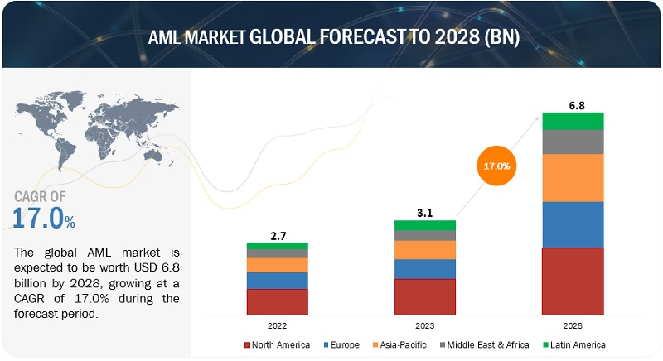
Figure 7: Global Forecast 2022 to 2028
The Global AML market size is growing up from USD 3.1 billion in 2023 to USD 6.8 billion by 2028. The Compound Annual growth Rate (CAGR) 17.0% through the forecast. The AML market attributed to the adopting of cloud-based solution to combat financial crimes.

5.3 Money laundering Throw hundy:

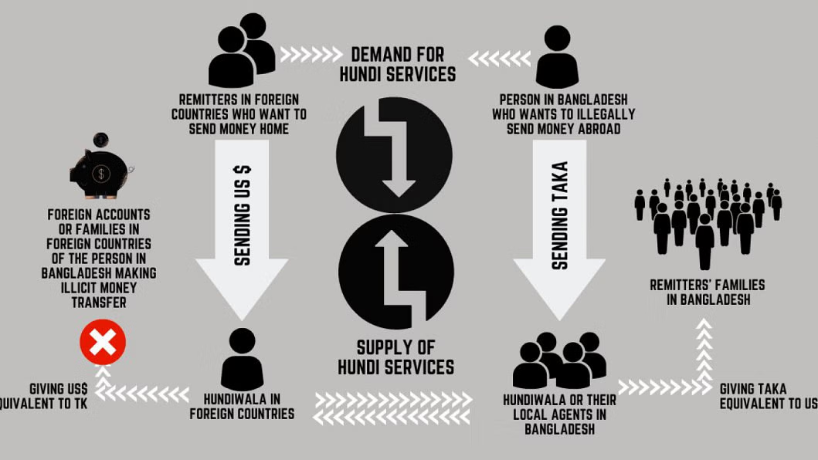
Figure 8: Hundi Analysis

International remittances play a role in driving economic growth and reducing poverty in Bangladesh. The positioning the country pf the seventh heights earner of remittances globally. Bangladesh migrant work in the middle-Eastern country US UK European countries and east Asian. Despite a recent macroeconomic crisis of substantial growth in remittance for an increasing trade deficit and sustaining growing foreign exchange reserves until the end of 2021.bangladesh through formal reach the including banking systems contributing to macroeconomic stability by providing the government with essential foreign currencies. Operating outside the conventional banking system is involves hundi verbal agreements for money transfer and serves various purposes ,transaction and remittance transfers. Its illegality the well-organized hundi system is extensively used by migrant workers from Bangladesh. The utility of collected foreign currency to hundi service providers abroad involves individuals or groups seeking to transfer illicit money abroad. In this scenario local hundi operators receives illicit funds in taka and in exchange foreign currency is deposited in designated accounts and maintaining the flow of remittances. The demand for hundi services is not only driven by legitimate remittances but also the engaging in illicit money transfer within Bangladesh. So money transfers persist hundi service providers will continuum to be active. Irrespective of state actions on exchanges rates of tacking this challenge requires a comprehensive approach and strong political will be concerns surrounding of money transfer in Bangladesh.

5.4 Frequently Use Money Tracking:

5.4.1 Common methods of money Laundering:

Money laundering employs various tactic and one prevalent method involves the creation of fictitious companies. This practice entails setting up the businesses that legitimize unlawfully obtained funds. These perpetrators manipulate financial transactions through these making the challenging for money laundering illicit origins of the funds. The money behind these counterfeit companies navigates of the finical system. Prevalent method is structuring is where larges sums of illegal money are broken down into smaller of suspicious amounts and deposited into multiple accounts to avoid detection. Layering involves moving illicit money through multiple financial transactions buying and selling assets or transferring funds between accounts to avoid detection. Laying is moving illicit money through multiple financial transactions are buying and selling assets or transferring funds between accounts to obscure its origin. The use of shell companies or fake businesses is criminals establishing fake enterprises to conduct transactions and launder money under the legitimate operations. So real estate is another key vehicle properties or property flips is used to launder funds. These strategies along with other trad bashed money laundering complicate efforts by authorities to detect and treacle illegal financial making money laundering effectively.
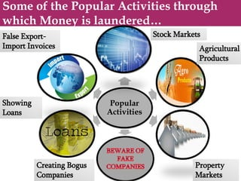
Figure 9 : Popular activity of money laundering

5.4.2 Stock Markets:

Money laundering in the stock market is a groups of trying to make illegally obtained funds appear legitimate through stock-related activities this can include manipulating stock price. Money laundering may exploit the complexity of financial instruments anonymously trade to across borders to make it harder for authorities to trace their activities. It’s a anti money laundering and regulatory measures in places to maintain the integrity of the stock market. Money laundering can exploit the complexities and liquidity of the stock market to move large sum of money often using a series of transactions to obscure the illegal source of the funds. These method of money laundering money through the stock market involves layering illicit funds by purchasing stocks with criminal money and the rapidly selling and buying different securities to create a transactions. This can makes it difficult for regulators to trace the money back to original criminal source. It also manipulate stock prices by engaging in market manipulation and artificially inflate the price of a stock using illicit funds and then sell of these shares prices products and other financial assets or withdrawn appearing legitimate. Illicit funds are invested based on confidential information of money launder can used front running or trading insider. They can be transferred into more legitimate assets. The stock market provides an opportunity for criminals to use shell companies to hide their identity and ownership to the connect them to the illegal activities. To combat money laundering in the stock market regulators have imposed strict know your customer and anti money laundering regulations and financial institutions to monitor suspicious transactions. The complexity and global nature of stock markets detecting of money laundering challenge

5.4.3 Agricultural products:

Money laundering is involving the trade the transaction related to farming goods to conceal and legitimize the obtained funds. So the terms individuals illegal activities use buying the selling products to make their illicit money seem legal this involve manipulating trade. It involves manipulating agricultural transactions to disguise the origin of illicit funds. The method is the inflation of product values where criminals overstate or understate the quantity or quality of goods like crops livestock equipment in trade agreements. This creates an artificial transaction that allows money to be integrated into the legitimate economy. The tactic is the use of shell companies or front farms businesses that appear to engage in agricultural activities are used to launder money by purchasing and selling goods at inflated prices and moving funds across borders agricultural exports. Trade based money laundering also playing a signification role to good agricultural goods international transactions to shift illicit funds. Involving agricultural land in engage real estate transactions is property is purchased with dirty money and then sold a higher price to launder the funds. It might loans to obtain legitimate funding to funnel illegal proceeds through the agricultural sector. Transactions criminals are able to disguise the true arraign of funds for trace illegal financial activity the agricultural industry. So the integrity of the agricultural market and prevent from using money laundering.

5.4.4 Property markets:

Property markets involves the estate transaction to legitimize illegally obtained funds. People engaged in illegal activities trafficking or corruption buy or sell properties to make their illicit money appeal legal. This purchasing proportions to hide the true slouch of funds.so money laundering is the obscure ownership and conceal the true identity of the buyer. Property flipping are properties are quickly bought and resold at inflated prices is another common tactic. Cash transactions compels layered deals and foreign investment also serve to integrate illegal money into the legitimate market. Mortgage fraud renovations and development project can be used to launder money by making illicit funds appear legitimate. The involvement of intermediaries like real estate agents and lawyers may further facilitate of regulated of rural markets. Common method involves inflating property prices through overvalued transactions. Criminals may buy and sell the same property inflated prices legitimizing the illicit funds by making it appear though the money came from a legitimate sale. Another technique is using cash payments or large down payment to avoid by financial institutions particularly buyer is not subject to usual banking checks. It uses to multiple properties to further complicate the paper trail and difficult for the authorities to the origins money. Transparency laws are less stringent allowing for the anonymous ownership of real estate. These transactions may be masked by complex ownership of distancing the property from its criminal origin. So real estate markets are particularly vulnerable to money laundering due to their ability to conceal large of money and the relatively low risk of detection compared to other financial sectors. Governments and regulatory bodies continue to focus on improving anti money laundering measures in the property market to mitigate risk.

5.4.5 Creating bogus companies:

In this think money laundering involves of companies businesses on paper complete with fake names and addresses people doing this create fake documents to make it seem like theses companies. They put illegally obtained money into these companies look like the money comes from business activities. The fake companies might pretend to buy and sell those thing. The fake companies might pretend to buy and sell thinks that don’t actually exist. It will be helps hide the origin of the illegal money. They provide a façade of legitimacy to conceal the true nature of the financial transaction behind them. This process involves the illegal funds are deposited and transferred the shell company can then issue invoices for fictitious services of goods creating a false paper trail appear the money from a legitimate business operation. These invoice may be used to disguise the movement of money of lay illicit funds through various accounts. Some of cases companies are used to engage in trade based money laundering good are falsely invoiced and shipped between countries legitimate payments for good services. Criminals may also use these companies to own valuable assets like real estate luxury items and further distancing the illicit money from its original source. The creation of companies typically involves minimal regulation or oversight in jurisdictions with weak corporate governance. Business and financial transactions money laundering can obscure the origin of the fund and integrate them into the legitimate economy. Governments and regulatory babied have increasingly focused on the corporate structures to combat this method of money laundering.

Chapter six

Recommendation
Money laundering continues to pose a significant threat to the economic and financial stability of Bangladesh as illicit financial activities can infiltrate various sectors such as remitting channels stock exchanges agriculture real estate and corporate structures. Give the evolving nature of money laundering techniques tackling this issue necessitates a collaborative approach that involves government bodies, financial organizations regulatory entities and the general populace. It is crucial to enhance the legal and regulatory framework and existing anti money laundering regulations should be routinely evaluated and updated to meet international standards while ensuring stringent enforcement and appropriate punishment for offenders. Financial institutions play a vita role in identifying suspicious activities banks and other financial entities must improve their monitoring systems adopt robust know you customer (KYC) practices and financial institutions should ensure that employees receive regular training so the can recognize unusual financial patterns including structured deposits irregular transfers or questionable business transactions. Remittances are a significant source of foreign exchange for Bangladesh however the presence of informal transfer systems such as hundi increases the possibility of illegal money movements. For this reason the government should motivate migrant workers to send through formal banking channels by lowering transacting fees expanding access to financial services and providing incentives for legal remittance transfers while also strengthening monitoring systems to limit illegal remittance networks. Greater transparency in the real estate sector is also essential because property markers can be used to conceal illicit funds through high value transactions. Authorities should therefore require clear identification of property buyers and sellers verify the sources of funds used for property purchases. And stronger supervision of companies and fictitious businesses that may be used to hide illegal financial activities. This can be achieved by requiring companies to reveal beneficial ownership details strengthening business registration systems and carrying out regular financial audits. Trade based money laundering including manipulation in agricultural trade must also be carefully monitored because criminals may misrepresent the value of good to transfer illegal funds across borders. As a result customs authorities and regulatory agencies should strengthen the monitoring of import and export activates and promote information sharing among financial activities can help people understand the risks and encourage them to report suspicious financial behavior. Because money laundering often involves cross border financial networks international cooperation is also crucial and Bangladesh should continue working with international organization and foreign governments to exchange information and strengthen entry-money laundering measures. In addition the use of modern technologies such as digital monitoring systems artificial intelligence and data analytics and strengthen regulatory efficiency. Finally effective coordination among governments agencies financial institutions law enforcement. Improved communication and joint investigations can enhance anti money laundering efforts and by implementing these combined measures Bangladesh can improve financial transparency reduce illegal financial flows and safeguarded the stability of its economies and financial system.

Conclusion

The study has shed light on the intricate challenges posed by money laundering in the developing countries on Bangladesh. Money laundering impact of money laundering of Bangladesh financial stability is multifaceted involving challenges such as weak regulatory frameworks poor governance and limited resources for enforcement. The study highlights various methods employed for money laundering in Bangladesh including of informal remittance of hundi and engagement in illicit activities like stock market manipulation and property transaction. The impact of money laundering study objectives of broad and specific aimed to assess vulnerabilities in financial systems of developing country and evaluate the effectiveness of exiting countermeasures and examine the linkages between money laundering and other financial crimes. Its research of employing statistical tools for analysis. The money laundering prevention in Bangladesh has been a crucial step for more comprehensive and effective measures . financial activities curb illicit of international collaboration is essential of Bangladesh economy. The study of emphasizes the importance of understand the intricate dynamics of money laundering addressing both economic and social dimensions and fostering global achieve sustained and economic growth.

Reference
- https://sas-space.sas.ac.uk/4732/1/Ayodegi_Aluko_LLM_ICGFREL_dissertation.pdf
- Financial stability: ps://www.imf.org/en/Blogs/Articles/2023/09/04/money-laundering-poses-a-risk-to-financial-sector-stability
- Money laundering cycle: https://allbankingalerts.com/what-is-money-laundering-three-methods-or-stages-in-money-laundering/
- Data design: https://www.slideshare.net/TanjirHossain7/money-laundering-24550752
- Data analysis: https://www.researchgate.net/figure/Money-Laundering-Data-Analysis-of-the-SAARC-Countries-Year-2008-12_fig1_355921877
- https://www.polarismarketresearch.com/industry-analysis/anti-money-laundering-market
- https://www.slideshare.net/HimanshuGoyal108/the-prevention-of-money-laundering-act-2002-2-72399113
- https://www.marketsandmarkets.com/Market-Reports/anti-money-laundering-solutions-market-95490454.html
- https://www.thedailystar.net/law-our-rights/news/reviewing-the-money-laundering-prevention-act-2012-3311551
- https://www.bfiu.org.bd//pdf/regulationguideline/act/mlp(amendment)act2015.pdf
- https://www.thedailystar.net/tags/hundi-traders-money-laundering

