Organizational atmosphere, Staff administration, and Recruitment operations at Shomvob.



Mehreen Hassan Hridy

This report is submitted to the school of Business and Economics, United International University as a partial requirement for the degree fulfilment of Bachelor of Business Administration

Organizational atmosphere, Staff administration, and Recruitment operations at Shomvob

Submitted to:
Name: Nasrin Akter
Designation: Assistant Professor
Major: Human Resource Management

Submitted by:
Name: Mehreen Hassan Hridy
ID:111 211 047
Major: Human Resource Management


School of Business and Economics
United International University

Date of submission: March 11, 2026

Letter of Transmittal

Nasrin Akter
Assistant Professor
School of Business and Economics
United International University.
Subject: Submission of internship report on “organizational atmosphere, staff administration, and recruitment operations Evidence from Shomvob.
Dear Ma’am,
With due respect, I would like to submit my internship report on “organizational atmosphere, staff administration, and recruitment operations Evidence from Shomvob.Working in a Job and HR Technology Platform in Bangladesh was a great experience for me. The internship program helps me to earn experience and gives me the opportunity to improve my theoretical knowledge through hands-on experience with HRM and business operations.
I pray and hope that this report will offer the information that is needed on the corporate culture, personnel management, and hiring practices Evidence from Shomvob. I would appreciate it if you will accept this report.
Thanking you.

Sincerely,
Mehreen Hassan Hridy
ID:111 211 047
Major: Human Resource Management

Certification of Similarity Index

Declaration of the Student
I, Mehreen Hassan Hridy, ID: 111211047, and currently pursuing a Bachelor of Business Administration with a major in Human Resource Management at United International University, confirm the successful completion of a three-month internship at Shomvob. The internship spanned from October 8th 2025 to January 8th 2026, during which I actively contributed to various programs within recruitment department. I extend my sincere appreciation to the entire Shomvob team for providing me with a valuable and educational experience. I affirm the accuracy and truthfulness of the information presented in this declaration, including both primary and secondary details.

Corporate Evidence
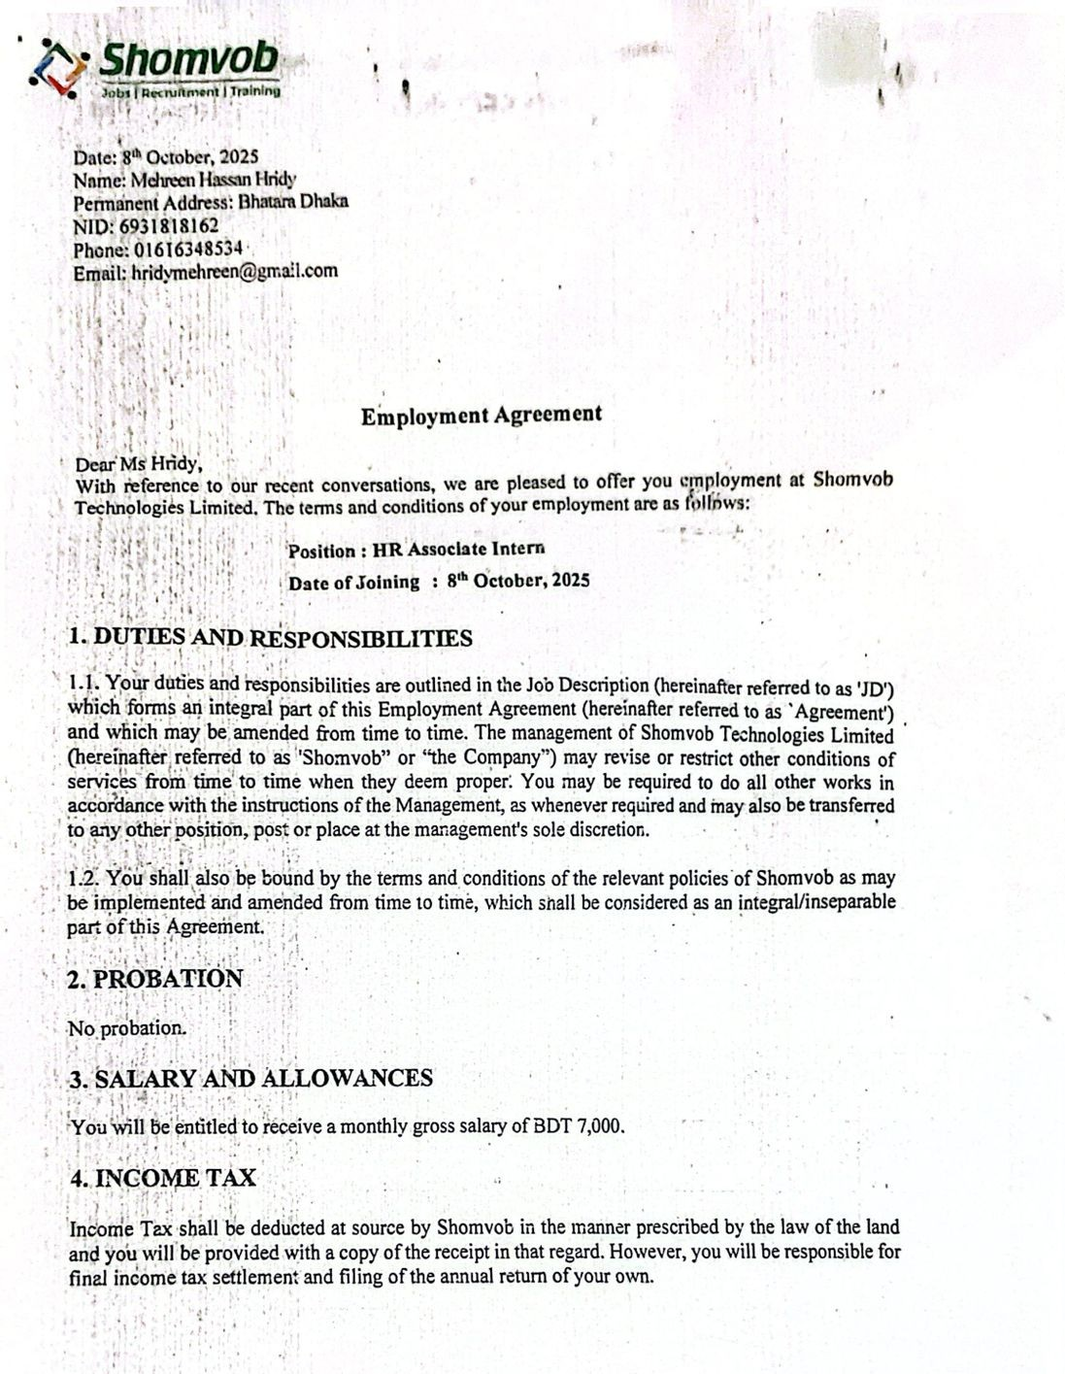

Acknowledgement

I am extremely grateful to Almighty Allah for giving me the strength, energy and potential to successfully complete this internship report. I would like to give sincere thanks to my academic institute United International University (UIU) for giving me the opportunity to acquire hands-on skills through this internship program and for providing a welcoming academic environment.
I am sincerely grateful to Ms. Nasrin Akter, Assistant Professor, United International University, who supervised my internship while writing this report, for her invaluable advice, support and guidance. I also want to sincerely thank Shomvob for letting me accomplish my internship there and for providing me with practical experience in whole recruitment process, training and development, personnel management, and corporate culture. I would especially want to thank Mr. S. M. Muhin for his thoughtful observation, direction, and proper lead. which allow me to better perform my duties and develop my professional abilities with hands on skill.
Their unwavering support during my internship was a memorable experience. They were all mentors to me, and I was happy to help out when I could. I also want to express appreciation to all the team members of all departments who guided me in finishing this report through giving me their expertise, experience, and source of data. Lastly, I want to express sincere thanks to everyone who helped me finish this internship and report, both directly or indirectly. Their collaboration and support made this educational experience useful and important

Executive Summary

This report provides a comprehensive analysis of the leading Bangladeshi job and HR technology platform Shomvob, specifically on human resource management (HRM) practices, organizational operations, growth and partnerships, projects and strategies, and recruitment. Shomvob works on technology that drives services and builds a bridge between job seekers and job with local and international clients. The company has ‘gained experience’ in managing and leveraging young workforce and technical skills to meet client needs. This study shows key human resource-related issues, including recruitment, training, employee compensation, that affect employee satisfaction and organizational effectiveness. Employee reviews and external observations of candidates it indicates challenges such as workload management, career development opportunities, and the balance between job expectations and the responsibilities.
These clear perspectives which were analysed through relevant HRM theories, which provide a theoretical framework for understanding the impact of HR practices on employee motivation in the organization, acceptability, and productivity and business development in achieving company goals. In addition, the report identifies Shomvob as an HR consulting firm that explores trends such as increased outsourcing, talent shortages, providing job opportunities to job seekers, and partnering with academic institutions for internships and staff development. Combining industry-level introspection with company-specific information, the report provides a holistic view of Shomvob’s operational strategies, HR practices, and potential areas for improvement. Finally, the findings emphasize the importance of strategic human resource management, continuous employee development, and alignment with industry best practices to ensure sustainable growth and competitive advantage for Shomvob.
Key Words: Organizational Atmosphere, Staff Administration, Recruitment Operations, Human Resource Management, Shomvob
Contents
Letter of Transmittal iii
Certification of Similarity Index iv
Declaration of the Student iv
Corporate Evidence v
Acknowledgement vi
Executive Summary vii
CHAPTER I: 10
INTRODUCTION 10
1.1 Background of the Report 10
1.2 Objectives of the Report 10
1.3 Rationale of the Report 11
1.4 Scope and Limitations 11
1.5 Definition of Key Terms 12
CHAPTER II: 13
COMPANY AND INDUSTRY PROFILE 13
2.1 Company Analysis 13
I. Overview and History 14
II. Trend and Growth 14
III. Product / Service / Customer mix: 15
IV.Company Operations / Activity: 16
V.SWOT Analysis 17
2.2 Industry Analysis 20
2.2.1 Specification of the Industry 20
2.2.2 Size, Trend, and Maturity of the Industry 21
2.2.3 Industry SWOT Analysis 21
Industry Rivalry 23
CHAPTER III: 23
INTERNSHIP EXPERIENCE 23
3.1 Position, Duties, and Responsibilities 24
3.2 Training & Development 27
HR Theory: ADDIE Training Model 28
3.3 Contribution to Organization / Operations 29
3.4 Evaluation 31
3.5 Skills Applied 32
CHAPTER IV: 33
CONCLUSIONS AND KEY FACTS 33
4.1 Recommendations 33
4.2 Conclusion 34
Reference 35
Appendix-A: 35

CHAPTER I:

INTRODUCTION

1.1 Background of the Report
Internship program is very important component of BBA at United International University (UIU). It gives all the students a chance to achieve hands on experience and it helps to understand the theoretical knowledges that students learn in their graduation program is applied in real life organizational way. This report is organized on the internship experience of mine that I completed at Shomvob, Dhaka, from October 8 to January 8 under the Recruitment Department.
The Factors of HRM specially recruitment and selection, training and development, and basic understanding of compensation and benefits was the main parts of my internship. I have learned and attended real HR activities such as candidate screening, interviewing, training assistance, and employee data management during my whole internship period.
This report described everything about the company details, my internship experience, all the HR activities that company follows and the lessions and proficiency I have learned in the internship period

1.2 Objectives of the Report
- Understanding HR practices. The work shows how a real company manages people.
- Learning about hiring. The focus is on how a company finds and picks new staff.
- Gaining training knowledge. The goal is to see how workers learn new skills.
- Understanding pay systems. The study covers how a company handles money and benefits.
- Applying school lessons. The work puts classroom theories into real situations.
- Developing career skills. The experience builds better talk and teamwork.

1.3 Rationale of the Report
We prepare the report to connect the whole academic knowledge with practical experience in real world. In our academic period we learn theoretical concepts of Human Resource Management. But in real world that means in our internship period it has provide us the opportunity to see and those skills that we have learn in books in an actual organizational environment.
This report exhibit that in real life how the HRM factors handled in a real company like recruitment, training, and employee management. Also, it represents the contributions, responsibilities, challenges, and achievements during the internship period as an intern. Furthermore, this report is provided as a compulsory requirement for finishing the BBA degree at UIU
Scope and Limitations of the Report

1.4 Scope and Limitations
Scope
The report covers specific parts of the HR department. It focuses on these areas:
- The report explains hiring. It shows how the company finds and picks new staff.
- The study covers training. It looks at how the company teaches new skills.
- The work describes screening. It details how the company checks and interviews people.
- The report mentions data. It looks at how the office keeps records and writes reports.
- The text shares experience. It lists the real HR lessons learned on the job.

Limitations
The internship offered good lessons, but some problems existed:
- The time was short. The program lasted for only three months.
- The rules hid some data. The company kept some private information secret.
- The workload caused stress. A high number of job seekers created a lot of pressure.
- The role stayed basic. The intern did not help with big company decisions.
- The facts came from watching. Some details came from looking instead of doing the work.

1.5 Definition of Key Terms

Recruitment
Recruitment is the process of searching and identifying and then choosing the best candidate for open positions inside an organization. When an organization look for a new employee for the dedicated positions, they advertise the vacancy, review the resumes and then selecting the right candidate for the job.
Selection:
The process of screening and choosing the most suitable candidates through different type of tests. These evaluations usually include written tests, interviews, and other evaluation methods that help in determining which candidate fits and qualified for the job requirements.
Training and Development:
Training and development refer to the structures process that gives employees the chance to learn and gather knowledge about the organization and organizational behavior. This process includes job-related skills, soft skills like communication and teamwork, and leadership abilities. This helps employees in career growth and develop employee performance.
Compensation and Benefits:
Benefits are extra advantages that provided by the organization where compensation the salary or wages that paid for the regular responsibilities of employees. Health insurance, bonuses, retirement programs, over time bonuses, and other non-cash incentives that increase an employee's total compensations are examples of benefits.
Blue-Collar Employees:
laborers who perform manual or physical labor are referred to as blue-collar workers. In general, they are employed in industry like manufacturing, logistics, or construction. Those in manufacturing facilities technicians, machine operators, and field workers are a few examples.
White-Collar Employees:
Employees who perform on office-based, management, or professional responsibilities are known as white-collar employees. Basically, these employees are work in corporate jobs such as offices, hospitals, banks, or schools. Examples include executives, office managers, teachers, doctors, or engineers.
HRM (Human Resource Management):
The procedure of managing a company's workforce and make sure their skills and abilities are used efficiently is known as human resource management, or HRM. Recruiting, training, performance management, compensation, and creating a positive work environment to help achieve the organization's goals.

CHAPTER II:

COMPANY AND INDUSTRY PROFILE

Company Analysis

I. Overview and History
Shomvob is an HR technology and consulting platform that connects employers and job seekers and provides various HR-related services to companies. It began as a tech-focused program with a aims to create a bridge and close the gap between businesses and workers, concentrating on the blue- and silver-collar industries.Hasibur Rahman, Naqib Muhammad Faiyaz, and Rifad Hossain founded it in 2022.This company specializes in HR technology and job matching platforms. It also offers consultancy-style HR services and solutions to other companies.
Vision
Shomvob's goal is to become one of Bangladesh's top suppliers of employment solutions by using modern technology and top-notch services in the hiring process. In their ideal future, every person would be able to succeed in their career goals and every company will have a link to top workers.
Mission
The goal of Shomvob is to close the gap by offering a strong platform that links eligible candidates with suitable organizations. They help organizations in creating effective teams and support individuals in reaching their individual goal.

II. Trend and Growth
In Bangladesh Shomvob brings a revolution in employment in the Job and HR technology platforms. It has registered hundreds of thousands of job seekers and thousands of company clients. They managed the cost and time with organized hiring with ATN compliance tools. It has created more than 12,000 employment opportunities in various fields. The company raised $1 million in pre-seed funding led by Cocoon Capital. Also, Bill & Melinda Gates Foundation provides a grant to Shomvob to support growth. This funding helped them in different sector to expand like funding helped them expand into HRIS, payroll services, and global workforce solutions. It ranked in Forbes Asia's "100 to Watch 2025" for its impact on the Bangladesh job market.
This company has increasing and developing its recruitment operations and currently conduct workforce for many organizations. It manages a huge number of candidates continuously that improves its hiring process by using technology and structured HR practices. The use many digital platforms such as Shomvob App, internal portal, and Bdjobs that helped the company grow faster and reach more job seekers.
Workforce outsourcing and digital recruitment are growing sector in Bangladesh and Shomvob is ensuring its future growth by this.

III. Product / Service / Customer mix:
Shomvob basically provides Human resource and workforce related service by using many tools. The services Shomvob includes:
• Recruitment and Selection Services
Helping companies find suitable employees by CV screening, interviewing, and selecting candidates. By these organizations can find their appropriate candidates for the specific positions.
• Workforce Outsourcing
Workforce Outsourcing refers managing temporary or permanent employees to organizations according to their workforce needs. It helps both the employees and employer to fulfil their goals.
• Training and Development
Training provides by the employer to employees to improve skills, understanding organization culture, company ethics, communication and so on.
• Payroll and Workforce Management
In organization we need to manage employee records, attendance, and workforce data for regular operations.
• Customer Mix
Shomvob serves different types of clients, including:
• Corporate companies
• Manufacturing Industries
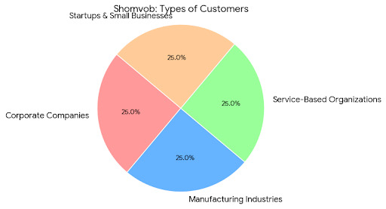
- Service-based organizations
- Startups and small businesses

IV.Company Operations / Activity:
Human resource management and workforce solutions are important to Shomvob's operations. The business has a systematic approach to hiring and managing staff.

The recruitment process starts when employers post job vacancies according to their requirements on Shomvob platforms. Then HR team reviews the job description and find required qualification, experience, age and location. Candidates apply through the Shomvob app, internal portal, or external platforms like Bdjobs based on their preference.

After the application HR team collects the applications and start CV screening and shortlisted suitable candidates. Then they call the selected candidates and invite for the written test and interviews. After completing this process, they evaluate and select the final candidates and they hired in the respective organizations.

The company arranges training sessions for newly appointed employees in as well as engaging new ones. Company policy, safety, communication, behaviours at work, and organisational culture are all covered by these training sessions. Also, the company develops HR reports for workforce analysis and maintains workers databases.

V.SWOT Analysis
Every organization has some internal and external factors that need to assess. SWOT analysis is the tool that helps to find the strengths, weaknesses, opportunities, and threats of the company. Shomvob also use the tool for the SWOT analysis.
Strengths:
Every company wants to reach the competitive edge in the market. Shomvob has many strengths that helps to reach to competitive edge in the HR industry. These include:
- Digital Recruitment Platform: Shomvob has its own technology to optimize its recruitment process. Shomvob has Shomvob App and internal portal by these employers can easily post job vacancies, and job seekers can apply directly from their smartphones based on their qualification, experience etc. These platforms are time consuming, increased hiring speed and easier for both employers and candidates.
- Skill for Leading Comprehensive Recruiting: Shomvob has a greatest strength to manage huge number of recruitment activities at one time. It may blue collar or white-collar positions, this company is prepared to handle large-scale recruitment projects.
- Technology-Based Human Resources Operations: In every operation Shomvob has use its technology, from candidate searching to interview scheduling it works under the technology. This makes the whole process faster, less human error and organized.
- Innovative System for Workforce Outsourcing: Shomvob can instantly supply companies with both temporary and permanent workers because of its well-designed outsourcing platform. The system is variable and supports an extensive number of customer needs.
- Reliable Candidate Database: Over the years Shomvob has create magnificent database of dedicated candidates. This huge number of candidates candidates allows them to find the right person for any job faster, without having to rely solely on new applicants.
- Effectiveness in both white-collar and blue-collar hiring: white-collar and blue-collar hiring, both type of workers are recruited by Shomvob. This comprehensive experience makes the company skilled and adaptable to serve and make a wide connection with many industries.

Weaknesses:

Shomvob has specific problems that might delay its development regardless its many benefits. Among them are:
- Time limitations and excessive workload during mass recruitment: Sometimes the recruitment for different positions need to done at once, like CV screening for different positions, contact candidates, schedule interviews, and handle a large number of applications. So, this may affect the quality the quality of recruitment in the short term and HR professionals may burnout for this.
- Limited Automation in Certain HR Procedures: Shomvob uses automation system in some process but still there are some works that have to do manually such as CV screening or initial candidate evaluation. So, the company can improve the automation and done this process automated for make the processes faster and more accurate.
- Dependency on Third Party Job Portals: Shomvob is very dependable on external job portals such as Bdjobs and social app like LindedIN,Facebook and so on to attract the candidates. These portals work very well, but they also put Shomvob in competition with a lot of other companies for the same type of workers.
- Insufficient Brand Awareness in Connection to Greater HR Firms: In the industry there are more larger and established HR firms where Shomvob is trying its best to grow the reputation among them. Increasing branding and marketing actions can help increase popularity and engage in fresh clients.
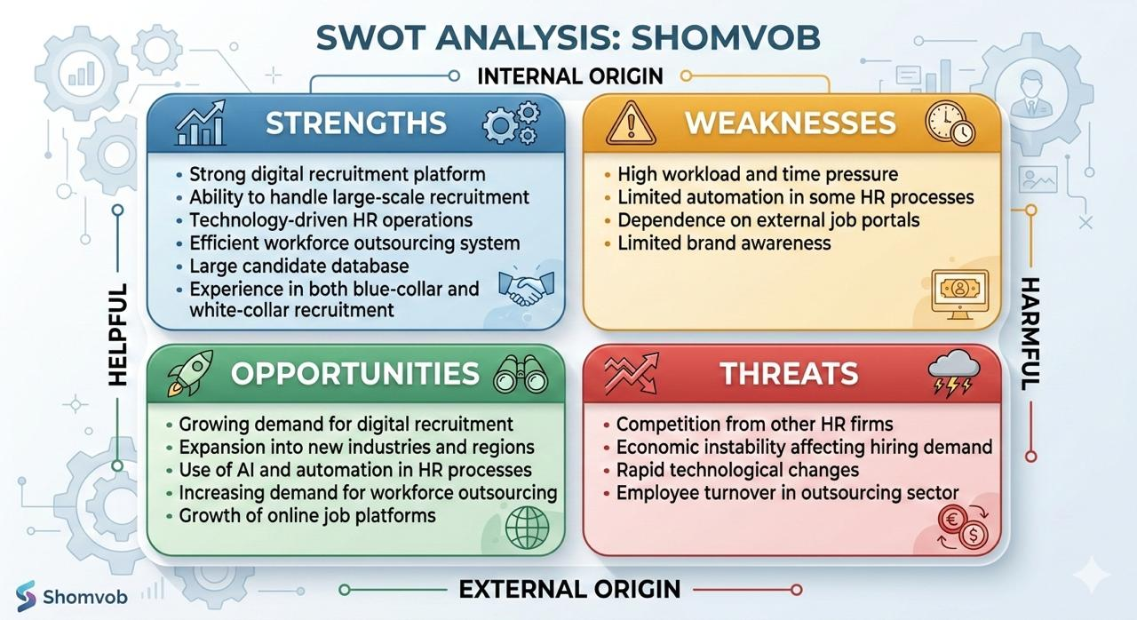
Opportunities:
In Bangladesh HR industry creating many chances for Shomvob to develop and expand. Some of these opportunities include:
- Bangladesh is seeing an increase in demand for digital recruitment: In the industry many businesses shifted from manual recruitment process to digital platforms. Through Shomvob also following into this growing trend but they can upgrade the process. With the increasing use of the internet in Bangladesh, job seekers are turning to online platforms, making digital recruitment services like shomvob.
- Growth into New Sectors and Areas: Shomvob has the chance to offer its services into new sectors, such as health care, retail, and IT. Also, the company may enter new markets and develop the client base by growing its operations to other Bangladeshi cities or even countries around it.
- AI and Automation in HR Processes: Like other sectors AI and automation tools are being advance in HR worldwide. Soo Shomvob can take this chance to upgrade its recruitment services. Where a person takes a lot of time in in candidate matching, interview scheduling, and even performance evaluations, AI leading to faster and more accurate HR decisions.

Threats:
While Shomvob has many opportunities to gain there are also some threats that may affect its growth.
- Other HR and Recruitment Firms' Competition: There are many HR firms that gives the same services. So, this creates a hard completion with other firms that may critical for Shomvob to manage market share and competing for clients in the same market.
- How Economic Uncertainty Impacts Demand for Employment: There could be fewer recruiting chances during financial crises or economic difficulties because companies can feel pressure to terminate employees or avoid hiring. Because company will not do job postings that will change into less recruitment effort, this could influence Shomvob's business.
- Quick Changes in Technology: Technology is upgrading in rocket speed so every company need to adapt with this change. So, while the technology bring opportunity it becomes a challenge whom can adapt fast and grow. If Shomvob wants to remain competitive it needs to adapt and upgrade continuously. If it fails, they cannot compete with their competitors.
- The loss of employees in the Outsourcing Industry: Particularly in blue-collar industries, a high turnover of employees can result to uncertainty and make it challenging for Shomvob to build strong customer connections. To maintain growth, Shomvob needs to focus on client and employee loyalty.

Industry Analysis

Specification of the Industry
Human Resource Management and workforce Solution industry basically works on managing employees, training, outsourcing, recruitment, and staffing. Shomvob operates in this industry and this type of industry help other organization to manage the employees with an organized way and search suitable skilled worker according to the positions.
By minimizing unemployment and enhancing worker productivity, this sector provides strongly to economic growth.

Size, Trend, and Maturity of the Industry
Bangladesh's HR and employment outsourcing sector is developing quickly because of the country's industrial growth and digital transformation. There are many companies that do not want or they don’t have enough scope to maintain a HR department for workforce management so instead of this they prefer to deal with other HR industry for outsourcing recruitment like Shomvob.
Online job portals, mobile applications, and digital HR systems are used significantly and the ratio if using these are increasing day by day. Because it minimizes company expenses and raises staffing productiveness, workforce outsourcing is growing in popularity.
The industry is now in a growing stage, which means there are enough of chances for growth and high demand.

Industry SWOT Analysis

HR industry is developing in Bangladesh very rapidly, directed by many driven by various economic, technological, and competitive factors. The factors which are included in industry Swot analysis are economic factors, Technological factors, barriers to entry, threat of substitutes, industry rivalry.

Economic Factors:
- Economic Growth Increases Hiring Demand:
When in a country economic growth increase, companies start to expand so business if business starts expanding and they start hire more employees to meet the demand which is increasing.
- Inflation can reduce employment:
Inflation or recession can become the reason for of economic slowdown so after that company get back from hiring, hold job openings or even lay off employees for cost cutting that extremely impacts the recruitment industry.

Technological Factors:
- Digital Recruitment Platforms Improving Hiring Efficiency
The mass use of digital recruitment platforms like Shomvob, LinkedIn, and Bdjobs has made it very easy and time consuming for the companies to find and hire required candidates. These platforms help to match candidate with the job requirements as long as better presence for job seekers.
- Use of HR Software and Automation Increasing:
Advanced HR and automation tools are becoming more efficient for HR operations. These tools help to make the process easy such as CV screening, interview scheduling, and candidate management, saving time and decrees errors which is not easy for humas.

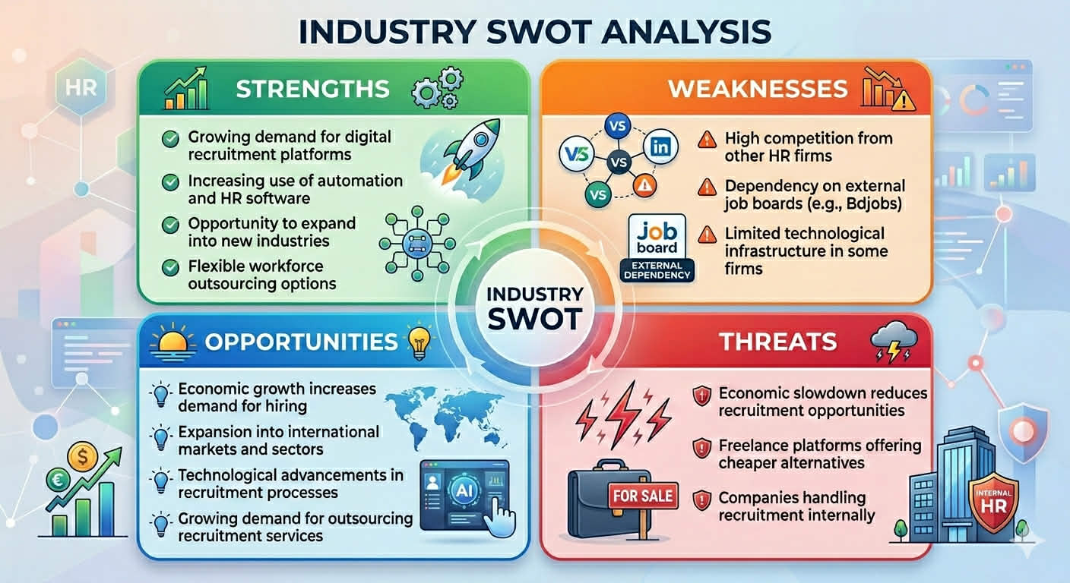

Barriers to Entry
- Need for Strong HR Expertise:
In Hr industry companies will need strong expertise in human resource management to succeed in this competitive sector. The expertise need to understand recruitment processes, Labor laws and maintain a strong network with candidates.

- Need for a Large Candidate Database:
HR firms must have different and large database for their recruitment team because without these it becomes very tough to match candidates with job vacancies. Either it will become very time consuming and delays in hiring.
- The necessity of technological support
Digital technology support for example digital platforms, databases, and HR management software is very important for successful hiring in this modern world. It would be challenging for HR companies for growth their operations without these technologies.

Threat of Substitutes
- Companies Using Internal HR Departments
A lot of renowned company prefer to use their own HR departments for internal hiring. This simplifies how dependent they are on outside recruiting companies, which can serve as a temporary replacement for services provided such as Shomvob as third party.

Industry Rivalry
- Strong Competition Among HR Firms
There is significant competition in the HR sectors in Bangladesh, with many companies providing comparable services like Shomvob. Organizations fight to draw in customers and provide the best candidates, which sometimes results in pricing competition and demands for timely delivery of high-quality work.
- Companies Competing on Speed, Cost, and Candidate Quality
Recruitment firms constantly compete on three main factors, one, how quickly they can provide candidates, two, how much they charge for their services and three, the quality of the candidates they provide. Companies that are successful in every field ultimately control the market.

CHAPTER III:

INTERNSHIP EXPERIENCE

3.1 Position, Duties, and Responsibilities
I am Mehreen Hassan Hridy and my internship period was from October 8, 2025 to January 8, 2026. I worked as Recruitment Intern in the Recruitment Department at Shomvob, Dhaka, under the supervision of Manager M. A. Muhin. My core responsibilities were to assist the recruitment and selection process and support overall HR activities.
This internship program has given the practical experience to real Human Resource operation. Especially the factors that I got hands on experience are recruitment, training and development, employee screening, and HR reporting.
The key responsibilities and duties that I have been experience:
I. Job Description Analysis and Screening:
As an intern I reviewed job description carefully and job summaries which was provided by the employers.
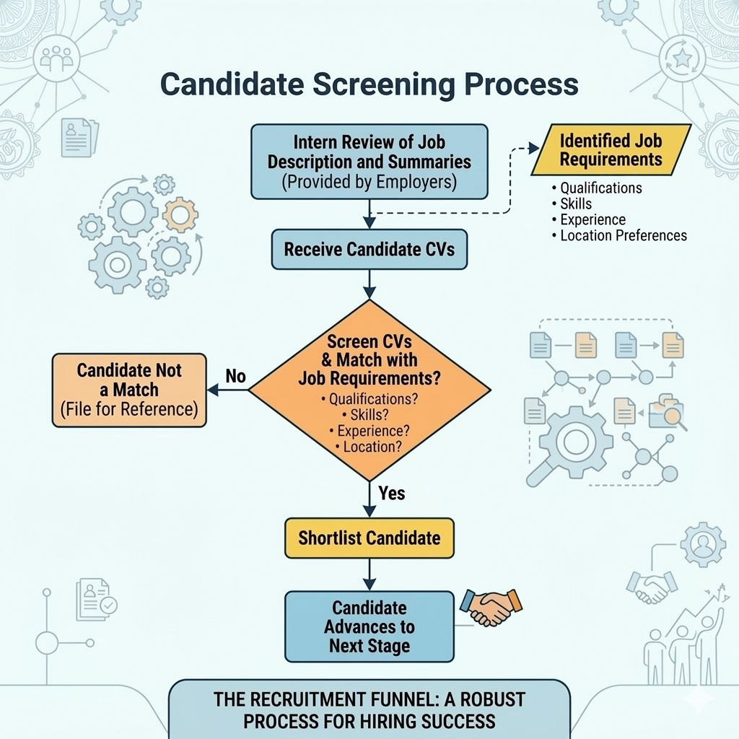

It helps to identify required qualifications, skills, experience, and location preferences. CVs were screened and matched with job requirements based on this process.
II. Candidate Shortlisting
Shomvob App, Internal Portal, linkedIN, Bdjobs etc these were the portals from where we collected the CVs so after reviewing the cv I shortlisted suitable candidates based on education, experience, locations, and job relevance. For example, I worked for Illiyeen brand for looking for their sale executive position.
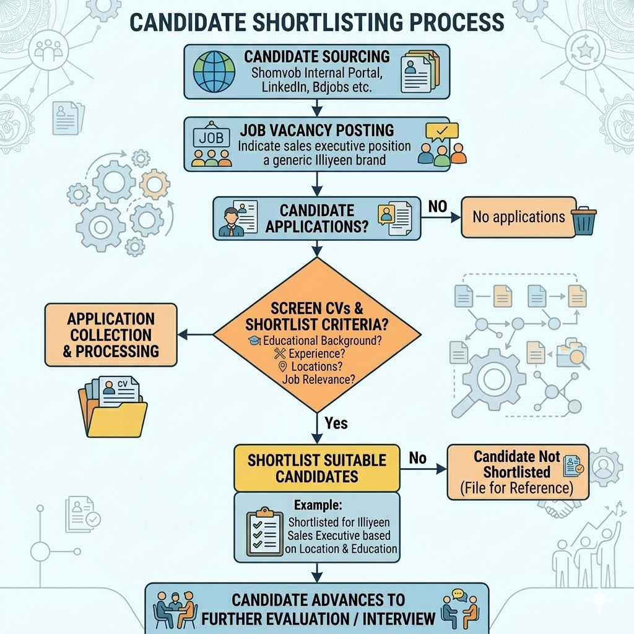

After posting the job vacancy, candidates applied on that and then I was screening the CV’s.Based on their locations and educational background I shortlisted them.
III. Candidate Communication and Interview Arrangement
I contacted candidates over phone calls, text or emails and invited them for the interview. On some days, more than 100 candidates were contacted, which helped reduce hiring time and improve recruitment speed. 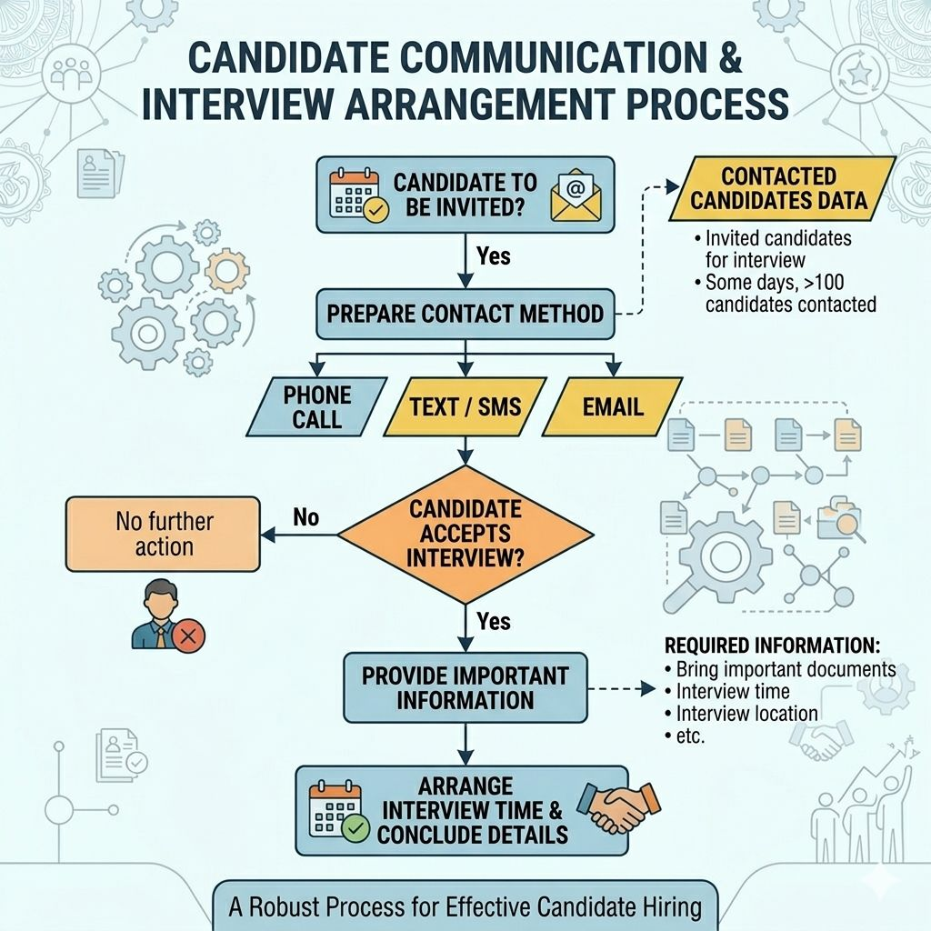
After that I need to provide them important information about the interview such as bringing the important documents, interview time and location etc.
IV. Interview and Evaluation Process
I worked on conducting recruitment test which are Written test evaluation, viva/interview participation, Candidate performance assessment. Additionally, I reviewed written exam papers and assisted in selecting the best potential employees.
V. Database and Reporting
I used Google Sheets, Microsoft Excel, and other tools to create employee databases and keep track of employment records.
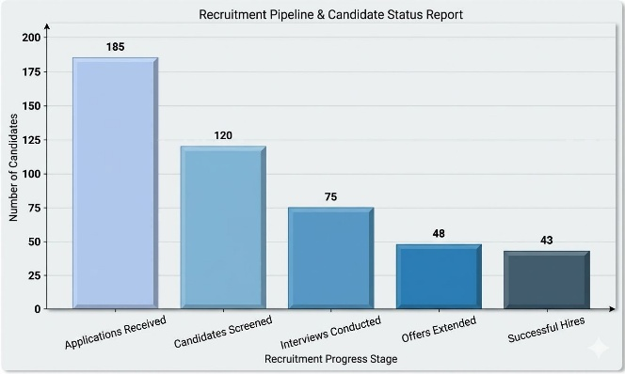
Reports were created depending on hiring results, candidate status, and recruitment progress.
VI. Recruitment Achievement
During my internship period my contribution on recruiting was successful. I worked with both blue-collar and white-collar employees.
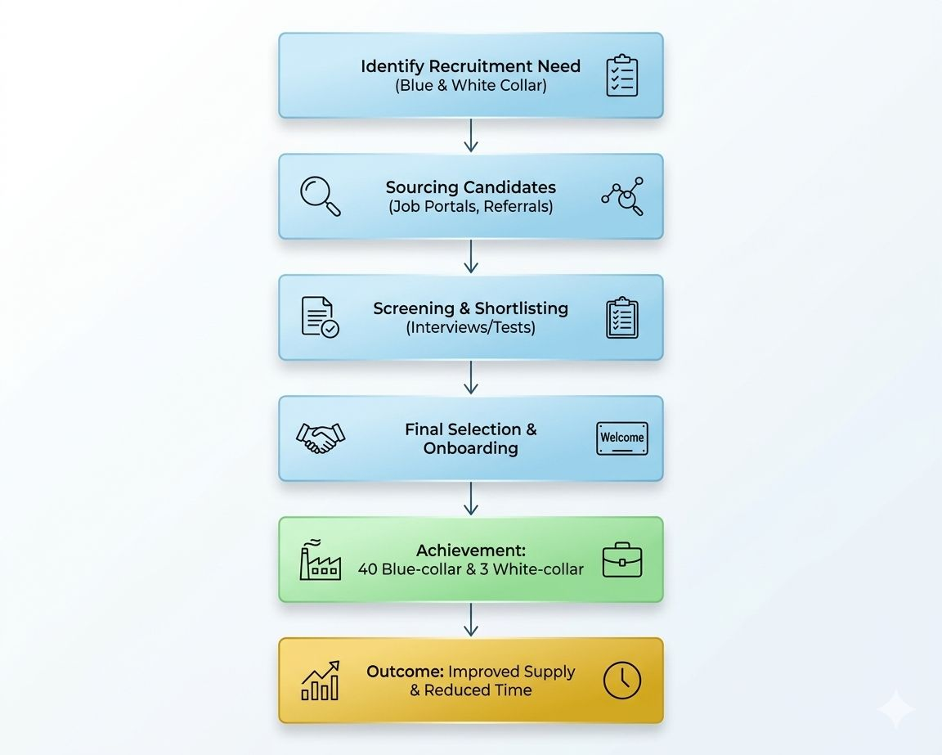
So, in my 3 months internship period I recruit 40 blue-collar employees and 3 white-collar employees. This contribution helped improve workforce supply and reduce recruitment time.

3.2 Training & Development
As an intern I also assist the Training and Development Team. Basically, the purpose of these training was providing the basic idea and prepare newly recruited employees for their responsibilities in the organization and reduce errors and improve their performance. This is the idea of induction training. Where newly recruited employees get the knowledge about company’s mission, vision, culture and company policies and so on.
The training sessions generally takes 10-15 days and it could be paid or unpaid training based on the job types. At Shomvob I have experienced different topics at training session. Including company policy and rules, workplace safety and security, communication skills, team work policy, workplace behaviour and professionalism, ethics and organizational culture and values. So, I helped to organize whole the training sessions, managed attendance like cross check the candidate’s data and assist trainers.1st I listed all of the candidates then during training we monitored their performance we ranked them and selected the top 10 or top 3. Through this I get idea about the whole process of training and development, gained knowledge about compensation and benefits as well.

HR Theory: ADDIE Training Model
The ADDIE training model is the framework which is used very commonly for making the employee training program effective and successful. It makes sure that the training program is well structured and organized that will be develop performance within the organization. The five stages of model used at Shomvob as well.
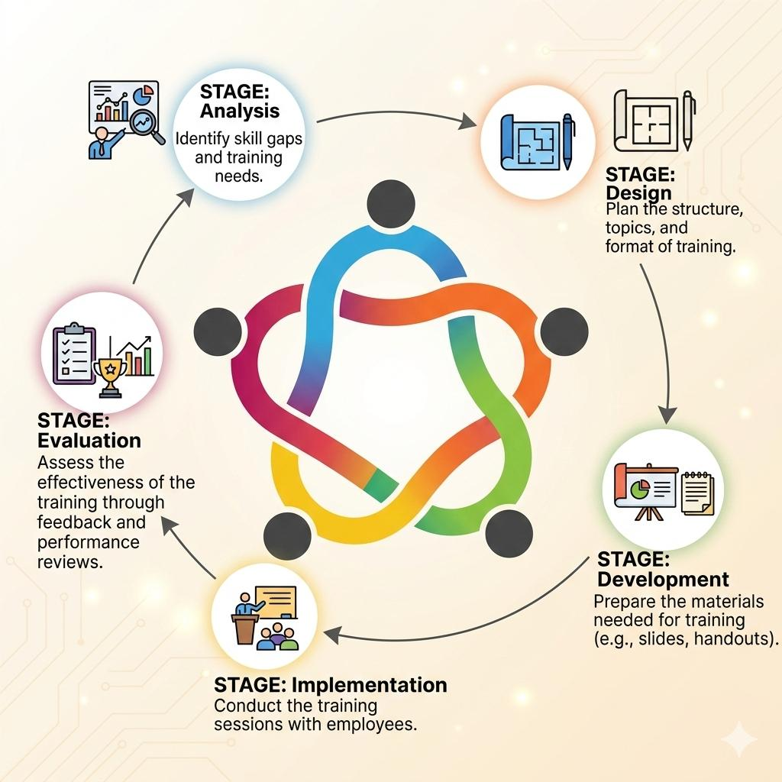
- Analysis: First, Shomvob analysis their skill gaps and organizational requirements and then identified the specific training that need to organize.
- Design: In this stage Shomvob starts plaining and decide the topics and training systems.
- Development: Shomvob prepare a specific script and a presentation and provide devices like laptop to candidates and gives hands on training based on modules.
- Implementation: In this stage Shomvob conducted the training and employee get the session.
- Evaluation: Last stage of the model where Shomvob takes an assessment and evaluate either employee developed their skills and the training sessions was effective.

Contribution to Organization / Operations
Shomvob gives me a lot of opportunity to contribute at their several operations, through this I gained knowledge and learned skills from different sectors.
o Improving Recruitment Speed
By contacting over 100 candidates daily, I helped reduce hiring time and improve recruitment efficiency.
o Supporting Mass Recruitment
I handled recruitment for almost 20 companies, which helped fulfill workforce requirements for them quickly.
o Database Management
I was maintaining employee records and preparing Excel reports that improved HR for tracking and recruitment transparency.
o Training Support
I was also assisting training sessions that helped to ensure employees understood company policies, safety, and workplace cultures.HR Theory: Recruitment Funnel Model
The recruitment funnel model works like a funnel where many candidates starts but, in the end, only the suitable and perfect one is selected for the job. This approach is a structured approach to the recruitment process that helps employers understand and select the best candidates for job vacancies. The funnel model includes these stages:
      - Job Posting:
The recruitment process starts with a job vacancy posting. This is generally done on company website, social media or job boards to seek potential candidates.
      - Application Collection:
From the job post, candidates submit their applications. Then the employers collect resumes of candidates, cover letters, and other necessary documents from applicants.
      - CV Screening:
After receive the application employer starts cv screen and see which candidates are qualified and meet the basic requirements for the job. For example, educational qualification, location and ages.
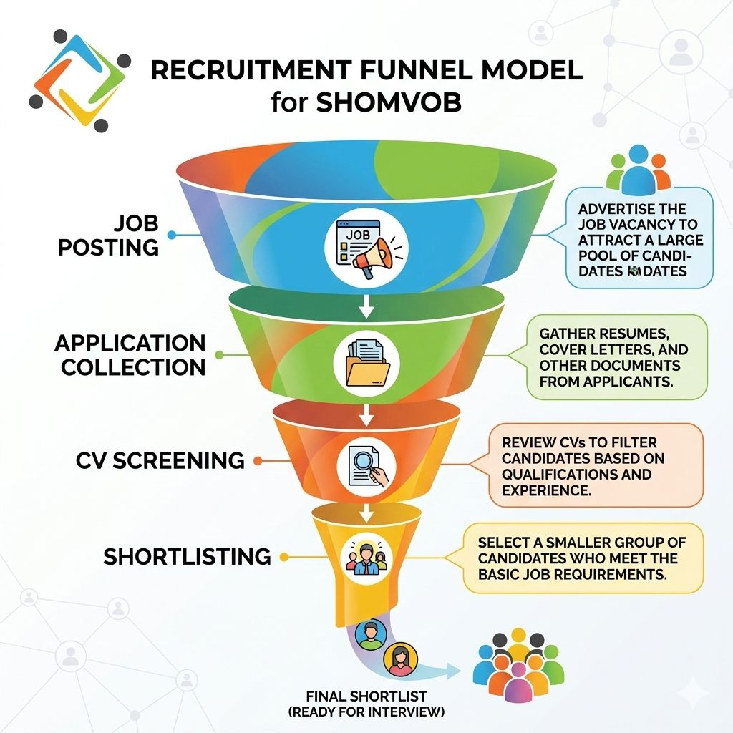
      - Shortlisting:
After Cv screening, recruiter shortlisted the candidates who are qualified and meet the requirements of the specific role. Then they got the invitation for interview.
      - Written Test:
In many cases, a written test is conducted to assess the candidates' skills, knowledge, and suitability for the role. This helps employers evaluate how well candidates perform in practical tasks related to the job.
      - Interview:
After the written test, selected candidates are invited for an interview. This is the stage where employers assess candidates' communication skills, personality, and cultural fit with the organization.
      - Final Selection:
Based on the interview performance, employers choose the final candidate(s) who best meet the job requirements and fit with the company’s culture and values.
      - Hiring:
The final step in the recruitment funnel is the hiring stage. Once the top candidate is selected, the job offer is made, and the candidate is hired to begin their employment

Evaluation
This internship program gives me very significant standard and opportunity to apply my theoretical knowledge to real life situation in a professional way for for both professional and personal improvement. The experience helped me to capture how HR functions, such as recruitment and employee training, organizational culture within an organization. The key skills I have been experienced and learned throughout from my internship are:
- Communication Skills:
I improved my communication skill by interacting with a large number of candidates over call, interview sessions and emails and also with colleagues, learning how to convey messages clearly and professionally.
- Time Management:
I managed multiple tasks together and facing deadlines that taught me pyritizing work and meeting deadlines, especially during busy recruitment period
- Multitasking Ability:
I faced several tasks together such as scheduling interviews, contacting candidates, and preparing reports. This helped me to improve multitasking skills.
- Candidate Handling:
For some specific companies I dealer with bulk hiring with large number of candidates that gives me chances to interview and managing candidates effectively.
- HR Reporting:
I was creating and recording recruitment reports that used in teams and helps for recruitments.

3.5 Skills Applied
During the internship, several academic and professional skills were applied:
- Application of HR Knowledge
I applied HR concepts that I learned at university —such as hiring, selection, training, and staff management.
- Communication Skills
Better communication skills help me a lot. I did this by talking to job candidates. I also practiced how to lead interviews.

- Technical Skills
I improved my technical skills. I used Microsoft Excel to manage data. I also used it to create reports.

- Teamwork
I became a better team member. I worked with the training department and the HR department every day.

- Solving Problems
I got better at solving problems. I learned how to work with tight deadlines. I also managed a very large group of job seekers.
HR Theory: Life Cycle of HR
The phases when an employee experiences while working for a company are referred to as the HR Life Cycle. The following periods are generally included in the HR Life Cycle: 1. Recruitment: The process of gathering and choosing eligible candidates for open positions. Companies search and review potential employees at this initial phase. 2. Hiring: The process of hiring, which includes confirming employment conditions and providing required documentation and then starts when the organization offers a position to the ideal candidate.
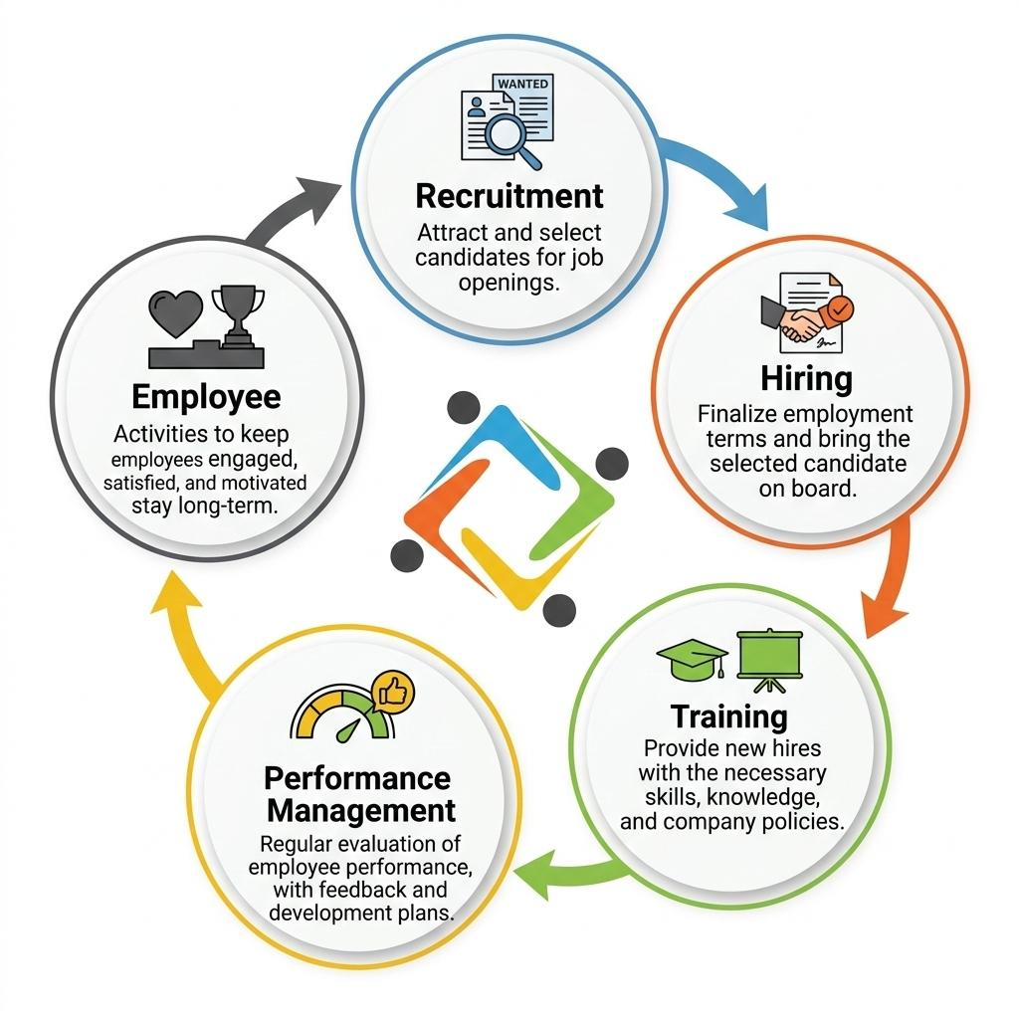
3. Training: After the new employees hires, they go through the training session to learn about the company's culture, policies, and particular job-related qualifications. 4. Performance Management: During this phase, an employee's work is regularly reviewed to make sure they are fulfilling their responsibilities they are hiring for. 5. Employee Retention: This period focused on creating a happy workplace and providing rewards that attract the employees to remain with the company. It covers things like managing wages, promoting job happiness, and career growth. I primarily worked in the HR Life Cycle's recruitment and training phases.

CHAPTER IV:

CONCLUSIONS AND KEY FACTS

4.1 Recommendations
Shomvob can improve how it works based on what I saw during my internship. Here are a few ideas to help the company perform better.
1.The company handles most of the hiring itself. So, this takes a lot of time. Shomvob should use more automated tools to find candidates. They should also use software to screen resumes. This will save time. It will also take the pressure off the staff by removing manual work.
2.Training sessions should have a standard style and use useful teaching techniques including role-playing, real-world case studies, and performance evaluation to improve. Also Limited time become a problem during huge recruitment. So, candidate flow can be more effectively managed with assistance of an improved scheduling and job management system.
3.I faced some challenges during my internship program such as time pressure when I had to manage bulk recruitment. I had to contact large number of candidates and screen them in a short time. It was very difficult for me as an intern to maintain high-quality work under such tight deadlines. To overcome this challenge, I focused on improving time management skills. By better planning tasks and setting clear priorities. Which can be a practice for all the employees work there.
4.Shomvob can use better HR software to help with hiring. This software can also track how employees perform and check their attendance. These tools make the work more accurate. They also help the team get more done.
5. Last but not the least they should use reward systems and programs that recognize hard work. Shomvob should also offer chances for workers to grow in their careers. These steps will help people feel better about their jobs. Improving company branding can attract more skilled candidates and reduce recruitment effort.

4.2 Conclusion
My internship at Shomvob was a great way to learn. I got to do real HR work. I worked as a recruitment intern. This job helped me build professional skills. I improved my communication skill with people.
I also learned how the hiring and training process works. I had a very busy role there. I screened candidates and did interviews. I also helped with training and managed the database. These tasks helped me learn a lot about HR. I hired 40 blue-collar workers and 3 white-collar workers. I helped many different companies find employees. This work was a big contribution to Shomvob.
I did face some problems as well. I had a lot of work in a limited time. But these challenges helped me get better at solving problems. I also learned how to do many things at once and manage my time. That helps me to taught me give value the things. This internship helped me use what I learned in my academic books in a real office. Now, I feel ready for a career in HR Profession.

Reference
- Shomvob Official Website : https://shomvob.com/about
- Human Resource Management – Gary Dessler
- Training and Development – Raymond Noe
- Class lecture materials, UIU
- Internship practical experience

Appendix-A:

