Factors Impact on Brand Equity of Smartphones: An Analysis

Maria Afrin Mily

This report is submitted to the School of Businesses & Economics, United International University as a partial requirement for the fulfillment of Bachelor of Business Administration Degree

Factors Impact on Brand Equity of Smartphones: An Analysis

Submitted By
Maria Afrin Mily
ID: 111211019
Major: Marketing
School of Business & Economics
United International University

Supervised by
Dr. Kawsar Ahmmed
Professor
School of Business & Economics
United International University

Date of Submission: 25/11/2025

Letter of Transmittal

Date: November 25, 2025
To
Dr. Kawsar Ahmmed
Professor
School of Business and Economics
United International University
Dhaka, Bangladesh
Subject: Submission of Project Report – “Factors Impact on Brand Equity of Smartphones: An Analysis”
Dear Sir,
With due respect, I submit my project report titled “Factors Impact on Brand Equity of Smartphones: An Analysis”, prepared as a partial requirement for my undergraduate program.
The study examines how five factors influence the brand equity of smartphones and which factor influence the most.
I am sincerely obliged for your valuable guidance, feedback, and support throughout this work, which greatly contributed to its successful completion.
Sincerely,
Maria Afrin Mily
ID: 111211019
School of Business and Economics (SOBE)
United International University

Acknowledgement
First and foremost, I would like to express my sincere gratitude to Dr. Kawsar Ahmmed, Professor at United International University, for his unwavering support and valuable guidance throughout the course of this project. His vast knowledge and experience in the field of research have been instrumental in shaping the direction of my work. I am truly grateful for his constructive feedback, continuous encouragement, and the insightful suggestions he provided at every stage of this study.

As a respected researcher and academic, Dr. Kawsar Ahmmed’s mentorship has not only enhanced the quality of this project but also deepened my understanding of entrepreneurship and its practical implications. His supervision has been a constant source of inspiration, and it has been a privilege to work under his direction.

I am also very much thankful to my institution for providing the academic framework and resources that enabled the completion of this research.

Executive Summary
This research examines the crucial elements of brand equity inside the competitive smartphone market of Bangladesh. Along with a quantitative survey of 92 smartphone users and proceeding multiple regression analysis, the study empirically tests the impact of four critical dimensions—brand loyalty, perceived quality, brand associations, and brand awareness—on overall brand equity.

The findings disclose a robust and statistically notable model, explaining 76.8% of the variance in Overall Brand Equity. Brand Loyalty appears as the single most powerful predictor, underscoring the supreme importance of cultivating a devoted customer base. Perceived Quality and Brand Awareness also demonstrate to be remarkable and effective contributors. Interestingly, while Brand Associations appear a positive correlation, it is not a statistically significant predictor in the presence of the other three factors in this model.

The study concludes that for smartphone brands in Bangladesh, a hierarchical strategy focused first on fostering loyalty, then on delivering and communicating quality, and finally on building broad awareness is the most effective path to building strong, valuable brand equity.

Keywords: Brand Equity, Smartphone Industry, Perceived Quality, Brand Loyalty, Bangladesh

Contents
Letter of Transmittal 2
Acknowledgement 3
Chapter One 7
Introduction 7
Introduction 8
Objective 8
Motivation 8
Limitations 9
Organization of the Remaining Chapters 9
Chapter Two 11
Literature Review 11
Brand Equity 12
Brand Awareness: 12
Brand Associations: 12
Perceived Quality: 12
Brand satisfaction: 13
Importance of Building Brand Equity, Problems, and Solutions 13
Problems in Building Brand Equity 15
Factors Affecting the Development of Brand Equity 16
Chapter Three 20
Literature Review 20
Literature Review 21
Summary of the Literature Review 22
Chapter Four 32
Methodology & Analysis 32
Research Design 33
Population and Sampling 33
Research Instrument 34
Data Collection Procedure 36
Ethical Considerations 37
Responses 37
Chapter Five 48
Results and Discussion 48
The Supremacy of Brand Loyalty: 49
The Perceived Quality: 49
Brand Awareness: 50
The Nuanced Role of Brand Associations: 50
Chapter Six 52
Recommendations and Conclusion 52
Recommendations 53
Conclusion 54
References 55

Chapter One

Introduction

Introduction

In marketing terms, brand equity refers to the intrinsic value of a brand itself. The social and financial worth of a well-known brand name. This value come from the power of brand familiarity, where customers recognize products from established brands as higher to those from less familiar competitors, even when the actual product attributes are related. This perception is constructed upon a foundation of customer awareness, emotional associations, perceived quality, and ultimately loyalty.
In today's highly aggressive smartphone market, where technical specifications often merge, brand equity becomes a condemning differentiator and a primary driver of consumer choice. It permits companies to command premium prices, foster unwavering customer loyalty, create barriers for competitors, and facilitate successful market growth. This report digs into the core dimensions of brand equity: Brand Awareness, Brand Associations, Perceived Quality, and Brand Loyalty to investigate their individual and collective effect on the Overall Brand Equity of smartphone brands within the particular context of the Bangladeshi market.

Objective

The main objective of this report is to investigate the key factors that highly influence brand equity in the smartphone industry of Bangladesh. The specific aims are:
- To evaluate the impact of Brand Awareness, Brand Associations, Perceived Quality and Brand Loyalty on Brand Equity among smartphone buyer in Bangladesh.
- To examine the relationship between these variables and their joint influence on Brand Equity.
- To examine the relative importance and predictive power of each dimension in establishment the brand equity.
- To issue data-driven strategic recommendations for smartphone companies to build and encourage strong brand equity in this competitive market.

Motivation

The motivation for this study stems from the condemning role brand equity takes part in the long-term success and profitability of companies in a dripping market like smartphones. While the conceptual models of brand equity (from Aaker, Keller, etc.) are well-established in global literature, and their specific hierarchy and influence can vary notably across different cultural and market circumstances. There is a direct need for empirical, context-specific research to escort marketers in Bangladesh. Understanding which brand equity dimensions be it awareness, loyalty, quality, or associations hold the most load allows businesses to assign their often-limited marketing resources more efficiently and successfully. This study points to bridge the gap between theory and practice by providing a localized, evidence-based blueprint for building a very much valuable smartphone brand in Bangladesh, eventually contributing to more strong and informed marketing strategies.

Limitations

Given the useful details this study offers, it is essential to recognize its limitations:
1. Sample Size and Sampling Method: With a sample size of just 92 respondents, the study depends on a non-probability convenience sampling technique. This restricts the discovery's application to all Bangladeshi smartphone users, even though it is sufficient for a preliminary examination for the time being. The hardiness of the findings would undoubtedly be improved by a larger, probability-based sample.
2. Geographical Scope: The research focused solely on the Bangladeshi market. Furthermore, the findings and recommendations are clearly tailored to this context and may be not directly applicable to other countries or regions with separate consumer behaviors and competitive landscapes.
3. Cross-Sectional Design: The information was gathered all at once. A long-term study would be required to understand brand equity's evolution over time because it is dynamic and can change in response to market trends, competitor actions, and the introduction of new products.
4. Emphasis on Consumer Perceptions: The study does not include financial measures of brand value; instead, it focuses on customer-based brand equity. A more comprehensive perspective might be provided by an integrated approach that incorporates financial data.

Organization of the Remaining Chapters

This report is arranged into five chapters to issue a structured and comprehensive analysis:
- Chapter Two: Literature Review provides an evaluative study of existing scholarly work on brand equity, generate the theoretical foundation for the study by assess key models and empirical discovery from renowned authors.
- Chapter Three: Methodology details the research design, population and sampling technique, data collection instrument, and the procedures go after to gather and process the data, make sure the transparency and repeatability of the study.
- Chapter Four: Results, Discussion, and Analysis help findings of the statistical analysis, including descriptive statistics, correlation, and multiple regression results. Moreover, this chapter explains the data, talk through its implications in light of the existing literature and reports, and provides a comprehensive analysis of the connection between the variables.
- Chapter Five: Recommendations and Conclusion sum up the key findings, interpret them into actionable strategic guidance for practitioners, furthermore it presents the final ending of the study, highlighting its offering and potential for future research.

Chapter Two

Literature Review

Brand Equity

Brand equity in the marketing term refers to the value of a brand in itself – the social value of a well-known brand name. The creator of a well-known brand name can generate additional revenues simply due to brand familiarity, since customers believe that brands products are better than less familiar brands products. Different brands may offer very similar products in terms of ingredients, design, or quality, but customers will often prefer the one with a stronger and more trusted brand. These preferences come from the extra value that people put on the brand itself, which includes its name, image, and emotional connection.
According to marketing experts, brand equity is not just one single thing—it has different sides, almost like layers of a relationship between the brand and its customers. These levels are the true strength of a brand:

Brand Awareness:
It measures how familiar people are with the brand. The brand awareness is high if customers can easily identify or remember a brand when they need a product. For example, if one says "soft drink," the immediate answer of most individuals is Coca-Cola or Pepsi. This immediate remembering shows high awareness. A low-awareness brand can falter since customers don't even think about it when they make a purchase.

Brand Associations:
It consists the emotions, thoughts, and images that people connect with a brand. It's not just the product, it's what the brand makes you feel. For example, Red Bull is associated with energy, adventure, and extreme sports, and Rolex is associated with success, luxury, and wealth. These associations give a brand its personality, and this is why consumers choose it for emotional, not just functional, reasons.

Perceived Quality:
This is where customers rate the general quality of a brand's products or services in comparison to competitors. Even if two products are made from the same materials, the brand name makes one of them appear superior. For instance, people view Nike shoes as of better quality than a generic brand, even when the quality difference margin is very small. This perception builds confidence and enhances the possibility of purchasing.

Brand Loyalty:
Brand Loyalty is the strength of the relationship between the brand and the customers. customers who become loyal buy repeatedly and spread the word about the brand. They are less likely to switch even when others drop their prices. For example, most Apple customers buy iPhones, iPads, and Macs repeatedly because they have an emotional attachment to the brand. This kind of loyalty is extremely valuable to long-term success.

Brand satisfaction:
Brand satisfaction is a central element in brand equity because it signifies to what level customers are satisfied and content after the consumption of a brand's service or product. Customers who are satisfied more probable to repeat the purchase, remain committed to the brand relative to competitor’s options, and even promote it to others. Satisfaction also gives rise to trust and emotional bond, which raises perceived quality and overall value of the brand. Eventually, it plays an important part in long-term equity as it is not only increasing repeat purchasing behavior but also supports the development of a positive reputation and sustainable brand power.

Importance of Building Brand Equity, Problems, and Solutions

Importance of Building Brand Equity
The value of brand equity lies in how it affects the behavior of customers, their choices, and the expansion of businesses in the long term. As an organization invests in establishing a strong brand, it is not simply advertising—instead, it is constructing the foundation of long-term growth and stability. A robust brand engages the loyalty of the customer, holds competitors at bay, and ushers in new business prospects. If your brand has positive equity, customers will pay more for your product. Examples of positive brand equity from Creating Brand Value include:
- Nike: Nike has a durable association with peak athletic performance, dedication, and inspiration.
- Apple: Apple represents constant innovation, user-friendliness, and design simplicity.
- Lego: Lego is known to offer a quality creative play experience.
Negative brand equity occurs when your brand's reputation suffers in the minds of the people. They may avoid your brand despite its quality matching that of its competitors.
This could be due to:
- Product recalls
- Poor customer service
- Unreliable products
- Business ethics scandals, cultural insensitivity, and inauthentic branding
- Price increases without added value
- Environmental damage
- Association with controversial figures

Other than these, poor public relations management can cause you to lose the trust of consumers—potentially tarnishing your brand's image and resulting in lower loyalty and sales. One of the greatest benefits is loyalty. Once people have an emotional connection to a brand, they stick with it even when there are cheaper alternatives. A prime example is Apple. Despite the presence of so many brands of smartphones in the market, millions of people still stick with iPhones because they relate to and believe in the brand. That loyalty buffers the company from competition.
Another advantage is being able to command premium prices. Brands that are strong can usually sell their products at a premium price since customers perceive a value beyond the actual product. Consider Starbucks, for example. Coffee from a local café may be less expensive, but customers are willing to pay more for Starbucks due to the experience - the environment, the name, and the consistency they expect from the brand. Brand equity also creates competitive advantage. Once a brand is strong, it becomes very difficult for new competitors to enter the market. That is why Nike, Adidas, and Puma dominate the sportswear industry. They have such powerful branding in individuals' minds that even if some other competitor enters the market with the same products, customers will be less likely to switch. One of the other advantages is that high brand equity makes it easier to expand in the market significantly. If customers already trust a brand, they do not mind trying new products under the same brand name. For example, Dove started off as a soap brand but later developed skincare products, deodorants, and shampoo. As people trusted Dove's quality, they instantly accepted these relatively newer products.
Lastly, there is financial value. A good brand increases the overall worth of a business. Businesses like Google, Amazon, and Microsoft are worth not only what they do, but how powerful their names are. Their names alone are worth billions before we even look at their businesses.

Problems in Building Brand Equity
Brand equity is powerful, yet it is not so simple to establish. There are several hurdles in the path for businesses. One of them is the absence of differentiation. Unless a brand is different from the rest in some manner, it simply gets lost in the crowd. There is no incentive for customers to remember it, and that makes growth a problem.
One other major concern is negative publicity. A single misstep can undo years of effort. Volkswagen's emissions scandal is a case in point—despite being one of the world's biggest auto makers, the brand image suffered a battering when the scandal broke.
And then there's the problem of a muddled brand message. If an organization sends out conflicting messages via advertising or changes identities too often, customers start to question its credibility. Building brand equity is also expensive. Advertising, sponsorships, packaging, and interacting with customers cost a lot of money. For small businesses, this can be overwhelming.
Finally, there are rapidly changing consumer tastes. Technology and social trends change fast, which means if a brand fails to keep up, it will be outdated. Something that is in style today will not necessarily be so tomorrow.
Solutions to overcome these problems
- Though the threats are real, there are also resolutions whereby companies can create and protect their brand equity. First is distinct positioning. A brand needs to decide what makes it unique and stick with that message. Customers need to be very clear about what the brand stands for.

- Next, brands must be consistent in their identity. The same tone, colors, logos, and values must be found on all platforms, whether social media, advertising, or packaging. Consistency builds trust.

- As quality and innovation are also essential, customers may forgive small mistakes. But if a brand delivers poor quality consistently, it loses trust. In spite of innovation keeps the brand relevant and engaging.

- Another solution is to attach with customers. Brands that talk to their customers regularly through social media, events, and loyalty programs have a stronger emotional connection with them. And more often than not, this connection is more important than the product itself.

- In case of negative publicity, rapid crisis management is the solution. Companies should respond honestly and openly instead of suppressing the issue. Openness tends to restore trust sooner.
Finally, there are affordable digital strategies that small businesses can use to compete with others. Without massive budgets there are social media campaigns, influencer partnerships, and word-of-mouth marketing can also build brand equity. Overall, brand equity is something about building trust, delivering value, and being consistent over time.

Factors Affecting the Development of Brand Equity

Positive Factors
There are several positive factors that assist an organization in the creation of strong brand equity. They all help towards the manner in which the consumer perceives the brand and the likelihood of their remaining affiliated with it. Brand awareness is perhaps the most important aspect. When people can instantly recognize a brand logo or name, then chances are that they will choose it. McDonald's golden arches, for example, can instantly be recognized anywhere on the planet. People won't even need to check the words to instantly know what it is.
One of those aspects is positive brand associations. People will generally associate a brand with some values, lifestyle, or emotion. Red Bull, for instance, is most likely associated with energy and adventure, while Rolex is associated with achievement and luxury. Those associations make people believe that buying the brand does not just give them the product but also an identity.
Perceived quality is also at large to blame. Whether or not the product itself is superior is immaterial; whether or not people see it as being high quality is crucial. Nike shoes, for example, are always seen to be more fashionable and durable than similar brands which are lesser known, and that makes people happy to pay extra. Brand loyalty is yet another force that moves forcefully. These customers are the financial safety net of companies. They don't buy once and walk away, they come back and even recommend the brand to friends and family. This word-of-mouth promotion also enhances brand equity further.
Firms that promote values and corporate social responsibility (CSR) will gain. Customers nowadays like to buy from firms that take care of society and nature. For example, The Body Shop is famous due to cruelty-free products, and TOMS Shoes earned equity through giving a pair of shoes for every sold pair. All these activities gain the trust and respect of conscientious consumers. Good narrative is another contributor. When a brand has something to say through meaningful stories - be it its history, its culture, or its customers- it emotionally resonates with people. A well-told story makes a brand human, relatable, and memorable.
Also, Innovation is necessary. Brands who keep introducing new products, re-inventing their services, or creating new ideas, they stay in customer mind. Netflix might be best example, stayed strong by changing from DVDs to streaming and then to producing original content.
Lastly, customer experience generates brand equity. customers remember how they were treated more than the product they were using. When the after-sales service is perfect, and when companies show concern towards pleasing customers, individuals feel associated with the brand. This attachment makes them loyal.
Negative Factors
Wherever there are points building brand equity, there are others that can drain or kill it if companies are not careful. They serve as warning signals to companies. If they are not addressed, they have the potential to destroy customer trust and render years of work useless.
One of the most powerful negative drivers is negative publicity. A single scandal, negative review, or unethical act can be long-term destructive. For example, the Volkswagen emissions scandal damaged the confidence people had in the company. Even though the company had strong equity in the first place, this mistake made most of its clients lose faith in its integrity. The warning is clear here: trust, once lost, is extremely difficult and costly to regain.
Another hurtful situation is inconsistent brand messaging. When a company releases conflicting messages about what it stands for, customers are confused. For instance, if a brand touts itself as green and later finds itself caught smogging, people feel cheated. Warning: consistency is not an option, it's a matter of survival. Cutting corners on quality of the product is risky too. Small flaws can be forgiven by customers one or two times, but when quality across the board is down, they switch to alternatives with lightening speed. Reputation of a brand is directly proportional to the experience that individuals have had with its brands. The warning here is that regardless of how well a brand is going to do, below-par quality can kill equity in the long run.
Failing to keep up with changing consumer preferences is another threat. Trends turn over rapidly, especially with innovations and changes in lifestyle. Organizations stuck in the time warp have the potential to become irrelevant. Nokia and BlackBerry, once legendary telephone brands, lost their value because they would not evolve to become smartphone-friendly. The threat is easy: being relevant is about staying on top of consumer needs every step of the way. Price sensitivity is an issue also. The consumers will stop purchasing if they end up thinking that a brand is too costly compared to what it provides. The luxury brands have to be extra cautious with this—premium prices can only be charged when consumers are thinking in terms of price equaling value.
Finally, bad customer service hurts equity. These days with social media, anyone shares stories online, and one negative service experience can become viral and soils the reputation of the firm. Be aware: do not underestimate the influence of customer service, angry customers turn into the loudest critics.
Balancing Factors
To build brand equity effectively, companies must invest in leveraging positives and mitigating threats from negatives. It requires time, investment planning, and constant monitoring of what customers are feeling. Done correctly, brand equity is the best instrument for a company's growth, survival, and global outreach.

Chapter Three

Literature Review

Literature Review

A literature review is an overarching, critical, and systematic inspection of existing scholarly work on a specific topic or research question. Additionally, it involves collecting, analyzing, and synthesizing details from academic books, journal articles, reports, theses, reports and other acceptable sources to acknowledge what is already known, what discussion exist, and what gaps stand in the field. Unalike a simple summary, a literature review is systematic and interpretive. It not only describes past research but also evaluates it, compares different viewpoints, identifies patterns and trends, and builds a very much strong foundation for the new research. It shows the reader how someone’s study fits within the existing body of knowledge.
Furthermore, the concept of brand equity has been a main focus of marketing research for almost more than three decades, evolving through multiple theoretical and experimental refinements. Foundational contributions by Aaker (1991, 1996) and Keller (1993) established brand equity as a multidimensional construct built through consumer perceptions of awareness, associations, perceived quality, and loyalty. These early models introduced structured frameworks—such as Aaker’s “Brand Equity Ten” and Keller’s Customer-Based Brand Equity (CBBE) model—that continue to guide contemporary research and managerial practice. Subsequent empirical studies, such as those by Pappu, Quester, and Cooksey (2005, 2006), strengthened the measurement of brand equity by validating the distinctiveness of its dimensions and examining the contextual influence of factors like country of origin. Therefore, these works provide a theoretical backbone for understanding how brands create psychological and financial value across different markets.

Hence, consumer markets, scholars have enlarged brand equity theory into business to business and service environments. Davis (2003) highlights the strategic importance of brand equity within supply chain relationships, showing that strong brands reduce perceived risk and increase cooperation between firms. Similarly, studies in the banking sector (Pinar et al., 2012; Rambocas et al., 2014) illustrate how service experience, brand affinity, and customer satisfaction interact to shape brand value in high-contact service industries. These works appears that brand equity is not only merely a consumer sentiment but also a strategic organizational blessing influencing trust, commitment, and long-term competitive advantage. Advertising and marketing mix strategies also play a vital role in building the brand equity. Yoo, Donthu, and Lee (2000) show that advertising intensity, pricing strategies, store image, and distribution collectively shape the core dimensions of equity, while overemphasis on price promotions can weaken brand perceptions. Ha et al. (2011) further explain that advertising influences loyalty indirectly by improving store image and perceived quality, which subsequently drive satisfaction. These insights underline the importance of integrated marketing communication and consistent brand-building over time.
Overall, the literature shows that brand equity is a complex, multidimensional construct shaped by cognitive, emotional, and contextual factors. It controls not only consumer choice but also organizational relationships and financial outcomes. The studies reviewed conjointly stress the importance of strong brand management, robust measurement tools, and context sensitive strategies. Moreover, this body of knowledge gives a strong theoretical foundation for the present study and highlights the need for further empirical investigation, Mainly, within emerging markets and evolving service part.

Summary of the Literature Review

The following table is constructed from the academic literature on which I have conducted my literature review. The table consists of papers that is very much responsible to make this paper happen.
Reference | Summary
“The Structure of Survey-Based Brand Metrics” by Donald R. Lehmann, Kevin Lane Keller, and John U. Farley (2008) | Lehmann, Keller, and Farley (2008) address the lack of a unified structure for survey-based brand metrics by integrating measures from academic models (Aaker, Keller) and commercial systems (BAV, BrandZ). Prior studies identified many brand equity dimensions—awareness, associations, perceived quality, loyalty—but offered little cross-cultural validation. Using data from the U.S. and China covering multiple categories, the authors identify six key proportions of brand performance and those are: comprehension, comparative advantage, interpersonal relations, history, preference, and attachment. These follow a hierarchy of effects pattern from awareness to loyalty. Additionally, The study contributes a clearer, more consistent framework for measuring brand performance across countries and highlights the significance of intangible factors like brand heritage and interpersonal perceptions.
“Conceptualizing, Measuring, and Managing Customer-Based Brand Equity” by Kevin Lane Keller (1993) | In this paper, Keller (1993) makes a vital contribution to branding research from introducing the Customer-Based Brand Equity (CBBE) framework, that defines brand equity as the influence of brand knowledge on consumer reaction to marketing. Furthermore, Earlier branding studies recognized the value of brand names but lacked a unified explanation of how consumer perceptions interpret into brand equity. Additionally, Keller integrates memory theory and consumer behavior research to propose that the brand equity is built through mainly two components which are brand awareness and brand image. As well as brand image is shaped by powerful, favorable, and unique brand associations stored in consumer memory. Moreover, the paper advanced the literature by offering a very clear structure for measuring brand equity and decribe how brand associations drive loyalty, preference, and positive marketing outcomes. Also, Keller’s framework became foundational for both academic research and industry practice, affecting later models such as the CBBE pyramid and guiding plans for building and managing strong brands.
“The Effect of Brand Equity in Supply Chain Relationship” by Donna F. Davis (2003) | Davis (2003) finds a gap in branding research by inspecting brand equity not only from the consumer’s perspective but also within interorganizational supply chain relationships. Additionally, traditional brand equity literature—such as Aaker (1991) and Keller (1993)—focuses on how brands create value for individual consumers, highlighting dimensions like awareness, associations, perceived quality, and also loyalty. Though, Davis argues that this consumer-centric view gives over how brands influence relationships with important trade partners like suppliers, distributors, and also retailers.  Drawing from relationship marketing, resource dependence theory, and interorganizational exchange literature, the study proposes trade-based brand equity as a distinct construct that affects how organizations perceive risk, dependence, cooperation, and commitment in supply chain partnerships. Using a mixed-method approach—grounded theory interviews followed by a survey and structural equation modeling—Davis finds that strong brand equity reduces perceived risk, strengthens relationship commitment, and improves cooperation between firms.  This work expands the brand equity literature by showing that brands create value not only in consumer markets but also in business-to-business exchanges, offering a more complete understanding of how brands function across the entire supply chain.
“The Effects of Advertising Spending on Brand Loyalty in Services” by Hong-Youl Ha, Joby John, Swinder Janda, Siva Muthaly (2011) | Previous research shows that advertising can build brand loyalty, but its effect is not direct. Although studies have confirmed that advertising spending acts as a signal, affecting key consumer perceptions like store image and perceived quality. Still these perceptions, in turn, drive customer satisfaction, which is a very much known direct antecedent of brand loyalty. However, Ha et al. (2011) identified a gap: no study had simultaneously modeled all these variables to show the absolute pathway. Furthermore, their research settled that advertising has no direct effect on loyalty. Instead, it doesn’t work directly by first enhancing store image and perceived quality, which then grow satisfaction and ultimately lead to brand loyalty. Lastly, this robust indirect pathway demonstrates that advertising makes loyalty by shaping the underlying perceptions that drive it.
“Consumer-Based Brand Equity: Improving the Measurement – Empirical Evidence” by Ravi Pappu, Pascale G. Quester, Ray W. Cooksey (2005) | This study addresses the measurement of consumer-based brand equity (CBBE). Prior research, notably by Aaker (1991) and Keller (1993), conceptualized CBBE as a multi-dimensional construct. However, empirical validation was inconsistent; some studies (e.g., Yoo & Donthu, 2001) found a three-factor structure combining brand awareness and brand associations, while others supported a distinct four-factor model.  The authors identify key limitations in existing scales: a lack of discriminant indicators, the omission of brand personality measures, and a reliance on student samples. To address this, they develop and test a refined scale that clearly distinguishes between the four hypothesized dimensions—brand awareness, brand associations, perceived quality, and brand loyalty—and incorporates brand personality as a key component of brand associations.  Using confirmatory factor analysis on data from actual consumers across two product categories (cars and televisions), the results robustly support the four-dimensional model. This provides empirical evidence that brand awareness and brand associations are distinct dimensions, thereby validating Aaker's and Keller's foundational conceptualizations and improving the measurement of CBBE.
“Consumer-Based Brand Equity and Country-of Origin Relationships Some Empirical Evidence by Ravi Pappu, Pascale G. Quester, Ray W. Cooksey (2006) | This study finds that a product's country of origin significantly impacts its brand equity. For Australian consumers, brands of cars and TVs made in Japan had higher perceived quality, stronger brand associations, and greater customer loyalty than the same brands made in China or Malaysia.  The key takeaway is that moving production to a country with a weaker reputation for a product category can erode brand value, even if the brand name stays the same. Companies must weigh cost savings against this potential damage to their brand.
“A Cross-National Validation of the Consumer-Based Brand Equity Scale” by Isabel Buil, Leslie de Chernatony, Eva Martı´nez (2008) | This study validates a consumer-based brand equity scale across the UK and Spain. The research confirms that the scale, which measures brand equity through dimensions like brand awareness, perceived quality, brand loyalty, and brand associations, is invariant between the two countries.  This means the scale has the same structure and meaning in both markets, allowing for direct and meaningful comparisons of brand equity scores. The findings provide international marketers with a reliable tool to measure and manage brand equity consistently across different countries, supporting the development of effective global brand strategies.
“The Relationship Between Brand Equity and Firms Performance in Luxury Hotels and Chain Restaurants” by Hong-Bumm Kim, Woo Gon Kim (2005) | This study examines how customer-based brand equity impacts the financial performance of luxury hotels and chain restaurants. It finds a strong positive relationship, confirming that brands with higher equity achieve better results (higher RevPAR for hotels, higher sales per unit for restaurants).  The research identifies that while brand equity is built from four components—brand loyalty, brand awareness, perceived quality, and brand image—their direct influence on performance varies by sector:  - In chain restaurants, performance is primarily driven by brand awareness and perceived quality.  - In luxury hotels, performance is driven by brand loyalty, brand awareness, and perceived quality.  A key insight is that brand awareness is critically important for driving sales in both sectors, even if it is not the most important factor for building the overall brand equity construct.
“Measuring Customer-Based Brand Equity: Empirical Evidence from the Sportswear Market in China” by Xiao Tong, Jana M. Hawley (2009) | This study by Tong & Hawley (2009) investigates the dimensions of customer-based brand equity (CBBE) in the Chinese sportswear market, using Aaker's brand equity model.  The key findings are:  - Brand loyalty and brand association (image) have a significant, direct positive effect on overall brand equity.  - Perceived quality and brand awareness were found to have no direct significant influence on overall brand equity.  - However, perceived quality and brand awareness are significantly correlated with brand association and loyalty, suggesting they have an indirect effect on brand equity by strengthening these other dimensions.  The study concludes that in the competitive Chinese sportswear market, managers should prioritize building a strong brand image and fostering brand loyalty, as these are the primary drivers of brand equity. While quality and awareness are still important foundational elements, they alone are not sufficient to build strong brand equity directly.
“An Examination of Selected Marketing Mix Elements and Brand Equity” by Boonghee Yoo, Naveen Donthu, Sungho Lee (2000) | This study by Yoo, Donthu, and Lee (2000) investigates how specific marketing mix elements influence brand equity. Using a structural equation model, the authors propose that marketing efforts affect brand equity through three key dimensions: perceived quality, brand loyalty, and brand awareness/associations.  Key findings include:  - High advertising spending, high price, good store image, and high distribution intensity positively influence brand equity by strengthening its dimensions.  - Frequent price promotions (e.g., discounts, deals) have a negative effect on brand equity, as they can signal low quality and weaken brand associations.  - Among the brand equity dimensions, brand loyalty has the strongest direct effect on overall brand equity.  The study concludes that managers should focus on long-term brand-building activities (like advertising and selective distribution) and avoid overusing price promotions to sustain and enhance brand equity.  The research is based on consumer perceptions across three product categories (athletic shoes, camera film, and TVs) and emphasizes the importance of strategic marketing decisions in building a strong brand.
“Consumer-Based Brand Equity in Banking Industry A Comparison of Local and Global Banks in Turkey” by Musa Pinar, Tulay Girard, Zeliha Eser (2012) | This study examines Consumer-Based Brand Equity (CBBE) in the Turkish banking sector, comparing state, private, and foreign banks.  Building on established CBBE theory (Aaker, 1991; Keller, 1993), the research analyzes key dimensions like perceived quality, brand loyalty, and brand image.  A gap in the literature is addressed, as few studies compare how these dimensions perform for different bank types in an emerging market. The findings reveal that private banks have the strongest overall brand equity, while foreign banks face significant challenges, scoring lowest in loyalty and organizational associations. This provides crucial insights into the real-world effectiveness of global branding strategies against local competitors.
“Building Brand Equity in Retail Banks: The Case of Trinidad and Tobago” by Meena Rambocas and Vishnu M. Kirpalani, Errol Simms (2014) | This study investigates brand equity in retail banking in Trinidad and Tobago.  It builds on established brand equity theory but focuses on the service sector, where such research is limited. The paper proposes an integrated model with two key antecedents: service experience and brand affinity (emotional connection).  A key contribution is testing the mediating role of customer satisfaction. The findings show that customer satisfaction fully mediates the relationship between service experience and brand equity, and partially mediates the relationship between brand affinity and brand equity.  This provides a holistic framework for building bank brands, moving beyond isolated marketing tactics.
“Measuring Brand Equity  Across Products  and Markets” by David A. Aaker (1996) | Based on David A. Aaker's 1996 paper, brand equity is a multi-dimensional asset crucial for strategic management. To measure it effectively across different products and markets, Aaker proposes the "Brand Equity Ten" framework. This framework groups ten key metrics into five categories derived from the core dimensions of brand equity:  - Loyalty (Price Premium, Satisfaction/Loyalty)  - Perceived Quality/Leadership (Perceived Quality, Leadership)  - Associations/Differentiation (Perceived Value, Brand Personality, Organizational Associations)  - Awareness (Brand Awareness)  - Market Behavior (Market Share, Price and Distribution Indices)  Aaker argues that while the price premium is a powerful single indicator of brand strength, a multi-faceted approach is necessary for a complete and diagnostic view. The paper establishes this framework as a adaptable starting point for companies to systematically track, benchmark, and manage the health and value of their brand portfolios.
“Measuring Customer-Based Brand Wquity” by  Walfried Lassar, Banwari Mittal and Arun Sharma 1995) | Based on Lassar, Mittal, and Sharma's 1995 paper, customer-based brand equity is defined as the perceived utility and desirability a brand name adds to a product. The authors develop a measurement scale centered on five key perceptual dimensions:  - Performance: The brand's perceived physical reliability and effectiveness.  - Value: The brand's utility relative to its cost.  - Social Image: The esteem the brand confers upon the user within their social group.  - Trustworthiness: The consumer's confidence in the company behind the brand.  - Attachment: The strength of the consumer's positive emotional connection to the brand.  Through a multi-stage scale development process, the authors refined an initial set of 83 items down to a manageable 17-item scale. They validated this instrument in product categories like televisions and watches, finding a strong correlation between their brand equity scores and actual market prices. This research provides managers with a practical tool to measure, track, and manage the core drivers of their brand's value from a consumer perspective.

Chapter Four

Methodology & Analysis

Research Design

First of all, this study uses a quantitative descriptive correlational research design to inspect the relationships among the five main factors that usually influence smartphone brand equity-brand awareness, Brand Associations with Brand Awareness, perceived quality, brand loyalty, and overall brand equity. Additionally, this design helps to measure how strongly these factors are linked with each other and which one have the foremost effect on brand equity.
Data were collected through an online questionnaire that used a five-point Likert scale. It permitted participants to judge how much they agreed or disagreed with different type of statements about each factor. Using this method made the responses crystal clear, reliable, and easy to analyze.
Overall, this research design helps to understand how these brand factors work with each other. It also provides useful data for businesses who want to develop customer perception, loyalty, and satisfaction in the competitive smartphone market.

Population and Sampling

The target population of this research involved general smartphone users in Bangladesh, no matter their gender, age or preferred brand. This broad approach helped collect opinions from a wide range of people with different backgrounds. As it was impossible to reach all the smartphone users, the research used a non-probability convenience sampling method, which is very common in consumer perception and exploratory research. This method made it easier to collect data from people who were available and willing to participate.
The survey was made using google forms and shared throughout Facebook, WhatsApp, Instagram and email to reach as many participants as possible. In total, 92 valid responses were collected and used for analysis. This number of feedback was sufficient to study the connection among the five factors that influence smartphone brand equity.

Research Instrument

The primary data collection tool was a self-administered online questionnaire designed based on prior brand equity literature (Aaker, 1991; Keller, 1993). There are two sections for the questionnaire:
Section A: Demographic Information
This section collected various type of background data of participants, including:
- Age: (15–20, 21–25, 26–30, 31–35, 36–40, 40+)
- Gender: (Male, Female)
- Education Level: (SSC, HSC, Undergraduate, Graduate)
Section B: Variables Related to Brand Equity
There are 23 items for the survey in total.

Variable | Code | Number of Items
Brand Awareness (BA) | BA1-BA4 | 4
Brand Associations with Brand Awareness (AA) | AA1-AA6 | 6
Perceived Quality (QL) | QL1-QL6 | 6
Brand Loyalty (LO) | LO1-LO3 | 3
Overall Brand Equity (OBE) | OBE1-OBE4 | 4

This section measured five major constructs using a five-point Likert scale:
1 = Strongly Disagree
2 = Disagree
3 = Neutral
4 = Agree
5 = Strongly Agree
The variables and their corresponding measurement items are as follows:
Brand Awareness (BA)
Brand Awareness variable is measured using four items on five-point Likert scale anchored from 1= Strongly Disagree to 5= Strongly Agree. Total items for this variable are as given in the following table.
BA1 Name the brand in Smartphone product class.
BA2 I have heard a lot about this brand
BA3 I know what this brand stands for
BA4 I have an opinion about this brand.

Brand Associations with Brand Awareness (AA)
Brand Associations with Brand Awareness variable is measured using six items on five-point Likert scale anchored from 1= strongly disagree to 5= strongly agree. Total items for this variable are as given in the following table.
AA1 I know what this smartphone looks like.
AA2 I can recognize X among other competing brands.
AA3 I am aware of X.
AA4 Some characteristics of X come to my mind quickly.
AA5 I can quickly recall the symbol or logo of X.
AA6 I have difficulty in imagining X in my mind. (r)

Perceived quality (QL)
Perceived quality variable is measured using six items on five-point Likert scale anchored from 1= strongly disagree to 5= strongly agree. Total items for this variable are as given in the following table.
QL1 X is of high quality.
QL2 The likely quality of X is extremely high.
QL3 The likelihood that X would be functional is very high.
QL4 The likelihood that X is reliable is very high.
QL5 X must be of very good quality.
QL6 X appears to be of very poor quality. (r)

Brand loyalty (LO)
Brand loyalty variable is measured using three items on five-point Likert scale anchored from 1= strongly disagree to 5= strongly agree. Total items for this variable are as given in the following table.
LO1 consider myself to be loyal to X.
LO2 X would be my first choice.
LO3 I will not buy other brands if X is available at the store.

Overall brand equity (OBE)
Overall brand equity variable is measured using four items on five-point Likert scale anchored from 1= strongly disagree to 5= strongly agree. Total items for this variable are as given in the following table.
OBE1 It makes sense to buy X instead of any other brand, even if they are the same.
OBE2 Even if another brand has same features as X, I would prefer to buy X.
OBE3 If there is another brand as good as X, I prefer to buy X.
OBE4 If another brand is not different from X in any way, it seems smarter to purchase X.

Data Collection Procedure

The data for this study were collected by way of an online survey using Google Forms over a period of three weeks. Before answering, participants were given a short and clear introduction that explained the purpose of the study, its academic use, and how to complete the questionnaire. It helped the participants to understand the study well before giving response.
The participation was entirely unforced and confidentiality was precisely maintained. No personal information for instance phone numbers, names, or IP addresses were collected. This guaranteeing that all responses stayed anonymous and secure.
When the survey period ended, all the responses were checked very much carefully. Incomplete or incorrect answers were not inserted, leaving 92 valid responses for analysis. After that, this final set of data was used for statistical analysis, helping to make the study’s findings trustworthy and reliable.

Ethical Considerations

Proper ethical guidelines were followed throughout the process of this research. All participants were clearly informed about the purpose and scope of the study before they participated in the survey. Their participation was completely voluntary, and they were assured that their information would stay anonymous and confidential.
No personal or sensitive data were collected, and all information was used only for academic purposes. Participants also had the right to withdraw at any time without any problem or consequence.

Responses

In the assessment, there are 92 responses in total. The result of all the questions are shown in pie chart with the percentage.

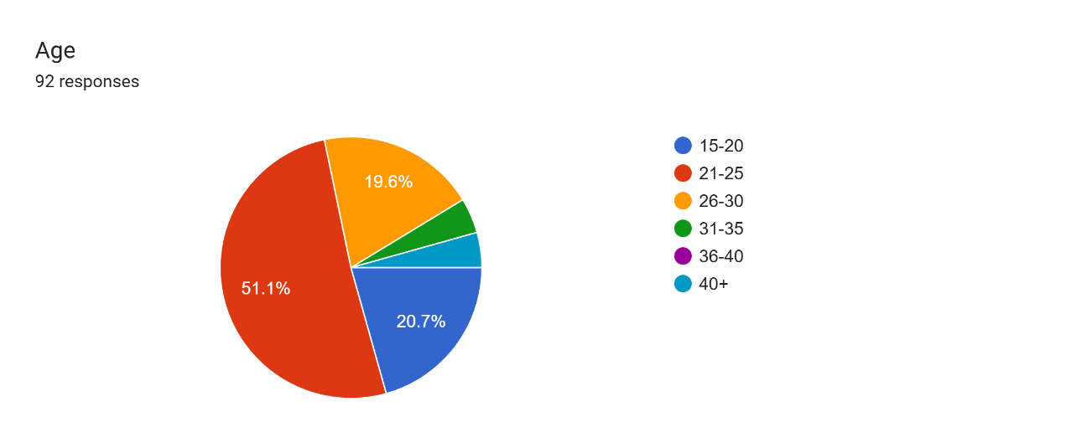

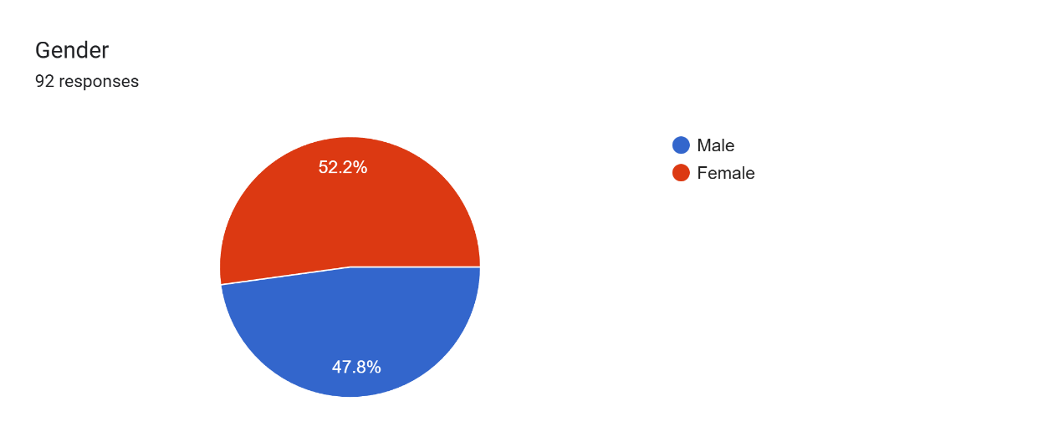

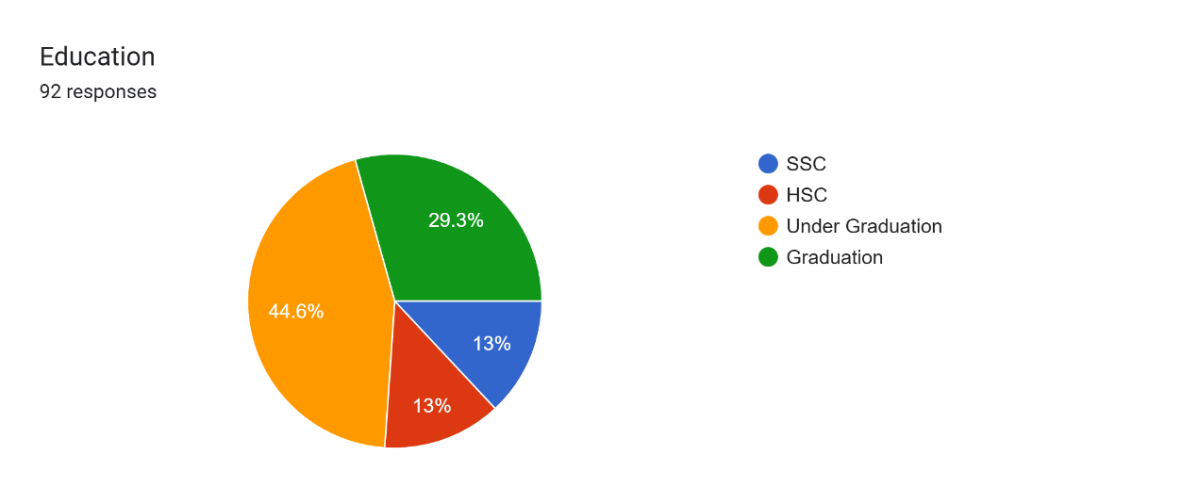

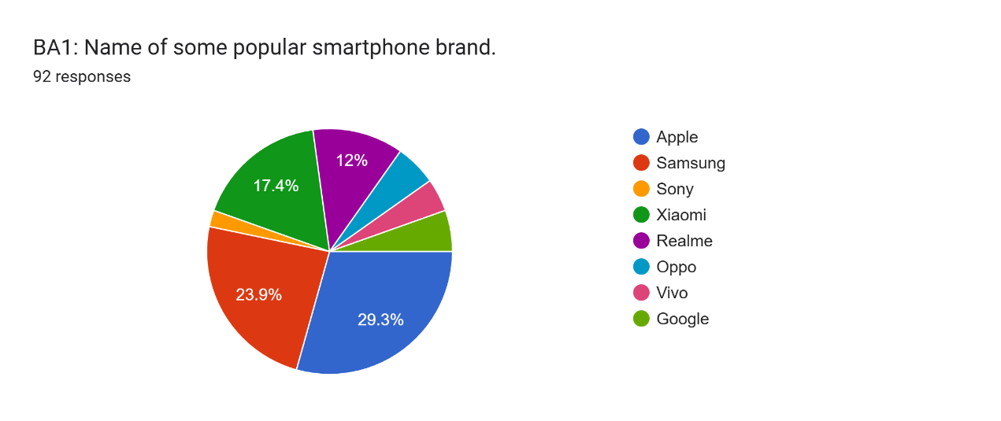

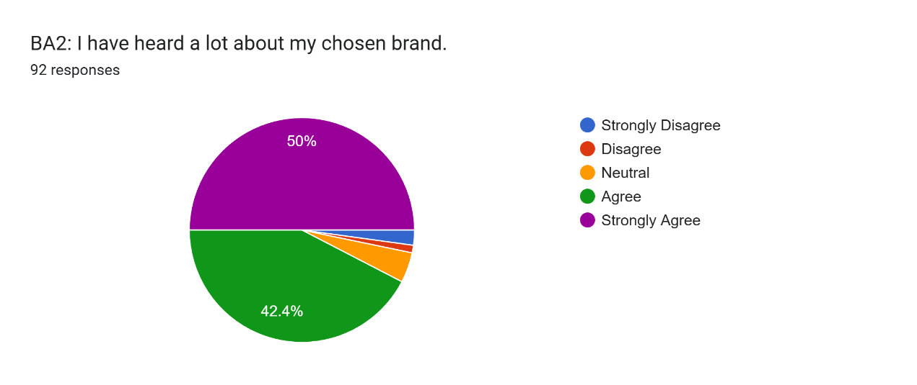

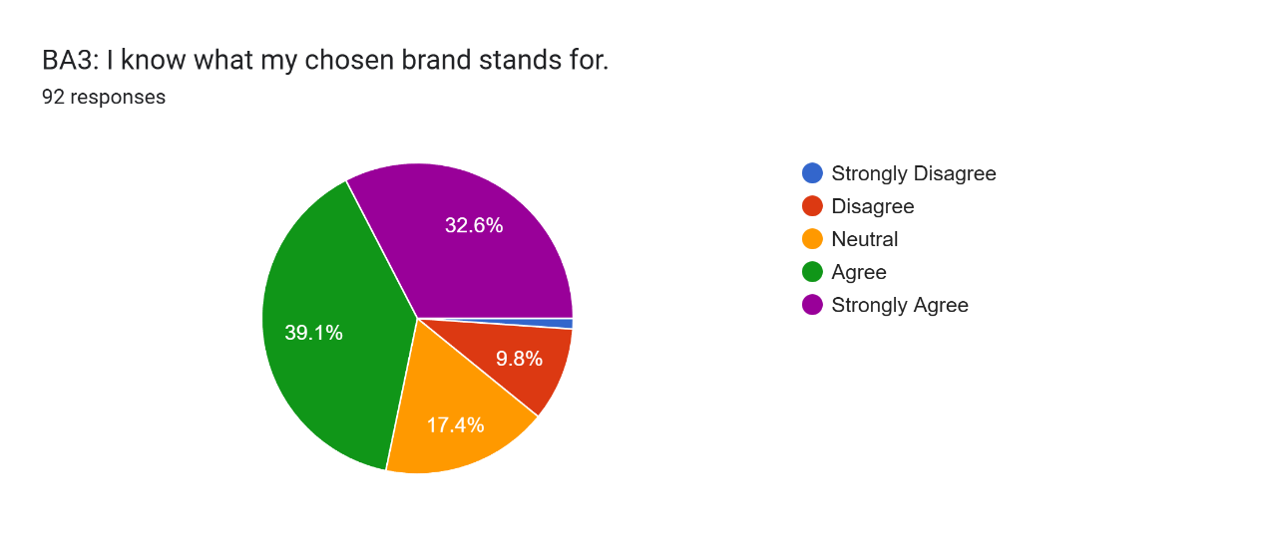

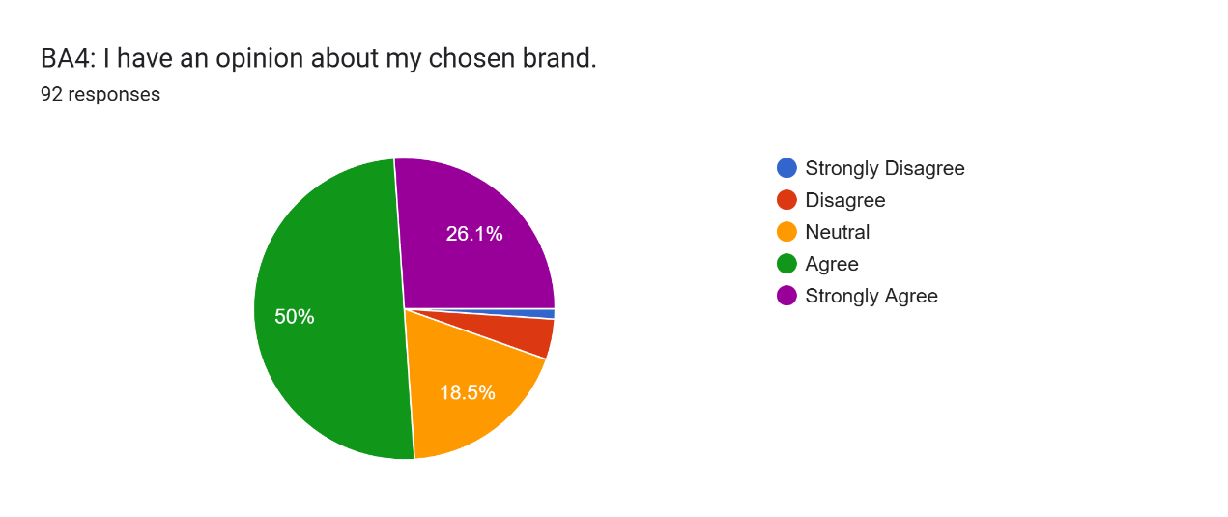

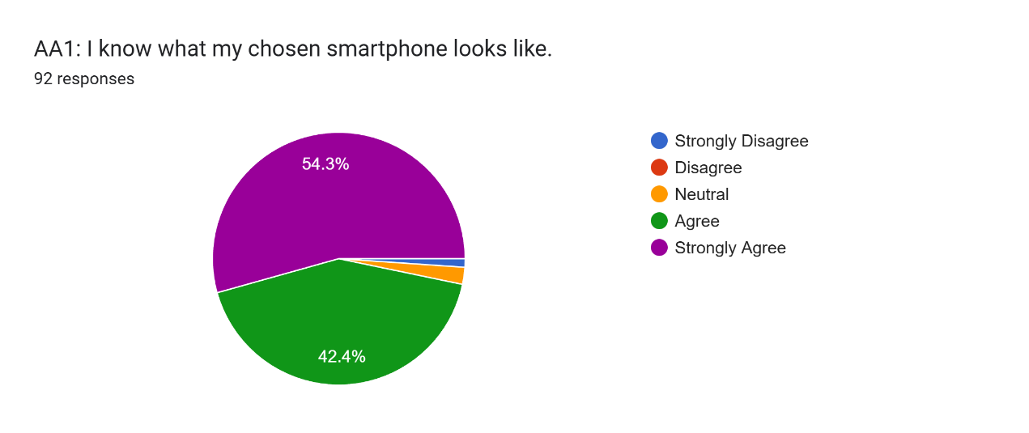

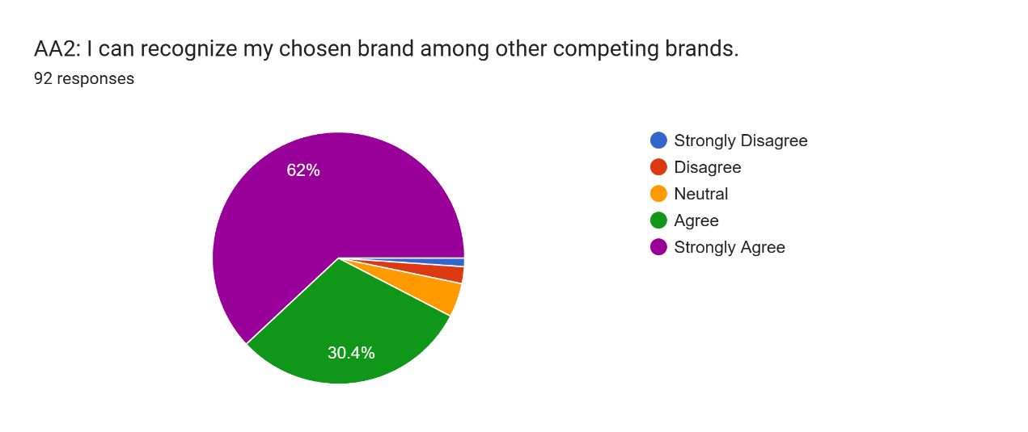

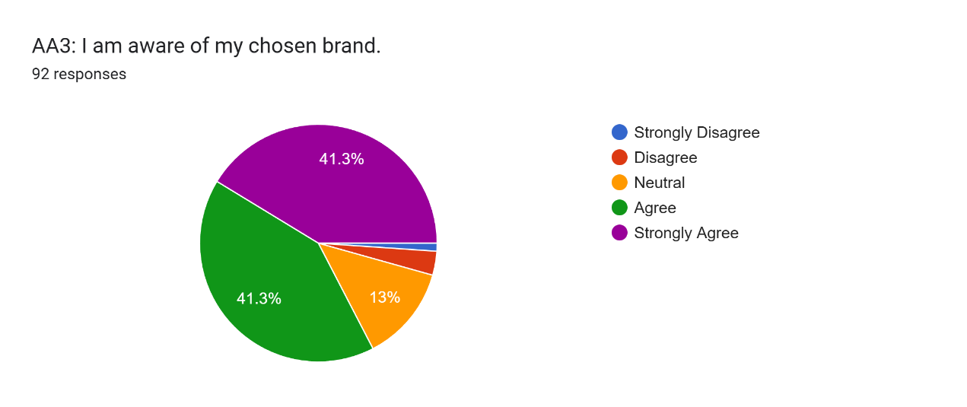

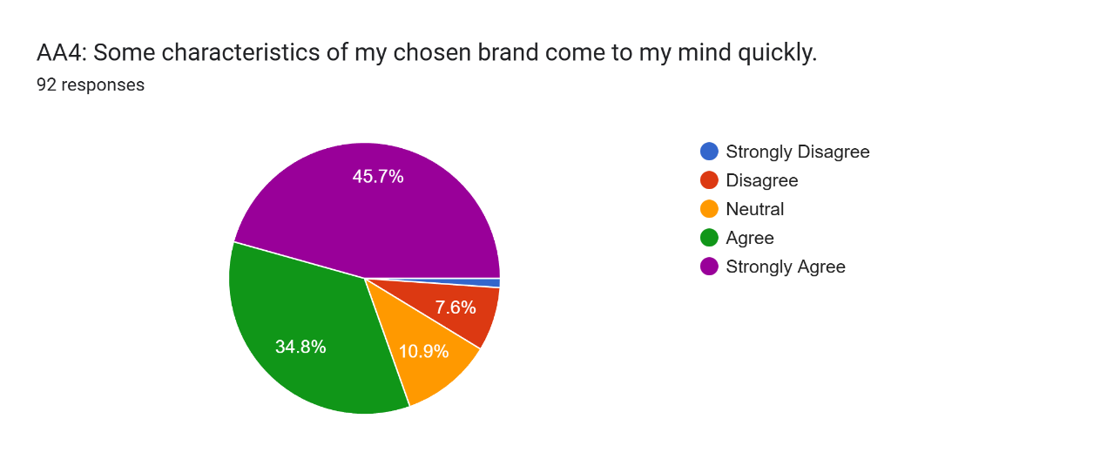

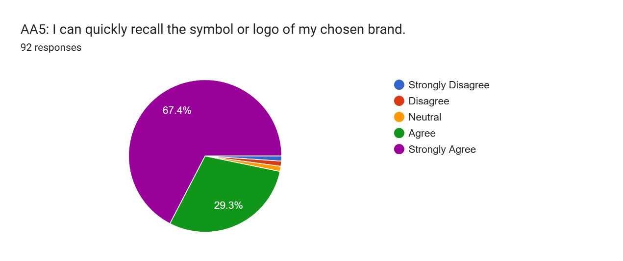

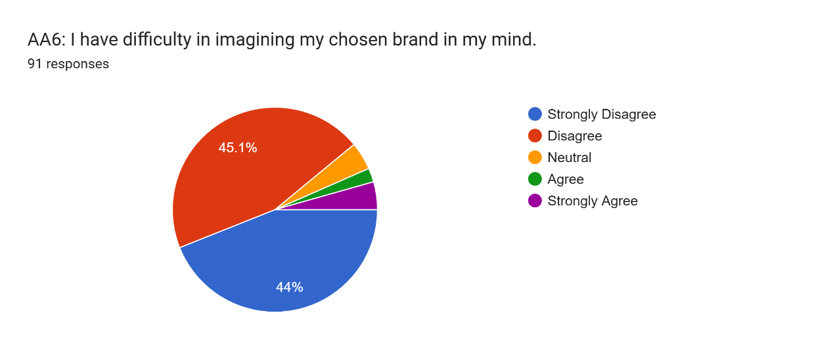

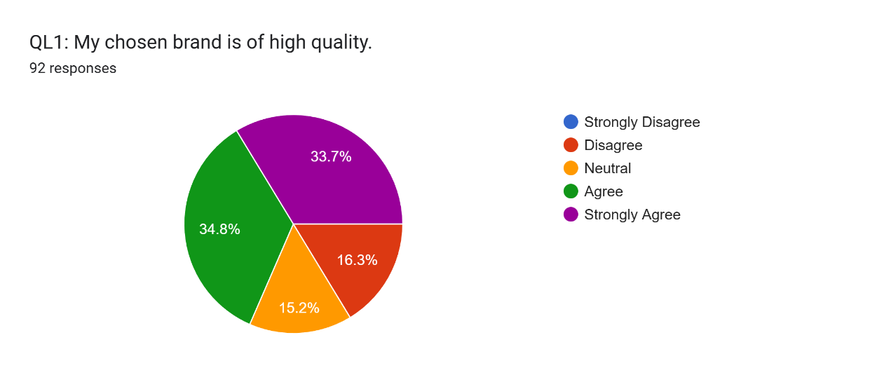

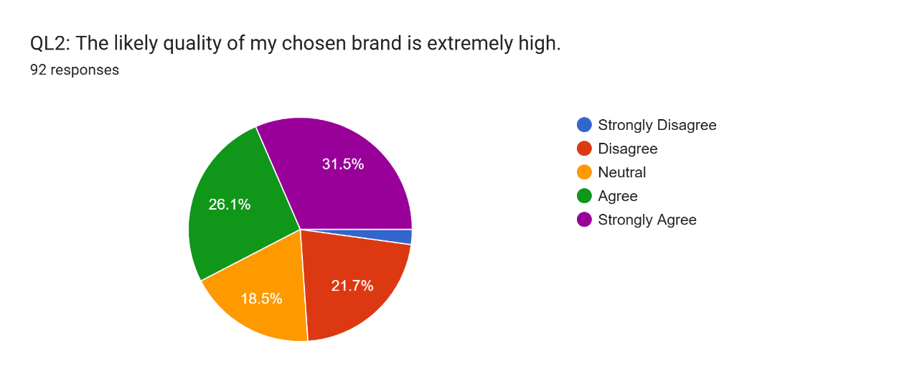

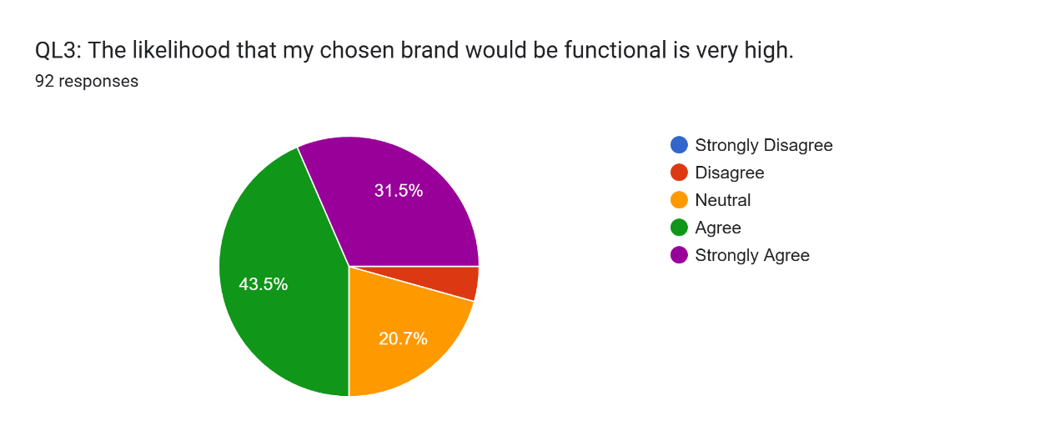

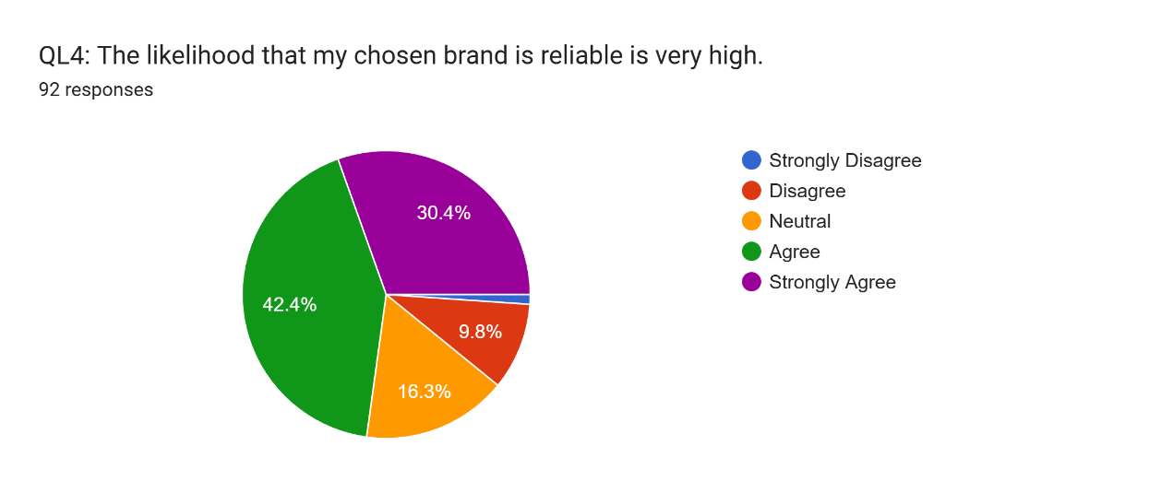

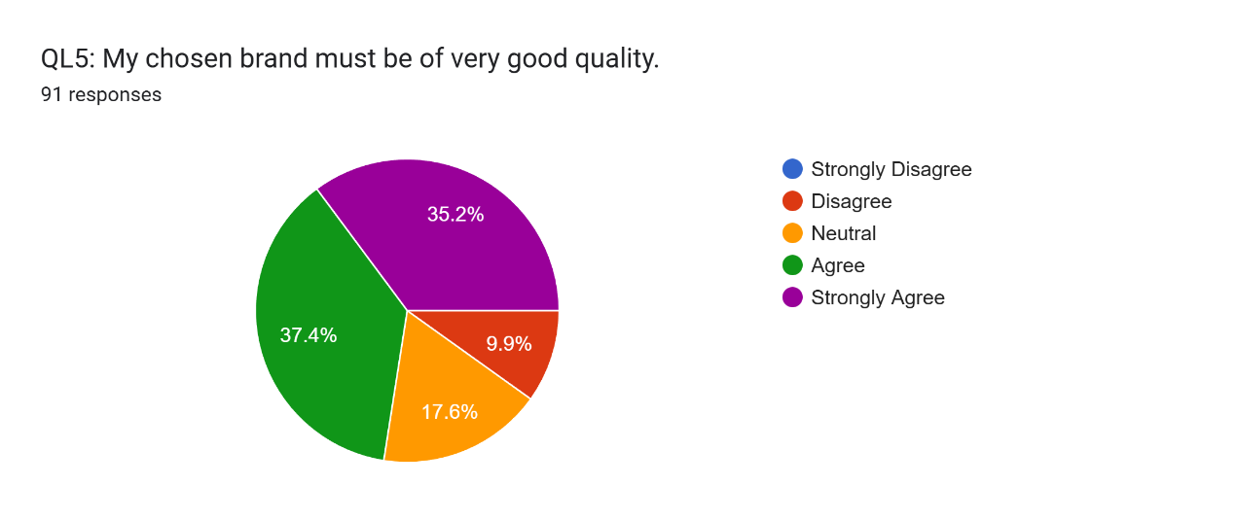

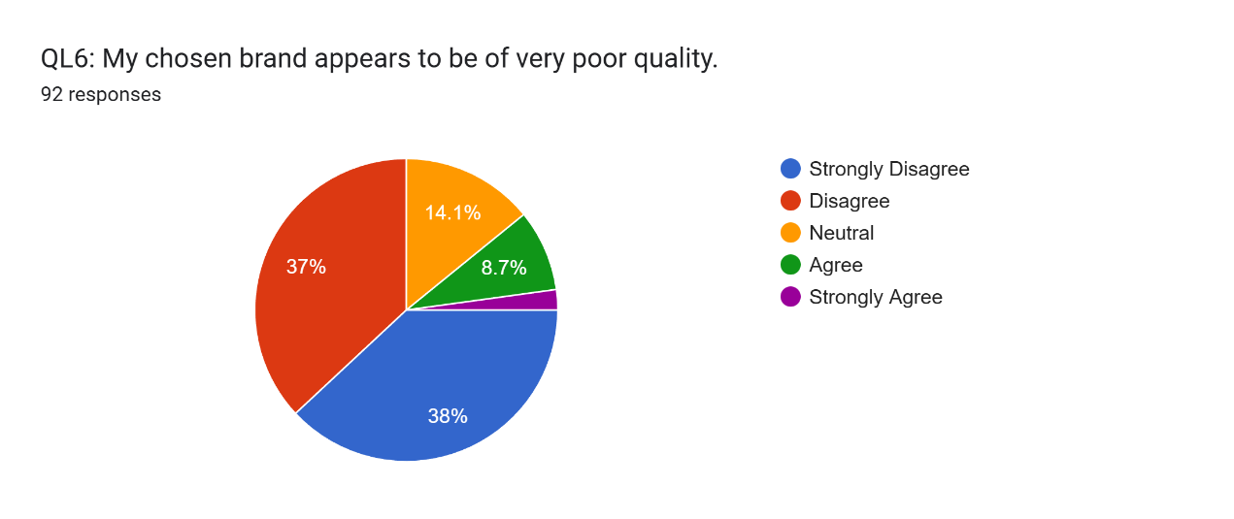

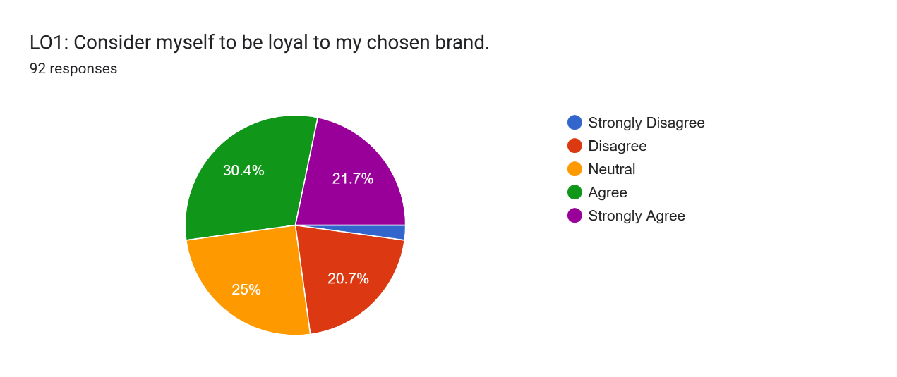

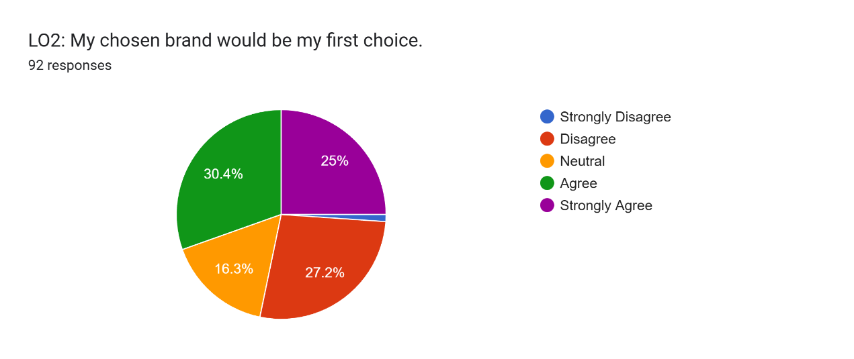

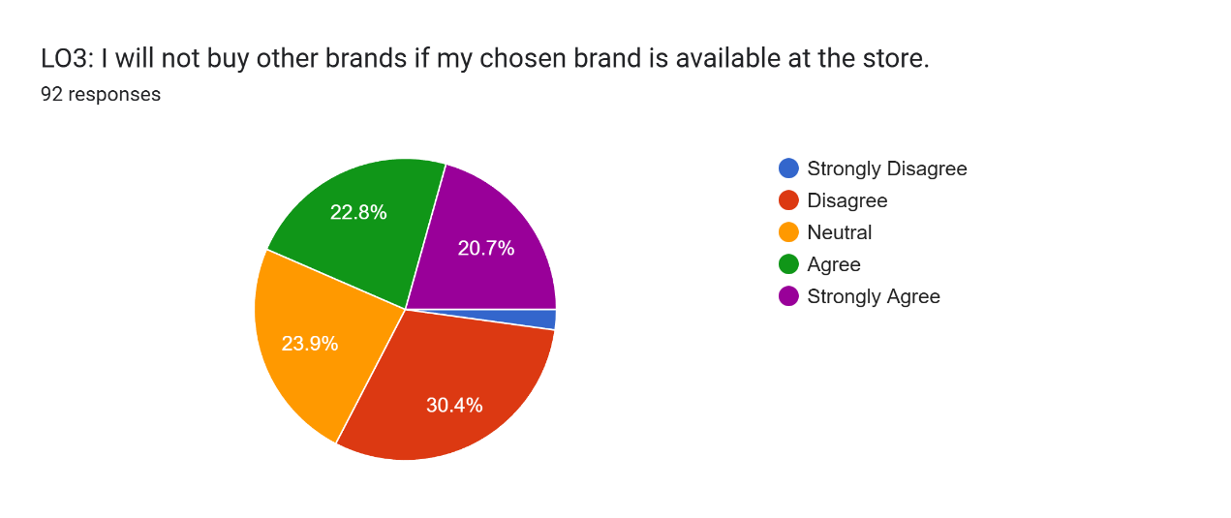

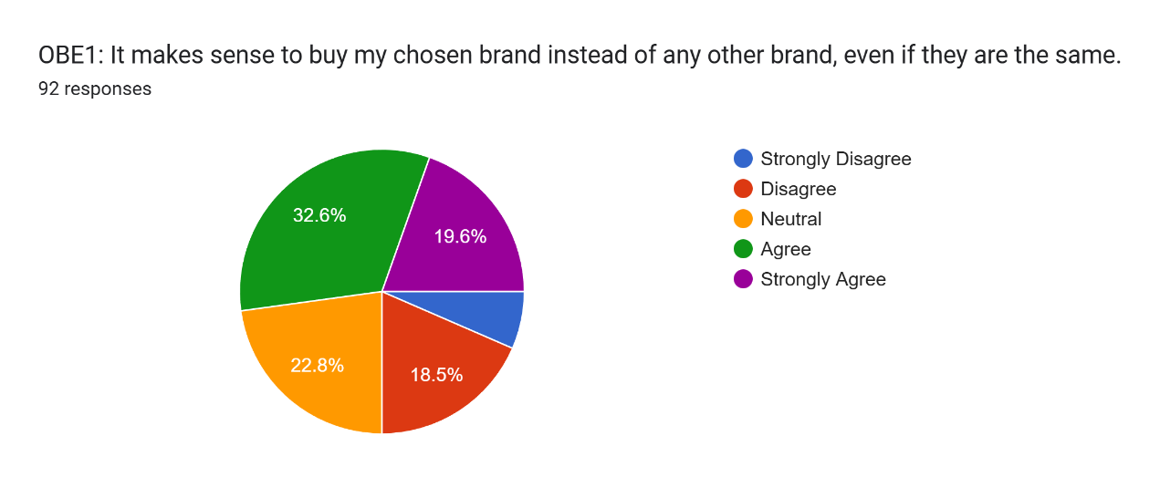

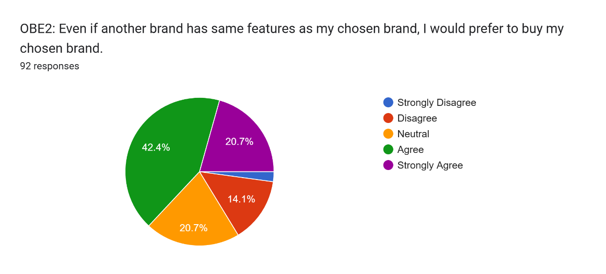

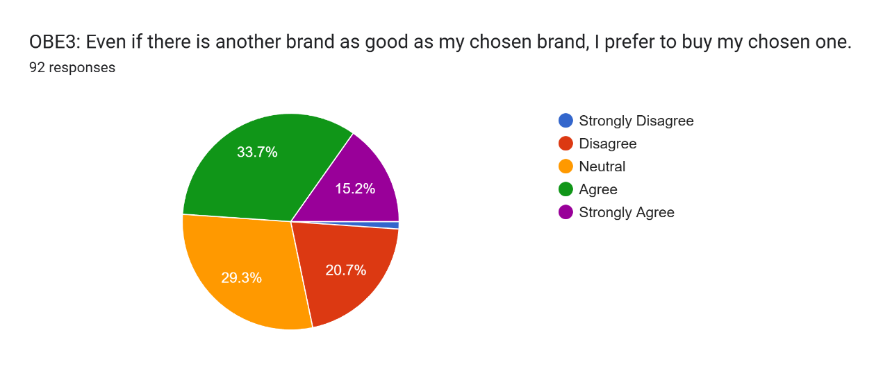

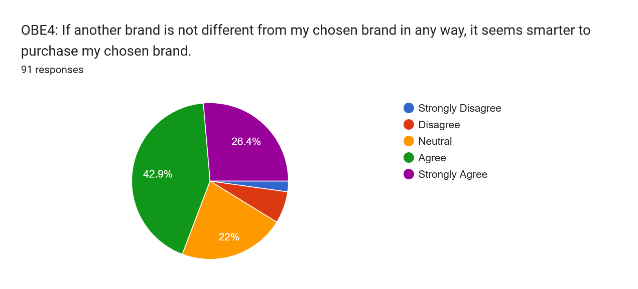

Chapter Five

Results and Discussion

The regression analysis provides a powerful and nuanced understanding of brand equity dynamics in the Bangladeshi smartphone market. The model's high explanatory power (R-squared = 0.768) indicates that the selected dimensions from Aaker's and Keller's foundational frameworks are highly relevant, but their relative importance reveals a distinct hierarchy specific to this competitive context.

The Supremacy of Brand Loyalty:

The identification of Brand Loyalty (β = 0.352) as the strongest predictor is the most critical finding of this study. This aligns with the literature, such as Kim & Kim (2005), who found loyalty to be a key driver in service sectors, and Yoo et al. (2000), who noted its strong direct effect on overall equity. In practice, this means that the ultimate value of a smartphone brand in Bangladesh is less about one-time customer acquisition and more about creating a captive, recurring consumer base. This loyalty acts as a formidable barrier to competition; as your introduction noted, loyal customers, like those of Apple, "are less likely to switch even when others drop their prices." In a market flooded with options, this loyalty provides pricing power and operational stability. The data suggests that marketing strategies yielding a high customer lifetime value are far more effective for building equity than those focused solely on expanding market share.

The Perceived Quality:
The significant role of Perceived Quality = 0.287 confirms its status as the essential bedrock upon which brand equity is built. This finding strongly supports the conceptual models of both Aaker (1991) and Keller (1993), who positioned quality as a primary dimension. In the context of a high-involvement product like a smartphone, which is a significant purchase for most consumers, the perceived reliability, functionality, and durability are paramount. A customer must believe the device will not fail. This perception justifies the price premium mentioned in your introduction and creates the trust necessary for loyalty to develop. As your literature review highlighted, Tong & Hawley (2009) found that while perceived quality might not always have a direct effect, it works indirectly by strengthening loyalty and associations. This study confirms that its direct effect is, in fact, robust and critical.

Brand Awareness:

Brand Awareness (0.243) functions as the essential entry point into the consumer's consideration set. This is a practical validation of Keller's (1993) CBBE pyramid, where awareness is the foundational step. A brand cannot be loved, trusted, or even evaluated if it is not known. In a crowded market, top-of-mind awareness is a significant competitive advantage. However, its position as the third-ranked predictor indicates that awareness alone is insufficient. It is a necessary, but not sufficient, condition for strong brand equity. Marketing efforts that generate buzz and recognition are effective, but their ultimate value is realized only if they funnel consumers toward an experience that builds perceptions of high quality and, ultimately, loyalty.

The Nuanced Role of Brand Associations:

The non-significance of Brand Associations (p-value = 0.199) is not an indication that brand image is irrelevant. Rather, it suggests that in the presence of the other three powerful predictors, its unique contribution to the regression model is minimized. This can be interpreted in two ways, both of which are insightful:
- Mediation Effect: Brand Associations likely exert their influence indirectly. For example, a strong association with "innovative camera technology" directly boosts Perceived Quality. An association with "a brand for successful youth" might help foster Brand Loyalty among that demographic. Thus, its value is embedded within the other variables.
- Market Maturity: In a highly competitive and marketing-saturated industry, many brand associations become table stakes. Most major brands advertise high-quality cameras and sleek designs, making it difficult for any single brand's associations to stand out enough to directly move the needle on overall equity on their own. The functional and emotional benefits are expected; it is the delivery on those promises (Quality) and the resulting relationship (Loyalty) that truly differentiates.

- Synthesis and Model Validation:
The statistical robustness of the model—with no multicollinearity, normally distributed residuals, and high significance—lends great credibility to these findings. The results paint a clear picture: the journey to building brand equity in this market begins with making the brand known (Awareness). This awareness must be followed by a product and service experience that consistently meets or exceeds expectations (Perceived Quality). If this is achieved successfully, it cultivates a committed customer base that repeatedly purchases and advocates for the brand (Loyalty), which is the ultimate engine of brand value.

Chapter Six

Recommendations and Conclusion

Recommendations
Based on the analytical findings, smartphone companies operating in Bangladesh should adopt a prioritized, three-tiered strategy:

1. Prioritize Customer Retention and Loyalty Building:
- Action: Shift a significant portion of marketing budgets from pure acquisition to retention programs.
- Tactics: Implement tiered loyalty rewards, offer exclusive benefits for repeat customers, create a vibrant user community, and provide exceptional after-sales service. Focus on building emotional connections rather than just transactional relationships.

2. Reinforce Perceived Quality Through Every Touchpoint:
- Action: Ensure that product quality, software experience, and customer service are consistently excellent.
- Tactics: Use marketing communications to highlight durability, performance, and reliability. Encourage and showcase positive user reviews and testimonials. A minor product failure can severely damage the perceived quality that is so critical to equity.

3. Maintain Strategic Brand Awareness Campaigns:
- Action: Continue investments in broad-reach advertising but with a strategic message that feeds into loyalty and quality.
- Tactics: Instead of just increasing name recognition, awareness campaigns should communicate the brand's value proposition and quality credentials.

Conclusion
First of all, this research successfully transitions the theoretical framework of brand equity into an empirically validated planned blueprint for the Bangladeshi smartphone market. By quantitatively analyzing the relationships between key brand equity dimensions, the study moves beyond stating what factors are important to revealing how much important they are relative to each other and in what way they interact. Secondly, the overarching conclusion is that building brand equity is not a parallel process where all dimensions are equally weighted. Instead, it is a sequential and hierarchical value chain. The findings compellingly argue that for smartphone brands in Bangladesh, the most efficient and effective path to creating a valuable brand is to focus on a core strategic sequence: 1) Secure Loyalty, 2) Deliver Quality, and 3) Maintain Awareness.

Moreover, the implications for marketing practitioners are profound. The "emotional connection" described in the introduction is not a standalone marketing theme. It is the outcome of a consistently positive experience driven by perceived quality, which in turn cements loyalty. Furthermore, this study contributes to the broader literature on brand equity, by providing a context-specific validation and refinement of accepted models. The delicate role of Brand Associations, in particular, summons further research to explore its mediating relationships with loyalty and quality more keenly.

In finality, this paper shows that in the high stakes ground of the Bangladeshi smartphone market, sustainable competitive lead is not merely won through spec sheets or advertising spend, but through the calculated and masterful cultivation of customer loyalty, which is itself the eventual measure and manifestation of a powerful brand.

References

- Lehmann, D. R., Keller, K. L., & Farley, J. U. (2008). The structure of survey-based brand metrics. Journal of International Marketing, 16(4), 29-56.
- Keller, K. L. (1993). Conceptualizing, measuring, and managing customer-based brand equity. Journal of marketing, 57(1), 1-22.
- Davis, D. F. (2003). The effect of brand equity in supply chain relationships. The University of Tennessee.
- Ha, H. Y., John, J., Janda, S., & Muthaly, S. (2011). The effects of advertising spending on brand loyalty in services. European journal of marketing, 45(4), 673-691.
- Pappu, R., Quester, P. G., & Cooksey, R. W. (2005). Consumer‐based brand equity: improving the measurement–empirical evidence. Journal of product & brand management, 14(3), 143-154.
- Pappu, R., Quester, P. G., & Cooksey, R. W. (2006). Consumer‐based brand equity and country‐of‐origin relationships: Some empirical evidence. European Journal of marketing, 40(5/6), 696-717.
- Buil, I., De Chernatony, L., & Martinez, E. (2008). A cross‐national validation of the consumer‐based brand equity scale. Journal of Product & Brand Management, 17(6), 384-392.
- Kim HongBumm, K. H., & Kim WooGon, K. W. (2005). The relationship between brand equity and firms' performance in luxury hotels and chain restaurants.
- Tong, X., & Hawley, J. M. (2009). Measuring customer‐based brand equity: Empirical evidence from the sportswear market in China. Journal of product & brand management, 18(4), 262-271.
- Yoo, B., Donthu, N., & Lee, S. (2000). An examination of selected marketing mix elements and brand equity. Journal of the academy of marketing science, 28(2), 195-211.
- Pinar, M., Girard, T., & Eser, Z. (2012). Consumer‐based brand equity in banking industry: A comparison of local and global banks in Turkey. International Journal of Bank Marketing, 30(5), 359-375.
- Rambocas, M., M. Kirpalani, V., & Simms, E. (2014). Building brand equity in retail banks: the case of Trinidad and Tobago. International Journal of Bank Marketing, 32(4), 300-320.
- Aaker, D. A. (1996). Measuring brand equity across products and markets. California management review, 38(3).
- Lassar, W., Mittal, B., & Sharma, A. (1995). Measuring customer‐based brand equity. Journal of consumer marketing, 12(4), 11-19.

