Strategic Business Plan for International Market Expansion: A Case Study of eGeneration PLC in Japanese Market

Sattwik Ahmed Arnab

This internship report is submitted to the School of Businesses & Economics, United International University as a partial requirement for the fulfillment of Bachelor of Business Administration Degree

Strategic Business Plan for International Market Expansion: A Case Study of eGeneration PLC in Japanese Market

Submitted by
Sattwik Ahmed Arnab
Student ID: 111-202-004
Major: Marketing
School of Business and Economics
United International University

Supervised by
Dr. Kawsar Ahmmed
Professor
School of Business and Economics
United International University

Date of Submission
24th November, 2025

Letter of Transmittal
November 24, 2025
Dr. Kawsar Ahmmed
Professor
School of Business and Economics
United International University

Subject: Submission of Internship Report On “Strategic Business Plan for International Market Expansion: A Case Study of eGeneration PLC in Japanese Market.”

Dear Sir,
With due respect and humble obedience, I want to inform you that I have prepared this Internship Report on “Strategic Business Plan for International Market Expansion: A Case Study of eGeneration PLC in Japanese Market”. The report examines the strategic approach of eGeneration PLC as it prepares to expand into Japan, analyzing the industry landscape, challenges, and opportunities for growth. I tried to present the findings of the report in the most succinct and presentable manner.
This report also provides a deep dive into the market entry strategies and positioning of eGeneration PLC, offering actionable insights based on my research and internship experience. I would like to express my sincere gratitude for your continued support and valuable guidance during this process. I hope this report will meet your expectations. I would be grateful if you would accept my internship report with the utmost appreciation.
Thank you for your time and consideration.

Sincerely Yours,

Sattwik Ahmed Arnab
ID: 111 202 004
BBA in Marketing
School of Business and Economics
United International University (UIU)

Declaration of the Student

Myself Sattwik Ahmed Arnab, a student from (United International University's) School of Business and Economics. I am certifying that,
This internship report is based on my experience in the (Business Development) department of eGeneration PLC. The internship report of (eGeneration PLC) has been completed by my hard work and efforts. I do not follow any unethical ways; information’s were added with honor and morals. I also state that my report is free from any kind of plagiarism. Information’s have been taken from primary and secondary sources.
I have completed the report and this report is completed only for any academic purpose.


Sattwik Ahmed Arnab
ID: 111 202 004
BBA in Marketing
School of Business and Economics
United International University (UIU)

Corporate Evidence
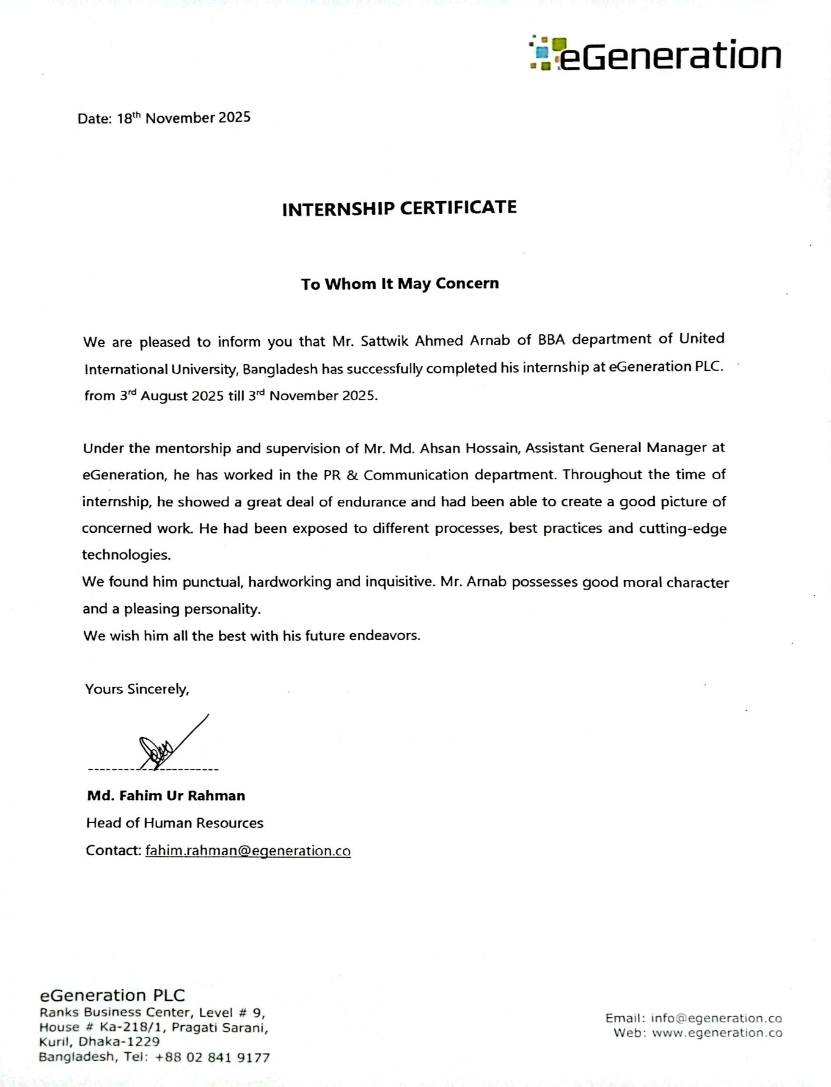

Acknowledgement

First, I would like to express my heartfelt appreciation to the Almighty ALLAH for giving me the power and capability to finish my internship program at (eGeneration PLC). Without ALLAH’s blessing, it would not have been a great tour starting from getting an internship and finish the internship with submit the report on time.
It is enormous pleasure to get chance for internship at (eGeneration PLC) and get such a blissful opportunity to prove my experience. The support and cooperation I gained during my internship program are remarkable and grateful. I want to express my heartfelt to Md. Ahsan Hossain sir, Assistant General Manager, to provide me with clear guidance on how to complete my everyday responsibilities. Despite his busy schedule, he took out his time to teach me and provided important information for completion of my report. I am sure that the knowledge and abilities I have acquired from this internship will come in helpful for my future position.
Now, I also express my gratitude to Dr. Kawsar Ahmmed sir, professor, School of Business and Economics, United International University, for all his wise advice and encouraging words throughout my academic career. Without his amazing counsel, direction and support throughout the process, I could not have completed the whole report before the deadline given to me. Being able to learn from him and complete my internship directly under his guidance is, honor, and privilege.
Finally, I would like to thank every employee of eGeneration PLC, particularly those in the Business Development department for the time and effort they put into completing my internship program smoothly. I am extremely grateful to each one of them for their constant support, tolerance and inspiration.

Executive Summary

This report provides an in-depth analysis of eGeneration PLC’s strategic business plan for expanding into the Japanese market, focusing on the company’s market entry strategy, challenges, and growth opportunities. eGeneration PLC, a leading IT services provider in Bangladesh, specializes in AI-driven business automation, cloud computing, and embedded systems reengineering. The company aims to capitalize on Japan’s growing demand for digital transformation solutions in industries such as automotive, finance, and manufacturing.
The Japanese market presents a significant growth opportunity, as businesses increasingly seek innovative IT solutions to enhance operational efficiency. The report highlights that Japan’s commitment to adopting advanced technologies, such as AI and IoT, will drive demand for AI-powered business automation, a core strength of eGeneration PLC. Additionally, the report projects a steady growth trajectory for Japan’s IT services sector, particularly in the areas of AI and business process optimization.
The report includes a SWOT analysis of eGeneration PLC, noting the company’s strengths in AI expertise and flexible hybrid service delivery model. However, it also identifies challenges, including the regulatory complexities in Japan, as well as the cultural differences that must be navigated for successful market entry. Japan’s business culture, which emphasizes long-term relationships and trust, requires eGeneration PLC to adapt its approach accordingly.
In terms of competitive positioning, eGeneration PLC faces competition from both local giants like Fujitsu and NTT Data and global players such as IBM and Accenture. However, eGeneration PLC’s focus on customized AI solutions and its ability to offer both offshore and on-site support allow it to stand out. The report also outlines strategic recommendations for entering the Japanese market, including leveraging AI and embedded systems, building strategic partnerships, and ensuring compliance with local regulations.

Keywords:
Strategic Planning, Digital Transformation, Process Optimization, Market Expansion, Competitive Positioning, Japan.

Contents
Letter of Transmittal i
Declaration of the Student ii
Corporate Evidence iii
Acknowledgement iv
Executive Summary v
Chapter – 1 Introduction 2
Primer 3
Objective of the Report 3
Limitations of the report 4
Key terms: 5
Chapter – 2 Industry and Company Analysis 7
Analysis of the IT Services Industry in Bangladesh 8
Specification of the Industry 8
Size, Trend, and Maturity of the Industry 8
Technological Factors 8
Political, Legal, and Regulatory Factors 9
Industry Rivalry 9
Summary of Challenges and Opportunities 10
Analysis of eGeneration PLC 10
Overview and History 10
Mission Statement 11
Location and Facilities 11
Customer Mix 11
Product/Service Mix 11
Service Quality 12
SWOT Analysis 12
Strategies to Meet the Challenges and Opportunities 13
Chapter – 3 Market Scenario Analysis 14
Market Scenario Analysis for eGeneration PLC in Japan 15
Overview of the Japanese IT and Business Automation Market 15
Factors Driving Market Growth 15
Market Challenges 16
Opportunities for eGeneration PLC 16
Market Data and Trends 16
Competitor Overview 17
Projected Demand for eGeneration PLC Services 18
Outlook for 2025–2030 18
Chapter – 4 New Market Creation 20
New Market Creation 21
Demand Forecast for eGeneration PLC in Japan 21
Market Trends and Opportunities: 21
Growth Projections: 21
Customer Insights: 21
Situational Analysis for eGeneration PLC in Japan 22
Current Competitors Analysis in Japan 23
Where We Stand Against Competitors in the Japanese Market 24
eGeneration’s ongoing project with LOOOP in Japan 26
Chapter – 5 Internship Experience, 28
Recommendations & Conclusions 28
Learning outcomes and Experience of the Personal Internship 29
Final words 30
Recommendations 31
Conclusion 32
References 33

Chapter – 1
Introduction

Primer

The IT services market is now experiencing a significant growth across the world due to the rising trend of operational efficiency through digital transformation programs, which eGeneration PLC, a powerhouse company dealing with television, radio and internet services, in Bangladesh, is developing a strategy to expand its reach in the Japanese market. Japanese fame in terms of technological advancement and extreme need to digital transformation services make it a competitive target of eGeneration PLC, which plans to implement the experience in artificial intelligence-based business automation, cloud computing, and embedded systems reengineering as a solution to the changing needs of Japanese businesses.

This report will carry out an in-depth analysis of how eGeneration PLC plans on penetrating the Japanese market primarily looking at how they can enter the Japanese market, position themselves in the market, and how they will overcome the challenges inherent in the operation in a highly competitive and technologically enhanced market like Japan. The analysis focuses on the trends in the market, the potential opportunities available and strategic adjustments which must be made in order to be in line with Japanese business culture and business legal frameworks.

Objective of the Report
The major object of this investigation is to examine the strategic business plan of eGeneration PLC as it tries to extend to international markets with specific focus on Japan. The report outlines how the firm will market entry, communicate to its stakeholders as well as positioning, and examines the challenges and opportunities that the firm should be looking towards sustainable growth in a very competitive international environment.
The primary objectives of this report are:
• To assess the Japanese market of IT services and identify the best entry path to take by eGeneration PLC.
• To identify its strengths, weaknesses, opportunities, and threats for eGeneration PLC in the Japanese market.
• To provide strategic suggestions based on market intelligence, with a focus on AI-based solutions, business automation, and custom service delivery.

Limitations of the report
During the internship program, there were some limitations that were experienced, which are listed below:
• Limited availability of sensitive data.
• Unavailability of certain resources.
• The contact with key stakeholders is limited.
• Technical limitations.
• Time constraints.

Organization of the remaining chapters:
The following paragraphs of this internship report are organized in a systematic manner in such a way that each section is developed out of the previous one thus giving a logical account of how eGeneration PLC plans its strategic expansion to Japan.
Chapter two discusses the present situation in the IT services industry in Bangladesh, its size, growth pattern, technological factors, and competitive rivalry. It provides a summary of eGeneration PLC, its mission, range of its service, its clients and overall dynamics of its operations. The SWOT analysis provided helps us understand the ability of the company to respond to the challenges emerging in the future and take advantage of the opportunities existing in it.

Chapter three analyzes the market of IT and business automation in Japan. The key growth factors, threats facing foreign entrants in the country and possible opportunities of eGeneration PLC are examined. The competitive environment has been analyzed, and forecasts as to the future demand for the company’s offerings are given. The chapter is also concluded with a future-oriented analysis of Japanese IT market in 2025-30.

In the chapter four the demand forecast of eGeneration PLC in Japan is given with the support of the data of the market trend and customer perceptions and industry statistics. A situational analysis determines the internal strengths and external factors relevant to entering the market. They are compared to other local and international competitors and the current project with LOOOP in Japan is discussed. The chapter also demonstrates the way the firm can position itself strategically in the Japanese market.

Key terms:
AI-Driven Business Automation:
With the use of artificial intelligence, business automation can be used to streamline processes, reduce human labor, and improve efficiency.
Embedded Systems Reengineering:
Upgrading and modernization of old embedded systems that are typically used in areas like automotive, electronics and manufacturing.
Digital Transformation (DX):
The process of digital technologies is integrating into various business areas to enhance performance, become more innovative, and make businesses more competitive.
Hybrid Service Delivery Model:
A combined solution of offshore and on-site support services, which allows providing cost-saving and at the same time tailored solutions to clients.
SWOT Analysis:
This is a strategic analytic tool used to determine the strengths, weaknesses, opportunities and threats facing an organization.
Industry 4.0:
The mission the most recent stage of industrial automation that is defined by robotics, the Internet of Things, intelligent production and smart systems.
Regulatory Compliance:
This is the compliance with legal requirements and data security regulations required under a certain market or jurisdiction.
Market Entry Strategy:
An organized strategy that helps penetrate a new market in a foreign country successfully.

Process Optimization:
The generalization and redesigning of business processes to make them more efficient and cost effective.
Reverse Engineering:
This process involves systematic analysis of an existing system to understand how it is designed and how it works so that it may be improved or redeveloped.

Chapter – 2
Industry and Company Analysis

Analysis of the IT Services Industry in Bangladesh

Specification of the Industry
The Bangladesh IT services industry is emerging at a very high pace. It has a wide range of services such as software development, business process automation, IT consulting, cloud computing, cybersecurity, and enterprise resource planning (ERP) systems. These services are critical in helping other industries like banking, telecommunications, manufacturing industry and the healthcare industries to facilitate their operations, improve efficiency, and save on cost.
Increased demand of IT services has been enhanced by the emergence of startups and the entrepreneurial culture in Bangladesh. These businesses need tailor-made solutions that can expand with them. The digital Bangladesh drive and spread of digital literacy have provided a conducive environment that supports growth in the IT services industry thus helping a company like eGeneration PLC.

Size, Trend, and Maturity of the Industry
The Bangladesh IT services sector is a significant national economic factor, which is currently estimated to be worth US 1.5 billion dollars in 2023, and is expected to grow at a compound annual growth rate (CAGR) of 10 per cent in the next five years. The development trend is largely fueled by a rising need of digital solutions especially in automation of businesses, artificial intelligence (AI), and cloud services.
Even though the industry is still in the maturity stage, it is emerging as an established industry with the companies switching to the use of cutting-edge technologies e.g., AI, blockchain, and the Internet of Things (IoT). The sector has been given the necessary assistance through government programs such as the National ICT Policy and the Digital Bangladesh Vision 2021. The industry is on the rise with more investments in technology and an apparent rise in the need to get smarter solutions.

Technological Factors
The IT services industry in Bangladesh is being transformed by the technological advances. The increased use of cloud computing, big-data analytics, AI, and machine learning (ML) help companies to become more efficient in their operations and cost less. In the case of companies like eGeneration PLC, these innovations provide the possibilities to offer AI-oriented solutions, automate business processes and create specialized software.
Another important trend is the significant increase in the use of mobile technology thereby creating the need to use mobile applications and cloud-based solutions. The development of the 5G technology and the trend of creating smart cities also widened the prospects of businesses such as eGeneration PLC to expand their product into new spheres, consequently enlarging the market in relation to IT services.

Political, Legal, and Regulatory Factors
The politics of Bangladesh are generally friendly to the IT industry, and the government has given several initiatives like the Digital Bangladesh Vision 2021, which promote favourable growth. These have made Bangladesh a good choice in terms of IT outsourcing and technological innovation.
However, there are still regulatory problems. Although there is a set of laws that protect data privacy and cybersecurity, the regulatory framework should be developed to match the development of technologies. In the case of IT service providers like eGeneration PLC, it is necessary to keep abreast of the changes in regulations, especially those that have to deal with data protection and intellectual property (IP) laws, to ensure that business operations are smooth, especially in the global marketplace.

Industry Rivalry
Bangladesh IT services market is very competitive with both local and world IT giants competing to capture the market. National companies, including Data Soft, BJIT, and Celestica, are dominant and they provide a variety of services, which are cloud computing, ERP solutions, and IT consulting. Simultaneously, there is the presence of multinational companies such as IBM, Accenture and Capgemini that are active in the market particularly in the field of enterprise level IT services.
One area of difference that eGeneration PLC is differentiated is the focus on AI-based business automation, embedded systems reengineering, which form the major differentiators. The flexibility and ability to customize solutions to the clients give the company an upper hand over the local competitors as well as large multinational companies.

Summary of Challenges and Opportunities
Challenges:
- Skilled Labor Shortage: There is a lack of skilled labor, even though Bangladesh has an impressive number of talented IT professionals, there is still a vast disparity on skilled expertise, which is especially in AI, cloud computing, and cybersecurity.
- Regulatory Compliance: It is essential to keep up with the laws of data protection and IP regulations especially when working with international clients.
- Intense Competition: The market is highly competitive with domestic firms and international companies vying overmarket share.
Opportunities:
- AI and Digital Transformation: The increased interest in AI-based solutions and business automation will provide eGeneration PLC with a chance to increase its market share due to the provision of the latest services.
- Government Initiatives: The programs of digital transformation and smart cities developed by the government suggest new opportunities for expansion to IT service providers.
- SME Market Growth: As small and medium-sized businesses need scalable solutions to IT issues, a profitable market exists where eGeneration PLC can access its market through serving these businesses.

Analysis of eGeneration PLC

Overview and History
eGeneration PLC is an organization established in 2003 that has grown to be among the leaders in the supply of IT services in Bangladesh. The company is also focused on software development, business process automation, and digital transformation which have contributed to its strong reputation on providing innovative and high-quality solutions to local and international customers. With the course of time eGeneration PLC has diversified its service offerings to include AI integration, DevOps solutions, embedded systems reengineering, which has made it one of the most important players in the field of IT services in the country. The company has also developed a customer base who are loyal to the firm in different sectors such as banking, finance, telecommunications, and manufacturing.

Mission Statement
The eGeneration PLC mission aims to provide business with innovative, reliable and efficient IT solutions that enable the businesses to optimize operations, and to be capable of sustainable growth. The firm hopes to become a reliable collaborator to organizations that want to utilize the force of technologies like AI and cloud computing to drive digital transformation.

Location and Facilities
eGeneration PLC is based in Dhaka, a Bangladesh capital city. The company has a state-of-the-art facility where the development teams, research and development activities and a working environment are located. The office is fully furnished with sophisticated infrastructure where eGeneration PLC can offer world-class IT services and solutions to customers across the world.

Customer Mix
eGeneration PLC provides services in a wide range of different types of industries that include banking, finance, telecommunication, health, and manufacturing. The company has been able to provide customized IT solutions to multinational companies, local businesses and start-ups and tailor them to meet unique needs of each client.
The customer base also reaches further to encompass other international customers who are based in Japan and Middle East where eGeneration PLC has established their presence. Such a scope of customers indicates the ability of the company to do business with customers in non-homogenous industries and geographical regions using its adaptable strategy and the desire to provide high-quality solutions.

Product/Service Mix
eGeneration PLC offers a wide range of services, including:
- Custom Software Development
- Business Process Automation
- AI and Data Analytics Solutions
- Cloud and IT Infrastructure Services
- DevOps Solutions
- Embedded Systems Engineering
The services are designed to help businesses to automate their operations, cut down on the cost of operation, and improve efficiency. The portfolio of the firm is scalable and customized to suit the individual needs of the clients that come in diverse industries.

Service Quality
In eGeneration PLC, the service quality is a top priority to maintain. The company believes in internationally recognized standards and best practices in provision of its services. Its quality assurance (QA) system consists of intensive testing and validation stages that would guarantee that every solution can meet high standards of performance, security, and reliability.
In addition, eGeneration PLC constantly upgrades their services and thus abreast with technological changes and the fluctuating demands of their clients.

SWOT Analysis
Strengths:
  - AI-based automation and embedded systems reengineering experience.
  - Strong technical team and experience in the industry.
  - Agile, service delivery model-oriented to clients.
Weaknesses:
- Independent brand recognition in foreign markets in comparison with bigger competitors.
- Too dependent on few big clients to achieve a good percentage of revenue.
Opportunities:
  - Increment in the demand of AI solutions and digital transformation.
  - International growth to new markets like Japan.
  - Greater demand of cloud-based solutions and business automation.
Threats:
  - Rigorous rivalry among the local IT companies and international technology providers.
  - Fast change in technology always requires innovation.

Strategies to Meet the Challenges and Opportunities
To meet the challenges and capitalize on the opportunities, eGeneration PLC will:
- Diversify its customer base by exploring new international markets, especially Japan and Middle East, where the need to use AI-based solutions and automate businesses is increasing.
- Invest in developing employees to ensure that they remain relevant in the new technology including AI, cloud computing, and machine learning.
- Improve global presence by attending global technology conferences, digital marketing campaigns, and strategic alliances.
- Exploit partnerships with technological companies across the world to reach new markets and new technologies, which will enhance the competitive advantage of the firm.

Chapter – 3
Market Scenario Analysis

Market Scenario Analysis for eGeneration PLC in Japan

Overview of the Japanese IT and Business Automation Market
The technology sector in Japan is experiencing a strong move towards digital transformation, as organisations in various sectors are seeking to turn to information technology to promote productivity, efficiency, and competitiveness in the fast-changing market. The most popular topics include software development, IT infrastructure, automation of businesses with the help of AI, and modernization of embedded systems.
This is a great opportunity to the eGeneration PLC since the Japanese companies are progressively demanding offshore and on-site support to streamline the operations, adopt DevOps, and re-engineer embedded systems. The demand is particularly intense in those areas such as manufacturing, automotive, finance, and healthcare where the efficiency of operations and technological breakthrough are paramount.

Factors Driving Market Growth
Some of the trends that are driving the development of IT and business automation business in Japan include:

- Government Support: Government efforts to encourage the use of artificial intelligence, smart factories, and the modernization of old systems are stimulating the use of new IT solutions in firms.

- Industry 4.0 Trends: The manufacturing and car industries are implementing automation, the Internet of Things, and AI, and require specialized services in large quantities.

- Competitive Pressures: IT and automation are being invested in by organizations to maintain a competitive advantage locally and globally.

- IT Talent Shortages: Skilled professionals are in short supply, and this has forced businesses to outsource specialized services thus creating opportunities to service providers like eGeneration PLC.

Market Challenges
Although the opportunities of expansion are high, the Japanese market is entered with a number of challenges:
- Cultural Considerations: Japanese business practices emphasize a lot on trust, long term relationships, and slow decision making, which requires strategic handling of clients
- Regulatory Requirements: Tight policies on the issue of data privacy and computer security need to be followed, especially by foreign service providers.
- Intense Competition: Local companies like Fujitsu, NEC and NTT Data along with international firms like IBM and Accenture control the market with reputations that are well established and large networks.

Opportunities for eGeneration PLC
Taking into account the current situation in the market and existing gaps, eGeneration PLC can focus on the following strategic opportunities:
- AI-based Business Automation: Japanese companies do not have the internal skills required to develop AI solutions; eGeneration PLV may be able to provide customized automation solutions to improve the efficiency of operations.
- Embedded Systems Modernization: Picnic industries such as automotive and electronics as well as industrial machinery need to be updated on their old systems to match with eGeneration PLC specialization.
- Hybrid Service Delivery: A combination of offshore and on-site services will allow offering cost-efficient and high-quality solutions to Japanese customers.
- SME and Startup Support: Small and medium businesses and startups also need scalable and flexible IT services, which is a relatively unexplored market segment.

Market Data and Trends
IT Services Market:
- Japanese IT services market has been estimated to be US 130 billion, and the market is projected to grow at 4.5 percent per annum within the next five years.

AI and Automation Adoption:
- AI adoption by Japanese companies has increased by 15 per cent in 2018 to 32 per cent in 2024, and it is predicted to grow to 45 per cent in 2027.
- This is set to be led by manufacturing, finance, and healthcare industries, with operational savings projected to reach as much as US 12billion/year by 2027 because of AI.

Embedded Systems Market:
- Japan is one of the biggest world systems in embedded systems, which is presently of the US 20 billion, with a projected compounded yearly growth of 5 percent up to 2028.
- Growth is driven by smart factories, industrial robotics, and the automotive sector, particularly electric and autonomous vehicles.
SMEs and Startups:
- 99% of businesses in Japan are SMEs, and about half of them intend to invest in digital transformation in the next three to five years.
- Startups are seeking and using cloud-based and AI-enabled solutions more and more, creating the demand of flexible and affordable services.

Competitor Overview
Competitor | Estimated Market Share | Strengths | Weaknesses
Fujitsu | 18% | Well-established brand, extensive network | Less agile for highly customized projects
NTT Data | 14% | Strong infrastructure, global client base | Slower to adopt niche AI solutions
NEC | 10% | Expertise in embedded systems | Limited flexibility for SMEs/startups
IBM / Accenture | 12% | Advanced global capabilities | Less personalized and culturally adapted services
eGeneration PLC | 0% (new entrant) | Agile, AI-focused, hybrid support model | Needs to establish trust and local presence

Projected Demand for eGeneration PLC Services
Service Area | Projected Market Size (2025) | Expected Growth (CAGR 2025–2030)
AI-driven Business Automation | $1.5 billion | 7%
Embedded Systems Reengineering | $0.8 billion | 5%
IT Infrastructure & DevOps | $2.0 billion | 4%
SME & Startup IT Support | $0.5 billion | 8%
Among these, AI-driven automation and services for SMEs and startups present the largest growth potential, making them the most strategic areas for eGeneration PLC’s expansion in Japan.

Outlook for 2025–2030
In the future, Japanese market is expected to outsource specialized IT services even more due to the shortages of workers. The use of AI and other automation technologies will likely grow faster, especially in manufacturing and finance. The startups and SMEs will become even more important customers, demanding flexible and scalable IT solutions.
eGeneration PLC will be well placed to capture the market share due to its experience in the areas of AI and embedded systems, proposing a hybrid service model that will combine offshore efficiency with the local in-situ support and serving the underserved segments of the market.

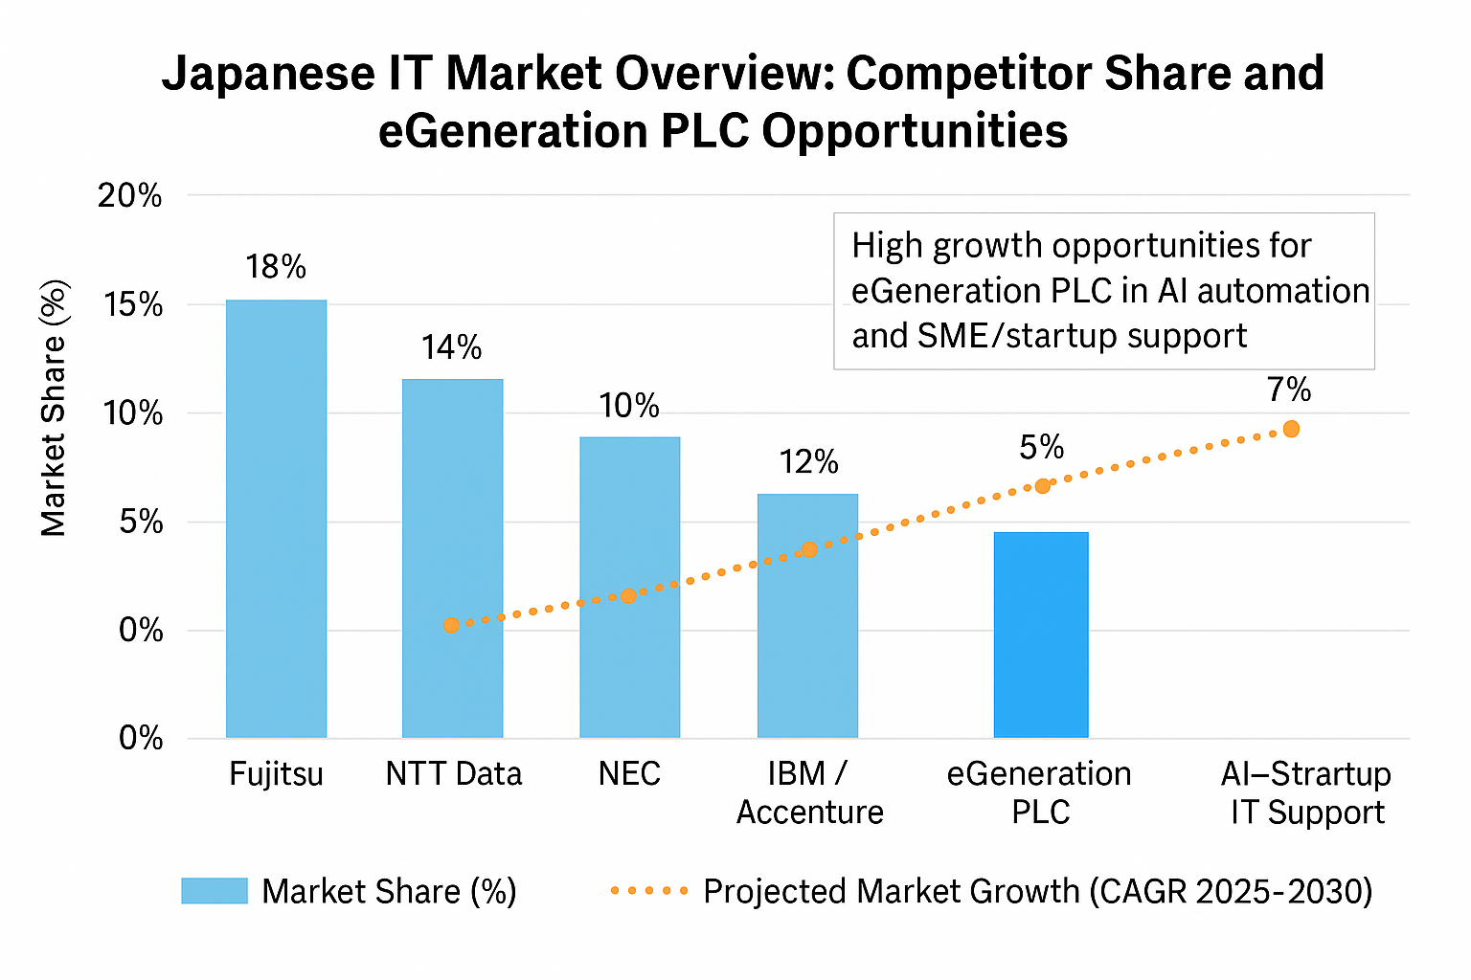
Strategic Market Analysis: Japanese IT Sector Dynamics

I have found a structural bifurcation in my analysis of the Japanese IT ecosystem between established market dominance and new growth vectors. The synthesized information demonstrates a strong negative correlation between the current market share and the future compound annual growth rates (CAGR) over the next 20252030 years. Although long-established market leaders like Fujitsu and NTT Data still rule the market, as they control more than a third of the industry, the trend of growth of these companies seems to have leveled, which is characteristic of the mature or stagnant stage of their operations. On the other hand, my analysis shows the shift of value creation to agile, high-innovation segments. Even though egenerationPLC is currently holding a relatively small market share of 5% per cent, the trend line shows that, in the future, the company is going to be focusing on the most vibrant verticals of the sector: AI automation and SME support systems. This separation implies that volume-based legacy providers will be removed, but the market will grow in the future with specialised, technologically advanced entrants (maximum peak of 7 % growth rate). In turn, I would argue that egeneration PLC is in a well-positioned position to overcome stagnation that has plagued the traditional conglomerates hence tapping the high-yield potential over the next half-decade.

Chapter – 4
New Market Creation

New Market Creation

Demand Forecast for eGeneration PLC in Japan
When making a demand forecast of entering the Japanese market with eGeneration PLC, I have put into consideration several factors that have a direct impact on the demand of our core services that include IT infrastructure, automation of businesses, and digital transformation. The current results show that the fast-growing technological environment in Japan together with certain requirements of the industry provide a significant opportunity to our services.

Market Trends and Opportunities:
A major change being witnessed in the Japanese market is the digital transformation especially in the automotive, financial and manufacturing industries. Japan has had a reputation of being technologically advanced and present economic trend is inclined towards technology-based solutions. More advanced AI-powered automation systems and embedded systems reengineering are in more demand, which eGeneration PLC is superior in. As indicated in numerous reports within the industry, the Japanese companies are interested in increasing the efficiency of their operations and improve innovation, which makes the offerings of eGeneration PLC very relevant.

Growth Projections:
The future outlook of the IT services industry in Japan, and in such spheres as AI and digital transformation, is promising. This is spearheaded by the fact that Japan has been committed to embracing the cutting-edge technologies due to the global competition. Moreover, the efforts of the government to promote innovation and the development of smart cities will contribute to the increased demand of business automation solutions and optimization of services only. I expect a gradual growth in the demand for solutions of e generation PLC in the coming three-five years.

Customer Insights:
I have supplemented data obtained based on industry reports by direct outreach via the Japanese job portals and the Entrepreneurs’ Organization. The information gathered on the feedback of the potential clients and business leaders supported the fact that the companies are more than ever before seeking partners who would take them through the complicated digital changes. Japanese companies are willing to cooperate with the ones that can offer offshore and on-site support of the custom solutions. This is in line with the strengths the eGeneration PLC has, especially with optimization of the processes and AI-driven innovation.
Conclusively, the prospects of eGeneration PLC demand in Japan are bright, especially with the adoption of the latest technologies by the industries in the region to streamline their operations and achieve a relative competitive edge. I expect a long-term demand for our services, and AI and automation of business will be key drivers of growth.

Situational Analysis for eGeneration PLC in Japan

Maximizing the situational analysis would be critical in determining whether or not e generation PLC is prepared to venture into the Japanese market. The analysis has played an important role in determining the internal and external factors that may affect our operations, such as opportunities, challenges, and the competitive environment.

Internal Strengths:
eGeneration PLC has been seen to excel in the field of software development, business automation and IT infrastructure which is greatly appreciated in the Japanese market. The ability of the company to offer offshore and on-site services enables it to serve a very broad scope of client requirements. This is a major benefit in Japan whereby businesses might need customized services. Additionally, the fact that eGeneration PLC has already incorporated AI in its solutions puts it at an advantage since it is one of the priorities of many companies that want to streamline their operations.

External Environment:
Japanese external environment has its opportunities and challenges. The economy of Japan is one of the largest in the world, and it still insists on technological innovation as the way of ensuring a competitive advantage. The regulatory environment may however be complex to the foreign companies. The Japanese government has strict compliance rules to foreign companies especially those dealing with data security and privacy. These regulations shall be important in navigating in order to have smooth entry into the market. Also, the Japanese and Bangladeshi culture might be thought to require some changes in the business approach including more focus on relationship building and trust.

Market Dynamics:
The technological industry in Japan is a very dynamic sphere and the fast development in the field of AI, IoT, and embedded systems takes place. These trends are consistent with the competencies of the egeneration PLC, especially the reengineering of embedded systems and AI-based business automation. The companies of Japan also want to find new ways of using digital solutions that will make operations easier and more efficient. The knowledge of these market dynamics will help the egeneration PLC to customize its products to suit the changing demand of the Japanese businesses.

Cultural Considerations:
In Japan, the business culture lays a lot of emphasis on long-term relations, trust, and reliability. The need to adjust to such cultural peculiarities in approaching potential clients is critical to egeneration PLC. Developing a long-term partnership based on personal contacts and familiarity with local business culture will be one of the strategies to success. Moreover, Japan puts a great emphasis on quality and precision which means that eGeneration PLC must be able to uphold the best standards of service and operation excellence.
The situational analysis shows that egeneration PLC has the resources and capabilities of succeeding in Japan provided it adjusts to the local business environment and survives in the regulatory environment.

Current Competitors Analysis in Japan

The competitive environment requires an analysis of the existing competitors in the Japanese market to enable proper positioning of eGeneration PLC. By conducting this analysis, I have been able to compile some of the major competitors locally as well as internationally and analyzing their strategies and market presence.

Local Competitors:
There are a number of already established IT and technology companies in Japan, which prevail on the market. The key competitors like Fujitsu, NTT Data, and NEC are a wide-ranging service provider, which includes business automation, cloud computing, and embedded systems. The benefits of these companies are that they have the profound local knowledge, networks and have long-standing relations with Japanese businesses. Their size and scope may occasionally make them incapable of providing highly customized or nimble solutions, which offers an opportunity to eGeneration PLC to offer tailored and flexible services.

International Competitors:
Alongside the local players, international companies like Accenture, IBM and Cap Gemini have operations in Japan. These firms provide high-technology solutions to the market but face the problem of cultural adaptation and penetration to the local market regularly. The fact that they can target the whole world also gives them a competitive advantage, but it also means that they cannot always deliver the same degree of personal engagement and customization that Japanese companies desire. This loophole gives eGeneration PLC a chance to be differentiated in terms of offering more personalized and specialized services.

Competitive Positioning:
eGeneration PLC can establish itself in the Japanese market by highlighting its distinctive capability to offer both offshore and on-site services and offer highly customized solutions in AI-based business automation and embedded systems. The large local competitors, in turn, have no such capability and cannot provide more agile and flexible approach, which means that the solutions provided by the firm are directly aligned with the specific needs of its clients. This strategy will play a central role in luring companies that are after innovation and efficiency.

Where We Stand Against Competitors in the Japanese Market

The position of eGeneration PLC against the existing players in the Japanese market has also been evaluated after analyzing the competitive environment. Based on its strengths and market opportunities, a number of areas where the company can differentiate and create a competitive edge have been identified.

Unique Strengths:
One of the key distinctions that e generation PLC has to offer is its experience in the use of AI in optimizing processes. Considering the fact that Japanese companies still focus on the automation process and digitalization as their priority, EGeneration PLC is in a good place to meet the need of AI-based applications that can optimize business processes. The ability of the company to combine AI with embedded systems reengineering provides an advantage of competition in a market that is more and more interested in such sophisticated features.

Technological Edge:
eGeneration PLC is uniquely placed among the competitors in the country because it takes advantage of the recent developments in AI and business automation. Although bigger players can also provide similar services, the possibility of providing the latest solutions and integrating the latest technologies in the personalized client services will allow the firm to find a niche in the Japanese market.

Flexibility and Customization:
In comparison to bigger companies that are likely to be guided by standard solutions, eGeneration PLC does an excellent job in providing highly customized services, which are based on the unique needs of each customer. Japanese companies that will be interested in this flexibility will be those companies that need specialized solutions in the DevOps, embedded systems, and AI-driven automation.

Relationship-building and Trust:
The importance of building trust and long-term relationships cannot be overestimated in Japan, and the practices used by eGeneration PLC to contact major industry players via its networks like Entrepreneurs Organization or local job portals provide a solid basis of creating relevant partnerships. This will help the company stand out of the competitors that might have a more transactional approach.
To sum up, eGeneration PLC has high chances to enter the Japanese market with its technological advantages, providing specific solutions, and establishing long-term relationships. The company can also distinguish, focusing on high-quality, AI-based automation solutions and embedded-systems reengineering services, and thus, cover the particular concerns of the Japanese businesses.

eGeneration’s ongoing project with LOOOP in Japan

About LOOOP:
LOOOP is a business in the power solutions enterprise dedicated to streamlining and enriching the current systems to achieve operational effectiveness and scalability. eGeneration initially provides two services namely a Business Analyst (BA) and a System Analyst (SA) to help LOOOP analyze their current system. Reverse engineering will be the main center of focus in order to understand the architecture and functionality of the current system. Though these two positions formed the beginning of the project, additional resources will be added little by little in regards with the demands of LOOOP and the needs of the project that are going to develop.



Human Resources Deployed in Japan:
• Solution Architect
• Business Analyst

Human Resources Deployed in Bangladesh:
• 30+ Technical Resources

Our Services:
• System Understanding & Analysis Support
• Business & System Analyst Allocation
• Reverse Engineering of Existing System
• Process Mapping & Documentation
• Gradual Resource Scaling Based on Needs
• Collaboration for System Enhancement Planning

Technical Skills & Expertise of eGen HR engaged for TP project:
The LOOOP project implies reverse engineering and analysis of an existing enterprise system. eGen team possesses significant experience in business processes modelling and system architecture analysis as well as documentation. The major technologies used are Java, Spring Framework, and MySQL as the backend systems and expertise in the analysis of the legacy systems and API integration. The analysts are well versed with system mapping tools like draw.io, lucid chart, and Microsoft Visio and project tracking and knowledge management tools like JIRA and Confluence. The team allows effective communication with the stakeholders and requirement collection using well-organized workshops and agile documentation procedures, which preconditions the following system improvement and scalability.

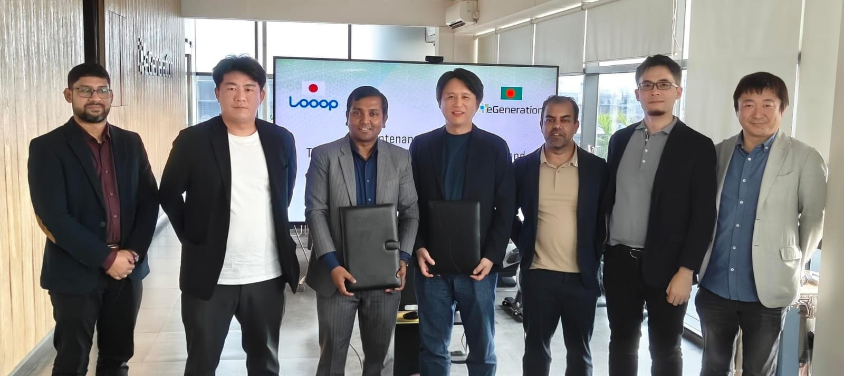

Chapter – 5
Internship Experience,

Recommendations & Conclusions

Learning outcomes and Experience of the Personal Internship
The eGeneration PLC internship program was an extremely valuable experience, which allowed applying the theoretical constructions in a very dynamic, IT services environment. This chapter will look at the main dimensions of the period reviewed which include the roles performed and the duties assumed, the professional and technical capabilities gained, and how these experiences were applicable in the strategic analysis that is discussed in the earlier chapters.
Overview and Major Responsibilities of the Internship
The internship took place over a period of three months, starting on 3 August 2025 and ending on 3 November 2025, during which I was mostly based at eGeneration PLC which is a leading force in technology industry.
Mentorship and Guidance: The guidance and mentoring of Mr. Md. Ahsan, Assistant General Manager, was especially valuable to me as it helped not only to develop professionally but also to manage successfully the everyday tasks. I would also like to give a lot of credit to the Business Development department that played major role in my project.
• Strategic Market Research: I was instrumental in the process of gathering intelligence in the market, research and analysis of the Japanese IT and business automation market. This is the main research which is an empirical basis of Chapter 3 of this report.
• Competitive Analysis: I assisted in the process of competitive overview and positioning analysis and this allowed to clearly define the specific competitive advantages of eGenerationPLC, specifically in terms of AI - based business automation and embedded systems re-engineering.
• Contact with Corporate Practices: I was kept in contact with professional work ethics, various processes, best practices and latest technologies that eGeneration PLCl uses in its global operations.
Learning Outcomes and Skill Development
My experience at eGeneration PL C was a highly important experience to connect theory with practical business implementation. The experience and skills gained in this internship are also very helpful and will be applicable in my future career life.
Strategic and Analytical Acumen: The fact that I was directly involved in the formulation of the Strategic Business Plan of International Market Expansion gave me practical, hands on experience in strategizing market entry, conducting risk analysis, and positioning the company against other market competitors in an overseas market. This practical experience reinforced my academic studies to a great extent.
• Technical Domain Familiarity: I had much familiarity with the high-demand services of eGeneration PLC, which are integration of AI, cloud computing, DevOps solutions, and embedded systems re-engineering. It is this exposure that has given me an all-encompassing insight into the role of these new emerging technologies in fueling digital transformation (DX) in major target markets, including Japan.
Professional and Interpersonal Skills: The business world inculcated the necessary professional qualities. The process required strength of character and solidified the importance of time and hard work and being curious. Constant support provided to me by my supervisor was also helpful in ensuring that I was able to handle the daily tasks and commitments successfully.
Corporate Culture Reflection
The conditions under which eGeneration worked at eGeneration PLC were also very favorable. The organization works as a family unit, which generates the atmosphere of the family. This constant support, patience, and motivation by all the employees, especially those working in the Business Development department made my internship to be organized and fun. Such a favorable atmosphere came in handy to affirm my passion to work-related tasks and to acquire the requisite corporate industry skills that would lead to success.
Final words
My experience at eGeneration PLC as an intern was very rewarding, which allowed me to afford a practical, analytic, and professional growth. My contribution to a real-life strategic project, the expansion to the extremely competitive Japanese market, equipped me with a holistic insight into the strategy of a business, the market dynamics, and technological breakthroughs. The acquired knowledge and skills are going to be a strong base in my future career.

Recommendations
As per all the analyses and findings presented in my internship and in my research, I have given out some recommendations which can help eGeneration PLC to establish a high presence in the Japanese market:
1. Strengthen Local Engagement
The development of the long-term relations is crucial in Japan. Creating a small representative office or working hand in hand with the local consultants would increase credibility and trust.
2. Develop Strategic Partnerships
By partnering with the Japanese companies, especially the SMEs, technology partners, or system integrators, it will be easier to enter the country and reduce cultural and operational barriers.
3. Ensure High Standard Regulatory Compliance
There are strict laws that regulate data privacy and cybersecurity in Japan. Adhering to METI standards and gaining accreditation like ISO 27001 would help increase the clients trust.
4. Focus on High-Growth Segments
eGeneration PLC ought to focus on the high innervation domains including AI automation, modernization of embedded-systems, and DevOps. Such directions are growing and are in tandem with the company strengths.
5. Customize Solutions for the Japanese Market
Japanese customers want accuracy and consistency. It will be value added by designing Japan specific service packages, bilingual documentations, and culturally oriented practices of communicating with clients.
6. Invest in Workforce Skill Enhancement
The company must keep on improving technical strengths within the company in AI, cloud-based technologies, and embedded systems by training and developing skills programs.
7. Strengthen Brand Visibility
The emphasis on successful projects, in particular, the current cooperation with LOOOP, will help to gain early credibility. Brand recognition will go up through attendance at Japanese technology events and focus digital marketing programs.

Conclusion
eGeneration PLC has a strong potential to enter the growing Japanese market on IT services sector because of the need to digitize the market, particularly in the automotive, finance, and manufacturing industries. The expertise that the company has in AI-based automation, cloud computing, and embedded systems provides the company with a competitive edge. This differentiation would enable eGeneration PLC to position themselves in contrast to other larger competitors that use more standardized services by providing customized solutions and hybrid support model (offshore and on-site). However, overcoming the regulatory landscape and adjusting to the Japanese business culture, where trust and lasting relationships are important, will be the key to success. By dedicating itself to innovation, establishment of local relations, and building trust, eGeneration PLC will be able to secure a market share and make a formidable market contribution in the Japanese competitive IT industry.
The internship program helped in discovering that I like working and the corporate industry competencies needed. The (eGeneration PLC) organization is a whole that operates like a family.
Lastly, I would like to thank my heartfelt gratitude to the (e generation PLC) Business Development department and everyone who was a part of my internship program.

References
- Kotler, P., & Armstrong, G. (2018). Principles of Marketing (17th ed.). Pearson Education.
- Cravens, D. W., & Percy, N. (2018). Strategic Marketing (10th ed.). McGraw-Hill.
- Walker, O. C., & Mullins, J. W. (2014). Marketing Strategy: A Decision-Focused Approach (8th ed.). McGraw-Hill.
- Porter, M. E. (2008). The Competitive Advantage of Nations. Free Press.
- Japan External Trade Organization (JETRO). (2022). Japan’s IT Industry: Opportunities for Foreign Companies. JETRO Reports.
- eGeneration PLC Official Website. (2025). Company Overview and Services. Retrieved from www.egeneration.com.
- Information from (eGeneration PLC) Linked-In site-https://www.linkedin.com/company/egeneration/
- Ministry of Economy, Trade and Industry (METI), Japan. (2024). Digital Transformation in Japan’s Economy. Retrieved from www.meti.go.jp.
- World Bank. (2024). Japan: Digital Economy and Innovation Strategy. World Bank Group.

