Internship Report
on
Financial Performance Analysis Of Mutual Trust Bank PLC.

Mohadi Ibne Monir Tajran

This report is submitted to the school of Business and Economics, United International University as a partial requirement for the degree fulfillment of Bachelor of Business Administration

Internship Report
on
Financial Performance Analysis Of Mutual Trust Bank PLC.

Submitted to:
Dr. James Bakul Sarker
Professor
School of Business and Economics

Submitted by:
Mohadi Ibne Monir Tajran
Id- 114 212 003
BBA in AIS

School of Business and Economics
United international university

24 November, 2025

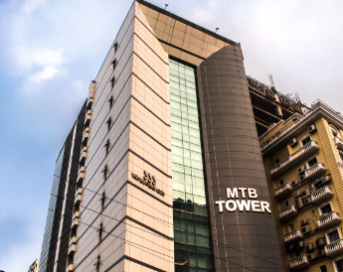


The Internship Report is hereby submitted to United International University to fulfill of the Bachelor of Business Administration Program requirements

Letter of transmittal

Nov 24, 2025
Dr. James Bakul Sarker
Professor
School of Business and Economics
United International University
Dhaka- 1212

Subject: Submission of Internship Report on “Financial Performance Analysis of Mutual Trust Bank PLC”

Dear Sir,
I am Mohadi Ibne Monir Tajran, bearing ID No. 114 212 003, and I hereby submit my internship report on “Financial Performance Analysis of Mutual Trust Bank PLC.” During my internship I gained valuable insights into the organization’s culture and operations.
This report presents my observations, analysis, and recommendations based on secondary data. I appreciate your guidance as my internship supervisor and the support of Mutual Trust Bank PLC throughout this period.
I hope the report meets your expectations and remains informative. Thank you for your consideration.

Sincerely,
Mohadi Ibne Monir Tajran
Id 114 212 003

Certification of similarity index

[Arial, 12 pt., 1.5 line space]

Declaration of the student

I, Mohadi Ibne Monir Tajran, hereby declare that this internship report titled “Financial Performance Analysis of Mutual Trust Bank PLC” has been prepared by me and is submitted for grading as a partial requirement for the degree of Bachelor of Business Administration in Accounting Information Systems at United International University.

I further certify that this report is my original work and has not been submitted, in whole or in part, for the award of any other degree or qualification at this or any other academic institution. All sources of information used in this report have been duly acknowledged and referenced following the APA referencing style.

___________________________
Mohadi Ibne Monir Tajran
ID: 114 212 003
Date: 24$th$ November 2025

Acknowledgement

I express my deepest gratitude to Almighty Allah for granting me the strength, guidance, and perseverance needed to complete this journey successfully.
I am sincerely grateful to United International University for providing me with a rich and comprehensive education in Accounting & Information Systems. The knowledge and skills I gained throughout my academic years have been instrumental in preparing me for the professional challenges ahead.
My heartfelt appreciation goes to Dr. James Bakul Sarker for her constant support, invaluable guidance, kindness and encouragement. It is truly an honor to have completed my internship under his supervision.
I would also like to extend my sincere thanks to the management and staff of Mutual Trust Bank PLC for giving me the opportunity to complete my internship at their esteemed organization. The team at Mutual Trust Bank PLC was welcoming, supportive, and always willing to share their knowledge, which greatly enriched my overall internship experience.
I am truly grateful to everyone who has contributed in any way to my academic and professional growth.
Mohadi Ibne Monir Tajran
114 212 003

Abstract
This report is submitted as a partial requirement for the completion of a Bachelor of Business Administration degree in Accounting and Information Systems at United International University. It covers the internship experience of three months at Mutual Trust Bank PLC (MTB), focusing on a comprehensive financial performance analysis of the bank. The internship was conducted at MTB’s Dhanmondi Branch, where the primary objective was to apply theoretical knowledge in financial management and performance analysis to actual banking operations.
The primary responsibilities during the internship included supporting day-to-day banking operations, assisting customers with account openings, transaction processing, loan applications, reconciliation activities, and compliance checks. Special emphasis was placed on learning and evaluating MTB’s processes for liquidity management, asset utilization, capital adequacy, and profitability through the analysis of publicly available financial statements from 2020 to 2024. The intern participated in the preparation of financial ratio analyses, comparative assessments, and graphical presentations to interpret trends over the five-year period, encompassing crucial metrics such as current ratio, loan-to-deposit ratio, ROA, ROE, operating profit margin, EPS, and capital adequacy ratios.
MTB operates as a third-generation commercial bank in Bangladesh, with an extensive suite of products and services including retail banking, SME banking, corporate finance, and digital solutions. The bank’s vision is to become the most trusted financial partner, guided by values of transparency, innovation, and regulatory compliance. Over the past five years, MTB has emphasized digital transformation, innovative customer service, and strict adherence to Bangladesh Bank’s directives, maintaining a stable and responsible corporate image within the financial sector.
Throughout the internship period, significant effort was invested in understanding the financial health of MTB by scrutinizing key ratios and identifying underlying strengths and weaknesses. The financial analysis revealed that while MTB demonstrated steady improvements in operating profit margin and return on equity, recent years saw a drop in its current ratio, indicating potential short-term liquidity challenges. The bank also maintained capital adequacy comfortably above regulatory minimums, reflecting prudent risk management practices. However, volatility was observed in net interest margins, and EPS growth was inconsistent, suggesting areas for further operational refinement. Documentation and compliance checks revealed robust internal controls, but highlighted the need for more advanced digitalization, especially in terms of IT infrastructure and process automation.
Limitations during the internship included reliance on secondary data due to restricted access to confidential bank records, limited exposure to all bank functions due to branch-specific assignments, and time constraints inherent in a short-term internship. Notwithstanding these challenges, the internship enabled valuable practical exposure in key operational areas, audit support, compliance review, and team collaboration.
Based on analytical findings, several recommendations are suggested: MTB should prioritize strengthening its short-term liquidity buffer, further digitize its operational processes, and continue investing in employee capacity building. Attention should also be paid to emerging risks in the wider banking environment, including non-performing loans and cybersecurity issues, to maintain sustainable growth and stakeholder confidence.
Overall, this internship experience offered a strong grounding in both the theoretical and practical aspects of financial performance analysis in banking, supporting future academic and professional development in finance.
Key Words: Financial ratio, Mutual Trust Bank, liquidity, profitability, asset management, Bangladesh banking, capital adequacy, compliance, digital banking, internship

Table of contents for Internship
Table of Contents
Letter of transmittal 4
Certification of similarity index 5
Declaration of the student 6
Acknowledgement 7
Abstract 8
Table of contents for Internship 10
List of Figures 12
List of Tables 1
List of Equations 2
List of Abbreviation 3
Chapter 1: Introduction 4
1.1 The purpose of the Mutual Trust Bank PLC in the Banking Industry in Bangladesh 4
1.2 Bangladesh Banking Industry. 5
1.3 Rationale of the Study 5
1.4 Background of the Study 6
Chapter 2: Objectives of the Study 9
Chapter 3: Financial Performance Analysis of Mutual Trust Bank PLC. 9
3.1 Introduction of Ratio Analysis 9
3.2 Liquidity Analysis of Mutual Trust Bank PLC. (2019-2024) 10
3.2.1 Current Ratio 11
3.2.2 Loan to Deposit Ratio 12
3.3 Earning Performance Analysis of Mutual Trust Bank PLC. 14
3.3.1 Return on Asset (ROA) 14
3.3.2 Return on Equity (ROE) 16
3.3.3 Operating Profit Margin 17
3.3.4 Earning Per Share (EPS): 18
3.3.5 Net Interest Margin (NIM): 20
3.3.6 Cost to Income Ratio 22
3.3.7 Return on Investment 23
3.4 Capital Adequacy Analysis of Mutual Trust Bank PLC. 24
3.4.1 Capital To Risk Weighted Ratio 25
3.5 Asset Management Analysis of Mutual Trust Bank PLC. 27
3.5.1 Assets Turnover Ratio 27
3.6 Financial risk ratio of Mutual Trust Bank PLC. 28
3.6.1 Debt Equity Ratio 28
3.8 Business risk ratio of Mutual Trust Bank PLC. 30
3.8.1 Financial Leverage 30
Graphical Presentation: The change of the financial leverage ratio of Mutual Trust Bank Limited is shown in the graph below- 31
5.5 SWOT Analysis of Mutual Trust Bank PLC. 32
Chapter-4: Internship Experience 33
Chapter 5: Conclusion AND KEY FACTS 36
5.1 Recommendations for improving departmental operations 37
5.2 Key understanding 37
5.3 Conclusion 38
Chapter 7: Appendix 38
References 38

List of Figures

List of Tables

List of Equations

List of Abbreviation

Chapter 1: Introduction

1.1 The purpose of the Mutual Trust Bank PLC in the Banking Industry in Bangladesh

Mutual Trust Bank PLC (MTB) is among the leading third-generation commercial banks in Bangladesh that are privately owned. Since it started its operations in 1999, the bank has established itself as a dependable financial intermediary by marshaling the deposits of surplus units and using the same in lending to deficit units in the form of loans and investments. MTB currently provides an extensive product portfolio of retail banking, SME banking, corporate and institutional banking, Islamic banking, card services, trade finance and digital banking solutions.

The bank has a diversified client base of individuals, small and medium enterprises, large corporations, NGOs and NRBs with its headquarters at MTB Centre, Gulshan, Dhaka and an expanding network of branches, sub-branches and ATMs in the country. MTB contributes to trade, commerce and industrial development in Bangladesh through various deposit schemes, loan products, foreign exchange services and technology-based banking channels.

Over the past few years, the bank has been very strong in terms of innovation and digital transformation with the introduction of internet banking, mobile banking applications and real time online banking. Such efforts have made customers more convenient and have made the bank competitive in the fast changing financial landscape. Simultaneously, Mutual Trust Bank focuses on good corporate governance, reasonable risk management and strict adherence to the regulatory policies of Bangladesh Bank that helps to stabilize the banking system in general.

Under the guise of its vision that is to become the most trusted bank, surpassing the changing customer expectations by providing excellence through innovation and sustainable banking solutions, MTB tries to strike a balance between profitability and long-term sustainability and responsible banking. This has seen the bank emerge as a key participant in the private banking industry and a key player in the financial intermediation process in the country.

1.2 Bangladesh Banking Industry.

One of the most important parts of the financial system of Bangladesh is the banking sector. It is at the center of mobilizing domestic savings, investment financing, facilitating foreign trade and generally boosting economic growth. The industry is composed of state owned commercial banks, specialised development banks, commercial banks that are privately owned and foreign commercial banks. Of these, commercial banks such as private commercial banks such as Mutual Trust Bank PLC have acquired a large portion of the total deposits and advances and have become the prime source of competition and innovation.

In the past few decades, the banking industry has undergone a lot of reforms such as prudential regulations, credit-risk grading systems, and automation of payment systems. The reforms will focus on enhancing financial stability, quality of assets and customer service. Nonetheless, the industry is also subject to a number of threats including the increase in non-performing loans, liberalization of interest rates, volatility of the capital market, exchange rate pressure, inflation and post-crisis impact.

In this context, there is a need to assess the performance of individual banks. All the regulators, investors, depositors and the management must evaluate the profitability, liquidity, solvency, efficiency and quality of assets of a bank. One of the most commonly used tools in this regard is the financial ratio analysis based on the audited financial statements. Thus, analyzing the financial performance of a privately owned commercial bank such as the Mutual Trust Bank PLC allows not only to learn about the internal strengths and weaknesses of the bank but also about the general state and competitiveness of the banking sector.

1.3 Rationale of the Study

Financial institutions are under a very competitive and regulated environment where performance is constantly checked. In the case of a commercial bank, good financial performance is required to keep the customer's confidence, regulatory requirements, attract new business and sustainability.

This internship report is prepared as Financial Performance Analysis of Mutual Trust Bank PLC (2020-2024) to analyse the recent financial position of this bank using various financial ratios and trend analysis on the basis of published annual reports of the bank during the five years 2020-2024. The study tries to measure the profitability, liquidity, solvency, efficiency and quality of assets of the bank and whether the bank is performing better or struggling in these areas.

Academically, the report satisfies a part of my Bachelor program and enables me to implement theoretical knowledge of financial management, banking and ratio analysis to a real life institution. Practically, my internship experience at the Dhanmondi Branch of Mutual Trust Bank PLC has provided me with the experience of observing day to day activities, internal control procedures, customer transactions and reporting processes of a commercial bank. This practical exposure coupled with quantitative analysis would give a more in-depth picture of the performance of MTB and its standing in the banking industry.

Thus, the research will be useful to:
- By offering a reference on the financial performance analysis of a private commercial bank in Bangladesh.
- By pointing out the strengths and weaknesses that can be used in strategic planning. Other stakeholders, including investors and depositors, by providing a better understanding of the financial health of the bank in the 2020-2024 period.

1.4 Background of the Study

1.4.1 History of the Bangladesh Banking Sector.
Following the independence of Bangladesh in 1971, most of the banks were nationalized by the government to restructure the economy that was ravaged by the war and direct credit towards priority sectors. In the 1980s and 1990s, the reforms in the financial sector promoted both the domestic and foreign investment in the banking sector, which resulted in the first, second and third generation of the private commercial banks. These banks brought in new management practices, competitive interest rates and a variety of financial products which assisted in boosting efficiency and diversifying financial services.

As trade expands, remittances and industrialization, the need for banking services has also increased. In the current times, banks do not only carry on the conventional role of mobilizing deposits and lending money, but also provide card services, internet banking, mobile financial services, SME financing, agent banking, green banking and other fee-based services. However, non-performing loans, corporate governance, liquidity pressures and macroeconomic fluctuations remain a problem to the sector.

1.4.2 History of Mutual Trust Bank PLC.
Mutual Trust Bank PLC was established as a public limited company on 29 September 1999 under the Companies Act 1994 and was licensed as a bank by Bangladesh Bank on 5 October 1999. The bank was started on 24 October 1999 as a third generation privately owned commercial bank. Since that time, MTB has been steadily increasing the number of branches, sub-branches and ATM booths and created different subsidiaries such as capital market and brokerage services to satisfy the needs of its customers in different ways.

The vision of the bank is to be the most trusted bank and the mission is to enhance the lives and livelihood of the customers using innovative and sustainable solutions provided by a dedicated and qualified workforce. Its values are commitment to excellence, customer focus, transparency, accountability and agility in change.

Since its inception, Mutual Trust Bank has launched several deposit schemes, retail and corporate lending products, Islamic banking products under the name MTB Islamic, women-centered products under the name MTB Angona, and high-tech digital products under the name MTB Neo. By these initiatives, the bank aims at setting itself apart in the market without violating the regulatory requirements and global best practices.

Since the bank has already served over 20 years of its existence, it is worthwhile to assess whether MTB has been capable of achieving acceptable financial performance, creating sustainable profits, risk management and value creation to shareholders. It is based on this historical background that a systematic financial performance analysis of the Mutual Trust Bank PLC is to be conducted within the five years 2020-2024.

1.5 Limitations of the Study

Despite all the attempts to make this report as careful as possible, some limitations were inevitable:
- Relying on secondary data:
The analysis will rely on secondary data as the main source of information, which is the published annual reports of the Mutual Trust Bank PLC of the years 2020-2024, publications of the Bangladesh Bank, and articles and information on the official site of the bank. Some crucial data might be omitted as the access to all internal records was not possible.
- Time constraints:
The internship was not more than a few months. In this brief period, no detailed research could be carried out on all the operations of the bank in all the branches or divisions.
- Restricted access in the organization:
Being an intern, I could not have access to confidential financial information and internal policies. I was assigned to work primarily in the Dhanmondi Branch, thus, most of my observations are limited to the work of this branch and may not be a full reflection of all the branches and departments of the MTB.
- Possible personal bias:
It was my initial official working experience. The report may include some interpretations that are affected by my personal perceptions and interactions at the branch instead of a totally neutral perspective of the organization as a whole.
- Data reliability:
The report is based on audited financial statements and government and international sources of information. Nevertheless, such errors, the further restatements or alterations of the economic situation can influence the absolute accuracy of the figures and the possibility of the generalization of the conclusions.

Chapter 2: Objectives of the Study

Chapter 3: Financial Performance Analysis of Mutual Trust Bank PLC.

3.1 Introduction of Ratio Analysis

The process of measuring the financial performance of banks is just like measuring the performance of a conventional firm. The income of a bank is the investment return which is earned on investments by the bank and this is earned in the form of interests or appreciation of assets on investments. The cost of money used in making these investments should also be put into consideration by banks. The profit is eventually gained by the difference between what banks pay the investments and what they gain off the borrowers. The number of measures applicable to gauge the performance of banks is enormous and each category of Stakeholders has areas of concern. Techniques that are normally employed to measure the performance of Bank are:
- Ratio Analysis
- Measures of performance in the economy
- Performance measurements that are based on the market.
Ratio Analysis has been chosen and measuring financial performance of Mutual Trust Bank Limited is the task that I have chosen to study in my research. This report aims at assessing the financial performance of Mutual Trust Bank Limited. In this regard, give discussion on the five year (2020-2024) financial ratio of Mutual Trust Bank Ltd.
My general ratio analysis has been broken down into seven distinct sections as follows:
Calculated Ratios of the Study

Liquidity Analysis | - Current Ratio  - Loan to Deposit Ratio
Earning Performance Analysis | - Return on Asset (ROA)  - Return on Equity (ROE)  - Operating profit margin  - Earning per share  - Net interest margin (NIM)  - Cost to income ratio  - Return on investment
Capital Adequacy Analysis | - Capital to Risk Weighted Ratio
Asset Management Analysis | - Assets Turnover Ratio
Financial Risk Analysis | - Debt Equity ratio
Business Risk | - Financial leverage

3.2 Liquidity Analysis of Mutual Trust Bank PLC. (2019-2024)

Liquidity is the capacity to swiftly convert an asset into cash. The ability of a business to pay back its short-term debt commitments is evaluated using liquidity ratios. The margin of safety that the company has adequate cash on hand to pay down short-term loans is often larger when the ratio number is higher. The liquidity ratio of a certain business may be calculated using a number of formulae. They possess:
- Current Ratio
- Loan to Deposit ratio

3.2.1 Current Ratio
The current ratio is a liquidity ratio that assesses a company's ability to pay short-term debts. One measure of a company's liquidity is the current ratio. Industry-specific acceptable current ratios differ. Because a high current ratio suggests that the firm is more likely to repay the creditor, a creditor would frequently view a high current ratio as preferable to a low current ratio. The current ratio will be less than 1 if current liabilities are greater than current assets. If the company's current ratio is less than 1, it might be difficult for it to fulfill its immediate obligations. It is expressed as follows and contrasts the current assets and current liabilities of a company:
Current ratio = $\frac{Current Asset}{Current Liability}$
Year | Current Asset (million) | Current Liability (million) | Current Ratio
2024 | 244,953 | 299,974 | 0.8165807703
2023 | 186,068 | 178,740 | 1.040998098
2022 | 186,852 | 170,499 | 1.095912586
2021 | 157,214 | 149,612 | 1.050811432
2020 | 166,105 | 159,095 | 1.044061724

Graphical Presentation: The change of the cash ratio of MTB is shown in the graph below:
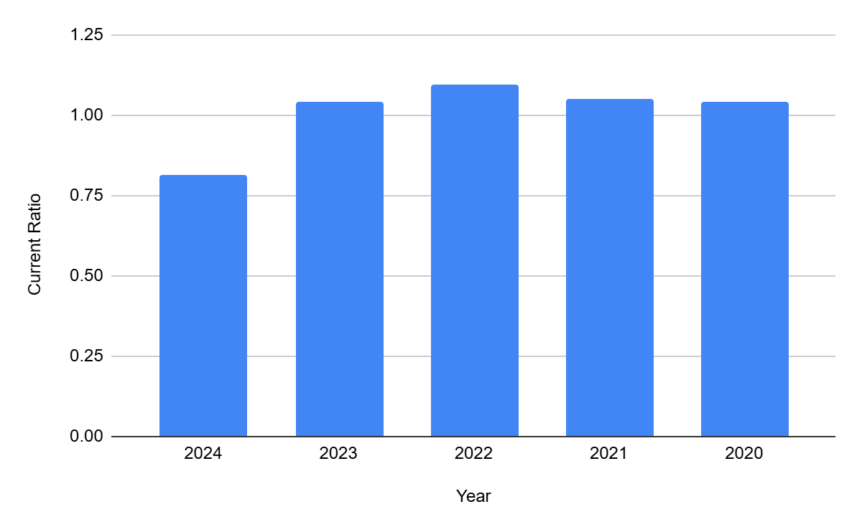
Analysis: From 2020 to 2025, the current ratio of Mutual Trust Bank Ltd shows a statistically significant decreasing trend, as can be seen from the annual observations presented. In 2020, the ratio was more than 1.04, which shows a liquidity position adequate to cover the current obligations; such a slight buffer was maintained in 2021, and the ratio peaked at about 1.10 in 2022, the year with the best short-term solvency in the period under consideration.
However, from 2023, the bank's liquidity declined. The ratio dropped to about 1.04 in 2023 and took a significant dive to 0.82 in 2024, the first time the current liabilities exceeded the current assets (exposing the institution to the risk of short-term solvency). A ratio less than 1.0 is generally considered a warning signal with the potential to put the bank under stress or unexpected withdrawal.
The overall mean current ratio for the 2020-2025 window is just above 1.0, but the trajectory and estimated negative annual growth rate of almost 6 percent point to a continued decline. This pattern serves as an underlined need for vigilance in monitoring without corrective measures such as improved asset-liquidity management or increased liquidity buffer, which can lead to loss of confidence of depositors and investors in the bank.
In summary, while Mutual Trust Bank Ltd started the analyzed period with a strong liquidity profile, the steady decline, especially the significant drop in 2024, indicates that management should focus on liquidity improvements to regain a more flexible short-term financial position.

3.2.2 Loan to Deposit Ratio

Year | Total loan (million) | Total Deposit (million) | Loan to Deposit Ratio
2024 | 300,780 | 328,837 | 0.9146780928
2023 | 261,023 | 262,584 | 0.9940552357
2022 | 253,836 | 232,657 | 1.091031003
2021 | 226,012 | 211,782 | 1.067191735
2020 | 203,744 | 188,732 | 1.07954136

Chart
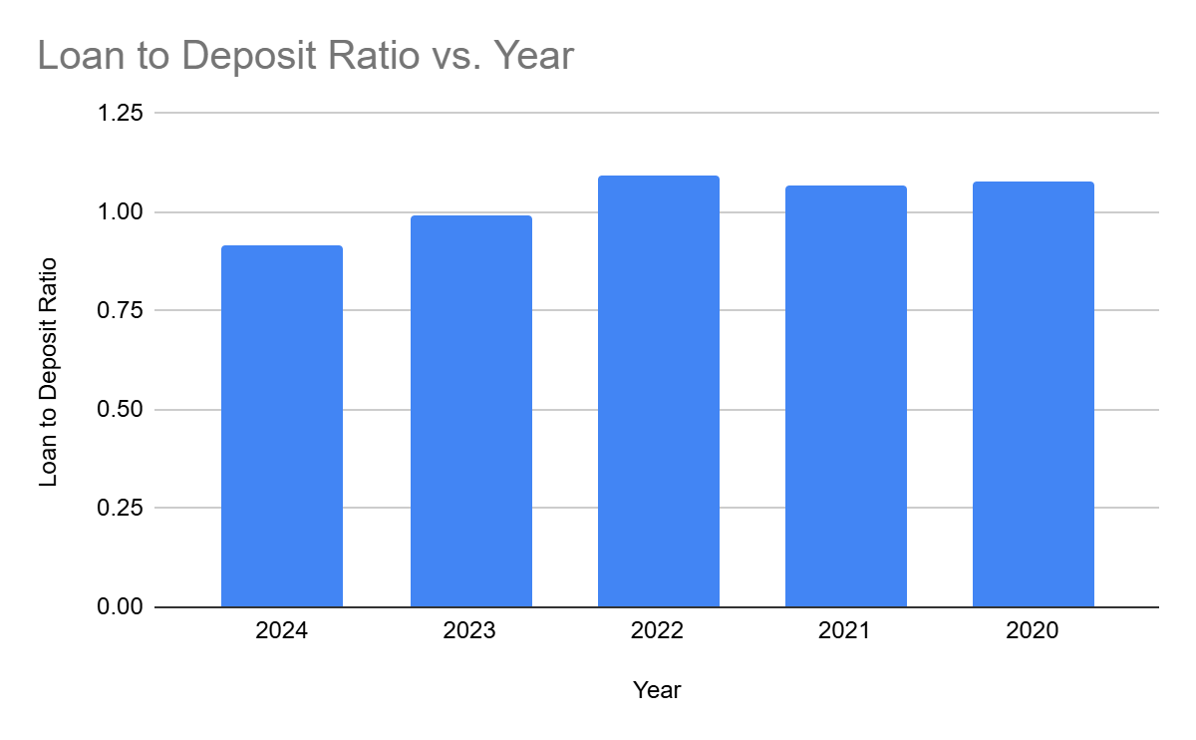
Analysis: From 2020 to 2024, the loan to deposit ratio of Mutual Trust Bank Ltd shows significant changes in the bank's lending and deposit taking activities. In 2020, the ratio was around 1.08, meaning loan issuance was higher than deposit acquisition status and it is an aggressive stance of credit expansion in comparison to the deposit base. This trend, continuing through 2021 and 2022 at a peak of around 1.09, promotes lending-facilitated revenue but at the same time increases liquidity risk if not carefully managed, given the traditional banking practice of keeping a deposit buffer for contingency purposes.
Starting in 2023, there is a marked decrease in the ratio, falling below 1.0, then to 0.91 in 2024. This shift represents a more conservative strategy with the bank holding a larger proportion of deposits as compared to its loan portfolio. Such a change probably has a positive impact on the immediate liquidity position of the institution and to make it compatible with the sectoral trends witnessed in Bangladesh where the loan to deposit ratio has declined to around 77-78 per cent in 2024 as per Bangladesh Bureau of Statistics and regulatory guidance. Bangladeshi regulators usually recommend a prudent ratio of not more than 85 per cent to provide buffers against liquidity shocks and maintain stability of the sector.
The average ratio over the five-year period is about 1.03 with a standard deviation around 0.07 indicating moderate annual volatility. The negative compound annual growth rate of just over -4 per cent further underlines a deliberate moderation in the credit growth vis-a-vis mobilization of deposits. By 2024, Mutual Trust Bank Ltd has a more conservative ratio, which indicates greater vulnerability to deposit withdrawal or liquidity shocks.
Overall, the recent evolution in the loan to deposit ratio reflects the bank's shift towards greater liquidity protection and regulatory compliance, and thereby strengthens depositor confidence, and assures more sustainable growth as the bank balances the lending ambitions with prudent risk management.

3.3 Earning Performance Analysis of Mutual Trust Bank PLC.

3.3.1 Return on Asset (ROA)
A financial measure known as return on assets (ROA) shows a bank's profitability relative to its total assets. Investors can use ROA to assess how well a bank makes use of its resources in order to turn a profit. A company's net income and average assets are often used to quantify the metric as a percentage. While a lower ROA suggests there is space for development, a greater ROA implies a corporation is more productive and effective at managing its financial sheet to create profits. A company's net income is divided by its total assets to determine ROA. It may be written as a formula:
Return on Asset = $\frac{Net income}{Total Asset}$

Year | 2024 | 2023 | 2022 | 2021 | 2020
ROA | 0.77% | 0.79% | 0.72% | 1.03% | 0.37%

Graph:
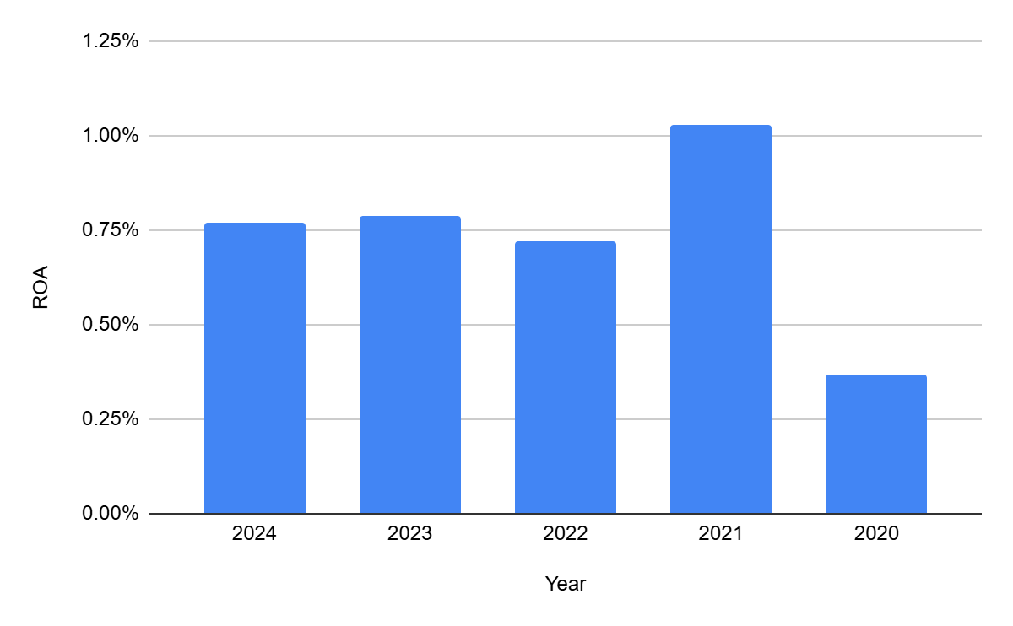
Analyse: Return on assets (ROA) of Mutual Trust Bank Ltd over the period 2020 to 2024 shows an overall positive trend but with some fluctuations. In 2020, the ROA hit its lowest point at 0.37 percent, indicating a relatively low level of profitability compared to total assets. The figure improved significantly in 2021 to 1.03 percent, indicating better utilisation of assets or better earnings, thus making more profits per unit of assets.
Nonetheless, ROA fell to 0.72 per cent in 2022 before stabilising at 0.79 per cent in 2023. In 2024, a slight dip to 0.77 percent followed, which shows a relatively steady but slightly declining trend of profitability in the last two years. The five-year mean of the ROA is about 0.74 percent with a standard deviation of 0.24, indicating moderate variation from year to year. Notably, the compound annual growth rate for ROA between 2020 and 2024 is strongly positive, highlighting significant long term improvement even in the face of short term volatility.
This trend indicates that although Mutual Trust Bank Ltd experienced difficulty in sustaining maximum profit efficiency after 2021, there was a consistent moderate profit level above the minimum levels in history. Looking ahead, the bank could work towards the quality of assets and operational efficiency to recover its peak ROA performance and continue this positive trend.

3.3.2 Return on Equity (ROE)
Return on equity (ROE) is a financial performance metric that divides net income by shareholders' equity. ROE is referred to as the return on net assets as shareholders' equity is equal to a company's assets less its debt. A company's profitability and profit-generating efficiency are measured by ROE. The more successfully management generates revenue and growth from equity funding, the better the ROE. Thus, the following is how the formula is expressed:
Return on Equity = $\frac{Net income}{Total Equity}$

Year | 2024 | 2023 | 2022 | 2021 | 2020
ROE | 12.77% | 12.59% | 11.56% | 16.22% | 5.83%

Graph:
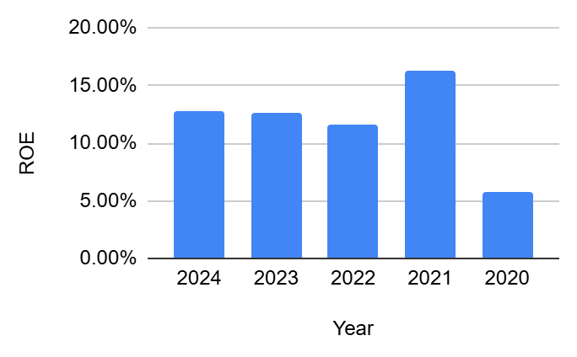
Analysis: The return on equity (ROE) of Mutual Trust Bank Ltd over the period 2020-2024 shows a generally strong trend in performance with some variation from year to year. In 2020, the ROE started at a rather low level of 5.83 percent, which could be indicative of challenges of generating shareholder returns from equity. The bank recovered quickly and reached its peak in 2021 at 16.22% indicating better profitability and capital utilisation, possibly due to enhanced efficiency or good market conditions.
Following 2021, the ROE moderated to fall to 11.56 per cent in 2022, which then stabilised at 12.59 per cent in 2023 and 12.77 per cent in 2024. These levels remain strong by industry norms and signify the bank's continued ability to create significant shareholder value. The 5-year average ROE is around 11.8 percent with a standard deviation of 3.8 percent, indicating that there is some volatility but overall positive movement. In addition, ROE compound annual growth rate from 2020 to 2024 is higher than 21 percent, indicating strong long-term improvement.
This performance suggests that Mutual Trust Bank Ltd has significantly enhanced its ability to use equity to generate profits and recent numbers are indicative of effective management and increasing shareholder confidence. The trend also suggests a healthy return vis-a-vis the cost of equity of the bank, thereby placing the institution in a happy position for future growth and investment.

3.3.3 Operating Profit Margin
The ratio of a bank's operational profit to its sales or revenue is known as operating profit margin, or simply operating margin. Profit margin may be measured in a number of ways, including operating margin. Typically, it is stated as a percentage; the larger the percentage, the more lucrative the bank. The following is an expression of the formula:
Operating Profit Margin = $\frac{Operating profit}{Total revenue}$ x 100

Year | 2024 | 2023 | 2022 | 2021 | 2020
Operating Profit Margin | 28.45% | 26.52% | 27.57% | 26.18% | 16.28%

Graphical Presentation:
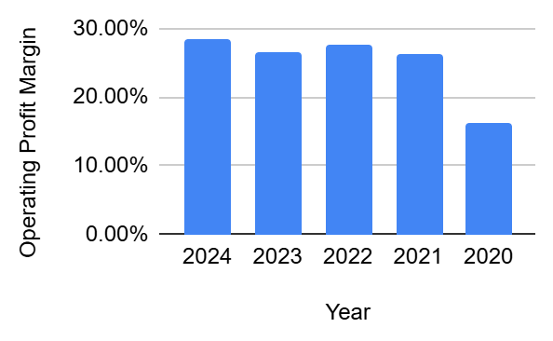
Analysis: Mutual Trust Bank Ltd has shown a strong and positive trend in operating profit margin from 2020 to 2024, indicating positive operational efficiency and profitability. In 2020 the margin was 16.28 per cent, which indicates initial narrowing between revenues and operating costs. Subsequently, the margin increased significantly to 26.18 percent in 2021 and stayed above 26 percent till 2022 and 2023. In 2024, the margin was a peak of 28.45 percent.
On average, in these five years, the operating profit margin was 25 per cent, which can be regarded as a good performance in comparison with many of its peers in the banking sector of Bangladesh, where efficiency improvement has been focused on. The standard deviation of around 5 percent is moderate fluctuation as a result of both external operating conditions and internal efficiency initiatives. Importantly, the compound annual growth rate of the operating profit margin from 2020 to 2024 is almost 15 per cent, indicating ongoing operational improvement and attention to cost control, product mix and balance sheet management.
In 2024, Mutual Trust Bank Ltd reported a 22 percent increase in operating profit, reflecting effective deposit mobilisation, balance sheet management and cost rationalisation in line with favourable industry developments and the bank's strategic priorities. Sector-wise such growth rates are quite notable because some of the Bancs in Bangladesh have achieved high double digits growth of operating profit on robust deposit growth with good loan management. This is a particularly competitive position for the bank to absorb shocks, invest in new products, and create sustainable shareholder value.

3.3.4 Earning Per Share (EPS):
A bank's profit is divided by the number of outstanding shares of its common stock to determine earnings per share, or EPS. A bank's profitability is indicated by the final figure. A bank will frequently report EPS that has been adjusted for unusual events and possible share dilution. A bank is seen as more profitable if its EPS is higher. The EPS formula is:
Operating Profit Margin = $\frac{Net income−Preferred dividend}{Common Share Outstanding}$

Year | 2024 | 2023 | 2022 | 2021 | 2020
EPS (Million) | 3.22 | 2.91 | 2.65 | 3.66 | 1.31

Graphical Presentation:
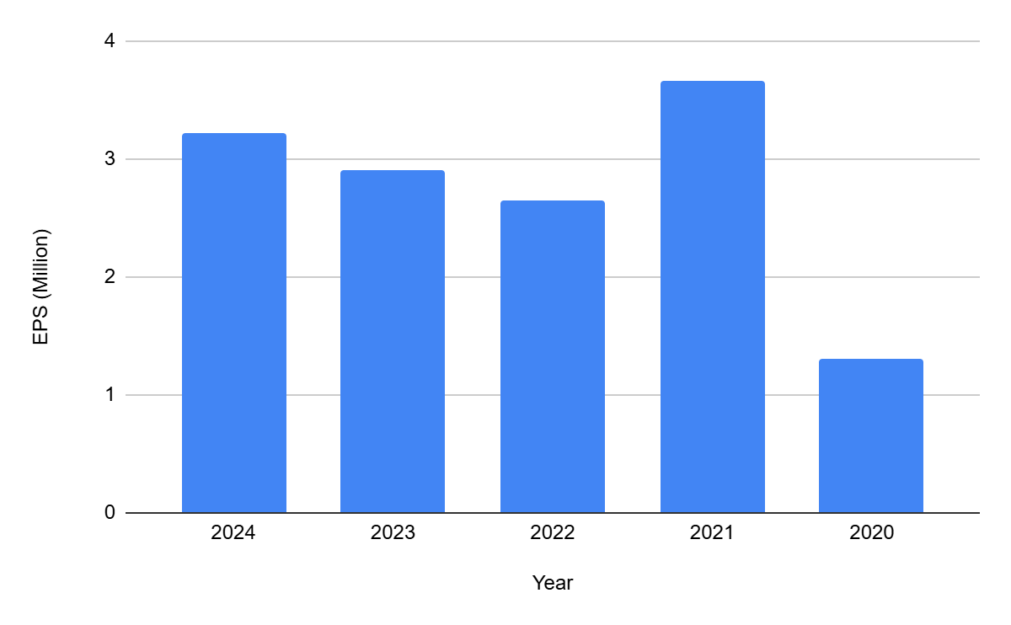
Analysis: Earnings per share (EPS) for Mutual Trust Bank Ltd from 2020 to 2024 - there are periods of significant growth interspersed with temporary setbacks. In 2020, EPS was 1.31 indicating moderate earnings performance per share. Over the next year, the number jumped to 3.66 in 2021, which showed a great improvement in profitability as the net income grew in shares.
In 2022 and 2023, EPS cooled to 2.65 and 2.91, respectively, which could mean that gains experienced in 2021 were not fully sustained, possibly due to changing market conditions, increased competition, or rising costs. By 2024 EPS rebounded at 3.22, showing renewed momentum and the ability to create shareholder value.
Over the five year period, EPS averaged at 2.75, with a standard deviation of 0.89, indicating some volatility but generally positive growth. Significantly, the compound annual growth rate in EPS from 2020 to 2024 is more than 25 percent, indicating the bank's growing ability to generate profit attributable to each share. Such a strong EPS trend is one of the most important indicators of profitability, which is likely to boost investor confidence and contribute to higher market valuation for the bank.

3.3.5 Net Interest Margin (NIM):
The net interest margin (NIM) is a measure of the difference between the interest revenue earned by banks or other financial institutions and the amount of interest paid to their lenders (for example, deposits), in relation to the quantity of their (interest-earning) assets. This ratio looks at how well a company manages its debt condition in relation to its investment choices. Typically, a percentage is used to indicate it. An organization may be operating successfully if its net interest margin is positive; investment inefficiency is implied if it is negative. Below is an expression for the formula:
Net interest margin = $\frac{Interest income−Interest expenses}{Interest Earning Asset or Average earning asset}$

Year | 2024 | 2023 | 2022 | 2021 | 2020
Net Interest Margin | 2.39% | 2.97% | 1.62% | 2.70% | 2.03%

Graphical Presentation:
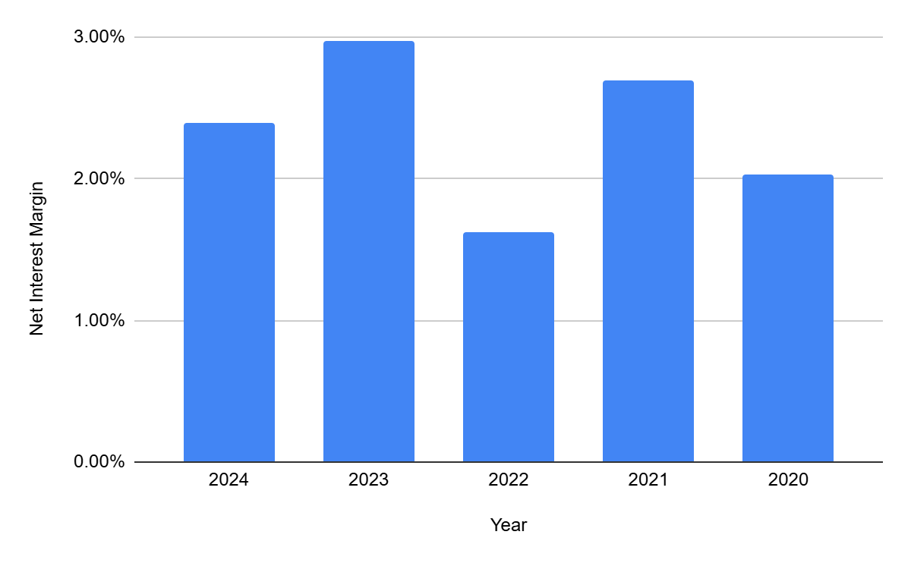
Analysis: Net interest margin (NIM) for Mutual Trust Bank Ltd over the period 2020-2024 shows both highs and lows but an overall upward trend. In 2020, the NIM was 2.03 percent, which means it was moderately efficient at generating net interest income from earning assets. This number improved significantly to 2.70 percent in 2021, indicating successful asset - liability management and possibly stronger lending activity or effective control of deposit costs.
However, the margin has shrunk significantly to 1.62 per cent in 2022, which could be due to compressed lending spreads, increased funding costs, or an increasingly competitive sector. The next year, 2023, a large rebound occurred with the NIM at its highest point at 2.97 percent, and in 2024, the number has settled in at 2.39 percent, which is still higher than the average for the period.
The five-year NIM averaged 2.34 percent with a standard deviation of 0.53, showing some volatility, but also an overall upward direction as a result of a compound annual growth rate of around 4.2 percent. Comparisons within the Bangladeshi banking sector show that a NIM of more than 2 percent is considered healthy for major banks, especially as tighter monetary policies and liquidity conditions have an impact on spreads.
Overall, the trend suggests successful management of both the interest earning and interest paying aspects of the bank's operations, although there are difficulties in achieving optimal levels in each year. Sustained attention to balancing lending activities with efficient resource mobilisation will be key to keeping NIM stable and competitive in the future.

3.3.6 Cost to Income Ratio
The cost-to-income ratio is crucial for assessing a bank's profitability. The ratio provides a clear picture of the bank's operational efficiency; the lower the ratio, the more lucrative the bank. Potential issues are also brought to light by changes in the ratio; if it increases from one quarter to the next, it indicates that expenses are growing faster than revenue. The cost-to-income ratio and the bank's profitability are therefore inversely correlated. These are the formulas:
Cost to income ratio = $\frac{Operating expenses}{Operating income}$x 100

Year | 2024 | 2023 | 2022 | 2021 | 2020
Cost to income ratio | 47.50% | 53.05% | 51.54% | 55.70% | 64.77%

Graphical Presentation:
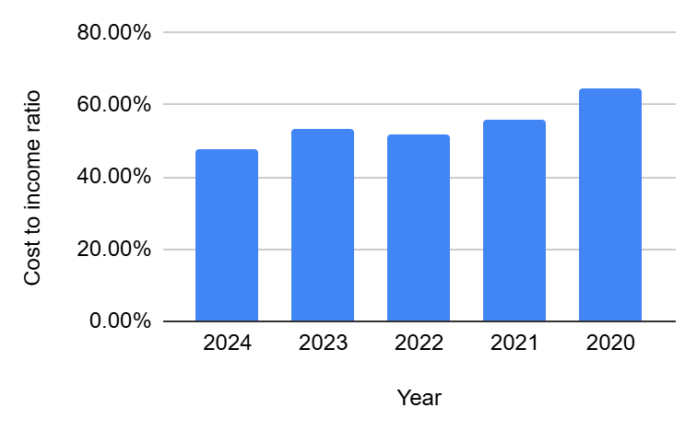

Analysis: The cost to income ratio of Mutual Trust Bank Ltd from 2020 to 2024 shows huge progress in the efficiency of the operations. In 2020, the ratio was found to be 64.77 percent, indicating that a large portion of operating income was consumed by expenses. Over the next few years, the bank has had great success and the ratio has decreased to 55.70 percent in 2021, 51.54 percent in 2022, and 53.05 percent in 2023. In 2024, the ratio was at its optimum level of 47.50 percent, which shows a successful implementation of cost management strategies and incremental income generation in relation to expenses.

On average, the cost to income ratio for the period stands at 54.51 per cent with a standard deviation of about 6.46, indicating moderate variability. The negative compound annual growth rate of about -7.5 per cent confirms that cost efficiency has been steadily improving. Lower cost - to - income ratios are favourable as it implies a greater share of operating income is retained as profit which increases financial resilience and positioning for future growth.

3.3.7 Return on Investment
A performance metric called return on investment (ROI) is used to assess an investment's profitability or efficiency or to compare the effectiveness of several distinct investments. ROI seeks to quantify the return on a certain investment in relation to its cost. ROI is a ratio of either a profit or a loss. The ratio is stated in terms of an investment, where the % change in value is displayed. The ratio is frequently used to calculate the likelihood that a specific investment will result in a profit or a loss. Below is an expression for the formula:
Return on Investment= $\frac{Net income}{Average total equity + Average long term debt.}$

Year | 2024 | 2023 | 2022 | 2021 | 2020
Return on Investment | 11.50% | 8.61% | 7.32% | 8.73% | 9.77%
Graphical Presentation:
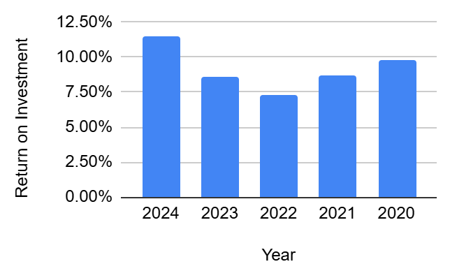
Analysis: ROI for Mutual Trust Bank Ltd in the period 2020 to 2024 shows an overall positive trend in the profitability of investments. In 2020, the ROI was 9.77 percent, which can be considered a good initial position in generating returns from investments. The figure fell slightly in 2021 to 8.73 percent and again to 7.32 percent in 2022, a temporary dip that may have been affected by changes in the market points or adjustments made to asset allocation.
Moving into 2023 and 2024, ROI recovered with a rate of 8.61 percent and a high of 11.50 percent in 2024-the highest over the five-year span. This recovery is an indication of improved efficiency in the deployment and management of investments as well as potentially better market or operational conditions.
The bank's ROI averaged about 9.19 percent during this period, with a standard deviation of 1.56 percent, which is moderate year-to-year variability. Importantly, the compound annual growth rate between 2020 and 2024 is positive at 4.2 percent, reflecting the underlying strength and continuing improvement in investment profitability of the bank. This steady upward trend reflects the increasing capacity of Mutual Trust Bank Ltd to derive higher and higher value from investments in support of long-term sustainability and stakeholder confidence.

3.4 Capital Adequacy Analysis of Mutual Trust Bank PLC.
A bank or other financial institution is obliged by its financial regulator to maintain a certain level of capital, sometimes known as regulatory capital or capital requirement. This is commonly expressed as a capital adequacy ratio of equity that has to be maintained as a percentage of risk-weighted assets. A number of regulations have been put in place to stop these banks from utilizing excessive leverage and failing.

3.4.1 Capital To Risk Weighted Ratio
The ratio of a bank's capital to its risk is called the Capital Adequacy Ratio (CAR), often referred to as the Capital to Risk Weighted Assets Ratio (CRAR). The creation of new branches, new lending in high-risk but profitable regions, hiring personnel, and company diversification through or through specifically designated branches are all examples of how capital adequacy may impact a bank's overall performance. layer one capital, which can withstand losses without requiring a bank to stop trading, and layer two capital, which can withstand losses in the case of a winding-up, therefore offering depositors less protection. Additionally, the capital adequacy ratio assesses the bank's ability to pay its obligations on time as well as other risks including credit and operational risk. In its most basic form, a bank's capital serves as a "cushion" for any losses, safeguarding depositors and other lenders. In order to safeguard depositors and preserve trust in the banking system, banking authorities in the majority of nations define and oversee CAR. The Bangladesh Bank issued a regulation requiring all banks in Bangladesh to fulfill the capital adequacy level of 11.2% after realizing the significance of capital adequacy. The following formulas are provided:
Capital To Risk Weighted Ratio = $\frac{TIER1 Capital + TIER 2 Capital}{Risk weighted Assets}$x 100

Year | 2024 | 2023 | 2022 | 2021 | 2020
Capital To Risk Weighted Ratio | 13.62% | 14.98% | 14.50% | 14.41% | 12.92%

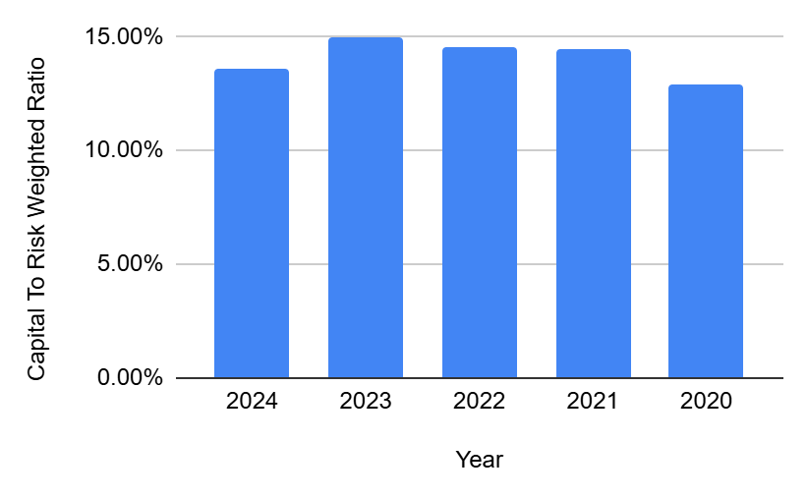
Analysis: The capital to risk - weighted ratio (CRWR) of Mutual Trust Bank Ltd from 2020 to 2024 shows a strong and prudently managed capital position and consistently above the regulatory minimum as mandated by Bangladesh Bank. The CRWR has gone from 12.92 per cent in 2020 to a range of 14.41 per cent to 14.98 per cent between 2021 and 2023, and then fallen slightly to 13.62 per cent in 2024.
Bangladesh Bank's Basel III framework mandates that the banks maintain a minimum CRAR of 10 percent with a regulatory target of 12.50 percent with the inclusion of the capital conservation buffer. Mutual Trust Bank Ltd's performance easily exceeded this benchmark over the period. The CRWR of 13.62 per cent in 2024, with an expanded capital base and a strong growth in loans and advances, attests to compliance with international standards.
Although the 2024 CRAR represents a small decrease from the 2023 peak of 14.98 percent, it is still well above the sector average, which decreased slightly above 3 percent by year-end 2024 as many banks were dealing with deteriorating asset quality and capital shortfalls. By contrast, Mutual Trust Bank Ltd regularly outperformed both regulatory minimums and industry averages, indicating superior risk coverage as well as a resilient balance sheet.
This sound capital position comes from sound capital planning, responsible risk management and earnings retention, thus ensuring continued adherence to global regulatory norms as well as the bank's ability to absorb financial shocks. As a result, depositor confidence is strengthened and the bank is well positioned for future growth.
.

3.5 Asset Management Analysis of Mutual Trust Bank PLC.

3.5.1 Assets Turnover Ratio
The assets turnover ratio is a financial metric that measures how efficiently a company uses its assets to generate sales revenue, calculated by dividing net sales by the average total assets during a given period. The following formulas are provided:
Assets Turnover Ratio = $\frac{Net Sales}{Average Total Assets}$

Year | 2024 | 2023 | 2022 | 2021 | 2020
Assets Turnover Ratio | 9.07% | 8.45% | 8.00% | 7.05% | 8.02%

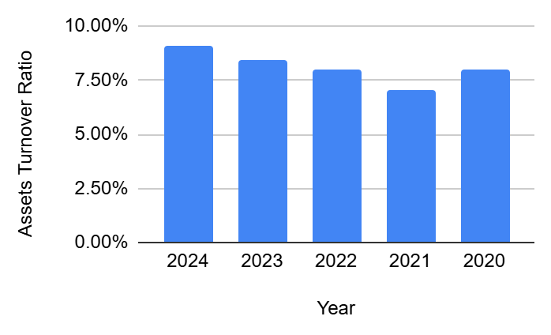
Analysis: The asset turnover ratio of Mutual Trust Bank Ltd from 2020 to 2024 shows effective and gradually improving utilisation of the asset base for revenue generation. The ratio stood at 8.02 percent in 2020, which has marginally decreased to 7.05 percent in 2021, showing temporary decline in revenue-generating efficiency. From 2022 onwards the ratio rose steadily: 8.00 percent in 2022, 8.45 percent in 2023 and reaching a maximum of 9.07 percent in 2024.
The five-year mean asset turnover ratio is 8.12 percent, with a standard deviation of approximately 0.74, which shows a stable and incremental growth. The compound yearly development from 2020 to 2024 is around 3.1 per cent, which underpins a positive long-term development. This upward movement implies better asset management, increased lending/investment activity and better working in recent years.
Within the Bangladeshi banking industry, steady growth in asset turnover ratio is generally taken to be a positive sign of the bank's capacity to convert assets into revenue effectively in a changing industry environment. Mutual Trust Bank Ltd's improvement in this ratio gives confidence to stakeholders that the bank is using its asset portfolio well to support profitability and sustainability of growth.

3.6 Financial risk ratio of Mutual Trust Bank PLC.

3.6.1 Debt Equity Ratio

A financial ratio called the debt-to-equity ratio (D/E) shows how much of a company's assets are financed by debt and shareholders' equity. The two elements are frequently extracted from the statement of financial status or bank balance sheet. The debt-to-equity ratio, or D/E ratio, displays a bank's debt load in relation to its assets. It is calculated by dividing the total debt of a bank by the total equity held by shareholders. High risk is associated with a high debt-to-equity ratio. A high ratio indicates that the bank is borrowing money from other sources to fund its expansion. Because of this, investors and lenders frequently choose the bank with the lower debt-to-equity ratio.
Debt Equity Ratio = $\frac{Total Debt}{Total Shareholder Equity}$

Year | 2024 | 2023 | 2022 | 2021 | 2020
Debt to Equity Ratio | 14.60% | 12.17% | 13.02% | 12.57% | 12.91%

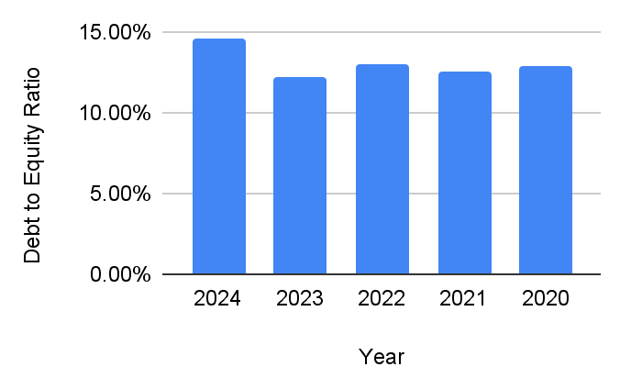
Analysis: The debt - to - equity ratio for Mutual Trust Bank Ltd between 2020 and 2024 shows a relatively stable profile of leverage with a moderate upward trend. In the year 2020, the ratio was 12.91 percent, which means that for every unit of equity that the bank held, they had about 0.13 units of debt. Over the next few years, the ratio has remained fairly stable, ranging from 12.17 per cent in 2023, to 13.02 per cent in 2022, to 12.57 per cent in 2021.

In 2024, the ratio rose noticeably to 14.60 percent which was the highest ratio in the period surveyed. This increase indicates that the bank has increased its debt to equity ratio, possibly to fund asset expansion, lending growth or strategic investments. The five-year mean debt/equity ratio is approximately 13.05 percent with a standard deviation of 0.93, implying low volatility and disciplined capital structure management. The compound annual growth rate of the ratio over the period is around 3.1 per cent, indicating gradual but controlled increases in the financial leverage.

A prudent debt to equity ratio is imperative to balance the risk and growth. Over-leveraging exposes banks to increased financial risk, especially in volatile market environments. The steady increase to 2024 is within a comfortable range for a bank of Mutual Trust Bank Ltd's size and business model, which suggests that the institution is using debt to increase the growth potential of the bank while ensuring that risk is mitigated and the interests of the equity holders are protected.

3.8 Business risk ratio of Mutual Trust Bank PLC.

3.8.1 Financial Leverage
Financial leverage is the percentage change in net profit relative to operating profit, which indicates how sensitive net income is to changes in operating income. The use of debt in bank financing choices is the main source of financial leverage. According to this ratio, earnings will be more erratic the more financial debt there is. This can be problematic when operating income is under pressure, but it is beneficial when operating income is increasing. These are the formulas:
Financial Leverage = $\frac{Operating Income}{Net Income}$
Year | 2024 | 2023 | 2022 | 2021 | 2020
Financial Leverage (times) | 16.61 | 15.91 | 16.11 | 15.70 | 15.80

Graphical Presentation: The change of the financial leverage ratio of Mutual Trust Bank Limited is shown in the graph below-
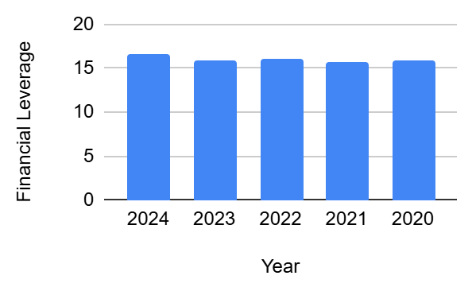
Analysis: The financial leverage ratio of Mutual Trust Bank Ltd from 2020 to 2024 is consistently high and reflects the key role played by borrowed funds in its capital structure. In 2020, this ratio was 15.80* meaning that total assets were close to sixteen times the shareholders' equity. The ratio showed some minor fluctuations but generally trended upwards to reach 15.91 times in 2023, 16.11 times in 2022 and peaks at 16.61 times in 2024.

Across the five-year period, the average financial leverage ratio is around 16.03 times with little volatility as the standard deviation is recorded at only 0.36. A compound annual growth rate of 1.26 percent indicates a steady, slow growth in the reliance on leverage.

High financial leverage is common in the banking industry as part of a business model that depends heavily on deposits and other forms of debt to fund asset expansion and lending operations. Mutual Trust Bank Ltd's consistent high leverage indicates an effective funding strategy and efficient capital utilisation without excessive risk exposure as the bank's capital and risk-weighted ratios have remained robust. This leverage makes it easier to generate revenue and provide shareholder returns but requires careful management of risk to ensure long-term resilience and compliance with regulations.

5.5 SWOT Analysis of Mutual Trust Bank PLC.
- Strengths
- The mutual trust bank plc has a good brand name and customer confidence in the banking industry in Bangladesh as reflected in its ability to maintain a steady deposit and profit growth despite the industry.
- The bank is diversified in its product range (SME financing, retail banking, digital banking, corporate solutions and investment services), and therefore it is not overly susceptible to industry changes.
- It has a broad network of branches and online channels, it has great coverage of service both in urban and rural settings, and it was awarded multiple national and international prizes of innovation and inclusion.
- The management team is qualified and experienced in their fields creating interactive corporate culture, quality decision making, and operational efficiency all of which have led to growth and stability of the bank.
- The great performance metrics, like the return on assets (ROA), high CRAR (capital to risk-weighted asset ratio), and impressive earnings growth, are indicative of good fundamentals.

- Weaknesses
- The bank is facing the issue of high cost of funds partly owing to the stiff competition of customers deposits and overdependence on the term deposits that subject the bank to pressure on the net interest margins.
- Exposure to volatile industries, including garments industry, is high, which exposes it to risk especially during declines in sectors.
- Despite its developmental state, IT infrastructure is one of the spheres that require additional investments so as to keep abreast with the rapid digitalization and demand on consumers to have a seamless banking experience.
- In certain segments, oversight and power delegation might be poor and in certain cases, it leads to delays in decision making and execution.
- In the banking industry, profit margins are still endangered by the increasing operating costs and price competition.
- Opportunities
- The growing financial inclusion and growing middle-income portion of the population mean that Bangladesh has a huge untapped market of banking services, particularly in rural and semi-urban regions.
- The fast adoption of technologies, particularly in fintech and digital banking, can help Mutual Trust Bank PLC increase digital penetration, create new revenue streams, and enhance efficiency.
- Diversification to SME banking, agent banking, and green financing would create new clients and income streams to assist the bank in taking over the market share of unbanked populations.
- Growth lanes are provided by sectoral diversification and innovation in product offerings including digital wallets, mobile banking and more specialized financial services.
- Research partnerships with government initiatives and NGOs along with the international technology providers can hasten the growth and consolidate the bank in the market.

- Threats
- The industry is currently experiencing high competition, both among the established banks and new fintech firms that can eliminate the market share and customer base.
- Any volatility on the macroeconomic front, like an increase in interest rates, currency exchange, and economic downturns, would hamper loan books and dim growth opportunities.
- Operation costs and risks are further increased by regulatory and compliance forces, and growing demands of capital, transparency, and anti-money laundering initiatives.
- Earnings and stability may be jeopardized by the possibility of increasing non-performing loans, particularly as a result of exposure to risky areas.
- Cyber attacks on digital banking services are also security risks that are still a major issue as the services go online.

Chapter-4: Internship Experience

My internship at a bank in Mutual Trust Bank made me know very much about how a bank functions and allowed me to assist in various activities. These are the primary things that I did and learned:
- Supporting Clients Open Accounts:
- Helped clients with the process of account creation and paperwork.
- Explain the numerous types of accounts and services including fixed deposits and savings accounts.
- I managed to enhance my communication skills by talking to clients and helping them to comprehend the services offered by a bank.
- Transaction and funds management:
- Cash deposit, cash withdrawal as well as daily cash reconciliation has been observed and assisted.
- Learned the hard way the importance of handling a transaction involving cash fast and precisely to preserve the integrity and trust of customers.
- Studied the process of teller, which include maintenance of proper records, cash balancing, and fund checking.
- Assisting in Loan Applications:
- Assisted in the documentation checks of different types of loans (business and personal loans) when working with the loan department.
- Knowledge of how the bank evaluates a person to be in a position to get a loan and credit checks.
- Understood the importance of managing loan applications in a reasonable manner in order to reduce banks risks.
- Processing Cheques:
- Verified signatures and cross-examined information as my support to the cheque-clearing process.
- Witnessed how the bank does not miss a step by balancing checks on a daily basis.
- Determine how other financial institutions make payment by checks.
- Compliance-understanding Bank Rules:
- Took part in the training on the most important rules in the banks, including the Know Your Customer (KYC) and the Anti-Money Laundering (AML) principles that are aimed to prevent fraud.
- Learned that banks should adhere to these regulations in order to be safe and secure.
- My understanding of the effects of banking laws on banking activities has been increased.
- Organizing Documents:
- Maintained records and helped in sorting of customer records.
- Obeyed the rules to ensure client information was confidential and secure.
- Developed better my organization skill, which is significant when working with multiple papers.
- Knowing about Digital Banking:
- It was observed that Mutual Trust Bank does offer digital banking, including mobile banking applications and online banking.
- Provide the clients with an opportunity to use digital banking systems to access their accounts and conduct transactions.
- Discovered how technology is enhancing consumers' accessibility and convenience to banking.
- Promoting Internal Audits and Reviews:
- Prepare the records that will be necessary to support the audit team in terms of internal evaluations.
- Noted the audit practices embraced by Mutual Trust Bank to ensure that the bank is accurate, transparent and compliant to the banking regulations.
- Appreciated the importance of regular audits in maintaining integrity of bank operations.
- Team Cooperation and Teamwork:
- Assisted various teams of Mutual Trust Bank regularly with their daily tasks.
- I was able to participate in team meetings to understand the objectives, plans and active projects of the bank.
- Sparked my collaboration and communication skills, which are essential in a working environment that is interdependent.
- Obtaining Feedback and Professional Development:
- Set personal goals to improve on areas such as attention to detail, accuracy of documentation and customer service.
- Mentorship helped me to understand the banking industry, as well as potential professional opportunities within Mutual Trust Bank, in a wider perspective.

This internship experience at Mutual Trust Bank enabled me to have a great experience about the banking industry and it also contributed to the development of my technical and professional skills. It was an excellent learning experience that has prepared me for a career in the field of finance and banking.

Chapter 5: Conclusion AND KEY FACTS

The 5-year analysis of the financial performance of Mutual Trust Bank PLC shows that the bank is a strong and stable organization with significant strengths in terms of profitability, capital adequacy, and operational efficiency. The major financial indicators such as the return of equity, operating profit margins, and the cost-to-income ratios indicate consistent growth and good management behavior. However, the decrease in liquidity indicators, particularly, the current ratio decreasing to less than one in 2024, is an indication that there could be short-term solvency issues that must be resolved. The conservative approach of the bank in terms of loan to deposit ratio though prudent highlights liquidity shock vulnerability. The institution is challenged by the high cost of funds, the exposure of the institution to the volatile industry sectors, and the urgency of upgrading the IT infrastructure to facilitate the current trends of digital banking changes. Nevertheless, there are growth prospects in the financial inclusivity expansion, especially focusing on rural and SME segments, and the further use of innovative banking technologies and diversified products. The threats are still there, such as the heightened competition, macroeconomic volatility, regulatory forces, and the cybersecurity threats, which need to be managed closely and adapted to.

5.1 Recommendations for improving departmental operations
As a way of dealing with the identified challenges and building on strengths, it is advisable that Mutual Trust Bank PLC focus on the enhancement of the liquidity management to guarantee improved financial flexibility in the short term and buffer capacity. They will need to invest in the IT infrastructure upgrades in order to address the increased demands of digital banking and convenience to the customers. Moreover, the risks management practices particularly those relating to areas that are more volatile will be intensified to reduce exposure to unfavorable financial developments. The operational efficiency can also be increased by maximizing the cost-income ratios by implementing a constant improvement of the processes and the control of costs. The bank must also promote product development and increase its reach into rural and SME markets that are yet to be exploited to promote growth and inclusiveness. On the effectiveness of the organization, there can be less time wasted and more responsiveness, which will aid agile operations in a competitive environment by streamlining the decision-making processes and assigning the right powers.

5.2 Key understanding
The most important thing that has been learned in this study is that financial and operational management is essential to the competitive advantage and customer trust in a dynamic banking industry. The change in the strategy of Mutual Trust Bank to more conservative lending patterns and increased liquidity buffers can be seen as a good governance in the face of economic uncertainties and change in regulation. The concept of sustainable growth will rely on the constant improvement processes, product and service innovation, and compliance and regulation with the emerging compliance and regulatory frameworks. The dynamic nature of the banking sector demands agility and responsiveness, particularly in the implementation of new technologies and business models that will suit the emerging customer expectation and market need.

5.3 Conclusion
In general, Mutual Trust Bank PLC is in a good position that has robust financial underpinnings and aggressive management practices. Although the bank is experiencing liquidity stress and sector risk, it has still been able to show strong profitability, strong capital position, and efficiency in its operations. To continue its growth trend and competitive advantage, liquidity management, technology infrastructure, and risk mitigation should be improved with a specific focus. This assessment confirms the bank in its pursuit of balance between profitability and long-term sustainability by responsible banking and innovation. The experience of this internship has given me useful practical knowledge on the operations of the banking sector and financial analysis that has played a significant role in professional development and understanding of the dynamics of institutional financial performance.

Chapter 7: Appendix

References

