Internship Report on
Recruitment and Selection Practices of Meghna Group of Industries

Fahima Sultana

This report is submitted to the school of Business and Economics, United International University as a partial requirement for the degree fulfillment of Bachelor of Business Administration
Internship Report on Recruitment and Selection Practices Of Meghna Group of Industries

Submitted to:
Shayla Khanam
Assistant Professor, School of Business & Economics (SoBE)
United International University

Submitted by:
Fahima Sultana
Id: 111191016
Major: Human Resource Management
Trimester: 251



School Of Business and Economics
United International University

Submission Date: November 24, 2025

Letter Of Transmittal
November 24, 2025
Shayla Khanam
Assistant Professor
School of Business and Economics
United International University
Dhaka-1212
Subject: Submission of Internship Report.
Dear M’aam,
I am glad to inform you that I have completed my internship report on “Recruitment and Selection Practices of Meghna Group of Industries’’. This report is in fulfillment of the requirement for the BBA program at United International University.
The report is the reflection of my internship at HR department in MGI as an intern where I had learnt various HR activities such as intake interview, documentation part and the onboarding session of new employees. Here is to hope I have explained my discoveries in the above as plainly as they can be told.
Thanks for the direction and help. I trust you will find this contention enlightening and worthy of your consideration.
Sincerely,
Fahima Sultana
ID: 111191016
BBA
United International University

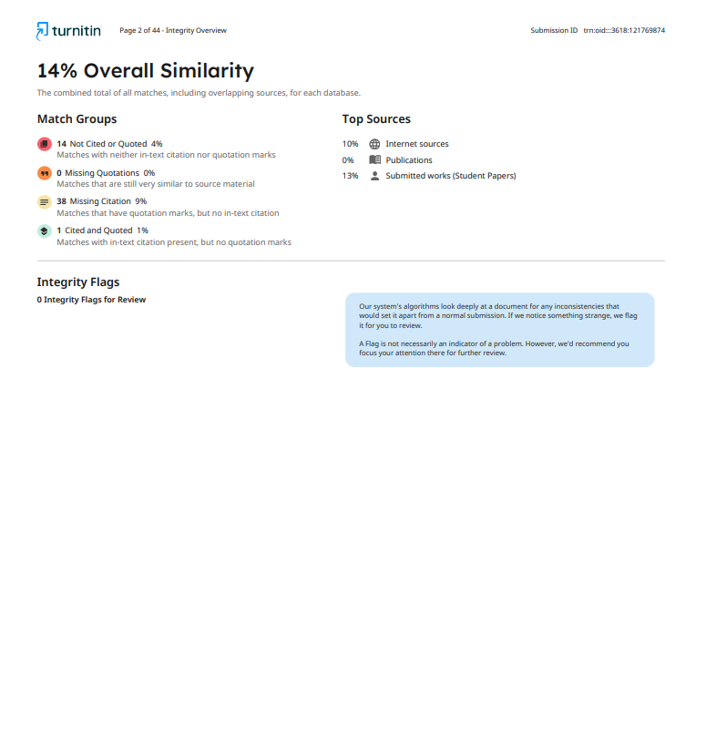
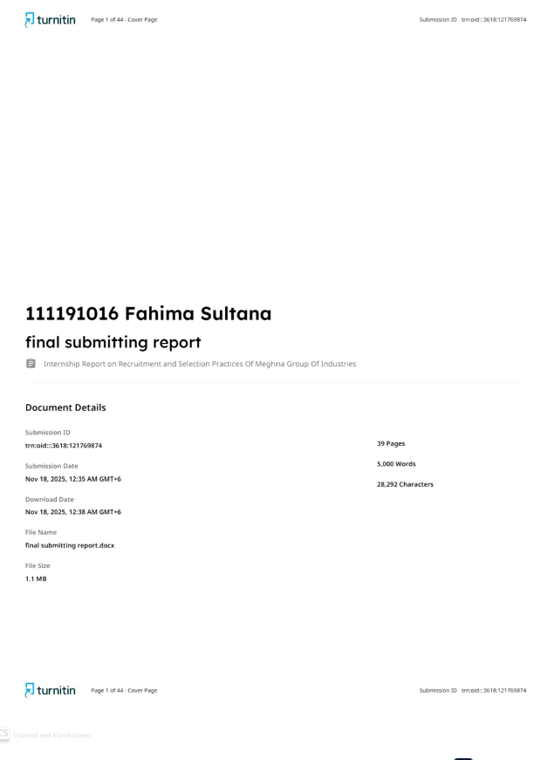
Certification of Similarity Index

Declaration of the Student

I, Fahima Sultana, a student of Bachelor of Business Administration (BBA) at United International University, declare that this internship report titled “Recruitment and Selection Process of Meghna Group of Industries” is my own original and unique work.

The report is made based on my internship experience at Meghna Group of Industries, along with knowledge I gained from my academic studies. It has not been copied from any other source. It has not been submitted elsewhere for academic purposes.

……………………………………………………………………………………………………..
Fahima Sultana
ID: 111191016
BBA Program
United International University.

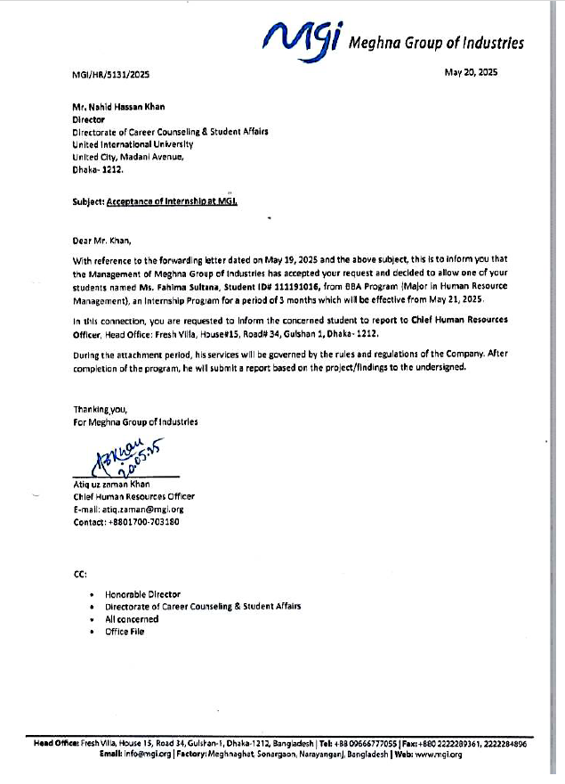
Corporate Evidence

Acknowledgement

First and foremost, I am thankful to Almighty who blessed me with the capability of carrying out my internship and this report.
I am grateful to my internship supervisor at United International University who have advice and guide me to prepare the report. With her assistance I was able to focus and get the work done.
I also owe a great deal of gratitude to the Human Resource Department of Meghna Group of Industries for allowing me to serve as an intern. Had it not been for the cooperation of my intern bosses and fellow HR team members, my internship would not have been fruitful enough and could not have enabled me to discover many of the practical dimensions of HR management.
Lastly, I tried to make less error as possible. As I am a human, error is likely to happen. I would like to consider the errors.

Executive Summary

This report is compiled based on my internship in the Human Resource Department of Meghna Group of Industries (MGI). This report is meant to reflect my learning during my times at United Independent University.
The background, objectives, scope, and limitations are presented in the first part of the report. The second chapter provides an overview of MGI as an organization with its historical background, growth, products, services, and standing ecumenic the industry. The report also provides the company's Strengths, Weaknesses, Opportunities, and Threats.
The third section describes my internship. It details my role and responsibility, which talents I used and how I added value to the department. It is also a testimony to the education, direction, and guidance I received, which taught me to communicate better, manage and organize my time better.
At last, I end the report with my own views and suggestions. Overall, I gained practical experience of human resource management for the first time as this being my first internship.
Table of Contents
Letter Of Transmittal I
Certification of Similarity Index II
Declaration of the Student III
Corporate Evidence IV
Acknowledgement V
Executive Summary VI
INTRODUCTION 1
1.1 Background of the Report 2
1.2 Objective of the Report 3
1.3 Rationale of the Report 4
1.4 Scope and Limitation of the report 5
1.5 Definition of Key Terms: 6
Company and Industry profile 7
2.1 Company analysis: 8
2.1.1 Overview and History: 8
2.1.2 Trend and Growth: 9
2.1.3 Product / Service / customer mix: 10
2.1.4 Company Operations: 13
2.1.5 SWOT Analysis: 14
2.2 Industry Analysis: 16
2.2.1 Specification of the Industry: 16
2.2.2 Size, Trend and Maturity of the industry: 17
2.2.3 Industry SWOT analysis: 18
Internship Experience 19
3.1 Recruitment and Selection Process of MGI: 20
3.2 Position, Duties and Responsibilities 23
3.3 Training & Development 23
3.4 Contribution to Organizations / Operations 23
3.5 Evaluation 24
3.6 Skills Applied 24
Conclusion and Key Facts 25
4.1 Recommendation 26
4.2 Key Understanding 27
4.3 Conclusion 28
References 29

CHAPTER ONE

INTRODUCTION

1.1 Background of the Report

As a part of the academic program of the Bachelor of Business Administration (BBA) degree at United International University, this report is based on my internship at Meghna Group of Industries (MGI). I worked in the Human Resource Department and supported various activities related to the working field as recruitment, documentation, data entry, etc. This report will describe the vast importance of Human Resource Department and the major influence it puts on Meghna Group of Industries, a well-known company having a great leadership in the country.

1.2 Objective of the Report

The main objectives of this report will be focusing on my work in the Human Resource Department and how it influences the company’s working order. Following are the objectives that this report will focus on-
i. To gain practical experience in supporting recruitment and onboarding processes like candidate shortlisting and document preparation.
ii. To enhance communication and coordination by interacting with candidates and HR team members.
iii. To understand and participate in HR administrative task as attendance tracking, file management and manpower planning.

1.3 Rationale of the Report

The internship allowed me to observe how real business activities work and let me apply my academic learning in a corporate setting. MGI, known as a massive and reputable group, provided a great platform to learn, inspect how a large organization handle recruitment, employee relation with the company, logistics, marketing, daily operation and so on. This report serves as both an academic and personal reflection of my experience as an intern.

1.4 Scope and Limitation of the report

Scope:
This report covers my working experience at MGI, with a focus on the operations of the department I was assigned to. It also includes an overview of the company and industry context.
Limitations:
i. Due to confidentiality, some internal data could not be included.
ii. The internship duration was limited, so observations may not cover every detail.
iii. The report is based on my personal experience, which might be subjective.

1.5 Definition of Key Terms:

- HRM (Human Resource Management): The process of managing people in an organization through recruitment, development, retention, and compliance with labor laws.
- Recruitment: The process of attracting and selecting suitable candidates for employment.
- Onboarding: The process of integrating new employees into the organization by familiarizing them with policies, culture, and expectations.
- Manpower Planning: Estimating the future human resource requirements of an organization and planning accordingly.
- FMCG (Fast-Moving Consumer Goods): Products with high demand and quick turnover such as food, beverages, and personal care items.

CHAPTER TWO

Company and Industry profile

2.1 Company analysis:

2.1.1 Overview and History:

Back in 1976, Meghna Group of Industries (MGI) began its journey as a modest trading company named Kamal Trading Company, founded by Mostafa Kamal—an entrepreneur with big ideas and strong business instincts. The walk of this company started mainly focusing on trading but as time went this company evolved into one of Bangladesh’s most powerful industrial business. In 1989, the group changed its fortune by stepping into manufacturing, launching Meghna Vegetable Oil Industries Limited at Meghnaghat, Narayanganj. Today, nearly five decades later, MGI owns and operates more than 50 large industrial units across a wide spectrum of sectors—ranging from FMCG and cement to shipping, insurance, aviation, and even media. MGI has a great contribution significantly to the country’s economy, generating around $3 billion in annual revenue and over 50000 workers are working under its structure. Its well-known brands—like "Fresh," "No.1," and "Actifit"—have become household names across Bangladesh, found in everything from kitchens to bathrooms in millions of homes. MGI has expanded their presence in markets like Middle East, Southeast Asia, Europe, and Africa. Their excellent decision on development of industrial zones such as the Meghna Economic Zone helped them to have smooth operations and reduced logistics costs. Importantly, while growing its business, MGI hasn’t ignored its social responsibilities—it’s invested heavily in education, healthcare, and community development, reinforcing its reputation not just as an industry leader, but as a company that cares and is operating successfully its services/products with 100% customer satisfaction.

2.1.2 Trend and Growth:

MGI's growth has been described as regular. The company invested $300 million to set up eight manufacturing units at the Meghna Economic Zone in 2018 and $451 million to set up nine more in 2020. Annual turnover for the group is now $3.0 billion. Other sources have described an annual turnover of $2.5 billion which would also represent growth over previous years. In 2023-24, MGI topped the billion-dollar club of export-import activities in Bangladesh, with $3.21 billion in transactions, including $2.64 billion in imports and $165 million in exports. In 2023, the group entered the ceramics industry by setting up a bricks and tiles manufacturing unit at the SAEZ Special Economic Zone. MGI has expressed interest in entering the sustainable steel industry. The company signed a deal with the International Finance Corporation (IFC) in 2023 to set up Bangladesh's first climate-smart steel plant. The group's diversification and financial growth reflect its resilience against global economic challenges, including the post-2022 Ukraine war and currency volatility. In December 24, MGIs Tanveer Dal Mil & Flour Mills Secured a USD 20 million ADB financing to build an energy efficient flour milling plant. MGI collaborated with the IFC (International Finance Corporation) to develop Bangladesh’s first climate smart, green steel mill via Meghna rerolling & steel Mills (MRSL) with aimed to cover 20%of national steel demand while reducing carbon emissions. In late 2025, MGI shows resilient baseline revenue with growth driven by soy based and energy-efficient flour processing, large scale green steel, Hospitality via MGI tower which is also known as Grand Hyatt and last but not the least its infrastructure presence continuously growing specially in economic zones and industrial units which is making MGI unstoppable.

2.1.3 Product / Service / customer mix:

MGI has worked over a lot of industrial products, consumer products and services. Some of them include:

Fast-Moving Consumer Goods (FMCG): This includes sugar, edible oils, milk, spices, personal care products (like soaps, shampoos), and household goods under brands like "Fresh," "No.1," "Actifit," and "Pure." These products were made to target daily consumer needs and have a strong presence in Bangladeshi households with products- Atta, Moida, Suji, Salt, sugar, tea, Mineral water, condense milk, toiletries. Fresh’s products go through strict quality checks in ISO-certified factories. Hygiene and food safety are maintained through automated packaging and good quality manufacturing units. MGI uses economic of scale to offer better products at affordable prices. This pricing strategy attracts both urban and rural consumers. Extensive supply chain and logistics ensures product availability even in remote villages-its tamperproof packaging keeps products fresh and increases shelf life, competitor’s often fail to maintain such consistent availability which helps FMCG stand out on supermarket shelves compared to locally available other brands.

Industrial Products:
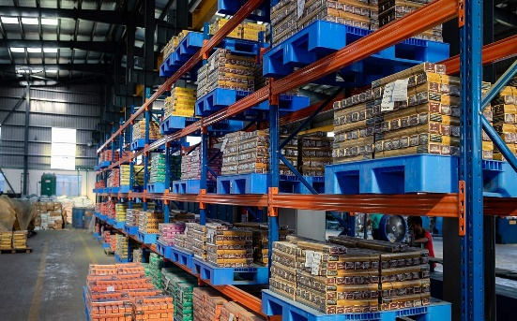
The group has a well production of cement (Fresh Cement, Meghnacem Deluxe), chemicals (Tasnim Chemical Complex), steel (Sonargaon Steel Fabricate), ceramics (Fresh Ceramics), and PVC products (Meghna PVC Limited), serving construction and manufacturing industries. MGI source import raw materials, in house power generation, factory production and inland transportation and logistics thus minimizes delays, cuts costs, and ensures consistent quality. Sonargaon Steel Fabricate Ltd. And Fresh Steel have a monthly capacity of thousands of metric tons of rods, bullets and fabrication structures. MGI operates its own Meghna Industrial Economic Zone (MIEZ) for centralize operations, support industrial scale production without external dependency. Its cement, steel, and chemicals are regularly used in bridges, roads, and highways, power plants, and refineries. Government and private sector projects prefer MGI due to consistent supply and durable quality.
Services:

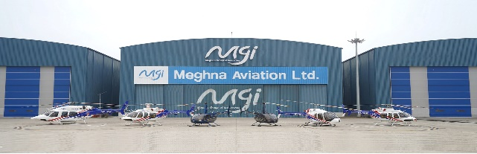
MGI also has their presence in insurance (Bangladesh National Insurance Company Limited), securities (Dhaka Securities Limited), shipping (Mercantile Shipping Lines), aviation (Meghna Aviation), and media (Ekattor Television).

Power Energy:
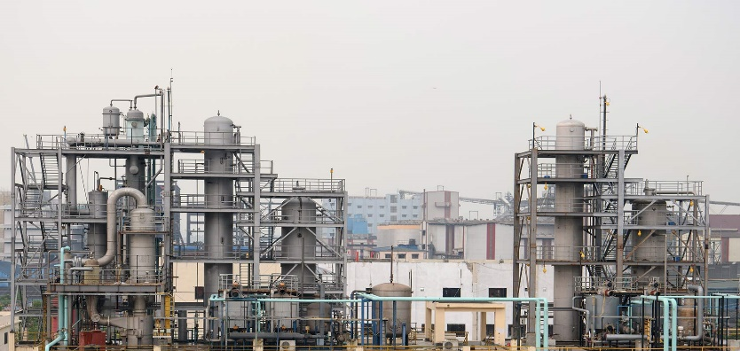
MGI generating Plants HFO and energy infrastructure support by invested in green factories, solar energy, waste management, and ETPs. That’s why many global buyers prefer MGI over competitors due to its sustainability initiatives.

Customer Mix:
Businesses and Industries: Cement and steel cater has attracted construction companies, real estate developers, and manufacturers.
International Markets: MGI exports food products, chemicals, and cement to countries like the Middle East, Southeast Asia, Europe, and beyond, directing that they have a growing global customer base.

2.1.4 Company Operations:
MGI’s operates over 54 industrial units. All of these are located on its economic zones. The zones are Meghna Economic Zone, Meghna Industrial Economic Zone, and Cumilla Economic Zone providing a strategic advantage. It does centralize manufacturing and logistics which reduce costs and increase efficiency. MGI has their own in-house logistics and shipping capabilities, including MGI Transport and Logistics and Mercantile Shipping Lines (operating vessels like MV Meghna Princess and MV Meghna Adventure, each with a 62,500-tonne capacity) which ensure control over its supply chain, from raw material procurement to product distribution. MGI’s HR Department plays a pivotal role in recruiting, managing, and retaining employees by mass recruitment for factory and logistics, skilled hiring for engineering, executive, IT & administrative positions. MGI also take interns in different departments for grooming future professionals. If casual employees perform outstanding, then he/she becomes permanent. MGI’s export operations are handled by a dedicated division that manages compliance with international quality standards. Product packaging and custom clearance and shipment coordination- Each department ensures smooth internal workflows, compliance, and innovation in different sectors which not only ensures effective business practices of the company but also helps boost Bangladesh’s image in the global market.

2.1.5 SWOT Analysis:
Strengths:
i. MGI runs many types of businesses, like FMCG, cement, chemicals, and services, which helps reduce risks.
ii. The company benefits from large-scale operations by having 54 industrial units and around 50,000 employees.
iii. Its brands have peoples trust and reach about half of the households in Bangladesh.
iv. They have their own logistics and shipping which reduce costs and improve efficiency.
v. The company has strong financial backing, earning about $3 billion annually, allowing it to invest in new projects.
Weaknesses:
i. Running many different businesses can create coordination and management challenges.
ii. MGI relies mostly on the global market, which makes it vulnerable to economic ups and downs in Bangladesh.
iii. As a large company, it may face delays in decision-making due to internal bureaucracy.
iv. Some employee reviews mention issues like high staff turnover and poor work-life balance.
Opportunities:
i. They have rising demand in both cities and rural areas offers a chance to grow further in the domestic market.
ii. Using modern tech like automation and e-commerce can improve operations and customer reach.

Threats:
i. Economic issues like inflation, currency drops, or global crises can raise costs and lower profits.
ii. MGI faces tough competition from local companies like Pran and Akij, as well as global brands like Unilever and Nestlé.
iii. Sudden changes in government rules or trade policies might disrupt its business.
iv. The company depends on importing many raw materials, which can be risky if global supply chains are disrupted.

2.2 Industry Analysis:

2.2.1 Specification of the Industry:
The FMCG industry in Bangladesh sell products people use every day, like food (biscuits, milk, soft drinks, cooking oils), personal care items (soaps, shampoos, cosmetics), and household goods (detergents, disinfectants), with high sales but small profits because of big competition. Local companies like MGI, Pran, and Akij, and international ones like Unilever, Nestlé, and Procter & Gamble, work hard to meet demand from over 170 million people, especially the growing middle class and city dwellers who like branded products. These products are sold in traditional shops, supermarkets, and online platforms, as e-commerce grow fast due to changing lifestyles. This industry is very important for Bangladesh’s economy because people spend a lot on these goods, making up a big part of GDP, and the rise of digital platforms help FMCG grow even more.

2.2.2 Size, Trend and Maturity of the industry:
Size:
The FMCG sector in Bangladesh was worth about 3.9 billion dollars in 2021–22 and grew to an estimated 4 billion dollars by 2023.
The personal care segment alone was valued at over 1 billion dollars in 2020 and is expected to reach 2 billion dollars by 2027, thanks to increased consumer spending.
Trends:
FMCG is one of the fastest-growing industries in the country, with a projected CAGR of 16.18% between 2022 and 2027.
Growth is fueled by a rising middle class which is expected to reach 34 million dollar by 2025 as well as more people living in cities (39% urban population in 2023).
Maturity:
The industry is moderately mature, with many well-known local and international brands.
Local companies like MGI enjoy strong brand loyalty, while multinationals bring in global strategies and innovation.
The use of digital marketing, online sales, and organized retail is helping the sector grow faster.
However, rural areas, home to over 60% of the population, still have low FMCG penetration, leaving room for further growth.

2.2.3 Industry SWOT analysis:
Strengths
- Bangladesh have over 170 million people, and growing middle class mean high demand for FMCG products.
- Strong Spending: Over 66% of GDP come from consumer spending, which keep sales steady.
- Local and international brands compete, thus leaving them to make better products and innovate more.
- Tax benefits and economic zones support industry to grow fast.
Weaknesses
- Many raw materials like palm oil and chemicals come from other countries thus affecting price changes
- Poor roads and transport make it harder to deliver products, especially in rural places.
Opportunities
- Many rural areas don’t have much FMCG products, but people there have more money now, so it’s big chance.
- Internet and smartphone use (45% in 2023) grow fast, so e-commerce is getting bigger.
- As people earn more, they want branded and high-quality items.
- Export Chance: More demand from South Asia and Middle East open doors for export.
Threats
- High inflation (9.5% in 2023) and weaker currency make goods costly and reduce.

chapter three

Internship Experience

3.1 Recruitment and Selection Process of MGI

MGI basically does recruiting in two structured ways- i) Internal Recruiting, ii) External Recruiting.
For Internal Recruiting-
- DGM informs HR department about the job vacancy. Then the employees examine whether the internal employees are capable or not for the post by reviewing their honesty, sincerity, their past and current performance in the organization.
- Then HR post about the vacancy through g-mail, Mgi’s website etc. Interested employees can apply if they think they are capable for the post.
- After employees applies for the post HR head (mainly GM, DGM, CHRO) review their performances, skills, attendance at the office. If they satisfied with employee’s background then they move forward otherwise they refuse to give the post.
- Shortlisted candidates interviewed by HR heads and senior HR employees like assistant manager via written tests or technical assessments depending on the position.
- After getting selected (either in promotion, transfer, or job rotation) employees are given workshop/training of their new post about 1 week by HR heads and senior employees if the employees in HR department, and if in different department, the managers (for the selected department) along with HR heads gives training the selected candidate/candidates for a week.
- After completing the workshop, the employees are congratulated via their new team members and HR for his/her/their achievement. They don’t given official onboarding process as they already know about the company policy, rules and guidelines rather they are provided brief idea about new role responsibilities, short-term and long-term goals, and computer skills necessary in the workshop/training.

For External Training-
1. Job Posting Information:
The Deputy General Manager (DGM) gives adequate information on the job, needed qualifications, and job specifications.
2. Job Posting:
The HR team (HR Executive, Senior HR Executive, Assistant Manager) gathers details from the DGM and advertises on job boards such as LinkedIn and bdjobs.
3. CV Screening & Interview:
- The CVs are filtered through the HR department once the job is posted.
- Once a CV is suitable for the position, the candidate is called for an interview.
- Shortlisted candidates are approached first through WhatsApp or email to let them know that they have been shortlisted for the interview.
- Subsequently, an offer letter is dispatched to chosen candidates via email, along with instructions to report with educational certificates, a National ID copy, and photographs.
4. Interview Process:
Interview is done in two modes: Online and Offline.
- Google Meet Interviews: Organized for junior-level positions such as Dealer, MIG Welder, Helper, Filling Man, Personal Assistant through Google Meet.
- Offline Interviews: Performed for senior-level roles (e.g., Sales Executive, HR Executive, Manager, Assistant Manager, Finance Executive, Route In-Charge) in face-to-face. These interviews assess the candidate's communication skills, confidence level, nervousness, and computer literacy, as these roles call for more efficient and confident individuals.

5. Onboarding:
- While onboarding, the documents of the recruit are gathered and kept in a file.
- They submit the Provident Fund application form and then have lunch.
- They sign the appointment letter after lunch, and the candidate checks the details including name, address, post, salary, and father's name.
6. Induction & Training:
- At 3:00 PM, the induction begins, where new joiners are introduced to the company (MGI) and their role.
- They start training the next day.

3.2 Position, Duties, and Responsibilities:

During my internship, I worked as an HR Intern in the Human Resource Department. My works were about:
- To prepare files for new hires and coordinate the onboarding process.
- To prepare offer and appointment letters.
- To manage employee files and verifying documents.
- To maintain employee data in Excel. (Data Entry and Exposure Sheet).
- Contacted shortlisted candidates via messages-calls and e-mails.
I also communicated with candidates regarding interview schedules and document submissions.

3.3 Training & Development

There was no official induction process, I learnt on-the-job and shadowed by HR managers. I learned about documentation file, recruitment methodology, professional way of communication and about the HR software. This hands-on experience gave me a practical sense of how an HR department operates in a real business environment.

3.4 Contribution to Organization / Operations

I was able to take off some burden from their shoulders, especially when it comes to recruitment paperwork, data updating and employee datacenter. I ensured timely communication with candidates and proper file management to facilitate efficient HR functions. My work contributed to streamline HR tasks and processes and my work helped in improving efficiency in handling routine HR tasks.

3.5 Evaluation

I carried out my work with commitment and efficiency during the course of the internship. They liked that I was on time, talked well, picked up fast. I had gained the ability to be flexible under new assignments, working under pressure of time and respect to HR confidentiality. The team had a positive evaluation of my performance in general.

3.6 Skills Applied

MS Excel & Word: For data entry, formatting, and document creation.
Communication: Verbal and email communication with candidates and team members.
Teamwork: Communicated with the HR department to make daily objectives.
Organization: Maintained files and data in a systematic way.
Time Management: Completed multiple tasks within tight deadlines.

Chapter Four

Conclusion And Key Facts

4.1 Recommendation
During my internship at Meghna Group of Industries, I saw good implementation of several strengths in the HR department. However, I also noticed some areas can be improved so that it could enhance both the recruitment process and the overall intern experience. Based on my learning and observations, I would like to suggest the following recommendations:
- After interviews, the candidates should get a mail about the outcome whether they get selected or not. In general, candidates are told that they will be contacted in future but if they are rejected, there is no confirmation, and the candidate must assume about rejection after a period of time which actually waste their time and increase tension. If this direct outcome is provided, it will help in better communication, reduce stress, and shows respect to their time and effort.
- A brief orientation can be done about the company policies, HR departments working strategy, employee’s responsibility. It can help the interns to understand the whole situation and to work better.
- MGI can do social branding about how they manage their fields like HR department. This helps to have a better image to young generation and get more brand recognition.
- Regular training programs can be done to sharpen the skills of employees and their knowledge. It will help them to realize their responsibility along with boosting morale.

4.2 Key Understanding

My internship at the Meghna Group of Industry was an exciting experience to bridge conceptual learning from classroom teaching to the practical learning of corporate world. I also learned an important lesson; HR is more than administration of some paperwork or having people hired, it is about managing people with care, treating them with respect and professionalism.” I realized that even small HR activities such as communication on time or record-keeping can have a large impact on the reputation of the firm and the satisfaction of employees.
It also taught me that recruiting is hard and delicate work. Right from screening candidates and getting in touch with them for interviews to shortlisting and hiring, every aspect should be done with precision and professionalism. Yet a breakdown in communication or an honest error in documentation can breed confusion, and frustration – even a negative impression. This taught me that HR professionals must always remain calm since they are the front line for the company and prospective staff.
Another valuable lesson I learned is the power of working as a team. There are no individuals in isolation within the HR team, every activity that the department works on, whether it is maintaining filing, writing letters, or arranging interviews, is undertaken in co-ordination with others. I witnessed how my peers and managers back each other up, and how to run the process more smoothly with good communication in the team. It was a great lesson in how submission + patience is as important, if not more so, in the workplace as technical aptitude.

4.3 Conclusion

The internship at Meghna Group of Industries was one of the most rewarding experiences of my academic and professional journey so far. Here I directly applied the theories I learned in my BBA and watched how they fit in a real corporate environment. HR Department provided me the experience of realizing how crucial it is to manage people, to shape organizational culture, and to make sure of the smooth functioning of such a big group like MGI.
My work here was to help in recruitment, documentation, candidate communication, and employee record management. These helped me to gain control over my accuracy, attention to detail in HR operations. I experienced how trivial a small mistake can be doing any of these, disrupting the workflow. I worked with supervisors and team members, which helped to improve my communication skills.
I was able to observe MGI’s organizational structure and how it runs all operations. Being one of the largest tycoons in Bangladesh, MGI have control across multiple industries. HR department must come forward for maintaining this vast workforce of over 50,000 employees. I have witnessed how HRs are struggling and how they organize to face all this harshness. I believe this internship also helped me to have patience, to be disciplined and to manage my time well under pressure. I remember that I had to do a lot at the same time, and it taught me how to handle to keep details correctly, and to always do attend of what must be done. I also learned how to think on my feet in a fast-paced environment, which I think will be a huge advantage in my future career.
This internship has helped me know what I wanted to do in my life. I believe HR is the area in which I want career development. I am grateful to my mentors and colleagues at MGI who guided me through this.

References

- Glassdoor. (2022). Meghna Group of Industries reviews. Retrieved from https://www.glassdoor.com/Reviews/Meghna-Group-of-Industries-Reviews-E874383.htm
- International Finance Corporation (IFC). (2024). IFC and Meghna Group partner to build Bangladesh’s first climate-smart steel plant. Retrieved from https://www.ifc.org/en/pressroom/2024/ifc-and-meghna-group-partner-to-build-bangladesh-s-first-climate-smart-steel-plant-driving-economic-growth-and-sustainability
- Invest Bangladesh. (n.d.). FMCG industry in Bangladesh. Retrieved from https://investbangladesh.co/fmcg/
- LightCastle Partners. (2019). FMCG in Bangladesh: An overview. Retrieved from https://lightcastlepartners.com/insights/2019/07/fmcg-bangladesh/
- Meghna Group of Industries. (n.d.). Official website. Retrieved from https://www.mgi.org/
- Prothom Alo. (2024). Meghna Group tops billion-dollar club in export-import activities. Retrieved from https://en.prothomalo.com/business/local/6jk1aggimq
- Sokrio. (n.d.). FMCG companies chase growth in the rural markets of Bangladesh. Retrieved from https://www.sokrio.com/fmcg-companies-chase-growth-in-the-rural-markets-of-bangladesh/
- The Business Standard. (2023). Despite economic pressure, FMCG industry still has room to grow. Retrieved from https://www.tbsnews.net/supplement/despite-economic-pressure-fmcg-industry-still-has-room-grow-980941
- Wikipedia. (2025). Meghna Group of Industries. Retrieved from https://en.wikipedia.org/wiki/Meghna_Group_of_Industries

