

An Internship Report
On
Management of Payroll Digitization Services of bKash

Submitted by Name: Tamanna Ferdous
ID No: 111181157

Submitted to

Mr. Muhammad Hasan Al-Mamun,

Assistant Professor,

School of Business and Economics,

United International University
Date of submission: January 28, 2023

ii

An Internship Report

On

Management of Payroll Digitization Services of bKash

LETTER OF TRANSMITTAL

January 28, 2023

Mr. Muhammad Hasan Al Mamun,
Assistant Professor, School of Business and Economics, United International University

Subject: Management of Payroll Digitization Services of bKash

Dear Sir,

It is a privilege for me to present my internship report entitled "Management of Payroll Digitization Services of bKash " The report was written using information obtained during my internship at bKash Limited and theoretical knowledge gained from my academic studies. As far as I am concerned, the report has all credible and valid facts and does not contain any manufactured materials or narratives about the business. I genuinely hope that your approval and admiration of my report will inspire me to conduct more of this type of work in the future.

Sincerely Yours,

Tamanna Ferdous

ID: 111-181-157

BBA Program

School of Business and Economics

United International University (UIU)

STUDENT’S DECLARATION

I am a student of Bachelor of Business Administration (BBA) program, United International University, hereby declare that this particular internship report has been formulated on an Internship Report on- Challenges of Payroll digitization.
In accord to the applicable guidelines, I hereby submit my internship report and announce that –

-The report has been prepared for academic purpose only.
-This has been formulated with all reliable and valid information
- This report does not contain any confidential or destructive information about the organization.
-This report does not represent any fabricated information or fictional narratives
- This report has not been submitted previously for any degree, neither fully nor partially.

Tamanna Ferdous

ID: 111-181-157

BBA Program

School of Business and Economics

United International University (UIU)

ACKNOWLEDGEMENT

I am ecstatic to have the opportunity to express my heartfelt gratitude to everyone who helped me prepare this report, whether directly or indirectly.
First and foremost, all the praises go to Almighty Allah for keeping me fit enough to finish the report in time. Then I'd like to express my gratitude to my parents for their unwavering supports. Following that, I'd want to express my gratitude to my respected academic supervisor for his unwavering supports and enthusiastic cooperation during the internship period. I couldn't have completed this paper without his assistance and instruction.
I am grateful to ‘S.M. Khaled Bin Halim, General Manager, Payroll Business, Commercial Division, bKash Limited’ for his outstanding assistance and cooperation during the tenure.
I am also grateful to ‘Riad Mahmud, Senior Executive, Payroll Business, Commercial Division bKash Limited’. He was my reporting supervisor and mentor,
Lastly I want to thank and show my heartiest gratitude to all the people who directly and indirectly helped me to complete this report successfully.

EXECUTIVE SUMMARY

Payroll business is the digitalized solution of salary disbursement procedure that adds a whole new value to the people concerned with the process. This report consists of background of the company, the payroll business and their salary disbursement procedure, and the efforts directed to the better management of these payroll services in the context of bKash.

The report has been developed for portraying the overall experience gathered during the completion of the internship program in Payroll Business, Commercial Division, bKash Limited. The whole report has been divided into nine Chapters. Each chapters of the report adds value to the report and makes the whole report a meaningful one.

The bKash Payroll business process and operations were created with the goal of changing the lifestyle of lower-level workers or employees and thereby accelerating their living standards. However, among well-known organizations, this payroll service has become one of the most sought-after wage disbursement services. Hence the market is growing tremendously. The vision behind the payroll business solution is not just disbursing salaries but bringing the changes in the lifestyles of workers.

It is to be believed that the whole economy will be shifted into digitization within no time meaning that people will rely more into e-money transactions; e-wallet will be heavily used rather than cash transaction. So here, bKash is providing the opportunity to lower-middle class people to have the experience of cashless economy and facilitating their payroll engagements.

Keywords: Payroll Digitization, bKash

TABLE OF CONTENTS

Contents | Page No.
Chapter 1: Introduction | 1-4
1.0 Introduction……………………………………………………………………. | 02  02  02  03  03  04  04
1.1 Background……………………………………………………………………. | 02  02  02  03  03  04  04
1.2 Scope of the Report……………………………………………………………. | 02  02  02  03  03  04  04
1.3 Statement of the Problem………………………………………………………. | 02  02  02  03  03  04  04
1.4 Justification of the Report………………………………………………………. | 02  02  02  03  03  04  04
1.5 Objectives of the Report………………………………………………………... | 02  02  02  03  03  04  04
1.6 Limitations of the Report………………………………………………………. | 02  02  02  03  03  04  04
Chapter 2: Methodology | 05-06
2.1 Research Design……………………………………………………….............. | 05  05  06  06  06
2.2 Data Collection Method………………………………………………………. | 05  05  06  06  06
2.3 Sources of Data Collection……………………………………………………. | 05  05  06  06  06
2.3.1 Primary sources……………………………………………………………… | 05  05  06  06  06
2.3.2 Secondary sources…………………………………………………………… | 05  05  06  06  06
Chapter 3: Literature Review | 07-09
- Emergence of Mobile Financial Services……………………………………  - A drastic shift from traditional service………………………………………  - Payroll Business (Payroll service provider) …………………………………. | 08  09  09
Chapter 4: Industry Analysis | 10-14
4.1 The rise of MFS industry in Bangladesh………………………………………. | 11
4.2 Players in the market …….……………………………………………………. | 12
4.3 Market Competitors……………………………………………………………. | 13
Chapter 5: Organizational Synopsis …………………………………………. | 15-22
Chapter 6: Internship Role & Responsibilities……………………………. | 23-26
Chapter 7: Payroll Business Operations of bKash Limited……………. | 27-30
Chapter 8: Challenges of digitization…………………………………………. | 31-37
Chapter 9: Recommendations & Conclusions……………………………. | 38-40
References…………………………………………………………………………. | 41-42

CHAPTER 1 INTRODUCTION

Introduction

The purpose of the internship report is to reflect the experiences from the tasks performed during the internship. The aim is to ensure that different talents are acquired during the internship while developing the learning outcomes. I did my internship at bKash Limited in the business department of payroll. Trading acts as the life blood of a business as it grows the business and expands its customer base by generating cash. If a business area is divided into two functional areas, one for B2C business development and the other for B2B business development. The B2B business development department works to build relationships with corporate offices to expand the customer base. Salary payment solution is one of the most promising offerings of bKash Limited as it has developed a digital solution for various businesses for digital payment of salaries. Working in this field has given me the opportunity to develop various skills that will be useful in my future career. In addition to the acquired skills, I tried to apply my knowledge within the organization. The activities I did during my internship encouraged me to improve my existing skills and develop new skills that benefited both my personal and professional development.

Background

Bangladesh is one of the most populous countries in the world. In recent years, population growth has increased the demand for all goods and services. So banking is simpler than most people think. Banking should not be restricted by certain income limits but should be accessible to all. This will help Bangladesh's economy grow much more than expected as private and public investments increase. bKash paid business processes and operations are initiated to change the lifestyle of workers or lower level employees to improve their standard of living. But this payroll business has become one of the most desirable payroll services among reputable companies in all industries. This report includes a brief scenario of how bKash has changed the financial services industry and an in-depth analysis of the features that the payroll
Department offers to the market.

Scope of the Report

Mobile financial services, also known as mobile banking, are the newest banking services. This revolutionary breakthrough changed the way banking works and made it possible to do business anywhere, anytime. The MFS industry is a great new revolution in the country's economy, so the scope of research is very wide. However, the scope of this report is limited to basic payroll functions and general overview of bKash Limited.

Problem identification

For Corporate & Manufacturing employees and RMG workers, salary payment remained a manual process. The main issue is that most employees are quite resistant to maintain e-wallet transaction-based activities since they consider it to be a difficult duty. This is where bKash`s automated payroll solution entered the market to replace the manual procedure and make daily financial transactions, such as sending money and purchasing necessities, easier.
As the whole economy is moving towards digitization. bKash payroll solution is the platform by which you can enter into the digitization economic zone. Payroll provides you the solution through e-money transaction. Because by Payroll Business solution, bKash can serve below the poverty line or lower-middle class consumers. Not only that bKash is serving, but also, they (consumers) are enrolled into the economy system. By acquiring this service, they are opting for a long-term sustainable solution. The main motto of digitization is having a cashless economy for a sustainable future & Payroll Business is helping by providing the service.
Now, what could be the issue here? The issue here is having resistance of consumers changing the payment method from cash(manual) to this e-wallet. Because banking system is very old and comfortable method for years. But it is only matter of time when e-money transaction will be the only reliable method to adapt.

Justification of the Report
The Internship report is made completely based on the personal experience while working at bKash Limited. To make the report more resourceful and fruitful information’s are taken from

various websites, previous research papers, News Paper articles, blogs and personal interviews of few executives of bKash limited working on the Payroll Business, Commercial Division. 1.5 Objectives of the Report This report seeks to accomplish two sorts of objectives: primary and secondary objectives. The main objectives are the topics that the report should cover and the secondary objectives are the presentation of results, suggestions and recommendations at the end of the report so that the objectives are integrated with practical and theoretical knowledge.

Key Objectives

Critically analyze the operations of the payroll business, Business Sector, Bkash Limited and complete the mandatory internal reporting requirements for the Bachelor of Business Administration (BBA) degree.

Secondary Objectives

♣ Provide an overview of the MFS industry in Bangladesh
♣ Critically examine market development and wage opportunities.
♣ Discussion on MFS market expansion considering customer demand.
♣Discussion about changes in the way of life of workers through salary offer bKash.

1.5 Limitations of the Report

Despite the immense support from the supervisor, there were some limitations that I encountered while preparing the report. How- - MFS is considered a very competitive market, therefore most information is highly confidential and cannot be released outside the organization. Therefore, there were some limitations in the preparation and review of report. - Three work months are not enough to describe the duties of the entire department, so the report focuses entirely on the Payroll Business Department of the Business Department.

CHAPTER 2 METHODOLOGY

Report Structure & Design

Qualitative descriptive method was used in the preparation of this report. This method includes observing their work procedures, analyzing their operational and field activities, reviewing their performance records, and conducting informal interviews with department personnel. The format of the report conforms to the guidelines of my academic supervisor, Mr. Muhammad Hassan Al- Mamun, Assistant Professor, School of Business and Economics, United International University.

Data Collection Method:

Direct research of articles, documents, operational processes and various personnel has helped to gather relevant information for this study. This method has helped in real time situation as I was present in the work station. No formal questionnaire was used.

Sources of Data Collection

The data used in this report is obtained from both primary and secondary sources. They are listed below:

    - Primary sources
Personal observation: Personal observation was used for most of the analysis and decision making. Interviews with managers: To better understand the scenarios, I conducted some short interviews with the managers of my department.

Secondary sources

- Supervisor's supporting documents.
- Various websites that publish articles on MFS activities.
- Previous research was conducted on bKash Limited.
- Official website of bKash Limited.

CHAPTER 3 LITERATURE REVIEW

Emergence of Mobile Financial Services (MFS)

The "Charter for Change" aims to achieve "Digital Bangladesh" by 2021. (Mazumdar and Akhirahs 2020). In 2011, the Bangladesh Bank approved the Mobile Services (MFS) licenses among other government initiatives to realize the ideal of "Digital Bangladesh" (Kumar, 2021). Dutch Bangla Bank Limited was the first to offer mobile financial services in Bangladesh, launched on March 31, 2011 with the help of two telecom operators, Banglalink and City cell, and Sybase 365 software. (Akhter and Khalili, 2017). In July 2011, bKash, a subsidiary of BRAC Bank, became the second bank in Bangladesh to enter the MFS market. It was started as a joint venture between BRAC Bank Limited of Bangladesh and Money in Motion LLC of the United States (Islam and Hussain, 2018). After a long evaluation and special approval for MFS, on September 22, 2011, the Central Bank of Bangladesh released regulatory standards for MFS: "Guidelines for Mobile Financial Services (MFS) for Banks". It was changed again in December of the same year (Sultana, 2014). Later in 2018, Bangladesh Bank released the Bangladesh Mobile Financial Services (MFS) Regulations, 2018.

A drastic shift from Traditional Banking to Mobile Banking Service:

bKash Limited is currently the market leader in Bangladesh with a 48 percent MFS market share. BRAC Bank Limited operates bKash, a joint venture between BRAC Bank Limited of Bangladesh and Money in Motion LLC of the United States. The International Finance Corporation (IFC) joined as an equity partner in 2013, and the Bill & Melinda Gates Foundation began investing in 2014. (Islam & Hossain, 2018). In 2018, Alipay, a subsidiary of Alibaba Group, became the company's first foreign investor (Kumar, 2021). bKash now has a network of over 200,000 agents in urban and rural Bangladesh with over 50 million verified accounts.

Payroll Business (Payroll Service Provider):

A payroll service provider assists or assumes all parts of payroll on behalf of another organization. Employers who value their time and want to ensure that their employees and taxes are paid correctly and on time can often benefit from this arrangement.
When considering how a payroll service provider might assist them avoid costly tax penalties, business owners may save money in some circumstances. Another facet of payroll service is that many payroll service providers also handle employee gratuities and deposits. Aside from that, some of them provide administrative support, analyze employee tax obligations, and prepare paperwork for submission to the National Board of Revenue (NBR).
Another benefit of using a payroll service is that it is accurate and up to date on recent legislative changes; this is because they strive to execute their job correctly in order to retain a long-term relationship with the employer. Expert payroll service providers may also ensure that foreign enterprises comply with Bangladesh's regulations and taxation legislation.
The administration of the monetary record of employees' salaries, wages, bonuses, net pay, and deductions is referred to as payroll management. Regardless of the number of employees they employ, associate degree leaders should keep all payroll tax documents.

CHAPTER 4 INDUSTRY ANALYSIS

The Rise of MFS Industry in Bangladesh:

MFS is altering the traditional money transaction method, and it has gained widespread acceptance in a short period of time due to its affordability and secure medium of transaction. Since its establishment, a tech-savvy populace, mobile connectivity, and internet penetration have all contributed to the MFS sector's positive expansion. The number of registered MFS customers surpassed 10.27 crore in July 2021. In the last four years, it has increased by 159%. In July, the total number of MFS transactions was 32.64 crore. Bangladesh has made significant progress in improving financial inclusion in recent years. MFS has also taken an active role as a significant driver. In 2013, 20% of people were financially included.
Retail e-commerce has been increasing at a rate of 72 percent per month on average since January 2020, and is expected to reach TK 25,500 crore by 2023, thanks to the MFS platform's convenient digital payment gateway and increased internet penetration. Going cashless has numerous local and macro benefits. It not only makes life easier, but it also lowers the cost of producing paper cash. For long years, digital payments have been steadily increasing in Bangladesh, assisting the country in increasing revenue collection.

Players in the Market:

Serial No. | Name of the Mobile Financial Service (MFS) | Name of Bank Providing MFS
1 | bKash | Brac Bank Limited
2 | Rocket | Dutch Bangla Bank limited
3 | mCash | Islami Bank Bangladesh Limited
4 | MY Cash | Merchantile Bank Limited
5 | T cash | Trust Bank Limited
6 | FirstPay Sure Cash | First Security Islami Bank Limited
7 | U Cash | United Commercial bank Limited
8 | OK wallet | One bank Limited
9 | Sure cash | Rupali bank limited

10 | TeleCash | Southeast Bank Limited
11 | BCB Sure Cash | Bangladesh Commerce Bank Limited
12 | Jamuna Bank Sure Cash | Jamuna Bank Limited
13 | Islamic Wallet | Al-Arafah Islami Bank Limited
14 | Spot Cash | Standard Bank Limited
15 | Tap’ n Pay | Meghna Bank Limited
16 | Sonali e wallet | Sonali Bank Limited
17 | Hello | Bank Asia Limited
18 | Nagad | Bangladesh Post Office

Monthly transaction volume grew by more than 50% year on year to Tk 62,230 crore in August 2021, up from Taka 41,403 crore the previous month, according to Bangladesh Bank statistics. The Economist released a widely circulated article in 2017 saying that data had surpassed oil as the world's most valuable resource. A digital economy's raw material is data. MFS is one of the most important sources of financial data in Bangladesh.

Current Market Share Distribution among the top MFS companies:



bK as

Figure: Current Market Share of Top MFS companies
Source: Bangladesh Bank MFS comparative summary statement of September and October, 2021.

According to experts and industry insiders, the number of mobile financial services (MFS) transactions in the country is growing due to the convenience of fast payment for goods and moving money anywhere in the country. In January 2022, mobile banking transactions climbed by Tk 2210.8 crores, or

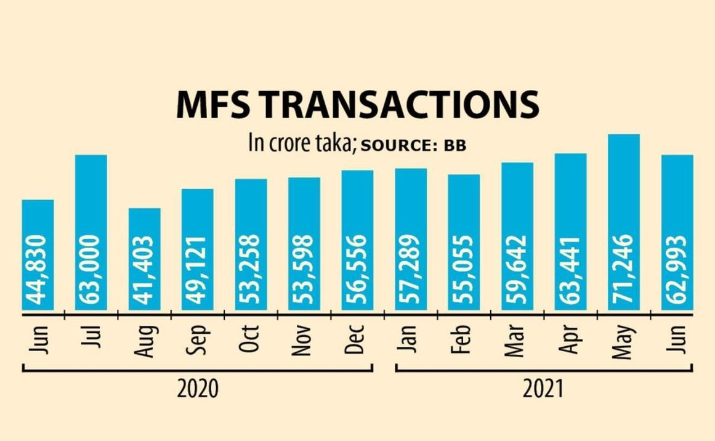

Source: https://www.thedailystar.net/business/economy/news/mfs-transactions-the- charts-2152546

3.11 percent, from December 2021 to Tk73393.3 crores, according to Bangladesh Bank (BB) data. When compared to the same period the previous year, mobile banking transactions climbed by Tk99663.3 crores, or 26.63 percent.

Mobile financial services (MFS) transactions reached Tk 77,022 crore, an all-time high, in March 2022, clocking a 13 per cent increase compared to February and a 29 per cent rise than last year’s March.
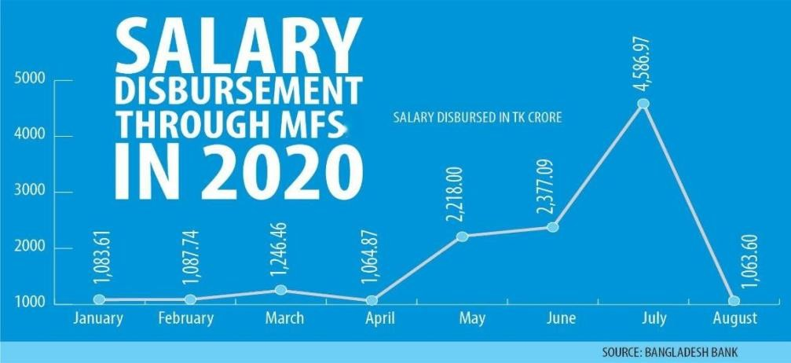

Besides, salary disbursements through MFS rose by 5 per cent to Tk 2,878 crore, utility bill payments by
22.6 per cent to Tk 1,232 crore, and talk time purchases by 12.4 per cent to Tk 694 crore that month.

CHAPTER 5 ORGANISATIONAL SYNOPSIS



  - The Journey of bKash:

bKash Limited is Bangladesh's major mobile financial service (MFS) provider, operating under Bangladesh Bank's license and approval. As a subsidiary of BRAC Bank Ltd, the company has been conducting business. The unbanked, banked, and underbanked people of the country are served by bKash with a comprehensive range of services that can help them become financially inclusive. bKash's key services include quick and fast money transfers and payments.
bKash began its journey in 2010 as a joint venture between BRAC Bank and Money in Motion LLC. The organization was founded by two groups from opposite regions of the world, one from Bangladesh and the other from the United States, with the goal of creating a financially inclusive ecosystem for all of the country's citizens.

Other significant corporations began to participate in bKash over time, resulting in a pool of six investors who are now bKash equity holders. In 2018, the group of investors included the International Finance Corporation, the Bill and Melinda Gates Foundation, and Ant Financial (Ali Pay). Softbank is the most recent investor to join bKash's pool of equity holders, having contributed a total of $200 million to make bKash Limited the country's first "Unicorn Startup." bKash Limited strives to provide a diverse range of financial services to Bangladeshis while also making financial transactions more convenient. The group focuses on developing an ecosystem for low-income people who do not have constant access to banks. The purpose of bKash Limited is to provide convenient and accessible financial transaction options to the country's populace.

Vision: bKash aspires to be a global trendsetter in financial inclusion, and a contributor in enriching people’s lives through alternative platforms.

Mission: To be the most preferred financial service provider for all walks of life by providing affordable and innovative service for empowering lives.

Divisional overview:

The organizational chart of bKash limited ensures a swift flow of communication from bottom to top. bKash follows an open culture that empowers the employees to communicate conveniently without any barriers. These grants access to the employees in the lower level of the organization to have direct communication with the upper management easily. bKash has several divisions conducting different operations.



CXO
Executive Vice President &
Vice President
General Manager
Deputy General Manager
Manag
Assistant Manager
Senior Officer
Officer
  - Corporate Organogram: The HR Hierarchy of bKash limited is shown below-

C

Board of Directors:

Mr. Shameran Abed
Chairman (Nominee Director of BRAC Bank Limited)
Mr. Ryan Gilbert
Nominee Director of BRAC Bank Limited
Mr. Selim Reza Farhad Hussain
Nominee Director of BRAC Bank Limited
Mr. Meheriar M. Hasan
Nominee Director of BRAC Bank Limited
Mr. Asif Saleh
Nominee Director of BRAC Bank Limited
Ms. Fahima Choudhury
Nominee Director of BRAC Bank Limited
Mr. Nicholas Hughes
Nominee Director of Money in Motion LLC
Mr. Shinya Yoshino
Nominee Director of International Finance Corporation - IFC
Mr. Guoming Cheng
Nominee Director of Alipay Singapore E-Commerce Private Limited
Mr. Jason Park
Nominee Director of SVF II Beam (DE) LLC
Mr. Chris Lee
Nominee Director of SVF II Beam (DE) LLC
Ms. Anita Ghazi Rahman
Director
Mr. Douglas Feagin, Director
Mr. Dr. Jamaluddin Ahmed, FCA ,Director

  - Products and Services:
There are various products and services that bKash provide to its customers and local businesses. These services are discussed below:

Add Money:

The add money feature helps the end user to add money to the users account. A user can add money via bKash agents. On the other hand, money can be added via:
    - Bank to bKash: Right now, money can be added from 13 local banks to bKash via internet banking. The banks are: Standard Chartered, City Bank, Dhaka Bank Ltd, Midland Bank, Social Islami Bank Limited, Jamuna bank, Brac Bank, Bank Asia, Mutual Trust Bank, South Bangla Agriculture and Commercial Bank Ltd, Eastern bank Limited, NRBC Bank, First Security Islami bank Limited.
      - Mastered Card to bKash: A bKash customer with an account can add money from Mastered Card issued by Banks/financial institutions in Bangladesh without any charge or fee for transactions.
      - Visa Card to bKash: bKash introduced the service to add money from Visa cards issued in Bangladesh without any charge for users who are willing to add money to the bKash account.

Transfer Money:

Money can be transferred to selective banks via bKash. This reduces the physical availability to the Banks and eliminates further process.

Pay Bill:

bKash introduced this service to make banking activities accessible and to make the process easier to make life simple. Drawing inspiration from this vision, bKash incorporated the bill paying option. With the help of “Bill Pay” a user can pay:
  - Electric bills
  - Gas bills

  - Internet Bills
  - Cable TV Bills
  - Water Bills

Cash in and Cash Out:

Cash in and cash out from a user’s account can be made from any bKash agent and selective Bank ATM’s across the country. Right now, there are 140,000 active bKash agents in the country and expanding rapidly.

Send Money:

Any bKash user can send money to other bKash users at any time. On the other hand, a new service has been introduced recently where a bKash user can send money to non-bKash users. In this regard the non- bKash user needs to register the number to get the money.

Payment:

Apart from the catering personal account of users, bKash is also catering the local business by providing merchant account so that the business can receive payments easily and automatically transfer in their bank accounts. The payment process is secured and safe for Merchants. With the help of payments any bKash users can pay for shopping and services. Another type of payment is education payments, with the help of education payments students can easily pay to their respective educational institutions without any hassle and from any parts of Bangladesh.

Mobile Recharge:

One of the services bKash provides is mobile recharge. Any bKash users as well as bKash agents can recharge any number as fast as possible. This eliminated error of numbers while recharging.

Remittances:

According to Bangladesh Bank, any Bangladeshi’s living in abroad can send money through international remittance to any bKash user in Bangladesh. The remittance can be sent from authorized and enlisted Foreign Bank, Money Transfer Organizations and

Exchange Houses. This process is quick, simple and error fee as bKash ensures secured transfer process.

Donations:

Recently, the whole world is devastated by Covid-19. This deadly virus also affected our country. Due to the lockdown imposed by the Government, it was hard for the non-profit organizations to collect donations. With the help of bKash, these organizations started taking donations from people via bKash and the response was immense. This service helped to pave a way for these organizations to collect donations easily and use the donations in time of need.

- DPS: From the bKash App's 'Savings' function, one can simply start a Savings scheme with a financial institution for any reason. The monthly deposit will be withdrawn automatically from your bKash Account, and at maturity, you will get the complete maturity amount (including interest) in your bKash Account. One can also Cash Out the matured amount free of charge.

- Tickets: Users can purchase bus, train and movie tickets via bKash app instantly.

Interest on Savings:

Just like the Saving account in a traditional banking environment, bKash along with keeping the money safe also provides up to 4% interest (per annum) on savings. This provides the similar banking services to mobile banking users who are saving money on their account. So, these are the products and services that bKash is offering to its customer base. More services and products are getting introduced from time to time making the life of the customer easier.

CHAPTER 6
INTERNSHIP ROLE & RESPONSIBILITIES

Position, Duties & responsibilities:

As part of my academic requirements, I performed a three-month internship with the Payroll Business Department of the Commercial Division in bKash. Throughout the three months, I was responsible for a variety of responsibilities and activities in several departments. My responsibilities were not restricted to one function inside the department; rather, I was responsible for doing several tasks at various times. The major tasks performed are-

KYC Management & QC:

As part of the internship program, recurring duties were done. The supervisor usually handed on new and unique activities and tasks. However, several of the activities were repeatable and required effective completion. I was able to gain abilities that helped me understand and accomplish these jobs efficiently over the course of my internship program, which lasted three months. One of the most crucial things in opening a disbursement account is KYC management and quality control. The KYC form is the sole one that includes all of the company's and signatory's information for the newly opened disbursement account. The first page (included in the appendix) has all of the pertinent information. The documents that are required for opening an institutional account with bKash include the following:
- Trade License of the Institution
- Memorandum and Article of Association
- Certificate of Incorporation
- Board Resolution
- TIN Certificate of Institution
- National ID card of the applicant
- Photo of the Applicant
- Declaration of Personal Details of the Applicant

Preparing Monthly Operational Reports:

At the end of month, it was mandatory to submit the operational reports which would contain all the operational activities of Payroll Business. This helped to keep the management updated about the activities of the departments across the Commercial Division of bKash. The duty focused on collecting information from co-workers about the operational activities conducted throughout the month. A typical report would contain the following information:

-Numbers of newly on boarded clients in the past week,

-Number of letters of Interest (LOI) received from clients in the past week,

-Different promotional activities conducted in different factories and other sites of the clients,

-Updated progress on the running projects (if any).
-All this information was collected from the co-workers and compiled in one PowerPoint presentation file following the preset. The PowerPoint file is submitted to the management for further evaluation of the operational activities of Payroll Business.

Making Presentation Slides

Throughout my internship, I was required to create various PowerPoint presentations that would be delivered to various employees. These presentations were developed for both internal and external audiences.
  - Market Alignment Data Sheet: A market alignment data sheet is generated before any major salary disbursement within the region to ensure seamless flow of liquid money in the market (to bKash agents).

Receiving Gifts and Inventory Management:

One of the more interesting responsibilities I had was to manage the gifting inventory for kept for the higher officials. During the first week, a database was created to keep track of

the present goods. Every time a KAM removed a gift item from the inventory, it was recorded in the database, which then calculated the number of gifts still available in the inventory.

Visiting Existing and New Clients:

One of the most significant objectives of my internship in the Commercial Division was to visit clients and onboard them as bKash Payroll Business clients. I was required to visit potential clients, specifically those for whom I had generated leads, according to my supervisor's instructor.

Lead Generation

- Generating Lead for potential corporate or RMG clients was another challenging and most enjoyable task assigned by the supervisor.

Prospect Finding

- Finding Prospects for Salary disbursement and creating a list for the KAMs

There were the major tasks that has been performed by me. Apart from these many small and interesting skills development Sessions were taken by the supervisor to increase the wok efficiency.

CHAPTER 7
PAYROLL BUSINESS OPERATIONS OF BKASH LIMITED

Overview of Payroll Business of bKash Limited

Payroll Business provides client with creative and simple options for disbursing salaries, allowances, and other financial aid. All that the clients need to have is bKash account and supporting documents to enroll themselves into this procedure.
At first it was totally a new idea in the industry which bKash Limited has to introduce everyone to. After that, very few companies agreed to disburse salaries. Next experiencing the hassle free, less time consuming procedure the client base of Payroll Business increased in number. Now, many renowned companies/factories/organizations are opting for Payroll disbursement solution. The facilities that client experience while disbursing salary are-

    - Less time consuming
    - No time/day limitation
    - ULess hassle-free than banking system
    - Can avail other benefits of bKash as well e.g. loans, savings etc.

The target customer for Payroll Business is under privileged, lower-middle class people. They try to provide digitized salary solution to these level worker/employee/labor to have a better life style. This service is a big step towards better future.

Another reason behind this cashless transaction is SDG’s goal of sustainability. The whole economy is moving towards digitization to have a sustainable ecosystem. Now Payroll Business has taken the responsibility to enroll this specific target market into the upgraded economy system. The unprivileged ones can get into the ecosystem and enjoy the advantages as other. As the lower-middle class grabs the biggest market share of consumers so bKash Limited doesn’t want to leave that market untapped. As it will be a huge contribution to the overall economy.

CHAPTER 8 FINDINGS & DISCUSSION

Organizational Level Analysis:

- Organizational Culture: bKash Always promotes cultural diversity in the workplace to balance the creativity and effectiveness. The work environment in bKash is more employee centric because the management believe in the theory that ‘if employees are satisfied then the numbers will talk loudly’. Again, participative decision-making process is also followed by the managers to choose the best suitable option available in the table.
- Scalar Chain: Each department comprises work team based on their functions or projects. Each team has a reporting manager and the communication flow is maintained both upwards and downward
- Intra-Organizational Cooperation: Every Department in bKash directly and indirectly linked with multiple departments. Hence the intra-organizational co- operation among the departments plays very critical role in the value chain. Such as the operations of payroll Business Team depended on the Customer service section and finance department to complete the value chain process effectively and efficiently.

Operational analysis:

- Thrive for Excellence: Fintech industry is very much depended on the technology and proper execution. bKash always try to incorporate the technology and human brain to bring out the best possible outcome for their customers. They always run after excellence and the drive of achieving that landmark is visible in every employee’s gesture.

- Continuous Process Improvement: bKash is one of the fastest growing companies in Bangladesh or even in South Asia. All the big Investors across the globe are eyeing at bKash to see its biggest jump in near future. This success is the result of adopting Continuous process improvement. All the Divisions try to improve their value adding process more flexible and fit for the market.
- Setting up Performance parameters: KPIs are set by the line manager (LM) based on the employee capabilities skill and knowledge. Employee performances are tracked by both the HOD, Team Lead & HR.

Market Level Analysis:

- Handling Positive Competitions: MFS industry has become very competitive in the recent times. With the passage of time the number of players in the industry has increased dramatically. Hence the competitiveness among the MFS companies is quite visible in the market. But bKash always shows respect to their competitors yet deeply focused on gaining and maintaining the larger part of the bread.

- Expansion Opportunities: The view and operations of MFS has also changed due to the market growth and expansion. Once it was considered only a money sending and receiving platform. From that cash in and cash out perspective to become a one stop financial solution the journey is quite remarkable. However, there are still some of the areas where the market is expanding rapidly.

- Innovative yet impactful marketing campaigns: bKash's promotional efforts are always designed having the customers in mind. All marketing initiatives are

managed by the industry's most creative marketer, who is constantly coming up with new ways to place the brand 'bKash' in the customers' daily lives.

Industry level Analysis:

    - Pacing up with the industry trend: bKash is very much aware of the industry trend and very much responsive to any change that has been seen within the industry that can hamper of foster the business growth. From time to time bKash is coming up with the new products and services in the market to cater almost every sector of the economy. Such as they have introduced saving scheme which can be open up in association with IDLC with the help of bKash app.
    - Infrastructure Development: bKash Limited has announced an investment from Softbank Vision Fund 2 to promote financial inclusion by developing a digital financial ecosystem in Bangladesh. The proceeds from this investment will be used to enhance bKash's existing robust and customer-friendly platform, expand digital adoption, and give customers with access to the best technology available.

Porters Competitive Model analysis of bKash Limited:

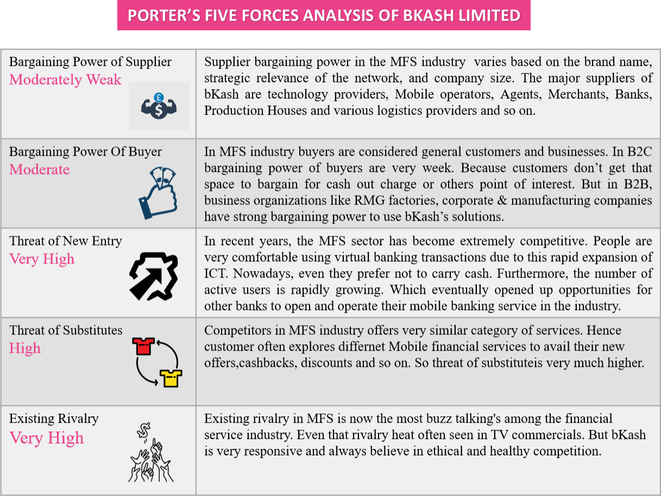

  - PESTEL Analysis of bKash Limited:

P | Political Factors | - Political unrest within the country  - Role of the government in the business  - Transition in the government, and  - Changes in policies
E | Economic Factors | - Changes in the gross income of the country  - Structure of the financial market  - Fluctuation in the price of different products and services, and The economic growth rate of the country
S | Social Factors | - Level of education of the society  - Trends in the demographic changes, and  - Expenditure trend of the people
T | Technological Factors | - Integration of different improved technologies,  - Increased penetration rate of the internet, and  - E-commerce growth trend.
E | Environmental Factors | - Changes in the environmental regulations, and  - Influence of climate change.
L | Legal Factors | - Changes in the business laws,  - Changes in the consumer laws, and  - Changes in the employment laws

SWOT Analysis of bKash Limited:

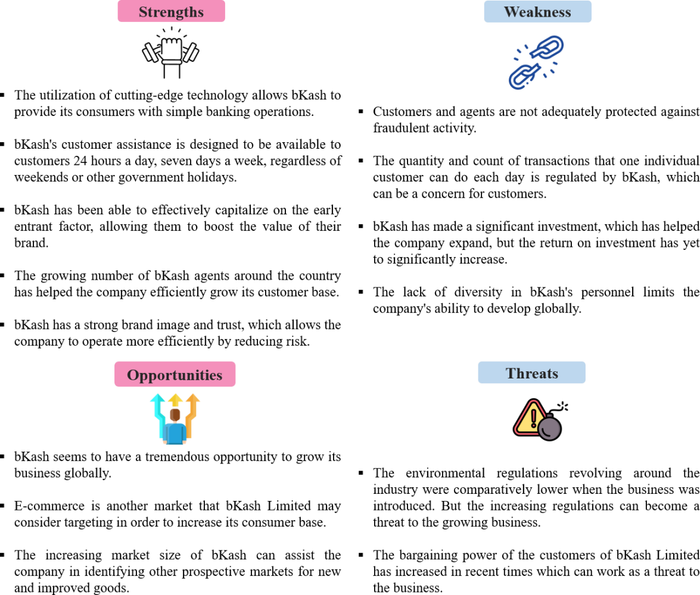

Chapter 8
Challenges of Payroll Digitization

Challenges of Digitization (Payroll perspective):
Now what Payroll Business of bKash suggests as digitization is, converting this whole process of Payroll into e-money transaction. Here the goal is towards a sustainable economy through e- money transaction. Not only this whole process is less hassle-free compared to bank but also it drives towards a smart way of banking system. If we look around a little, the whole economy is shifting towards digitization for many advantages of it; like- easily accessible at any place and at any time, can avail other benefits/services of bKash as well (loan, savings, send money etc.).
But in general people have a resistance towards this system. One of the many reason would be the intangible aspect of it. You cannot evidently see or touch the money. Next would be the illiteracy condition of Bangladeshi poor or lower middle class people. For this, no matter how easy this process is, it is difficult for them to understand this procedure or even adapt to it. Now there are other factors as well but as the economy is moving towards a better future, to a sustainable economy the more Payroll Business is expanding. The more people are onboarding into this process of e-money transaction or smart banking system. Now it is only a matter of time when digitization would take place in every corner of every industry. By then, it is important that people should actually know all the features of it and be habituate to it as well.

To decrease this resistance tendency of people in general, Payroll has taken certain actions like- providing training and other materials actively. So, that at least, people can be aware of the situation or shifting of banking system.

  - Challenges of Digitization (Market perspective): The whole market as well as industries are converting into digitization for good. It is said that, digitization is taking a step towards better future. But it got evidently proved while this Corona/Pandemic. Not only it’s easy to reach out to people who is not within the reach and provide them the service, but also it helps to have easy access. It is less time consuming, more effective as you can do a lot of task at a time, can always take the smart way to complete any task etc. Also as bKash provides advance banking service you can store loads of data without caring about the storage or space it takes. Full proof confidentiality and security can also be managed under such advanced system. Thus people are

giving more importance to skills like- tech savviness, being good at MS Word, Excel, Power Point, Outlook, SEO etc. Because these are and will be companies’ future need for a long time. Companies as well as top level management are giving more priority to skillful employees.
As digitization is taking a grip all over the sectors of business, all the sectors and market needs are changing with it. To make it more relevant let’s talk about the perspective of MFS (Mobile Financial Service) industry. Every bank is opening a wing operator for its client to deliver banking services more easily. For example- Dutch Bangla Bank has Rocket, UCB has Upay, BRAC has bKash etc. Not that banks are delivering less service or one can question the quality of it. But with internet and e-money transaction service it is way more affordable, effective and less time consuming. Not only companies are converting into digitization, already they are competing into this industry. bKash is undoubtedly in lead of MFS industry. bKash holds more share in this market.
Digitization of Payroll program is quite hassle free and feasible compared to banking system.

  - Service Profit Chain of Payroll Business: The concept of service profit chain basically indicates the relationship between profitability, customer loyalty, employee satisfaction & productivity. For example- let’s talk about the service profit chain of Payroll Business. The service that Payroll provides is the salary disbursement of blue/white collar employees, RMG workers, partial payment, petty cash, incentive/bonus, bulk amount of companies etc. Payroll disburses any sort of amount from the company end to the end user. Now, this business idea was actively generated about 2-3 years ago. Means the business team of Payroll Business has been established during 2020. During this year, Bangladesh economy was going through a declining phase because of pandemic situation.
During this time Payroll pillar has been formed and expanded all over the country. They provide service by providing a portal for each organization. Through this portal company deposits their amount they wish to disburse, also with the data of individual employees.
Now their amount of consumer is increasing day by day. Around 12million RMG workers are getting disbursement of their salary through bKash. For Corporate & Manufacturing sector the number of client base is 200. Lastly for Education Payment the number of client base is around 1300. Payroll Business is booming day by day. Why is it possible? Because, there is a demand that has been created in the market. The demand can only be created if the end users(customers)

are feeling the need of it. It also means that customers are satisfied, thus such demand has been created. Whatever the infrastructure or development Payroll Business is forming in its service, customers are satisfied, it also means bKash Payroll is providing a standard level of service.
As this pillar is on demand, it also means this pillar is generating a good amount of revenue. So, I can conclude that indeed bKash Payroll Business is operating a good example of service profit chain.

CHAPTER 9 RECOMMENDATIONS & CONCLUSIONS

Recommendations:

The journey of Internship in bKash at Payroll Business Pillar from Commercial division has been nothing but a privileged and learning experience for me. From the organizational culture to work environment everything is International standard. But three are few areas that I would like to recommend –

Overcoming the obstacles:
While implementing this digitized solution two things Payroll Business needs to work with- Resistance & Illiteracy. The first obstacle of the target customer here is their resistance towards a better economy. Well, banking has been there to handle all the transactional stuff for all these years. So, naturally most of them won’t be interested to convert into this new process. Payroll Business has to reach out to every possible corner to create awareness and better knowledge about their solution. Now, if they can implement the first change, the second obstacle will be resolved half way. If the consumers have interest about the Payroll solution, generally they will try to know more about it. About its operation, method, other benefits etc. Next all that need to be done is provide the employees/workers with proper training material, session etc. So, for the time being I don’t feel like suggesting a different solution other than making people aware of the service/solution that Payroll Business of bKash provides.

Internet Access:

Though all the interns get their workstation with a laptop, there are no internet connectivity. This hampers the work efficiency of the interns because most of the tasks were required the help of internet. Again project research and idea generation requires internet access for faster output. The fact is also not ignorable that there are lot of sensitive information available within the servers but limited access of browsing may help the interns to perform their tasks more effectively and efficiently.

Role & responsibilities Orientation:

There was no specific role described in the intern position. Hence no Foundation training had been conducted for the interns working at Payroll Business pillar. So I would recommend the management that before assigning the interns to any team they should be provided a brief overview of the functions the pillar conducts.

Conclusion:
The working environment at bKash Limited was exceptional, allowing me to focus on and finish assigned tasks efficiently. The personnel at bKash Limited were exceedingly kind and helpful in every aspect. My three-month internship has provided me with life-changing experiences that will benefit me both personally and professionally throughout my career.
After completing my internship at the Commercial Division of bKash Limited's Payroll Business, I discovered how the department's processes are performed. This department's responsibilities range from performing activation campaigns to onboarding clients. Participating in the activities allowed me to get knowledge of all the processes. I had a variety of theoretical information about the activities that take place in an organizational context, but after completing the internship program, I was able to grasp the practical knowledge that I needed and connect the theories with the real-world scenario. bKash Limited has been working hard to build a long-term ecosystem for its stakeholders.
We must acknowledge that Mobile Financial Services is one of the "Big Things" in an affluently developing country's economy. It has built a notable customer base, despite the fact that, as an oligopoly industry, there are few reliable options for customers. Mobile Financial Services are still in their early stages in Bangladesh. The MFS providers must establish a hub to market their services to our country's unbanked citizens. In addition, MFS firms' infrastructure must be improved so that they can deliver secure and economical service as quickly as feasible.

REFERNCES

Ahmed, S. (2020). Analyzing customer expectations towards financial services of mobile: A study on bKash Limited.
Chen, G., & Rasmussen, S. (July 2014). bKash Bangladesh: A Fast Start for Mobile Financial Service. CGAP.
Hossain, M. A. (2020). Acceptance of Mobile Financial Services in Bangladesh: An Overview of bKash LTD (Doctoral dissertation, University of Dhaka).
Kumar, D. (2022). Prospects and Challenges of Mobile Financial Services (MFS) in Bangladesh. In Handbook of Research on Social Impacts of E-Payment and Blockchain Technology (pp. 320-341). IGI Global.
Latifee, Enamul & Tamanna, Mehdina. (2022). A Review of Mobile Financial Services in Bangladesh. 4. 870-873. 10.35629/5252-0402870873.
Mannan, A. (2017). Analysis of consumer satisfaction level on bKash Limited as a mobile financial service provider.
Saniel, W. H. K. (2020). Analysis of bKash Limited & Mobile Financial Services Industry in Bangladesh: An Internship Experience Perspective.
Tanvir, S. N. (2021). Financial Performance Analysis of bKash Limited.

Yesmin, S., Paul, T. A., & Uddin, M. (2019). bKash: Revolutionizing mobile financial services in Bangladesh?. In Business and Management Practices in South Asia (pp. 125-148). Palgrave Macmillan, Singapore

Chowdhury, A. Y., Hossain, A. K. M. A., Habib, M. M., & Yue, X. G. (2019). Role of mobile financial service in promoting online small business in Bangladesh. IETI Transactions on Social Sciences and Humanities, 5, 140-148.

Saniel, W. H. K. (2020). Analysis of bKash Limited & Mobile Financial Services Industry in Bangladesh: An Internship Experience Perspective.

Ahmed, L. (2019). Performance analysis of mobile financial industries: a comparative analysis between bKash Limited and Dutch Bangla Bank Rocket.

Hossain, M. (2021). Increasing number of fraudulent activities in MFS industry and the role of Compliance Management Service in order to reduce it: A case analysis through bKash and relevant issues.

Sultana, A. (2021). Customer Mobile Financial Service (MFS) Using Intention: In Digital Bangladesh Perspective. Nasrul Aiman Bin Abd Aziz Web designer, 523.

Alam, S. N. (2019). Analyzing consumer behavior and perception regarding Mobile Financial Service (MFS) in Bangladesh.

Khondoker, M. (2022). Prospects and Challenges of the E-Commerce Industry in Bangladesh.

Pranta, A. R. R. (2021). Bkash Bangladesh: an innovative start for mobile financial services and its impact on long term poverty.

