Internship Report On

GREENLAND TECHNOLOGIES LIMITED

A concern of Getco Group



United International University

Internship Report On

GREENLAND TECHNOLOGIES LIMITED
`

Supervised By:

Mosabbir Ahmad

School of Business & Economics

Submitted By:

Md. Shahadat Hossain

ID: 111 142 308

Subject: BBA
Major: Finance

Date of Submission: 01-10-2020

Letter of Transmittal

Date: 01-10-2020
To
Mosabbir Ahmad,

B.Sc.Engg. (EEE), MBA

Assistant Professor,

School of Business at United International University.

Subject: Submission of Internship Report.
Dear Sir,
With due respect, I would like to express that, I am a student of United International University and I had prepared my internship report on Greenland Technologies Limited.
I tried to give my best effort to prepare this report through your guidance and motivation. I have tried to provide which seems most important information to me. This report was a great opportunity for me by which I had learned many practical material tasks which increase my inner knowledge. By this report I have implemented my bookish knowledge on my work. It could be better if there were no limitations.
As a result, I hope you will review the report by considering the limitations

Thank you

Md. Shahadat Hossain
ID: 111 142 308

Acknowledgement Letter

Firstly, I would like to express my gratitude to Almighty Allah for giving me the capability to prepare this report.And I also indebted to many other people who helped me to prepare, data collection, submission, recommendation, co-operation, direction of this report. I also like to express my gratitude to my honourable senior Mr. ASM Main Uddin and Mr. TarakNathShaha. Without their consideration this report was unestablished. There are many other people in my office who helped me to learn and complete my work. By all of them I had gain many experiences and knowledge practical work. The marketing team and supply chain management team also helped me to make this report by spending their valuable time and strength.
Secondly, I would like to express my gratitude to my family and friends who helped me and motivate me a lot to make this report properly.
Finally, I would like to express that, I have tried to give my best quality and effort to make this report properly. Though there could have many existences of many limitations and error which required your kind consideration because I am in learning process.

Executive Summary

Greenland Technologies Limited is sister concern company GETCO group. It is a trading company who imports AED, IED products and also provide services for the tractors. GTL’s also have a tender department who provide service after getting any tender for and Government or private companies. GTL started its business from 2011 but they started itsoperational activity in 2014. Mr. GolamAhramKibria is the CEO of GTL, he is the prominent decision maker of this company who continuing his process by taking efficient decisions from 2011. He is key point of this company.

Greenland Technologies Limited has more than 20 showrooms and has many dealer points all over the country.They sell AED products like Tractors, Rotavators, Power tiller and IED products are KARCHER and INGCO. All of those products already become popular for its quality and service.

GTL provides farmers agricultural business solutions by providing qualitative products and make their operational precesseasier. Nowadays the agricultural business is being the profitable business farmer, which is very helpful for our economy of the country.

In the 3 months internship period I have learned many usage financial and accounting terms. In this internship report I have discussed about the SOWT analysis, financial position, profitability, selling procedures and comparisons to other competitors and so on.

In comprehension, I know that internship is period of learning process. As a student I have gained knowledge and experience from AUDIT department which avails me to know about the many business process practically. I have also can implement my bookish knowledge into their business.

Table of Content
CHAPTER1 - Introduction10

  - Background of study
  - Origin of the report
  - Objective of the Report

    - Main objective
    - Specific objectives

  - Methodology
  - Limitations of the study

CHAPTER 2 - Company Profile
- Companies Mission and vision
- The Board of Directors of Greenland Technologies Limited
- SOWT Analysis.

Chapter 3 - product of the organization
3.1 IED(karcher, INGCO, spare parts of karcher and ingco)
3.2 New Holland Tractor
3.3 Features of New Holland Tractor
3.4 Rotavator
3.5 Power Tiller
3.6 Comparison between New Holland Tractors and ACI Motors Tractors
3.7 Comparison between TOLSEN and INGCO

CHAPTER-04 Selling System of the product
4.1 Cash Sale
4.2 Credit sale
4.3 Installment
  - Leasing

Chapter 5 –Financial performance analysis
5.1 Liquidity Ratio
5.2 Profitability Ratio
5.3 Activity Ratio
5.4 Debt to Equity Ratio
Chapter 6 – Findings
Chapter 7 – Recommendation
Chapter 8 –Conclusion
Chapter 9 –Appendix
Chapter 10 Biography

Chapter 01: INTRODUCTION

- Background of study
In my internship period I had worked in Internal Audit Department where I have learned many business activities. As an auditor I had the opportunity to see the financial and accounting activity and I had to deal with the other marketing and service department. The Internal Audit department is actually worked for remove the fraudulent activity and establish SOP (Standards of Process) for the company. My organizational supervisor from audit department was TarakNathShaha(Internal Audit, Deputy Manager).

  - Origin of the Report

The internship period is very helpful for students to gain any practical knowledge and experience which will help not only making a report but also comprehend idea. Here students can gain experience of corporate world through the period of internship program.

- Objective of the Report

    - Main Objective of the report

The main objective of the report is to present the business process and compare to other’s companies.And the financial and accounting activities and ratio of GTL.

1.3.2 Specific Objectives

- Present a proper report to fulfill the academic requirement.
- To establish a standard of procedure.
- To implement the theoretical knowledge in practical experience.
- Gain practical knowledge and experience about corporate world to make a bright future.
- Focus on the managing all of the departments together.

  - Methodology.

This study reflects the insights and experience of the organization and how it’s affected its profitability. To show the report I have collected some sources of information which is given below:

- Primary sources of data: The primary sources of data are collected directly by observations and conversations. In the period of internship,I have conducted many activities of GTL. I have conducted many employees of GTL.

- Secondary sources of data: The secondary sources of data are collected from outside sources like websites, newspapers and books, annual report of GTL etc.

- Limitation of the study:
In the period of preparing report I have faced different types of problems which is limitations of the report. Which are given below:

- There is many confidential information which brings the lack of information in this report.
- As a new comer I also unable to understand some terms, policies and so on.
- In a private company the employees are always busy to do their tasks. So, their I face many difficulties to collect information from all.
- Distance is also limitations because many showrooms are situated outside of Dhaka, so it’s difficult to collect proper authentic information and understand that.
- GTL is a new comer of the industry, so they are less experience to conduct business.

Chapter 02: Company Profile

  - GREENLAND TECHNOLOGIES LIMITED.
Greenland Technologies Limited is sister concern company of GETCO group. They have come in the market with some solutions. They started their work with some AED and IED products. AED products includes with New Holland Tractors, Rotavator, Power Tiller and spare parts of those products. Then IED products includes with cleaning products and other solutions of Karcher and INGCO is alsoan IED products.
- Karcherand Cleaning Equipments.
- Tractor, Rotavetor, Noveltech spare Parts, Power Tiller
- INGCO (Hand Tools, Power Tools), Ingco Spare Parts.
- Demag Overhead crane
- Jungheinrich Material Handling Equipment.
- Noveltek Forklifts.
GTL has a family with more than 300 employees, 10 Showrooms and 4 Wearhouse. And has a Head Office, Regional office in Bogura, Chittagong, Jessore. GTL use many softwares to manage their operations. Those are VANGUARD ERP, TALLY software. They are also have a plan to buy new software you operate their business. The employees of the company are very dedicated to do their work. Employees are very supportive, helpful, friendly and experienced to serve their service to the organization. Without their co- operation’s GTL couldn’t reach in this position.

Companies Mission and vision
Mission: Our mission is to bring more business solutions and give more technologically updated products to the customer in Agricultural equipment and industrial equipment which could also bring the client a successful business.
Vision: Our vision is to become the largest AED and IED products provider in Bangladesh.
2.2Board of Directors of GTL
Name | Designation
K.M Khaled | Chairman
K.M Rakib Hasan | Managing Director
Golam Ahram Kibria | Chief Executive Officer

2.3 Swot Analysis: Swot analysis very paramount for every company. Swot analysis avails the company to justify about their Strength, weakness, opportunity & threats.
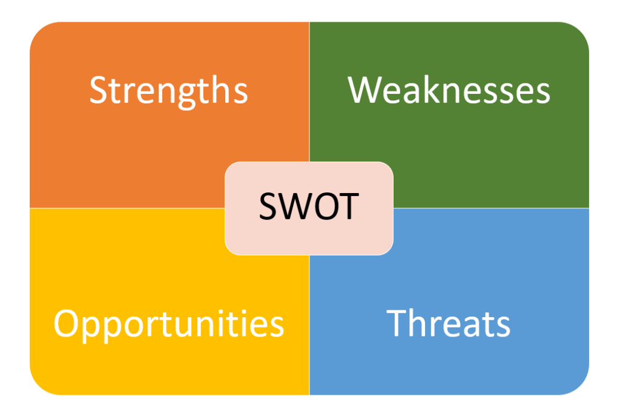

- Strengths:
- GTL hasa competitive company image with stylish logo design
- GTL imports quality products by proper guidance.
- Working with dedicated and helpful employees.
- Establish their showrooms in popular place.
- Great feedback and response from corporate companies.
- Usage of modern software to operate the business.

- weakness:
- Less attention in cost minimization.
- Less supply of products.
- High price in IED products.
- Political environment is very unhelpful.
- Less expertise in accounting department.
- Less promotional activities.

- Opportunity:
- Has enormous demand in Bangladesh.
- Increasing of machineries dependence.
- Support from government in Agricultural sectors.

- Threats:
- Ecumenical economicrecession.
- Dependent on peregrine supply.
- Higher purchase model.
- Leaving of experience staff.

Chapter 3: Product of the Organization

3.1 Product of the organization:Greenland Technologies Limited is a trading company. As a new comer in the market they are adopting many products. Theyhave capability to adapt products, for the reason of dedicated employees. And are going to adapt more products which will be gain more profit in future. Now GTL is working with some products which given below:
1 IED(karcher, INGCO, spare parts of karcher and ingco)
2 New Holland Tractor
3 Features of New Holland Tractor
4 Rotavator
5 Power Tiller

3.1 I.E. D (Karcher and Cleaning products, NH Spare Parts)
Innovation continues to be Karcher's most significant magnification element. Karcher and Cleaning products: In 1950, Karcher began its business in cleaning technology solutions with the invention of the first European pressure washer for ultry-dihydrogen monoxide.
NH Spare Components: NH Spare Components is the components of KARCHER. It’s avails the Customers to rehabilitate and upgrade the product.

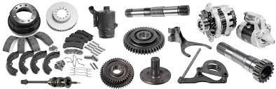
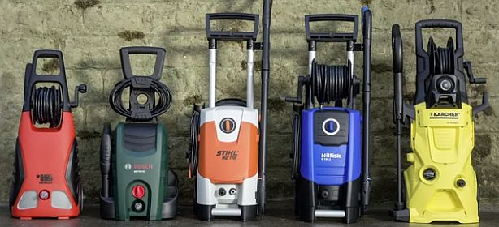
A.E.D (New Holland Tractor, Rotator,Noveltech Spare Parts, Power Tiller).

3.2 New Holland Tractor: The tractors of NEW HOLLAND began their business in Incipient Holland, Pennsylvania, in 1895. The 3-point hitch (pristinely designed by Harry Ferguson) on the 'N' tractor series was introduced by Ford in 1939. In 1985, Ford bought Incipient Holland, forming the Ford-Incipient Holland line. In 1990, Ford's farm equipment division was sold to Fiat, which started phasing out the Ford brand.
Feature of New Holland Tractor
No. Of Cylinder: 3
Horsepower: 55 HP
Engine: 2991 CC
Gear Box: 8 F +2 R / 12 F +3 R (Optional)
Break: Oil immersed multi disc brakes
Warranty: 2400 Hours Or 6 months service warranty.

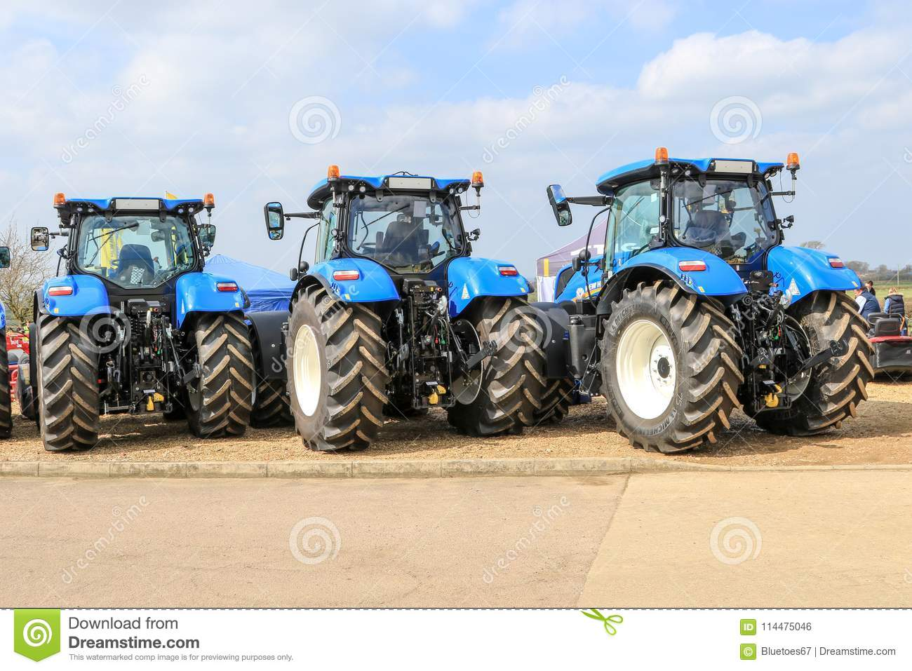

3.4 Rotator:
- 4-speed gear box - congruous for all types of soil more Blades - for better pulverization
- More Blades - for better pulverization better efficiency and less diesel consumption
- Better efficiency and less diesel consumption
- More warranty (one year)

3.5 Power Tiller: Features of power tiller.
- Fuel Diesel
- Machine Color Red, Blue
- Power 8 HP, 14 HP

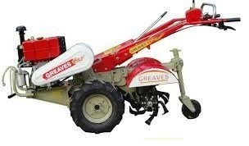
3.6Comparison between New Holland Tractors and ACI Motors Tractors
ACI Motors: ACI motors started their business with Sonalika tractors in 2007 and tried to bring the business solutions in agricultural sectors. At the first time ACI motors were striving to serve proper mercenaries’ solutions. They also provide spare parts and service to repair the tractors. They also ensure high quality products in the competitive market.
We are going to compare between the latest product of New Holland and ACI Motors:
ACI Motors latest product is Sonalika DI-45RX and New Holland’s new product is TT 75
Name | TT 75 | Sonalika DI-45RX
Engine | Evoco- New Holland
No of cylinders | 4 Cylinder | 3 Cylinder ITL
Fuel capacity | 62 | 55
Cooling system | Water Cooled and pressurized | Water Cooled
Steering type | Power | Mechanical
Weight | 2355 | 2060
Origin | India | Bangladesh

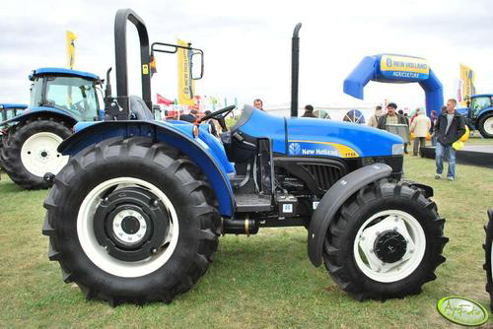
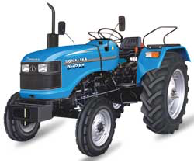

3.7 Comparison between TOLSEN and INGCO
INGCO: INGCO is world’s famous brand for industrial equipment. They started their business in 1991. They manufacture their products from China. They have many types of products Screwdriver, knife, Angle grinder, impact drill, Jig saw, Rotary hammer, nose pliers, pipe wrench, bolt cutters, suction etc. GTL started their business with INGCO in Bangladesh from2017. Now they are getting huge response from customer. They areincreasing their capacity of business day by day.
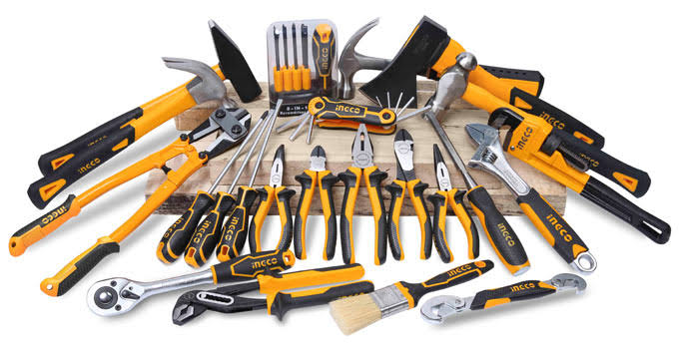
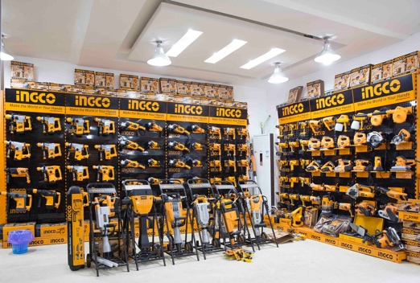

TOLSEN In 1980, the Tolsen Company began business. During the design, manufacturing , packaging and quality control process, TOLSEN products are all strictly regulated at every stage. TOLSEN tools assume that accessibility, reliability and performance are the key to quality software. In the local market, they're very well known. In 100 nations, their goods are sold in.

Comparison between INGCO and TOLSEN
Name | INGCO | TOLSEN
Features | Many types of products | Types are less than INGCO
Price | Customer based | Product based
Product Quality | High quality | Medium quality
Product Variation | Ingco has various kind of products. | Tolsen has less various kind of products than Ingco.

Chapter 4: Selling system of the Product

4.Selling procedure of products
- Cash sales
- Credit sale
- Installment
- Leasing
4.1 Cash sale:Cash sale is directly sales to customer on cash payment.There are many opportunities for customer in the procedure of cash sales. Because customer can get many discountsand offer through cash payment. Cash payment is very good for company because it’s doesn’t make any hassles.

4.2 Credit sale:In credit sale procedure customer make delayed payments. Credit sale is usually not allowed to sale to all the customer. A salesman needs some approval to make a credit sale. Credit sale are allowed to those customers who is good known in market and has a strong relationship with GTL.
4.3 Installment: GTL provides EMI payment facility to customer. In this procedure customer get the products in 0% interest for 12 months. Then 12% interest after 12 months.This procedure can be used only by credit card. These featuresare given to customer customer in IED products only.
4.4 Leasing: GTL provides leasing facility to customer. Customer can buy products by providing some amount of deposit.But there is some procedure to lease the products. Customer has to give all national information and bank account information, some blank cheques and have to pay remaining amount by installment.

Chapter 5: Financial Performance Analysis

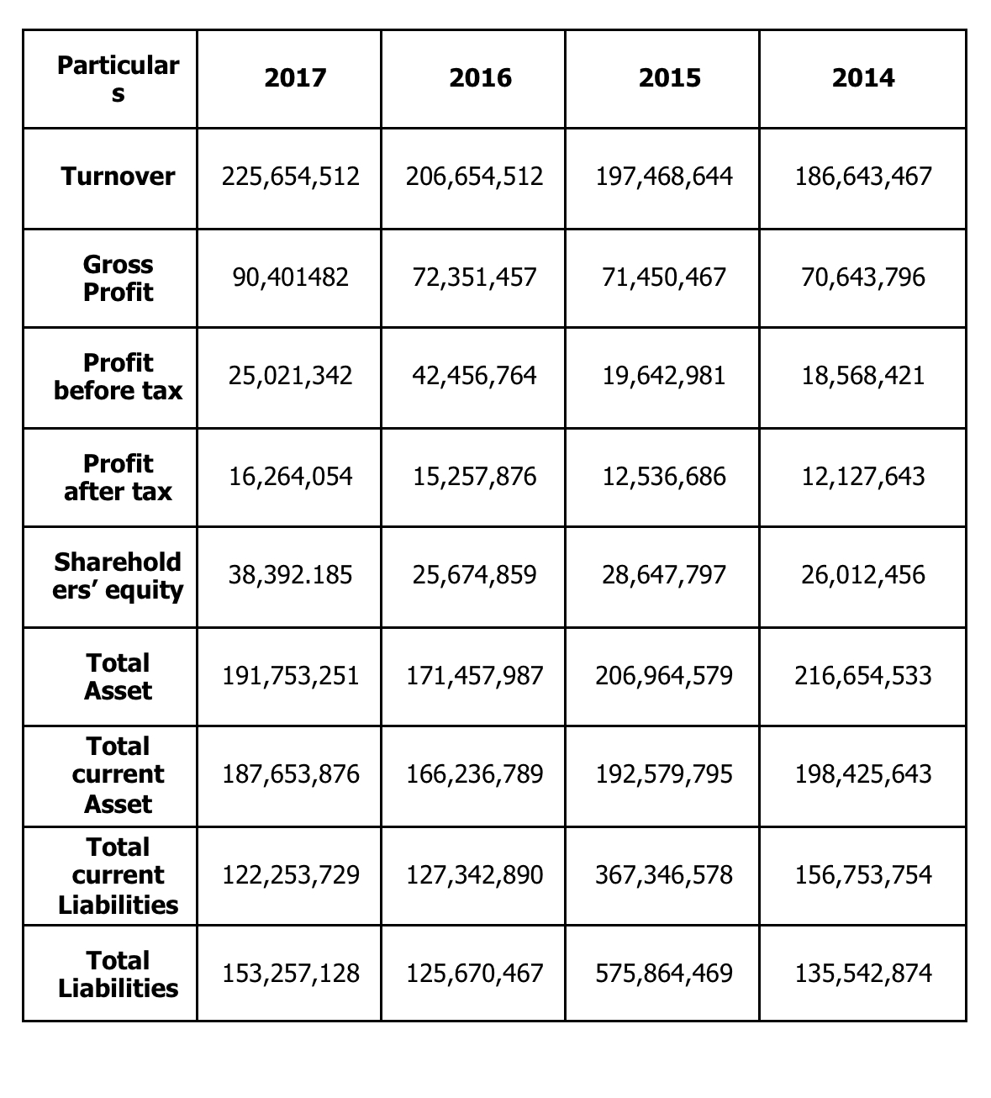
Financial ratiosFinancial ratios are elaborate and indicate the financial performance and financial position of a company. GTL also analysis their ratio to measure performance. To make ratio company need to make some equations. Some financial statement is given below:
Types of Ratio:
- Liquidity Ratio
- Profitability Ratio
- Activity Ratio
- Debt to Equity Ratio

- Liquidity Ratio: Liquidity ratio is actually referring to some several ratios which is analyzed to know about the company’s ability to pay the liability on time. This is actually measuring the creditors and lenders. Some liquidity ratios are given below:

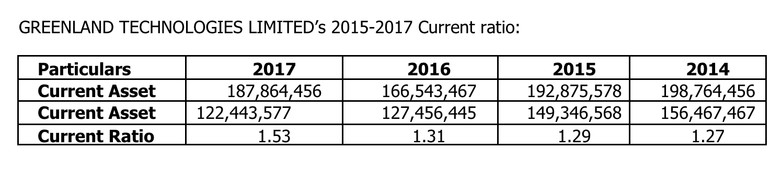
- Current Ratio: Current ratio is for measure the short-term liquidity of a company. It’s indicated the relationship between current asset and currentliabilities.

Interpretation: The standard of current ratio is 2:1. Whereas GTL has 1.27 in 2015. Which is not standard. Even in 2017 it is not reached at standard position. But the position of the ratio is increased day by day. In 2015 it has been increased at 1.29 from 1.27 which is not standard but appreciable for a new company. In 2016 it’s increased to 1.31 and in 2017 it’s increased to 1.53. So that we can hope that one day it will be reached at the standard position.

- Quick Ratio:
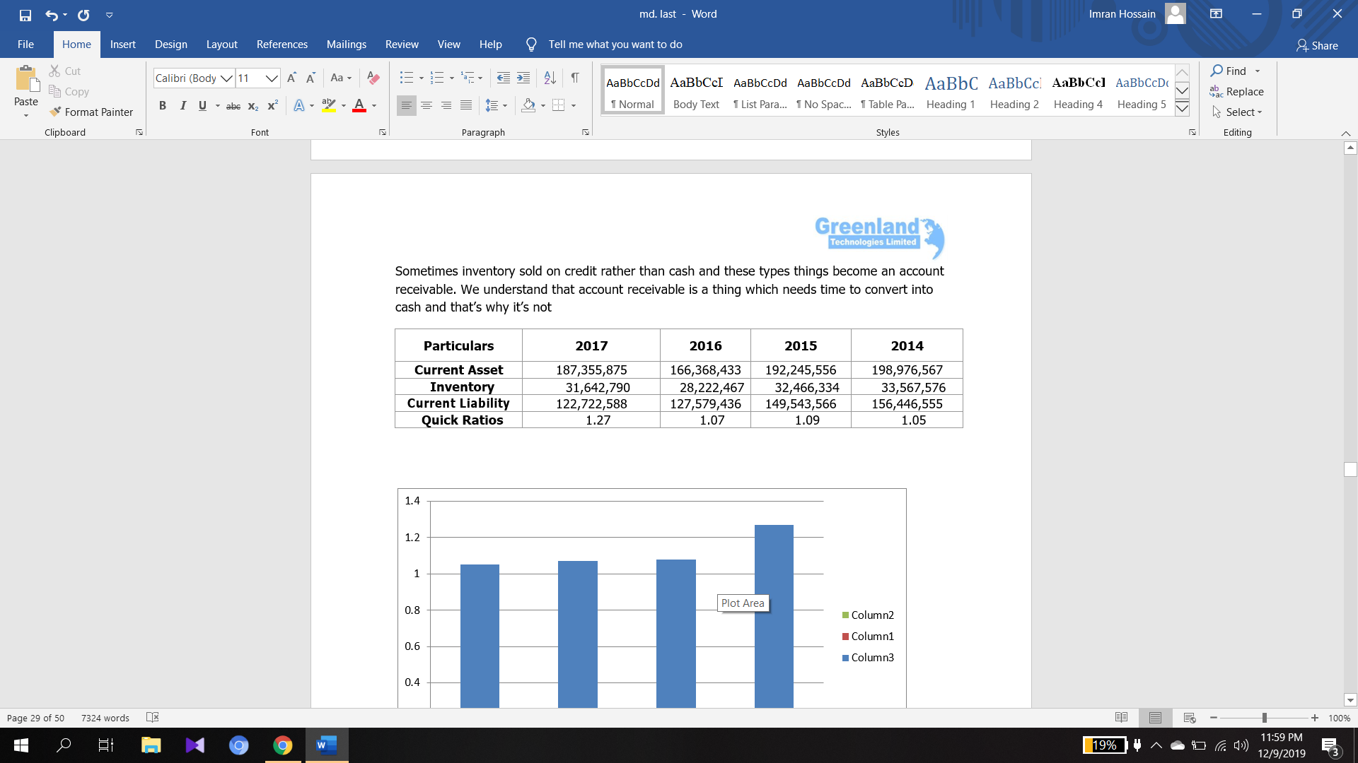

Interpretation: The standard of current ratio is 1, whereas GTL has 1.05 in 2015. Which is more than standard. In 2015 it’s increased to 1.09 and in 2016 it’s decreased to 1.07 and in 2017 it’s increases to 1.27 which is a huge achievement for GTL and highest for the GTL.
- Profitability Ratio: Profitability ratio is measure for net income. Profitability ratio is actually referring to some ratio which is given below. To calculate those ratios, we need the data of profit and loss report.
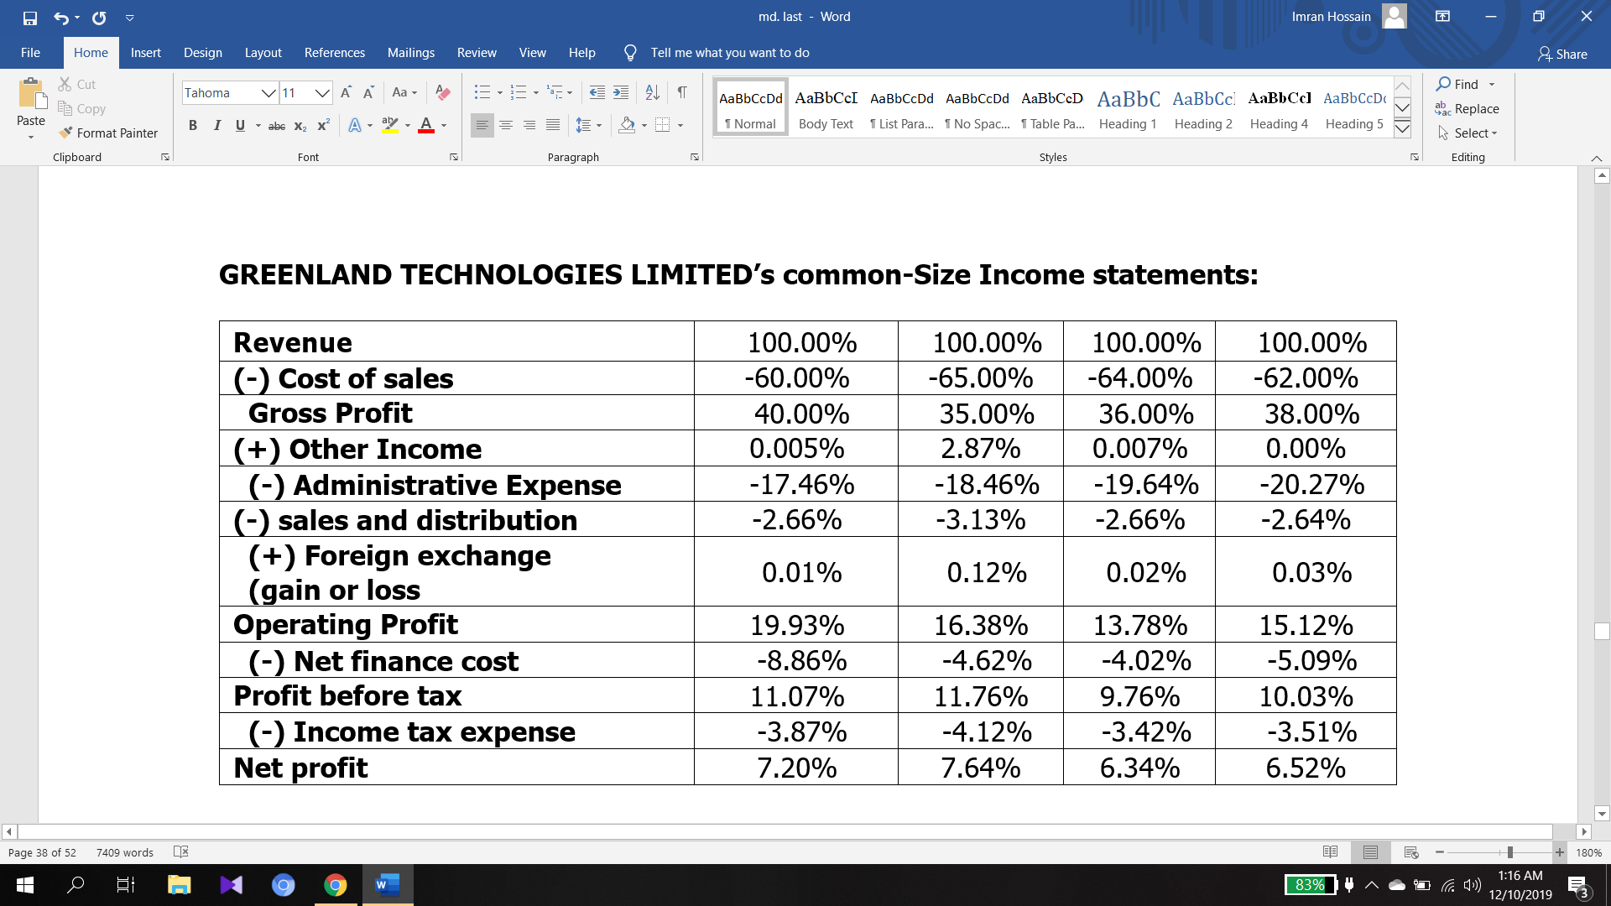
- Gross profit
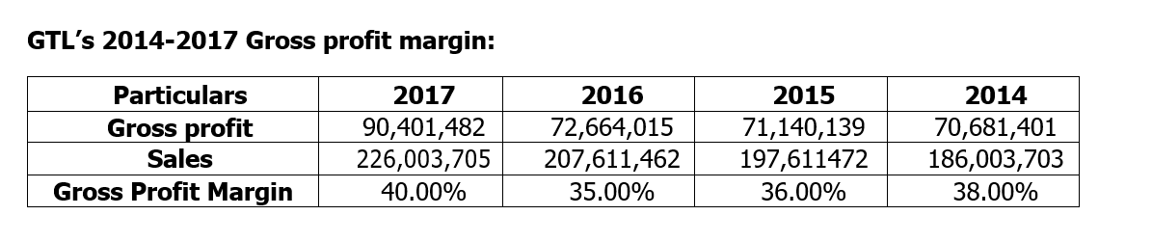
Interpretation: Gross profit ratio indicates that how a company can produce or import and sell the product. The gross profit ratio is good when it is higher. In 2014 Gross profit is 38% and in 2015 gross profit decreased 36% and in 2016 gross profit is decreased to 35%. In 2017 the gross profit is 40% which is highest gross profit.
- Net Profit Ratio:
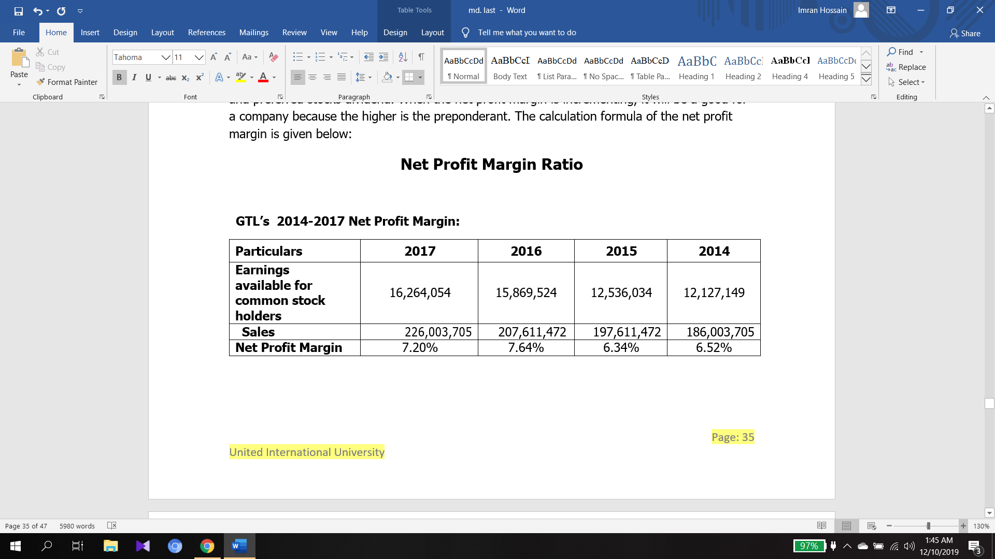Interpretation: The net profit margin measures the company’s financial health. In 2014 the net profit is 6.52% and in 2015 net profit is decreased to 6.34%, in 2016 net profit has highest increase of 7.64.
- Return on Asset
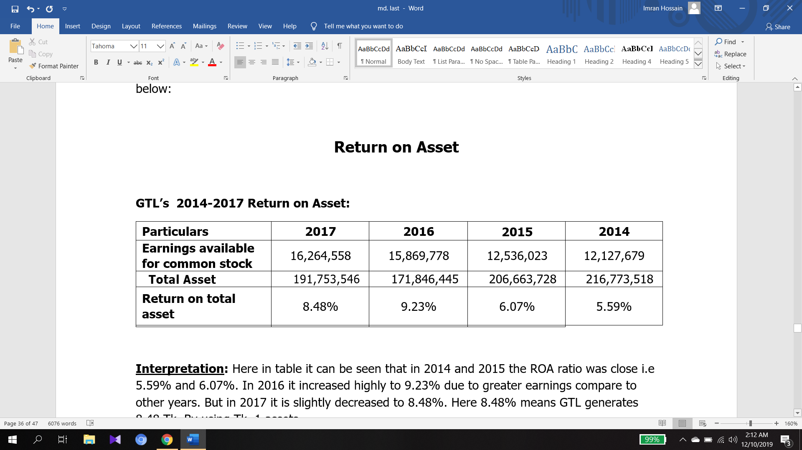
- Activity Ratio:Activity ratio ismeasuring how the company is running their business and the company is using their asset to generate revenue. The activity ratio is actually referring some others ratio which are given below:
- Inventory turnover ratio:Inventory turnover ratio is actually reporting how much the company is generates their revenue. It’s also measures the stock of the inventory in hand, work in process and finished goods
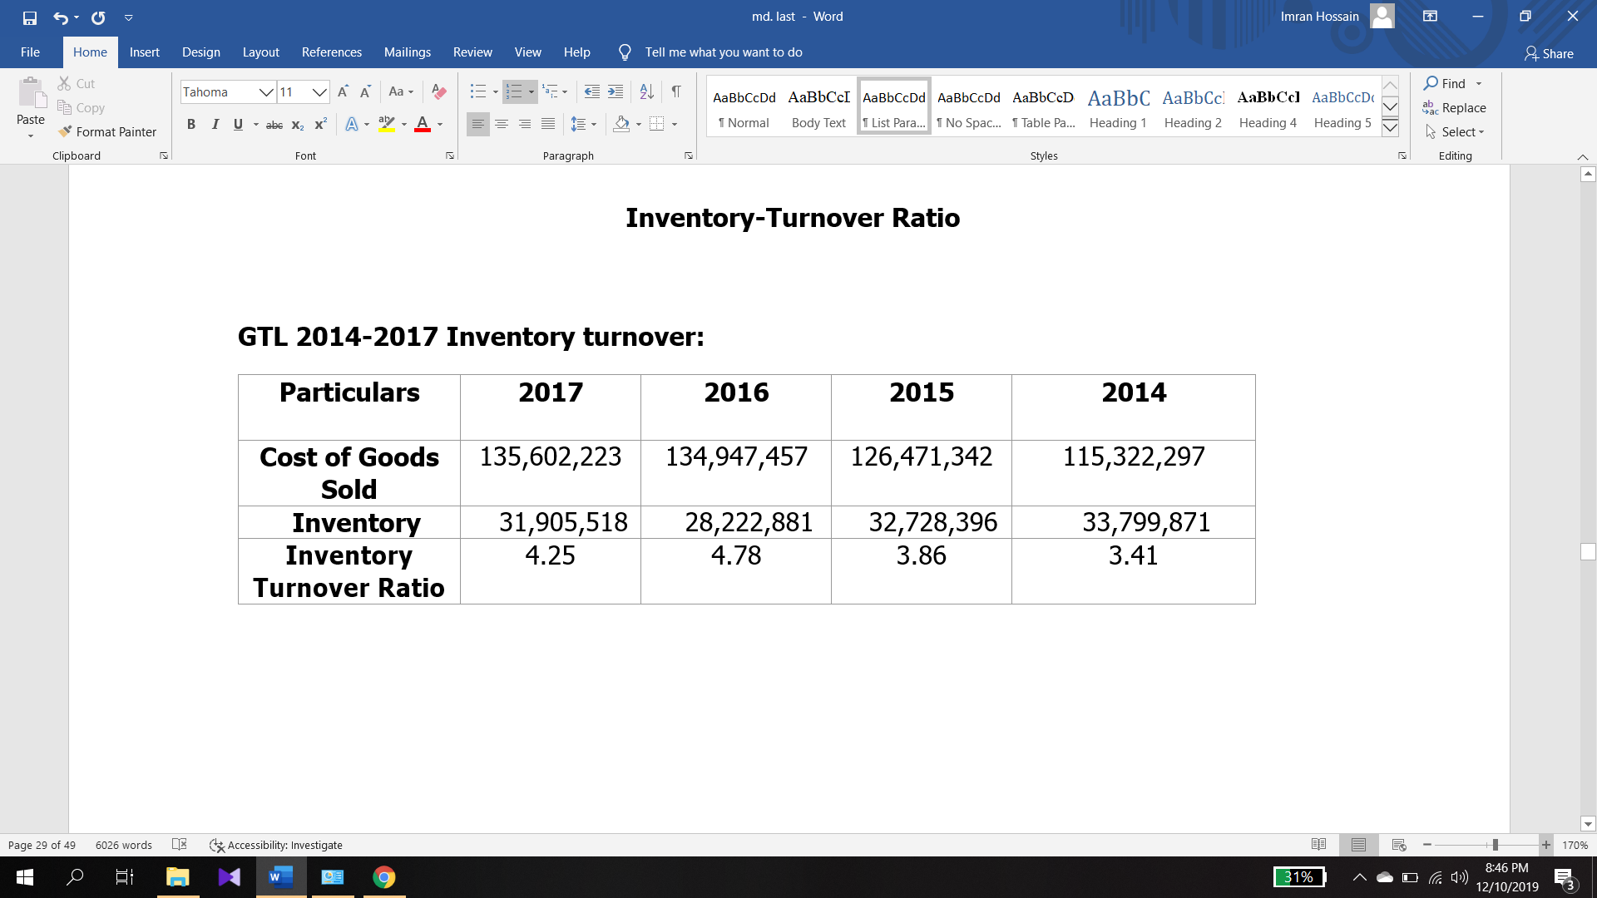

Interpretation:The inventory turnover ratio of GTL is indicating that in the company is gaining accelerations day by day. In 2014 the inventory turnover ratio was 3.41 which is GTL is was selling their product 3.41 times in a year. IN 2015 inventory turnover ratio increased to 3.86 and in 2016 it’s increased to 4.78 which was highest inventory turnover ratio.

- Asset turnover ratio:The asset turnover ratio is reporting that how much sale is generating from companies’ asset. It also shows how effectively company is using their assets. The asset turnover ratio is referring some other ratios which are given below:

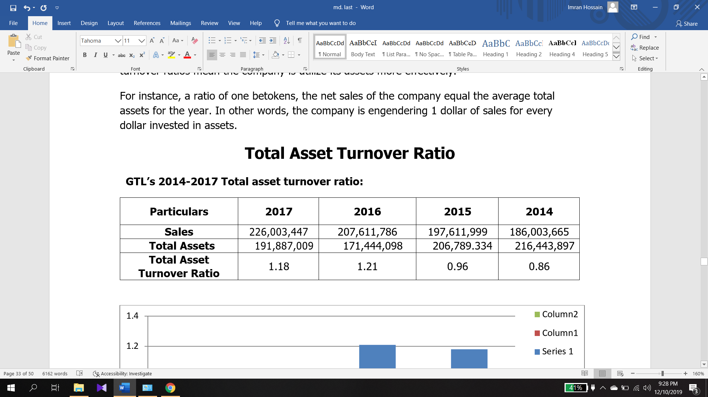

Interpretation:The asset turnover ratio is actually measuring how much a company earns by investing 1 taka. Here the GTL’s asset turnover ratio is showing that they had 0.86-taka turnover against 1 taka. In 2015 it increased to 0.96 and in 2016 in it’s decreased to 1.21 which is the highest achievement of the company. But in 2017 the asset turnover ratio of the company is decreased by 1.18.

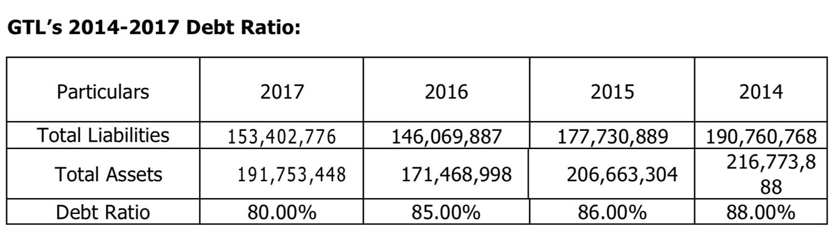
Debt to equity ratio:

Interpretation: Debt to equity ratio measures the financial growth of a company. By debt to equity ratio we can focus on long term debt. The D/E of 2014 is 88% which is decreased in 2015 to 86% and in 2016 it decreased to 85% and in 2017 it’s decreased to 80% which is a great achievement for GTL.

Chapter 6: Findings

There is an array of ratios, but few of them are more important to the business, such as the current ratio, expeditious ratio, ROA , ROE, inventory turnover and debt equity ratio. This is the firm 's primary ratio. That does not imply that other ratios are less relevant since a company's output is further calculated. The financial performance review will observe all the positive and negative outcomes expected. The overall finding we observed from the above ratio of GTL analysts is expressed verbally below:
Liquidity Ratio
- Current Ratio: may not meet 2:1 requirements, but it does not mean negative all the time to adjust every year and lower current ratio. That could prove a good sign. It relies on the framework of organizations.
- Quick Ratio: Follows the 1:1 requirement. Therefore, business is willing to offset existing liabilities with current assets.
Activity Ratios
- Inventory turnover ratio: Complies with 2017 & 2016 norms. Though in 2015 & 2014 it was below expectations. Yet we can visually observe the transformation.
- Average ratio of amassment period: Does not fulfill the criteria. But it is slightly amended every year.
- Average ratio of payment periods: It is virtually similar to expectations. Although it was regrettable in the beginning, it was close enough to the expectations in 2017.
- Total asset turnover ratio: It's nice because it produces more revenue than the amount of assets invested.
Debt Ratios:
- Debt ratio: Debt ratio is not good for company.
- Time interest earned ratio: It is acceptable but it should be ameliorated.
Profitability Ratio:
- Last year's gross profit margin showed an growing pattern.
- The operating profit margin shows fluctuating value, but it can be acknowledged as it has been positive every year.
- Net profit margin: suggests patterns that are growing, which is beneficial. Though it was barely decremented last year.
- The return on total assets suggests that patterns are growing, which is beneficial. But it was barely decremented last year.
- The return on mundane equity suggests fluctuating prices, but it was positive. 1. Last year's gross profit margin showed an growing pattern.
- The operating profit margin shows fluctuating value, but it can be acknowledged as it has been positive every year.
- Net profit margin: suggests patterns that are growing, which is beneficial. Though it was barely decremented last year.
- The return on total assets suggests that patterns are growing, which is beneficial. But it was barely decremented last year.
- The return on mundane equity suggests fluctuating prices, but it was positive.

Others:
  - The business should not be versatile with respect to the payment of agricultural product installments.
  - Do not engage in ads for the citizens of agricultural goods as a result.
  - If they skipped three installments, they will not give them any chance.

Chapter 7: Recommendations

Though GTL operating their business from 5 years but they are not in a competitive position. They are providing quality products to customer to ensure satisfaction about the products.
- GTL should establish a quality management system to ensure the quality of the products. They should realize the importance of TQM for a company.
- GTL should reduce the use of paper to reduce the costs.
- They should import varieties of products.
- Company should take care their employees who are working dedicatedly for GTL.
- They should make some training to their service payer.

Chapter 8: Conclusion

Greenland Technologies Ltdis now a well-known company in Bangladesh. They supporting the farmers with the business of tractors. Which contribute to the country’s economy. GTL is also serving to the country by providing industrial and home and garden product which makes the people life easier. GTL has more than 300 employees who are spending their ability by serving this company. Company also grant many benefits to them. One day this company will be a listed company in Bangladesh. They have many opportunities to grab the market and Govt. is also providing many opportunities for making business.
In my three months internship I had learned many things from GTL and also gained many practical knowledges. I hope this knowledge will help to reach in my goals.
Lastly, I am very grateful to them for giving me the opportunities to work with them and make from them.

Chapter 9: Appendix

Abbreviations Elaborations
GTL GREENLAND TECHNOLOGIES LIMITED
TO TURN OVER
PBIT PROFIT BEFORE INTEREST AND TAX
UIU UNITED INTERNATIONAL UNIVERSITY
BD BANGLADESH
BBA BACHELOR OF BUSINESS ADMINISTRATION

Chapter 10: Bibliography

Publications:
Greenland Technologies Limited Annual report 2014 to 2017

Internet:
http://slideshare.com/
https://www.investopedia.com/
https://www.wallstreetmojo.com/
https://greenland-bd.com/
https://www.getco.com.bd/

