United international university

Internship Report

Analysis of Trust Bank Limited and The Banking Industry of Bangladesh: An Internship Experience Perspective

Submitted to
Dr. Md Mohan Uddin
Professor
School of Business and Economics
United International University

Submitted by
Nazia Afrin
111 153 154
School of Business and Economics
United International University
Date of submission: 7th September 2020

Letter of Transmittal
Data: 7th September 2020
To
Dr. Md Mohan Uddin
Professor
School of Business & Economics United International University
Sub: Submission of Internship Report

Dear Sir,
It is a great opportunity for me to present you my internship report on “Analysis of Trust Bank Limited and The Banking Industry of Bangladesh: An Internship Experience Perspective”. I am very much happy and thankful to you for your guidance and support. You gave your students full freedom to choose the internship topic and so, I found quite easy to select my topic. While preparing this report I have followed the format and instructions given by you. I develop this report with full effort and dedication since this report is part of my BBA program and it is important for me to complete my total credits.
To make this report, all the necessary information, documents I have tried to collect from my office. I also asked the questions to my seniors that helps me to conduct my report. I also took help from internet as a secondary source.
I would be very happy to provide you with any clarification regarding the report. Please contact with me if you have any inquires.
I would request you to accept my report because your acceptance and appreciation is very much important to me.

Sincerely Yours
Nazia Afrin
ID: 111 153 154
BBA Program
United International University

Acknowledgement

I am very much thankful to my one and only Almighty Allah because for Him I got courage to complete my last step of BBA that is my internship report.
I would like to give special thanks to my honorable Advisor Dr. Md Mohan Uddin, Professor, School of Business and Economics, United International University for his immense support and friendly behavior which helps me to complete my report without any fear. From starting point of my report, I followed all his instructions which helped me to complete my report.
I would also like to express my gratitude to the Trust Bank Limited, Dhanmodi Corporate Branch for allowing me to conduct my internship journey in their premises. I am very much thankful to foreign exchange and credit risk manager Mir Mohammad Shahadat Hossain sir for helping me with my internship report. My immense repect goes to Mousafa Akhter mam, Sayeda Naznine Sabin mam, Sanjida Islam mam, Farhana karim mam because without their support I could not be able to gather internal information about foreign exchange department.
Finally, I would like to give thanks to Authority of United International University (UIU) for making this internship program mandatory for the BBA students. This internship honestly helps students to get idea about the corporate world which helps students in future doing their official tasks.

Executive Summary

Banking sector is very essential for every nation because it works as a repository of money. Banking industry is linked with economy. Recently due to Covid-19 our economy condition is getting worst. Private sector credit growth and mobile financial service are decreasing. By considering the current status of Bangladesh, the author analyzes the Bangladesh banking industry and Trust Bank Limited and provide some recommendation. If the policy maker and participants of banking industry read this report it will help them to implement new policy.
Bangladesh banking industry is in growth stage. Every year, new banks are joining in banking industry and they are monitored by Bangladesh Bank. Banking industry are becoming more competitive day by day because of globalization and technological improvement. Unnecessary intervention can demotivate the banking sector to work smoothly. Commercial banks are trying their level best to give better services to their clients because they are the one following the international banking system. Well reputed business company and depositors are the potential customers for banks therefore, commercial banks cannot charge interest rates according to their wish. Sometimes commercial banks face cash shortage due to increase in demand for loans and so they borrow from Bangladesh Bank. Bangladesh Bank acts as a regulatory body so, during economic crisis they comes forward to support them and guide them.
Trust Bank Limited is the first bank in Bangladesh conducted by Bangladesh Army in 1987. Previously they used to provide services only army people but now they target all ranges of customers and offer attractive packages of goods and services to their premium customers. They maintain all protocols and work in discipline manner. TBL already introduced international category products and services to grab the attention of the customers. Previously they did not provide international trade services but now, they offer this service to their clients. Trust Bank need to focus more on advertisements otherwise they will fail to promote their products and services in front of their audience. Trust Bank has opportunity to expand their branches because they are using their assets and liabilities in effective way.
Foreign exchange department is very crucial part for any bank. As an intern, I was appointed in this department. Checking discrepancy, sending intimation, updating register book was my daily basis activities that I contributed in this department. I applied both my interpersonal skills and academic knowledge and I was praised with positive compliment by my supervisor and senior officers. I was trained only in this department where I got the opportunity to learn things practically which helps to enrich my skill level.
According to author’s personal experience and observations she recommends some suggestions for TBL and for herself. To maintain organization’s standard, TBL should train their employees in all activities and should focus on management system. The author needs to be more open if she wants to do job in future.
Overall I would like to say that TBL are working with full dedication which helps them survive in this competitive sector.

Table of Contents

Letter of Transmittal ii
Acknowledgement iii
Executive Summary iv
Chapter 1: Introduction 1
1.1 Background of the Report 1
1.2 Objectives of the Report 4
1.3 Significance of the Report 4
1.4 Organization of the Report 5
Chapter 2: Analysis of the Industry 7
2.1 Specification of the Industry 7
2.2 Size, Trend, and Maturity of the Industry 8
2.2.1 Size: 8
2.2.2 Trend 11
2.2.3 Maturity: 12
2.3 Seasonality 13
2.4 External economic factors 14
2.4.1 Recession: 14
2.4.2 Inflation: 14
2.4.3 Interest rate: 15
2.5 Political, Legal, and Regulatory factors 15
2.5.1 Political factors: 15
2.5.2 Legal factors: 15
2.5.2.1 Consumer law: 15
2.5.2.2 Privacy policy 16
2.5.2.3 Custom duties 16
2.5.3 Regulatory factors: 16
2.6 Technological factors 17
2.7 Barriers to Entry 18
2.7.1 Brand loyalty: 18
2.7.2 Economies of scale: 18
2.7.3 Government regulations: 18
2.8 Supplier Power 19
2.9 Buyer Power 19
2.10 Threat of Substitutes 19
2.11 Industry Rivalry 20
2.12 Summary of Challenges and Opportunities 20
2.12.1 Challenges in Bangladesh Banking Industry 20
2.12.2 Opportunities in Bangladesh Banking Industry 20
Chapter 3: Analysis of the organization 22
3.1 Overview and History 22
3.1.1 Vision of Trust Bank Limited 23
3.1.2 Mission of Trust Bank Limited 23
3.2 Trend and Growth 24
3.3 Customer Mix 28
3.4 Product / Service Mix 30
3.4.1 Retail Banking 30
3.4.2 International Banking 30
3.4.3 Islamic Banking 30
3.4.4 Digital Banking 30
3.4.5 Trust Locker Service 31
3.5 Trust Bank Operational Areas 31
3.5.1 General Banking Department 31
3.5.1.1 Accounts Opening Department: 32
3.5.1.2 Cash Department : 32
3.5.1.3 Remittance Department: 33
3.5.1.4 Financial Control & Accounts Department (FCAD): 33
3.5.2 Foreign Exchange Department 34
3.5.2.1 Export Operations: 34
3.5.2.2 Imort Operations: 34
3.5.3 Credit Department 35
3.6 SWOT Analysis of Trust Bank Limited 36
3.6.1 Strengths 36
3.6.2 Weakness 36
3.6.3 Opportunities 37
3.6.4 Threats 37
3.7 Steps/ Strategies to Meet the Challenges &Opportunities 38
Chapter 4: Internship Experience 39
4.1 Position, Duties and Responsibilities 39
4.1.1 Position: 39
4.1.2 Duties and Responsibilities: 39
4.2 Training 40
4.3 Contributions to Departmental Functions 40
4.4 Evaluation of Internship Performance 41
4.5 Skills Applied 41
4.6 New Skills Developed 42
4.7 Application of Academic Knowledge 43
Chapter 5: Recommendations 44
5.1 Recommendations for Improving Departmental Operations 44
5.2 Recommendations for Improving Self-Performance 45
Chapter 6: Conclusion 46
References: 47
Appendices: 49
Appendix 1: Training Contents 49
Appendix 2: Lists of Abbreviations 52

Chapter 1: Introduction

Background of the Report
If there were no financial institutions in the world then imagine from where we will borrow money, where to keep our savings, how international trade will take place, etc. That is why for every country, banking sector is very essential for the nation. Banking Industry is most reliable financial institutions and it work as a repository of money. Every country has their own central bank and our central bank is Bangladesh Bank. It was established in Dhaka 1972. Bangladesh Bank act as a regulatory body and is responsible to control the monetary and financial system. In past year, the banking sector suffered from mismanagement such as inefficiency, lack of discipline, corruption, etc. Latter to bring stability in banking industry both Bangladesh Bank and government worked together. Depending on economic situation central bank set a limit on interest rates. Bangladesh Bank publish Monetary Policy Statement that is written in such a way where government can see the performance of economic growth, poverty related issues, price stability, interest rate issues. Below, the figure 1.1 shows deposit growth and interest rate that was published by Bangladesh Bank in Monetary Policy Statement.
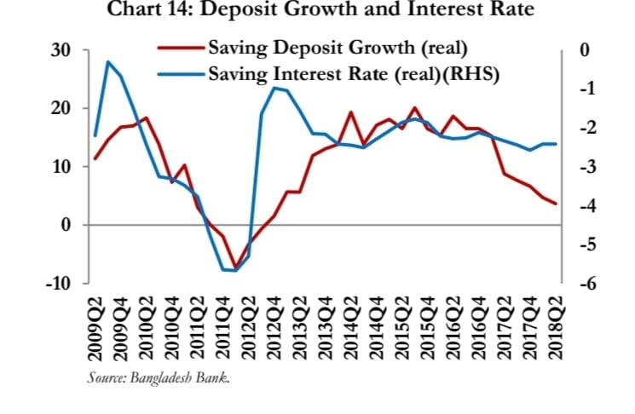
Figure 1.1: Deposit Growth and Interest Rate
Figure 1.1 shows how Bangladesh Bank tried to improve liquidity position and they decided to keep the policy rates unchanged.
We all know that natural calamity affects the economy and if economy get affected then banking industry will also get affected because both are link with each other. Recently the whole world is now suffering from natural disease that is corona virus and due to pandemic situation financial sectors are suffering a lot. Below, the figure 1.2 and figure 1.3 shows how credit growth and mobile financial service decreased in private commercial banks
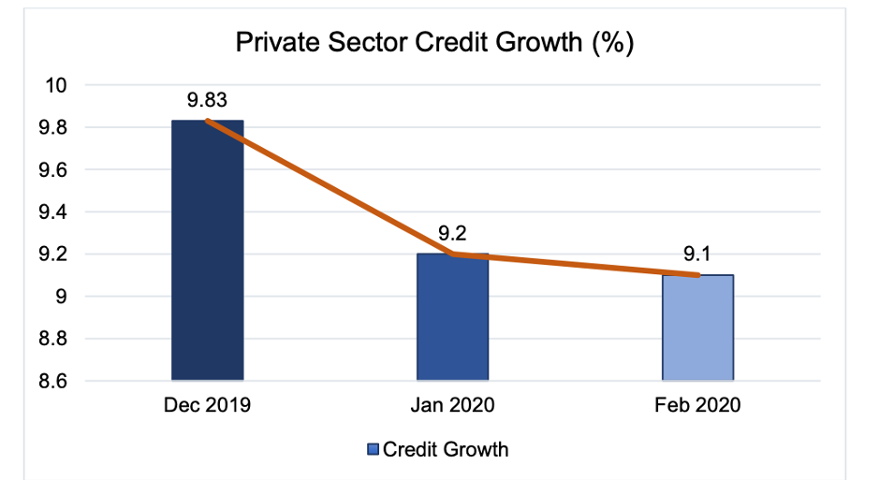
Figure 1.2: Growth Rate of Private Sector Credit
Figure 1.2 shows how private sector credit growth fell due to Covid-19. Large number of loans got cancelled and so private commercial banks worried because loans default may occur.
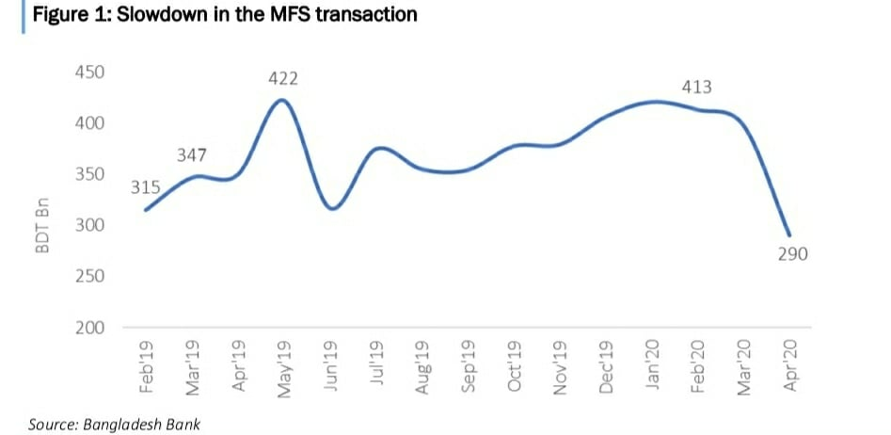
Figure 1.3: Mobile Financial Services

Figure 1.3 shows how mobile financial service have decreased in recent year compare to past year due to corona virus. Many people are avoiding shopping mall and so card transactions decline. Therefore, commercial banks are receiving less revenue.
If we talk about commercial banking area, they are the crucial part in banking sector. Commercial Banks also plays an important role for the economy because they are the one who are trying to follow the international style and trying their level best to give more prominent services to satisfy the customers. They provide specialized financial services which helps to make the economy more efficient.

Objectives of the Report
The objective of the internship report is:
- To analyze the banking industry of Bangladesh
- To analyze the Trust Bank Limited
- To present the internship experience
- To provide recommendation for the organization and for myself

Significance of the Report
From this report, the reader will get to know some important aspects. This report is significant mainly for three reasons.
First reason, in this report I have analyze the banking industry of Bangladesh. I have tried to present the issues related with banking industry and this will help the participants of banking industry and the policy maker to know the current status of banking industry within our country and they will be able to make better policy related to banking sector of Bangladesh.
Second reason, in this report I have analyze the organization and my organization is Trust Bank Limited. In this report I tried to present SWOT analysis for TBL also discuss some strategies which will give an idea what challenges they may face and how TBL can meet with the opportunities. I also recommend some suggestions that how to improve departmental operations. This report will help management of the organization to take decision.
Third reason, this report is very essential for me because here I wrote some recommendation for my self- improvement issues. This report will stay as a written record and in future I can go through this report to recall my self-recommendation.

Organization of the Report
The first chapter is about introduction of this report which includes background of the report, objectives of the report, significance of the report. In background of the report I had tried to show the connection between banking industry of Bangladesh with economy for example due to recent pandemic situation that is corona virus our economy is in recession so this fact how it is affecting our banking industry. Then in objectives of the report I highlighted the main objectives such as analyzing banking industry of Bangladesh, analyzing my organization that is Trust Bank Limited, discussion about internship experience. Significance of the report means for whom this report is important. I categorized significance in three steps such as, by reading the policy maker or participants of banking industry can take help while taking any decision the second significance is analyzing the organization and provide some recommendation for organizational betterment so, in Trust Bank Limited management group read this report it may help them during decision making purpose
The second chapter is about analysis of the banking industry of Bangladesh. In this chapter I tried to highlight the fact like the role of Bangladesh Bank, how banking industry growing by following the trend, how seasonal trend, external economic factors, technological factors, political factors, legal factors, barriers to entry, supplier power, buyer power, industry rivalry, threat of substitute affects the banking industry are discussed in this report also a short summary is given on what challenges the banking sector may face and some opportunities they may meet.
The third chapter is about the analysis of organization and my organization is Trust Bank Limited. Here I have written a short summary on TBL’s history, in which sector TBL’s performance is growing, TBL’s customers mix and in which area customers are high, what are the products that TBL provide to their customers, about TBL’s operational sector such as (general banking, foreign exchange department, credit department), SWOT analysis of TBL and at last I have written how TBL can meet their challenges and opportunities.
The fourth chapter is about my internship experience. In this chapter I have discussed about my (position, duties and responsibilities) that I hold in Trust Bank Limited, I have mentioned the topics on which I was trained in foreign exchange department, how my contributions were essential in foreign exchange department, how my performance was evaluated by my supervisor and senior officers in foreign exchange department, what were skills that I applied also the skills that I gained and at last the academic knowledge I applied. All these matters I have written in this section.
The fifth chapter is about recommendation part where I recommend some suggestions for improving departmental operations of Trust Bank Limited that may help them in future. I have also written some recommendation for myself about my improvement that is necessary to rectify.
Sixth chapter is conclusion where I have summarized shortly on recommendation for both organization and for myself how to improve performance. Then I also wrote about future perspective of Trust Bank Limited.

Chapter 2: Analysis of the Industry

Specification of the Industry
For my internship report I have selected banking industry and I did my internship at Trust Bank Limited and so I would discussion about banking industry of our country Bangladesh.
For every country, banking industry is very important sector because bank is the reliable place where customers can get financial services. Bangladesh is a developing country. Bangladesh has recently improved their policies on many things such as progress in agricultural sector, garments sector, population control, increasing education sector, etc. Likewise, banking industry in Bangladesh also booming which helps to accelerate the economic growth of our country. Banking industry in Bangladesh is becoming more competitive because every year new private banks are opening and the existing banks which are already operating are increasing their branches in different areas for the customers’ convenience. Customers are also showing their interest on banking sector because they consider bank as a safe and reliable place where they can deposit their money by opening an account. People can also take loans from bank and due to this, investment in business are increasing which is a positive sign for country’s growth.
In Bangladesh there are two types of banking industry we can categorized them as Specialized Banks (SBs) and Commercial Banks (CBs). Example of Specialized Banks are Bangladesh krishi Bank looks after agricultural area, Bangladesh Shilpa Bank looks after industrial area. Specialized banks focus on specific area and industrial area. The second category is commercial Banks. Before commencing as a commercial bank, the rules and regulations that are set by the Central Bank need to be abide. Commercial banks are of three types: Nationalized Commercial Banks, Foreign Commercial Banks, and Private Commercial Banks. Commercial banks are guided by Bangladesh Bank. All the commercial banks must have account in Bangladesh Bank (BB) so that if they face shortage of cash, they can bring from Bangladesh Bank. Commercial banks are getting adapted with new technology and they are providing services all around the world. Commercial banks play a vital role for economic development.

Size, Trend, and Maturity of the Industry
- Size:
The banking sector in Bangladesh is growing in large size. We can see that many commercial banks reopen their branch in native area also. Besides posh area banking sector also giving services to rural areas and due this the size of banking sector are getting lager. Many foreign banks also open their branch in our country and there are total 9 foreign banks in country. This shows that size of the banking industry in Bangladesh getting lager. Below the figure shows how commercial banks expand their branches both in rural and urban area.

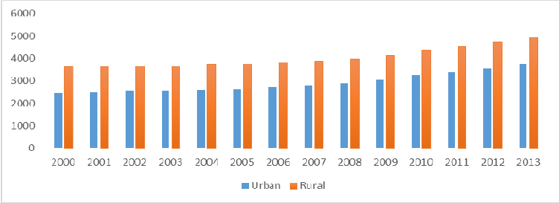
Figure 2.1: Urban and Rural Branches of Commercial Banks
Figure 2.1 shows how branches of commercial banks increasing in both urban and rural areas. Expansion of branches indicates a positive sign because commercial banks are now trying to increase their customers so they are trying to target rural segment also.
At present, number of banks are increasing in Bangladesh. In Bangladesh there are six state owned commercial banks, three specialized banks, thirty-three private commercial banks, nine foreign commercial banks. The lists of the banks that are operating in Bangladesh are given below:
State Owned Commercial Banks (SOBs)
- Sonali Bank Limited
- Janata Bank Limited
- Agrani Bank Limited
- Rupali Bank Limited
- BASIC Bank Limited
- Bangladesh Development Bank
Specialized Banks (SBs)
- Bangladesh Krishi Bank
- Rajshahi Krishi Unnayan Bank
- Probashi Kallyan Bank
Private Commercial Banks (PCBs)
- AB Bank Limited
- Bangladesh Commerce Bank Limited
- Bank Asia Limited
- BRAC Bank Limited
- City Bank Limited
- Community Bank Bangladesh Limited
- Dhaka Bank Limited
- Dutch Bangla Bank Limited
- Eastern Bank Limited
- IFIC Bank Limited
- Jamuna Bank Limited
- Meghna Bank Limited
- Mercantile Bank Limited
- Midland Bank Limited
- Modhumoti Bank Limited
- Mutual Trust Bank Limited
- National Credit and Commerce Bank Limited
- National Bank Limited
- NRB Bank Limited
- One Bank Limited
- Padma Bank Limited
- Premier Bank Limited
- Shimanto Bank Limited
- Southeast Bank Limited
- Trust Bank Limited
- United Commercial Bank Limited
- Uttara Bank Limited
- Al-Arafah Islamic Bank Limited
- EXIM Bank Limited
- First Security Islamic Bank Limited
- ICB Islamic Bank Limited
- Shahjalal Islamic Bank Limited
- Social Islamic Bank Limited
Foreign Commercial Banks (FCBs)
- Bank Al-Falah Limited
- Commercial Bank of Ceylon
- HSBC Bank Limited
- Habib Bank Limited
- National Bank of Pakistan
- Standard Chartered Bank State Bank of India
- Woori Bank

- Trend:
At present, banking sector becomes more modernized. Their service pattern changes a lot compare to previous years. The banks accept the challenges and tries their level best to adapt their services to create new looks by maintaining their cultural norms and try to come up with new thoughts that will benefit their customers. Previously there was no online services in banks but recently banks came up with this service for customer’s convenience. Debit card, credit card is available through which people can do shopping and they do not have to carry cash with them so, there is less chance of stealing money and if the card gets stolen or somehow get lost then customers can contact with bank and the bank will block the pin number of the customer. The number of ATM machines are implemented in Bangladesh for customer’s convenience. Through card people can now easily transfer money from one account to another. Previously people have to stand in a queue to pay their fees but now many private university allows online payment or payment through card and all these services are provided by the banks. Though online banking system people can now pay utility bills, can check their account balance. Mobile banking, Retail banking, Islami banking are also available in banking sector recently. This is how, the trend of banking sector in Bangladesh improved. Below, the figure 2.2 and the figure 2.3 shows how Internet banking and ATM banking have increased by following the trend.

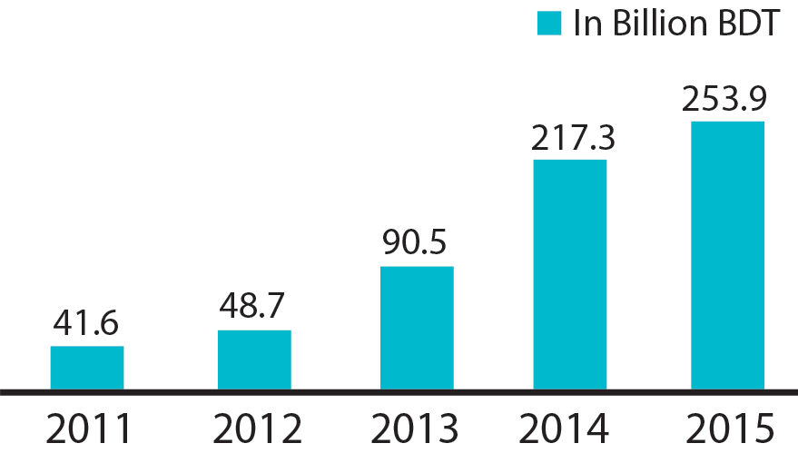
Figure 2.2: Internet Banking
Figure 2.2 shows how internet banking increased. Now, people can easily transfer money through this technique. For this reason, internet banking trend is getting famous day by day because it makes people life easier.
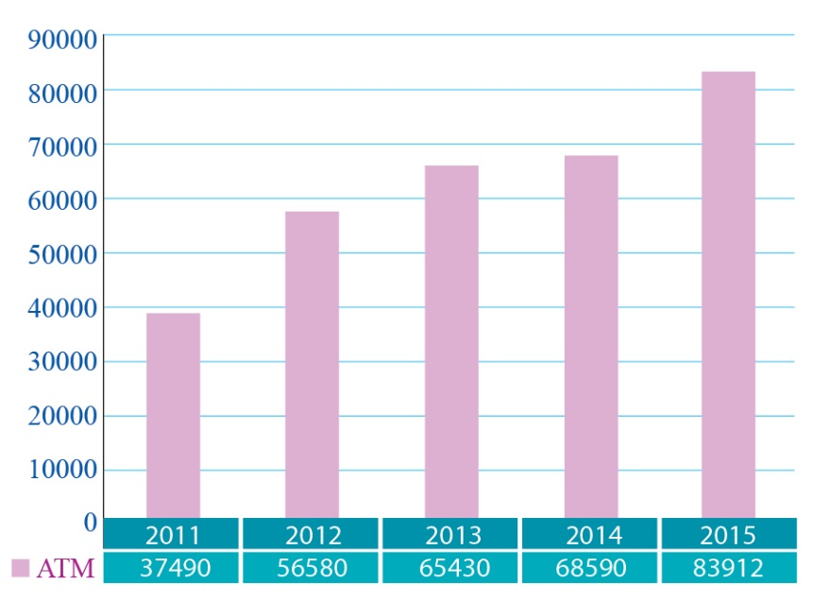
Figure 2.3: Volume of transactions through ATM Banking
Figure 2.3 shows after implementation of ATM booths volume of transactions increased. Maximum booths are set up in divisional cities and district level also in rural areas ATM booths can be seen but very few.

- Maturity:
In Bangladesh, banking industry response is positive and for this reason, this area is becoming more successful and become very demandable sector in recent years. Recently many new banks open their branch such as Shimanto Bank, Police Bank and this proves that banking sector in Bangladesh is in growth stage. Customers are also showing their interest in this sector and are also interested to take different types of services and facilities from the bank. For export and import banks plays a significant role. For all these reason, maturity of banking industry in Bangladesh expanding day by day. Below the figure 2.4 shows the industry life cycles. According to this figure we can say Bangladesh banking sector is in growth stage.
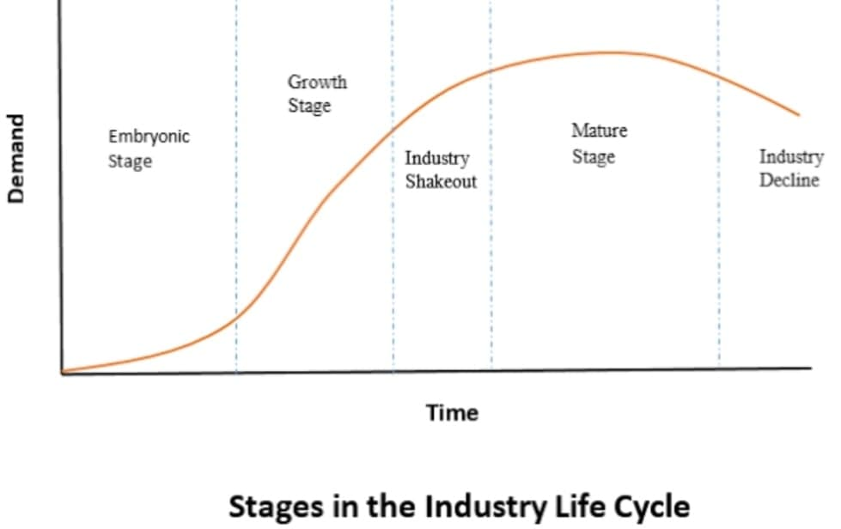
Figure 2.4: Industry Life Cycle

Seasonality
There are number of activities in bank that get changes due to seasonal trend. Some of them are:
- In the month of January LC is low. In the month of March till April LC is high.
- December, January, June, July these four months’ employees work load is high
- In spring and fall season interest rate is low. Interest rate is high in winter and summer season.
- In the month of March and April, return on investment from stock is high but, in February the return from stocks is worst.
- In the month of December and starting point of January the demand for investment services rises.
- Due to lower interest rates in spring that is from March till May the demand for mortgage goes up and so customers visit banks to take mortgage loan.

External economic factors
To know any country’s economic conditions then banking industry comes in front of the scenario since banking industry and economic factors are connected with each other. Macroeconomic factors such as Inflation, recession, depression, boom, economic growth are all linked up with banking industry. The following factors are discussed below:

Recession:
Bangladesh is facing negative economic growth due to corona virus. This pandemic situation also affects banking sector. Deposits, opening letter of credit, declined. Customers are withdrawing their money from the bank. International trade reduced so importers are not coming to bank to open letter of credit. Banks are facing cash shortage since customers are not depositing their money in bank like before and many creditors are unable to pay back the loans. New banks are facing huge problem in running their operations. If this situation continues then banking industry will be in great loss and their profit margin will decrease.

Inflation:
High inflation creates negative impact on economy. Banking industry suffers a lot during inflation because it affects the currency value. Inflation reduce purchasing power. If inflation is high in Bangladesh, then price of goods seems to be expensive. Exports will fall because foreign countries will be less interest to buy from us. This will reduce production so investment will also reduce. Banks will lose their clients as clients will reduce borrowing money from bank. Exporters of Bangladesh will open less letter of credit which will affect the bank negatively. Alternatively, if inflation is high in foreign country like China then, their goods will seem expensive to us. Bangladesh will reduce import from China and this will affect banking sector negatively. Clients will open less letter of credit for import so banks will lose their clients.

Interest rate:
High interest rates makes borrowing costs expensive. Entrepreneurs prefer low interest rates. High interest rates creates obstacles in doing business and so, it discourages borrowing which ultimately reduce investment. For banking industry high rates is not good. Banks will lose the customers. Countries like Sri Lanka, Pakistan, India they charge low interest rates. Bangladesh Bank takes this matter seriously and set lower interest rates and asked private commercial banks to follow their instruction.

Political, Legal, and Regulatory factors
- Political factors:
Although banking industry is a powerful sector but they are linked with political factors too. Political risks that includes are: tax rules, government interventions, barriers to entry (tariffs, quota, and embargo). Unnecessary government intervention in banking sector is not a good decision and due to this performance of banking sector may get down. Federal state and local government are always linked with the banking industry.
- Legal factors:
The banking industry need to abide the strict laws such as consumer’s law, privacy policy, and custom duties formalities during international trade. Now, we will discuss how these factor affects the banking sector.

Consumer law:
In Bangladesh, banking industry has already introduced consumer protection laws. Banks try to keep their client’s history secure which has been shared with the bank because financial contract depends on trust and if banks can assure their customers with safety then people will be more satisfied. If clients face any problem regarding the service, then bank must explain the matter clearly because customers have right to ask questions. If banks want to inform their customers about their new service through advertisement, then they must follow the consumer’s law.

Privacy policy
Banks must check the clients’ history of his / her business before giving them any loans. This checking purpose is necessary to identify their client’s honesty. Banks must give loan by following the legal factors so that later on they don’t face any hassle. If banks don’t check their client’s history then number of bad debts may increase because it is very much important to see whether their client has the ability to pay back the due amount.

Custom duties
Due to recent pandemic situation, many importers are facing problem to receive their products on time as goods are stuck in customs and so shipment is getting delayed. They cannot place their next order before they receive their previous products as uncertainty increases. Banks are facing huge loss because importers are not coming to bank for LC purposes.

- Regulatory factors:
Bangladesh Bank is the central bank of our country. Bangladesh Bank act as a regulatory and supervisory body. Bangladesh Banking industry now maintain the international standards and compliance requirements. Bangladesh Bank monitors the banking system and they have the right to set rules and regulations and if necessary they can also bring changes. Bangladesh Bank monitor the borrowers, monitor the fraudulent activities, monitor both internal and external factors etc. Bangladesh Bank implement risk management guidelines including asset liability management in banking sector. Commercial banks need to follow the required guidelines that are set by Bangladesh Bank. Bangladesh Bank monitor the reserve funds. Bangladesh Bank implement many other policies as a regulatory body and every year they revise guidelines.

Technological factors
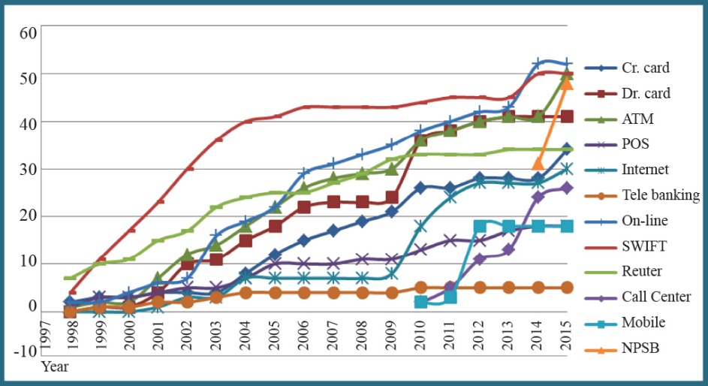
Due to globalization effects, people, organization are becoming more dependent on technological aspects. Technological factors make our day to day life easier. Technological factor plays a vital role in banking sector. Previously lots of paper works were involved but now the works get easier. Through email bank now send their documents from one branch to another now they don’t to need send so many papers in hand. Card system makes people life easier and this service are available in banking sector. Previously lots of paper work were involved while opening an account in bank because all the details were maintained in papers and sometimes the paper may get lost but now all details of customers are kept in computer and banks are providing online services to their clients. People can pay their utility bill through online and this service also available in banks. People can check their account balance through online. Using smartphone cheque can be easily scan. By using smart devices such as smartphone, tab, laptop meeting can be easily attending now, bank officers do not have to frequently move from one country to another and this also saves time. So, we can say that technology changes our life and it added value in banking sector and due to technology advance, banking works become better and services are getting faster which brings happiness and comfort for both customers and banking sectors. Below the figure 2.4 show how technological trends improved.
Figure 2.4: Trends in Technology Adoption, 1985-2015
Figure 2.4 shows how Bangladesh flourish faster with technology trends. Bangladesh Commercial Banks implement ATM, Online, Call center, Mobile banking, and SWIFT.

Barriers to Entry
In banking sector of Bangladesh, the common barriers to entry are brand loyalty, economies of scale & government regulations. These barriers are set by the existing banks and due to this the new comer face difficulty to enter in banking industry. The following barriers to entry are given below:

Brand loyalty:
Customers who are loyal will not move to new bank to take service. For example, ACME Group is a loyal customer of TBL. They get secured services from TBL and hence, ACME Group will not move to new bank.

Economies of scale:
Existing banks enjoy economies of scale compare to new entrants. Existing banks already know how to satisfy their clients and have number of branches that helps them to reach their customers. New comer cannot open in many places because they need some time and costing also matters because huge financial support needed to open branches in different areas.

Government regulations:
Banking industry in Bangladesh is in stable position so, government gives full support to new entrants and welcome them in banking sector. But, new entrants are monitored with great attention to see whether they are carrying out their activity properly or not.

Supplier Power
Depositors are the main supplier for bank because for them the funds create in the bank. The depositors can be businessmen, service holders such as teachers, doctors, lawyers, etc. Well renowned business holders keep large amount of money in bank which is a positive side for bank. Service holders like doctors, teachers, and lawyers keep their money in bank as fixed deposit, this is also positive side for bank. Banks then use the fixed deposit money for reinvestment purposes as the money are kept for long time. Depositors who keep large amount in the account has the power to set the interest rate. Private Commercial banks cannot set the interest rate according to their wish. Banks use depositor’s money for investment activity, giving loans to clients and due to this depositor’s power is more.

Buyer Power
Loan takers are the buyers in banking sector. Customer’s power is huge because if they are not satisfied with the particular bank service then they can easily switch to another bank. Every banks interest rate is same so switching to another bank is not that much difficult. Customers who apply for large amount of credit they have the power to bargain about credit rate. Banks then sort their prime customers and set different rate for them. Their prime customers are mainly well reputed businessmen and to satisfy them a prime interest rate is charged.

Threat of Substitutes
Industrial Development and Leasing Company, Industrial Promotion and Department Corporation, United Leasing Company are the main substitute for banking sector because they do similar kinds of activities like financial institutions. Vanik Bangladesh Ltd is a merchant bank that discussion about investment and provides credit services. These sectors can be threat for commercial banks and for them profit margin may get lower. But, for international trade that is export and import has no substitute option because this are activities carried by banks.

Industry Rivalry
Banking sector in Bangladesh are becoming more competitive because every year new banks are opening for example in recent year, two new banks started their activity they are: Community Bank Bangladesh Limited and Shimanto Bank Limited. Existing banks are facing huge competition because new entrants are coming up with more innovative way. New banks are coming up with different benefits to attract customers and due to these existing banks are losing the shares.

Summary of Challenges and Opportunities

Challenges in Bangladesh Banking Industry
Bangladesh is a developing country and our banking sector is still weak compare to international banking system. Foreign commercial banks that are located in our country are the main rivals for private commercial banks. Private commercial banks are facing huge challenges to compete with them because Bangladesh private commercial banks are still not financially strong. Bangladesh banking industry lacks good governance system. Malpractices and corruption makes our banking sector worst. Technology is another big challenge for banks. Many banks still fail to initiate technical system. So, to survive in this sector, banks need to overcome such challenges and need to keep themselves update to meet the challenges.

Opportunities in Bangladesh Banking Industry
At present, Bangladesh banking sector is in growth stage. This is a great opportunity to make this sector stronger. Every year new banks are entering and they are trying to present themselves in more innovative way to attract customers. Banks can focus more on technological factors as they have chance to implement. Staying in competition will encourage banks to search more new ideas which will keep them unique compare to their rivals.

Chapter 3: Analysis of the organization

Overview and History
There are so many private commercial banks in Bangladesh and among them, Trust Bank Limited (TBL) is one of the well reputed private commercial bank in Bangladesh. Like all other banks, Trust Bank Limited is registered under Central Bank of Bangladesh. TBL got license from Central Bank on 15th July 1999. After getting permission they started their journey from November 1999. Now, TBL can do their business all over the country by committing to maintain all the rules and regulations mentioned by the Central Bank of Bangladesh. Slowly by slowly TBL started to increase their branches and services. Army Welfare Trust (AWT) is the main supporter and founder of TBL. Board of Directors are selected from the army people. In 2006, they introduced Online Banking and in 2008 they introduced Merchant Banking and Islamic Banking. At first, they did not deal with foreign exchange trade but later, they started foreign exchange trade (export and import) and started making relationship with foreign banks and doing foreign businesses.
Table 3.1: Trust Bank Limited – At a Glance
Banking License received on | 15th July 1999
Certificate of incorporation received on | 17th June 1999
Certificate of commencement of business received on | 17th June 1999
First branch licenses on | 9th August 1999
Formal inauguration on | 29th November 1999
Headquarters | Shadhinota Tower, Bir Shrestho Shahid Jhangir Gate, Dhaka Cantonment, Dhaka, Bangladesh
Number of branches | TBL total number of branches 114 among of which 29 are located in Dhaka and rest are scattered in other zone.
Sponsor Shareholders | Army Welfare Trust
Key people | General Aziz Ahmad (Chairman), Mr. Faruq Moinuddin (Managing Director & CEO)
Products | Banking services, ATM services, Consumer Banking, Corporate Banking, Investment Banking
Logo | 
Website | www.tblbd.com

Vision of Trust Bank Limited
Vision of TBL is to provide financial services according to customers’ expectations to make them feel that TBL is always ready to provide services.

Mission of Trust Bank Limited
TBL always focus on how to make banking system easy for their clients. For their customer’s convenience they introduce many innovative concepts and also appoint qualified human resources. TBL also concern about local community, social responsibility and economic growth of the country.

Trend and Growth
According to the source of secondary data, the financial data from the year 2005-2008 are given below in table 3.2 and according to the data, graphs also provided which shows some of the sectors progress of Trust Bank Limited.
Table 3.2: Financial Data
Details | 2005 | 2006 | 2007 | 2008
Shareholds’ Equity | 613,369,226 | 870,685,941 | 991,972,309 | 115,42,61,983
Statutory Reserve | 24,604,805 | 67,881,642 | 113,138,916 | 21,46,77,986
Fixed Assets | 61,369,226 | 86,179,587 | 11,06,16,082 | 14,60,54,811
Total Assets | 7,858,833,009 | 1205,97,10,225 | 1478,21,51,192 | 2119,75,92,200
Total Deposits | 4,483,256,901 | 9,314,952,180 | 1207,49,02,083 | 1898,59,51,094
Loans and Advances | 4,358,314,092 | 6,804,448,553 | 9,738,323,349 | 1318,80,92,885

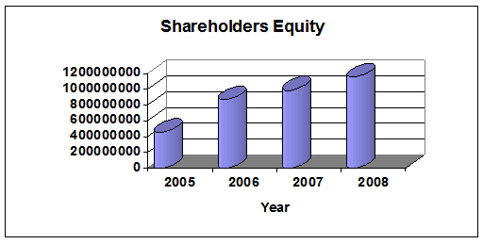
Figure 3.1 Shareholders’ Equity

Figure 3.1 shows the increase of shareholders’ equity from the year 2005 to 2008. It has increased due to expansion of the bank and financial strength of Army Welfare Trust.

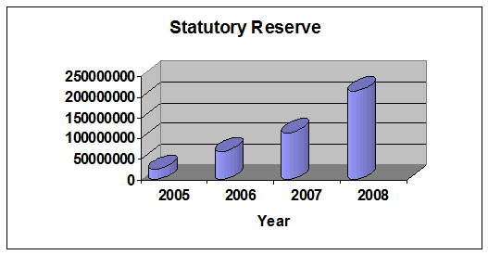
Figure 3.2 Statutory Reserve

Figure 3.2 shows the increase of statutory reserve from the year 2005 to 2008 and the reason was due to increase of the bank’s overall capital and according to Banking Act 1991 TBL kept 20% of share capital or profit as statutory reserve. 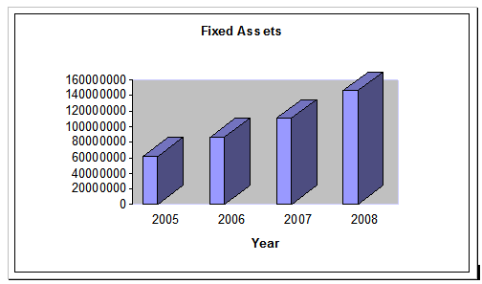
Figure 3.3 Fixed Assets
Figure 3.3 shows the increase of fixed assets of TBL from the year 2005 to 2008. Fixed assets include fixtures and furniture, office equipment, vehicles, leasehold land. Depreciation was charged on fixed assets on straight line basis. Fixed assets increased due to expansion of branches in different zone.
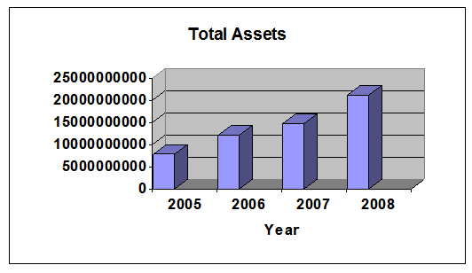
Figure 3.4 Total Assets
Figure 3.4 shows the increase of total assets of TBL from the year 2005 to 2008. The reason was TBL responds to the market. Therefore, TBL hired buildings for office, bought cars to give facility for the employees since they expand their services.
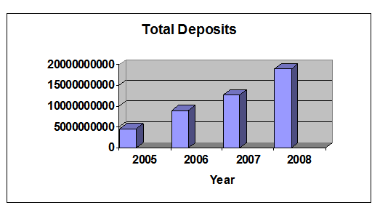
Figure 3.5 Total Deposits

Figure 3.5 shows how total deposits of TBL increased from the year 2005 to 2008. The reason behind this TBL offer high interest rates on deposit.

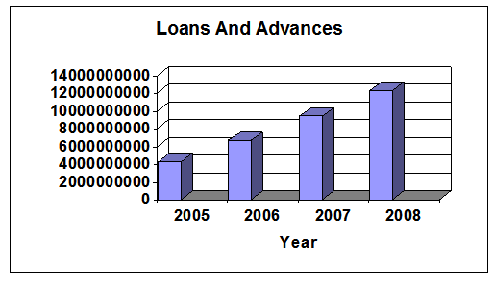
Figure 3.6 Loans and Advances

Figure 3.6 shows how loans and advances increased from the year 2005 to 2008 and the major lending areas were import and industry units and for these reason, advances and loans increased.

Customer Mix

Figure 3.7 Customer Mix
Who: Trust Bank limited need to know who are there targeted customers before they come up with new financial products or services. TBL should target different segment of customers like upper level, mid level, lower level and according to that they can easily categorized what type of products and services can be provide to them. Bank can use relevant data to know the customers. For example nowadays, most people in Bangladesh become used to on technological devices and services. So TBL can target those people who will be willing to grab the sevices related with technological base.
Why: Bank management need to know ‘why’ people prefer technological bases things. This may be because people are getting more educated, busy with job life and getting mordernized like foreign countries.So,TBL came up with online banking services.
What: Now, through online banking service ‘what’ types of services availabe for customers convenience like TBL provide mobile banking, internet banking, phone banking.
Where: Customers can grab these service by sitting their home, office, car anywhere they are. Customers donot have to stand in queue to withdarw or depoit cash since they can do this from anywhere. They can also check their balance through internet which saves huge time.
When: Now, the concern is when customers can get these sort of services. TBL ATM booths are open for 24 hours and for customers flexibility they open their booths in maximum areas. TBL online sevice are also smoothly carried on during day time and employees try to be responsive as much as possible to give prompt services.
What Next: Customer mix is very important part to run the business. If TBL wants to retain their customers bank management need to focus what they should do next to keep their customers with them. Need to come up with new ideas to attract new and old customers. Customer Relatioship Management (CRM) can help TBL how to retain customers lifetime value. For example; TBL can start giving home services to their clients especially to those clients who are 50+ age because they hardly able to move. This sevice will make the clinents feel happy and they will be satisfied by knowing that TBL cares about them.

Product / Service Mix
Trust Bank Limited offers their customers with different types of banking services and products. Some of their important services are discussed below:

Retail Banking
Private commercial banks has already introduced this retail banking due to huge demand. Trust Bank Limited introduce the following retail banking products such as, Loans Products which includes: ( car loan, home loan, doctor’s loan, marriage loan, education loan, digital loan ), Deposit Products which includes: ( Current Deposit, Savings Deposit Account, Trust Echo, Trust Jhinuk, Trust Kotipati, Trust Assurance Deposit Scheme, Trust Maxmill Deposit , Lakhopati Savings Scheme, etc.).

International Banking
Trust Bank Limited introduced international banking service. Customers can open their account in foreign currencies like US Dollars, EURO, Japanese Yen.Trust Bank Limited offer export and import transactions, foreign exchange dealing, foreign currency drafts, travelers cheque.

Islamic Banking
By abiding all the Islamic laws,Trust Bank Limited provides their customers Islamic Banking service. According to Islamic Shariah, interest is completely avoided. It is very important that, both bank and clients must have good knowledge on Islamic Banking. TBL gives full dedication and effort on Islamic Banking and provides the services to their clients by maintaining full professionalism. TBL offer Islamic Deposit Accounts to their clients such as: Al-Wadiah Current Account, Mudaraba Savings Account, Mudaraba Special Notice Deposit, Barakat Hajj Deposit Scheme.

Digital Banking
Trust Bank Limited already introduced digital banking services and focus on technological area and successfully they made huge progress. TBL introduced Online Banking service, ATM Banking, Telephone Banking, Card system such as: Debit card, Credit card, Platinum card.

Trust Locker Service
Many people now prefer locker service for safety concern. For this reason, TBL offer their customers with best locker service. Below the table 3.3 shows the locker size and yearly rent of TBL.
Table 3.3 Trust Locker Service
Lockers | Size | Rent ( yearly)
Big | 21.5”×14.5”×9.75” | TK. 2000.00
Medium | 21.5”×14.5”×5” | TK. 1500.00
Small | 21.5”×7”×5” | TK. 1000.00
Godrej Indian Locker | Size | Rent (yerarly)
Big | 20”×14”×11” | TK. 30,000.00
Medium | 20”×14”×5” | TK. 20,000.00
Small | 20”×7”×5” | TK. 15,000.00

Trust Bank Operational Areas
Trust Bank Limited has three operational areas and they are given below:
- General Banking
- Foreign Exchange Department
- Credit Department

General Banking Department
General Banking is the basic operational section in all banking institutions. Operation manager of every branch is responsible to control all the works and assist the employees who works under general banking section.In Dhanmondi Branch, MS Asma Rahman is the operation manager who is responsible to monitor the GB Department. Under general banking, employees are responsible to give prominent services to the clients.There are many functions that general banking section holds: They are:
- Accounts Opening Department
- Cash Department
- Remittance Department
- Financial Control & Accounts Department (FCAD)

Accounts Opening Department:
Trust Bank Limited maintain different category of accounts to give better service to their clients. The most common accounts that every customers seeks for are given below:
- Savings Account: To open savings account TK. 500 is required. If the account holder is 18 years old, then he / she can solely operate the account and if the account holder is below 18 then parents can have right to operate the account. Same person is not allowed to have more than one account.
- Fixed Deposit Account: People open this account to keep their extra money secured for long time. Different rate of interest are offered to the customers. Below table 3.4 shows the interest rates that TBL offer their clients.

Table 3.4: Fixed Deposit Interest Rates
Deposit Accounts | 1st month | 3rd month | 6th month | Above 1 year
Any Amount | 7.00% | 12.00% | 12.00% | 12.00%

Cash Department :
The activities of cash department are given below:
- Payment through Cash: When customers visit bank to withdraw money they are asked to give cheque and the cheque must be signed. The signature then varified by the bank. If the signature is correct only then the money is handed over to their clients.
- Payment through Transfer: Payment is not made through cash. Cash is transfer from one account to another account according to clients wish.
- Payment through ATM Card: It is a cost free service because no processing cost or service charge are asked from the customers. Card holders just need to be an account holder.

Remittance Department:
To transfer the local money from one place to another within the country means local remittance. The money that is transfer from overseas is known as foreign remittance. Remittance can be collected through electronic payment system, mail, draft or cheque. Remittance are of two types such as (inward) remittance and (outward) remittance. Inward remittance means money comes from abroad to home country and outwad remittance means money goes out from home country to abroad. The sender, the receiver the service provider are the main people in transfer of remittance. Trust Bank Limited always try to provide better remittance service to their customers. Functions that are carried out in remittance department are: issue and payment of Demand Draft (DD), Telegraphic Transfer (TT), Mail Transfer (MT), issue of Travelers Cheques, Sale of foreign exchange currency, maintaining non resident accounts. The remittance department of Trust Bank Ltd need to inform all the details of transactions about inward and outward remittance to Bangladesh Bank at the end of every month. In Savar Cantonment Branch of TBL, many army people stays there so huge transactions takes place in that branch.

Financial Control & Accounts Department (FCAD):
This section mainly deals with administrative tasks. The lists of tasks are given below :
- Paying every bill for example: for arranging any program they order cake, food, gifts and FCAD department is responsible to make a bill for those things.
- Reducing the expenditure of the branch,
- Cutting cost,
- Solving problems like if other sectors employee face problem in computer related issues then FCAD is responsible to slove.
- Buying stationery like: A4 papers, pen, stapler, pencil, etc.
- Arranging transportation for the employees
- Sanctioning leaves and holidays
- Collecting voucher from the employees and checking it
- Other HR related works are processed by FCAD department in Dhanmondi Corporate Branch.

Foreign Exchange Department
This department deals with import, export, foreign remittance and significant funding. In Gulshan Corporate branch their daily basis activities are: export and import, foreign currency endorsement, wage earners development bonds. In Dhanmondi Corporate branch they mostly deal with import activities.Now, let us know the details of export operations and import operations.

Export Operations:
We all know that Bangladesh is famous for its agricultural sector and readymade garments sector. These two items are the main things that we export to abroad. Since, labor cost is low in Bangladesh for this reason it becomes easy to enlarge the production in these two sectors such as readymade clothes, products made with jute, tea. Maximum of the garments products are exported to U.S and European countries. Many agencies in Bangladesh export through Trust Bank Limited (TBL). The company open export L/Cs in TBL so that company can export their goods. TBL acts as advising bank and negotiable bank for the exporter. The paper documents that are required are: Airway Bill / Bill of Freight, Bill of Lading, Industrial Invoice, Packing List, Certificate of origin. When any company wants to export through TBL it needs: to open current account, need to show export registration certificate, certificate from traders associate.

Imort Operations:
Bank plays a vital role in foreign exchange trade. It also acts as an intermediary party. When Bangladeshi importer wants to import from abroad at that time importer needs to open a L/C. The importer needs to submit the required papers at Trust Bank Limited. The following procedure that TBL maintain are : purchase, forwarding, permission from head office (shadhinota tower), adjustment, informing the letter of report to Bangladesh Bank. Acme is the only company who engaged in both import and export and other companies likeTechnokit and Radiant are the importer and they import mostly medical equipment.

Credit Department
This department is one of the important section in TBL and all other commercial private banks. Employees who work under this department are reponsible to disburse the money from the fund to their client (who visit the bank to take loan) and after maturity they claim back from the clients. The credit department of Trust Bank Ltd provides three types of loans. They are: Corporate loan such as : overdraft, short & long term loan, syndicated loan. Retaile loan such as: car loan, marriage loan, vehicale repair loan, house renovation loan, etc. SME loan such as: Trust Shufola loan, Peal Seasons loan, Agri-Business loan, loan for poutary firm,loan for village people who does small business, etc. The credit department employees gives sevices to their clients by maintaining professionalism. They try to provide their clients with fastest services by maintaining accuracy and this helps to make strong bond with the clients. They are comitted to ensure safety to their clients and offer the services at competitive price. While lending loan to the clients, there are some basic principals that TBL credit department need to follow. They are:
- Need to know customer profile
- Customers liquidity position
- Income level
- Safety & security like, if customer fail to repay the loan what asset the customer has that will act mortgage security
- Need to know for what purpose cutomer need loan and verify the truth by visiting their company.

SWOT Analysis of Trust Bank Limited
SWOT analysis is a strategic plan that helps managers to make a quick review about the company’s strategic situation. Every banks need to do SWOT analysis. SWOT analysis of TBL are given below:

Strengths
- Shena Kalyan Shongsthan is the main sponsor for Trust Bank Limited. This Shongstha help TBL to compete because they contribute financial support.
- The top management are run by the Army Officers who are knowledgable because they are more disciplined than non Army Officers which helps the bank to grow.
- Trust Bank goodwill is belongs to Army Welfare Trust. Defense members are the key customers for the TBL and this creates positive image in front of general public which encourage people to take service from TBL.
- TBL introduce telax and fax facilities, introduce PC banking. TBL is always try to stay updated with modern technology which help them to compete.
- TBL corporate culture maintain friendly environment and also interactive. Employees are cooperative with each other also bank manager which encourage employees to work with full dedication and makes them more competitive.
- TBL introduce online banking service which helps them to increase the number of customers because the world is getting modernized and staying updated is very important .
- Most of the branch of TBL are build in cantonment area. This type of area are very much pleasant and attractive location. The infrastructure decoration both inside and outside is very much pretty which brings positive thoughts in customers mind.

Weakness
- TBL weakness is they donot advertise their activities in media. Dutch Bangla Bank Limited focus on media such as tv ads, billboard but, TBL doesnot focus on media. For this reason, customers donot know about TBL’s new services that much.
- TBL has low branches, low ATM booths for this reason they are less connected with the customers and this makes them weak.
- Employees who work in TBL are not permanent any time employee can leave the organization so there is possibility to get the information leaked.

Opportunities
- Beside defense people, TBL also give service to general people. They now target different segment of customers which means TBL involves in diversification . This is a great opportunity for TBL to stay in competition.
- TBL has the opportunity to introduce different types of card services like: VISA, MASTER CARD and recently they introduce PLATINUM CARD.
- TBL has the chance to increase their branches in those areas where they have not been yet such as EPZ area, tribal area.
- TBL has the opportunity to concentrate on micro credit program which will help them to maximize their profits .

Threats
- Dutch Bangla Bank, Mutual Trust Bank, Mercantile Bank, Prime Bank are the main rivals for Trust Bank LTD..These banks are doing very well at their field and trying very hard to attract the customers attention. To compete with these banks, TBL must take proper steps and should make more strong strategies to compete with them.
- Foreign Banks such as Standard Chartered, Bank of Ceylon, HSBC, etc. established their branch in Bangladesh which is a threat for Bangladesh local banks because these foreign banks are more financially strong.
- Bangladesh economic conditions are not that much stable so it becomes difficult for TBL to run their business smoothly.
- Day by day number of private commercial banks are increasing also foreign banks, due to this number of competitors are increasing which is a big threat for TBL.

Steps/ Strategies to Meet the Challenges &Opportunities
Trust Bank Limited plan their strategies to meet the opportunities and challenges. They are:
- Trust Bank Limited can open their branch in overseas like China, Japan and Asian countries.
- Trust Bank Limited can go for partnership with foreign banks.
- Trust Bank Limited has already updated their software for accounts opening and other software that are necessary for doing their work with the help of Information Technology ( IT).
- Nowadays, updated technology matters a lot because people are getting modern day by day. TBL always try to train their employees with new and modern technology so that employees can easily provide their clients with better and fastest services.
- Trust Bank Limited recruit the best IT Officers.
- Trust Bank Limited can apply Delphi Technique. Delphi Technique means to hire the expertise who gives unique ideas and opinions without any group discussion. To get this type of ideas TBL must give high salary to the consultant. This will help TBL to meet their challenges .
- Trust Bank Limited can start giving home service to their customers especially those who are aged clients.

Chapter 4: Internship Experience

Position, Duties and Responsibilities

Position:
As an intern, my designation was a foreign exchange intern officer. I joined in Dhanmondi Corporate Branch of Trust Bank Limited this year on 2nd February.

Duties and Responsibilities:
As an intern, I had to carry my duties and responsibilities on daily basis. The lists are given below:
- Every day I update the register book such as Deferred LC register update, Sight LC register update, Payment Against Document ( P.A.D) register update, These registers are essential to update on daily basis so that when auditors comes the manager can show the updated register.
- To fill up the Import Form (IMP), Travel and Miscellaneous form (T/ M).
- Input bill of entry in excel sheet
- Input Deferred and Sight LC in excel sheet
- Posting FC transactions for Bangladesh Bank
- To check the document if there is any discrepancy
- Entry of cheque and deposits slips number and amount in the register and give serial number to those slips.
- Scanning the documents before sending to head office. The document mostly are forwarding letter, invoices, transport documents such as bill of lading, airway bill, truck receipt and many other important documents.

Training
Trust Bank Limited Dhanmondi Corporate Branch mainly deals with foreign exchange trade and credit risk management. Since I did my internship only two months, I was only trained up in foreign exchange sector. The last month I was supposed to shift credit risk management but unfortunately could not continue. I was not taken outside for training purpose. My work was limited within office premises. I was asked to work with my four senior officers who helped me to learn many things on foreign exchange. Every day I went to office at 9:30 am and leave at 7:00 pm. Within this time, I was trained up in many things in foreign exchange department such as how to prepare Letter of credit agreement (LCAF), how to send intimation mail to head office, how to check discrepancy, how to input data entry through Bangladesh Bank’s dashboard, how to input bill of entry in excel, how to fill up Import form, how to scan the documents.

Contributions to Departmental Functions
There are many departmental functions such as Operational Department, Cash Department, Credit Risk Management Department, Financial Control and Account Department (FCAD), General Banking Department, Retail Banking Department, Foreign Exchange Department. Since, I was totally connected with Foreign Exchange Department, so I contribute this section mainly. I focus this department with huge encourage because I found quite interesting. I contribute in this department whatever they asked me to do. I helped them in checking discrepancy and almost every day ten to 12 files I checked. I update the PAD (Payment against document) it was very important task for foreign exchange department. I also print out LC from SWIFT. I was asked to finalize the final submission in Online Import Monitoring System Bangladesh. I update the sight LC and deferred LC in register. I fill up the letter of credit authorization form for both industrial and commercial consumers and put necessary seals. In computer I fill up the form named ‘Import Payment Schedule’ where I input the necessary information. This were my tasks that I contribute to my foreign exchange department.

Evaluation of Internship Performance
My overall journey at Trust Bank Limited (TBL) was quite good. I tried myself to adjust with the new atmosphere. We all know that everyone is not perfect in all aspects. I am a learner and in this stage of my life I will make mistakes and will try to rectify my mistakes. Like other employees, my performance was also evaluated as an intern by my supervisor and other officers in foreign exchange department. My performance was quite satisfactory they said. I asked my supervisor questions about my work-related topic because while doing my task some questions arised in my mind and I cleared those confusion during lunch time. My supervisor was happy with me by seeing my interest on my work and mostly she liked about me that I had idea when to ask queries because I did not ask any question while she was busy with her work. I always entered office on time and exit office not before 6 pm and sometimes I had to stay office till 7:30 p.m. This act was quite impressive, and my colleagues were very much happy by seeing that I stayed for them at late to assist them in their work. I tried to finish my task on time so that I could start the next and never showed any laziness. Within a short span of time I got close with my colleagues and communications with them turned to be very friendly. If I did any mistakes my supervisor always support me to correct my mistakes. My supervisor and other officers were so good and they tried to reduce my nervousness by showing their friendly attitude. All these positive evaluations made me happy and increase my motivation level.

Skills Applied
As an intern, I tried to apply some skills which helped me during this journey. Some of skills that I applied are given below:
- Adaptability: Nowadays, in maximum organization they look for computer and excel skills. If candidates are good in this technological sides, then it becomes easy to get job. I was not that much good in excel but with my little knowledge I was able to continue my task. In bank, their computer was already set up systematically all I need to do was just input the information systematically. When my seniors gave me work related with computer, I noted down the rules so that next time I don’t have to ask again.
- Time management: I always tried to finish my work on time. I never kept my work pending because I focused how to finish my task as early as possible so that I could start my other task and tried to manage the time properly.
- Ethical: While staying inside office I did all my task ethically. When I entered in bank, I always signed in attendance sheet. I never left office before 6 p.m. and sometimes if the work pressure was high, I used to stay with my colleagues to assist them. I never gave absent unnecessarily and if I need to take leave I gave my supervisor genuine reason.
- Interpersonal Skill: I did all my tasks with patience and with great interest. I tried to follow the instructions that my supervisor and other senior officers told me. I was always serious with my responsibilities and never showed any laziness.

New Skills Developed
During my internship journey, I have gained some new skills. In my opinion, internship is very important platform for the students as we get the opportunity to gain new skills. My supervisor and senior officers helped me to learn new things.
My communication skill improved because in office I had to communicate with my seniors and manager. I learned how to scan the documents, how to do photocopy, how to print the SWIFT message of LC. These were small task but, for me these small tasks were completely new because I haven’t done these before. I got the opportunity to learn things practically which will definitely help me in future. Another important thing that I learned checking discrepancy the meaning of each documents was explained by my supervisor and this helped me to learn new terms. I can now explain the terms of the documents if someone wants to know such as meaning of bill of lading, invoices, country of origin, packing lists. I also got to learn how employees gives posting in Bangladesh Bank. The employees are responsible to inform about all the transactions on daily basis to Bangladesh Bank through online posting. I got the opportunity to learn things practically which will definitely help me in future.

Application of Academic Knowledge
Some academic courses that helped me a lot during my internship journey. The first course I would like to mention is insurance and banking. From this course first I came to know about the term letter of credit, bill of lading, insurance purpose. When my supervisor Mausafa Akhter mam started to discuss about LC at that moment it was quite easy for me to catch her lecture. I already knew that why LC is opened, and it related with international business. Different category of insurance policy I learned from this course which helped me to understand why insurance policy also important for international business purpose. Already knew the term of custom duties. My supervisor while talking about custom duties work, I found myself quite easy to catch her discussion. Another course was International business course. From this course I already know how international transactions involves in between two countries. Another course from finance was International Financial Institutions (IFM). From this course, whatever knowledge I gained I was able to relate during my internship for example, how to calculate freight charge. Basically, I was quite familiar with many terms since these courses related with international trade and in bank I worked in foreign exchange department

Chapter 5: Recommendations

Recommendations for Improving Departmental Operations
During my internship journey, I have gained practical experience about foreign exchange department activities in Dhanmodi Corporate branch of Trust Bank limited. I observed that employees and officers they faced some problems while working. So, in this report I tried to present some recommendations that will help them to improve their departmental operations. The following recommendations are given below:
- All employees in foreign exchange department are not trained up with all the activities. I saw that, if any employee stays absent for one day then that employee’s work other employees cannot do this is because others are not aware of his /her work. Due to this, activities get delay because foreign exchange work are interlinking with other. So, in my opinion all employees should be trained up with all sort of activities so that they don’t have to face any problems if any employee stays absent.
- Trust bank limited should establish its own networking system between its branches. This will help them to carry their work more efficiently.
- In Dhanmodi branch I noticed that the space is very little. Foreign exchange department need to maintain lots of paper documents. Sometimes employees get puzzled where the documents kept. So, need to look after spacing.
- Every after one-year employees should be exchanged to another department. This will make the employees more efficient because this will help them to gain knowledge on multiple tasks.
- In Dhanmodi corporate branch they only focus on import part and avoid export part. As a result, other branch like Gulshan corporate branch of TBL, Principal branch of TBL, Karwan Bazaar branch of TBL face huge pressure because these branch handle both import and export activities. So, in my opinion all activities of TBL should be maintain in all branches.

Recommendations for Improving Self-Performance
While doing my internship I faced some difficulties due to my own problems. Therefore, I have some recommendation for myself and they are given below:
- I am a bit introvert, and this is my main problem because I feel shy and uneasy to ask any query. Due to this I face difficulty and sometimes confusion stayed in my mind. So, I should make myself more open because in working place I must clear my confusion so that, later on I don’t need to face any haphazard situation.
- My confidence level is very weak. I am facing this problem from my childhood. But, after joining in bank I realized that, if I want to do job then I must keep trust on myself. Therefore, I need to be serious about my attitude and behavior and should focus on my task with full dedication which will help me to overcome with the problems.

Chapter 6: Conclusion

Banking industry is very essential part for every country. Bangladesh is a developing country and our country is dependent in this sector. Without bank, international trade is not possible. Entrepreneurs get financial support from bank. Commercial Banks are considered as heart for our nation because for them our economy shows strong. Commercial Banks work hard which helps our economy to grow. Bangladesh Bank is the Central Bank of our country. Bangladesh Bank is responsible to keep this sector peaceful because banking industry is crucial part for our country. Day by day bad loans and malpractices are increasing in banking industry so, Bangladesh Bank trying to reduce this activity by investing in proper place which helps to improve our economy.
My internship period was for three months but due to pandemic situation I continued for two months because TBL suspend all the internship program. Within this short time, it was very difficult to know everything about TBL but, with my little knowledge I have tried to analyze TBL. Trust Bank Limited is under Bangladesh Army. TBL managed to keep their credit portfolio perfect also keep interest rates low for classified loans. This is possible only because for good credit policy practices. At starting point of their journey, foreign exchange trade activity was not there. As the time passed, TBL introduced this activity in their organization. Now, reputed companies like ACME, Radiant, Technokit are involved with TBL for import and export activity. Overall, I would like to say that Trust Bank Limited shines with great success in this competitive world and successfully hold their position by showing full dedication in their performance. If they work in this pace, then in future they can open their branch in abroad.
I enjoyed my internship journey because for the very first time I got the opportunity to work in corporate world. I got the chance to see the work practically. In this report, I tried to present my opinion about TBL and used my academic knowledge to prepare this report.

References:

FederalReserveEducation.org. (2008, 03 11). www.frbsf.org. Retrieved from www.frbsf.org: www.frbsf.org/education/publications/doctor-econ/2001/july/bank-economic-function/?fbclid=IwAR2P5CBjplPVtlSWina1wstpyNfr1ah4vWy0QBIYSKb1TRmylra1uojI6pI
fintechbd. (2017, 2 11). www.fintechbd.com. Retrieved from www.fintechbd.com: http://www.fintechbd.com/the-digital-banking-revolution-in-bangladesh/?fbclid=IwAR1Vn3AUhY5CzAqB30wYCpSym5dr3wP8MFmF4j8L3sZH7AnXnglflP1roCU
Foregin exchange. (2015, 11 25). assignmentpoint.com. Retrieved from assignmentpoint.com: https://www.assignmentpoint.com/business/banking/deposit-products-and-schemes-of-trust-bank-limited.html?fbclid=IwAR1HyN2A2TSOGnaDgTtPBpmbXONE89G2uWXJFzz7736AUqLlQPvnuye7YrA
Foreign Exchange Operations of Trust Bank Limited. (2015, 11 25). assignmentpoint.com. Retrieved from assignmentpoint.com: https://www.assignmentpoint.com/business/banking/foreign-exchange-operations-of-trust-bank-limited-2.html?fbclid=IwAR2P5CBjplPVtlSWina1wstpyNfr1ah4vWy0QBIYSKb1TRmylra1uojI6pI
Growth in Different Businesses of Trust Bank Limited. (2012, 02 09). assignmentpoint.com. Retrieved from assignmentpoint.com: https://www.assignmentpoint.com/business/marketing-business/growth-in-different-businesses-of-trust-bank-limited.html
Performance of the Trust Bank Limited. (2015, 11 07). assignmentpoint.com. Retrieved from assignmentpoint.com: https://www.assignmentpoint.com/business/banking/performance-of-the-trust-bank-limited.html?fbclid=IwAR3_vsIOzNffsIPNCztYXZWf89JKWtzu_41f625sRNGd73yqRIyJTJhqWbg
researchgate. (2017, 3 09). www.researchgate.net. Retrieved from www.researchgate.net: www.researchgate.net/publication/282436993_Role_Of_Banking-Sector_To_Inclusive_Growth_Through_Inclusive_Finance_In_Bangladesh?fbclid=IwAR2Rwvcm2PXeWFnCu0fdrhNf1Ya--dUE5SLafPgCh382pQja4Q6xWY2TcOA
The banking Industry of bangladesh. (2012, 02 07). assignmentpoint.com. Retrieved from assignmentpoint.com: https://www.assignmentpoint.com/other/the-banking-industry-of-bangladesh.html?fbclid=IwAR2w9GkD-PqK0L1wAMfluu7PfHEcVurkq9TDfHu9VFV-EyLXlTPl9WQhZ8I

Appendices:

Appendix 1: Training Contents
- Letter of credit (LC) - It is a type of contract which means if importer fail to pay the money to the exporter then bank will pay on behalf of the importer which means the bank guarantee the payment. This contract is necessary for international trade. During my internship I saw ACME and Technokit these two company visits TBL for LC making purpose. They bring documents and give to foreign exchange department officers and according to that the officers are responsible to prepare LC. Letter of credit are of two types. They are:
- Sight LC- Instant payment for goods and services within five working days. This LC is more demandable than other LC because for instant payment. This LC must be negotiated by the seller, buyer and banking institutions.
- Deferred LC- Here also bank pay to the buyer on behalf of the seller but, the payment is not instant the payment is made at the end of tenor. It is also known as maturity payment like within 180 days. The buyer must present the necessary documents to the bank and after that LC will be prepared and after that payment will be made.

- Import Form (IMP Form) - In this form all the details information given about imports only. In the form it is written “Application for permission under section 4/5 of the Foreign Exchange Regulations Act, 1947 to purchase foreign exchange for payment of imports.” I was asked to fill up the form and before that one of the officer taught me how to fill up the form. The information that need to fill up such as invoice value, LC number, description of good such as ( raw materials , medical equipment , spare and parts), Harmonized System (HS) code number, quantity of goods along with units like: ( kg, pcs, gm.), freight amount, country of origin, port of shipment, name of the transportation through which good are delivered like : ( truck, steamer, airway ), full name of the applicant, name of the beneficiary (exporter), name of the place where good will be dispatched. The client must sign the paper and hand it over to bank. To fill up this import form the documents that are required such as invoice document, transport document (airway bill / truck receipt / sea track), Packaging list, country of origin, LC copy.

- Finding Discrepancy: Sayeda Nazina Sabin mam trained me how to find out the discrepancy. I was asked to check the documents to find out the discrepancy. The discrepancy that I need to find out are: LC Expired, Late Shipment, and Late Presentation. These three are the major discrepancy that usually happen. By looking at the information provided in the LC, I was asked to read the information from there and then match the documents to see whether it match with the information provided in the LC.
- LC Expired: From SWIFT (Society for Worldwide International Financial Telecommunications) LC sheet is printed out. Then field number (F31D) expiry data is mentioned with that date need to count with the data written in forwarding letter. If the date mentioned in the forwarding letter is exceeded over the LC data, then it is treated as LC expired. For example, in LC the expiry data is mentioned 27th January 2020 and in forwarding letter it is mentioned 18th February 2020. The LC has expired since in forwarding letter, the data exceed over compare to LC mentioned in F31D.
- Late Shipment: In LC, field number F44C the latest data of shipment is mentioned now with this data I was asked to check with the date mentioned in the transport document. If data written in transport document exceeded the data mentioned in LC then it is considered as late shipment. For example: In LC the latest data written 12th January 2020 but, in transport document written 21st January 2020 so, the data has exceeded and it is considered as late shipment.
- Late Presentation: In LC, field number F48 presentation period is written in days and most of the time 21 days is written. Now, I was asked to count the data written in forwarding letter with the transport document data. If the time range falls within 21 days or less than 21 days then it is not considered discrepancy but, if the range exceeded more than 21 days then it is considered as late presentation which is a discrepancy.
Suppose, if the time period is changed in LC then amendment will be sent and in amendment new time period will be clearly mentioned. Amendment is one kind of message that is send if there is correction in time period of LC expiry data, shipment data, and presentation data.
- Payment against document: I was trained how to update payment information both on register copy and how to input in excel sheet. Need to fill up data, forwarding bank’s name (beneficiary bank which is export’s bank), drawer’s name (applicant’s name for example The ACME Laboratories Limited), drawer’s name (beneficiary name for example Divis Laboratories Limited), foreign currency value which is the document value), description of the goods (for example pharmaceutical raw materials), and last need to mention serial number of Import Form (IMP Form).
- Intimation: TBL is responsible to clear the payment after goods is imported. So to close the A/C, Dhanmodi Corporate branch need to inform this to head office by sending an email that they have outward the LC payment. By seeing their mail head office will then outward the LC payment. During my internship, I was trained how to prepare intimation message also I mail to head office by informing how many LC payments we have outward from Dhanmodi Corporate branch. On top of the message need to write transmission of FTT (FOREIGN TELEGRAPHIC TRANSFER) / or LC payment. Before sending this intimation message to head office, I was asked to input the necessary information in word file and bring a print out and then get it signed by Syeda Nazina Sabin mam (First Assistant Vice President Officer), Maosafa Akhter (Assistant Vice President officer), Mir Muhammad Shahadat Hossain sir (Senior Assistant Vice President & foreign exchange manager), Md. Mozakkerul Islam sir (Chief Manager). After this procedure completed need to scan the print out of intimation and then send the scan copy via mail to head office.
- How to input Bill of Entry information in excel: Sanjida Islam mam taught me how to inputs the information on excel sheet. Before inputting the information in excel she gave me idea about the term bill of entry. Bill of entry is proving that products have reached safely. It is a document that must be handover within four months. If time exceed then new LC cannot be submitting. Customs duties give this document to importer as a certificate and importer need to submit this bill of entry to TBL. Then in excel sheet I input LC types like sight LC /Deferred LC, Importer name like: Acme / Radiant / Technokit, bill of entry value, bill of entry date, bill of entry number. I found quite easy to input since the table was already organized in their computer.

Appendix 2: Lists of Abbreviations
Short Forms | Abbreviations
TBL | Trust Bank Limited
AWT | Army Welfare Trust
FDA | Fixed Deposit Account
ATM | Automated Teller Machine
LC | Letter of Credit
SWIFT | Society of Worldwide Interbank Financial Telecommunications

